ACT Public Service

**Classification Review**



Contents

1. Executive Summary 4

2. Definitions 7

3. Background 9

3.1. Purpose of the review 9

3.2. Overview of the existing ACTPS employment framework 9

3.3. Priority groups 9

4. Workstream 1: Comparative Work Value 11

4.1. Workstream 1 objectives 11

4.2. A work value model that aligns to the ACTPS workforce 11

4.3. Research approach 16

4.4. Summary of findings and future considerations 24

5. Workstream 2: Specified Shared Salary Spines 34

5.1. Workstream 2 objectives 34

5.2. Where are we now and how did we get here? 34

5.3. Why have shared salary spines? 35

5.4. What is a contemporary career pathway? 37

5.5. Research Approach 38

5.6. Findings, interpretation, and analysis 40

5.7. Summary of findings and recommendations 56

6. Workstream 3: Work Level Standards 62

6.1. Workstream 3 objectives 62

6.2. An overview of work level standards 62

6.3. Research approach 63

6.4. Considerations for the future 64

7. Workstream 4: Historical Percentage-Based PAY Increases 65

7.1. Workstream 4 objectives 65

7.2. Background 65

7.3. Research approach 68

7.4. Findings, interpretation, and analysis 69

7.5. Recommendations 72

8. Future Considerations 72

9. Attachments 74

# Executive Summary

The ACT Public Service (ACTPS) is a modern public sector organisation employing a complex workforce across a wide range of functions from Policy Development through to Automotive Maintenance. The ACTPS employment framework has evolved over time and has led to the creation of many classification groups aimed at addressing the diverse nature of its workforce. The ACTPS also adopted many of its classification groups from the Commonwealth following the establishment of a separate service (e.g. GSO, TO, ITO, PO) which have largely remained unchanged and may no longer be fit for purpose.

As well as the natural evolution of the nature of work, there are upcoming decisions regarding the structuring of the workforce, such as the renewal of the suite of Enterprise Agreements in place across the ACTPS. There is, therefore, an opportunity to look at the effectiveness of the current structure and put in place measures to ensure it is fit-for-purpose.

The Workforce Capability and Governance Division of the Chief Minister, Treasury and Economic Development Directorate (CMTEDD) commissioned this review to look at a specific set of priority employee groups (an overview of these priority groups is provided in *Section 3.3*) and deliver analysis and insights across four workstreams:

* **Workstream 1: Comparative Work Value** – an analysis on the Comparative Work Value of the priority groups.
* **Workstream 2**: **Specified Shared Salary Spines** – an analysis on the efficacy of Territory specified (priority group) shared salary spines in the ACTPS with respect to internal staff mobility, career progression and specialisation.
* **Workstream 3: Work Level Standards –** the development of Work Level Standards for the priority groups, described in work value terms.
* **Workstream 4: Historical Percentage-Based Pay Increases** – an analysis on the impact of historic percentage-based pay increases with respect to the extent to which these have contributed to greater pay disparity.

#### Workstream 1: Comparative Work Value

Workstream 1 focused on the development of a model that recognises the unique context of the ACTPS workforce, providing a current state view of work value.

This was undertaken by developing a Work Value Framework that aligns to the diverse nature of the ACTPS workforce and an accompanying assessment tool. This was used to measure and compare work value within and across classifications by undertaking work value assessments for a cross-section of roles within the priority groups.

A market comparison analysis was also undertaken for each priority group. Market comparators included average wage data for NSW State Government, ACT private sector, and ACT federal government employees. The primary data source used was Australian Bureau of Statistics (ABS) census data mapped to the Australian and New Zealand Standard Classification of Occupations (ANZSCO) model.

Findings displayed there are classifications that, in terms of distribution of work value across levels and alignment to market comparators, are fit for purpose. However, the analysis also identified opportunities to enhance the structure of some of the classifications reviewed. This included proposed changes to the structures for the Legal Officer and Ranger-related classifications (as detailed in *Attachments 4* and *7*).

The primary finding from both the *Comparative Work Value analysis* and the *Specified Shared Salary Spines analysis*, was that the General Service Officer (GSO) classification is the most diverse of those considered in this review in terms of role and work value. The work value assessments of the GSO classification suggests there is more than one discrete occupational group in the classification and there is an opportunity to restructure roles within the GSO group into occupationally based classification groups.

#### Workstream 2: Specified Shared Salary Spines

Workstream 2 examined how the ACTPS remuneration structure intersects with career pathways for the workforce.

The analysis was undertaken using an HR dataset for roles within the priority groups between 2011-2020. The dataset was used to analyse workforce trends over time including employee mobility, promotion and career progression, salary progression, tenure, turnover, use of higher duties allowances, and age profile.

The analysis of the shared salary spines identified that there are differences in career pathways (tenure, progression rates, etc.) across classifications. However, these reflect the nature of the particular workforce rather than any specific effect created by the shared salary spine system.

The analysis also revealed that the existing system explicitly acknowledges specialisation within the workforce. However, there are some classifications that are less focused on specialisation and are organisationally based (such as Building Service Officers and Capital Linen Service classifications) or catch-all classifications (such as the General Service Officers).

A key recommendation of this review is to consider restructuring existing classifications to ensure that they are occupationally based, rather than organisationally based or catch-all. This would support the horizontal and non-linear nature of modern career pathways as well as reduce the confusion related to similar occupations existing across multiple classifications.

The immediate priority is to address the GSO classification. The outcomes of the Comparative Work Value and Shared Salary Spines analyses have identified that there is an opportunity to re-think how roles in this group are classified. A new approach to classifying roles currently in the GSO group would be to create additional occupationally based classifications (discussed further in *Section 5.6*).

#### Workstream 3: Work Level Standards

Workstream 3 involved the development of work level standards (WLS) for the priority groups included in this review.

WLS describe the distinctive elements of work at each classification level. They are a statement of the broad job requirements and operating context, the typical duties, and the qualifications, skills and experience required of each classification level.

The WLS were developed using multiple sources of information to ensure they reflect and are relevant to, the operating context within which the classification is currently operating. Information sources included: existing WLS, external examples, position descriptions, and outcomes from the work value assessments undertaken in Workstream 1.

As part of this workstream, a guide to WLS and a standard template was developed which can be applied to the development of WLS for other ACTPS classifications. Having a contemporary and standardised set of WLS supports consistent and sound decision-making for role design and the classification of roles. It also provides a common language across work areas and Directorates within the ACTPS and helps employees understand what is expected of them in their role.

#### Workstream 4: Historical Percentage-Based Pay Increases

Workstream 4 examined the inequities generated by the historic percentage-based pay increase system used by the ACTPS and identified potential alternate options.

This analysis was undertaken using historic EA data for the past eight years. Baseline salary data for each level of each classification under review was used and the EA agreed percentage increases applied to develop a model of salaries over this time period. The difference between the top and bottom pay point in each classification was calculated to identify the pay disparity in each classification which was then modelled over time.

A separate model based on the salary increase model used in the ACTPS in 2013 was then calculated. This model provided a split increase equal to the greater of a specific fixed amount or a fixed percentage increase across the classifications. The pay disparity across classifications was then calculated from this 2013 model (albeit using actual percentage-based pay increases rather than the 2013 figure of 2%) and compared with purely percentage-based increases.

This analysis showed that there had been an increase in the salary disparity across the ACTPS classifications under review as a result of the purely percentage-based salary increases but that the application of the 2013 model would have reduced the increase in salary disparity for only a small increase (3%) in the overall salary cost for the ACTPS. Finally, a model was developed to estimate the cost to return the salary disparity across the classification levels in the ACTPS from the 2021 levels to 2013 levels. The model indicated that this can be achieved in a modest one-off payment.

It was concluded that a mixed model containing a fixed dollar increase and a percentage increase, along the lines of that used in 2013, is most effective in reducing pay disparity increases.

# Definitions

#### Common terminology

*Table 2.1* provides definitions for the common terminology used throughout this report and associated attachments.

*Table 2.1: Common terminology used in this report.*

| **Term** | **Definition** |
| --- | --- |
| ANZSCO model | Australian and New Zealand Standard Classification of Occupations. ANZSCO is a skills-based classification model used to classify all occupations and jobs in the Australian and New Zealand labour markets. It provides a basis for the standardised collection, analysis, and dissemination of occupation data. |
| Broadband | A term applied to a classification. It means the grouping of two or more levels within a particular Classification Group, designed to achieve the advancement of employees from a lower classification level to a higher classification level within a Broadband without the need for a merit selection process. |
| Priority Group | A priority group refers to a grouping of employees that have been identified for the purposes of this classification review. The groupings are based on a particular category of employee or class of work.  Some groups are focused on the type of work being undertaken such as Rangers, which vary across several classification groups and shared salary spines.  Others are purely based on the classification (see definition below) such as the General Service Officers, which operate under a shared salary spine, but the work undertaken varies widely or Prosecutors which also operate under a shared salary spine and undertake similar work. |
| Classification Group | Classification group refers to a category of employee that is specified in a relevant *Enterprise Agreement* and in which employees within the classification group are remunerated based on the same *shared salary spine*. |
| Enterprise Agreement | Enterprise Agreement refers to the industrial agreement made under s.172 of the Fair Work Act 2009. |
| Job Family | A grouping of similar jobs at the highest level. *Managers*, *Technicians and Trades Workers*, *Social and Welfare Professionals,* and *Environmental Scientists* are examples of job families referred to in this report. For the purposes of this review, job families are primarily based on the ANZSCO model. |
| Pay Band | The grouping of pay points within a Salary Scale corresponding to a particular classification level. |
| Position Description | A structured document describing the predominant and recurring duties and responsibilities that are assigned to and performed by a given position and how the position relates to other positions within the work unit. They may also include Qualification requirements, selection criteria and a description of the work environment. |
| Qualification | Under the Public Sector Management Act 1994, the term qualification includes:   * an academic qualification * an apprenticeship * a license * membership of a professional body * a registration * a security clearance. |
| Salary Scale | A generic term relating to pay. The Salary Scale for a particular category of employee or specific class of work may comprise:   * a single pay point * two or more pay points comprising a single Pay Band * all the pay points comprising two or more Broadbanded Pay Bands * all the pay points for a particular category of employee or specific class of work. |
| Shared Salary Spine | Shared salary spine refers to the salary scale for a particular classification group. |

#### Acronyms

*Table 2.2* describes the wording for the common acronyms used throughout this report and associated attachments.

*Table 2.2: Common acronyms referred to in this report.*

| **Common Acronyms** | **Directorates** | **Classifications and Roles** |
| --- | --- | --- |
| ABS – Australian Bureau of Statistics  ACTPS – ACT Public Service  APS – Australian Public Service  ANZSCO – Australian and New Zealand Standard Classification of Occupations  ANZIC – Australia and New Zealand Standard Industry Classification  ARIn – Attraction and Retention Incentives  CPI – Consumer Price Index  EA – Enterprise Agreement  FTE – Full Time Equivalent  PD – Position Description  WVA – Work Value Assessment  WLS – Work Level Standards  HDA – Higher Duties Allowance | CHS – Canberra Health Services  CFC – Cultural Facilities Corporation  CIT – Canberra Institute of Technology  CMTEDD – Chief Minister Treasury and Economic Development Directorate  CSD – Community Services Directorate  ED – Education Directorate  EPSDD – Environmental Protection and Sustainable Development Directorate  HD – Health Directorate  IC – Integrity Commission  JACSD – Justice and Community Safety Directorate  SS – Shared Services  TCCS – Transport Canberra and City Services  MP – Major Projects | ACTCT – ACT Courts and Tribunals  BSO – Building Service Officer  CLS – Capital Linen Service  CITC – Canberra Institute of Technology Counsellor  ESAMT – Emergency Services Agency Mechanical Technician  FACMGR – Facilities Manager  GSO – General Service Officer  HP – Health Professional  HSO – Health Service Officer  ITO – Information Technology Officer  PO – Professional Officer  PRO – Prosecutor  SITO – Senior Information Technology Officer  SPO – Senior Professional Officer  SST – Sterilising Services Technician  STO – Senior Technical Officer  TO – Technical Officer  TT – Theatre Technician |

# Background

## Purpose of the review

Good workforce information is important for the smooth functioning of any complex modern public sector organisation and this is critical for an organisation with the size and complexity of the ACTPS.

There are several major workforce changes occurring within the ACTPS in the short to medium term, including the renewal of the suite of Enterprise Agreements (EAs) in place across the ACTPS. The decisions taken in renewing EAs are improved through the availability of good workforce data. For example, an evidence-based understanding of how current remuneration practices are affecting the workforce and having current comparative work value assessments for priority groups are critical inputs as part of the EA bargaining process.

The ACTPS has commissioned this review to look at a specific set of priority groups (an overview of the priority groups is provided in *Section 3.3*) and provide:

* An analysis on the comparative Work Value of the priority groups.
* An analysis on the efficacy of Territory specified (priority group) shared salary spines in the ACTPS with respect to internal staff mobility, career progression and specialisation.
* Work level standards for the priority groups, described in work value terms.
* An analysis on the impact of historic percentage-based pay increases with respect to the extent to which these have contributed to greater pay disparity.

The specific requirements of this review and how and where they have been addressed in this report are provided in *Attachment 1*.

## Overview of the existing ACTPS employment framework

The ACTPS consists of approximately 60 classification groups across 19 Enterprise Agreements[1]. In some cases, the same classification group is listed in more than one EA (for example, Technical Officers are listed in one occupationally based and three organisationally-based EAs) though the salary spines for these duplications are the same within each EA. *Section 3.3* highlights the EAs related to the classifications that were included in this review.

## Priority groups

For the purposes of the review, it was requested that seven specific groupings of roles were analysed. The taxonomy applied to these seven priority groups is described below.

A priority group refers to a grouping of employees that have been identified for the purposes of this classification review. The groupings are based on a particular category of employee or class of work.

Some groups are focused on the type of work being undertaken such as the Ranger group. The Ranger priority group includes several classifications and shared salary spines. Others are purely based on the classification such as the Technical Officers, which operate under the same shared salary spine, but the work undertaken varies widely or the Prosecutors which also operate under a shared salary spine and undertake similar work. It is worth noting that in some cases, there are associated classifications that are included in a priority group. For example, the General Service Officer (GSO) priority group includes some similar classification groups that have been considered in the analysis. *Table 3.1* provides a summary of the priority groups analysed as part of the review.

*Table 3.1: Summary of priority groups.*

|  |  |  |  |
| --- | --- | --- | --- |
| Priority Group | Classifications | Enterprise Agreements | Directorates |
| 1. General Service Officers | * General Service Officers * Building Service Officers * Capital Linen Service | * Infrastructure Services EA * Transport Canberra Operations (ACTION) EA * Cultural Facilities Corporation EA * CIT EA | * CMTEDD * ED * EPSDD * CSD* * CFC * CIT * JACSD * TCCS |
| 1. Rangers | * Administrative Service Officers (City Rangers) * Park Rangers * Sportsground Rangers * Technical Officers | * Infrastructure Services EA * Technical and Other Professionals EA * Administrative and Related Classifications EA | * EPSDD * TCCS* |
| 1. Information Technology Officers | * Information Technology Officers | * CIT EA * Technical and Other Professionals EA | * ED * HD * JACSD* * SS |
| 1. Technical Officers | * Technical Officers * Theatre Technicians * Sterilising Technicians** | * CIT EA * Technical and Other Professionals EA * Transport Canberra Operations (ACTION) EA * Cultural Facilities Corporation EA | * CHS * CIT * CMTEDD * CFC (Theatre Technicians only) * EPSDD* * HD* * JACSD* * MP* * TCCS |
| 1. Legal Officers | * Legal Officers | * Legal Professionals EA | * JACSD * CMTEDD* * HD* * IC* |
| 1. Prosecutors | * Prosecutors | * Legal Professionals EA | * JACSD |
| 1. CIT Student Counsellors | * Professional Officers (Student Counsellors) | * CIT EA | * CIT |

*\*headcount of 5 or less (based on permanent headcount 22/10/2020).*

*\*\*Sterilising Technicians have been included in the analysis for Workstreams 2 and 4 but not in Workstream 1 based on availability of data.*

*Note: Health Service Officer Planners and Supervisors were initially identified to be reviewed as part of the GSO priority group. Subsequent enquiries established they were being addressed separately by CHS.*

# Workstream 1: Comparative Work Value

## Workstream 1 objectives

*Development of a model that recognises the unique context of the ACTPS workforce, providing a current state view of work value.*

The aim of Workstream 1 was, for each priority group, to understand:

*Internal and external context*

* The context the priority group is operating within (both within the ACTPS and externally).
* Suitable comparators (internally and externally).
* What remuneration data looks like against market comparators.
* Historical changes in work and work requirements.
* What the current use of attraction and retention payments for the group looks like.

*Work value*

* Whether the work and work requirements have changed over time.
* What work value currently looks like and what impact this has on the existing classification structure.

## A work value model that aligns to the ACTPS workforce

A work value model is used to assess the work value of a role relative to other roles within the ACTPS. It focuses on the nature, impact, and accountabilities of the role. A work value assessment (WVA) is a method for assessing the work value of a role relative to other similar roles within the ACTPS.

It is important to note that a WVA is not:

* An assessment of a staff member currently performing the role.
* A performance management system.
* A measure of workload.
* A system for determining the number of jobs in an organisation.
* A system for measuring market forces (i.e., supply and demand factors).

#### Identifying a model that suits the context of the ACTPS

There are several existing examples of work value models used by both the APS and State and Territory Governments[2]. In identifying a suitable model for the ACTPS it was determined that a customised model would best suit the operating context of the ACTPS.

Models such as the *APS Role Evaluation Framework* provide a good basis for a model that could be applied to the ACTPS. However, the operating context and workforce composition of the ACTPS is unique, when compared with the APS and even other State and Territory Governments. For example, the diversity of work undertaken by the ACTPS is broad, ranging from administrative office-based work through to roles such as City Rangers (which are often employed at the local council level in other State and Territory Governments).

The ACTPS workforce includes roles that can be found at all three levels of government. Because of this, the ACTPS workforce is unique in terms of its diversity. Therefore, there is a need to use other work value models as a guide but develop a fit-for-purpose approach for the ACTPS.

#### The ACTPS work value model

The ACTPS model (*Figure 4.1*) focusses on the nature of work – the regular and enduring characteristics of the work. It is principles-based and has been designed to be applicable to all jobs in the ACTPS and focuses on four key features of work:

* Responsibility and accountability
* Social nature of work
* Physical nature of work
* Cognitive nature of work

Figure 4.1: ACTPS Work Value Model

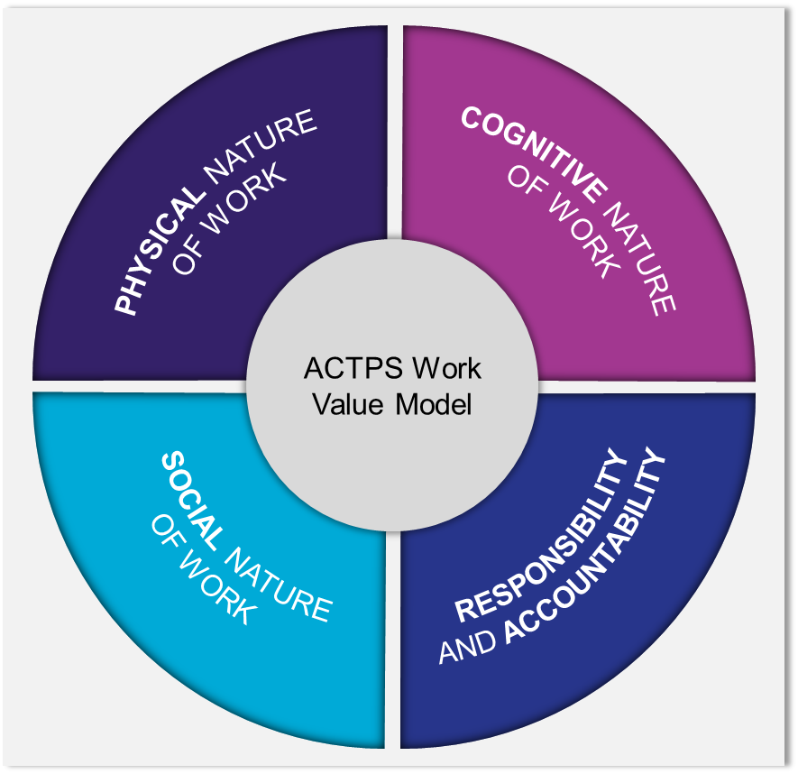

For each feature, there are several evaluation factors (see *Figure 4.2*), for example, the *Physical Nature of Work* feature includes two evaluation factors: *Physical Environment* and *Degree of Physicality*. Each evaluation factor is assessed against the nature of the environment in which work is conducted (from less to more difficult) and the nature of the work conducted by the individual (from simpler to more complex).

 Figure 4.2: ACTPS Work Value Model – Evaluation Factors

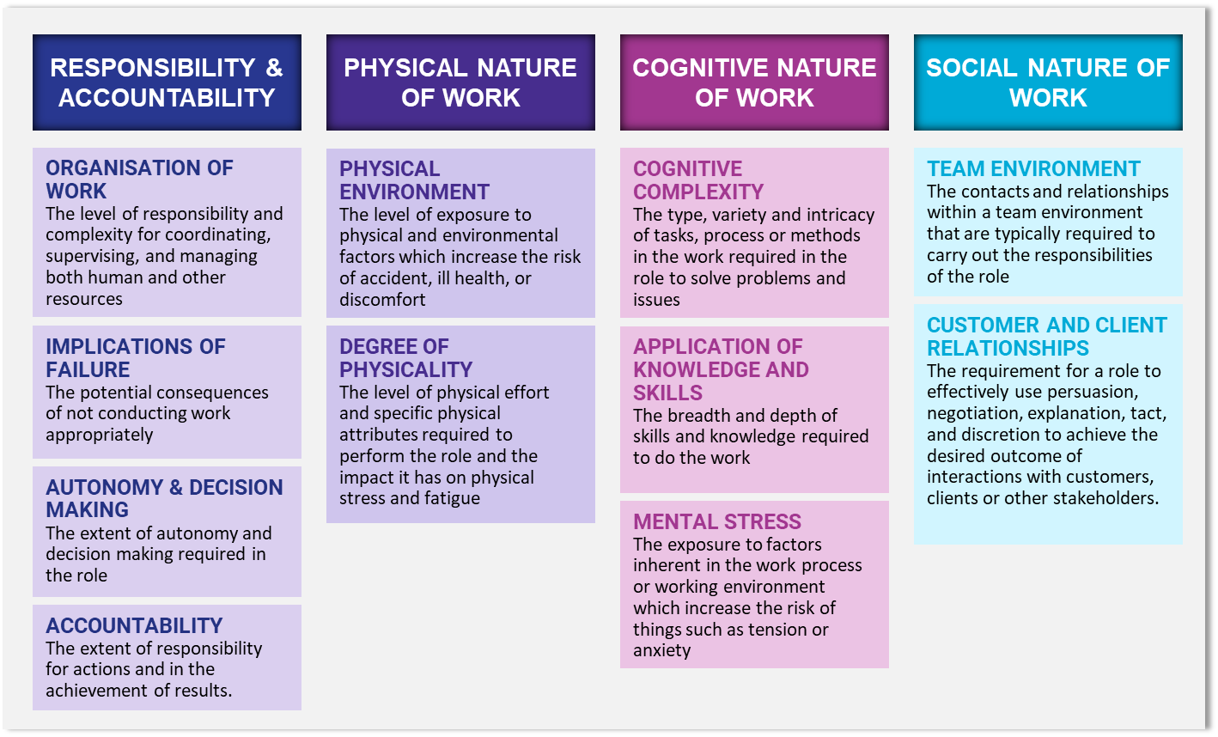

For each evaluation factor there are work value descriptions which relate to different degrees of the factor with a corresponding scale for scoring roles. The full Work Value Assessment Tool is provided in *Attachment 2*.

#### Using the ACTPS work value model

The ACTPS work value model has been a key component of the classification review and has been used to:

* Develop a database of measurement properties for each priority group analysed as part of this review (these are presented in the *Comparative Work Value Summary Report* for each priority group which can be found in *Attachments 3-9*).
* Develop the *characteristics* components in the Work Level Standards that have been developed as part of this review (these are in *Attachments 3-9*).

Further details on how the model has been used are provided in *Section 4.3.* Moreover, the model can also be used further by the ACTPS for a range of activities including:

* For classification groups not included in this review, this framework and approach can be applied to determine work value scores and develop Work Level Standards. The methodology described in *Section 4.3* outlines the approach that can be applied to undertake this activity for other classification groups.
* The database of work value scores for each priority group analysed as part of this review (see *Section 4.4*), and the work value assessment tool, can be used to undertake work value assessments to determine a suitable classification level for new roles or roles that require re-classifying. How the work value assessment tool can be used in the classification of a role is described below.

**Using the work value assessment tool for classifying a role**

Assessing a role for the purposes of classification involves objectively evaluating a role based on information and evidence gathering and mapping against the ACTPS work evaluation framework features. Information and evidence gathering includes activities such as reviewing position descriptions and interviewing or surveying individuals within a role and those supervising the role.

It is important to note the work value assessment tool (see *Attachment 2*) provides an assessment of work value only. To determine what classification a role best fits within, a review of relevant work level standards will also need to be undertaken. Work level standards capture the way in which tasks, responsibilities, skills, and experience differ across classifications.

There are also additional considerations, such as market conditions, that are important when it comes to determining remuneration for a role.

An example of how the work value assessment, work level standards, and other considerations all form part of determining the classification for a role is depicted in *Figure 4.3* below.

*Figure 4.3: Classifying a new role.*

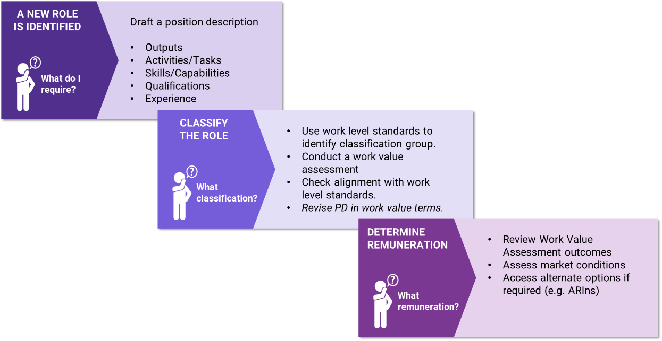

Two examples of how the work value assessment tool can be used to either classify a new role or re-classify an existing role (within the same classification group) are provided below.

Assessing a role involves objectively evaluating a role based on information and evidence gathering and mapping against the ACTPS work evaluation framework features.

**Example 1: assessing an existing role where it is expected that the work value of that role aligns to a different level within the classification group it sits within.**

*An ITO1 level role has significantly changed over time and it is expected that the role may need to be upgraded to an ITO2 level role.*

The work value assessment tool can be used to determine the appropriate level for the role.

Compare the assessment score against the work level standards for the classification to check for alignment.

**Example 2: a new role is being created and it is unclear which classification group it should be classified under**

*A new role is being created in a legal policy business unit. It is unclear if the role should be classified as a Legal Officer or as an Administrative Service Officer.*

The work value assessment tool can be used to determine the initial work value of the role.

Information obtained about the role requirements can be compared to the work level standards for Legal Officer and Administrative Service Officer classifications to determine the most suitable classification group for the role.

The classification level is determined using the initial work value for the role and mapping it to the relevant classification group levels.

## Research approach

#### Methodology

An overview of the methodology used to undertake Workstream 1 activities is summarised in *Figure 4.4*.

*Figure 4.4: Workstream 1: Overview of methodology.*

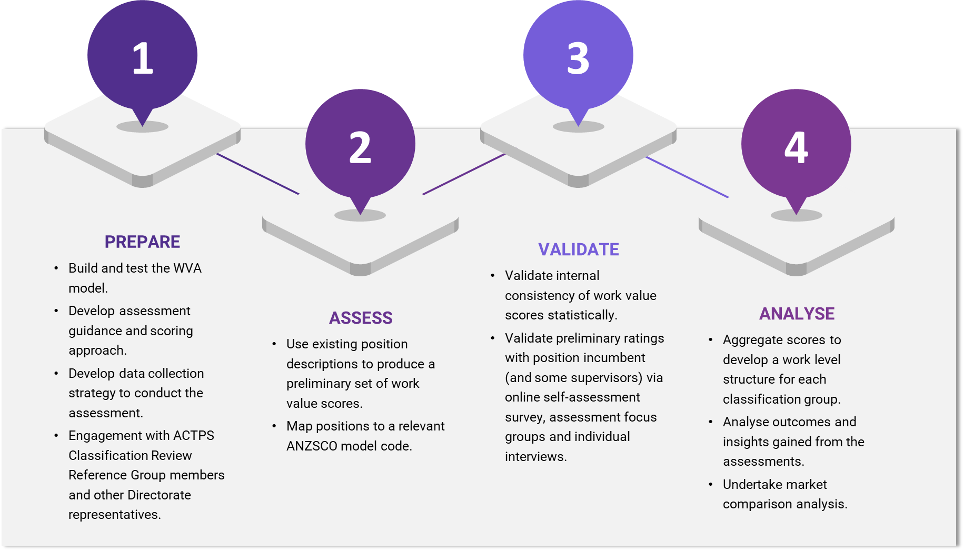

##### Phase 1: Prepare

The preparation phase involved the development of a suitable work value assessment model (as described in *Section 4.2*) and guidance materials that describe the model and how a WVA should be undertaken.

A data collection strategy was developed which included:

* Identification of a suitable cross-section of positions for each priority group to be analysed. The sample needed to include a cross-section of positions in terms of classification level, type of work, and Directorates the positions are located in.
* A stakeholder engagement approach was developed identifying how and when Directorate representatives and staff members included in the identified cross-section would be engaged as part of the process.
* Communication messages and materials were developed to explain the assessment process and describe the purpose of it to staff participating in the engagement activities.
* The development an online version of the work value assessment form.
* The development of focus group materials, used to undertake a group assessment process. Focus group materials included a PowerPoint presentation, paper-based assessment tool, and self-assessment form.

The preparation phase also involved engaging with members of the ACTPS Classification Review Reference Group. This group includes representatives from ACTPS Directorates and unions which hold memberships with ACTPS employees. The aim of engaging with these representatives was to understand the context within which each priority group operated, including any challenges or issues that exist within the group. Directorate representatives also supported the research team in identifying a suitable cross-section of staff to engage with, as well as communicating with and making the logistical arrangements for staff to attend engagement sessions.

In the preparation phase, the research team engaged with over 30 Directorate representatives including business unit leads and HR management team members.

##### Phase 2: Assess

The assessment phase involved individually reviewing a cross-section of existing position descriptions and undertaking a WVA using the assessment tool and scoring system. The research team applied the following principles when undertaking the position-description assessments and the overall assessment and validation process:

* The quality, credibility, and integrity of an assessment is dependent on an evidence-based assessment of a role. This includes using multiple inputs and validation where possible.
* An analysis relates to the role and its requirements, not the qualities of the person performing it.
* The existing classification of a role was ignored, the WVA is an opportunity to take a fresh look at a role.
* The assessment should consider both the significance and frequency of tasks undertaken.
* A role should not be assessed based on workload or how busy the role is.
* A role needs to meet the full intent of a description for that description and score to be selected.
* The value for the same input should not be attributed to more than one evaluation factor.

A total of 225 position description based assessments were undertaken by the research team.

A breakdown of the number of position description based assessments undertaken per priority group is provided in *Figure 4.5* and a list of all the position descriptions reviewed is provided in *Attachment 10*.

##### Phase 3: Validate

The validation phase involved two main activities, undertaking an internal validation to ensure the position description assessments were undertaken consistently and engaging with position incumbents and supervisors to undertake self-assessments or interview to provide additional insights not available in the position descriptions. Engagement with position incumbents and supervisors was conducted using focus groups, online engagement sessions, and one-on-one interviews.

***Focus groups***

Small group sessions with employees (ranging from 3 – 10 employees per session) were conducted at employee work premises.

Each session was delivered in the following format:

1. An overview of the purpose and activities of the ACTPS Classification Review.
2. A presentation on the work value model and how it will be used as part of the review.
3. Guidance on completing the self-assessment.
4. Individual self-assessment undertaken by participants with assistance provided by the session facilitator.

The value of meeting with employees at their place of work was that the research team was able to make additional observations regarding the operating context employees operated within (i.e. the physical environment, team interaction, etc.). This information was used to further validate work value assessment insights.

A total of 25 focus groups were conducted across 14 different worksites, 4 focus groups were conducted online, and 14 individual interviews were conducted.

***Online engagement sessions***

Small group sessions with employees were also conducted over videoconference. These sessions followed the same format of the in-person focus groups, with participants completing the self-assessment using the online version of the WVA tool.

***One-on-one interviews***

In some cases, the research team met individually with employees. These sessions were conducted in the format of a one-on-one interview with the assessment being conducted by the facilitator (as opposed to a self-assessment).

A summary of the number of self-assessments and one-on-one interviews undertaken per priority group is provided in *Figure 4.5*.

*Figure 4.5: Number of assessment and validation activities undertaken per priority group.*

##### Phase 4: Analyse

The analyse phase of work involved the consolidation and interpretation of the data, both numerical and anecdotal, gathered in the previous phases in order to produce the findings and observations of the ACTPS Classification Review. This was achieved through the aggregation, moderation and presentation of the data as well as the allocation of an Australian and New Zealand Standard Classification of Occupations (ANZSCO) code to each position assessed.

***Aggregation***

Throughout the process of conducting the previous phases of work, the data gathered was recorded in a central database of Work Value and Stakeholder Engagement. This process of aggregation allowed for the combination of Work Value Assessments conducted by the research team and stakeholders, enabling the scores to be compared and validated. Critical to this step was the use of a central work value model that allowed for a common language and understanding between all of those who conducted work value assessments.

Throughout this process, ANZSCO codes were assigned to each role assessed by the research team. This provided additional information about the position and allows for it to be understood in the broader Australian labour market so that it can be used to inform findings and action. It provides another lens for identifying which roles carry out similar work across the ACTPS and various classifications and compare their work value. ANZSCO coding was also used as the basis for conducting a market comparison of remuneration levels for similar jobs.

The ANZSCO classification is used for the development of all official government labour market statistics. It is comprehensive but, as with any organisational classification system, it does not provide a perfect mapping to ACTPS classifications or occupations. The mapping exercise conducted in the analysis phase was based on a comparison of occupation titles, position descriptions, and ANZSCO job descriptions by a workforce analyst. Where there was any concern about the potential mapping of an ACTPS occupation to an ANZSCO code, the mapping was validated by another analyst. However, the mapping, in the final analysis was subjective and therefore is open to other interpretations of the mapping.

***Moderation***

The moderation process for the numerical data involved removing the highest scores from those classification levels that contained more than three WVAs. The purpose of the moderation process is to remove any potential outliers and compensate for the general tendency of individuals to inflate scores for their role. From this newly moderated dataset the mean and median were calculated for each classification level as well as the minimum and maximum scores.

***Presentation***

In order for the numerical data to be easily interpreted it has been presented in the form of several graphs. These were developed using the mean, median, maximum and minimum WVA score for each level of each classification. These measures have been used as they show both the range of the work values and where the concentration of scores lies. For each classification reviewed, several standard graphs have been created:

1. Spread of work value scores with median (middle score) across levels within a classification.
2. The breakdown of mean (average) work value scores by each factor of work across the levels of a classification.
3. Progression of the average work value score per level within a classification against a line of best fit (described below) from the lowest to the highest WVA score.

The line of best fit, on graph type c), was calculated by:

* Taking all the work value scores within a classification, removing the highest and lowest scores, and calculating the difference between the subsequent highest and lowest score.
* Dividing the difference between the highest and lowest score by one less than the total number of levels within the classification group. This provides a standard ‘step-size’ for a smooth transition between each level which has been used to map the line of best fit on each relevant graph.

Examples of these graphs are displayed in *Figure 4.6.* Each of these visualisations provide a different insight into the nature of the classification and the work value of the positions within them. They are also critical for providing insight into the formation of the new Work Level Standards which are based on these assessments.

*Figure 4.6: Examples of standard graphs used in the Comparative Work Value analysis.*

Examples of the graphs used to present the work value analysis.

a. Spread of work value scores 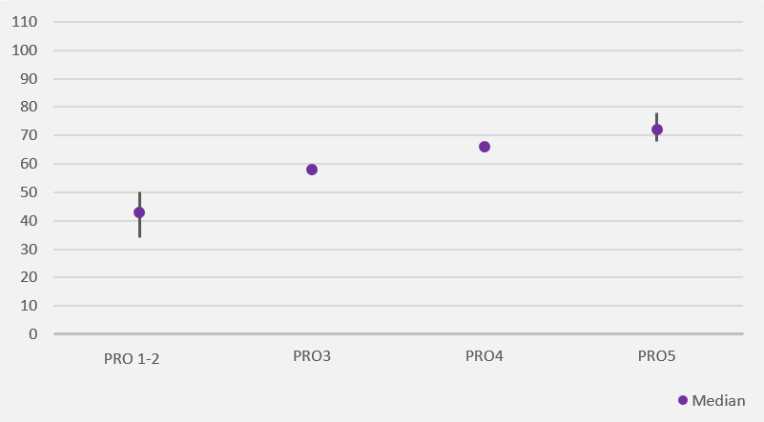

b. Breakdown of work value scores

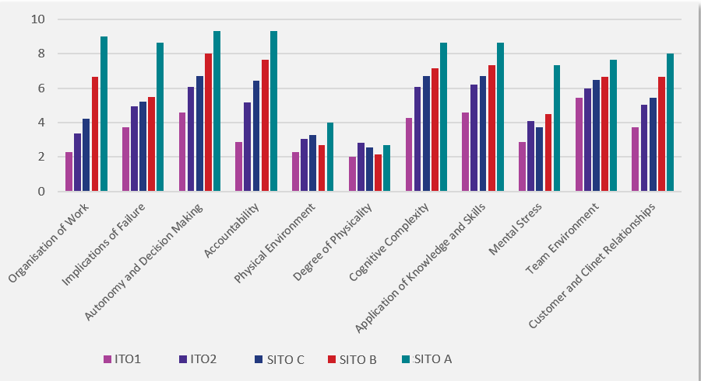

c. Progression of work value against standard linear growth

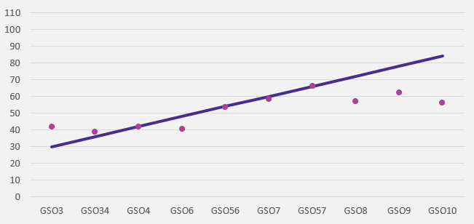

***Market value***

Remuneration is one of the levers used by organisations to deliver workforce capability through its ability to recruit and retain suitable employees. A WVA is commonly used to assist in the determination of remuneration levels for an occupation or role. However, the WVA is only one of the contributors to determining the remuneration levels for a position and, as an inward-looking assessment, is arguably less relevant to determining remuneration levels than the market value of the occupation.

For example, two different types of occupation may have similar WVAs however, if the comparative market value of the occupations is substantially different alignment to the market should be weighted more highly than to the WVA. WVA are more useful for making remuneration comparisons within a classification, but remuneration comparisons across different classifications are better made using market value of the respective occupations.

In identifying an appropriate market value data against which to compare remuneration levels within the ACTPS, the following requirements were identified:

* Comprehensive and trusted – the use of a comprehensive, trusted source of remuneration data that was relevant to the diverse roles within the ACTPS.
* Relevant – data on market value for relevant locations, as in the locations in which the ACTPS is likely to compete for resources (i.e. ACT private and public sector and the NSW public sector).

The data needed to be comprehensive so that market comparisons could be conducted across all ACTPS occupations. It needed to be trusted so that market comparisons could be made with confidence. It needed to be relevant to the ACTPS in order to be meaningful, for example, the comparison needed to be able to identify the remuneration rates in the ACT (and region).

There are multiple potential sources of data with which to make market comparisons on remuneration. Many industry groups conduct or sponsor research to identify wage data for their industry or employee groups. Professionals Australia, for example, conducts annual surveys of individuals who are registered members of the organisation (the survey is advertised more broadly) in a number of fields including IT professionals. Commercial organisations may aggregate salaries of positions advertised on job websites or on professional social media platforms. Some may also survey their (often extensive) client base to identify remuneration levels for occupations. Finally, national labour market data, based on the Australian Bureau of Statistics (ABS) Census provides remuneration data that is mapped to the ANZSCO framework and geographical location.

In this case, the Australian Bureau of Statistics (ABS) 2016 Census database was used as the primary data source used to undertake the comparison of remuneration data against market comparators. This data set met the requirements outlined above as it is:

* Comprehensive – the Census data covers all occupations in the Australian labour market at the time and completion of the Census is mandated by law.
* Trusted – the ABS Census data is the primary data source used to calculate all government labour market statistics.
* Relevant – the inclusion of geographical place of employment meant that data relevant to the ACT (and region) could be identified.

Data was captured from ABS 2016 Census database by applying the following fields:

* Place of work in the ACT and NSW.
* ANZSCO 4-digit occupation code.
* Australia and New Zealand Standard Industry Classification (ANZIC) 4-digit industry levels.
* Total weekly personal income.

The total weekly personal income was annualised to adjust to total income. Income was further adjusted to match the 2020 financial year (and interim financial years) by applying the Wage Price Index for the ACT and NSW respectively.

The analysis was further divided by industry (*Table 4.1*) to match the labour market segments of the ACT and NSW Government, Federal Government as well as the private sector in the ACT.

*Table 4.1: Industries covered in the market comparison dataset.*

|  |  |  |
| --- | --- | --- |
| Comparators | Place of Work | ANZSIC Industry Levels |
| Local Government employees | ACT and NSW | * State Government Administration * Local Government Administration * Education and Training * Preschool and School Education * Primary Education * Secondary Education * Combined Primary and Secondary Education * 50% of Hospitals[3] |
| Federal Government employees | ACT | * Public Administration and Safety * Fire Protection and Other Emergency Services * Correctional and Detention Services * Other Public Order and Safety Services * Regulatory Services * Special School Education * Technical and Vocational Education and Training |
| Private Industry | ACT | * All other industries (including 50% of hospitals) |

#### Limitations

The following limitations were identified in the methodology:

* Position descriptions were a key source of evidence. It is acknowledged that in some cases position descriptions are not up-to-date or accurately reflect the actual expectations of the role. This limitation was mitigated by further validation with role incumbents through self-assessments and interviews.
* It was observed that often, when employees were undertaking the self-assessment process, there was a tendency to self-rate higher than the ratings given by an independent assessor on some of the work value elements. This was mitigated through the moderation process.
* Whilst a representative cross-section of employees and stakeholder was identified to engage with the research team as part of the review, not all of those contacted chose to or were available to engage with the research team. In cases where it was critical to engage every effort was made to follow-up with the individuals or to identify an alternate contact.
* Most roles that were assessed are currently occupied. In some cases, particularly for the position description assessments, an assessment may have been conducted for unoccupied or obsolete role.
* Trainee classification levels are not included in the analysis as the HR dataset indicated these levels are not currently in use within the classifications included in this review. The other reason for excluding training positions is that their pay rates are usually set with regard to higher classifications. Apprentices were also excluded as only a small percentage of apprentice roles are in use within the classifications included in this review.

*Limitations specific to the analysis for each priority group have been included in the individual summary reports provided in Attachments 3-9.*

#### Assumptions

The following assumptions were made as part of the research approach:

* There were a small number of cases in which it was evident that a self-assessment was not undertaken in an appropriate manner, as per the instructor’s specifications, e.g., an individual assessed their role with the maximum score on every factor. In these circumstances, the self-assessment results were excluded from the analysis.
* Qualitative data gained through interviews with employees and Directorate representatives formed one of the inputs used to develop the WLS and have been treated as a key source of evidence.

*Assumptions specific to the analysis for each priority group have been included in the individual summary reports provided in Attachments 3-9.*

## Summary of findings and future considerations

#### Comparative Work Value analysis – detailed findings

*Attachments 3-9* provide summary reports on the outcomes of the comparative work value analysis for each priority group:

* + Attachment 3: General Service Officers – including GSO, CLS and BSO classification groups.
  + Attachment 4: Rangers – including Park Rangers, Sportsground Ranger and City Ranger classification groups as well as several Technical Officer classified ranger roles.
  + Attachment 5: Information Technology Officers – ITO classification group.
  + Attachment 6: Technical Officers – includes TO classification group as well as the Canberra Theatre Technician 2 and 4 classification.
  + Attachment 7: Legal Officers – Legal Officer classification group.
  + Attachment 8: Prosecutors – Prosecutor classification group.
  + Attachment 9: CIT Student Counsellors – includes the CIT Student Counsellor roles that sit within the Professional Officer classification group.

#### Recommended work value scores

Based on the outcomes of the work value analysis, a set of recommended work value scores have been developed for classifications within the priority groups (see *Figures 4.7 - 4.15)*. The recommended work value scores are used for classification purposes (as described in *Section 4.2*). Noting that the recommended work value scores are only valid for comparisons within a classification group, not between classification groups. Based on the outcomes of the work value assessment analysis there are some classifications for which recommended work value score sets have not been created, these are:

* The GSO classification group – due to the diversity of roles, a consistent set of work values were not identified in the comparative work value analysis (this is discussed in *Sections 5.6 and Attachment 3*) and the outcomes of the analysis have led to recommendations related to re-designing the classification structure for roles that currently sit within the GSO classification. Following this, a suitable set of recommended work value scores can be created.
* City Rangers – as described in *Attachment 4*, there was insufficient data to determine a suitable set of recommended work value scores.
* CIT Student Counsellors – as these are only a subset of the broader Professional Officer classification.

*Figures 4.7 - 4.14* present each set of optimal work value scores in a graph. The vertical axis indicates the work value score range (with the minimum work value score being 22 and maximum 110). The horizontal axis displays each classification level, with the table specifying the minimum and maximum work value score for each classification level.

The optimal work value scores were developed by considering the range of work value scores for each classification level and, where there was overlap between the range of scores for two adjacent levels, identifying the midpoint of the overlap as the cut point between the two levels. In cases where there was no overlap, the midpoint of the gap between the scores between the two levels was identified as the cut point between the two levels.

##### Using the recommended work value scores for classification purposes

The Work Value Assessment tool, provided in *Attachment 2*, outlines the steps that should be undertaken when undertaking a work value assessment process which includes the use of a scoring system.

The tool includes a scale for scoring roles based on the work value descriptions selected. Scores correspond with each work value description. The combined total score indicates the suggested classification level, when cross-referenced with the relevant recommended work value scores.

It is important to note that the scores alone should not be used as the only source of authority for the classification of a role.

*Managing borderline scores*

Some roles will score within the range for a proposed classification level. However, some roles may score on the borderline for example, the total score is just below the maximum or just above the minimum score for a classification level.

If this is the case, the evaluation should be re-visited to ensure all relevant information has been considered. This may include obtaining additional information or have another person undertake a subsequent assessment.

If the score remains on the borderline, this may suggest a need to consider job design e.g., reassigning or adding specific duties to better balance the role in alignment with a classification level.

*Figure 4.7: Range of optimal work value scores for the CLS classification.*

*Figure 4.8: Range of optimal work value scores for the BSO classification.*

*Figure 4.9: Range of optimal work value scores for the Park Ranger and Sportsground Ranger classifications.*

The optimal range of work value score for the *Sportsground Ranger* classification aligns to the *Park Ranger 1* classification.

*Figure 4.10: Range of optimal work value scores for the ITO classification.*

**

*Figure 4.11: Range of optimal work value scores for the TO classification.*

**

*Figure 4.12: Range of optimal work value scores for the Theatre Technician 2 and 4 classification.*

**

*Figure 4.13: Range of optimal work value scores for the Legal Officer classification.*

*Figure 4.14: Range of optimal work value scores for the Prosecutor classification.*

#### Future considerations

The detailed findings of the comparative work value analysis are provided in *Attachments 3-9.* A summary of the overall themes and future considerations from the exercise are described below.

##### Priority Group 1: General Service Officers

The GSO classification is the most diverse of those considered in this work. The work value assessments of the GSO classification suggests there is more than one discrete occupational group in the classification.

Overall, the diversity of the GSO classification suggests strongly that further analysis needs to be conducted to determine how the classification might be restructured into distinct and more homogeneous classifications. An initial approach to how roles within the GSO classification could be structured into occupationally-based groups is discussed further in *Section 5* of this report.

In regard to the CLS classification, whilst the analysis showed discrete occupational groupings within this classification (such as technicians and trades workers), the results of the work value assessment showed a clear pattern of work value across each CLS classification level. Whilst there is an opportunity to streamline roles within the CLS classification into other related classification groups, it appears the current structure is fit for purpose and suits the needs of the organisation it has been designed for.

The BSO classification showed a limited difference in the spread of work value scores between the highest and lowest classifications, and as discussed in the analysis, is likely due to additional factors that are used to determine suitable classification levels within this group. Similar to the CLS classification, there is an opportunity to streamline this classification into a related classification group as there are similar roles in the GSO classification (e.g. Campus Manager and Campus Caretaker roles in CIT), however this group does have some unique features which justify keeping it as an independent classification.

##### Priority Group 2: Rangers

The City Ranger and Sportsground classifications appear to have a classification structure that logically aligns to a single ANZSCO job family – *Inspectors and Regulatory Officers*. Likewise, the Park Ranger classification and Ranger roles that are classified as Technical Officers align to the ANZSCO*Environmental Scientist* job family. This indicates that there are two distinct groupings in terms of the type of work undertaken by employees within the Ranger priority group.

An insight gained through a comparative work value assessment for the Technical Officer classification was there are roles that also align to these two job families. For example, Park Care Support Officer and Wildlife Officer roles that are classified as TOs align to the *Environmental Scientist* job family. Similarly, there are some TO classified roles such as Environmental Protection Officer and Invasive Plants Officer that align with the *Inspectors and Regulatory Officers* job family. The work value assessment results also showed close alignment between the Park Ranger classifications and respective Technical Officer levels.

This indicates there is an opportunity to streamline Ranger-related roles, particularly those within the *Environmental Scientist* job family. This could be achieved either by re-classifying the relevant roles that are currently classified as Technical Officers into the Park Ranger classification. Alternatively, there is an option to reduce the number of classifications by re-classifying existing Park Ranger classified roles into the Technical Officer classification.

There is a similar opportunity for the roles within the *Inspectors and Regulatory Officers* job family (City Rangers and Sportsground Rangers). There are roles that map to this job family across the Technical Officer and General Service Officer classifications, and it is likely that the Administrative Service Officer classification also includes roles within this job family. Streamlining could be achieved by re-classifying the roles into an existing classification group. Alternately, the City Ranger classification could remain as is. This option should also consider incorporating the Sportsground Ranger into this classification group.

Noting, in circumstances where roles are re-classified into an alternate classification group, the qualifications identified in the Work Level Standards for the classification group being used may need to be adjusted to align with the qualification requirements of the roles being re-classified.

##### Priority Group 3: Information Technology Officers

The results of the work value assessment and market comparison indicate that the current structure and remuneration for the ITO classification are fit for purpose and generally aligned to market comparators.

##### Priority Group 4: Technical Officers

The results of the work value assessment and market comparison indicate that the current structure and remuneration for the Technical Officer and Theatre Technician classifications overall are fit for purpose and suitably aligned to market comparators.

However, for the TO1 roles that operate as Medical Technicians (roles operating in the pathology and pharmacy fields within CHS), the results of the work value assessment showed that their work value scores were closer to the recommended work value rangefor the TO2 level. This warrants a more detailed job evaluation for specific TO1 roles that operate as Medical Technicians to confirm whether the roles have been suitably classified or if re-classification is required.

##### Priority Group 5: Legal Officers

Based on the results of the work value assessment and market comparison, there are some opportunities to enhance the Legal Officer Classification framework to support the attraction, retention, and career progression of employees operating within the framework as having only two levels within the classification limits career progression. Additionally, the large salary spine for Legal Officer 1, with the arbitrary lower and upper levels, is currently not utilised in alignment with the apparent original intent of the structure. There are currently only two employees sitting below the 8th salary point, both at the 5th salary point (lower level). The most likely reasons for this, given the average length of service for this group is less than 2 years[4], are the work expected of Legal Officer Grade 1 employees is primarily at the upper level of work value and higher pay points are used as an attraction and retention incentive and to meet market demand.

An option for re-structuring would be to reduce the size of the Legal 1 salary spine either by splitting into two separate salary spines or removing the lower pay points (below the 5th pay point) if indeed they are rarely used or not required.

In addition, an overall uplift in salary may be considered in light of the results of the market comparison detailed in *Attachment 7* of this report.

Qualitative evidence gained from stakeholder interviews, suggested the structure and salary of other ACTPS legal classifications have an effect on the career opportunities and mobility of employees working within the ACTPS legal field. This is mainly as each classification structure differs in terms of levels and remuneration, creating internal comparison in terms of remuneration and making it difficult to easily second employees or support lateral career moves within the service.

A comparative analysis across all of the ACTPS legal professional classification groups should also be considered to further understand mobility and career progression across these groups.

##### Priority Group 6: Prosecutors

The results of the work value assessment and market comparison indicate that the current structure and remuneration for the Prosecutor classification are fit for purpose and suitably aligned to market comparators.

##### Priority Group 7: CIT Student Counsellors

In terms of average salary against external market value, it appears there is a logical fit between the two Professional Officer classification levels that are used for CIT Counsellor roles. Work value between the two CIT Counsellor levels seems appropriate however whether they align to the work value of other roles within the same levels of the Professional Officer classification has not been determined as part of this analysis. This would need to be considered as part of a wider review of the Professional Officer classification itself.

Regarding the possible impacts of the internal comparison between CIT Counsellors and School Psychologists, the data shows that there has been no movement of CIT Counsellors over the last ten years so this would appear to not be an issue of concern from a mobility perspective.

# Workstream 2: Specified Shared Salary Spines

## Workstream 2 objectives

*Providing a remuneration structure that facilitates contemporary career pathways for the ACTPS.*

This workstream examines how the ACTPS remuneration structure intersects with career pathways for the workforce. The guiding question was whether the remuneration structure facilitated career pathways and, if not, are there changes that could be made to the structure to better facilitate contemporary career pathways?

## Where are we now and how did we get here?

As noted previously, the current remuneration structure for the ACTPS is based on about 60 classification groups employed across 19 Enterprise Agreements. The classifications segment the workforce, are generally homogeneous groupings of jobs, and are the foundation for the shared salary spine construct. For example, those who work as IT professionals fall in the same classification group, similarly for Prosecutors and Park Rangers.

However, there are outliers from this system. There are classifications that reflect an organisational rather than an occupational structure. There is a classification for Canberra Linen Services (CLS) for example, that contains a broad collection of occupations including Linen Assistants, Drivers, and Supervisors. Building Services Officers (BSO), who work only within the Education Directorate, were previously part of the General Services Officer (GSO) classification up until 2011. BSO 1/2 was introduced in 2003 with pay aligned with GSO 3/4. BSO 2 and BSO 3 were introduced in 2010 with pay aligned with GSO 5 and GSO 6 respectively. BSO 4 was introduced in 2013 with pay aligned with GSO 10, and BSO 2 and BSO 3 were aligned with GSO 6 and GSO 8 respectively.

There are also classifications that appear to have been developed as “catch all” classifications with occupations placed in them due to historical reasons or because there was no classification that better represented the job. The GSO and the Technical Officer (TO) classifications both embrace a diverse range of occupations which undermines the homogeneity which is typically sought in a classification system and can reduce the effectiveness of the system.

The origin of the ACTPS classification and shared salary spine system stems from when self-government was established in 1988 and the ACTPS separated from the Australian Public Service (APS). Since then, the ACTPS shared salary spine system appears to have evolved organically; that is, it has evolved from the ground-up to meet emergent and local workforce needs rather than being driven centrally from an overarching remuneration strategy. This type of growth in workforce structures is not unusual and, in this case, appears to have also been as influenced by the diverse needs of the ACTPS workforce as much as anything else.

This analysis of the ACTPS shared salary spines was limited to a set of priority groups (as described in *Section 3.3*). These are a subset of the complete shared salary spine system. Some of these priority groups were classifications proper, such as Legal Officers, while others were a subset of classifications, such as CIT Student Counsellors. Others represented a blend of positions that logically fell together but were not confined to a single classification, for example Rangers. The complexity of this is shown in *Table 5.1*.

*Table 5.1: Classifications and mapping conventions used in the Shared Salary Spines Analysis.*

|  |  |
| --- | --- |
| **Classification/*Work Grouping***   1. General Service Officer (GSO) 2. Building Service Officer (BSO) 3. Capital Linen Service (CLS) 4. Information Technology Officer (ITO) 5. Technical Officer (TO) 6. Sterilising Technician (SST) 7. Theatre Technician (TT) 8. Legal Officer (LG) 9. Prosecutor (PRO) 10. ***Rangers (RNG)*** 11. ***CIT Counsellors (CITC)*** | ***Rangers***   * Senior Park Ranger * Park Ranger 1 and 2 * Ranger in Charge * Sportsground Ranger * City Ranger 1-4 * Senior City Ranger   *Ranger grouping excludes the TO roles that are titled as Rangers* |
| ***CIT Counsellors***   * Professional Officer 2 (5 FTE) * Senior Professional Officer C (1 FTE)   *This review does not look at the PO and SPO classifications in entirety, only the CIT Counsellor roles.* |

## Why have shared salary spines?

The purpose of a shared salary spine is to simplify the remuneration structure in an organisation by grouping together employees who do similar work or similarly valued work and therefore should receive the same remuneration rather than having separate remuneration arrangements for each employee. It is a common practice in public sector organisations and larger private sector organisations.

Determining what “similar work” means is often done on the basis of an existing workforce segmentation. The current Australian standard for this is the Australian and New Zealand Standard Classification of Occupations (ANZSCO). This hierarchical system groups occupations into eight Major Classification groups, and then adds a further four levels of segmentation to yield a classification of occupations that is very granular. An example of this is provided in *Table 5.2* below.

*Table 5.2: Example of ANZSCO hierarchical grouping*

|  |  |
| --- | --- |
| ANZSCO Group | Example |
| Major Group (1-digit code) | 1 – Managers |
| Sub-Major Group (2-digit code) | 14 – Hospitality, Retail, and Service Managers |
| Minor Group (3-digit code) | 149 - Miscellaneous Hospitality, Retail and Service Managers |
| Unit Group (4-digit code) | 1492 – Call or Contact Centre and Customer Service Managers |
| Occupation (6-digit code) | 149212 – Customer Service Manager |

This system is often augmented by the addition of distinct levels of work within an occupation, again this is common in larger workforces and particularly in the public sector. These levels may reflect an increasing level of seniority, supervisory responsibilities, or technical knowledge. For example, within a large retail organisation, there might be three levels of ANZSCO 149212 Customer Service Manager which might each attract increasing levels of remuneration:

* Customer Service Manager
* Senior Customer Service Manager
* Area Customer Service Manager

A workforce segmentation such as this provides a wide range of benefits to the organisation and its workforce beyond simplifying the remuneration structure:

* It can provide a career pathway for individuals, supporting movement through different levels within each occupation. This is a common feature of workforce segmentation in larger organisations.
* It can provide an understanding of the skills required for a particular role. The ANZSCO framework includes an indication of the qualification and experience required for each position, and hence support learning and development initiatives across a large organisation.
* It can provide an understanding of common skillsets within the organisation and hence support career pathways across an organisation.
* At a macro level, it provides an understanding of the capabilities inherent in different segments of the organisation.
* It allows easier comparison to the broader labour market (all official Australian labour market information uses ANZSCO as its segmentation model).

The workforce segmentation embodied in a shared salary spine system provides a range of benefits to the organisation in managing its workforce and to employees in helping them determine their career pathway.

#### What does this mean for the ACTPS?

The ACTPS shared salary spines broadly meet the common understanding of the term and are being used to segment the workforce for remuneration purposes based on the nature of the work in the occupation. In other words, they are occupationally based. However, there are some classifications that are organisationally based and some that are catch-all classifications.

It is unclear whether or how effectively the system is being used for some of the other purposes that can benefit the ACTPS and its workforce.

## What is a contemporary career pathway?

The concept of a career pathway is well known in workforce management, although can lack clarity in its definition when reflecting changes in the workforce and the nature of work.

Traditionally, career pathways were linear and vertical. Linear in that a “career” was defined as being spent within a single, usually hierarchical, organisation and vertical in that a career was defined as upwards progression through the organisation. The concept of a career was not really considered outside of large organisations.

By way of illustration, tradespeople or artisans who were self-employed had no “career” as such, they had a job. There was no progression to more senior positions as the individual typically plied their trade as a sole operator. The only concept of progression was in the transition from tradesperson to craftsperson to artisan which was common in the guild structures of some trades.

For many employees, progression in their employment was measured in terms of increases in remuneration, or salary progression. So, an individual might not change their job title or the actual work they do but they may get increased remuneration.

In the modern workplace, how we think about work and career are changing. The key drivers for this include:

* The increased use of automation is changing how we work.
* The increased use of information technology is changing where we work.
* The blurring of the relationship between work and non-work is changing why we work.

While the impacts have been experienced differently across industries, employees are generally:

* more mobile
* moving between employers more often – though typically staying within a specific industry
* seeking more flexible work such as work that offers flexible working hours, or the ability to work in different locations
* seeking more varied work where they have more autonomy
* seeking work that is more meaningful – work is no longer just a way to gain the financial means to survive.

This has led to careers becoming more horizontal and non-linear.

The concept of progression is still fundamental to the modern career pathway, but how progression is understood is different. It might be a traditional upwards movement through different levels of responsibility in a single organisation, it might mean moving to a different organisation in the same industry to gain more responsibility, it might be moving to another organisation to work that is more meaningful, or it might be working across several organisations to get a variety of work.

The shared salary spine structure can affect all these career decisions. It provides an understanding of how an individual can progress in an organisation. If the structure is based on occupational skills and experience, it can help an individual identify other parts of the organisation that offer:

* similar but perhaps a broader variety of work in their area
* more meaningful work
* or opportunities to progress to higher levels of responsibility within their particular work type.

#### What does this mean for the ACTPS?

It is arguable whether a shared salary spine structure defines a career pathway. A career is largely defined by working in a particular profession or trade or organisation; a shared salary spine simply codifies this primarily for remuneration purposes. A modern career pathway still has a sense of progress however, whilst in the past this was mostly defined in terms of salary progression or advancement to greater levels of accountability, other factors also influence career choices now such as flexibility, meaningful work, and organisational culture.

Identifying whether and how the current ACTPS shared salary spine affects career pathways in the workforce is the purpose of this research.

## Research Approach

#### Methodology

Existing HR data was used to establish a subset containing active employees and occupied positions for each reporting year between 2011 and 2020. The dataset represents an annual end of financial year (as at 30 June) snapshot of the ACTPS workforce, for each individual year.

A matching exercise was performed for all pay points in all salary spines for each classification in the HR dataset against those contained in the relevant ACTPS EA for each reported year. In circumstances where the classification and level for an employee was not identifiable (i.e., classification code was not standardised), additional matching was undertaken by looking at the employee salary and Directorate or business unit and matching this to EAs that most closely mapped to the Directorate and business unit. The final matching on outstanding employee categorisations was confirmed with the assistance of the Directorates and the HR data administrator.

Employee mobility statistics were calculated using employee number and relative position changes over time, including leaving, returning, and new employees.

Promotion, or career progression, statistics were based on movements of employees between classifications, levels, and roles from year to year. Higher duties were not considered as promotions or position movements due to their temporary nature.

Salary progression statistics were based on employee movements to a higher pay point within the same level and classification each year.

Tenure was calculated as the length of time (in years) that the employee had remained in the same position.

#### Limitations

The following limitations were identified in the methodology:

* The analysis focused on the identified priority classification groups in ACTPS. This limits the comparative analysis and hence the conclusions that can be drawn from the dataset. ​ For example, when analysing turnover, if an employee moved to another classification in the ACTPS that was not in one of the priority groups they have been coded in the dataset as having left the ACTPS.
* There are errors in the data that we have attempted to address but, in many cases, have had to make assumptions. ​
* A significant number of positions were unoccupied, and it was not possible to determine whether these were active positions that were vacant or inactive positions; they were excluded from our analysis. ​
* The coding used for the various classifications was not consistent across Directorates and business units and in some cases had to be estimated.
* Trainee classification levels are not included in the analysis as the HR dataset indicated these levels are not currently in use within the classifications included in this review.

#### Assumptions

The following assumptions were made as part of the research approach:

* Used known pay point and level conventions to map the pay points and levels in various Directorates to match the pay points in the Enterprise Agreements (EAs).
* Four executives, on individually negotiated salary arrangements, were not included in the analysis.
* Two grandfathered level and pay point positions which did not match current EAs were not included in the analysis.
* It was assumed that all remuneration that was provided to us was correct – there were no additional loadings included in the remuneration data and therefore are not included in this analysis.
* Change in position number has been utilised as a key measure throughout the process of developing this dataset. We understand, anecdotally, that at times position numbers will change with no real change in the duties.
* Simple change in position number does not provide clarity on the motivation or type of movement.
* We have applied our own mapping conventions for each classification group (as shown in *Table 5.1* above).

## Findings, interpretation, and analysis

#### Understanding ACT PS Remuneration Structure

The first step in understanding the ACTPS remuneration structure was to consider it holistically. *Figure 5.1* shows the relative positions of the ACTPS EAs for each of the classification groups included in this review. Each colour block represents the spread between the top pay point of a level and the top pay point of the next level up. For example, the first block shows the salary spread between the top pay point of the first level within the classification to the top pay point of the second level of the classification. If a classification only has two levels, only one block will show.

*Figure 5.1: Salary spine comparison across classification groups*

*Note, Sportsground Ranger shares the same salary spine as RNG1*.

The bulk of the classification groups sit within a salary band of $60,000 to $100,000 with some notable outliers representing specific professions (ITO, Legal, and Prosecutors). Three related classifications (GSO, BSO, and CLS) all show a high degree of similarity in their remuneration levels. They are related in that the BSO and CLS salary spines are based on the GSO salary spine.

The graph also shows a degree of difference among classifications which have implications for career pathways:

* There is a substantial difference in the number of levels in each classification from Legal, which has only two levels, through to GSO which has nine levels. While this is compensated for in some way by the number of individual pay points within levels, it suggests that for some salary spines there may be a focus on career progression while others may have a greater focus on salary progression.
* There is variation in the range of remuneration for different levels in different classifications. For example, in the GSO and Rangers classifications, the differences between levels are quite small compared with the Legal and, to a lesser extent, ITO classifications. This suggests that some classifications see little difference in the perceived value of the work done within distinct classification levels, while others see a substantial degree of difference within levels. Noting the comparison depicted in *Figure 5.1* does not take into account differences in the gap between salary bands from one classification to another (for example the gap for GSOs is small in the range of $1,000-$2,000, compared to the gap for Legal at around $12,000).

To understand how the current ACTPS remuneration structure, particularly the shared salary spine construct, might affect career paths for ACTPS employees it was important to understand key workforce factors including: mobility, turnover and retention, career and salary progression, and specialisation. Specifically, the analysis sought to understand:

*Mobility*

* What is the general mobility rate?
* Does the mobility rate vary across classifications?

*Turnover and retention*

* Does the proportion of employees on higher duties vary across classifications?
* Do people enter different classifications from outside the ACTPS at different rates?
* Is there an age effect on differences between staff turnover across classification groups?
* Does the turnover rate vary across classifications?

*Career Progression*

* How long do people stay in a position?
* Does the progression rate vary across classifications?
* Does the promotion rate vary across classifications?
* Is there a difference in the distribution of pay points across classification groups?
* How many people are in a broadband vs not in a broadband?

*Specialisation*

* Are there any areas of specialisation across the classification groups?

#### Staff mobility

**General mobility**

General mobility refers to any employee changes in position across the ACTPS. This includes promotion or changing of roles and does not differentiate the type of movement. It is a general indicator of workforce mobility. *Figure 5.2* shows the percentage of individuals (as a proportion of the total number of employees in that classification) changing position in each of the classification groups included in this review over time.

*Figure 5.2: General mobility rate*

No data available

The data shows a diversity of mobility levels across classifications:

* The Prosecutors and Rangers show higher levels of mobility (averaging over 30% over time) while the GSO, BSO, and ITO average about 20% mobility over time.
* CLS shows very low mobility and CITC showed no mobility.
* While most classifications show no discernible pattern, both Rangers, and GSO have seen a steadily increasing pattern of mobility since 2013 and 2012 respectively.

The different rates of mobility across classifications suggests that a different experience of work or career occurs across the classification groups. Determining whether the different salary spines are contributing is difficult to determine. The nature of the Prosecutor and Ranger salary spines are quite different suggesting that there may not be a common effect on their mobility rates.

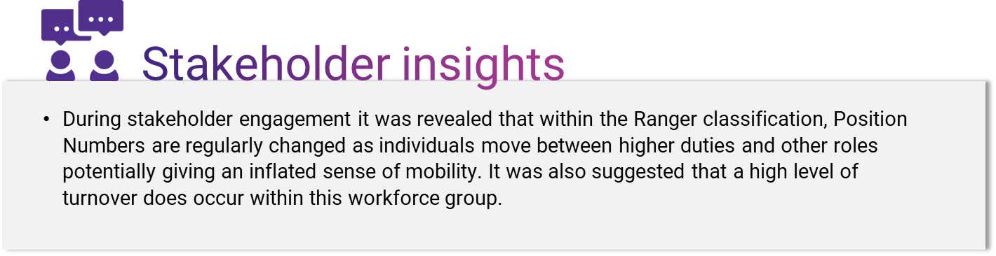

##### Mobility rate across classifications

Mobility refers to the specific movement of employees between classifications within the ACTPS. This provides a picture of the ability of employees to move across and around the ACTPS and its classifications. For example, an employee moving from a position working as a GSO 6 to a Ranger 2 position.

The data shows limited mobility between salary spines, generally less than 5% in any classification in any year. There were some outliers in the data and are of a nature that suggests that they are most likely to be because of systemic changes such as reclassifications.

The low degree of movement across classifications is not unexpected as the classifications considered in this analysis are generally quite specialised in the nature of the work they do, except the catch-all classifications such as GSO and TO that are further discussed in *Areas of Specialisation*. Therefore, the shared salary spines may reflect the specialisation in the workforce rather than being the cause of any specialisation.

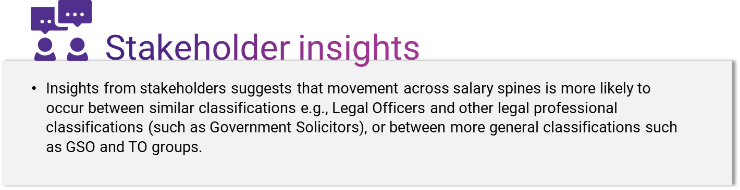

##### What does this mean for the ACTPS?

Mobilityvaries across the classifications in the ACTPS with general mobility very low in CLS to relatively high in the Ranger and Prosecutor groups – one in three employees in these groups experience some change in their work annually. Mobility across salary spines is low and not unexpected given that most of the salary spines reflect distinct occupations or work types.

#### Staff turnover and retention

Staff turnover and retention, or the workforce flow, is one of the key concerns for any organisation. Turnover was measured by identifying individuals who no longer appeared in the data set from one year to another, which provides a basic measure that is not able to identify why an employee was no longer in the data set. Moreover, drawing conclusions from this data is also problematic because there is no record of why an individual is no longer in the data. Individuals may have voluntarily left the organisation, or they may have been made redundant, or they may be on long term leave, and so on. Understanding the reasons for turnover is critical because of the different implications each has for workforce management.

Analysis of the data available for the review was complicated by the fact that only a portion of the data was available – that relating to the priority groups included in this review. Therefore, it was not possible to calculate actual separations, i.e. individuals who permanently left the ACTPS. However, data from the most recent ACT Government State of the Service Review show that turnover rates vary widely across the classification groups from a low of 3.7% in CLS to a high of 22.4% in the Ranger classification. However, without an understanding of the reasons for this turnover, it is impossible to tell whether there is a systemic reason for the turnover that is related to the classification group.

There are other indicators of the impact of the shared salary spines on workforce flow including the effect on recruitment, the age profile of the workforce (which has an implication for turnover due to retirement), and tenure in position.

##### Attracting individuals from outside the ACTPS

The ACTPS represents a large internal labour market with many positions being filled from within the ACTPS. However, there is value in attracting individuals from outside the ACTPS to increase diversity and bring new ways of thinking to the organisation. Differences in the rate at which individuals move to a position within the ACTPS classification groups may also reflect potentially attractive or unattractive qualities about them (i.e., remuneration and other employment benefits). Existing HR data shows that:

* Recruitment from outside the ACTPS is less than half of the total recruitment within the ACTPS and averages 15% of all those entering.
* The ITO classification has seen a downward trend in the proportion of external hires from almost 6% in 2013 to 1% in 2020.

Attracting entrants from outside the ACTPS is likely to bring a new viewpoint which encourages diversity in thinking and improve innovation. The average rate of entrants from outside the ACTPS (excluding those classifications with very few total entrants), at about one in five, is reasonable to support diversity of thinking and innovation in the workforce.

However, the question is whether the shared salary spines influence this. The primary benefit of the shared salary spines is that, because individuals are typically recruited to a position within a specified classification, potential candidates can identify whether they have the skills necessary to do the work.

From an organisational perspective, if the shared salary spines can be mapped into the broader labour market, the ACTPS can better target their recruitment and particularly the value proposition that they offer to potential candidates, resulting in a high proportion of better qualified candidates for position.

##### Average age of employees and turnover

The average age of the workforce has implications for retention and workforce planning, particularly in terms of the impact of age retirement. The impact of age on retirement is moderated by factors such as superannuation and, for the ACTPS specifically, this means the impact of the Commonwealth Superannuation System (CSS) which has specific benefits for individuals who retire before their 55th birthday – the so called “54-11” effect. However, the CSS system closed to new members on 1 July 1990 and therefore is only a consideration for employees aged 49 years and over (assuming an employee joined the workforce at age 18 years).

The ACTPS priority groups show a relatively wide range of average age for the various classifications, and the average age of the workforce for most classifications is in the 40-49 years age group. This makes the ACTPS workforce relatively older, with the average age of the working Australian at 39 years[5]. CIT Counsellors are the oldest workforce and a potential retention risk as their average age is 55-59 years. Prosecutors are the youngest group with an average age of 30-34 years.

The effect of the shared salary spines is more to segment individuals and identify differences that are specific to particular occupational groups. For example, during stakeholder engagement it was noted that to work as a CIT Counsellor, a substantial amount of experience is required, hence leading to an older workforce. Meanwhile the relative youth of the Prosecutor workforce is considered broadly characteristic of legal workforce.

##### Tenure in position

Tenure in position refers to the defined length of time spent by an individual in a specific position (classification and level). While tenure can be considered an indicator of career stability, another perspective is that tenure is an indication of organisational stagnation. There is no definitive guide to what length of tenure is good from a career or organisational point of view, in part because of differences between occupational career paths. *Figure 5.3* shows the average length of time spent in a position by year for each classification.

*Figure 5.3: Average length of time spent in a position.*

No data available

The data in *Figure 5.3* shows:

* There is a degree of variability in the length of tenure based on an individual’s classification.
* There is no overall trend over time, other than a generally increasing trend for CLS which reflects the stable workforce.
* CLS (in particular) and CIT Counsellors have longer tenure than the other classifications.

The data showed that there was no significant relationship between turnover and tenure.

The data suggests that there are different experiences of career within each classification group. Some suggests a degree of stability, bordering on stagnation. In a knowledge-based occupation this might be considered problematic because it diminishes innovation, however, in an industrial occupation this can translate into a high degree of expertise. CLS, a largely industrial workforce, has a very high level of stability. Whereas Prosecutors and Legal Officers – both knowledge-based occupations – have much shorter tenure in positions. This suggests that the current rate of tenure in the ACTPS is appropriate.

##### What does this mean for the ACTPS?

The relationship between tenure, career pathway, and shared salary spines is more one of segmenting the workforce into like occupations that have similar tenure and career patterns. It is the nature of the occupation that influences tenure rather than the shared salary spines. However, there are likely to be more consistent career patterns in each shared salary spine which means that workforce management can be tailored to meet the specific needs of that classification.

#### Career progression

##### Promotion rates

Promotion refers to the movement of an individual from one classification level to another higher level. As indicated earlier, there are considerable differences in the number of levels and hence promotion opportunities in the different classifications considered here. So, the promotion rate comparison across classifications is difficult to interpret. However, the data shows that promotion rates in the Prosecutor classification were much higher than the other classifications; note however that the very high rate of promotion in this group in 2011 may be due to a restructuring of the Prosecutor classification at this time. (*Figure 5.4*).

*Figure 5.4: Annual Rate of Promotion.*

No data available

No data available

##### Salary Progression rate

Salary progression is the movement of individuals through the pay points within a level and classification. This can often be an automatic process occurring annually or at some other fixed time period. *Figure 5.5* shows the percentage of pay point progression within the same level for each classification (note that employees who are already at the top pay point have been removed from this analysis).

*Figure 5.5: Pay point progression rate.*

No data available

The data shows that:

* Salary progression varies both across the different classifications as well as within classifications. Low levels of progression means that employees will stay at the same pay point for longer periods of time.
* Some classifications show very high rates of progression consistent with a process of annual or accelerated pay progression.
* There is no clear pattern of career progression over time across the classifications.

Given that annual progression is common, the low levels of progression in some of the classifications suggests that this may not be the case in all areas.

Given that annual progression across pay points is typically automatic in the Australian Public Service, if progression in the ACTPS does not occur at a similar rate, this may be a workforce risk for the ACTPS as employees may feel they are able to get more certain salary progression in the APS rather than the ACTPS.

##### Reaching the top pay points

One of the effects of a shared salary spine model with different levels for each classification, is the ability of individuals to see some guaranteed salary progression in their current role. However, once an individual reaches the top pay point in a classification level, salary progression ceases until they are promoted to the next level. This typically involves moving to another role (except in the case of broadbanded positions which are discussed in the following section). *Figure 5.6* shows the proportion of employees in each classification group who are at the top pay point in their position over time and across the different classification groups.

*Figure 5.6: Distribution of pay points.*

No data available

The data in *Figure 5.6* shows that most of the workforce currently sit at the top pay point for their role across each of the salary spines (except for GSO and BSO). This has to be qualified by the fact that several classifications only have two or three pay points, but these classifications only account for 3% of the workforce considered.

The data suggests that individuals are progressing at a greater rate than they are being promoted. Therefore, some can experience a sense of career stagnation as a result of sitting at the top pay point without promotion, which can increase the risk of attrition. On the other hand, it can mean there are employees who are content in their current role and do not seek promotion and thus will continue to build experience in their role and become an increasing valuable asset for the ACTPS.

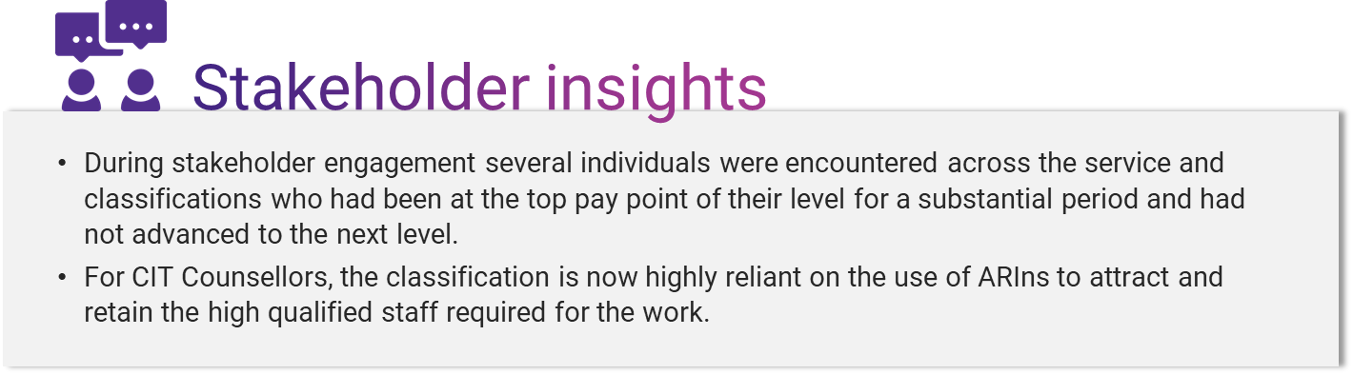

##### Broadbanding

Broadbanding refers to the grouping together of two or more levels within a particular classification group, so that employees can progress across a broader range of pay points within a specific role. The effect of broadbanding is to allow employees to build capability in their current role by spending more time in that role, hence gaining greater experience, or to complete any extended training and upskilling required to progress to the next level. A broadbanding arrangement may require an individual to demonstrate a particular level of competence before moving to the next higher classification level (a hard barrier) or simply support a regular progression to the next highest pay point even if it is at the next classification level in the broadband (a soft barrier). Irrespective, the value of broadbanding is that employees can spend longer in their role without the need to move to a new role to receive a salary increase.

The data analysed here shows that broadbanding is widely used in the GSO classification. In 2020, there were 165 positions at the GSO3/4 level (22.4% of total GSO positions), 141 at the GSO5/6 level (19.2% of positions) and 56 GSO5/7 positions (7.6%). Almost half of all GSO positions (49.2%) in the GSO classification are broadbanded. However, in terms of building capability or gaining training through an extended period in one position, the data shows that individuals in broadband positions are not spending any more time in their role than those in non-broadband positions (Table 5.3).

*Table 5.3: Average employee years spent in GSO broadbanded positions.*

|  |  |  |
| --- | --- | --- |
| Classification Level | Number | Average Years in position |
| GSO3 | 29 | 2.4 |
| GSO4 | 66 | 1.6 |
| GSO3/4 | **165** | **2.2** |
| GSO5 | 30 | 4.2 |
| GSO6 | 11 | 3.1 |
| GSO7 | 59 | 2.1 |
| GSO5/6 | **141** | **1.8** |
| GSO5/7 | **56** | **4.0** |

Given that the broadbanding supports capability and upskilling through allowing employees to spend more time in a specific role and still receive regular salary increases, the data shows that broadbanding is not being used effectively to build capability in or upskill the GSO workforce.

The other classification to use broadbanding is the Prosecutor classification where all Prosecutor 1/2 roles are broadbanded and the data shows that the average length of time in these roles is less than one year. Broadbanding in the Prosecutor 1/2 level does provide a larger number of pay points within individual roles and greater scope for capability building and upskilling, but the short tenure in Prosecutor 1/2 roles would suggest that there is limited capability building occurring specifically as a result of the broadbanding of postitions.

##### Higher duties allowance

Higher duties allowance (HDA) is when an individual is assigned and remunerated for duties above their current classification. The use of HDA can build capability in the organisation through giving employees exposure to more challenging roles but it can also lead to hollowness in organisational capability due to too many inexperienced individuals in acting roles. High levels of HDA can also reflect a lack of discipline in workforce management through the organisation simply taking too long to fill positions.

There is no prescriptive level of HDA in an organisation, and comparisons across different classifications is perhaps most useful in assessing the impact on career pathways. *Figure 5.7* below shows the proportion of employees on HDA at the end of the financial year within each classification group.

*Figure 5.7: Proportion of employees on HDA.*

No data available

The data shows that, apart from Rangers, Prosecutors, and increasingly GSOs, the level of HDA in the ACTPS is about 10%. With the exception of GSOs who show a steady increase in the use of HDA, there is no apparent trend in the use of HDA in the ACTPS.

This suggests there is a healthy balance of development opportunities across the classifications. However, classifications with HDA levels over 20% (Prosecutors, Rangers, and GSO) may warrant investigation to determine the reason for the higher rates of HDA.

##### What does this mean for the ACTPS?

Salary progression varies across the priority groups and may present a workforce risk for employees who are not experiencing progress at the same rate as comparable organisations, such as the APS. However, the data suggests that employees are progressing more quickly than they are being promoted which may represent a workforce risk as individuals reach the top pay point in a classification level and stay there for an extended period of time, but it can also build capability in the workforce from experience in a particular role over time. Broadbanding, provides a similar effect on capability building and upskilling through allowing employees to spend more time in a role, however it does not appear that this is being used effectively to build capability as employees are not spending appreciably more time in broadbanded roles than non-broadbanded roles.

#### Areas of specialisation

The current ACTPS employment framework includes multiple classifications and differing salary spine models and so explicitly acknowledges occupational specialisation. Separate classifications exist for occupations that require specialist legal skills, IT skills and technical skills (e.g., Sterilising Services Technical Officers) and in some cases, membership within a classification group requires a specific formal qualification or accreditation (e.g., Legal Officers).

However, other classifications are based more on an organisational than occupational basis– the CLS and BSO classifications for example. This can lead to some degree of confusion. In the creation of a new position a supervisor can have multiple potential classifications from which to choose and may select one that provides greater salary options, and hence better recruitment opportunities, rather than one that more accurately reflects the work done in the position. Noting, in this review there was no direct evidence of this occurring.

The Comparative Work Value analysis conducted in Workstream 1 (see *Section 4*) corroborates specialisation within the workforce. When a classification is specialised, in that it contains a single distinct work types, it is expected that there is a clear relationship between work value and level, with work value increasing as the classification levels increase. For example, when looking at the median work value score, there is a clear pattern of increasing work value across the ITO classification levels (*Figure 5.8*). With regard to the GSO classification where there was no clear comparative work value pattern, this suggests areas of specialisation within the GSOs, as discussed further below.

*Firgure 5.8: Spread of work value scores for each ITO classification level*

In the Comparative Work Value analysis, (see *Attachments 3-9*) most classifications demonstrated this simple relationship between work value and level other than TO, where there is an issue with a possible misclassification of a distinct set of TO1 occupations, and the GSO classification.

As indicated previously, the GSO classification might be considered a generalist or catch-all classification. In this case it is more likely that there will not be a simple pattern in the work value assessment scores because the classification represents a range of different work types. This can be seen in the case of the GSO classification, where, while there is a general increase in work value as the classification levels increase, there are inconsistencies in the pattern of work value (*Figure 5.9*). This suggests that the GSO classification may consist of a number of occupations representing distinct work types and potential areas of specialisation.

*Figure 5.9: Spread of work value scores for each GSO classification level*

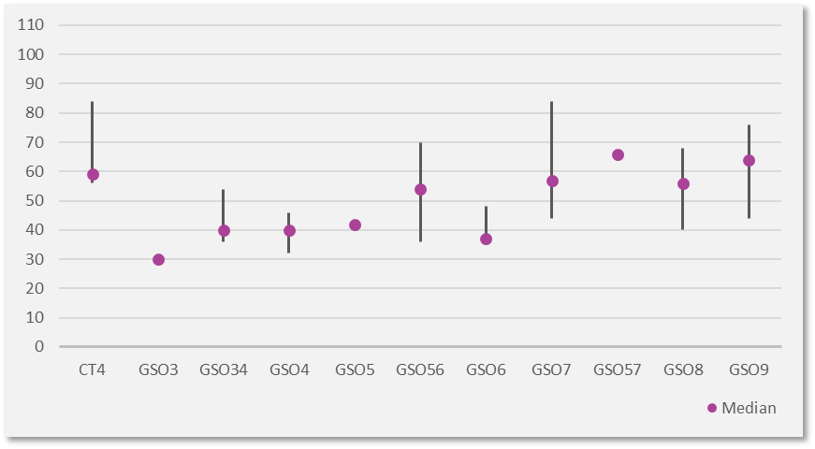

##### Specialisation in the General Service Officer Classification

The current GSO classification includes a wide range of occupations and the existing GSO work level standards (WLS) include multiple sub-groups within the classification (such as Building and Construction, Transport, and Stores). However, the process used for the identification and development of these subgroups is unclear and may have been an organic process, i.e., in response to local and immediate needs, rather than a structured process, e.g., using the ANZSCO framework.

The existing HR data does not codify these sub-groups, hence it is not possible to determine the effect that they have on career paths, mobility, salary progression etc. But, when using the cross-section of roles included in the Comparative Work Value workstream, the research team were able to identify similarities in the type of work conducted in these roles and segment them using the ANZSCO system.

The GSO roles analysed in the Comparative Work Value analysis were spread across all eight ANZSCO major groups:

1. Managers (e.g. Production Managers)
2. Professionals (e.g. Senior Field Officer)
3. Technicians and Trades Workers (e.g. Heavy Vehicle Mechanic)
4. Community and Personal Services Workers (e.g. Fire Management Crew Supervisor)
5. Clerical and Administrative Workers (e.g. Depot Support Officer)
6. Sales Workers (e.g. Nursery Sales Coordinator)
7. Machinery Operators and Drivers (e.g. Inventory Parts Interpreter)
8. Labourers (e.g. Road Worker)

A full list of the positions analysed as part of the Comparative Work Value analysis and the four-digit ANZSCO code to which they were mapped is provided in *Attachment 11*.

When the average work value for GSO occupations in each of the ANZSCO Major Groups is plotted it shows a distinct set of groupings. Positions in the Labourers and Machinery Operators and Driver categories had a noticeably lower average work value than those in the Community and Personal Services, Manager, and Sales groups (*Figure 5.10).*

*Figure 5.10: Average work value for GSO classifications by ANZSCO Major Groups*

This analysis suggests that there is potentially a logical segmentation of GSO positions in terms of work value using the ANZSCO framework. This is discussed further in the recommendations (*Section 5.7)*.

##### Specialisation in the Technical Officer Classification

TO is the other classification that is considered a catch-all classification with six levels (TO1-4, STOC and STOB). The cross-section of roles assessed as part of the Comparative Work Value analysis span across five of the ANZSCO major groups and incorporates 25 ANZSCO 4-digit occupations (see *Attachment 6*).

Despite the breadth of occupations addressed in the TO classification, the results of the work value assessment show a simple relationship with level, once a specific group was removed from the TO1 level (Pathology and Pharmacy Technicians, discussed further in *Attachment 6*). This suggests that within the group there is a logical structure of increasing work value with classification level and therefore the classification can be considered as a single group.

##### Specialisation and Managerial Roles

Whilst not a classification in itself, there are clearly identifiable manager or supervisor positions in four of the classifications included in this review:

* Capital Linen Service
* General Service Officers
* IT Officers
* Technical Officers

The relationship between occupations and management positions is complicated and includes technical management positions (often called supervisors e.g. Field Maintenance Supervisor) or more general management positions within the classification (e.g. Deputy Director ICT). The distinction between the two lies primarily in the level of subject matter knowledge required for the manager to do their job.

Insights gained from stakeholder engagement indicated that the Administrative Service Officer (ASO) classification is sometimes used in ACTPS for managerial roles and for progression to Executive levels through the Senior Officer classification level. These classifications were not included in this review as the progression to management levels for these employees was unclear. This may be because the data used for this review did not have a service-wide focus.

## Summary of findings and recommendations

The shared salary spine system used by the ACTPS is consistent with most of the key elements of such systems. It has the effect of segmenting the workforce, in most cases, based on type of work undertaken. However, in the group of shared salary spines considered in this review, there are catch-all classifications and some that are organisationally based rather than occupationally based. Having different types of classifications in the ACTPS can lead to confusion if similar occupations are given different names and it reduces the ability of the organisation to understand its workforce in a comprehensive way.

The analysis of the ACTPS shared salary spines identified the following:

* The shared salary spine system explicitly acknowledges specialisation within the workforce.
* There are differences in career pathways (tenure, progression rates, etc.) in different classifications, but these reflect the nature of the particular workforce rather than any specific effect of the shared salary spine system.
* The majority of the shared salary spines reflect a logical relationship between work value and classification level with two exceptions:
* The TO classification does not show a simple pattern of work value, but this appears to be due to the potential misclassification of a number of TO1 positions (this is discussed further *Attachment 6*).
* The GSO classification appears to consist of discrete sub-groups or areas of specialisation that, as a whole, do not provide a simple pattern of work value and classification level, but when considered individually, produce a clearer relationship between work value and level.
* There is a reasonably close concordance between the GSO sub-groups and the ANZSCO job family model.
* The shared salary spines contribute little to building capability in the ACTPS workforce.

In terms of structuring the ACTPS remuneration framework to facilitate modern career pathways it is important to revisit the meaning of the modern career pathway, primarily that careers are becoming more horizontal and non-linear. The concept of progression is still relevant, but the meaning of progress is broadening.

#### Supporting a modern career pathway

The shared salary spine construct still has a role to play but needs to be structured to support greater horizontal and non-linear aspects of a “career”. Employees likely want the option to move into different roles within the same or similar skill set. Some will seek opportunities to broaden their skill sets into similar areas.

To meet this need, the ACTPS shared salary spine construct needs to align similarities in roles and identify where similar work skills are required across work areas – it will need to support horizontal career pathways. It should also articulate how an individual can move into a supervisory or leadership role within their discipline – it will still need to support vertical career pathways.

The existing ACTPS classification system, based on the subset of the classifications included in this analysis, has many of the characteristics needed to support modern career pathways. However, the creation of a fully occupationally based employment framework would further support this.

##### An occupationally based employment framework

Specialisation is explicit in the ACTPS classifications considered in this analysis with the exception of the GSO, CLS, and TO classifications. There is broad concordance between the ACTPS classifications and the ANZSCO framework and within the GSO and TO classifications it is possible to map sub-groups within these classifications to an occupational classification model such as ANZSCO.

A key recommendation is to consider reviewing existing classifications to ensure that they are occupationally based, rather than organisationally based or catch-all. This involves mapping roles against a consistent, externally recognised occupational framework, such as ANZSCO and ensuring a clear pattern of work value across levels within a classification group. Mapping to a model such as ANZSCO allows the ACTPS to integrate with the broader Australian labour market in terms of understanding workforce supply and demand, remuneration, and skills development.

The outcomes of the Comparative Work Value analysis demonstrated that some of the organisationally based and catch-all classifications such as the CLS, BSO and TO groups are fit for purpose in terms of a structure that supports an increase in work value by level and remuneration is competitive against external comparators. However, there is an opportunity to consider how they may align within an occupationally based employment framework.

The immediate priority is to address the GSO classification. As shown in the outcomes of the Comparative Work Value and Shared Salary Spines analyses, there is an opportunity to re-think how roles in this group are classified.

A new approach to classifying roles currently in the GSO group would be to create additional occupationally based classifications. Based on the analysis, it is proposed that the classifications outlined in *Table 5.4* are created. These groupings align in terms of the type of work undertaken and display logical work value patterns (with the exception of a few outliers – how to treat these are discussed further below).

This structure would also support reviewing roles within other classification groups that may align more closely to these occupationally based classifications (such as the storeperson roles that exist within the GSO, Health Service Officer, and Administrative Service Officer classifications).

*Table 5.4* below shows examples of existing roles that would fit into each of the classifications, the types of ANZSCO Minor Groupings (4-digit ANZSCO code) and notes some additional considerations related to each of these.

*Table 5.4: Suggested occupationally based classifications.*

| Suggested Classification | Examples of GSO roles that would sit in this classification group | ANZSCO Minor Groupings | Additional considerations |
| --- | --- | --- | --- |
| Horticultural workers | * Tree Worker * Tree Surgeon * Leading Hand, Tree Operations * Wholesale Nursery Horticulturalist | 3622 - Gardeners  3623 - Greenkeepers  3624 - Nurserypersons | These roles are already identified as a specific group within the GSO classification. Most horticulture focused roles appear to sit within the GSO classification noting there are some other horticulture-based roles within the TO classification which could be considered part of this grouping if moving to an occupationally based employment framework. |
| Hospitality workers | * Kitchen hand * Catering assistant * Head cook * Cook * Chef | 3513 - Chefs  3514 - Cooks  8512 - Food Trades Assistants  8513 - Kitchenhands | There are hospitality related roles that currently exist in other classifications (not included in this review). For example, the Health Service Officer (HSO) classified roles – HSO Food Services Officer, Chef etc. If moving to an occupationally based employment framework then these roles should be considered part of a *Hospitality Worker* classification. |
| Automotive and mechanical trades workers | * Heavy Vehicle Mechanic * Trade Assistant | 3212 - Motor Mechanics | There are automotive and mechanical trades workers in other classifications such as the Emergency Services Agency Mechanics (automotive mechanics) and CLS Maintenance Technicians (mechanical fitters). If moving to an occupationally based employment framework then these roles should be considered part of an *Automotive and mechanical trades workers* classification. |
| Storepersons | * Inventory Parts Interpreter * Resource Assistant * Storeperson, Plumbing Trades * Storeperson, Electrical Trades | 7411 - Storepersons | There are storeperson roles within the HSO and ASO classifications such as Stores Officers (ASO), Storeperson (HSO), and Spare Parts Manager (ASO). If moving to an occupationally based employment framework then these roles should be considered part of a *Storepersons* classification. |
| Field officers | * Field Officer * Senior Field Officers * Fire Management Senior Field Officer * Field Officer (Seasonal Fire) | 2343 - Environmental Scientists  4412 - Fire and Emergency Workers | Similar roles exist in other classifications such as the Park Ranger and Technical Officer groups. There is an option to create a specific *Field Officer* classification and consider including related roles in existing classifications into this one. Alternately, roles within the GSO classification that fall into a field offer grouping could be moved over to an existing group (such as Park Rangers). |
| Trades and Labourers | * Plumber * Road Worker * Cemetery Worker * Carpenter | 3312 - Carpenters and Joiners  3341 - Plumbers  8111 - Car Detailers  8414 - Garden and Nursery Labourers  8991 - Caretakers  8994 - Motor Vehicle Parts and Accessories Fitters  8999 - Other Miscellaneous Labourers | There are labourer roles within other classifications such as the Linen Assistants in CLS group and Building Service Officers in the BSO group.  If moving to an occupationally based employment framework then these roles should be considered part of a *Labourers* classification. |
| Inspectors and Regulatory Officers | * Vehicle Inspector * Vertebrate Pest Officer | 5995 - Inspectors and Regulatory Officers | Similar roles exist in other classifications such as the City Rangers in the City Ranger classification, and Environment Protection Officers in the TO classification. It is also likely that similar roles operate in the ASO classification. There is an option to create a specific *Inspector and Regulatory Officers* classification and consider including related roles in existing classifications into this one. Alternately, roles within the GSO classification that fall into an inspector and regulatory officer grouping could be moved over to an existing group (such as the TO or ASO classification). |

*Treating ‘outlier’ roles in the GSO classification*

There will be existing roles within the GSO classification that do not align to the groupings suggested in *Table 5.4* or their work value is not consistent with that of the grouping they would appear to best fit in.

When determining the ‘best fit’ for a role, the mapping of existing roles should be considered more broadly, as in all classifications should be considered. Conducting a typical re-classification process will assist in identifying a suitable classification and identify if there is a need to re-develop the position description.

The classification process using the ACTPS Work Value Model and Work Level Standards is described further in *Section 4.2*.

*Managers*

Whilst not a stand-alone classification, there are clearly identifiable manager or supervisor positions in some of the classifications included in this review. Specific recommendations regarding the classification of managerial roles have not been made, given the scope of the review is limited to a sub-set of ACTPS classifications and this should be analysed and considered more broadly prior to identifying a suitable course of action.

For example, several roles in the GSO classification were identified as managers when mapped against the ANZCO model e.g. Production Supervisor, Operations Supervisor, Site Maintenance Supervisor (see *Attachment 3*).

The relationship between occupations and management positions is complicated and includes technical management positions (often called supervisors e.g. Field Maintenance Supervisor) or more general management positions within the classification (e.g. Business Manager). The distinction between the two lies primarily in the level of subject matter knowledge required for the manager to do their job.

A logical option when classifying such roles would be to distinguish between technical and general management positions. This would mean technically focussed managerial roles would sit within a classification relevant to the types of occupations being managed and the technical expertise required (such as a Team Leader, Tree Operations role being classified under a *Horticultural Workers* classification) and provide a clear career path. General Management positions (such as a Service Development Manager) would be classified under a *Management* classification or an existing classification that includes managerial roles such as the Administrative Service Officers.

# Workstream 3: Work Level Standards

## Workstream 3 objectives

*Develop contemporary work level standards that can be leveraged across a range of HR activities such as recruitment, job design and performance management. ​*

The aim of workstream 3 was to develop work level standards (WLS) for the priority groups included in this review. The WLS needed to include:

* Type, scope, variety and complexity of tasks, activities and functions performed.
* The nature and level of supervision and direction received and provided.
* The nature and level of autonomy in decision-making and delegations exercised both financial and staffing, and potential impact of decisions made, and advice provided.
* Responsibilities in respect of representation, collaboration, communication, planning, and leadership.
* Internal and external complexities of work requirements and the work environment, such as legislation, policies, guidance/guidelines available and problem solving.
* Knowledge, skills, training, and qualifications/job requirements (consisting of mandatory, highly desirable, and desirable qualifications).
* Competency and capability requirements.

The WLS that have been developed as part of this review are provided in *Attachments 13-21*.

## An overview of work level standards

Work level standards (WLS) describe the distinctive elements of work at each classification level. They are a statement of the broad job requirements and operating context, the typical duties, and the qualifications, skills and experience required of each classification level. WLS are not supposed to be a comprehensive list of responsibilities and duties for each classification level and roles will not necessarily involve all of the examples listed in the WLS.

WLS should be considered as being general in nature and will require some interpretation to translate from the broad job context and conditions of a classification and level into a specific role context.

A guide to the development and use of Work Level Standards for the ACTPS has been developed as part of this review and is provided in *Attachment 12*.

WLS consist of the following three elements:

1. **Characteristics**

Characteristics contain general statements about the broad job requirements and operating context for each classification level. They are described in work value terms, using the four key elements of the ACTPS Work Value Framework:

* Responsibility and accountability
* Physical nature of work (where applicable)
* Cognitive nature of work
* Social nature of work

1. **Functions**

Functions detail the typical duties and provides examples of the types of tasks and/or functions performed at each classification level.

1. **Qualifications, skills, and experience**

Qualifications, skills, and experience detail the general type and extent of the qualifications, skills and experience expected at each classification level.

## Research approach

#### Methodology

The WLS have been developed using multiple sources of information to ensure they reflect and are relevant to the operating context within which the classification group is currently operating. *Figure 6.1* below summarises the various inputs that have been used to develop the WLS.

*Figure 6.1: Inputs used to develop the WLS*

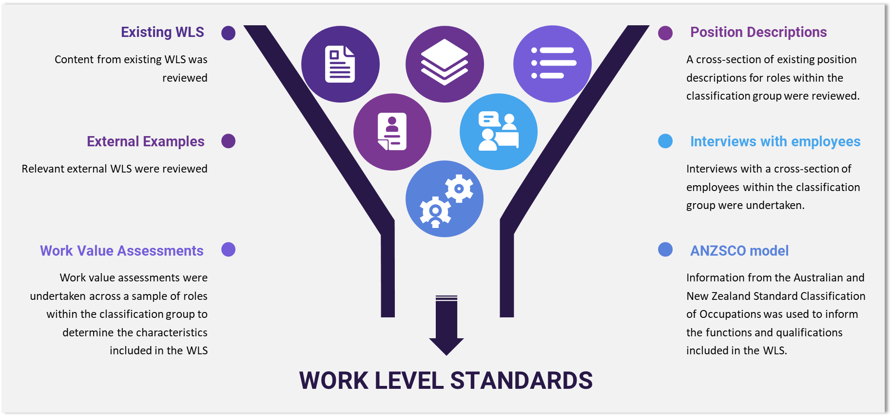

#### Limitations

The following limitations were identified in the development of the WLS:

* The characteristics included in each set of WLS are based on the outcomes of the comparative work value analysis (see *Section 4*). The comparative work value analysis is based on a cross-section of roles within each classification group not all roles within the classification group.

#### Assumptions

The following assumptions were made in the development of the WLS:

* Qualitative data gained through interviews with employees and Directorate representatives formed one of the inputs used to develop the WLS and have been treated as a key source of evidence.
* Existing documentation (identified in the methodology above) were a key source of input relied upon for the development of the revised work level standards.

## Considerations for the future

WLS are a tool that can assist in segmenting the workforce, allowing differentiation of remuneration based on the work undertaken in an effective and consistent way.

Generally, WLS are a public sector expectation as they provide transparency in the allocation of public funds. The private sector does use similar models, but the use of them is less common compared to the public sector.

The ACTPS WLS:

* Provide a common language across work areas and Directorates within the ACTPS.
* Support consistent and sound decision-making for role design and classifications.
* Help employees understand what is expected of them in their role.

The main uses for WLS include:

* **Role classification** – for example, a new role is being created and the WLS are used to determine what classification and level within the classification the role should be (this is further described in *Section 4.2*).
* **Role design or re-design** – for example, the operating context a role is working within has changed and the role needs to be re-designed to reflect the changes.
* **Evaluation of work value** – for example, when the requirements of a role have changed they should be assessed using the *ACTPS Work Value Assessment Framework* to determine the most suitable classification level.
* **Developing a position description or job advertisement** – for example, when advertising to recruit for a role, the WLS can be used to describe the key requirements associated with the role.
* **Learning and development** – for example, an employee who wants to progress to a higher classification level can use the WLS to identify the areas where they need to gain more experience or be used when developing learning and development programs.
* **Performance management** – for example, a manager can use the WLS to set performance expectations related to the role and classification level with their team members.

# Workstream 4: Historical Percentage-Based PAY Increases

## Workstream 4 objectives

*Identify the inequities generated by the historic percentage-based pay increases and identify alternate options.*

The aim of Workstream 4 was, for the classification groups included in this review, to:

* Collate and analyse information on historical percentage-based pay increases under relevant Enterprise Agreements.
* Evaluate the magnitude of the increase in pay dispersion by classification.
* Calculate the total cost of redressing the increase in pay dispersion.

## Background

#### The Employment Relationship and remuneration

The relationship between an employer and its employees is based on a value exchange between each other – the employee exchanges their labour for some form of reward from the employer.

For the employer, the value the employee brings can be rewarded in multiple ways:

* It can be direct, e.g. when a salesperson is paid a direct commission on their sales, or wages paid at an hourly rate.
* It can be indirect, e.g. in the case of a salaried employee.
* It can be mixed, where an employee might receive a bonus for meeting a performance target on top of a base salary.

For the employee, reward can take many forms and it is typically considered in terms of financial and non-financial remuneration.

However, not all work will be valued equally by the organisation and so the structure of the reward provided will vary depending on what the organisation values. In simple terms this might be the percentage commission mentioned above. However, in a more complex organisation, a formal assessment might be used to determine the value an employee provides and hence the value of the reward provided. Work value assessments are typically multidimensional and incorporate a range of factors including the nature of the work, the conditions under which work is performed, and the level of authority and responsibility of the employee.

#### A reward strategy is part of a workforce management framework

In a simple organisation reward can be managed on a case-by-case basis, however in a more complex organisation that includes multiple different types of work across multiple business units, reward needs to be considered strategically. There are several reasons why a complex organisation should develop a formal reward strategy, including:

* Reward is typically the largest cost of any organisation, even more so in the public sector, so a strategic approach to managing reward is good practice.
* A reward strategy allows the organisation to identify where it wants to be in terms of how and why they reward their employees.
* There is a positive relationship between reward and performance so reward can be used as a lever to improve organisational performance, however the complexity of the relationship between reward and performance requires a strategic view.
* As the workforce becomes more diverse and complex the nature and impact of reward becomes more complex.

A reward strategy has many features that address the above. As with any strategy a reward strategy will be a high-level document underpinned by a set of reward principles.

#### Reward principles

As with any strategy, the organisation may choose to adopt a particular position. There are common principles that should underpin a reward strategy including:

* **Equity.** Equity is one of the most important reward principles – employees need to feel that they are being rewarded appropriately for their labour, but also that reward is equitable across the organisation.
* **Reward position.** The organisation may adopt a reward position as a principle. This means an organisation may deliberately choose to remunerate employees, under, at, or over the market rate.
* **Reward package.** An organisation may choose to use a broad-based reward package including a range of non-financial elements (e.g. flexible hours, extra leave, gym memberships) or a purely financial remuneration package.
* **Reward progression.** Reward, and particularly reward progression (not promotion) can be based on seniority, i.e. as the individual spends more time in the organisation, or on work performance. A combination of these can be used where individuals are required to spend a minimum amount of time at a particular level and then meet performance requirements to gain salary progression.
* **Collective or individual systems.** The organisation can use a purely collective system, where individuals in specific segments of the workforce receive the same remuneration, or it can have individual agreements with employees.
* **Public sector related principles.** There are other principles that are specific to the public sector. These include transparency (where remuneration levels for specific segments of the workforce are publicly available) and meritocracy (where selection for a position is based on merit).

#### Equity in reward

As mentioned above, equity is one of the key principles of any reward system. There are three types of equity present in a reward system:

* **Internal equity**: where different jobs in the same organisation need to be seen to be equitably rewarded.
* **External equity**: where similar jobs in other organisations need to be seen to be equitably rewarded.
* **Individual equity**: where individuals employed in the same job in the same organisation are seen to be equitably rewarded.

#### What type of remuneration system is appropriate for the ACTPS?

There are four broad types of reward systems each of which is more or less applicable to the public sector and the ACTPS specifically. These are:

* **Seniority-based systems**: where remuneration is based solely as a function of time in a position, such as annual salary progression. This is applied as a standard across the organisation that is then applied to individuals as they meet time in position criteria.
* **Merit-based**: where remuneration is based on performance in a role. This is usually linked to a performance appraisal system and can be applied across the organisation or individually.
* **Incentive-based**: where bonuses are paid (in addition to salary) based on, for example, the financial performance of the business.
* **Performance-based system**: where salary increases (as opposed to bonuses) are tied to the financial performance of the business unit.

The ACTPS reward system appears to be a blend of seniority and merit-based systems:

* Within each level of each classification pay progression is influenced by seniority, that is, individuals can progress automatically over time.
* In many of the classification levels pay progression is based on some form of performance assessment, even if it is just for performing adequately. Individuals may also receive accelerated advancement through the pay band as a form of merit-based progression based on performance.

#### Why and how do we increase reward?

Independent of automatic progression to a different pay point, or promotion through a merit-based system, organisations will often build a system of regular (typically annual) reward increases. These can be based on several factors:

* The organisation anticipates increases in CPI (Consumer Price Index) and wants to ensure employees spending power is not diminished.
* The organisation and employees agree on a productivity increase (this will often be in exchange for a reduction in some other employment condition or associated with the introduction of some cost of labour-saving initiative).
* The organisation expects that work value will increase over time.
* The organisation expects external demand for labour to increase and wants to become a leader in reward in order to retain its workforce.

Increases in reward can be varied on two main dimensions:

* They can be applied to the whole workforce or segments of the workforce through a collective agreement.
* They can be applied individually through an individual agreement.

Finally, increases in reward can be made as either a percentage increase in salary, a fixed dollar amount of increase, a change to an employment condition (e.g. additional leave or allowances), or a combination of all three.

Salary increases using either the percentage-based system or a fixed dollar approach is likely to generate concerns about potential inequity arising from the increase. For a percentage-based pay increase, those on lower salaries will receive a smaller dollar increase than those on a higher salary because they start with a lower base rate. Conversely for a fixed dollar amount increase, individuals on a higher salary will receive a relatively lower percentage increase than those on a lower salary.

The two approaches can be combined by providing individuals the greater of a percentage-based pay increase or a fixed dollar amount. This combined model allows individuals on the higher end of the salary scale to retain a greater absolute increase while providing those at the lower end of the salary scale a greater relative increase. Moreover, this model retains pay relativities, i.e., depending on how it is structured, a lower classification level can never overtake a higher classification level. This is the model that was applied in the ACTPS in 2013 and will be used for comparison purposes as part of this analysis.

## Research approach

#### Methodology

The purpose of this analysis was to understand the effect of the annual percentage-based pay increases on pay disparity across the ACTPS classifications included in the review and what would be required to redress any inequities that had developed.

The primary dataset used for the analysis was the *Classifications and Rates of Pay* tables extracted from each ACTPS Enterprise Agreement – both current (2018-21) and historical (2013-17). The dataset was then filtered by the specific classifications required for the review. Each pay point within each classification level was defined by matching the EA dataset with the pre-existing pay point identifiers in the HR dataset (used as part of the Shared Salary Spines analysis).

To determine the level of inequity in a classification the absolute difference between the lowest and highest pay points in a classification, calculated in dollar terms. Then, the change in the difference from 2013 to 2020 was calculated to determine how much the difference had changed over time. Finally, to determine the impact to actual total salary costs, the HR dataset was used to capture the FTE (full time equivalent) for each pay point. This involved calculating the number of FTE in active, occupied roles against each pay point in each classification. Given there is no HR data for 2021, the assumption was made that the structure remains the same as 2020.

Several remuneration models were designed to assess the various impacts of differing salary increase scenarios. These looked at variations to both the percentage-based approach and the fixed-dollar amount approach.

The key model used for comparison was the combined fixed-dollar amount/percentage-based pay increase modelled after that which was applied by the ACTPS in 2013 (the 2013 increase, involved employees receiving the greater of a $2,090 or 2% increase, in this case the actual percentage pay increase was considered rather than a flat 2% as this disadvantaged a number of classificaiton). The effect this model would have had on salary disparity, had it been applied continuously since 2013, was modelled.

Another model considered the cost of restoring the differences between pay points within a classification level as they were in 2013 to 2021 whilst maintaining the top pay point within the level at the amount specified in the relevant EA for 2021.

The data tables used as part of this analysis are provided in *Attachment 22*.

#### Limitations

The following limitations were identified in the methodology:

* The analysis focused on the identified priority classification groups in the ACTPS. This limits the comparative analysis and hence the conclusions that can be drawn from the dataset employed. ​
* To calculate the baseline total wage cost the EA salaries were used and multiplied by the existing FTE numbers in the HR dataset for each pay point (as described in the methodology above). The same methodology was applied as part of the remuneration models. This approach has some limitations on the total wage costs specified in the analysis, in other words it is a hypothetical model. If this model is applied in reality, different results may present themselves in terms of actual costs, depending on the makeup of the workforce at the time it is applied.

#### Assumptions

The following assumptions were made as part of the research approach:

* EA data formed the base of the assessment and has been assumed as true and correct.
* Based on the priority groups that were specified for the purposes of this review, we have applied our own mapping conventions for each classification group (as shown in *Table 5.1* in *Section 5*).
* For the BSO classification, salary data prior to 2018 was not available in the relevant EA as roles in this classification were previously part of the GSO classification. The pre-2018 salary data for the BSO classification has been calculated by matching relevant GSO level wages against each BSO level, based on the following mapping:
  + BSO 1 equal to GSO 3-4
  + BSO 2 equal to GSO 6
  + BSO 3 equal to GSO 8
  + BSO 4 equal to GSO 10
* For the Theatre Technician classification, salary is specified as an hourly rate in the relevant EA. The annualised base salary for Theatre Technicians was calculated based on the hourly base rate provided in the EA (assuming a full time equivalent 8-hour workday, 5-day working week and a 52-week work year).

## Findings, interpretation, and analysis

In 2013 the ACTPS used a hybrid model for workforce salary increases where employees were given the greater of a fixed-dollar increase of $2,090 or a 2% salary increase. Where the cut-off point occurred at an annual salary of $104,500. Since then, the ACTPS has used a percentage-based increase system. The actual effect of this percentage-based pay increase model on salary disparity in dollar terms is show in *Figure 7.1*. Note that this is based on actual EA salary rates.

This shows that there has been an increase in pay disparity since 2013 between the top and bottom pay points across all the classifications except for Theatre Technicians.

*Figure 7.1 Pay disparity in dollar terms – historical percentage-based pay increases.*

##### Impact of a different model

As discussed above, a combination of a fixed-dollar rate and percentage-based salary increase is likely to produce a reduction in pay disparity across levels in each classification. This was the model used in 2013 in the ACTPS and was modelled across all the classifications from 2013 to 2021.

For this modelling, a fixed value amount of $2,090 was used (as in the 2013 model) but the percentage increase was based on the actual percentage increases applied for each of the classifications. When applying the 2013 model, the difference in disparity was reduced compared with the actual pay disparity; this data is shown in *Figure 7.2*. In many cases there was no increase in disparity, reflecting those classifications where the salary range was below the cut-off point for the move to a percentage-based increase and therefore all received a fixed-dollar increase. The only classification which showed a slight increase in pay disparity was Prosecutors.

*Figure 7.2: Actual pay disparity using the 2013 model.*

The overall impact of the two models and the difference between them in the ACTPS wages bill is shown in *Table 7.1* below.

*Table 7.1: Overall impact of salary increase models.*

|  |  |  |  |
| --- | --- | --- | --- |
|  | EA Salary Estimate 2021 | Mixed Model Salary Estimate 2021 | Difference |
| GSO | $ 27,241,430 | $ 28,616,882 | $ 1,375,452 |
| BSO | $ 14,662,266 | $ 15,403,670 | $ 741,404 |
| CLS | $ 4,838,894 | $ 5,133,545 | $ 294,651 |
| ITO | $ 61,183,512 | $ 62,333,519 | $ 1,150,007 |
| TO | $ 45,258,495 | $ 46,631,757 | $ 1,373,262 |
| SST | $ 1,812,834 | $ 1,868,994 | $ 56,160 |
| TT | $ 206,437 | $ 223,640 | $ 17,203 |
| LG | $ 7,075,194 | $ 7,236,846 | $ 161,652 |
| PRO | $ 9,010,894 | $ 9,213,757 | $ 202,863 |
| RNG | $ 8,795,966 | $ 8,903,330 | $ 107,365 |
| CITC | $ 931,448 | $ 949,763 | $ 18,315 |
| TOTAL | $ 181,017,369 | $ 186,515,704 | $ 5,498,335 |

This data shows the overall effect on ACTPS salary costs of implementing the 2013 model would have led to a slight increase in the total wages cost for the ACTPS workforce under review of $5,498,335 or approximately 3% of the EA salary estimate costs.

##### Resetting the pay disparity using the 2013 model

Using percentage-based salary increases has led to an increase in disparity between the higher and lower levels of salary in the ACTPS. To reverse the effect of this requires either a one-off increase in salaries across the classification levels or a graduated increase in those lower salaries through the application of a fixed dollar increase and percentage-based increase over a period of time.

Salary modelling, using current EA salary rates, show that the cost to readjust the pay disparity from its current level, across each of the pay points in each of the classifications included in this review, to the 2013 level of disparity will require a one-off cost of $17,306,112 to reset the current salaries, which would then flow through to subsequent salary increases.

## Recommendations

The regular increase in salaries across the ACTPS workforce since 2013, using an annual percentage-based pay increase, has increased the disparity in salaries across each of the classifications in absolute dollar terms.

Applying a combined fixed-dollar rate and percentage-based salary increase (based on the actual percentage-based pay increases) over that same period would have resulted in a reduction in disparity in dollar terms. The combined model would have reduced the disparity between the maximum and minimum salary points across the classifications with only a 3% increase in the total salary bill for the ACTPS.

A combined fixed-dollar rate and percentage-based salary increase is the most effective model of regular salary increases for maintaining relative salary levels across classifications.

# Future Considerations

The approach to the workstreams in this document was driven by an intent to better understand work in the ACTPS, how this is rewarded, and reflect on how things might be improved.

In the course of doing this, a robust work value framework and assessment method has been developed that is specific to the needs of the ACTPS whilst remaining consistent with current good practice in work value assessment methods. A work value assessment tool has been developed that has been used in a wide range of assessment settings to produce, in most cases, a good fit between work value and classification levels, though it is more effective for classifications that are occupationally based.

As part of the Comparative Work Value assessment, all positions assessed were mapped into the ANZSCO framework – this provided another lens on the classifications and the internal segments in the catch-all classifications such as GSO. The ANZSCO mapping was also fundamental to being able to compare remuneration levels in the ACTPS with the broader ACT and Australian labour market. The ACTPS classification system is reasonably aligned with the ANZSCO structure, so mapping of the entire system to ANZSCO would be feasible and provide alignment with the external labour environment. Moreover, this would not necessarily mean that existing job titles or position descriptions would need to change, they would just be organised differently. The outcomes of the work value assessment analysis were also used as the basis for developing a set of Work Level Standards for the classifications considered in this analysis.

In analysing the effects of shared salary spines on career pathways in the ACTPS it was found that some classifications reflect occupational groups while others are organisationally based or catch-all groupings. Having a classification system that was based solely on occupation groupings would provide a degree of clarity in the system that has important implications for managing the workforce including recruitment, internal mobility, workforce planning at an ACTPS level, and learning and development. Being supported by a robust Work Value framework would allow the identification of true ‘outlier’ roles in terms of work value and remuneration and more effective application of specialist workforce interventions such as ARIns as well as the allocation of staffing resources to meet priority needs. Observations were also made about the effect of shared salary spines on other important workforce elements including mobility, tenure, the use of higher duties and broadbanding for capability building, and promotion and progression rates.

The effect of a percentage-based pay increase system on pay disparity across the ACTPS was also considered and it was found that this did increase disparity in pay between the lowest and highest paid employees in each classification. However, modelling showed that a combination of either a fixed-dollar increase or a percentage increase that had been used prior to the percentage-based pay increases, reduced pay disparity with little impact on the overall salary costs.

Actions that logically follow on from this work include:

* The Work Value framework and assessment model developed should be used to conduct a similar work value assessment exercise for the rest of the ACTPS classifications to build a contemporary database of work value.
* A review of the overall classification system should occur to ensure that it is occupationally based. This could then be mapped to ANZSCO for consistency with the broader labour market.
* If broadbanding is purely used as a mechanism for capability building or upskilling the workforce then it is not achieving this objective and consideration should be given to either collapsing broadbanded positions into a single classification level to simplify the remuneration system.
* Future annual salary increases should be based on a combined model including a fixed-dollar increase and percentage-based increase.

Other future actions that should be considered include:

* Standardising and updating all Position Descriptions, aligning to relevant work value terminology and work level standards.
* Reviewing existing HR data and incorporating greater descriptive information including position title and occupational mapping (using an occupational categorisation model such as ANZSCO). As well as incorporating all sources of remuneration such as overtime, and role specific benefits.
* Ensuring that position data is up to date, including removing positions no longer required and using a single position number for the same position.

# Attachments

This report includes the Attachments specified in *Table 9.1* below.

*Table 9.1: Summary of Attachments.*

|  |  |
| --- | --- |
| # | Title |
|  | Summary of Requirements |
|  | Work Value Assessment Model and Tool |
|  | General Service Officers – Comparative Work Value Summary Report |
|  | Rangers – Comparative Work Value Summary Report |
|  | Information Technology Officers – Comparative Work Value Summary Report |
|  | Technical Officers – Comparative Work Value Summary Report |
|  | Legal Officers – Comparative Work Value Summary Report |
|  | Prosecutors – Comparative Work Value Summary Report |
|  | CIT Student Counsellors – Comparative Work Value Summary Report |
|  | Summary of Documentation Reviewed in the Desktop Analysis |
|  | Summary of Positions included in the Comparative Work Value Analysis |
|  | ACTPS Guide to Work level Standards |
|  | Legal Officer – Work Level Standards |
|  | Prosecutor – Work Level Standards |
|  | Technical Officer – Work Level Standards |
|  | Theatre Technician – Work Level Standards |
|  | Information Technology Officer – Work Level Standards |
|  | Park Ranger – Work Level Standards |
|  | Capital Linen Service – Work Level Standards |
|  | Building Service Officer – Work Level Standards |
|  | Horticulture Workers (Test Group) – Work Level Standards |

1. ACTPS Enterprise Agreements: <https://www.cmtedd.act.gov.au/employment-framework/for-employees/agreements>
2. For example: [APS Role Evaluation Framework](https://www.apsc.gov.au/part-1-aps-evaluation-framework), [Northern Territory Government Job Evaluation System](https://ocpe.nt.gov.au/__data/assets/pdf_file/0007/244294/JES_info_book.pdf) (based on the Mercer Job Evaluation model), [Hay Job Evaluation method](https://www.kornferry.com/content/dam/kornferry/docs/pdfs/job-evaluation.pdf).
3. 50% of Hospitals has been used in order to exclude private hospitals from this analysis. This industry level also excludes Psychiatric Hospitals.
4. Existing HR data between 2011-2020 showed that the average length of service for employees within the Legal 1 classification is 1.67 years.
5. Department of Education, Skills and Employment: [https://lmip.gov.au/default.aspx?LMIP/GainInsights/IndustryInformation#:~:text=In%20total%2C%20there%20are%20approximately,are%20around%20%241%2C100%20per%20week](https://lmip.gov.au/default.aspx?LMIP/GainInsights/IndustryInformation).