LGBTIQ

Ministerial Advisory Council

2017 report

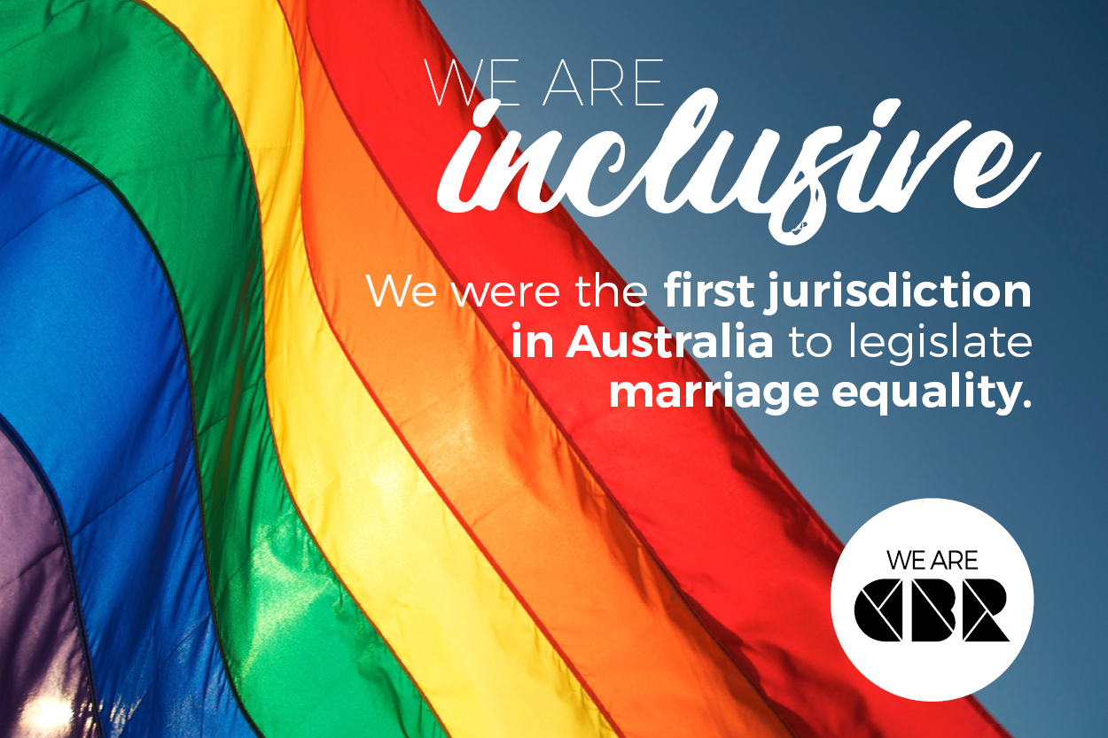

Contents

Purpose and objectives of the ACT LGBTIQ Ministerial Advisory Council

Members
- Establishment of the Office of LGBTIQ Affairs

Marriage equality and Events
  - Speaking Confidently About Ourselves in Difficult Times
  - Intersex is not invisible: Intersex Awareness Day
  - Fair Day
  - Inclusive Canberra Think Tank

Sub-Committee reports

Health

Beyond the Binary

Aged Care

Education

Looking ahead to 2018 – key issues

The Purpose and objectives of the ACT Government LGBTIQ Advisory Council
The ACT Lesbian, Gay, Bisexual, Transgender, Intersex and Queer (LGBTIQ) Ministerial Advisory Council (the Council) provides advice to the ACT Government and community on issues affecting LGBTIQ persons. The Council provides practical and strategic advice to support the LGBTIQ community, improve the lives of people who identify as LGBTIQ and promotes a more inclusive Canberra.
The Council welcomes input from all stakeholders on strategic policy issues affecting LGBTIQ persons in the Canberra community.

‘… valuing our own kind of diversity - isn’t really the proper test… the real test comes when we are asked to value those kinds of diversity that are different from our own. When we are asked to take some responsibility for ensuring the inclusion of others who are not exactly the same as us… or perhaps who are not very much like us at all’.
Peter Hyndal

- Members
Anne-Marie Delahunt (Chair)
Wayne Herbert (Deputy Chair)
Ali Khan
Suzanne Eastwood
Stephanie Lum
Scott Clouder
Isabel Mudford
Lynne O’Brien
Tushara Wickramariyaratne
Simon Copland
Harley Dennett (to June 2017)
Christine Healy
Kat Reed
Joseph Ishow (to September 2016)

- Establishment of the Office of LGBTIQ Affairs
The Council warmly welcomes the establishment of the Office of LGBTIQ Affairs (the Office). The Office was announced as part of the 2016/17 budget. The establishment of the Office is a reflection of the ACT Government’s leadership on LGBTIQ issues and will improve the development and coordination of effective LGBTIQ policy across government. The opportunity to be working closely with the newly established Office for LGBTIQ Affairs has greatly improved the effectiveness of the Council.

- Marriage Equality
A key focus for the Council has been working to achieve marriage equality. We have been actively involved in many aspects of the campaign at both the national and territory level. The Council also convened a special marriage equality community meeting to ensure a fully coordinated approach to supporting our communities during what has proven to be a very difficult and confronting time for many.
The Council strongly supports marriage equality and is delighted that after decades of advocacy this has been achieved. All members of the Council have been involved in the campaign in a range of ways including; participating in community events, rallies, community consultation, and awareness raising activities.
The Council was appreciative of the additional funding provided by the ACT Government for additional counseling resources for the LGBTIQ communities, and our allies, during what was a difficult and stressful time. As a Council, we actively campaigned for Canberra to return the highest yes vote and are proud of the result – 74% of Canberran voters said ‘Yes’.
Speaking Confidently About Ourselves in Difficult Times: A Special Seminar for LGBTI+ Canberrans and their Allies
In early October, half way through the marriage equality postal survey, the Council hosted a seminar in conjunction with the Rainbow Ranters Toastmasters group. The panel of speakers represented members and allies of the community. The group provided attendees with tips and ideas on engaging in the ‘debate’. The evening was well attended by a diverse range of community members.
Intersex is not invisible: Intersex Awareness Day
On the 26^{h} of October, Intersex Awareness Day, the Council in conjunction with the Office, A Gender Agenda (AGA), and Organisation Intersex International Australia hosted an awareness event at Canberra Museum and Gallery. Council member Stephanie Lum and AGA’s Cody Smith spoke about their intersex activism.
Inclusive Canberra Think Tank
The Council is committed to ensuring that Canberra is Australia’s most LGBTIQ friendly and inclusive city. The We Are CBR campaign is an example of the promotion of Canberra as a friendly and inclusive city. As part of the Spring Out festival, the Council ran a Think Tank event. The Think Tank posed to attendees the question of ‘what would make Canberra the most LGBTIQ inclusive city?’
The event was fully subscribed in the first few weeks of advertising and was well attended on the night. Outcomes of the Think Tank will be sent to attendees and the ‘what Canberra already does well’ session will be disseminated more widely.
The Council was pleased to engage with a group of graduates to assist in exploring both local and international themes and approaches that are successful.
The Council will seek feedback and input from a broad range of community members and allies to inform the future work of the Council and the Office. While we proudly see Canberra as Australia’s most inclusive city, we are deeply invested in continuing to ensure that all communities within the LGBTIQ grouping are treated with respect and dignity. The Council recognises that each part of our community may have a different focus, expectation and journey towards inclusion. As Council member Stephanie Lum expressed in her speech at the Think Tank:
‘How can we even begin to feel included when most people don't even know who we are? How can we even begin to feel included when every time we want to talk about what we need or what the problems are that we face, we have to take on the role of teacher and begin by explaining who we are and how different we are from each other?’
Stephanie Lum
Wear it Purple Day
The Council understands that visibility is an important way to break down barriers and reduce stigma and discrimination. Council members showed our support for Wear it Purple Day as we share in the mission of the day to foster supportive, safe and accepting environments for young LGBTIQ people.
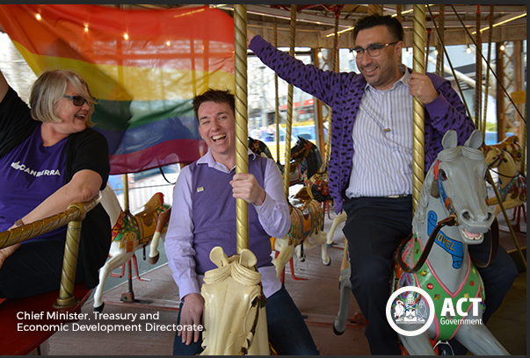
Lynne O’Brien, Wayne Herbert, and Ali Khan on Wear it Purple Day 2017

Fair Day
Council had a hugely successful Fair Day sharing a stall with the Office. It was a great way for us to engage with individuals, groups, and families on the work of the Council and for members of the Council to become more widely known within our community. An important feature of our stall was our Inclusive Canberra survey. With well in excess of 200 surveys completed, this will be vital information to inform our work and help build a picture of what the community believes an inclusive Canberra look and feels like.
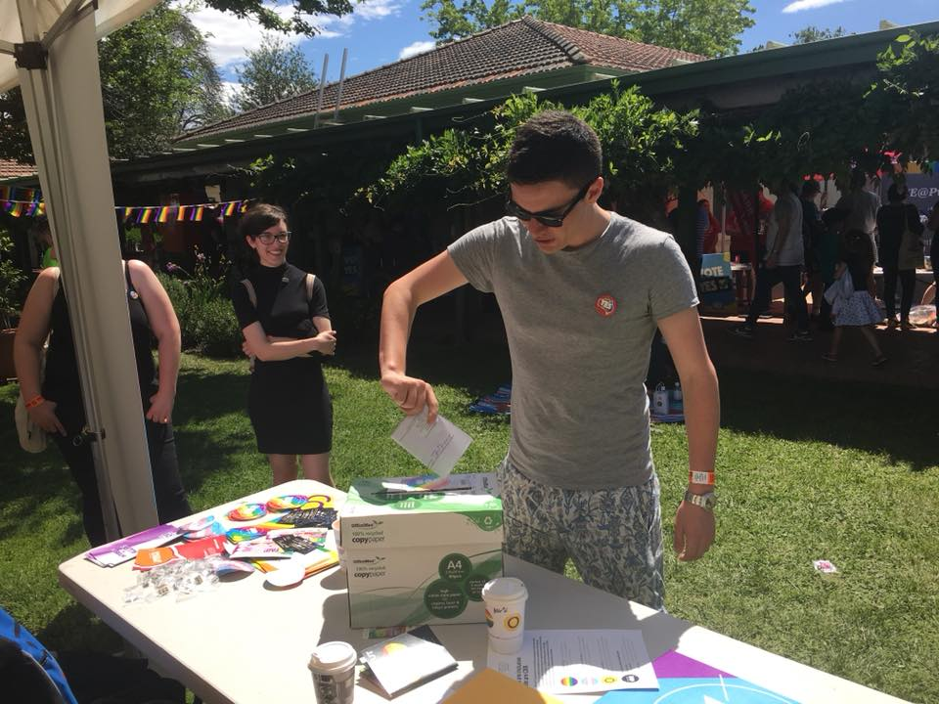
Dropping completed survey into box at Fair Day
- Sub-Committee Reports
Health
The Council has been working on a number of health priorities, including strongly advocating for an ACT based PrEP trial. We welcome the commencement of the 315-person trial of individuals at risk of HIV.
The Council has a particular focus on the health and wellbeing of trans and gender diverse as well as intersex individuals in the ACT. We have been consulting with Capital Health Network on the development of a health pathway for GPs in the ACT on trans and gender diverse health. We have also provided feedback to Capital Health Network on their Needs Assessment review of mental health, in the areas related to LGBTI people, and hope to continue to be involved in this review.
The Council has also sought to develop a mental health professional network for clinicians working with trans and gender diverse people in the ACT and will progress this into our second term.
We have also sought information about ACT Health’s policies regarding people with intersex variations and provided feedback on the draft ACT Health LGBTI Inclusion Framework 2016-2018. We look forward to continued involvement in these issues.
Beyond the Binary
The Council has provided advice to the Justice and Community Services Directorate regarding amendments to the Births, Deaths and Marriages Registration Act 1997 which would see the territory continue to lead the way in the inclusion of trans and gender diverse people.
Aging and Aged Care
The Council continued its work on aging and aged care, with several of our members participating in a number of training sessions for Aged Care workers.
This year, the Council was pleased to be part of Seniors Week in the ACT. A number of members attended the Seniors Week Expo and had very productive discussions with senior members of the ACT LGBTIQ community about their access to appropriate care and support.
Council members also attended the third National LGBTI Ageing & Aged Care Conference in Melbourne keen to provide further input to the experience of LGBTIQ seniors in the ACT.
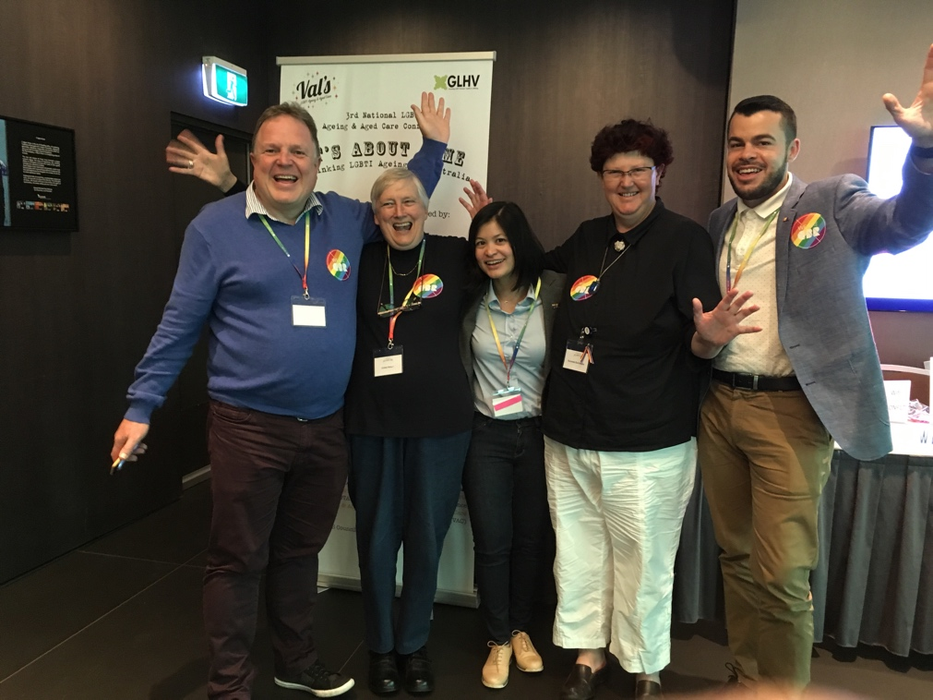
John Guppy (AIDS Action Council), Chris Healy, Tushara Wickramariyaratne, Suzanne Eastwood and David Momcilovic (the Office) at the National LGBTI Ageing and Aged Care Conference
Education
Council has advocated for the continued funding of the Safe Schools program in the ACT. We welcome the budget allocation to ensure this vital program continues to assist and support in particular young LGBTIQ members of the ACT community. Council is aware that only a limited number of Canberra schools participate in the program and will be seeking to increase this number in the future.
Council also highlighted the omission of the LQBTIQ community from the recently released On Safe Ground: Strengthening Australian university responses to sexual assault and harassment. We were pleased that the ACT Government committed to raising this issue with representatives from the university sector.

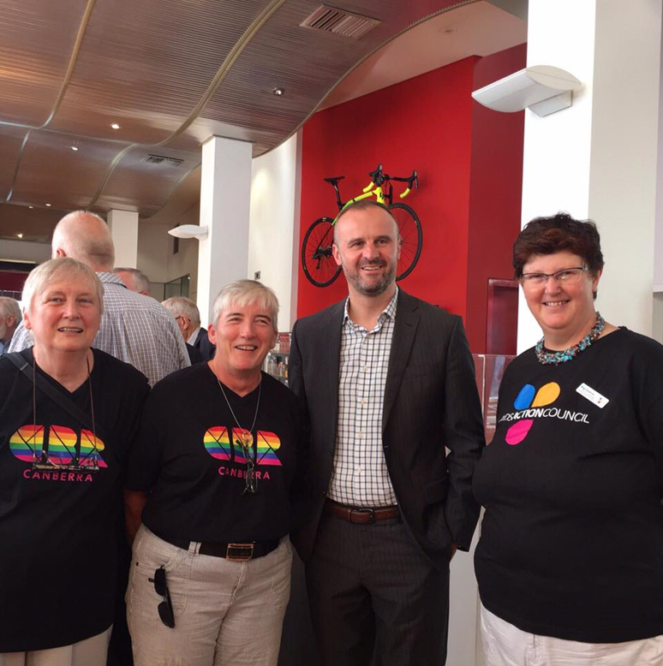
- Looking ahead to 2018 – Key Issues
Chris Healy, Anne-Marie Delahunt, Chief Minister Andrew Barr & Suzanne Eastwood
In 2018, the Council will continue work on the services and supports available to members of the LGBTIQ community in the ACT. Early in the year, we will develop a work plan informed by the Inclusive Canberra and survey outcomes. The plan will also update our current focus areas:
- Developing an information portal for LGBTIQ communities.
- Establishing a professional network for mental health clinicians working with our communities.
- Supporting QWIRE’s bid for funding to support it hosting the Out and Loud Festival.
- Supporting Sexual Health and Family Planning ACT and the Education Directorate in their work with ACT schools.
- Targeting social programs for older LGBTIQ people.
- Continuing to support service provision to our communities.
- Beginning a feasibility study for a Canberra Pride Centre.
- Promoting the human rights of intersex people.

