

ACT PUBLIC SERVICE

Whole of Government Performance Framework
Guidance Statement

Table of Contents

Contents 2
INTRODUCTION BY THE HEAD OF SERVICE AND COMMISSIONER FOR PUBLIC ADMINISTRATION…3
1. THE ACTPS PERFORMANCE FRAMEWORK APPROACH 4
1.1 What is it? 4
1.2 Who does it apply to? 5
2. LEGISLATION RELATING TO ACTPS PERFORMANCE FRAMEWORK 6
2.2 ACT Public Service Enterprise Agreements 6
2.3 Public Sector Management Act 1994 6
2.4 Public Sector Management Standards 2006 7
3. ACTPS EXPECTATIONS 7
3.3 Setting Performance Expectations 7
4. HOW DOES IT WORK? 9
4.1 Good quality informal feedback and dialogue 9
4.2 Performance Appraisal (Formal feedback) 10
4.3 Flexibility 11
5. GOVERNANCE 11
6. REPORTING 12

INTRODUCTION BY THE HEAD OF SERVICE AND COMMISSIONER FOR PUBLIC ADMINISTRATION
The ACT Public Service (ACTPS) is strengthening its organisational culture to ensure every employee feels engaged and supported through a positive workplace environment and that we each have clarity in what is expected of us. As a Service, we want to recognise and promote good performance and provide support in areas where performance needs to improve.
The ACTPS approach to performance management and development, as set out in the ACTPS Performance Framework Policy Statement and this Guidance Statement, is intended to improve the workplace experience of all employees as well as improve the performance and outcomes delivered across the Service. Performance management and development provides a clear link between the work that we do and the professional learning, development and growth that we require to remain engaged and satisfied in our jobs. It is one of a number of ways in which the ACTPS seeks to fulfil its obligations to its employees in terms of strengthening employee satisfaction, wellbeing and engagement as well as ensure that we are achieving strong performance outcomes.
Performance management and development is the means by which we articulate our expectations and then continually check that we are delivering on these expectations. The ACTPS Performance Framework approach includes consideration of three components of work performance: the work which an employee executes, their skills and knowledge, and their behaviour. Effective performance management and development requires discussion, agreement and mutual commitment between each employee and their supervisor on each of the three strands. It involves engaging in good quality performance conversations so that everyone has a clear understanding of their performance progress. This way of working builds trust, productive relationships and teamwork.
Our community is entitled to have high expectations of its Public Service. I look forward to every team engaging in good quality feedback and conversations about performance. An open approach and focus on our performance is to be part of the way that we work in the ACTPS.

Andrew Cappie-Wood Andrew Kefford
Head of Service Commissioner for Public Administration
July 2013 July 2013

1. THE ACTPS PERFORMANCE FRAMEWORK APPROACH

1.1 What is it?
- At an everyday level: Performance management is a development tool for promoting open communication between an employee and their manager about their expectations of each other. It focuses on setting shared expectations and agreement on the three elements of work performance; behaviour, skills and knowledge, and work executed.
  - Employees, through good quality conversations with their manager about performance, let their supervisor and/or manager know what they need in order to do their work well, get clarification on what is required of them, give their supervisor and/or manager feedback, discuss ongoing professional development, reflect on their work challenges and receive recognition for their achievements.
  - Supervisors and managers, through good quality conversations about performance, let employees know what is expected in terms of their conduct and way they behave at work, the skills and knowledge they need, the tasks they are expected to perform and how the manager will support them to reach their professional potential.
- The phrase ‘good quality conversations’, for the purposes of the ACTPS Performance Framework Policy and this guidance statement, means: respectful, constructive and timely discussion of matters relating to an individual’s work performance.
- At a strategic level: The Performance framework links with other ‘people management’ practices, especially Learning and Development, to assist the ACTPS to reach its strategic objectives by getting the best from its people.
  - ACTPS performance management and development embeds expectations of conduct and behaviour at every level in the organisation and makes these expectations an explicit part of the organisational culture.
  - Achievement and talent is to be recognised and acknowledged, improvement and development is to be supported and a more engaged and a resilient, adaptable and outcomes focussed workforce will develop across the ACTPS.
  - These factors will assist the ACTPS in becoming a model employer and attracting and retaining a high performing workforce.

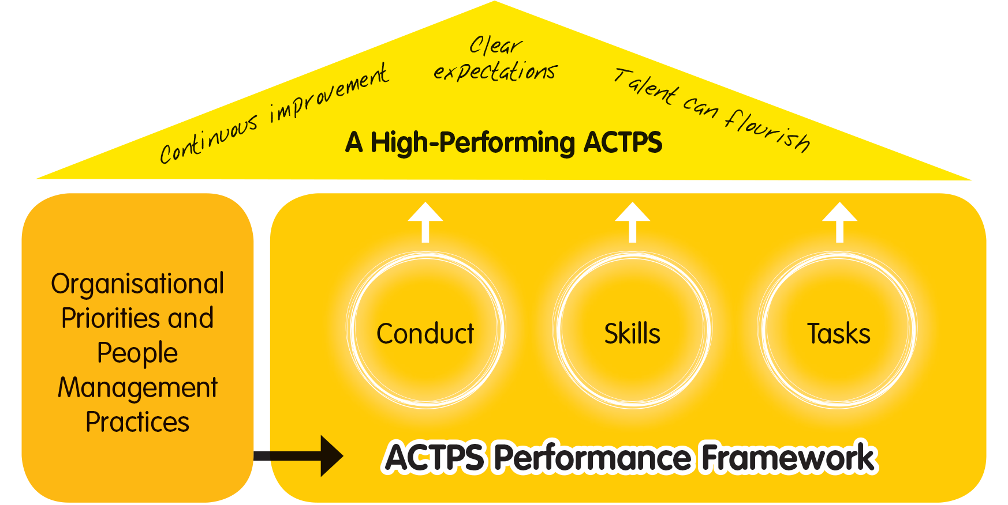
Figure 1. ACTPS Performance Framework links together different elements of the way we do our job and supports an overarching aim.
- Performance management is not the same as managing underperformance. The formal process for addressing underperformance is detailed in Enterprise Agreements.
- The ACTPS Performance framework operates throughout the duration of an individual’s employment with the ACTPS, not just ‘when things go wrong’.

Who does it apply to?
- The ACTPS Performance Framework policy applies to all ACT Public Service organisations and people employed within them under the Public Sector Management Act 1994 (PSM Act). Broadly, this includes:

- permanent employees (those who hold a permanent position with the ACTPS, regardless of whether they are currently acting in another role);
- temporary employees (those whose contract of employment specifies an ‘end date’);
- casual employees (those who are engaged under the PSM Act to perform work for a short period on an irregular or non-systematic basis. Specific information on the performance management and development of these employees can be found in section 4.1.8);
- executive and non-executive employees;
- those employees who are employed under the PSM Act within ACT Public Service organisations; and
- all the above regardless of whether they work full-time or part-time.
- It does not apply to:
- People or companies who hold contracts of employment that have been negotiated independently of the PSM Act, such as consultants and Labour Hire Contractors. The performance of these staff or companies should be addressed through a robust contract management approach;
- those employed under the Legislative Assembly (Members’ Staff) Act 1989 (LAMS); and
- volunteers.

2. LEGISLATION RELATING TO ACTPS PERFORMANCE FRAMEWORK
The ACTPS approach to performance management and development is supported by legislation which aims to ensure consistently fair and reasonable treatment of employees.
2.1 Fair Work Act 2009
- The Fair Work Act forms the overarching legal instrument for Industrial and Employee Relations for any employee in the Australian Capital Territory.
- Amongst many other provisions, it establishes the legal basis for action against discrimination, unjust, harsh, or unreasonable treatment of employees and unfair dismissal.
- To comply with the Fair Work Act, ACTPS Performance Framework must be reasonable, fair and supportive, never used to bully or discriminate against employees, and applied consistently.

2.2 ACT Public Service Enterprise Agreements
- Negotiated under the Fair Work Act 2009, the ACTPS has a number of Enterprise Agreements providing terms and conditions of employment for all its employees.
- All ACTPS Enterprise Agreements include a section setting out the way in which employee underperformance is to be addressed. This process is set out in a similar way to misconduct and the process can ultimately end in termination of employment.

2.3 Public Sector Management Act 1994
- The Public Sector Management Act 1994 (the PSM Act) provides the legislative framework for employees in the ACT Public Service. The PSM Act sets out service-wide employment conditions and values.
- In the event of any inconsistency between the PSM Act and the Enterprise Agreements, the Agreements prevail.

2.4 Public Sector Management Standards 2006
- The PSM Act is supported by the Public Sector Management Standards (subordinate law). The PSM Standards are made by the Commissioner for Public Administration.
- Under the PSM Standards, the Head of Service has a responsibility to issue guidance and principles for ACTPS Performance Framework and ensure appropriate monitoring and assistance to agencies in the implementation of Performance Schemes.
- Directors-General, managers and individual employees all have responsibilities under the PSM Standards which relate to implementation of the ACTPS framework within their Directorates and agencies.

3. ACTPS EXPECTATIONS
- Three elements of activity make up the way we think about employee performance in the ACTPS.
- The work that an employee executes or is expected to execute: their main outputs, tasks, projects or deliverables.
- The way in which an employee engages with their work and other people they come into contact with relating to that work: their conduct and behaviour.
- The understanding and expertise that an employee has or is developing in order to meet work performance expectations: their knowledge and skills.

- The ACTPS recognises that employees are entitled to clarity about what their organisation or manager expects of them in each of these three areas. For this reason ACTPS organisations should take care to localise and articulate their expectations in a way which is meaningful to their employees.

Setting Performance Expectations
- ACTPS organisations might choose to set performance expectations in a number different ways. Some of the following mechanisms could be used or combined to support employee understanding.
- ACTPS Tasks: Expectations of the pieces of work an employee is expected to complete is expressed in terms of local expectations, specific to Directorates, Divisions and Teams. Work priorities, tasks and deliverables are often clearly explained within position descriptions at the recruitment stage however if the remit of a role has changed since that time employees may feel the need to seek clarification about what they are being asked to do. If this is the case, a manager may choose to refresh or review a position description and (depending on the scale of the changes proposed) should ensure that it is done in accordance with EA requirements for consultation. As part of their ongoing performance management and development practices some managers choose to use employee-maintained work-plans to ensure their staff have constant clarity about what they are being asked to achieve. Other managers use informal regular ‘catch ups’ about the progress of projects to great effect. As well as the formal performance appraisal documentation; these are examples of effective ways to set expectations of employee performance as it relates to deliverables, tasks or work projects.
- ACTPS Behaviour: As defined by the ACTPS conduct: expectations of conduct and behaviour are the same at a general level for everyone who is considered an employee under the Public Sector Management Act 1994. The general obligations of Public Employees are set out in the Code of Conduct and Values and Signature Behaviours. Many ACTPS organisations have chosen to localise these further and have spent time developing them with their employees. Some teams across the ACTPS have chosen to express their agreed signature behaviours through team conduct charters. Other managers may feel that talking individually to an employee and incorporating work-related behaviours into the annual performance appraisal is a useful approach to test understanding and develop high performance. These are all effective ways to set expectations of performance relating to conduct and behaviour.
- ACTPS Skills: Expectations of the knowledge and skills that an employee should have, or should develop, is already articulated in a number of ways across the ACTPS. Requirements relating to employees in certain roles mean that some skills and knowledge, such as qualifications, are mandated by law. For these employees’ managers; ways of articulating their expectations of the skills and knowledge of these employees (and addressing them if they fall short) will be built in to clinical supervision frameworks, recruitment practices and registration renewal processes. For other ACTPS employees, whose skills and knowledge requirements are not so strictly defined, the way of setting expectations of skills and knowledge required for a role is often done at the recruitment stage through position descriptions or work level standards. As time passes a manager or employee may wish to review that documentation to ensure its currency. Issues may arise during the usual course of employment which prompt an employee to informally let their manager know that they feel the need to develop their level of knowledge or skill in a certain area. During performance appraisal discussions agreements can be made about what skills an employee may need to develop to perform well in the role. These are all effective ways to set expectations of work performance relating to skills and knowledge. The Performance framework is closely linked to learning and development particularly as it relates to skills and knowledge. Using performance management and development practices, managers should identify gaps in an employee’s skills and knowledge and support improvement through learning and development (which should not be limited to formal training).

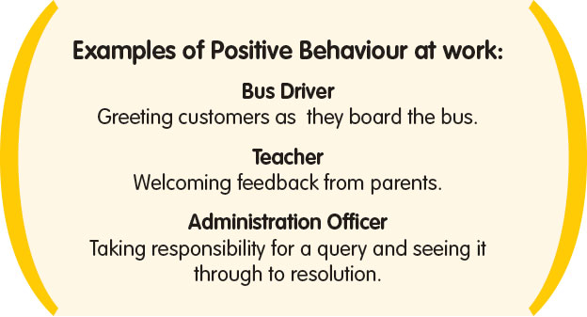 | 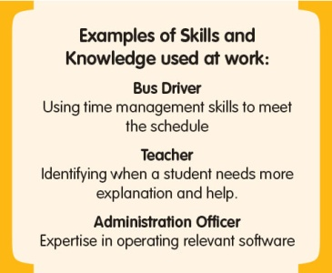 | 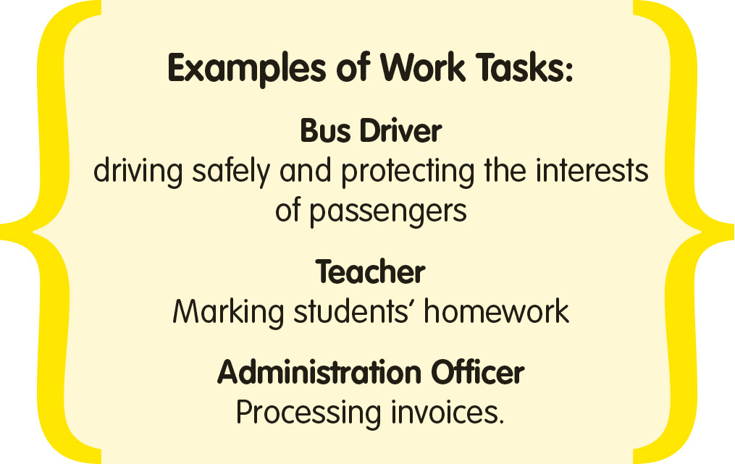
Figure 2. Examples of behaviours, skills and knowledge, and work tasks

4. HOW DOES IT WORK?

4.1 Good quality informal feedback and dialogue
- Effective, informal feedback and discussion of performance is critical for forming a sound understanding of expectations and building resilient working relationships within teams and between managers and their staff.
- Managers and supervisors have primary responsibility for making informal feedback and dialogue successful in their workplaces.
- Continuous performance dialogue takes many forms within workplaces. Examples include ad-hoc workload discussions, ‘team values’ meetings and conversations about ‘how did you think that went?’. Discussion topics could include, but not be limited to, behaviour, skill and task elements.
- The big picture: Supervisors and managers have a responsibility to engage and inspire employees by explaining how their work fits into ‘the big picture’.
Informal discussion is an ideal opportunity to introduce teams to the way their performance links into broader organisational goals. It builds a sense of collective achievement and accountability as individuals understand how their performance impacts on the achievements and reputation of the team and broader organisation.
- Factors affecting employee performance: In order to work effectively, each employee requires a clear understanding of what is expected of them and how they are progressing towards meeting these expectations. Informal feedback and discussion is an effective way of achieving these aims and gives the employee a chance to respond to and address any concerns at an early stage.
- Informal performance management and development discussions should respond flexibly to the needs of an individual employee or team. Issues such as health, finances, relationships in (and outside of) work, workplace safety, wellbeing needs and communication style preferences all impact on work performance. Informal discussion and ‘approachability’ is the best way for managers to become aware of these issues and support employees to maintain their performance.
- Where a performance issue or potential issue is identified, this should be discussed with the employee as soon as possible. An initial informal discussion is often an effective means of drawing the issue to the employee’s attention and enabling open discussion.
- Employees contracted on a casual basis or for a period of less than three months are not required to undergo formal, documented performance appraisal. It is recommended that, for these employees, expectations are clearly set and achievements are recognised through good quality feedback .This will enable casual employees to gain the same benefits from performance management and development as other employees.

4.2 Performance Appraisal (Formal feedback)
- Performance appraisal is the process by which an employee’s performance is formally assessed over a set period of time, usually a twelve-month period. It provides a record of the agreed goals, exchange of feedback and discussion of between managers and employees achievement and areas for improvement.
- Team Performance Plans are a suitable way of setting work expectations and assessing the performance of employees where there is a large team with a high staff to manager/supervisor ratio. The principles of the ACTPS Performance framework apply to team- based performance planning and appraisal.
- Performance appraisal will only be successful if feedback and informal performance discussion has occurred throughout the period covered by the formal appraisal.
- Formal performance appraisal meetings should not introduce new or surprising feedback issues. Performance appraisal cannot be conducted in the absence of continuous feedback and dialogue on performance. Feedback, positive or negative, should not be ‘stockpiled’ for performance appraisal meetings.
- The following process should be conducted by employees and their supervisor/manager in a formal manner, with records kept and signed by both:
- Agree - Goals for individual employees or teams should be set and agreed. Discussion should take place as to how the employee or team’s performance fits into broader team, Division and Directorate commitments. Performance appraisal goals should be constructed around the three themes of; conduct and behaviour, skills and knowledge and pieces of work, projects or tasks;
- Review - A review of progress towards agreed goals should take place after a reasonable time has elapsed so that achievements to date can be acknowledged and/or work can be redirected or refocussed if necessary;
- Assess - A final appraisal meeting should be conducted after a reasonable period following the review. Formal feedback should be given at this point relating to whether the employee or team has met the goals contained in their agreement. The appraisal process should then begin again.

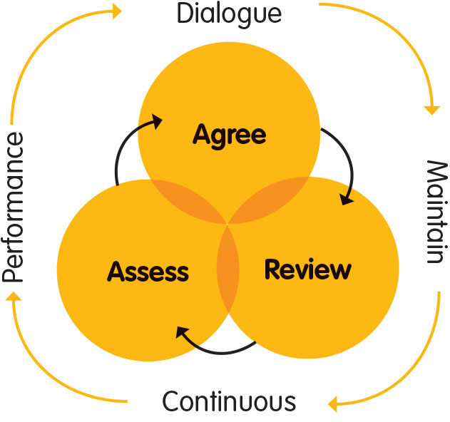
- ACTPS Performance Appraisal template documents are available for use (see www.act.gov.au/performance). They are deliberately simple to assist clarity. The templates are intended as best practice examples that can be tailored by each manager for use with individual employees and teams if desired.

4.3 Flexibility
- The ACTPS Performance framework provides flexibility to respond to the individual circumstances of an employment situation. Because of the highly diverse nature of employment within the Service, a ‘one size fits all’ approach will not be as effective as one that can be customised to suit individual Directorates, teams, work patterns and individual employees.
- Supervisors and managers are responsible for finding a way to hold good quality feedback conversations with the employees in their teams. It is acknowledged that this may be difficult in some situations, for example, shift workers and their supervisors may need to find alternate means of communicating if regular face to face communication is not feasible.
- Employees have an equal responsibility to work with their manager to participate in and contribute to feedback and performance discussion that is appropriate for their situation.

5. GOVERNANCE
- Under the PSM Standards, the Head of Service is responsible for issuing principles and guidelines for ACT Public Service Performance Management Schemes and ensuring appropriate monitoring and assistance to agencies in the implementation of Performance Management Schemes.
- Each Director-General/Chief Executive is responsible for implementing the ACTPS Performance framework and delivering it in a way that is consistent with the principles contained within the ACTPS Performance Framework policy and this Guidance Statement. This means:
- ensuring that continuous performance dialogue is practiced across their organisation; and
- ensuring performance appraisals are conducted fairly, consistently and appropriately.
- Human Resources teams within Directorates have a role and responsibility to assist all Managers and Supervisors to build their capability to maintain reasonable, effective and appropriate performance management and development practices in line with the principles detailed in the ACTPS Performance Framework Policy Statement and this Guidance Statement.
- Review and evaluation of the ACTPS Performance Framework’s application within ACTPS organisations must take place every three years, guided by the ACTPS Performance Framework maturity model.

6. REPORTING
- Directorates and other ACTPS organisations are responsible for recording whether performance management and development appraisals have been completed.
- This quantitative information will be:
- gathered centrally by CMTD and used to identify areas of strengths and weakness across the Service, for recognition or improvement; and
- used within Directorates and Independent Statutory Authorities, to inform ongoing implementation, improvement and development of the ACTPS Performance Framework.
- Qualitative data on the impact of performance management and development, particularly concerning the value of regular feedback and performance discussion, will be gathered via employee satisfaction surveys. Questions will measure how the ACTPS approach to performance management and development affects employee engagement and how satisfied employees feel with the level of performance support they receive.
- This qualitative information will be:
- used within organisations to identify areas of good practice and areas where performance management and development can be improved and act on this information; and
- used by CMTD inform whole of government policies and Strategic HR for the ACTPS.

Details are available in the ACTPS Performance Framework Policy Statement as well as Part 7.4, of the Public Sector Management Standards 2006.
As stated in the ACTPS Code of Conduct and Our Values and Signature Behaviours 2012
Some skill expectations are also mandated at a national level, for example, Registered Nurses need to prove their knowledge and skill level by holding a Bachelor of Nursing and maintaining a registration with the Nursing and Midwifery Board of Australia.

