

Attachment 5

ACTPS Classification Review
Work Value Summary Report
Information Technology Officers

overview
The Information Technology Officer (ITO) classification includes 5 levels:
- ITO 1
- ITO 2
- Senior ITO C
- Senior ITO B
- Senior ITO A
The classification rates of pay are listed under the Technical and Other Professionals Enterprise Agreement 2018-21 and Canberra Institute of Technology Enterprise Agreement 2018-21.
The majority of ITOs lie within the Shared Services and Health Directorates. ITOs within Shared Services provide ICT support services to ACTPS Directorates and include embedded roles that operate within Directorates. ITOs within the Health Directorate establish and manage the range of IT systems and infrastructure used across ACT Health. The Education Directorate holds a small number of ITO positions which primarily deliver ICT Support Services within ACT Government primary schools, high schools, and colleges.
Figure 1: Overview of the Information Technology Officer classification group.

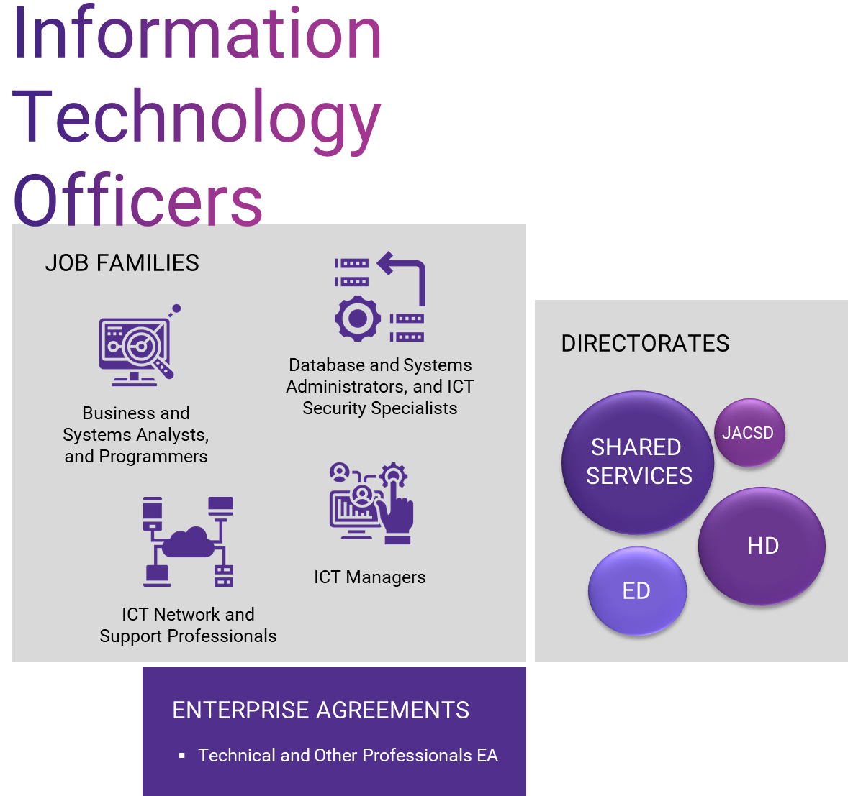

The ITO classification group is relatively specialised, with the work focusing on a range of Information and Communications Technology (ICT) professional capabilities and specialist ICT management capability (see Figure 2: ANZSCO model mapping). It is important to note that the Administrative Service Officer classification group also includes roles that require ICT professional capabilities, particularly ICT management capability which include Senior Officer Grade A (SOG A) and other roles.
The cross-section of roles reviewed in this analysis were categorised across a number of job families and aligned to the Australian and New Zealand Standard Classification of Occupations (ANZSCO) model. Table 1 lists the ANZSCO model categories under each of the job families that have been identified for the purposes of the analysis.
Table 1: ANZSCO model mapping
Job Family | ANZSCO classification (by unit group)
ICT Managers | 1351 - ICT Managers
Business and Systems Analysts, and Programmers | 2611 – ICT Business and Systems Analysts  2613 – Software and Applications Programmers
ICT and Network Support Professionals | 2631 – Computer Network Professionals  2632 – ICT Support and Test Engineers  2633 – Telecommunications Engineering Professionals  3131 – ICT Support Technicians
Database and Systems Administrators, and ICT Security Specialists | 2621 – Database and Systems Administrators, and ICT Security Specialists

Research approach

Methodology
An overview of the methodology applied to undertake the work value analysis is shown in Figure 2. Further details on this methodology and the work value model used for the review are provided in Section 4 of the ACTPS Classification Review Report.
Limitations and assumptions related to the methodology are also provided in Section 4.3 of the main ACTPS Classification Review Report. Any additional limitations and assumptions specifically related to the analysis for this priority group have been included as footnotes in this summary report.
Figure 2: Overview of work value analysis methodology
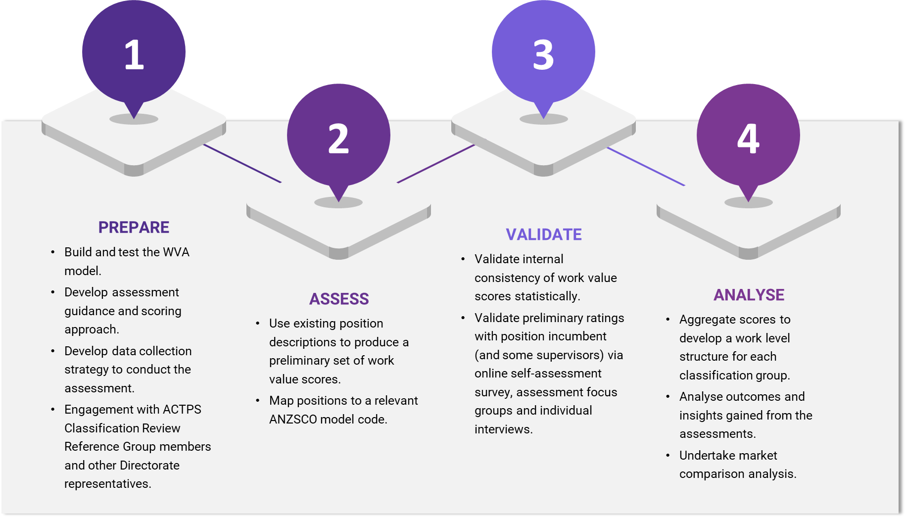
A summary of the number of assessment and validation activities is provided in Figure 3 below. Engagement with ITOs was conducted over six focus group sessions and four individual interviews in the Health Directorate, Education Directorate, and Shared Services.
Approximately 56 positions were included in the cross-section of ITO roles.

Figure 3: Assessment and validation summary

Findings, interpretation, and analysis

Work value assessment
A set of recommended work value scores for the ITO classification is provided in Section 4.4 of the main ACTPS Classification Review Report.
As shown in Figure 4, the results show a fairly typical spread of work values across the ITO Classification levels, with work value increasing alongside classification level.
Figure 4: Spread of work value scores for each ITO classification level
SITO C
SITO B
SITO A
There is a larger spread of work value scores for the ITO2 and SITO A roles. There are several reasons for why this may be the case:
- ANZSCO mapping revealed there were some ITO2 roles that were identified as ICT Managers (see Table 1). With these roles scoring, on average, higher in work value overall compared to other ITO2 roles. In particular, there were higher average scores related to responsibility and accountability and the cognitive nature of work for these roles.
- As noted in the limitations and assumptions, there was a noticeable tendency for work value scores to be higher for self-assessed roles. In further analysis of the SITO A results it appeared that, on average, self-assessment scores were 24% higher than those conducted using a position description.
As shown in Figure 5, there is a linear increase in work value across levels for each work value evaluation factor, with the exception of the Physical Environment, Degree of Physicality, and Mental Stress factors. This may be due to the fact that some ITO roles involve working in differing physical environments such as correctional facilities or emergency services agencies (particularly at the ITO 2 and SITO C levels).

Figure 5: Spread of work value scores for each work value evaluation factor for each ITO classification level.
SITO C
SITO B
SITO A

Remuneration
For the purposes of the market comparison, the primary data source used was Australian Bureau of Statistics (ABS) census data mapped to ANZSCO. Further details on the methodology are available in Section 4.3 of the main ACTPS Classification Review Report.
For the ITO classification eight ANZSCO 4-digit codes were identified within the sample group:
- 1351 - ICT Managers
- 2611 - ICT Business and Systems Analysts
- 2613 - Software and Applications Programmers
- 2621 - Database and Systems Administrators, and ICT Security Specialists
- 2631 - Computer Network Professionals
- 2632 - ICT Support and Test Engineers
- 2633 - Telecommunications Engineering Professionals
- 3131 - ICT Support Technicians
Utilising ABS census data, an average wage for individuals who work in these ANZSCO codes was calculated for the NSW State Government, ACT private sector and ACT Federal Government markets. They were compared to the ACTPS EA data which contained the average wages for the various levels of ITOs. Tables 2-5 below show the variance in the market comparison across the ITO job families.
For the purposes of additional analyses, tables with salary ranges (as opposed to average salary) have also been provided for each category. Noting these should be viewed with caution as the range includes outliers and therefore in some cases shows a significantly large salary range when analysing market comparators.
The comparison shows a general trend of lower ITO levels (ITO1s) lagging behind the average market comparators, whilst higher levels are on par or leading. This is an expected result given the market comparators are based on an average salary range and therefore lower-level roles will fall into the lower-end of the salary scale based on work value, and the capability and experience required to perform at those levels.
Table 2: Market comparison based on ABS Census Data for Information Technology Officer – ICT Manager job family.
ICT Managers
Level | ACTPS EA Average Wage | ANZSCO Code | ACT Private Sector | ACT Federal Gov | NSW State Gov
ITO2 | $92,139.40 | 1351 - ICT Managers | $149,369.33 | $130,452.98 | $151,133.66
SITC | $113,087.50 | 1351 - ICT Managers | $149,369.33 | $130,452.98 | $151,133.66
SITB | $135,874.00 | 1351 - ICT Managers | $149,369.33 | $130,452.98 | $151,133.66
SITA | $148,991.00 | 1351 - ICT Managers | $149,369.33 | $130,452.98 | $151,133.66
KEY

Level | ACTPS EA Wage Range | ANZSCO Code | ACT Private Sector | ACT Federal Gov | NSW State Gov
ITO2 | $ 86,547.00 - $ 99,051.00 | 1351 - ICT Managers | $ 64,012.77 - $ 218,236.32 | $ 98,894.52 - $ 167,186.48 | $ 55,478.31 -$226,209.05
SITC | $ 108,926.00 -$117,249.00 | 1351 - ICT Managers | $ 64,012.77 - $ 218,236.32 | $ 98,894.52 - $ 167,186.48 | $ 55,478.31 -$226,209.05
SITB | $128,286.00 -$144,418.00 | 1351 - ICT Managers | $ 64,012.77 - $ 218,236.32 | $ 98,894.52 - $ 167,186.48 | $ 55,478.31 -$226,209.05
SITA | $148,991.00 | 1351 - ICT Managers | $ 64,012.77 - $ 218,236.32 | $ 98,894.52 - $ 167,186.48 | $ 55,478.31 -$226,209.05

Table 3: Market comparison based on ABS Census Data for Information Technology Officer – Business and systems analysts, and programmers.
BUSINESS AND SYSTEMS ANALYSTS, AND PROGRAMMERS
Level | ACTPS EA Average Wage | ANZSCO Code | ACT Private Sector | ACT Federal Gov | NSW State Gov
ITO2 | $92,139.40 | 2611 - ICT Business and Systems Analysts | $137,740.39 | $117,477.81 | $135,666.13
SITC | $113,087.50 | 2613 - Software and Applications Programmers | $127,336.29 | $142,924.60 | $129,043.27
SITC | $113,087.50 | 2611 - ICT Business and Systems Analysts | $137,740.39 | $117,477.81 | $135,666.13
SITB | $135,874.00 | 2613 - Software and Applications Programmers | $127,336.29 | $142,924.60 | $129,043.27
SITB | $135,874.00 | 2611 - ICT Business and Systems Analysts | $137,740.39 | $117,477.81 | $135,666.13
KEY

Level | ACTPS EA Wage Range | ANZSCO Code | ACT Private Sector | ACT Federal Gov | NSW State Gov
ITO2 | $ 86,547.00 - $ 99,051.00 | 2611 - ICT Business and Systems Analysts | $ 57,868.15 - $ 215,492.50 | $ 81,249.70 - $ 166,437.69 | $ 46,908.72 - $ 223,210.45
SITC | $ 108,926.00 -$117,249.00 | 2613 - Software and Applications Programmers | $ 37,097.55 - $ 213,951.39 | $ 107,970.37 - $ 196,054.76 | $ 66,950.35 - $ 215,856.67
SITC | $ 108,926.00 -$117,249.00 | 2611 - ICT Business and Systems Analysts | $ 57,868.15 - $ 215,492.50 | $ 81,249.70 - $ 166,437.69 | $ 46,908.72 - $ 223,210.45
SITB | $128,286.00 -$144,418.00 | 2613 - Software and Applications Programmers | $ 37,097.55 - $ 213,951.39 | $ 107,970.37 - $ 196,054.76 | $ 66,950.35 - $ 215,856.67
SITB | $128,286.00 -$144,418.00 | 2611 - ICT Business and Systems Analysts | $ 57,868.15 - $ 215,492.50 | $ 81,249.70 - $ 166,437.69 | $ 46,908.72 - $ 223,210.45
Table 4: Market comparison based on ABS Census Data for Information Technology Officer – ICT and network support professionals.
ICT AND NETWORK SUPPORT PROFESSIONALS
Level | ACTPS EA Average Wage | ANZSCO Code | ACT Private Sector | ACT Federal Gov | NSW State Gov
ITO2 | $92,139.40 | 2631 - Computer Network Professionals | $ 129,132.77 | $ 67,259.04 | $ 107,475.82
ITO2 | $92,139.40 | 2633 - Telecommunications Engineering Professionals | $126,469.00 | No data available | $114,831.60
SITC | $113,087.50 | 2632 - ICT Support and Test Engineers | $99,760.60 | $109,367.38 | $89,068.07
SITC | $113,087.50 | 2633 - Telecommunications Engineering Professionals | $126,469.00 | No data available | $114,831.60
SITC | $113,087.50 | 3131 - ICT Support Technicians | $83,031.95 | $78,150.55 | $77,786.29
SITB | $135,874.00 | 2631 - Computer Network Professionals | $129,132.77 | $67,259.04 | $107,475.82
SITB | $135,874.00 | 2633 - Telecommunications Engineering Professionals | $126,469.00 | No data available | $114,831.60
SITB | $135,874.00 | 3131 - ICT Support Technicians | $83,031.95 | $78,150.55 | $77,786.29
KEY

Level | ACTPS EA Wage Range | ANZSCO Code | ACT Private Sector | ACT Federal Gov | NSW State Gov
ITO2 | $ 86,547.00 - $ 99,051.00 | 2631 - Computer Network Professionals | $ 65,023.33 - $ 199,177.91 | $ 73,006.40 - $ 112,329.63 | $ 62,451.18 -$189,064.03
ITO2 | $ 86,547.00 - $ 99,051.00 | 2633 - Telecommunications Engineering Professionals | $ 78,085.50 - $ 182,793.52 | No data available | $ 106,500.57 -$146,078.14
SITC | $ 108,926.00 -$117,249.00 | 2632 - ICT Support and Test Engineers | $ 53,500.70 - $ 192,899.22 | $109,367.38 | $ 57,983.48 - $ 168,927.10
SITC | $ 108,926.00 -$117,249.00 | 2633 - Telecommunications Engineering Professionals | $ 78,085.50 - $ 182,793.52 | No data available | $ 106,500.57 -$146,078.14
SITC | $ 108,926.00 -$117,249.00 | 3131 - ICT Support Technicians | $ 41,789.18 - $ 184,084.86 | $ 55,564.16 - $ 92,594.13 | $ 27,828.44 -$176,059.21
SITB | $128,286.00 -$144,418.00 | 2631 - Computer Network Professionals | $ 65,023.33 - $ 199,177.91 | $ 73,006.40 - $ 112,329.63 | $ 62,451.18 -$189,064.03
SITB | $128,286.00 -$144,418.00 | 2633 - Telecommunications Engineering Professionals | $ 78,085.50 - $ 182,793.52 | No data available | $ 106,500.57 -$146,078.14
SITB | $128,286.00 -$144,418.00 | 3131 - ICT Support Technicians | $ 41,789.18 - $ 184,084.86 | $ 55,564.16 - $ 92,594.13 | $ 27,828.44 -$176,059.21

Table 5: Market comparison based on ABS Census Data for Information Technology Officer – Database and systems administrators, and ICT security specialists.

DATABASE AND SYSTEMS ADMINISTRATORS, AND ICT SECURITY SPECIALISTS
Level | ACTPS EA Average Wage | ANZSCO Code | ACT Private Sector | ACT Federal Gov | NSW State Gov
ITO1 | $75,196.17 | 2621 - Database and Systems Administrators, and ICT Security Specialists | $120,645.44 | $81,773.82 | $106,339.85
ITO2 | $92,139.40 | 2621 - Database and Systems Administrators, and ICT Security Specialists | $120,645.44 | $81,773.82 | $106,339.85
SITC | $113,087.50 | 2621 - Database and Systems Administrators, and ICT Security Specialists | $120,645.44 | $81,773.82 | $106,339.85
SITB | $135,874.00 | 2621 - Database and Systems Administrators, and ICT Security Specialists | $120,645.44 | $81,773.82 | $106,339.85
SITA | $148,991.00 | 2621 - Database and Systems Administrators, and ICT Security Specialists | $120,645.44 | $81,773.82 | $106,339.85
KEY

Level | ACTPS EA Wage Range | ANZSCO Code | ACT Private Sector | ACT Federal Gov | NSW State Gov
ITO1 | $ 70,058.00 - $ 79,749.00 | 2621 - Database and Systems Administrators, and ICT Security Specialists | $ 62,881.15 - $ 205,243.60 | $ 71,474.00 - $ 129,975.00 | $ 53,231.98 -$185,958.16
ITO2 | $ 86,547.00 - $ 99,051.00 | 2621 - Database and Systems Administrators, and ICT Security Specialists | $ 62,881.15 - $ 205,243.60 | $ 71,474.00 - $ 129,975.00 | $ 53,231.98 -$185,958.16
SITC | $ 108,926.00 -$117,249.00 | 2621 - Database and Systems Administrators, and ICT Security Specialists | $ 62,881.15 - $ 205,243.60 | $ 71,474.00 - $ 129,975.00 | $ 53,231.98 -$185,958.16
SITB | $128,286.00 -$144,418.00 | 2621 - Database and Systems Administrators, and ICT Security Specialists | $ 62,881.15 - $ 205,243.60 | $ 71,474.00 - $ 129,975.00 | $ 53,231.98 -$185,958.16
SITA | $ 148,991.00 | 2621 - Database and Systems Administrators, and ICT Security Specialists | $ 62,881.15 - $ 205,243.60 | $ 71,474.00 - $ 129,975.00 | $ 53,231.98 -$185,958.16

Future considerations
The results of the work value assessment and market comparison indicate that the current structure and remuneration for the ITO classification are fit for purpose and generally aligned to market comparators. Noting the comparison shows a general trend of lower ITO levels (ITO1s) lagging behind the average market comparators, whilst higher levels are on par or leading. This is an expected result given the market comparators are based on an average salary range and therefore lower-level roles will fall into the lower-end of the salary scale based on work value, and the capability and experience required to perform at those levels.

ANZSCO is a skills-based classification model used to classify all occupations and jobs in the Australian and New Zealand labour markets. It provides a basis for the standardised collection, analysis, and dissemination of occupation data.
This is only an approximation as this number is based on position numbers. There are some cases where there are different position numbers for the same role and others where no position number was evident in the information provided to the research team.
There are certain ANZSCO codes which do not have an associated ACT Federal Government comparator. This is due to the Federal Government not containing individuals who fall under those ANZSCO codes.
Within market defined as within 10% of the average wage designated for the ANZSCO code

