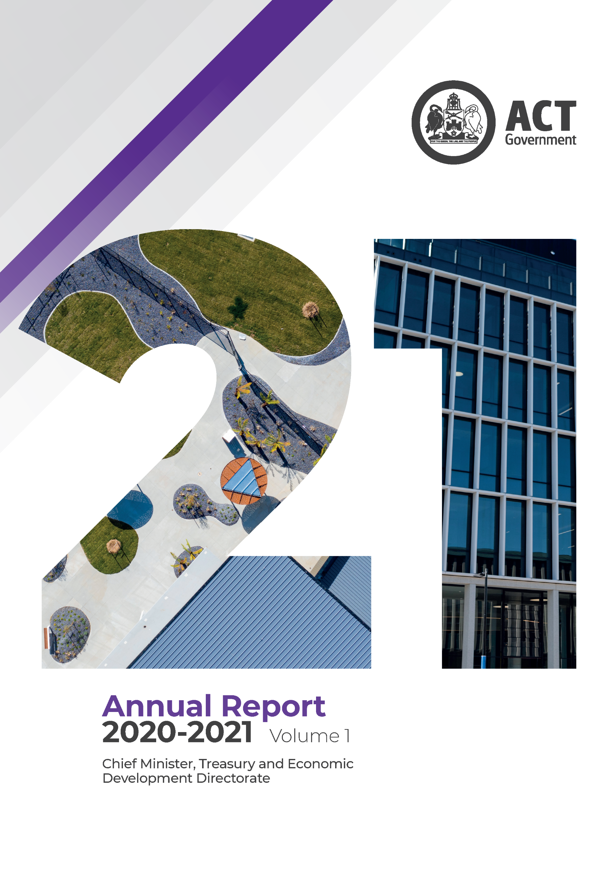
tember

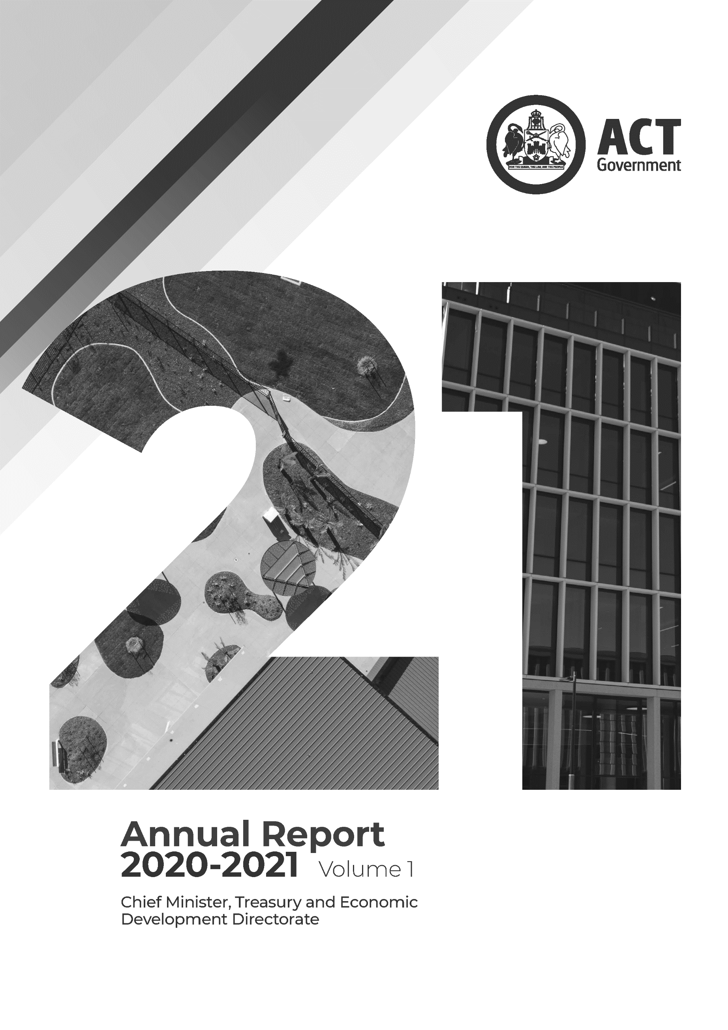
The Chief Minister, Treasury and Economic Development Directorate wish to acknowledge the Traditional Custodians of the ACT, the Ngunnawal People. We wish to acknowledge and respect their continuing culture and the contribution they make to the life of this city and this region.
Together, 2019 by Selina Walker. Artwork for the CMTEDD Stretch Reconciliation Plan 2020-23
Contact for this report
General enquiries about this report should be directed to: CMTEDD Corporate: Phone (02) 6207 5868 or email CMTEDDCorporate@act.gov.au.
Freedom of information
Freedom of information requests can be made by emailing CMTEDDFOI@act.gov.au or through CMTEDD’s Freedom of information webpage https://www.cmtedd.act.gov.au/functions/foi.
Accessibility
The ACT Government is committed to making its information, services, events and venues accessible to as many people as possible. If you are deaf, or have a hearing or speech impairment, and need the telephone typewriter (TTY) service, please phone 13 36 77 and ask for 13 34 27. For speak and listen users, please phone 1300 555 727 and ask for 13 34 27. For more information on these services, contact us through the National Relay Service: www.relayservice.gov.au
If English is not your first language and you require a translating and interpreting service, please telephone Access Canberra on 13 22 81.
IBSN: 978-0-642-60727-0
© Australian Capital Territory, Canberra 2021
The 2020-21 CMTEDD Annual Report is licensed under a Creative Commons Attribution 4.0 licence. You are free to re-use the work under that licence, on the condition that you credit the ACT Government as author, indicate if changes were made and comply with the other licence terms.
The licence does not apply to the ACT Coat of Arms, the CMTEDD logo and branding, images, artwork, photographs and any material protected by trademark.
The form of attribution for any permitted use of any material from this report (and any material sourced from it) must be:
Source: Licensed from the ACT Government under a Creative Commons Attribution 4.0 Australia Licence. The ACT Government does not necessarily endorse the content of this publication.
First published December 2021. Information about the directorate and an electronic version of this annual report can be found on the website http://www.cmtedd.act.gov.au/functions/publications.
Summary of volumes
The 2020-21 CMTEDD Annual Report has two volumes, with Volume 2 consisting of two parts.

Volume 1
Contains all Transmittal Certificates and Organisational Overview and Performance reporting for CMTEDD and all public sector bodies required to have their annual report annexed to the CMTEDD Annual Report. Each entity’s reporting includes, where relevant:
- Organisational overview
- Performance analysis
- Scrutiny
- Risk management
- Internal audit
- Fraud prevention
- Freedom of information
- Community engagement and support
- Aboriginal and Torres Strait Islander reporting
- Work health and safety
- Human resources management
- Ecologically sustainable development
- Reporting by exception and annual report requirements for specific reporting entities.
Volume 1 includes the following entities:
- ACT Architects Board
- ACT Construction Occupations
- ACT Executive
- ACT Government Procurement Board
- Default Insurance Fund
- Director of Territory Records
- Environment Protection Authority
- Lifetime Care and Support Fund
- Motor Accident Injuries Commission
- Office of the Nominal Defendant of the ACT
Public Sector Workers Compensation Fund

Volume 2

Part 2.1
Contains all Financial Management reporting sections for:
- Chief Minister, Treasury and Economic Development Directorate
- Territory Banking Account
- Superannuation Provision Account
Each entity’s Financial Management reporting includes, where relevant:
- Financial management analysis (management discussion and analysis)
- Financial statements
- Capital works
- Asset management
- Government contracting
Statement of performance

Part 2.2
Contains all Financial Management Reporting sections for:
- ACT Executive
- Default Insurance Fund
- Lifetime Care and Support Fund
- Motor Accident Injuries Commission
- Office of the Nominal Defendant of the ACT
- Public Sector Workers Compensation Fund
Each entity’s Financial Management reporting includes, where relevant:
- Financial management analysis (management discussion and analysis)
- Financial statements
- Capital works
- Asset management
- Government contracting
Statement of performance

Contents
CMTEDD organisation chart at 30 June 2021 viii
Abbreviations and acronyms ix
Glossary xi
Foreword 1
Transmittal certificate 3
Compliance statement 5
Organisational overview 8
Our purpose and role as a central agency 8
Our values 9
Our planning framework 10
Our clients and stakeholders 11
Changes to our organisational structure in 2020-21 12
Internal accountability 13
Performance summary 18
Outlook 23
Performance analysis 26
Output 1.1 Government Policy and Reform 27
Coordinator-General for the Whole of Government (Non-Health) COVID-19 Response 31
Coordinator-General for Climate Action 32
Output 1.2 Workforce Capability and Governance 33
Output 1.3 Coordinated Communications and Community Engagement 40
Output 1.4 Digital Strategy 44
Output 2.1 Access Canberra 45
Output 3.1 Innovation, Industry and Investment 57
Output 3.2 VisitCanberra 62
Output 3.3 Sport and Recreation 65
Output 3.4 Events 67
Output 3.5 Arts Engagement 70
Output 3.6 Higher Education, Training and Research 73
Output 4.1 Economic Management 76
Output 4.2 Financial Management 79
Output 5.1 Workforce Injury Management and Industrial Relations Policy 82
Output 6.1 Revenue Management 84
Output 7.1 Shared Services 86
Output 8.1 Infrastructure Finance 89
Output 8.2 Goods and Services Procurement 91
Output 9.1 Property Services 94
Output 9.2 Venues 97
Output EBT 1 Territory Banking Account 101
Output EBT 1 Superannuation Provision Account 102
Scrutiny 103
ACT Auditor-General reports 103
ACT Legislative Assembly Committee reports 115
ACT Ombudsman 134
Risk management 136
Internal Audit 136
Fraud prevention 138
Freedom of information 139
Community engagement and support 141
Community engagement activities 141
Community support initiatives: grants and sponsorship 147
Aboriginal and Torres Strait Islander reporting 176
CMTEDD’s Stretch Reconciliation Action Plan 2020-2023 176
Working with Aboriginal and Torres Strait Islander people 176
Aboriginal and Torres Strait Islander staff 178
Supporting improved educational, social and economic outcomes 181
Work health and safety 183
Health and safety structures and consultation arrangements 183
Highlights 183
Injury prevention and health and wellbeing 184
Human resources management 188
Culture, attraction and retention 188
Workforce planning and employment strategies 188
Capability 189
Staffing profile 189
Ecologically sustainable development 192
Support to the Commissioner for Sustainability and Environment 192
Business area activities 193
Other reporting 200
Financial management reporting 200
Tobacco compliance testing 200
Public land management plans 200
Covert surveillance authorisations issued to ACT employers 200
Annexed annual reports 201
ACT Architects Board 203
Transmittal certificate 203
Compliance statement 204
Organisational overview and performance 205
ACT Construction Operations 208
Transmittal certificate 208
Compliance statement 209
Organisational overview 210
Performance – proactive programs 212
ACT Executive 217
Overview 217
ACT Government Procurement Board 220
Transmittal certificate 220
Compliance statement 221
Organisational overview and performance 222
Default Insurance Fund 227
Transmittal certificate 227
Compliance statement 228
Organisational overview and performance 229
Financial management reporting 233
Director of Territory Records 234
Transmittal certificate 234
Compliance statement 235
Organisational overview and performance 236
Outlook 242
Whole of government reporting on Territory Records 243
Environment Protection Authority 260
Transmittal certificate 260
Compliance statement 261
Organisational overview and performance 262
Performance analysis 263
Complaint handling 269
Australian Government commitments 271
Lifetime Care and Support Fund 275
Transmittal certificate 275
Compliance Statement 276
Organisational Overview and Performance 277
Motor Accident Injuries Commission 286
Transmittal certificate 286
Compliance Statement 287
Organisational Overview and Performance 288
Office of the Nominal Defendant of the ACT 300
Transmittal certificate 300
Compliance statement 301
Organisational overview and performance 302
Financial management reporting 307
Public Sector Workers Compensation Fund 308
Transmittal certificate 308
Compliance statement 309
Organisational overview and performance 310
Financial management reporting 314

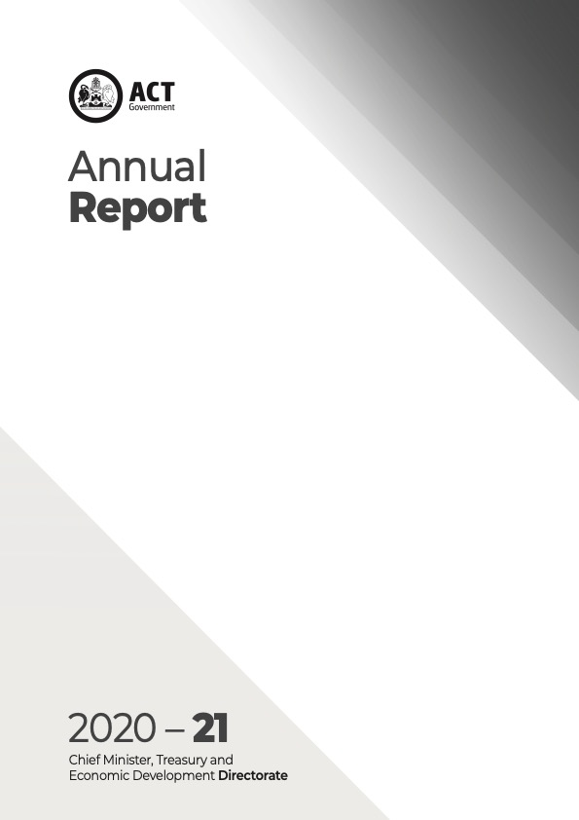
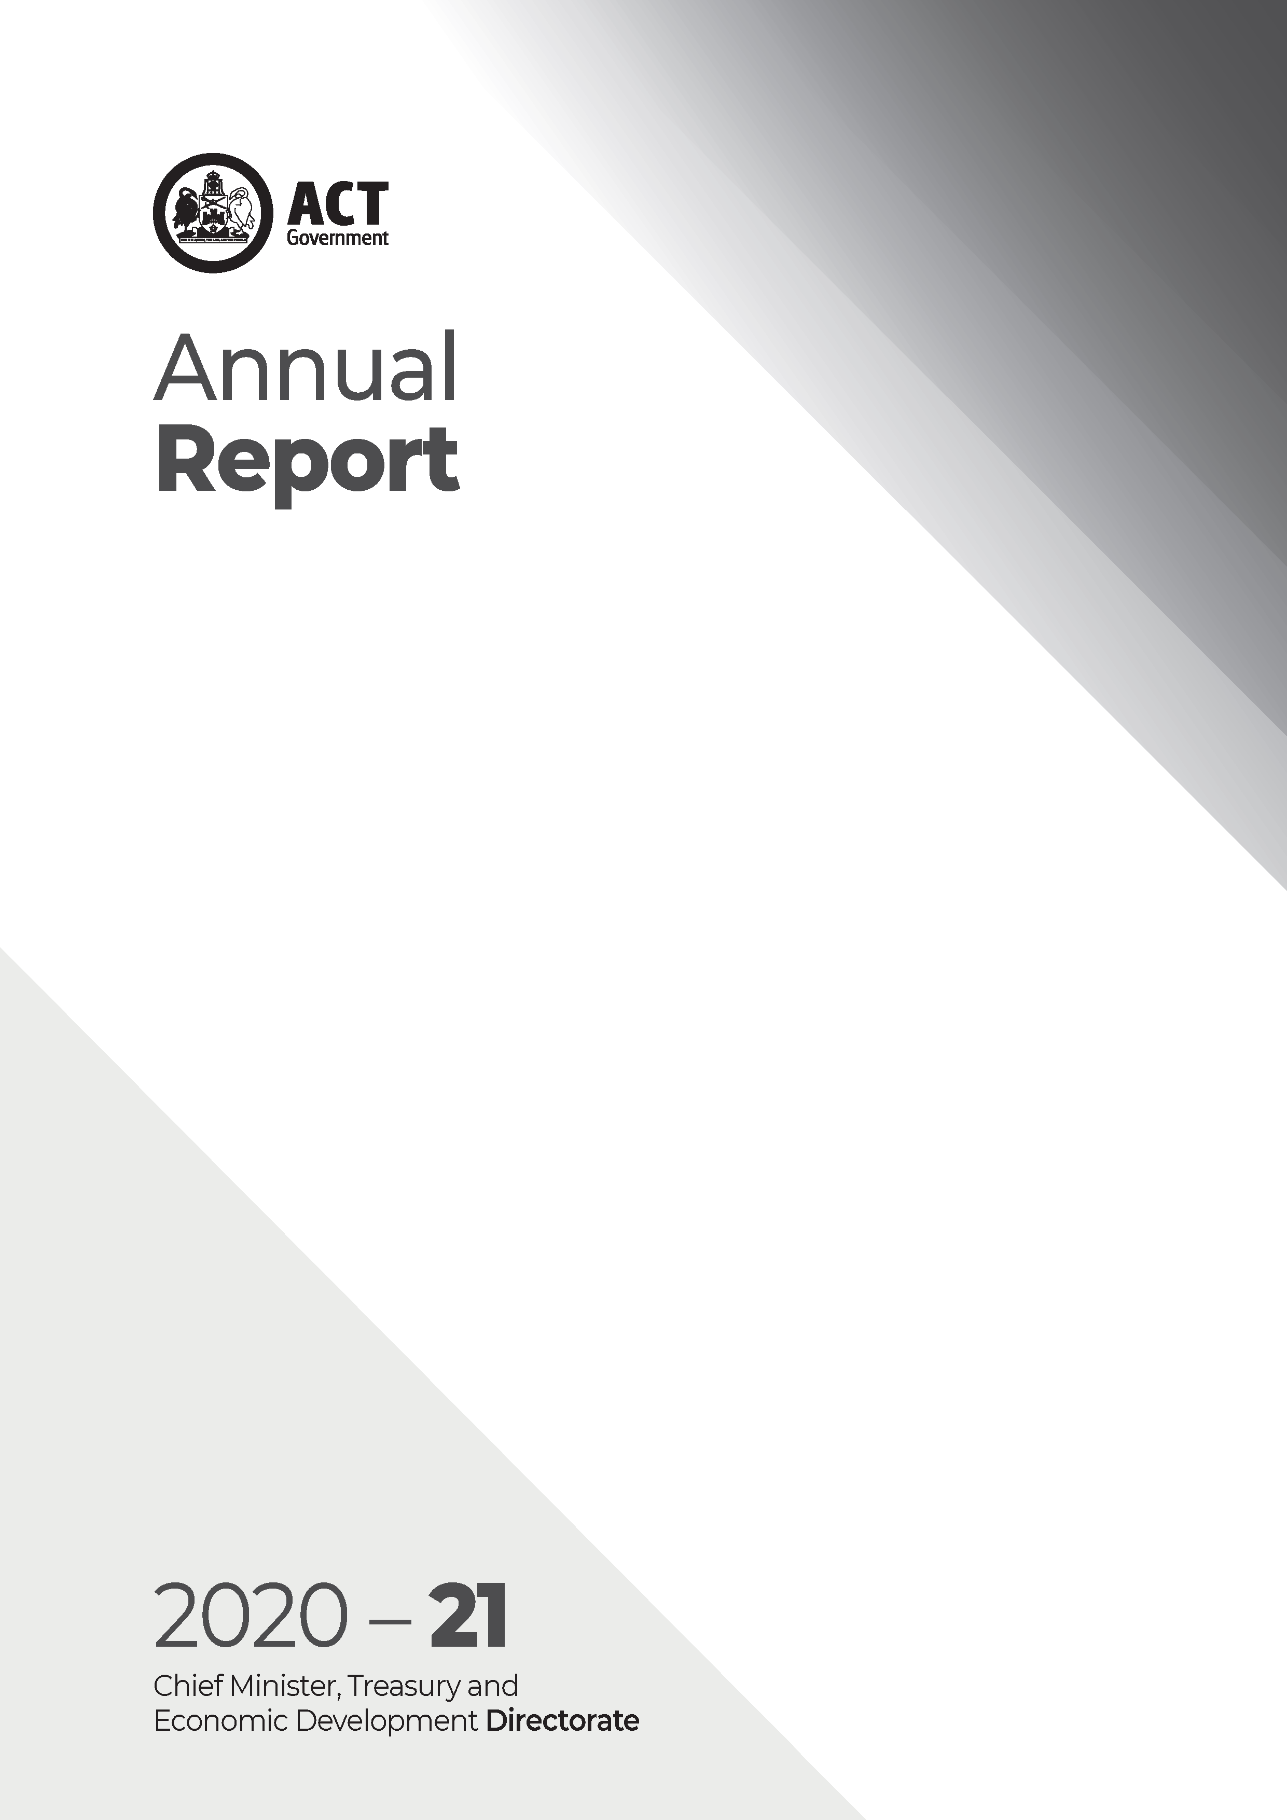
CMTEDD organisation chart at 30 June 2021
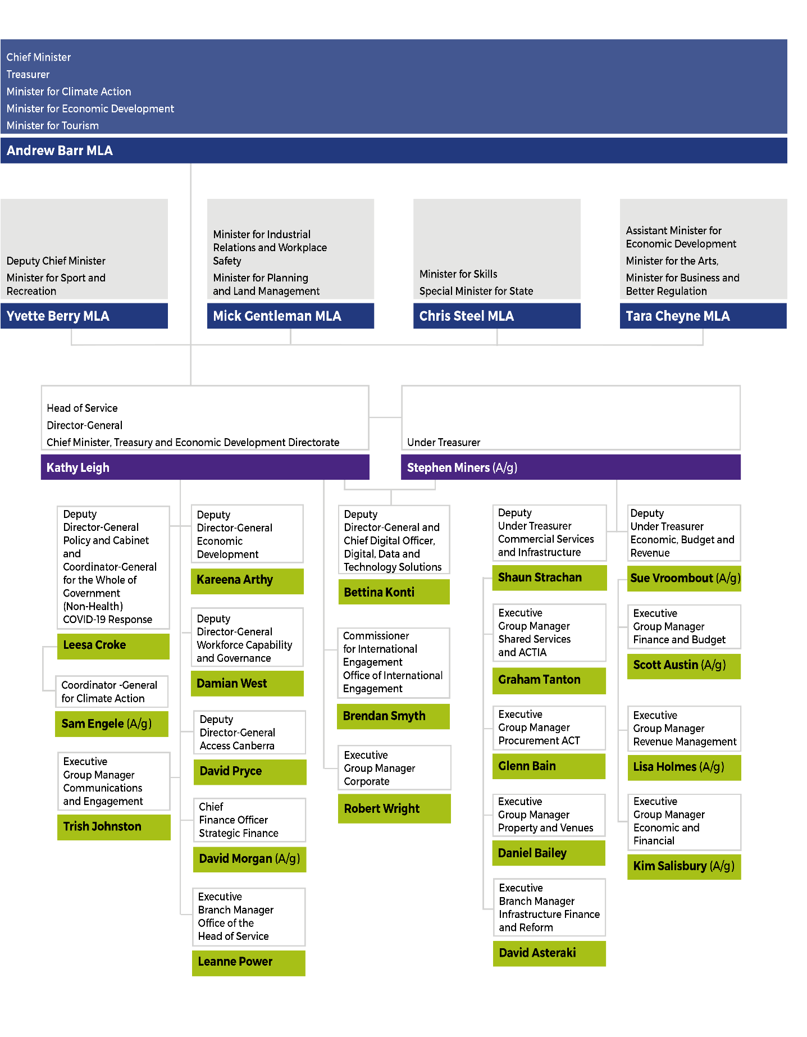

Abbreviations and acronyms
AACA | Architects Accreditation Council of Australia
ABW | Activity-based work
ACAT | ACT Civil and Administrative Tribunal
ACT | Australian Capital Territory
ACTIA | ACT Insurance Authority
ACTLIS | ACT Land Titles Information System
ACTPG | ACT Property Group
ACTPS | ACT Public Service
AER | Authorised Examiner Repairers
AES | Authorised Examiner Scheme
AIE | Academy of Interactive Entertainment
AIS | Authorised Inspection Stations
AMR | Automatic mutual recognition
ANU | Australian National University
APIAS | Accounts Payable Invoice Automation System
APM | Application Portfolio Management
ASBA | Australian School Based Apprenticeship
BIF | Better Infrastructure Fund
CALD | Culturally and linguistically diverse
CBRIN | Canberra Innovation Network
CFC | Cultural Facilities Corporation
CFMEU | Construction Forestry Mining and Energy Union
CIF | Collapsed Insurer Fund
CIT | Canberra Institute of Technology
CMDB | Configuration Management Database
CMT | Crisis Management Team or Complaints Management Team
CMTEDD | Chief Minister, Treasury and Economic Development Directorate
COLA | Construction Occupations (Licensing) Act 2004
COU | Certificate of Occupancy and Use
CRJO | Canberra Region Joint Organisation
CRVC | Canberra and Region Visitors Centre
CSD | Community Services Directorate
CSIG | Commercial Services and Infrastructure Group
CSS | Commonwealth Superannuation Scheme
CTP | Compulsory Third-Party (Insurance)
CVVR | Concessional Vintage Vehicle Registration
DCC | Directorate Consultative Committee
DCI | Digital Capability and Investment (Committee)
DDTS | Digital, Data and Technology Solutions
EBT | Expense on behalf of the Territory
EDRMS | Electronic document and records management system
EMG | Executive Management Group
EPA | Environment Protection Authority
EPIC | Exhibition Park in Canberra
EPSDD | Environment, Planning and Sustainable Development Directorate
FOI | Freedom of information
FTE | Full time equivalent
FWC | Fair Work Commission
GST | Goods and services tax
HR | Human resources
HRIMS | Human Resources Information Management Solution
HSR | Health and Safety Representative
ICRC | Independent Competition and Regulatory Commission
ICT | Information and Communications Technology
IGA | Intergovernmental agreement
IT | Information technology
JACS | Justice and Community Safety (Directorate)
LGBTIQ+ | Lesbian, gay, bisexual, transgender, intersex and queer
LTCS | Lifetime Care and Support (Scheme or Act)
LTCSA | NSW Lifetime Care and Support Authority
MAI | Motor Accident Injuries (Scheme)
MLA | Member of the Legislative Assembly
MoU | Memorandum of Understanding
MPC | Major Projects Canberra
MSD | Musculoskeletal disorders
NABERS | National Australian Built Environment Rating System
NHVR | National Heavy Vehicle Regulator
OCDO | Office of the Chief Digital Officer
PICC | Public Information Coordination Centre
PPP | Public Private Partnership
PPT | People, Priorities/Projects and Transition plan
PSS | Public Sector Superannuation
PRI | Principles for Responsible Investment
PSS | Public Sector Superannuation
QMAC | Quality and Measurement Advisory Committee
RAP | Reconciliation Action Plan
RED | Respect, equity and diversity
RMP | Records Management Program
SDS | Access Canberra Service Delivery State
SERBIR | Senior Executive Responsible for Business Integrity and Risk
SIDC | Strategic ICT and Digital Capability (Sub-Committee)
SLJC | Secure Local Jobs Code
SPA | Superannuation Provision Account
SSICT | Shared Services ICT
TBA | Territory Banking Account
TCCS | Transport Canberra and City Services (Directorate)
UEF | Uninsured Employer Fund
UNSW | University of New South Wales
UPSC | Unsolicited Proposal Steering Committee
VET | Vocational Education and Training
WHS | Work, health and safety
WHSC | Work, Health and Safety Committee
WIRE | Window to the Information and Records Environment
WWVP | Working with Vulnerable People

Glossary

Aboriginal and Torres Strait Islander Procurement Policy – The policy instigates a cultural change within the Territory to reduce some of the barriers to government procurement encountered by Aboriginal and Torres Strait Islander enterprises. Each Territory Entity is required to identify and act upon opportunities for Aboriginal and Torres Strait Islander enterprises in its procurement activities. The policy encourages Territory officers to seek quotes from relevant Aboriginal and Torres Strait Islander Enterprises wherever possible, driving growth in economic participation for Aboriginal and Torres Strait Islander enterprises through an increase to the Government’s spend with Aboriginal and Torres Strait Islander enterprises.
ACTGOV Learn system – A whole of government learning management system. Can be used by staff to book face-to-face and e-learning courses, and by managers to monitor the training requirements of their team.
COVID-19 – Refers, depending on context, to the abbreviation used for coronavirus disease 2019 (the respiratory disease caused by severe acute respiratory syndrome coronavirus 2) or to the short-form name for the COVID-19 pandemic (declared by the World Health Organisation in March 2020).
Activity-based work (ABW) – Provides staff with a choice of environment in which to work, both within and outside of the office. Staff can choose the most appropriate location to work throughout the day depending on the nature of work they are doing. They can choose from quiet focus spaces, spaces for phone calls and private discussions, semi-collaborative workstation areas and a range of spaces suited to meetings and team collaboration activities. Staff are provided with an array of technology to enable this flexibility, including the ability to work from locations other than the office.
ACT Digital – A program within the directorate that is transforming the delivery of ACT Government digital services to citizens and businesses.
Actsmart – Actsmart is a “one-stop-shop” for ACT Government programs and assistance that help Canberrans save energy and water, reduce waste and cut greenhouse gas emissions. Through Actsmart, the ACT Government assists households, businesses, schools and community groups contribute to a more sustainable future and to reduce the ACT’s carbon footprint.
ACT Remuneration Tribunal – Under the Remuneration Tribunal Act 1995 the ACT Remuneration Tribunal must inquire into and determine the remuneration, allowances and other entitlements to be granted to particular public offices every year.
Australian Apprenticeships – A program of training of apprenticeships and traineeships resulting in a nationally recognised qualification available to anyone of working age whether they are still at school, a school-leaver, re-entering the workforce or an adult worker wishing to change careers. Australian Apprenticeships provides training in conjunction with employment at a variety of qualification levels in most occupations as well as in traditional trades.
Canberra Region Joint Organisation (CRJO) – Consists of the following local councils: Bega, Eurobodalla, Hilltops, Goulburn Mulwaree, Queanbeyan-Palerang, Snowy Monaro, Upper Lachlan and Yass Valley and the ACT Government, with the aim of facilitating opportunities and partnerships to create sustainable vibrant communities.
CBR – The CBR Brand is a city brand developed as a logo and a new way of thinking and talking about Canberra. The brand is used by government when talking about the city as a place to live, work, play, invest, do business, study or visit, and is also available for private and community businesses to use.
CBR Innovation Network – Established to accelerate innovation and diversify the economy in the ACT region.
Headcount and Full Time Equivalent – Headcount and Full Time Equivalent (FTE) are standard measures of staff numbers. Headcount considers each employee as one regardless of whether they are full time or part time. In contrast, FTE represents total employee numbers based on equivalent full time hours worked. For example, an employee working standard full-time hours attracts an FTE of 1.0 whereas an employee working half the standard full-time hours attracts an FTE of 0.5. The total FTE in this example would be 1.5 whereas the headcount would be two.
HPE Content Manager – An electronic document and records management system used by ACT Government (previously known as TRIM).
One government – The ACT Public Service approach to priority setting, policy development and implementation, program and service delivery, and communications and engagement, through a culture and way of working that enhances coordination, cohesion and alignment of effort to better serve the ACT Government and Canberra citizens.
Priority Investment Program – A funding program established to support collaboration between the ACT Government, industry, research and the tertiary sectors to attract investment and grow established and emerging priority sectors of Canberra’s economy.
Public Information Coordination Centre – The PICC is the central coordination point for public information, media enquiries and briefings during a major emergency. PICC draws on staff from across ACT Government to manage communication during ACT emergencies.
Shared Services – Provides the ACT Government with core corporate services across the ACT Government’s directorates and agencies, including human resources, finance and property.
Skilled Capital – An ACT Government funded training initiative that provides access to high quality training in areas of skills needs in the ACT and maximises employment outcomes.
TRev – The ACT Revenue Office in CMTEDD uses the TRev application to record revenue from taxes, duties and levies.
Whole of government – Refers to matters, issues or arrangements affecting or applicable to the whole of the ACT Public Service.

Foreword
I am pleased to present the 2020-21 Annual Report of the Chief Minister, Treasury and Economic Development Directorate.
Since the beginning of the pandemic in March 2020, I have been immensely proud of the way our directorate has demonstrated its resilience and adaptability in supporting our Ministers and our community.
In 2020-21 our directorate continued to play a key role in coordinating the government response to COVID-19 and supporting community and business. The Office of the Coordinator-General for the Whole of Government (Non-Health) COVID 19 Response sat within CMTEDD, drawing together the efforts of all directorates and agencies to ensure the alignment of health and non-health related COVID-19 work. CMTEDD supported the Chief Minister’s role in National Cabinet and collaborated with other States and Territories and the Commonwealth at officials level to address issues as they arose. We led the Public Information Coordination Centre, ensuring Canberrans received up-to-date COVID-19 information. CMTEDD also adapted whole of service workforce policies to support staff across our service as the pandemic evolved.
Image 1: Kathy Leigh Director-General and Head of Service
Through Access Canberra we supported ACT Health in the roll-out of the vaccination program and implementation of the Public Health Directions, as well as continuing to operate the COVID-19 Helpline. Economic Development and Treasury continued to support business and the community by administering a range of assistance measures, including the ChooseCBR Digital Discounts program and COVID-19 test hardship payments. Our directorate also continued to support a large proportion of the ACT Public Service to work remotely.
In 2020-21, notwithstanding the impacts of the pandemic, we delivered several key Government priorities including the establishment of the Office of the Coordinator-General for Climate Action and the release of the first Wellbeing Data Dashboard, the first State or Territory-level wellbeing data dashboard in Australia. The dashboard measures how our community is faring across 12 wellbeing domains and will inform the programs and services the ACT Government delivers.
CMTEDD supported the transition of thousands of staff into new ACT Government office buildings in Civic and Dickson. The opening of the Civic office building at 220 London Circuit in March 2021 marked an exciting step in our journey as One Service, complementing our flexible work strategy.
We also supported the 2020 ACT Government Election by coordinating and conducting the 2020 ACT Election commitment costing process, costing 150 commitments.
I would like to express my immense gratitude for the efforts of our directorate’s dedicated staff in 2020-21. You have continued to deliver high quality outcomes for the community and our public service in the face of changing workplace conditions and public health restrictions.
Kathy Leigh
Director-General and Head of Service

Transmittal certificate
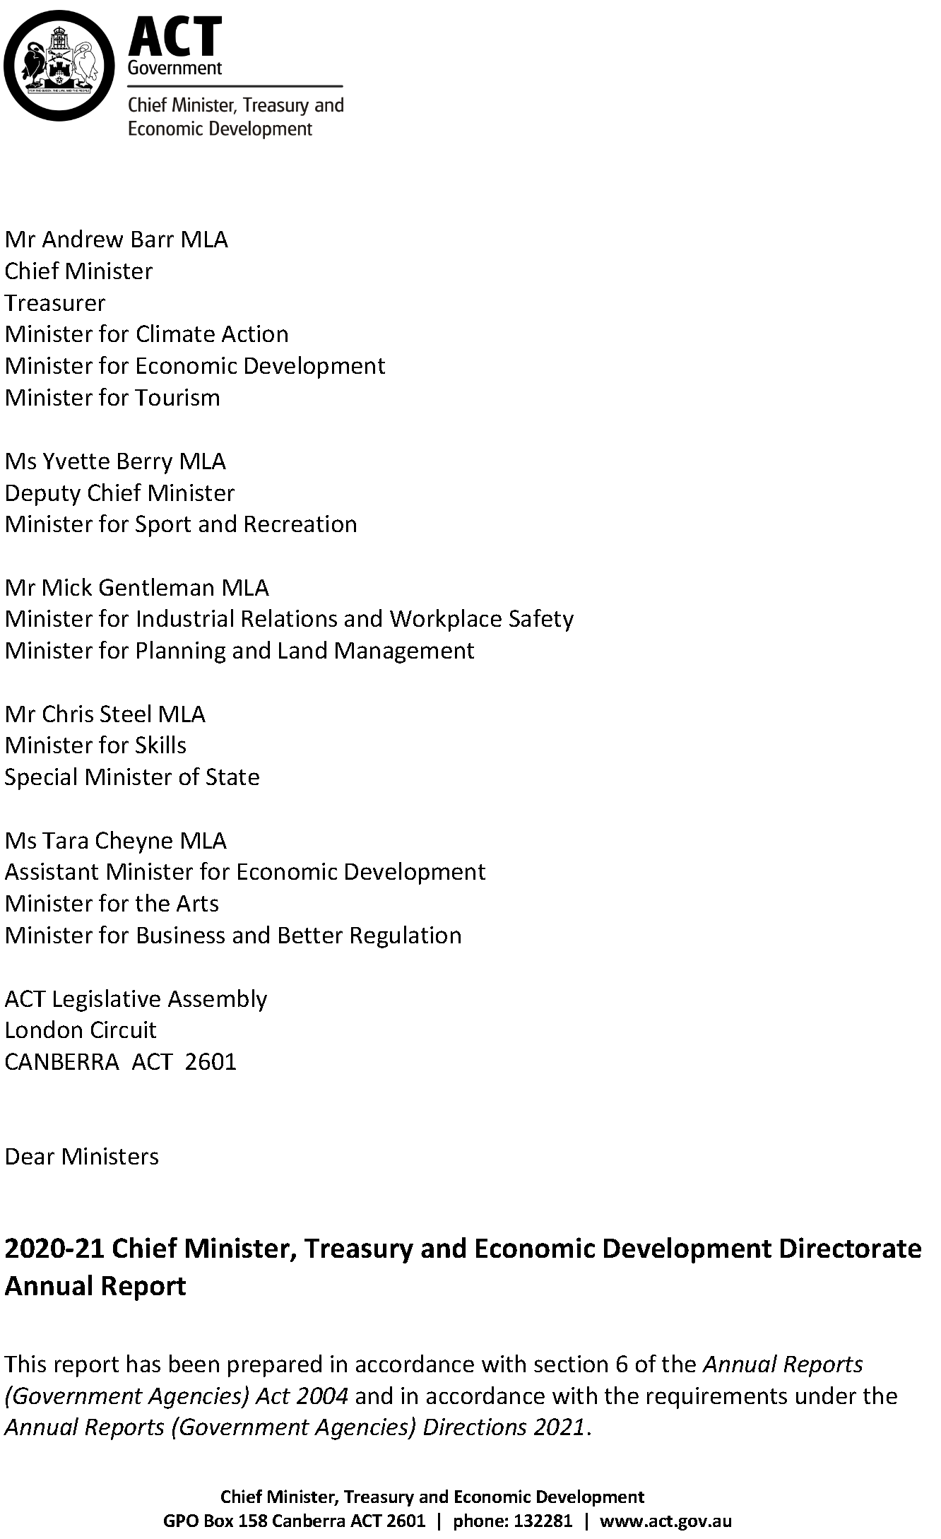

Compliance statement
The 2020-21 Chief Minister, Treasury and Economic Development (CMTEDD) Annual Report must comply with the Annual Reports (Government Agencies) Directions 2021 (the Directions) made under section 8 of the Annual Reports (Government Agencies) Act 2004. The Directions are found at the ACT Legislation Register.
The compliance statement indicates the subsections, under Parts 1 to 5 of the Directions, that are applicable to CMTEDD and the location of information that satisfies these requirements.

Part 1 Directions overview
The requirements under Part 1 of the Directions relate to the purpose, timing and distribution, and records keeping of annual reports. The 2020-21 CMTEDD Annual Report complies with all subsections of Part 1 under the Directions.
To meet Section 15 Feedback, Part 1 of the Directions, contact details for CMTEDD are provided within the 2020-21 CMTEDD Annual Report to provide readers with the opportunity to provide feedback.

Part 2 Reporting entity annual report requirements
The requirements within Part 2 of the Directions are mandatory for all reporting entities and the 2020-21 CMTEDD Annual Report complies with all subsections. The information that satisfies the requirements of Part 2 is found in the 2020-21 CMTEDD Annual Report as follows:
- A. Transmittal Certificate, see the previous page.
- B. Organisational Overview and Performance, inclusive of all subsections, see the Organisational Overview and Performance section of this report.
C. Financial Management reporting, inclusive of all subsections, see Volume 2.1 of this report.

Part 3 Reporting by exception
CMTEDD has no information to report by exception under Part 3 of the Directions for the 2020-21 reporting year.

Part 4 Directorate and public sector body specific annual report requirements
The following subsections of part 4 of the 2021 Directions are applicable to CMTEDD and reported in the Other Reporting section of this report.
- Tobacco Compliance Testing.
Public Land Management Plans.

Part 5 Whole of government annual reporting
All subsections of Part 5 of the Directions apply to CMTEDD. Consistent with the Directions, the information satisfying these requirements is reported in one place for all reporting entities as follows:
- Bushfire Risk Management, see the annual report of the Justice and Community Safety Directorate.
- Human Rights, see the annual report of the Justice and Community Safety Directorate.
- Legal Services Directions, see the annual report of the Justice and Community Safety Directorate.
- Public Sector Standards and Workforce Profile, see the annual State of the Service Report.
Territory Records, see the CMTEDD Annual Report.
ACT Public Service directorate annual reports are found at the following web address: http://www.cmd.act.gov.au/open_government/report/annual_reports.

Organisational overview

Our purpose and role as a central agency
The Chief Minister, Treasury and Economic Development Directorate (CMTEDD) leads the ACT Public Service (ACTPS).
We work collaboratively within government and with the community to deliver government priorities and drive initiatives aimed at making Canberra a better place to live. CMTEDD also leads the strategic direction of the ACTPS to ensure it is well positioned to perform its role.
As a central agency, we:
- Support the Chief Minister, Ministers and the Cabinet by providing informed, holistic and innovative advice.
- Provide direction and support across the ACTPS on policy and strategy.
- Drive the evolution of Canberra into a smart and connected digital city, through leading-edge initiatives.
- Improve the liveability and productivity of our city in collaboration with business, education institutions and industry partners.
- Connect businesses and communities to government through Access Canberra’s ‘one-stop shop’ licensing and regulatory services.
- Provide strategic financial and economic advice to the ACT Government to improve the Territory's financial position and economic management.
- Administer the ACT tax laws and manage the assessment and collection of ACT taxes.
- Lead the ongoing development of the ACTPS including advising on the structure of the ACTPS, ACT public sector employment legislation and conditions, employment, industrial relations and human resource management.
- Support public sector health and productivity by providing effective injury prevention and management services and infrastructure.
- Support government through the provision of financial, human resources, property, insurance, infrastructure advisory and procurement services.
Keep the Canberra community well informed about government policies, programs and services, including, in particular during the past year, on the COVID-19 health emergency through the whole of government Public Information Coordination Centre. We also provide meaningful opportunities for Canberrans to engage with government decision-making.

Our values
We promote and demonstrate the ACTPS employee values: respect, integrity, collaboration and innovation.
- We take pride in our work.
- We value and acknowledge the contribution of others.
We relate to colleagues and clients in a fair, decent, caring and professional manner.
- We do what we say we’ll do and respond appropriately when the unexpected occurs.
- We take responsibility and are accountable for our decisions and actions.
We engage genuinely with the community, managing the resources entrusted to us honestly and responsibly.
- We work openly and share appropriate information to reach shared goals.
We actively seek out other views when solving problems and value and act on feedback on how we can do things better.
- We look for ways to continuously improve our services and skills.
We are open to change and new ideas from all sources.
As the central agency, we are committed to:
- Communicating openly and honestly, explaining context and reporting back on outcomes.
- Engaging early with an open mind.
- Demonstrating and earning trust.
Acting collectively, both as a directorate and as one government.

Our planning framework
CMTEDD’s Strategic Intent 2021 guided the directorate’s work in 2020-21. Our Strategic Intent sets the annual outlook for the directorate’s purpose, priorities, values and contribution to the ACTPS as the central agency. The document brings together our significant and diverse deliverables by identifying the strategic and operational priorities of each CMTEDD business area.
Our Strategic Intent also summarises the key elements of our primary strategic documents: our Annual Report, the annual Budget Statement including our strategic objectives and accountability indicators, the Chief Minister’s Statement of Ambition, and the ACTPS Code of Conduct, Values and Behaviours.
The directorate’s strategic objectives, summarised below, guide our long-term direction and priorities.
- Provision of high-quality policy advice and support to the ACT Government, including coordinated and integrated policy development and service delivery across government agencies.
- Delivery of an agile, responsive and innovative public service to deliver government priorities.
- Support for the Government in the delivery of responses to urgent and complex emerging priorities.
- Economic growth, innovation and opportunity, and social inclusion.
- Providing high quality advice and support to the ACT Government in the economic and fiscal management of the Territory, working closely with relevant government agencies.
- ‘One government’ communications and community engagement.
Driving transformation of government through collaborative partnerships to harness the power of digital and technology to continue to grow Canberra as an inclusive, progressive and connected city.
Image 2: CMTEDD Strategic Intent 2021
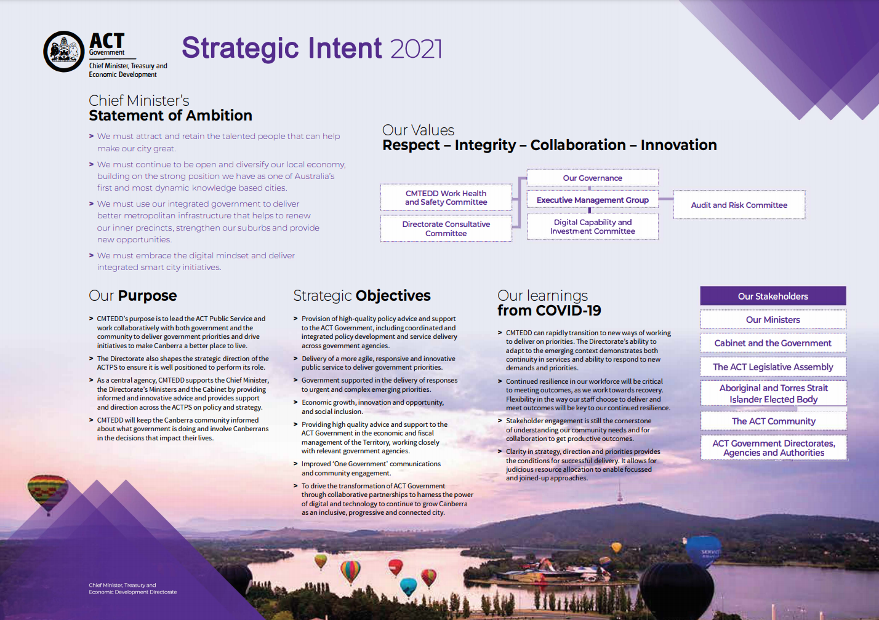

Our clients and stakeholders
We provide strategic policy advice and high-level support to our principal stakeholders, our Ministers. The following table lists our Ministers on 30 June 2021 and their portfolios.
Table 1: CMTEDD Ministers and portfolios on 30 June 2021
Minister | Portfolios
Andrew Barr | Chief Minister  Treasurer  Minister for Climate Action  Minister for Economic Development  Minister for Tourism
Yvette Berry | Deputy Chief Minister  Minister for Sport and Recreation
Mick Gentleman | Minister for Industrial Relations and Workplace Safety  Minister for Planning and Land Management
Chris Steel | Minister for Skills  Special Minister of State
Tara Cheyne | Assistant Minister for Economic Development  Minister for the Arts  Minister for Business and Better Regulation
In 2020-21 we also provided advice to:
- Minister Rattenbury, as Minister for Consumer Affairs, Minister for Gaming, Attorney-General and Minister for Water, Energy and Emissions Reduction.
- Minister Vassarotti, as Minister for Sustainable Building and Construction and Minister for the Environment.
We support and assist many other key stakeholders and clients including:
- Cabinet and the ACT Government.
- ACT Legislative Assembly.
- ACT community.
- Community councils and groups.
- ACT Aboriginal and Torres Strait Islander Elected Body.
- Industry and business institutions.
- Key arts organisations, professional and community sporting clubs and representative groups.
- Higher and vocational education institutions.
- Consumers and licensees.
- Media.
ACT Government directorates, agencies and authorities.

Changes to our organisational structure in 2020-21

Office of International Engagement
Following the new Administrative Arrangements in November 2020, the Commissioner for International Engagement function (and the Office of International Engagement) moved from within Economic Development to become a separate business area. The Office now directly reports to the Director-General and will have a separate International Engagement output in 2021-22.

Digital, Data and Technology Solutions
In November 2020, the Head of Service and former Under Treasurer announced the merger of the Office of the Chief Digital Officer (OCDO) and Shared Services ICT (SSICT). The new group is called Digital, Data and Technology Solutions (DDTS).
Both the OCDO and SSICT played a critical role in providing whole of government digital and data strategy, advice, and services. The merger helps better meet the ever-increasing demand for these services and solutions, and aims to achieve a whole of government approach to technology priorities and investment, working with directorates and their Chief Information Officers.
For 2020-21, financial reporting for the Shared Services ICT component of DDTS continues to be included in Output Class 7 Shared Services. In 2021-22, DDTS will be reported (financially) under Output 1.4 Digital Strategy and the new Output 6.2 Digital, Data and Technology Solutions.

Workplace Safety and Industrial Relations
In May 2021 Workplace Safety and Industrial Relations Group (WSIR) changed its reporting line from the Treasury stream to within Workforce Capability and Governance (WCaG) in the Chief Minister stream.
The new reporting line enables closer collaboration between WSIR, which has responsibility for whole of government work health, safety and wellbeing, ACTPS workers' compensation and ACT employment and industrial relations legislation, and WCaG's broader ACTPS workforce responsibilities. It also strengthens WSIR's contribution to ACTPS workforce and workplace initiatives, such as flexible working and activity-based working.
In 2021-22, the existing WSIR output class will be discontinued, and be replaced by a separate output under Output Class 1.

The Office of the Coordinator-General for Climate Action
The Office of the Coordinator-General for Climate Action was established in January 2021 to coordinate and support the ACT Government’s ambitious agenda for Climate Action. The Office oversees the delivery of major projects and coordinates activities across the ACT Government, including:
- Coordinating the rollout of the Sustainable Household Scheme of small-scale zero interest loans to help households with the upfront costs of investing in sustainable upgrades to their homes.
- Delivering the Big Canberra Battery of at least 250MW of new ‘large-scale’ battery storage distributed across the ACT.
- Establishing policy, legislative, procurement and planning reforms associated with climate adaptation and resilience.
See the Office of the Coordinator-General for Climate Action section for further details.

Internal accountability

Senior executives and their responsibilities
Our directorate consists of two streams:
- The Chief Minister stream, led by the Director-General.
The Treasury stream, led by the Under Treasurer.
The names of the primary business areas within each stream and their responsible senior executives are below. Where business areas have an associated output, we explain their functions and responsibilities by output in the Performance Analysis section.

Chief Minister stream

Head of Service and Director-General – Kathy Leigh
The Director-General of CMTEDD leads the Chief Minister stream and is also the head of the ACTPS. The Director-General provides high level strategic advice to the Chief Minister and is Secretary to the Cabinet. As Head of Service the Director-General provides whole of government leadership and strategic direction to the ACTPS and chairs the Strategic Board.
Table 2: Chief Minister stream executives at 30 June 2021, by budget output
Responsible senior executive | Business area name | Relevant budget output/s
Output Class 1: Government Strategy
Leesa Croke Deputy Director-General | Policy and Cabinet | Output 1.1: Government Policy and Reform
Damian West Deputy Director-General | Workforce Capability and Governance – includes:  Workplace Safety and Industrial Relations | Output 1.2: Workforce Capability and Governance
Trish Johnston Executive Group Manager | Communications and Engagement | Output 1.3: Coordinated Communications and Community Engagement
Bettina Konti  Deputy Director-General and Chief Digital Officer | Digital, Data and Technology Solutions ¹ | Output 1.4: Digital Strategy  Output 7.1 Shared Services (ICT services)
Output Class 2: Access Canberra
David Pryce Deputy Director-General | Access Canberra | Output 2.1: Access Canberra
Output Class 3: Economic Development
Kareena Arthy Deputy Director-General  Brendan Smyth  Commissioner for International Engagement | Economic Development – includes:  Business and Innovation  VisitCanberra  Sport and Recreation  Events ACT  artsACT  Skills Canberra  Tertiary Education and Research  Office of International Engagement ² | Output 3.1: Innovation, Industry and Investment  Output 3.2: VisitCanberra  Output 3.3: Sport and Recreation  Output 3.4: Events  Output 3.5: Arts Engagement  Output 3.6: Higher Education, Training and Research
Output Class 5: Workforce Injury Management and Industrial Relations Policy
Damian West  Deputy Director-General | Workplace Safety and Industrial Relations ³ | Output 5.1: Workforce Injury Management and Industrial Relations Policy
Notes:
- During 2020-21 the former Office of the Chief Digital Officer and Shared Services ICT (SSICT) merged to create a new group called Digital, Data and Technology Solutions. The functions of the former OCDO are included in Output 1.4 Digital Strategy and the functions of SSICT are included in Output 7.1 Shared Services. In 2021-22, the ICT function will have a separate output. The ICT function continues to be part of Treasury Stream and reports to the Under Treasurer.
- In 2020-21 the Office of International Engagement became a separate business area, reporting directly to the Director-General instead of through Economic Development. This change will be reflected in CMTEDD’s output structure in the 2021-22 Budget.
- During the reporting year Workplace Safety and Industrial Relations moved from the Treasury stream to the Chief Minister stream. The relevant output will be part of Output Class 1 in 2021-22.
In addition to the business areas listed in Table 2, Chief Minister stream includes the following whole of directorate coordination and business support functions.

Coordinator-General for the Whole of Government (Non-Health) COVID-19 Response – Leesa Croke
The Coordinator-General works closely with the Chief Health Officer to ensure alignment of health and non-health responses to COVID-19, maintains sound governance, decision-making and other processes, regularly reviews structures and legal authority as the COVID-19 response evolves, works with Treasury and Economic Development to monitor implementation of economic support packages, and supports a strategic approach on longer term issues. The Coordinator-General works with all directorates and agencies to ensure well-coordinated and effective COVID-19 efforts without duplication of effort.

Coordinator-General for Climate Action – Sam Engele (acting)
The Office of the Coordinator-General for Climate Action was established in January 2021 to coordinate and support the ACT Government’s ambitious agenda for climate action.

Corporate – Executive Group Manager – Robert Wright
Corporate supports the directorate through delivery of a range of strategic, governance, organisational development, administrative, digital transformation and human resource functions. Corporate also provides business support services to the ACT Executive. The Executive Group Manager is also the CMTEDD Senior Executive Responsible for Business Integrity and Risk.

Strategic Finance – Chief Finance Officer – David Morgan (acting)
Strategic Finance is responsible for the financial and budgetary management for CMTEDD and the ACT Executive. This includes the development of internal budgets and budget papers, strategic financial monthly and annual reporting, monitoring and reporting on capital works and assets, support for the Ministers, Executive Management Group, senior management, and business areas generally.

Treasury stream

Under Treasurer – Stephen Miners (acting)
The Under Treasurer leads the Treasury stream of CMTEDD and is responsible for the provision of strategic financial and economic policy advice to the Government. The Under Treasurer plays a leading role in promoting accountability and transparency in the delivery of services to the community.
The Under Treasurer also oversees a range of whole of government functions including procurement, property and venues, shared services, general insurance and risk management, and infrastructure finance and reform policy and advice.
In 2020-21 Treasury comprised of two sub-streams:
- Economic, Budget and Revenue, led by Acting Deputy Under Treasurer Sue Vroombout; and
- Commercial Services and Infrastructure, led by Deputy Under Treasurer Shaun Strachan.
Commercial Services and Infrastructure included the ACT Insurance Authority (ACTIA). ACTIA is led by General Manager Penny Shields and provides insurance protection and risk management advice for the ACT Government. ACTIA has its own annual report, available on the ACTIA page of CMTEDD’s website.
Tables 3 and 4 list key Treasury business areas and the responsible senior executive by budget output.
Table 3: Economic, Budget and Revenue executives on 30 June 2021, by budget output*
Responsible senior executive | Business area name | Relevant budget output/s
Sue Vroombout – Deputy Under Treasurer (A/g), Economic, Budget and Revenue
Output Class 4: Financial and Economic Management
Kim Salisbury (A/g) Executive Group Manager | Economic and Financial | Output 4.1: Economic Management
Scott Austin (A/g) Executive Group Manager | Finance and Budget | Output 4.2: Financial Management
Output Class 6: Revenue Management
Lisa Holmes (A/g) Executive Group Manager  Commissioner for ACT Revenue | Revenue Management (ACT Revenue Office) | Output 6.1: Revenue Management
*Note: Output Class 5 Workforce Injury Management and Industrial Relations Policy is listed in Table 2, reflecting the movement of the Workplace Safety and Industrial Relations business area from Treasury Stream to Chief Minister Stream in the 2020-21 reporting year.

Table 4: Commercial Services and Infrastructure executives on 30 June 2021, by budget output
Responsible senior executive | Business area name | Relevant budget output/s
Shaun Strachan – Deputy Under Treasurer, Commercial Services and Infrastructure
Output Class 7: Shared Services
Graham Tanton Executive Group Manager | Shared Services | Output 7.1: Shared Services (human resources, finance and records services)
Antony Stinziani  Executive Group Manager | Digital, Data and Technology Solutions | Output 7.1: Shared Services (ICT services)
Output Class 8: Infrastructure Finance and Procurement
David Asteraki Executive Branch Manager | Infrastructure Finance and Reform | Output 8.1: Infrastructure Finance
Glenn Bain Executive Group Manager | Procurement ACT | Output 8.2: Goods and Services Procurement
Output Class 9: Property Services and Venues
Daniel Bailey Executive Group Manager | ACT Property Group  Venues Canberra | Output 9.1: Property Services  Output 9.2: Venues

Key committees
A number of boards and committees oversee our strategic direction, priorities and governance (Table 5).
Table 5: Roles and membership of significant directorate committees
Name of committee | Role of committee and membership
ACTPS Strategic Board | The ACTPS Strategic Board provides whole of government leadership and strategic direction to the ACTPS.  Strategic Board is chaired by the Head of Service and Director-General CMTEDD and includes all Directors-General, the Under Treasurer, the Chief Digital Officer, the Deputy Director-General, Workforce Capability and Governance, and the Deputy Director-General, Policy and Cabinet.  During 2020-21, Strategic Board established four committees and a number of working groups to help progress its work.
Audit and Risk Committee | The Audit and Risk Committee assists the Director-General and the Under Treasurer in fulfilling their oversight and governance responsibilities. The Committee's functions are governed by an Audit and Risk Committee Charter.  Committee membership includes appointees from CMTEDD, an executive from another ACT Government directorate (the Environment, Planning and Sustainable Development Directorate) and an independent chair and deputy chair. Observers and a representative from the ACT Auditor-General's Office also regularly attend meetings. The Internal Audit section contains further details on this committee.
CMTEDD Executive Management Group | The Executive Management Group (EMG) oversees governance within CMTEDD.  EMG’s membership consists of the Director-General CMTEDD, the Under Treasurer, the Executive Group Manager Corporate and the Chief Finance Officer.
Digital Capability and Investment Committee | The Digital Capability and Investment Committee (DCI) Committee’s role is to:  Inform EMG members regarding the integrity of digital and ICT systems and associated investments moving forward.  Provide a forum for EMG members to provide strategic insights and direction for the management of digital and ICT capabilities within the directorate.  Membership consists of the existing members of the EMG (Director-General, Under Treasurer, Executive Group Manager Corporate, and Chief Finance Officer). The Chief Information Officer also attends the DCI Committee.
CMTEDD Work Health and Safety Committees | The CMTEDD Work Health and Safety Committees (WHSC) provide consultative forums for work health and safety (WHS) matters across the directorate. The WHSCs comprise three tiered committees (directorate level, organisational group and workgroup) and are established in accordance with the ACT Work Health and Safety Act 2011 (the WHS Act) and the Public Sector Management Act 1994.  Information is cascaded from the Tier 1 (directorate level) committee. Matters can also be raised at Tier 3 level and reported and managed through the higher tiers.  The role of the committees is to:  Facilitate communication and consultation between management and workers relating to workers’ health and safety at work.  Assist in the development of health and safety protocols, rules and procedures.  Review information related to WHS performance to assist CMTEDD to achieve continuous improvement in the management of WHS.  Consider relevant programs that enhance employee health and wellbeing.  Provide a mechanism for escalation and resolution of unresolved WHS issues.
Directorate Consultative Committee | The ACTPS Enterprise Agreements 2018-2021 provide for the establishment of a Directorate Consultative Committee (DCC). The DCC’s key objectives are to:  Monitor the operation and implementation of the agreements.  Consider any proposed new or significant changes to directorate policy statements and guidelines that relate to the provisions of the agreements.  Exchange information about workplace issues affecting employees.  Consult on any existing directorate performance management schemes, and on the development of any new performance management schemes.  The DCC consists of employee, union and management representatives, with Corporate providing secretariat support.

Performance summary

Leading the COVID-19 response
As the central agency we continue to play a key role in leading the COVID-19 response, particularly through the role of the Coordinator-General, Whole of Government (Non-Health) COVID-19 Response. The Coordinator-General’s role is to draw together the efforts of all directorates and agencies to ensure the alignment and efficiency of health and non-health related COVID-19 work. Since the establishment of the Coordinator-General role and the Office of the Coordinator-General, the Coordinator-General’s Group has met over 100 times.
Our directorate is responsible for the establishment of the Public Information and Coordination Centre (PICC) to deliver public information to the community before, during and after an emergency, including for the COVID-19 pandemic. Our Communications and Engagement team has provided the majority of resourcing for the COVID-19 PICC this financial year and has delivered communications advice, media responses, community engagement coordination, management of the COVID-19 website, social media strategy and monitoring, campaigns and design, and targeted stakeholder engagement.
The Coordinator-General and our Policy and Cabinet business area continued to support the ACT’s engagement with the new federal architecture including the National Cabinet, created in response to the COVID-19 pandemic in 2019-20. Throughout 2020-21 we provided strategic advice and administrative support to the Chief Minister’s participation in this forum. National Cabinet meets monthly and more frequently as required to progress critical policy responses relevant to the COVID-19 response. Since its establishment in March 2020 up until 30 June 2021, the National Cabinet has met 44 times.

Leading key government priorities
In 2020-21 we prepared the first Wellbeing Data Dashboard, providing an overview of Canberra’s performance across measures under the 12 wellbeing domains. The dashboard will help to inform the programs and services the ACT Government delivers. The dashboard includes data and information on 100 measures across the 12 domains and 56 indicators that make up the ACT Wellbeing Framework. As wellbeing is embedded in government processes and reporting, the dashboard will support evidence-based decision-making and targeted investment where it is most needed.
To coordinate and support the ACT Government’s agenda for climate action, we established the Office of the Coordinator-General for Climate Action. We implemented whole of government governance arrangements to support the delivery of projects and initiatives to reduce emissions, support vulnerable households experiencing energy poverty, and increase the resilience of the ACT to climate heating, through the Sustainable Household Scheme and the Big Canberra Battery.
The Sustainable Household Scheme initiative was announced as a climate action policy commitment in the Parliamentary and Government Agreement, and shortly thereafter a detailed design of the sustainable household scheme was made in collaboration with delivery partners and subject matter experts in the Environment, Planning and Sustainable Development Directorate (EPSDD). Contracting with the preferred supplier commenced in June 2021 and preparations for a pilot soft launch of the scheme were undertaken in parallel.

The Big Canberra Battery initiative was announced as a climate action policy commitment in the Parliamentary and Government Agreement, and shortly thereafter market sounding for the Big Canberra Battery was undertaken in collaboration with delivery partners and subject matter experts in EPSDD. A co-design workshop facilitated by experts from the ANU’s Battery Storage and Grid Integration Program was attended by 35 key industry stakeholders in April 2021. The half day workshop asked participants to explore battery design concepts and help develop an optimal procurement approach.
We Implemented the First Action Plan for the Capital of Equality Strategy, to improve outcomes for LGBTIQ+ Canberrans, and delivered on the Government’s commitment to prevent and respond to the serious damage and trauma caused by sexuality and gender identity conversion practices, through the Sexuality and Gender Identity Conversion Practices Act 2020, which came into effect on 4 March 2021.
As part of the ACT Government’s Jobs and Economic Recovery Plan, we established the Better Regulation Taskforce. The Taskforce will make it easier to start, run and grow a business in the ACT. We supported the National Deregulation agenda to improve occupational mobility by implementing automatic mutual recognition (AMR) of occupational licences. Under an ambitious timeframe, the Better Regulation Taskforce put in place the frameworks for the ACT to transition occupational registrations to the national scheme of AMR.

Building our current and future workforce capability and shaping workplace culture
In 2020-21 we transitioned 3,000 staff into 33,322 metres squared of modern, energy efficient, activity-based office accommodation at 480 Northbourne Avenue Dickson and 220 London Circuit Canberra City. We also progressed the development and implementation of a flexible work strategy which will position the ACT Government as the most progressive jurisdiction in Australia for the way we work. This program will sustain and improve upon the positive impacts of flexible work whilst maintaining focus on outcomes and productivity. We assisted CMTEDD and other agencies to prepare for this move by managing the archiving and disposal of more than 50,000 files and other records.
We made several improvements to the ACTPS Graduate Program. We expanded the program by 70 per cent, including the implementation of the Talent Bank Program. We also developed an accessible online application and assessment platform to ensure the program could continue alongside changing COVID-19 restrictions. The online platform will be further developed to support remote applications and assessments for the 2022 ACTPS graduate program. We also enhanced the learning and development component of the 2021 program by supporting graduates to complete a Diploma of Government alongside their graduate rotations.
We developed legislation, now introduced in the ACT Legislative Assembly, that would add an industrial manslaughter offence to the ACT’s work health and safety legislation. This amendment enhances the suite of regulatory responses available for addressing poor work safety practices.

Keeping the community informed
In 2020-21 we continued to keep the community informed about COVID-19. Results from our YourSay Community Panel show 88 per cent of Canberrans feel well informed about COVID-19. We also increased the YourSay Community Panel membership to more than 5,000 Canberrans, providing a more robust and representative sample for our regular surveys.
We grew our social media reach. We now reach more Canberrans online than ever, with strong growth across the primary ACT Government social media accounts (a 27 per cent increase on Facebook, a 19 per cent increase on LinkedIn and a 15 per cent increase on Twitter). Engagements with the Canberra community also reach more people than ever, with a 47 per cent increase in visitors to the YourSay Conversations website (93,000 visitors in 2020-21).

Driving the digital transformation of government services
In 2020-21 we embedded the principles of the ACT Digital Strategy to provide a community-centred approach to how we use technology to improve the quality of life for all Canberrans. This work included delivery of digital services that reflect reforms to the Working with Vulnerable People scheme and provision of support and best practice advice on the design and delivery of digital initiatives.
We also supported the Government’s COVID-19 response, and subsequent recovery initiatives, by:
- Chairing and supporting the Technology Leadership Group and supporting the creation of the Technology Governance Group.
- Supporting national forums, such as the Data and Digital Ministers, through engagement on national digital and data initiatives.

Providing services to the ACT community and business
We supported the community and business through the COVID-19 public health emergency by:
- Supporting ACT Health in the roll-out of the vaccination program by answering phone calls and enquiries via the Access Canberra Contact Centre and COVID-19 Helpline.
- Answering 99,198 calls via the COVID-19 Helpline.
- Undertaking over 4,500 educational visits to businesses affected by the Public Health Directions.
- Supporting 9,744 vulnerable clients to make it easier for them to renew their driver licence where they needed to obtain a Driver Licence Medical Examination and/or eye test assessment.
Delivering several elements of direct financial stimulus to the hospitality industry.
We implemented significant amendments to the Working with Vulnerable People (Background Checking) Act 2011. These amendments further enhance the protection of vulnerable people in our community and align with national approaches to worker screening for people providing services through the National Disability Insurance Scheme, and to working with children checks. We also adopted a new business system to administer the Working with Vulnerable People scheme which makes the customer experience simpler.

Leading the ACT Government’s international engagement activities
In May 2021 we delivered a Chief Minister-led trade mission to Wellington and Auckland, New Zealand. The main objectives of the trade mission were to reconnect with stakeholders involved in the Canberra-Wellington Sister City Relationship and promote tourism, new flight routes, business to business links and government to business links.
We also provided, independently and in partnership with Austrade and the Canberra Business Chamber, advisory and education support to Canberra businesses exporting services and products. We undertook relationship facilitation with the diplomatic community and other stakeholders for the purpose of enabling exports and other international activities.

Supporting Canberra’s liveability, vibrancy and economic growth
We delivered the Jobs and Economic Recovery round of the Priority Investment Program, committing matched funding support to projects in the building and construction, advanced manufacturing, cyber security and screen industry sectors. We also delivered the ChooseCBR Digital Discounts program, providing around $7.1 million in direct economic stimulus to approximately 800 businesses in the ACT.
To support the visitor economy, we developed the ACT Government’s new destination marketing campaign platform. The integrated brand and marketing campaign operated across paid, partnered, owned, and earned channels to address barriers to choosing Canberra as a short break destination. The campaign also highlighted the unique features of our city and reasons to visit. We developed and delivered partnerships with airlines and online travel agents to facilitate a conversion element to the campaign.
We supported 32 local athletes in their endeavours for selection in the Australian Olympic and Paralympic teams for the rescheduled 2020 Tokyo Games.
We delivered events in COVID safe formats, including:
- The Where You Are Festival, a new two-month program of events that provided opportunities and stimulus for local organisations, event organisers, artists, and businesses to continue their creative pursuits during the uncertainty of the COVID-19 pandemic.
- Floriade: Reimagined, an altered format of the traditional Floriade event, due to mass gathering restrictions associated with COVID-19. The reimagined program focused on tulip plantings and displays across the city, along with innovative online content.
The 2021 Enlighten Festival, which was the first large-scale, multi-day festival to be approved and delivered in Canberra under a COVID Safe exemption.
We provided $1 million in COVID-19 Organisational Emergency Support Funding to nine arts organisations, and over $190,000 in COVID-19 rent relief support to artists, arts organisations and commercial tenants in six ACT arts centres. We also commenced the Creative Recovery and Resilience Program for delivery in 2021-22.
To support ACT businesses to re-open safely during the COVID-19 recovery, we facilitated the delivery of free training in infection control. We also implemented the Australian Government’s JobTrainer Fund in the ACT, to provide free training places for job seekers and young people (aged 17-24) in skills needs areas.
We hosted the COVID-19 drive through testing centre at Exhibition Park in Canberra. This has been the most utilised testing centre in the Territory during the COVID-19 response.
We led the return of events under COVID safe plans in the Territory by hosting events at GIO Stadium and Manuka Oval and moving from limited to 100 per cent capacity.
At the National Arboretum Canberra, we established the Forest Sculpture Gallery, completed the planting of new gardens and delivered infrastructure improvement projects for increased site safety and accessibility through lighting, security, and path upgrades.
We delivered the fourth annual Reconciliation Day event at the National Arboretum Canberra on 31 May 2021. Delivered in a COVID Safe manner, the attendance of 8,316 was the largest recorded in the event’s short history.

Providing strategic financial and economic advice and services to the ACT Government
In 2020-21 we continued to provide advice to the ACT Government on the economic and fiscal impacts of the COVID-19 pandemic.
We supported the community and business in the continuing recovery of the economy and jobs from the pandemic by delivering a range of assistance measures. These measures included implementing the Australian Government HomeBuilder Grant in the ACT, oversighting the Fast-track Infrastructure program and the Jobs for Canberrans Fund, and administering the COVID-19 test hardship payments and quarantine waivers for returned international travellers.
We ensured that funding remained available to directorates and agencies to continue to deliver services to the community through the pandemic by advising on the amendment of the Financial Management Act 1996 to increase the Treasurer’s Advance and allow for a longer duration of the supply period.
We kept the community informed on the impact of the pandemic on the economy and the Territory’s fiscal position through the publication of the August 2020 Economic and Fiscal Update. This was the first four year economic and financial update by any Australian government since the outbreak of the pandemic. We then coordinated the delivery of the Pre-Election Budget Update on 16 September 2020 and the delayed 2020-21 Budget on 9 February 2021.
We supported the 2020 ACT Government Election process by coordinating and conducting the 2020 ACT Election commitment costing process. We costed 150 commitments (and 12 withdrawn commitments) in accordance with the Election Commitments Costing Act 2012.
We provided analysis and advice to inform the direction of the third phase of the ACT tax reform program and continued to improve the effective and efficient operation of the ACT tax system. We also progressed implementation of the ACT Government’s Wellbeing Framework in the 2021-22 Budget process.

Supporting ACT Government directorates and agencies
In 2020-21 we reached a significant milestone with the completion of the new 20,122 square metre ACT Government City office building, handed to the Territory on 14 January 2021. We managed the relocation of over 1,900 staff from four sites to the new building’s activity-based work environment. We also managed the relocation of over 1,100 staff to the new Dickson office building, which was completed in June 2020.
We continued to support directorates using the Capital Framework process to develop stronger business case submissions. The ACT Government funded 249 projects worth $3.6 billion in the 2020-21 Budget, enabling more thorough planning, appraisal and evaluation in the formative stages of the investment lifecycle. We also successfully managed the refinancing of approximately $430 million senior debt of both the Law Courts and Light Rail Stage 1 Public Private Partnerships, protecting the Territory’s interests.
In January 2021 we released the Probity in Procurement Guide that requires all ACTPS officers, employees and contracted service providers involved in a procurement to complete a Conflict-of-Interest Disclosure.
We implemented end-to-end debt management framework, including the implementation of the debt management system and engagement of the whole of government mercantile agent for debt recovery and consultancy services. We also completed and opened the Stromlo Leisure Centre in August 2020, which has seen over 330,000 visitors since its opening.

Outlook

Continuing to lead the ACT Government’s COVID-19 response and recovery
In 2021-22 we will continue to support and coordinate the ACT Government’s COVID-19 response and recovery initiatives through the office of the Coordinator-General Whole of Government COVID-19 (Non-Health) Response, ensuring the health and non-health related aspects of the response are measured and aligned. We will also continue to support the ACT’s engagement in National Cabinet and associated forums including the First Secretaries Group and the Council for the Australian Federation.

Delivering key government priorities
We will continue to embed the ACT Wellbeing Framework across government, including through Budget and Cabinet processes, and with the community. We will begin to deliver data on the wellbeing of specific groups within our community that may experience lower wellbeing than the Canberra average.
We will coordinate and deliver on commitments and actions in the Parliamentary and Governing Agreement and the Climate Change Strategy 2019-25. This will include launching the Sustainable Household Scheme, providing eligible households zero interest loans up to $15,000, and commencing procurement of the first phase of the Big Canberra Battery.
We will continue to deliver our regional commitments under the ACT-NSW Memorandum of Understanding on Regional Collaboration, including development of the Canberra Region Economic Development Strategy. This work will include continuing to work with the NSW Government and other relevant parties on the provision of government services and infrastructure to the Parkwood development, and negotiating with the Canberra Region Joint Organisation (CRJO) on development of a new ACT – CRJO Memorandum of Understanding.
We will deliver policy advice to Government on the national regulatory reform agenda, building on the national deregulation agenda through the work and reform program being developed by the Better Regulation Taskforce. To deliver the Discovery Phase of the Better Regulation Taskforce we will engage with industry, community and business – especially small businesses – to identify ways to improve the ACT Government rules, regulations, processes, information and support for business.
As part of the national deregulation agenda on occupational mobility, we will continue to support ACT Government directorates, agencies and regulators to automatically recognise a range of interstate occupational licences by 1 July 2022.
We will pursue new initiatives to improve ACT Government human and technical capability to manage and engage with records and information in an evolving digital context.

Supporting workforce capability
In 2021-22 we will continue to support ACTPS workplaces to be safe and responsive to the changing COVID-19 situation in the ACT community. We will develop polices, guidance and programs that address the risks associated with COVID-19 and our changed working arrangements.
We will deliver a whole-of-service survey so that workforce trends and patterns inform strategic decision making. We will continue to hone and improve delivery of the ACTPS Graduate Program in consultation with our stakeholders, ensuring it provides a pipeline of exemplary candidates whose skills are matched with the future needs of the ACTPS. We will also work to continually improve accessibility to the program for Aboriginal and Torres Strait Islander people and people with disability.
We will progress negotiations with unions and bargaining representatives for the common core provisions of the ACT Public Sector Enterprise Agreements. We will continue to develop the foundations for the ACTPS Secure Employment Framework, including drafting associated legislation. We will also commence a review of the ACT’s portable long service leave legislative framework.
We will work closely with union and employer representatives, business and industry stakeholders to ensure our work health and safety laws better protect workers from exposure to respirable crystalline silica dust in the workplace, and continue implementing the recommendations of the 2018 independent review of the model work health and safety laws.

Informing and engaging the community
In 2021-22 we will coordinate and deliver a Territory-wide campaign to support climate action. The campaign will inform Canberrans, businesses and schools about the work the ACT Government is doing to tackle climate change, and how they can also take action.
We will continue to lead support for the Public Information Coordination Centre, to ensure Canberrans continue to feel well informed about COVID-19.
We will also improve online services across ACT Government, with a focus on enhancing the Access Canberra website and consolidating websites across the ACTPS.

Continuing to drive digital transformation
We will continue to support national forums such as the Data and Digital Ministers, providing advice and guidance for the ACT’s leadership and participation in priority initiatives such as Birth of a Child, Digital Identity, and National Data Sharing initiatives.
We will deliver more digital services that provide real value to the community, including:
- Ways to make it easier for people to prove their eligibility for a range of concessions to access ACT Government services.
Design and delivery of automated mutual recognition of occupational licences.
We will continue to support ACT Government directorates to implement the Data Governance and Management Framework, including to enhance data sharing across the service for public benefit.

Improving services to the ACT community and business
In 2021-22 we will continue to support the whole of government response to the COVID-19 pandemic through Access Canberra’s engagement and compliance activities, and through supporting priorities and initiatives aligned with the Government’s response and recovery.
We will continue to support national reforms to electronic conveyancing (e-conveyancing), including implementation of e-conveyancing in the ACT. We will continue to improve services to the ACT Government through the digitisation of services. We will also complete the fit-out and transition to a new and modernised Access Canberra Service Centre in Belconnen.

Leading the ACT Government’s international engagement activities
In 2021-22 we will plan and, subject to global public-health conditions, deliver a minimum of two trade missions. We will plan for and deliver virtual trade missions and other export-themed events in Singapore and other target country markets that align with Key Capability Areas of our economy.
We will continue, with our Austrade and Canberra Business Chamber partners, to deliver advisory and educational support for exporting firms.

Continuing to support Canberra’s economic growth and cultural diversity
We will deliver programs to support key growth industries across the ACT. This will include investing in high-growth businesses through targeted grants, partnering with business, and higher and vocational education sectors to develop and attract skilled workers to the ACT, and providing business support services.
We will implement a refined Aboriginal and Torres Strait Islander business support program, targeting the needs of the ACT’s Aboriginal and Torres Strait Islander business community.
We will continue to facilitate the Government’s consideration of the UNSW Canberra City Campus Master Plan for approval and provide oversight of its implementation.
We will work with institutions and the Australian Government to return international students to Canberra when possible. We will also support the ACT tertiary education and research sector to continue research and development activities while managing the impacts of COVID-19 and bans on international students coming to the ACT.
Consistent with our Framework for Recovery of the Visitor Economy and our 2022 Action Plan for Recovery, we will implement demand driving activities focused on the growth of the ACT visitor economy, such as:
- Continuing the delivery of Canberra's domestic marketing platform, raising awareness of Canberra as a short break leisure destination.
- Continuing our engagement with key markets to support the return to Canberra of tourists, international students, and businesses when possible.
Promoting demand-driving activities, including major events that attract travellers from target markets.
We will continue to deliver events including Floriade 2021, New Year’s Eve and Australia Day celebrations and Enlighten 2022 where possible and subject to COVID restrictions. We will deliver content creatively in COVID-safe formats to engage the community whenever possible. We will develop the 2023-2027 Floriade and Enlighten Major Event Strategies, and also undertake planning for a new Winter Innovation Festival to help drive tourism to Canberra in winter.
Our major venues, GIO Stadium, Manuka Oval and EPIC, will lead the Territory’s return to events under COVID safe plans. We will seek to attract new events to support the Territory’s economic growth.
At the National Arboretum Canberra, we will support the health of the forests through appropriate horticultural and arboriculture practices. We will also promote the National Bonsai and Penjing Collection of Australia nationally and internationally.
To enhance community access to tennis courts and to further active participation opportunities we will design a new Tennis Centre for Gungahlin.
To support the ACT arts sector, we will deliver programs including the ACT Creative Recovery and Resilience program, the third round of HOMEFRONT funding and arts activities funding.
We will also work with the Australian Government and other jurisdictions to implement a range of measures to enhance the accessibility, quality and relevance of the national vocational education and training system under the Heads of Agreement for Skills Reform.

Leading the Territory’s economic and financial management
In 2021-22 we will continue to support the ACT economy and community through the transition from the effects of COVID-19 through policy advice and delivery of initiatives, while returning to more business-as-usual compliance and debt recovery activities to support the funding of services to the community.
We will support the Government in delivery of the 2021-22 Budget, prepare the 2021-22 Budget Review and the Territory’s Consolidated Financial Statements.
We will continue to implement and deliver on the Government’s tax reform program and improve the effective and efficient operation of the ACT tax system. We will also deliver a revised ACT Infrastructure Plan to reflect the disruptions to infrastructure delivery as a result of the COVID-19 pandemic.

Supporting ACT Government directorates and agencies
In 2021-22 we will finalise the construction and then relocation of 450 staff into Allara House and the Canberra Nara Centre as part of the City Office Building 2 project.
We will explore options to allow for ACT Government buyers to ask questions and interact with businesses that align with the ACT Government’s procurement needs. This will include the potential for holding clinics to assist businesses in working with the ACT Government and to host panels and speaking events.
We will finalise the updated guidance and launch online training for the Capital Framework, and update the Partnerships Framework. We will also continue to advise on infrastructure project development, including Light Rail Stage 2.
We will continue readiness plans for the implementation and transition to the new Human Resources Information Management Solution (HRIMS). We will also work to establish the future direction of the Territory’s banking arrangements, including conducting a current state review and needs/benefits analysis to be incorporated into any future banking arrangements.

Performance analysis
The following section details our performance during 2020-21 by output class. It also includes high level commentary on performance against our accountability indicator targets, as set in the 2020-21 Budget Statement. Please see the CMTEDD Statement of Performance in Volume 2 of this report for complete accountability indicator results for each output. The Statement of Performance includes descriptions of each indicator, how results are measured and detailed explanations for significant variations from the target.

Output 1.1 Government Policy and Reform

Overview
Through this output we provide advice and support to the Chief Minister, the Head of Service, and the Director-General on complex policy matters. We perform a central agency coordination role in strategic planning, social, economic, and regional policy, including high priority reforms and effective delivery of government policies and priorities. We also work closely with the Coordinator-General, Whole of Government (Non-Health) COVID-19 Response role.
Policy and Cabinet delivers this output by:
- Providing ongoing advice to the Chief Minister and the ACT Government in relation to whole of government policy development and priorities, and the implementation of key government decisions.
- Supporting the Chief Minister as Chair of Cabinet and the Head of Service as Secretary of Cabinet.
- Supporting the Head of Service as Chair of the Strategic Board and providing advice on whole of service issues.
- Leading, coordinating and monitoring policy and project initiatives to promote across government outcomes and delivery.
- Supporting the development and improvement of policy capabilities, including design and evaluation, across government.
- Leading and coordinating the ACT Government’s participation in the National Cabinet, National Federation Reform Council, Council for the Australian Federation, and the Council of Capital City Lord Mayors and its engagement with regional leaders and local governments, including through the Canberra Region Joint Organisation.
- Through the Coordinator-General, Climate Action, leading and coordinating the ACT’s emissions reduction initiatives and undertaking climate adaptation policy analysis to improve Canberra’s resilience to the effects of a warming climate.
- Providing advice and support to Cabinet and the Manager of Government Business in the Legislative Assembly.
- Leading policy and project initiatives that promote digital recordkeeping and embed information governance principles and practices in ACT Government business.
- Providing increased opportunities for the community to enjoy the stories found in ACT Government archives.
- Through the Office of LGBTIQ+ Affairs, implementing the ACT Government’s Capital of Equality Strategy 2019-2023 to deliver equitable outcomes for Canberrans of diverse sex, gender, sexuality and relationships and make Canberra the most LGBTIQ+ friendly city in Australia.
Implementing the ACT Wellbeing Framework across government and with the community to embed wellbeing into decision-making, and to use wellbeing data to deliver better services and programs for our community.

Performance

Accountability indicators
6 met 1 not met
We met six out of seven accountability indicators for this output. We did not meet our target of two for indicator 1.1f – Regulatory and process reform initiatives, relating to delivery of the first phase of the Better Regulation Taskforce. Although underway, phase one of the Taskforce program is not yet complete and will be delivered early in 2021-22. On commencing the Discovery Phase, the Taskforce resolved to undertake a deeper level of engagement than was initially considered. This has extended the discovery period. Activities completed to date include finalisation of an engagement plan, three facilitated workshops with stakeholders, focus group engagement, commencement of a legislative review, bi-lateral discussions with stakeholders and formal interviews.
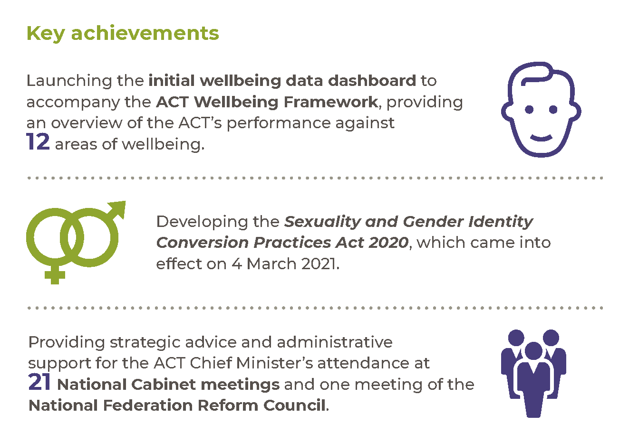

Highlights
In 2020-21 we delivered a range of projects including:
- Implementing the First Action Plan for the Capital of Equality Strategy, to improve outcomes for LGBTIQ+ Canberrans.
- Delivering the Sexuality and Gender Identity Conversion Practices Act 2020, which came into effect on 4 March 2021. The Act is an important step towards preventing and responding to the serious damage and trauma caused by sexuality and gender identity conversion practices. It ensures LGBTIQ+ Canberrans can live their lives authentically with pride, and clarifies that a person’s sexuality and gender identity are not broken and do not need to be fixed.
- Launching the ACT wellbeing data dashboard in April 2021. The dashboard includes data and information on 100 measures across the 12 domains and 56 indicators that make up the ACT Wellbeing Framework. As wellbeing is embedded in government processes and reporting, the dashboard will support evidence-based decision-making and targeted investment where it is most needed.
To support records management and digital recordkeeping capability we:
- Prepared a five-year plan for improving the maturity of records and information capabilities across the ACTPS, informed by the strategic assessment of ACTPS digital recordkeeping capability in 2019-20.
- Supported whole of government improvements in records and information governance by building relationships and supporting the development of risk-based and in place solutions for keeping records in business systems. We have had ongoing engagement with Digital, Data and Technology Solutions and provided recordkeeping advice on business transformations such the whole of government concessions integration project and implementation of reforms to the Working with Vulnerable People scheme.
- Initiated research and provided support on cross-government initiatives to identify improvements to the whole of government digital recordkeeping systems, and support effective use and management of information and records.
- Assisted ACT Government agencies transitioning to new office accommodation. We provided dedicated resources and recordkeeping advice to support the orderly management of existing hard copy records. Agencies successfully moved to the new office accommodation in a ‘paper-lite’ environment, with staff primarily working digitally. The transition also accelerated agency adoption of whole of government digital recordkeeping systems.
Our other activities in 2020-21 included:
- Establishing and coordinating the Parkwood Urban Release Area Governance Steering Committee to facilitate ongoing cooperation and negotiation on the provision of government services and infrastructure to the Parkwood development.
- Finalising a Collaboration Deed with Infrastructure Australia (IA) to support the provision of information for IA’s Market Capacity Program.
- Developing a strategic approach to the Canberra Region Economic Development Strategy through collaboration with counterparts in the NSW Government and Canberra Region Joint Organisation.
- Supporting the Chief Minister’s attendance at the inaugural meeting of the newly established National Federation Reform Council on 11 December 2020 in Canberra. We also supported the Chief Minister’s attendance at the Council for the Australian Federation on 2 December 2020.
We continued to progress work from previous years, including:
- Supporting the delivery of services to Jervis Bay Territory under an existing Memorandum of Understanding with the Commonwealth Government.
- Supporting the Council of Capital City Lord Mayors, who advocate on behalf of Australia’s capital cities.
- Engaging with the NSW Government and local councils on issues that impact the Canberra Region. This has included supporting implementation of the Memorandum of Understanding on Regional Collaboration between the NSW and ACT Governments and continuing to work with local councils as an associate member of the Canberra Region Joint Organisation.
- Supporting the ACT’s engagement with National Cabinet. In 2020-21, we provided strategic advice and administrative support to the Chief Minister and Head of Service’s attendance at 21 meetings of the National Cabinet.

Future direction
In 2021-22 we will continue to support the Government of the 10th Assembly by regularly advising Cabinet on the development, agreement to and implementation of ACT Government policies and programs.
We will continue to support the ACT’s intergovernmental relationships and forum participation by:
- Engaging with the NSW Government and local councils on matters that impact the Canberra Region, including collaboration through the Canberra Region Joint Organisation, and negotiating the development of a new ACT – CRJO Memorandum of Understanding.
- Working with the NSW Government and other relevant parties on the provision of government services and infrastructure to the Parkwood development.
- Working with the Australian Government on service delivery to Jervis Bay Territory.
- Working with the Australian Government and other relevant parties on matters relating to Canberra’s status as the National Capital.
- Supporting the participation of the Chief Minister, Head of Service and other senior officials in the intergovernmental forums under the National Federation Reform Council including National Cabinet, the First Secretaries Group and First Deputies Group.
We will commence the implementation of our plan for improving records and information maturity, specifically targeting improvements in knowledge, skills and understanding. This work will support effective recordkeeping practices and governance principles in a digital landscape, now and into the future. We will increase opportunities for the community to access records, information and data through improved systems for discovering the breadth of publicly available material.
We will continue to oversee implementation of the ACT Government’s Capital of Equality strategy, by:
- Finalising reforms to protect the rights of intersex people and provide better support to them and their families.
- Developing the second action plan for the Capital of Equality strategy, to further improve the wellbeing of LGBTIQ+ Canberrans.
- Providing grant funding to support and strengthen Canberra’s LGBTIQ+ communities.
To continue the delivery of key climate action initiatives in 2021-22 we will:
- Complete the pilot and launch the full Sustainable Household Scheme. New products will be progressively included over time. The scheme will assist ACT households to improve the comfort of their homes while reducing costs and emissions.
- Build on the market sounding work already complete on the Big Canberra Battery and narrow down the options to those identified as best able to meet the ACT Government’s goals. We will develop a design brief for Cabinet submission and planning approvals for identified sites. We will approach the market by the most appropriate means in the context of the chosen options. This is likely to be a two-stage procurement approach and will lead into construction of the first components of the Big Canberra Battery in the following financial year.
Further information
Leesa Croke Deputy Director-General, Policy and Cabinet
(02) 6207 3751 Leesa.Croke@act.gov.au

Coordinator-General for the Whole of Government (Non-Health) COVID-19 Response
The ACT Government established the role of Coordinator-General, Whole of Government (Non-Health) COVID-19 Response (Coordinator-General) in March 2020. To respond to the complex and dynamic nature of COVID-19, whole of government emergency arrangements continued throughout 2020-21.
A newly appointed Coordinator-General was engaged in the role in early 2021. The Office of the Coordinator-General, Whole of Government (Non-Health) COVID-19 Response sits within Policy and Cabinet Division and also supports the ACT’s engagement with National Cabinet and the National Coordination Mechanism of National Cabinet.
The role of the Coordinator-General continues to draw together the efforts of all directorates and agencies, ensuring health and non-health related COVID-19 work is well aligned, and that responses are well coordinated and working efficiently. The Coordinator-General also seeks to maintain sound governance, decision-making and other processes, and support a strategic approach on longer term issues.
In 2020-21 the Coordinator-General worked closely with all directorates and agencies, including:
- Planning, through the Strategic Board and Coordinator-Generals’ Group, for different scenarios that could unfold in response to COVID-19, allowing consideration of the business continuity, health, economic and social implications of different approaches. This work has allowed the ACT to be in a strong position of preparedness for possible future situations.
- Driving whole of government responses to issues such as quarantine arrangements for returning Australians and continuing to work closely with other directorates, the Commonwealth and the accommodation sector on quarantine arrangements for the ACT.
- Continuation of the cross-government forum, Coordinator-Generals’ Group, to review administrative processes and practices across government, ensuring sound governance and decision-making processes throughout the COVID-19 Public Health Emergency.
The role of the Coordinator-General will continue into 2021-22 as COVID-19 continues to be the primary issue facing the ACT and the nation. Our focus in 2021-22 will include supporting the work of the National Cabinet including facilitating the vaccine rollout and implementing the National Plan to transition Australia's National COVID-19 Response.
Further information
Leesa Croke Coordinator-General for the Whole of Government (Non-Health) COVID-19 Response
(02) 6207 3751 leesa.croke@act.gov.au

Coordinator-General for Climate Action
The Parliamentary and Governing Agreement (PAGA) for the 10th Legislative Assembly includes an ambitious agenda for climate action in the ACT. To meet this agenda, the ACT Government established the Office for Climate Action (the Office) in 2021 to oversee the delivery of major projects, coordinate activities across government and identify ways to increase climate adaptation and resilience.
This year the Office has been establishing processes to ensure effective oversight on the delivery of climate commitments, including through:
Supporting the Climate Action Cabinet Subcommittee in our role as secretariat and coordinating directorates to bring items forward for consideration.
Establishing the Strategic Board Climate Action Committee to discuss cross-cutting risks to the delivery of commitments and to ensure Subcommittee materials provide sufficient information to support decisions by Cabinet.
Initiating a series of cross-directorate workstream meetings to oversee implementation and coordinate reporting on programs relating to transport, fossil fuel gas transition and energy, household and community energy efficiency, and resilience and adaptation climate initiatives.
Reviewing the Government’s approach to communicating and engaging with the community around new and current ACT Government initiatives for climate action.
The Office has also co-led the delivery of key climate action initiatives with the Environment, Planning and Sustainable Development Directorate, including the rollout of the $150 million Sustainable Household Scheme and market sounding for the $100 million Big Canberra Battery.
As we move into 2021-22 the Office will focus on supporting the delivery of priority PAGA commitments around phasing out fossil fuel gas, and expanding Zero Emissions Vehicles uptake in the ACT, to meet our 2045 emissions reductions targets. The Office will implement a whole of government approach to communicating and engaging with the community about the new and current ACT Government initiatives for climate action. We will also begin to review the ACT Government’s capacity to adapt to climate change. We will work across government to embed adaptation planning and risk management into our operations, building resilience across the Territory.
Further information
Sam Engele Coordinator-General for Climate Action
(02) 6205 0230 Sam.Engele@act.gov.au

Output 1.2 Workforce Capability and Governance

Overview
Through the Workforce Capability and Governance output we provide an employment and policy framework to support a professional, skilled and accountable public service that is responsive to the ACT Government and the community. We also manage whole of government capacity building programs.
Workforce Capability and Governance delivers this output by:
- Developing and reviewing whole of government employment policies, regulations and standards and providing industrial relations services to support better employment practices.
- Leading, supporting and coordinating enterprise bargaining, enterprise agreement implementation and application across the service.
- Supporting and coordinating workforce planning and capability development across government, including through whole of government learning, development and capability programs.
- Driving transformational and cultural change to support the move to largely activity-based working in the Dickson and Civic office buildings in 2020 and 2021.
- Developing and implementing ACTPS capacity building programs, including programs for graduates, Aboriginal and Torres Strait Islander people, and people with disabilities.
- Maintaining and monitoring whole of government ethics and accountability frameworks.
- Supporting the Head of Service, the Public Sector Standards Commissioner, the ACT Remuneration Tribunal, the Strategic Board and its sub-committees and the Secure Local Jobs Code Ministerial Advisory Council.
Managing the Secure Local Jobs Code certification scheme, assisting Territory entities and tenderers to meet their legislative obligations under the Code and undertaking education and awareness raising activities on the implementation of the Code.

Performance

Accountability indicators
7 met or exceeded 1 not met
We met or exceeded seven of our accountability indicator targets against this output. We exceeded our targets for:
- 1.2a – Conduct the annual whole of government Graduate Program – (100 per cent of the graduate cohort completed the program).
- 1.2h – Issue Secure Local Jobs Code Certificates within five working days – (97 per cent met the timeframe following receipt of complete and correct audit report).
We did not meet our accountability indicator target for 1.2d – Conduct vocational employment programs. The 2020-21 Vocational Employment Programs for Aboriginal and Torres Strait Islander people and People with Disability had a delayed start in 2020 due to the COVID-19 pandemic when many teams moved to remote working environments. We delayed the program start to ensure participants could be onboarded in a safe and supported way into their new workplaces. Between October and December 2020, 12 participants commenced across the programs.
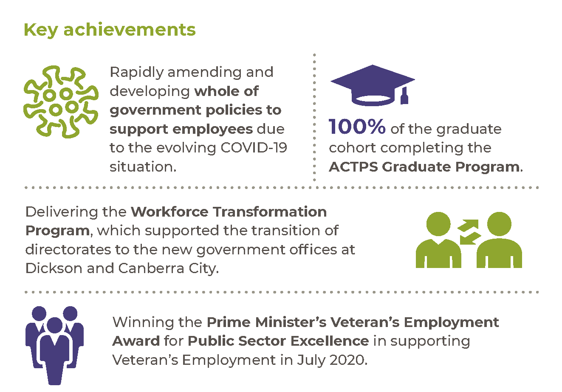

Highlights
In 2020-21 we continued to support the ACTPS to respond to the COVID-19 pandemic through workforce policies and guidance materials. We developed and refreshed whole of government COVID-19 related policy advice on a range of employment matters as the COVID-19 circumstances evolved. The new policies provided guidance for employees who visited, or were deployed to, identified areas of concern of COVID-19 risk, including the provision of supportive employment arrangements when employees were required to isolate after visiting these areas of concern. We developed a policy that provided supportive arrangements to employees attending COVID-19 vaccination appointments and leave entitlements for those employees who experience an adverse reaction to the vaccination. The policy decision sought to mitigate the risk of COVID-19 in our workplaces through vaccination. Policy decisions continued to provide supportive leave arrangements to ensure there was no disincentive for employees, including casual employees, to absent themselves from work for COVID-19 related reasons. This continued to ensure we have kept our community safe and provided mitigation of risk in ACTPS workplaces.
Policy decisions have also ensured employees in insecure work would not be unduly disadvantaged by lockdowns or isolation requirements. We provided guidance and advice to HR areas, employees and managers on how existing flexibilities in the employment framework could best support employees working from home, and employees who remained in the workplace. During periods of high risk of COVID-19 transmission in the Territory, we facilitated weekly and fortnightly meetings of HR Council (made up of Executive Branch Managers of HR across government).

In 2020-21 we implemented the Youth Support Package to expand the ACTPS Graduate Program by 20 per cent, to support young people to find jobs in the community. The funding recognises the program’s value in assisting graduates to begin high-performing, mobile and impactful careers in the ACTPS.
During the reporting period, our Workforce Capability and Governance business area implemented the ACTPS Graduate Talent Bank Policy in support of the program. The talent bank provides the ACTPS with an essential human resource pipeline, supporting the medium and long-term capacity of the ACTPS to deliver on the ACT Government’s agenda. Combined, the ACTPS Graduate Program and the ACTPS Graduate Talent Bank resulted in a 70 per cent increase in our graduate intake.
We encouraged diversity and inclusion in the ACTPS by:
- Conducting a pilot project to better understand the nature and extent of racism in ACTPS workplace settings. The project involved inviting Aboriginal and Torres Strait Islander employees from across the ACTPS to complete a small number of short, repeat surveys. Data is de-identified and will assist the ACTPS combat racism through new approaches and tools.
- Coordinating the Aboriginal and Torres Strait Islander Vocational Employment Program and the Inclusion Vocational Employment Program for People with Disability for 2020-21 participants. During the reporting period a total of 12 participants were onboarded into ACTPS workplaces as part of these programs and are currently engaged in tailored learning and development plans.
- Implementing a Pilot Neurodiversity Program in partnership with leading neurodiversity employment recruiters Specialiststearne, to harness the significant skills and business-value offered by neurodiverse candidates.
- Continuing to embed the 2020 Veterans’ Employment Strategy, including winning the Prime Minister’s Veterans’ Employment Award for Public Sector Excellence in supporting Veteran Employment in July 2020. Data captured over the reporting period indicated that the ACTPS is an employer of choice for veterans.
- Addressing unconscious bias in ACTPS recruitment and other activities by securing access for ACTPS employees to undertake the SBS e-learning module on unconscious bias. The module is now available on the ACTGOV Learn system.
Delivering a whole of government research project to better understand diversity and inclusion in the ACTPS workforce and how we might mature the ACTPS’s workforce diversity and inclusion position to positively influence employee engagement and wellbeing.
To address future workforce needs and build capability in the ACTPS we:
- Continued to improve the ACTPS Graduate Program and the Talent Bank Program to support young people to find jobs in the community.
- Undertook a review of senior executive leadership and leadership development to ensure the ACTPS is well positioned with capable leaders who can respond to current and future challenges facing the ACTPS. We will now move to designing and implementing contemporary, fit-for-purpose initiatives for the SES which respond to the findings.
Successfully implemented a whole of government learning management system – ACTGOV Learn.

As part of coordinating enterprise bargaining and enterprise agreement implementation we:
- Finalised negotiations and received Fair Work Commission approval of enterprise agreements covering ACT Fire and Rescue Service and ACTPS Medical Practitioners.
Commenced negotiations with unions and bargaining representatives for the common core provisions of the ACT Public Sector Enterprise Agreements, which are due to expire in October 2021.
To deliver this output in 2020-21 we also:
- Delivered the Workforce Transformation Program, supporting the transition of directorates to the new Dickson and Canberra City office buildings. The technology and flexibility aspects of this program supported the continuing adoption of flexible working arrangements including options for working from home throughout 2020-21.
Image 3: Opening of the new City government office building at 220 London Circuit, Canberra City in March 2021.
- Progressed the development and endorsement of a flexible work strategy which will help position the ACT Government as the most progressive jurisdiction in Australia for the way we work. This program will sustain and improve upon the positive impacts of flexible work whilst maintaining focus on outcomes and productivity.
- Continued to provide secretariat support to the ACT Remuneration Tribunal in reviewing remuneration, allowances and other entitlements for Members of the Legislative Assembly, full-time Statutory Office Holders, Executives, the Judiciary and Part-time Public Office Holders as part of their Spring and Autumn sittings.
- Delivered the ACT Public Service Awards for Excellence.
- Progressed amendments to the Public Interest Disclosure Act 2012, which were passed by the Legislative Assembly on 27 August 2020. Provisions of the amended Act became effective on 4 March 2021.
- Prepared the 2019-20 State of the Service Report.
- Provided advice to directorates and agencies in relation to the Annual Report Directions that applied during 2019-20 and the revised tabling timeframes due to the COVID-19 pandemic. We also updated the Annual Report Directions for 2020-21.
- Updated the Guidelines to the Caretaker Conventions that applied for the 2020 ACT Election and provided advice to directorates and agencies in the implementation of these Conventions.
- Updated the Governance Principles for Appointments to Boards and Committees.
- Issued a Request for Tender in relation to ACT Public Service Job Sizing and Work Value Assessments for Executive and Non-Executive Positions and Related Remuneration Services.
- Commenced the 2021 Senior Executive Service Executive Review to consider whether the current executive structure and arrangements are fit-for-purpose and whether they meet the original objectives of the earlier reviews to support the needs of the ACT Public Service.
- Continued to provide technical and advisory support to the Human Resources Information Management Solution (HRIMS) project on matters relating to the employment framework.
- Successfully supported the delivery of a review of operations of the Secure Local Jobs Code on behalf of the Secure Local Jobs Code Advisory Council to fulfil their obligation under section 22ZD of the Government Procurement Act 2001.
- Commenced work on developing the policy and stakeholder engagement framework that will give effect to the ACT Government’s commitment in the Parliamentary and Governing Agreement to implement a secure employment framework. The framework is based on the presumption that work will not be contracted out where it could be performed by public servants.
- Delivered a classification review which looked at a specific set of priority employee groups and delivered analysis and insights across a number of workstreams: comparative work value of these groups, efficacy of specified shared salary spines in the ACTPS, documentation of Work Level Standards and historical percentage-based pay increases with respect to the extent to which these have contributed to greater pay disparity.
Professional Standards Unit
Throughout the reporting period, the directorate worked with the ACT Integrity Commissioner and his staff regarding potential amendments to the Integrity Commission Act 2018, including reimbursement of witness costs and exploring a potential telecommunications intercept authority. This important work will be prioritised in 2021-22 and will include consultation and engagement with relevant stakeholders.
The directorate also facilitated a Memorandum of Understanding (MoU) between the ACT Integrity Commissioner, the ACT Head of Service, and the Public Sector Standards Commissioner. This MoU establishes agreement between the parties regarding the referral of complaints and investigations, liaison and information sharing and avoidance of unnecessary duplication of statutory functions.

The directorate supports the function of the Public Sector Standards Commissioner (PSSC) through the Professional Standards Unit (PSU), which provides administrative and investigative support for misconduct matters. During the 2020-21 financial year, the PSSC referred 92 misconduct related matters to the PSU for investigation or management, an increase of 42 per cent from the previous financial year (see figure 1).
Figure 1: Referrals received by PSU by financial year
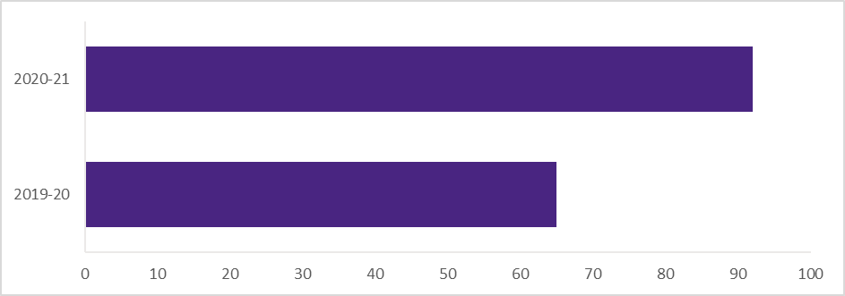
The two most prevalent reasons for referral to the PSU were ‘Failed to treat people with courtesy, sensitivity and respect’ and ‘Failed to do the public servant’s job with reasonable care and diligence’.
Figure 2: Alleged misconduct referred to PSU by financial year
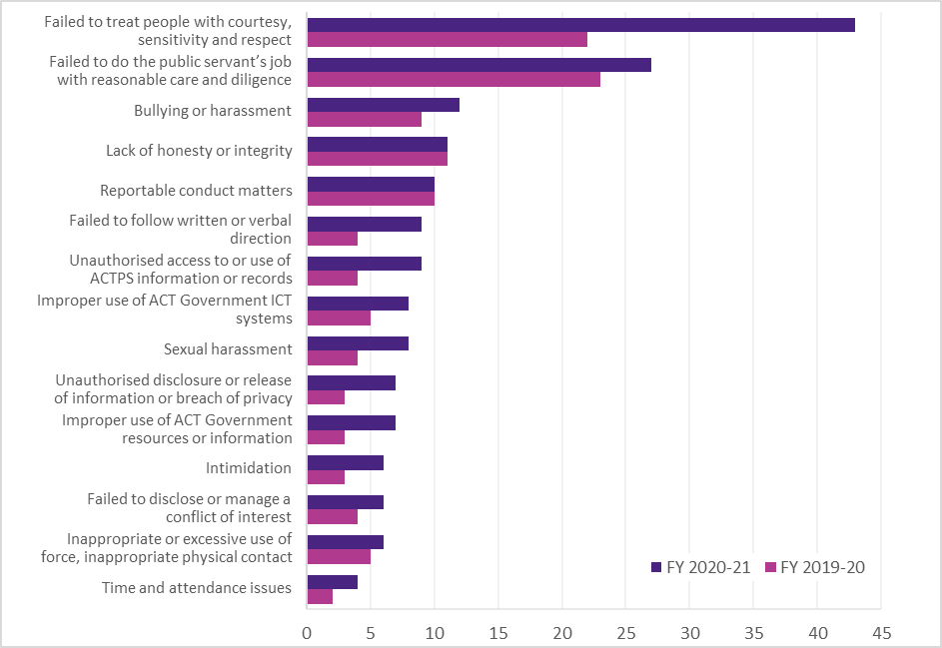

The PSU completed and provided 62 comprehensive investigative reports to delegates of the PSSC for consideration under the relevant enterprise agreements. This represents an increase of 20 per cent from the last reporting period. The PSU continued to receive positive feedback for the integrity of these investigative reports in appeals processes this financial year.
In addition, the PSU managed and provided advice to the PSSC on complaints and on public interest disclosures received prior to 4 March 2021, when responsibility for public interest disclosures transferred to the ACT Integrity Commission. The PSU also provided advice and assistance to employee relations teams throughout the ACT Public Service concerning misconduct and behavioural issues arising.
To address the increase in misconduct referrals, the directorate increased PSU staffing numbers by hiring additional Senior Investigators and restructured its management framework with the selection of an Executive Branch Manager. Further structural changes and information technology enhancements are in progress. It is anticipated that these changes will put the PSU in a better position to support the PSSC and respond to misconduct matters on a timely basis.

Future direction
In 2020-21 we will develop a contemporary employment strategy that reflects the lessons learned from COVID-19. We will also commence working on the following priorities and initiatives:
- Progressing a whole-of-service vision for the ACTPS including workforce models and supporting culture and practices.
- Continuing to implement the flexible work strategy to position the ACT Government as the most progressive jurisdiction in Australia for the way we work.
- Delivering a whole-of-service survey so workforce trends and patterns inform strategic decision making.
- Designing and delivering contemporary initiatives to further develop leadership capability across the ACTPS and support those in senior roles to respond to current and future challenges.
- Progressing a leadership and talent strategy that ensures the ACTPS is well positioned to attract and retain leaders who thrive in a highly dynamic environment.
- Delivering targeted diversity and inclusion plans, aligned with identified needs across the Service and within specific cohorts of employees. This work will include introducing a monitoring framework across the ACTPS through promotion and education of the value of workplace diversity as a high-performance business strategy.
- Delivery of the ACTPS 2021 Graduate Program and recruitment of graduates for the 2022 program via an online, multi-phase assessment process. We will also continue to develop and improve the program and further embed use of a talent bank of recruited graduates as an accessible resource for ACTPS directorates looking to recruit at level to relevant streams of work.
- Progressing the review of the Respect, Equity and Diversity (RED) Framework.
- Updating the ACTPS workforce capability framework to provide an understanding of the capabilities required for a dynamic and agile ACTPS into the future.
- Continuing work on translating data and analytics into workforce insights that will drive high performance by channelling efforts into priority issues.
- Reforming the employment framework to enable a modernised, secure and flexible workforce.
- Continuing to work with all areas of the ACTPS to ensure our policy and employment framework supports managers and employees throughout the COVID-19 response. This includes developing and reviewing guidelines, policies and employment conditions to ensure they are contemporary, fit-for-purpose and responsive.
- Finalising negotiations in the current round of bargaining for the new ACTPS enterprise agreements, aiming to ensure the employment framework is modern, strategic and supports an effective public service.
- Progressing the 2021 Senior Executive Service Executive Review.
- Updating the Annual Report Directions for 2021-22.
- Continuing to provide secretariat support to the ACT Remuneration Tribunal.
- Continuing to deliver on the Government’s commitment to provide secure employment through the Taskforce on Insecure Work and Outsourcing, as well as the bargaining framework.
- Continuing to develop the foundations for the ACTPS Secure Employment Framework, including drafting associated legislation.
Implementing recommendations from the review of operations of the Secure Local Jobs Code package of measures.
Further information
Dr Damian West Deputy Director-General, Workforce Capability and Governance
(02) 6207 5397 Damian.West@act.gov.au

Output 1.3 Coordinated Communications and Community Engagement

Overview
Through the Coordinated Communications and Community Engagement output we deliver communications support and protocol services to the ACT Government and community.
Communications and Engagement delivers this output by:
- Delivering priority communications and engagement activities for the Chief Minister and the directorate’s Ministers.
- Providing whole of government advice and assistance on strategic communications activities and community engagement policies and practices.
- Leading and supporting a coordinated communications response in times of crisis.
- Providing research and insights services and management of the YourSay Community Panel and digital engagement platform YourSay Community Conversations.
- Managing the ACT Government’s key channels including Our Canberra and ACT Government Facebook, Twitter, Instagram and LinkedIn.
- Preparing an annual whole of government communications and engagement plan to outline the Government’s priority public information campaigns and engagements.
- Providing high quality creative design and production services to CMTEDD and the ACT Government.
Providing ceremonial and protocol services to the Chief Minister.

Performance

Accountability indicators
2 met or exceeded 1 not met
We met or exceeded two of our accountability indicator targets against this output, exceeding our target for:
- 1.3a – Annual numbers of ACT Government digital mail newsletters. We distributed 31 newsletters due to a more frequent publishing schedule including COVID-19 updates.
We did not meet our target for:
- 1.3b – Annual numbers of ACT Government Our Canberra newsletters. We distributed nine newsletters against a target of ten. The longer than anticipated period between the ACT Election and the appointment of the new ACT Government meant editions were not distributed in either October or November 2020.
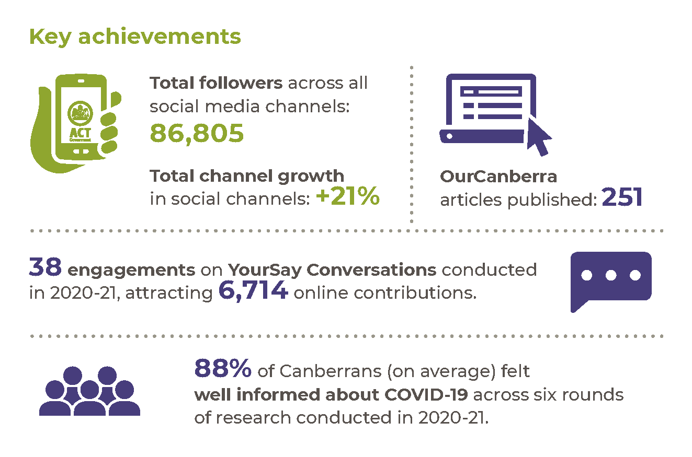

Highlights
In 2020-21 we continued to lead the ongoing Public Information Coordination Centre (PICC) for COVID-19. Our work in the PICC ensured the community remained well informed with up-to-date COVID-19 information. When surveyed, 88 per cent of the community reported they felt well informed during COVID-19.
Across 2020-21, the YourSay Panel grew into a highly active group of more than 5,000 Canberrans. The group size ensures we can gather statistically representative data. This data will allow us to better understand the behaviours and attitudes of Canberrans and bring their voices into the decision-making processes of government. During the COVID-19 pandemic the panel has been a critical tool for government to better understand and monitor the perspectives of the Canberra community. In 2020-21, panel members completed close to 9,000 individual responses on COVID-19 across six rounds of research.
In 2020-21 work continued to ensure the community was well informed about ACT Government policies, programs and services and directorates were supported to communicate with a one government approach.
The Our Canberra print and digital newsletter supported direct communication with Canberrans on ACT Government news, programs and services, including:
- A monthly regionalised newsletter to over 200,000 Canberra households.
A digital newsletter delivered to more than 50,000 subscribers.
In 2020-21 we continued to lead and manage the growth of the ACT Government’s primary social media accounts.
Table 6: Social media performance in 2020-21
Social media platform | Followers (% change from 2019-20) | Average monthly impressions
Facebook | 34,356 (+27%) | 801,446
Twitter | 18,287 (+15%) | 121,118
LinkedIn | 20,927 (+19%) | 59,714
Instagram | 13,235 (n/a) * | 120,293
*Note: CMTEDD has not previously reported on Instagram followers for the We are CBR account.
We also managed the Government’s online engagement website, YourSay Community Conversations, which had more than 93,000 visitors in 2020-21, a 47 per cent increase from the previous year. Over 2,400 people became members of YourSay Conversations in 2020-21, an increase of 22 per cent from 2019-20, bringing the total members to 13,300.
Aligning with the ‘One Government, with one voice’ communication approach, we commenced a range of activities directed towards improving ACT Government websites to create a simple, unified and customer focused digital experience.
We supported business areas across the directorate with the delivery of priority engagements and public information campaigns, including:
- Delivering the communications to support the launch of the Government’s Jobs and Economic Recovery Plan.
- Leading the communication program for the Government’s approach to climate action, in collaboration with directorates and working with the Office of the Coordinator-General for Climate Action.
- Delivering priority economic recovery campaigns including ChooseCBR, JobTrainer, Choose Local, Supporting Local.
- Producing all campaigns associated with the COVID-19 communications response including the promotion of the Check in CBR app.
- Coordinating designs for a new Territory Coat of Arms, ahead of selection and adoption in 2021-22.
- Supporting the commencement of the automatic mutual recognition scheme through communication and stakeholder engagement activity.
- Helping our community access services by promoting the more than 450 online services and transactions available through Access Canberra.
- Continuing to provide information to the community on the ACT Infrastructure Plan and the ongoing delivery of new infrastructure across the city.
- Supporting the ACT’s community councils, including the establishment of the new Molonglo Council.
To deliver this output in 2020-21 we also:
- Supported the independent review of campaign advertising under the Government Agencies (Campaign Advertising) Act 2009.
- Delivered the 2021 ACT Australian of the Year Awards, the Chief Minister’s Canberra Gold Awards, the Canberra Citizen of the Year Award and the ACT Honour Walk induction.
Supported the delivery of the Order of Australia honours and the Public Service Medal.

Future direction
In 2021-22 we will continue to lead a coordinated approach to communicating and engaging on the Government’s priorities for the ACT community. We will also:
- Lead and support communications for the Government’s response to COVID-19 and any other emergencies.
- Continue to support the ACT Government to seek the views of our community that will inform the development of policies and programs via the YourSay Community Panel and YourSay Community Conversations website.
- Continue to improve the YourSay Community Panel by increasing membership and broadening its scope to particular sectors.
- Design, deliver and evaluate a Neighbourhood Democracy pilot, using participatory budgeting to determine local expenditure and improve local community connections and resilience.
- Progress the ‘One Government, with one voice’ communication approach by developing a whole of government website strategy that will make it easier to find, use, and understand information published online by the ACT Government.
- Deliver integrated cross-directorate campaigns on ACT Government priorities such as climate action and infrastructure.
Coordinate at least seven honours and awards processes as well as protocol advice and support.
Further information
Trish Johnston Executive Group Manager, Communications and Engagement
(02) 6207 2644 Trish.Johnston@act.gov.au

Output 1.4 Digital Strategy

Overview
Through the Digital Strategy output we drive the digital transformation of government services and provide advice, support and project delivery on digital strategy development and implementation.
The Digital, Data and Technology Solutions Group* takes advantage of digital, data and technology to achieve:
- Better digital services that provide real value for the community.
- Greater engagement and better outcomes for business and academia.
- Informed choices about technology investments for government.
- More sustainable and efficient government.
A more productive, engaged and learning workforce.
*Note: In November 2020 the Office of the Chief Digital Officer and Shared Services ICT merged to form the Digital, Data and Technology Solutions Group (DDTS). The merger takes advantage of the natural synergies between the strategic direction for digital, data and technology and enabling this through our central ICT delivery capability. The performance of DDTS is also discussed in Output 7.1 Shared Services.

Performance

Accountability Indicators
3 met
We met all three of our accountability indicator targets against this output in 2020-21.

Highlights
In 2020-21 we embedded the principles of the ACT Digital Strategy to provide a community-centred approach to how we use technology to further improve the quality of life for all Canberrans. This work included the delivery of digital services that reflect reforms to the Working with Vulnerable People scheme, including enhanced protection for vulnerable people through the National Disability Insurance Scheme.
We supported the Government’s COVID-19 response and recovery initiatives by:
- Chairing and supporting the Technology Leadership Group.
- Supporting the creation of the Technology Governance Group. The Technology Governance Group’s primary purpose is to support the achievement of government priorities through a focus on ensuring fit-for-purpose implementation, and effectively govern change to the digital and technology landscape.
- Prioritising technology and digital initiatives to ensure they provide the best outcomes.
- Working collaboratively across government to provide best practice advice on the design and delivery of digital initiatives.
Supporting national forums, such as the Data and Digital Ministers, through engaging on national digital and data initiatives.

Future direction
In 2021-22 we will deliver more digital services that provide real value to the community, including:
- Developing ways to make it easier for people to prove their eligibility for a range of concessions to access ACT Government services.
Designing and delivering automatic mutual recognition of occupational licences that will allow licence holders to carry out activities in another jurisdiction.
We will continue to support ACT Government directorates to implement the Data Governance and Management Framework, including to enhance data sharing across the service for public benefit.
We will continue to support national forums such as the Data and Digital Ministers, providing advice and guidance for the ACT’s leadership and participation in priority initiatives such as Birth of a Child, Digital Identity, and National Data Sharing initiatives.
We will continue to support the Government’s COVID-19 recovery to ensure digital and technology initiatives are delivered in a way that provides the best outcomes for both the community and government.
Further information
Bettina Konti Deputy Director-General and Chief Digital Officer, Digital, Data and Technology Solutions
(02) 6207 2242 CDO@act.gov.au

Output 2.1 Access Canberra

Overview
Through the Access Canberra output we contribute to the economic growth and vibrancy of Canberra and protect the community through compliance, licensing and regulation.
Access Canberra delivers this output by:
- Undertaking regulatory activities to protect the community and contribute to economic growth through risk-based compliance, licensing and regulation.
- Providing services and collecting revenue on behalf of other directorates.
Providing services to businesses, community groups and individuals through a ‘no wrong door’ approach to government.

Performance

Accountability Indicators
7 met or exceeded 2 not met
We met or exceeded seven of our nine accountability indicator targets against this output. We did not meet our target for:
- 2.1a – Percentage of customers satisfied with Access Canberra (85 per cent satisfaction against a target of 90 per cent); and
2.1b – Percentage of the Canberra community satisfied with the ease of interacting with Access Canberra (87 per cent against a target of 95 per cent).
The overall satisfaction and ease of dealing with Access Canberra was adversely impacted by lower ratings for the Contact Centre. As part of the Government’s COVID-19 response the Access Canberra Contact Centre took on responsibility for the COVID-19 Helpline and COVID-19 Business Liaison line.
This substantial increase in demand on Contact Centre was further exacerbated by significant fluctuations in demand for telephone services as public health directions changed. Access Canberra modified its service model to shift many of its face-to-face services to online and telephone delivery during times of increased COVID-19 restrictions. Notwithstanding these challenges, average wait times for the Contact Centre between 2019-20 and 2020-21 decreased by 10.3 per cent (4 minutes and 23 seconds in 2019-20, down to 3 minutes and 56 seconds in 2020-21). We anticipate satisfaction levels will improve as COVID-19 restrictions ease.
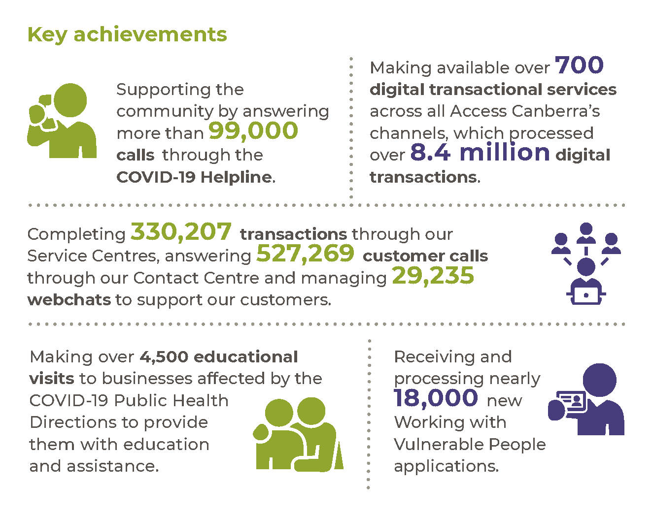

Highlights

Supporting the Government response to COVID-19
In 2020-21 we supported the ACT community through the ongoing COVID-19 public health emergency. Through the Jobs for Canberrans program, we provided work opportunities for people who lost their jobs or had been significantly impacted due to COVID-19. We continued to expand our online services in response to COVID-19 by providing flexible, digital-first solutions to delivering services on behalf of the ACT Government. We also opened a new central Service Centre located in Dickson that combines our Land Titles office with our traditional Service Centre functions.
Image 4: Service screen at the new Access Canberra Service Centre in Dickson
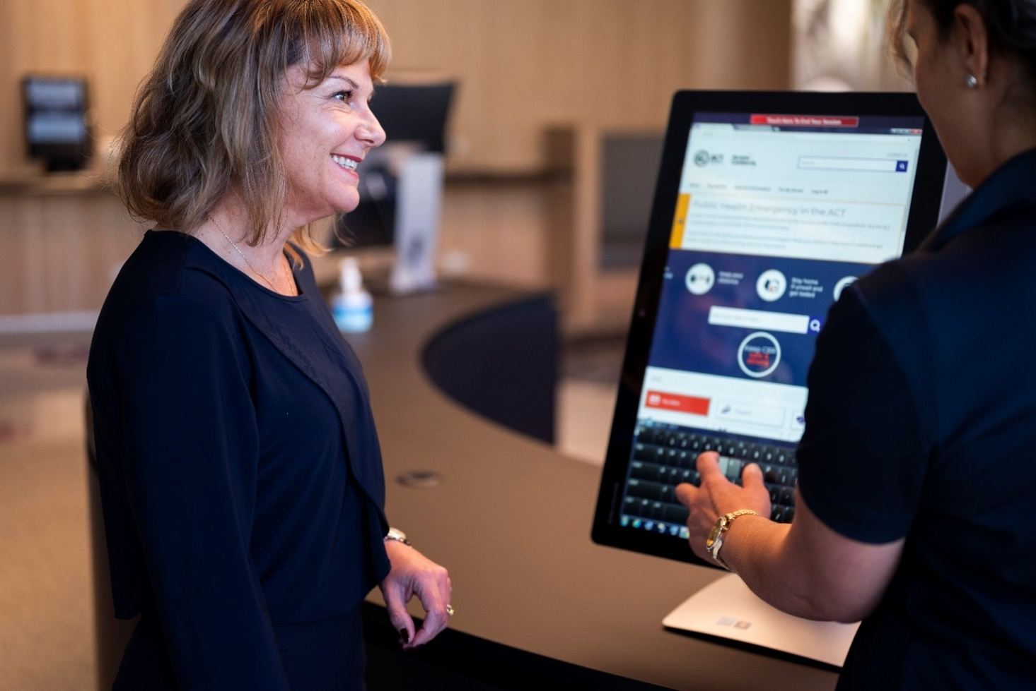
We continued to modify our service delivery approach to ensure the ACT community still had access to essential government services during the COVID-19 public health emergency and associated restrictions. We also answered more than 99,000 calls through the COVID-19 Helpline.
Our teams conducted over 4,500 educational visits of businesses affected by Public Health Directions issued in response to COVID-19. We provided timely education and assistance to businesses and community groups including liquor venues, clubs, incorporated associations, real estate, and gyms. We also worked closely with the ACT Health Directorate and ACT Policing on inspectorial and regulatory compliance activities to ensure a consistent approach and high levels of compliance.
The Access Canberra Business Industry Liaison team responded to over 2,700 calls from the business community providing timely advice and engagement on available stimulus funding, as well as providing general advice for businesses. As part of the Government’s COVID-19 support for business, we also assisted event organisers in obtaining 346 approvals for 116 events of varying scale, and provided pathway solutions to 58 business enquiries.
We delivered several elements of direct financial stimulus to the hospitality industry during COVID-19, including:
- Providing a mechanism for ‘on’ liquor licensees to access a fee waiver to transition to a ‘general’ liquor licence allowing the sale of liquor for consumption both on and off the licensed premises.
- Implementing a 12 month 50 per cent fee reduction for ‘on’ liquor licensees and an additional 12-month fee waiver to outdoor dining permit holders. These initiatives offset the impact of ongoing occupancy restrictions under the Public Health Directions.
- Simplifying the process for businesses to apply for a temporary outdoor dining permit and commercial liquor permit to activate outdoor spaces and allow for increased occupancy numbers.
- Continuing to support businesses activating outdoor dining options on public unleased land under the 12 months free outdoor dining trial.
Implementing a process that provided nightclubs the opportunity to operate as a bar during their compulsory closure under the Public Health Directions.
We responded to COVID-19’s impact on the ACT taxi industry by facilitating a one-off payment of $5,000 to 156 taxi operators who leased a private taxi plate.
The Registrar-General continued to support associations by extending temporary COVID-19 measures under the Associations Incorporation Act 1991 through to 8 October 2021.
To protect the health of staff and the ACT community during the COVID-19, we amended the online application for security licence applications, allowing new applicants and renewing licensees to upload their signature and photo identification to the online form. This eliminated the need for applicants to attend service centres.
Consistent with legislative amendments passed in February 2020 in response to the public health emergency, we automatically extended the Working with Vulnerable People (WWVP) registrations of 32,107 people whose registrations would have otherwise expired during that time. This was an important government initiative, during what was a very uncertain time, to ensure that key services could continue to be provided to the most vulnerable in our community. In February 2021, further legislation was passed to allow for resumption of the usual registration renewal process in a way which is seamless for registrants while still maintaining the protections afforded through the scheme.
During the reporting period, we wrote to all WWVP registrants (in excess of 125,000) advising of the changes. We provided similar advice to key stakeholders.
The below tables show some of our activities during COVID-19 and ongoing trading restrictions.
Table 7: Outdoor dining permits
 | Number
New permits | 6
12-months free trial | 34
Temporary permit – new area | 2
Temporary permit – extend existing area | 16
Table 8: COVID-19 liquor fee waiver
 | Number
Total entitled to waiver | 699
Refunds processed | 32
On to General | 5
Table 9: COVID-19 commercial liquor permit
 | Number
Off sales - total issued | 15
Off sales - total extended | 23
Temporary permit – outdoor areas | 16
Temporary permit extended – outdoor area | 8
Table 10: Cancellations and refunds of liquor permits
Liquor Permit | Number | Cancelled other reasons | Cancelled COVID-19 | Refunded COVID-19
Commercial | 174 | 9 | 0 | 0
Non-commercial | 222 | 2 | 7 | 7
Total | 394 | 11 | 7 | 7

Serving the community
In addition to our COVID-19 response work, we continued to deliver efficient service to our customers in 2020-21. We completed 330,207 transactions through our Service Centres, answered 527,269 customer calls through our Contact Centre and managed 29,235 webchats. We handled an additional 67,022 calls through our Building Services Centre. There were 722 digital transactional services available across all Access Canberra channels, which processed over 8.4 million digital interactions.
We implemented significant amendments to the Working with Vulnerable People (Background Checking) Act 2011. These amendments further enhance the protection of vulnerable people in our community as well as align with national approaches to worker screening for those people providing services through the National Disability Insurance scheme, and to working with children checks.
The amendments to the Act also strengthen the scheme by:
- Placing the best interests of vulnerable people as the paramount consideration.
- Introducing disqualifying offences for some registrations.
- Expanding information sharing arrangements about registered persons.
Introducing ongoing monitoring of registered persons.
We also released the new Working with Vulnerable People system, in partnership with our Digital, Data and Technology Solutions business area, which was designed to make it easier for the community to apply for an approval through Access Canberra while also increasing the protections for vulnerable people.

The following tables show some of our key shopfront transactions in 2020-21.
Table 11: Top 5 Service Centre transactions
Transaction | Number
Create/maintain client | 96,454
Establish registration | 87,431
Renew licence | 81,070
Issue driver licence | 80,173
Renew registration | 78,871
Image 5: Assisting customers at the Access Canberra Service Centre Woden
Table 12: Top 5 Contact Centre enquiries
Enquiry | Number
Travel - interstate (COVID-19) | 41,610
Registration - establish/transfer | 31,929
Registration - renewal | 30,718
Housing - tenancy management | 24,320
Registration - unregistered vehicle permits (UVPs) | 15,440
Table 13: Environment, Land and Planning Shopfront transactions
Transaction | Number
Development Application lodgements | 867
Compliance Certificates issued | 844
Lease conveyancing enquiries completed | 14,791
Exemption declaration applications processed | 1,285
Fingerprint services provided* | 35
Access cards issued | 404
Land Access Activity Notices processed | 695
Deposited Plan Requests processed | 1,087
*Note: Fingerprint services ceased on 3 September 2020 due to COVID-19.
Table 14: Building Services Shopfront transactions
Transaction | Number
Building approval registrations processed | 5,310
Certificates of Occupancy and Use issued | 4,237
Building file requests processed | 2,950
Energy Efficiency Rating returns processed | 6,565
Building conveyancing reports processed | 6,384
Plumbing inspections booked | 21,523
Electrical inspections booked | 18,999
Plumbing, drainage, and gas certificates / plans processed | 27,984
Certificates of Electrical Safety registered | 51,469

Land titles
In 2020-21, there was a total of 76,781 land title lodgements, representing an increase of 24.2 per cent compared to 2019-20 for a total of 61,803 lodgements. In responding to this increase in transactions, there was a slight increase in average registration timeframes to 11 days from 8 days the previous year.
Work continued to enable the commencement of electronic conveyance (E-Conveyancing) transactions in the ACT – offering the choice of digital transactions for property sales and transfers. This digital advancement will improve settlement processes and assist industry in providing safer practices for COVID-19 by facilitating settlements and lodgements online, and streamlining lodgement of documentation with the Land Titles Office.
The Land Titles Office also implemented ‘Title Watch’, which was introduced to protect against property fraud and made available to the public in February 2021. Title Watch is an online title monitoring service that sends automatic email notifications to subscribers when an action is detected on a Certificate of Title and provides with quarterly updates on title changes to ownership details, mortgages, leases, and caveats.

Compliance
During 2020-21 we continued to support the safety of the ACT community in our role as regulator, through inspection and investigation activities aimed at securing compliance with the law in regulatory spheres including liquor venues and fair trading, COVID-19 and product safety.
During 2020-21, a total of 1,604 reports of non-compliance with public health directions and social distancing were received, and triaged between ACT Policing, ACT Health Protection Service and Access Canberra for response. Throughout COVID-19 we have worked closely with the ACT Health Protection Service and ACT Policing to ensure ACT businesses have been compliant with Public Health Directions, primarily through a strong engagement and education approach.
In 2020-21 we conducted over 4,535 targeted compliance inspections in relation to business compliance with the Public Health Directions. We also conducted 619 inspections through targeted compliance programs, with a further 837 inspections completed on Fair Trading and Gambling and Racing legislation outside of targeted programs.

Fair trading
Access Canberra supported the Commissioner of Fair Trading to promote a fair and informed marketplace for consumers and businesses. Ms Derise Cubin, an ACT Public Servant, was appointed as the Commissioner for Fair Trading on 21 January 2021 following the retirement of the previous Commissioner for Fair Trading, Mr David Snowden, from the ACT Public Service on 20 January 2021.
We undertook a range of fair-trading product safety activities, including:
- Engaging with local retailers to increase awareness and ensure compliance with the product safety requirements of children’s toys and summer play equipment.
- Initiating a voluntary product safety recall of ESS Home Energy System Batteries to remove potentially harmful products from circulation in the ACT.
We also undertook fair-trading enforcement activities, including participating in two ongoing court and tribunal matters and finalising three court and tribunal matters. We continued to monitor elements of a court enforceable undertaking entered into by a local plumbing business arising from previous enforcement action relating to contravention of the Australian Consumer Law.
We developed advice for consumers through the “Choosing a Tradie” campaign. The campaign supported consumers to know the risks when hiring a tradesperson and outlined their consumer rights.

Road safety
In 2020-21 we completed the following activities to support and promote road safety in the ACT:
- Completed 8,570 vehicle roadworthy inspections and 4,330 vehicle identity inspections.
- Completed 31,093 on road inspections, with the Vehicle Safety Standards team issuing 375 defect notices. The number of on road inspections of light vehicles were reduced due to work health and safety considerations relating to COVID-19.
- Issued 152 infringements for driving an unregistered vehicle, 149 infringements for the use of an uninsured vehicle, one infringement for an unsecured load, one infringement to an unlicensed driver and five for failing to display their Public Vehicle Driver Accreditation card.
- Licensed 1,819 new rideshare vehicles, issued or renewed 13 taxi licences and issued or renewed 19 hire car licences. We also processed a total of 1,413 applications for public passenger service operator accreditations.
- Managed over 35,000 motorists with medical conditions which require monitoring and regular assessments to retain their driver licence. This included supporting 9,744 vulnerable clients during the COVID-19 pandemic to make it easier for them to renew their driver licence where they needed to obtain a Driver Licence Medical Examination and/or eye test assessment, by extending due dates for these assessments based on individual risk assessments of driving risks posed by medical conditions.
- Assisted the community to understand their responsibilities to protect road safety through our Infringement Review team, and provided options for, and information about, infringement notice offences and remediation action.
- Established over 11,500 payment plans with a combined total value of $5.8 million for over 30,000 infringements. During 2020-21, we closed 6,300 payment plans due to applicants successfully paying off their debt. At the end of 2020-21, there were over 6,400 active plans, with a total value of $4.8 million.
- Continued to encourage the replacement of defective Takata airbags in registered (and unregistered) vehicles in the ACT. Unfortunately, despite these efforts and extensive public awareness campaigns, some vehicles still contain these defective airbags. To address the remaining unsafe vehicles, we introduced a program to further encourage defective airbag replacement. This program includes the suspension of vehicle registrations for those vehicle owners that have failed to heed the safety warnings and have their defective airbags replaced.
- Completed a total of 69 inspections on special purpose vehicles, such as cranes, mowers, and agriculture machinery.
Partnered in joint on-road operations including ‘Operation J-Bay Blitz’ in Jervis Bay Territory (a joint operation between Access Canberra and the Australian Federal Police), as well as ‘Operation Re-coupling’ with the National Heavy Vehicle Regulator (targeting heavy vehicles) that was further leveraged by Access Canberra’s ‘Operation Safety Check’ (targeting light vehicles).
During 2020-21 we performed the following assessments, authorisations and audits to support and promote road safety outcomes in the ACT:
- In response to the health risks associated with COVID-19, on road audits of ACT Accredited Driving Instructors (ADI) were put on hold in March 2020, recommencing in September 2020. Due to the suspension of audits only 56 in-car and 71 desk top audits were conducted during 2020-21. Of the audits performed, 44 were satisfactory, 55 received a recommendation for improvement and 28 received an unsatisfactory report. Those ADI identified as receiving an unsatisfactory audit report were provided with ongoing engagement and education by the ADI Auditors to assist them improve their instruction and assessments to the Standards required by Code of Practice. The issues identified as unsatisfactory were mostly administrative in nature and not related to road safety. Access Canberra adopts an engagement and educative approach to regulation, and we continue to work with industry to raise awareness and improve compliance.
- We conducted 219 random quality assurance audits on vehicles inspected by Authorised Examiner Repairers (AER) via our Authorised Examiner Scheme (AES) Auditors. Of the 219 vehicles audited, 75 passed without any issues being identified. Most identified failures were administrative in nature and not road safety related. Five AERs were served a show cause notice due to the identification of issues that were more serious in nature, resulting in outcomes ranging from sanctions to cancellation with disqualification periods.

We conducted 62 audits of Authorised Inspection Stations (AIS), with 20 receiving a failed audit report from our AES Auditors for non-compliant equipment, which was remedied soon after. Two AIS had their authorisations cancelled for two years for failing to perform inspections in an approved manner and the issue of passed Certificates of Inspection for non- compliant vehicles. Three AIS received a warning notice for administrative non-compliance by failing to attach brake test results to Certificates of Inspection.

Controlled Sports Act
Access Canberra performs the statutory function of Controlled Sports Registrar. Through the application of educative engagement and a risk-based approach, Access Canberra worked with stakeholders to identify and mitigate risks related to the integrity of controlled sports events and contests, and also the health and safety of contestants. We continued to strengthen our processes by increasing the industry’s knowledge of their legislative requirements through both the registration process and our regulatory compliance and engagement activities.
Table 15: Licensing and Registrations – Controlled Sports
Registration type | Number of registrations
Registerable events | 7 ¹
Registered contestants | 110
Interstate contestants | 89
International contestants | 1
Officials | 51 ²
Interstate officials | 150
Non-registerable event notifications | 7
Notes:
- Event applications for registration which were postponed or cancelled do not appear in the total.
- It is common for officials to register for more than one role.

Licensing and Registrations
The Australian Government introduced amendments to their Mutual Recognition Act 1992 in June 2021 which created an automatic mutual recognition scheme for individuals who hold occupational licences and registrations. We supported preparations for commencement of the scheme on 1 July 2021. The three ACT occupations chosen to pilot the scheme, due to their risk profiles, were architects, commercial pesticide controllers and water drillers, with workers within these occupations in participating jurisdictions able to utilise the scheme in the ACT. Most other in-scope occupations are due to join the scheme in July 2022.
In recognition of the significant contribution that organ and tissue donors provide to the community, the ACT Government passed legislation to provide the opportunity for this to be formally acknowledged in the death register and/or a letter from the Chief Minister. Access Canberra worked alongside colleagues in the Justice and Community Safety Directorate and Donate Life ACT to commence the Organ and Tissue Donor Acknowledgment in early May 2021. A statement to acknowledge organ/tissue donation is added to the death register upon application by the donor’s next of kin. This statement will read: “The deceased gave a gift of life, generously donating organs/tissue” and will appear on the deceased’s death certificate, which is issued free of charge. As part of these reforms, families of the organ/tissue donor may also request a letter from the Chief Minister acknowledging the precious gift of life the donation provided.
The following tables show some of our licensing and registration activity for 2020-21.
Table 16: Births, Deaths and Marriages
Registration type | Number of registrations | Certificates issued
Births | 6,316 | 11,444
Deaths | 2,367 | 2,983
Marriages | 1,401 | 2,379
Same sex marriages | 60 | 54
Civil relationships | 613 | 661
Changes of name | 928 | 566
Table 17: Licensing and Registrations – Community Industry and Traders Licensing
Registration type | New registration | Registration renewals
Security
Employee | 1,064 | 1,223
Master | 72 | 99
Trainer | 11 | 1
Real estate licences
Agent | 313 | 574
Business | 36 | 102
Stock and station | 27 | 78
Real estate salespersons
Salesperson | 296 | 615
Business | 9 | 8
Stock and station | 17 | 12
Motor vehicles
Dealer | 15 | 22
Repairer | 39 | 63
Wholesaler | 2 | 1
Second-hand dealer | 16 | 7
Other
Employment agent | 63 | 98
Pawnbrokers | 0 | 0
Charitable collections | 6 | n/a
Associations | 95 | n/a
Co-operatives | 0 | n/a
Brothel notifications | 11 | n/a

Improving building quality in the ACT
Information on Access Canberra’s role in improving building quality in the ACT is contained in the ACT Construction Occupations Annual Report, annexed to this report.

Future direction
In 2021-22 we will continue to respond to emerging issues quickly to support businesses and the community through incentives, legislative amendments, and stimulus initiatives.
We will support the ACT economy’s recovery from the impact of the ongoing COVID-19 emergency by reducing red tape and working closely with industry, particularly hospitality, gaming, building and construction, and the events sector. We will encourage recovery and growth post COVID-19 through the provision of efficient licensing and registration services, continuing to address regulatory barriers to business recovery.
We will also:
- Continue to work with other directorates to expand our digital service offering, with a focus on end-to-end digital-first approaches. We aim to better support our customers by delivering efficient, effective user-friendly services on behalf of the ACT Government, regardless of the service channel customers choose.
- Continue to build on our track record of making it easier for Canberrans to deal with us through ongoing improvement and release of digital enabled services, such as the introduction of electronic conveyancing and new ways of providing up-to-date information to customers.
- Deliver a new and modernised Service Centre in Belconnen that will be designed to better support the community during COVID-19 and reflect a digital first, customer-centric model.
- Support work to enable automatic mutual recognition of occupational licences for a wide range of industries from 1 July 2022.
- Continue to apply a risk-based approach to regulation and compliance to ensure attention is focused on the areas that pose the greatest risk of harm to the community. We will also continue to improve how we collect and use data to support our risk-based decision making and inform policy development.
- Continue to support the safety and protection of the ACT Community through regulatory compliance and enforcement activity across a range of domains.
Continue to support our statutory office holders including the Registrar-General, Commissioner for Fair Trading, Construction Occupations Registrar, Environment Protection Authority and the Controlled Sports Registrar to fulfil their legislative functions.
Further information
David Pryce Deputy Director-General, Access Canberra
(02) 6205 9898 David.Pryce@act.gov.au

Output 3.1 Innovation, Industry and Investment

Overview
Through the Innovation, Industry and Investment output we deliver programs, initiatives and information that promote the economic development of the broader capital region. This involves consultation and partnership with universities, research organisations, commercialisation entities, business organisations and other government agencies.
Business and Innovation delivers this output through the following:
- Implementing targeted industry strategies in job-creating areas including space, defence, cyber, renewable energy, advanced technology and manufacturing, and the creative industries.
- Assisting a connected innovation ecosystem that supports and enables entrepreneurs, start-ups and high growth businesses.
- Investment attraction and facilitation, and investing in tertiary education institutions, research partners and industry to boost productivity and save and create jobs.
- Creating enablers and platforms for small and medium sized businesses to open and grow in the ACT.
Promoting Canberra as Australia’s higher education and research capital with a particular focus on promoting Canberra as a study destination for international and domestic students.
Note: Under the new Administrative Arrangements 2021 (No 1) the business area delivering this output changed its name from Innovation, Industry and Investment to Business and Innovation. In addition, responsibilities for the internationalisation of ACT businesses through trade and export were transferred to the Office of International Engagement. The functions of the Commissioner for International Engagement will be reported under a separate output in 2021-22.

Performance

Accountability Indicators
7 met or exceeded 3 not met
Output 3.1 had four accountability indicators comprising ten separate measures. We met seven of our targets for this output but did not meet our targets for the following indicators:
- 3.1a (i) – Number of international trade and investment campaigns and delegations – We delivered one trade delegation against a target of five. Due to the COVID-19 pandemic international travel was prohibited in line with the Australian Government state of emergency. The one ministerially-led trade delegation to New Zealand in May 2021 capitalised on the international travel bubble established between Australia and New Zealand, and allowed opportunity to reinforce the sister-city relationship between Canberra and Wellington, New Zealand.
- 3.1a (ii) – Number of lead responses generated from Invest Canberra program activity – The target was 30 and the actual result was 16. This was due to a global slowdown of foreign direct investment associated with COVID-19 restrictions, resulting in a reduced number of qualified investment leads handled. Renewable energy and ICT-related businesses showed the highest interest in the ACT consistent with the Government’s promotion of our clean energy and knowledge-economy strengths.
3.1b (iii) – ACT Vice-Chancellors’ Forum – We did not achieve our target of one. No formal meetings of the Vice-Chancellor’s Forum were held during the reporting period as institutions and the Government responded to the COVID-19 crisis. Notwithstanding this, the Government maintained extensive interaction with Vice Chancellors to support institutions navigate their own unique challenges.
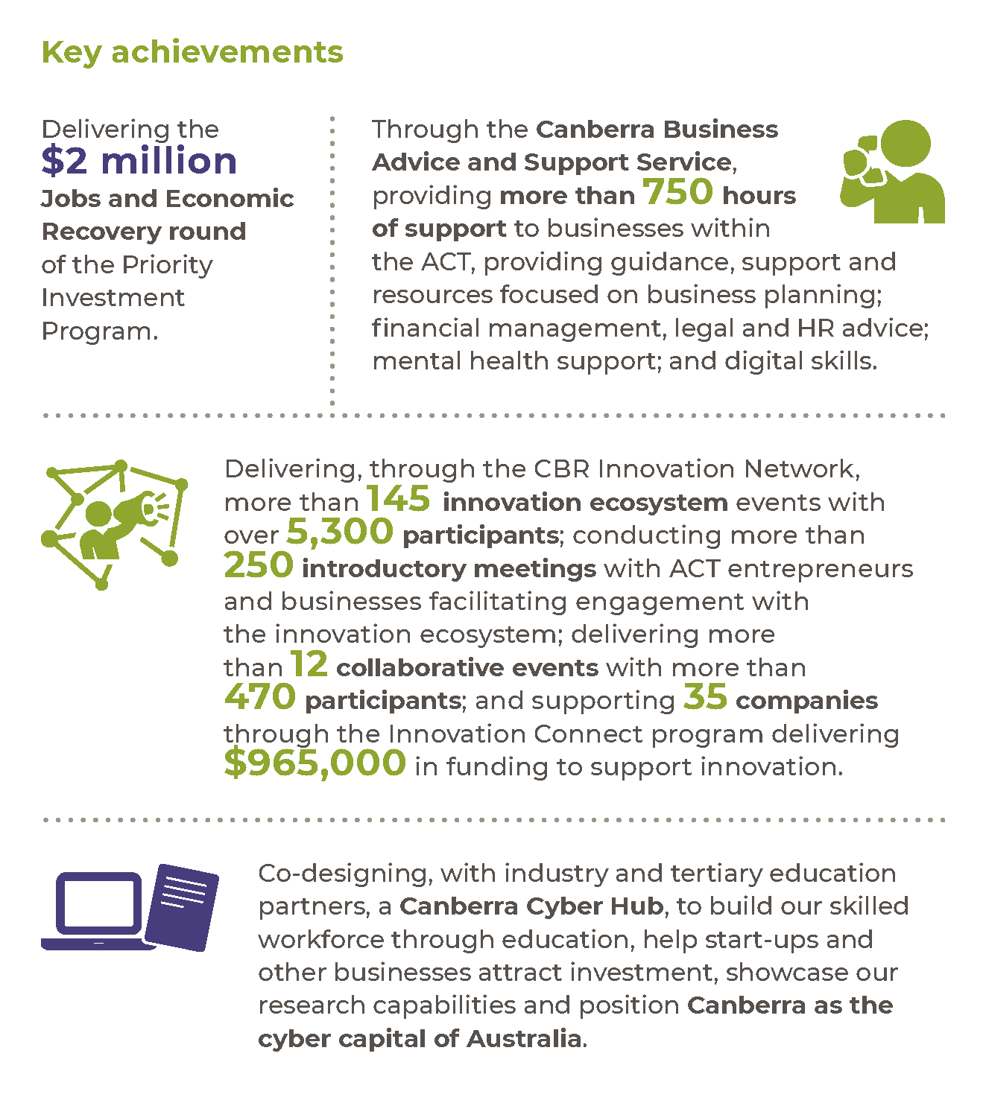

Highlights
In 2020-21 we worked with the Canberra Business Chamber and its associated organisations, along with AusIndustry Canberra and the CBR Innovation Network, to communicate and engage with businesses via regular business webinars and a specific communications campaign focused on small businesses. The Canberra Business Advice and Support Service was established with the Canberra Business Enterprise Centre, part of the Southern Region Business Enterprise Centre. We also established a business support service for Aboriginal and Torres Strait Islander businesses to provide a concierge service into the range of assistance programs available at the Australian and ACT Government levels.
Through the CBR Innovation Network we implemented new and modified initiatives, leveraging the innovation and entrepreneurial capacity of Canberra to assist during the COVID-19 crisis and in support of economic recovery. These initiatives included:
- Six Collaborative Innovation Labs focused on different sectors of the business and innovation community, including the creative arts sector, small business, and the visitor economy.
- Two COVID-19 streams of the Innovation Connect grant program.
Fifty scholarships to the Idea to Impact program.
We delivered the ChooseCBR Digital Discounts program in pilot form in December 2020. Nearly 48,000 customers registered to redeem vouchers at 336 participating businesses, with over $1.9 million in direct economic stimulus going to Canberra businesses. We launched a larger-scale program in June 2021, providing $5.2 million in economic stimulus to almost 800 businesses in the ACT. An independent review is being undertaken to evaluate the design and implementation.
In 2020-21, we also delivered the following initiatives:
- Priority Investment Program – During 2020-21 four projects were awarded funding support covering the sectors of building and construction, advanced manufacturing, cybersecurity/defence and screen in the $2 million Priority Investment Program Jobs and Economic Recovery Round.
- Future Jobs Fund – Announced as part of the 2020-21 ACT Budget, the Future Jobs Fund will access $2 million in the 2021-22 financial year to deliver the Territory’s commitments to support economic recovery and grow high value jobs in the ACT. The Future Jobs Fund will drive economic growth through talent attraction and supporting projects that create and protect local jobs in the tertiary education sector, research and development, and key sectors in the ACT. Policy development of the Future Jobs Fund has been ongoing through 2021, with new program elements to be launched in 2021-22.
- MADE IN CBR – Screen Canberra established the $250,000 MADE IN CBR fund to provide specific support to ACT screen professionals whose work and income were negatively impacted by the pandemic. During the period nine applications were approved for MADE IN CBR funding support, totalling $180,310.
- Location Incentive Scheme – The ACT Government has committed $500,000 towards a proof-of-concept program aimed at attracting high budget screen productions to the ACT. This collaboration with Screen Canberra will support its work promoting Canberra’s creative industries as a location for high value screen productions to create local jobs and contribute to the recovery and growth of our economy. The production in Canberra of major international film Blacklight in January 2021 successfully demonstrated Canberra’s suitability for productions of this scale.
- Academy of Interactive Entertainment – In August 2020 the ACT Government announced it had agreed on the terms of a direct sale of part of Block 1 Section 13 Watson (Canberra Technology Park) to the Academy of Interactive Entertainment (AIE). The decision will see investment of around $200 million in new construction over approximately 20 years, consolidating AIE’s Global Headquarters in Canberra and delivering a world-class education and training facility. AIE undertook community consultation on the development during 2020 and 2021 and continues working with government to establish how the stages of development will be progressed.
- University of New South Wales (UNSW) Canberra City Campus – Following the March 2020 announcement of the establishment of the UNSW Canberra City Campus, the ACT Government and UNSW have continued working together to progress development of the Campus Master Plan. UNSW delivered a range of community engagement activities during 2020 and 2021, which showed wide ranging support for the Draft Master Plan and continued support for the project. UNSW will continue to engage with the ACT Government and the National Capital Authority to progress approval of the master plan.
- Canberra Cyber Hub – in April 2021 the ACT Government committed $700,000 to establish the Canberra Cyber Hub, leveraging Canberra’s high concentration of cyber security stakeholders and research and development capabilities. The Canberra Cyber Hub is being co-designed and delivered by industry, to grow Canberra’s cyber security education pathways. The Hub will enhance growth opportunities for local cyber security small and medium sized enterprises (SMEs) and further cement Canberra’s reputation as a leader in cyber security technologies.
- Defence and space advocacy – While many activities planned for 2020 were cancelled due to the COVID-19 pandemic, we delivered a Team Canberra exhibition at Land Forces 2021. As part of the ACT Government’s Team Canberra, 13 Canberra region SMEs and research organisations with strengths in research, cyber security, ICT integration and professional services attended, along with two ACT Defence Ambassadors to advocate Canberra’s defence industry capabilities.
Work Integrated Learning Pilot Program – In collaboration with the University of Canberra and the Australian National University, the ACT Government delivered work integrated learning units for students across the ACT. Aimed at improving students’ employability, the semester one pilot program allowed students to utilise their problem-solving skills while working in key industry sectors including the innovation ecosystem, advanced technology and manufacturing, and data integration.
International students – We provided financial and other support to international students based in Canberra who required emergency support during COVID-19. We also worked with universities on the development of a student return pilot. While there are delays to the return of international students, work continues to plan for the return of international students.
Office of International Engagement
The ACT Government established the Office of International Engagement (OIE) in 2016 to spearhead the growth of export and two-way trade activity, and build Canberra’s reputation in line with the 2050 Vision for Canberra, found in Canberra’s International Engagement Strategy. The OIE, under the direction of the Commissioner for International Engagement, coordinates all the Territory’s international engagement activity, and leads the delivery of trade missions, inbound delegations, and export-support programs. It also works with TradeStart to deliver export-advisory services to exporters in Canberra and the Canberra Region, the Canberra Business Chamber to deliver export education programs and activities, and leverages relationships with the Canberra diplomatic community to realise export opportunities. The OIE also helps to build and manage formal sister-city relationships, of which the ACT has three.
The export of services and goods from the ACT is critical to the growth and development of ACT businesses, and it is essential to the diversification of the ACT economy. Broader international engagement with the world – economically, scientifically, culturally and socially – is also important to building the Territory’s reputation as an attractive place to work, study, visit, and live. Specifically, attracting global talent to Canberra will be key to our building a vibrant economic future.

The global COVID-19 pandemic has created unprecedented challenges to international export activity and the flow of people between countries for business, social and other reasons. Notwithstanding disruptions to regional supply chains and elevated freight costs, the OIE continued in 2020-21 to assist exporters with approaches to delivering services and goods to existing and new marketplaces. It also continued to make important global connections between exporting firms and other stakeholders to enable activities abroad. The OIE was responsive to travel-bubble opportunities by delivering a trade mission to New Zealand in May 2021, and re-establishing in-person connections important to Canberra’s economic, cultural and social relationships, particularly related to the City of Wellington, with which Canberra has a formal sister-city relationship.
In the coming financial year, subject to global public health conditions, the ACT Government, through the OIE, will capitalise on anticipated travel bubbles by planning and delivering at least two trade missions. The OIE also plans to deliver virtual trade missions and other export-themed events in Singapore and other target country markets that align with Key Capability Areas of our economy, as outlined in Canberra’s International Engagement Strategy.
Further information
Brendan Smyth Commissioner for International Engagement
CIE@act.gov.au

Future direction
In 2021-22 we will deliver the following priority initiatives:
- Deliver the Future Jobs Fund, supporting tertiary education, research and key industries such as renewable energy, defence and space, and cyber-security. This will include a pilot Business Growth Program to support businesses in critical growth phase and invest in Canberra’s innovation capacity to support entrepreneurs, start-ups and high growth businesses.
- Develop and deliver a workforce attraction strategy, partnering with business, higher education and vocational education sectors to develop and attract skilled workers to meet future workforce needs and help grow local businesses.
- Implement a refined Aboriginal and Torres Strait Islander business support program, targeting the needs of the ACT’s Aboriginal and Torres Strait Islander business community.
- Implement the Canberra Cyber Hub harnessing Canberra’s unique cyber capabilities to create more jobs and further diversify the ACT economy.
- Continue to progress the development and finalisation of the UNSW Canberra City Campus Master Plan.
- Work with Screen Canberra to bring more screen productions to the Territory, showcasing Canberra to the world and enhancing Canberra’s branding as a cultural and international city.
Work with institutions and the Australian Government to return international students to Canberra.

Output 3.2 VisitCanberra

Overview
VisitCanberra creates and implements a range of innovative tourism marketing and development programs.
VisitCanberra delivers this output by partnering with local industry, national bodies, and attractions. These partnerships aim to support the Territory’s economic growth through increased visitation to the ACT and region.

Performance

Accountability Indicators
3 exceeded
We exceeded all three of our accountability indicators targets for this output, achieving above target results for the following indicators:
- 3.2a – ACT Accommodation Room Occupancy Rate.
- 3.2b – Canberra and Region Visitors Centre – overall visitor satisfaction with customer service levels.
3.2c – Number of visits to the ‘visitcanberra’ website.
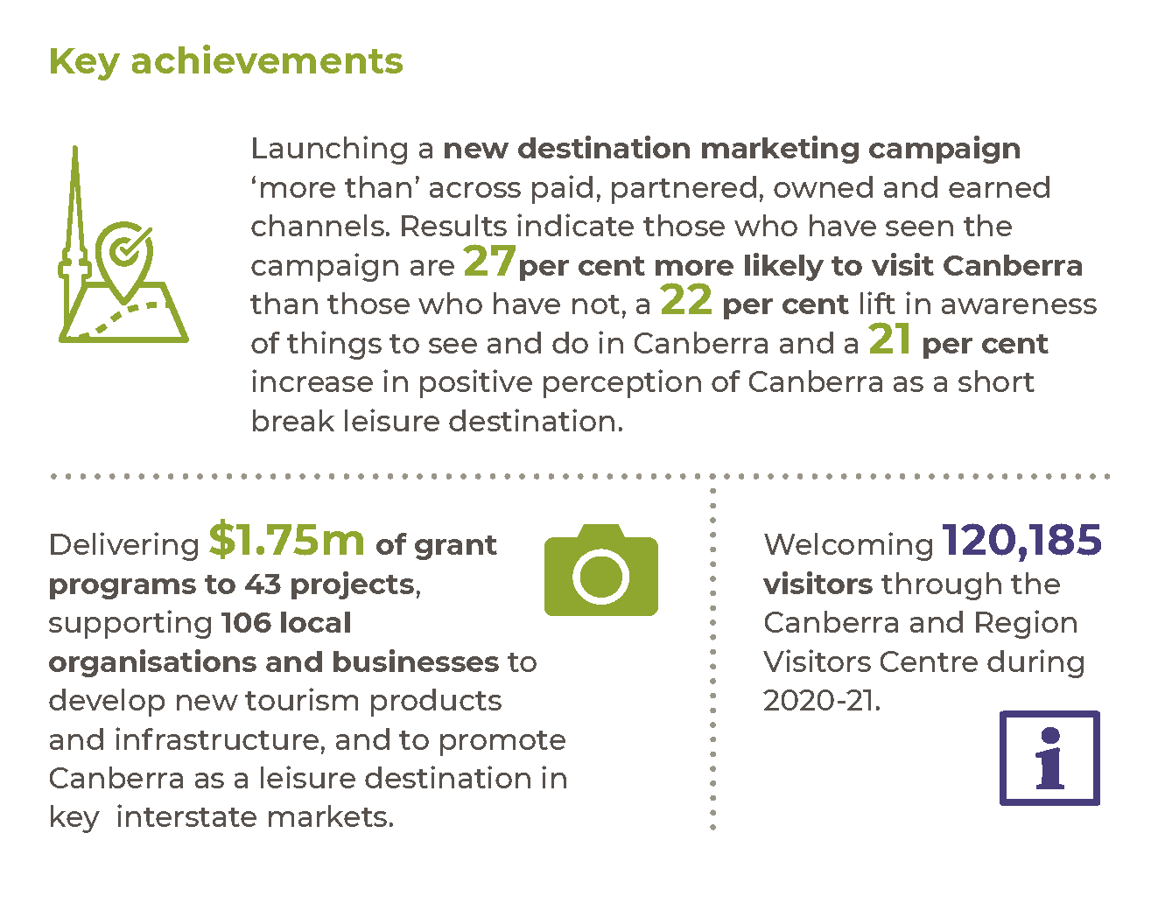

Highlights
In 2020-21 we were targeted in our approach to recovery. We launched the Framework for Recovery of the Visitor Economy in September 2020, which outlined our four focus areas:
- Restoring major access routes, particularly Canberra’s aviation network.
- Supporting development and delivery of quality events and experiences, which are key demand drivers for visitation to the ACT.
- Growing spend and visitation through destination marketing campaigns to build awareness of Canberra as a destination.
Supporting Canberra businesses through a range of initiatives to stimulate the local economy, such as grant programs, and relief to businesses.
We worked closely with Canberra Airport to support the recovery of the Territory’s aviation sector. By June 2021, and for the first time in over a decade, Canberra had direct flights to every capital city in the country and is now connected to more domestic destinations than ever before.
We also supported four major exhibitions and events through the 2020-21 Major Event Fund:
- Botticelli to Van Gogh at the National Gallery of Australia.
- Australian Love Stories at the National Portrait Gallery.
- Come From Away, which will open at the Canberra Theatre Centre in February 2022.
Ancient Greeks, which will open at the National Museum of Australia in December 2021.
In 2020-21 we launched our new destination marketing campaign platform, ‘more than’. This campaign has reached over 2.45 million people in our key markets of Sydney, Melbourne, regional NSW and Victoria, and south-east Queensland.
We also delivered the following initiatives to promote Canberra:
- Managed major long-term content partnerships to promote the capital as the ultimate short break destination – with popular Australian publishers Concrete Playground and Urban List.
- Worked with conversion partners to expand the reach of our campaigns and drive to book travel, including Expedia Group, Qantas Hotels, Link Airways, Fly Pelican, Alliance Airlines and Virgin Australia.
- Hosted 20 domestic media outlets as part of VisitCanberra’s Visiting Journalist and Influencer Program. We showcased a wide variety of Canberra product in the itineraries and promoted events.
Launched the refreshed canberra.com.au website to support and attract investors, students and new residents to Canberra.
In 2020-21, we delivered industry grant and support programs to assist with investment in infrastructure, to drive demand through promotions and marketing, and to build resilience. These included:
- The Tourism Cooperative Marketing Fund – The fund encouraged Canberra-based businesses to collaborate on innovative marketing campaigns to increase awareness of Canberra and the region as a leisure destination, and drive demand. A total of 24 projects were funded by the grant, supporting 86 businesses, to the value of $480,108.
- The COVID-Safe Tourism Co-investment Program – The program provided funding for the development of COVID-Safe tourism products and infrastructure following the impact of bushfires and COVID-19. A total of 15 projects were funded to the value of $750,000. Projects are due to be completed by 30 June 2022.

The Tourism Reboot program – The program was developed following feedback from industry on the development support they were looking for after the events of 2020. Tourism Reboot is designed to rebuild capability in the areas of marketing, product and experience development, and tourism distribution. A total of 140 representatives from a range of tourism, hospitality and events businesses registered for the program and engaged across eight learning modules and mentoring sessions.
We promoted Canberra and trained tourism travel trade representatives both domestically and internationally by:
- Participating in four virtual business-to-business tourism travel trade events domestically and internationally Australia Marketplace China (December 2020), Australia Marketplace UK/Europe (November 2020), Australia Marketplace USA (October 2020) and ATEC Meeting Place (November 2020) – including 123 one-on-one appointments with domestic and international travel trade representatives.
- Participating in the Australian Tourism Exchange (ATE) 2021 Live event and ATE Online event, attending more than 90 one-on-one appointments with domestic and international tourism travel trade representatives.
- Delivering 33 webinars and other training activities to a collective audience of more than 3,700 tourism travel trade representatives across the following markets: Australia, China, France, Hong Kong, India, Germany, Indonesia, Korea, Malaysia, New Zealand, Singapore, United Kingdom and United States.
- Participating in the Aussie Specialist program, with 1,584 Aussie Specialist travel agents completing the ACT online training module from July 2020 to March 2021 across international markets including: India, Indonesia, Japan, Malaysia, New Zealand, Singapore, South Korea, United Kingdom, and United States.
Hosting one familiarisation program for four travel agents and travel trade partners prior to ATE 2021 commencing.

Future direction
In 2021-22 we will support the growth of the visitor economy by delivering initiatives that raise awareness of Canberra as a destination and increase visitation to the city, including:
- Continuing the delivery of Canberra’s domestic marketing platform, and working with partners to extend reach, drive bookings, disperse visitors across a range of experiences and attractions and increase advocacy for the destination.
- Continuing our engagement with key markets to support the return to Canberra of tourists, international students, and businesses when possible.
Promoting demand-driving activities, including major events that attract travellers from our target markets.
Our plans to support the growth of the visitor economy are laid out in VisitCanberra’s Framework for Recovery of the Visitor Economy and Action Plan for Recovery. In 2021-22 we will also continue to:
- Work closely with industry, including through our grants programs, to support the development of new tourism products and infrastructure, and promote of Canberra as a destination, aligning where possible to Canberra’s unique selling point and brand.
- Pursue opportunities to grow domestic and international aviation capacity, establishing new routes and attracting new carriers.
- Invest in the Major Events Fund to support events with the ability to drive significant visitation.
Work on the refresh and launch of our new consumer facing website aimed at visitors to Canberra – visitcanberra.com.au.

Output 3.3 Sport and Recreation

Overview
Through the Sport and Recreation output, we support Canberra’s participation in organised sport and recreation through delivery of programs, facilities, and pathways.
Sport and Recreation delivers this output by:
- Providing support services to local high-performance athletes.
- Administering grants and delivering education and training opportunities to maintain and enhance the capabilities of the community sport and recreation sector in the ACT.
- Planning and developing sporting infrastructure to broaden access to participation opportunities.
Partnering with elite teams to engage the community in sport and recreation.

Performance

Accountability indicators
2 exceeded
We exceeded our targets for both accountability indicators for this output, exceeding our target for:
- 3.3a – Number of nationally identified priority athletes supported by the ACT Academy of Sport – We achieved 134 against a target of 120 scholarships. The increase is primarily due to additional netball athletes being serviced through commercial arrangements after the Netball Program partnership and scholarships ceased on 31 March 2021.
3.3b – Number of organisations funded to support participation opportunities in sport and recreation – We exceeded our target of 80, supporting 89 organisations through the annual grants program.
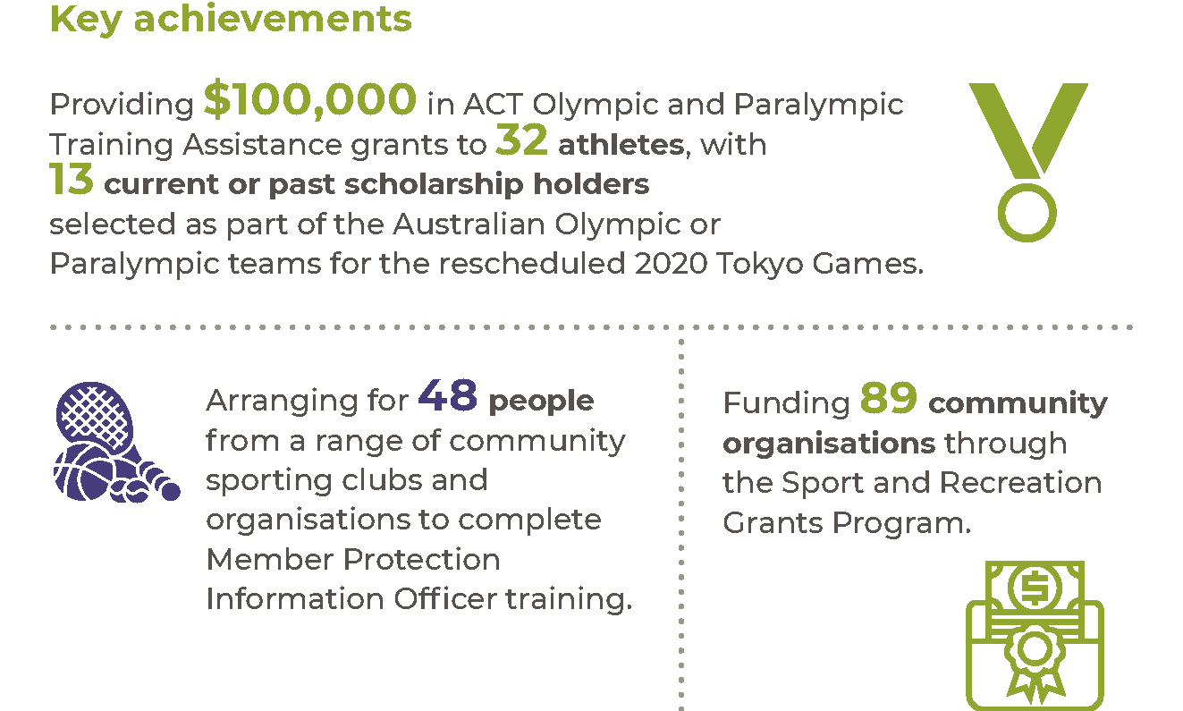

Highlights
The sport and recreation sector faced many challenges returning from an enforced shutdown due to the COVID-19 pandemic. Sport and Recreation provided continued support and leadership to the sector to return to a new sense of normal, including advice regarding the ongoing application of health directions during the progressive return of sport and physical activity.
COVID-19 presented challenges to the delivery of many programs and events in 2020-21, including Olympic and Paralympic preparations. Sport and Recreation made changes to many planning processes and showed flexibility in meeting the sector’s needs. The difficult year was not without its highlights, which included:
- Delivery of an online 2020 CBR Sport Awards event which, despite the constrained level of activity and events across the sector, still attracted almost 50 nominations.
- Through the ACT Academy of Sport, performance service support for 134 nationally identified ACT athletes from Olympic, Paralympic and Commonwealth Games sports. Performance services include coaching, strength and conditioning, psychology, nutrition, sports science, and sports medicine coordination.
- Support of key community projects funded through the Sport and Recreation Grants Program including:
- Installation of a solar power system at Phillip Oval.
- Continued development of mountain bike trail works in the Cotter Precinct.
- Funding to Australian Sailing for the “She Sails” Leadership program.
- Shading infrastructure work at the Hawker Softball Centre.
- Support for Cyclabilities and Waterabilities programs targeting children with autism.
- Construction of a vertical challenge facility at Mt Taylor Scout Group.
- Releasing the Strategic Review of Bowls in the ACT, in partnership with Bowls ACT, which seeks to highlight future opportunities and challenges for the sustained delivery of the sport in the ACT.
- Delivering education opportunities regarding the inclusion of members of the LGBTIQ+ community in sport, supporting eight peak sporting organisations to join and work with Pride in Sport to benchmark current performance, and to identify and progress areas for practical improvements to enhance the inclusion of the LGBTIQ+ community.
Continued to support governance reform/improvement work across the sector, including key projects with Basketball, Netball and Athletics.
We worked across Canberra’s elite sporting team landscape to understand the continued impacts of the pandemic on their activities and business models. We provided timely advice around health directions and government support to ensure that each was best positioned to make informed decisions.

Future direction
In 2021-22 we will continue to work to deliver key government priorities including:
- Completing or progressing design work for a new home for Dragon Boating at Grevillia Park, a new Gungahlin Tennis Centre in Amaroo, a District Playing Field at Stromlo Forest Park, and a Home of Football at Throsby.
- Completing a full review of the Sport and Recreation Grants Program.
- Consulting on the development and release of a new government strategic plan for sport and recreation.
Supporting ACT athletes within the Australian team competing in the Birmingham 2022 Commonwealth Games.

Output 3.4 Events

Overview
Through the Events output we manage, support and deliver signature events for visitors and the community.
Events ACT delivers this output through key events including:
- Floriade and Floriade NightFest (noting that an alternative Floriade: Reimagined event was delivered in 2020-21 given the impacts of COVID-19).
- The Canberra Nara Candle Festival.
- New Year’s Eve celebrations.
- The Enlighten Festival (incorporating Illuminations, Lights!Canberra!Action!, Canberra Day celebrations, Symphony in the Park and the Canberra Balloon Spectacular).
Reconciliation Day in Canberra.
We also provide grant funding assistance to external event organisers through programs including the ACT Event Fund as a means of supporting event development and delivery outcomes across the Canberra region.

Performance

Accountability indicators
1 exceeded 6 not met or not measured
Due to the ongoing impacts of COVID-19 we did not meet or were unable to measure the following accountability indicator targets:
- 3.4a (i) – Attendee satisfaction rating for New Year’s Eve celebrations – The traditional fireworks and concert event for Canberra's 2020 New Year’s Eve celebrations was cancelled due to COVID-19. We implemented alternative festivities to celebrate New Year's Eve in Canberra.
- 3.4a (ii) – Attendee satisfaction rating for Australia Day activities – The traditional Australia Day fireworks and concert event delivered by Events ACT was cancelled for 2021 due to COVID-19. Australia Day celebrations in Canberra were instead delivered by the National Capital Authority.
- 3.4a (iii) – Attendee satisfaction rating for the Canberra Nara Candle Festival – The Canberra Nara Candle Festival was not held due to COVID-19. Instead, a private ceremony was held at the Japanese Embassy and we coordinated the Canberra Nara Foodie Weekend.
- 3.4a (iv) – Attendee satisfaction with Canberra Day – Canberra Day activities were delivered on Monday 8 March 2021 as part of the 2021 Enlighten Festival (in a COVID-safe format). The attendee survey returned a satisfaction rating of 77.5 per cent, below the target of 80 per cent.
- 3.4b – Economic activity generated as a result of staging Floriade – The traditional Floriade event staged in Commonwealth Park was cancelled for 2020 due to COVID-19. We instead developed the Floriade: Reimagined program, with planting displays located around Canberra for the benefit of the local community. Interstate and international visitors were not a target audience for the reimagined format so the economic impact was not applicable.

3.4c – Economic activity generated as a result of staging the Enlighten Festival – Direct visitor expenditure generated as a result of the 2021 Enlighten Festival was $0.5 million, below the accountability indicator target of $3 million. We delivered the 2021 Enlighten Festival in a revised COVID-safe format approved by the Chief Health Officer, which included venue capacity restrictions and attendee pre-registration for free tickets. This significantly limited the attendance capacity when compared to the traditional Enlighten Festival format. Given the strict capacity limitations, our marketing efforts were also targeted more heavily towards a local audience.
We exceeded our accountability indicator target for 3.4d – Satisfaction with the management of Events grants in the ACT. We achieved a satisfaction figure of 90 per cent against a target of 80 per cent.
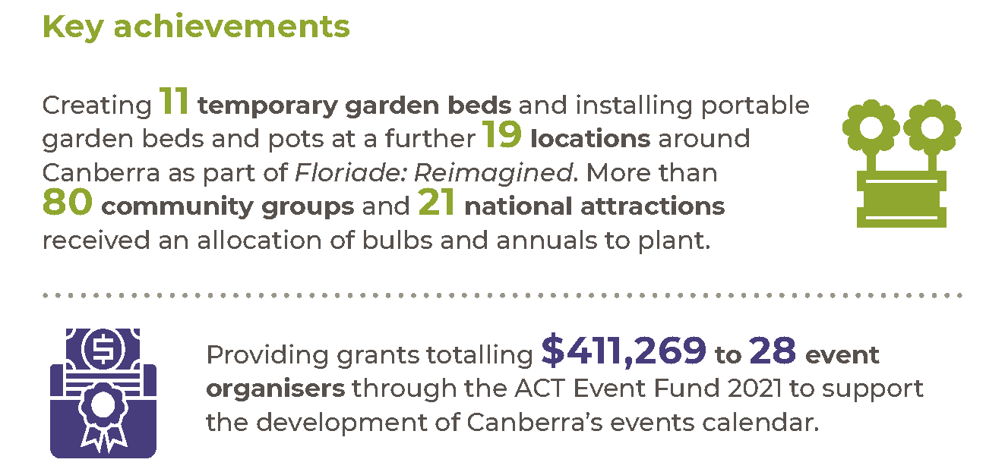

Highlights
In 2020-21 we continued to support the events sector and associated stakeholders during the ongoing COVID-19 pandemic.

Where You Are Festival
To connect Canberrans and visitors through event activity, we staged the Where You Are Festival as part of the RISE Canberra program to provide economic stimulus to the events sector. The festival provided funding to 20 of Canberra’s creators to provide 60 individual online and physical events from July to September in 2020. The festival featured unique Canberra experiences across arts and culture, music, ideas and forums, community and food. The Where You Are Festival achieved a total attendance of almost 150,000 made up of physical engagement (3,758) and digital engagement (145,486). Based on survey feedback, almost 90 per cent of attendees indicated a positive response to their experience and 73 per cent said the event ‘helped me cope better with life during the COVID-19 pandemic’.

Canberra Nara Candle Festival
We adapted the Canberra Nara Candle Festival from its traditional public event format in Canberra Nara Peace Park due to ongoing event restrictions. A small group of dignitaries and invited guests instead marked the 27th anniversary of the Canberra-Nara Sister City relationship at a reception held in the gardens of the Japanese Embassy. In addition to the reception, the Itadakimasu Canberra Nara Foodie Weekend was held from Thursday 22 to Sunday 25 October 2020.

This initiative encouraged Canberrans to engage with Japanese culture and cuisine by supporting 23 local Japanese restaurants and eateries over the weekend that the Canberra Nara Candle Festival would normally be held. Events ACT provided marketing support for participating restaurants through radio and print advertising, promotion via the event website, social media posts and branded candles for display over the weekend.

New Year’s Eve celebrations
We facilitated an alternative format for New Year’s Eve celebrations following the cancellation of the traditional city-based fireworks and concert event due to COVID-19. Instead, we activated popular eat streets in five town centres to encourage the community to celebrate locally. Over the three evenings in the lead up to the new year, countdown clocks were projected onto buildings, atmospheric lighting was installed, and a roster of local musicians was engaged to perform at each location. This activity helped generate vibrancy in town centres while providing economic benefits to local artists, event suppliers and restaurants that had been heavily impacted by COVID-19.

Floriade: Reimagined
We delivered Floriade: Reimagined between 12 September and 11 October 2020. Given the impact of COVID-19 on mass gatherings, the festival program was reimagined to distribute flowers around Canberra rather than in Commonwealth Park, so that locals could enjoy the colour and vibrancy of Floriade closer to home. Floriade: Reimagined saw the creation of 11 temporary garden beds by the Transport Canberra and City Services horticultural team and the installation of portable garden beds and pots at a further 19 locations around Canberra. As part of the Floriade Community program in 2020, more than 80 community groups received an allocation of bulbs and annuals to plant and maintain in their local area – including schools, sporting clubs and residents’ groups. A further 21 national attractions, education institutions and public facilities, such as hospitals, participated in the program to produce larger scale plantings.
Image 6: Floriade display at Canberra Hospital

2021 Enlighten Festival
We successfully staged the 2021 Enlighten Festival. The festival was the first large-scale, multi-day festival to be approved by the Office of the Chief Health Officer and delivered in Canberra under a COVID-safe exemption. In line with the festival’s exemption, this included limits on attendance and a need to pre-register for tickets to defined event precincts. Although the festival did not meet its economic activity target for spending by interstate visitors, it did generate almost $3.4 million of spending activity, providing valuable stimulus to local businesses in the Canberra region.

Other activities
In 2020-21 we provided grants totalling $411,269 to 28 event organisers through the ACT Event Fund 2021 Main Round, Community Event Funding stream and Out-of-Round funding allocation to support the development of Canberra’s events calendar.
We established the ACT Winter Event Fund to boost event activity in Canberra over the 2021 winter period and to test how the proposed themes and pillars for the 2022 Winter Innovation Festival resonate with audiences. Through the ACT Winter Event Fund, the ACT Government is supporting the delivery of 12 arts, innovation, and entrepreneurship events that will take place across Canberra in July and August 2021.
We also delivered to the fourth annual Reconciliation Day event on 31 May 2021. This event is discussed in further detail in the Aboriginal and Torres Strait Islander Reporting section.

Future direction
In 2021-22 we will continue to monitor the changing events landscape in light of COVID-19 to ensure that major and community event activities can be safely adapted or delivered in new and unique ways. We will also continue to actively support the local events sector with strategic advice and grant funding support.
In support of these focus areas, we will:
- Finalise development of the Floriade and Enlighten Festival Major Event Strategies for the period 2023-2027.
- Continue development of a new winter innovation festival to be held in winter 2022 (postponed in 2021 due to COVID-19). The new festival will drive visitation over the winter period and position Canberra as a vibrant, future-focused city by promoting the ACT’s strengths in arts and innovation.
- Continue to develop and enhance our online/digital platforms for supporting major and community events activities.
Continue to support the ACT events and festivals sector through delivery of the ACT Event Fund, sector development workshops and through provision of general planning advice and support as event organisers regroup and recover from the impacts of COVID-19.

Output 3.5 Arts Engagement

Overview
Through the Arts Engagement output we implement the ACT Arts Policy.
The artsACT business area implements the Policy by:
- Facilitating participation in and access to the arts by working in partnership with the community and the arts sector to fund, enable and deliver arts activity and programs.
- Supporting great art and great artists by funding and promoting Canberra art and artists.
- Supporting and recognising the vitality of the Canberra Region arts ecology.
Engaging with Aboriginal and Torres Strait Islander arts and cultures.

Performance

Accountability indicators
2 exceeded 2 not met
We exceeded two of our accountability indicator targets and did not meet the following targets:
- 3.5c – Satisfaction with the management of grants administered by artsACT – We achieved 78 per cent against a target of 80 per cent. ArtsACT surveys both successful and unsuccessful grant applicants for this measure. In 2020-21 the number of applicants and call on funding far exceeded successful grantees and available funds. This may have resulted in a marginally higher rate of dissatisfaction.
3.5d – Number of attendees at programs delivered by Key Arts and Program funded organisations – The target was 350,000 and result achieved was 201,000. The variance is due to the impact of COVID-19 and consequent restrictions on audience numbers and programs delivered by artsACT funded organisations.
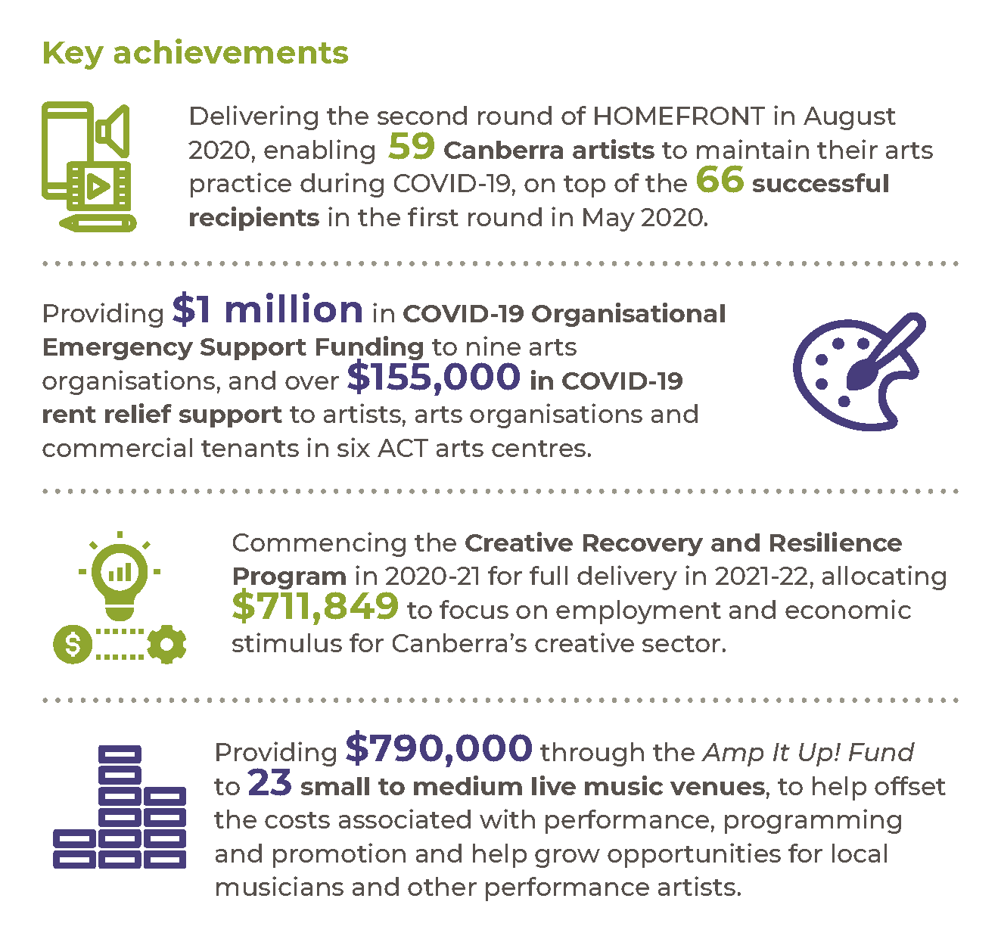

Highlights
In 2020-21 we responded to COVID-19 by:
- Delivering the second round of HOMEFRONT in August 2020, enabling 59 Canberran artists to maintain their arts practice during COVID-19, on top of the 66 successful recipients in May 2020 who received $500,000.
- Providing $1 million in COVID-19 Organisational Emergency Support Funding to nine arts organisations, and over $155,000 in COVID-19 rent relief support to artists, arts organisations and commercial tenants in six ACT arts centres.
- Delivering the Amp It Up! Fund which supported 23 small to medium live venues by providing $790,000 towards the costs of programming, performance and promotion. The fund covered payments to artists and technicians, and for up to 50 per cent of marketing costs.
- Providing $375,000 for removal of hazardous materials at Watson and Belconnen Arts Centres, a new shade structure for outdoor events at the Tuggeranong Arts Centre and a projector for digital artwork at Belconnen Arts Centre as part of the Fast Track program.
Commencing the $711,849 Creative Recovery and Resilience Program in 2020-21 for full delivery in 2021-22. The program was designed to focus on employment and economic stimulus for the creative sector in the process of recovery, and building of resilience. The program includes a series of Residencies, a Creative Recovery and Resilience Forum and a collaboration laboratory connecting artists with marketing and communications professionals for skills exchange.
In 2020-21 we also:
- Completed the commissioning process for the $15 million Belconnen Arts Centre Stage 2. Works were completed as part of the Budget initiative More and better jobs – Expanding Belconnen Arts Centre. The expansion includes a flexible theatre space with back-of-house facilities, a dance and rehearsal studio space, a new gallery, an events kitchen, and a café space. Through this project we supported the local economy with 42 local businesses (150 individuals) working on construction.
- Delivered over $11 million in arts funding to artists, arts groups and arts organisations.
- Commenced a pilot of using the Cultural Development Network Measurable Outcomes Schema for HOMERONT funding acquittals.
- Continued work on the $5.9 million major upgrade project at the Former Transport Depot, Kingston.
- Continued work on the $1.68 million Upgrading Local Arts Facilities project, including works at Ainslie Arts Centre and Gorman House Arts Centre.
- Lead the engagement process with arts organisations who will be relocating to the future Kingston Arts Precinct, focusing on design development and establishing governance structures.
- Completed repairs and maintenance of the public art collection managed by artsACT including an intensive clean of the collection.
- Delivered a range of government budget initiatives including pop up arts activities and events in Woden and Gungahlin.
- Delivered two rounds of $5,000 to $50,000 arts activities funding for a range of arts activities and projects, with a total of $670,000 to 21 recipients.
Delivered an ongoing program for up to $5,000 arts activities funding for a diverse range of arts projects, with a total of $187,000 to 49 recipients.

We continued to manage funding agreements to:
- 25 arts organisations in the ACT that provide key programs and services to support and develop artists and enable the ACT community to strongly engage with the arts.
13 ACT arts facilities that provide critical infrastructure to support artists and arts organisations, and to enable the ACT community to strongly engage with the arts.

Future direction
In 2021-22 we will continue to support the arts sector’s recovery from the impacts of COVID-19, supporting the community through the implementation of the ACT Creative Recovery and Resilience program. The program will support the economic, social and mental wellbeing of the Canberra community as we emerge from the COVID-19 pandemic.
We will also continue to:
- Lead the process for relocation of arts organisations to the future Kingston Arts Precinct.
- Lead capital works projects and upgrades at arts facilities. This will include the final design for capital improvements at the heritage-listed Ainslie and Gorman House Arts Centres, and the completion of critical works related to aged electrical systems.
- Deliver Arts Funding programs, with grants for arts activities worth up to $5,000 and between $5,000 to $50,000.
- Deliver the ACT Book of the Year award.
- Develop programs to engage with Aboriginal and Torres Strait Islander arts and cultures.
Consult with the sector on the development and delivery of a new arts policy for the ACT and a new funding model for arts organisations.

Output 3.6 Higher Education, Training and Research

Overview
Through the Higher Education, Training and Research output we partner with tertiary education institutions to support the growth and development of the sector.
Tertiary Education and Research, and Skills Canberra deliver this output by:
- Managing government-funded vocational education and training (VET) in the Territory.
- Administering, monitoring and auditing Territory and national funds for a variety of skills development programs.
Promoting Canberra as Australia’s study destination of choice for international, interstate and local students and driving continuous improvement in Canberra’s student experience.

Performance

Accountability indicators
9 met or exceeded 4 not met

We met or exceeded nine of our accountability indicator targets for this output. We did not meet our target for the following four indicators:
- 3.6b (ii) – Participation rate of 15-64-year-olds in VET – Aboriginal and Torres Strait Islander students – The target was 13.4 per cent and the result was 13.1 per cent. The participation rate of 15–64-year-old Aboriginal and Torres Strait Islander students was more than double the overall participation rate of all 15–64-year-olds engaged in vocational education and training in the ACT.
- 3.6c (ii) – VET graduate outcomes after training – Employed after training or in further study – The target was 92 per cent and the result was 86 per cent. The COVID-19 pandemic and the associated economic downturn has impacted employability outcomes for graduates. All states and territories experienced a decrease in outcomes for this measure.
- 3.6e (i) – Skilled Migration Attraction and Facilitation - Employer Sponsored Nominated – We targeted 100 employer nominations supported by the Regional Certifying Body (Skills Canberra) and achieved a result of 28. Border closures and the economic impacts of COVID-19 likely impacted program numbers in the reporting period. In addition, changes to visa criteria as a result of the Australian Government visa reform program in 2018-19 reduced the pool of available skilled workers who could be sponsored by employers, as they did not meet the new subclass 494 visa criteria.
- 3.6e (iii) – Average number of monthly visits to Canberra. Create Your Future website – The decrease in visits (980 views against a target of 15,000 views) is due to redirection of traffic to the replacement Canberra.com.au website.
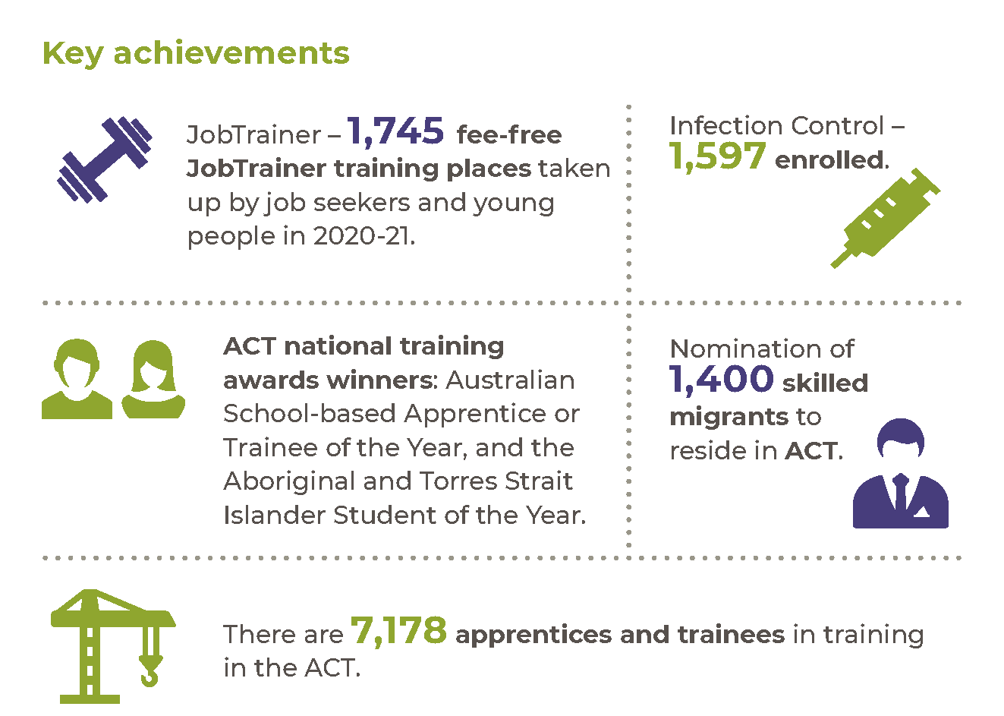

Highlights
In 2020-21, we undertook a range of activities to promote and support the growth of the higher education, training and research in the ACT, including:
- Receiving $5.162 million from the Australian Government for meeting all targets and milestones under the National Partnership on the Skilling Australians Fund.
- Implementing the national JobTrainer Fund, providing an additional $16.75 million to deliver free vocational education and training places to job seekers and young people in the ACT (1,745 enrolments).
- Allocating $990,000 under the Future Skills for Future Jobs Grants Program for six innovative projects aiming to increase the number of Australian Apprenticeship commencements in the ACT.
- Allocating $188,150 under the ACT Adult Community Education Grants Program for five projects delivering quality foundation skills training to Canberrans experiencing barriers to learning, training and work.
- Increasing apprenticeship and traineeship commencements by 20.5 per cent, and in-training numbers from 6,221 to 7,049 (between June 2020 and June 2021).
- Increasing the number of apprentices and trainees in the building and construction sector from 2,397 in 2020 to 2,525 in 2021 (an increase of 6 per cent).
- Increasing the proportion of women undertaking apprenticeships and traineeships in building and construction from 4.7 per cent to 5.8 per cent.
- Continuing to fund the Wage and Entitlements Information Service, to assist employers, parents, apprentices and trainees to understand their entitlements and obligations under the Fair Work Act 2009 (Cth).
- Visiting 1,207 apprentices and trainees, and their employers, to ensure all parties were abiding by their obligations under the training contract.
- Releasing 1,621 Skilled Capital training places in May 2021 in over 90 qualifications and skill sets.
- Continuing to deliver free infection prevention and control training for the ACT workforce under the National Infection Control Training Fund (1,597 enrolments).
- Finalising an inter-governmental agreement between the ACT and NSW to reduce red-tape associated with the registration of Group Training Organisations operating in both jurisdictions.
- Nominating 1,400 Canberra residents, who were working in occupations critical to economic recovery from COVID-19, for a skilled migration visa.
- Nominating 25 overseas businesspeople to invest, in total, $13 million in establishing or purchasing a business in Canberra.
- Establishing an emergency relief fund to support vulnerable international students who did not qualify for JobKeeper or JobSeeker.
- Maintaining engagement with student recruitment agents in key student markets, such as India and Vietnam, to ensure Canberra will remain a competitive student destination.
- Updating and improving Study Canberra’s destination attraction materials for use by institutions and recruitment agents.
Supporting tertiary education providers’ student experience events, such as Open Days and Orientation Week.

Future direction
In 2021-22, we will ensure the ACT vocational education and training system can continue to respond to the needs of workers, businesses, jobseekers and unemployed people as they respond to the challenges of COVID-19.
We will ensure the ACT Migration Program is focused on targeting and attracting highly skilled workers to work in critical occupations.
In 2021-22 we will also:
- Continue to deliver free training places under the Infection Control programs to support customer-facing workers in the ACT.
- Deliver up to 2,500 free additional training places for eligible Canberrans under the extended and expanded JobTrainer Program.
- Work with the Australian Government and other jurisdictions on vocational education and training system reform and a new National Skills Agreement.
- Continue to subsidise training in skills needs areas through the Skilled Capital, User Choice, JobTrainer, Infection Control and grants programs.
Continue to efficiently manage the ACT’s Migration Program to ensure the best economic and social outcomes for the ACT, including workforce attraction and population growth.
Further information – Outputs 3.1-3.6
Kareena Arthy Deputy Director-General, Economic Development
(02) 6207 556 Kareena.Arthy@act.gov.au

Output 4.1 Economic Management

Overview
The Economic Management output incorporates provision of economic and revenue modelling, analysis and advice to the ACT Government and agencies, coordination of engagement on federal financial relations matters, management of financial assets and liabilities (including borrowings, superannuation and insurance), and provision of insurance policy advice and administration of the Motor Accident Injuries and Lifetime Care and Support schemes.
Economic and Financial Group delivers this output by:
- Monitoring and providing advice on the state of the ACT economy.
- Preparing economic and fiscal modelling and providing economic forecasts and revenue forecasts for own source revenue.
- Undertaking analysis and modelling to provide short, medium and long-term demographic projections.
- Publishing tax expenditure statements.
- Facilitating the development and review of taxation reform.
- Providing advice on economic policy, competition reform, cost of living and industry sectoral matters, including economic regulation of water and energy markets.
- Contributing to the development and review of climate action reforms, including vehicle emissions reductions.
- Providing economic modelling and policy support, including in the areas of health, disability, and skills.
- Proving advice on federal financial relations matters, and coordinating and contributing to:
- Heads of Treasuries, Board of Treasurers and Council on Federal Financial Relations processes.
- ACT Government involvement with the Commonwealth Grants Commission.
- Providing advice on the performance of selected government entities, including emerging issues and associated corporate governance arrangements.
- Providing insurance policy advice and regulating the Motor Accident Injuries (MAI) Scheme.
- Administering the Lifetime Care and Support (LTCS) Scheme.
Managing the Government’s borrowings, investments, cash and liquidity needs and the unfunded employer superannuation liabilities through the Territory Banking Account and the Superannuation Provision Account.

Performance

Accountability indicators
4 met or exceeded
We met or exceeded all four accountability indicators targets for this output, including exceeding our targets for the following indicators:
- 4.1a – Briefings on the ACT economy (165 briefings against a target of 105). We prepared additional economic briefings on both new and more frequent data releases from the Australian Bureau of Statistics.
4.1c – Coordinate government participation in intergovernmental Treasury fora (37 meetings against a target of 7). There were more Ministerial and Heads of Treasuries meetings held to consider the economic effects of COVID-19 and discuss responses by all levels of government.
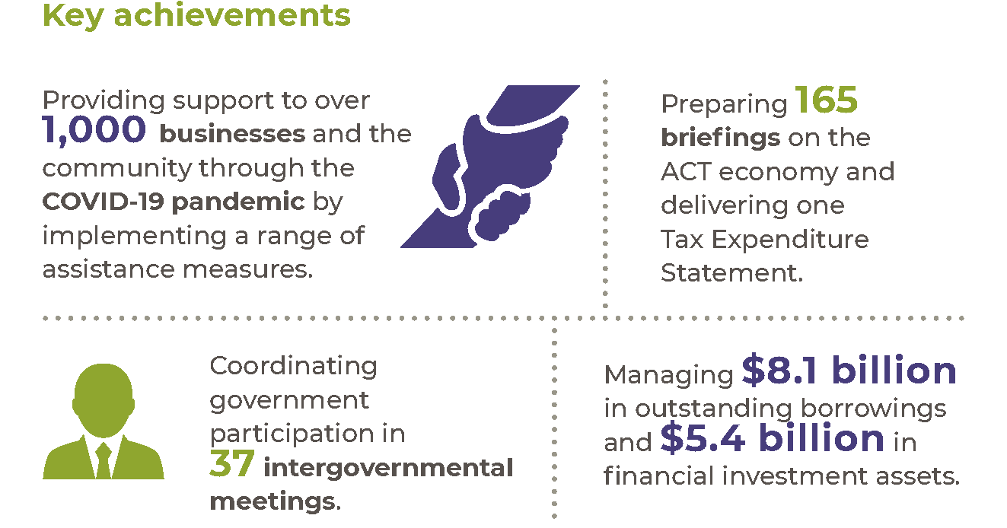

Highlights
In 2020-21 we supported the recovery of the economy and jobs from the impacts of COVID-19 by:
- Developing and facilitating the extension of a range of revenue and concession measures to support the economic recovery and jobs.
- Contributing to the August 2020 Economic and Fiscal update and the 2020-21 ACT Budget outlining the ACT’s economic performance during the COVID-19 pandemic.
- Continuing to monitor the economy and provide economic and revenue analysis and forecasts and briefing to support advice to government on economic impacts from COVID-19.
- Working collaboratively with the Australian Government and our state and territory counterparts to develop economic and financial responses to the COVID-19 pandemic.
Finalising analysis of the Government’s ongoing tax reform program on the economy, the revenue base, and Canberrans across the income distribution, and provided advice on the settings for stage three of the program that commenced in 2021-22.
In 2020-21 we also:
- Worked with the ANU School of Demography to develop a new demographic model for the ACT that will facilitate the development of population projects.
- Contributed to the development of the Wellbeing dashboard, by developing indicators and measures for the economic and living standards domains.
- Made it easier for consumers to compare energy deals by implementing a reference price.
- Produced the Tax Expenditure Statement for the 2019-20 financial year, enabling the community to understand the scope and financial implications of various concessional tax treatments.
- Continued to engage with the Commonwealth Grants Commission, including as part of its 2021 update of the GST Revenue Sharing Relativities work program, and provided advice to government on the implications of the update for the ACT’s GST share.
- Participated in the development of funding agreements and reform options for federal financial relations, including sponsoring reform papers for the Council of Federal Financial Relations and facilitating increased engagement and collaboration across jurisdictions and between central and portfolio agencies.
- Continued to implement the Motor Accident Injuries (MAI) Scheme following its commencement on 1 February 2020, including developing guidelines to support the Scheme and assist insurers to manage the delivery of defined benefits under COVID-19 public health restrictions.
- Supported the functions of the MAI Commissioner (see annexed MAI Commissioner Annual Report) and LTCS Commissioner of the ACT (see annexed LTCS Commissioner Annual Report).
Managed the functions of the Territory Banking Account (see Output EBT 1 Territory Banking Account) and the Superannuation Provision Account (see Output EBT 1 Superannuation Provision Account) and managed the centralised investment administration structure for Territory financial investment assets.

Future direction
In 2021-22 we will continue to support the ACT economy as it transitions from the effects of COVID-19 by:
- Monitoring and advising on the state of the ACT economy and providing analysis of the impact of the pandemic on economic activity in the ACT.
- Providing advice on policy settings and initiatives to assist with the transition of the economy.
- Continuing to work with the Australian Government and our state and territory counterparts on the economic and fiscal pathway out of the COVID-19 pandemic, including by supporting the ACT Treasurer as he assumes the role of the Chair of the Board of Treasurers.
Providing economic modelling, assessment and advice on a range of projects and policy proposals for government consideration, including revenue and concessions reforms and water, energy, climate change and housing.
In 2021-22 we will also deliver work across priorities including:
- Providing insight into the reform direction for federal financial relations, with Treasurers to have a more active role in the development and finalisation of funding agreements.
- Assisting the ACT Government to consider further changes to general rates, taxes and concessions to support low income and low wealth households.
- Concluding a non-potable water review and providing advice to government on future policy settings.
- Contributing to work across government on transitioning the ACT to net zero carbon emissions by 2045, and lead work across government on policy frameworks that encourage and support lower transport emissions from private vehicles.
- Working with directorates to enhance Treasury’s demographic modelling and provide specific data that meets directorate planning needs.
- Supporting the functions of the MAI Commissioner and the LTCS Commissioner of the ACT.
- Maintaining strategic financial oversight of selected government business entities including Icon Water, the Suburban Land Agency and the City Renewal Authority.
- Managing the Territory’s borrowing program, cash, liquidity and the centralised investment administration structure for Territory financial investment assets and manage and report on the Government’s Responsible Investment Policy.
- Managing the Investment Plan and the financial investment assets of the SPA.
Completing the annual actuarial review of the defined benefit employer superannuation liabilities using salary and membership data as at 30 June 2021. We will continue to monitor the funding plan to extinguish the unfunded defined benefit superannuation liability.
Further information
Kim Salisbury A/g Executive Group Manager, Economic and Financial Group
(02) 6207 0010 Kim.Salisbury@act.gov.au

Output 4.2 Financial Management

Overview
We provide analysis, monitoring and reporting on the financial performance of agencies, the Territory’s budget, and major projects, to assist the ACT Government to achieve its policy objectives.
Finance and Budget delivers this output by:
- Managing the preparation and presentation of the ACT Government’s annual budget, budget review and annual financial statements.
- Providing quarterly whole of government consolidated financial reports.
- Reporting to external agencies, including the Australian Bureau of Statistics and the Commonwealth Grants Commission.
- Providing advice to the ACT Government on financial and budget policy issues, including new spending proposals.
Reviewing government programs and functions.

Performance

Accountability indicators
5 met or exceeded 1 not met
We met our accountability indicator targets for this output except 4.2b – Budget Review presented in accordance with legislative timeframes. Consistent with the Legislative Assembly resolution of 18 June 2020, the 2020-21 ACT Budget was delivered on 9 February 2021, addressing the reporting requirements in the Financial Management Act 1996 that would ordinarily be met via presentation of the Budget Review around this time. If a Budget Review had been produced, its estimates would have been unchanged from those released in the 2020-21 Budget.
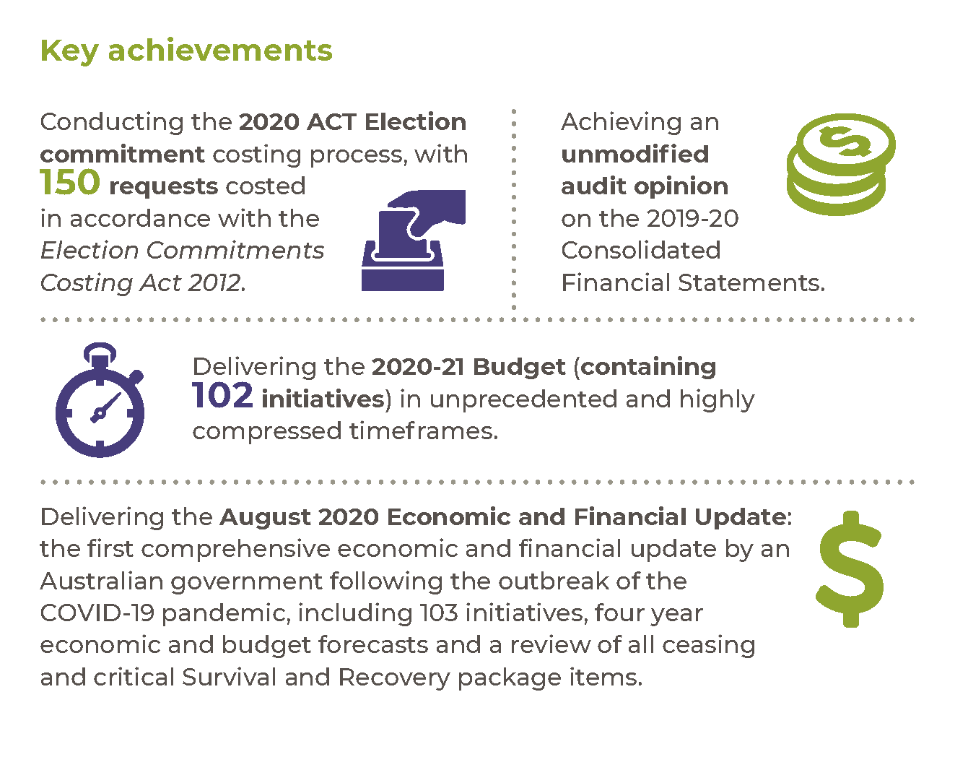

Highlights
In 2020-21 we continued working with agencies and across the directorate to develop and deliver the Government’s responses to the COVID-19 pandemic. We continued to oversight and implement COVID-19 support activities, such as the Screwdriver Ready Implementation program (a fast tracked suburban infrastructure program to deliver jobs and support to local businesses during COVID-19), the Jobs for Canberrans Fund (a program to provide work opportunities for people in the casual or semi-skilled workforce who have lost their jobs or have been significantly impacted due to COVID-19), and the administration of COVID-19 test hardship isolation payments and quarantine waivers for returned international travellers.
In 2020-21 we also undertook the following work:
- Delivered the August 2020 Economic and Financial Update, the first economic and financial update by any Australian government following the outbreak of the pandemic, including a comprehensive review of all ceasing and critical Survival and Recovery package items.
- Released the Pre-Election Budget Update 2020 on 14 September 2020.
- Coordinated and conducted the 2020 ACT Election commitment costing process, which saw 150 requests costed (with 12 items being withdrawn) in accordance with the Election Commitments Costing Act 2012, as part of the 2020 election pre-polling costing period.
- Participated in the Incoming Government briefing process.
- Achieved an unmodified audit opinion on the 2019-20 Consolidated Financial Statements.
- Delivered the 2020-21 Budget in unprecedented and highly compressed timeframes.
- Continued implementation of the ACT Government’s Wellbeing Framework, by starting to embed the framework into the budget process.
- Provided regular updates to the Expenditure Review Committee of Cabinet on the Territory’s finances, allowing the Government to manage public finances appropriately and maintain a strong balance sheet.
- Provided advice to the Expenditure Review Committee of Cabinet on new spending proposals to enable the Government to prioritise available resources.
- Prepared the Annual Financial Statements for the Territory, which were provided to the Auditor-General in accordance with the timing prescribed in section 24 of the FMA.
- Prepared the Quarterly Consolidated Financial Statements, which were presented to the Legislative Assembly in accordance with the timing prescribed in section 26 of the FMA.
- Prepared the budget appropriation bills – the Appropriation Act 2020-21 and Appropriation (Office of the Legislative Assembly) Act 2020-21 – both passed by the Assembly on 22 April 2021.
- Coordinated and participated in ‘across government’ and national working groups and provided policy advice on national reform initiatives, including the National Health Reform Agreement and Training and Skills reforms.
- Provided regular updates to the Government on the progress of its infrastructure program. These updates included regular reports to the Expenditure Review Committee of Cabinet and the Legislative Assembly.
Assisted directorates on policy development by providing budgeting, accounting, and analytical advice.

Future direction
In 2021-22 we will support the Government in delivering the 2021-22 Budget, prepare the 2021-22 Budget Review and the Territory’s Consolidated Financial Statements. In 2021-22 we will also:
- Deliver a revised ACT Infrastructure Plan, a consequence of disruptions associated with the COVID-19 pandemic.
- Coordinate the Government’s budget processes and report on financial outcomes.
- Look towards greater automation of the Government’s budget production processes, including expansion and integration of existing financial management information systems.
- Provide regular updates to the Expenditure Review Committee of Cabinet on the Territory’s finances to allow the Government to manage the public finances appropriately and maintain a strong balance sheet.
Work with directorates to ensure sound financial management and high-quality advice to Cabinet.
Further information
Scott Austin A/g Executive Group Manager, Finance and Budget Group
(02) 6207 7879 Scott.Austin@act.gov.au

Output 5.1 Workforce Injury Management and Industrial Relations Policy

Overview
Through the Workforce Injury Management and Industrial Relations Policy output we provide health and work sustainability solutions, focusing on risks arising from work and the relationship between employers and workers.
Workplace Safety and Industrial Relations delivers this output by:
- Managing ACT workers’ compensation, work health and safety and industrial relations regulatory and policy frameworks.
- Supporting the Public Sector Workers Compensation Commissioner in the management of the Public Sector Workers Compensation Fund (see annexed report).
- Developing and reviewing whole of government health, safety and rehabilitation policies and providing work health and safety services to support the policy framework.
Coordinating the Territory’s consultative bodies for industrial relations regulation, workers’ compensation and work health and safety.

Performance

Accountability indicators
3 met or exceeded 1 not met

We met or exceeded three out of four accountability indicator targets for this output. We did not meet our target for indicator 5.1b – Maintain consultative work injury management fora within the ACT – due to a scheduling issue preventing one meeting of the WHS Council from occurring in the relevant reporting quarter. All agenda items from the delayed meeting were dealt with by the Council out of session or deferred to the following meeting.
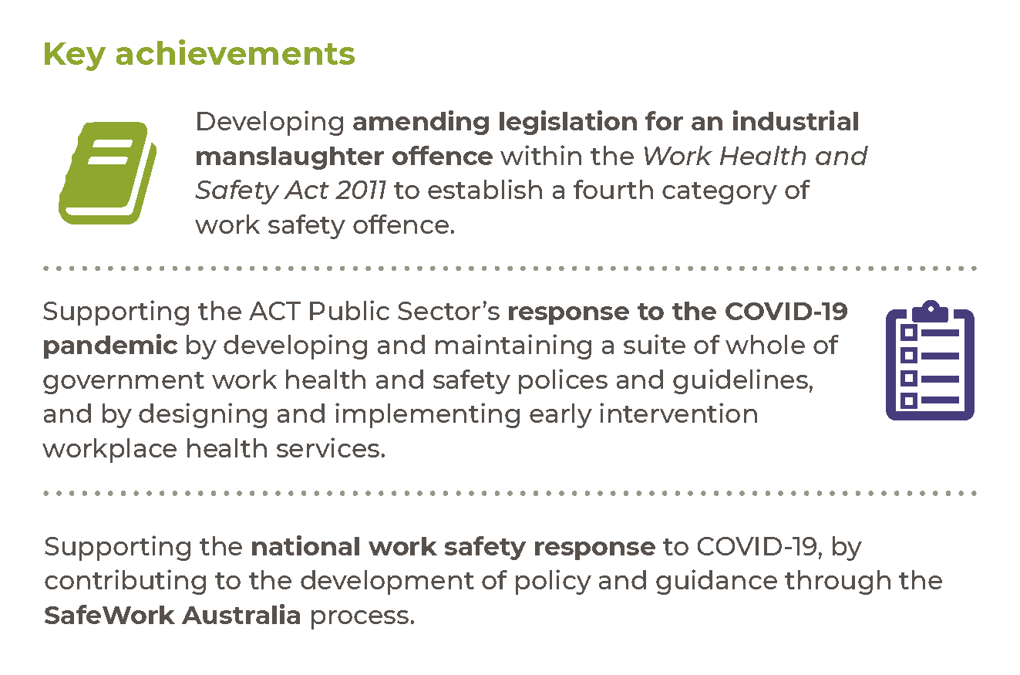

Highlights
In 2020-21 we continued to support the ACT Public Sector’s response to the COVID-19 pandemic by developing and maintaining whole of government work health and safety polices and guidelines to prepare for, and respond to, the changing situation. This included:
- Providing directorates with guidance to develop transition plans to ensure that workplaces were managed in a safe way as restrictions were eased, but also able to respond if the risk for the ACT community changed.
- Supporting workplaces to undertake risk-based assessments to identify and manage the risks associated with COVID-19 in workplaces and ensure staff and those using our services were safe.
Ensuring staff working from home, in hybrid working arrangements and in usual workplaces had access to a suite of resources and tools to support physical and mental health and wellbeing. An early intervention physiotherapy program was expanded to provide virtual services as well as face to face services for staff requiring treatment for potentially work-related musculoskeletal symptoms.
In 2020-21 we also:
- Worked closely with union and employer representatives to design changes to work health and safety laws to introduce an industrial manslaughter offence. The new industrial manslaughter offence provides a greater deterrence for WHS non-compliance and add a fourth category offence to the suite of regulatory responses available to the ACT’s work safety regulator.
- Engaged with stakeholders to design the supporting implementation instruments for the ACT’s new labour hire licensing scheme. The new scheme commenced on 27 May 2021 and provides better protection for workers in vulnerable or insecure employment.
- Engaged with stakeholders to support the transition of staff into new government office buildings with guidance to promote effective and safe working in the building. We also provided staff with health issues access to supports to facilitate reasonable adjustments.
Continued to maintain and improve whole of government approaches to support ACTPS workplaces to implement contemporary prevention, health promotion, early intervention, and work rehabilitation approaches to reduce the impact of illness and injury in our workplaces.

Future direction
In 2021-22 we will continue to support ACTPS workplaces to be safe and responsive to the changing COVID-19 situation in the ACT community by developing polices, guidance and programs that address the risks associated with COVID-19 and our changed working arrangements. We will also:
- Continue to improve workers’ compensation services for ACT public sector workers who become injured or ill because of their work.
- Deliver, evaluate and enhance whole of government prevention, early intervention and injury management programs.
- Improve workers’ compensation insurer and self-insurer licensing arrangements.
- Support ACT employers to develop and deliver evidence-based health and wellbeing initiatives in their workplaces through the ACT Government’s Healthier Work Program.
- Work closely with the Work Health and Safety Commissioner to ensure data analytic and regulatory policy services are aligned and integrated with WorkSafe ACT organisational arrangements.
- Consult with the community about and make changes to work safety laws, in response to a Safe Work Australia review of the national template work safety laws and identified work hazards including silica dust exposure, occupational violence, sexual harassment and bullying.
Provide more and better data to industry about its work safety performance.
Further information
Michael Young Executive Group Manager, Workplace, Safety and Industrial Relations
(02) 6205 3095 Michael.Young@act.gov.au

Output 6.1 Revenue Management

Overview
Through the Revenue Management output, we administer the ACT Government’s taxation revenue.
Revenue Management (ACT Revenue Office) delivers this output by:
- Collecting taxation revenue in accordance with legislation.
- Providing high quality and timely advice to assist taxpayers in meeting their obligations.
- Processing objections to taxation assessments and decisions, in accordance with timeframes published on the ACT Revenue Office website.
- Ensuring the integrity, consistency and effectiveness of the ACT’s taxation system through prioritised compliance programs and regular reviews of legislation.
- Processing concessions in accordance with government community assistance schemes.
Administering Rental Bonds.

Performance

Accountability indicators
1 exceeded 4 not met
We exceeded one of our accountability indicator targets for this output and did not meet our targets for the remaining four accountability indicators:
- 6.1a – Debt management – level of overdue rates as a percentage of total rates revenue
- 6.1b – Debt management – level of overdue debt (not including rates) as a percentage of tax revenue (not including rates)
- 6.1d – Internal reviews of objections completed within 12 months
6.1e – Compliance revenue per inspector
The results for 6.1a and 6.1b were higher than the target as compliance debt recovery activity was largely suspended from March 2020 due to the impact of the COVID-19 pandemic on the community. The result for 6.1d reflects that, on occasion, detailed and complex matters may require an extended period of time to resolve. The result for 6.1e was below target as a result of the almost complete cessation of compliance activity in 2020-21 due to the COVID-19 pandemic and the diversion of staff resources to assist other areas (such as with COVID-19 assistance measures). Both debt recovery and compliance activities are expected to gradually resume over 2021-22.

Highlights
A key focus in 2020-21 was administering the assistance measures introduced through the ACT Government’s COVID-19 economic survival and recovery packages, and the Australian Government HomeBuilder Grant. As part of this, we continued to develop and implement system solutions to ensure that businesses, homeowners, property investors and commercial property owners were able to access this assistance.
We developed the Revenue Legislation Amendment Bill 2021, which was passed by the Legislative Assembly on 12 May 2021. The legislation is part of an ongoing series of bills to promote the effective and efficient administration and operation of the ACT tax system.
We also made improvements to enhance our system capabilities and taxpayer interactions including:
- Enhancements to the Rental Bonds portal to allow tenants to interact digitally and to integrate it with the ACT Digital Account,
- A new notification capability allowing us to communicate with clients via secure email and SMS, and
Migrating the Spectacles and Low Vision Aids Concession Schemes onto a new work management platform.
More than $1.9 billion in taxation revenue was collected in 2020-21.

Future direction
In 2021-22 we will:
- Continue to administer the remaining assistance measures introduced by the ACT Government’s economic survival and recovery packages and the Australian Government HomeBuilder Grant.
- Introduce new processes to allow commercial property owners to request additional information on unimproved values prior to lodging an objection. This information will assist the owner to decide whether to lodge an objection or to inform any objection the owner chooses to lodge.
- Continue to automate business processes within the ACT Revenue Office, including:
- Extending the new work management platform to the Taxi Subsidy scheme; and
Digitising several processes, including Change of Address and Requests for Certificates of Rates, Land Taxes and other charges.
Further information
Lisa Holmes A/g Executive Group Manager, Revenue Management
(02) 6207 0207 Lisa.Holmes@act.gov.au

Output 7.1 Shared Services

Overview
Through the Shared Services output* the directorate provides a range of ICT and corporate services, including infrastructure, applications support and development, ICT project services and tactical and transactional human resource and finance services to directorates and agencies.
Shared Services Human Resources, Finance and Records Services deliver this output by:
- Providing payroll, personnel and recruitment services.
- Providing records management and courier activities to government directorates.
- Providing monthly and annual financial reporting services.
- Providing accounts payable, accounts receivable, banking and debt management functions.
- Providing general ledger, cash flow and fixed asset management.
- Providing advice on Fringe Benefits Tax, Goods and Services Tax and PAYG, including arranging external advice as required.
- Administering production and lodgement to the Australian Taxation Office of monthly Business Activity Statements and annual Fringe Benefits Tax Returns.
- Delivering salary packaging services for employees across the ACT Government.

Digital, Data and Technology Solutions delivers this output by:
- Providing services to government agencies as outlined in the ICT catalogue of services and affirmed through various service level and support agreements.
- Managing the whole of government data and communications network.
Providing general service and help desk functions.
*Note: In 2020-21 the ICT services component of this output moved from Shared Services to the Office of the Chief Digital Officer, becoming part of the new business area called Digital, Data and Technology Solutions. In 2020-21 these functions continue to be reported under Output 7.1 Shared Services but will be reported as a separate output in 2021-22.

Performance

Accountability indicators
6 met or exceeded 4 not met
We met or exceeded six of our ten accountability indicator targets for this output and did not meet the following four indicator targets:
- 7.1a – ICT costs compared to peer organisations' costs, as benchmarked by an independent organisation. Our result of ‘6 per cent lower’ was outside of our target range of ‘within 5 per cent’. The variance reflects the fact that ICT services, within the scope of the comparison, are delivered more cost effectively than the target, being approximately 6 per cent lower than those of the public sector peer. In financial terms, DDTS delivers ICT services for $9,470,091 less.
- 7.1b – ICT service requested made via the Service Desk are resolved within Service Level Agreement timeframes and 7.1d – Average time taken for telephone ICT service requests to be answered by a Service Desk Officer. These targets were not met due to the complexity of supporting a workforce working from home, which led to significant increases in the time required to resolve issues, and increased call volumes during COVID-19, at 23 per cent higher than in 2019-20.
7.1f – Human resources service requests made via the Service Desk are resolved within Service Standard timeframes. We achieved 89 per cent against a target of 90 per cent.
Highlights
In 2020-21 we continued to lead the whole of government program to implement a contemporary payroll and human capital management solution for the ACT Government workforce encompassing all aspects of the employee lifecycle. We also:
- Implemented end-to-end debt management framework, including the implementation of the debt management system and engagement of the whole of government mercantile agent for debt recovery and consultancy services. Shifting the direction of debt management to an end-to-end basis allows for centralisation and standardisation of debt management process, better debt policies, enhanced compliance, improved reporting and analytics, and offers greater transparency and accountability.
- Delivered a financial feasibility study to enable the Territory to determine its financial reporting requirements and to move its financial applications to a cloud environment in the near future.
Created and maintained a suite of documents and artefacts covering the strategic and operational aspects of human resources and finance services. The ‘Service Overviews’ underpin the Government’s ongoing commitment to continuous improvement and service delivery transparency.

In 2020-21 we also:
- Finalised the Desktop Modernisation Program in November 2020. Over 17,000 ACT Government assets were updated to a Windows 10 environment, and the 95 per cent target was met ahead of schedule. The program won the ICT/Telecommunications category in the ACT chapter of the Project Management Achievement Awards.
- Developed and rolled out a new shared ICT Work Point to over 1500 activity-based working desks in the Civic Office Building located at 220 London Circuit.
- Designed, built and installed all IT infrastructure, wired and wireless networks including integration of all external vendor equipment to the ACT government environment to support the 2020 ACT Election.
Rapidly piloted and deployed a collection of cloud-based contact centres for ACT Health to support COVID-19 response operations.
Future direction
In 2021-22 we will work to establish the future direction of the Territory’s banking arrangement post 30 June 2023, including conducting a current state review and needs/benefits analysis to be incorporated into any future banking arrangements. It is anticipated that the future direction of the Territory’s banking arrangement will allow greater flexibility and adoption of innovative technologies, provide a more streamlined approach to transactions and payments, improve security, and facilitate a greater use of digital payment options.
We will continue work to ascertain the Territory’s financial system needs. The 2020 Financial Feasibility Study noted the move to a cloud-based finance system may provide multiple benefits for Government, including defined best practice processes, significantly reducing operational costs, along with providing efficiency and productivity gains. Continue to prepare for the implementation of the new HRIMS and associated processes, significant effort to identify and develop new working methods to maximise the benefits of the new system will be required across Shared Services business functions.
Shared Services will work with the Australian Government to support the implementation of the Australian Government’s E-invoicing initiative, which see the Australian Taxation Office (ATO) taking the lead role for its implementation.
We will also continue work to implement the Human Resource Information Management Solution (HRIMS) across government, including working closely with directorates and our partner vendors to complete build, test and business readiness activities associated with the staggered release of whole of government functions.
Further information – Shared Services
Graham Tanton Executive Group Manager, Shared Services
(02) 6207 5757 Graham.Tanton@act.gov.au
Further information – Digital, Data and Technology Solutions
Bettina Konti Deputy Director-General and Chief Digital Officer, Digital, Data and Technology Solutions
(02) 6207 2242 CDO@act.gov.au

Output 8.1 Infrastructure Finance

Overview
Through the Infrastructure Finance output we provide advice to government on the development and management of major infrastructure projects, including unsolicited proposals and the use of private finance where appropriate. We partner with directorates to ensure project business cases provide the required evidence and analysis to justify the funding decisions of government.
Infrastructure Finance & Reform delivers this output by:
- Advising on the development of infrastructure projects within the Capital Framework.
- Providing financial and commercial advice on the structuring and procurement of Public Private Partnership (PPP) and other major, complex infrastructure projects, and managing life-of-project transactions for PPP projects.
- Coordinating and managing the assessment of unsolicited proposals.
- Maintaining, and providing advice on, and training in, the policy frameworks that guide the development of infrastructure projects.
Providing governance and administrative support to infrastructure-related committees.

Performance

Accountability indicators
1 met 1 not met
We met one of two 2020-21 accountability indicator targets for this output:
8.1a – Life of Project PPP transactions successfully executed.
We did not meet our target for the following indicator:
8.1b – Assessments of Unsolicited Proposals completed within the prescribed timescales. Three out of five Concept Submissions received did not achieve the three-month time frame for notification to the proponent of whether the Unsolicited Proposal Steering Committee (UPSC) would receive a presentation. This was due to the unique nature of each proposal, which required extensive cross directorate consultation with a broad range of stakeholders. Throughout the process, the proponents were kept informed of the status of the assessment of their submission and were made aware that the assessment would likely exceed the timeframes in the Guidelines for Unsolicited Proposals.
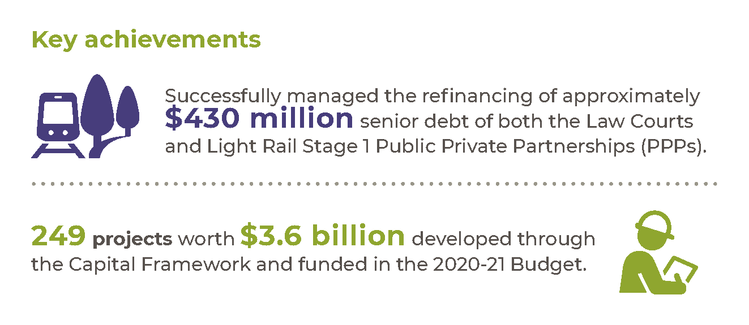

Highlights
In 2020-21 we achieved this output by:
- Providing financial and commercial advice on the development of complex infrastructure projects, including the development of Light Rail Stage 2A.
- Managing the process and providing commercial support for assessment of five Unsolicited Proposals.
To deliver this output we also:
- Continued to provide support to directorates using the Capital Framework process to develop stronger business case submissions on 249 projects worth $3.6 billion funded in the 2020-21 Budget. This support enabled more thorough planning, appraisal and evaluation in the formative stages of the investment lifecycle.
- Undertook Stage 3 of the Capital Framework review to update the policy framework that supports the development, procurement, and delivery of capital projects, due for completion in early 2021-22.
Undertook the Post Implementation Review of the Law Courts PPP, due for completion in 2021-22.

Future direction
In 2021-22 we will continue to assist directorates and agencies by:
- Providing advice to directorates and agencies using the Capital Framework process, conducting Post Implementation Reviews, and monitoring and reporting on benefits realisation.
- Providing analysis and advice throughout the Budget process.
- Advising on complex infrastructure projects, including Light Rail City to Woden, Zero Emission buses and waste treatment facilities.
- Managing Life-of-Project transactions for the Territory’s PPP projects.
- Managing the process and providing commercial support for the assessment of Unsolicited Proposals.

- Reviewing and updating the policy frameworks that support the development, procurement, and delivery of capital projects:
- The Capital Framework.
- The Partnerships Framework, Guidelines for PPPs.
- The Partnerships Framework, Guidelines for Unsolicited Proposals.
- Finalising and rolling out online training for the Capital Framework.
Undertaking the Post Implementation Review of Margaret Hendry School.
Further information
David Asteraki Executive Branch Manager, Infrastructure Finance & Reform
(02) 6205 5198 David.Asteraki@act.gov.au

Output 8.2 Goods and Services Procurement

Overview
Through the Goods and Services Procurement output we support goods and services procurement activities of government directorates and agencies and establish and manage whole of government arrangements. We advise the Government on procurement policy and develop and implement the Government’s procurement related policies. We also offer training and support to staff across government undertaking procurement activities, and administer online tendering and procurement support systems.
Procurement ACT delivers this output and supports directorates to achieve value for money procurement outcomes by:
- Providing procurement advisory and support services.
- Administering the ACT Government contracts register and procurement systems.
- Supporting Territory staff to undertake procurement activities efficiently and effectively with contemporary advice and provision of templated and standardised documentation and processes.
- Supporting the procurement workload across government by applying contemporary category procurement knowledge and contract management skills to establish and manage cost effective whole of government arrangements.
Representing the ACT Government in cross-jurisdictional engagement on procurement policy matters, including in relation to international trade agreements.

Performance

Accountability indicators
3 met or exceeded
We met or exceeded all three accountability indicator targets for this output. We exceeded our target of one per cent for indicator 8.2a – Proportion of Goods and Services contracts awarded to Indigenous suppliers or Social suppliers – with a result of 2.57 per cent. This reflects ACT Government agencies prioritising the inclusion of opportunities for Aboriginal and Torres Strait Islander Enterprises in their procurement activity since the introduction of the Aboriginal and Torres Strait Islander Procurement Policy.

Highlights
In 2020-21 Procurement ACT facilitated the completion of 146 complex procurement projects with an approximate value of $735 million.
We conducted detailed assessments of a number of the Territory’s whole of government arrangements including training services, creative services and natural gas supply. An approach to market was also commenced for an employee assistance program and critical incident support services, which will be awarded in 2021-22.
We established a procurement community of practice to bring together ACT Government procurement professionals to share knowledge, leverage their expertise and collaborate on innovation.
In January 2021 we released the Probity in Procurement Guide that requires all ACTPS officers, employees and contracted service providers involved in a procurement to complete a Conflict-of-Interest Disclosure.
We continued to enhance our procurement systems and platforms by updating and modernising the Tenders ACT platform to provide greater usability and accessibility for more than 20,000 registered users. Tenders ACT is a central point to release tenders and lodge tender responses.
We improved the procurement planning process to enable the ACT Government to provide real time advance notice to the market in relation to key, major or strategic procurement.
In 2020-21 we also continued to undertake the following work:
- Supporting directorates by engaging with them individually and through coordinated consultation and acting on their feedback and suggestions.
- Working with our jurisdictional counterparts to develop improved nationwide procurement practices.
- Reviewing and improving the ACT Government’s procurement framework, including guidance, templates and procedures. We will also continue to improve procurement policies and processes to optimise support for delivering effective procurement and advancing social outcomes.
- Supporting procurement officers and suppliers through the provision of advice and assistance via the Procurement Help Desk.
Enhancing the ACT Government’s procurement capability and promoting a shared understanding of our procurement framework and systems by developing a range of training packages, targeted engagement strategies and strategic procurement planning.

Women in procurement and business virtual forum
On 10 and 11 March 2021, to coincide with International Women’s Day (IWD), the Policy and Capability Branch in Procurement ACT held a two-part virtual forum Women in Procurement and Business – Inspiring and Igniting Innovation. Using the IWD 2021 theme of “Choose to Challenge”, the branch, which has an all-female senior leadership team, invited senior women from within and outside the ACT Government to showcase women's achievements in procurement and business support. The forum also aimed to celebrate, collaborate, and share experiences to inspire and ignite future leadership in this area.
The panel discussions covered:
- Leading innovation in procurement.
- Delivering infrastructure to the community – human centred procurement.
- Inspiring the next generation of procurement professionals through education and programs.
Image 7: Flyer from women in procurement and business virtual forum
- Igniting business success.
Participants from across the ACT Government had the opportunity to hear about each panel member’s personal experiences, what leadership means to them, how they are supporting and promoting gender equality and their IWD message.
The Head of Service, Kathy Leigh, opened the forum with an address that highlighted the ACT Government's commitment to removing barriers to better enable women to reach their potential, innovate and share ideas and to take up leadership positions.
We supported the ACT Government’s response to COVID-19 through work including:
- The urgent procurement of goods and services.
- Sourcing of scarce and/or high demand products and locking down supply chains to ensure ongoing support for critical services.
The speedy release to market of economic stimulus and support measures.

Future direction
In 2021-22 we will continue to work with and support agencies in the planning, preparation and conduct of complex goods and services procurements. We will also work with agencies to improve the program management and tracking of complex goods and services procurements.

We will explore opportunities for aggregation of purchasing through new whole of government arrangements. We intend to conduct market activities for media placement and advice services and the supply of natural gas in the 2021-22 period. Detailed assessments will also be conducted to assess the current professional consulting services, fleet services and digital mail services arrangements.
Further information
Glenn Bain Executive Group Manager, Procurement ACT
(02) 6207 6569 Glenn.Bain@act.gov.au

Output 9.1 Property Services

Overview
Through the Property Services output we manage 238 Territory-owned buildings including commercial buildings, government office and service provision accommodation, community/multipurpose buildings, and aquatic/leisure facilities. We also lease 24 commercial buildings on behalf of the Territory.
ACT Property Group (ACTPG) delivers this output. ACTPG provides property upgrade services and planned and reactive maintenance services on Territory-owned properties managed by CMTEDD and other directorates.

Performance

Accountability indicators
1 met 2 not met
We met one of our accountability indicator targets for this output and did not meet the following two indicators:
- 9.1a – Percentage of customers satisfied with management of aquatic centres. We achieved a satisfaction rating of 91.7 per cent against a target of 93 per cent.
9.1c – Average square metres of office accommodation per employee. The Office Accommodation Capacity and Occupancy Rate June 2021 Report results were 34.46 square metres (target 14.3 square metres) per employee for properties established prior to 2016 and 39.39 square metres (target 12 square metres) per employee for office accommodation established from 1 January 2016. The annual survey occurred in late June 2021 when ACT Government office-based staff were primarily working away from office locations due to COVID-19. This resulted in reduced occupancy of office buildings. A count of workstations was also completed to determine the capacity rate. Using this measure, we determined capacity of 13.76 square metres per workstation for properties established prior to 2016 and 13.62 square metres per workstation for office accommodation established from 1 January 2016.
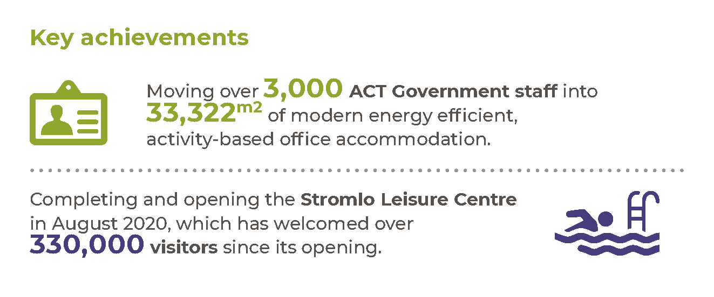

Highlights
In 2020-21 we supported the ACT Government’s Economic Survival Package through coordination of the rent relief package for tenants of ACT Government owned properties. ACTPG led a cross-agency working group to facilitate the program including the assessment of commercial applications for rent relief. We also delivered several property improvement projects, in support of the ACT Government’s Economic Survival Package. Projects included disability and sustainability upgrades in community facilities, and other upgrades to aquatic facilities.
We reached a significant milestone with the completion of the new 20,122 square metre ACT Government office building in Canberra City, which was handed to the Territory on 14 January 2021. Following completion, we entered into a 20-year lease for the new City Office Block, with options to extend. The new building will provide ongoing accommodation for various ACT Government directorates and agencies.
In 2020-21 we undertook the following work:
- Managed the relocation of over 1,900 staff relocated from four sites to the activity-based work (ABW) environment in the new City office building. The building offers 1,550 workstations and modern meeting and customer contact spaces.
- Managed the relocation of over 1,100 staff to the new ABW environment in the new Dickson office building including staff from Access Canberra, the Environment, Planning and Sustainable Development Directorate, the Transport Canberra and City Services Directorate, and the Suburban Land Agency.
- Implemented COVID-19 related changes in management of our buildings to ensure clients could continue serving the community. CMTEDD worked collaboratively with government tenants to implement several measures across our buildings to ensure services to the community were not disrupted.
- Completed construction of the $36.5 million Stromlo Leisure Centre. This project has delivered a high quality sporting facility for the Canberra community, particularly those in the Weston Creek and Molonglo Valley regions. The Stromlo Leisure Centre has welcomed more than 330,000 visitors since it opened in August 2020.
- Commenced repairs to the 50-metre pool at the Gungahlin Leisure Centre.

- Completed a major upgrade to 1 Moore Street in the City including new lifts, HVAC and thermal envelope. This building provides significant services to the community through ACT Health, the ACT Civil and Administrative Tribunal (ACAT) and the Canberra Innovation Network.
- Supported the Local Roads and Community Infrastructure (LRCI) Program Phase 1 and Fast Track Phase 2 to deliver capital upgrades to ACT Government owned properties. This program upgraded 23 community facilities including major works at Southside Community Centre and Tuggeranong Community Centre. LRCI Phase 2 also commenced in early 2021 to deliver projects for Dickson Pool and other community facilities including libraries. This work will be completed in 2021-22.
- Supported the Education Directorate in the delivery of high-quality school facilities through capital works projects including delivery of seven transportable units to meet increased student demand, facilitating upgrades to ageing school facilities and delivering sustainability and energy efficiency improvements.
- Supported the continued viability of community and commercial tenants of ACT Government buildings and operators of ACT Government owned pools through the provision of rental relief due to COVID-19 related financial pressure. This support delivered over $10 million in rent waivers to 230 tenants.
- Supported a culturally rich and vibrant community through management of the ACT Government flagpoles and banners along roads. ACTPG erected flags and banners for events such as the Botticelli to Van Gogh Exhibition, International Workers Memorial Day (CFMEU), Royal Australian Airforce Centenary, 200th Anniversary of the Greek War of Independence, and 50 years of independence for Bangladesh. ACTPG also managed adjustments to flags on behalf of the ACT and Commonwealth Governments to recognise passing of significant people including His Royal Highness The Duke of Edinburgh and for the Apology to Members of the Stolen Generations.
- Ensured the continued provision of high-quality community and government facilities through completion of $10.8 million in building upgrades to government, leisure and community facilities in properties managed by ACTPG. This included a package of building upgrades under the ACT Government’s economic support package and the Australian Government’s Local Roads and Community Infrastructure program.
- In partnership with other ACT Government directorates, managed 1,113 property upgrade projects with a value of $28.5 million.
Managed timely maintenance of ACT Government facilities through operation of a 24-hour, seven-day a-week trades and services intake works allocation team. During the period we managed more than 10,000 calls and raised over 15,000 work orders for building repairs and maintenance. ACTPG tradespeople or external contractors completed the work. During the reporting period reactive maintenance activities totalled $26.9 million.

Future direction
In 2021-22 we will continue to support our tenants through the impacts of COVID-19. This will include supporting good practices in facilities management and providing agreed financial support for tenants significantly impacted by COVID-19. We will also:
- Support the relocation of remaining ACT Government business units and statutory agencies to new office accommodation in Allara House and Nara House, Civic.
- Complete repair work on the 50-metre pool at Gungahlin Leisure Centre.
- Continue to improve property management services.

- Deliver improvements to ACT Government buildings, increasing functionality, efficiency, longevity and reducing running costs.
Continue procurement of building maintenance service panel and contracts across its service provision areas, seek continuous improvement in energy efficiency for assets and deliver positive outcomes to our tenants.
Further information
Graham Tanton Executive Group Manager, Shared Services
(02) 6207 5757 Graham.Tanton@act.gov.au

Output 9.2 Venues

Overview
Through the output we promote and manage major events at venues including GIO Stadium, Exhibition Park in Canberra, Manuka Oval and Stromlo Forest Park. We also manage the National Arboretum Canberra.
Venues Canberra delivers this output along with the National Arboretum Canberra and Stromlo Forest Park Branch.

Performance

Accountability indicators
4 met or exceeded 4 not met
We met or exceeded four of our accountability indicator targets for this output. We did not meet four of our targets, including:
- 9.2a (iii) – Number of major events at Exhibition Park in Canberra (we delivered 66 events against a target of 88). Due to COVID-19 restrictions on large gatherings and travel, scheduled events at venues were either cancelled or postponed, resulting in less major events at EPIC.
9.2b (i), (ii) and (iii) – Own source event at GIO Stadium ($2 million against a target of $3 million), Manuka Oval ($282,000 against a target of 360,000), and Exhibition Park in Canberra ($2.1 million against a target of $3.5 million). Although we achieved above target for the number of events at GIO Stadium and Manuka Oval, the decrease in capacity at events due to COVID-19 restrictions impacted the ability of GIO Stadium, Manuka Oval and EPIC to generate own source revenue and achieve the targeted revenue result.

Highlights
In 2020-21 we supported the ACT Government’s response to COVID-19 by continuing to host the drive through COVID-19 testing facility. We also assisted the Community Services Directorate to establish a food bank and warehouse distribution centre which remained open until 30 June 2021. We also:
- Delivered 15 international and first-class cricket matches over the 2020-21 summer at Manuka Oval in a safe and secure environment for patrons. Over a period of 64 days, Manuka Oval’s biggest summer of cricket was delivered with attendance from 66,000 patrons. Matches commenced at 50 per cent capacity, progressed to 65 per cent and finals were held at 75 per cent capacity. This was facilitated through close engagement with the Office of the Chief Health Officer and Cricket Australia.
- Hosted four ‘Live in Ya Lounge’ gigs at EPIC as part of the Where You Are Festival program to support local musicians and artists during the COVID-19 pandemic.
- Led the Territory’s return to events under COVID-safe plans by hosting events at GIO Stadium and Manuka Oval. Over the year, capacity moved from no crowds, to 1,500 attendees, to 100 per cent capacity.
Held a total of 222 events at EPIC with an estimated attendance of 220,012, as detailed in the consolidated breakdown of events below.
Table 18: EPIC Consolidated Events and Estimated Attendance
Type of Events | No. of events | Estimated Attendance
Farmers Markets | 50 | 200,000
Training | 50 | 517
Concert | 4 | 0 *
Event | 83 | 17,309
Function | 14 | 742
Meetings/Conferences | 21 | 1,444
Total | 222 | 220,012
*Note: These concerts were delivered virtually as part of ‘Live in Ya Lounge’, with no physical attendees.

The National Arboretum Canberra
In 2020-21 the National Arboretum Canberra:
- Welcomed a record 719,787 visitors.
- Hosted the 2021 ACT Reconciliation Day event on 31 May 2021, with a record 8,316 people attending.
- Planted approximately 900 trees and pruned over 25,000 trees.
- Delivered a security upgrade to its facilities, including updated CCTV cameras, security bollards, electronic swipe passes, and Village Centre lighting upgrades.
- Planted Forest 15 with Xanthorrhoea trees (Grass Trees) culturally significant to Indigenous Australians.
- Extended the Forest Sculpture Gallery and established its advisory committee and deductable gift recipient cultural gift status.
- Undertook 1.4km path upgrades for better accessibility as well as asphalting of the events terrace road.
- Conducted Australian Hero tree dedications acknowledging Professor Tom Calma AO, Ricky Stuart, Professor Fiona Wood AM FRACS, and David Williamson AO. We also conducted a ceremonial tree planting for the Governor General of Australia, His Excellency General the Honourable David Hurley AC DSC (Retd) and Mrs Hurley.
- Accommodated over 21,500 Village Centre visitors across the Easter weekend, who used the new 500 capacity overflow carpark.
- Attracted a total of 21,279 visitors through school groups for facilitated and self-guided programs.
- Hosted 213 corporate functions attracting a total of 13,555 onsite visitors to the Arboretum.
Held 39 school holiday programs attended by a total of 1,395 children and accommodated 114 birthday parties for a total of 1,710 children.

Stromlo Forest Park
In 2020-21 Stromlo Forest Park:
- Attracted several significant events with interstate competitors, attended by over 500 people in a COVID-19 environment.
- Undertook consultation with user groups to prioritise the Stromlo Forest Park Masterplan.
- Progressed the implementation of the Bushfire Management plan, including detailed work on firebreaks.
Refurbished public facilities including streamlining the canteen area, increased signage on fire-trails, and more accessible gate padlocks.

Future direction
In 2021-22 we will actively seek to attract new events to the Territory’s venues to support economic growth and diversification, liveability and social inclusion, noting COVID-19 restrictions will impact on scheduled events. We will also:
- Develop a Venues Canberra customer service charter.
- Continue to support community events with onsite partners and volunteers.
- Implement new revenue sources through tourism and marketing initiatives.
- Continue to manage and deliver the scheduled program of events at our venues.
- Enhance security measures, implement capital upgrade works programs and environmentally sustainable projects, and continue to provide a safe, clean, accessible environment at our venues.
At the National Arboretum Canberra and Stromlo Forest Park in 2021-22 we will:
- Promote the National Bonsai and Penjing Collection Australia nationally and internationally.
- Continue to host Arboretum ceremonial visits and tree plantings as part of the Department of the Prime Minister and Cabinet State Visits Program and/or as directed by the ACT Chief Minister.
- Promote new Arboretum gardens as donor opportunities.
- Continue to manage and support the health of our forests through appropriate horticultural and arboriculture practices.
- Support existing Arboretum MoU relationships. We will also develop new MoUs as relevant, especially with the National Bonsai and Penjing Collection.
- Review and facilitate the Arboretum’s school educational and tourism programs.
- Maintain existing assets and oversee upgrades including:
- The installation of the National Rock Garden,
- the first Forest Pod shelter at the Arboretum, asphalting of unsealed roads, Stromlo fire-trail grading and signage upgrades.
- Launch the Arboretum’s extended Forest Sculpture Gallery.
- Progress the National Arboretum Canberra and Stromlo Forest Park Masterplan, including consultation with key user groups.
- Attract local, national and international level Major Events at Stromlo Forest Park – as this has multiplying economic impacts on the wider Canberra economy.
We will also support the delivery of the CMTEDD Reconciliation Action Plan, with Aboriginal and Torres Strait Islander mentee support and delivery of Indigenous Australian public programs.
Further information
Daniel Bailey Executive Group Manager, Venues
(02) 6207 5618 Daniel.Bailey@act.gov.au

Output EBT 1 Territory Banking Account

Overview
Through the Territory Banking Account (TBA) output we recognise and manage the Government’s financial investment assets and borrowing liabilities.
Revenues on behalf of the Territory are transferred to the TBA and fortnightly appropriation disbursements are made to agencies from the TBA. CMTEDD, through the financial operations of the TBA, provides services to the Government including financial asset and liability management through the establishment of financial investment and borrowing policies and objectives, and the coordination and implementation of cash management, investment and borrowing activities.

Performance

Accountability indicators
10 met or exceeded
We met all ten accountability indicator targets against this output.

Highlights
In 2020-21 under this output we:
- Managed the centralised investment administration structure for Territory financial investment assets.
- Managed and reported on the Government’s Responsible Investment Policy.
Managed the Territory’s borrowing program, including cash flow and liquidity requirements.

Government’s Responsible Investment Policy
Reporting and disclosure of responsible investment related activity is available from the directorate’s website. This includes the disclosure of the Government’s Responsible Investment Policy, the Investment Plan, directly-owned share holdings (updated quarterly), a summary of the Sustainability Proxy Voting guidelines, and share voting activity for the financial year (updated quarterly).

Future direction
In 2021-22 we will:
- Manage the Territory borrowing program.
- Manage cash and liquidity.
- Manage the centralised investment administration structure for Territory financial investment assets.
Manage and report on the Government’s Responsible Investment Policy.
Further information
Patrick McAuliffe, Executive Branch Manager, Asset Liability Management
(02) 6207 0187 Patrick.McAuliffe@act.gov.au

Output EBT 1 Superannuation Provision Account

Overview
Through the Superannuation Provision Account (SPA) output we assist the Government to effectively manage the defined benefit employer superannuation liabilities of the Territory.
The SPA is established to recognise the defined benefit employer superannuation liabilities of the Territory and the financial investment assets set aside to fund these liabilities over time. The liabilities include past and current ACT employees who are members of the Australian Government’s Commonwealth Superannuation Scheme (CSS) and Public Sector Superannuation Scheme (PSS), and Members of the Legislative Assembly Defined Benefit Superannuation Scheme.

Performance

Accountability indicators
5 met or exceeded
We met all five accountability indicator targets against this output.

Highlights
In 2020-21 under this output we:
- Managed the SPA investment portfolio in accordance with the established investment plan and policies.
Completed the triennial actuarial review of the defined benefit employer superannuation liabilities of the Territory.

Future direction
In 2021-22 we will:
- Complete the annual actuarial review of the defined benefit employer superannuation liabilities using salary and membership data as at 30 June 2021.
- Monitor the funding plan to extinguish the unfunded defined benefit superannuation liability.
Manage the Investment Plan and the financial investment assets of the SPA.
Further information
Patrick McAuliffe, Executive Branch Manager, Asset Liability Management
(02) 6207 0187 Patrick.McAuliffe@act.gov.au

Scrutiny
Several bodies have responsibility for scrutiny of CMTEDD’s activities, including Committees of the ACT Legislative Assembly, the ACT Auditor-General, the ACT Ombudsman and the ACT Integrity Commission.
The tables below describe progress on implementing recommendations by those bodies where the ACT Government has agreed to them. This includes both recommendations the Government agreed to in 2020-21 and recommendations from previous years where the directorate undertook further work during 2020-21 to progress their completion.
In accordance with the Annual Report Directions, we have not included recommendations below where the Government’s initial response indicated that implementation of the recommendation was already complete. The ACT Integrity Commission is not listed as it did not publish a report during the period.

ACT Auditor-General reports
Table 19: Auditor-General Report No.1 of 2021 – Land Management Agreements – Government response tabled 3 June 2021
Recommendation number and summary | Status and action in reporting year
Recommendation 6 – Agreed  MONITORING AND COMPLIANCE  The Environment, Planning and Sustainable Development Directorate (EPSDD) and Access Canberra should develop a risk-based framework for the monitoring and enforcement of Land Management Agreements including processes for:  - monitoring rural leaseholders’ compliance with their Agreements; and  - taking enforcement action in the event of potential non-compliance. | In progress  The Government response to this recommendation provided a milestone date of 30 June 2022 for completion.  EPSDD is in the process of establishing a stakeholder governance forum for the development, implementation, and monitoring of the Auditor-General’s report.  This will be established in quarter 3 of 2021.  EPSDD continues to engage with rural leaseholders to review and/or develop Land Management Agreements as required. This serves as the initial step in engagement and implementation of the compliance framework.
Table 20: Auditor-General Report No.3 of 2020 – Data Security – Government response tabled 27 August 2020
Recommendation number and summary | Status and action in reporting year
Recommendation 1 – Agreed  WHOLE-OF-GOVERNMENT DATA SECURITY RISK ASSESSMENT  Shared Services (CMTEDD) and the Security and Emergency Management Branch (Justice and Community Safety Directorate – JACS) should develop a whole‐of‐government data security risk assessment. The whole‐of-government data security risk assessment should be reviewed and updated at scheduled intervals. | In progress  Pricewaterhouse Coopers (PwC) has been engaged by the ACT Government and the Threat Risk Assessment (TRA) is near completion, with a draft of the TRA delivered in May 2021. The steering committee has determined it prudent to perform a substantiation exercise to validate the findings and ensure quality of data. ACT Government has negotiated a variation of the contract with PwC for that purpose. The updated report was delivered in October and is being socialised with directorates.
Recommendation 2  ICT SECURITY POLICIES  Shared Services (CMTEDD) should:  - Agreed  Revise and update the ICT Security Policy (August 2019) to accurately refer to supporting documents referred to in the policy. Where supporting documents and policies are out of date, they should be reviewed; and  - Agreed  Develop policy guidance, in support of the ICT Security Policy, for ACT Government agencies on their responsibilities with respect to managing and monitoring ICT service vendors. | - Complete  The Cyber security policy (previously ICT Security Policy) had a major revision in December 2020 and has addressed this recommendation.  - In progress  The directorate, through Digital, Data and Technology Solutions (DDTS), has published a range of supporting material to provide guidance to directorates while planning and development is underway for of a Whole of Government guideline. This is targeted for release before the end of 2021.
Recommendation 3  CYBERSEC CONTROLS AND REPORTING  The Security and Emergency Management Branch (JACS), Shared Services (CMTEDD) and the Office of the Chief Digital Officer (CMTEDD), through the auspices of the Security and Emergency Management Senior Officials Group should:  - Agreed  Review and update the CYBERSEC requirements of the ACT Protective Security Policy Framework to reflect the most important system security measures from the ICT Security Policy (August 2019). These measures should be targeted at the areas of agency responsibility and able to be reported in dashboard form; and  - Agreed  Require agencies to report on the implementation of these measures in their ICT systems as part of the GOVSEC 4 reporting process of the ACT Protective Security Policy Framework, in order to provide reasonable assurance that data security risks are being effectively managed. | - In progress  The Security and Emergency Management Branch in JACS has commenced a full review of the Protective Security Policy Framework (PSPF). The Cyber Security requirements within the PSPF will be considered and updated as part of the review process. The updated documents will be provided to the Security and Emergency Management Senior Officials Group and Cabinet during 2021 for endorsement.  - In progress  The PSPF review will consider the GOVSEC 4 reporting requirements and develop a new reporting structure. This will be completed in line with the review noted in a) above.
Recommendation 4  DATA SECURITY STRATEGY  The Office of the Chief Digital Officer and Shared Services (CMTEDD) and Security and Emergency Management Branch (JACS), in partnership with ACT Government agencies, should document and agree a whole of government data security strategy and plan. This document should identify:  - Agreed  The role and responsibilities of governance bodies and agencies responsible for managing and improving data security across ACT Government;  - Agreed  Any related whole‐of‐government plans for addressing specific data security issues, such as the planned Cyber Security Incident Emergency Sub‐plan to the ACT Emergency Plan;  - Agreed  Activities and resources to improve data security for ACT Government; and  - Agreed in principle  Identifying the Chief Digital Officer as the responsible senior executive for implementing the strategy to improve data security across ACT Government. | - In progress  The ACT Data Governance and Management Framework was endorsed by Strategic Board in August 2020.  - In progress  A Cyber Emergency Sub-Plan has been drafted between DDTS and SEMB. This plan has been endorsed by the Chief Digital Officer and will be circulated for out of session endorsement by SEMSOG.  - In progress  This item is on hold until after the completion of the Threat and Risk Assessment referenced in Recommendation 1.  - In progress  This item is on hold until after the completion of the Threat and Risk Assessment referenced in Recommendation 1. Directors-General have appointed Executive Data Leads whose role will be to implement the Data Governance and Management Framework within directorates and whole of government oversight of its implementation is to be provided by the Data Reform Group and supported by the Data Management Group. The proposed data-specific roles and responsibilities will also be identified within directorates to ensure good data security practice.
Recommendation 5  SYSTEM SECURITY RISK MANAGEMENT PLAN ASSESSMENTS  Shared Services (CMTEDD) should:  - Partially agreed  In conjunction with Recommendation 4, ensure agencies take account of the full cost of managing security across a system’s lifecycle as part of ICT projects, including undertaking security assessments; and  - Agreed  Address the backlog of security risk management plan assessments so that agencies can access security assessments and advice to help them manage data security risks in a timely manner. | - Complete  In the quarterly security reports currently provided to directorates they are supplied inventory of requirements for security assessments. For new systems, an estimation of costs is provided when directorates submit registration requests for new security assessments.  - In progress  The backlog of security assessments has lessened but has not been resolved during this period. DDTS is considering a range of strategies to expand the capacity of the in-house assessment team to meet demand. The outcome of this is expected to be known around February 2022. Directorates can still seek to perform assessments with suitable external security providers.
Recommendation 6  SYSTEM SECURITY MANAGEMENT PLANS  The Security and Emergency Management Branch (JACS) and Shared Services (CMTEDD) should:  - Agreed  In conjunction with Recommendation 3, require ACT Government agencies to report on the currency of their system security risk management plans using a common authoritative list of critical systems; and  - Agreed  In conjunction with Recommendation 1, develop a process to capture common risks and treatments from ACT Government agencies’ system security risk management plans to inform the whole of government data security risk assessment. | - Complete  This is provided to directorates by DDTS Cyber in regular reports and is also available via dashboards accessible by Directorate CIO offices.  - In progress  This work is currently in progress as part of the Whole of Government threat and risk assessment.
Recommendation 7 – Agreed  DATA SECURITY TRAINING  Shared Services (CMTEDD), with input from the Security and Emergency Management Branch (JACS) and the Office of the Chief Digital Officer (CMTEDD), should coordinate the development of data security training that:  - Agreed  Considers the specific training needs for all users, privileged users and executives; and  - Agreed  Addresses the risk of using unsanctioned methods of sharing sensitive personal data.  The data security training package should be capable of being delivered and customised by ACT Government agencies as necessary. | - Complete  A range of activities have been offered, including:  Proof of Concept within CMTEDD, delivering a cybersecurity training platform (July to December 2020) with a focus on email phishing.  An e-learning Privacy Awareness training package, which was released in July 2020 that addresses the risk of unsanctioned methods for sharing personal data and has been shared with other directorates for their consideration.  A monthly, whole of government cyber security community of practice, hosted by Shared Services ICT, to build understanding and knowledge of robust cyber security practices including data security.  - Complete  As per recommendation 4, the ACT Data Governance and Management Framework was endorsed by Strategic Board in August 2020.
Recommendation 8 – Agreed  DATA BREACH RESPONSE PLANS  The Security and Emergency Management Branch (JACS), the Office of the Chief Digital Officer and Shared Services (CMTEDD) should complete all agreed actions from the March 2019 Security and Emergency Management Senior Officials Group meeting to improve the data breach response processes. | Complete  The Cyber Security Policy provides a baseline requirement for agencies data breach plans to implement the policy.  The Data Reform Group and the Data Management Group have established an implementation plan for the Data Governance and Management Framework which will includes the development of whole of Government guidance materials and templates relating to data breach policy and responses plans – as a way of supporting directorates to have consistent data security practices and governance within the Directorate’s within their unique context and operating environment. This is planned for delivery by the end of 2021.
Table 21: Auditor-General Report No.2 of 2020 – 2018-19 Financial Audits – Computer Information Systems – Government response tabled 20 August 2020
Note: The recommendations below replace those reported in previous Auditor-General reports on Computer Information Systems. Open recommendations from previous Computer Information Systems reports are tracked as part of this 2020 report.
Recommendation number and summary | Status and action in reporting year
Recommendation 3 – Agreed  WHITELISTING OF APPLICATIONS  CMTEDD (Shared Services) should complete its implementation of application whitelisting for desktop and server computer systems operating on the ACT Government network. | Complete  The Windows 10 roll-out is complete. The build has implemented desktop application whitelisting.  Note: This recommendation supersedes no.4 in Auditor-General Report No.4 of 2019 – 2017-18 Financial Audits – Computer Information Systems
Recommendation 5 – Agreed  RECONCILIATION OF SYSTEM CHANGES  CMTEDD (Shared Services) should perform regular reconciliations of changes recorded in the audit logs to authorised change records in the change management system. | In progress  DDTS has now completed the ServiceNow normalisation work which is the precursor to DDTS reviewing the ServiceNow CMDB audit capabilities. The review of these capabilities will be completed in the first half of 2022..  Note: This recommendation supersedes no.7 in Auditor-General Report No.4 of 2019 – 2017-18 Financial Audits – Computer Information Systems
Recommendation 6 – Agreed  USER ACCESS MANAGEMENT  - CMTEDD (ACT Revenue Office) with respect to TRev should document its procedures for performing user access reviews for the TRev application. The procedures should define the roles and responsibilities for performing the reviews, including the focus of these reviews (e.g. higher risk users), the frequency of the reviews, and the documentation requirements for the reviews (i.e. details of when the review was performed, the reviewing officer and actions taken following the review). | Complete  - The Business Systems User Access Review Policy and the Privileged User Access Review Policy documents were developed in 2019 and 2020. The documents outline the procedures and independent review process undertaken. Documents associated with the reviews are stored in the ACTRO Sharepoint site. To complement the independent review of privileged user reviews, ACTRO will investigate creating system generated logs for particular actions of privileged users, ie System Administrators.
Recommendation 7 – Agreed  MONITORING OF AUDIT LOGS  - CMTEDD (ACT Revenue Office) with respect to Community 2011 should:  i) formally assess the risk associated with the Community 2011 system not being capable of logging changes made by database administrators. This assessment should be documented and used as a basis for the Directorate’s decision about the timing of the upgrade or replacement of the Community 2011 system to provide this capacity; and;  ii) assess whether other compensating controls or reviews can be implemented that may assist mitigate this risk until the system is upgraded or replaced.  - CMTEDD (ACT Revenue Office) with respect to TRev should:  i) document procedures for the independent review of audit logs of activities performed by privileged users;  ii) perform reviews of these audit logs on a regular basis (e.g. quarterly); and  iii) retain evidence of these reviews, including the date, name and position of the reviewing officer. This includes evidence that any errors or irregularities identified from the review have been investigated and resolved. | - In progress  i) and ii) A risk assessment relating to the inability of the Community System to log database administrator actions will be completed by 31 December 2021.  - Complete  (i) The Business Systems User Access Review Policy and the Privileged User Access Review Policy documents were developed in 2019 and 2020.  (ii) The documents outline the procedures and independent review process to be undertaken quarterly. Reviews have been completed and will continue in accordance with the policy.  (iii) Documents associated with the reviews are stored in ACTRO’s SharePoint. To complement the independent review of privileged user reviews, ACTRO will investigate creating system generated audit logs for particular actions of privileged users, ie System Administrators.  Note: This recommendation supersedes no.10 in Auditor-General Report No.4 of 2019 – 2017 18 Financial Audits – Computer Information Systems
Recommendation 8 – Agreed  GENERIC (SHARED) USER ACCOUNTS  CMTEDD (Shared Services) should remove the generic (shared) user account that enables users to change EFT payment files relating to CHRIS21. | In progress  As indicated in the Government response to the Computer Information Systems Financial Audit, due to limitations of the current HR system (CHRIS21), Shared Services will address the recommendation as part of the project to procure a new Human Resources Information Management Solution (HRIMS) which is expected to be completed in 2021.  Current risk mitigations are in place within the current CHRIS21 system.
Recommendation 9 – Agreed  SEGREGATION OF DUTIES  CMTEDD (Shared Services) should:  - document its risk assessment in the ORACLE System Security Plan; and  - include the requirement for system-based controls which would prevent a system administrator from being able to create and use multiple user accounts in any future upgrade or replacement of the ORACLE application. | - Complete  The documentation of the risk assessment has been completed and is included within the Oracle EBS System Security Plan.  - In progress  The ability to add a secondary approver to create user profiles has been investigated. Oracle advised that the current e-Business Suite (version R12) does not have the functionality to accommodate this change. However, Shared Services is currently conducting a feasibility study of the financial system to determine the best option. Shared Services will ensure that this requirement is included in any future system development.
Recommendation 12 – Agreed  MANUAL ENTRY OF LEAVE DATA  CMTEDD (Shared Services) should continue with its work to eliminate the need for the manual entry of leave data from other systems into the human resources information management system for casual and shift work staff. | In progress  This is an ongoing piece of work for Shared Services and directorates. Shared Services has developed a whole of Government rostering platform (Kronos) and is actively working with directorates to onboard staff to rostering environments with the view to eliminate manual processes in both the rostering process and timesheet management. In addition, the implementation of the Human Resources Information Management Solution (HRIMS) will eliminate manual (paper) timesheets. The Go Live date for HRIMS is scheduled for 2021.  Note: This recommendation supersedes no.17 in Auditor-General Report No.4 of 2019 – 2017-18 Financial Audits – Computer Information Systems
Table 22: Auditor-General Report No.1 of 2020 – Shared Services Delivery of HR and Finance Services – Government response tabled 18 June 2020
Recommendation number and summary | Status and action in reporting year
Recommendation 1 – Agreed  Shared Services, in cooperation with directorates and agencies and under the auspice of the Quality and Measurement Advisory Committee, should develop and agree a services agreement (or similar document) with directorates and agencies which:  - Identifies and documents respective roles and responsibilities.  - Documents mechanisms that govern service delivery and assurance.  - Performance management arrangements.  - How often the agreement will be reviewed.  The recently developed Draft Services Catalogue (August 2019) commissioned by the Quality and Measurement Advisory Committee could serve as a foundation for the agreement. | - Complete  Section 2 of the Service Overview (previously known as the Services Catalogue) contains detailed explanations of each service, including a description of the service, factors which affect how services are delivered and the roles and responsibilities and workflows for each service. The Services Overview was endorsed at the September 2020 Quality Measurement and Advisory Committee (QMAC) meeting.  - Complete  Section 1 of the endorsed Services Overview provides an overview of Shared Services' approach to service delivery and its relationship with Directorates/Agencies (and includes a section on the governance mechanisms).  - Complete  Section 3 of the endorsed Services Overview is a set of appendices providing supporting reference material such as various performance measures, Customer Service Charter and Strategic Plan.  - Complete  The Services Overview will be reviewed annually unless other major revisions of service delivery occur. These reviews are considered business as usual, and the recommendation is recommended to be marked as complete due to the establishment of the document.
Recommendation 2 – Agreed  In conjunction with Recommendation 1, Shared Services should agree and document with directorates and agencies how strategic human resources and finance teams:  - Access Shared Services’ more complex services.  - Escalate and resolve complex service delivery issues. | - Complete  Section 2 of the Service Overview (previously known as the Services Catalogue) contains detailed explanations of each service, including a description of the service, factors which affect how services are delivered and the roles and responsibilities and workflows for each service. The Services Overview was endorsed at the September 2020 Quality Measurement and Advisory Committee (QMAC) meeting.  - Complete  Section 1 of the endorsed Services Overview provides an overview of Shared Services' approach to service delivery and its relationship with Directorates/Agencies (and includes an escalation process to resolve any issues in the event that agreement cannot be reached between the relevant directorate and Shared Services officers).
Recommendation 3 – Agreed  Shared Services should improve its risk management activities to ensure:  - Risk assessments are comprehensive and accurate.  - Treatments effectively address the risk and are assigned to a specific responsible individual or position.  - Strategic and operational risk registers are clearly linked.  - Managers at all levels of the organisation can clearly understand the risk treatments they are responsible for and are able to evidence their risk management activity. | Complete  Shared Services has reviewed business area risks and put in place revised risk registers for all branches which address these recommendations.
Recommendation 4 – Agreed in principle  Shared Services, in cooperation with directorates and agencies through the Quality and Measurement Advisory Committee, should develop and agree an approach to benchmarking of its services that:  - Uses measures that are directly relevant and focused on Shared Services, its activities and accountabilities.  - Provides transparency in the nature of organisations and activities against which it is benchmarked.  - Makes qualified comparisons with commercial entities. | Complete  Final benchmarking reports have been delivered and presented to the Quality and Measurement Advisory Committee. The reports and methodology compare Shared Services to both public and commercial entities. Further work to define the benchmarking process to focus on key indicators will continue as the areas of interest are further defined.
Table 23: Auditor-General Report No.6 of 2019 – ICT Strategic Planning – Government response tabled 24 September 2019
Recommendation number and summary | Status and action in reporting year
Recommendation 2 - Agreed  CMTEDD should develop a whole of government ICT strategic plan that supports the ACT Government Digital Strategy. The whole of government ICT strategic plan should identify at a minimum:  The ICT capabilities required to meet the ACT Government’s business needs.  The ‘current state’ of the ACT Government’s ICT capabilities.  How, and by when, gaps between current and required ICT capabilities are to be closed. | In progress  Following on from the recommendations of the Technology Roadmap that was presented to Strategic Board in 2019-20, a whole of government business architecture development has been undertaken with a specialist consultancy firm. The project engaged all directorates in identifying and mapping the relationships between government strategies and outcomes that support direct customer service delivery, the capabilities needed to achieve those outcomes, and the business systems that enable delivery of the outcomes. The architecture consultancy proposes recommendations which have been contributed to, reviewed, and agreed by Technology Leadership Group (TLG), comprising Chief Information Officers across government. The newly formed Technology Governance Group (TGG) is reviewing the report with a view to proposing recommendations for whole of government ICT strategic planning.
Recommendation 3 - Agreed  In order to support the development of a whole of government ICT strategic plan CMTEDD should develop and implement a whole of government application portfolio management approach, including:  - Identification and implementation of a software tools that assists directorates to identify:  Existing ICT systems, hardware and capabilities.  Future ICT systems, hardware and capabilities and associated investment needs.  - Development and formalisation of governance arrangements, including roles, responsibilities and processes for the implementation and maintenance of the software tools and its data. | In progress  The Service Management Program (SMP) which concluded in January 2021, delivered a re-baselined Configuration Management Database (CMDB) to more effectively discover and capture data needed to deliver Application Portfolio Management (APM). ACTGOV and CIT environments are discovered weekly, and integration with Education and ESA environments are now in progress to further enrich the applications dataset. Delivery of the technical foundations, in parallel with delivery of a Whole of Government Business Architecture project now provides opportunity to develop a Whole of Government Framework for APM to establish the people, process and policy elements to support the capability, and understand and plan ICT current and future state in partnership with directorates.
Table 24: Auditor-General Report No.4 of 2019 – 2017-18 Financial Audits – Computer Information Systems – Government Response tabled 20 August 2019
Recommendation number and summary | Status and action in reporting year
Recommendation 5 – Agreed  MANAGEMENT OF PATCHES TO APPLICATIONS  CMTEDD (Shared Services) should:  - routinely scan all critical applications to identify security vulnerabilities for patching; and  - document and implement a defined patch management strategy that sets out the planned approach for patching of applications. | Complete  All directorates (including CMTEDD) have been advised (via papers/emails to the CIOs and Technology Leadership Group) of the importance of application patching for business systems.  All CMTEDD Government Critical System Security Risk Management Plans (SRMPs) have been reviewed and updated for roles and responsibilities. These SRMPs have all been updated/reviewed/signed-off by the application business owners.  DDTS works with CMTEDD business owners to implement relevant application patches when they are identified by vendors and/or business system owners.  DDTS has integrated the application patching roles and responsibilities into the Cyber Security Policy and templates used for all new System Security Plans. These plans are verified and signed by the relevant business executives on implementation of new systems. Reporting beyond the CMTEDD critical systems would require resourcing adjustment, which will be sought as part of the business case for the Cyber Security Centre for the ACT Government.
Table 25: Auditor-General Report No.3 of 2019 – Access Canberra Business Planning and Monitoring – Government response tabled 22 August 2019
Recommendation number and summary | Status and action in reporting year
Recommendation 1 – Agreed  Access Canberra should develop, endorse and promulgate a business planning methodology that clearly identifies:  - What the Executive aims to achieve through the process of its business planning activity.  - The sequencing of the different levels of planning across the organisation and how each plan should be used to inform other plans and activities.  - The level of team-based planning, i.e. what teams are to participate in annual planning.  - How plans are to be reviewed, agreed and finalised. | Complete  Throughout this period, Access Canberra has continued to update its business planning arrangements and methodology due to COVID-19.  The COVID-19 Public Health Emergency significantly impacted Access Canberra operations. A program of recovery planning was developed and implemented in response to these impacts. This included a Service Delivery State (SDS) tool for operating in a fluctuating environment which is predicated on the Public Health Directions enforceable at each point in time. This process allowed for more agile organisational adjustments dictated by the unpredictable nature of COVID-19.  Access Canberra also developed a People, Priorities/Projects, and Transition (PPT) plan template that requires each of the Branch’s and Teams to have PPT plans showing how each Branch or Team will transition between the SDS depending on organisational requirement.
Recommendation 2 – Agreed  Access Canberra should develop, endorse and promulgate a monitoring and reporting framework for its divisional and team-based business plans that clearly identifies:  - Expectations for the specification of performance measures, including targets that are capable of being monitored and reported against.  - How and when performance is to be reported.  - Expectations of teams with respect to the ongoing review and updating of team-based business plans. | Complete  Throughout this period, Access Canberra has continued to update its operational priorities under business planning arrangements due to the COVID-19 response.  Planning for potential changes to Public Health Directions due to the COVID-19 Health Emergency has seen the introduction of the Service Delivery State (SDS) to supplement or replace formal business planning and align activity to SDS as dictated by Public Health Directions.  A PPT plan was developed as a reporting tool to evaluate planning for transition between service states and to enable reviews after each transition or on a six-monthly basis.  This was identified as the most appropriate way to undertake planning and monitoring while Access Canberra is operating under business continuity arrangements which have and continue to require significant agility to its operations.
Table 26: Auditor-General Report No.1 of 2019 – Total Facilities Management Procurement – Government Response tabled 13 May 2019
Recommendation number and summary | Status and action in reporting year
Recommendation 1 – Agreed  Procurement ACT, in CMTEDD, should review and revise its procurement and probity information to provide more detailed guidance on, and clarity with respect to, the engagement of probity advice in a procurement process, including requirements for:  - A Probity Plan to specify the activities to be undertaken and services provided by a probity adviser.  - The nature and timing of assurance to be provided by a probity adviser during a procurement process, including assurance through written reports. | Complete  Procurement ACT has developed a package of probity guidance, consisting of the Probity in Procurement Guide and eight Appendices (collectively, the Guide) that provide probity principles, a detailed role description of a probity advisor and probity auditor, a probity risk assessment checklist, protocols, and example templates. The Guide meets the Audit Report’s recommendation, and was completed and promulgated within ACT Government in January 2021.
Table 27: Auditor-General Report No.8 of 2017 – Selected ACT Government Agencies’ Management of Public Art – Government Response tabled 13 February 2018
Recommendation number and summary | Status and action in reporting year
Recommendation 1 – Agreed  artsACT should lead the development of an ACT Public Art Strategic Plan that covers all ACT Government public art. The plan should incorporate: a desired management model, mechanisms for the involved agencies to work cooperatively, and awareness raising of the contribution of ACT public art to the public realm. If the Australian Government and private sector entities who manage public art in the ACT agree, this plan should be jointly developed. | In progress  Specialist consultation and subject matter input is required to complete the ACT Public Art Strategic Plan in accordance with the audit requirements. A project engagement plan will be progressed in 2021-22.
Recommendation 2 – Agreed  artsACT should improve its operational activities by:  - Updating the Public Art Database so that information is available for all ACT Government public artworks. The cooperation and support of the Australian Government and private sector entities to list their works on this database should be explored.  - Reviewing and updating the ACT Government Public Art Guidelines (2015), in consultation with stakeholders, providing further guidance on:  Different commissioning models that may be used; acceptance and management of public art loans; and cultural and local Indigenous community protocols in procuring and decommissioning artwork. | - In progress  The Public Art Database is updated as new works are commissioned by or gifted to the ACT Government. A comprehensive database update will be completed in tandem with the development of the ACT Public Art Strategic Plan.  - Complete  The reviewing and updating of the ACT Public Art Guidelines is ongoing as relevant policy work is completed. Commissioning models will be considered during the development of the ACT Public Art Strategic Plan.  Note: Recommendations a, b, e, f, g, h and i were reported as complete in previous CMTEDD annual reports.
Recommendation 5 – Agreed  artsACT and the Transport Canberra and City Services Directorate (TCCS) should develop and implement public art asset acceptance protocols. | Complete  Protocols have been agreed. Revisions to Municipal Infrastructure Design Standards are under consideration. An Advisory Note has been drafted and issued to TCCS for its review, endorsement and publication.
Table 28: Auditor-General Report No.6 of 2016 – Management and Administration of Credit Cards by ACT Government Entities – Government response tabled 13 December 2016
Recommendation number and summary | Status and action in reporting year
Recommendation 3 – Agreed  AUTOMATED CREDIT CARD ACQUITTAL FACILITY  Shared Services should progress actions to advance the implementation of an automated credit card acquittal facility for the administration of credit cards. | In progress  An Expense Management System will be trialled through a pilot program. Pilot details are currently being finalised.
Recommendation 4 – partially agreed  ACT GOVERNMENT POLICY ON USE OF CARDS  CMTEDD should assess the merits, or otherwise, of using cards as a key accounts payable mechanism for goods and services and if appropriate, provide whole of government direction including specifying controls to manage associated risks. | Complete  The credit card policy has been developed and agreed across Government to support the rollout of the Expense Management System.
Table 29: Auditor-General Report No.1 of 2015 – Debt Management –Government response tabled 29 October 2015
Recommendation number and summary | Status and action in reporting year
Recommendation 3 – Agreed  CONSIDERATION OF BETTER PRACTICE INITIATIVES  ACT Government entities who manage non-ACT Government debts, and do not have a low risk with respect to the collection of this revenue, should assess their debt management practices against better practice, and modify their practices accordingly. | Complete  The ACT Government Debtor Management Policy (the Policy) was issued in December 2020. The Policy outlines principles associated with the management of debts owed to ACT Government entities. The Policy aims to:  • Provide frameworks for financial and management authorisations and delegations for debt management;  • Clearly articulate roles and responsibilities for debt management and collection;  • Clearly articulate a debt recovery strategy, options for recovering outstanding debts and the requirements for the monitoring of debts;  • Provide guidance on procedures for the write-off and waiver of debts; and  • Provide guidance and propose appropriate authorisations and delegations for the use of external debt collection agencies.  Shared Services is finalising the implementation of end-to-end debt management arrangements for directorates/agencies whose debts are managed by Shared Services. End-to-end debt management, which will see Shared Services managing debts for up to 365 days past due, promotes better practices through the standardisation and centralisation of debt management. End-to-end debt management is supported by the guide and in the Policy detailed above, as well as specialised debt management software and a supporting Whole of Government mercantile agent for external debt recovery and consultancy services, as required.  A full copy of the Government Debtor Management Policy can be found on the Treasury webpage.

ACT Legislative Assembly Committee reports
Table 30: Standing Committee on Economy and Gender and Economic Equality – Report 1 – Inquiry into COVID-19 Emergency Response Legislation Amendment Bill 2020 (No. 3) – Government response tabled 8 February 2021
Recommendation number and summary | Status and act+tesfcxdv ion in reporting year
Recommendation 1 – Agreed  The Committee recommends (to the extent that work is not already taking place) after the COVID-19 pandemic crisis has passed and the ACT has exited from its state of emergency, the ACT Government give consideration to examining and reviewing the emergency measures that were enacted. This should not be limited to the ACT but should also include emerging evidence of good practice from across Australia and the globe. | In progress  Several COVID-19 measures were temporarily introduced through the COVID-19 Emergency Response Act 2020 (CERA), COVID-19 Emergency Response Legislation Amendment Act 2020 (CERLAA), COVID-19 Emergency Response Legislation Amendment Act 2020 (No 2), and COVID-19 Emergency Response Legislation Amendment Act 2021, to support the ACT Government’s emergency and operational response to the COVID-19 public health emergency.  The Emergency Response Legislation Amendment Bill 2020 (No 3) foreshadowed that a future omnibus Bill would be progressed to permanently adopt COVID-19 measures that have continuing benefit, particularly through significant reductions in red tape and effecting operational efficiencies. A Red Tape Reduction and Operational Efficiencies (COVID-19 Legacy) Legislation Amendment Bill is under development for this purpose.  The ACT continues to share information with, and learn of good practice from, other jurisdictions in response to COVID-19 through Access Canberra’s corporate membership of the ANZSOG National Regulators Community of Practice (NRCoP), participation in regulator leadership masterclasses and through participation in a several intergovernmental forums including the National Coordination Mechanism, working groups of the Commonwealth Deregulation Taskforce and the National Cabinet and its sub-groups.
Table 31: Standing Committee on Economic Development and Tourism – Report 9 – Inquiry into Building Quality – Government response tabled 2 December 2020
Recommendation number and summary | Status and action in reporting year
Recommendation 4 – Agreed  The Committee recommends that the ACT Government and/or Building Commissioner establish a comprehensive audit scheme that:  - Applies to all who hold a license or registration;  - Underpins the accreditation and licensing system which applies to all professionals and other practitioners;  - Deals with processes, procedures, and work performed;  - Includes all trades, practitioners, and professionals involved in the building and construction process; and  - Include both randomised audit inspections and scheduled inspections of high-risk work. | Complete  The audit scheme has been established and expanded. The audit scheme covers single residential dwellings, multi-unit dwellings, and DA exempt structures. In the 2020-21 financial year, audits took place focusing on damp and weatherproofing, approved building plans, single dwelling housing development code, energy (sale of premises), certificate of occupancy compliance, and cost of work assessments.  The annexed annual report of the Construction Occupation Registrar details inspections, audit and compliance activities undertaken by Access Canberra in 2020-21.  Additionally, in the recent budget, Access Canberra received ongoing funding for the employment of technical specialists including qualified structural engineers and building surveyors. This funding will increase the focus on building quality in class 2–9 buildings, namely medium to high rise commercial construction.  The work program of the Medium-High Rise Building Compliance Assessment Team is primarily focused on compliance assessments of class 2 buildings with respect to minimum documentation, completion documentation and on-site verification. In addition to the documentation assessments, site audits will be undertaken and will form part of an ongoing program to improve compliance in class 2 to 9 buildings.  The team will also look at assessing completed buildings and will review works undertaken by licensees identified through data as having verified complaints about defective or non-compliant work.
Recommendation 5 – Agreed in principle  The Committee recommends that the ACT Government, noting that plumbing, electrical, waterproofing and drainage works are frequent sources of building quality issues, review the current level of inspection of these works and report back to the Assembly. | Complete  In 2020-21, Access Canberra construction audits identified 50 instances of damp and weatherproofing non-compliance. These matters were brought to the attention of the relevant builders and certifiers, who subsequently rectified the defects.  The Construction Audit team regularly engage with Industry to provide education and awareness as well as issue construction/advisory notes highlighting the level of identified non-compliances with instructions on where improvements can be made to address the issues.  All new plumbing, drainage, gas, and electrical installations continue to be inspected by inspectors appointed by the Construction Occupations Registrar.  The annexed annual report of the Construction Occupation Registrar details inspections activities undertaken by Access Canberra in 2020-21.
Recommendation 6 – Agreed  The Committee recommends that the ACT Government review funding for enforcement staff within Access Canberra, so that all building, design and development complaints can be responded to, and disputes resolved, in a timely and consistent manner. | Complete  Access Canberra’s Rapid Regulatory Response Team (RRRT) is fully staffed and strives to respond to complaints about planning, development and building in a timely manner.  The role of RRRT is to undertake a preliminary investigation of matters of significant building structural and quality issues. By having this specialist technical team assess these matters and respond within a short timeframe, it reduces the risk of major building defects impacting the community and allows for more timely regulatory responses based on risk and harm. With a heightened public focus on building quality and major structural issues seen in high rise buildings in other states, the role of RRRT is to inspect and determine whether these building defect issues will require immediate regulatory action.
Recommendation 9 – Agreed  The Committee recommends that the ACT Government implement a mechanism where recurring problems or findings of certifiers and inspectors are conveyed to industry including through training or information sessions for industry to highlight problems and best practice methods. | Complete  The first newsletter was emailed to all licensed building surveyors on 23 March 2021 and focused on regulatory matters relevant to building surveyors and information about regulatory activities. The newsletter will be distributed on a quarterly basis. In addition to the newsletter, the Construction Occupations Registrar will continue engagement with the industry in other forums and through regular stakeholder meetings.
Recommendation 10 – Agreed in principle  The Committee recommends that the ACT Government strengthen processes to ensure that developers lodge plans “as built”, with an initial focus on large multi-unit developments. | Complete  The Access Canberra Compliance Assessment Medium to High Rise team has been undertaking audits of all new multi-unit developments at the Building Application and Certificate of Occupancy and Use (COU) stages since December 2020. This ensures that sufficient documentation is provided at these key stages of the project, including “as constructed” plans at COU stage.
Recommendation 12 – Agreed in principle  The Committee recommends that the ACT Government consider establishing an ACT Building advice line to inform consumers about the processes involved including available dispute mechanisms. | Complete  Existing contact centre arrangements and website content are providing an appropriate level of service so a specific advice line has not been established.
Recommendation 13 – Agreed in principle  The Committee recommends that the ACT Government:  Provide information to consumers, including Owners’ Corporation Executive Committees, on their rights and processes to seek redress when building quality issues take place, including by developing tool kits to support those taking legal action; and  Require builders to supply information on that material at the quote or draft contract stage. | In progress  As indicated in the Government Response to the Inquiry, the information noted in the recommendation is already available via the Build, Buy, Renovate website.  EPSDD is considering if further information should be provided via the Build, Buy, Renovate website and if there would be benefit in providing the information via fact sheets or a guide.  EPSDD is also considering if builders should be required to provide the information at quote or draft contract stage.
Recommendation 32 – Agreed  The Committee recommends that the ACT Government provide more transparent statistics regarding disciplinary action against licensees. | Complete  The relevant positions have been established and filled within Access Canberra.  The Disciplinary Register is a list of licenced practitioners who have incurred suspensions, cancellations, occupational discipline, and disciplinary action in the last 10 years and is published on the Access Canberra website.
Recommendation 37 – Agreed  The Committee recommends that the ACT Government ensure building plans (detailed rather than concept plans) are reviewed and assessed by certifiers from the beginning of the development. | Complete  The Access Canberra Compliance Assessment Medium to High Rise team has been undertaking audits of all new multi-unit developments at the Building Application (BA) and Certificate of Occupancy and Use (COU) stages since December 2020. This ensures that sufficient documentation is provided at these key stages of the project, including “detailed” plans at the BA stage and “as constructed” plans at the COU stage. At the BA stage the documentation is checked against the Minimum Documentation and Information for Building Approval Applications – Class 2-9 Buildings Guideline 2019.
Table 32: Standing Committee on Environment and Transport and City Services – Report 12 – Report on Annual and Financial Reports 2018-2019 – Government response tabled 23 July 2020
Recommendation number and summary | Status and action in reporting year
Recommendation 1 – Agreed  The Committee recommends that the ACT Government includes a breakdown of complaints data in its CMTEDD annual report to demonstrate how many complaints led to infringement notices, Environmental Protection Orders or prosecutions for breaches of the Environment Protection Act 1997, and how many were dismissed. | Complete  This is included in the Environment Protection Authority Annexed Report to the CMTEDD Annual Report.
Recommendation 2 – Agreed  The Committee recommends that the ACT Government includes information in its CMTEDD annual report that specifies whether a noise complaint prosecution recorded in one financial year stems from an infringement notice issued in the previous financial year, so it is clear the data is in relation to an ongoing matter that has crossed reporting periods. | Complete  This is included in the Environment Protection Authority Annexed Report to the CMTEDD Annual Report.

Table 33: Standing Committee on Planning and Urban Renewal – Report 11 – Report on Annual and Financial Reports 2018-2019 – Government Responses tabled 23 July 2020
Recommendation number and summary | Status and action in reporting year
Recommendation 15 – Agreed in principle  The Committee recommends that the ACT Government ensure that full and transparent consultation is undertaken with arts groups, local residents and businesses. | Complete  The Suburban Land Agency and artsACT meet monthly with the six visual arts organisations relocating to the Kingston Arts Precinct. Geocon convened the Community Panel, made up of representatives from community groups, residents, and local businesses, several times throughout 2020-21. Updates are regularly provided on the Kingston Arts Precinct dedicated web site: kingstonartsprecinct.com.au and on the artsACT website.  Further engagement is planned for 2021-22.
Table 34: Standing Committee on Public Accounts – Report 9 – Inquiry Into Annual Reports 2018-19 –Government Responses tabled 23 July 2020
Recommendation number and summary | Status and action in reporting year
Recommendation 5 – Agreed  The Committee recommends that Shared Services amend its targets for response times for telephone service requests so that they require a certain percentage of positive service outcomes from interactions. | In progress  Digital, Data and Technology Solutions will be seeking a review of the current targets for response times for telephone requests, given the ongoing complexity of supporting a workforce working from home and increased call volumes during COVID.
Table 35: Standing Committee on Education, Employment and Youth Affairs – Report 8 – Report on Annual and Financial Reports 2018-2019 – Government response tabled 23 July 2020
Recommendation number and summary | Status and action in reporting year
Recommendation 12 – Agreed  The Committee recommends that the ACT Government continue to support the expansion of the higher education sector and University of Canberra. | Complete  Supporting the expansion of the higher education sector remains a priority for the ACT Government.  Examples of the Government’s ongoing support of the sector’s growth delivered in 2020-21 include:  • Deferral of up to 18 months of payroll tax from 1 January 2021, capped at $10 million, to assist the sector manage the impacts of COVID-19.  • The ACT Government worked with the sector throughout the pandemic to develop plans for the eventual return of international students.  • In June 2020 the ACT Government allocated $150,000 from the Study Canberra budget to provide financial assistance to international students residing in the ACT who were experiencing vulnerability and hardship due to COVID-19 restrictions. This support was administered in partnership with the Australian Red Cross, to complement existing support programs. In June 2021 a further $75,000 was provided to extend this support.  • The Priority Investment Program supported collaborative projects between industry, tertiary education and research in the priority and emerging sectors.  Further support to encourage the growth of the sector in the Territory was announced in March 2020 when the ACT Government and the University of New South Wales (UNSW) committed to the establishment of the UNSW Canberra City Campus. This commitment will establish a world-class research, education and innovation campus in the Territory, secure a second Group of Eight university in Canberra, and provide critical stimulus activity during construction and beyond in support of our economy’s recovery from the impacts of COVID-19.
Recommendation 13 – Agreed  The Committee recommends that the ACT Government explore further options to collaborate with the University of Canberra. | Complete  In addition to the range of supports provided to the sector identified at Recommendation 12, during 2020-21 the ACT Government completed a review of the University of Canberra Act 1989. The review focused on implementation of enhanced governance and commercial opportunities enacted through the University of Canberra Amendment Act 2015. The review found that the Amendment has created, and will continue to create, significant economic and other benefits for the University of Canberra and the regional community. Further the review found no gaps or inconsistencies that would prohibit future collaborations.  The ACT Government will continue to explore opportunities to collaborate with the University of Canberra.
Table 36: Standing Committee on Economic Development and Tourism – Report 8 – Report on Annual and Financial Reports 2018-2019 – Government Responses tabled 23 July 2020
Recommendation number and summary | Status and action in reporting year
Recommendation 2 – Agreed in principle  The Committee recommends that the CMTEDD annual report include a breakdown of events at EPIC and their attendance. | Complete  A consolidated list of events for 2020-21 and estimated attendance has been provided under Output 9.2 Venues of the 2020-21 Annual Report.  In 2020-21, due to COVID-19 and the hosting of government initiatives, there was a downturn of events hosted at EPIC.
Recommendation 4 – Agreed  The Committee recommends that once digital drivers licences are introduced, the ACT Government continue to make accessible a hard-copy identity document. | Complete  Access Canberra will continue to make hard-copy drivers licence cards available for those who choose to retain that option as a part of any future digital licence scheme.
Recommendation 5 – Agreed  The Committee recommends that the ACT Government ensures that the notifiable invoices register is updated in a timely manner. | Complete  Procurement ACT collates the invoicing data from Territory entities and publishes them on the notifiable invoices register within 21 days of the end of the month in which the invoice was paid. This is a service metric for Procurement ACT.
Table 37: Select Committee on COVID-19 Pandemic Response – Interim Report 3 – Government response tabled 13 August 2020
Recommendation number and summary | Status and action in reporting year
Recommendation 17 – Agreed  The Committee recommends that the ACT Government continue to lower and/or remove stamp duty where possible as a lever to encourage housing sales. | Complete  The ACT Government has continued to remove and reduce stamp duty from 1 July 2021 with:  No stamp duty on off-the-plan unit (unit-titled apartment and townhouses) purchases up to $500,000, for owner occupiers; and  Duty on any owner-occupier purchase between $200,000 to $1,455,000 reduced by $1,040 and duty on purchases under $200,000 reduced by 43 per cent.  The ACT Government will continue to reduce stamp duty rates every year under its tax reform program.
Table 38: Standing Committee on Public Accounts – Report 11 – Tender for the sale of Block 30 Dickson – Government Responses tabled 20 August 2020
Recommendation number and summary | Status and action in reporting year
Recommendation 2 – Agreed  Some members of the Committee recommend that the ACT Government review the role of Probity Advisers in tender evaluations. | Complete  Procurement ACT, in consultation with the ACT Government Solicitor, has developed a package of probity guidance, consisting of the Probity in Procurement Guide and eight Appendices (collectively, the Guide) that address the practice for engaging probity advice in procurement processes, consistent with the Government Response to Auditor-General's Report No.1/2019 Total Facilities Management Procurement. Completion and promulgation of the Guide within ACT Government in January 2021 closed off this recommendation.
Recommendation 8 – Agreed in principle  The Committee recommends that the ACT Government propose amendments to legislation which, if passed by the Assembly, would provide comprehensive legislative guidance on the procurement and disposal of public assets, as in the Commonwealth Procurement Rules. | Complete  Procurement ACT has considered the matter and confirms that the Government Procurement Act 2001 does not apply to the grant, acquisition or sale of Crown leases, which is provided for by the Planning and Development Act 2007.
Recommendation 9 – Agreed in principle  The Committee recommends that the ACT Government propose amendments to legislation which, if passed by the Assembly, would provide comprehensive legislative guidance on the conduct of tenders by government. | Complete  Please refer to the status update for recommendation 8 above. Procurement ACT has launched a training module of the ACT Government Procurement Framework which clarified what is covered and not covered by the definition of procurement in the Government Procurement Act 2001.
Table 39: Select Committee on COVID-19 Pandemic Response – Interim Report 1 – Government response tabled 4 June 2020 *
*Note: The ACT Government also responded to Select Committee on COVID-19 Pandemic Response Interim Reports 2, 4 and the Final Report, but these recommendations are either the responsibility of other directorates or were considered complete at the time of tabling the Government Response.
Recommendation number and summary | Status and action in reporting year
Recommendation 22 – Agreed  The Committee recommends the ACT Government continues to work with the hospitality and club sector on occupancy arrangements, informed by up-to-date health advice, particularly with a view to reopening venues and increasing employment in the sector. | Complete  The ACT Government has established mechanisms to engage with the hospitality and club sector on the impacts of COVID-19, including through monthly meetings with the Canberra Region Tourism Leaders Forum.
Table 40: Select Committee on Fuel Pricing – Report on Inquiry into ACT Fuel Pricing – Government response tabled 11 February 2020
Recommendation number and summary | Status and action in reporting year
Recommendation 1 – Agreed in principle  The Committee recommends that the Assembly establish a standing committee to monitor fuel pricing and competition in the ACT. The role of this standing committee should include but not necessarily be limited to:  - regular analysis and reporting on the function and performance of the ACT fuel market for a given period, including price movement, comparison with markets surrounding and adjoining the ACT, and the prevailing terminal gate price.  - Oversight and reporting on any price monitoring scheme implemented in the ACT.  The scope of the committee could also be broadened to inquiry into other markets that have a significant impact on ACT consumers. | No longer required  The Government agreed to explore tasking the Independent Competition and Regulatory Commission with ongoing reporting and monitoring of the ACT fuel market. This would require access to NSW FuelCheck information. A feasibility assessment of expanding the NSW FuelCheck scheme to incorporate the ACT fuel market found that there would be significant costs to the ACT, hence, this proposal is not being pursued. Fuel prices fell considerably during the COVID pandemic, with disruptions to both demand and supply. At this stage the ongoing impact on fuel markets is not clear.
Recommendation 3 – Agreed in principle  The Committee recommends that the ACT Government initiate a real-time, mandatory price-monitoring scheme similar to the FuelCheck scheme operating in NSW and, in doing so:  - Investigate the feasibility of NSW FuelCheck adapting to incorporate the ACT market.  - Ensure that accurately capturing, recording and publishing ACT fuel prices through a government-regulated body enhances transparency of prices.  - Arm consumers with the ability to more easily shop around and take advantage of cheaper prices.  - Ensure that data captured as part of such a mandated scheme is available in real-time as open source public information for use in other apps, websites etc. | No longer required  A feasibility assessment of expanding NSW FuelCheck scheme to incorporate the ACT fuel market was completed in 2019-20 and found that there would be significant costs to the ACT in adopting this scheme. As a result, this option is not being pursued.
Recommendation 4 – Agreed  The Committee recommends that the ACT Government continue to provide public, accessible education and sources about fuel prices to ACT consumers, enhancing what is already available. | No longer required  The government already provides information about the ACT fuel market through Access Canberra, including detail of the factors that affect fuel prices, advice on purchasing petrol, and information about fuel price comparison apps.
Table 41: Standing Committee on Environment and Transport and City Services – Report 9 – Inquiry into Territory Coat of Arms – Government response released 24 December 2019
Recommendation number and summary | Status and action in reporting year
Recommendation 2 – Agreed  Dependent on the legal standing of the City of Canberra Coat of Arms, the Committee recommends that the ACT Government either adopt a Coat of Arms for the Territory or update the City of Canberra Coat of Arms. | In progress  The selection and adoption of a new Territory Coat of Arms is underway.  During this period, there has been further consultation with Ngunnawal groups and the broader Canberra community to build a design brief and parameters to inform the development of a new symbol or insignia for the ACT.  Through public submissions and a memorandum of understanding with the University of Canberra, a selection of designs will be considered by a Community Reference Group – selected through a public recruitment campaign.  By late 2021, the Community Reference Group will select shortlist for Cabinet consideration, which will then be put to a public vote.  Following selection of a new symbol or insignia by public vote, the adoption of the new Territory Coat of Arms will be finalised by mid-2022.
Recommendation 3 – Agreed  The Committee recommends that the ACT Government engage in community consultation to determine the final design for any new Coat of Arms for the ACT. | In progress  Building on initial research, the ACT Government has further consulted the community on the new Territory Coat of Arms through a second set of survey questions posed to the YourSay Community Panel.  The Community Reference Group, open to public expression of interest, also provides a range of views from across the Canberra Community as a final short list of designs is selected.  Public submissions have been invited, and the project promoted through the media.  The final step will be a public vote to determine the new symbol or insignia for the ACT.
Recommendation 4 – Agreed in principle  The Committee recommends that in consultation with the community the ACT Government redesign the ACT Flag. | Pending  No action is required at this time as the redesign of an ACT Flag will be considered following the process to adopt a new Territory Coat of Arms.
Recommendation 5 – Agreed  The Committee recommends the ACT Government develop a guideline on the appropriate use of the ACT’s Official Symbols and make this publicly available. | Pending  This will be the final piece of work following the Coat of Arms and ACT Flag items above, and as such has not progressed.
Table 42: Select Committee on Estimates 2019-2020 – Inquiry into the Appropriation Bill 2019-2020 and the Appropriation (Office of the Legislative Assembly) Bill 2019-2020 – Government response tabled 13 August 2019
Recommendation number and summary | Status and action in reporting year
Recommendation 37 – Agreed in principle  The Committee recommends that the ACT Government include applications for Seniors Cards in the new online services package. | In progress  Work is underway at a whole of government level on Concessions, to provide ongoing verification of a citizen's concession status and have these automatically applied for all ACT Government services they access. This work is still the predecessor for online Seniors Cards, of which implementation will be subject to budget funding.
Recommendation 38 – Agreed  The Committee recommends that the ACT Government improve accountability indicators to track meaningful results for innovation initiatives, for example actual outcomes for businesses involved. | Complete  In 2020-21 Economic Development completed a review of all its accountability indicators to better align with: the ACT Government response to the ACT Auditor-General’s Report 2/2018; the ACT Jobs and Economic Recovery Plan; the ACT Wellbeing Framework; the Parliamentary and Governing Agreement for the 10th Legislative Assembly; the 2020-21 ACT Budget and the 2020 Election Commitments. Economic Development’s indicators have been reframed across its output classes, and the reviewed set of indicators will be in place from 2021-22 onwards.
Recommendation 39  The Committee recommends that the ACT Government invest in recreational road biking amenity and opportunities, as well consider expanding Stromlo Forest Park and other recreational mountain biking locations, to encourage participation and community health, and to take advantage of growing tourism opportunities. | In progress  EPSDD is leading the response to this recommendation. The National Arboretum Canberra and Stromlo Forest Park Branch provides minor input in relation to Stromlo Forest Park.  In 2020-21 Stromlo Forest Park has been planning for expansion of the parks offerings and upgrades relating to improvements for trails, cycling facilities and general amenities which support the needs of its recreational users. Upgrades to some of the trail network have been completed, and design development has been undertaken to extend the Criterium Circuit. Planning has also commenced regarding a long-awaited volunteer program, which will see members of the community able to assist with trail maintenance and shaping, helping to strengthen community participation and foster positive health outcomes. A 2020-21 business case to progress the next stage of park development was submitted but was deferred until 2021-22.
Recommendation 46 – Agreed  The Committee recommends that the ACT Government undertake a review in consultation with local business, industry groups and unions on the impact of workplace health and safety laws, enacted in 2019, on local businesses. | No longer required  The Work Health and Safety Act 2011 (WHS Act) now includes a formal statutory mechanism for local business, industry and unions to continuously monitor and review the effectiveness of the 2019 reforms, which established the office of the Work Health and Safety (WHS) Commissioner including:  Advice to the portfolio Minister and WHS Commissioner to be provided by the ACT Work Health and Safety Council (made up of employer and employee representatives) on matters including but not limited to the performance of the office of the work health and safety commissioner and the WHS Commissioner;  Advice about the confidence of the Work Health and Safety Council (the Council) members in the WHS Commissioner; and  Increased transparency and consultation with the WHS Council on key governance documents for the Office of the WHS Commissioner, relevantly, the Ministerial Statement of Expectations for the office, the strategic plan, statement of operational intent and compliance and enforcement policy of the office.
Recommendation 48 – Agreed in principle  The Committee recommends that the two-year pilot of a land tax exemption scheme for affordable housing purposes be assessed after 12 months, so that decisions on any continuation of the scheme can be announced in time for participants to make appropriate plans. | In progress  The maximum number of properties able to receive the affordable rental land tax exemption scheme been increased from 125 to 250 and the time limit has been removed.  The Government will assess the performance of the scheme well ahead of the current 250 property cap being reached, when sufficient information is available to determine its effectiveness. This will enable the Government to consider whether to further increase, or remove, the cap.
Recommendation 50  The Committee recommends that the ACT Government closely monitor the land tax exemption scheme for landlords who provide affordable housing through registered housing providers with a view to assessing:  - The number of affordable housing properties that have become available through this scheme.  - The cost to government for providing access to this scheme.  - The level of take-up with a view to increasing the time limit and cap if it is well subscribed. | Complete  The scheme is now operating on an ongoing basis following amendments to section 13A of the Land Tax Act 2004 in the Revenue Legislation Amendment Act 2021.  The cap on the number of eligible properties has been increased to 250 – see Land Tax (Affordable Community Housing) Determination 2021.
Recommendation 55 – Agreed  The Committee recommends that the ACT Government ensure that Budget funding decisions are explicitly considered in the context of the zero emissions by 2045 target and associated interim targets, and the cost of carbon emissions (or ‘the social cost of carbon’) are factored into Treasury and directorate cost benefit analyses. | In progress  Major Projects Canberra is leading a sustainability working group to consider how sustainability, climate change and zero emission requirements can be embedded in capital works procurement processes, together with support from EPSDD and Infrastructure Finance & Reform within CMTEDD.  Infrastructure Finance & Reform is updating the Capital Framework (which guides directorates in methodically undertaking robust analysis of infrastructure projects to inform government investment decision making), including strengthening analysis under the Government’s Wellbeing Framework and sustainability goals, and promoting the inclusion of funding for sustainability ratings into business cases, to accord with ecologically sustainable development principles.
Recommendation 56  The Committee recommends that the ACT Government undertake a review, within two years, into the impact of the Secure Local Jobs Code (SLJC) on Territory infrastructure projects. | Complete  A review of the operations of the SLJC part of the Government Procurement Act 2001 is a legislative requirement. Its scope is wider than Territory infrastructure projects. The review has been completed by the Secure Local Jobs Code Advisory Council and recommendations have been delivered to Government.
Recommendation 57 – Agreed  The Committee recommends that the ACT Government report to the Legislative Assembly on the impact of the Dickson Office relocation on workplace practices, improvements in efficiencies and cultural changes. | No longer required  At the time that the new Dickson office was occupied in July 2020, the impact of the COVID-19 health crisis had already necessitated significant uptake of flexible work practices across agencies. Limitations have continued to constrain the full intended use of the building, including social distancing constraints which restrict the number of available desks in each location.  While these limitations remain in place the buildings cannot be used in accordance with their design intent, and as such it is impractical to evaluate the impact of the relocations against the original criteria.  Workforce Capability and Governance will continue to monitor and assess the apparent impact of more flexible work practices which are being encouraged in our new office spaces on engagement, productivity and employee work/life balance, noting this is not a causal relationship.
Recommendation 59 – Agreed in principle  The Committee recommends that the ACT Government establish a set of accountability and completion indicators against year-by-year funding allocated under ACT Property upgrades and clarify the maintenance works completed to ACT Government Properties using this funding. | Complete  A new accountability indicator 8.1d has been included in 2021-22 Accountability Indicators. This indicator measures the completion of ACT Property Group’s capital upgrade projects by expenditure, expressed as a percentage.
Table 43: Standing Committee on Public Accounts – Report 6 – Inquiry into commercial rates – Government response tabled 30 July 2019
Recommendation number and summary | Status and action in reporting year
Recommendation 1 – Agreed  The Committee recommends that the ACT Government publish, in each year’s budget papers and on the website of the ACT Revenue Office, the rationale for all rating factors determined for that financial year. | Complete  The rationale for rating factors determined for the 2020-21 financial year was published in the 2020-21 Budget. The rationale for the 2021-22 rating factors will be published in the 2021-22 Budget and in annual budget papers for future financial years.  The Economic and Fiscal Update in August 2020 announced average rates (for residential and commercial properties) would increase by 3.75 per cent increases over stage three of tax reform.  The Government will publish aggregate land value data used in the calculation of 2021-22 rating factors on the Budget website when the 2021-22 Budget is released.  Information will be published on the ACT Revenue Office website as appropriate, following publication.
Recommendation 10 – Agreed  The Committee recommends that the ACT Government clarifies the process used by the Commissioner for ACT Revenue to value Crown leases in the ACT under Section 10 of the Rates Act 2004 and publish the process on the ACT Revenue Office’s website and include it in information provided to leaseholders about the lease variation process. | Complete  The ACT Revenue Office website has been updated and now includes a document on “Rates Charges and Valuation Process” which can be accessed via a button on the Land Valuation website page “Like to Know More About the Valuation Processes?” The document covers the legal basis for the application of property taxes and concepts of land valuation. It provides a detailed explanation of the various steps in the land valuation process and the rationale for changes to valuations.  There will be ongoing monitoring and possible further updates incorporated as part of business-as-usual practices.
Recommendation 15 – Agreed  The Committee recommends that the ACT Government prepare a reconciliation of revenue foregone and raised in the transfer from duties to a broad-based property tax. | Complete  Analysis of the revenue neutrality of the first seven years of tax reform was published at the time of the Economic and Fiscal Update in August 2020. The analysis found that the transfer from duties to a broad-based property tax has been broadly revenue neutral. See https://apps.treasury.act.gov.au/taxreform  The Government will extend the analysis to stage three as data becomes available.
Recommendation 21 – Agreed  The Committee recommends that the ACT Government give consideration to an education and information campaign for new and existing ACT ratepayers to ensure existing and future commercial property owners have a sufficient understanding of the commercial tax system in the ACT and how the reform is being achieved. | In progress  To be progressed. Due to COVID-19, all communication with rate payers has been focused on providing advice and assistance on economic survival and recovery initiatives.
Table 44: Standing Committee on Economic Development and Tourism – Report 5 – Report on Annual and Financial Reports 2017-2018 – Government response tabled 30 July 2019
Recommendation number and summary | Status and action in reporting year
Recommendation 3 – Agreed  The Committee recommends that Access Canberra seek to improve their communication around the expected timeframe for action on logged jobs and provide the public with updates on occasions when those timeframes will not be met. | Complete  Following migration of the Access Canberra website to a new platform in May 2021, TCCS is leading work to improve Fix My Street with support from Access Canberra.
Recommendation 5 – Agreed  The Committee recommends that ACT Property Group compile and publish a list of all community facilities available for event hire, including details of how to contact the relevant group managing bookings. | Complete  The list of community facilities available for event hire are listed on the CMTEDD website at https://apps.treasury.act.gov.au/act_property_group/hireable-community-venues.
Table 45: Standing Committee on Environment and Transport and City Services – Report 8 – Report on Annual and Financial Reports 2017-2018 – Government responses released 5 July 2019
Recommendation number and summary | Status and action in reporting year
Recommendation 9 – Agreed  The Committee recommends that TCCS continue to work with Access Canberra to improve the Fix My Street website, including giving people the capability to track the progress of their case via the website. | Complete  Following migration of the Access Canberra website to a new platform in May 2021, TCCS is leading work to improve Fix My Street with support from Access Canberra.
Table 46: Standing Committee on Justice and Community Safety – Report 4 – Report on Inquiry into the Exposure Draft of the Motor Accident Injuries Bill 2018 – Government response tabled 19 March 2019
Recommendation number and summary | Status and action in reporting year
Recommendation 14 – Agreed  The government should commit to review insurer profits as part of the full scheme review within three years of implementation and take steps to cap profits as other jurisdictions have done if they are shown to be above fair and reasonable levels. | No longer required  A review of the Motor Accident Injuries (MAI) Scheme is required under the MAI Act in the third year of the scheme’s operation (2023). As part of that review, the percentage of MAI premiums used to pay defined benefits and motor accident claims is required to be assessed. Should the review indicate that insurer profitability requires further consideration, the legislation provides for this analysis and includes a regulation making power to allow a mechanism to be prescribed to assess and determine reasonable industry profit.
Table 47: Select Committee on an Independent Integrity Commission 2018 – Inquiry into the Establishment of an Integrity Commission for the ACT – Government response tabled 27 November 2018
Recommendation number and summary | Status and action in reporting year
Recommendation 54 – Agreed  The Committee recommends that the ACT Government establish a comprehensive review of the Public Interest Disclosure Act 2012 as soon as is possible with the aim of having changes implemented by 2020. | Complete  Amendments to the Public Interest Disclosure Act 2012 were passed by the Legislative Assembly on 27 August 2020. Provisions of the amended Act became effective on 4 March 2021.
Table 48: Standing Committee on Economic Development and Tourism – Report 4 – Report on the Government Procurement (Secure Local Jobs) Amendment Bill 2018 – Government response tabled 23 October 2018
Recommendation number and summary | Status and action in reporting year
Recommendation 4 – Agreed in principle  The Committee recommends that, if the Assembly proceeds with the Bill, section 22ZD be amended to require the Secure Local Jobs Code Advisory Council’s review of the operation of the legislation to include an examination of the impact of the legislation on procurement with small and medium local business. | Complete  The Secure Local Jobs Code Advisory Council completed the review in 2020-21. The review terms of reference included a focus on small and medium sized businesses’ interaction with the code. The review report and recommendations were delivered to Government for considerations in the fourth quarter of 2020.
Recommendation 6  The Committee, noting the importance of the approved auditors to the Secure Local Jobs Code certification package, recommends that, should the Assembly proceed with the Bill, the ACT Government explore options for building capacity over time to have the auditing work undertaken by public servants. | Complete  The Secure Local Jobs Code Advisory Council’s terms of reference for the review of operations of the Secure Local Jobs Code package of measures included consideration of in-housing the audit function. The review report and recommendations were delivered to Government for considerations in the fourth quarter of 2020.
Table 49: Select Committee on Estimates 2018-19 – Report on the Inquiry into Appropriation Bill 2018-2019 and the Appropriation (Office of the Legislative Assembly) Bill 2018-2019 – Government response tabled 14 August 2018
Recommendation number and summary | Status and action in reporting year
Recommendation 9 – Agreed in principle  The Committee recommends that the ACT Government publish clear guidelines for the participation of ACT Government employees in public consultation run by the ACT Government which recognise their human right to participate in public life. | Complete  In 2020, the Caretaker Conventions were released in preparation for the ACT Election.  The Conventions include an appendix providing guidelines for the behaviour of public employees wishing to participate actively in the political process.
Recommendation 14 – Agreed  The Committee recommends that, while the Asset Management System is being established, Access Canberra and TCCS work on interim measures to improve communication with a customer when a call or job is closed or completed. | Complete  Following migration of the Access Canberra website to a new platform in May 2021, TCCS is leading work to improve Fix My Street with support from Access Canberra.
Recommendation 16 – Agreed  The Committee recommends that licence plate recognition data be made available on www.data.act.gov.au in a similar way to data for mobile speed camera visits. | Complete  Licence Plate Recognition data is available on www.data.act.gov.au.
Recommendation 29 – Agreed  The Committee recommends that the ACT Government, in consultation with the arts sector, review arts funding and the adequacy of CPI as a funding growth factor for key arts organisations. | In progress  The ACT Government is currently considering a new funding model for arts organisations, which will be developed in consultation with the arts sector in 2021-22. Any reviews of funding amounts would need to be considered as part of the new model and subject to the available budget.
Recommendation 48 – Agreed  The Committee recommends that the ACT Government develop a policy for when peppercorn rents will be offered to community groups leasing ACT Government property.  Recommendation 49 – Agreed  The Committee recommends that the ACT Government develop and publish new guidelines, systems and policies in relation to peppercorn rental agreements, and create a public register of those organisations who benefit from peppercorn rental arrangements during each financial year. | In progress  A list of organisations who benefit from peppercorn rental arrangements is in progress to be included on the ACT Property Group website.  CMTEDD is drafting a policy on peppercorn rents which will include consultation with other ACT Government directorates to ensure consistency of application.
Table 50: Standing Committee on Economic Development and Tourism – Inquiry into a New Convention Centre for Canberra – Government response tabled 31 July 2018
Recommendation number and summary | Status and action in reporting year
Recommendation 9 – Agreed  The Committee recommends that the ACT Government, in consultation with the private sector, investigate temporary solutions to Canberra’s lack of suitable largescale banqueting facilities. | In progress  The government will continue to consider options.
Table 51: Standing Committee on Health, Ageing and Community Service – Report 2 – Report on the Inquiry into Employment of People with Disabilities – Government response tabled 30 November 2017
Recommendation number and summary | Status and action in reporting year
Recommendation 11 – Agreed  The Committee recommends that the ACT Government review the ACT Government’s social procurement guidelines to better support disability employment outcomes. | Complete  The Government launched the Government Procurement (Charter of Procurement Values) Direction 2020 in September 2020 and the accompanying Procurement Values Guide to drive greater social, environmental, and economic outcomes through government procurement. One of the six Procurement Values in the Charter of Procurement Values is Diversity, Equality, and Inclusion. This Procurement Values requires Territory entities to specifically consider opportunities in their procurement for diverse employees and businesses including people with disability and disability enterprises.  The Territory has also entered into a membership with Social Traders to gain access to a certified supplier list of Social and Disability Enterprises. This will make it easier for Government Buyers to identify and engage with Social Enterprises. The membership with Social Traders will also support business development for Social Enterprises in the Canberra Region.
Recommendation 20 – Agreed  The Committee recommends that the ACT Government implement the Doing it Differently recommendation of co-designing a developmental performance review system to support public servants with a disability. | In progress  The Human Resource Information Management System (HRIMS) includes a performance and learning framework and consideration of inclusion requirements will be considered as part of the new system.
Recommendation 22 – Agreed  The Committee recommends that the ACT Government adopt an anonymous reporting process for people employed in the ACTPS that is reported on annually in the State of the Service Report. The Survey should use terminology consistent with the definition of disability.  Recommendation 23 – Agreed  The Committee recommends that the ACT Government consider the Washington Group questions to inform future data collection processes. | Complete  There is already an ability for staff to record on HR21 (the employee self-service system) whether they have a disability. This information is collated annually and included in the State of the Service Report.
Table 52: Select Committee on the Legislative Assembly (Parliamentary Budget Officer) Bill 2016 –Report 1 – Inquiry into the Legislative Assembly (Parliamentary Budget Officer) Bill 2016 – Government response tabled 9 August 2016
Recommendation number and summary | Status and action in reporting year
Recommendation 1 – Agreed in principle  The Committee recommends that the Legislative Assembly (Parliamentary Budget Officer) Bill 2016 not be further considered by the Eighth Assembly, and that the Bill be scheduled for consideration by an appropriate committee of the Ninth Assembly in a manner that the Ninth Assembly may decide is appropriate following the formation of the Ninth Assembly. | In progress  The government is reviewing this matter further and has not yet decided when it will be returned to the Assembly.
Table 53: Standing Committee on Planning, Environment and Territory and Municipal Services – Report 12 – Report on Annual and Financial Reports 2014-15 – Government response tabled 2 August 2016
Recommendation number and summary | Status and action in reporting year
Recommendation 1 – Agreed  The Committee recommends that the ACT Government continue to work with indigenous organisations with a view to having the management of Boomanulla Oval returned to Indigenous leadership as soon as it is sustainable to do so. | No longer required  Work continues to implement this recommendation but CMTEDD is no longer involved in this project.  The Community Services Directorate (CSD) is leading work on the long-term governance arrangements for Boomanulla Oval.  TCCS is responsible for the oval’s infrastructure management.
Table 54: Select Committee on Estimates 2015-2016 – Report 1 – Inquiry into Appropriation Bill 2015-2016 and the Appropriation (Office of the Legislative Assembly) Bill 2015-16 – Government response tabled 11 August 2015
Recommendation number and summary | Status and action in reporting year
Recommendation 46 – Agreed  The Committee recommends that the ACT Government update its Tourism 2020 strategy to consider the ten years to 2030 and take into account:  - Accommodation.  - Attractions.  - Events. | In progress  After pausing in 2019-20, Austrade has commenced work on the National Beyond 2030 strategy, appointing a Reimagining the Visitor Economy Expert Panel. VisitCanberra has been in discussions with the Panel and other State Tourism Organisations. It is anticipated that work on the ACT’s Tourism 2030 strategy will commence in late 2021 or early 2022.
Recommendation 80 – Agreed  The Committee recommends that the ACT Government update the Legislative Assembly on the outcomes of actions that are being taken to find suitable alternative accommodation for Gugan Gulwan. | In progress  There are currently no suitable vacant ACT Government owned properties to meet the accommodation needs of Gugan Gulwan. In 2020-21, the Office for Aboriginal and Torres Strait Islander Affairs in CSD supported the significant community priority to establish a purpose-built facility with Gugan Gulwan Youth Aboriginal Corporation to better deliver essential services. A tender process was undertaken, and Cox Architects were engaged to design the new building. Cox conducted stakeholder engagement with Gugan Gulwan representatives on 11 June 2021 to ascertain what was important for Gugan Gulwan and the community regarding use of the space. After consultation, Cox presented a draft sketch plan for the Board. Feedback was received and the next stage of the project will commence in 2021-22. A total of $425,000 was provided by CSD to complete the design phase of the project.
Table 55: Standing Committee on Health, Ageing, Community and Social Services – Report 2 – Report on the Inquiry into ACT Public Service Aboriginal and Torres Strait Islander Employment – Government response tabled 12 August 2014
Recommendation number and summary | Status and action in reporting year
Recommendation 10 – Agreed  The Committee recommends that the ACT Public Service take the necessary steps to ensure exit data relating to Aboriginal and Torres Strait Islander employees is collected and reported:  - To the ACT Aboriginal and Torres Strait Islander Elected Body.  - In directorate annual reports for 2013-14.  - In annual ACT Public Service State of the Service Reports. | In progress  In addition to existing exit survey mechanisms, the introduction of the Human Resource Information Management Systems (HRIMS) may provide improved capability to capture workforce data including exit data for Aboriginal and Torres Strait Islander staff. Additionally, the 2021 Staff Survey will provide the opportunity to analyse the responses of Aboriginal and Torres Strait Islander staff, including their unique views compared with the broader views of ACTPS staff. Anonymity allowing, themes from this analysis will be reported in the State of the Service and other reporting.

ACT Ombudsman
Table 56: ACT Ombudsman – Report No.3/2020 – Investigation into the transparency of commercial land valuation decisions in the ACT – August 2020 – ACT Revenue Office response dated 3 August 2020
Recommendation number and summary | Status and action in reporting year
Recommendation 1 – Agreed  The ACTRO develop and maintain a policy which provides transparency and guidance about how the commercial land valuation process occurs, including where a regrading program is undertaken for a particular suburb. This policy should outline the high-level policy framework. | Complete  The ACTRO website now includes a document on “Rates Charges and Valuation Process” which can be accessed via a button on the Land Valuation website page “Like to Know More About the Valuation Processes?” The document covers the legal basis for the application of property taxes and concepts of land valuation. It provides a detailed explanation of the various steps in the land valuation process and the rationale for changes to valuations.
Recommendation 2 – Agreed  This new policy should be complemented by an updated procedures manual, to provide guidance to decision-makers, particularly with respect to data entry and quality assurance processes, to promote more consistent decision-making and documentation. The new procedures should outline requirements in terms of valuation analysis and documentation of decisions. | In progress  The core of the ACT Rating and Taxing Valuation Procedures Manual has progressed to first draft and is being peer reviewed.  The drafting of the appendices, which include supporting documentation, as well as some clarification of the technical valuation reasoning, is well advanced.
Recommendation 4 – Agreed  ACTRO develop a mechanism for commercial property owners to obtain reasons for UV increases upfront, before the objections process. This should be done as a priority for property owners impacted by significant increases (that is, more than 20 per cent). | Complete  For 2021-22 new arrangements are in place to allow owners of commercial properties to obtain additional information on property valuation before they decide to lodge an objection. This has been supported by:  Legislative amendments under the Revenue Legislation Amendment Act 2021 to section 71 of the Rates Act 2004.  The Rates (Objections Period) Determination 2021.  Updates to information on the ACTRO website and Valuation Notices.  The ACTRO website also provides information (updated annually) on the outcomes and approach to the valuation program for the relevant year.
Recommendation 5 – Agreed  ACTRO provide clear advice to the community via its website and in relevant correspondence regarding:  The threshold for accepting an objection.  The information that must be provided in order to ‘sustain’ an objection. | In progress  Once Recommendation 4 has been fully implemented, the further valuation information that can be provided by the Revenue Office will enable further consideration of what is a reasonable basis for the property owner to dispute a valuation.  The recommendation contemplates a higher threshold for accepting an objection than is currently required and relies on assumptions regarding property owner knowledge of and access to information on comparable sales.  Recommendation 5 will be progressed in 2021-22 with the implementation of Recommendation 4.
Recommendation 6 – Agreed  Once finalised, ACTRO (CMTEDD) publish the recommended policy as per its open access obligations under the Freedom of Information Act 2016 (FOI Act) or provide reasons why publishing the policy is not appropriate. | In progress  All documentation related to the completion of Recommendations 1, 8 and 9 is available on the ACTRO website.  The updated procedures manual (Recommendation 2) and response to all other recommendations will be made available at the ACTRO website.
Recommendation 7 – Agreed  ACTRO (CMTEDD) review whether it is meeting its open access obligations under the FOI Act, and consider more pro-active release of policy documentation consistent with the objects of the FOI Act. | No longer required  This is an ongoing obligation under the FOI Act to make available open access information such as policy documents consistent with FOI objectives. ACTRO makes available open access information via its website, which is updated regularly, or as soon as it is reasonably practicable.
Recommendation 8 – Agreed  ACTRO review its website information on property valuation in the ACT. As part of this review, ACTRO consider providing tailored information for commercial and residential property owners on separate web pages. Information provided should meet accessibility standards and be clear and easy to understand. | Complete  This recommendation has been addressed by the addition of Residential Property Values and 2020 Commercial Valuations sections on the Land Valuation page of the ACTRO website. This information was placed on the website in early 2020-21 and will be updated each year following the issuing of Valuation Notices.  The Residential Property Values section describes, at a high level, how residential properties are valued each year and shows the average change in value by locality. It also notes the localities where valuation effort was focused and outlines the focus in future years.  The 2020 Commercial Valuations section notes that because of few commercial property sales, changes in property values tend to be infrequent yet material when they occur. Changes in value for each commercial area are described and presented in an accompanying PDF file. The future program for commercial valuations is outlined.
Recommendation 9 – Agreed  ACTRO publish on its website a summary of the changes that have led to revaluations in particular suburbs following an annual revaluation exercise. | Complete  This recommendation has been addressed by the addition of Residential Property Values and 2020 Commercial Valuations sections on the Land Valuation page of the ACTRO website.  This information will be updated each year following the issuing of Valuation Notices.

Risk management
Effective risk management practices support the directorate’s commitment to ensuring the delivery of our services at all levels – strategic, business and operational.
CMTEDD’s approach to risk management is based on the Australian Risk Management Standard AS ISO 31000:2018 (‘The Standard’) and is consistent with the ACT Government Risk Management Policy 2019. This enables the directorate to ensure risks to successful delivery of our services are identified and managed.
Our risk policies, Risk Management Framework and Policy Statement, Risk Management Plan and Business Continuity and Disaster Recovery Framework are reviewed at least every two years to ensure that risk management is effective and continues to support organisational performance. The directorate reviewed and updated the policy documents during the reporting period for endorsement.
The CMTEDD Audit and Risk Committee and Executive Management Group (EMG) has oversight of risk management activities within the directorate. During business continuity activations, like the COVID-19 Public Health Emergency, the CMTEDD Crisis Management Team (CMT) provides an additional layer of risk oversight to manage risks. Risks are monitored and reviewed by the CMT, and progress reports are provided to EMG and the Audit and Risk Committee for strategic oversight.
Business continuity management is a risk control that supports CMTEDD’s commitment to the ongoing delivery of the directorate’s critical business functions where a business interruption risk has been realised. The CMT has coordinated regular updates of the directorate’s strategic risks and issues since activation of the business continuity plan in March 2020 in response to the Public Health Emergency.
At a business area level, senior managers and executives maintained and reviewed business area risks. Existing risks were monitored, reviewed and reported on as part of the directorate’s review process. Emerging risks were identified and reviewed, to determine if they should be included in the Strategic Risk Register. The directorate Strategic Risk Register was reviewed and updated in conjunction with the CMTEDD COVID-19 strategic risks, following consultation with business areas, senior managers and executives.
During the 2020-21 reporting year, we have reviewed the structures and effectiveness of our business continuity planning documents, lessons learned and practices adopted in response to COVID-19. The directorate’s business continuity plans, CMTEDD Control Centre Team Centralised Support Framework, CMTEDD Business Continuity Plan and ACT Government ICT Disaster Recovery Plan were updated during the period.

Internal Audit
The CMTEDD Audit and Risk Committee assisted the Director-General and the Under Treasurer in fulfilling their oversight and governance responsibilities. The Committee’s role, composition, authorities and responsibilities are set out in the CMTEDD Audit and Risk Committee Charter.

The Audit and Risk Committee provides independent assurance and assistance to the Director-General and Under Treasurer on the directorate’s risk, control and compliance frameworks, and its external accountability responsibilities. The Audit Committee also reviews the annual financial statements and provides advice to the Director-General and Under Treasurer on audit outcomes, significant risks and implementation of mitigation strategies.
The membership of the Committee includes an external independent Chair, an external independent Deputy Chair, a Senior Executive from another ACT Government directorate and three members from within CMTEDD. In 2020-21, the Committee farewelled Ms Carol Lilley in her position as Chair and welcomed two new members. Mr Greg Field commenced as Chair in February 2021 and Ms Penny Shields commenced in May 2021 as a CMTEDD member. The Committee held four ordinary meetings and two special meetings. Details are in the table below.
Representatives from the ACT Audit Office and CMTEDD staff regularly attend to present to the Committee.
Table 57: Membership of the CMTEDD Audit and Risk Committee 1 July 2020 – 30 June 2021
Name of Member | Position | Duration | Meetings attended
Carol Lilley | Independent Chair (outgoing) | 1 July 2020 – 20 February 2021 | 3
Greg Field | Independent Chair (commencing) | 21 February 2021 – 30 June 2021 | 3
Jennifer Johanson | Independent Deputy Chair | 1 July 2020 – 30 June 2021 | 6
Geoffrey Rutledge | Senior Executive Officer from other ACT Government directorate | 1 July 2020 – 30 June 2021 | 5
Sam Engele | Member | 1 July 2020 – 30 June 2021 | 6
David Pryce | Member | 1 July 2020 – 30 June 2021 | 6
Liz Clarke | Member (outgoing) | 1 July 2020 – 18 May 2021 | 4
Penny Shields | Member (commencing) | 19 May 2021 – 30 June 2021 | 1
CMTEDD engaged external service providers from the ACT Government Internal Audit Panel, or specialists, to write Internal Audit reports. The directorate develops the Internal Audit Program by identifying areas of strategic, operational or fraud risk. The Committee reviews this Program with endorsement from the Director-General and the Chair of the Audit and Risk Committee.
The directorate presented eight audits to the Audit and Risk Committee in the 2020-21 financial year:
- Payroll Verification Review.
- Land Valuation Methodology Review.
- Labour Hire Management Review.
- Accounts Payable Invoice Automation Solution (APIAS) Support and Improvements Review.
- Human Resources Information Management Solution (HRIMS) Readiness for Service - Gateway 4 Review – three interim reports - Phases 2, 3 and 4.
- COVID-19 Business Focus, Business Continuity Planning, Risk and Fraud Prevention.
- Bushfire Response – Lessons Learned Review.
Construction Audit Team Review.

The directorate commenced another four audits 2020-21, all of which are expected to be presented to the Committee in 2021-22. These audits are as follows:
- Data Lake Review.
- Follow up Grants Management Review incorporating Grants Allocation.
- Arboretum Work Health and Safety Contract Management Review.
COVID-19 Initiatives.

Fraud prevention
CMTEDD has prepared and maintains the CMTEDD Fraud and Corruption Prevention Plan and CMTEDD Fraud Risk Assessment (incorporating the Fraud Risk Register).
The CMTEDD Fraud and Corruption Prevention Plan provides the overarching policy position for corruption prevention in the directorate and is consistent with the ACT Integrity Policy. The Plan and Risk Register are externally reviewed every two years. In early 2021 both the Plan and Register were the subject of an external review and have since been updated to ensure the fraud controls remain effective.
High fraud risk issues will continue to be monitored regularly and compliance auditing completed through the internal audit program with oversight through the Audit and Risk Committee and Executive Management Group. Medium and low fraud risks will be monitored through the compliance review and assurance program.
Fraud awareness and ethics are key themes for training and development within CMTEDD. Specific fraud awareness training is provided in the Fraud and Ethics e-learning and staff induction. In the 2020-21 financial year 682 CMTEDD staff completed the e-learning.

Integrity Commission
The ACT Integrity Commission has published several briefs identifying recommendations for directorates to strengthen their internal processes in respect of fraud and corruption prevention, gifts and hospitality and conflict of interest. CMTEDD has reviewed these recommendations to ensure that the directorate’s policies, frameworks and plans are aligned.

Incidents of fraud reported in 2020-21
At the end of the 2019-20 reporting period there was one Public Interest Disclosure matter that that was undergoing a preliminary assessment. This preliminary assessment has now been completed. An element of the complaint has been referred to the Public Sector Investigations Unit for investigation.
During the period, the SERBIR received 12 allegations of fraud and corruption. Six matters were received which did not relate to CMTEDD staff. All six matters were the subject of mandatory notifications to the ACT Integrity Commission. Two of these matters were also reported to ACT Police. Six reports were received in relation to CMTEDD staff. All these matters were the subject of mandatory notifications to the ACT Integrity Commission. One matter remains the subject of assessment by the ACT Integrity Commission. One matter remains the subject of consideration by the SERBIR. One matter is the subject of an ongoing preliminary assessment. Three matters were referred to the Public Sector Investigations Unit. Two of these referred matters are awaiting finalisation and one matter resulted in termination of employment.

Freedom of information
Section 96 of the Freedom of Information Act 2016 (the FOI Act) sets out the FOI reporting requirements for agencies and Ministers. We manage FOI applications on behalf of a number of public sector bodies aligned to CMTEDD and the reporting requirements for these entities are included in this section.

Making an access application
To apply for access to information under the FOI Act please visit the Freedom of Information page on the CMTEDD website, email CMTEDDFOI@act.gov.au or post to The FOI Information Officer, CMTEDD, GPO Box 158, CANBERRA ACT 2601. There is no application fee, but processing charges may apply.
We publish details of FOI requests we receive, including the access application, decision and any released documents, on CMTEDD’s Disclosure Log. We do not publish access applications for personal information.

Availability of open access information
Open access information is publicly available government-held information that can be freely used, reused and redistributed (noting any copyright and attribution requirements). Open access information includes agencies’ functional information, policies, budgetary papers, information about government grants and other categories of government-held information listed under Section 23 of the FOI Act.
Table 58: Availability of open access information (Section 24 of the FOI Act)
 | Number
Number of decisions to publish open access information | 450 ¹
Number of decisions not to publish open access information | 76 ²
Number of decisions not to publish a description of open access information withheld | 3
Notes:
- Includes 363 Cabinet decisions.
- Includes 10 Cabinet documents, 65 Freedom of Information requests and 1 Open Access Decision.

FOI applications received and decisions made
Table 59: FOI applications received and decisions made
 | Number
Number of access applications received | 262
Number of applications where access to all information requested was given | 41
Number of applications where access to only some of the information requested was given (partial release) | 74
Number of applications where access to the information was refused | 58
Number of applications transferred, withdrawn, completed outside of the FOI Act or still pending a decision at 30 June 2021 | 89

FOI processing timeframe
Section 40 (1) of the FOI Act states that an access application must be decided no later than 20 working days after receipt. Under section 40 (2) of the Act, if a relevant third party is consulted the period under subsection (1) is extended by 15 working days. The statutory timeframe is also met if an extension of time is negotiated/granted as provided for in sections 41 and 42 of the Act.
Table 60: Processing timeframes
 | Number
Total applications decided within the statutory timeframe | 254
Applications not decided within the statutory timeframe | 2
Number of days exceeding statutory timeframe | On average 47 days

Amendment to personal information
There were no requests made to amend personal information in the reporting period.

Applications for Ombudsman review
Table 61: Applications for Ombudsman review under section 74 of the FOI Act
 | Number
Affirmed | 2
Varied | 1
Set aside and substituted | 1
Withdrawn | 1
Other | 3
Total number | 8

Applications for ACT Civil and Administrative Tribunal (ACAT) review
There were no applications for ACAT review under section 84 of the FOI Act.

Charges collected from access applications
In 2020-21, CMTEDD did not collect any charges to process access applications.
Further information
Robert Wright Executive Group Manager, Corporate
(02) 6207 0569 Robert.Wright@act.gov.au

Community engagement and support

Community engagement activities
We are committed to ensuring stakeholders and members of our community have a genuine opportunity to engage in and have a say on the policies, programs and services that are important to them. Projects are enriched by community and stakeholder input.
During 2020-21 CMTEDD undertook a range of community and stakeholder engagement activities. The following section contains details of selected key engagement projects.

COVID-19 Response
In 2020-21 we continued to respond to the needs of the community and of business and industry by developing and implementing responses to the impacts of COVID-19.

Business and industry engagement
We engaged with key businesses and industry sectors, peak organisations and key institutions on the impact of COVID-19. These discussions supported the effective communication of the ACT Government’s economic assistance measures and the COVID-19 public health directions. These engagements included:
- COVID-19 Business Webinars to engage and inform the business community about changes due to COVID-19 restrictions, government stimulus measures, and other support offered. This also led to the development of a regular COVID-19 business electronic newsletter to ensure timely and effective communication with ACT businesses.
- Seeking industry input on the skills gaps that should be supported through JobTrainer courses in the ACT.
- A series of meetings with representatives from 17 key ACT arts organisations to understand the specific challenges they faced. These meetings informed the development of HOMEFRONT, the Creative Recovery and Resilience Program, and COVID-19-related communications to the arts sector.
Direct contact with representatives from tourism, arts, hospitality, screen and media, building and construction, electrotechnology, disability support services, community services, early childhood education and care, after-school care, small business, community pharmacy, deaf services, and cyber security.

COVID-19 YourSay Community Panel Surveys
The directorate continued to carry out surveys with the YourSay Community Panel in 2020-21, conducting seven COVID-19 related surveys to build on those performed in 2019-20.
We used the surveys to gain important insights to inform government decision-making and COVID-19 related communications. We received almost 11,000 responses across the seven rounds for COVID-19 surveys which investigated:
- Uptake of COVID-19 vaccinations.
- Public usage of face masks.
- Public transport usage.
Mental health and wellbeing.

2021-22 Budget consultation process
Commencing in April 2021, the Budget consultation is designed to encourage interested community members, businesses and local organisations to share their views and suggestions on how the ACT Government’s resources are allocated, where services could be enhanced, and where possible efficiencies could be made.
At the completion of the process, the Government received 103 submissions and 75 responses to a series of survey questions.
Given COVID-19 associated delays to the release of the 2020-21 Budget, ACT Government officials and the Chief Minister held meetings with key community and industry groups in November 2020 to get an insight into the economic and community recovery priorities of these groups. This informed the development of many aspects of the ACT Government’s pandemic responses, and the 2020-21 ACT Budget (delivered on 9 February 2021).
Following positive feedback from the November 2020 meetings, CMTEDD completed another round of stakeholder discussion to inform development of the ACT’s 2021-22 Budget.

Aboriginal and Torres Strait Islander Arts Network
The Arts Network is a working group for artsACT that met three times in 2020-21. The establishment of the Arts Network supports self-determination for ACT Aboriginal and Torres Strait Islander communities in co-designing policy and programs. The group helps to promote Aboriginal and Torres Strait Islander cultures through the arts. The establishment of this Network is a deliverable of the ACT Aboriginal and Torres Strait Islander Action Plan.
Feedback from the Network has been incorporated into planning for the Kingston Arts Precinct and has increased the scope of the ACT Government’s Protocol for the use of Aboriginal and Torres Strait Islander Artworks. The Network has also contributed to the project planning for the Ngunnawal Artwork for the Whole of Government Buildings.
Interaction with the Network has increased the ACT Government’s understanding of cultural protocols and considerations associated with First Nation’s cultural arts practices. The Network will play an integral role in the design and implementation of new programs for First Nations peoples in 2021.

Aboriginal and Torres Strait Islander Business Showcase
In December 2020 and June 2021, Procurement ACT facilitated virtual supplier showcases with focused discussions based on the type of goods or services being offered by suppliers. Feedback from suppliers indicated that the event was useful to enable them to create connections with ACT Government staff and other Aboriginal and Torres Strait Islander Businesses. The directorate is exploring options to expand this into a virtual tradeshow to allow for a broader range of businesses to attend.

Access Canberra Customer Satisfaction Survey
Access Canberra conducted a survey of 600 residents to address several research objectives relating to customer satisfaction.
The survey gathered information on awareness of Access Canberra; usage of Access Canberra’s channels (i.e. Service Centre, Contact Centre, Digital Services); overall satisfaction, ease of use and suggested changes for Service Centres used; community preferences for undertaking transactions or interactions with ACT Government/Access Canberra; and the perceptions of quality of life.

Adaptive City CollabLab: Tourism
A workshop facilitated in October 2020 engaged local tourism leaders to identify solutions to challenges faced by the visitor economy. The insights were used to generate discussion on the future recovery of the night-time economy and promotional opportunities for Canberra.

Barriers to Services User Research
Interviews were conducted with representatives from the community to understand the barriers to accessing ACT Government services through a review of three example services: working with vulnerable people registration; driver licence application; and accessing government concessions.
Identified barriers to ACT Government services included some people having limited awareness of services available, overly complicated processes, insufficient support, and a lack of trust that they would be treated fairly when engaging with a service.
The resulting report was distributed across government. Work is underway to develop strategies to address the identified barriers. This work will facilitate better initial design and delivery of community-centred services to ensure they are accessible, empathetic and inclusive.

Belconnen modernisation project
In April 2021, Access Canberra hosted a community engagement to inform the design and accessibility of services for the new Belconnen Service Centre. A total of 32 participants took part and a consultation report was developed capturing community feedback relating to motivations behind choosing to access services in-person or online; key aspects of the Belconnen community to reflect in the new Service Centre; in-centre experience and identified areas for improvement (including COVID-19 responses and cashless transactions); and preferred communication channels of workshop attendees.
The findings of this work have been used in the design considerations of the new Service Centre.

Canberra cyber security cluster co-design workshop
A co-design workshop and one-on-one meetings with stakeholders in the cyber ecosystem were conducted in November 2020. This activity helped the ACT Government gain industry sector input on the role and key objectives of the Cluster. This feedback informed the concept and implementation of a Canberra Cyber Hub which aims to build our skilled workforce through education, help start-ups and other businesses attract investment, showcase our research capabilities and cement Canberra as a key player in the national and international cyber security landscape.

Canberra Region Tourism Leaders Forum
A roundtable was held with peak bodies and business owners in February 2021 to uncover regulatory barriers facing the tourism sector. Key insights regarding regulatory barriers centred on fees and costs in terms of the value and scale, regulatory culture, burdensome regulatory processes, development of regulatory policy, timeliness of ACT Government responses, clarity of communication, labour mobility and planning issues.

Climate action
More than 870 households participated in a series of focus groups and a YourSay Panel survey conducted in February to March 2021. The findings informed development of programs like the Sustainable Household Scheme and showed most households in the ACT were interested in renewable energy where it provided a financial benefit.

Contractor Central Supplier Forum
On 24 September 2020 the directorate held an online forum that presented data from Contractor Central on the number and spread of labour hire engagements across the Territory over the previous year. The forum also included feedback and advice from Contractor Central users. There were approximately 185 attendees, principally from labour hire companies. The forum was an opportunity to raise or highlight issues in the performance of Contractor Central both for suppliers and buyers, and to advise of opportunities for businesses for future sourcing. Feedback from the forum is used to improve business processes and practices and to stimulate further business through Contractor Central by enabling communication between buyers and suppliers.

Innovation sector workshop
A facilitated workshop in June 2021 was held with representatives from relevant peak bodies and business owners and managers to uncover regulatory barriers facing the innovation sector.
The workshop outcome was that the relationship between government and business needs to change. The innovation sector wants to work in partnership with the ACT Government, but they need clarity and consistency in regulation and the broader government approach to the sector. The results from the workshop will be used to shape the program of reform to be delivered by the Better Regulation Taskforce.

International Women’s Day Women in Procurement panel discussion
The directorate facilitated a Women in Procurement panel discussion to coincide with International Women’s Day (IWD). The two-part virtual forum Women in Procurement and Business – Inspiring and Igniting Innovation used the IWD 2021 theme of “Choose to Challenge” to showcase women's achievements in procurement and business support. Further information on the event is included in Output 8.2 Goods and Services Procurement.

Kingston Arts Precinct
The directorate held monthly workshops or meetings to inform decisions and provide recommendations associated with the realisation of the Kingston Arts Precinct.
These workshops and meetings created a greater understanding of the concerns of organisations and led to the establishment of a new Steering Committee which redefined the Vision, Mission statement and Values for the Kingston Arts Precinct.
The outcome will assist with finalising designs for the arts facilities, developing a strategic plan and governance model, and contributing to a communications plan.

Land titles modernisation
Through regular forums and stakeholder engagements throughout the year, Access Canberra sought feedback and input on E-Conveyancing enablement and further digitisation of Land Titles processes.
The ACT is well prepared to take advantage of these national reforms and has been an active player in providing feedback to the Australian Registrars National Electronic Conveyancing Council. The goal of this project is to provide the community with fast, easy, and secure electronic lodgement options, and to prepare the ACT to join other state and territories in the national scheme.

Minister’s Creative Council
The Minister’s Creative Council (MCC) is a positive, solutions-focused, Ministerial advisory body for the arts in Canberra. MCC provides strategic advice to the ACT Government on the arts and sector issues.
The Minister for the Arts regularly seeks advice from the MCC to inform the Minister’s arts policy and vision statement. The advice from the MCC contributes to the development of arts policy and programs.

New Territory Coat of Arms
In line with recommendations from the 2019 Inquiry into Territory Coat of Arms, CMTEDD began the process of sourcing submissions to inform the design and development of a new Territory Coat of Arms. Drawing from consultation with the Canberra community (via two YourSay Community Panel surveys), submission to the Inquiry, and engagement with the local Ngunnawal community, a design brief was finalised to inform the design of concepts for a new Territory Coat of Arms.
In February 2021 the ACT Government partnered with the University of Canberra to enlist the support of design and research students to source a range of concepts based on this brief. Public submissions were also received as part of an open design submission process.
A Community Reference Group has been established to shortlist a selection of designs for Cabinet consideration, with representation from a range of key stakeholder and community groups. It is intended that Cabinet confirm a final shortlist of designs, and a public vote on this shortlist will select the final design to be adopted as the new Territory Coat of Arms.

Night-time economy and entertainment sector
In April 2021 the directorate held a facilitated workshop to uncover regulatory barriers facing the night-time economy and entertainment sectors. Representatives from peak bodies and business owner attended, identifying that the challenges facing the night-time economy and entertainment sector are not new, and that stakeholders want to see action.
The advent of COVID-19 brought some challenges into sharper focus, but the core issues – including around licensing, noise management, and development applications – were identified through previous consultation processes and have been well-known for several years. The results from the workshop will be used to shape the program of reform to be delivered by the Better Regulation Taskforce.

Protecting the rights of intersex people in medical settings
The ACT Government engaged with stakeholders to develop an approach for protecting the rights of intersex children and young people in the context of deferable medical interventions. Beginning in December 2020, the engagement has included discussion/options papers, workshops and meetings directly with key stakeholders.
The engagements identified a range of views regarding the scope of practices that would be covered and the mechanism for regulating decisions regarding medical interventions that are in scope. Feedback is being used to shape how the rights of intersex people in medical settings can be protected in Canberra. Initial feedback informed the development of the regulatory options paper released in June 2021.

Registered Training Organisation forums
A series of online forums in 2020-21 provided an opportunity to inform and build a cooperative working relationship with registered training organisations operating in the ACT. Feedback from training providers informed design and delivery of training programs.

Review of the Secure Local Jobs Code
From October to November 2020, the Secure Local Jobs Code Advisory Council sought input from stakeholders on the Secure Local Jobs Code. The council received 12 submissions from 41 stakeholders. Feedback was considered and used in the development of the Secure Local Jobs Code Advisory Council’s review recommendations to government.

Skills Needs List 2021-22
An online survey was conducted to ensure the ACT vocational education and training (VET) sector is responsive to the needs of employers and businesses in the ACT. It sought input from employers on the training needs of their workforces to inform and direct government funding on VET qualifications in the ACT.

Small business communications research
Online focus groups in May and June 2021 provided insights to help inform direct ‘government to business’ communications. Six focus groups included participants from a range of business types, locations, and demographics, highlighting the different needs of businesses in the ACT and how they prefer government to communicate with them.
The research will help inform the development of a government to business communications strategy as well as inform the work undertaken by the ACT Better Regulation Taskforce, with a focus on wide-ranging legislative review and removing regulatory burden on industry and business to help drive Canberra’s economic recovery.

Yarning circle with Aboriginal and Torres Strait Islander business owners
Around 20 businesses were engaged in a yarning circle – which is an interactive event including inspirational speakers, pitching sessions and an interactive session through which to gather feedback and evaluate the program.
As well as providing an opportunity for networking and consultation, the outcomes will help to inform the design of future Aboriginal and Torres Strait Islander support programs.

Community support initiatives: grants and sponsorship
During 2020-21 CMTEDD provided grants, assistance and sponsorship to the following individuals and organisations. All amounts are rounded to the nearest whole number.

Access Canberra sponsorship
Table 62: Access Canberra sponsorship recipient
Recipient | Project Purpose | Amount ($)
Master Plumbers Association of the ACT | 2021 Sponsorship | 5,000

ACT Event Fund
The ACT Event Fund is a key mechanism for stimulating and fostering a range of positive economic, social and community outcomes for the Canberra region through the festivals and events sector. Funding in 2020-21 was provided through a main round, a community event funding stream and an out-of-round funding allocation. The Fund also played an important role in supporting events that could safely connect our community and visitors in line with public health directions. The below funding was delivered in 2020-21 to support events in the 2021 calendar year.
Table 63: ACT Event Fund recipients
Recipient | Project Purpose | Amount ($)
Beerfest No 1 Pty Ltd | Canberra Beerfest 2021 | 20,000
Stromlo Running Festival | Stromlo Running Festival 2021 | 15,000
Sole Motive Pty Ltd | The Canberra Times Marathon Festival | 15,000
Canberra International Music Festival Ltd | Canberra International Music Festival | 20,000
Rocky Trail Entertainment Pty Ltd | Rocky Trail Mountain Bike Series (3 events) | 20,000
Black Betty Productions Pty Ltd | Wine Island Canberra | 16,764
Pedal Power ACT | The Big Canberra Bike Ride | 20,000
MMR Entertainment Pty Ltd T/A Sunset Cinema | Sunset Cinema | 12,000
Liz Lea | The BOLD Festival | 10,000
Tennis ACT | 2021 UTR Pro Tour | 10,000
Brindabella Motorsport Club | Netier National Capital Rally | 5,000
Winadell Pty Ltd | Canberra Craft Beer & Cider Festival | 12,000
Canberra Comedy Festival Inc | Canberra Comedy Festival | 15,000
Elite Energy Pty Ltd | Broken Marathon | 10,000
Truffle Festival Canberra Region Association Inc | Truffle Festival Canberra Region | 10,000
Lakespeare & Co | Shakespeare by the Lake | 14,966
Lifesmith Pty Ltd | Rotary Aussie Peace Walk | 10,000
Onscreen ACT | Stronger Than Fiction Documentary Film Festival | 10,000
ACT Masters Athletics Club Incorporated | Australian Masters Athletics 2021 Track and Field Championships | 2,540
The GAMMA.CON Society Inc | GAMMA.CON 2021 | 15,000
Equality Night Street Party Inc. | Yes!Fest Canberra | 10,000
National Sheep Dog Trial Association | National Sheep Dog Trial Championships | 15,000
You Are Here Canberra Inc | You Are Here: Cahoots Lab | 15,000
Australian Sharpie Sailing Association | Australian Sharpie Championships | 3,000
Warehouse Circus - Canberra Circus Festival | Canberra Circus Festival | 15,000
Amy Pocknall | Canberra Small Business Markets | 5,000
Elite Energy - Duathlon | Australian Duathlon Championships | 15,000
Canberra Hospital Foundation | CAN GIVE DAY | 15,000
Sole Motive | Canberra Times Fun Run | 15,000
Craft ACT | Design Canberra | 40,000

ACT Winter Event Fund 2021
The ACT Winter Event Fund 2021 provided grants of up to $15,000 to support event organisers to deliver events in the ACT over the winter of 2021. The program opened in May and closed in June 2021. The program had the following aims:
- To support organisations, where appropriate, that had developed content for the Winter Innovation festival now taking place in 2022.
- To generate vibrancy in Canberra over the winter period.
To better understand how the proposed theme and pillars of the postponed Winter Innovation Festival resonate with audiences.
Table 64: ACT Winter Event Fund 2021 recipients
Recipient | Project Purpose | Amount ($)
Arts Capital Limited (trading as Ainslie and Gorman Arts Centres) | To deliver the event Sensory Art Lab | 14,997
Auspicious Arts (on behalf of Joel Bray) | To deliver the event I LIKED IT… | 15,000
Australian School of Entrepreneurship (ASE) | To deliver the event Canberra Youth Science & Entrepreneurship Festival | 15,000
Belco Arts | To deliver the event Other Worlds | 15,000
Canberra Innovation Network | To deliver the event First Wednesday Connect | 4,759
Canberra Potters' Society | To deliver the event Fired Up | 14,747
Fiftysix Creations | To deliver the event Winter STEM in Community Challenge | 15,000
Music for Canberra | To deliver the event Music on the Move | 15,000
Nathan Harrison | To deliver the event How to Manage a Disaster: Complexity in the 21st Century | 12,000
Pablo Latona | To deliver the events Public Art Treasure Hunt – Tuggeranong & O'Connor | 13,847
The Stellar Company | To deliver the event The Stars in 3D | 14,975
Tuggeranong Community Arts Association | To deliver the event Wilding: The secret life of urban plants | 12,350

Adult Community Education Grants Program
The Adult Community Education (ACE) Grants Program supports delivery of accredited and non-accredited foundation skills training. Importantly, these broad-based activities also teach participants—aged 17 years or older—how to engage in informal learning that makes formal training possible and future employment more likely. ACE Grants Program 2020-21 recipients are shown in the table below.
Table 65: Adult Community Education Grants Program recipients
Recipient | Project Purpose | Amount ($)
Capital Region Community Services | The Youth Employment Pathways Hub works with vulnerable young people, aged 17-25, who are facing barriers to education and employment. Support includes case management, resume creation, job-ready skills practice, outreach visits, mentoring, job application guidance and access to education and training opportunities. | 14,450
Council on the Ageing ACT | This project aims to develop a package of training tailored to the growing number of Men’s and Community sheds. Over the past few years, the Men’s Shed movement has increased exponentially. Men’s and Community sheds provide a space for locals to get together, learn new techniques, work on projects and gain new skills to support their future employment/volunteering opportunities. | 24,000
MARSS Australia Inc. | The English for workplace and business skills program identifies and addresses difficulties facing a considerable number of MARSS clients. The program addresses language barriers that many individuals confront before and during employment. Participants are offered training to assist them to communicate and negotiate in a workplace environment. | 49,700
Multicultural Employment Service (managed by Queanbeyan Multilingual Centre Inc) | The Communications for Employment Outreach project supports the most vulnerable job seekers by delivering communication for employment and workplace culture in a familiar and comfortable environment. It develops language skills and employment opportunities for migrants and refugees who are unable to attend formal classes. | 50,000
Support Asian Women's Friendship Association Inc. | The ‘Stepping Up’ Project enables adults from culturally and linguistically diverse backgrounds to develop their computer and English language skills further by completing both an accredited computer program and a non-accredited English program. | 50,000

artsACT – ACT Screen Arts fund
The Screen Arts Fund is administered by Screen Canberra Ltd and is offered once a year. The fund supports Canberra screen artists, groups and organisations to undertake one-off self-identified activities across a range of film and screen activities.
Table 66: ACT Screen Arts fund recipients
Recipient | Project Purpose | Amount ($)
Chynoweth, Adele | Skills Transfer for long-form documentary film through mentorship with Andrew Pike OAM | 14,550
De Feyter, Hannah | For mentorship and development for a visual concept and collateral for the feature screenplay, ‘Red Stradivarius’ | 13,726
Foulds, James | Producer attachment with Arcadia film productions, working with Lisa Shaunessy | 14,880
Gould, Greg | Production of short film ‘You Gotta Go’ | 17,204
Jobson, Dan | Script creation for bilingual podcast series with an accompanying animated children’s TV series | 5,727
Kilner, Jacob | Mentorship and production of pilot episode for the web series ‘The Leftovers’ | 10,336
Mackay, Julie | Mentorship and drafting for the feature film ‘The Girl on Darling Beach’ | 12,309
Patel, Ruqiyah | Final development stage with other collaborators for a long- form interactive fiction game ‘Amarantus’ | 8,850

artsACT – Amp It Up! Fund
The Amp It Up! Fund was designed to assist small to medium live venues to recover from the impacts of COVID-19 by offsetting the costs associated with performance, programming and promotion. The fund covered payments to artists and technicians, and for up to 50 per cent of marketing costs.
Table 67: Amp It Up! Fund recipients
Recipient | Project Purpose | Amount ($)
Arts Capital Limited | Live music program | 35,436
The Basement - Icefall Pty Ltd | Live music shows spanning a range of genres by local performers | 57,550
Belconnen Bowls Club - Belconnen Bowling Club | Live music program featuring local and emerging artists | 15,730
Blackbird - Hellfish Harper Pty Ltd | Live diverse program of local and interstate artists | 57,023
The Boardwalk Bar and Nightclub - C & P Entertainment Pty Ltd | Program of live music and performances and promotion | 18,200
Capital Brewing Co - Capital Brewing Co Pty Ltd | Live music and outdoor festivals | 37,448
The Canberra Highland Society and Burns Club Ltd | Live music program | 26,161
The Civic Pub Civicflow Pty Ltd | Live comedy programming | 8,824
The Front - Front Café Pty Ltd | Live music by local performers | 25,938
Gong Gang Café and Bar - Conway Brothers Pty Ltd | Program of local and interstate acts | 57,166
Harmonie German Club Canberra Incorporated | Program of live music and promotion | 28,008
Hippo Bar - Preston Dyriw Holdings Pty Ltd | Live music by local performers and touring artists | 23,476
King O’Malleys Pty Ltd | A diverse range of free live music | 21,457
Live at the Polo - David J Howe | Regular weekly gigs for local live bands and promotion | 57,003
Molly Bar - Easily Spoken Pty Ltd | Program of live music | 28,775
Old Canberra Inn - The Trustee for the Old Canberra Inn Trust | Program of local, touring and interstate live music | 26,041
Rose Cottage –LFCBFC Pty Ltd | Program of local live music | 16,138
The RUC - Canberra North Bowling Club | Program of live music and performance | 14,153
Sideways - Ntf Industries Pty Ltd | Live music shows spanning a range of genres by local performers | 57,550
Smith’s Alternative - Culturazi Pty Ltd | Weekly program of local artists and attract touring artists | 57,550
The Street Theatre - The Stagemaster Inc | Live music program featuring local and touring artists | 40,261
Transit Bar Pty Ltd | An ongoing weekly calendar of local live performances | 57,550
UC Live - Ucx Ltd | Assist with the development of an all-age events program | 23,308

artsACT – Community Outreach
Community Outreach funding enables the Canberra community to access and participate in a range of arts programs delivered by the Australian National University, Canberra Symphony Orchestra, and Belconnen and Tuggeranong Arts Centres, as well as capacity building initiatives for organisations and individual artists.
Table 68: Community Outreach funding recipients
Recipient | Project Purpose | Amount ($)
Arts Capital Ltd | To assist with the costs of managing the Ainslie and Gorman Arts Centres | 250,000
Artsound FM | To assist with costs of obtaining strategic financial advice | 25,000
Australian National University | To deliver a range of music and visual arts community access programs through the School of Music and School of Art and Design | 655,067
Belconnen Arts Centre Inc | To assist with costs of delivering the community arts and cultural development program, and employing a community arts officer | 273,305
Canberra Symphony Orchestra Inc | To assist with costs of hiring Llewellyn Hall, and for a range of community outreach activities | 229,687
MusicACT Inc | To provide a range of capacity building programs for the contemporary live music sector | 112,666
Screen Canberra Ltd | To assist with costs of providing a range of screen programs | 111,669
Tuggeranong Community Arts Association | To assist with costs of delivering the community arts and cultural development program | 192,106

artsACT – HOMEFRONT funding
A second round of HOMEFRONT funding was provided to assist artists impacted by COVID-19 to continue their work.
Table 69: HOMEFRONT funding recipients
Recipient | Project Purpose | Amount ($)
Adams, Nick | Lampworking and Kiln studio setup, including start-up for online shop and jewellery line. | 5,000
Ahmad, Sia | Breather - online deep listening sessions | 10,000
Asch, Alex | To assist with the development and completion of new works for upcoming exhibitions in 2021 | 10,000
Balfour, Leonardo | Costume design and creation, specialising in both artistic and realistic monsters and animals. | 2,000
Bot, GW | To create an illustrated artist’s book based on Anna Akhmatova's poem 'Requiem' | 8,600
Bourne, Tracy | Research and Development of The Human Voice, based on the opera by Poulenc and Cocteau | 10,000
Boye, Kaitlyn | The writing and development of a female coming of age TV/web series | 4,700
Boynes, Robert | Funding for upgraded silk screening equipment | 4,904
Britton, Hannah | Freelance Multimedia Artist | 1,000
Bye, Ashlee | Dance practice, teaching and collaboration online | 10,000
Cahill, Lisa | Create new glass artworks and expand and adapt online presence to reach new audiences | 10,000
Cameron Dalman, Elizabeth | Dance-in-Nature: Preparing a book, video-tutorial and workshop | 10,000
Conway, Sam | Purchase equipment to enable artistic development and provide online lessons | 1,594
Cottee, Alice | Life and song writing support for Keven 007 | 8,350
Curran, Tony | New Digital Drawing Forms to exhibit in Arts & Health Contexts and online | 10,000
Daukus, Rasa | Compose, perform, record and engineer a set of solo multitrack piano works for digital distribution | 6,000
de Feyter, Hannah | Editing phase of ‘Team’ documentary feature | 10,000
del Castillio, Mariana | To assist in development, transport and installation of three separate exhibitions in Canberra, Melbourne, Sydney | 10,000
Dreyer, Bermi | Online Business set up, materials to make products and research continued | 9,114
Geier, Fiete | Production of an online songwriter's portfolio | 10,000
Greenaway, Sally | To assist in digitally releasing audio and video of original Contemporary Classical works | 8,025
Hayes, Shaun | Assistance with artist and living fees whilst developing a new body of work exhibited interstate | 7,500
Higgs, Michelle | Exploration of Direction Technique | 10,000
Horwitz, Tess | Charcoal depictions of how the events of 2020 affect the family of an artist | 10,000
Hunt, Ella | Recording and release of single for musical artist Cathy Diver | 6,396
Jamieson, Abbey | Exhibition commitments and artistic development during isolation | 5,090
Kane, Rowan | Artworks for exhibition exploring the changing cultural conditions within Canberra as the city evolves | 5,337
Kayser, Mary | Develop a website to provide an online presence for art practice and art teaching | 9,000
Kilner, Jacob | Developing and writing a web series pilot about a group of disabled superheroes | 9,200
Leone, Daniel | Neighbourhood Artist/Maker specialising in, but not limited to, ceramics, bonsai and woodworking | 10,000
Lieutenant, James | Support online content associated with solo exhibition | 3,815
Manzo, Krei | Zine publication and art show funding. | 2,500
Mason, Sarah | Development of narrative non-fiction manuscript - Thistle Soup and Other Recipes for Two | 8,000
McClean, Peter | Distant Friends - Series of relief printed portraits | 7,500
McDowell, Marissa | Develop new technical skills in script writing and research for Indigenous storytelling. | 10,000
McMenamin, Janelle | Feature film development including screenplay, resourcing and shooting proof of concept | 9,600
Meng, Jacqueline | Creating and researching for artworks for postponed exhibitions in 2021 | 1,200
Miller, Nyssa | Capital Deformation- a new project investigating environmental degradation under Extractivist Capitalism in Australia. | 10,000
Mutton, Katy | Development and production of wearable artworks titled 'Shelter in Place' | 10,000
Newton, Catherine | Our sense of touch has vital functions for our psychological and physical well-being | 10,000
Nugent, Robert | Development of a film proposal and script | 4,000
Orkin, Zev | Live-in Live Arts - Queer Flesh Edition | 2,000
Owens, Sarahlouise | Voice of Canberra in the Age of COVID: Commissioning and performing new Vocal works | 10,000
Peric, Julie | Fashion designer | 10,000
Pierlot, Maura | Research and development for online adaptation of dramatic work, Fragments (youth mental health themes) | 8,000
Polack, Gillian | Build a new world in a science fiction universe and write stories set in it | 6,000
Ryan, Christine | Live comedy show filming and online delivery | 10,000
Ryder, Julie | To purchase essential equipment for the creation of new work for exhibition and retail | 10,000
Sharrock, Jim | Lucky Jim Live | 9,400
Silvestro, Jake | Redeveloping and redefining arts practice amid a pandemic | 10,000
Spiteri, Kenneth | ‘The Hiding’ a transhuman quest for privacy. A short film in Virtual Reality 3D 180 (VR) | 7,500
Sugerman, Lucy | Development and sustained musical creation and practise | 4,000
Thorson, Amanda | There Is No Normal | 10,000
Tyrrell, Joel | To develop skills as a professional songwriter | 7,800
Varjavandi, Masoud | Development of a TV pilot script for a series called ‘sightings’ | 2,800
Walsh Smith, Shane | Virtual writers room for scripted TV comedy ‘surface tension’ | 7,500
Wichta, Vendulka | Online EP marketing, media strategy and distribution | 10,000
Wilkins, Hope | Skills Development Assistance | 6,000
Withycombe, Hugh | The creation and development of two quarantine instruments in collaboration with experimental musician | 10,000

artsACT – Key Arts Organisation funding
The Key Arts Organisation category provides five-year funding to arts organisations that provide critical arts infrastructure in Canberra through high quality programs, services and/or facilities.
Table 70: Key Arts Organisation funding recipients
Recipient | Project Purpose | Amount ($)
ACT Writers Centre Inc | To assist with annual program operating costs for literature | 175,040
Arts Capital Ltd | To assist with annual program operating costs in managing the Ainslie and Gorman House Arts Centres | 307,241
Canberra Contemporary Art Space Inc | To assist with annual program operating costs of contemporary visual arts, and manage the Canberra Contemporary Arts Space | 201,140
Canberra Potters’ Society Inc | To assist with annual program operating costs for ceramics and to manage the Watson Arts Centre | 114,858
Canberra Symphony Orchestra Ltd | To assist with annual program operating costs for orchestral concerts | 357,620
Canberra Youth Theatre Company Inc | To assist with annual program operating costs for youth theatre programs | 259,076
Craft ACT Inc | To assist with annual program operating costs for craft and design programs | 218,356
Music for Canberra Inc | To assist with annual program operating costs for music programs | 286,976
Megalo Print Studio + Gallery Inc | To assist with annual program operating costs for print media programs | 295,568
PhotoAccess Inc | To assist with annual program operating costs for photo media, and to manage the Manuka Arts Centre | 207,560
QL2 Dance Inc | To assist with annual program operating costs for youth dance | 344,574
The Stagemaster Inc | To assist with annual program operating costs in theatre, and to manage the Street Theatre | 866,000
Strathnairn Arts Association Inc | To assist with annual program and operating costs for visual arts, and to manage the Strathnairn Arts Centre | 155,012
Tuggeranong Community Arts Association Inc | To assist with annual program operating costs for community arts programs, and to manage the Tuggeranong Arts Centre | 467,474
Warehouse Circus Inc | To assist with annual program operating costs for youth circus | 100,850

artsACT – Program Funding
The Program Funding category provides two-year funding to arts organisations that provide significant programs of activity to support and develop the arts in Canberra, and that strongly engage with the Canberra community.
Table 71: Program Funding recipients
Recipient | Project Purpose | Amount ($)
Ausdance ACT Inc | To assist with annual program operating costs for dance | 134,995
Australian National Capital Artists Inc | To assist with costs of presenting an annual exhibition program | 45,586
Australian Dance Party Ltd | To assist with annual program operating costs for dance | 86,000
Girls Rock! Canberra Inc | To assist with costs of delivering music programs for youth | 50,000
Canberra International Music Festival Ltd | To assist with costs of delivering the Canberra International Music Festival | 90,335
M16 Artspace Inc | To assist with costs of presenting an annual exhibition program | 50,075
Rebus Theatre Inc | To assist with costs of delivering an annual theatre program for mixed abilities | 72,974
You Are Here Inc | To assist with costs of reviewing and evaluating the You Are Here festival and providing artist mentoring | 68,000

artsACT – Rent relief funding
Rent relief funding was provided to ACT arts centres to offset the costs of rent to centre tenants, to assist with the impact of COVID-19 on their work.
Table 72: Rent relief funding recipients
Recipient | Project Purpose | Amount ($)
Arts Capital Ltd | To offset the costs of rent to the Ainslie and Gorman arts centre tenants and restaurant | 118,804
Canberra Glassworks Ltd | To offset the costs of rent to the arts centre studio tenants | 3,265
Canberra Potters Society Inc | To offset the costs of rent to the arts centre studio tenants | 1,375
Strathnairn Arts Association Inc | To offset the costs of rent to the arts centre studio tenants | 10,636
The Stagemaster Inc | To offset the costs of rent to the café tenant | 25,545

artsACT – Special initiatives funding
Special Initiatives Funding provides support to strategic arts initiatives and projects.
Table 73: Special initiatives funding recipients
Recipient | Project Purpose | Amount ($)
Australian National University | To support the Advanced Music Performance Program | 250,000
Arts Law Centre Inc | To assist with costs of providing legal services to the ACT arts sector | 23,000
Belconnen Arts Centre Inc | To assist with annual program operating costs, and to manage the Belconnen Arts Centre | 361,802
Belconnen Arts Centre Inc | To assist with costs of delivering community projects as part of the Regional Arts Fund | 17,627
Belconnen Arts Centre Inc and Tuggeranong Community Arts Association Inc | To provide pop-up arts activities and events in Gungahlin and Woden regions | 270,000
Canberra Contemporary Art Space Inc | To assist with costs of delivering the Visual Arts and Craft Strategy | 49,000
Canberra Glassworks Ltd | To assist with annual program operating costs for glass art, and to manage the Canberra Glassworks | 771,654
Canberra Glassworks Ltd | To assist with costs of delivering the Visual Arts and Craft Strategy | 11,165
Craft ACT Inc | To assist with costs of delivering the Visual Arts and Craft Strategy | 49,000
Craft ACT Inc | To assist with the costs of delivering the DESIGN Canberra festival | 100,000
Megalo Print Studio + Gallery Inc | To assist with costs of delivering the Visual Arts and Craft Strategy | 32,000
PhotoAccess Inc | To assist with costs of delivering the Visual Arts and Craft Strategy | 19,285
The Molonglo Group | To assist with costs of staging the Art, Not Apart festival | 130,000
Tuggeranong Community Arts Association Inc | To assist with costs of delivering community projects as part of the Regional Arts Fund | 17,627

Arts Activities funding – $5,000 to $50,000
Arts Activities funding – $5,000 to $50,000 is offered through two rounds each calendar year. The funding supports Canberra artists, groups, and organisations to undertake one-off self-identified arts activities across a range of activities and artforms.

Round Two 2020
Table 74: Arts Activities funding – $5,000 to $50,000 – Round 2 recipients
Recipient | Project Purpose | Amount ($)
Art Monthly | Mentor, publish and promote ACT writers and artists through a new fellowship program | 10,900
Dooley, Michael | Produce a recording of a contemporary choral work | 16,130
Douglas, Mel | Develop a new body of glass work for international solo exhibition at Traver Gallery USA | 20,000
Eriksen, Yen | Create Season Two of ‘Margin Notes’ podcast | 22,431
Kama, Sonja | Assist with publishing ‘Capital mums: The untold stories of multicultural motherhood in Canberra’ | 21,000
Kemarre Martiniello, Jenni | Research traditional Aboriginal fish nets in Institutional collections for new body of work | 9,544
Lea, Liz | Audio Description training and professional development | 14,474
Munro, Megan | Production of a LGBTIQA variety show, featuring people living with a disability and queer cast and crew | 15,715
Owusu-Ansah, Kojo | Citizen Kay - a collaborative recording project bridging Canberra and Ghana | 38,900
Pierlot, Maura | Produce a digital adaptation of original theatre work ‘Fragments’ | 39,775
Rea, Kirstie | Support a major retrospective exhibition at Toyama Glass Art Museum, Japan | 23,000
Reid, Rachel | Undertake creative development and mentorship for ‘Exotic Hypnotica’ | 19,545
Sanders, Eliza | Final creative development of contemporary performance work ‘That Was Friday’ | 50,000
Sullivan’s Trail | Support creative public activation and awareness along Sullivan’s Creek | 23,260

Round One 2021
Table 75: Arts Activities funding – $5,000 to $50,000 – Round 1 recipients
Recipient | Project Purpose | Amount ($)
Arthur, Joel | Making new larger scale paintings and developing a body of work for exhibition | 12,595
Beer, Emma | Producing work for a Drill Hall Gallery exhibition of new paintings | 27,574
Blair, Annette | Create a new body of glass works for a solo exhibition at Canberra Glassworks | 15,450
Chiswell, Luke | Upscaling of equipment and expertise for a new body of screen-printed work | 10,468
CLUBSCORE | Developing a memorial/celebration for trans and gender diverse sport heroes who didn't get to exist | 49,972
Demos Journal | To publish Demos Journal Issue #12 | 35,506
Dounoukos, Sotiris | For the mentored writing of a new Canberra-based play | 29,400
Guitar Trek | To record newly commissioned original works for guitar | 10,561
Kirkland, Daniel | To support production, release and touring of a second EP | 29,000
Luminescence Chamber Singers | ‘Drawing Breath' - commission and creative development for new works for vocal ensemble | 16,380
Maloney, Peter | To create and exhibit new works in Sydney representing the history of his practice. | 13,830
Monro-Allison, Julie | Studio research investigating the intersection between textiles, the built environment and biological systems | 8,430
Pieloor, Ruth | Script development exploring the synergy of dementia characteristics with clowning and puppetry | 8,105
Shaw, CJ | Create a music video and to promote a new album ‘All Sorts’ | 9,415
Silvestro, Jake | Complete the development of an interdisciplinary, solo physical theatre production inspired by climate change | 36,096
St Vincent Welch, Sarah | Travel to research creative non-fiction 'We Don't Have Words: a meditation on suicide and place' | 5,812
The Stellar Company | To produce a new dance works by ‘Chamaeleon’, a new inclusive dance collective | 26,660

Arts Activities Funding – Up to $5,000
Arts Activities Funding – Up to $5,000 is offered all year round and supports Canberra artists, groups, and organisations to undertake one-off self-identified arts activities across a range of activities and artforms.
Table 76: Arts Activities funding – Up to $5,000 recipients
Recipient | Project Purpose | Amount ($)
Bloomouth | To assist with costs of producing and release of debut LP | 4,717
Buckley, Evan | To assist with costs of vinyl pressing and promotion for an album | 4,892
Canberra Dance Theatre | To assist with costs associated with GOLD: a decade of dancing disgracefully! | 5,000
Chagnaud, Marilou | To create framed works for an upcoming exhibition at ANCA Gallery | 2,088
Cloughley, Glenda | To develop a new multi-arts performance work as part of a BelcoArts Rhizome residency | 5,000
Craft, Nick | To develop the 'I am singing in a room' event | 4,860
Davey, Sean | To weather seal photographic prints and exhibition installation for an outdoor exhibition | 4,400
Dobie, Elliot | To record Kid Presentable's debut album | 5,000
Fallon, Liam | Mount a first solo exhibition | 3,604
Feeney, Deirdre | Researching a new body of work at the Museum of Applied Arts and Sciences in Sydney | 4,172
Geier, Fiete | To promote the live compilation album 'Under The Yellow Lamp - Live At The Polo' | 5,000
Gospel Folk Choir | To assist with costs of a choral workshop to develop harmony singing skills | 500
Gow, Stephen | Development of new Hip Hop/Street/ Club dance work titled ‘Crossroads’ | 4,056
Harga, Arkie | To assist with costs associated with learning Flameworking glass | 4,786
Harrison, Stephen | Producing a thylacine and piano sculpture with sensor activated piano music for exhibition | 5,000
Hay, Paul | To Produce New Work for Sculpture by the Sea 2020 and Cottesloe 2021 | 3,245
Jackson, Alison | To assist the development of new object-based work for exhibition | 4,918
Kearney, Christine | To attend a residency at Varuna Writers Centre | 985
Kurz, Ella | To develop an anthology manuscript of contemporary Australian poetry on childbearing | 4,995
Lucifungus | Assist with costs of production, promotion and distribution of a new album 'Night of the Living Derek' | 5,000
Maguire, Daniel | To assist with recording and producing a new album of contemporary music. | 3,600
Malizon, Alexi | To assist with costs of participating in Australia’s national graduate show 'Hatched' in Perth | 2,098
Mathews, Lucy | To present a new work at Flight Path Theatre's 2021 Season | 4,650
Mulders, Jacinta | To assist with costs of engaging a mentor for a short story manuscript | 3,216
Ophel, Josh | To assist with costs of participating in Australia’s national graduate show 'Hatched' in Perth | 882
Palmer, Belle | To assist with living/material costs associated with a residency at Fremantle Arts Centre | 2,650
Pierlot, Maura | To rework and revise original theatre work 'Fragments' | 5,000
Radice, Marlene | To assist with costs of making a multimedia performance work. | 4,032
Ramano, Fran | To assist with costs of an exhibition and public program at ANCA Gallery | 4,427
Reid, Rachel | To get mentorship and develop three new short form works | 3,905
Reynolds, Diana | To assist with the creation of 200 artworks for your book: Until I Couldn’t Breathe. | 5,000
Richards, Joanna | Write first draft of a play ‘Baby Dyke’ for future development | 3,500
Rogers, Ylaria | Research material to develop a ‘Verbatim Theatre Project’ about survivors of child sexual abuse | 4,778
Schwarzrock, Harriet | To assist with costs of re-formatting, refining and leak-proofing a plasma manifold, to produce a new exhibition | 3,200
Shaw, CJ | To assist with the mixing, mastering and production of an album | 4,630
Smith, Fred | To overhaul and integrate digital infrastructure | 2,500
Sputnik Sweetheart | Produce a music video for a new single release | 4,795
St Vincent Welsh, Sarah | To assist with costs of a poetry project involving online publication and a public reading at Smiths Alternative | 800
Taylor, Bec | To assist with costs of a music video and publicity | 4,741
van de Velde, Anneka | To assist with costs of a debut performance of ‘Sole Mates’ at the Adelaide Fringe Festival 2021 | 3,352
Venables, Daniel | To assist with the purchase of knifemaking equipment | 3,220
Withers, Matt | To assist with costs of recording an album for ABC Classic | 2,583
Wojcik, Teresa | To compose an original musical suite | 2,521
Wretch | To record and promote a new album | 5,000
Yang, Yu-Ching Kim | To finish recording, mixing, mastering and promotion of a new EP | 4,850
Zeising, Marissa | To assist with costs of producing work for Goldsmiths’ Fair’s, London September, 2021 | 3,000
Zevon, Delali | With costs of mixing and mastering an audio-visual work | 4,761

Business and Innovation grants and sponsorships
The directorate entered into three sponsorships and one deed of grant listed below during 2020-21, supporting industries that align with the ACT Government’s priority objectives in developing key industries.
Table 77: Business and Innovation grants and sponsorships recipients
Recipient | Project Purpose | Amount ($)
Pearcey Foundation | Sponsorship of the 2021 ACT Chief Minister’s Pearcey Award | 5,500
Canberra International Riesling Challenge | Sponsorship of 2021 Canberra International Riesling Challenge (postponement of 2020 sponsorship to 2021 due to COVID-19) | 22,000
Australian Information Industry Association | Sponsorship of 2021 Digital Canberra iAwards and Digital CBR Award | 22,000
Significant Capital Ventures | Funding to support its administration costs | 150,000

Capital Assistance Program
The primary objective of the Capital Assistance Program is to provide financial assistance for capital developments to sport and recreation facilities, that will assist to increase community access and participation opportunities in sport and physical recreation activity in the ACT.
Table 78: Capital Assistance Program recipients
Recipient | Project Purpose | Amount ($)
ACT Basketball | Belconnen basketball stadium refurbishment | 56,300
ACT Companion Dog Club | New storage container for dog training equipment | 9,000
ACT Equestrian Association | Enhanced security for competition and recreation area maintenance equipment | 4,500
ACT Softball Association | Contribution to diamond shading structures as part of broader precinct upgrades | 91,000
Belconnen Tennis Club | LED lighting upgrade | 30,000
Burley Griffin Canoe Club | Storage facility upgrade project | 4,400
Canberra Royals Rugby Club | Royals Rivett equipment shed security upgrade | 1,675
Forrest Tennis Club | LED lighting upgrade | 50,000
Hockey ACT | Off field safety and access upgrade | 32,000
Kaleen and District Tennis Club | LED lighting upgrade | 20,000
Kippax Tennis Club | LED lighting upgrade | 19,900
Pedal Power ACT | Development of mountain bike trails in Cotter precinct project | 50,000
Phillip Oval Management Group | Installation of a solar power system at Phillip Oval | 36,000
Reid Tennis Club | LED lighting upgrade | 38,790
Riding for the Disabled ACT | Safety upgrades to unmounted horsemanship program facilities | 10,000
Rowing ACT Association | Starting pontoon refurbishments and fuel storage upgrade | 7,600
South Canberra Netball Association | Construction of a new pergola facility | 7,000
The Scouts Association of Australia, ACT Branch | Installation of Mt Taylor vertical challenge facility | 76,000
Tuggeranong Adult Riding Club | Construction of a safer round yard | 2,280
Volleyball ACT | Connection of ablutions to sewer as part of broader amenities provision | 58,000

Capital of Equality 2021 Grant
The ACT Government’s Capital of Equality Grants Program was launched in 2019 as part of a package of measures to support and strengthen Canberra’s LGBTIQ+ communities. The program has been allocated $400,000 over four years to be made available through annual grant rounds.
Table 79: Capital of Equality 2021 Grant recipients
Recipient | Project Purpose | Amount ($)
Flazeda | LGBTQIA+ Alternate Performing Arts Mentorship Program  The project supports opportunities for mentorships at Flazeda for professional development in the performing arts. | 6,000
A Gender Agenda | ACT Gender Expression Collective  To establish an emergency gender affirming items pantry for trans and gender diverse people. Items will be distributed for free. | 7,000
Sexual Health and Family Planning ACT | CBR LGBTIQA+ community - Library resource consultation and donation  The project will identify a list of LGBTIQ-related literature items for schools jointly with school librarians and provide 20 gift packs for participating schools. | 9,000
Ms Tess Yvanovich | queerAble: An LGBTIQ+ inclusive teaching and learning program for young Canberrans with disability  The project will establish and pilot an LGBTIQ+ inclusive sex education & respectful relationships program for young Canberrans who are autistic or have a learning disability. | 4,000
Relationships Australia | Got Your Back - Support for LGBTIQ+ people aged 18-25 years who have experienced family and domestic violence  The project will run a support group for young people (18-25 years) affected by family violence, expanding on a successful program. | 8,000
YWCA Canberra | ‘They Leads’ program  The project will run a leadership program for LGBTIQ+ youth (an equivalent of the highly successful ‘She Leads’ program). | 14,000
Blakout | Blakout  The project will run an Indigenous-led performance, in conjunction with SpringOUT and the ACT Aboriginal and Torres Strait Islander LGBTIQ+ Network. | 6,950
DEiFY (auspiced by A Gender Agenda) | Beneath the Surface: Unpacking the intersectional identities of Queer, Trans and Intersex Bla(c)k People and People of Colour  The project will run monthly hybrid series of social and education events for and by LGBTIQ+ Black and People of Colour. | 14,000
Forcibly Displaced People Network (FDPN) | Building evidence and providing support for LGBTIQ+ forcibly displaced people in COVID  Building on previous funding, the project will establish the first annual data collection on the needs and rights for LGBTIQ+ forcibly displaced people (with a special focus on COVID impacts) and provide educational workshops to ease the integration of LGBTIQ+ refugees in the ACT. | 20,000
Intersex Peer Support Australia | Intersex Peer Support Australia - Peer Support Retreat 2021  To support IPSA’s annual intersex retreat to be held in Canberra. The retreat is an important event for intersex people to create community-building opportunities, connect in a safe and inclusive environment and share experiences in the absence of widely available support. | 11,000

Community council annual deed of grant
An annual grant is provided to each of the seven community councils in order to enable them to communicate the views, expectations and concerns of community members to the ACT Government.
Table 80: Community council annual deed of grant recipients
Recipient | Project Purpose | Amount ($)
Belconnen Community Council Inc. | Annual grant to assist local community council | 12,821
Gungahlin Community Council Inc. | Annual grant to assist local community council | 12,821
Inner South Canberra Community Council Inc. | Annual grant to assist local community council | 12,821
North Canberra Community Council Inc. | Annual grant to assist local community council | 12,821
Tuggeranong Community Council Inc. | Annual grant to assist local community council | 12,821
Weston Creek Citizens Council Inc. | Annual grant to assist local community council | 12,821
Woden Valley Community Council Inc. | Annual grant to assist local community council | 12,821
Belconnen Community Council Inc. | Annual grant to assist local community council | 12,821

Community Sport and Recreation Development Program
The primary objective of the Community Sport and Recreation Development Program is to provide financial assistance for outcome-based projects, programs and initiatives to support participation in active lifestyles for the benefit of all the Canberra community.
Table 81: Community Sport and Recreation Development Program recipients
Recipient | Project Purpose | Amount ($)
ACT Athletics Association | Steeple barriers for Woden Athletics Park | 5,845
ACT Football Federation | Disability awareness training program | 5,324
ACT Softball Association | COVID sanitisation and safety project | 971
ACT Table Tennis Association | Development of the Spinneroos youth participation program | 8,900
ACT Table Tennis Association | Online booking system development | 2,425
Boxing ACT | Purchase of electronic scoring system | 3,076
Canberra Lakes Pony Club | Construction of a beginner’s cross country course and competition show jumping gear | 5,000
Centre for Martial Arts & Human Development | Defibrillator purchase | 1,225
Majura Football Club | Provision of COVID safe operating environment at Dickson Oval | 1,125
Molonglo Juggernauts Football Club | Defibrillator purchase | 1,532
Tuggeranong Little Athletics Association | Club storage Improvements | 3,508

Community Support Fund
The Community Support Fund is designed to meet emerging community needs, fund initiatives that do not meet any existing ACT Government grants program eligibility requirements, and make donations to charitable organisations on behalf of the ACT Government.
Table 82: Community Support Fund recipients
Recipient | Project Purpose | Amount ($)
ACT Anti Poverty Week Committee (ACTCOSS) | Sponsorship of ACT Anti-Poverty Week 2021 | 15,000
ACT Deafness Resource | Donation to upgrade coffee making equipment for clients | 1,000
Anglicare NSW South NSW West & ACT | Donation to support Gordon Community Centre to improve signage | 5,000
Australian Red Cross | Donation to Beirut appeal | 5,000
Australian Red Cross | Donation to 2021 Red Cross Calling appeal | 10,000
Carer's ACT | Donation to support flying street flags for 2020 Carers Week | 3,000
Dennis Rose | Donation to support educational visits to Well Station | 400
Friends of the Grasslands | Donation to support work controlling invasive weeds at Hall Cemetery | 1,500
Friends of the National Arboretum Canberra | Donation towards fundraising for new gazebo | 20,000
Hawker Men's Shed | Donation towards fundraising for a workshop space | 5,000
India Australia Association of Canberra | Donation to provide support to community in response to COVID-19 | 5,000
Indian Australian Multicultural Sports Association | Donation to support coaching activities and equipment | 4,000
Karen Champion | Donation to support Northside Recreation Group (NRG) discos | 1,500
Lake Ginninderra Sea Scouts | Donation towards new motor for safety boat | 10,000
Lifeline Canberra | Donation to Lifeline Canberra Gala Ball fundraiser | 10,000
Order of Australia Association ACT Branch | Donation to support receptions for ACT recipients | 2,000
Palliative Care ACT | Donation to support the introduction of recreational activities | 3,000
Pegasus Riding for the Disabled ACT | Donation to support Riding for the Disabled of the ACT services | 15,000
Pegasus Riding for the Disabled ACT | Donation to scholarship program | 3,000
Rotary Club of Canberra | Donation to Beirut Calling appeal | 5,000
Roundabout Canberra | Donation to support services | 15,000
Salvation Army | Donation to 2021 Red Shield Appeal | 12,000
Special Children's Christmas Party | Donation to Mix 106.3 Special Children's Christmas Party 2021 | 1,909
St Vincent de Paul | Donation to 2021 Vinnie's Winter Appeal | 12,000
The Santos Science Experiment | Sponsorship of students to attend STEM outreach programs | 864
The Smith Family | Donation to 2020 Christmas Appeal | 10,000
Weston Scout Group | Donation to support 50th anniversary celebrations | 2,000
YWCA Canberra | Donation to support Mura Lanyon Youth and Community Centre | 5,000

COVID-Safe Tourism Co-Investment Program 2020-21
The COVID-Safe Tourism Co-Investment Program (CSTCIP) provides funding support for industry-led projects for the development of COVID-safe tourism products, experiences and infrastructure.
Table 83: COVID-Safe Tourism Co-Investment Program 2020-21 recipients
Recipient | Project Purpose | Amount ($)
The Dock Kingston | Development of a new dining experience – Dock Dining Domes | 30,563
Edgars Inn | Development of a new hospitality experience - Wakefield bar and wine room focusing on Canberra District wines and local produce | 50,000
Big River Distilling | Upgrading of the distillery door experience with enhancements to venue and introduction of new experiences | 50,000
The Sebel Canberra | Creation of outdoor dining spaces for existing restaurant and Café on London Circuit to revitalise the spaces | 30,000
Cockington Green Gardens | Enhancement and introduction of new minimum touch experiences to existing products | 14,037
National Capital Educational Tourism Project | Improve school groups visitor experience by adding more Canberra product onto the Book Canberra Excursion platform | 50,000
Sage Dining Rooms | Development of a new dining concept | 50,000
National Dinosaur Museum | Development of a new exhibit “Ice Age and the Hominid” | 11,000
Dynamic Motivation | Enhancement of current experience offering by purchasing an additional shuttle bus and trailer | 30,000
National Zoo and Aquarium | Development of a new night experience of “Wild Night Safari” | 50,000
Mount Majura Vineyard | Investment in new infrastructure to provide covered outdoor seating for tastings and events | 34,400
Jamala Wildlife Lodge | Building of a new luxury suite to support accessible tourism requirements | 80,000
The Truffle Farm | Building of an outdoor structure to support with COVID-safe delivery of events | 100,000
Mount Stromlo Observatory | Building of a new astro-tourism facility at Mount Stromlo to support with development of night-time experiences | 100,000
GoBoat Canberra | Investment in the creation of a new product and experience through GoBoat Charter, connecting venues along the lake | 70,000

Data and Digital Transformation Service sponsorship
GovHack provides government at all levels with the ability to directly engage with a passionate hacker community to find creative and innovative mashups to defined (or not so defined) civic problems, using government agency open data.
The ACT Government sponsors the ACT GovHack event. State/Territory sponsorship helps to provide all participants in the ACT with an immersive experience, including the opportunity to attend the GovHack Connections event and State/Territory Awards event, with region-wide prizes and exposure.
Table 84: Data and Digital Transformation Service sponsorship recipient
Recipient | Project Purpose | Amount ($)
GovHack | Sponsorship of GovHack 2021 | 15,000

Future Skills for Future Jobs Grants Program
The Future Skills for Future Jobs Grants Program provides funding for innovative projects that promote market diversity and aim to increase the number of Australian Apprenticeship commencements in the ACT. The program aligns with objectives of the National Partnership on the Skilling Australians Fund (NPSAF). Future Skills for Future Jobs Grants Program 2020-21 recipients are shown in the table below.
Table 85: Future Skills for Future Jobs Grants Program recipients
Recipient | Project Purpose | Amount ($)
Indigenous Allied Health Australia (IAHA) | This project supports a cohort of Aboriginal and Torres Strait Islander young people in the ACT to undertake a Certificate III in Allied Health via an Australian School-based Apprenticeship (ASBA). The project includes additional wrap-around support, via the new ACT Aboriginal and Torres Strait Islander Health Academy, to maximise the ASBA uptake, retention and completion. | 270,170
MARSS Australia Inc. | The MARSS Job Success Program supports participants from culturally and linguistically diverse (CALD) backgrounds. Participants complete a Certificate III in Individual Support or a Certificate III in Commercial Cookery, with the aim of progressing to an Australian Apprenticeship pathway, employment or further work experience. Ongoing English language, cultural awareness and pastoral support will be provided across all stages of the project. | 187,871
Master Builders Association of the ACT | The Mentorship to Power Apprenticeships project provides a digital mentoring and learning platform to support the retention of Australian Apprenticeships in the building and construction industry. | 100,000
Nexus Human Services | The Connect to Ability project provides an employment pathway for students with a disability while attending secondary school. Students will complete pre-employment training with CIT in Skills for Work and Vocational Pathways to prepare for entry to the workforce. Students are then placed in paid employment via an Australian School-based Apprenticeship with government agencies. | 171,959
St Andrew's Village | In collaboration with the College of Transformation Education and Training (CTET), Canberra Police Community Youth Club (PCYC) and Sally Pink Pty Ltd, ‘Inclusion Hands Across the Ages’ Program creates and maintain ties to the community, ensuring participants embrace educational and employment opportunities as they arise. The project provides a pre-apprenticeship program focused on vocational training and career pathways in aged care and community services, hospitality and hairdressing. | 160,000
Worldview Foundation | This project provides supported pre-traineeship/career positions for the Worldview Foundation's social enterprises candidates. The program includes a focus on juveniles in detention, youth supported by the ACT Government’s Child and Youth Protection Services, and young men and women at risk of homelessness. | 100,000

Inclusive Participation Funding Program
The primary objective of the Inclusive Participation Funding Program is to increase participation opportunities in sport and recreation for the identified target populations including Aboriginal and Torres Strait Islander people, culturally and linguistically diverse (CALD) people, older adults, people with a disability and LGBTIQ+ people.
Table 86: Inclusive Participation Funding Program recipients
Recipient | Project Purpose | Amount ($)
Australian Capital Territory Tenpin Bowling Association | Development of disability bowling program | 15,000
Cyclabilities Incorporated | MoveAbilities - ride and road safety disability program | 15,000
Deaf Advocacy Sports and Recreation ACT | Together More Active - Deaf sport program | 15,000
Royal Life Saving Society Australia ACT Branch | WaterAbilities' Swim and Survive Pilot Project for children with autism | 15,000

Nature Play Grants Program
The primary objective of the Nature Play Grants Program is to provide financial assistance to eligible organisations for outcome-based projects, programs and initiatives to support participation in active lifestyles through the delivery of quality outdoor recreation, play and adventure programs and services for the benefit of all the Canberra Community.
Table 87: Nature Play Grants Program recipients
Recipient | Project Purpose | Amount ($)
Play Australia (IPA Australia) | Playground Finder - helping our ACT Communities access outdoor play spaces | 12,450
Wattle Community Association | Exploring the wet wonders of the world | 1,813
Tuggeranong Town Occasional Child Care Centre | Bush Days Along the Murrumbidgee Corridor | 3,400
Cubby House On Campus - Early Learning Centre Incorporated | Cubby Gone Bush project | 13,833
Capital Woodland and Wetlands Conservation Association | Orienteering at Wildbark | 4,155

Priority Investment Program
The Priority Investment Program supports co-investment in projects that contribute to attracting and retaining investment in the Territory and that grow Canberra’s knowledge economy. The following projects were awarded funding from the 2020-21 jobs and economic recovery round of the Priority Investment Program. Two other projects were also successful through this funding round, pending final contract negotiations, which are in train.
Table 88: Priority Investment Program recipients
Recipient | Project Purpose | Amount ($)
Academy of Interactive Entertainment | Film Plus Virtual Studio. The term of the funding is 1 July 2021 – 30 September 2022. | 389,401
Liquid Instruments | Enabling world leading remote education and establishing new advanced manufacturing capability. The term of the funding is 1 July 2021 – 22 July 2022. | 650,000

Special purpose
Funding provided outside of established programs where a community need was identified.
Table 89: Special purpose funding recipients
Recipient | Project Purpose | Amount ($)
Netball ACT | Governance review | 10,000
Pride in Sport | Pride in Sport Project | 21,600
Gungahlin Jets | CBR Sport Awards - Ministers Award | 3,000
Orienteering ACT | CBR Sport Awards - Ministers Award | 3,000

Sport and Recreation Operational Program – Annual
The primary objective of Sport and Recreation Operational Program assistance is to subsidise operational costs to assist eligible peak body organisations to work in partnership with Sport and Recreation to develop participation opportunities in sport and physical recreation in the ACT.
Table 90: Sport and Recreation Operational Program – Annual recipients
Recipient | Project Purpose | Amount ($)
ACT Badminton Association | Sport and Recreation Operational Program – Annual | 7,500
ACT Chess Association | Sport and Recreation Operational Program – Annual | 2,500
ACT District Amateur Water Polo Association | Sport and Recreation Operational Program – Annual | 7,500
ACT Equestrian Association | Sport and Recreation Operational Program – Annual | 10,000
ACT Fencing Association | Sport and Recreation Operational Program – Annual | 8,500
ACT Pistol Association | Sport and Recreation Operational Program – Annual | 5,000
ACT Rogaining Association | Sport and Recreation Operational Program – Annual | 5,000
ACT Water Ski Association | Sport and Recreation Operational Program – Annual | 5,000
ACT Wrestling Incorporated | Sport and Recreation Operational Program – Annual | 2,500
Australian Capital Territory Tenpin Bowling Association | Sport and Recreation Operational Program – Annual | 8,000
Australian Capital Territory Ultimate Association | Sport and Recreation Operational Program – Annual | 8,500
Australian Sailing | Sport and Recreation Operational Program – Annual | 2,500
Billiards and Snooker Association of the ACT | Sport and Recreation Operational Program – Annual | 2,500
Boxing ACT | Sport and Recreation Operational Program – Annual | 5,000
Burley Griffin Canoe Club | Sport and Recreation Operational Program – Annual | 6,000
Calisthenics ACT | Sport and Recreation Operational Program – Annual | 10,000
Canberra Dragon Boat Association | Sport and Recreation Operational Program – Annual | 10,000
Canberra Rifle Club | Sport and Recreation Operational Program – Annual | 5,000
Floorball ACT | Sport and Recreation Operational Program – Annual | 2,500
Judo Federation of Australia ACT | Sport and Recreation Operational Program – Annual | 5,000

Sport and Recreation Operational Program – Triennial
The primary objective of Sport and Recreation Operational Program assistance is to subsidise operational costs to assist eligible peak body organisations to work in partnership with Sport and Recreation to develop participation opportunities in sport and physical recreation in the ACT.
Table 91: Sport and Recreation Operational Program – Triennial recipients
Recipient | Project Purpose | Amount ($)
ACT Football Federation | Sport and Recreation Operational Program – Triennial | 70,000
ACT & Southern NSW Rugby Union | Sport and Recreation Operational Program – Triennial | 70,000
ACT Athletic Association | Sport and Recreation Operational Program – Triennial | 26,000
ACT Baseball Association | Sport and Recreation Operational Program – Triennial | 45,000
ACT Basketball | Sport and Recreation Operational Program – Triennial | 70,000
ACT Gymnastic Association | Sport and Recreation Operational Program – Triennial | 70,000
ACT Little Athletics Association | Sport and Recreation Operational Program – Triennial | 26,000
ACT Softball Association | Sport and Recreation Operational Program – Triennial | 45,000
AFL NSW/ACT | Sport and Recreation Operational Program – Triennial | 70,000
ACT Cricket Association | Sport and Recreation Operational Program – Triennial | 70,000
ACT Squash Rackets Association | Sport and Recreation Operational Program – Triennial | 45,000
Australian Sports Medicine Federation | Sport and Recreation Operational Program – Triennial | 45,000
Bowls ACT | Sport and Recreation Operational Program – Triennial | 45,000
Canberra Raiders | Sport and Recreation Operational Program – Triennial | 70,000
Cycling ACT | Sport and Recreation Operational Program – Triennial | 26,000
Hockey ACT | Sport and Recreation Operational Program – Triennial | 70,000
Netball ACT | Sport and Recreation Operational Program – Triennial | 70,000
Orienteering ACT | Sport and Recreation Operational Program – Triennial | 26,000
Pedal Power ACT | Sport and Recreation Operational Program – Triennial | 45,000
Rowing ACT Association | Sport and Recreation Operational Program – Triennial | 45,000
Royal Life Saving Society Australia ACT Branch | Sport and Recreation Operational Program – Triennial | 35,000
Snow Australia | Sport and Recreation Operational Program – Triennial | 26,000
Swimming ACT | Sport and Recreation Operational Program – Triennial | 26,000
Table Tennis ACT | Sport and Recreation Operational Program – Triennial | 26,000
Tennis ACT | Sport and Recreation Operational Program – Triennial | 70,000
Touch Football ACT | Sport and Recreation Operational Program – Triennial | 70,000
Triathlon ACT | Sport and Recreation Operational Program – Triennial | 70,000
Volleyball ACT | Sport and Recreation Operational Program – Triennial | 35,000

Tourism Cooperative Marketing Fund 2020-21
The Tourism Cooperative Marketing Fund is designed to encourage Canberra-based organisations or businesses to collaborate on innovative marketing campaigns that drive expenditure, visitation and increase awareness of the Canberra region as a leisure destination.
Table 92: Tourism Cooperative Marketing Fund 2020-21 recipients
Recipient | Project Purpose | Amount ($)
Alivio Tourist Park Canberra | Marketing collaboration to promote stay, tour and experience Canberra. | 10,000
The Avenue | Marketing collaboration with a hotel for stay and gallery visit package over summer 2020‑21. | 10,000
Bubble Hotel | Marketing collaboration to promote the dining bubble. | 2,500
Canberra Region Farmers Market | Marketing collaboration to promote Canberra based food businesses. | 10,000
Canberra Secrets Personalised Tours | Marketing collaboration to promote a tour, experience and wine tasting. | 10,000
Classic Capital Golf Tours | Marketing collaboration with restaurant and a golf club for promotion of Gift of Golf (lunch and golf package). | 8,200
Cockington Green Gardens | Marketing collaboration across National Dinosaur Museum, GoBoat and National Zoo and Aquarium to create a new brand and visitor experience - 4Canberra. | 96,000
Cubby and Co | Marketing collaboration to promote a stay in the cubby ‘Dinny’ and experience Canberra food and beverage. | 10,000
East Hotel | Marketing collaboration for a stay and exploration of the Canberra District wine region. | 10,000
Gallery of Small Things | Marketing collaboration with a winery and a hotel for an art, wine and stay experience package. | 10,000
GetAboutAble | Development of a marketing campaign to build awareness of accessible tourism businesses and experiences available in Canberra. | 20,000
King O’Malley’s Pty Ltd | Marketing collaboration for an art, stay and indulge package. | 10,000
Link Airways and Corporate Air | Marketing collaboration for a fly and stay package. | 9,962
National Capital Attractions Association | Collaboration to represent Canberra at the NSW Caravan Camping Holiday Supershow. | 10,000
National Dinosaur Museum | Marketing collaboration and joint ticketing pass across four Gold Creek Village business. | 10,000
National Museum of Australia | Marketing and ticketing collaboration across Canberra based Cultural Attractions of Australia. | 10,000
National Museum of Australia | Collaboration between twelve Canberra national attractions to create a new brand “Made of Australia” and marketing campaign. | 100,000
National Portrait Gallery | Marketing collaboration with a hotel for stay and gallery visit package over summer 2020‑21. | 9,518
Novotel Canberra | Marketing collaboration with tour operators to create a stay and explore package. | 10,000
Novotel Canberra | Marketing collaboration with eight Accor properties in the ACT to increase hotel bookings over summer and autumn 2020‑21. | 64,000
Outdoors ACT | Marketing collaboration for tour operators focusing on nature and wildlife. | 10,000
Pique Nique | Marketing collaboration focusing on the Canberra District wine region. | 10,000
Ramada Diplomat Canberra | Marketing collaboration for a stay and shop package. | 10,000
The Tradies Group | Marketing collaboration to increase mid-week visitation into Canberra, partnering with Canberra-based food and beverage providers. | 20,000

Venues Canberra discounted support
Venues Canberra provides in-kind assistance to not-for-profit organisations to enable the delivery of events that benefit the Canberra community and increase visitation to the city.
Table 93: Venues Canberra discounted support recipients
Recipient | Project Purpose | Amount ($)
Canberra Lapidary Club Inc. | Provision of discounted indoor facilities for the staging of the Spring Gemcraft and Mineral Shows. These events are the club’s main activities aimed at showcasing and raising the club’s profile to a wider community. Exhibition Park was able to demonstrate its support to special interest community groups through in-kind support of this event. | 1,400
Convoy for Cancer | Provision of discounted facilities for the completion of the annual Convoy for Cancer event. Exhibition Park was able to demonstrate its support and commitment to not-for-profit organisations working within the Canberra community through in-kind support of this event. | 7,500
Event Audio Visual Services (EAVS) | Provision of discounted facilities to conduct a live streaming music program, “Live in Ya Lounge”. Venue hire was discounted and waived on non-event days and equipment stayed on set. These events were to support local musicians and artists and was provided as it was recognised that the local events sector has been significantly affected by COVID-19. | 65,600
Friends of Manuka Pool | Provision of discounted facilities to conduct community events and meetings. Manuka Oval was able to demonstrate its support and commitment to a not-for-profit organisation that has close proximity to the venue. | 1,350

Women’s Sport and Recreation Participation and Leadership Program
The primary objective of the Women’s Sport and Recreation Participation and Leadership Program is to provide financial assistance to eligible individuals, clubs and organisations within the ACT. The program supports participation, education and training activities that enhance the availability of participation and leadership opportunities for women and girls in the ACT.
Table 94: Women’s Sport and Recreation Participation and Leadership Program recipients
Recipient | Project Purpose | Amount ($)
Australian Sailing - ACT | SheSails - She Leads - Succession program for female sailing officials | 2,050
Boxing ACT | Project Tigress - female boxing participation program | 3,149
Canberra Off Road Cyclists | Come and try it off road female cycling program | 3,000
Capital Lakes Rowing Club | Purchase of sculling oars for female rowers | 4,150
Gungahlin United Football Club | Women's coaching development program | 8,100
Mums Exercise Group Australia | Women's fitness and wellbeing training program | 8,000
South Canberra Netball Association | Leadership development program for young women from diverse backgrounds | 3,370

Aboriginal and Torres Strait Islander reporting
For CMTEDD, reconciliation involves collaborating and building partnerships with the Aboriginal and Torres Strait Islander people of the ACT and surrounding regions. Our Stretch Reconciliation Action Plan (RAP) centres on working with Aboriginal and Torres Strait Islander people instead of doing for or to. Our RAP continues to inform and direct our reconciliation journey while actively supporting the objectives in the ACT Aboriginal and Torres Strait Islander Agreement 2019-28.

CMTEDD’s Stretch Reconciliation Action Plan 2020-2023
On 3 June 2021 as part of National Reconciliation Week, our Stretch RAP celebrated its first anniversary and the completion of over one third of the committed deliverables. Held at the National Arboretum Canberra, the event included a Welcome to Country provided by Ngunnawal Elder, Caroline Hughes, who spoke about the importance of revitalising the Ngunnawal Language Project to revitalising the Ngunnawal language of the ACT and nearby areas of New South Wales. This was followed by the presentation of the CMTEDD Reconciliation Staff Awards.
Some of our key achievements in delivering the first year of the Stretch RAP included:
- Continuing to partner with the Canberra Institute of Technology Yurauna Centre, the Winanggaay Ngunnawal Language Group and the Office for Aboriginal and Torres Strait Islander Affairs to support the Ngunnawal Language Project.
- Celebrating NAIDOC Week in November 2020 and National Reconciliation Week in May and June 2021 through a variety of activities and cultural events.
- Displaying cultural artefacts at our 220 London Circuit office building to increase understanding, value and recognition of Aboriginal and Torres Strait Islander culture and history.
- Continuing to enable opportunities to procure goods and services from Aboriginal and Torres Strait Islander enterprises as part of the Aboriginal and Torres Strait Islander Procurement Policy.
Commencing development of an Aboriginal and Torres Strait Islander Employment Action Plan.
This section further details each of these achievements and the other ways that CMTEDD is making a difference through the implementation of our Stretch RAP. Our RAP Working Group continues to meet regularly throughout the year, driving various reconciliation initiatives across the directorate.

Working with Aboriginal and Torres Strait Islander people

Engagement with the Aboriginal and Torres Strait Islander Elected Body
To ensure Aboriginal and Torres Strait Islander people have a strong voice within government decision-making, we continued to engage with the Aboriginal and Torres Strait Islander Elected Body on significant matters. In 2020-21 this included implementation of the National Agreement on Closing the Gap through the Closing the Gap Partnership Working Group, and development of the ACT Wellbeing Framework. We also engaged with the Elected Body on work to acknowledge kin-based family structures as a consideration in the issuing of birth, death, and marriage certificates.

Engagement with the Aboriginal and Torres Strait Islander LGBTIQ+ Network
In 2020-21 we supported the Co-Chairs of the Territory’s Aboriginal and Torres Strait Islander LGBTIQ+ Network to attend the Better Together national LGBTIQ+ conference and Aboriginal caucus in Adelaide. We also supported Localjinni, an Aboriginal LGBTIQ+ digital storytelling project through the Capital of Equality grants program.

Ngunnawal Language Project
We continued our partnership with the Canberra Institute of Technology Yurauna Centre, the Winanggaay Ngunnawal Language Group and the Office for Aboriginal and Torres Strait Islander Affairs to support the Ngunnawal Language Project.
The project contributes to the revitalisation and reengagement of the endangered Ngunnawal language through recorded voice and video content. These recordings will serve to promote and preserve the language for future generations of Ngunnawal people and will encourage confidence and competence in the use of Ngunnawal language as they come into use across the public service.
As part of the project, we produced a series of short instructional videos to teach viewers about the importance of an Acknowledgement of Country and how to deliver an Acknowledgement of Country in Ngunnawal language. Once the videos have been shared within the Ngunnawal community, they will be distributed widely throughout the ACT Public Service via internal communication channels.
We shared the documentary style video that was produced in 2020 about the Ngunnawal Language Project with hundreds of staff during the 2021 CMTEDD Reconciliation Staff Awards. We also shared this video with the broader ACT community during Reconciliation Day 2021 at the National Arboretum Canberra.

NAIDOC Week 2020
Our Stretch RAP commits to engaging with Aboriginal and Torres Strait Islander cultures and histories by celebrating NAIDOC Week. In November 2020 we celebrated through a variety of activities such as Indigenous plant workshops, virtual townhalls and virtual weaving workshops. We launched the new email signature block incorporating the Stretch RAP ‘Together' artwork by Ngunnawal Leader Selina Walker, which all staff are invited to use.
A highlight of the week included a visit to Government House by ten Aboriginal and Torres Strait Islander staff, accompanied by CMTEDD’s Cultural Adviser, Scott Saddler AM. Mr Saddler is also the Executive Branch Manager of the National Arboretum Canberra and Stromlo Forest Park, and a proud Wiradjuri man. The visitors shared the significance of NAIDOC Week and ways of closing the gap with His Excellency, General the Honourable David Hurley AC DSC (Retd).

National Reconciliation Week 2021
Our Stretch RAP commits to building relationships through celebrating National Reconciliation Week. To begin National Reconciliation Week in 2021, Ngunnawal Elder, Warren Daley provided a Welcome to Country at the Canberra and Region Visitors Centre, followed by a yarning session with staff discussing ‘reconciliation in the workplace’. Throughout the week staff participated in immersive cultural events and workshops provided by Wiradjuri woman, Jessika Spencer and Kalkadoon, Pitta woman, Ronnie Jordan from Culture on the Move. Both held weaving workshops teaching participants how to weave baskets and a dilly bag from local native fibres.
CMTEDD delivered the 2021 ACT Reconciliation Day event at the National Arboretum Canberra on 31 May 2021. The event, themed as ‘More than a word, Reconciliation takes action’ aimed to bring the community together to promote responsible, respectful, and honest conversations towards further reconciliation. Delivered in a COVID-Safe manner, the attendance of 8,316 was the largest recorded in the event’s short history. Program highlights included an exhibition featuring portraits and the accompanying story behind 18 local advocates for Reconciliation, including Aboriginal, Torres Strait Islander and non-indigenous representatives; a panel discussion onstage sharing personal stories of Reconciliation and experiences with racism and intergenerational trauma; and a range of cultural workshops sharing craft and basket weaving skills, Ngunnawal language, and bush tucker knowledge. The event was also honoured to host Elders who led Men’s and Women’s Business Yarning Circles.
Image 8: Mark Sanderson with woven artwork by Jessika Spencer, CMTEDD Cultural Coordinator
Mark Sanderson, an active member of the Aboriginal and Torres Strait Islander Staff Network, won the National Reconciliation Week 2020 competition. The competition invited entrants to explore their personal experience of reconciliation and their future aspirations for reconciliation in Australia. As part of his submission, Mark said he hoped to see a "future where Aboriginal and Torres Strait Islander culture is part of everyday life. A safe environment where Aboriginal and Torres Strait Islander people feel they can express and celebrate culture." Mark was presented with a beautiful woven artwork by Jessika Spencer, CMTEDD’s Cultural Coordinator, and a proud Wiradjuri woman.
During National Reconciliation Week, members of the ACT Government Aboriginal and Torres Strait Islander Network visited Government House where they participated in a question-and-answer session with Government House staff discussing culture and reconciliation. Government House staff were able to ask questions, further their cultural awareness and clarify cultural practices. Network members added their painted handprints to the artwork titled ‘Sea of Hands’ by Waluwarra, Pitta woman, Carla Knight.

Aboriginal and Torres Strait Islander staff

Recruitment and retention
Our Stretch RAP commits us to improve employment outcomes by increasing Aboriginal and Torres Strait Islander recruitment, retention and professional development. In support of this goal, in 2020-21 we commenced development, in collaboration with staff, of our three-year Employment Action Plan through workshops and discussions.
We continued to administer our Aboriginal and Torres Strait Islander Employment Pathway Program. In 2020-21 we permanently appointed four of our Aboriginal and Torres Strait Islander Australian School Based Apprentices (ASbA) engaged through the program. These individuals are now completing the Vocational Employment Program. We also commenced recruitment to engage a new cohort of ASbA participants, scheduled to commence in the second half of 2021.
We continued to coordinate the ACTPS Vocational Employment Program for Aboriginal and Torres Strait Islander people. We welcomed ten participants into ACTPS workplaces during 2020-21 who are actively engaged in tailored learning and development plans as well as work-based learning. We also implemented ACTPS Graduate Strategy actions on targeted marketing and engagement strategies to connect more effectively with Aboriginal and Torres Strait Islander students at universities.

Supporting our Aboriginal and Torres Strait Islander employees
Mr Scott Saddler AM, Executive Branch Manager of the National Arboretum Canberra and Stromlo Forest Park, and proud Wiradjuri man, is CMTEDD’s Aboriginal and Torres Strait Islander Cultural Adviser. This is a senior role providing leadership and advocacy across the directorate on behalf of Aboriginal and Torres Strait Islander employees.
Mr Saddler continues to mentor 17 ACT Government employees who identify as Aboriginal and/or Torres Strait Islander. In 2020-21 the mentoring group participated in creating an educational video explaining what ‘acknowledgement of country’ personally means to them. This footage, created by a Supply Nation Indigenous business, will be shared with ACT Government employees to foster a better understanding of the importance of acknowledging Australia’s first inhabitants and reconciliation.
Mr Saddler also continues 'Yarning Brew' for Aboriginal and Torres Strait Islander staff from across the ACT Government. Yarning Brew uses the centuries-old yarning circle tradition to bring staff together to share experiences and support each other in a casual setting.
The Aboriginal and Torres Strait Islander Staff Network continues to meet regularly for cultural exchanges, Back to Country activities, network meetings, Yarning Brews, and mentoring. In 2020-21 members of the network filmed a series of videos aiming to increase staff understanding of the purpose and significance behind cultural protocols, including Acknowledgement of Country and Welcome to Country protocols and important cultural days. The videos also ask thought provoking questions such as ‘what does reconciliation mean to me?’ and ‘how will we know when we are closing the gap?’ On National Sorry Day, members of the network discussed the significance of National Sorry Day and Reconciliation Week as part of a Facts and Snacks session, which was broadcast for all staff to view.
In 2020-21 CMTEDD delivered a pilot project to better understand the nature and extent of racism in ACTPS workplace settings. The pilot project invites Aboriginal and Torres Strait Islander employees from across the ACTPS to complete a small number of short, repeat surveys. Data is de-identified and will be used to assist the ACTPS to better understand the experience of Aboriginal and Torres Strait Islander staff with regard to systemic racism, building a better evidence base to combat racism through new approaches and tools.
We also partnered with the University of New South Wales (UNSW) to seek a Doctoral-level student to undertake research about workplace racism. This will contribute to knowledge and evidence about work-based racism and inform the development of strategies and practices which build a more inclusive workplace, free from racism.

Cultural learning
The Stretch RAP 2020-23 commits to increasing understanding, value and recognition of Aboriginal and Torres Strait Islander cultures, histories, knowledge, and rights through cultural learning. We promoted awareness and learning in our workplaces about Aboriginal and Torres Strait Islander culture and history through continued provision and promotion of regular virtual Cultural Awareness Training for CMTEDD staff. The SBS Cultural Awareness e-learning is also available to all ACT Government staff. CMTEDD recorded a video introduction with Selina Walker, Ngunnawal Leader, at the Canberra and Region Visitors Centre. Selina’s message introduces the e-learning, providing a Ngunnawal setting and context, asking viewers to consider "what does reconciliation mean to you?"
We also engaged a Public Art Coordinator to facilitate workshops with the Ngunnawal community to develop cultural works for display in the new government office buildings at 220 London Circuit and 480 Northbourne Avenue.
The Aboriginal and Torres Strait Islander Staff Network presented cultural artefacts to the Head of Service and Under Treasurer at a ceremony at the National Arboretum on 26 November 2020. The large woven basket and yarning sticks were a gift from the Aboriginal and Torres Strait Islander staff network, made with Elders and community members. These cultural artefacts symbolise reconciliation, representing over 60,000 years of cultural knowledge. The basket holds the dreams and aspirations of Aboriginal and Torres Strait Islander staff, now and into the future. The artefacts are on display in the foyer of 220 London Circuit alongside a video explaining the creation journey.
Image 9: Woven basket and yarning sticks on display in the foyer of 220 London Circuit

In 2020-21 we delivered a policy to establish the enactment of Acknowledgement of Country or other appropriate protocols awareness at ACT Government sporting events at GIO Stadium, Manuka Oval and Exhibition Park in Canberra.
To support cultural learning the Arboretum’s Indigenous Tourism Officer created a series of tourism products including a dilly bag with locally sourced products. The Tourism Officer also presented various events and programs (online and face-to-face) for visitors, including adult art workshops, bush tucker cultural immersion for Embassy staff, school holiday cultural programs and educational school programs.

Supporting improved educational, social and economic outcomes

Business support
In 2020-21 in response to COVID-19, we adapted the focus of the Government’s program funding for Aboriginal and Torres Strait Islander business support. We provided a referral service for all Aboriginal and Torres Strait Islander businesses to programs and resources to assist in navigating the business impacts of the COVID-19 pandemic. The program was co designed with the Aboriginal and Torres Strait Islander Elected Body and delivered by Yerra Pty Ltd for a six-month period between 3 July 2020 and 3 January 2021.
We also undertook an independent review of the Aboriginal and Torres Strait Islander business support landscape in the ACT. The review’s purpose was to undertake an environmental scan of Aboriginal and Torres Strait Islander business support measures and create an evidence base to inform the ACT Government’s Aboriginal and Torres Strait Islander business development policy and program directions into the future. The outcomes of the review are being considered by the government and will help to shape future support programs.
We initiated a new six-month Aboriginal and Torres Strait Islander business support contract on 2 March 2021. The new program was informed by recommendations from the independent review, with a focus on providing a form of concierge service into existing support initiatives. The program targets the provider, Yerra Pty Ltd, to use its expertise, sector networks and awareness of the ACT business support infrastructure to provide meaningful support to at least 40 Aboriginal and Torres Strait Islander businesses.
We also supported Aboriginal and Torres Strait Islander enterprise through the following initiatives:
- The Canberra and Region Visitors Centre continued to stock a range of local and regional Aboriginal merchandise for sale to the general public.
- We promoted local tourism businesses and tour operators sharing Aboriginal cultural knowledge with local, domestic and international markets. We promoted local Indigenous experiences and content through marketing activity including social media, publications, and public relations activity.
- We worked with the Community Services Directorate to support development of a strategic vision for the Yarramundi Cultural Centre and the associated potential for tourism business development.
We partnered with major peak sporting organisations to increase the promotion and uptake of the Indigenous Small Grants Program. We also delivered the Future Skills for Future Jobs grants including to Indigenous Allied Health Australia ACT Academy, and Worldview Foundation.

Support for Aboriginal and Torres Strait Islander art and artists
We provided support for Aboriginal and Torres Strait Islander artists and communities through the Arts Activities and Key Arts and Program Organisations funding. In 2020-21 there were 22 identified programs for Aboriginal and Torres Strait Islander artists and communities delivered through Key Arts and Program organisations, and three arts projects supported with total funding of $24,261. We also provided funding for Aboriginal and Torres Strait Islander artists across 11 projects for pursuit of arts and cultural activities.
In 2020-21 we engaged Terri Janke and Associates to develop protocols that will ensure culturally appropriate use of Aboriginal and Torres Strait Islander art across the ACT Government.

Increasing Aboriginal and Torres Strait Islander supplier diversity
In 2020-21 we delivered two Aboriginal and Torres Strait Islander Business Showcases, with the latest one being held to coincide with Reconciliation Week and the anniversary of the High Court Mabo Decision. The showcase was held virtually, with ACT Government buyers having the opportunity to hear and ask questions about the goods, services and works provided by a number of Canberra Region Aboriginal and Torres Strait Islander Enterprises. We also provided an opportunity for businesses to network and consider ways to strategically align their services.
On 10 and 11 March 2021, to coincide with International Women’s Day, we hosted a Women in Procurement Panel Discussion. Panel members included Rachelle Towart OAM, a Wonnarua woman, who formed Pipeline Talent in 2016 to build and support emerging Indigenous Leaders. Pipeline Talent is on the Canberra Region Aboriginal and Torres Strait Islander Enterprise List which is promoted through the Procurement ACT website.
In May 2021, we hosted a virtual booth at the Supply Nation Connect 2021 event. As the government’s representatives at the event, Procurement ACT, Economic Development, the Secure Local Jobs Code Registrar and Major Projects Canberra released a Working with the ACT Government Guide. This guide provides practical advice and support in navigating the ACT Government’s Procurement Framework, including practical tips on seeking opportunities to work with the ACT Government.
We also progressed the continued implementation and promotion of the Aboriginal and Torres Strait Islander Procurement Policy and Aboriginal and Torres Strait Islander Peoples’ Economic Participation Procurement Value across the ACTPS.

Improving access to services
In 2020-21 the directorate analysed ways to address systemic barriers for Aboriginal and Torres Strait Islander people accessing essential government services. These services include obtaining a Working with Vulnerable People registration and the development of options for digital drivers’ licences.
We also progressed an important piece of work that aims to improve accessibility to ACT birth, death, and marriage records for Aboriginal and Torres Strait Islander people. This work, progressed in partnership with the Elected Body, acknowledges kin-based family structures as a consideration in the issuing of birth, death, and marriage certificates. The improved accessibility to birth, death and marriage records has the potential to ease access to other services that rely on birth certificates for proof of identity purposes. We expect to finalise this work in 2021-22.

Work health and safety
Work health and safety (WHS) is managed in accordance with the statutory provisions of the Work Health and Safety Act 2011 (the WHS Act) and the directorate’s Work Health and Safety Management System, PeopleSafety.
In 2021-22 we continued to manage the WHS challenges caused by COVID-19 and the sustained changes to the way we work. We have continued to address significant work and community health and safety risks while delivering key services to the ACT community and ensuring, so far as reasonably practicable, the health, safety and wellbeing of our workers and members of the community that use our services.

Health and safety structures and consultation arrangements
Table 95: Work Health and Safety Committee structure
Consultative Committee Structure
Tier 1 – Directorate-wide WHS Committee
Tier 2 – CMTEDD WHS Network
Tier 3 – Local WHS Committees
The tiered CMTEDD WHS Committees and Network met quarterly and comprised Executives, Senior Managers, Health and Safety Representatives (HSRs), officers in safety and compliance roles and union representatives. The directorate monitored and managed work health and safety issues through the tiered committee structures, the directorate’s 62 HSRs as well as through local Work Health and Safety Coordinators (eight), and officers in safety and compliance roles. The committees monitored the effectiveness of our Work Health and Safety Management System, considered injury prevention initiatives and programs, and promoted the achievement of improved health and safety outcomes.

Highlights
During the 2020-21 reporting period we:
- Issued a new CMTEDD WHS Policy Statement, outlining our vision for health and safety, and the principles which underpin, and reissued the CMTEDD WHS Management Policy updating the arrangements and responsibilities for WHS management within CMTEDD.
- Developed the CMTEDD Mental Health Action Plan 2021-2023.
- Launched WHS due diligence e-learning.
- In consultation with workers, reviewed WHS Work Group structures and held elections as required for HSRs.
- Participated in the COMCARE Licence Improvement Program Audit of WHS management within the ACTPS and conducted two internal assurance programs, in line with the CMTEDD PeopleSafety WHS Management System.
We also held the directorate’s Safety Awards. We received a total of 55 nominations for 37 individuals or teams, in seven individual award categories. The Deputy Director-General of Economic Development and the Under Treasurer presented 14 awards at a virtual Awards Ceremony in October 2020. The following table details the award recipients.
Table 96: 2020 CMTEDD Safety Awards
Award | Recipient/s
Health and Wellbeing Initiative Award | Winner: Kristine Dun  Highly commended: 2020 CMTEDD Graduates
Work Health Safety Coordinator of the Year Award | Winner: Melanie Gordijn
Leadership Award | Winner: Katrina Fleck
Health and Safety Representative Award | Winner: Amanda Lyristakis  Highly commended: Fiona Tandy
Solution to an Identified Hazard Award | Winner – individual: Raelene Nayler  Winner – team: Rise Canberra  Highly commended – individual: Kerrie Wilmot
Excellence in Workplace Health and Safety Culture Award | Winner – individual: Benjamin Hobbs  Winner – team: People and Capability Branch – Safety and Wellbeing  Highly commended – individual: Alex Eglitis
Rehabilitation Case Manager of the Year Award | Winner: Sharna Groot  Highly commended: Valentina Fernandes

Injury prevention and health and wellbeing
CMTEDD promotes a culture where health, safety and wellbeing are a part of everyday business. In support of this we implemented a range of safety promotion, health and wellbeing, and early intervention and injury management initiatives, some of which are detailed below.

Ongoing response to the COVID-19 health emergency
Our work in 2020-21 included:
- Providing ongoing communications and up-to-date information via our COVID-19 Intranet Page to ensure workers are able to access timely and relevant information.
- Promoting our WHS Management System, PeopleSafety, as the established arrangements for the management of COVID-19 related WHS hazards and risks
- Reviewing local risk management arrangements to identify and implement controls in the workplace to reduce the potential for exposure to COVID-19 to workers, clients, visitors and others.
- Developing COVID-Safe plans, setting out the requirements for individual workplaces to ensure the ongoing safety of services accessed and delivered to the ACT Community.
- Using the Check-In CBR App.
- Developing a COVID-Safe Training fact sheet and checklist to support a simple risk-based approach to planning and holding training (including face to face events).
- Developing and promoting of a range of supports to identify and manage psychosocial hazards associated with the COVID-19 health emergency.
- Promoting mental health and wellbeing resources to support staff and managers cope that have been rolled out continuously since the onset of the pandemic.
- Providing virtual mindfulness sessions for our staff, via MS Teams.
- Addressing WHS in messaging to our executives and senior leaders to reinforce WHS roles and responsibilities and promote available resources.
- Commissioning a mental health and wellbeing videocast series, addressing the following themes:
- Techniques of Switching Off
- Building Boundaries
- Supportive Leadership Behaviour
- Caring Conversations and Psychological Safety
Change and Dislocation.
- Promoting staff connectedness and the importance of maintaining mental and physical wellbeing through the CMTEDD Graduate Challenge 2020.

Safety, health and wellbeing promotion
Our work in 2020-21 included:
- Developing and reporting against WHS key performance indicators and targets.
- Promoting tools and resources to support worker welfare, and developing specific guidance, tools and resources to provide a framework for assessing and controlling associated WHS risks.
- Promoting mental health and wellbeing via the CMTEDD Mental Health Champion, Mental Health Conferences, mindfulness sessions and development of the CMTEDD Mental Health Action Plan.
- Providing ongoing support for flexible working arrangements and office relocations, while implementing COVID-Safe controls to ensure the ongoing safety and delivery of services to the community.
- Identifying and managing the increased risks of occupational violence.
- Promoting a suite of WHS e-learning and WHS Due Diligence training for Executives and Facilities Management staff.

Early intervention and injury management
Our work in 2020-21 included:
- Provision of a virtual physiotherapy service to provide additional support to staff to identify and manage WHS issues arising from the rapid transition to remote work in response to COVID-19.
- Continuing to provide an early intervention physiotherapy program.
- Promoting Facilitated Discussion, an early intervention program to support establishment of positive workplace relationships.
- Engaging rehabilitation providers for both compensable and non-compensable injuries/illnesses to support employees to an early, safe and supported return to the workplace.

Incident reporting and notices under the WHS Act
During 2020-21 there were 524 reported incidents across CMTEDD and of those 28 were reported to WorkSafe in accordance with Part 3 Section 38 of the WHS Act. This is a slight decrease from the 546 incidents reported last year.
During the reporting period, CMTEDD was not issued (under Part 10 of the Act) with any improvement, prohibition or non-disturbance notices during the reporting period, nor did the directorate fail to comply with any enforceable undertakings under Part 11 or Part 2 (Divisions 2.2, 2.3 and 2.4) of the Act.

Performance against targets
In 2020-21 CMTEDD had seven claims resulting in one or more weeks off work, four of which are for musculoskeletal disorders. CMTEDD achieved the targeted incidence rate of both claims resulting in one or more weeks off work, and claims for musculoskeletal disorders resulting in one or more weeks off work.
Table 97: Target 1 – reduce the incidence rate of claims resulting in one or more weeks off work by at least 30 per cent*
Financial year | Number of new 5-day claims | Rate per 1000 employees | Directorate target | ACTPS number of new 5-day claims | Rate per 1000 employees | ACTPS Target
2012-13 | 16 | 7.47 | 4.63 | 274 | 13.42 | 12.08
2013-14 | 13 | 5.98 | 4.48 | 257 | 12.20 | 11.70
2014-15 | 18 | 7.63 | 4.34 | 228 | 10.49 | 11.33
2015-16 | 9 | 3.77 | 4.20 | 205 | 9.36 | 10.96
2016-17 | 17 | 7.01 | 4.05 | 243 | 10.91 | 10.58
2017-18 | 6 | 2.76 | 3.91 | 202 | 8.93 | 10.21
2018-19 | 8 | 3.49 | 3.77 | 201 | 8.50 | 9.84
2019-20 | 14 | 5.74 | 3.63 | 231 | 9.32 | 9.46
2020-21 | 7 | 2.68 | 3.48 | 325 | 9.32 | 9.09
2021-22 |  |  | 3.34 |  |  | 8.72
Figure 1: Bar chart for Target 1 – reduce the incidence rate of claims resulting in one or more weeks off work by at least 30 per cent*
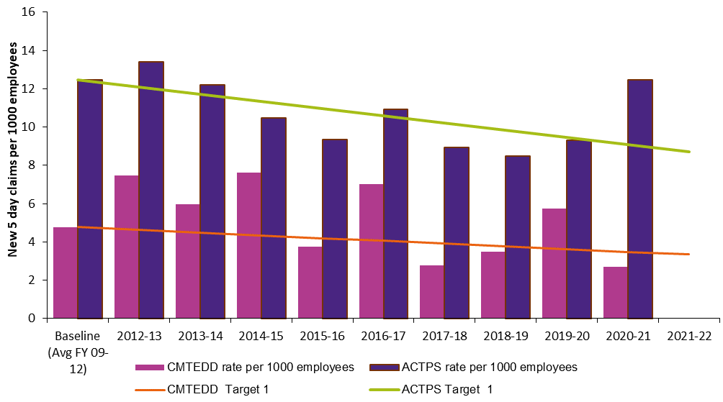
Table 98: Target 2 – reduce the incidence rate of claims for musculoskeletal disorders (MSD) by at least 30 per cent*
Financial year | Number of new 5-day MSD claims | Rate per 1000 employees | Directorate target | ACTPS number of new 5-day MSD claims | Rate per 1000 employees | ACTPS Target
2012 - 13 | 9 | 4.20 | 3.35 | 183 | 8.96 | 8.29
2013 - 14 | 6 | 2.76 | 3.25 | 175 | 8.31 | 8.03
2014 – 15 | 12 | 5.09 | 3.14 | 144 | 6.63 | 7.78
2015 – 16 | 6 | 2.51 | 3.04 | 146 | 6.67 | 7.52
2016 – 17 | 10 | 4.12 | 2.94 | 150 | 6.73 | 7.26
2017 – 18 | 5 | 2.30 | 2.83 | 128 | 5.66 | 7.01
2018 – 19 | 5 | 2.18 | 2.73 | 102 | 4.31 | 6.75
2019 – 20 | 8 | 3.28 | 2.63 | 126 | 5.09 | 6.49
2020 – 21 | 4 | 1.53 | 2.52 | 194 | 7.44 | 6.24
2021 - 22 |  |  | 2.42 |  |  | 5.98
Figure 2: Bar chart for Target 2 – reduce the incidence rate of claims for musculoskeletal disorders (MSD) by at least 30 per cent*
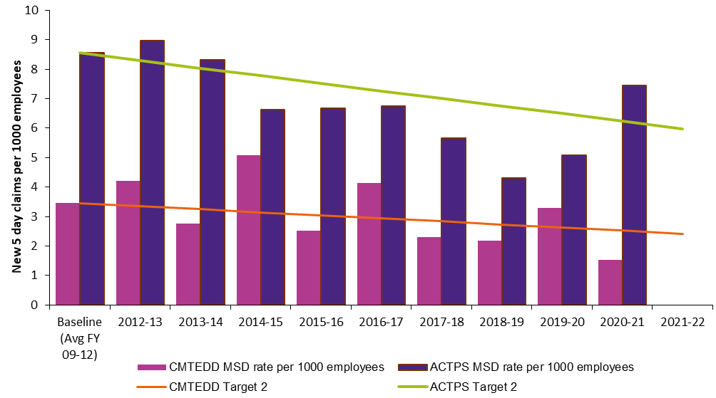
*Notes (for both tables and figures):
- Dates are based on those claims received by the Insurer in each financial year.
- Data is taken at 30 June in each of the years to allow for direct comparisons to be made between years.
- The report includes accepted claims which result in one or more weeks off work.
- Data includes claims up to 30 June 2021.

Human resources management
In 2020-21 CMTEDD’s human resources priorities were guided by the impact of COVID-19 on service delivery and the opening of our new government office buildings in Dickson and Canberra City.

Culture, attraction and retention
Key initiatives to progress a positive culture, attract and retain staff during the reporting period included:
- Supporting positive mental health and wellbeing of staff during COVID-19.
- Development of a Mental Health and Wellbeing Action Plan and new Diversity and Inclusion Strategy.
- Supporting the transition to flexible work arrangements to support changes due to COVID-19.
- Measuring and responding to staff engagement and wellbeing through surveys including a COVID-19 Staff Check-In in 2020 and the CMTEDD Pulse Survey in 2021.
- Recognising 15 teams and 12 individuals in the CMTEDD Staff Awards.
- Celebrating the first anniversary of the directorate’s Stretch Reconciliation Action Plan (RAP) 2020-2023 and the completion of more than one third of our RAP deliverables.

Workforce planning and employment strategies
In 2020-21 the ACT created over 500 ACT Government jobs in the Jobs for Canberrans program. CMTEDD employed more than 50 of these roles, increasing employment for our community during COVID-19. We recruited via targeted employment programs to increase workforce diversity and build capability into the future. Specifically, we notably increased our graduate intake and attracted a strong pool of candidates who will commence in our CMTEDD Employment Pathway Program for Aboriginal and Torres Strait Islander People in 2021. About half of our graduate intake included graduates who identify as having a disability, are culturally and/or linguistically diverse or Aboriginal and/or Torres Strait Islander. Through the CMTEDD ICT Service Desk Traineeship we also engaged seven trainees as a talent pipeline into ACTPS ICT roles.
Table 99: CMTEDD participants in targeted employment programs
Program name | Participants
ACTPS Graduate Program | 24 ¹
CMTEDD Employment Pathway Program for Aboriginal and Torres Strait Islanders | 5
ACTPS Vocational Employment Program for Aboriginal and Torres Strait Islanders | 5 ²
Work Experience Support Program for Culturally and Linguistically Diverse People | 8
ACTPS Vocational Employment Program for People with Disability | 0
Notes:
- The Graduate Program figure in the staffing profile section is 33, which represents graduates in CMTEDD who received a payment on the last payday of 2020-21. However, the total number of graduates in CMTEDD is comprised of 24 graduates who have a place in CMTEDD specifically. The remainder are part of the whole of government graduate talent bank who are part of Workforce Capability and Governance and will be placed across ACTPS Directorates at the end of their graduate program.
- Four employees completed the Employment Pathway Program in late 2020 and commenced Vocational Employment Program (VEP) while one commenced directly into the VEP in 2020. The Vocation Employment Program numbers are inclusive of the Employment Pathway Program due to differing start dates and arrangements to transition employees through the programs.

Capability
The focus of our capability-building in 2020-21 was to:
- Continue to deliver core learning accessible to a largely remote or hybrid workforce.
- Address development needs identified through staff surveys.
Build staff capability for new models of working going forward.

Learning and development programs and activities
Our suite of e-learning modules grew, and most instructor-led training was delivered in a virtual format.
In 2020-21 there were over 5,500 module completions across 20 online courses. There were over 600 attendees at instructor-led training (mostly virtual) across 45 sessions for 5 courses organised by CMTEDD Corporate. Additionally, participants accessed training from the whole-of-government ACTGov Learn platform, and business areas provided targeted training for their teams as required to meet their unique business goals. Staff also participated in leadership development opportunities including leadership programs, mentoring and coaching.
Our learning areas included core learning such as induction, work health and safety, respect and diversity topics, domestic and family violence awareness, governance and compliance topics and supervisor skills. Additional training was introduced to equip staff and managers for remote and hybrid work, as well as promoting mental health and wellbeing.
Table 100: Studies assistance and ACTPS training
 | Number of employees | Cost ($)
Studies assistance program | 51 | 78,187
ACTPS training via ACTGov Learn* | 553 | 163,980
*Note: Includes bookings for face-to-face or virtual training, but not e-learning courses.
We will continue to build whole of directorate future capabilities by:
- Creating learning opportunities to address the needs of our workforce including recruitment, performance, supervisory skills and working in remote or hybrid environments.
- Developing innovative learning approaches that suit ongoing hybrid working arrangements, including e-learning, virtual training, safe face-to-face training and hybrid learning models.
Acting on staff feedback from surveys and other feedback mechanisms.

Staffing profile
The staff numbers in the tables below represent CMTEDD employees who received a payment on the last payday of 2020-21. The figures exclude board members and people on leave without pay. They also exclude ACT Insurance Authority, Independent Competition and Regulatory Commission, Cultural Facilities Corporation and the ACT Long Service Leave Authority. Recruitment and separation rates are defined as commencing or departing the ACTPS respectively for permanent employees, and Executive Officers with long-term contracts. Internal transfers are not included.
Table 101: FTE (full-time equivalent) and headcount by business area
 | FTE | Headcount
Graduate Program | 32.8 | 33
Chief Minister Stream | 1,657 | 1,712
Access Canberra | 705.7 | 728
Corporate | 61.9 | 64
Communications and Engagement | 58.0 | 61
Economic Development | 188.6 | 199
Digital, Data and Technology Solutions ¹ | 482.4 | 493
Office of Head of Service | 4.0 | 4
Office of International Engagement | 6.0 | 6
Policy and Cabinet | 65.2 | 69
Strategic Finance | 22.6 | 23
Workforce Capability and Governance | 62.6 | 65
Treasury Stream | 875.9 | 902
Business Enablement Services | 31.6 | 32
Economic and Financial | 41.6 | 43
Finance and Budget | 55.8 | 56
Infrastructure Finance and Reform | 6.0 | 6
Office of Deputy Under Treasurer, Commercial Services and Infrastructure | 7.0 | 7
Office of Deputy Under Treasurer, Economic, Budget and Revenue | 2.0 | 2
Office of Under Treasurer | 4.6 | 5
Revenue Management | 114.3 | 119
Procurement ACT | 46.3 | 48
Property and Venues | 185.5 | 193
Shared Services | 315.7 | 323
Workplace Safety and Industrial Relations ² | 65.5 | 68
Total for CMTEDD | 2,565.7 | 2,647
Notes:
- Staffing numbers for the Digital, Data and Technology Solutions Group are listed as one line item under Chief Minister stream, but this group includes staff with reporting lines through both the Chief Minister Stream and Treasury.
- In May 2021 Workplace Safety and Industrial Relations Group changed its reporting line from the Treasury stream to within Workforce Capability and Governance in the Chief Minister Stream. The FTE is reflected in the Treasury stream in line with Output 5.1 Workforce Injury Management and Industrial Relations Policy as at 30 June 2021.
Table 102: FTE and headcount by gender
 | Female | Male | Total
FTE by Gender | 1,349.8 | 1,213.1 | 2,565.7
Headcount by Gender | 1,414 | 1,230 | 2,647
Percentage (%) of Workforce | 53.5 | 46.5 | 100.0
Table 103: Headcount by classification group and gender
Classification group | Female | Male | Total
Administration Officers | 885 | 467 | 1,352
Executive Officers | 42 | 50 | 92
General Services Officers & Equivalent | 0 | 66 | 66
Information Technology Officers | 31 | 126 | 157
Legal Officers | 2 | 0 | 2
Professional Officers | 7 | 19 | 26
Senior Officers | 439 | 483 | 922
Statutory Officer Holders | 0 | 2 | 2
Technical Officers | 8 | 14 | 22
Trainees and Apprentices | 0 | 3 | 3
Total | 1,414 | 1,230 | 2,647
Table 104: Headcount by employment category and gender
Employment Category | Female | Male | Total
Casual | 23 | 18 | 41
Permanent Full-time | 1,022 | 1,014 | 2,036
Permanent Part-time | 180 | 29 | 209
Temporary Full-time | 177 | 163 | 340
Temporary Part-time | 12 | 6 | 18
Total | 1,414 | 1,230 | 2,647
Table 105: Headcount by diversity group
Diversity group | Headcount | Percentage (%) of Agency Workforce
Aboriginal and/or Torres Strait Islander | 49 | 1.9
Culturally & Linguistically Diverse | 609 | 23.0
People with Disability | 128 | 4.8
Table 106: Headcount by age group and gender
Age Group | Female | Male | Total
Under 25 | 100 | 62 | 162
25-34 | 418 | 327 | 745
35-44 | 381 | 319 | 700
45-54 | 324 | 310 | 634
55 and over | 191 | 212 | 403
Total | 1,414 | 1,230 | 2,647
Table 107: Average length of service by gender
 | Female | Male | Total
Average years of service | 7.6 | 8.5 | 8.0
Table 108: Recruitment and separation rates
 | Recruitment rate (%) | Separation rate (%)
CMTEDD | 12.0 | 5.0
Further information
Robert Wright Executive Group Manager, Corporate
(02) 6207 0569 Robert.Wright@act.gov.au

Ecologically sustainable development

Support to the Commissioner for Sustainability and Environment
In 2020-21, the directorate supported the Commissioner for Sustainability and the Environment as follows:
- The Environment Protection Authority (EPA) held regular meetings with the Commissioner for Sustainability and the Environment to discuss and progress environmental issues.
- In decision-making processes and when providing advice, for example on development applications and environmental authorisations, the EPA assessed the effective integration of environmental, economic, and social considerations.
The EPA provided information and support to the Commissioner for Sustainability and the Environment to undertake an investigation into a woodfire smoke complaint from a member of the community.

Business area activities
To align with the ACT Climate Change Strategy to reduce emissions from government operations, CMTEDD has developed an emissions pathway plan, following a workshop to identify actions and initiatives to reduce emissions across priority facilities. We actively monitor progress against set targets via regular emission reports and sustainability updates to the directorate’s Executive Management Group.
The Coordinator-General for Climate Action and the Office for Climate Action were established within CMTEDD in 2021 to oversee the delivery of major projects, coordinate activities across the ACT Government and identify ways to increase climate adaptation and resilience. CMTEDD co-led the delivery of key climate action initiatives with the Environment, Planning and Sustainable Development Directorate (EPSDD), including the rollout of the Sustainable Household Scheme and co-design with industry on the future Big Canberra Battery. Further information can be found under Output 1.1 Government Policy and Reform in the Performance Analysis section.
In 2020-21 the directorate supported ecologically sustainable development through a range of initiatives, detailed further in the following sections.

Improving energy efficiency through facilities upgrades
In 2020-21 we continued to implement the whole of government Office Accommodation Strategy. The strategy provides a framework for achieving the government’s sustainability outcomes within its stock of office accommodation. Buildings that are constructed and subleased under the ‘Hub and Satellite’ approach in the Accommodation Strategy will achieve at least a 4.5-star National Australian Built Environment Rating System (NABERS) rating. The subleasing of the additional two office buildings and vacating of older office buildings ensures all ACT Government leased office accommodation achieves a NABERS rating of at least 4.5 stars. The new Dickson office building at 480 Northbourne Avenue achieved a 5-star Green Star designed and as-built rating, and is targeting a 5-star NABERS rating (which is usually assessed over a longer period of time). Our new City office building at 220 London Circuit is also targeting a GOLD rating for WELL Shell and Core. The WELL building standard is a performance-based system for measuring, certifying, and monitoring features of a project that impact human health and well-being.
We also improved energy efficiency through the following upgrades and inclusions to facilities within the CMTEDD portfolio, including:
- Inclusion of rooftop solar panels in the 220 London Circuit office building. The panels generate power shared by the base building and the Territory tenants within the building. The 480 Northbourne Avenue office building also has solar array providing energy to the base building.
- Having Green Leases in place for Winyu House, Cosmopolitan Centre, Bowes Place, 220 Northbourne Avenue, Nature Conservation House, 220 London Circuit and 480 Northbourne Avenue. These Green Leases allow for more sustainable management of these tenancies.
- Continued implementation of ecologically sustainable work practices at Venues Canberra’s major sporting and entertainment venues. This includes the ongoing installation of LED lighting at EPIC, GIO Stadium and Manuka Oval as older-style lights require replacement.
- Completion of energy efficiency improvements at ACT Government owned swimming pools, including:
- Installation of a pool blanket at Stromlo Leisure Centre in 2021.
- New solar hot water units for showers were installed at Dickson Pool in July 2020 to replace the old system.
- Installation of a building analytics system at Lakeside Leisure Centre in June 2021. The system will provide information on the utility consumption, which guides the effective efficiency measures appropriate for the site.
- Undertaking five-year preventative maintenance and additional capital works at Lakeside Leisure Centre during the COVID-19 shutdown period. This work included electrical board upgrades and the replacement of gas fired hot water units with electric energy saving options.
For arts infrastructure, completion of design and implementation planning for the replacement of an aged gas-powered heating system in A Block at Gorman House Arts Centre. The system will be replaced with an energy efficient electric system.
Image 10: New pool blanket at Stromlo Leisure Centre
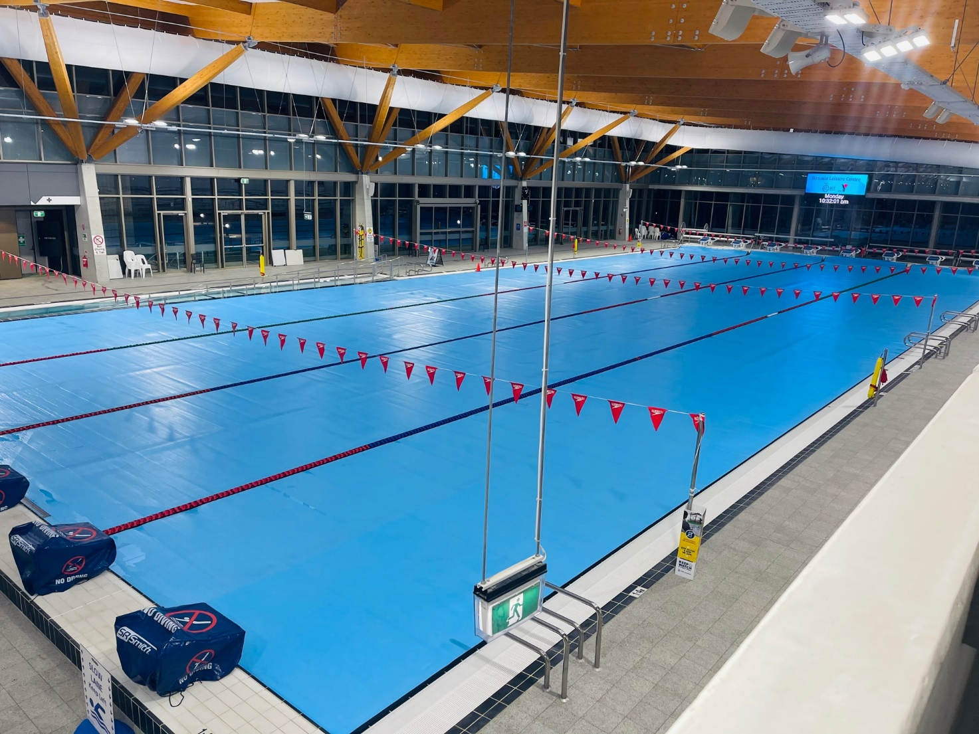

Improving water efficiency
In 2020-21 our initiatives targeting water efficiency included:
- The inclusion of rainwater recycling systems in our new government office buildings. This includes 40,000L at 220 London Circuit servicing toilets flushing, and 160,000 at 480 Northbourne Avenue servicing cisterns, urinals and HVAC cooling towers.
- Continued use of rainwater and non-potable water for irrigation of grounds at Venues Canberra’s major sporting and entertainment venues.

- Continued best practice maintenance of National Arboretum Canberra Forests, ensuring tree health and optimal conditions to reduce reliance on water. This has included the pruning of over 25,000 trees, planting close to 900 new trees, and installing over 2,500 cubic metres of mulch. We also continued to use the Smart Sensor Soil Moisture software at the Arboretum. The software is installed in ten of the 94 forests to manage the unique requirements of each tree species – indicating excessive or insufficient soil moisture. The Arboretum further managed sustainable water retention with tree mulching, including recycled mulching made from onsite tree pruning, and is also operating an upgraded irrigation system that reduces water run-off and soil erosion.

Waste, reuse and recycling
In 2020-21 we worked to reduce our waste by:
- Continuing to reduce the presence of single-use plastics at major events and community events managed and delivered by Events ACT. To achieve this reduction, we eliminated the use of plastic plates and cutlery by food vendors and increased the number of drinking fountains and water stations available at events to refill reusable bottles.
- Implementing recycling across all major sporting and entertainment venues, with organic waste from GIO Stadium going to a worm farm. All major venues are Accredited Actsmart Business Recyclers.
- Ensuring reuse of our office furniture and other equipment. To prepare for the office accommodation relocation to the new City office building at 220 London Circuit, CMTEDD redistributed a large amount of office furniture, office stationery, equipment and appliances to other ACT Government agencies, public schools, and charitable organisations.
- Recycling our ICT assets. When ICT assets reach or approach the end of their useful life, disposal is facilitated through offerings to the market as arranged by the CMTEDD disposal broker, Capital Easy Finance and Leasing. All ICT assets have been refreshed either through the ACT Standard Operating Environment project, business as usual refresh or collected from ACT Government sites on request by Verser Technology Lifecycles. These assets have been reviewed and are not eligible for reuse within government as they do not meet the required specifications and/or have become surplus to business requirements. In 2020-21, the total recoveries from ICT disposals were $649,000.

Reducing paper usage
We continue to reduce our paper usage via digital transformation through:
- Continued service delivery model changes driven by the impacts of COVID-19, which has seen Access Canberra rapidly expand its online self-service offerings. To protect the health and safety of our staff and the community, customers have been encouraged to take a digital-first approach to accessing services to reduce unnecessary travel to Service Centres.
- Supporting a ‘paper-lite’ culture through the increased the use of electronic document and records management systems, and capitalising on their functionality to replace paper-based processes.
- Implementation of the PaperCut printing system project, which only prints when the staff member accesses the printer using their ACT Government pass. At an operational level, for a variety of compatibility, legacy and process reasons, not all printing is managed via PaperCut. Progress is incrementally made in this space as business systems are updated.
Continued implementation of different digitalised customer services to replace paper-based processes, such as the Shared Services Customer Portal, the Shared Services Accounts Payable Invoice Automation System (APIAS), and ACT Revenue Office electronic rates notices.

Promoting sustainable transport
Through Procurement ACT the directorate continued to support EPSDD in the transition of the Territory’s fleet to electric vehicles (where fit-for-purpose), with the following achievements across the government:
- All eligible leased vehicles being electric in line with the Zero Emission Strategy, with 74 new passenger zero emissions vehicles (ZEV) leases commencing in the reporting year.
- Integration of 20 Hyundai NEXO Hydrogen Fuel Cell Electric Vehicles into the ACT Government Fleet to assigned directorates and agencies participating in the Hyundai NEXO Loan Vehicle Program. The ActewAGL Fyshwick refuelling facility was officially opened in March 2021 and is now operational.
Proactively providing support to the Realising Electric Vehicle-to-grid Services (REVS) project led by EPSDD and the Australian Renewable Energy Agency (ARENA). This will see 50 Nissan Leaf 2.0 vehicles integrated into the Territory Fleet complete with bidirectional chargers to enable the vehicle to grid charging initiative partly funded by the Australian Renewable Energy Agency by December 2021. The program aims to increase the amount of distributed energy storage connected to the electricity grid to enhance grid resilience and energy reliability and security.
We continued to encourage business areas within the directorate to identify and implement fleet emissions reduction opportunities. This included:
- Replacing existing passenger vehicles with electric or hybrid models upon end of lease and when it is operationally feasible and fit-for-purpose. Justification as to why an electric vehicle is not business fit-for-purpose is required with each vehicle lease.
- Participating in the ARENA REVS trial program by installing four bi-directional EV chargers and leasing four Nissan Leaf electric vehicles in CMTEDD locations (Winyu House, Cosmopolitan Building).
- Participating in the Hyundai NEXO Loan Vehicle Program, with five Hyundai NEXO hydrogen fuel cell vehicles allocated to the CMTEDD fleet.
Encouraging staff to use sustainable transport options such as electric vehicles, public transport, electric bikes, and active travel options.

Sustainability in procurement
In 2020-21, the directorate implemented the Government Procurement (Charter of Procurement Values) Direction 2020 and the Procurement Values Guide. One of the Procurement Values is Environmental Responsibility. We value environmental responsibility and seek to ensure procurement by government buyers has a positive impact on our physical environment and local and global ecosystems. The ACT Government is committed to reducing the draw on natural resources, consumption and greenhouse gas emissions in procurement. We support a transition to a circular economy that values resources by keeping products and materials in use for as long as possible. Acquisition and disposal activities use opportunities to reduce waste and single use plastics through recycling and reuse.

Supporting sustainable infrastructure
In 2020-21 the directorate’s Infrastructure Finance and Reform area business area worked to update the Capital Framework. This framework guides directorates in methodically undertaking robust analysis of infrastructure projects to inform government investment decision making. The update includes strengthening analysis under the government’s Wellbeing Framework and sustainability goals and promoting the inclusion of funding for sustainability ratings into business cases, to accord with ecologically sustainable development principles.
Additionally, the Utilities Technical Regulation team in Access Canberra regulates licensed utilities (electricity and gas distribution and transmission, water, and sewerage) and unlicensed regulated utilities (including light rail, solar farms, and other large generators) in accordance with the Utilities (Technical Regulation) Act 2014.

Supporting innovation and investment in ecological sustainable development
We supported innovation and investment in ecologically sustainable development initiatives by:
- Pursuing investment opportunities and supporting innovation and industry growth across the renewable energy sector in collaboration with EPSDD. Renewable energy is a key capability sector for the ACT.
- Integrating the objectives of the ACT Climate Adaptation Strategy into Economic Development’s key strategies on investment, trade, innovation and business development.
- Collaborating with ACT NoWaste to develop and promote trade and investment opportunities to attract inward investment and promote export opportunities for ACT innovations in waste streams and the circular economy.
- Continuing to support development for agri-technology and environmental sciences across research, teaching and industry in the ACT.
- Continuing the implementation of projects funded through the Priority Investment Program such as:
- The development of the Distributed Energy Resources Laboratory, to support growth opportunities in the renewable energy sector.
- Enhancement of the Centre for Entrepreneurial Agri-Technology, to include an innovation hub for ACT based start-ups and agri-technology small to medium enterprises to facilitate regional collaboration and support Canberra Region agri-technology innovation.
Establishment of a cloud-based biodiversity and biosecurity analysis hub using a software and DNA analysis platform to unlock wider research opportunities and commercial applications.
Table 109: Sustainable development performance: Current and previous financial year ¹
Indicator as at 30 June | Unit | Current FY | Previous FY | Percentage change (%)
Stationary energy usage ²
Electricity use | Kilowatt hours | 12,211,274 | 12,938,687 | -5.6
Natural gas use (non-transport) | Megajoules | 88,493,183 | 53,821,493 | 64.4
Diesel (non-transport) | Kilolitres | 1.5 | 2.67 | -44
Transport fuel usage ³
Electric vehicles | Number | 13 | 15 | -13.3
Hybrid vehicles | Number | 14 | 16 | -12.5
Hydrogen vehicles | Number | 5 | 0 | n/a
Total number of vehicles | Number | 186 | 191 | -2.6
Fuel use – Petrol | Kilolitres | 35 | 50 | -29.6
Fuel use – Diesel | Kilolitres | 237 | 234 | 1.3
Fuel use – Liquid Petroleum Gas (LPG) | Kilolitres | 0 | 0 | n/a
Fuel use – Compressed Natural Gas (CNG) | Gigajoules | 0 | 0 | n/a
Water usage ⁴
Water use | Kilolitres | 195,026 | 207,938 | -6.8
Resource efficiency and waste ⁵
Reams of paper purchased | Reams | 6,242 | 10,659 | -41.4
Recycled content of paper purchased | Percentage | 81 | 85 | -4.5
Waste to landfill | Litres | 3,131,998 | 2,036,916 | 53.8
Co-mingled material recycled | Litres | 1,352,062 | 2,093,978 | -35.4
Paper & Cardboard recycled (incl. secure paper) | Litres | 1,315,989 | 1,153,034 | 14.1
Organic material recycled | Litres | 77,423 | 192,197 | -59.7
Waste to landfill  (Events ACT Actsmart Public Events) | Litres | 42,800 | 162,200 | -73.6
Material recycled (incl. comingle recycling, paper and cardboard recycling, and organic recycling)  (Events ACT Actsmart Public Events) | Litres | 43,080 | 247,310 | -82.6
Greenhouse gas emissions ⁶
Emissions from natural gas use (non-transport) | Tonnes CO2-e | 4,518 | 2,733 | 65.7
Emissions diesel use (non-transport) | Tonnes CO2-e | 4 | 7 | -41.8
Emissions from transport fuel use | Tonnes CO2-e | 725 | 755 | -4.0
Total emissions | Tonnes CO2-e | 5,247 | 3,489 | 50.4
Notes:
- The directorate’s data (for both years’ measures except for paper usage) include the ACT Insurance Authority when they were in Canberra Nara Centre as it cannot be readily separated. Current and previous year results have been rounded to the nearest whole number. The result for percentage change is calculated prior to rounding.
  - There has been significant change in the directorate’s facility portfolio during this financial year, with a number of changes to accommodation, as well as the addition of the Stromlo Leisure Centre to the portfolio.
- Energy, water, and transport fuel data was extracted from the Enterprise Sustainability Platform (ESP) on 23 August 2021.
  - Data completeness in the ESP for current year is 98.3 per cent electricity, 99.6 per cent gas use, and 98 per cent water use. For analysis and reporting purposes the ESP dashboard reports ‘accrued’ data, which incorporates estimated missing data in the full year performance. Accruals are calculated from the average annual daily consumption of the most current 12-month period applied for the number of days of missing data.
  - The significant increase in gas use is largely due to the almost full year operation of the Stromlo Leisure Centre, in addition to a higher proportion of the full year’s operation of the other ACT Government pool facilities (that were closed for the colder portion of the 2019-20 reporting year). There was also colder weather over the shoulder months during 2020-21, resulting in an increased need for pool facility heating (although this was slightly offset by the continued closure of the 50-metre pool at the Gungahlin Leisure Centre).
  - Non-transport diesel was used for onsite generators at the National Arboretum Canberra and for events at Venues Canberra sites.
- Fleet data was extracted from Fleet Intelligence on 5 July 2021.
  - Total number of vehicles refers to all leased vehicles via SG Fleet. The number of electric vehicles and hybrid vehicles for previous year has been updated to reflect the change of definition. Electric vehicle refers to fully electric vehicle or plug-in hybrid electric vehicle (also known as a range-extended vehicle). Hybrid vehicles refer to petrol/electric hybrid vehicles (with internal combustion engine and an electric propulsion system/drivetrain).
  - The reduction of electric and hybrid vehicles has largely been in line with reductions in the fleet overall. As the majority of the CMTEDD fleet is operational vehicles (and largely utes and vans for which there currently no zero-emission option) any reduction in fleet numbers tends to occur within the smaller pool of passenger vehicles, of which approximately half are currently electric. CMTEDD also added 5 hydrogen vehicles to our fleet this year.
  - Petrol use has decreased due to a number of factors, including reduction in number of fleet and reduced use of vehicles during COVID-19.
- The reduced water consumption in 2020-21 was evidenced across almost all CMTEDD sites, with the most significant related to: temporary repairs to the Civic Olympic Pool (reduced water loss from ongoing leak); preventative maintenance works carried out at the Lakeside Leisure Centre during COVID shutdown in 2020, reopening at the end of August 2020; and the closure of the Gungahlin Leisure Centre’s 50 metre pool for ongoing tiling issues for the whole of the 2020-21 year. The reduction was offset by a water leak at Exhibition Park which resulted in a significant consumption increase at that location.
- There was a reduction in the amount of paper purchased and waste and recycling generated in 2020-21.
  - Number of reams of paper purchased and recycling content is based on the whole of government paper reports provided by Procurement ACT. For 220 London Circuit and 480 Northbourne Avenue, paper usage is calculated based on the percentage split from the paper printing report.
  - Reduction in paper purchased was due to the directorate transition to a ‘paper-lite’ work environment and the majority of the staff working from home.
  - Waste and recycling data was calculated on a basis of Total (L) = Capacity of bins (L) x number of bins x number of times emptied during the reporting year.
  - 2020-21 waste data was largely provided by billing data by business areas, or by the ACTsmart data provided as part of accreditation processes. At least 3 major and long-term office locations undertook clean-ups related to the office relocations completed during the year, accounting for the increase in paper and cardboard recycled, and waste to landfill.
  - The reduction in organics recycling resulted from the impact COVID-19 and staff working from home.
  - Waste and recycling data related to major events held by Events ACT has reduced significantly in 2020-21. For many events the traditional event format was not delivered due to COVID-19 and waste collection was not required for the reformatted event (e.g., Floriade, New Year’s Eve in the City, Australia Day Firework Spectacular).
  - The 2021 Enlighten Festival was delivered in a revised COVID-safe format approved by the Chief Health Officer, which included venues capacity restrictions and attendee pre-registration for free tickets. This significantly limited the attendance capacity when compared to the traditional Enlighten Festival Format, with a corresponding reduction in the amount of waste and recycling generated. Similarly, Reconciliation in the Park held on 31 May 2021 had a smaller amount of waste and recycling.
- Emissions reported for stationary energy and transport fuels include Scope 1 and Scope 2 emissions only.
  - Scope 1 are direct emissions from sources owned and operated by the government including: emissions from transport fuel and natural gas use. Scope 2 are indirect emissions from mains electricity.
  - Emissions from all emission sources are extracted from the Enterprise Sustainability Platform (ESP). The ESP is maintained with the latest emissions factors. Emission factors for electricity are revised annually and updated in the ESP on 1 July. As of January 2020, the ACT shifted to 100% renewable energy. All electricity consumption now produces zero emissions, and the emissions factors are no longer required going forward.
  - The increase and decreases in emissions are in line with the increase (gas) and decrease (transport and non-transport fuel) in consumption.
Further information
Robert Wright Executive Group Manager, Corporate
(02) 6207 0569 Robert.Wright@act.gov.au

Other reporting

Financial management reporting
All Financial Management reporting is included in Volume 2 of CMTEDD’s Annual Report, including:
- Financial Management Analysis (Management Discussion and Analysis)
- Financial Statements
- Capital Works
- Asset Management
- Government Contracting
- Statement of Performance

Tobacco compliance testing
Access Canberra did not undertake any tobacco compliance testing during the 2020-21 financial year. Compliance testing is used as a tool when there is a level of alleged non-compliance identified that warrants this activity being undertaken.
Access Canberra continues to monitor complaint data and encourages the reporting of any suspected unlawful conduct in relation to this matter.

Public land management plans
The Albert Hall precinct public land (Pd-Special Purpose Reserve) is managed by ACT Property Group as the custodian on behalf of the Territory. The Planning and Development (Albert Hall) Land Management Plan 2016 is available at https://legislation.act.gov.au/di/2016-7.

Covert surveillance authorisations issued to ACT employers
The Workplace Privacy Act 2011 (Workplace Privacy Act) requires employers to apply to the Magistrates Court for authority to conduct any workplace covert surveillance.
Prior to 1 July 2016, the number of authorisations issued was reported under section 45 of the Workplace Privacy Act. Following the repeal of that section, future reporting was to be transferred to the annual report of the ACT Government directorate with responsibility for the Act. Under the Administrative Arrangements that responsibility rests with the Chief Minister, Treasury and Economic Development Directorate.
In the financial year ending 30 June 2021 the Magistrates Court issued nil covert surveillance authorities under the Workplace Privacy Act.
As this is the first time this information has been reported since 1 July 2016, it is also reported that nil covert surveillance authorisations were issued for the period 1 July 2016 ending 30 June 2020.

Annexed annual reports
Public sector bodies required to have their annual report annexed to CMTEDD’s report are listed below. Their reports are included in alphabetical order in the following annex.
- ACT Architects Board
- ACT Construction Occupations
- ACT Executive
- ACT Government Procurement Board
- Default Insurance Fund
- Director of Territory Records
- Environment Protection Authority
- Lifetime Care and Support Fund
- Motor Accident Injuries Commission
- Office of the Nominal Defendant of the ACT
Public Sector Workers Compensation Fund

ACT Architects Board

Transmittal certificate
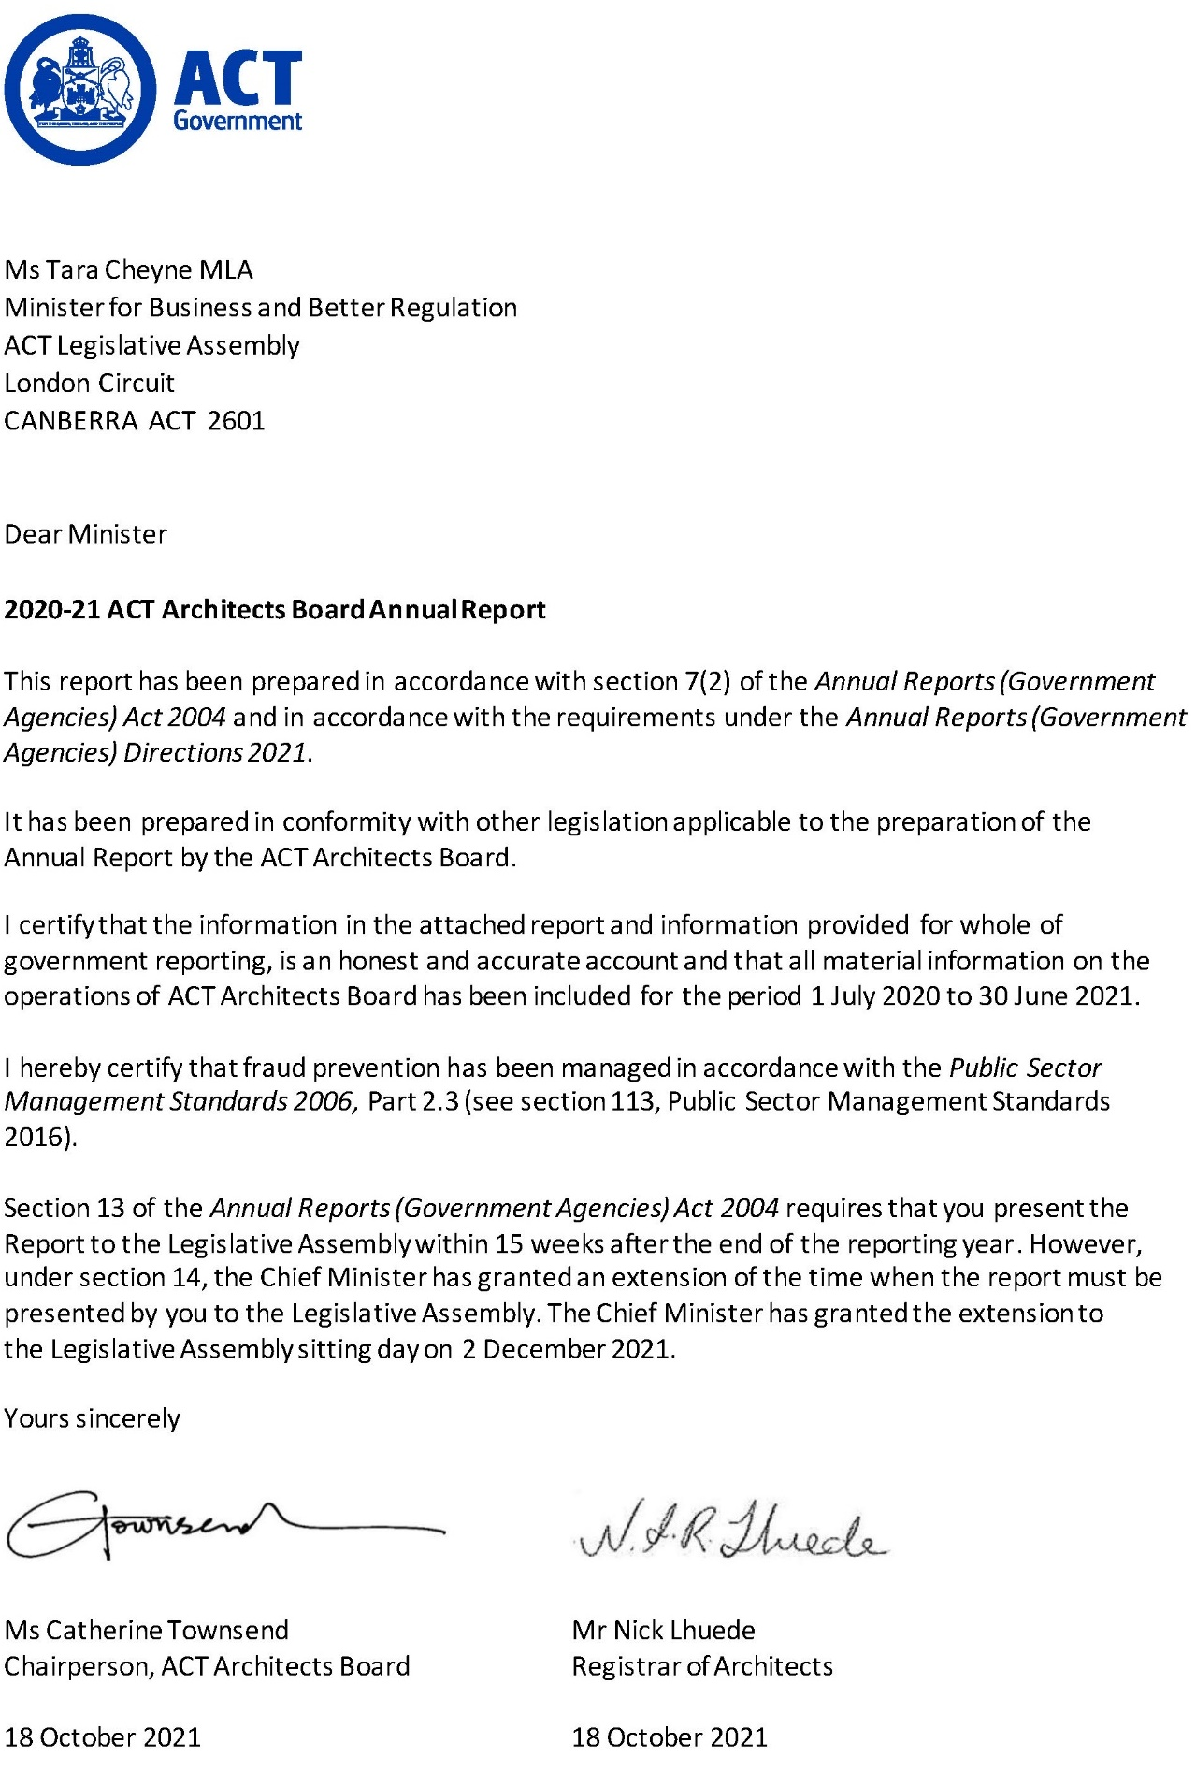

Compliance statement
The 2020-21 ACT Architects Board Annual Report must comply with the Annual Reports (Government Agencies) Directions 2021 (the Directions) made under section 8 of the Annual Reports (Government Agencies) Act 2004. The Directions are found at the ACT Legislation Register.
The Compliance statement indicates the subsections, under Parts 1 to 5 of the Directions, that are applicable to the ACT Architects Board and the location of information that satisfies these requirements.

Part 1 Directions overview
The requirements under Part 1 of the Directions relate to the purpose, timing and distribution, and records keeping of annual reports. The 2020-21 ACT Architects Board Annual Report complies with all subsections of Part 1 under the Directions.
To meet Section 15 Feedback, Part 1 of the Directions, contact details for the ACT Architects Board are provided within the 2020-21 ACT Architects Board Annual Report to provide readers with the opportunity to provide feedback.

Part 2 Reporting entity annual report requirements
The requirements within Part 2 of the Directions are mandatory for all reporting entities and the ACT Architects Board Annual Report complies with all subsections. The information that satisfies the requirements of Part 2 is found in the ACT Architects Board Annual Report as follows:
- A. Transmittal Certificate, see the previous page.
- B. Organisational Overview and Performance Analysis subsections, see the Organisational Overview and Performance section on the next page. As the ACT Architects Board sits within Access Canberra in CMTEDD, all other subsections in Section B, Part 2 of the Directions are contained within the CMTEDD Annual report.
C. Financial Management reporting, inclusive of all subsections, see Volume 2 of the CMTEDD Annual Report.

Part 3 Reporting by exception
The ACT Architects Board has no information to report by exception under Part 3 of the Directions for the 2020-21 reporting year.

Part 4 Directorate and public sector body specific annual report requirements
The ACT Architects Board has additional reporting requirements under section 67 of the Architects Act 2004 and regulation 12 of the Architects Regulation 2004.

Part 5 Whole of government annual reporting
All subsections of Part 5 of the Directions apply to the ACT Architects Board. Consistent with the Directions, the information satisfying these requirements is reported in one place for all reporting entities as follows:
- Bushfire Risk Management, see the annual report of the Justice and Community Safety Directorate.
- Human Rights, see the annual report of the Justice and Community Safety Directorate.
- Legal Services Directions, see the annual report of the Justice and Community Safety Directorate.
- Public Sector Standards and Workforce Profile, see the annual State of the Service Report.
Territory Records, see the CMTEDD Annual Report.
ACT Public Service directorate annual reports are found at the following web address: http://www.cmd.act.gov.au/open_government/report/annual_reports

Organisational overview and performance

Registrar functions
The role of the Registrar is to manage the administration of the board and to maintain the register of Architects, as outlined under section 13 of the Architects Act 2004.

ACT Architects Board
The ACT Architects Board (‘the Board’) is established under the Act. The Board ensures registered architects provide services to the public in a professional and competent manner. The Board has a range of powers to investigate complaints against architects and to discipline those who are found to have acted unprofessionally or incompetently. The Board’s functions are to:
- Register architects.
- Investigate complaints given to the Board about registered people and people who have been registered.
- Consider whether it is necessary to take disciplinary action against registered people and people who have been registered and, if it is, to take the necessary action.
- Consider and report to the Minister about issues referred to the Board by the Minister for advice.
- Advise the Minister in relation to the practice of architectural regulation, for example, about codes of professional conduct.
- Further a common and harmonious approach to the administration of legislation about architects by cooperation with local jurisdictions.
- Accredit courses of study in architectural regulation.
Provide general advice to consumers about the professional conduct and standards of competence expected of registered architects.
The ACT Architects Board is also part of a national network of Boards which administer the state and territory legislation pertaining to architectural education and the registration of architects. The eight state and territory architect registration Boards are Nominated Bodies of the Architects Accreditation Council of Australia (AACA). The AACA was established by the Boards to ensure national consistency in the pathway that leads to registration as an architect in Australia. The Architects Board of the ACT is represented by the Registrar and the Board Chair, as are the other state and territory Registration Boards.
The AACA is recognised as the national organisation responsible for advocating, coordinating and facilitating national standards for the registration of architects in Australia and for the recognition of Australian architects overseas by the relevant Registration Authorities. The AACA also has the responsibility for assessment of overseas qualifications in architectural regulation for the purpose of migration to Australia under the Australian Government’s Skilled Migration program.

Complaints and disciplinary actions
In each state and territory of Australia it is a legal requirement that any person using the title architect, or offering services to the public as an architect, must be registered with the architect registration Board in that jurisdiction. Architect legislation has been enacted to protect consumers and the public. Only people whose names appear on a state and territory architect registration Board register can use the title architect in that jurisdiction. Therefore, it is illegal for people to use the title architect or offer architectural services if they are not on a register of architects in the state or territory in which they are practicing.
During 2020-21, the Board received four complaints about individuals and organisations offering architectural services without a registered nominee and advertising without details. The Board wrote to each entity requesting necessary action to remove all public advertising. As a result of the Board’s actions, compliance was achieved, and no further action was undertaken. Firms operating without a registered nominee appointed a registered architect as nominee, and firms advertising without details removed misleading information.

National engagement
In October and November 2020, the Registrar and Board Chair attended the AACA annual forum and Annual General Meeting via zoom. These meetings were attended by Registrars and Board chairs from all other Australian jurisdictions. These meetings provided an opportunity for Registrars and Board Chairs to share information about emerging issues in each of the jurisdictions and to look at ways to work together in the progression of architectural regulation across Australia.

Architects’ registrations
Table 1: Registrations from 1 July 2020 to 30 June 2021
Type of registration | Number of registrations
New architects (including 14 through Mutual Recognition) | 30
Re-issued | 78
Renewed architects | 283
Registered architects as at 30 June 2021 | 391

Internal accountability

Membership of the Board
Section 70 of the Act stipulates that the Board consists of the following members:
- 1 member nominated in writing by a representative body
- 1 member who is, or has recently been, an academic architect
- 1 member who is registered
- 1 member who is a commercial lawyer
1 member to represent community interests who is not registered.
The Minister must appoint the Board members and an appointment must be for a term of no longer than three years.
Table 2: Membership of the Board and attendance for 2020-21 financial year
Members | Name | Meetings attended
Peak Body Representative | Catherine Townsend | 11
Academic architect representative | Erin Hinton | 9
Registered architect representative | Scott Hodgson | 9
Legal representative | Maurice Falcetta | 10
Community interests representative | Vacant* | n/a
*Note: The community interests representative position lapsed in February 2020 and remains vacant.

Board meetings
The Board is required to meet at least four times a year. During 2020-21 the Board met 11 times on the following dates:
Table 3: 2020-21 Architects Board meeting dates
Dates
10 July 2020 | 11 August 2020 | 22 September 2020
23 October 2020 | 24 November 2020 | 15 December 2020
15 February 2021 | 22 March 2021 | 19 April 2021
24 May 2021 | 17 June 2021

Remuneration
In accordance with the Remuneration Tribunal Act 1995, the remuneration rate for the chair of the Board is $555 (per diem) and for a Member of the Board is $480 (per diem).
Further information
Nick Lhuede Registrar ACT Architects Board
(02) 6207 8606 Architectsboard@act.gov.au

ACT Construction Operations

Transmittal certificate
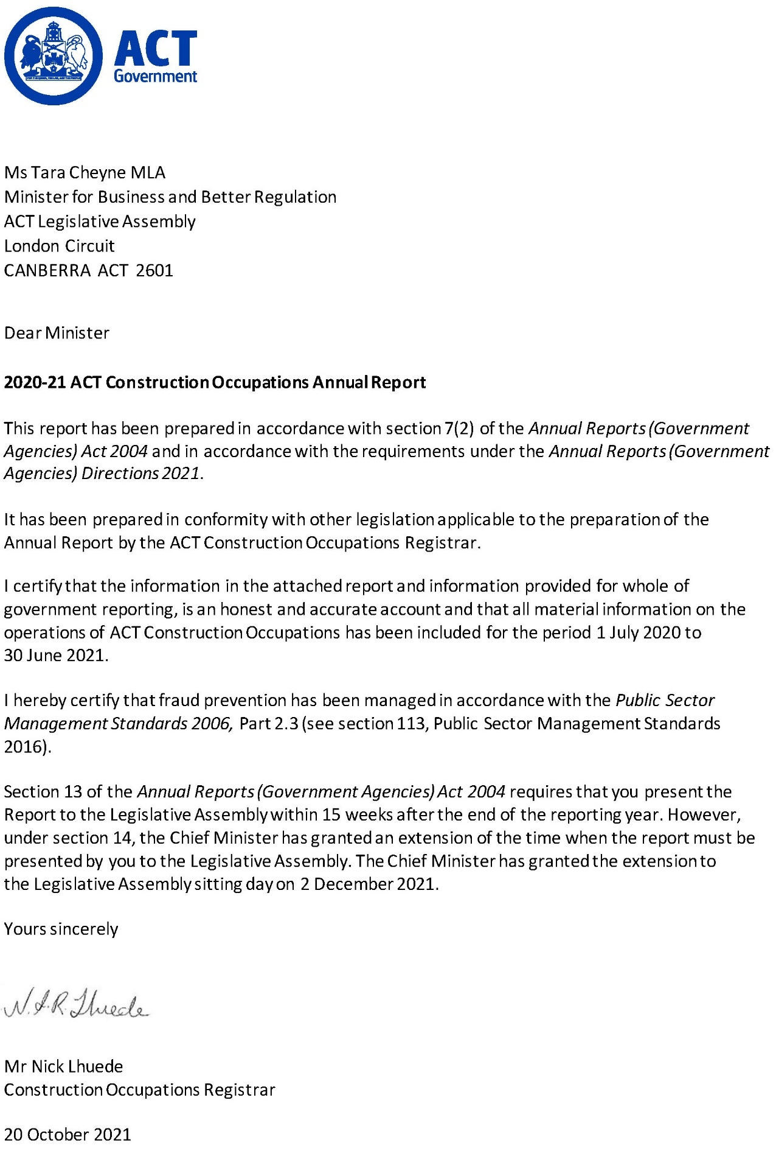

Compliance statement
The 2020-21 ACT Construction Occupations Annual Report must comply with the Annual Reports (Government Agencies) Directions 2021 (the Directions) made under section 8 of the Annual Reports (Government Agencies) Act 2004. The Directions are found at the ACT Legislation Register.
The compliance statement indicates the subsections, under Parts 1 to 5 of the Directions, that are applicable to ACT Construction Occupations and the location of information that satisfies these requirements.

Part 1 Directions overview
The requirements under Part 1 of the Directions relate to the purpose, timing and distribution, and records keeping of annual reports. The 2020-21 ACT Construction Occupations Annual Report complies with all subsections of Part 1 under the Directions.
To meet Section 15 Feedback, Part 1 of the Directions, contact details for ACT Construction Occupations are provided within the 2020-21 ACT Construction Occupations Annual Report to provide readers with the opportunity to provide feedback.

Part 2 Reporting entity annual report requirements
The requirements within Part 2 of the Directions are mandatory for all reporting entities and the ACT Construction Occupations Annual Report complies with all subsections. The information that satisfies the requirements of Part 2 is found in the ACT Construction Occupations Annual Report as follows:
- A. Transmittal Certificate, see the certificate on the previous page.
- B. Organisational Overview and Performance Analysis subsections, see Organisational Overview and Performance on the next page. As ACT Construction Occupations sits within Access Canberra in CMTEDD, all other subsections in Section B, Part 2 of the Directions are contained within the CMTEDD Annual Report.
C. Financial Management reporting, inclusive of all subsections, see Volume 2.1 of the CMTEDD Annual Report.

Part 3 Reporting by exception
ACT Construction Occupations has no information to report by exception under Part 3 of the Directions for the 2020-21 reporting year.

Part 4 Directorate and public sector body specific annual report requirements
There are no specific annual report requirements for ACT Construction Occupations.

Part 5 Whole of government annual reporting
All subsections of Part 5 of the Directions apply to ACT Construction Occupations. Consistent with the Directions, the information satisfying these requirements is reported in the one place for all reporting entities as follows:
- Bushfire Risk Management, see the annual report of the Justice and Community Safety Directorate.
- Human Rights, see the annual report of the Justice and Community Safety Directorate.
- Legal Services Directions, see the annual report of the Justice and Community Safety Directorate.
- Public Sector Standards and Workforce Profile, see the annual State of the Service Report.
Territory Records, see the CMTEDD Annual Report.
ACT Public Service directorate annual reports are found at the following web address: http://www.cmd.act.gov.au/open_government/report/annual_reports.

Organisational overview
This annual report has been prepared according to the Construction Occupations (Licensing) Act 2004 (s.112 Annual Report by Registrar) and the Construction Occupations (Licensing) Regulation 2004 (s.44 Information in report to Minister).

Role and functions
The Construction Occupations (Licensing) Act 2004 (COLA) is the principal legislation governing the responsibilities of construction occupation licensees including builders, plumbers, electricians, and building surveyors in the ACT. It also includes disciplinary and complaints processes for construction practitioners (including in relation to work undertaken under ‘operational Acts’ such as the Building Act 2004, the Electricity Safety Act 1971 and the Gas Safety Act 2000).
The Construction Occupations Registrar (‘the Registrar’) is appointed under section 103 of the COLA with their functions articulated under section 104.
The Registrar sits within Access Canberra, part of the Chief Minister, Treasury and Economic Development Directorate.
Table 1: Registrar’s roles and functions
WHAT WE DO
Decide applications for licences | Keep registers of construction occupations licensees | Monitor compliance
Respond to complaints | Take consistent regulatory action | Empower community and hold industry to account

Strategic priorities of the Registrar 2020-21
The Registrar’s strategic priorities for 2020-21 were rapid regulatory response, citizen protection and industry engagement. These priorities reflect the key role Access Canberra plays in supporting a safe and liveable city. Consistent with Access Canberra’s Accountability Commitment and compliance frameworks, the Registrar applies a risk-based compliance approach to ensure resources are targeted to where the risks of harm, unsafe practices or misconduct are the greatest.
Table 2: Strategic priorities in 2020-21
STRATEGIC PRIORITIES 2020-21
Rapid regulatory response | Citizen protection | Industry engagement

Functional areas
The work of the Registrar is undertaken by the functional areas in the Construction, Utilities and Environment Protection Branch of Access Canberra as identified below.
Construction Occupations Registrar
Executive Branch Manager – Construction, Utilities and Environment Protection
Compliance Assessment Medium to High Rise Building | Compliance Assessment Low Rise Buildings and Energy Efficiency | Rapid Regulatory Response | Compliance Monitoring and Inspections | Building Investigation
Lease Compliance and Occupational Licensing | Builder and Building Surveyor Licensing | Strategic Business and Coordination | Plumbing and Gas Inspectorate | Electrical Inspectorate

Building activity in the ACT – An overview

Building Approvals
Building approval may be required when building, altering, adding to, or demolishing a building. Approval must be obtained before any building work begins. Building approvals are issued by class of building type.
In 2020-21, there were 5,248 building approvals issued.

Certificates of Occupancy and Use
For most new building work, including new buildings or additions to existing buildings, a Certificate of Occupancy and Use (COU) is required before the building, or new part of the building can be lawfully occupied. The COU specifies the class of building, which indicates the type of occupancy and uses that apply to the building.
In 2020-21, there were 3,732 COUs issued.

Certificates of Electrical Safety
Electricians must submit a Certificate of Electrical Safety to the Registrar and the landowner within seven days of completing electrical wiring work. The Electrical Inspectorate is responsible for inspecting all new electrical installations in the ACT.
In 2020-21, there were 55,096 Certificates of Electrical Safety submitted to the Registrar.

Certified Drainage Plans
Plumbers and drainers must notify the Registrar when work is ready for inspection by submitting a Work as Executed plan. Commercial plans certified by a plumbing plan certifier are required to be submitted to Access Canberra prior to a final inspection for all work except that for single residential buildings.
In 2020-21, there were 5,269 Work as Executed plans and 2,376 commercial plans submitted to the Registrar.

Gasfitting Compliance Certificates
Gasfitters are required to notify the Registrar before commencing work. Gasfitters must submit compliance certificates to the Registrar on completion of all gasfitting work. Gasfitters and gas appliance workers must also inspect and test appliances immediately after completing appliance work, to ensure they operate as per manufacturer's instructions and specification.
In 2020-21, there were 1,306 gas compliance certificates issued.

Performance – proactive programs

Overview
A core function of the Registrar is to monitor and determine levels of compliance with the requirements of legislation, licences, and other statutory instruments, with a view to minimising incidents of non-compliance and reducing their impacts.
The manner in which the regulatory function of the Registrar is undertaken may differ across the construction occupations. For example:
Private Building surveyors are responsible for issuing approvals for building work, conducting certification inspections during construction, and issuing the certificate of completion once the building work has been satisfactorily completed. The Registrar, through delegated Inspectors undertakes targeted compliance audits of a proportion of building works.
The Electrical Inspectorate, as delegates of the Registrar, inspects all new electrical installations and undertakes targeted inspections of other electrical work.
The Plumbing and Gas Inspectorate (also delegates of the Registrar) are required to pass all sanitation and drainage works with other works subject to targeted inspections.
Inspections/audits undertaken during 2020-21, compared with 2019-20 are in the Table 3 below.
Table 3: Inspections/audits conducted in 2019-2020 and 2020-21 ¹
Inspection/audit | 2019-20 | 2020-21
Construction | 1,816 | 2,063
Electrical | 28,321 | 27,934
Plumbing | 16,568 | 14,116
Gas | 4,209 | 1,860 ²
Notes:
- The significant difference in numbers of construction inspection/audit numbers, as compared with plumbing, electrical and gas inspections reflect the different requirements for inspections as detailed above.
- The reduction in the number of inspections/audits is due to a reduction in the number of new houses being connected to gas.

Building audit and inspection
Proactive inspections undertaken by Access Canberra seek to ensure minimum compliance levels in the work undertaken by builders and building surveyors and protect the community by ensuring that licensees are meeting their legislative obligations. To ensure that buildings have been built in accordance with the legislative requirements, the team conducted audits/inspections of building work across the Territory.
The focus of the audit program is to identify systemic errors or departures from administrative and legislative/code requirements, provide feedback and education to industry on areas of non-compliance, and recommend areas for improvement. The program ensures that a continuing presence and engagement with industry is visible and maintained for the duration of the year.
In 2020-21, Access Canberra employed technical specialists including structural engineers and building surveyors. The purpose of this was to increase Access Canberra’s focus on the building quality of class 2-9 buildings. As part of improvements to our operations, the Construction Audit Team was restructured into two teams:
- Compliance Assessment Medium to High Rise Buildings Team (CAMHR); and
Compliance Assessment Low Rise Buildings & Energy Efficiency Team.
The aim of the CAMHR team is to focus on compliance issues relating to multi-unit developments.
In 2020-21, the Compliance Assessment Medium to High Rise Buildings Team and the Compliance Assessment Low Rise Buildings & Energy Efficiency Team together performed 2,063 audits. The areas of focus are identified in Table 4 below.
Table 4: Areas of focus, Construction Audit in 2020-21
Type of audit | Number of audits
Onsite audits TOTAL | 993
Onsite Construction Audits | 326
Building Approval Onsite Energy audits | 130
COVID-19 Recognisance onsite audits | 537
Administrative audits TOTAL | 1,070
Single Dwelling Housing Development Code Compliance administrative audits | 352
Sale of Premises (SOP) Energy Rating administrative audits | 112
COVID-19 Recognisance administrative audits | 426
Cost of Work Assessment | 20
Unsubstantiated COU administrative audits | 1
Class 2 – 9 | 159
Audits TOTAL (onsite and administrative) | 2,063

Plumbing and gas inspections
The Plumbing and Gas Inspectorate inspects mandatory installations to ensure compliance with the Water and Sewerage Act 2000 and the Gas Safety Act 2000 and their associated Regulations and Instruments and the Australian Standards. The Inspectorate also educates the industry, the community, and stakeholders in the plumbing and gas fitting communities on the ACT’s regulatory regimes.
The inspections undertaken included assessing whether drainage systems, stacks, ties, and sanitary and water systems meet compliance requirements.
In 2020-21, the Plumbing and Gas Inspectorate conducted 15,976 inspections.

Electrical inspections
The Electrical Inspectorate is responsible for the regulation of licensed electricians and the audit of their work. The Inspectorate’s responsibilities include product safety and electric shock incident investigation.
In 2020-21, the Electrical Inspectorate conducted 27,934 inspections. This includes 4,228 inspections of solar energy system installations. The electrical Inspectorate also responded to 32 reports of electrical shock and tingle, with no electrocutions reported.

Licensing
Licensing plays a key role in proactive and reactive construction regulation in the ACT. Applicant interviews for particular classes of building licences were introduced in the last 12 months. Occupational discipline against licensees has become part of the regulatory toolkit with occupational disciplinary action being published on the Build, Buy and Renovate website. The proactive and reactive licencing action forms part of delivering on the Construction Occupation Registrar’s Strategic Priorities of an empowered community and accountable industry. Licences are required for the following occupations:
- Builders, including owner–builders
- Electricians
- Plumbers, drainers, and gasfitters
- Building surveyors (private certifiers)
- Building assessors
- Gas appliance workers
- Works assessors
Plumbing plan certifiers.
Table 5 and Table 6 contain the number of current and new licences issued in 2020-21, and the total number of active licences for the occupation identified.
Table 5: New Builder licences issued, and total licences by Class under COLA in 2020-21
Class | Total new builder licences | Total active licences
Class A | 189 | 1,232
Class B | 56 | 962
Class C | 155 | 1,490
Class D | 21 | 277
Owner-Builder | 199 | 664
Total | 620 | 4,625
Table 6: New licences, and total licences for other occupations under COLA in 2020-21
Construction Occupation | Total new licences | Total active licences
Electrician | 839 | 4,851
Gas Appliance Worker | 18 | 184
Gasfitter | 218 | 1,643
Plumber | 266 | 2,127
Drainer | 173 | 1,276
Plumbing Plan Certifier | 2 | 15
Building Assessor | 4 | 60
Building Surveyor | 10 | 107
Works Assessor | 0 | 4
TOTAL | 1,530 | 10,267

Performance – reactive compliance and regulatory actions

Response to complaints
The Registrar acts on complaints made about construction occupations licensees, including former licensees.
Access Canberra records ‘incidents’ when a member of the public makes contact about a matter - this may be an inquiry, or a complaint. Where a complaint is made, a case will be opened. However, there may be multiple complaints relating to a single case, for example where several complaints are received about a single site or building.
In 2020-21, the Registrar received 420 building complaints relating to 387 new or ongoing cases.
During this reporting period, 291 building cases were resolved and closed. This included cases that were ongoing from prior reporting periods.

Regulatory actions
The Registrar takes regulatory action against construction practitioners in line with the Access Canberra Accountability Commitment framework to protect the community. Cooperative compliance is the most effective regulatory tool. Most of the construction industry continues to comply with minimum compliance requirements.

Enforcement actions are being taken where required. These can include:
- Issuing a rectification order requiring the practitioner to take action to rectify their work, or demolish a building and undertake work, or start or finish work.
- Issuing demerit points against a construction licensee.
- Occupational discipline under section 44 of the COLA regulation
- Directing the licensee to undertake building work.
- Issuing a stop notice prohibiting the carrying out work.
Issuing an infringement notice for failing to comply with an order or direction.
Table 7: Regulatory enforcement in 2020-21
Type of notice | Number issued
Notice of Intention to issue a Rectification Order | 15
Rectification Order | 8
Emergency Rectification Order | 2
Demerit points | 86
Direction to undertake building work | 2
Stop work notice | 52
Infringement Notice | 2

Registers
In accordance with Part 9 of the COLA, specific information is made public when disciplinary action has been taken against a construction occupation licensee under the Act. The Disciplinary Register is a list of licensed professionals in the building industry who have incurred suspensions, cancellations, or occupational disciplinary action in the last ten years.
The disciplinary register is accessible to the public and is updated when disciplinary action or suspension has been taken against a licensee.
A full list of public registers can be found on the below link. These registers list construction occupations licensees and other professionals in a range of sectors. It can be found here:
https://www.accesscanberra.act.gov.au/s/public-registers
Further information
Nick Lhuede ACT Construction Occupations Registrar
(02) 6207 8606 Strategiccompliance@act.gov.au

ACT Executive
The ACT Executive consists of the Chief Minister and other Ministers and their staff. The ACT Executive has powers under the Australian Capital Territory (Self Government) Act 1988 to govern the Territory and execute and maintain enactments and laws.

Overview
During the reporting period the Chief Minister, Treasury and Economic Development Directorate (CMTEDD) was responsible for the administration of the ACT Executive budget appropriation. The ACT Executive financial results, including asset management, and the Management Discussion and Analysis are reported in Volume 2.2 of the 2020-21 CMTEDD Annual Report.
Table 1: Barr Ministry (as at 30 June 2021)
Minister | Portfolios
Andrew Barr | Chief Minister  Treasurer  Minister for Climate Action  Minister for Economic Development  Minister for Tourism
Yvette Berry | Deputy Chief Minister  Minister for Early Childhood Development  Minister for Education and Youth Affairs  Minister for Housing and Suburban Development  Minister for Women  Minister for the Prevention of Domestic and Family Violence  Minister for Sport and Recreation
Mick Gentleman | Minister for Planning and Land Management  Minister for Police and Emergency Services  Minister for Corrections  Minister for Industrial Relations and Workplace Safety
Shane Rattenbury | Attorney-General  Minister for Consumer Affairs  Minister for Water, Energy and Emissions Reduction  Minister for Gaming
Rachel Stephen-Smith | Minister for Health  Minister for Families and Community Services  Minister for Aboriginal and Torres Strait Islander Affairs
Chris Steel | Minister for Transport and City Services  Minister for Skills  Special Minister of State
Tara Cheyne | Assistant Minister for Economic Development  Minister for the Arts  Minister for Business and Better Regulation  Minister for Human Rights  Minister for Multicultural Affairs
Rebecca Vassarotti | Minister for the Environment  Minister for Heritage  Minister for Homelessness and Housing Services  Minister for Sustainable Building and Construction
Emma Davidson | Assistant Minister for Seniors, Veterans, Families and Community Services  Minister for Disability  Minister for Justice Health  Minister for Mental Health

Staff
Staff are employed under the Legislative Assembly (Members Staff) Act 1989.
Table 2: Staff employed at 30 June 2021
Classification | Staff FTE | Staff headcount | Female FTE | Male FTE | Female headcount | Male headcount
Executive Chief of Staff | 0.9 | 1 | 0 | 0.9 | 0 | 1
Chief Adviser | 3.0 | 3 | 1.0 | 2.0 | 1 | 2
Senior Adviser L2 | 10.0 | 10 | 5.0 | 5.0 | 5 | 5
Senior Adviser L1 | 13.0 | 14 | 9.0 | 4.0 | 10 | 4
Adviser L2 | 12.5 | 13 | 3.9 | 8.6 | 4 | 9
Adviser L1 | 21.6 | 24 | 17.0 | 4.6 | 19 | 5
Total | 61.0 | 65 | 35.9 | 25.1 | 39 | 26
Table 3: Gender breakdown at 30 June 2021
LAMS – ACT Executive | Female | Male
FTE by Gender | 35.9 | 25.1
Percentage (%) of Workforce | 58.9 | 41.1
Headcount by Gender | 39 | 26
Percentage (%) of Workforce | 60 | 40

Other reporting
In the reporting period, CMTEDD provided the ACT Executive with financial management and associated reporting services. CMTEDD also provided payroll services through Shared Services.
The Office of the Legislative Assembly (OLA) controlled accommodation and building security. OLA also provided oversight of workplace health and safety and associated risk management, facilities management and workplace environmental management. Reporting on these issues is contained in the 2020-21 Office of the Legislative Assembly Annual Report. OLA managed emergency management and shared management of business continuity arrangements with CMTEDD.
CMTEDD provided the ACT Executive with corporate administrative and financial support, including protocol matters, awards, functions and events.
The ACT Government Solicitor’s Office provided the ACT Executive’s legal services and reviewed any issues to ensure compliance with the Model Litigant Guidelines.

Freedom of Information
During the reporting period the ACT Executive received one Freedom of Information access request. The request was decided within the FOI processing timeframe, with access refused as no documents within the scope of the request were found. There were no applications for Ombudsman review and no requests to amend personal information.

Availability of open access information
During 2020-21 the ACT Executive published 39 open access information documents on ministerial diaries, and ministerial and ministerial staff travel and hospitality expenses. Ministers’ open access information is published at https://www.act.gov.au/open-access/ministers-information.
Further information
Robert Wright Executive Group Manager, Corporate
(02) 6207 0569 Robert.Wright@act.gov.au

ACT Government Procurement Board

Transmittal certificate
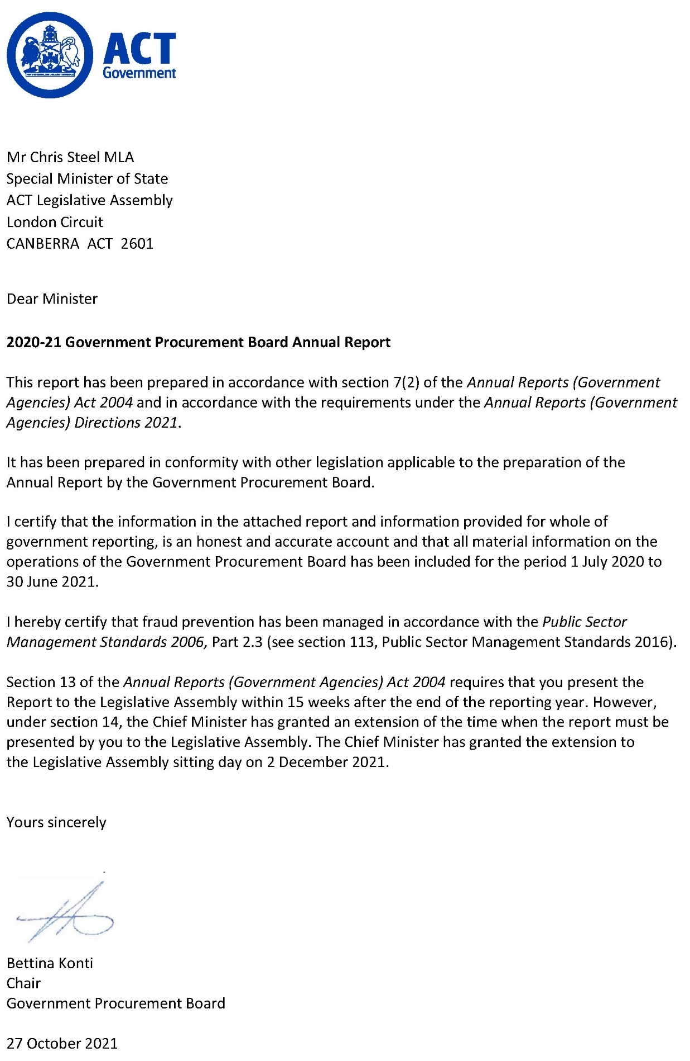

Compliance statement
The 2020-21 ACT Government Procurement Board Annual Report must comply with the 2020-21 Annual Reports (Government Agencies) Directions 2021 (the Directions) made under section 8 of the Annual Reports (Government Agencies) Act 2004. The Directions are found at the ACT Legislation Register.
The compliance statement indicates the subsections, under Parts 1 to 5 of the Directions, that are applicable to the ACT Government Procurement Board and the location of information that satisfies these requirements.

Part 1 Directions overview
The requirements under Part 1 of the Directions relate to the purpose, timing and distribution, and records keeping of annual reports. The 2020-21 ACT Government Procurement Board Annual Report complies with all subsections of Part 1 under the Directions.
To meet Section 15 Feedback, Part 1 of the Directions, contact details for the ACT Government Procurement Board are provided within the 2020-21 ACT Government Procurement Board Annual Report to provide readers with the opportunity to provide feedback.

Part 2 Reporting entity annual report requirements
The requirements within Part 2 of the Directions are mandatory for all reporting entities and the ACT Government Procurement Board complies with all subsections. The information that satisfies the requirements of Part 2 is found in the 2020-21 ACT Government Procurement Board Annual Report as follows:
- A. Transmittal Certificate, see the previous page.
- B. Organisational Overview and Performance, see the Organisational Overview and Performance section.
C. Financial Management Reporting – the ACT Government Procurement Board has no information to report under this section.

Part 3 Reporting by exception
The ACT Government Procurement Board has no information to report by exception under Part 3 of the Directions for the 2020-21 reporting year.

Part 4 Directorate and public sector body specific annual report requirements
There are no specific annual report requirements for the ACT Government Procurement Board.

Part 5 Whole of government annual reporting
All subsections of Part 5 of the Directions apply to the ACT Government Procurement Board. Consistent with the Directions, the information satisfying these requirements is reported in one place for all reporting entities as follows:
- Bushfire Risk Management, see the annual report of the Justice and Community Safety Directorate.
- Human Rights, see the annual report of the Justice and Community Safety Directorate.
- Legal Services Directions, see the annual report of the Justice and Community Safety Directorate.
- Public Sector Standards and Workforce Profile, see the annual State of the Service Report.
Territory Records, see the CMTEDD Annual Report.
ACT Public Service directorate annual reports are found at the following web address: http://www.cmd.act.gov.au/open_government/report/annual_reports

Organisational overview and performance

Organisational overview
The ACT Government Procurement Board (the Board) is established by the Government Procurement Act 2001 (the Act). The functions of the board under the Act are:
- To review, and give advice to Territory entities on, procurement issues.
- To review, and give advice on:
- Procurement proposals and activities referred to the Board by a Minister or responsible chief executive officer; or
The procurement proposals for procurement matters declared by the Minister.
- To review procurement proposals of Territory entities in accordance with the regulations.
- To consider, advise on and, if appropriate, endorse procurement practices and methods for use by Territory entities.
- To provide advice to the Minister on any issue relevant to the procurement activities of Territory entities or the operation of this Act.
To exercise any other function given to the Board under this Act or any other Territory law.
The Chair of the Board at 30 June 2021 is Ms Bettina Konti, Deputy Director-General and Chief Digital Officer, CMTEDD. The position of Chair, like all Board memberships, is part-time. Ms Konti was appointed by the Special Minister of State under the Act. The Chair reports directly to the Special Minister of State, the responsible Minister under the Act, in relation to her role on the Board.
The ACT Government has a policy of achieving and maintaining 50 per cent representation of women on its boards and committees. The Office for Women (Community Services Directorate) is consulted each time a Board vacancy is filled. The Offices of Disability, Aboriginal and Torres Strait Islander Affairs, Multicultural Affairs and LGBTIQ Affairs are also consulted each time a Board vacancy is filled.
In 2021-22, the Board will continue to provide strategic procurement advice and endorse procurement practices and methods for use by Territory entities.

Internal accountability

Membership of the Board
Section 11 of the Government Procurement Act stipulates the Board comprises nine part time members:
- Chair, who is a public employee member.
- Deputy Chair, who is a public employee member.
- Three other public employee members.
Four non-public employee members.
The Chair of the Board at 30 June 2021 is Ms Bettina Konti.
Table 1: Membership of the Board for 2020-21 financial year
Name | Role | Meetings attended | Notes
Ms Bettina Konti  Chair  Public Employee Member | Chief Digital Officer, CMTEDD | 37/41
Ms Louise Gilding  Deputy Chair  Public Employee Member | Executive Group Manager – Housing  Community Services Directorate | 21/24 | Resigned from the Board in late 2020, last meeting was 15 December 2020
Mr Damon Hall  Public Employee Member | Executive Group Manager, Project Development and Support  Major Projects Canberra | 38/41
Ms Jo Wood  Public Employee Member | Director-General  Community Services Directorate | 20/28 | Resigned from the Board on 19 February 2021
Mr Geoffrey Rutledge  Public Employee Member | Deputy Director-General –Environment, Water and Emissions Reduction  Environment, Planning and Sustainable Development Directorate | 39/41
Ms Virginia Shaw  Non-Public Employee Member |  | 10/10 | Term ended and the last meeting was 8 September 2020
Ms Suzy Nethercott-Watson  Non-Public Employee Member |  | 41/41
Ms Susan Hall  Non-Public Employee Member |  | 39/41
Mr Mathew Baldwin  Non-Public Employee Member |  | 31/31 | First meeting was 15 September 2020
Ms Madeline Taylor  Non-Public Employee Member |  | 31/31 | First meeting was 15 September 2020

Conflict of interest
The Board has instituted arrangements to manage declarations of conflicts of interest to recognize that members, during the course of the year, may be faced with potential conflicts of interest due to their other responsibilities.
The Board has instituted the following arrangements:
- Members are aware and support the Board’s Charter and have signed a Code of Conduct agreement.
- Members are requested to identify whether they have a potential conflict of interest in respect of a proposal or policy matter prior to the related documents being considered.
- Prior to the commencement of all meetings, members are also invited to state any declarations of interest that may arise due to the business to be considered at the meeting.
Members with a financial conflict of interest in a matter are not involved in the discussion or endorsement relating to that matter. For declarations of interest that are non-financial, Board consensus is reached as to whether the member who declared the interest partakes in the discussion or endorsement of the proposal.
The minutes of the meeting reflect the identification of any potential conflict(s) of interest and any action taken by the Board in respect of any conflict(s).
There were 18 declarations of a potential conflict of interest recorded during 2020-21 financial year, of which 16 disclosures were made by Public Employee Members and two were made by Non-Public Employee Members. For openness and transparency, Public Employee Members may declare a potential conflict of interest when a procurement proposal relates to their directorate even though they may not have a direct involvement with the proposal.

Remuneration
Public Employee Members of the Board do not receive any remuneration for their participation.
The remuneration for Non-Public Employee Members of the board is determined from time to time by the ACT Remuneration Tribunal. Currently, Non-Public Employee Members are paid $26,635 per annum. The latest determination can be viewed at: https://www.remunerationtribunal.act.gov.au/__data/assets/pdf_file/0008/1623986/Determination-13-of-2020-PTPOH.pdf

Support staffing and financial resources
The Board is supported by a Secretariat, resourced by Procurement ACT.

Consideration of proposals
The Board considered 97 proposals in 2020-21 financial year, including 9 presentations. Of the 88 proposals presented for endorsement by the Board:
- 54: single pass proposals (procurement review, includes variations) and
34: two pass proposals (strategic review and procurement review).

Table 2: Board deliberations in comparison with previous years
Name | 2016-17 | 2017-18 | 2018-19 | 2019-20 | 2020-21
Total board meetings | 28 ¹ | 28 ² | 35 ³ | 33 ⁴ | 41 ⁵
Business meetings | 0 | 1 | 1 | 1 | 1
Proposal meetings | 28 ¹ | 28 ² | 34 | 32 | 40 ⁵
Proposals considered | 67 | 68 | 73 | 69 | 97
Estimated value of proposals ($ million) | 913 | 1,848 | 1,790 | 3,313 | 2,138
Notes:
- This includes 2 meetings held electronically via email.
- This includes 2 meetings held electronically via email.
- This includes 6 meetings held electronically via email.
- This includes one meeting held electronically via email. From 31 March 2020 to 30 June 2020, the Board met virtually using an electronic meeting application. Proponents have been able to continue to meet with the Board via the electronic meeting application.
- This includes two meetings held electronically via email. The Board has continued to meet virtually in 2020-21 using an electronic meeting application. Proponents have been able to continue to meet with the Board via the electronic meeting application.
When comparing 2020-21 to 2019-20, there has been a decrease in the estimated value of proposals by approximately $1,175 million and an increase of 28 proposals being considered. This is due to the Board considering more lower value procurements in 2020-21 than the procurements considered in 2019-20.
In 2020-21 the Board considered several large projects (e.g. the Margaret Hendry School Expansion and North Gungahlin High School (Taylor) and the Digital Heath Record and Related Systems Hosting) and the refresh of several high value panel arrangements (e.g. the Provision of Road and Path Maintenance Works Under a Panel).
Table 3: Summary of proposals considered by the Board in the 2020-21 financial year
Procurement method | Number | Percentage (%) of number | Estimated value ($M) | Percentage (%) of value
Public tender | 61 | 63 | 1,821 | 85
Variations | 17 | 18 | 133 | 6
Single select tender | 7 | 7 | 151 | 7
Select tender | 3 | 3 | 32 | 2
Presentation and updates | 9 | 9 | - | -
Table 4: Breakdown of proposals by directorate
Procurement method | Number | Percentage (%) of number | Estimated value ($M) | Percentage (%) of value
ACT Health Directorate | 4 | 4 | 89 | 4.2
ACT Long Service Leave Authority | 1 | 1 | 4 | 0.2
Canberra Health Services | 13 | 13 | 109 | 5.1
Canberra Institute of Technology | 2 | 2 | 13 | 0.6
Chief Minister, Treasury and Economic Development Directorate | 11 | 11 | 81 | 3.8
City Renewal Authority | 2 | 2 | 3 | 0.2
Community Services Directorate | 5 | 5 | 71 | 3.3
Education Directorate | 6 | 6 | 210 | 9.8
Environmental Planning and Sustainable Development Directorate | 1 | 1 | 10 | 0.5
Emergency Services Agency | 3 | 3 | 20 | 0.9
Justice and Community Safety Directorate | 3 | 3 | 37 | 1.7
Major Projects Canberra* | 13 | 13 | 797 | 37.3
Suburban Land Agency | 5 | 5 | 171 | 8.0
Transport Canberra and City Services Directorate | 28 | 29 | 523 | 24.4
*Note: Under the Administrative Arrangements 2020 (No 2), Major Projects Canberra is responsible for the delivery of designated major capital works projects and the delivery of physical capital works projects in coordination with government agencies.
In 2020-21 the Board has included in its focus the implementation of the Government Procurement (Charter of Procurement Values) Direction 2020, which commenced on 8 September 2020. This Direction applies to all new procurements regardless of dollar value and has six values:
- Aboriginal and Torres Strait Islander Peoples’ Economic Participation
- Business Development and Innovation
- Diversity, Equality and Inclusion
- Environmental Responsibility
- Fair and Safe Conditions for Workers
Transparent and Ethical Engagement
In response to COVID-19 the Board moved its meetings to online phone and video formats, and scheduled additional meetings as required to support the ongoing operations of government during the pandemic.
Further information
Bettina Konti Chair, ACT Government Procurement Board
(02) 6207 2242 Bettina.Konti@act.gov.au
Secretariat Government Procurement Board
(02) 6205 9797 GovernmentProcurementBoard@act.gov.au

Default Insurance Fund

Transmittal certificate
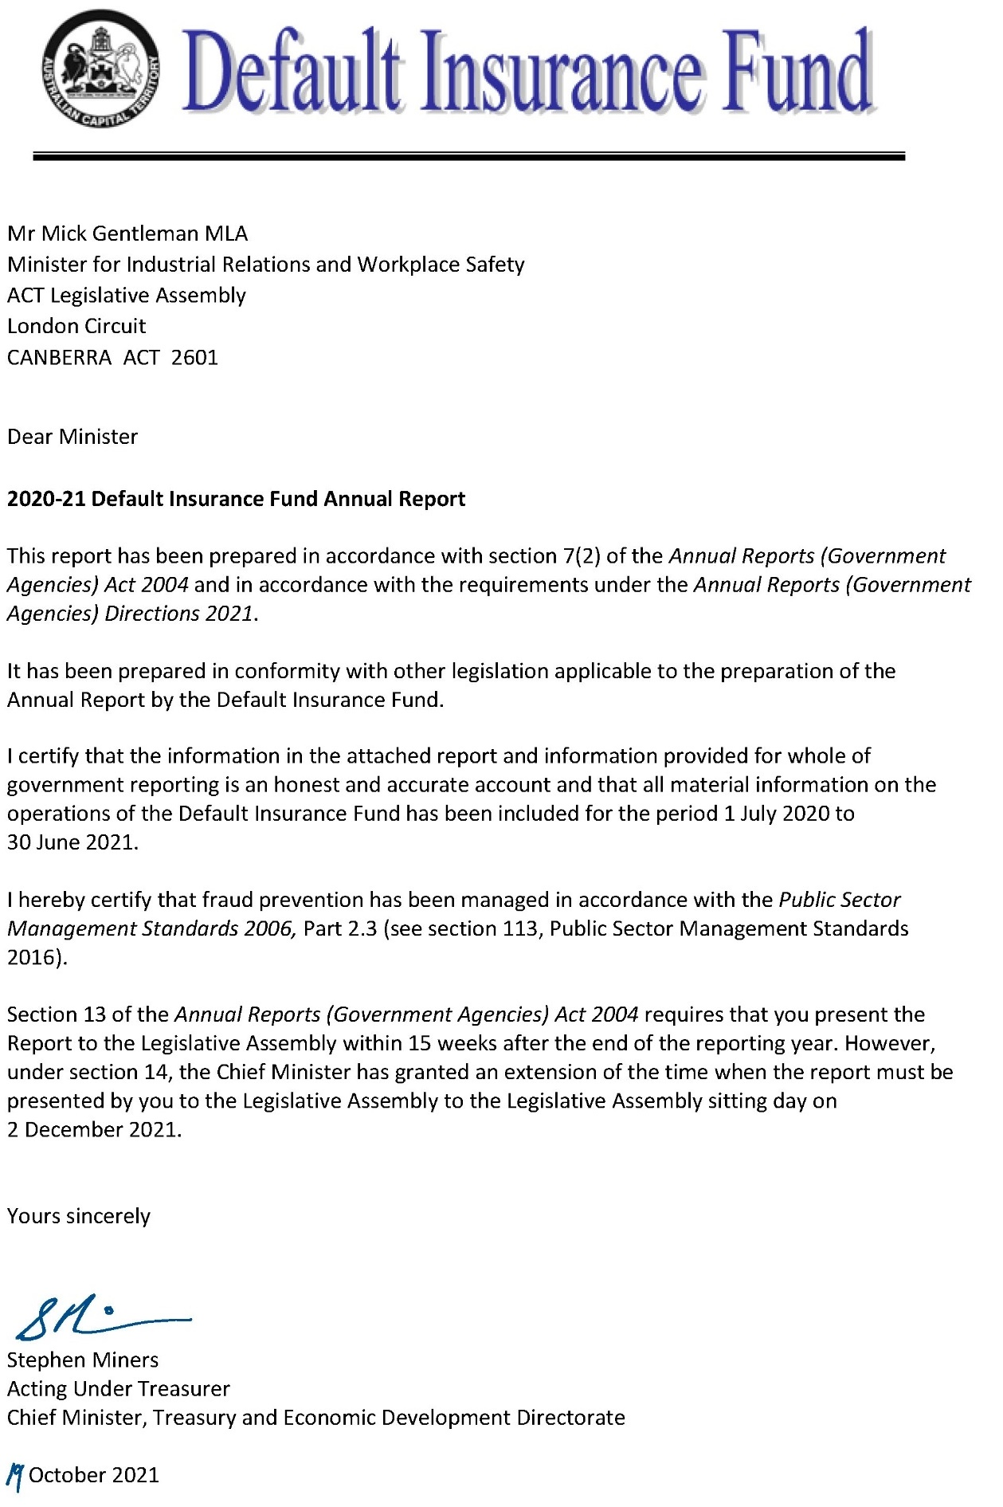

Compliance statement
The 2020-21 Default Insurance Fund Annual Report must comply with the Annual Reports (Government Agencies) Directions 2021 (the Directions) made under section 8 of the Annual Reports (Government Agencies) Act 2004. The Directions are found at the ACT Legislation Register.
The compliance statement indicates the subsections, under Parts 1 to 5 of the Directions, that are applicable to the Default Insurance Fund and the location of information that satisfies these requirements.

Part 1 Directions overview
The requirements under Part 1 of the Directions relate to the purpose, timing and distribution, and records keeping of annual reports. The 2020-21 Default Insurance Fund Annual Report complies with all subsections of Part 1 under the Directions.
To meet Section 15 Feedback, Part 1 of the Directions, contact details for the Default Insurance Fund are provided within the 2020-21 Default Insurance Fund Annual Report to provide readers with the opportunity to provide feedback.

Part 2 Reporting entity annual report requirements
The requirements within Part 2 of the Directions are mandatory for all reporting entities and the 2020-21 Default Insurance Fund Annual Report complies with all subsections. The information that satisfies the requirements of Part 2 is found in the 2020-21 Default Insurance Fund Annual Report as follows:
- A. Transmittal certificate, see the previous page.
- B. Organisational Overview and Performance Analysis, see Organisational Overview and Performance on the next page. The following subsections, contained within the 2020-21 ACT Insurance Authority Annual Report, apply to the Default Insurance Fund:
- Risk Management
- Internal Audit
- Fraud Prevention
- Community Engagement and Support
- Aboriginal and Torres Strait Islander Reporting
- Work Health and Safety
- Human Resource Management
Ecologically Sustainable Development.
C. Financial Management reporting, see the Financial Management Reporting section of this report. For the remaining subsections see Volume 2.2 of the 2020-21 CMTEDD Annual Report.

Part 3 Reporting by exception
The Default Insurance Fund has no information to report by exception under Part 3 of the Directions for the 2020-21 reporting period.

Part 4 Directorate and public sector body specific annual report requirements
Part 4 of the 2020 Directions is not applicable to the Default Insurance Fund.

Part 5 Whole of government annual reporting
All subsections of Part 5 of the Directions apply to the Default Insurance Fund. Consistent with the Directions, the information satisfying these requirements is reported in one place for all reporting entities as follows:
- Bushfire Risk Management, see the annual report of the Justice and Community Safety Directorate.
- Human Rights, see the annual report of the Justice and Community Safety Directorate.
- Legal Services Directions, see the annual report of the Justice and Community Safety Directorate.
- Public Sector Standards and Workforce Profile, see the annual State of the Service Report.
Territory Records, see the CMTEDD Annual Report.
ACT Public Service directorate annual reports are found at the following web address: https://www.cmtedd.act.gov.au/open_government/report/annual_reports.

Organisational overview and performance

Organisational overview
The Workers Compensation Act 1951 (the Workers Compensation Act) was established to provide compensation to workers employed in the private sector for injuries arising out of or in the course of their employment.
The Default Insurance Fund (the Fund) was established under the Workers Compensation Act effective from 1 July 2006. It provides a safety net to meet the cost of workers’ compensation claims made by workers in circumstances where:
- An employer does not have a workers’ compensation insurance policy and cannot meet the claim costs payable under the Workers Compensation Act;
- An employer’s insurance company is wound up under the Corporations Act 2001 (Cth) or cannot provide the indemnity required to be provided under a compulsory workers’ compensation policy; or
A worker is suffering from an imminently fatal asbestos-related disease as a result of exposure to asbestos fibres whilst employed as a worker in the Australian Capital Territory.
Funds are held in trust under the Financial Management Act 1996 in two separate accounts:
- the Uninsured Employer Fund (UEF); and
- the Collapsed Insurer Fund (CIF).
The General Manager for the ACT Insurance Authority (the Authority) is the appointed Fund Manager.
The Fund meets the cost of workers’ compensation settlements and any common law judgments including the payment of weekly compensation, medical expenses and rehabilitation costs. Funds required to satisfy the cost of claims and other relevant expenses are not guaranteed by the ACT Government. Part 8.2 of the Workers Compensation Act allows the Fund Manager to impose contributions and supplementary contributions on approved insurers and self-insurers to meet the cost of claims.
The Fund’s administrative operations are subject to the same governance controls in relation to risk management, fraud prevention and records management as the Authority. The reporting on these operations is included in the relevant sections of the Authority’s Annual Report.
The Authority also oversights workplace health and safety and associated risk management, accommodation, facilities management and workplace environmental management for the Fund. Reporting for these issues is contained in the Authority’s Annual Report.

Internal Accountability
The Default Insurance Fund Advisory Committee is established under Schedule 3 of the Workers Compensation Act. Its role is to monitor the operations of the Fund and, if requested by the Minister or the Fund Manager, advise on matters relating to the operation of the Fund.
The Committee consists of the Executive Group Manager, Workplace Safety and Industrial Relations (Chair), the Fund Manager and three members appointed by the Minister.
Table 1: Fund Advisory Committee membership 2020-21
Name | Member details
Michael Young | Executive Group Manager, Workplace Safety and Industrial Relations (Chair)
Belinda Farrelly | The Australian National University (Employer Representative)
Sharlene Watson | QBE Insurance (Insurer Representative)
Rosalind Read | Construction, Forestry, Maritime, Mining and Energy Union (CFMEU) (Employee Representative)
Penny Shields | Fund Manager
The Committee met on four occasions during 2020-21. At each meeting, a report on the status of the Fund was provided and a schedule detailing the status of all open claims was considered.

Performance Analysis
The Fund engages Taylor Fry Consulting Actuaries to estimate the provision for claims payable (liability) and related claims expenses. Actuarial assumptions are based on past claims experience, risk exposure and projections of economic variables.

Uninsured Employer Fund (UEF)
This component of the Fund currently administers claims that have arisen when a worker has been injured and the employer did not hold an ACT workers’ compensation policy. Where the employer does not or cannot meet the cost of claims, the UEF responds on behalf of the employer as the default insurer.

Claims
When a claim is received, the UEF undertakes a search in an attempt to locate an insurer for the injured worker. In some cases, an insurer is identified, and the claim is then forwarded to the appropriate insurer.
When satisfied that an insurance policy is not in place, the Fund acts as the default insurer for the injured worker. The Fund arranges and facilitates appropriate rehabilitation and medical treatment for injured workers with the aim of returning an injured worker back to their pre-injury condition where possible. Claims are managed pursuant to the Workers Compensation Act, and the Fund meets the cost of all legislated entitlements for injured workers including medical expenses, rehabilitation costs, weekly compensation and lump sum settlements.
Table 2: Uninsured Employer Fund claims
 | Number
Total claims opened during the reporting period | 13
Total claims closed during the reporting period | 11
Current open claims | 44

Revenue
Section 168A of the Workers Compensation Act requires the Fund Manager to undertake a review of the UEF each year to determine the appropriate levy on approved insurers and self-insurers.
In determining an appropriate levy for 2020-21, the Fund Manager took into consideration a range of issues including a sensitivity analysis of the volatility of the UEF, the potential for an increase in claims costs, and claim numbers in the current and future insurance years.
The Fund Manager imposed contributions from insurers and self-insurers equal to 2.9 per cent of the gross written premiums resulting in $6.130 million in levy revenue.

Expenses
The expenses for UEF during the year resulted in a credit of $0.669 million, which includes a credit of $0.938 million in claims expense and $0.269 million in supplies and services. The claims expense consisted of $3.2 million in settlements, compensation payments and other claims costs, along with a decrease in the provision for claims payable of $4.138 million as the result of the 2020-21 actuarial valuation.

Balance Sheet
As at 30 June 2021, the UEF held total assets of $29.712 million consisting of $27.322 million in cash and cash equivalents and receivables of $2.390 million comprising current receivables of $1.290 million and non-current receivables of $1.1 million. The UEF’s liabilities total $35.018 million, which includes $0.129 million in payables, along with $3.193 million of current provision of claims payable and $31.696 million of non-current provision of claims payable.

Collapsed Insurer Fund (CIF)
This component of the Fund currently administers claims that have arisen from a previously approved workers’ compensation insurer that has been wound up or is in liquidation. Currently the Fund administers claims for two collapsed insurers, National Employers’ Mutual Association Ltd in 1990 (NEM) and HIH Insurance in 2001 (HIH).

Claims
When satisfied that an insurer is unable to pay, the Fund acts as the default insurer for the injured worker. The Fund arranges and facilitates appropriate rehabilitation and medical treatment for injured workers with the aim of returning an injured worker back to their pre-injury condition where possible. Claims are managed pursuant to the Workers Compensation Act, and the Fund meets the cost of all legislated entitlements for injured workers including medical expenses, rehabilitation costs, weekly compensation and lump sum settlements.
As at 30 June 2021 there was one open claim against NEM and two open claims against HIH. The Fund Manager is the Fund’s representative on the committee of inspection for the HIH liquidation. The final scheme payments from the HIH liquidation were paid to creditors in early June 2021. The liquidation of NEM is complete.
Table 3: Collapsed Insurer Fund claims
 | Number
Total claims opened during the reporting period | 0
Total claims re-opened during the reporting period | 0
Total claims closed during the reporting period | 0
Current open claims | 3

Revenue
The CIF is not levying insurers or self-insurers for the CIF at present. The fund can appropriately and responsibly manage the impact of any future insurance collapses within the workers’ compensation industry through the retention of its current reserve and the imposition of a tailored levy on employers in the event of a collapse. The CIF collected $0.081 million in interest from its investment and $0.680 million in recoveries from HIH during the reporting period.

Expenses
The total expenses paid by the CIF during the year were $0.356 million, consisting of $0.032 million in supplies and services and $0.324 million in claims expense. The claims expense consisted of $0.024 million in compensation and legal costs and an increase of $0.300 million in the provision for claims payable as the result of the 2020-21 actuarial valuation.

Balance Sheet
As at 30 June 2021, the CIF had cash and cash equivalents totalling $9.062 million with an estimated outstanding claims provision of $1.129 million. The CIF Fund’s total equity as at 30 June 2021 is $7.933 million.

Scrutiny
There were no inquiries or reviews from the ACT Audit Office, the ACT Ombudsman, ACT Integrity Commission or any Legislative Assembly Committees in 2020-21. The only scrutiny from the Audit Office during the reporting period was the audit of the 2019-20 Financial Statements.

Freedom of Information
The Freedom of Information Act 2016 (FOI Act) gives individuals the legal right to:
- Access government information unless access to the information would, on balance, be contrary to the public interest;
- Ask for personal information to be changed if it is incomplete, out-of-date, incorrect or misleading; and
Appeal a decision about access to a document, or a decision in relation to a request to amend or annotate a personal record.
In accordance with Section 96 of the FOI Act the Fund is required to report on the operation of the FOI Act in relation to the Fund for the reporting year. The Fund did not receive any requests for access to any information under the FOI Act during 2020-21.
Further information relating to FOI including how to make an FOI application, what details you need to make an application and contact details for the CMTEDD Information Officer can be found on CMTEDD’s website https://www.cmtedd.act.gov.au/functions/foi. There are also details of requests received by the directorate listed on the Freedom of Information Disclosure Log for CMTEDD.

Financial management reporting

Government contracting
The Fund engages consultants to perform specialised actuarial and legal services. The procurement selection and management processes for all contractors including consultants complied with the Government Procurement Act 2001 and the Government Procurement Regulation 2007.
Procurement processes above $25,000 are reviewed by Procurement ACT, and if necessary, by the Government Procurement Board consistent with the provisions of the Government Procurement Regulation 2007. The Fund ensures all contractors comply with their employee and industrial relations obligations.
The Fund did not execute any new procurement activities during the reporting period; however, the Fund Manager initiated a process through ACT Government Solicitor to enable the Fund to access the Territory Legal Services Panel.
Further information
Penny Shields General Manager, ACT Insurance Authority
(02) 6207 0268 ACTIAInsuranceAndRiskManagement@act.gov.au
https://apps.treasury.act.gov.au/insurance-and-risk-management/contacts

Director of Territory Records

Transmittal certificate
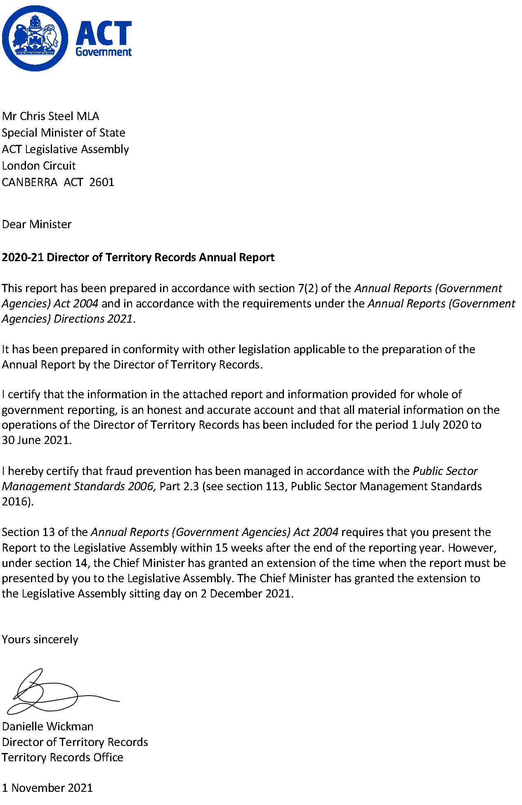

Compliance statement
The 2020-21 Director of Territory Records Annual Report must comply with the Annual Reports (Government Agencies) Directions 2021 (the Directions) made under section 8 of the Annual Reports (Government Agencies) Act 2004. The Directions are found at the ACT Legislation Register.
The compliance statement indicates the subsections, under Parts 1 to 5 of the Directions, that are applicable to the Director of Territory Records and the location of information that satisfies these requirements.

Part 1 Directions overview
The requirements under Part 1 of the Directions relate to the purpose, timing and distribution, and record keeping associated with annual reports. The 2020-21 Director of Territory Records Annual Report complies with all subsections of Part 1 under the Directions.
To meet Section 15 Feedback, Part 1 of the Directions, contact details for the Director of Territory Records are provided within the 2020-21 Director of Territory Records Annual Report to provide readers with the opportunity to provide feedback.

Part 2 Reporting entity annual report requirements
The requirements within Part 2 of the Directions are mandatory for all reporting entities and the Director of Territory Records Annual Report complies with all subsections. The information that satisfies the requirements of Part 2 is found in the 2020-21 Director of Territory Records Annual Report as follows:
- A. Transmittal Certificate, see the previous page.
- B. Organisational Overview and Performance Analysis subsections, see the Organisational Overview and Performance section. All remaining subsections are contained within the CMTEDD Annual Report.
C. Financial Management Reporting, inclusive of all subsections, is contained within the CMTEDD Annual Report.

Part 3 Reporting by exception
The Director of Territory Records has no information to report by exception under Part 3 of the Directions for the 2020-21 reporting year.

Part 4 Directorate and public sector body specific annual report requirements
There are no specific annual report requirements for the Director of Territory Records.

Part 5 Whole of government annual reporting
All subsections of Part 5 of the Directions apply to the Director of Territory Records. Consistent with the Directions, the information satisfying these requirements is reported in one place for all reporting entities as follows:
- Bushfire Risk Management, see the annual report of the Justice and Community Safety Directorate.
- Human Rights, see the annual report of the Justice and Community Safety Directorate.
- Legal Services Directions, see the annual report of the Justice and Community Safety Directorate.
- Public Sector Standards and Workforce Profile, see the annual State of the Service Report.
Territory Records, see the CMTEDD Annual Report.
ACT Public Service directorate annual reports are found at the following web address: http://www.cmd.act.gov.au/open_government/report/annual_reports.

Organisational overview and performance
The Territory Records Office supports the Director of Territory Records to lead the ACT Public Service (ACTPS) on records management policy, strategy and practice. The Territory Records Act 2002 provides for the Director to develop recordkeeping standards and tools for ACT Government agencies, oversee the disposal of government records and assist members of the public to access ACT Government archives.
The main purposes of the Territory Records Act are to:
- Encourage open and accountable government by ensuring that Territory records are made, managed and if appropriate, preserved in accessible form.
- Support the management and operation of Territory agencies.
- Preserve Territory records for the benefit of present and future generations.
Ensure that public access to records is consistent with the principles of the Freedom of Information Act 2016.
The Territory Records Act enables the Director of Territory Records to:
- Develop and approve standards and codes for records management by agencies.
- Examine the operation of agency records management programs.
- Encourage the development of records management training for staff.
Encourage consistency in the preparation of tools to assist in the awareness of and access to records.
The Territory Records Act establishes the statutory position of the Director of Territory Records. The Territory Records Office is an administrative unit within Policy and Cabinet in CMTEDD. The Office is made up of 5.6 full time equivalent staff, including the Director.
The current Director of Territory Records is Ms Danielle Wickman. The Director is a senior executive appointed under both the Public Sector Management Act 1994 and the Territory Records Act. The Director’s remuneration is as determined for all ACT Senior Executives under the Remuneration Tribunal’s Determination 2 of 2020 – Head of Service, Directors-General and Executives.
The Director’s responsibilities are to lead the work of the Territory Records Office and to provide advice to the Minister, the Strategic Board, CMTEDD Executives and ACT Government agencies on archives, records and information governance matters. The Director also exercises powers and functions under the Territory Records Act, including approving standards for government recordkeeping, authorising the disposal of Territory records, and making determinations regarding the restriction of records from public access.

Territory Records Advisory Council
The Territory Records Act establishes the Territory Records Advisory Council to advise the Director, particularly in relation to the development of standards and guidelines, access to and disposal of records, and on the protection of records about Aboriginal and Torres Strait Islander heritage.
Members of the Council are appointed on a part-time basis by the Minister. Appointments must be made from the range of categories set out in section 44 of the Territory Records Act. The Director of Territory Records is also a member of the Council. Members, apart from the Director, are appointed for a term of three years and may be reappointed. Members are paid a sitting fee in accordance with the ACT Remuneration Tribunal’s Determination 13 of 2020 – Part Time Public Office Holders.
The activities of the Council are funded from within the Territory Records Office’s budget. Financial oversight, including risk management, audit and fraud control arrangements, are managed within CMTEDD’s control systems. No specific code of conduct has been established for Territory Records Advisory Council members; however, members are required to sign a conflict-of-interest declaration as part of the appointment process. The Council has not established any sub committees.
The Territory Records Advisory Council met four times during 2020–21 as follows:
- Meeting 1 of 2020-21, 20 August 2020, Canberra Nara Centre and online.
- Meeting 2 of 2020-21, 12 November 2020, Canberra Nara Centre and online.
- Meeting 3 of 2020-21, 25 February 2021, 5 Constitution Ave and online.
Meeting 4 of 2020-21, 20 May 2021, 220 London Circuit and online.
Membership of the Council and attendance during the 2020-21 financial year is detailed in the following table.
Table 1: Membership of the Territory Records Advisory Council during the year and the number of meetings each member attended
Name of member | Role | Meetings attended
Mr Michael Piggott (Chair) | Records management and archives | 1/1
Ms Liesl Centenera (Chair and Deputy Chair) | Public administration, governance, public accountability | 4/4
Mr Adrian Cunningham (Deputy Chair) | Records management and archives | 3/3
Ms Lorien Mader | Records management and archives | 2/4
Ms Narelle Rivers | Aboriginal and Torres Strait Islander heritage | 4/4
Dr Roslyn Russell | History and heritage | 3/4
Mr Geoffrey Rutledge | ACT Government agencies | 2/4
Dr Terhi Nurmikko-Fuller | History and heritage | 3/3
Mr Keith Young | Public administration, governance, public accountability | 3/4
Ms Danielle Wickman | Director of Territory Records | 4/4
Notes:
- Ms Centenera was appointed to the Council as Chair in September 2020 following the expiration of Mr Piggott’s second term of appointment.
- Mr Cunningham was appointed to the council and replaced Ms Centenera as Deputy Chair in September 2020.
- Dr Nurmikko-Fuller was appointed to the Council in September 2020.
During the year the Minister reappointed Ms Liesl Centenera, Ms Narelle Rivers, and Mr Keith Young to the Council, each for a second term. The Council also welcomed two new members, Dr Tehri Nurmikko-Fuller and Mr Adrian Cunningham.
Dr Nurmikko-Fuller was appointed to represent history and heritage interests, following the resignation in 2019-20 of Professor Marnie Hughes-Warrington. Dr Nurmikko-Fuller is a senior lecturer in digital humanities at the Australian National University with expertise in issues related to ethical information gathering, curation, as well as storage and access in the digital age. Dr Nurmikko-Fuller also has qualifications in web science, cuneiform and Near Eastern Studies, museum studies, ancient history and archaeology.
The Council’s second new member, Mr Cunningham, was appointed to represent the archives and records profession, following the retirement from Council of Mr Michael Piggott. Mr Cunningham is a highly respected archivist who has extensive experience at senior levels in both government and non-government archives. He is a fellow of the International Council on Archives and the Australian Society of Archivists, and has formal qualifications in library science and history.
The Council farewelled Mr Michael Piggott, who retired after serving six years on the Council, with the last three years as Chair. During Mr Piggott’s time on the Council since 2014, the Territory Records Office has progressed some significant changes including the introduction of a new Standard for Records, Information and Data, the implementation of new digital recordkeeping frameworks, the move of the ArchivesACT Reading Room to Fyshwick and the revision of authorisation for the disposal of records relevant to child sexual abuse.
The Council receives regular reports on public access, relations with government agencies and progress against the Territory Records Office’s business plan. The Director keeps the Council informed of, and seeks its advice on, significant initiatives of the Office. During 2020-21 the Council considered and advised on matters such as the review of the Standard for Records Information and Data and supporting guidelines, and the business classification scheme and retention schedule framework for the ACT Government. The Council discussed the Office’s strategies to increase maturity in records and information management across the ACT Public Service and to connect ACT Government archives to the community. Members also considered regular updates on the Office’s significant projects.
The Territory Records Act gives the Council particular responsibility for advising the Director on the disposal of ACT Government records. The retention and disposal of records is authorised through records disposal schedules, issued under section 19 of the Territory Records Act. All draft schedules are referred to the Council for advice before they are approved by the Director. During 2020-21 Council considered two new or revised schedules. This is a decrease on the eight schedules considered in 2019-20. This decrease occurred as the Territory Records Office has focused during 2020-21 on preparatory work on some wide-ranging disposal schedules that would impact a number of areas of government. In addition, many agencies have focused on addressing their legacy holdings of hard copy records in preparation for large-scale office relocations, rather than working on changes to disposal schedules. This has resulted in fewer schedules being finalised and presented to the Council for review this year.
Council members continued their interest in the Office’s work to prepare ACT Government agencies for new office accommodation and for activity-based working. Members noted in the good connections made with agencies and significant records identified and documented in the course of this work.
An important aspect of Council’s role is to advise the Director on matters relating to public access to ACT Government archives. The Council’s meeting agenda includes a standing item on decisions to restrict archives from public access under section 28 of the Territory Records Act. The Director made ten section 28 declarations during 2020-21. Of these, eight related to personal information about staff involved in heritage management or asbestos management. One allowed for the protection of legal professional privilege for advice from the ACT Government Solicitor. The final exemption was granted on the basis of protection of law enforcement in relation to Aboriginal heritage sites. This is an increase on the number of exemptions applied in 2019-20, and arises primarily from the release of a large number of files relating to asbestos management in response to a researcher request.
Members were pleased that ArchivesACT, the Office’s public archives service, was able to go ahead with its event for the ACT Heritage Festival, which was cancelled due to COVID-19 in 2020. The Council continues its interest in ArchivesACT’s activities that promote and provide access to ACT Government archives, and was particularly pleased to see a demonstration of the ACT Memory database. Members saw an in-development version of ACT Memory, which will be available online in early 2021-22 to provide searchable information about publicly accessible ACT Government archives.
Since 2018-19, Council members have conducted an annual survey to complete a self-assessment of the Council’s performance and its satisfaction with the support provided by the Territory Records Office. Results of the 2020-21 survey indicate an improvement in members’ agreement that the Council’s goals and actions are guided by relevant and realistic strategic planning. While members’ perceptions of performance were very strong overall, the survey, as for last year, indicates a lower level of confidence in the breadth of skills and diversity of Council membership. This year’s results indicate that there is still more work to do to increase the diversity of skills and backgrounds represented on the Council, and to identify opportunities to increase members’ engagement with the Territory Records Office and its work. There may also be some appetite amongst members to increase the frequency or duration of meetings.

Performance overview and highlights for 2020-21
During 2020-21, the Office finalised its work to deliver on our budget-funded commitments to support the ACT’s transition to a ‘paper-lite’ environment and new government office accommodation. We continued to monitor recordkeeping capability across the ACTPS through our annual maturity assessment. In addition, we also sustained our engagement with the community to bring the wealth of the ACT Government’s archival record to a wide audience.
The Office’s core functions are guided by the Territory Records Act. We are both an information governance advisor to government and an archives service provider to the community. To fulfil the role set out for us under the Territory Records Act, we aim to:
- Increase opportunities for the community to access records, information and data.
Influence and embed good archives, records, information and data management principles and practices into ACT Government business.

Impact of COVID-19
COVID-19 continued to impact the Office’s ability to pursue its key aims during 2020-21. Staff worked primarily from home in 2020, transitioning back to the office on a part-time basis in early 2021. As foreshadowed in our 2019-20 report, we suspended planning for our 6th Chief Minister’s Governance Lecture, which is usually held late in each calendar year. We were pleased, however, to participate again in the Canberra and Region Heritage Festival after its cancellation in 2020.
Our Reading Room has remained open during 2020-21, with COVID-safe arrangements in place to protect our staff and researchers. We were also able to resume our engagement with colleagues in Digital, Data and Technology Solutions to align our ‘records by design’ thinking with other business transformation initiatives.

Supporting ACT agencies to transition to a ‘paper-lite’ work environment
In March 2021, the Office concluded its program of work to assist agencies to prepare for activity-based working (ABW) and the new ACT Government office accommodation. This involved the establishment of a dedicated project team to assess and provide advice and assistance to agencies on responsible approaches to managing paper records holdings in the lead up to office relocations. We were particularly pleased to be able to recruit three additional, highly valued staff through the ACT Government’s Jobs for Canberrans program. The program was established to provide employment opportunities for people who lost their jobs or were significantly impacted due to COVID-19 and were not eligible for the Australian Government’s wage subsidy scheme or other support.
The team provided advice and assistance to 14 agencies across government. More than 22,000 physical records were appraised and transferred offsite during the program by the project team, across nine agencies, with additional support provided in preparing thousands more files for later processing by agencies and the Physical Records Services unit within Shared Services. Equally important was the team’s work to build relationships with business units, providing support to records management and other staff through the transition, and championing good records management practice across government. While the focus of the project was to help transition agencies away from paper, the professionalism applied, and rapport developed enabled good recordkeeping practises to be shared and refined. The program helped business areas to significantly boost confidence in decision-making around records, as well as document retention and management.
As a result of the program, agencies successfully transitioned to the new office accommodation in a ‘paper-lite’ fashion and staff are overwhelmingly working digitally. The transition also sped-up agency adoption of the Whole of Government Electronic Document and Records Management Systems (EDRMS) platforms. Looking ahead, agencies are well placed to build on the skills developed through the program to re-establish good fundamental records management practices and further build recordkeeping capability in the digital space.

Improving government recordkeeping capability
The Territory Records Office received funding in the 2018-19 ACT Budget to assist the ACTPS to increase its transition to digital recordkeeping. This included funding for the Office to develop a long-term strategy for digital recordkeeping across the ACTPS. That work was completed in 2019-20, and in 2020-21 we developed our implementation plan for the strategy. This work was also informed by our annual recordkeeping maturity assessment processes, regular reviews of ACT Audit Office reports, the findings of our reviews under the Better Records Advice and Support Program, and the recommendations of the report Government Accountability in the Digital Age. This last review, conducted by Dr Vivienne Thom AM, was commissioned by the Council of Australasian Archives and Records Authorities (CAARA) to advise member institutions across Australia and New Zealand.
All of these strategic assessments point to a need for the Territory Records Office to provide greater support for capability development—both human and technological—across the ACTPS. Our response commits us to working with agencies to closely align recordkeeping effort to core purpose, provide skills, tools and confidence in ACTPS records management capability, embed strong information governance as a natural part of agency culture, and enable accountability for recordkeeping performance.
Our annual records management maturity assessment was important in informing this plan. The 2020 assessment against our 4-point maturity model shows that ACT Government directorates remain at the ‘Essential’ level of maturity. An assessment at the ‘Essential’ level indicates that agencies are able to meet minimum requirements for records management. The Office’s Standard for Records Information and Data indicates agencies should be striving to perform at the ‘Proactive’ level or above. Proactive performance indicates records and information governance is well established and continually improving, with these governance considerations routinely integrated into business decisions. The Office’s goal in 2021-22 is to take steps, though our capability maturity plan, to assist agencies to make a commitment to reaching a ‘Proactive’ level of performance in the most important aspects of records management activities.
While our work to implement the plan will primarily commence in 2021-22, we took advantage of the advent of Information Awareness Month in May 2021 to raise awareness of the importance of records and information governance. The Office encouraged and supported ACT Government records managers to hold events aligned with the 2021 theme of ‘Building Trust—Adaptability and Capabilities’. We also held our own event, Building Trust in the Care and Protection System: Records, accountability and identity. We were very grateful to Darug woman and Territory Records Advisory Council member Narelle Rivers PSM for presenting this seminar for us. Ms Rivers discussed with a small, COVID-safe audience her work on the Our Booris, Our Way report, which analyses the experiences of over 300 Aboriginal and Torres Strait Islander children involved with the child protection system. This work has helped in developing a deep understanding of these children’s experience, from consultations with the community and emerging data from case file reviews. In addition, the Director also participated in a number of seminars and round table discussions associated with the launch of Information Awareness Month at the National Archives of Australia. She also presented a paper at the Records and Information Management Professionals Australasia (RIMPA) ACT Branch workshop, Skills for the IM Professional Workplace.
We were pleased to recommence our involvement with the Chief Digital Officer and the Digital, Data and Technology Solutions Group after a pause in some activities due to COVID-19 priorities. These included providing recordkeeping advice on business transformations such as the whole of government concessions integration project, membership of the Data Management Committee and of the Budget Assessment Subcommittee. We continued our engagement with DDTS particularly on data management frameworks, and on opportunities for improving the way we manage our Open Access Information activities.
One of the essential tasks of the Office is to develop standards and codes of practice for agency records management. Our Standard for Records, Information and Data, along with its associated guidelines, was substantially reviewed in 2016, and forms the basis for our suite of advice products and our records management maturity framework. While we believe it remains largely fit-for-purpose, we have commenced, at this 5-year mark, a review of the standard to identify how we might enhance its relevance and usability for agencies. That work will continue into 2021-22.
Another core part of our business is to maintain the framework in which agencies are able to accountably dispose of records that do not have significant ongoing value to government or the community. We do this work primarily through the authorisation of records disposal schedules, which set out the minimum retention requirements for the records that arise from all areas of government business. The Territory Records Advisory Council has an important role in advising us on community expectations for records retention and disposal. During 2020-21 we notified five new or amended disposal schedules, two of which were considered by the Council in 2020-21, and three in the previous year. These included protection for records required by the Royal Commission into Natural Disaster Arrangements, as well as schedules allowing, in certain prescribed circumstances, for the disposal of records that have been digitised, or which are kept on obsolete or damaged media. Arrangements such as these are important for supporting both the preservation of archival records and the efficient functioning of government.
Another ongoing role for the Office is to continue to drive the take-up of EDRMS capability in the ACTPS. This work is primarily the role of our colleagues in Shared Services. We work closely with both the digital and hard copy records teams in Shared Services, and continue to provide advice and support on records management activities and governance arrangements.

Improving information access
As our public-facing services and events have come back onstream after the lock-down period in 2019-20, we have been pleased to see an increased public interest in ACT Government archives, with researcher numbers rising, particularly in recent months. It has been especially exciting to share some of our recent, and older, Finds of the Month with the Canberra community through the Canberra Times’ Panorama lift out. During the year Panorama republished 14 of our Finds, covering the Canberra Raiders’ move to Canberra from Queanbeyan, the Human Veins Dance Theatre and a range of other topics. Many of these articles have resulted in additional research requests to ArchivesACT from members of the public. Our regular Find of the Month, which seeks to bring some of the interesting, quirky or underappreciated stories in ACT Government archives to a wider audience, continues to be one of the most popular pages on our website. This year we placed a spotlight on the field books of the original Canberra border survey, the Civic merry-go-round and Royal visits.
During the year one of our highly capable Jobs for Canberrans recruits was able to index more than 1,500 historical ACT Government photographs, which came to us without captions or other descriptions. The work has enabled us to be much more responsive to requests for photographs, such as when we were asked to contribute images of Prince Philip to help the ACT Government to mark his passing in April 2021. This in turn increases our ability to make these important archives widely available.
We expect to make this index discoverable through our ACT Memory database, along with information about other publicly accessible ACT Government archives. We are currently putting the finishing touches on ACT Memory, and discussing with relevant agencies the availability of information for upload to the database. We expect to make the system publicly available early in the 2021-22 financial year. ACT Memory will include information about the agencies that have administered the ACT since self-government, as well as details of selected groups of archival records. It will become an important resource for identifying and understanding ACT Government archives as we progressively add publicly available information.
Our support for public access to information also takes other forms. We continue to help agencies to apply Creative Commons licensing to their publications, and we also maintain our role in managing the ACT Government’s license agreements to support the use of non-government intellectual property. In addition, we have an ongoing role in maintaining the ACT Government’s Open Access Portal, to support compliance with the open access provisions of the Freedom of Information Act 2016. This includes assisting the Chief Minister to make his annual statement under section 95 of the Territory Records Act about improving the public accessibility of government information.

Outlook
Over 2020-21 we examined the results of a number of strategic assessments of ACT Government recordkeeping to determine the actions the Territory Records Office can most effectively take to build whole of government capability.

The coming year will see us focusing on:
- Developing tools that articulate the contribution good records and information governance makes to ACT Government priorities.
- Establishing and communicating targets for capability development.
- Improving the availability of recordkeeping induction material.
Improving the utility of our maturity assessment process as an evidence base for further capability development.
Our goal in this work is to help ACT Government agencies make records management an essential and seamless part of the way they do business. We will also finalise the review of our standard and guidelines, and continue to work with Digital, Data and Technology Solutions to embed records thinking and functionality into emerging data and systems management frameworks and tools.
Early in 2021-22 we will make ACT Memory publicly available, and bed down our processes for expanding the range of records, and the information about them, that can be made discoverable. This will form the platform from which we hope to greatly enhance the accessibility of ACT Government archives to the Canberra community. This will be a valuable resource for researchers and others who want to engage directly with government archives. We will also work across government to explore the potential for improvements to the Open Access Information portal, which helps to make current information available in conformance with the Freedom of Information Act. We also anticipate a return of the Chief Minister’s Governance Lecture, after calling a halt to this event due to the COVID-19 pandemic in 2020-21. The Lecture is our flagship opportunity to demonstrate the links between the records of the past and our challenges and debates in the present. We look forward to welcoming the ACT community back to the Lecture, to consider the interaction of present and past, and the role that government archives and records play in our city.

Whole of government reporting on Territory Records
The ACT Government’s Annual Report Directions require information about reporting entities’ records management arrangements to be consolidated in the Director of Territory Records’ Annual Report. The reporting requirements and reporting entities responses are set out below.
Reporting entities must provide a statement that:
- Provides the date at which the most recent Records Management Program was approved by the reporting entity’s Principal Officer and submitted to the Director of Territory Records.
- Provides details of how the public can inspect the Records Management Program as required by section 21(1) of the Territory Records Act.
- Outlines the arrangements for preserving records containing information that may allow people to establish links with their Aboriginal or Torres Strait Islander heritage.
- Outlines the areas on which the reporting entity intends to focus in the coming reporting period to improve its records management capabilities.
For directorates—indicates whether a recordkeeping maturity assessment has been completed in conjunction with the Territory Records Office during the reporting period.

Records Management Programs
Table 2: Details of Records Management Programs (RMPs) by reporting entity
Entity | RMP approved on this date | RMP under review, completion scheduled on this date | RMP being developed, completion scheduled on this date | The RMP of this directorate has been adopted | Maturity assessment completed
ACT Health | July 2017 | October 2021 |  |  | Yes
Canberra Health Services | March 2018 |  |  |  | Yes
Chief Minister Treasury and Economic Development | October 2016 |  |  |  | Yes
ACT Insurance Authority |  |  |  | CMTEDD | n/a
Building and Construction Industry Fund Training Authority |  |  |  | CMTEDD | n/a
Cultural Facilities Corporation | November 2015 | September 2021 |  |  | n/a
Gambling and Racing Commission |  |  |  | CMTEDD | n/a
Independent Competition and Regulatory Commission | July 2018 |  |  |  | n/a
Long Service Leave Authority | June 2016 |  |  |  | n/a
Community Services | June 2018 |  |  |  | Yes
Education Directorate | November 2020 |  |  |  | Yes
ACT Teacher Quality Institute | September 2016 | October 2021 |  |  | n/a
Canberra Institute of Technology | October 2017 |  |  |  | n/a
Environment, Planning and Sustainable Development | April 2019 |  |  |  | Yes
City Renewal Authority |  |  |  | ESPDD | n/a
Commissioner for Sustainability and the Environment |  |  |  | EPSDD | n/a
Suburban Land Agency |  |  |  | EPSDD | n/a
Justice and Community Safety | April 2018 | October 2021 |  |  | Yes
Director of Public Prosecutions | August 2019 | December 2021 |  |  | n/a
Human Rights Commission |  |  |  | JACS | n/a
Inspector of Correctional Services |  |  |  | JACS | n/a
Legal Aid Commission |  |  |  | JACS | n/a
Public Trustee and Guardian |  |  |  | JACS | n/a
Transport Canberra and City Services | April 2017 | September 2021 |  |  | Yes
Major Projects Canberra |  |  | August 2021 |  | Yes
WorkSafe ACT | January 2021 |  |  |  | No
Table 3: How to access the Records Management Program (RMP) for each entity
Entity | Records Management Program access
ACT Health | The public can inspect the RMP by writing to the ACT Health Principal Records Officer at ACTHealthCIO@act.gov.au.
Canberra Health Services | The public can inspect the CHS RMP for Clinical Records by viewing it on the ACT Health Directorate’s website:  https://health.act.gov.au/about-our-health-system/data-and-publications/publications?search=%22clinical+records+management%22
Chief Minister, Treasury and Economic Development | The public can request access to the RMP by submitting a request to the Records Manager. The Program can also be found on the ACT Government Open Access webpage at www.act.gov.au/open-access
The Australian Capital Territory Insurance Authority (ACTIA) | The public can inspect the RMP by submitting a request to the Records Manager through the Authority’s website http://apps.treasury.act.gov.au/insurance-and-risk-management or email ACTIAInsuranceAndRiskManagement@act.gov.au.  The Program can also be found on the ACT Government Open Access webpage at www.act.gov.au/open-access
Cultural Facilities Corporation | The public can inspect the RMP by viewing it on the ACT Government Open Access webpage at https://www.act.gov.au/open-access or the CFC website located at http://www.culturalfacilities.act.gov.au or by applying to:  Cultural Facilities Corporation, PO Box 939, CIVIC SQUARE ACT 2608
Independent Competition and Regulatory Commission | The public can inspect the RMP by downloading it from ICRC’s website at www.icrc.act.gov.au
Long Service Leave Authority | The public can inspect the RMP by requesting a copy of the Program from the Long Service Leave Authority.
Community Services | The public can inspect the RMP by viewing it on CSD’s website: https://www.communityservices.act.gov.au/search?query=records+management+program
Education | The public can inspect the current Records Management Program by viewing it on the Education website at:  https://www.education.act.gov.au/__data/assets/pdf_file/0008/1757420/ACT-Education-Records-Management-Program-RMP-DG-Signed.PDF
ACT Teacher Quality Institute | The public can inspect the current RMP by visiting the ACT Teacher Quality Institute office at 170 Haydon Drive, Bruce or by requesting a copy – tqi@act.gov.au.
Canberra Institute of Technology | The public can inspect the RMP by viewing it on the CIT website at: https://cit.edu.au/__data/assets/pdf_file/0006/208635/CIT_Records_Management_Program.pdf
Environment, Planning and Sustainable Development | The public can inspect the RMP by visiting EPSDD’s website https://www.planning.act.gov.au/about-us/management-of-records, or contacting EPSDD’s Director of Information Governance.
Justice and Community Safety | The public can inspect the current RMP by viewing it on the Justice and Community Directorate website.
Director of Public Prosecutions | If you require further information regarding the RMP, please contact (02) 6207 5399.
Legal Aid Commission | The public can inspect the RMP by accessing it though Open Access or on the Legal Aid ACT external website at https://legalaidact.org.au/node/236.
Transport Canberra and City Services | The public can inspect the RMP at https://www.cityservices.act.gov.au/about-us/freedom_of_information/records_management_program
Major Projects Canberra | The public can inspect the RMP by contacting the Major Projects Corporate Support Team by emailing MPCCorporateSupport@act.gov.au.
WorkSafe ACT | The public can inspect the RMP by emailing worksafe@act.gov.au to request a copy.

Aboriginal and Torres Strait Islander Heritage
ACT Government agencies report that records management programs, policies and procedures include specific arrangements for preserving records containing information that may allow people to establish links with their Aboriginal or Torres Strait Islander heritage. Some reporting entities also provide additional information about arrangements to protect records relevant to Aboriginal and Torres Strait Islander identity and heritage.

ACT Health
The ACT Health Directorate policy and procedures include specific arrangements for preserving records containing information that may allow people to establish links with their Aboriginal or Torres Strait Islander heritage. The ACT Health Directorate and Canberra Health Services can confirm that a file will contain information associated with Aboriginal or Torres Strait Islander heritage on the electronic file creation form. When an existing file contains this type of information, it is identified during the routine review of files when returned to offsite storage. Additionally, staff can notify the Records Management area at any time if a record contains this information for inclusion in the metadata for that record.

Canberra Health Services
Canberra Health Services (CHS) Administrative Records are managed by ACT Health and clinical records are managed internally by the Health Information Services (HIS).
The CHS Clinical Records Management policy and procedures include specific arrangements for preserving records containing information that may allow people to establish links with their Aboriginal or Torres Strait Islander heritage. Aboriginal or Torres Strait Islander status is a mandatory data element recorded for all patients registered in the ACT Patient Administration System (ACTPAS).

Chief Minister, Treasury and Economic Development Directorate
Records management procedures have been created and are available to all staff in CMTEDD via the Intranet. The Directorate also refers to policy and factsheets as developed by the Territory Records Office.
The CMTEDD policy and procedures include specific arrangements for preserving records containing information that may allow people to establish links with their Aboriginal or Torres Strait Islander heritage. The Records Manager ensures that links are established and noted within the Directorate’s recordkeeping systems (HPE Content Manager and Objective) as records are identified through sentencing and disposal processes.

ACT Insurance Authority
Records management procedures are available to all ACT Insurance Authority staff via the CMTEDD Intranet and through the EDRMS. The Authority also accesses policies and factsheets developed by the Territory Records Office, as directed by the CMTEDD Records Manager.
CMTEDD’s Program includes specific arrangements for preserving records containing information that may allow people to establish links with their Aboriginal or Torres Strait Islander heritage. The CMTEDD Records Manager ensures that all records identified for disposal are actively reviewed prior to destruction to ensure records that establish links or should otherwise be retained are properly identified.

Cultural Facilities Corporation
Records management procedures have been created and are available to all staff in the CFC via the internal shared drive and the CFC website.
The CFC’s policy and procedures include specific arrangements for preserving records containing information that may allow people to establish links with their Aboriginal or Torres Strait Islander heritage. CFC staff members understand the sensitivities relating to records about Aboriginal and Torres Strait Islander people and the need for these records to be preserved for possible future access and reference. The Canberra Museum and Gallery (CMAG) owns a number of works of art by Indigenous artists. Records of these works of art are kept both on Territory Records files and on a database.

Independent Competition and Regulatory Commission
Records management procedures have been created and are available to all staff in the Commission.
The Commission has adopted practices which meet the document retention and disposal requirements and the file registry requirements of the ACT Government. The Commission’s records management practices are embedded in the Commission’s business continuity plan, risk management plan, internet policy and administrative procedures.
The Commission’s policy and procedures include specific arrangements for preserving any records containing information that may allow people to establish links with their Aboriginal or Torres Strait Islander heritage.

Long Service Leave Authority
Records management procedures have been created and are available to all staff via accessing the Authority’s common drive.

Community Services Directorate
The Community Services Directorate’s (CSD) policy and procedures include specific arrangements for preserving records containing information that may allow people to establish links with their Aboriginal or Torres Strait Islander heritage.
Records that could be used to establish links are identified and noted in the Directorate’s recordkeeping system (HPCM9) and they are preserved in secure but readily accessible facilities.

Education
Detailed guidance, instructions and training has been developed as part of the Education Directorate Records Management Program. The Education Directorate’s policies and procedures include specific arrangements for preserving records containing information that may allow people to establish links with their Aboriginal or Torres Strait Islander heritage.

ACT Teacher Quality Institute
Records management procedures have been created and are available to all staff in the ACT Teacher Quality Institute via the Teacher Quality Institute shared digital workspace.
The ACT Teacher Quality Institute’s policy and procedures include specific arrangements for preserving records containing information that may allow people to establish links with their Aboriginal or Torres Strait Islander heritage. Teachers or pre-service teachers may identify as an Aboriginal and/or Torres Strait person when they apply to be included on the teacher or pre-service teacher register. They may include previous names or subsequently change their name. Staff are advised that records relating to people who identify as an Aboriginal and/or Torres Strait Islander person must be preserved.

Canberra Institute of Technology
CIT’s Records Management policy and procedures include specific arrangements for preserving records containing information that may allow people to establish links with their Aboriginal or Torres Strait Islander heritage.
All records identified for disposal are actively reviewed prior to destruction to ensure that records that establish links in this regard that should otherwise be retained are properly identified.

Environment, Planning and Sustainable Development Directorate
The Environment, Planning and Sustainable Development Directorate (EPSDD) is the steward of many significant records of the ACT including those relating to the development, protection and ongoing management of Territory land for the Canberra community and its future generations. The directorate’s policies and procedures accord with the Territory Records (Records, Information and Data) Standard 2016 (No 1), ensuring the principles of open and accountable government are upheld, and the way in which Territory records are managed, preserved, and accessed meets compliance requirements and community expectations.
EPSDD demonstrates its commitment to best practice records management through the adoption of Objective ECM, an EDRMS that has been identified as compliant under the Territory Records Act, and through the provision of general guidance and training on recordkeeping requirements.
EPSDD’s policies and procedures include specific arrangements for preserving records containing information that may allow people to establish links with their Aboriginal or Torres Strait Islander heritage.

City Renewal Authority
The Authority is the steward of many significant records of the ACT including those relating to the development, protection and ongoing management of Territory land for the Canberra community and its future generations. The Authority’s policies and procedures, as adopted from the RMP, accord with the Territory Records (Records, Information and Data) Standard 2016 (No 1), ensuring the principles of open and accountable government are upheld, and the way in which Territory records are managed, preserved and accessed meets compliance requirements and community expectations.
When managing requests for access from individuals seeking connection to their Aboriginal or Torres Strait Islander heritage, appropriate care is taken to identify those records that could be considered sensitive in nature.

Commissioner for Sustainability and the Environment
The Office is the steward of many significant records of the ACT including those relating to the development, protection and ongoing management of Territory land for the Canberra community and its future generations. The Office’s policies and procedures, as adopted from the RMP, accord with the Territory Records (Records, Information and Data) Standard 2016 (No 1), ensuring the principles of open and accountable government are upheld, and the way in which Territory records are managed, preserved and accessed meets compliance requirements and community expectations.
The ACT Office of the Commissioner for Sustainability and the Environment has policies and procedures that include specific arrangements for preserving records containing information that may allow people to establish links with their Aboriginal or Torres Strait Islander heritage.
When managing requests for access from individuals seeking connection to their Aboriginal or Torres Strait Islander heritage, appropriate care is taken to identify those records that could be considered sensitive in nature.

Suburban Land Agency
The Agency is the steward of many significant records of the ACT including those relating to the development, protection and ongoing management of Territory land for the Canberra community and its future generations. The Agency’s policies and procedures, as adopted from the RMP, accord with the Territory Records (Records, Information and Data) Standard 2016 (No 1), ensuring the principles of open and accountable government are upheld, and the way in which Territory records are managed, preserved and accessed meets compliance requirements and community expectations.
Agency staff are advised to contact the Corporate Services team or the EPSDD Director of Information and Knowledge Management to discuss any records requiring special consideration or protection to ensure appropriate arrangements are put in place.
The Agency has policies and procedures that include specific arrangements for preserving records containing information that may allow people to establish links with their Aboriginal or Torres Strait Islander heritage.
When managing requests for access from individuals seeking connection to their Aboriginal or Torres Strait Islander heritage, appropriate care is taken to identify those records that could be considered sensitive in nature.

Justice and Community Safety
The Justice and Community Safety Directorate’s policy and procedures include specific arrangements for preserving records containing information that may allow people to establish links with their Aboriginal or Torres Strait Islander heritage. Staff are instructed to contact the records management team for further advice on the identification and preservation of records that contain name and family information that could be used to help people establish links with their Aboriginal and Torres Strait Islander heritage.

Director of Public Prosecutions
The Office of the Director of Public Prosecutions policy and procedures include specific arrangements for preserving records containing information that may allow people to establish links with their Aboriginal or Torres Strait Islander heritage.
The office is working on improving the process for established links via its internal case management system CASES.

Human Rights Commission
The Human Rights Commission’s policy and procedures include specific arrangements for preserving records containing information that may allow people to establish links with their Aboriginal or Torres Strait Islander heritage.

Legal Aid Commission
Records management procedures have been created and are available to all staff in the Legal Aid Commission (ACT) via the Intranet.
The Records Management system used in the Legal Aid Commission (ACT) establishes records for archiving and destruction.
The Practice Management system records information at creation that allows for suitable and appropriate destruction and preservation of records in accordance with legislated schedules. Sentencing is undertaken and formal approval granted by the CEO before any records are destroyed.
Legal Aid Commission (ACT) policy and procedures include specific arrangements for preserving records containing information that may allow people to establish links with their Aboriginal or Torres Strait Islander heritage. Records of clients who identify as Aboriginal or Torres Strait Island peoples are determined at creation from information provided by the client. These records are retained in perpetuity.
Records identified for archiving are audited prior to proceeding to storage.

Public Trustee and Guardian
The Public Trustee and Guardian policy and procedures include specific arrangements for preserving records containing information that may allow people to establish links with their Aboriginal or Torres Strait Islander heritage.

Transport Canberra and City Services Directorate
Transport Canberra and City Services Directorate policy and procedures will include specific arrangements for preserving records containing information that may allow people to establish links with their Aboriginal or Torres Strait Islander heritage. Core records management training will contain reference to the identification and preservation of Aboriginal or Torres Strait Islander heritage records.

Major Projects Canberra
The Major Projects Canberra policy and procedures will include specific arrangements for preserving records containing information that may allow people to establish links with their Aboriginal or Torres Strait Islander heritage.
Major Projects Canberra staff will be asked to inform the Records Manager or Records Management Unit if a record establishes links with Aboriginal or Torres Strait Islander heritage, ensure the links are noted in Objective, and awareness and instructions are provided as part of Major Projects Canberra’s training program.

WorkSafe ACT
The WorkSafe ACT Records Management Policy provides the basis for how the agency and its staff propose to adhere to legislation and better practice requirements for records, information and data. The Records Management Policy and Records Management Program are accessible by all WorkSafe ACT staff and include specific arrangements for preserving records containing information that may allow people to establish links with their Aboriginal or Torres Strait Islander heritage.

Records management capabilities

ACT Health
The ACT Health Directorate commenced implementation of the whole of government Objective ECM EDRMS in November 2020. Over 60 per cent of the ACT Health Directorate staff have been trained in Objective and are transitioning to digital recordkeeping using Objective. All staff are being trained in the use of Objective and encouraged to complete the ACTPS Recordkeeping and FOI general awareness online training. Once ACT Health Directorate has completed its transition to Objective, implementation of Objective to Canberra Health Services will commence. A digitisation project is underway with files being scanned and digitised on an ongoing basis for ACT Health Directorate files. ACT Health Directorate has an ongoing disposal program in place for both ACT Health Directorate and Canberra Health Services paper file holdings.

Canberra Health Services
The CHS digitisation program utilises the Clinical Patient Folder (CPF) as the primary system for the management of CHS clinical records and averages 580,000 scanned pages per month. The management of inactive decentralised hard copy clinical records is ongoing with several Clinical areas progressing with physical record sentencing or back-scanning projects.
The Digital Solutions Division of ACT Health is currently running a major project to implement the Epic Digital Health Record (DHR) across Canberra’s public health services including Canberra Health Services by the end of 2022. The DHR implementation will involve direct entry of clinical documentation into the DHR system and while it will not eliminate paper clinical records altogether, it will significantly reduce the volume of paper based clinical record documentation that will need to be scanned into CPF. After DHR go live, CPF will continue to be maintained as the archival storage system for the historical CHS clinical records.

Chief Minister, Treasury and Economic Development Directorate
CMTEDD has a central full-time Records Manager. Two full-time staff are engaged by Access Canberra for maintaining records management processes within Access Canberra.
The directorate’s records sentencing and disposal project for physical records held by business units, which commenced in 2018 as part of the move into the new office buildings and transition into a ‘paper-lite’ environment, formally concluded at the end of March 2021. This work was able to continue throughout the 2020 COVID-19 shutdown period, as procedures were modified to ensure staff safety. The focus during the reporting period was on business areas located within the Canberra Nara Centre.
A Digital Records Management Strategy was developed during the reporting period which will commence implementation over the coming year. The Strategy includes a review of the Records Management Program. The sentencing and disposal project carried out sentencing and disposal actions on records held on obsolete digital media, with records deemed to be of ongoing value relocated to stable and structured environments for ongoing digital capture and preservation.
All Directorate staff are responsible for undertaking a range of records management activities and are supported and encouraged to undertake recordkeeping in a way that is consistent and accountable. Records management training continues to be actively promoted and delivered, via a mix of face-to-face and digital delivery consistent with business needs and flexible working arrangements, with seven classification and titling sessions held during the reporting period. A focus over the report period has been given to records classification and titling requirements as part of transitioning to a fully digital recordkeeping environment.

ACT Insurance Authority
The Authority has one Records Management Delegate who is the internal and external liaison point for all records management related enquiries. Additionally, the Authority recruited, through the Jobs for Canberrans Program, two temporary staff to assist in the development of digital recordkeeping systems and records management processes during 2020-21.
Training is provided to all new staff via the ACT Insurance Authority induction process and through e-learning available via the CMTEDD training portal, with refresher training available as required. Additional training is provided whenever the Records Management Program changes.
The activity of arranging for records to be archived is conducted by trained staff, as necessary.

Cultural Facilities Corporation
CFC staff members have been advised of their responsibilities to make full and accurate records of their activities; to ensure that such records are incorporated into CFC’s record-keeping system; and to comply with all Records management procedures. Records management training is available to CFC staff members.
CFC continued the rollout of digital records management using the HPE Content Manager/WIRE platforms and ensures accurate record classification and disposal requirements are met. Digital records management is included in the CFC’s Corporate and Strategic Plans to ensure implementation across the CFC.
Specific records management projects undertaken in 2020-21 include:
- The Canberra Theatre Centre completed a significant digitisation project. This work involved the scanning and digital filing of approximately 3,000 physical show record documents dating back to 1988. This project is a significant refinement of the Centre’s record management processes that will ensure accessibility of this part of the organisation’s business into the future.
- Canberra Museum and Gallery digitised all of the objects from the Canberra Press Photography Collection, and catalogued a large number of them.
ACT Historic Places commenced digitising research and heritage management reports associated with the initial opening of Lanyon Homestead as a historic site museum; and also continued the cataloguing of the Calthorpes’ House collection.

Independent Competition and Regulatory Commission
The Commission implemented the Objective EDRMS in August 2019, which addressed potential risks identified in a 2019 Risk Assessment and further strengthened compliance with the Territory Records Act 2002.
All staff received in house training from Digital Records Support and the Objective Administrator has provided ongoing training and support.
New employees receive ongoing training through the Commission’s induction process, online e-learning, staff meetings, and on-the-job training.
All staff are aware of their legislative responsibilities for record keeping. The Objective Administrator oversees creation of all new files to ensure they have been named appropriately and have the correct disposal schedule applied. The Objective Administrator has reviewed and updated the disposal settings for all migrated files and performs regular audits on the file structure to ensure documents are saved in the correct place and with the required security settings.
A guideline is in development outlining the Commission’s naming conventions and information on applying the correct disposal schedule. On completion, training will be provided to all staff.
The Commission’s Office and Induction manual describes the key elements of record keeping. The manual is part of the Records Management Program.

Long Service Leave Authority
The Authority provides staff suitable training opportunities to ensure the continuation of sound record keeping practice.

Community Services Directorate
CSD continues to digitise case files with long term retention periods and files that may be relevant to royal commission enquiries.
The directorate has begun preparations to transition to the WHG EDRMS instance, with a view to completion as soon as practicable. The Records Management team has developed a work plan to resolve legacy records issues such as missing and unsentenced records. Discussions are also occurring around destruction of records which are past the sentencing date and which have been digitised.
The Records Management team are actively researching user centric software solutions that integrate with EDRMS platforms to increase end user adoption and support business processes more broadly.
The directorate is currently redeveloping and consolidating training packages for Records Management practices and the use of the HPCM9 (TRIM) system.

Education
The Education Directorate has a dedicated Records Management team supporting the Directorate and all ACT public schools. A staff member represents the Education Directorate in the Records and Information Management Community of Practice meetings facilitated by the Territory Records Office and the Digital Records Capability Working Group meetings facilitated by Records Services.
The Education Directorate has migrated to the whole of government digital records management system using the HPE Content Manager/WIRE platforms and ensures accurate record classification and disposal requirements are met. The Education Directorate is continuing to strengthen digital recordkeeping to support collaboration in line with whole of government practices to support an activity-based workplace. Business process improvements and training will continue to be conducted by the Records Management team, leveraging the Records Services and the Territory Records Office expertise.

ACT Teacher Quality Institute
Teacher Quality Institute provides staff training as part of the induction process. Refresher training is available. Additional training occurs as required to communicate records management changes.
Teacher Quality Institute has three staff with specific records management responsibilities:
- Assistant Director, Professional Registration Services.
- Assistant Director, Strategic Data and Digital Services.
Project Officer, Records Management.

Teacher Quality Institute is using an EDRMS framework for records management compliance. Until an upgrade to the business system occurred in 2020, the business system included the automated, real time transfer of key data to the record keeping system. This capability is not presently available. It is anticipated that the business system will be adapted to once again include this function in 2021-22.

Canberra Institute of Technology
All staff are responsible for records management as part of their day-to-day work and broader responsibilities as CIT employees. Records management training continues to be available and actively promoted across CIT and is provided on an as needs basis as part of the Institute’s Corporate Services and risk management framework. New staff receive training on records management via the induction process and through local area training.
CIT’s Records Management area has a full-time Senior Manager, one full-time Records Manager and a full-time Records Management Officer. The team works collaboratively across CIT’s business areas to ensure that all staff have access to the knowledge, tools and system support to ensure records management practices (including storage, accessibility, assessing record values and records disposals) meet the legislative standards and requirements.
Through the temporary ACT Government's Jobs for Canberrans program, CIT has engaged eight employees who have primarily been digitising paper-based records and undertaking general administrative tasks. This work program has included championing a multi-campus records census and enhancing the Institute’s visibility of its historic, paper-based holdings.
CIT uses an EDRMS for records administration, which facilitates records management compliance. The HPE Content Manager application is deployed across CIT.

Environment, Planning and Sustainable Development
The Environment, Planning and Sustainable Development Directorate’s (EPSDD) Information Governance team comprises seven staff (ongoing and non-ongoing) whose primary function is the management of Directorate information, processing of Freedom of Information and other information access applications, and helpdesk support for Objective. The team also looks after the privacy function and some data management.
During 2020-21 the Information Governance strategic plan was approved. This plan is a roadmap focusing on improving information management maturity across the Directorate and restructuring Objective to better align with how staff work. This work includes a Directorate-wide business analysis focusing on information management and operates in tandem with the annual records self-assessment framework.
All new staff to EPSDD are required to complete online introductory records management training. Staff can then request further tailored training from the Information Governance team as required. Records management procedures are available to all EPSDD staff via the Directorate’s website, staff intranet and Objective.
Under a service level agreement with the City Renewal Authority (Authority) and the Suburban Land Agency (Agency), the Information Governance team provides Authority and Agency staff with records management training and technical advice. The Information Governance team also services the Office of the Commissioner for Sustainability and the Environment.

City Renewal Authority
The City Renewal Authority demonstrates commitment to best practice records management through the adoption of Objective, an EDRMS that has been identified as compliant under the Territory Records Act and through the provision of general and tailored instruction on recordkeeping requirements. Records management procedures are available to all staff via EPSDD’s website and the Authority’s induction instructions.
Authority staff are advised to contact the Authority’s Business Operations Manager or EPSDD’s Information Governance team to discuss any records requiring special consideration or protection to ensure appropriate arrangements are put in place.
Under a service level agreement, EPSDD provides records management training (including workshops and refresher sessions) to Authority staff. The Authority encourages staff to complete records management training via MyLearning.

Commissioner for Sustainability and the Environment
The ACT Office of the Commissioner for Sustainability and the Environment demonstrates commitment to best practice records management through the adoption of Objective, an EDRMS that has been identified as compliant under the Territory Records Act and through the provision of general and tailored instruction on recordkeeping requirements. Records management procedures are available to all staff of the Office via EPSDD’s website.
The Office has an interactive learning framework under which online records management training is mandatory for all staff. This interactive e-learning encourages staff to meet their records management obligations under the Territory Records Act.
The EPSDD Information Governance team provides corporate support to the Office, delivering records management training, including workshops and refresher sessions when required. During 2020-21 staff participated in several training sessions including an introduction to records management, and Objective. The Information Governance team also assists in recordkeeping business improvement and compliance under the Territory Records Act.
The Office is implementing a records plan to assist staff in becoming ‘paper-lite’, including moving large files from network drives to Objective, which will assist staff transition to activity-based work practices.

Suburban Land Agency
The Suburban Land Agency demonstrates commitment to best practice records management through the adoption of Objective, an EDRMS that has been identified as compliant under the Territory Records Act and through the provision of general and tailored instruction on recordkeeping requirements. Records management procedures are available to all staff via EPSDD’s website and the Agency’s staff intranet.
Under a service level agreement, EPSDD provides support and advice to Agency staff aiming for continuous business improvement for records and information compliance under the Territory Records Act. The Corporate Services team attend regular meetings with the EPSDD Information and Knowledge team to instigate business improvement in recordkeeping and compliance under the Territory Records Act.
The Agency, supported by the EPSDD Information Governance team, regularly communicate to staff the importance of good recordkeeping practices and the ongoing development of Agency specific guidance materials.
The Agency is aligned to the EPSDD Information and Knowledge Management Three Year Strategic Plan 2020-2023 (Strategic Plan) designed to continually focus on best practice, governance and enhancing the management of digital and physical records and information that the Agency is required to retain under the Territory Records Act. The Agency will be an active participant in the EPSDD led Project Steering Committee to support implementation of the Strategic Plan.
On 13 July 2020, the Agency transitioned to the new Dickson Office Block and successfully implemented the 2020 Records Management Plan to become ‘paper-lite’ for activity-based work.

Justice and Community Safety Directorate
The Justice and Community Safety Directorate undertook a range of records management initiatives during 2020-21.
A project to assist business units to reduce their onsite physical record holdings continued throughout the reporting period. This included the successful digitisation of critical information assets.
The directorate also continued the rollout of ‘paper-lite’ and digital recordkeeping practices during 2020-21. The COVID-19 public health emergency accelerated the uptake of digital workflows to minimise reliance on hardcopy processes. Projects are now in the planning stages or underway across several business areas seeking to rollout the EDRMS to support digital recordkeeping.
A project to migrate the directorate’s EDRMS dataset to the whole of government instance is expected to be completed during the latter half of 2021.
A major review of the Corrective Services Record Disposal Schedule was completed during 2020-21 and work is underway to implement the schedule.
EDRMS and Records Management training options are made available through the directorate and ACT Government training calendars to educate staff on their recordkeeping responsibilities.
The directorate has realigned resources to provide a permanent ongoing capability to support the directorate and business units meet records management responsibilities under the Territory Records Act.

Director of Public Prosecutions
The Office of the Director of Public Prosecutions continues to work on improving and revitalising its records management structure and capabilities.
Over the last financial year, the Office has successfully combined the Integrated Courts Management System (ICMS) used by ACT Courts and Tribunal with its internal case management system, CASES. The ICMS facilitates the quick and accurate exchange of information relevant to the administration of justice within the ACT, and thus has enhanced work efficiency within the Office.
The Office is embracing a more paperless work environment for its employees. It is expected that the Office will move towards adopting TRIM (Content Manager) as the official EDRMS.

Human Rights Commission
In July 2020, the Commission’s new database program, Resolve, went live. Resolve is the major repository of records regarding clients, stakeholders and the community. It has provided the Commission with the ability to create and manage records which are more detailed. It also provides more timely access to records for staff.
The Commission moved to temporary accommodation in October 2020 (ahead of new permanent accommodation being ready late 2021). Prior to the move, the Commission worked with colleagues from the Territory Records Office and Justice and Community Safety Directorate on a large sentencing and archiving exercise. This was an opportune moment to take stock of physical records and Commission staff were grateful for expertise and advice provided by Territory Records Office and Justice and Community Safety Directorate colleagues at this time.

Legal Aid Commission
Records Management training provided to staff is covered in:
- Induction
- Operational training
- Operational Manuals
‘How to’ guides.
One Records Management Officer exists in the Commission and provides training and support to staff to undertake appropriate record keeping. The Records Management Officer will continue to undertake auditing of the Records Management systems and archiving processes and provide ongoing training and support as identified.

Public Trustee and Guardian
The Public Trustee and Guardian is currently implementing an EDRMS under which all records will be captured and held in electronic form. Back-scanning will only be undertaken in respect to PTG’s Will and Enduring Powers of Attorney.

Transport Canberra and City Services Directorate
Transport Canberra and City Services Directorate (TCCS) uses an EDRMS (Objective). As of 30 June 2021, TCCS has approximately 1,025 system users. Since adopting the EDRMS in late 2018-19, TCCS has successfully migrated 85 per cent of its business units onto the system. The remaining migrations will be undertaken during 2021-22.
In April 2021, a scheduled upgrade of the EDRMS was completed. This added several new functions, including a more user-friendly web-based interface.
Following changes to Administrative Arrangements Orders during 2020-21, responsibility for Road Safety and Transport Regulation was transferred from the Justice and Community Safety Directorate to TCCS. The migration of digital records for Road Safety and Transport Regulation will be a priority in the first quarter of 2021-22.
EDRMS user training is currently undertaken on an ad hoc basis for new users. Training is provided either face to face or virtually dependent on staff requirements. Records Management training will be rolled out in 2021-22 as a core training module for all staff and contractors. An e-learning module will be developed, providing an alternative to face-to-face group training. Once agreed, the new TCCS Records Management policy and procedures will make EDRMS user training mandatory.
A major sentencing project has been completed in 2020-21. The project included 70 unsentenced archive boxes sent for consignment to Records Services prior to TCCS moving to the new ACT Government building at 480 Northbourne Avenue, Dickson. A priority for 2021-22 will be the disposal of hardcopy records in Records Services and third-party storage providers that have met retention and sentencing requirements.
Once approved, the Records Management Program, policy and procedures will be fully implemented providing a focus in 2021-22 on recommendations made in the 2019-20 records management internal audit, which included:
- Increased opportunities for Objective and records management training.
- Robust user and records audits.
- Hardcopy records location audit, assessment, and archiving.
Completion of digital record, information and data architecture register and assessment to ensure compliance with the Territory Records Act 2002.

Major Projects Canberra
Major Projects Canberra intends to develop and improve records management capabilities across the organisation and within the current projects currently underway.
Initiatives include:
- Objective rollout across Major Projects Canberra.
- Records and information management training/refresher course/s.
- Reviewing the Major Projects Canberra induction package to ensure onboarding of new staff includes information and resources covering records/information management.
Professional development of records staff.

WorkSafe ACT
WorkSafe ACT created a Records Management Framework, identifying seven principles to assist with open and accountable governance to ensure records are managed and preserved to meet business requirements and community expectations. A number of action items for each principle have been identified and WorkSafe ACT remains committed to ensuring best practice and capability training for its staff.
Between January and March 2021, WorkSafe ACT worked with the Territory Records Office on the Paper Records Transition Project. A dedicated team from the Territory Records Office was embedded within WorkSafe ACT and during this period, it reviewed and consigned 1,536 separate files for records storage. This included paper files, maps, digital data and photographs. This project collated historical files from locations around Canberra and strengthened WorkSafe ACT’s continued adherence to records legislation.
WorkSafe ACT will continue to strengthen records management practices and procedures in 2021-22 by ensuring new staff are made aware of their responsibilities in this area. Worksafe ACT will also ensure ongoing training of staff involved in records management is provided.
Further information
Danielle Wickman Executive Branch Manager Director of Territory Records, Territory Records Office
(02) 6207 0194 Dani.Wickman@act.gov.au

Environment Protection Authority

Transmittal certificate
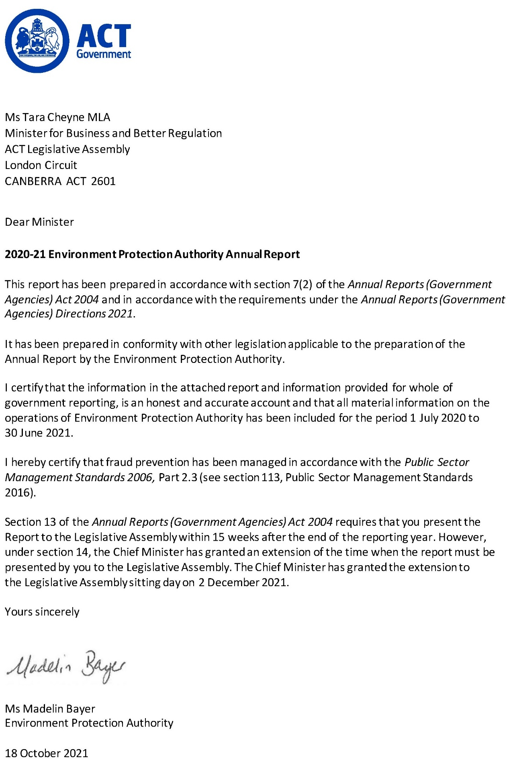

Compliance statement
The 2020-21 Environment Protection Authority Annual Report must comply with the Annual Reports (Government Agencies) Directions 2021 (the Directions) made under section 8 of the Annual Reports (Government Agencies) Act 2004. The Directions are found at the ACT Legislation Register.
The compliance statement indicates the subsections, under Parts 1 to 5 of the Directions, that are applicable to the Environment Protection Authority and the location of information that satisfies these requirements.

Part 1 Directions overview
The requirements under Part 1 of the Directions relate to the purpose, timing and distribution, and records keeping of annual reports. The 2020-21 Environment Protection Authority Annual Report complies with all subsections of Part 1 under the Directions.
To meet Section 15 Feedback, Part 1 of the Directions, contact details are provided within the 2020-21 Environment Protection Authority Annual Report to provide readers with the opportunity to provide feedback.

Part 2 Reporting entity annual report requirements
The requirements within Part 2 of the Directions are mandatory for all reporting entities and the 2020-21 Environment Protection Authority Annual Report complies with all subsections. The information that satisfies the requirements of Part 2 is found in the 2020-21 Environment Protection Authority Annual Report as follows:
- A. Transmittal Certificate, see previous page.
- B. Organisational Overview and Performance Analysis subsections, see Organisational Overview and Performance on the next page. As the Office of the Environment Protection Authority sits within Access Canberra in CMTEDD, all other subsections in Section B, Part 2 of the Directions are contained within the CMTEDD Annual Report.
C. Financial Management Reporting, inclusive of all subsections, see Volume 2 of the CMTEDD Annual Report.

Part 3 Reporting by exception
The Environment Protection Authority has no information to report by exception under Part 3 of the Directions for the 2020-21 reporting year.

Part 4 Directorate and public sector body specific annual report requirements
There are no specific annual report requirements for the Environment Protection Authority.

Part 5 Whole of government annual reporting
All subsections of Part 5 of the Directions apply to the Environment Protection Authority. Consistent with the Directions, the information satisfying these requirements is reported in the one place for all reporting entities as follows:
- Bushfire Risk Management, see the annual report of the Justice and Community Safety Directorate.
- Human Rights, see the annual report of the Justice and Community Safety Directorate.
- Legal Services Directions, see the annual report of the Justice and Community Safety Directorate.
- Public Sector Standards and Workforce Profile, see the annual State of the Service Report.
Territory Records, see the CMTEDD Annual Report.
ACT Public Service directorate annual reports are found at the following web address: http://www.cmd.act.gov.au/open_government/report/annual_reports

Organisational overview and performance

Organisational overview
The Environment Protection Authority (the Authority) is a statutory public servant position established by the Environment Protection Act 1997. The Office of the Environment Protection Authority (the EPA) within Access Canberra supports the Authority to carry out functions.

Legislative framework and functions
The Authority administers the following legislation:
- Environment Protection Act 1997
- Environment Protection Regulation 2005
- Water Resources Act 2007
Water Resource Regulation 2007.
The EPA is the primary environmental regulator for the ACT.
Our mission is to protect the well-being of the environment and community.

Overview of functions

Environment Protection Act 1997
The Environment Protection Act 1997 and the Environment Protection Regulation 2005 provide for the protection of the environment and for related purposes.
The objects of the Environment Protection Act 1997 are to:
- Protect and enhance the quality of the environment.
- Prevent environmental degradation and risk of harm to human health.
- Achieve effective integration of environmental, economic, and social consideration in decision-making processes.
- Establish a single and integrated regulatory framework for environmental protection and provide for monitoring and reporting of environmental quality on a regular basis.
- Facilitate the implementation of national environment protection measures and laws.
- Ensure contaminated land is managed having regard to human health and the environment.
Encourage responsibility by the whole community for the environment – general environmental duty of care.

Water Resources Act 2007
The Water Resources Act 2007 and the Water Resources Regulation 2007 provides for sustainable management of the water resources of the Territory, and for other purposes.
The objects of the Water Resources Act 2007 are to:
- Ensure that management and use of the water resources of the Territory sustain the physical, economic, and social wellbeing of the people of the ACT while protecting the ecosystems that depend on those resources.
- Protect aquatic ecosystems and aquifers from damage and, where practicable, to reverse damage that has already happened.
Ensure that the water resources are able to meet the reasonably foreseeable needs of future generations.

Compliance framework
The EPA carries out proactive and reactive activities, with resources allocated based on the level of risk and harm posed to the environment and/or human health. Compliance activities are conducted in accordance with the strategic objectives in the Environment Regulation and Protection Compliance Framework. This forms part of the Access Canberra Accountability Framework, which can be accessed via www.accesscanberra.act.gov.au.
Where an issue is identified, the EPA seeks to resolve the matter before it leads to an adverse impact on human health and/or the environment.
Reactive monitoring relies on the community, business or industry reporting environmental concerns or events, such as pollution of our environment or illegal water use.
Information and guidelines for industry and the public in relation to EPA legislation is available via the Access Canberra website. Information is also routinely shared through social media, radio and print platforms informing the community of their environmental obligations, while also providing important updates which may influence better environmental decision making by persons.
This annual report summarises the activities and performance of the EPA in 2020-21.

Performance analysis

Environmental Authorisations
An Environmental Authorisation (Authorisation) is a form of licence granted under section 49 of the Environment Protection Act 1997. An Authorisation sets out the conditions under which activities with a significant potential to cause environmental harm may be conducted. Authorisations granted for an unlimited period are reviewed every 5 years based on an assessment of the activity and the authorisation holder.
In 2020-21, a total of 29 Authorisations were granted, 19 Authorisations were terminated (of which 15 were ceased), 2 were cancelled and 2 expired, bringing the total number of Authorisations administered to 298 (refer to Table 1). During this period, 94 authorisations were reviewed and 23 varied.
Table 1: Number of Environmental Authorisations (EAs) issued per activity
Activity (Schedule 1 Class A) | New EAs issued in 2018-19 | New EAs issued in 2019-20 | New EAs issued in 2020-21 | EAs administered
Controlled burns | 0 | 0 | 0 | 0
Commercial incineration | 0 | 0 | 0 | 0
Composting | 1 | 0 | 0 | 2
Material crushing, grinding, or separating | 0 | 0 | 0 | 7
Commercial production of alcoholic beverages | 0 | 2 | 2 | 2
Crematorium | 0 | 0 | 1 | 2
Extraction of material from a waterway | 2 | 0 | 2 | 3
Extraction of material from Land | 0 | 0 | 0 | 1
Keeping poultry | 0 | 0 | 0 | 1
Commercial landfills | 0 | 0 | 0 | 2
Logging | 0 | 0 | 0 | 1
Milk production | 0 | 0 | 0 | 1
Motor sports | 1 | 2 | 1 | 4
Concert Venue | 0 | 1 | 1 | 1
Outdoor concerts | 8 | 3 | 3 | 5
Commercial use of agricultural and veterinary chemicals | 14 | 10 | 11 | 146
Petroleum storage | 2 | 4 | 1 | 69
Road building material production | 0 | 0 | 1 | 3
Production of concrete | 0 | 1 | 0 | 11
Sewage treatment | 0 | 0 | 0 | 4
Placement of soil on land | 7 | 3 | 4 | 13
Operation of waste transfer | 0 | 1 | 0 | 1
Transportation within the ACT of regulated waste | 4 | 0 | 1 | 18
Transport of Controlled Waste | 0 | 0 | 1 | 7
Sterilisation of clinical waste | 0 | 0 | 0 | 1
Timber milling | 0 | 0 | 0 | 1
Waste petroleum recovery | 0 | 0 | 0 | 1
Operation of a Firearm Shooting Range | 0 | 0 | 0 | 5
Total | 39 | 27 | 29 | 312*
*Note: There are 298 Environmental Authorisations, some of which are for multiple activities, so the total by activity type is 312.

Environmental Protection Agreements
Section 38 of the Environment Protection Act 1997 provides for the EPA to enter into Environmental Protection Agreements (Agreements) generally for the purpose of the Act. This section also allows Agreements to be used instead of an Authorisation where people are conducting certain activities that cause a moderately significant risk of environmental harm (listed in Schedule 1 Class B of the Environment Protection Act 1997 – see also subsection 42(2) of the Act). Agreements are designed to assist businesses to manage their environmental performance.
In 2020-21, the EPA entered into 42 Agreements, bringing the number of Agreements administered to 135 (refer to Table 2).
Table 2: Number of Environmental Protection Agreements issued per activity
Activity (Schedule 1 Class B) | 2018-19 | 2019-20 | 2020-21 | Total current Agreements
Land development/construction | 41 | 38 | 39 | 118
Landfill gas management | 0 | 1 | 0 | 1
Municipal services | 0 | 0 | 1 | 0
E-Waste Dismantling and Storage | 0 | 0 | 0 | 1
Wastewater reuse | 1 | 0 | 0 | 1
Contaminated sites | 0 | 3 | 2 | 14
Total | 42 | 42 | 42 | 135*
*Note: Of the 135 agreements, 118 relate to builders and developers undertaking construction works on sites greater than 0.3 ha.

Erosion and sediment control plans
A condition of an Agreement is the endorsement of an erosion and sediment control plan by the EPA prior to works commencing. During 2020-21 (refer to Table 3) the EPA:
- Received and endorsed 79 erosion and sediment control plans.
Conducted 1,226 inspections of development sites.
There was a reduction in the number of inspections of sediment and erosion control plans this financial year because staff were undertaking other activities which posed a higher risk of harm to the environment such as spills in waterways.
Table 3: Erosion and sediment control plans
Activity | 2018-19 | 2019-20 | 2020-21
No. of plans endorsed | 88 | 72 | 79
Inspections of development sites | 1,752 | 1,426 | 1,226

Contamination

Contaminated land notifications
During 2020-21, the EPA received 15 contaminated land notifications under section 23A of the Environment Protection Act 1997. The notifications related to asbestos, hydrocarbon, and per and poly fluoroalkyl (PFAS) substance impacts to soil and groundwater at the notified sites. There have been 129 notifications since the contaminated land provisions were enacted in 1999.

Contaminated sites
During 2020-21 the EPA (refer to Table 4):
- Reviewed and endorsed 15 independent contaminated land audits into site suitability by EPA approved auditors. These primarily related to greenfield developments and the re-development of sites potentially impacted by hydrocarbon and asbestos contamination.
- Reviewed and endorsed 41 contaminated land environmental assessment reports into the suitability of sites for their proposed uses.
Carried out 717 inspections of known, or potentially contaminated sites to review whether activities had the appropriate approval and whether re-development activities were underway or complete.
Table 4: Contaminated sites
Activity | 2018-19 | 2019-20 | 2020-21
Audits reviewed and endorsed | 20 | 14 | 15
Environmental assessment reports reviewed and endorsed | 56 | 69 | 41
Inspections of contaminated sites | 860 | 599 | 717

Register of contaminated sites
As of 30 June 2021, there are 184 contaminated sites recorded on the Register, which was the same number for 2019-20. The information on the Register is publicly available on the Access Canberra website and can also be obtained by contacting the EPA.

Contaminated land searches and data
The EPA maintains records of known, potentially contaminated and remediated land in the ACT. This information is made available through the Lease Conveyancing Enquiry through the ACT Planning and Land Authority and Contaminated Land Search through Access Canberra. It ensures persons with an interest in the land have access to records held by the EPA. The information is also provided under licence agreement to utility providers, their contractors, and other areas of the ACT Government for their operational requirements for installation and maintenance of infrastructure.
During 2020-21, the EPA received and responded to 599 Contaminated Land Search enquiries (refer to Table 5).
Table 5: Contaminated Land Searches and data
Activity | 2018-19 | 2019-20 | 2020-21
Licence Agreements | 0 | 1 | 0
Contaminated Land Searches | 518 | 612 | 599

Beneficial reuse approvals
Beneficial reuse involves the reapplication of soil which has a level of contamination that does not pose (subject to appropriate management) a risk to human health or the environment for a particular land use. Applications for reuse are undertaken by suitably qualified environmental consultants and are subject to rigorous assessment in accordance with EPA adopted guidance and criteria.
During 2020-21, the EPA received, assessed and approved 76 applications for the beneficial reuse of approximately 162,235 cubic metres of low-level contaminated soil (refer to Table 6).
Table 6: Beneficial Reuse Approvals
Activity | 2018-19 | 2019-20 | 2020-21
Applications for reuse approved | 82 | 79 | 76
Cubic metres of soil reused | 328,942 | 153,268 | 162,235

Controlled waste movements
In 2020-21, a total of 58 Consignment Authorisations were issued for the movement of a controlled waste into the ACT. Consignment Authorisations were issued primarily for the transport of clinical waste, asbestos, oily water, and polychlorinated biphenyl (PCB) free oil from other jurisdictions, which resulted in 625 controlled waste movements into the ACT (refer to Table 7).
During the same period, 1,027 controlled waste movements out of the ACT were notified and monitored by the EPA (refer to Table 7).
Table 7: Controlled waste movements
Activity | 2018-19 | 2019-20 | 2020-21
Consignment authorisations | 57 | 55 | 58
Controlled waste movements into the ACT | 643 | 855 | 625*
Controlled waste movements out of the ACT | 932 | 1,395 | 1,027
*Note: Number is reflective of total waste transport certificates received at the time of this report.

Enforcement actions
Individuals or businesses may incur penalties such as Infringement Notices, Environment Protection Orders, or prosecution for breaches of the Environment Protection Act 1997.
During 2020-21, the EPA undertook 20 enforcement actions (refer to Table 8 and Table 9). As can be seen, the EPA continues to take appropriate regulatory action to protect the environment and our community. Increased compliance activities help to reinforce legislative obligations and provides a strong general and specific deterrent. The EPA will continue to strengthen awareness of its role, identified environmental issues and its compliance activities in 2021-22.
Table 8: Enforcement actions under the Environment Protection Act 1997
Enforcement action | 2018-19 | 2019-20 | 2020-21
Infringement notices | 4 | 15 | 12
Environment Protection Orders | 2 | 4 | 8
Prosecution | 1 | 0 | 0
Table 9: Overview of enforcement actions under the Environment Protection Act 1997 in 2020-21
Offence | Penalty ($)/ action | Location of offence | Number
Infringement notices | 8,625 |  | 12
Areas near development to be kept clear | 500 | Wright
Offence to make noise louder than noise standard | 500 | Wright
Erosion and Sediment Control | 875 | Wright
Areas near development to be kept clear | 500 | Belconnen
Areas near development to be kept clear | 500 | Belconnen
Areas near development to be kept clear | 500 | Campbell
Erosion and Sediment Control | 875 | Campbell
Offence to make noise louder than noise standard | 1,000 | Braddon
Offence to make noise louder than noise standard | 1,000 | Braddon
Offence to make noise louder than noise standard | 1,000 | Belconnen
Areas near development to be kept clear | 500 | Wright
Pollution of a waterway | 875 | Belconnen
Orders |  |  | 8
Unauthorised Placement of Soil | Comply with Environmental Authorisation | Majura
Unauthorised Placement of Soil | Comply with Environmental Authorisation | Majura
Causing material environmental harm or likely material environment harm | Rectify works | Holt
Unauthorised Placement of Soil | Comply with Environmental Authorisation | Cotter
Excessive Noise | Rectify works | Narrabundah
Unauthorised placement of Soil | Comply with Environmental Authorisation | Symonston
Unauthorised placement of Soil | Comply with Environmental Authorisation | Mitchell
Enforceable Undertaking | $200,000 | Holt
Prosecutions |  |  | Nil

Complaint handling
During 2020-21, the Complaints Management Team (CMT) within Access Canberra received 2,473 complaints related to EPA matters, of which 2,028 (or 82 per cent) related to noise.
The EPA has reviewed its regulatory approach for managing noise complaints with increased education and engagement such as sending a second advisory letter for neighbour noise complaints, providing tips for having a conversation with your neighbour, using the Conflict Resolution Services and referring to the noise portal.
Table 10 provide a percentage breakdown of categories of EPA complaints received by the CMT for the past three financial years.
Table 10: Categories of EPA complaints received by CMT for 2018-19, 2019-20 and 2020-21*
Category | 2018-19 | % | 2019-20 | % | 2020-21 | %
Noise pollution | 2,282 | 80 | 1,878 | 75 | 2,028 | 82
Air pollution | 357 | 13 | 427 | 17 | 306 | 12
Waterways pollution | 89 | 3 | 83 | 3 | 49 | 2
Land contamination | 50 | 2 | 38 | 2 | 56 | 2
Light pollution | 59 | 2 | 76 | 3 | 34 | 1
Authorised activity | 7 | 0 | 0 | 0 | 0 | 0
Tree protection | 0 | 0 | 0 | 0 | 0 | 0
Total | 2,844 | 100 | 2,529 | 100 | 2,473 | 100
Figure 1: Bar chart representation of categories of EPA complaints received by CMT for 2018-19, 2019-20 and 2020-21*
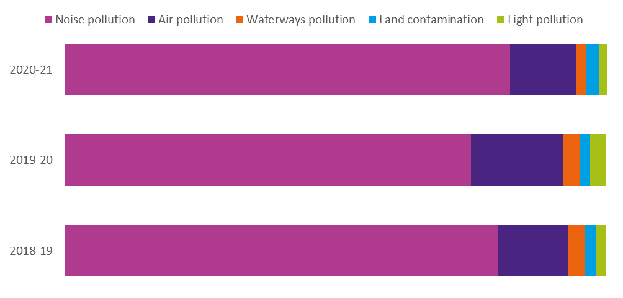
* Notes (for both Table 10 and Figure 1): Data represents a snapshot in time and some matters may be reclassified following more detailed consideration. This may result in small discrepancies from figures reported in the previous year.
Table 11 shows noise complaints by category for comparison between 2018-19, 2019-20 and 2020-21.
Table 11: Noise complaints by category for 2018-19, 2019 20 and 2020-21
Category | 2018-19 | Percentage | 2019-20 | Percentage | 2020-21 | Percentage
Amplified | 1,156 | 51 | 869 | 46 | 985 | 49
Construction | 506 | 22 | 447 | 24 | 439 | 22
Air conditioner/fan/heater | 146 | 6 | n/a* | n/a | n/a* | n/a
Mechanical plants and equipment | 143 | 6 | 166** | 9 | 220 | 11
Vehicles | 113 | 5 | 115** | 6 | 105 | 5
People | 80 | 4 | 91** | 5 | 133 | 7
Gym equipment | 62 | 3 | 106 | 6 | 66 | 3
Alarms | 35 | 2 | 44 | 2 | 28 | 1
Garden work | 33 | 1 | 24** | 1 | 35 | 2
Waste collection | 7 | 0 | 12** | 1 | 14 | 1
PA system | 1 | 0 | 4 | 0 | 3 | 0
Total noise pollution | 2,282 | 100 | 1,878 | 100 | 2,028 | 100
Figure 2: Bar chart representation of noise complaints by category for 2018-19, 2019-20 and 2020-21
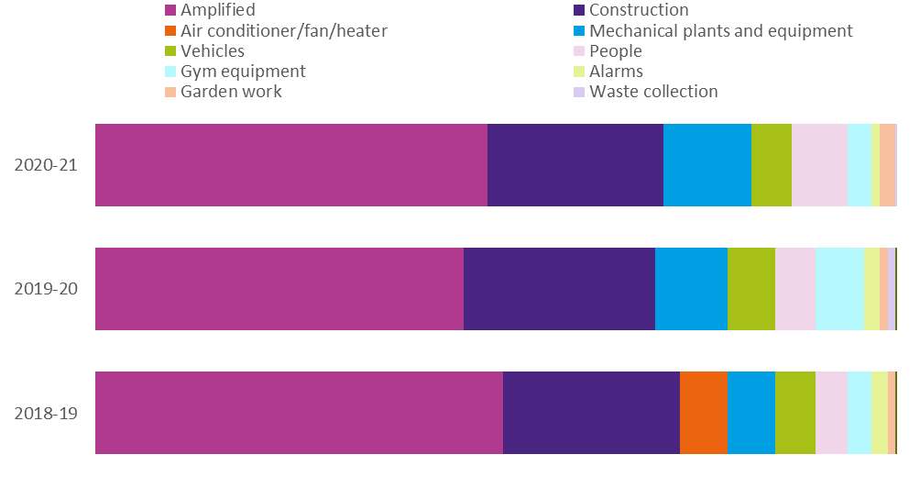
Notes (for both Table 11 and Figure 2):
* n/a - Air Conditioner/fan/heater was combined with mechanical plants and equipment from 2019-20.
** Numbers reported are accurate at the time of the report, however, can change over time due to investigation and re-categorisation of ongoing matters. This may result in changes to previous years’ figures.

Australian Government commitments

Air Quality Monitoring Report
The EPA produces an annual Air Quality Monitoring Report as part of its compliance with the Ambient Air Quality (AAQ) National Environment Protection Measure (NEPM). During 2020, air quality in the ACT was generally good after early February. The major air quality issue was particle pollution (both PM10 and PM2.5) between January to mid-February, associated with the continued impact of the 2019–2020 summer bushfires in south eastern Australia. As in previous years, PM2.5 levels also increased during winter because of emissions from domestic wood heaters.
The Report can be accessed via the Access Canberra website (www.accesscanberra.act.gov.au/s/article/air-pollution-tab-related-resources).

National Pollutant Inventory
The National Pollutant Inventory (NPI) is a joint program between the Australian Government and all participating States and Territories. The legislative framework underpinning this is the NPI National Environment Protection Measure, which was originally made in 1998 and varied in November 2008. Section 159A of the Environment Protection Act establishes reporting requirements for industrial facilities in the ACT. During 2020-21, the EPA received and validated 22 NPI facility reports. Associated training, compliance audit and intergovernmental liaison was also undertaken during this period.

Per and poly-fluoroalkyl substances
In February 2018, all jurisdictions in Australia adopted the framework for per- and poly-fluoroalkyl substances (PFAS) management through the Intergovernmental Agreement on a National Framework for Responding to PFAS Contamination (February 2018) (IGA). The IGA is unpinned by the PFAS National Environment Management Plan (NEMP), first developed in February 2018, and updated on 3 March 2020 with the NEMP version 2.
The EPA has developed an ACT PFAS Action Plan in accordance with the IGA and NEMP. The Action Plan includes activities such as the development of a PFAS inventory and a monitoring and sampling program. The Action Plan can be accessed via the Access Canberra website (www.accesscanberra.act.gov.au) by searching for “PFAS”.

Controlled waste
Controlled waste is the most hazardous category of waste and includes wastes that exhibit toxicity, chemical or biological reactivity, environmental persistence, or the ability to bio-accumulate or enter the food chain. These wastes need to be carefully managed and are closely regulated because of their potential to adversely impact human health and the environment. Some controlled wastes, such as tyres, are not strictly hazardous but they may also need special management.
The EPA has a statutory duty to protect the environment from the effects of controlled waste. Its powers range from requiring organisations to submit controlled waste data reports to enforcing the relevant provisions of the Environment Protection Act and other relevant legislation.
The National Environment Protection (Movement of Controlled Waste between States and Territories) Measure 1998 (NEPM) is an intergovernmental agreement made on 1 May 1992 to assist in achieving desired environmental outcomes. It provides a basis for ensuring that controlled wastes which are moved between States and Territories are properly identified, transported, and otherwise handled in ways which are consistent with environmentally sound practices for the management of these wastes.
This NEPM provides a national framework for developing and integrating State and Territory systems for the management of the movement of controlled wastes between States and Territories originating from commercial, trade industrial or business activities. The desired environmental outcomes of this NEPM are to minimise the potential for adverse impacts associated with the movement of controlled waste on the environment and human health.

Water Resources Act
The Water Resources Act 2007 aims to ensure the use and management of the Territory’s water resources are sustainable while protecting the ecosystems that depend on the waterways. It is also designed to protect waterways and aquifers from damage.
Under the Water Resources Act 2007, licences are issued for regulating potential harmful activities ranging from water abstraction, bore drilling and construction of dams or modification of waterways (rivers creeks and large stormwater drains).

Water Access Entitlements and Licences
The EPA administers 238 licences comprising: 182 Licences to Take Water, 1 Recharge Licences, 43 Drillers Licences, 6 Bore Work Licences and 6 Waterway Works Licences. We also administer 320 Water Access Entitlements.
During 2020-21, there were 182 active Licences to Take Water, with 5 new licences issued and no licences which expired or were cancelled.
In 2020-21, the EPA also issued:
- 4 Bore Works licences
- 8 Drillers licences
4 Water Access Entitlements.
Table 12 indicates licensing activity by number of new licences and entitlements issued compared to the previous two financial years.
Table 12: Number of licences per type issued under the Water Resources Act 2007
Licence type | 2018-19 | 2019-20 | 2020-21
Bore Works | 2 | 3 | 4
Drillers | 7 | 16 | 8
Waterways Works | 0 | 1 | 0
Take Water (new) | 2 | 3 | 5
Water Access Entitlements | 5 | 2 | 4

Assessment of water use and protection of environmental flows
Water use by licence holders is assessed to ensure that extraction does not reach a level that negatively impacts our aquatic ecosystems and that users pay a reasonable price for using the resource. Water use by licence holders (including Icon Water) was below the volume of water held in entitlements and there were no detections of non-compliance with licence conditions.

Metering of water use
All licenced water use in the ACT is metered and the inspection regime aims to have each meter inspected at least once every three years. Table 13 lists the number of meter inspections performed and the type of meter inspected in 2020-21, 2019-20 and 2018-19.
For transparency and to assist compliance, the ACT identifies meter using a unique serial number, most commonly located on the face of the meter. This is referred to as the meter number which is also kept on a customer’s licence file. The information is publicly available upon request by contacting the EPA by emailing environment.protection@act.gov.au.
The ACT’s metering requirements, which have been in place since 2003, meet the Murray Darling Basin Compliance Compact (which was introduced in 2018). ACT licences have conditions mandating the installation of a meter as well as requiring meter maintenance and data reporting. The ACT EPA Water Meter Installation, Maintenance and Replacement Guideline 2015 details metering standards that apply to various scenarios and aligns with the Compliance Compact and other states.

In 2020-21, there were 182 active Licences to Take Water with 316 meters in use.
The decrease in the number of meters was a result of changed data management process, which excluded the meters listed as “inactive” or “removed” in the 2020-21 data.
There was a significant change in meter inspections from the previous year. COVID-19 restrictions early in the year and staff movements in the water regulation team of the EPA resulted in the low number of inspections.
Table 13: Details of ACT non-utility network water meter fleet and inspections in 2018-19, 2019-20 and 2020-21
Activity type | 2018-19 |  |  | 2019-20 |  |  | 2020-21
 | Total | Groundwater | Surface water | Total | Groundwater | Surface water | Total | Groundwater | Surface water
Licences | 180 | n/a | n/a | 181 | n/a | n/a | 182 | n/a | n/a
Meters | 331 | 199 | 132 | 331 | 199 | 132 | 316 | 196 | 120
Meter inspections | 43 | 28 | 15 | 22 | 16 | 6 | 1 | 0 | 1
New meters | 0 | 1 | 0 | 0 | 1 | 0 | 0 | 0 | 0
Further information
Madelin Bayer Environment Protection Authority
13 22 81 Environment.protection@act.gov.au www.accesscanberra.act.gov.au

Lifetime Care and Support Fund

Transmittal certificate
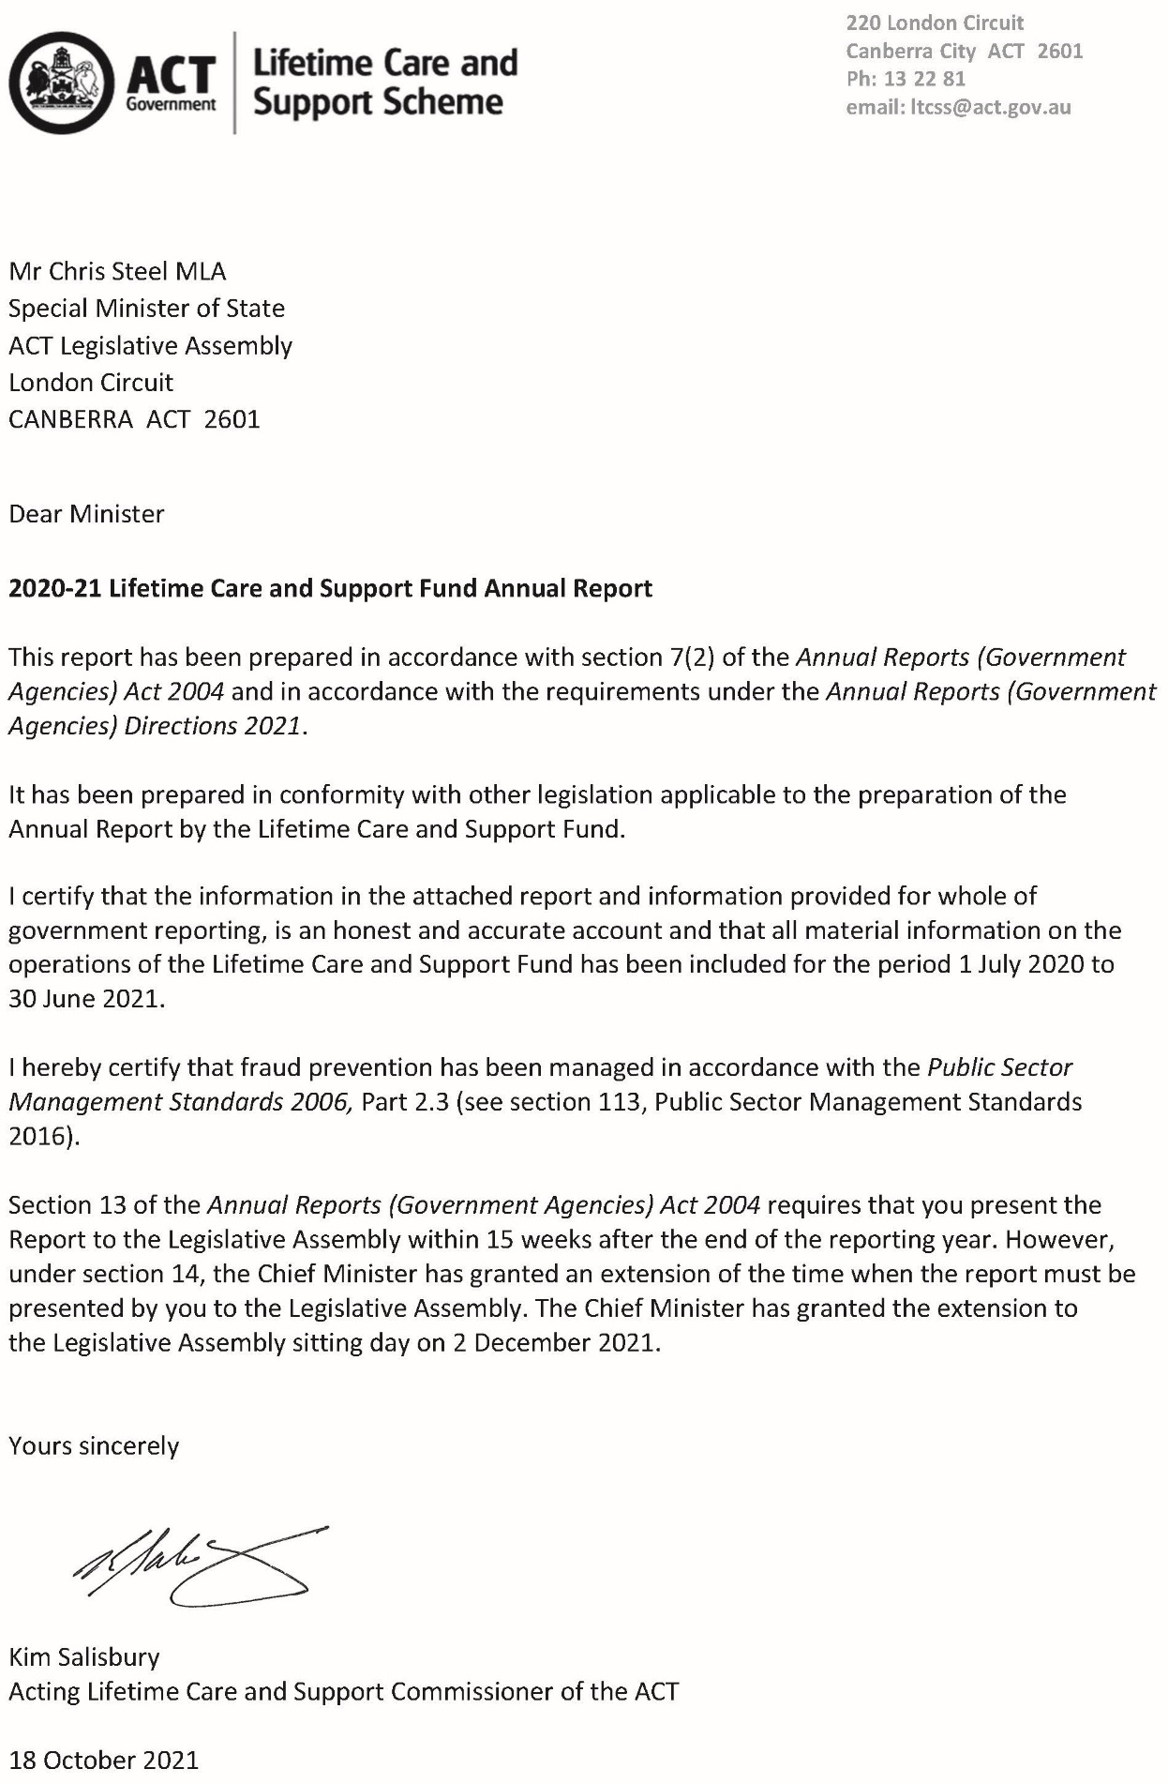

Compliance Statement
The 2020-21 Lifetime Care and Support Fund (LTCS Fund) Annual Report must comply with the Annual Reports (Government Agencies) Directions 2021 (the Directions) made under section 8 of the Annual Reports (Government Agencies) Act 2004. The Directions are found at the ACT Legislation Register.
The Compliance Statement indicates the subsections, under Parts 1 to 5 of the Directions, that are applicable to the LTCS Fund and the location of information that satisfies these requirements.

Part 1 Directions Overview
The requirements under Part 1 of the Directions relate to the purpose, timing and distribution, and records keeping of annual reports. The 2020-21 LTCS Fund Annual Report complies with all subsections of Part 1 under the Directions.
To meet Section 15 Feedback, Part 1 of the Directions, contact details for the LTCS Fund are provided within the 2020-21 LTCS Fund Annual Report to provide readers with the opportunity to provide feedback.

Part 2 Reporting entity Annual Report Requirements
The requirements within Part 2 of the Directions are mandatory for all reporting entities and the LTCS Fund Annual Report complies with all subsections. The information that satisfies the requirements of Part 2 is found in the LTCS Fund Annual Report as follows:
- A. Transmittal Certificate, see previous page.
- B. Organisational Overview and Performance Analysis, see Organisational Overview and Performance on the following pages. The following subsections, contained within the 2020-21 CMTEDD Annual Report, apply to the LTCS Fund:
- Scrutiny
- Risk Management
- Internal Audit
- Fraud Prevention
- Freedom of Information
- Community Engagement and Support
- Aboriginal and Torres Strait Islander Reporting
- Work Health and Safety
- Human Resources Management
Ecologically Sustainable Development
C. Financial Management Reporting, all subsections, see Volume 2.2 of the 2020-21 CMTEDD Annual report.

Part 3 Reporting by Exception
The LTCS Fund has no information to report by exception under Part 3 of the Directions for the 2020-21 reporting year.

Part 4 Directorate and Public Sector Body Specific Annual Report Requirements
Part 4 of the 2021 Directions is not applicable to the LTCS Fund.

Part 5 Whole of Government Annual Reporting
Consistent with Part 5 of the Directions, the information satisfying the requirements is reported in the one place for all reporting entities as follows:
- Bushfire Risk Management, see the annual report of the Justice and Community Safety Directorate,
- Human Rights, see the annual report of the Justice and Community Safety Directorate.
- Legal Services Directions, see the annual report of the Justice and Community Safety Directorate.
- Public Sector Standards and Workforce Profile, see the annual State of the Service Report.
Territory Records, see the CMTEDD Annual Report.
ACT Public Service Directorate annual reports are found at the following web address: http://www.cmd.act.gov.au/open_government/report/annual_reports

Organisational Overview and Performance

Organisational Overview
The Lifetime Care and Support Scheme (LTCS Scheme) is established under the Lifetime Care and Support (Catastrophic Injuries) Act 2014 (LTCS Act) and provides reasonable and necessary ongoing treatment and care to people who have been catastrophically injured as a result of a motor accident or private sector work accident in the Australian Capital Territory (ACT). The types of injuries covered by the Scheme are spinal cord injuries, traumatic brain injury, amputations, severe burns and permanent blindness (more information can be found at http://www.treasury.act.gov.au/ltcss).
The LTCS Scheme covers pedestrians, cyclists, and people travelling on, or in motor bikes and motor vehicles as long as there is at least one registrable vehicle involved in a motor accident that occurred on or after 1 July 2014, regardless of who is at fault for the accident. The Scheme also applies to catastrophic private sector work injuries that occurred from 1 July 2016.
As the LTCS Scheme is designed specifically for catastrophically injured people, participants will receive all their treatment and care needs under this scheme and not any other personal injury scheme under which they might have a claim / application (i.e. Compulsory Third-party Insurance, Motor Accident Injuries Scheme or private sector workers’ compensation scheme). As a no-fault scheme, the LTCS Scheme reduces stress on those injured and their families associated with litigating claims to meet ongoing treatment costs. It ensures early access to medical and rehabilitation care. Further, as treatment and care are ongoing, those injured do not have to worry about whether a lump sum payment will meet their needs for the rest of their life and whether they will receive the ongoing treatment and care they require.
Examples of treatment and care provided to participants in the Scheme include:
- Medical treatment
- Rehabilitation
- Attendant care services
Home and transport modification.

For motor accident injuries, from 1 February 2020 the LTCS Scheme is funded by a levy on Motor Accident Injuries Scheme insurance policies (prior to that date the levy was on Compulsory Third party Insurance policies). Private sector work injuries are funded through a separate levy collected from workers’ compensation insurers and self-insurers. The financial operations of the LTCS Scheme are reflected in the LTCS Fund which is a separate financial reporting entity.
The LTCS Act is administered by the Chief Minister, Treasury and Economic Development Directorate (CMTEDD). Under section 10 of the LTCS Act, the Minister must appoint a public servant as the LTCS Commissioner of the ACT. The position of the Executive Branch Manager, Insurance Branch, Economic and Financial Group (EFG), CMTEDD was appointed by the Minister as the LTCS Commissioner for a period of three years commencing 16 September 2019. The position of the Executive Group Manager of EFG was appointed by the Minister as the Acting LTCS Commissioner when the LTCS Commissioner is unavailable. During the reporting period, the acting arrangements were activated between April to June 2021. Further, an acting Executive Branch Manager was appointed to assist the acting LTCS Commissioner in the daily operations of the LTCS Commission.
The functions of the LTCS Commissioner are supported by the Insurance Branch of EFG within CMTEDD.
The NSW Government provides support for the ACT Scheme. The NSW LTCS Authority (LTCSA) provides coordinated lifetime care and support services on behalf of the LTCS Commissioner to participants in the ACT Scheme. This arrangement commenced on 1 September 2015 and gives effect to the Intergovernmental Agreement signed by the ACT Government with NSW in February 2015.

LTCS Commissioner Responsibilities
Under the provisions of the LTCS Act, some of the key responsibilities of the LTCS Commissioner are to:
- Provide an indemnity and insurance scheme to respond to and pay assessed treatment and care needs for eligible participants.
- Determine the LTCS levy amount separately for both the motor vehicle and work injuries streams.
- Issue and monitor guidelines for the LTCS Scheme.
- Assess applications for eligibility for Scheme participation.
Monitor the reasonable and necessary treatment and care needs of participants.

Highlights
The key priorities for the LTCS Commissioner during the 2020-21 financial year were to:
- Administer the LTCS Scheme in accordance with the requirements of the LTCS Act and Guidelines.
- Collect feedback from participants on their expectations and experience with the LTCS Scheme.
- Continue to improve guidelines and procedures for the efficient and effective delivery of the LTCS Scheme in consultation with our service partners – the NSW LTCSA.
Undertake investments in accordance with the Fund’s investment strategy.
Against these priorities, the LTCS Commissioner:
- Determined, having regard to independent actuarial advice, the LTCS levy for both motor vehicle and work injuries for 2021-22 (see Performance analysis, indicator (a) for further information on the levies).
- Commissioned and received the sixth LTCS participant feedback report on the administration and effectiveness of LTCS Scheme services provided to participants, including insights on how aspects of service delivery may be further enhanced (see Performance analysis, indicator (b) for further information on the survey and its findings).
Invested an additional $14.5 million of funds not required in the short-term in accordance with the approved LTCS Fund investment strategy. The investment portfolio achieved a record investment return for the 2020-21 financial year of 14.3 per cent (3.6 per cent in 2019-20). This was due to a combination of factors including unprecedented global fiscal and monetary stimulus provided during 2020-21 in response to the COVID-19 pandemic, record low interest rates, and strongly performing global share markets.

Our participants

Applications to the Scheme
The LTCS Commissioner accepted eight motor accident injury applicants and one work injury applicants as interim participants in the Scheme relating to accidents that occurred since July 2020. The associated expenses for all nine new participants are reflected in the LTCS Fund’s financial statements for 2020-21. As at the end of August 2021, one interim LTCS application is awaiting assessment and a further application is expected to be received.
All participants commence as ‘interim participants’ for up to two years. During this time, the Scheme will pay for any reasonable and necessary treatment, rehabilitation and care related to the motor accident or work injury.
After two years, an interim participant may be eligible to become a ‘lifetime participant’. Children cannot apply for lifetime eligibility until they are at least five years old.
Decisions about whether an interim participant is accepted as a lifetime participant are made before the end of the interim participation period. Around six months prior to the end of the interim participation period, a participant’s eligibility to remain in the scheme is assessed to determine whether the person may have sufficiently recovered to the extent that they no longer meet the eligibility criteria after the two-year period. If it is assessed that the injured person is likely to meet the eligibility criteria beyond two years, the person is accepted into the scheme for life.
During 2020-21, four interim participants were assessed and accepted for lifetime participation in the LTCS Scheme. Another participant’s interim participation status lapsed, with the person choosing not to apply for lifetime participation in the Scheme. As at September 2021, two further interim participants were assessed and accepted for lifetime participation in the Scheme, with a total of six new lifetime participants accepted in the Scheme since July 2020.

Applying to the Scheme
Since the LTCS Scheme commenced in July 2014, 27 participants have been accepted into the Scheme. As at the end of August 2021 there are 26 participants (22 motor accident injury participants and four work injury participants) who are receiving coordinated treatment and care benefits through the Scheme. Of the 26 participants, 13 are lifetime participants (10 motor injury participants and three work injury participants) and 13 are interim participants.
The LTCS Scheme continues to have a relatively young profile with the average age of participants currently 32 years, slightly lower than last year. Of the 26 participants in the scheme as at September 2021, two participants are under 10 years of age. Male participants comprise 81 per cent of all participants in the scheme.
Figure 1: Participant demographics
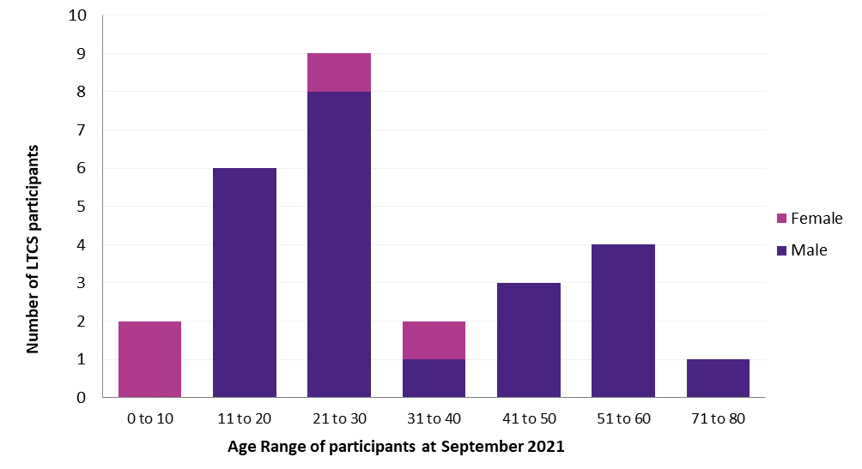
* Note: The above graph has 27 Scheme participants.
The scheme covers five types of catastrophic injuries – traumatic brain injury, spinal cord injury, amputations, burns and vision loss. In total, there are nine participants with a spinal cord injury. Of the accidents since July 2020, two of the injuries were spinal cord injuries; six of the injuries were traumatic brain injuries and one injury involved an amputation. In total 19 participants (73 per cent) have been accepted into the Scheme as a result of a traumatic brain injury. Another participant accepted into the Scheme for a spinal cord injury also sustained a traumatic brain injury.
Figure 2: Participant injury type
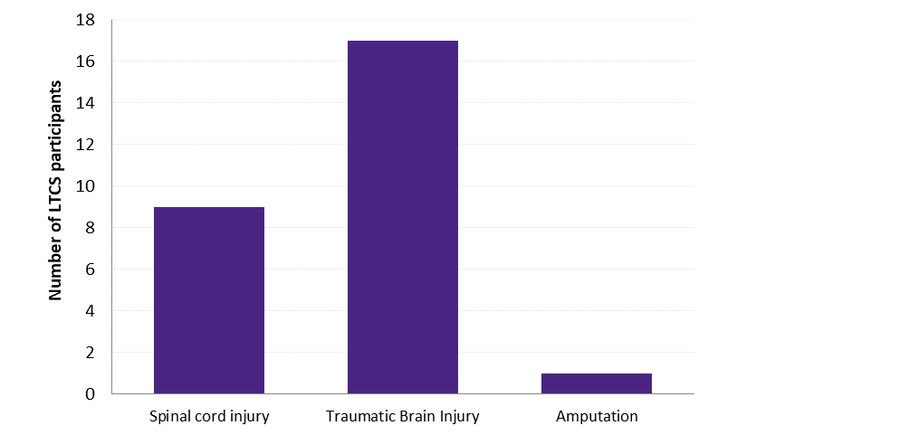
* Note: The above graph has 27 Scheme participants.
Of the four work injury participants, three were injured in a work motor vehicle accident and one was injured on a work site. Of the scheme participants who have been injured in an accident involving a motor vehicle (including the work injury category):
- Seven were passengers (26 per cent);
- Three were pedestrians (11 per cent);
- Two were riding bicycles (7 per cent); and
14 were drivers (52 per cent), including five motorcycle riders (18 per cent).
Figure 3: Participant's role in accident
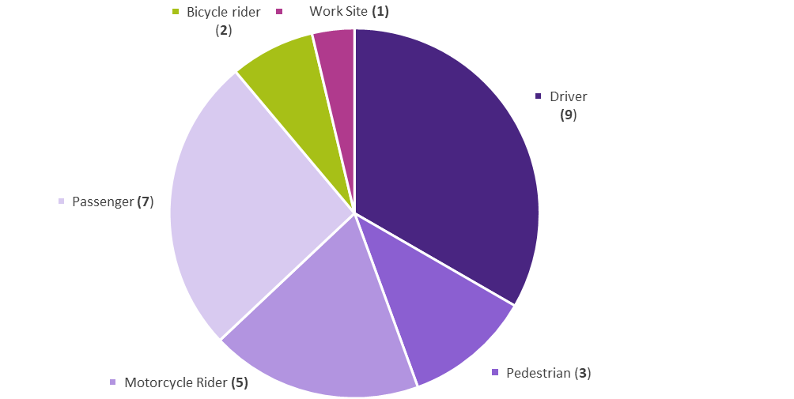
* The above graph has 27 Scheme participants.

Provided Treatment, Rehabilitation and Care
In 2020-21, the LTCS Scheme spent a total of $3.806 million on services for participants (up by 56 per cent compared with the previous year). Despite the number of new participants accepted in the financial year, hospital expenses accounted for a small proportion (10 per cent) of participant expenses. Attendant care services (39 per cent) was the largest category of participant expenses reflecting the complex and high care needs of some of the scheme’s participants.
The second highest expense category related to support services (16 per cent), which comprises mainly case management fees and travel expenses for participants and service providers to access and provide medical review and treatment. Equipment (14 per cent), Rehabilitation (nine per cent) and Home modifications (nine per cent) were the next largest expense categories which saw an increase share of total expenditure. Medical (three per cent) remained unchanged while Educational & Vocational Support fell marginally (three per cent).
Figure 4: Participant benefit payments 2020-21
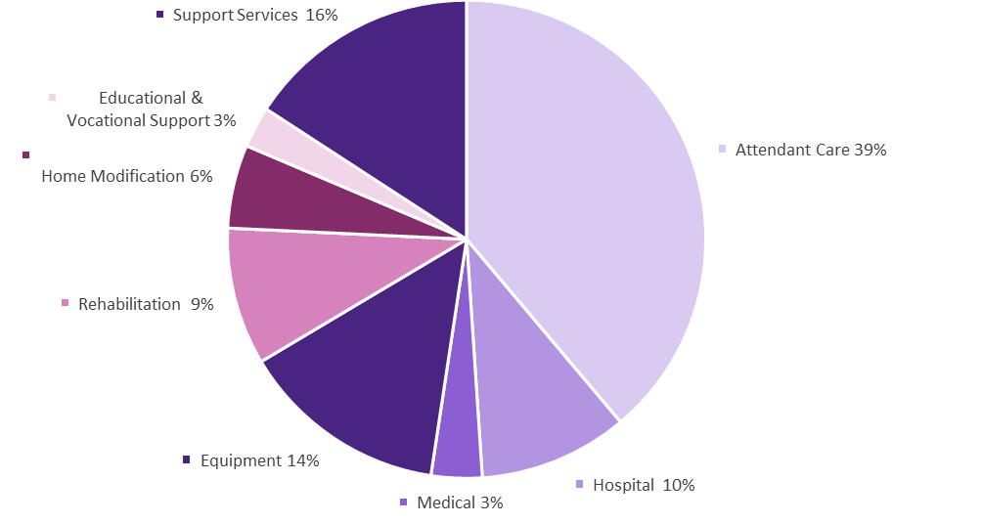
Accessing Services – How the scheme works with participants
The LTCS Scheme provides reasonable and necessary treatment, rehabilitation and care as it is required throughout the person’s life and assists them to plan their rehabilitation and care services.
Participants are supported as needed by a LTCS Scheme coordinator. The coordinator arranges for a case manager to help plan services required by the participant.
The case manager will work with the participant and their service providers to request approval for services. Services are organised as required and the participant and their families are closely involved in each of these requests. Usually payment of approved treatment and care needs is made by the LTCS Scheme directly to the supplier of the services.

Participants’ experiences of the LTCS Scheme support for recovery and rehabilitation
Participant research surveys each year seek feedback on different aspects of the support delivered by the LTCS Scheme. This survey is a performance indicator for the Scheme, discussed further under Performance Analysis. Research conducted in May 2021 sought feedback from participants and their nominated representatives on their experience and satisfaction with the Scheme benefits and, in particular, if benefits are provided efficiently and effectively; and meet the needs of participants’ individual recovery and rehabilitation goals.
The survey also sought to understand how participants who have been in the Scheme only for a relatively short period (in most cases under two years) perceived their progress; whether they are well-supported by the Scheme’s care team; and if the Scheme is responsive to their needs. The survey reported positive feedback in the context of quite high levels of satisfaction with the way the LTCS Scheme generally meets participants’ needs.
Participants were asked what they thought of the LTCS Scheme. Below is a selection of responses.
“It is fantastic for the medical and therapy goals. We’d be financially ruined without it. Great, very good.”
“Help, success, getting better and focusing on my goals … to complete my recover.”
“We feel very lucky to be part of Lifetime Care. They are good people, and they provide so much.”
“… I’m glad we are in Lifetime Care. It may not be perfect, but it’s not NDIS.”
Participants indicated that they felt well-supported by the Scheme-funded services and the model of care offered by the Scheme. Respondents indicated that goal development and service planning had been done very well and their goals were met as a result. When asked about what aspect of the Scheme they were most satisfied with, respondents commented:
“How quickly they are able to put things in place to get help”
“Everything I’ve needed I’ve got. They are just that good. It was all a bit of a shock that I got so much help”
“Everything. We don’t really have any issues. I’m grateful”
Participants reported having positive working relationships with their case manager and the Scheme’s coordinator, although all reported they usually communicated with their case manager. Participants also spoke positively about their involvement in their goal development and in choosing or planning the services they need using the Scheme’s multi-disciplinary team approach that considerably contributed to their recovery.
“It was the whole team, the speech, physio, social worker, all of them. If I had missed out on one of those it wouldn’t have worked. But they were all provided, and I’ve improved so much … Every time I make a plan, I achieve them [goals] “
“We have a team meeting and sit down and have a discussion about my goals and plan for support … The physio wrote a plan to the gym that would help. And speech and reading and writing help and a vocational counsellor … It was absolutely amazing. There’s no room for improvement.”
Overall, participants were very satisfied with the recovery and wellbeing that could be achieved and maintained through Scheme-funded supports and services. When asked how well the services provided from the Scheme ‘support the goals that they most want to work on’, one participant responded:
I couldn’t imagine anything better getting me towards those goals and they’ve done so much, they’ve done everything they can to support me”.
While there was very positive feedback on the Scheme, some suggestions were made to improve the Scheme, in particular, the timeliness of (travel) reimbursements; the need for some adjustments to the timing of the provision of family supports, where eligible, to alleviate trauma and stress on the family. The report also provided some suggested improvements and recommendations for consideration – such as the importance of ongoing coordinator-initiated communications with the participant at regular intervals and or when milestones occur (such as an upcoming two-year review); and the provision of refresher training for case managers and coordinators who work with ACT participants on any differences between the two Schemes.

Outlook
Strategic priorities for the LTCS Commissioner in 2021-22 include:
- administering the LTCS Scheme in accordance with the requirements of the LTCS Act and Guidelines;
- issuing / amending guidelines and determinations under the LTCS Act when required;
- collecting annual feedback from participants on their expectations and experience with the LTCS Scheme and in consultation with our service partner, the NSW LTCSA, implement improvements when required to the way LTCS Scheme benefits are delivered to ACT participants; and
undertaking investments in accordance with the Fund’s investment strategy.

Performance analysis
The LTCS Scheme’s 2020-21 performance indicators are included in the Budget Portfolio Statements for the LTCS Fund and are reported as part of the LTCS Fund’s Statement of Performance.

Explanation of Performance Indicators

a. LTCS Levies determined during the fourth quarter
The LTCS levies are crucial to the funding of the Scheme, with a levy applying to all Motor Accident Injuries insurance policies (prior to 1 February 2020 Compulsory Third-party Insurance policies) payable at the time of vehicle registration and a levy applying to private sector workers’ compensation insurers. As required by the LTCS Act, the levies are set by the LTCS Commissioner based on independent actuarial advice. The level at which the levies are set in any given year is intended to provide sufficient funds to meet the costs of all estimated present and future liabilities of new participants of the LTCS Scheme in that year. The LTCS levies are for a financial year and are set in May before the commencement of a financial year on 1 July.
In accordance with section 83 of the LTCS Act, before the beginning of the contribution period the LTCS Commissioner obtained a report from an independent actuary in relation to the amounts needed to be contributed to the LTCS fund for the contribution period.
Two actuarial reports for the 2021-22 contribution period were undertaken by the Scheme Actuary, Finity Consulting Pty Ltd, for the purposes of setting the 2021-22 LTCS Levy for motor vehicle injuries and the LTCS levy for work injuries.
The Acting LTCS Commissioner determined that the LTCS levy for a twelve-month Motor Accident Injuries insurance policy would increase to $45.70 in 2021-22 for all vehicles except those that are subject to distance restrictions applicable as part of the ACT’s Concessional Vintage Vehicle Registration (CVVR) Scheme. The LTCS Levy determined for the CVVR Scheme was set at $9.10 in 2021-22 for a twelve-month insurance policy.
The Acting LTCS Commissioner determined the total LTCS levy payable by private sector workers’ compensation insurers and self-insurers at $4.6 million.
The Levy determinations for the 2021-22 contribution period for motor vehicles and private sector workers’ compensation insurers and self-insurers, were notified on the Legislation Register on 17 May 2021 and 1 June 2021 respectively.
The Acting LTCS Commissioner determined these LTCS levies based on the best available data. As the Scheme will only be in its eighth year of operation for motor vehicle accidents and in its sixth year of operation for work accidents, a high degree of uncertainty remains with respect to the number of participants and the costs of providing services. By the very nature of the injury type covered by the scheme, the costs of the scheme can be expected to be volatile from year to year. Noting that it will take many years of experience before more robust scheme data becomes available, the LTCS Commissioner will continue to reassess the levy amounts yearly, on the basis of updated advice provided by an independent actuary.

b. Undertake an annual client feedback process
A survey of the LTCS Scheme participants was conducted by MODD Research + Evaluation, a social research consultancy that specialises in undertaking research of services in the disability and health sectors, in May 2021. A final report was received in June 2021.
This year’s survey also aimed to gain a better understanding of whether, and to what extent, participants needs are being met; their progress and meeting their goals; did participants and the families feel supported by their care team; and suggestions for improvement. There was a good response, with around 75 per cent agreeing to be interviewed.
The results of the survey indicate the Scheme is providing scheme-funded services, equipment and support effectively and efficiently. While some variation was noted, issues will inevitably arise with complex needs, and communication structures in place have generally been able to identify and manage the resolution of these issues. COVID-19 restrictions were reported to have had little impact on the provision of scheme-funded services during the 2020-21 period.
As the research touched on the administrative processes of the NSW LTCSA, a copy of the research report and learnings has been provided to the NSW LTCSA and discussed with them. The results of the survey will inform the responses to be taken in light of the report’s recommendations.
Further information
Nicola Clark Acting Executive Branch Manager, Insurance, Economic and Financial Group
(02) 6207 1189 Nicola.Clark@act.gov.au

Motor Accident Injuries Commission

Transmittal certificate
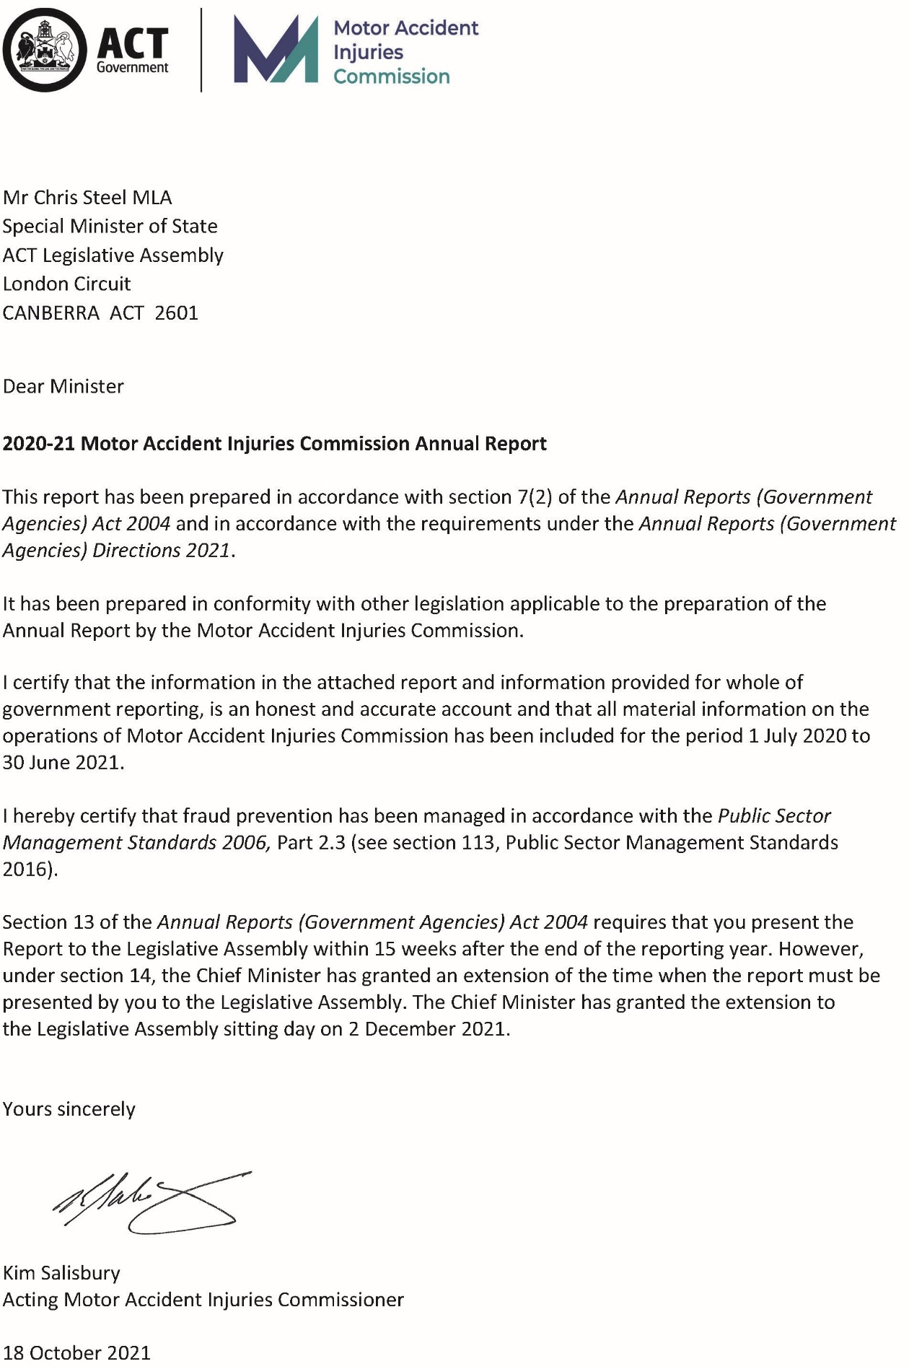

Compliance Statement
The 2020-21 Motor Accident Injuries Commission (MAI Commission) Annual Report must comply with the Annual Reports (Government Agencies) Directions 2021 (the Directions) made under section 8 of the Annual Reports (Government Agencies) Act 2004. The Directions are found at the ACT Legislation Register.
The Compliance Statement indicates the subsections, under Parts 1 to 5 of the Directions, that are applicable to the MAI Commission and the location of information that satisfies these requirements.

Part 1 Directions Overview
The requirements under Part 1 of the Directions relate to the purpose, timing and distribution, and record keeping of annual reports. The 2020-21 MAI Commission Annual Report complies with all subsections of Part 1 under the Directions.
To meet Section 15 Feedback, Part 1 of the Directions, contact details for the MAI Commission are provided within the 2020-21 MAI Commission Annual Report to provide readers with the opportunity to provide feedback.

Part 2 Reporting entity Annual Report Requirements
The requirements within Part 2 of the Directions are mandatory for all reporting entities and the MAI Commission Annual Report complies with all subsections. The information that satisfies the requirements of Part 2 is found in the MAI Commission Annual Report as follows:
- A. Transmittal Certificate, see previous page.
- B. Organisational Overview and Performance Analysis, see Organisational Overview and Performance. The following subsections, contained within the CMTEDD Annual Report, apply to the MAI Commission:
- Scrutiny
- Internal Audit
- Fraud Prevention
- Freedom of Information
- Community Engagement and Support
- Aboriginal and Torres Strait Islander Reporting
- Work Health and Safety
- Human Resources Management
Ecologically Sustainable Development
C. Financial Management Reporting, all subsections, see Volume 2.2 of the CMTEDD Annual report. MAI Commission reporting on Government Contracting is included in the CMTEDD Government Contracting section.

Part 3 Reporting by Exception
The MAI Commission has no information to report by exception under Part 3 of the Directions for the 2020-21 reporting year.

Part 4 Directorate and Public Sector Body Specific Annual Report Requirements
Part 4 of the 2021 Directions is not applicable to the MAI Commission.

Part 5 Whole of Government Annual Reporting
Consistent with the Directions, in particular all subsections of Part 5, the information satisfying these requirements is reported in the one place for all reporting entities as follows:
- Bushfire Risk Management, see the annual report of the Justice and Community Safety Directorate
- Human Rights, see the annual report of the Justice and Community Safety Directorate
- Legal Services Directions, see the annual report of the Justice and Community Safety Directorate
- Public Sector Standards and Workforce Profile, see the annual State of the Service Report
Territory Records, see the CMTEDD Annual Report.
ACT Public Service Directorate annual reports are found at the following web address: http://www.cmd.act.gov.au/open_government/report/annual_reports

Organisational Overview and Performance

Organisational Overview
The Motor Accident Injuries (MAI) Commission is a Territory authority established under the Motor Accident Injuries Act 2019 (MAI Act). The MAI Commission started operations on the commencement of the MAI Act on 1 February 2020.
The MAI Commission replaced the ACT Compulsory Third-party Insurance (CTP) Regulator. The CTP Regulator’s obligations for motor accidents that occurred before the new scheme commenced are now the responsibility of the MAI Commission. These obligations include overseeing and monitoring the CTP regulation and procedures, as well as compliance with the Road Transport (Third-Party Insurance) Act 2008 (CTP Act) until all remaining claims are finalised.
The Executive Branch Manager of the Insurance Branch, Economic and Financial Group, Chief Minister, Treasury and Economic Development Directorate (CMTEDD) was appointed by the Minister as the MAI Commissioner for a period of 5 years commencing from 17 September 2019. The Executive Group Manager of the Economic and Financial Group, CMTEDD was appointed by the Minister as the Acting MAI Commissioner when the MAI Commissioner is unavailable. During the reporting period, the acting arrangements were activated between April to June 2021. Further, an acting Executive Branch Manager was appointed to assist the acting MAI Commissioner in the daily operations of the MAI Commission. The functions of the MAI Commission are supported by the Insurance Branch, Economic and Financial Group, CMTEDD.

Principal objectives
The objectives of the MAI Act are specified in section 6 of the Act and are not the same as those specified in the previous CTP Act, reflecting the MAI Scheme’s different scheme design. The objectives include:
- Ensuring benefits are available to support all people injured in motor accidents on a no-fault basis, subject to some exclusions and limitations.
- Encouraging early and appropriate treatment and care of people injured in motor accidents to achieve optimum recovery and return to pre-accident levels of activity and work.
- Supporting people injured in motor accidents to access defined benefits.
- Promoting and encouraging the early, quick, cost-effective and just resolution of disputes.
- Keeping the costs of motor accident injury insurance at an affordable level.
Providing for the licensing and supervision of insurers providing motor accident injury insurance.

Functions
The functions of the MAI Commission are more extensive than those of the previous CTP Regulator. They include additional functions such as providing information and assistance on the MAI Scheme, and a strengthened monitoring and regulatory role particularly in relation to the provision of defined benefits by insurers. The MAI Commission’s functions are detailed in section 25 of the MAI Act. Its responsibilities include:
- Regulating the licensing of insurers under the MAI Scheme.
- Reviewing premiums to ensure they fully fund the present and likely future costs of the Scheme but are not excessive.
- Monitoring insurers’ compliance with their obligations under the Act.
- Providing information to the public about the MAI Scheme.
- Managing complaints about the market practices of licensed insurers and the handling practices of insurers under the MAI Scheme.
- Issuing, monitoring and reviewing the MAI guidelines and other statutory instruments under the Act.
Monitoring and advising the Minister about the administration, efficiency and effectiveness of the MAI Scheme.

Highlights

Implementation and operation of the MAI Scheme
The MAI Scheme commenced operation on 1 February 2020. During the reporting year the MAI Commission monitored trends within the Scheme, and published these quarterly on the MAI Commission’s website, under the Scheme Knowledge Centre at www.act.gov.au/maic. It had been expected that the number of applications in the early days of the Scheme would be lower than in a mature Scheme as injured people became more familiar with the new arrangements. The number of applications is also likely to have been affected by the COVID-19 pandemic, which may mean it will take some additional time for application numbers under the Scheme to reach maturity.
One of the objectives of the Government was to improve access to the Scheme by supporting injured people in navigating the scheme. The Defined Benefit Information Service (DBIS) was established on 1 February 2020. It is being provided by Care Inc as an initial pilot until April 2022. The DBIS assists the public with information in relation to available benefits for injured people, the application process and how to navigate the process. The DBIS has taken proactive steps to ensure community organisations and ACT Policing (through Supportlink) provide the DBIS’ contact details to people injured in a motor accident.
In addition, to better assist injured people in accessing and understanding benefits available under the MAI Scheme, the MAI Commission’s website was updated to give more prominence to the DBIS. The MAI Commission also provided information about the scheme to general practitioners, physiotherapists (through the Australian Physiotherapists Association) and funeral directors, being key service providers to people eligible for benefits under the MAI Scheme.
The MAI Commission also continued to further implement the legislative framework for the MAI Scheme. Guidelines were implemented to recognise the impact of the COVID-19 pandemic on the business operations of MAI insurers and other service providers, such as health practitioners. These guidelines have provided additional flexibility for individuals accessing health services and for the handling of applications and claims under the Scheme. In addition, the MAI Commission engaged with the legal profession in the development of a framework and portal for the collection of information about legal costs under the scheme.
A contract was finalised in August 2020, to authorise MedHealth Pty Ltd trading as MLCOA as an Independent Medical Examiner (IME) Provider for the scheme’s Whole Person Impairment (WPI) Assessments. WPI is a medical assessment of a person who has an injury or injuries of a permanent nature, with the first referrals for appointments being made from January 2021.

Competition and premium reductions
Since July 2013 there have been four licenced insurers in the ACT CTP / MAI insurance market, NRMA Insurance and three Suncorp brands being AAMI, APIA and GIO. As shown in Figure 1, premiums reduced significantly in 2020-21 in line with the commencement of the MAI Scheme on 1 February 2020. From 1 July 2020 to 30 June 2021, the average private passenger vehicle premium fell further by $15.63 (3.4 per cent). Since competition commenced in the ACT market in July 2013 until 30 June 2021, the average private passenger vehicle premium has fallen by nearly $153.00 or over 25.9 per cent. Motorists continue to also benefit from product choice and various offers from the insurers.
Figure 1: Fall in CTP / MAI premium prices since the introduction of competition
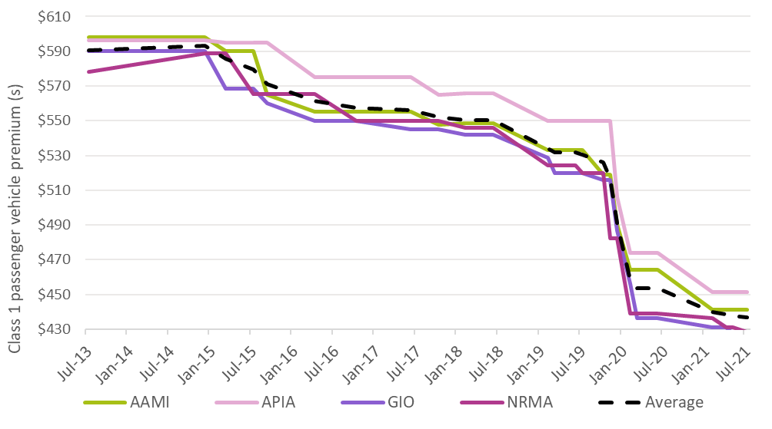

Maintaining claims statistics for the MAI Scheme
Due to the increased data collection and reporting requirements for the MAI Scheme compared to the previous CTP Scheme, a new ICT system was implemented that incorporates both the MAI Scheme and the previous CTP Scheme data on a shared platform to provide enhanced and systematic data capture and reporting capabilities. The ICT system (known as the MAI Register) assists the Commission in monitoring compliance as well as analysing how the new scheme is performing against its objectives. It also assists the Scheme’s actuary in its functions.
The data are collected from licensed insurers and the ACT Nominal Defendant at regular intervals. The MAI Commission also has an arrangement with the ACT Civil and Administrative Tribunal Registry staff to provide information to the Commission on external reviews of insurers’ reviewable decisions and applications for the payment of death benefits.

MAI Scheme monitoring and insurer compliance
To monitor the operation of the MAI Scheme, the MAI Commission held regular meetings with MAI insurers and the ACT Nominal Defendant. The MAI Commission also met with the Insurance Council of Australia in November 2020. These meetings focused on:
- Operational aspects of the MAI Scheme including any significant matters arising from applications under the Scheme.
- Insurer compliance and updates on any remediation activities.
Emerging issues, including operational impacts on insurers’ MAI Scheme business due to COVID-19.
Further feedback on the operation of the Scheme was also gathered through periodic discussions with the authorised providers for the DBIS and independent medical examinations, and from direct community enquiries regarding the Scheme through the Commission’s website link at www.act.gov.au/maic, telephone calls and correspondence.
In addition, procedures for complaints management and a compliance monitoring framework were further developed. A number of complaints have now been dealt with through the complaints management framework, with findings and subsequent remedial action conveyed to various parties as required. The varied nature and type of complaints received has assisted in assessing the effectiveness of different aspects of the MAI Scheme arrangements and refining the complaints framework.
As part of the compliance framework, the Commission has continued to review data in the MAI Register for quality and consistency with the MAI Act, regulations and guidelines. Data from the register is also used to identify trends and potential risks in each insurer’s systems and processes for administering the Scheme. A self-assessment tool was made available to insurers in June 2021, with the first questionnaire focusing on the initial handling of defined benefit applications to the Scheme. In addition, qualitative compliance activities were undertaken by the MAI Commission, including a review of template letters and scripts prepared by insurers for new applicants to the Scheme. Given the Scheme is still in its early phase of operations, the MAI Commission, in the first instance, is engaging and educating insurers on any questions or issues that arise.

Autonomous vehicles
The National Transport Commission is leading a number of workstreams in relation to the legislative, regulatory and policy environment in which autonomous vehicles (AVs) can be safely deployed in Australia. One of these streams includes the potential for using existing motor accident injury insurance (MAII) schemes to cover injuries from motor accidents involving AVs.
Infrastructure and Transport Ministers recommended that all MAII schemes review their statutory rights of recovery mechanisms. In this context, Heads of Motor Accident Injury Schemes (HMAIS) commissioned a review of MAII schemes to analyse options for a statutory rights of recovery mechanism. The mechanism would ensure people who are injured or die as a result of an AV accident would receive appropriate treatment, care, and compensation from at fault parties, such as car manufacturers.
Keeping in mind the need for the recovery mechanism to allow schemes to efficiently claim from at-fault parties as well as minimise litigation costs, a number of options have been recommended. Additional consultation with manufacturers and other parties is required to progress the most suitable approach.
To be effectively implemented, the final agreed regulatory approach and the associated next steps will require collaboration across MAII scheme regulators, HMAIS and the Commonwealth Government, including the National Transport Commission.
Once the supportive national market regulatory requirements are put in place, the timing of changes to MAII schemes, including implementing a preferred recovery mechanism, will largely depend on the penetration of AVs into the market and risk profile data.

Road safety initiatives
Campaigns to deter speeding, drink-driving and failure to wear a seatbelt
The MAI Commission provided funding of $100,000 in 2019-20 to develop and deliver road safety education material in 2020-21 to deter speeding, failure to wear a seatbelt and drink driving.
The MAI Commission provided additional funding of $80,000 in 2020-21 (with some of the delivery occurring in 2021-22) for these three campaigns as they are key factors in ACT drivers being injured, sometimes fatally. These road safety factors also align with the core guiding principles of Vision Zero and the Safe Systems approach in the ACT’s Road Safety Strategy 2020-2025.
The speeding campaign ($20,000) commenced in March 2021; followed by the seatbelt campaign ($30,000) which commenced in May 2021; and the drink driving campaign ($30,000) which commenced at the end of June 2021. Each campaign was delivered for a two-month period. The funding allowed for greater reach across the selected placement options and increased the placement by including catch up TV.
More detail on the campaigns conducted are as follows:
- The speeding campaign highlighted the dangers of travelling at even a little over the speed limit. Low level speeding contributes to a significant percentage of road casualties and fatalities. Even speeding at five kilometres an hour above the speed limit increases both the likelihood of a crash occurring, and the severity of driver and pedestrian injuries in a crash. During 2015-2018, speed was identified as a contributing factor in 21 per cent of all fatal accidents in the ACT.
- The seatbelt campaign was aimed at all ACT drivers and passengers to reinforce the message that not wearing a seatbelt, including not wearing it properly, significantly increases the chances of serious injury or death if involved in a collision. In the ACT over 2015-2018, 17.5 per cent of people who died as a result of a motor vehicle accident were not wearing a seatbelt.
- The drink driving campaign highlighted the potential dangers of drinking and driving. Even small quantities of alcohol can make it hard to concentrate on driving, slow down reaction times, reduce a driver’s ability to perform simple tasks and increase risk-taking behaviour; affect driving vision and increase the chances of the driver falling asleep at the wheel. This is underscored by the high proportion of motorists injured in motor accidents in the ACT with some blood alcohol reading.
Further, from 2015-2018, 17.5 per cent of all deaths as a result of motor vehicle accidents in the ACT involved drivers and motorcycle riders with a blood alcohol concentration above the legal limit; however, national data suggests that alcohol is a contributing factor in up to 30 per cent of fatal accidents, with 1 in 4 drivers or riders who died exceeding the legal limit. Evidence shows that casualty crash risk doubles when driving with an alcohol level just exceeding 0.05, and the risk of fatal crashes increases even more sharply.
Driver distraction campaign
In 2020-21 the MAI Commission also contributed $120,000 towards a community education campaign (to be delivered in 2021-22) to support the introduction of mobile device detection cameras. The cameras will be introduced in the Territory by early 2022 as part of the ACT’s existing Road Safety Camera Program. The cameras aim to improve road safety by reducing driver distraction and changing community behaviour.
These road safety factors align with the core guiding principles of Vision Zero and the Safe Systems approach outlined in the ACT’s Road Safety Strategy 2020-2025 and the Government’s commitment to addressing driver distraction outlined in the ACT Road Safety Action Plan 2020-2023.
The MAI Commission supported community education campaign is also designed to increase driver awareness and educate the community of the dangers of using a mobile device while driving, the penalties that apply for illegal mobile device use while driving and the use of the cameras in the Territory. The campaign commenced on 25 June 2021 and will run for three months targeting social media, newspapers, television, website, road infrastructure, bus backs and radio.

Insurer Market Share
Market share indicates the proportion of the market held by each insurer and provides an indication of how the ACT community is responding to a competitive market. Figure 2 shows the average market share over each of the financial years from 2013-14 when competition began, through to the end of 2020-21. Market share is based on premiums collected by insurers. Between 2013 and 2020, premiums reflected the CTP Scheme design (common law, no caps on compensation). Premiums since 2020 reflect the MAI Scheme, a hybrid defined benefits common law scheme.
Over 2020-21, NRMA and the Suncorp Group held 53.5 per cent and 46.5 per cent of the market respectively. Suncorp’s share increased in 2020-21 compared to 2019-20 as GIO introduced a competitive passenger vehicle premium in March 2020 (the premium was reduced by $19.80 from February 2020 and was $3.00 lower than NRMA) and remained lower than NRMA in the subsequent partial premium filings.
Relative to the 2019-20 market share:
- NRMA’s market share reduced to 53.5 per cent over 2020-21 (a reduction of 12.2 percentage points (pp) compared to 65.7 per cent over 2019-20).
- GIO’s market share increased to 40.7 per cent over 2020-21 (an increase of 13.5 pp compared to 27.2 per cent over 2019-20).
AAMI and APIA continue to hold relatively small market shares at 5.4 per cent and 0.4 per cent over 2020-21 respectively.
Figure 2: Movement in insurers’ average market share since the introduction of competition
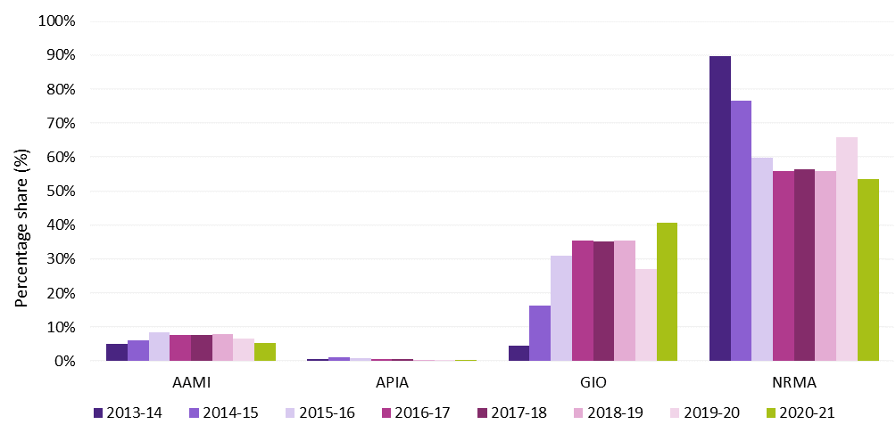

Premiums and scheme affordability
One of the objectives of the MAI Act is to keep the costs of insurance at an affordable level. The premiums charged by insurers reflect the benefit structure underlying the ACT’s insurance scheme. The MAI Scheme design provides fairer, faster and more comprehensive support for Canberrans if they are injured in a motor accident, regardless of whether they were at-fault in an accident or not. Everyone who is injured in a motor vehicle accident is entitled to receive treatment, care, and lost income benefits, for up to five years. People who are more seriously injured and were not at-fault in the accident are able to make a claim for further compensation through common law. Insurers reduced their premiums as a result of the scheme design compared to premiums under the previous CTP Scheme.
As shown in Figure 3, affordability, measured as premiums as a proportion of ACT average weekly earnings (AWE) improved between 2019-20 and 2020-21, with the effect of lower premiums following the commencement of the MAI Scheme on 1 February 2020. Average premiums have fallen as a proportion of AWE by 12.4 percentage points over the period 2013-14 to 2020-21. Affordability has improved despite low wage growth.
Figure 3: Average premiums for private passenger vehicles and as a proportion of ACT average weekly earnings
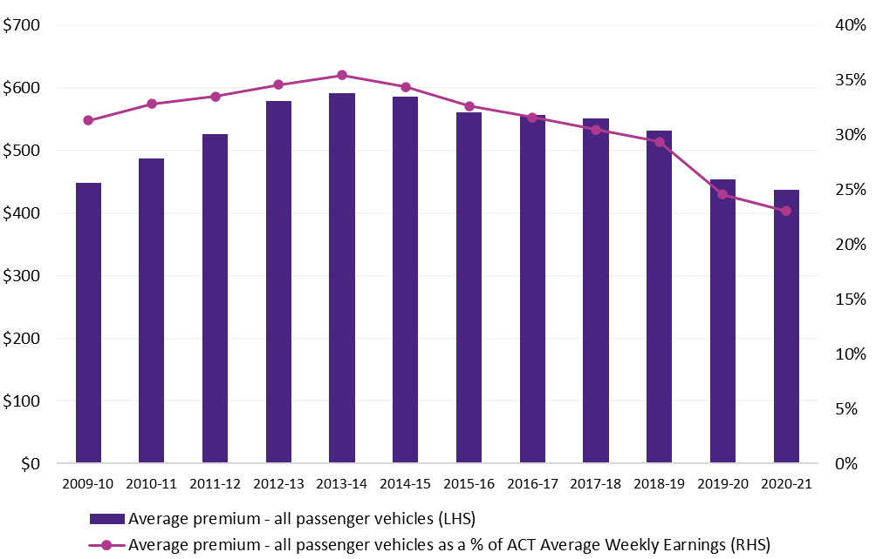
Note: The average CTP / MAI premium is for a class 1 passenger vehicle based on a 12-month policy.

MAI Scheme Statistics
The MAI Commission is publishing scheme statistics quarterly, commencing with the period ending 30 June 2020. The quarterly reports up to and including the 30 June 2021 quarterly report are available at www.treasury.act.gov.au/maic/scheme-knowledge-centre. Below are some of key statistics from the 30 June 2021 report which covers the period 1 February 2020 to 30 June 2021.
- 602 applications were received, 541 of which were complete applications and 61 are in progress. A complete application is where the insurer has all the information it needs to assess liability. Further applications will be received for accidents that occurred prior to 30 June 2021 given the time injured people have to make an application to the Scheme. The number of applications received to date is likely to have been affected by lower traffic volumes following COVID-19 restrictions. It is expected to take some time for application numbers to reach maturity and for the community to fully engage with the new scheme.
- 95.5 per cent of complete applications have been accepted by insurers.
- One of the key advantages of the Scheme is that everyone injured in a motor accident can receive benefits, including those at-fault. To 30 June 2021, the insurers have assessed that 9.6 per cent of applicants were either at fault in the accident or it was a blameless accident, with the fault status of 13 per cent of applications yet to be determined.
- Another benefit of the Scheme is that injured people can receive timely treatment and care and income replacement assistance. During the Scheme’s first 17 months of operation, the Scheme paid out more than $7,063,000, 91.6 per cent related to payments for treatment and care, and income replacement.
- Once an insurer received a complete application, the first treatment and care payment was made on average (median) in 13 days. 58 per cent of first payments were made within two weeks.
Once an insurer received a complete application, the first income replacement payment was made on average (median) in 29 days. 48 per cent of first payments were made within four weeks. Income replacement payments can be made only after liability has been accepted by the insurer.
Figures 4 to 6 below provide profile information about scheme applicants (with a complete application) to 30 June 2021. Applicants aged 30 to 44 made the highest number of applications to the Scheme. Most applicants (61 per cent) were driving a motor vehicle at the time of the accident. Of those applicants who declared their work status, the majority were earning an income prior to their accident.
Figure 4: Age groups of applicants to the Scheme up to 30 June 2021
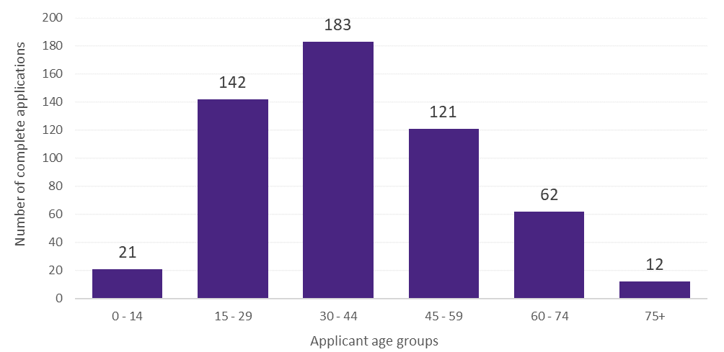
Figure 5: Applicants’ role in the accident, for applications to the Scheme up to 30 June 2021
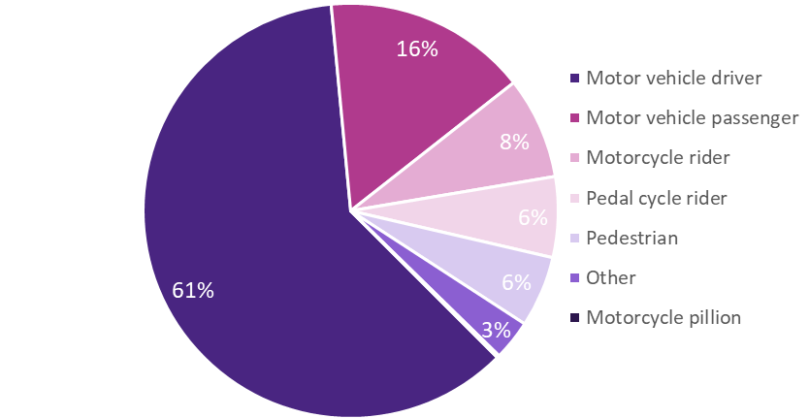
Figure 6: Applicants’ pre-accident work status, for applications to the Scheme up to 30 June 2021
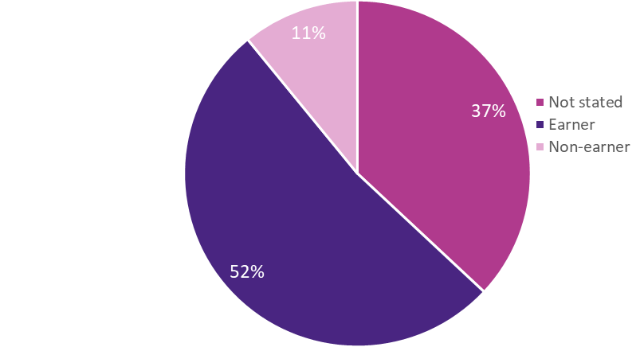

Premium determinations, loadings and levies
Under section 315 of the MAI Act insurers are only permitted to charge a premium approved by the MAI Commission. The MAI Commission will normally receive a premium filing from licensed insurers at least annually. The Commission assesses each premium filing, based on expert independent actuarial advice, and may approve a premium if it is assessed that it will fully fund the insurer’s liabilities and is not considered to be excessive. If a premium filing is not received within a year, the Commission will review and assess the existing premium in accordance with the same criteria.
A premium filing assessment includes consideration of claims frequency, claim size, investment returns, administrative expenses and insurer profit – generally elements that make up the overall cost of service for an insurer participating in the MAI Scheme insurance market.
The role of the Scheme Actuary is to provide expert actuarial advice to the MAI Commission. This role is currently performed under contract by Finity Consulting Pty Limited.

Motorcycle premium support and loading
For motorcyclists, who are expected to have more and higher cost claims under the MAI Scheme, premium affordability has been maintained through a subsidy from other vehicle classes that is reflected in premiums.
The most recent Motorcycle Premium Support and Premium Loading amounts for premiums commencing from 1 February 2021 have been communicated to insurers and published in a notifiable instrument on the ACT Legislation Register.
The premium support is the amount that each motorcycle MAI premium is subsidised, while the premium loading is the amount that is included in premiums for most other vehicle classes to fund the motorcycle subsidies.

Nominal Defendant
The Nominal Defendant is liable for claims against uninsured, unidentified motor vehicles for which an MAI or CTP insurer cannot be identified and vehicles with an unregistered vehicle permit. Under section 16 of the MAI Act the Australian Capital Territory Insurance Authority (ACTIA) is the Nominal Defendant.
The Nominal Defendant is largely funded by a Nominal Defendant Loading that is part of the premiums paid by motorists. The MAI Scheme’s assessed Nominal Defendant Loading is published in a notifiable instrument on the ACT Legislation Register.

Lost investment income loading
The insurer’s lost investment income loading applies to premiums on policies with a duration of less than 12 months (‘Short Term Premiums’). The MAI Scheme’s lost investment income loading is published in a notifiable instrument on the ACT Legislation Register.

Outlook
Priorities for the MAI Commission in 2021-22 include:
- Putting in place the refund of part of the premium for policies that spanned both the previous CTP Scheme and the MAI Scheme for eligible motorists (by way of a discount off their next registration renewal).
- Issuing or amending guidelines, regulations and forms under the MAI Act, as required.
- Promoting and providing information about the MAI Scheme and the DBIS.
- Evaluating the DBIS pilot and undertaking a process to engage a service provider going forward.
- Monitoring the MAI Scheme’s performance and undertaking compliance activities.
- Assessing MAI premium filings and monitoring premium processes.
- Maintaining the MAI Register for the Scheme’s data requirements and reporting on the Scheme’s statistics.
Contributing to targeted road safety initiatives that assist in reducing motor accidents and personal injuries, and mitigating their impact.

Performance analysis explanation of performance indicators
The MAI Commission’s 2020-21 performance indicators were included in its Statement of Intent and reported as part of the Commission’s Statement of Performance. For the 2020-21 financial year, the MAI Commission developed and achieved the following indicators.

a. MAI Premiums are approved in accordance with the MAI Act 2019 (the Act)
The MAI Commissioner was required to approve or reject a premium application under section 319 of the Act. Under section 318, there are two key grounds on which the MAI Commissioner is permitted to reject a premium filing: the premiums applied for by MAI insurers were too low (the fully funded test); or were too high (the excessive premium test). The MAI Commissioner also approved premium partial filings if the change in premiums was within the permitted set bands and above the agreed minimum amount under the streamlining arrangements.
Premium filings, all of which were assessed and approved in the 2020-21 in accordance with the Act, were received from:
- AAMI, APIA, GIO and NRMA de novo filings (received November 2020) and approved in November 2020.
- NRMA partial filing (received January 2021) and approved in January 2021.
- GIO partial filing (received February 2021) and approved in March 2021.
NRMA partial filing (received April 2021) and approved in April 2021.

b. The scheme is fully funded
All premium filings by licensed MAI insurers were reviewed by the Scheme Actuary to ensure they were fully funded. This ensures that the scheme is able to pay out all present and future liabilities. The Scheme Actuary considered that all insurers’ premiums met the fully funded test in the period 1 July 2020 to 30 June 2021.

c. Promote public awareness of the new MAI Scheme.
A flyer on the new scheme was inserted into all registration renewals from mid-December 2019 for renewals effective from 1 February 2020, concluding in September 2020. There will be further promotion of the Scheme by the MAI Commission once the impact of the COVID-19 pandemic has eased.

d. Promote public awareness of the causes of motor accidents through funding measures directed at reducing causes of motor vehicle accidents
The MAI Commission contributed $200,000 in 2020-21 towards road safety strategies associated with campaigns to support and promote the prevention of motor accidents and the safe use of motor vehicles. The aim is to reduce the number and/or severity of injuries arising from motor accidents, consistent with the relevant objective under the MAI Act.
The funding of $200,000 was allocated to the following campaigns:
- Speeding ($20,000); Seatbelts ($30,000); and Drink Driving ($30,000).
$120,000 towards a Community education campaign to support the introduction of mobile device detection cameras and increase driver awareness of the dangers of using a mobile device while driving.

e. Queries handling within ten working days of receipt of the query.
All queries received by the MAI Commission were responded to within ten working days of receipt.

f. Complaints handling within 25 working days of receipt of the complaint.
The MAI Commission received 4 complaints during 2020-21. Due to the complexity of the complaints, the need to review detailed documentation and undertake significant liaison between each complainant and the relevant insurer, none of the complaints were handled within 25 working days of receipt.

Risk Management
The MAI Commission has a risk management plan. The MAI Commission has overall responsibility for risk management, and for ensuring compliance with the risk management plan.
The risk management plan identifies the key risk areas as operational, financial, legal and reputational risk. The risk management plan has identified the following potential risks:
- The Commission not meeting stakeholder expectations.
- Insufficient staff and/or resources available to achieve outcomes.
- Failure to meet legislative requirements.
Failure of the ICT System for the MAI Scheme.
These risks are mitigated through the use of appropriate governance structures, application of risk-based management strategies and financial reporting processes.
Further information
Nicola Clark Acting Executive Branch Manager, Insurance, Economic and Financial Group
02 6207 1189 Nicola.Clark@act.gov.au

Office of the Nominal Defendant of the ACT

Transmittal certificate
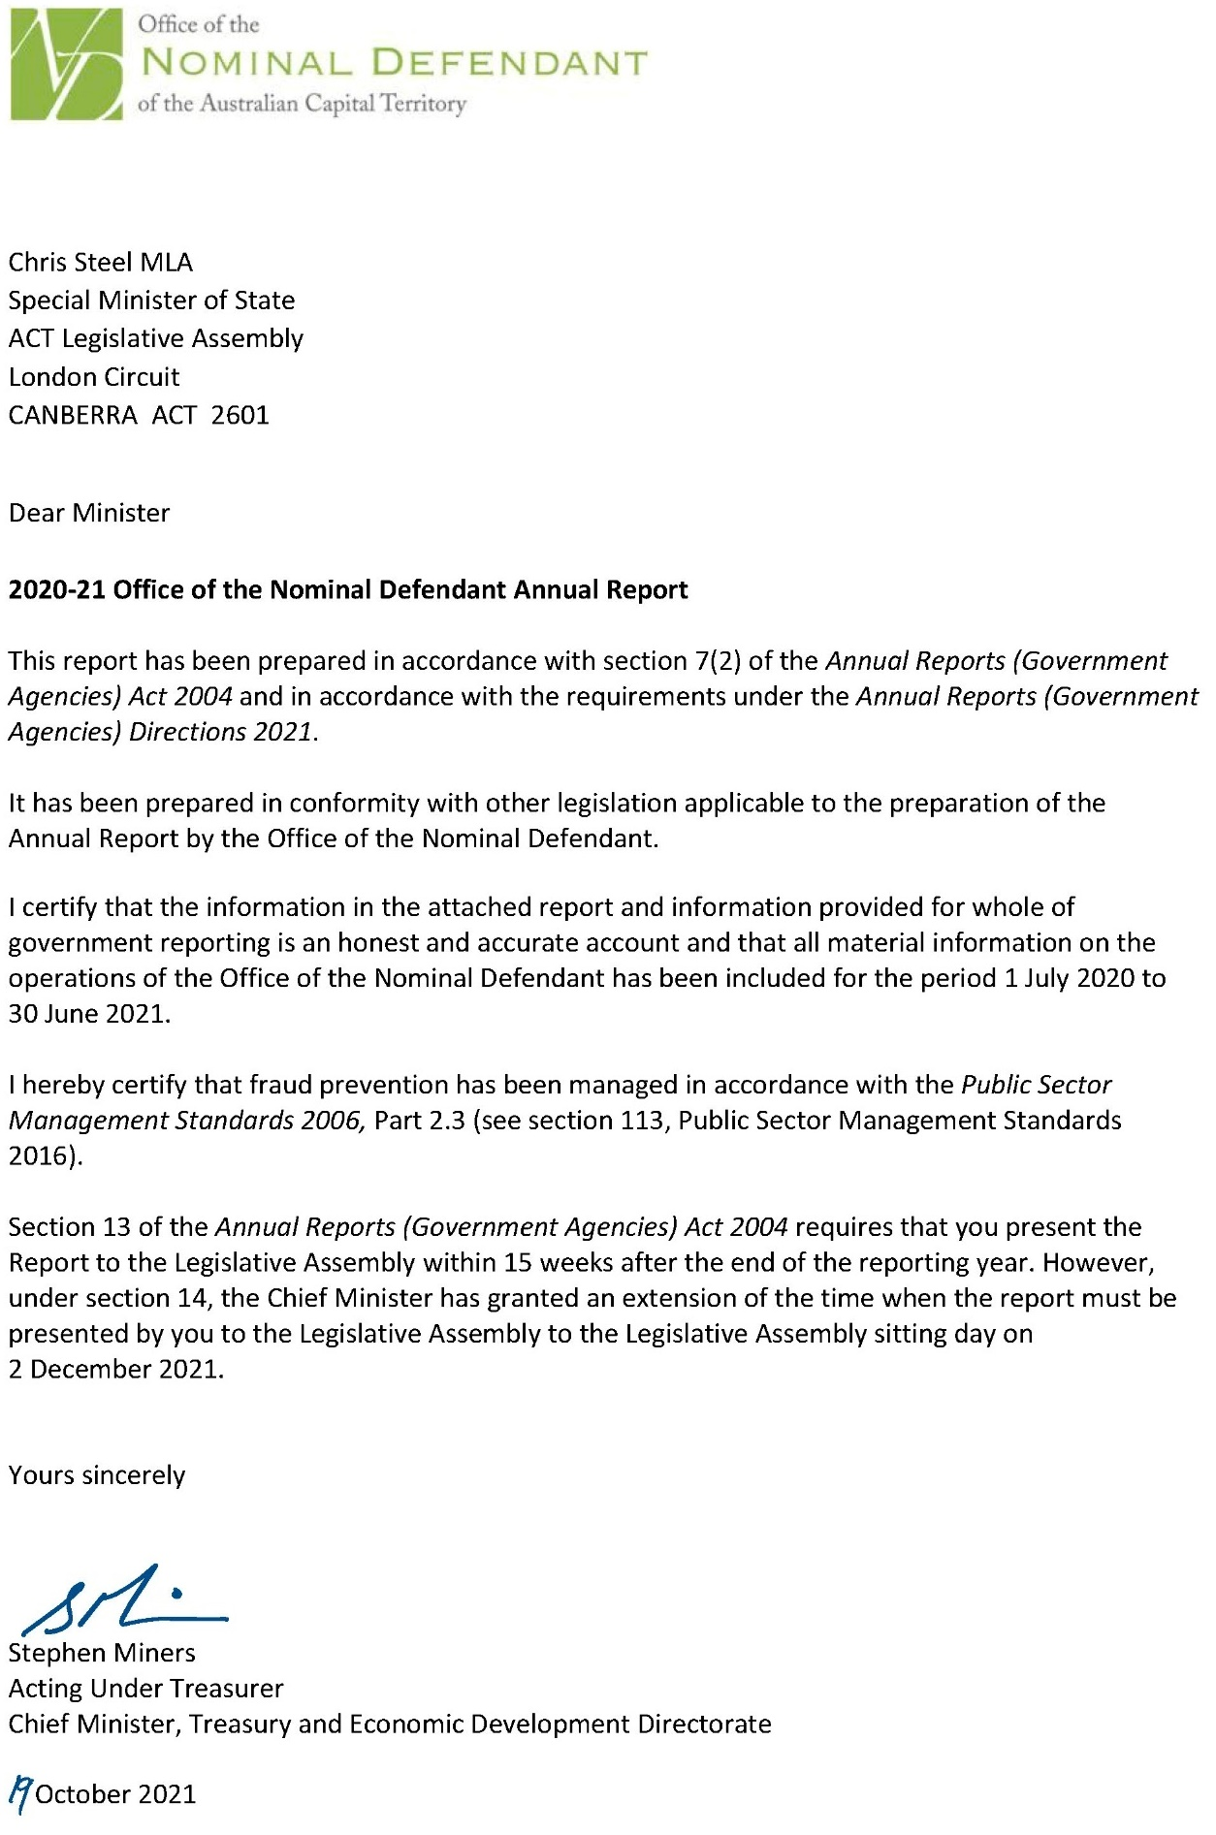

Compliance statement
The 2020-21 Office of the Nominal Defendant of the ACT Annual Report must comply with the Annual Reports (Government Agencies) Directions 2021 (the Directions) made under section 8 of the Annual Reports (Government Agencies) Act 2004. The Directions are found at the ACT Legislation Register.
The compliance statement indicates the subsections, under Parts 1 to 5 of the Directions, that are applicable to the Office of the Nominal Defendant of the ACT and the location of information that satisfies these requirements.

Part 1 Directions overview
The requirements under Part 1 of the Directions relate to the purpose, timing and distribution, and records keeping of annual reports. The 2020-21 Office of the Nominal Defendant of the ACT Annual Report complies with all subsections of Part 1 under the Directions.
To meet Section 15 Feedback, Part 1 of the Directions, contact details for the Office of the Nominal Defendant of the ACT are provided within the 2020-21 Office of the Nominal Defendant of the ACT Annual Report to provide readers with the opportunity to provide feedback.

Part 2 Reporting entity annual report requirements
The requirements within Part 2 of the Directions are mandatory for all reporting entities and the 2020-21 Office of the Nominal Defendant of the ACT Annual Report complies with all subsections. The information that satisfies the requirements of Part 2 is found in the 2020-21 Office of the Nominal Defendant of the ACT Annual Report as follows:
- A. Transmittal Certificate, see the previous page.
- B. Organisational Overview and Performance Analysis, see the Organisational Overview and Performance section. The following subsections, contained within the 2020-21 ACT Insurance Authority Annual Report, apply to the Office of the Nominal Defendant of the ACT:
- Risk Management
- Internal Audit
- Fraud Prevention
- Community Engagement and Support
- Aboriginal and Torres Strait Islander Reporting
- Work Health and Safety
- Human Resource Management
- Ecologically Sustainable Development
- C. Financial Management Reporting, see the Financial Management Reporting section. For the remaining subsections see Volume 2.2 of the 2020-21 CMTEDD Annual Report.

Part 3 Reporting by exception
The Office of the Nominal Defendant of the ACT has no information to report by exception under Part 3 of the Directions for the 2020-21 reporting year.

Part 4 Directorate and public sector body specific annual report requirements
Part 4 of the 2020 Directions is not applicable to the Office of the Nominal Defendant of the ACT.

Part 5 Whole of government annual reporting
All subsections of Part 5 of the Directions apply to the Office of the Nominal Defendant of the ACT. Consistent with the Directions, the information satisfying these requirements is reported in one place for all reporting entities as follows:
- Bushfire Risk Management, see the annual report of the Justice and Community Safety Directorate.
- Human Rights, see the annual report of the Justice and Community Safety Directorate.
- Legal Services Directions, see the annual report of the Justice and Community Safety Directorate.
- Public Sector Standards and Workforce Profile, see the annual State of the Service Report.
Territory Records, see the CMTEDD Annual Report.
ACT Public Service directorate annual reports are found at the following web address: https://www.cmtedd.act.gov.au/open_government/report/annual_reports

Organisational overview and performance

Organisational overview
The ACT Insurance Authority is the Nominal Defendant of the ACT as defined under section 16 of the Motor Accident Injuries Act 2019 (the Act). Under section 330(1) of the Act the MAI Commission (the Commission) established the Nominal Defendant Fund (the Fund).
The purpose of the Fund is to:
- Provide a safety net mechanism to pay defined benefits and motor accident injury claims made by injured parties where:
- the vehicle involved does not have a motor accident insurance policy; or
the injured person is unable to identify the driver and/or vehicle.
- Ensure that persons, who are injured in the circumstances listed above, receive the same entitlements as an injured person would receive where the vehicle did have motor accident insurance;
- Collect recoveries from uninsured drivers at fault to the sum paid out by the Fund; and
Receipt levies collected from licensed insurers in the Territory as well as the Australian and ACT Governments.
Funds required to satisfy the cost of claims and other relevant expenses for the Fund are not guaranteed by the ACT Government; however, Part 6.9 of the Act requires the Commission to collect amounts from licensed insurers and recognised self-insurers to meet the cost of nominal defendant claims.

Functions
The Fund exists to enable anyone who is injured in a motor vehicle accident and where there is no motor accident insurance to be compensated. The Fund meets the costs for individuals for treatment, care and lost income benefits for up to five years. Where possible, the Fund also recovers costs of claims from the at-fault driver of an unregistered vehicle.
The Fund’s administrative operations are subject to the same governance controls in relation to risk management, fraud prevention and records management as the ACT Insurance Authority. The reporting on these operations is included in the relevant sections of the 2020-21 ACT Insurance Authority Annual Report.
The ACT Insurance Authority also oversights workplace health and safety and associated risk management, accommodation, facilities management and workplace environmental management for the Fund. Reporting on these issues is contained in the 2020-21 ACT Insurance Authority Annual Report.

Internal accountability
As a small reporting entity, the Fund does not have any complex internal accountability structures and processes. As stated above, all administration operations and governance controls of the Fund are overseen by the ACT Insurance Authority.

Performance analysis

Revenue
Total income recognised by the Fund during the year was $6.611 million.
The Commission imposes a levy on licensed insurers and recognised self-insurers to meet the cost of nominal defendant claims in accordance with the Act.
The funds required to meet the cost of nominal defendant claims are apportioned among the insurers having regard to the amount of motor accident premium income they receive. Funds are transferred from the Commission to the Fund on a quarterly basis.
In addition, revenue is received by the Fund from the following sources:
- any penalties or penalty interest imposed under the Act;
- amounts recovered by the Fund;
- unregistered vehicle permits (UVPs) liability contributions;
- unregistered vehicle fines liability contributions; and
interest accruing from the investments.
The following table details funds received as other revenue during the period.
Table 1: Other revenue
Source | Amount ($m)
Unregistered vehicle permits | $0.404
Unregistered vehicle fines | $0.385
Insured recoveries | $0.085
Uninsured owners and drivers | $0.090
Total | $0.964
There are currently 74 ‘recovery only’ claim files open. These files are claims that have either settled or been finalised and the Fund is pursuing recovery from unregistered vehicle owners and/or the drivers of unregistered vehicles responsible for the accident.

Where the Fund has made payments on a claim involving an uninsured motor vehicle, attempts are made to recover the cost of those payments from the owner or driver concerned.
Recovery prospects are poor in the majority of matters as it is often difficult to identify or locate the driver/owner and, when located, generally they do not have the capacity to repay any/all of the costs incurred.
The Office of the Nominal Defendant of the ACT financial statements are reported in Volume 2.2 of the 2020-21 CMTEDD Annual Report.

Claims
During the reporting period the Fund received 53 applications for defined benefits under the MAI Scheme and 5 claims under the previous Compulsory Third-Party scheme. Nineteen of the applications for defined benefits are being managed by the Nominal Defendant on behalf of interstate insurers. There are 213 open claims remaining as at 30 June 2021 with a combined total provision for outstanding claims of $30.1 million.
Table 2: Claim types
 | Number | Percentage %
Unregistered and/or uninsured vehicles | 101 | 47
Unidentified vehicles | 75 | 35
Vehicles with unregistered vehicle permits | 12 | 6
Referred to insurer | 6 | 3
Interstate insured vehicles | 19 | 9
Total | 213
An estimate of the provision for claims payable is completed annually by an independent actuary. The Fund engages KPMG Actuarial Pty Limited to provide a full assessment of the provision for claims payable at 30 June 2021. The movement in the provision for claims payable can either reduce claims expense in the case of a reduction in liability or increase claims expense in the case of an increase in liability.

Claims frequency and vehicle registrations
As at 30 June 2021, the Australian Capital Territory has 312,701 registered vehicles.
For the most recent financial year ending 30 June 2021, the ultimate claim frequency is estimated at approximately 0.15 claims per 1,000 vehicles registered.

A comparison between the number of vehicles registered and the number of ultimate claims estimated to be made to the Fund for each accident year is shown in the following chart:
Figure 1: Claim frequency and vehicle registrations
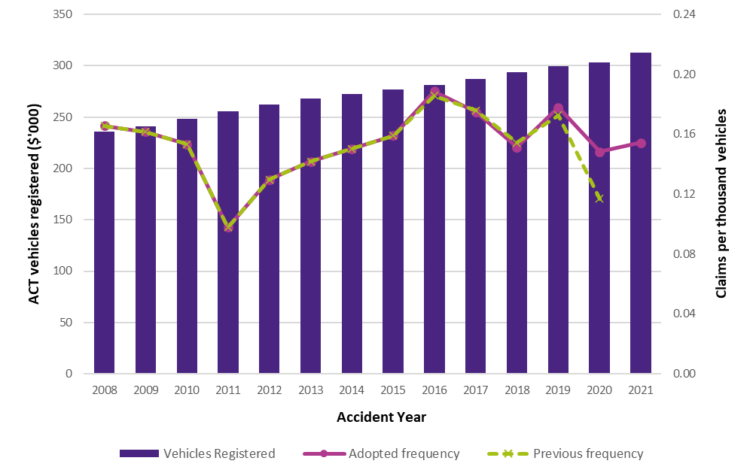
Notes:
- Source: Nominal Defendant Liability Valuation Report as at 30 June 2021 produced by KPMG Actuarial Pty Limited.
- The vehicle registrations for 2021 are sourced from Road User Services ACT, and other years from previous actuarial reports.
- Claim frequency refers to number of road incidents giving rise to a claim, whether one or more claimants. The measure is expressed per thousand vehicles registered.

Average claims size and cost per policy
A comparison between the estimated ultimate average size of a claim and the estimated ultimate cost of a motor accident policy is shown in the following chart for each accident year. For the most recent financial year ending 30 June 2021, the ultimate average claim size is estimated to be $0.175 million while the ultimate average motor accident claim per policy cost is estimated to be $26.97.
Figure 2: Average claim size and cost per policy by accident year (inflated and undiscounted)
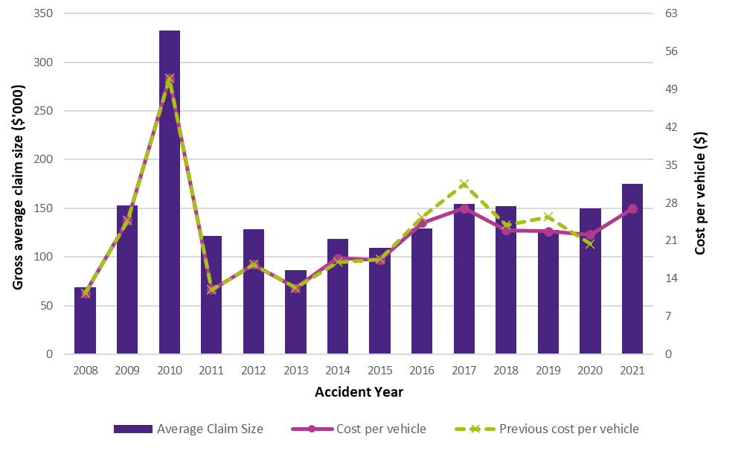
Notes:
- Source: Nominal Defendant Liability Valuation Report as at 30 June 2021 produced by KPMG Actuarial Pty Limited.
- Average claim size and Cost Per Policy (CPP) are in expected payment date values, but without allowance for time value of money (i.e. present value discounting) and are gross of all recoveries.
- The historical data component is sourced from previous actuarial reports

Other expenses
The total expenses paid by the Fund during the year was $5.291 million, which includes claims expense of $4.615 million.

Balance sheet
The Fund had total assets of $36.660 million and liabilities of $30.422 million. As at 30 June 2021 the total equity of the Fund was $6.238 million.

Scrutiny
There were no inquiries or reviews from the ACT Audit Office, the ACT Ombudsman, or any Legislative Assembly Committees in 2020-21. The only scrutiny from the Audit Office during the reporting year was for the audit of the 2019-20 Financial Statements.

Freedom of information
The Freedom of Information Act 2016 (FOI Act) gives individuals the legal right to:
- Access government information unless access to the information would, on balance, be contrary to the public interest;
- Ask for personal information to be changed if it is incomplete, out-of-date, incorrect or misleading; and
Appeal a decision about access to a document, or a decision in relation to a request to amend or annotate a personal record.
In accordance with Section 96 of the FOI Act the Fund is required to report on the operation of the FOI Act in relation to the Fund for the reporting year.
The Fund did not receive any requests for access to any information under the FOI Act during 2020-21.
Further information relating to FOI including how to make an FOI application, what details you need to make an application and contact details for the CMTEDD Information Officer can be found on CMTEDD’s website https://www.cmtedd.act.gov.au/functions/foi. There are also details of requests received by the directorate listed on the Freedom of Information Disclosure Log for CMTEDD.

Financial management reporting

Government contracting
The Fund engages consultants to perform specialised actuarial and legal services.
The procurement selection and management processes for all contractors including consultants complied with the Government Procurement Act 2001 and the Government Procurement Regulation 2007.
Procurement processes above $25,000 are reviewed by Procurement ACT, and, if necessary, by the Government Procurement Board consistent with the provisions of the Government Procurement Regulation 2007. The Fund ensures all contractors comply with their employee and industrial relations obligations.
The Fund did not execute any new procurement activities during the reporting period; however it initiated a process through ACT Government Solicitor to enable it to access the Territory Legal Services Panel.
Further information
Penny Shields General Manager, ACT Insurance Authority
(02) 6207 0268 ACTIAInsuranceAndRiskManagement@act.gov.au
https://apps.treasury.act.gov.au/insurance-and-risk-management/contacts

Public Sector Workers Compensation Fund

Transmittal certificate
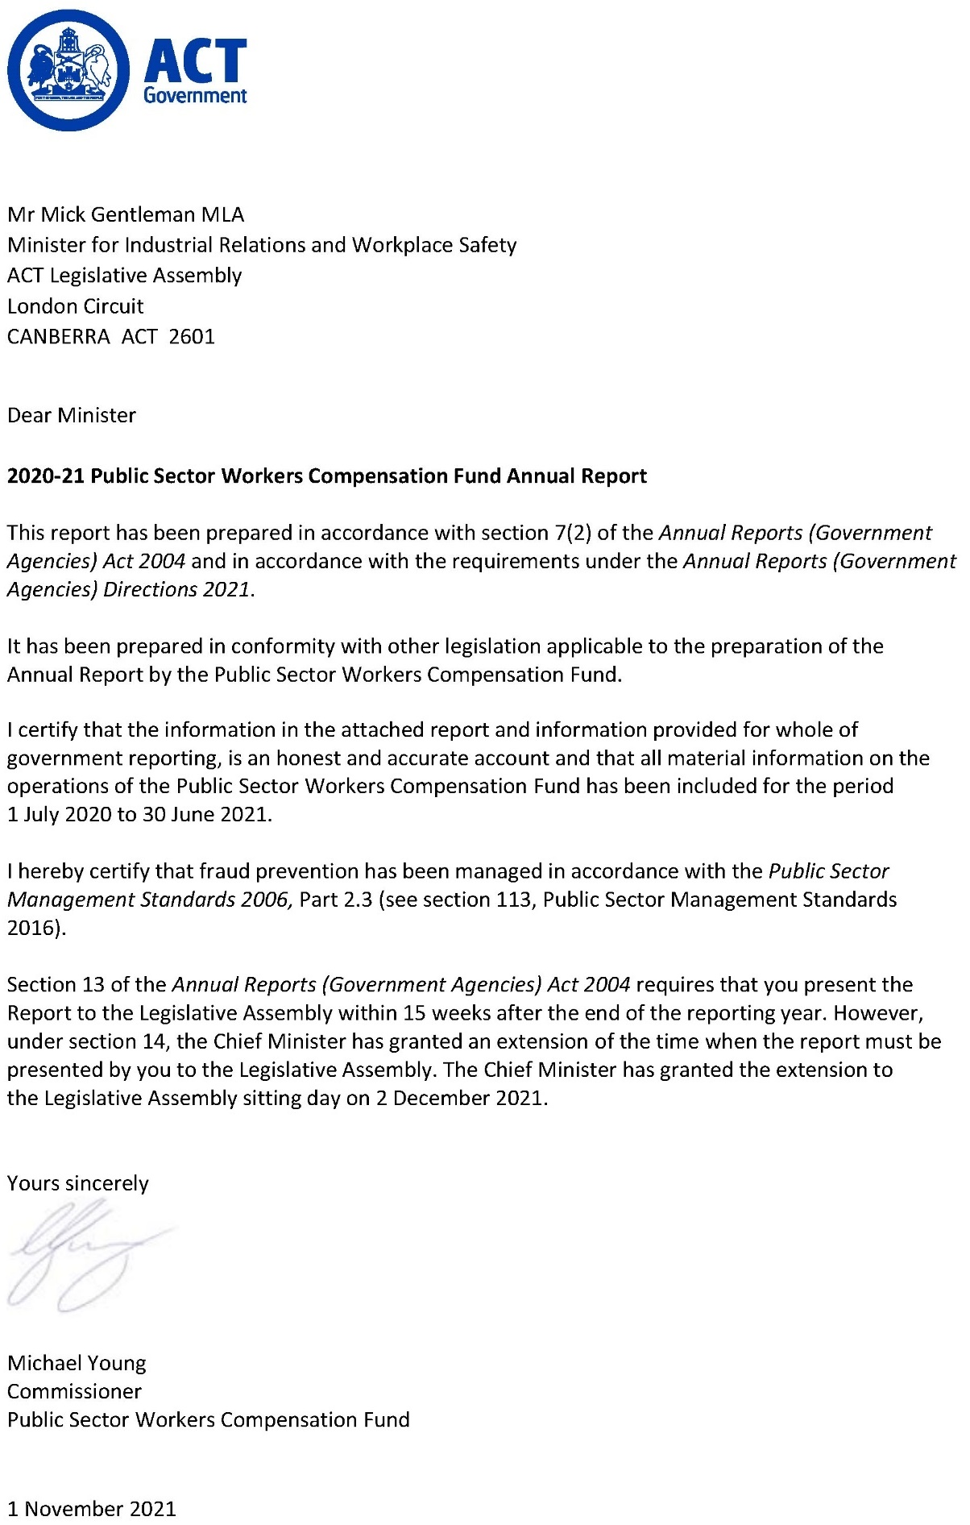

Compliance statement
The 2020-21 Public Sector Workers Compensation Fund (PSWC Fund) Annual Report must comply with the Annual Reports (Government Agencies) Directions 2021 (the Directions) made under section 8 of the Annual Reports (Government Agencies) Act 2004. The Directions are found at the ACT Legislation Register.
The compliance statement indicates the subsections, under Parts 1 to 5 of the Directions, that are applicable to the PSWC Fund and the location of information that satisfies these requirements.

Part 1 Directions overview
The requirements under Part 1 of the Directions relate to the purpose, timing and distribution, and records keeping of annual reports. The 2020-21 PSWC Fund Annual Report complies with all subsections of Part 1 under the Directions.
To meet Section 15 Feedback, Part 1 of the Directions, contact details for the PSWC Fund are provided within the 2020-21 PSWC Fund Annual Report to provide readers with the opportunity to provide feedback.

Part 2 Reporting entity annual report requirements
The requirements within Part 2 of the Directions are mandatory for all reporting entities and the PSWC Fund Annual Report complies with all subsections. The information that satisfies the requirements of Part 2 is found in the PSWC Fund Annual Report as follows:
- A. Transmittal Certificate, see the previous page.
- B. Organisational Overview and Performance Analysis, see the Organisational Overview and Performance section on the next page.
C. Financial Management Reporting: Government Contracting, see the Financial Management Reporting section. The remaining subsections are reported in Volume 2 of the CMTEDD Annual Report.

Part 3 Reporting by exception
The PSWC Fund has no information to report by exception under Part 3 of the Directions for the 2020-21 reporting year.

Part 4 Directorate and public sector body specific annual report requirements
Part 4 of the Directions is not applicable to the PSWC Fund.

Part 5 Whole of government annual reporting
All subsections of Part 5 of the Directions apply to the PSWC Fund. Consistent with the Directions, the information satisfying these requirements is reported in one place for all reporting entities as follows:
- Bushfire Risk Management, see the annual report of the Justice and Community Safety Directorate.
- Human Rights, see the annual report of the Justice and Community Safety Directorate.
- Legal Services Directions, see the annual report of the Justice and Community Safety Directorate.
- Public Sector Standards and Workforce Profile, see the annual State of the Service Report.
Territory Records, see the CMTEDD Annual Report.
ACT Public Service directorate annual reports are found at the following web address: http://www.cmd.act.gov.au/open_government/report/annual_reports

Organisational overview and performance

Organisational overview
The Public Sector Workers Compensation Fund (PSWC Fund) is established under the Public Sector Workers Compensation Fund Act 2018 (the PSWCF Act) and commenced operations on 1 March 2019.
The PSWCF Act provides a financial and prudential governance framework to support the Territory’s workers’ compensation self-insurance arrangements under the Safety, Rehabilitation and Compensation Act 1988 (SRC Act).
The PSWCF Act is administered by the Chief Minister, Treasury and Economic Development Directorate (CMTEDD). The functions of the PSWC Fund are supported by the Workplace Safety and Industrial Relations Group, CMTEDD.

Functions
The PSWC Fund was designed to ensure the effective management of the Territory’s workers’ compensation assets and features governance and management arrangements in relation to those assets. The PSWC Fund is an integral part of the Territory’s compliance with its self-insurance licence.
The PSWC Fund is administered by the Public Sector Workers Compensation Commissioner (PSWC Commissioner) who is responsible for:
- Managing the PSWC Fund.
- Advising the Minister about the administration, efficiency and effectiveness of the PSWC Fund.
- In relation to a licence granted to the Territory under section 103 of the SRC Act:
- Managing the Territory’s liability under the SRC Act; and
Managing claims under the SRC Act.
The PSWC Fund is funded by the Territory from premium amounts apportioned by the PSWC Commissioner amongst Territory directorates and agencies. Funds are invested, with earnings retained in the PSWC Fund, to help meet workers’ compensation costs.

Internal accountability
On 14 February 2019 Michael Young, Executive Group Manager, Workplace Safety and Industrial Relations, was appointed to the role of the PSWC Commissioner, with effect on commencement of the PSWC Fund.
Section 24 of the PSWCF Act establishes a PSWC Advisory Committee with the following functions:
- To keep informed of the operations of the PSWC Fund to provide advice to the Minister in relation to the fund.
To assist in meeting the Territory’s liabilities under the SRC Act by providing advice about claims management in relation to injured employees of the Territory.
Section 26 of the PSWCF Act stipulates the advisory committee consists of:
- The PSWC Commissioner.
- Three members appointed by the Minister to represent the interests of workers.
Two members appointed by the Minister to represent the interests of public sector bodies and territory instrumentalities.
The Chair of the advisory committee as at 30 June 2021 was Mr Michael Young, PSWC Commissioner. The PSWC Fund Advisory Committee met four times during 2020–21. Membership of the PSWC Fund Advisory Committee during the year and the number of meetings each member attended is included in the table below.
Table 1: Membership and attendance of the PSWC Fund Advisory Committee 2020-21
Name | Role | Meetings attended
Michael Young, PSWC Commissioner | Chair | 4
Penny Shields | Member | 3
Susie Walford | Member | 3
Patrick Judge | Member | 3
Melissa Payne | Member | 4
Matthew Harrison | Member | 4
Notes:
- Penny Shields, Susie Walford, and Patrick Judge were each unable to attend a meeting of the committee during the reporting period.
- All meetings of the committee occurred in accordance with s27 of the Public Sector Workers Compensation Fund Act 2018 and the committee’s terms of reference.

Performance analysis
The PSWC Fund’s 2020-21 performance indicators are included in the Budget Portfolio Statements for the PSWC Fund and are reported on as part of the PSWC Fund’s Statement of Performance.

Explanation of performance indicators

a. Reduce the ACT public sector incidence of serious workplace injury
This accountability indicator is sensitive to public sector injury prevention activities and aligns with targets from the Safe Work Australia Australian WHS Strategy 2012-22. A serious claim is an accepted workers’ compensation claim that results in the injured person being unable to perform their usual role for one or more weeks. This accountability indicator measures the number of ACT public sector workers’ compensation serious claims, per 1,000 employees.
Improved performance in relation to serious workplace injuries is indicative of improvements in injury prevention and management, for example from programs such as early intervention physiotherapy and safety auditing.

b. Achieve a conformance rating of 85 per cent or higher in the annual audit of the ACT workers’ compensation self-insurance rehabilitation management system
It is a requirement of the SRC Act that the Territory maintains a rehabilitation management system that complies with Australian Government guidelines and that conformance is audited annually. The 2020-21 audit was conducted by Comcare in January 2021.

c. Maintain a PSWC fund asset to liability ratio greater than or equal to 100 per cent
This accountability indicator aligns with the PSWC Fund requirements under the Public Sector Workers Compensation Fund (Investment and Funding Ratio) Management Guidelines 2019 (No 1).
An asset to liability ratio of 100 per cent or more indicates that the fund contains sufficient assets to meet the expected lifetime cost of public sector workers’ compensation claims.

d. Achieve a conformance rating of 85 per cent or higher in the annual audit of the ACT workers’ compensation self­insurance claims management system
It is a requirement of the SRC Act that the Territory maintains a claim management system that complies with Australian Government guidelines and that conformance is audited annually. The 2020-21 audit was conducted by Comcare in January 2021.

e. Investment earnings rate meets the benchmark rate
This accountability indicator aligns with the PSWC Fund requirements under the Public Sector Workers Compensation Fund (Investment and Funding Ratio) Management Guidelines 2019 (No 2) and associated investment plan for the financial investment of assets of the Public Sector Workers Compensation Fund.

Highlights
The key priorities for the PSWC Fund during the 2020-21 financial year were to:
- Develop and deploy best practice health, wellbeing and return to work strategies, policies and interventions for the ACT public sector.
- Ensure the effective and efficient management of new and existing ACT public sector workers’ compensation claims.
- Progress the finalisation of transitional arrangements with the Australian Government, including the final assessment of transferred claim liabilities and associated asset transfers.
- Ensure injured worker and directorate satisfaction with the services and arrangements under self-insurance.
- Review the processes between Shared Services Payroll and Employers Mutual Limited, the claims manager, to ensure that they support the timely resolution of periods of incapacity due to work related injuries, and that the process is as accessible and streamlined as possible for injured workers.
Conduct ongoing client surveys to ensure injured worker and directorate satisfaction with self-insurance services.

Transition management and activities
On 1 March 2021 the ACT Government reached a milestone of two years since commencing operations as a self-insurer under the SRC Act. The PSWC Fund was elevated to the status of ‘Established Licensee’, by the Safety Rehabilitation and Compensation Commission, having achieved a number of qualifying requirements.
In its second year the PSWC Fund:
- Finalised 819 claims.
- Received 696 new claims.
Made all payments to third parties within ten days, and most within five.

Client feedback has been positive. Indicative extracts include the following:
“I have been very pleased with communication at all times, and clear guidelines.”
“My case worker has kept me informed and updated me with my progress throughout the claim. Her professional status has made me more at ease as it has been a somewhat stressful few weeks with many different people involved but all for good reason. She explained things also I wasn’t sure of.”
Table 2: ACT public sector workers’ compensation claims in 2020-21
 | Number
Total claims opened during the reporting period | 696
Total claims closed during the reporting period | 819
Total reopened claims during the reporting period | 294
Current open claims | 1,372

Outlook
In 2021-22 the PSWC Fund will pursue strategic and operational priorities in undertaking its functions, including to:
- Develop and deploy best practice health, wellbeing and return to work strategies, policies and interventions for the ACT public sector.
- Ensure the effective and efficient management of new and existing Territory workers’ compensation claims.
- Ensure injured worker and directorate satisfaction with the services and arrangements under self-insurance.
- Finalise transitional arrangements with the Australian Government, including the final assessment of transferred claim liability and associated asset transfers.
- Improve the processes between Shared Services Payroll and Employers Mutual Limited, the claims manager, to ensure that they support the timely resolution of periods of incapacity due to work related injuries and that the process is as accessible and streamlined as possible for injured workers.
Review the viability of bringing contracted claim management services in-house.

Scrutiny
Scrutiny of the PSWC Fund’s activities is undertaken by a number of bodies including Committees of the ACT Legislative Assembly, the ACT Auditor-General and the ACT Ombudsman.
The Auditor-General’s Report No. 6 of 2020 – Transfer of workers’ compensation arrangements from Comcare was provided on 30 June 2020. This report made a number of findings and no recommendations.
During the reporting period, the PSWC Fund participated in one Legislative Assembly Standing Committee on Public Accounts inquiry related to its activities.
There were no Ombudsman reports in 2020-21 in relation to the Fund.

Financial management reporting

Government contracting
The Territory, and, pursuant to section 30 of the Public Sector Workers Compensation Fund Act 2018, the PSWC Fund is taken to have engaged for the purposes of that Act a claims manager responsible under section 23 for the following:
- Investigating claims.
- Assessing the Territory’s liability in relation to claims under the SRC Act, including initial liability and ongoing liability.
- Calculating benefits and authorising payments under the SRC Act.
- Paying an amount in relation to a provisional liability medical cost.
- Paying an amount in relation to a workers’ compensation claim.
- Managing claims data.
- Managing disputes in relation to claims made against the Territory under the SRC Act.
Anything else prescribed by regulation under the PSWCF Act.
Employers Mutual Limited (EML) continued to be engaged as the claims manager in the 2020-21 financial year. The value of this contract was reported in the 2018-19 Annual Report for the PSWC Fund.
Further information
Michael Young Public Sector Workers Compensation Commissioner
(02) 6207 0268 Michael.Young@act.gov.au

