GUIDELINES FOR FLYING THE ACT FLAG

BRIEF HISTORY OF THE ACT FLAG
In competitions held in 1988 and 1992 artists, and other interested ACT citizens, provided a large range of designs for consideration as the proposed Australian Capital Territory flag. Although there was no general agreement within the community on a particular design, there were some features in common amongst the entries. These elements were incorporated into four design options presented by Members of the Legislative Assembly to the ACT community for its consideration in February/March 1993.
The ACT Electoral Office reported that the most popular choice among ACT citizens who expressed preferences on any of the four options was a design featuring the Southern Cross and a modified form of the City of Canberra Coat of Arms.
As a result, the Chief Minister, Rosemary Follett MLA, put forward the following motion which was passed by the ACT Legislative Assembly for the Australian Capital Territory on
25 March 1993:
“That this Assembly, noting the outcome of community consultation on a flag for the ACT, adopts the design featuring the Southern Cross and a modified form of the Canberra City Coat of Arms as the official flag for the Australian Capital Territory.”
The ACT flag has been flown outside the Assembly building since that day.
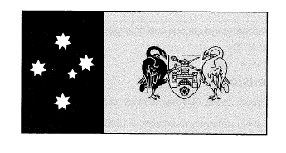

Colours
The colours of the ACT flag are blue, yellow and white. For publishing purposes they are:
Yellow – PANTONE 123 or PMS 116
Blue – PANTONE 293 or PMS 287

Size
The most commonly used flag size is 1830mm x 915mm (6ft x 3ft) (the length is always double the width).

LOCATION OF FLAGPOLES IN THE ACT
There are approximately 120 flagpoles in the ACT which are the responsibility of ACT Property Group. Two flagpoles located at the Member’s entrance to the Legislative Assembly building are the responsibility of the Legislative Assembly Secretariat.
Additionally, there are a number of flagpoles located around the ACT that are the responsibility of the Commonwealth.
There are 16 flagpoles located on Anzac Parade, 12 flagpoles located at the eight memorials along Anzac Parade, 40 flagpoles around Old Parliament House and the single Canadian flagpole at Regatta Point. These flagpoles are the responsibility of the National Capital Authority.
There are 50 flagpoles located around Parliament House. These flagpoles, together with the large pole located on top of Parliament House, are the responsibility of the Department of Parliamentary Services.
There are unknown quantities of flagpoles situated on or outside Commonwealth occupied and/or owned buildings. The Department of Prime Minister and Cabinet manage these flagpoles.
From time to time requests are received from organisations seeking to fly flags or banners from flagpoles located around Canberra. If the request includes flagpoles that are the responsibility of the Commonwealth, the request should be referred to the relevant agency (outlined above). If the request includes ACT Government managed flagpoles they should be directed to ACT Property Group on 6213 0700 or email to actpgflagsandbanners@act.gov.au. Further information can be found on their website.

MANAGEMENT OF ACT FLAGS
The Chief Minister, Treasury and Economic Development Directorate can provide protocol advice on the use of the ACT Flag and other flags. The Directorate also provides advice on the half-masting of flags, for memorial or funeral services, as well as the masting of other national flags on days of commemoration.
Management of flagpoles, and the raising and lowering of flags, in the ACT is undertaken by ACT Property Group. Any requests to use any ACT Government managed flagpoles will be closely scrutinised by ACT Property Group. The assessment criteria includes the purpose and/or significance of the occasion, the suitability of the flag/banner to be flown as well as timing and resource implications. If the request relates to, or has implications for an ACT Government agency, advice will be sought from that agency prior to agreeing to the request.
Before approval is given to fly a flag (other than the Australian Flag, ACT Flag, Aboriginal Flag or Torres Strait Islander Flag) on ACT Government managed flagpoles, the Department of the Prime Minister and Cabinet (PM&C) should be contacted to ascertain if there will be any VIP visitors or visiting dignitaries to the ACT during that time (this information may not be released, depending on the sensitivity of the visit.) Flying of the country of origin flag for VIPs will always take priority over other events, the only exception being the observance of national commemoration days.
The ACT Flag is the only flag authorised to be flown from City Hill. However the Chief Minister has final discretion over any requests to fly other flags on the Hill. Instructions for any changes to the flag flying on City Hill will be provided by Communications and Engagement Division in the Chief Minister, Treasury and Economic Development Directorate.

ISSUING OF FLAGS

National flags
Under the Constituents’ Request Program, the Australian national flag, the Australian Aboriginal flag and the Torres Strait Islander flag can be obtained free of charge from the electorate offices of Senators and Members of the House of Representatives.
The flags are available to all schools, local councils, churches and other non-profit or benevolent community organisations, associations and groups that have occasion to display a flag from flagpoles on their premises or who display the flag on special public occasions, in halls or in meeting rooms. Flags are also available to community organisations, exchange students and humanitarian aid workers undertaking official visits or duties overseas.
The flags are not available under this program to businesses, commercial enterprises or private individuals, with the exception of exchange students and humanitarian aid workers, as mentioned.

ACT flag
The ACT Government has, on occasion, donated flags on request with the approval of the Chief Minister or delegate. Flag donations are generally restricted to registered charities and certain community organisations such as sporting groups and scout groups. Each request is assessed on a case-by-case basis. Generally, ACT Flags may be loaned for brief periods of time (see below).
The Chief Minister, Treasury and Economic Development Directorate supplies the Chief Minister with gift flags for official occasions. Gift flags are available to Ministers where they are representing the Chief Minister.
When a Minister, not representing the Chief Minister, wishes to give a flag as a gift then the cost of the flag must be met by the appropriate agency.
When the ACT Flag was introduced, all schools within the ACT were issued with a flag. Requests from new schools should be directed to the Education Directorate, however schools are responsible for procuring replacement flags themselves.

ACT Flag Loans
The Chief Minister, Treasury and Economic Development Directorate holds a small number of ACT Flags for loan to the community, free of charge. The person borrowing the flag will be required to complete a form agreeing to certain conditions for the use of the flag. If the flag is damaged beyond repair, lost or not returned the organisation must pay to the ACT Government the replacement cost of the flag.

SECURITY
The security of flags/banners is the responsibility of the requesting agency/organisation. Where flags/banners are stolen the requesting body should bear the loss and the ancillary costs of any necessary repairs to the flagpole.

FLAG PRECEDENCE
As a general rule the ACT Government adheres to Commonwealth policies and protocols in relation to all flag related matters. The accepted precedence for flags is (from left to right for the observer):
- The Australian National Flag takes precedence over all other flags when flown in Australia. However, you do not need to fly a flag from each category, as long as they are flown in the appropriate order.
Thereafter when flown in the community the order of precedence of flags is:
- National Flag of other nations
- State and Territory Flags
- Other flags prescribed by the Flags Act 1953 including:
  - the Australian Aboriginal Flag and the Torres Strait Islander Flag in either order
  - the Defence ensigns which should be flown in the following order:
    - the Australian Defence Force Ensign
    - the Australian White Ensign
    - the Royal Australian Air Force Ensign.
- Ensigns and pennants – local government; Commonwealth, state and territory agencies; non-government organisations. The order of precedence may be varied in the following circumstances:
  - On military occasions or establishments, the Australian National Flag may be followed in the order of precedence by the prescribed Defence ensigns and military pennants ahead of other flags, ensigns and pennants.
  - On Commonwealth occasions and Aboriginal or Torres Strait Island occasions for their peoples, the Australian Aboriginal Flag or the Torres Strait Islander Flag may follow the Australian National Flag ahead of other flags prescribed under the Flags Act 1953, state and territory flags and other ensigns and pennants.

ACT Government buildings
The ACT flag should be flown, where feasible, outside all ACT Government buildings. Where more than one flagpole is available, contact the Chief Minister, Treasury and Economic Development Directorate for advice on which flags should be flown.

Non-ACT Government buildings
For buildings not owned by the ACT Government the choice between flying the Australian National flag, the ACT flag or other flag/s is left to the owner’s discretion, subject to the precedence requirements already set out.

FLAG FLYING PROTOCOL
Flags should be flown during normal business hours on all working days. They should be raised briskly and lowered ceremonially. They should be lowered no later than sunset, unless lit throughout the night.
When the flag is raised or lowered, or when it is carried past in a parade or review, all present should face the flag and remain silent. Those in uniform should salute.
Two flags should not be flown on the same flagpole.
The flag should not be flown upside down, not even as a signal of distress.

On a staff
The top left (or first) quarter should be placed in the position nearest the top of the staff. When being carried, the flag should be aloft and allowed to fly free.

On a flag rope (halyard)
The top left (or first) quarter should be placed as high up as possible, and raised as close as possible to the top, with the flag rope tight.

Displayed from crossed staff
The flag with higher precedence should be on the left of the observer when facing the flags. The staff should be in front of the staff of the other flag.

On a wall – horizontally or vertically
The top left (or first) quarter should be placed uppermost on the observer’s left (see example below). The flag may appear to be in reverse, but this is correct.
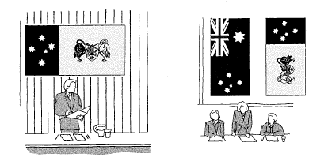

Suspended vertically in the middle of the street
The top left (or first) quarter should be on the observer’s left when facing north on an east-west street, or east in a north-south street (see example below).
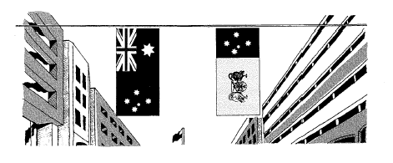

When flying only one national flag
When the Australian national flag is to be flown with the ACT flag and cultural/house or club pennants, the Australian national flag must be flown from the flagpole on the left of an observer facing the building; the ACT flag in the centre; and the house flag or pennant on the right-hand flagpole.
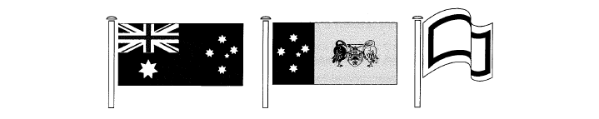

When flying more than one national flag
When flying more than one national flag in front of a building with three flagpoles of the same height, the Australian national flag is flown from the pole on the left of an observer facing the building. Any other national flag is flown from the centre flagpole, and the ACT flag is flown on the right.
Consultation should be undertaken with the Chief Minister, Treasury and Economic Development Directorate when considering any variation to existing policy and protocol arrangements for the ACT flag.

When flagpoles are of different heights

When flagpoles are of a different height with the centre pole the tallest, the Australian national flag must be flown in the centre with the ACT flag on the left of an observer facing the flags.
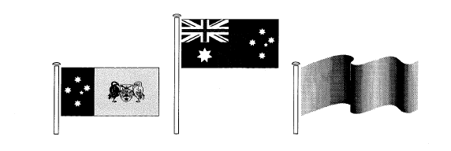

When using as a covering for a casket in a funeral ceremony
The flag should be placed so that the top left (or first) quarter lies in a position over the left shoulder of the deceased (see example below). The flag should be removed from the casket before it is lowered into the grave or cremated.
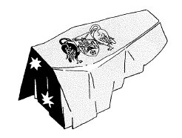

When used in a procession
The flags should be carried in single file with the highest precedence flag in the lead. For ceremonies commemorating an ACT event, it is not mandatory to carry the Australian national flag.
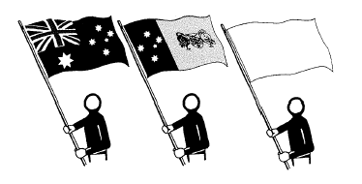

When carried in line abreast
The Australian national flag should be carried at each end of the line, with the ACT flags in between (see example below). For ACT commemorative events, the ACT flag may be carried at each end of the line, in place of the Australian national flag.

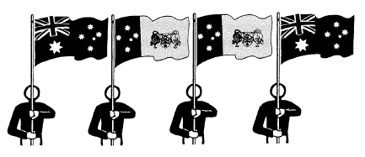
If only one Australian national flag is available, it should be placed in the centre of the line of flags carried abreast. The ACT flag should be carried to the right of the Australian national flag, when the observer faces the procession (see example below).
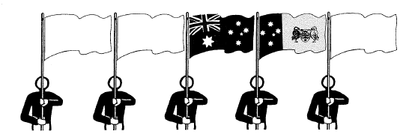
When the number of flags is even and the Australian national flag cannot be carried in the centre of a line of flags being carried abreast, it should be positioned on the left-hand end of the line when the observer faces the procession. The ACT flag should be carried to the right of the Australian national flag when the observer faces the procession (see example below). For local events, the ACT flag may (optionally) be carried in place of the Australian national flag.
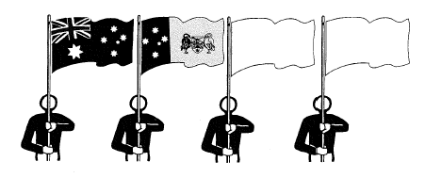
In a semi-circle of flags representing a number of states/territories, the ACT flag should be in the centre. If the Australian national flag is also flown it should become the central flag and the ACT flag should then be flown to the right of the Australian national flag as the observer faces the flag.

FLAG RESPECT

Dignity
Both the Australian national flag and the ACT flag should always be displayed in a manner befitting a national and Territory emblem. When more than one flag may be flown the Australian national flag takes precedence over any other state/territory flags, and so should not be displayed in a position inferior to any other flag or ensign.
In the ACT, the ACT flag normally takes precedence over any other state/territory flag, and so should also not be displayed in a position inferior to any other flag or ensign.
Flags should always be flown freely and should not be allowed to fall to, or lie upon, the ground.
It is undignified to use the ACT flag in any of the following ways:
- As a table or seat cover
- As a masking for boxes, barriers or intervening space between floor and ground level on a dais or platform

Defacement
Protocol prohibits the defacement of national and state/territory flags. This convention is also applied to the ACT flag. A flag is said to be defaced when a ‘Badge of Office’ or any other object is superimposed on an authorised flag.

Use for advertising/commercial purposes
The ACT flag may be used for advertising or commercial purposes provided:
- The design is not defaced by way of illustrations, or masked by other objects or lettering;
- All symbolic parts of the flag are identifiable (ie. Must be shown in its entirety); and
- It is shown, represented or used in a dignified manner.

Disposal of Flags
When a flag becomes dilapidated and is no longer in a suitable condition for use, it should be destroyed in a dignified way by burning privately. A flag may also be cut up into small pieces and placed in a rubbish bin.

HALF-MASTING FOR MOURNING
The Australian national flag and ACT flag are flown at half-mast as a sign of mourning. Half-masting can only occur for flags on flagpoles (not fixed flags such as those on a wall). The half-mast position is usually when the top of the flag is about one-third of the way down the flagpole, depending on the size of the flagpole.
On these occasions the Chief Minister, Treasury and Economic Development Directorate will receive instructions from PM&C, or the Chief Minister, to fly the ACT flag at half-mast. All ACT agencies and organisations on the Directorate’s advice list will be informed of the half-masting arrangements.
The costs of half-masting procedures are borne by individual agencies.
To bring the flag to the half-mast position, it should first be raised to the top of the mast, and then immediately lowered slowly to the half-mast position. Before being lowered for the day, the flag should first be raised to the peak and then immediately brought down again. Where both the Australian national and the ACT flags are being flown, the Australian national flag should be raised first and lowered last.
The Federal Government may give instructions for the Australian national flag to be flown at half-mast on any of the following occasions:
- On the death of the Sovereign:
  - From the time of the announcement of the death up to, and including, the funeral. It is customary on the day that the Accession of the new Sovereign is proclaimed for the flag to be raised to the top of the mast from 11:00am until the close of business.
- On the death of the current, or a former, Governor-General:
- On the death of a distinguished Australian citizen:
- Normally this is done on the day of the funeral, unless directed otherwise.
- On the death of a foreign Sovereign, or Head of State of a foreign country with which Australia maintains diplomatic relations:
  - Normally this is done on the day of the funeral, unless directed otherwise.
Flags in any locality can be flown at half-mast on the death of a local citizen or on the day, or part of the day, of their funeral.
- On the death of a prominent local citizen:
- The flag should be raised to the peak after the funeral.

DAYS OF NATIONAL COMMEMORATION
There are a number of days of national commemoration when the Australian national flag and the ACT flag will be flown in the ACT and will take precedence over other events. These include:

Australia Day – 26 January

Anniversary of the Apology to Members of the Stolen Generations – 13 February
The Australian Aboriginal Flag and the Torres Strait Islander Flag should be flown on additional flagpoles, where available, next to or near the Australian National Flag on Australian Government buildings and establishments. If there is only one flagpole available, the Australian Aboriginal Flag and the Torres Strait Islander Flag should not replace the Australian National Flag. If there are two flagpoles available, it is at the discretion of the authority concerned to determine which flag should be flown with the Australian National Flag. The Australian Aboriginal Flag and the Torres Strait Islander Flag have equal status and may be flown in any order after the Australian National Flag.

Canberra Day – 12 March

ANZAC Day – 25 April
Flags are to be flown at half-mast until noon, then at the peak until close of business.

National Sorry Day and National Reconciliation Week – 26 May to 3 June
The Australian Aboriginal Flag and the Torres Strait Islander Flag should be flown on additional flagpoles, where available, next to or near the Australian National Flag on Australian Government buildings and establishments. If there is only one flagpole available, the Australian Aboriginal Flag and the Torres Strait Islander Flag should not replace the Australian National Flag. If there are two flagpoles available, it is at the discretion of the authority concerned to determine which flag should be flown with the Australian National Flag.

Queen’s Birthday – 2nd Monday in June

NAIDOC Week –nominated week in July

International Day of World’s Indigenous People – 9 August

Australian National Flag Day – 3 September

United Nations Day – 24 October
The United Nations Flag, if available, should be flown all day. If only one flagpole is available, the United Nations Flag should be flown, even if that flagpole is ordinarily reserved for the Australian National Flag. If two flagpoles are available, the United Nations Flag should be flown in the pre-eminent position.

Remembrance Day – 11 November
Flags should be flown at the peak from 8:00am to 10:30am, at half-mast from 10:30am until 11:02am and at the peak from 11:02 until close of business. If the Australian flag is flown with other flags, this protocol also extends to those flags.
ACT Property Group undertakes the raising and lowering of flags on these occasions for the ACT Government and under contract for the National Capital Authority.

NATIONAL CAPITAL AUTHORITY - GUIDELINES FOR FLAGS AND BANNERS
Subject to traffic safety assessment by the relevant ACT Government agency flags and banners may be displayed within road reserves. Such signs should generally comply with the following:
- Approval may be granted by the National Capital Authority for the display of event banners and flags where these are of a standard which is consistent with the values of the National Capital
- Banners on light poles are not permitted in ANZAC Parade
- The use of light poles for the flying of banners is to meet the requirements of the ACT Government’s policy in respect of the use of its assets
- When erected on Territory Land flags and banners may only be installed by ACT Property Group trained staff
- The erection of flags in any location is not to be in conflict with the flag protocols administered by the Commonwealth Government’s Award and National Symbols Branch
- Banners on light poles should not compromise existing landscapes
- The use of commercial wording or sponsorship acknowledgement is limited to no more than 20 per cent of the banner, the appropriateness of the sponsor should be assessed in light of national/ACT considerations
- Artwork must be in good taste, harmonise with the environment and have artistic merit
- All costs associated with the design, manufacture, installation and removal of banners or flags are to be met by the applicant
- Materials used in flags and banners must be able to withstand the effects of rain, sun and wind without colours running or fading or fabrics tearing due to wind loads
- Material used in flags and banners are not to be highly reflective
- Flags and banners may be displayed for up to two weeks before an event, during an event and for no more than 48 hours after the event.

FURTHER FLAG PROTOCOL ASSISTANCE
The following organisations may be helpful in providing assistance should this guideline be unable to answer a particular query:

Communications and Engagement Division, Chief Minister, Treasury and Economic Development Directorate
Ph: 02 6205 3031
govtsupport@act.gov.au

ACT Property Group
Ph: 02 6213 0700
actpgflagsandbanners@act.gov.au

Commonwealth Flag Officer, Department of the Prime Minister and Cabinet
Ph: 02 6271 5601
nationalsymbols@pmc.gov.au

The Heraldry and Genealogy Society of Canberra
www.hagsoc.org.au

Flag Society of Australia
www.flagsaustralia.com.au

Australian National Flag Association
www.australianflag.org.au
Updated 19 September 2019

