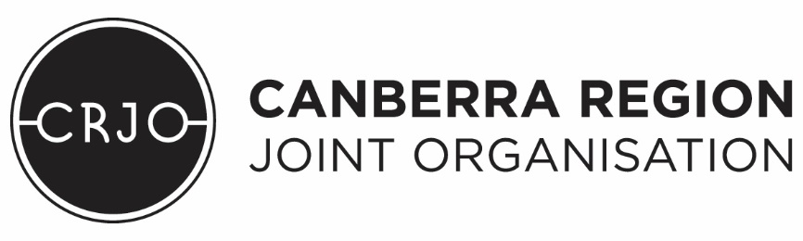
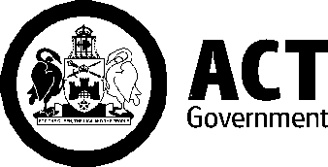

Memorandum of Understanding
between
Canberra Region Joint Organisation
and
Australian Capital Territory Government

September 2018

Purpose
We, the Canberra Region Joint Organisation (CRJO) and the Australian Capital Territory Government (ACT Government) (the parties) acknowledge the important relationship between the Australian Capital Territory and the surrounding NSW South East and Tablelands Region.
The proximity of the region to Canberra and the continuing impact of the nation’s capital on the growth and prosperity of the region requires close cooperation and collaboration between the parties to ensure strong mutual benefits for our communities.
The CRJO agrees the ACT Government shall be an associate member of the CRJO. This Memorandum of Understanding (MoU) provides a framework for the cooperation and collaboration between the CRJO and the ACT Government.
The CRJO is a regional leader, advocating for all parts of the Canberra Region in partnership to create vibrant communities and be the voice of a strong and cohesive region which recognises and celebrates unique sub regions.
The ACT Government’s associate membership of the CRJO will contribute to the pursuit of CRJO’s objectives, including:
- Facilitating opportunities and partnerships to create vibrant communities;
- Providing a forum for regional cooperation and resource sharing; and
- Cultivating investment and infrastructure development opportunities.
Where appropriate, the ACT Government will support the CRJO in its core functions as detailed in the CRJO Charter, including:
- Strategic planning and priority setting;
- Intergovernmental collaboration; and
- Regional leadership and advocacy.

Coverage
This Memorandum of Understanding covers the CRJO and ACT Government.

Status of Memorandum of Understanding
The CRJO and ACT Government acknowledge the MoU:
- is not legally binding on either party or members of CRJO; and
- does not diminish either party or CRJO members’ ability to make independent policy decisions.

Progressing Regional Collaboration
The ACT Government will work with the CRJO on priorities identified through an annual priorities list (Attachment A), in the first instance focusing on cross-border regional economic development and infrastructure opportunities.

Australian Capital Territory Representation
The Chief Minister for the Australian Capital Territory, or a delegate nominated by the Chief Minister, will participate in CRJO Board meetings, as an Associate member.
The ACT Head of Service, or a delegate nominated by the ACT Head of Service, will participate in CRJO General Managers Advisory Committee (GMAC) meetings, as an Associate member.

Financial Contribution
As a non-voting associate member of the CRJO, the ACT Government will pay a fixed annual fee of $39,045. This fixed fee is equivalent to the associate membership fee paid by the largest local Government associate member - Wagga Wagga City Council at signing of this MoU. This annual fee would be subject to any annual or proportional increases resolved by the Board of the CRJO and incurred by members from time to time.
In addition, the ACT Government will partner with the CRJO to contribute financially and/or in kind to initiatives aligned with the CRJO/ACT Government MoU annual priorities.

Review of this Memorandum of Understanding
The MoU will be reviewed three years from its commencement, and every three years thereafter. The MoU may be amended at any time by agreement in writing of the Parties.
The associated MoU priority list (Attachment A) will be reviewed annually.
- Dispute Resolution
Associate membership fees are to be determined by agreement between the Board and the Associate Member.
- Commencement
This MoU commences on the date of execution.
Cr. Rowena Abbey  Chair – Canberra Region Joint Organisation  Date: | Andrew Barr MLA  ACT Chief Minister  Date:

Attachment A
CRJO/ACT Government MoU 2018-19 Annual Priority List
The ACT Government agrees to support the CRJO Vision, Mission and Outcomes through the following priority areas, including:
- Infrastructure
  - Contributing to the Canberra Region Infrastructure Framework
  - Understanding the infrastructure requirements to support population growth in the ACT and surrounding NSW areas
  - Planning and collaboration on major and/or contiguous regional infrastructure developments
  - Advocacy in support of key regional and/or cross-border infrastructure designed towards seamless integration of cross-border networks
- Freight & Logistics
  - Contributing to the Canberra Region Freight and Transport Framework
  - Enhancing regional freight, export and investment capacity and capability
  - Improving regional freight connectivity to Canberra Airport
- Economic Development
  - Developing and implementing a Canberra Region Economic Development Strategy (CREDS), drawing on the respective Regional Economic Development Strategies developed in the Canberra Region.
  - Activating and supporting the success of the CBR Region Brand, including the LIVE, VISIT and INVEST pillars and CITY, COAST, ALPINE, TABLELANDS sub-brands
- Waste Management & Resource Recovery
  - Collaborating on policy, planning and operational opportunities to consider management of water, sewage, waste and renewable energy including waste to energy opportunities on a regional scale
- Sports, Culture & Wellbeing
  - Explore joint opportunities to enhance the profile and participation in sports, music and the arts across the Canberra Region
  - Recognise and support the importance of sport and culture in building strong and healthy communities
- Procurement and Shared Services
  - Examining joint procurement and cross-border project opportunities between the CRJO and ACT Government

