The Chief Minister, Treasury and Economic Development Directorate acknowledges the Ngunnawal people as traditional custodians of the ACT and recognise any other people or families with connection to the lands of the ACT and region.
We respect the Aboriginal and Torres Strait Islander people, particularly our Aboriginal staff, and their continuing culture and contribution they make to the Canberra region and the life of our city.
Contact for this report
General enquiries about this report should be directed to:
CMTEDD Corporate
Phone: 02 6207 5868
Email: CMTEDDCorporate@act.gov.au
Freedom of Information
Freedom of information requests can be made by emailing: CMTEDDFOI@act.gov.au or through CMTEDD’s Freedom of Information webpage https://www.cmtedd.act.gov.au/functions/foi
Accessibility
The ACT Government is committed to making its information, services, events and venues accessible to as many people as possible.
If you are deaf, or have a hearing or speech impairment, and need the telephone typewriter (TTY) service, please phone 13 36 77 and ask for 13 34 27. For speak and listen users, please phone 1300 555 727 and ask for 13 34 27. For more information on these services, contact us through the National Relay Service: www.relayservice.gov.au.
If English is not your first language and you require a translating and interpreting service, please telephone Access Canberra on 13 22 81.
IBSN: 978-0-642-60761-4
© Australian Capital Territory, Canberra 2023. This work is subject to copyright. Apart from any use permitted under the Copyright Act 1968, no part may be reproduced by any process without written permission from the Territory Records Office, GPO Box 158
Canberra ACT 2601.
Information about the directorate and an electronic version of this annual report can be found on the website: http://www.cmtedd.act.gov.au/functions/publications

Summary of volumes
The 2022-23 CMTEDD Annual Report has two volumes.

Volume 1
Contains all transmittal certificates and organisational overview and performance reporting for CMTEDD and all public sector bodies required to have their annual report annexed to the CMTEDD Annual Report. Each entity’s reporting includes, where relevant:
- organisational overview
- performance analysis
- scrutiny
- risk management
- internal audit
- fraud prevention
- freedom of information
- community engagement and support
- Aboriginal and Torres Strait Islander reporting
- work health and safety
- human resources management
- ecological sustainability development
- reporting by exception and annual report requirements for specific reporting entities
Volume 1 includes the following entities:
- ACT Architects Board
- ACT Construction Occupations
- ACT Executive
- ACT Government Procurement Board
- Default Insurance Fund
- Director of Territory Records
- Environment Protection Authority
- Lifetime Care and Support Fund
- Motor Accident Injuries Commission
- Office of the Nominal Defendant of the ACT
- Public Sector Workers Compensation Fund

Volume 2

Part 2.1
Contains all financial management reporting sections for:
- Chief Minister, Treasury and Economic Development Directorate
- Territory Banking Account
- Superannuation Provision Account
Each entity’s financial management reporting includes, where relevant:
- financial management analysis (management discussion and analysis)
- financial statements
- capital works
- asset management
- government contracting
- statement of performance

Part 2.2
Contains all financial management reporting sections (where relevant, as per the above) for:
- ACT Executive
- Default Insurance Fund
- Lifetime Care and Support Fund
- Motor Accident Injuries Commission
- Office of the Nominal Defendant of the ACT
- Public Sector Workers Compensation Fund
Contents
Organisation Chart as at 30 June 2023 viii
Abbreviations and acronyms ix
Glossary xii
Foreword 1
Transmittal Certificate 4
Compliance statement 6
Organisational overview 9
Our values 10
Our planning framework 11
Our clients and stakeholders 13
Changes to our organisational structure in 2022-23 14
Internal Accountability 14
Senior Executives and their responsibilities 14
Key Committees 18
Performance summary 20
Outlook 26
Performance Analysis 31
Output 1.1 Government Policy and Reform 31
Output 1.2 Workforce Capability and Governance 40
Output 1.3 Coordinated Communications and Community Engagement 49
Output 1.4 Digital Strategy 53
Output 1.5 International Engagement 57
Output 1.6 Workforce Injury Management and Industrial Relations Policy 60
Output 2.1 Access Canberra 63
Output 3.1 Economic Development 84
Output 4.1 Economic Management 94
Output 4.2 Financial Management 98
Output 5.1 Revenue Management 100
Output 6.1 Human Resources, Finance and Record Services 102
Output 6.2 Digital, Data and Technology Solutions 104
Output 7.1 Infrastructure Finance 106
Output 7.2 Procurement 108
Output 8.1 Property Services 113
Output EBT 1 Territory Banking Account 117
Output EBT 1 Superannuation Provision Account 118
Scrutiny 119
ACT Auditor-General reports 119
ACT Legislative Assembly Committee reports 130
ACT Ombudsman 156
Risk Management 157
Internal Audit 159
Fraud Prevention 161
Freedom of information 164
Community engagement and support 167
Community engagement activities 167
Community support initiatives: grants and sponsorship 184
Aboriginal and Torres Strait Islander reporting 215
CMTEDD’s Stretch Reconciliation Action Plan 2020-2023 215
Working with Aboriginal and Torres Strait Islander Peoples 215
Aboriginal and Torres Strait Islander Staff 228
Cultural Transformation Branch 230
Aboriginal and Torres Strait Islander representation on CMTEDD boards 231
Supporting improved educational, social and economic outcomes 231
Work health and safety 235
Health and safety structures and consultation arrangements 235
Highlights 235
Injury prevention and health and wellbeing 237
Human resources management 243
Culture, attraction and retention 243
Workforce planning and employment strategies 244
Capability 244
Gender Action Plan and Gender Impact Assessment Reporting 245
Staffing profile 246
Ecological sustainability reporting 251
Support to the Commissioner for Sustainability and the Environment 251
Business area activities 252
Other reporting 259
Financial management reporting 259
Public land management plans 259
Covert surveillance authorisations issued to ACT employers 259
Annexed annual reports 259
Annexed reports 260
ACT Architects Board 261
Compliance statement 262
Organisational overview and performance 263
Internal accountability 265
ACT Construction Occupations 267
Compliance statement 268
Organisational overview 269
Performance – proactive programs 272
Licensing 278
Performance – reactive compliance and regulatory actions 280
ACT Executive 282
Overview 282
ACT Government Procurement Board 286
Compliance statement 287
Organisational overview and performance 288
Default Insurance Fund 295
Compliance statement 296
Organisational overview and performance 297
Financial management reporting 302
Director of Territory Records 303
Compliance statement 304
Organisational overview and performance 305
Outlook 313
Whole of government reporting on Territory Records 314
Environment Protection Authority 335
Compliance statement 336
Organisational overview and performance 337
Performance analysis 340
Complaint handling 349
Australian Government commitments 356
Lifetime Care and Support Fund 361
Compliance Statement 362
Organisational Overview and Performance 363
Outlook 373
Performance analysis 373
Motor Accident Injuries Commission 375
Compliance Statement 376
Organisational Overview and Performance 377
Office of the Nominal Defendant of the ACT 391
Compliance statement 392
Organisational overview and performance 393
Financial management reporting 399
Public Sector Workers Compensation Fund 400
Compliance statement 401
Organisational overview and performance 402
Outlook 405
Financial management reporting 406

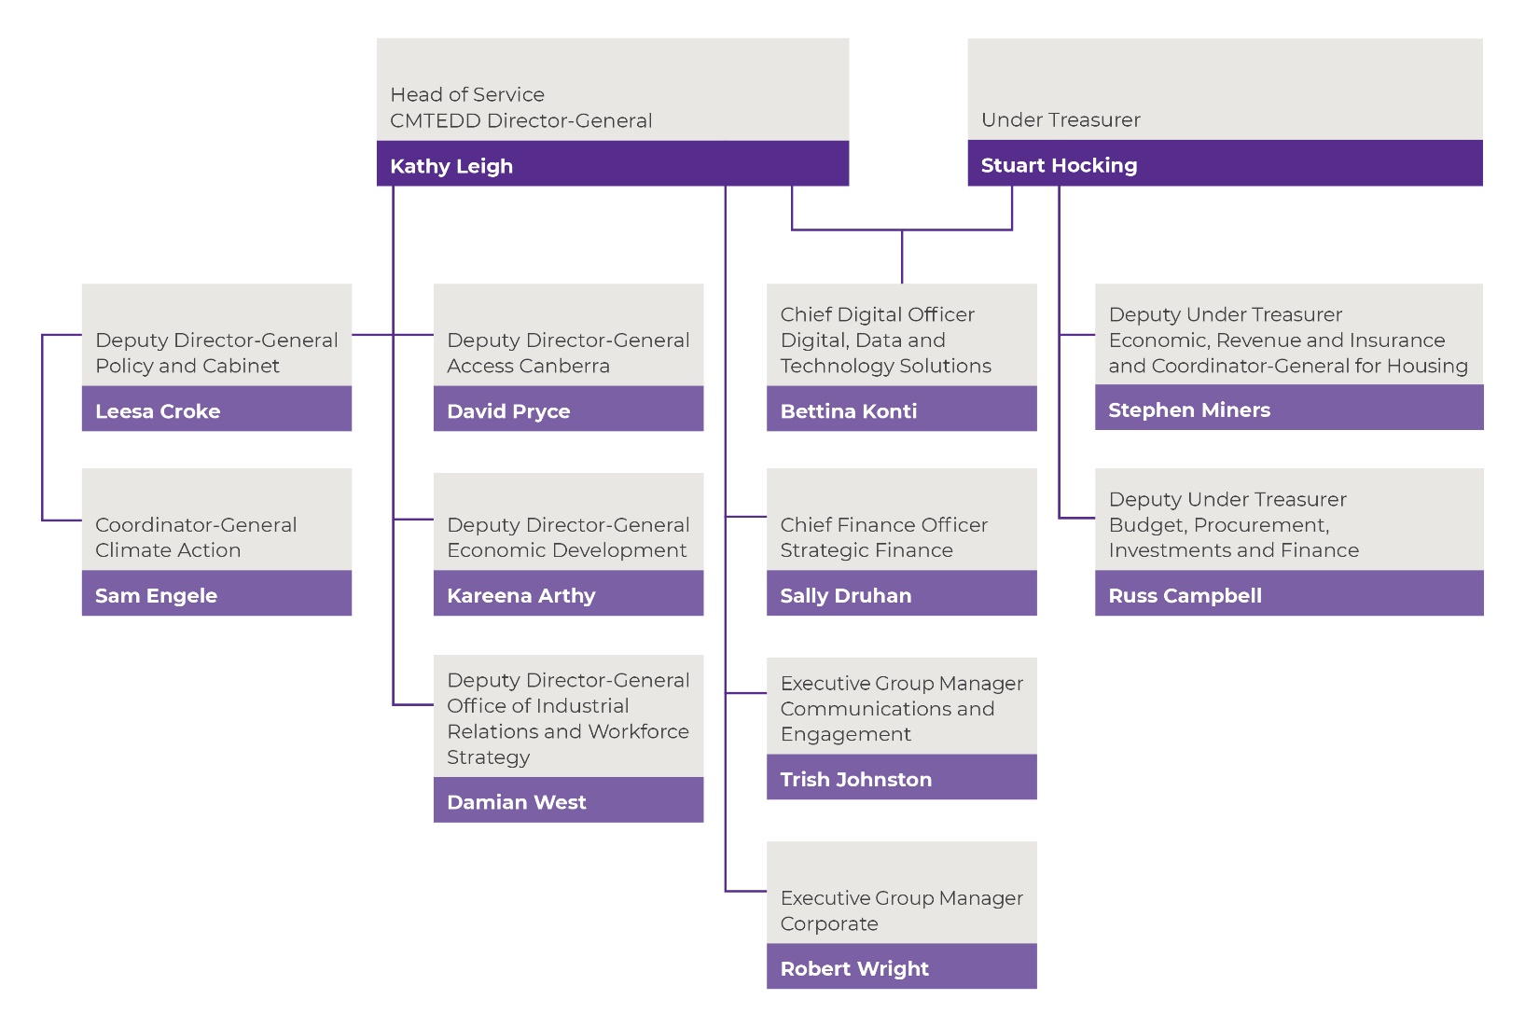
Organisation Chart as at 30 June 2023

Abbreviations and acronyms
AACA | Architects Accreditation Council of Australia
AACA | Architects Accreditation Council of Australia
AAQ | Ambient Air Quality
ACAT | ACT Civil and Administrative Tribunal
ACE | Adult Community Education
ACTIA | Australian Capital Territory Insurance Authority
ACTLIS | Australian Capital Territory Land Information System
ACTPAS | ACT Patient Administration System
ACTPS | ACT Public Service
ACTPSF | The ACT Protective Security Framework
APIAS | Accounts Payable Invoice Automation System
ASBA | Australian School Based Apprenticeships
ATSIPP | Aboriginal and Torres Strait Islander Procurement Policy
BDM | Business Development Manager
BEV | Battery Electric Vehicles
BSG | Business Support Grant
CASC | Climate Action Subcommittee of Cabinet
CASC | Climate Action Subcommittee of Cabinet
CBASS | Canberra Business Advice and Support Service
CBRIN | Canberra Innovation Network
CCCLM | Council of Capital City Lord Mayors
CFC | Cultural Facilities Corporation
CHC | Community Housing Canberra
CHP | community housing providers
CIF | Collapsed Insurer Fund
CIS | Critical Incident Support
CITL | Community, Industry and Trader Licensing
CITL | Canberra Institute of Technology
CMAG | Canberra Museum and Gallery
CMD | Configuration Management Database
CMT | Complaints Management Team
CMTEDD | Chief Minister, Treasury and Economic Development Directorate
CNG | Compressed Natural Gas
COLA | Construction Occupations (Licensing) Act 2004
COTA | Council on the Aging
COU | Certificate of Occupancy and Use
CPF | Clinical Patient Folder
CRA | City Renewal Authority
CRJO | Canberra Region Joint Organisation
CTB | Cultural Transformation Branch
CTO | Cultural Transformation Office
CTP | Compulsory Third-party
DCC | Directorate Consultative Committee
DHR | Digital Health Record
EA | Environmental Authorisations
EAP | Employee Assistance Program
ECBA | Event Coordination and Business Assist
EDM | Electronic Delivered Mail
EDRMS | Electronic Digital Records Management System
EFG | Economic and Financial Group
EMG | Executive Management Group
EML | Employers Mutual Limited
EMS | Expense Management System
EPA | Environment Protection Authority
EPA | Environment Protection Authority
EPIC | Exhibition Park in Canberra
EPSDD | Environment, Planning and Sustainable Development Directorate
FCEV | Hydrogen Fuel Cell Electric Vehicles
FJF | Future Jobs Fund
FMIS | financial management information system
FoG | Friends of Grasslands
FOI | Freedom of Information
HEVs | Hybrid Vehicles
IAM | Information Awareness Month
ICE | Internal Combustion Engine
ICMS | Integrated Case Management System
ICON | Innovation Connect
IFR | Infrastructure Finance and Reform
IGA | Intergovernmental Agreement
ILRP | Indicative Land Release Program
JACS | Justice and Community Safety Directorate
LGBTIQ+ | Lesbian, gay, bisexual, transgender, intersex and queer
LIPP | Local Industry Participation Plan
LLND | Language, Literacy, Numeracy and Digital Literacy
LNN | Language, literacy and numeracy
LPG | Liquid Petroleum Gas
LTCS | Lifetime Care and Support
MAI | Motor Accident Injuries
MARSS | Migrant and Refugee Settlement Services
MBA | Master Builders Association
MBA | Master Builders Association
MoU | Memorandum of Understanding
MPC | Major Projects Canberra
MVIS | Motor Vehicle Inspection Station
NAC | National Arboretum Canberra
NCVER | National Centre for Vocational Education Research
NDIS | National Disability Insurance Scheme
NEMP | National Environment Management Plan
NEMP | National Employers’ Mutual Association Ltd
NEPM | National Environment Protection Measure
NPI | National Pollutant Inventory
NPI | National Pollutant Inventory
NTE | Night-time and entertainment economy
OATSIA | Office of Aboriginal and Torres Strait Islander Affairs
OCA | Office for Climate Action
OCSE | Office of the Commissioner for Sustainability and the Environment
ODPP | Office of the Director of Public Prosecutions
OIE | Office of International Engagement
OIRWS | Office of Industrial Relations and Workforce Strategy
PAGA | Parliamentary and Governing Agreement
PALM | Pacific Australia Labour Mobility
PFAS | per- and poly-fluoroalkyl substances
PHEVs | plug-in hybrid vehicles
PIP | Priority Investment Program
POP | Post Office Projects
PPP | Public Private Partnership
PSSC | Public Sector Standards Commissioner
PSU | Professional Standards Unit
PTG | Public Trustee and Guardian
RAP | Reconciliation Action Plan
REOI | Request for an Expression of Interest
RFP | Request for Proposal
RMP | Records Management Programs
RMS | Records
RSA | Responsible Service of Alcohol
SBHS | Small Business Hardship Scheme
SERBIR | Senior Executive Responsible for Business Integrity Risk
SFP | Stromlo Forest Park
SHS | Sustainable Household Scheme
SLA | Suburban Land Agency
SME | Small and medium enterprise
SPA | Superannuation Provision Account
SRC | Safety Rehabilitation and Compensation Act 1988
SSCC | Stromlo Stakeholder Consultative Committee
STRA | Short Term Rental Accommodation
TBA | Territory Banking Account
TCCS | Transport Canberra and City Services
TIFA | Training Initiative Funding Agreement
TQI | Teacher Quality Institute
TRA | Threat and Risk Assessment
UEF | Uninsured Employer Fund
UNSW | University of New South Wales
VEP | Vocational Employment Program
VET | Vocational Education And Training
VHESS | Vulnerable Household Energy Support Scheme
WhoG | Whole of Government
WHS | Work Health and Safety
WHSC | Work Health and Safety Committee
WWVP | Working with Vulnerable People
ZEVs | Zero Emissions Vehicles

Glossary
Aboriginal and Torres Strait Islander Procurement Policy – The policy supports cultural change within the Territory to reduce some of the barriers to government procurement encountered by Aboriginal and Torres Strait Islander enterprises. Each Territory Entity is required to identify and act on opportunities for Aboriginal and Torres Strait Islander enterprises in its procurement activities. The policy encourages Territory officers to seek quotes from relevant Aboriginal and Torres Strait Islander Enterprises wherever possible, driving growth in economic participation for Aboriginal and Torres Strait Islander enterprises through an increase to the Government’s spend with Aboriginal and Torres Strait Islander enterprises.
COVID-19 – Refers, depending on context, to the abbreviation used for coronavirus disease 2019 (the respiratory disease caused by severe acute respiratory syndrome coronavirus 2) or to the short-form name for the COVID-19 pandemic (declared by the World Health Organisation in March 2020).
Activity-based work (ABW) – Provides staff with a choice of environment in which to work, both within and outside of the office. Staff can choose the most appropriate location to work throughout the day depending on the nature of work they are doing. They can choose from quiet focus spaces, spaces for phone calls and private discussions, semi-collaborative workstation areas and a range of spaces suited to meetings and team collaboration activities. Staff are provided with an array of technology to enable this flexibility, including the ability to work from locations other than the office.
ACT Digital – A program within the directorate that is transforming the delivery of ACT Government digital services to citizens and businesses.
Actsmart – Actsmart is a “one-stop-shop” for ACT Government programs and assistance that help Canberrans save energy and water, reduce waste and cut greenhouse gas emissions. Through Actsmart, the ACT Government assists households, businesses, schools and community groups contribute to a more sustainable future and to reduce the ACT’s carbon footprint.
ACT Remuneration Tribunal – Under the Remuneration Tribunal Act 1995 the ACT Remuneration Tribunal must inquire into and determine the remuneration, allowances and other entitlements to be granted to particular public offices every year.
Australian Apprenticeships – A program of training of apprenticeships and traineeships resulting in a nationally recognised qualification available to anyone of working age whether they are still at school, a school-leaver, re-entering the workforce or an adult worker wishing to change careers. Australian Apprenticeships provides training in conjunction with employment at a variety of qualification levels in most occupations as well as in traditional trades.
Canberra Region Joint Organisation (CRJO) – Consists of the following local councils: Bega, Eurobodalla, Hilltops, Goulburn Mulwaree, Queanbeyan-Palerang, Snowy Monaro, Upper Lachlan and Yass Valley and the ACT Government, with the aim of facilitating opportunities and partnerships to create sustainable vibrant communities.
CBR – The CBR Brand is a city brand developed as a logo and a new way of thinking and talking about Canberra. The brand is used by government when talking about the city as a place to live, work, play, invest, do business, study or visit, and is also available for private and community businesses to use.
CBR Innovation Network – Established to accelerate innovation and diversify the economy in the ACT region.
Headcount and Full Time Equivalent – Headcount and Full Time Equivalent (FTE) are standard measures of staff numbers. Headcount considers each employee as one regardless of whether they are full time or part time. In contrast, FTE represents total employee numbers based on equivalent full time hours worked. For example, an employee working standard full-time hours attracts an FTE of 1.0 whereas an employee working half the standard full-time hours attracts an FTE of 0.5. The total FTE in this example would be 1.5 whereas the headcount would be two.
HPE Content Manager – An electronic document and records management system used by ACT Government (previously known as TRIM).
One government – The ACT Public Service approach to priority setting, policy development and implementation, program and service delivery, and communications and engagement, through a culture and way of working that enhances coordination, cohesion and alignment of effort to better serve the ACT Government and Canberra citizens.
Priority Investment Program – A funding program established to support collaboration between the ACT Government, industry, research and the tertiary sectors to attract investment and grow established and emerging priority sectors of Canberra’s economy.
Public Information Coordination Centre – The PICC is the central coordination point for public information, media enquiries and briefings during a major emergency. PICC draws on staff from across ACT Government to manage communication during ACT emergencies.
Shared Services – Provides the ACT Government with core corporate services across the ACT Government’s directorates and agencies, including human resources, finance and property.
Skilled Capital – An ACT Government funded training initiative that provides access to high quality training in areas of skills needs in the ACT and maximises employment outcomes.
TRev – The ACT Revenue Office in CMTEDD uses the TRev application to record revenue from taxes, duties and levies.
Whole of government – Refers to matters, issues or arrangements affecting or applicable to the whole of the ACT Public Service

Foreword
I am pleased to present the 2022-23 Annual Report for the Chief Minister, Treasury and Economic Development Directorate (CMTEDD).
In 2022-23, our directorate focused on supporting the recovery of the ACT community from the impacts of COVID-19, and as community recovery progressed, we adapted our focus to support the ACT’s overall economic recovery and changing priorities.
CMTEDD contributed to the release of two updates to the 2019 Infrastructure Plan setting out the Government’s infrastructure priorities. The updates to the plan reflect the ACT Government’s ambition for Canberra to be recognised as Australia’s emerging cultural, arts and entertainment hub. We supported the launch of key Government strategies for sports and recreation, the arts and tourism.

Image 1: Kathy Leigh Director-General and Head of Service
To support the ACT Government’s commitment to a zero emissions target by 2045 CMTEDD collaborated with the Environment, Planning and Sustainable Development Directorate on the delivery of the Big Canberra Battery - a 250 megawatt, 500 megawatt-hour battery energy storage system for the ACT. Through the Sustainable Household Scheme almost 13,000 households across the ACT have had energy efficient products installed, including solar panels and batteries, electric vehicles, and insulation. We developed the ‘make your next choice electric’ campaign under the Everyday Climate Choices brand and co-led an initial program to upgrade insulation and undertake gas appliance replacement in 113 public housing properties under the Vulnerable Household Energy Support Scheme.
CMTEDD continued to administer the Government’s policy of providing two years of free registration for owners of new or used zero emissions vehicles (ZEVs) and implemented changes to provide for ZEVs transitioning off the two years free registration to move to the lowest weight fee. CMTEDD was responsible for designing significant cost of living assistance for the Canberra community as part of the 2023-24 Budget, including energy bill relief in partnership with the Commonwealth Government and expanded eligibility for the cost-of-living concession.
The Office of the Coordinator-General for Housing was established in CMTEDD in February 2023 to coordinate policy initiatives across Government. The 2023-24 Budget announcement of a $60 million Affordable Housing Project Fund was an important outcome of the work of the office.
To support customers in allowing them to choose the time which best meets their needs to undertake government services, our Access Canberra Dickson Specialised Centre provided services through a bookable appointment model. This was the first time such a model had been implemented in our service centres.
On 5 May 2023 the ACT community celebrated the National Arboretum Canberra’s 10th birthday. Throughout 2022-23 the National Arboretum Canberra welcomed 950,849 visitors and since opening has attracted over 6 million visitors and was recognised in winning the Tourist Attractions category in the 2022 Canberra Region Tourism Awards.
Throughout 2022-23 CMTEDD supported the safety of our staff through the development and implementation of a connected Occupational Violence and Management Action Plan. CMTEDD communications and engagement also lead the development of a media campaign (launched in July 2023) to draw attention to and discourage occupational violence against all public servants. We also progressed improvement of staff pay and conditions through finalising the negotiation of the Common Core Agreement which forms the basis of the ACTPS enterprise agreement, improving and expanding leave conditions, flexible work options and health and wellbeing support.
In 2022-23 we opened three whole of government FlexiSpaces - high quality office environments located in the City, Tuggeranong and Belconnen accessible by all ACTPS employees. We also created a dedicated innovation and collaboration facility in the Canberra City. These FlexiSpaces are designed to drive the adoption of flexible working across the ACTPS.
I would like to acknowledge the recent passing of Dr Damian West PSM, Deputy Director-General, Office of Industrial Relations and Workforce Strategy. Dr West had a genuine passion for making the ACTPS a nation-leading and safe place to work, and his legacy is in the reforms he implemented and the individuals he inspired both within his immediate team and across the ACTPS.
I would also like to thank all CMTEDD staff for their dedication and hard work during the past year and look forward to another year of working collaboratively to further strengthen policy and service delivery outcomes for our ACT community.
Kathy Leigh
Director-General and Head of Service

Part A

Transmittal Certificate and Compliance Statement
Transmittal Certificate

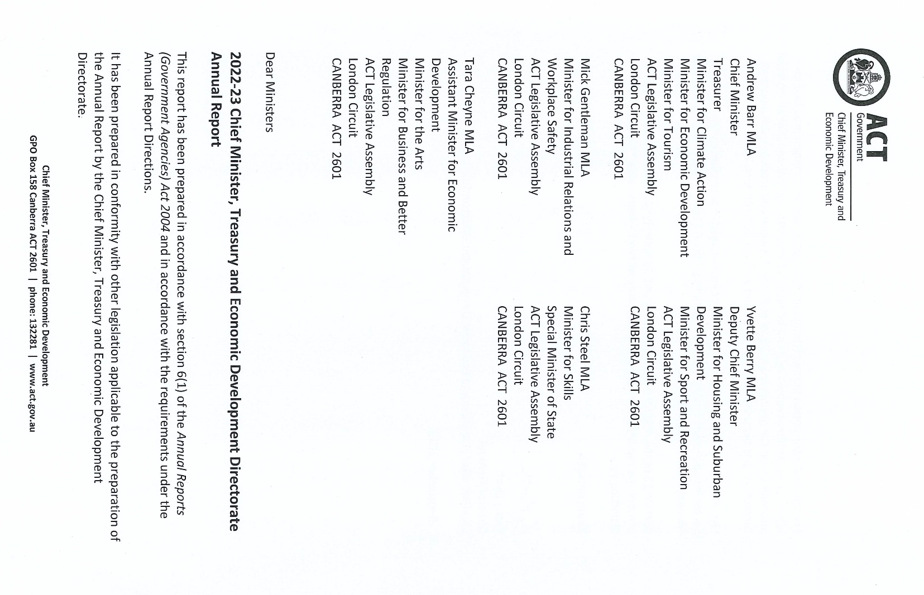

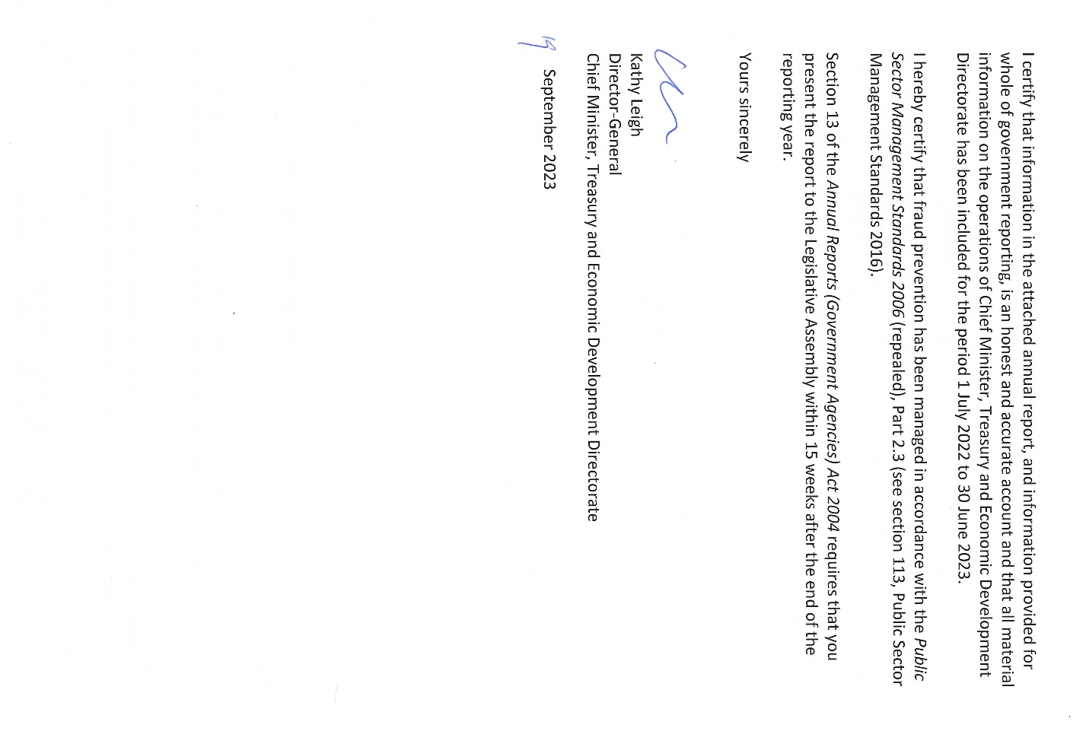

Compliance statement
The 2022-23 Chief Minister, Treasury and Economic Development (CMTEDD) Annual Report must comply with the Annual Reports (Government Agencies) Directions 2023 (the Directions) made under section 8 of the Annual Reports (Government Agencies) Act 2004. The Directions are found at the ACT Legislation Register.
The compliance statement indicates the subsections, under parts 1 to 5 of the Directions, that are applicable to CMTEDD and the location of information that satisfies these requirements.

Part 1 Directions overview
The requirements under Part 1 of the Directions relate to the purpose, timing and distribution, and records keeping of annual reports. The 2022-23 CMTEDD Annual Report complies with all subsections of Part 1 under the Directions.
To meet Section 15 Feedback, Part 1 of the Directions, contact details for CMTEDD are provided within the 2022-23 CMTEDD Annual Report to provide readers with the opportunity to provide feedback.

Part 2 Annual report requirements
The requirements within Part 2 of the Directions are mandatory for all reporting entities, and the 2022-23 CMTEDD Annual Report complies with all subsections. The information that satisfies the requirements of Part 2 is found in the 2022-23 CMTEDD Annual Report as follows:
- A. Transmittal certificate, see the previous page.
- B. Organisational overview and performance, inclusive of all subsections, see the Organisational Overview and Performance section of this report.
- C. Financial management reporting, inclusive of all subsections, see volume 2.1 of this report.

Part 3 Reporting by exception
CMTEDD has no information to report by exception under Part 3 of the Directions for the 2022-23 reporting year.

Part 4 Annual report requirements for specific reporting entities
The following subsections of Part 4 of the 2023 Directions are applicable to CMTEDD and reported in the Other Reporting section of this report.
- Public Land Management Plans.
- Covert surveillance authorisations issued to ACT employers.

Part 5 Whole of government annual reporting
All subsections of Part 5 of the Directions apply to CMTEDD. Consistent with the Directions, the information satisfying these requirements is reported in one place for all reporting entities as follows:
- Bushfire risk management, see the annual report of the Justice and Community Safety Directorate.
- Human rights, see the annual report of the Justice and Community Safety Directorate.
- Legal services directions, see the annual report of the Justice and Community Safety Directorate.
- Public sector standards and workforce profile, see the annual State of the Service Report.
- Territory records, see the CMTEDD Annual Report, annexed report of the Director of Territory Records.
ACT Public Service directorate annual reports are found at the following web address: https://www.cmtedd.act.gov.au/open_government/report/annual_reports.

Part B

Organisational overview and performance

Organisational overview

Our purpose and role as a central agency
The Chief Minister, Treasury and Economic Development Directorate (CMTEDD) leads the ACT Public Service (ACTPS).
We work collaboratively within government and with the community to deliver government priorities and drive initiatives aimed at making Canberra a better place to live. CMTEDD also leads the strategic direction of the ACTPS to ensure it is well positioned to shape and respond to change, and to continue to deliver against government priorities, now and in the future.
As a central agency, we:
- support the Chief Minister, the directorate’s ministers and the Cabinet by providing informed, holistic and innovative advice;
- provide support and direction across the ACTPS on policy and strategy;
- lead the ongoing development of the ACTPS, including advising on the structure of the ACTPS, ACT public sector employment legislation and conditions, industrial relations, senior executive leadership development and human resource management;
- drive the evolution of Canberra into a smart and connected digital city, through leading edge initiatives and cyber secure information and communication technology;
- drive growth in our knowledge-based economy and our reputation as a global destination in collaboration with business, tertiary education institutions as well as community and industry partners;
- provide strategic financial and economic advice to the ACT Government to improve the Territory's financial position and economic management;
- administer the ACT tax laws and manage the assessment and collection of ACT taxes;
- support public sector health and productivity by providing effective injury prevention and management services and infrastructure;
- support government through the provision of financial, human resources, property, insurance, infrastructure advisory and procurement services;
- connect businesses and communities to government through Access Canberra’s ‘one-stop-shop’ licensing and regulatory services;
- keep the Canberra community well informed, including in times of a territory emergency; and
- provide meaningful opportunities for Canberrans to inform government decision making, including the development of government policies, programs and services.

Our values
We promote and demonstrate the ACTPS employee values of respect, integrity, collaboration and innovation.
As the central agency, we are committed to:
- communicating openly and honestly, explaining context and reporting back on outcomes.
- engaging early with an open mind.
- demonstrating and earning trust.
- acting collectively, both as a directorate and as one government.
We take pride in our work.
We value and acknowledge the contribution of others.
We relate to colleagues and clients in a fair, decent, caring and professional manner.
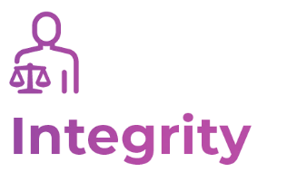
We do what we say we’ll do and respond appropriately when the unexpected occurs.
We take responsibility and are accountable for our decisions and actions.
We engage genuinely with the community, managing the resources entrusted to us honestly and responsibly.
We work openly and share appropriate information to reach shared goals.
We actively seek out other views when solving problems, and value and act on feedback on how we can do things better.
We look for ways to continuously improve our services and skills.
We are open to change and new ideas from all sources.

Our planning framework
CMTEDD’s Strategic Intent 2022-23 guided the directorate’s work in 2022-23. Our Strategic Intent set the annual outlook for the directorate’s purpose, priorities, values and contribution to the ACTPS as the central agency. The document brought together our significant and diverse deliverables by identifying the strategic and operational priorities of each CMTEDD business area.

Our Strategic Intent also summarised the key elements of our primary strategic documents: our Annual Report, the annual Budget Statement including our strategic objectives and accountability indicators, Canberra Switched On, and the ACTPS Code of Conduct, Values and Behaviours.

The directorate’s strategic objectives, summarised below, guide our long-term direction and priorities.
- Provision of high-quality policy advice and support to the ACT Government, including coordinated and integrated policy development and service delivery across government agencies.
- Delivery of a more agile, responsive and innovative public service to deliver government priorities.
- Supporting Government in the delivery of responses to urgent and complex emerging priorities.
- Promotion of economic growth, innovation and opportunity, and social inclusion.
- Providing high quality advice and support to the ACT Government in the economic and fiscal management of the Territory, working closely with relevant government agencies.
- Improved ‘One Government, One Voice’ communications and community engagement.
- Driving the transformation of ACT Government through collaborative partnerships to harness the power of digital and technology to continue to grow Canberra as an inclusive, progressive and connected city.

Image 2: CMTEDD Strategic Intent 2022-23
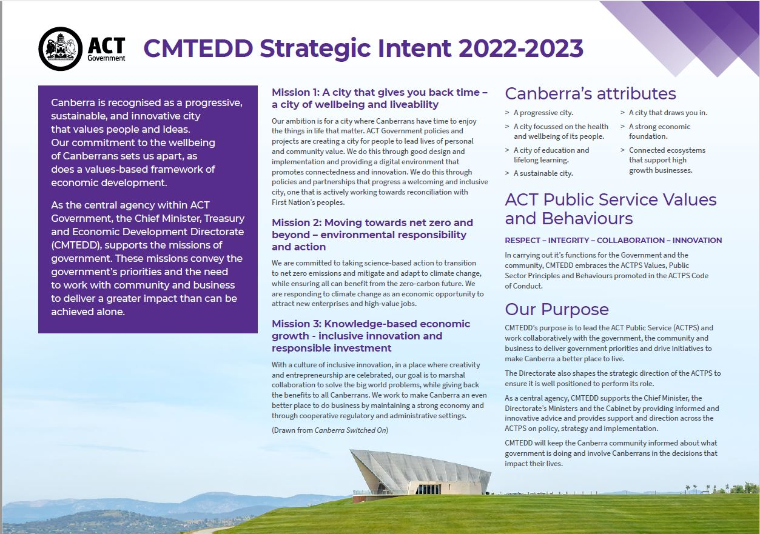

Image 3: CMTEDD Strategic Intent 2022-23
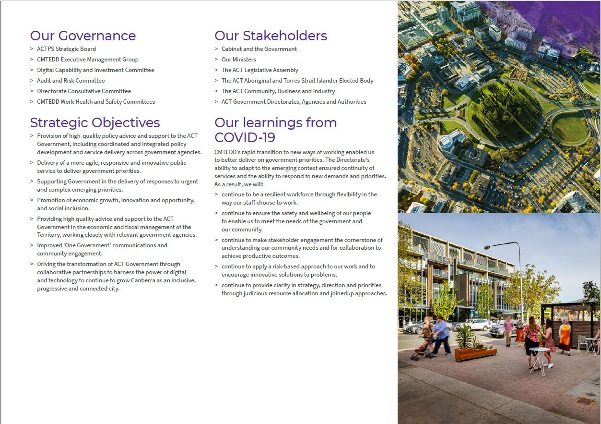

Our clients and stakeholders
We provide strategic policy advice and high-level support to our principal stakeholders, and our Ministers. The following table lists our Ministers on 30 June 2023 and their portfolios.

Table 1: CMTEDD Ministers and portfolios as at 30 June 2023
Minister | Portfolio
Andrew Barr MLA | Chief Minister  Treasurer  Minister for Climate Action  Minister for Economic Development  Minister for Tourism
Yvette Berry MLA | Deputy Chief Minister  Minister for Housing and Suburban Development  Minister for Sport and Recreation
Mick Gentleman MLA | Manager of Government Business  Minister for Planning and Land Management  Minister for Industrial Relations and Workplace Safety
Chris Steel MLA | Minister for Skills  Special Minister of State
Tara Cheyne MLA | Minister for the Arts  Minister for Business and Better Regulation  Assistant Minister for Economic Development

We support and assist many other key stakeholders and clients including:
- Cabinet and the ACT Government
- ACT Legislative Assembly
- ACT community
- ACT Aboriginal and Torres Strait Islander Elected Body
- community councils and groups
- industry and business institutions
- key arts organisations, professional and community sporting clubs and representative groups
- higher and vocational education institutions
- consumers and licensees
- media
- ACT Government directorates, agencies and authorities.

Changes to our organisational structure in 2022-23
There were a number of structural and reporting line changes in CMTEDD in 2022-23.
In October 2022, Workforce Capability and Governance was renamed to the Office of Industrial Relations and Workforce Strategy (OIRWS). OIRWS provides the formal structure to lead the ACT Public Service (ACTPS) industrial and employment agenda into the future. OIRWS has been established to support a more effective ACTPS – where strategy, industrial relations, WHS and employment policy and governance is developed and delivered in a consistent and collaborative manner.
Shared Services and ACT Property Group moved from the Treasury stream to OIRWS within the Chief Minister’s stream. The move of Shared Services to OIRWS provides the ACTPS with the opportunity to strengthen the strategic alignment between our human resource policy, human resource service delivery, and employment and industrial advice. This change took effect from 9 December 2022.
On 8 February 2023, the former Infrastructure Finance and Reform (IFR) team moved to the Economic and Financial Group (EFG) within Economic, Revenue and Insurance. This move capitalises on synergies between the two workgroups and improves opportunities to leverage the IFR team’s commercial expertise to address a wider range of government priorities. As part of reflecting this change, IFR is now known as the Infrastructure and Commercial Advice team.
In February 2023, the Chief Minister announced the establishment of the Office of the Coordinator-General for Housing within the Economic, Revenue and Insurance sub-stream of Treasury. The functions and responsibilities of the Office of the Coordinator-General for Housing was previously a part of the Environment, Planning and Sustainable Development Directorate (EPSDD). The Coordinator-General will work in collaboration with other directorates on the Government’s commitment to deliver greater affordable housing.

Internal Accountability

Senior Executives and their responsibilities
Our directorate consists of two streams:
- the Chief Minister stream, led by the Director-General.
- the Treasury stream, led by the Under Treasurer.
The names of the primary business areas within each stream and their responsible senior executives are below. Where business areas have an associated output, we explain their functions and responsibilities by output in the Performance Analysis section.

Chief Minister stream

Head of Service and Director-General - Kathy Leigh
The Director-General of CMTEDD is also the head of the ACT Public Service. The Director-General provides high level strategic advice to the Chief Minister and is Secretary to the Cabinet. As Head of Service, the Director-General provides whole of government leadership and strategic direction to the ACTPS and chairs the Strategic Board.

Table 2: Chief Minister stream executives at 30 June 2023, by budget output
Responsible senior executive | Business area name | Relevant budget output/s
Leesa Croke  Deputy Director-General | Policy and Cabinet | Output 1.1:  Government Policy and Reform
Damian West  Deputy Director-General | Office of Industrial Relations and Workforce Strategy | Output 1.2: Workforce Capability and Governance  Output 1.6: Workforce Injury Management and Industrial Relations Policy  Output 6.1 Human Resources, Finance and Record Services  Output 8.1: Property Services
Trish Johnston  Executive Group Manager | Communications and Engagement | Output 1.3: Coordinated Communications and Community Engagement
Bettina Konti  Chief Digital Officer | Digital, Data and Technology Solutions | Output 1.4: Digital Strategy  Output 6.2: Digital Data and Technology Solutions
Brendan Smyth  Commissioner for International Engagement | Office of International Engagement | Output 1.5: International Engagement
David Pryce  Deputy Director-General | Access Canberra | Output 2.1: Access Canberra
Kareena Arthy  Deputy Director-General | Economic Development | Output 3.1: Economic Development
In addition to the business areas listed above, the Chief Minister stream includes the following whole of directorate coordination and business support functions.

Coordinator-General for the Whole of Government (Non-Health) COVID-19 Response – Leesa Croke
The Coordinator-General for the Whole of Government (Non-Health) COVID-19 Response (the Coordinator-General) worked closely with the Chief Health Officer to ensure alignment of health and non-health responses to COVID-19. The Coordinator-General drew together the efforts of all directorates and agencies through the Coordinator-General’s Group, to maintain sound governance, decision-making and other administrative processes, and support strategic approaches on longer-term issues. The role of Coordinator-General ended in January 2023. Following the lifting of the Public Health (COVID-19 Management) Declaration on 28 February 2023, the Coordinator-General’s Group was replaced by the Deputy Director-General’s Group led by the Deputy Director-General Policy and Cabinet, which continues to support information sharing and whole of government coordination on priority issues.

Coordinator-General for Climate Action - Sam Engele
The Office for Climate Action was established in January 2021 to coordinate and support the ACT Government’s ambitious agenda for climate action.

Corporate - Executive Group Manager - Robert Wright
Corporate leads the delivery of strategic solutions to CMTEDD on key initiatives of business governance, workforce capability and digital transformation, and supports the Director-General and Under Treasurer. The Executive Group Manager drives integrity through their role as CMTEDD Senior Executive Responsible for Business Integrity Risk (SERBIR) and is also the directorate’s Public Interest Disclosure Officer, and Chair of the Directorate Consultative Committee, and the Work Health and Safety Tier 1 Committee.

Strategic Finance - Chief Finance Officer - Sally Druhan
Strategic Finance is responsible for the financial and budgetary management for CMTEDD and the ACT Executive. This includes the development of internal budgets and budget papers, strategic financial monthly and annual reporting, monitoring and reporting on capital works and assets, as well as support for our ministers, Executive Management Group, senior management, and business areas generally.

Treasury Stream

Under Treasurer - Stuart Hocking
The Under Treasurer leads the Treasury stream of CMTEDD and is responsible for the provision of strategic financial and economic policy advice to the Government. The Under Treasurer plays a leading role in promoting accountability and transparency in the delivery of services to the community.
The Under Treasurer also oversees a range of whole of government functions including procurement, general insurance and risk management, and infrastructure finance and reform policy and advice.
In 2022-23 Treasury comprised two sub-streams
- Economic, Revenue and Insurance, led by Deputy Under Treasurer and Coordinator-General for Housing Stephen Miners; and
- Budget, Procurement, Investments and Finance, led by Deputy Under Treasurer Russ Campbell.
The Economic, Revenue and Insurance stream include the ACT Insurance Authority (ACTIA). ACTIA is led by General Manager Penny Shields and provides insurance protection and risk management advice for the ACT Government. ACTIA has its own annual report, available on the ACTIA page of CMTEDD’s website.
Tables 3 and 4 list key Treasury business areas and the responsible senior executive by budget output.

Table 3: Economic, Revenue and Insurance executives at 30 June 2023, by budget output
Responsible senior executive | Business area name | Relevant budget output/s
Stephen Miners - Deputy Under Treasurer, Economic, Revenue and Insurance
Mitch Pirie  Executive Group Manager | Economic and Financial | Output 4.1: Economic Management  Output 7.1: Infrastructure Finance
Kim Salisbury  Executive Group Manager | Revenue Management | Output 5.1: Revenue Management

Table 4: Budget, Procurement, Investments and Finance executives at 30 June 2023, by budget output
Responsible senior executive | Business area name | Relevant budget output/s
Russ Campbell - Deputy Under Treasurer, Budget, Procurement, Investments and Finance
Scott Austin  Executive Group Manager | Finance and Budget | Output 4.2: Financial Management
Sanaz Mirzabegian  Executive Group Manager | Procurement ACT | Output 7.2: Procurement

Table 5: Digital, Data and Technology Solutions executives at 30 June 2023, by budget output
Responsible senior executive | Business area name | Relevant budget output/s
Bettina Konti - Chief Digital Officer, Digital, Data and Technology Solutions
Bettina Konti | Digital, Data and Technology Solutions | Output 6.2: Digital Data and Technology Solutions
Note that in relation to Output 6.2: Digital Data and Technology Solutions, the responsibility falls to the Under Treasurer, however the Chief Digital Officer reports directly to the Director-General on strategic issues.
In addition to the business areas listed above, the Treasury stream includes the following whole of directorate coordination and business support functions.

Coordinator-General for Housing – Stephen Miners
The Office of the Coordinator General for Housing was established in February 2023 to coordinate the many areas across Territory Government that intersect with housing – driving a whole-of-government approach housing issues.

Key Committees
A number of boards and committees oversee our strategic direction, priorities and governance.

Table 6: Key CMTEDD committees
Name of committee | Role of committee and membership
ACTPS Strategic Board | The ACTPS Strategic Board provides whole of government leadership and strategic direction to the ACTPS.  Strategic Board is chaired by the Head of Service and Director-General CMTEDD and includes all directors-general, the Under Treasurer, the Chief Digital Officer, the Deputy Director General, Office of Industrial Relations and Workforce Strategy, and the Deputy Director-General, Policy and Cabinet.
Audit and Risk Committee | The Audit and Risk Committee assists the Director-General and the Under Treasurer in fulfilling their oversight and governance responsibilities. The Committee’s functions are governed by an Audit and Risk Committee Charter.  Committee membership includes advisors from CMTEDD, an executive from another ACT Government directorate (currently the Environment, Planning and Sustainable Development Directorate) and an independent chair and deputy chair. Observers and a representative from the ACT Auditor-General's Office also regularly attend meetings. The Internal Audit section of this report contains further details on this committee.
CMTEDD Executive Management Group | The Executive Management Group (EMG) oversees governance within CMTEDD.  EMG’s membership consists of the Director-General CMTEDD, the Under Treasurer, the Executive Group Manager Corporate and the Chief Finance Officer.
CMTEDD Work Health and Safety Committees | The CMTEDD Work Health and Safety Committees (WHSC) provide consultative forums for work health and safety (WHS) matters across the directorate. They comprise three tiered committees (directorate level WHSC, directorate WHS Network, and local level WHS) and are established in accordance with the ACT Work Health and Safety Act 2011 (the WHS Act) and the Public Sector Management Act 1994.  Information is cascaded from the Tier 1 (directorate level) committee. Matters can also be raised at Tier 2 or 3 level and reported and managed through the higher tiers.  The role of the committees is to:  facilitate communication and consultation between management and workers on matters relating to workers’ health and safety at work;  assist in the development of health and safety protocols, rules and procedures;  review information related to WHS performance to assist CMTEDD to achieve continuous improvement in the management of WHS;  consider relevant programs that enhance employee health and wellbeing; and  provide a mechanism for escalation and resolution of unresolved WHS issues.
Directorate Consultative Committee | The ACTPS enterprise agreements provide for the establishment of a Directorate Consultative Committee (DCC). The DCC’s key objectives are to:  monitor the operation and implementation of the agreements;  consider any proposed new or significant changes to directorate policy statements and guidelines that relate to the provisions of the agreements;  exchange information about workplace issues affecting employees; and  consult on any existing directorate performance management schemes, and on the development of any new performance management schemes.  The DCC consists of employee, union and management representatives, with Corporate providing secretariat support.

Performance summary

Leading key government priorities
Through the Office of LGBTIQ+ Affairs, we finalised the first reform of its kind in the southern hemisphere to enhance care and legal protections for people with variations in sex characteristics (or ‘intersex’) and their families. This reform included a regulatory innovation confirming that intersex people must not be harmed by inappropriate medical interventions, and be able to make their own decisions about medical treatments that affect their bodies. The new law came into effect on 23 June 2023.
We continued delivery on the Parliamentary and Governing Agreement (PAGA) Commitment for large-scale batteries. Collaborating with Environment, Planning and Sustainable Development Directorate (EPSDD), the Office for Climate Action supported the ACT Government to partner with Eku Energy for the delivery of a 250-megawatt, 500 megawatt-hour battery energy storage system in Williamsdale. This battery system will be developed, built, and operated by Eku Energy. The Big Canberra Battery Project will support reliable and affordable electricity supply for the ACT as we transition to net-zero emissions. Construction will start in late 2024 with completion expected in 2025.
In 2022-23 we continued the delivery of the Sustainable Household Scheme (SHS), which commenced in September 2021 and since then, has financed almost 13,000 households across the ACT to purchase energy efficient products, including solar panels and batteries, electric vehicles, and insulation. The SHS was the first of its kind to make energy efficiency upgrades affordable and accessible for households and community organisations, and has been an overwhelming success. The PAGA commitment of $150m for a zero interest loans program was delivered in 2022-23. An additional $50m was added to the scheme in early 2023 and is now being rolled out.
We further embedded wellbeing in our Budget processes and announced a strategic partnership with the Australian National University to analyse the drivers of wellbeing outcomes. We continued work to consider the strengthening of public sector performance reporting and accountability arrangements in the context of wellbeing. An update of the Wellbeing Data Dashboard commenced, and we continued to deliver the ACT Evidence and Evaluation Academy.
The directorate began the development of a night-time and entertainment economy (NTE) regulatory quality framework approach by reviewing existing policy, legislative, regulatory and process requirements for the NTE. So far, we have developed a Vision for the night-time economy for consultation with industry and community and we have supported EPSDD in its work to establish a City Centre Entertainment Precinct in the Territory Plan.

Supporting workforce capability
In 2022-23 the directorate established the Office of Industrial Relations and Workforce Strategy (OIRWS) to continuously improve ACT employment conditions and workforce productivity. OIRWS brings together the staff, systems, and infrastructure responsible for ACT public sector workforce planning, health, safety, integrity and employment conditions, the industrial relations policy and legislative arms and related service areas. It will:
- optimise ACT workplace relations regulatory frameworks by monitoring the performance of and reforming work health and safety, workers’ compensation, public sector employment, workplace privacy and portable long service leave legislation;
- provide community and government property management and accommodation services and manage the Secure Local Jobs Code; and
- build the capacity, capability and agility of the ACT public service by:
- developing and leading innovative workforce transformation strategies, policies and programs;
- devising and delivering workers’ compensation, health safety and wellbeing services and programs that improve workforce health and resilience;
- developing progressive employment policy and promoting its consistent and compliant application;
- ensuring exemplary professional standards and accountability via integrity practice and frameworks; and
- providing efficient and effective support services to the ACT public sector including financial functions, payroll and recruitment.
We reviewed and revamped the Vocational Employment Program for Aboriginal and/or Torres Strait Islander peoples and people with disability, and expanded it to also include culturally and linguistically diverse people and defence family members.
The directorate continued to drive the adoption and enablement of flexible working across the ACT Public Service. We delivered three FlexiSpaces - high quality office environments accessible by ACTPS employees - in Tuggeranong, Belconnen and the City, as well as an Innovation Centre at the Canberra Nara Centre, designed to facilitate collaboration, learning, workshops and other problem-solving activities.
We continued to grow and improve the ACT Government Graduate Program. This investment in the Program as a key talent pipeline for the Service saw 108 Graduates commence the 2023 Program on 6 February 2023, representing a program growth of 157 per cent over the last three years. The ACT Government Graduate Program was recognised twice in the national 2023 Grad Australia Graduate Employers Awards, being awarded third in Government Sector and an overall ranking of 76 in the top 100 Graduate employers as rated by graduates.
We worked closely with union and industry stakeholders to strengthen our work health and safety laws and implemented new silica safety rules to better protect workers from exposure to silica dust.
In 2022-23 we delivered improved working conditions for those who change jobs in their profession by expanding access to portable long service leave entitlements to more workers.

Keeping the community informed/One Government, One Voice
In 2022-23 we progressed the One Government, One Voice program, our commitment to ensuring that through effective and well-targeted information campaigns and engagement activities, Canberrans know how to access services and have the information they need to actively participate in decision making, by:
- designing and implementing a new whole of government approach to delivering priority campaigns, with a focus on using evidence and insights to improve their quality and impact. These included campaigns encouraging Canberrans to transition their energy needs from gas to electric, to consider their travel behaviours and specifically, consider using public transport.
- enhancing our in-house research capability to include qualitative formative research and market testing of creative campaign approaches. This has provided an improved evidence base for the delivery of priority communication campaigns.
- progressing the improvement of the digital experience for the community to ensure we meet user needs and expectations, through consolidation and redevelopment of ‘high value’ websites and social media channels.
We led a whole of government approach to raise community awareness about the ACT Government’s investment and progress on infrastructure projects across Canberra. This included development of the Built for CBR brand and narrative across a new website and communications activities spanning both ACT Government owned channels (Our Canberra, social media and a new website) and external channels including news media and advertising. Integral to this project was a refreshed approach to communicating the ACT Infrastructure Plan, which outlines how the government is preparing for the delivery of new and improved infrastructure across the city for the next 5 years and beyond.
CMTEDD ensured Canberrans continued to remain informed about key ACT Government priorities by growing the priority social media channels by 20 per cent and increasing page views on the Our Canberra website by 25 per cent to 380,000 views.
We continued to engage with a wide range of Canberrans to seek their views on, and input into important policies, programs and services. This was achieved through online platforms, the YourSay Panel, of which 6,800 Canberrans undertook 10 surveys and YourSay Conversations which was visited by 165,000 Canberrans to participate in 112 engagements over the year.

Driving the digital transformation of government services
In 2022-23, we continued to embed the principles of the ACT Digital Strategy to provide a community centred approach to how we use technology to improve the quality of life for all Canberrans. This work involved working collaboratively across government to provide best practice advice on the design and delivery of two new digital initiatives:
- Since July 2022, the Automatic Mutual Recognition Scheme has been available to workers who hold an occupational registration/licence in one State or Territory and want to work in the ACT – these workers no longer need to apply for separate registrations, only complete and submit a notification application through the ACT Digital Account.
- More than 600 online applications have been made through this service.
- Subsequent phases of this scheme will see information sharing between other states and territories including validation of notifications and licence conditions.
- The ACT Digital Program and ACT Revenue Office worked in partnership to pilot a Concession Management Service for three ACT Government Concessions – this service enables a member of the community to prove their eligibility to claim a concession benefit once and have that apply automatically to all relevant and connected services. This pilot has also enabled integrations with Centrelink and Veterans Affairs for real time concession checking. Over 800 online applications have been streamlined through this new service in the ACT Digital Account.
- The first group of three concession services released in July 2022 included:
- applications for rates rebate (for pension card holders);
- deferral of payments based on age (applicants over 65 years); and
- deferral of payments based on hardship.
In addition, the ACT Digital Program has been working on designing a number of new digital services including:
- a new digital enrolment and parent interaction capability in partnership with parents and the ACT Education Directorate; and
- seeking expert advice on technology options to replace the current system supporting Motor Vehicle Registration and Renewal in partnership with Access Canberra.
In 2022-23, the ACT Digital Account saw the number of accounts increase to over 281,000 with 84 per cent of account holders identifying as ACT residents. In the same period 41 per cent of ACT Digital Account holders took steps to increase the level of identity assurance for their Digital Account, opening the opportunity to access services digitally rather than through face to face or phone channels.

Leading the ACT Government’s international engagement activities
During 2022-23 we provided export support to 158 businesses. This included education focused advice on market and channel selection, navigation of regulatory environments and positioning of products to buyers. The ACT Government’s dedicated Business Development Manager also provided businesses with in-depth market research, channel-selection advice and connections to wholesalers and retailers for export products. In March 2023 we delivered ACT Export Day, through which Canberra businesses learned about the range of export-support services available from the Office of International Engagement (OIE), Austrade and third parties to boost export transactions. The OIE also oversaw delivery of the Chief Minister’s Annual Export Awards which showcased the export achievements of Canberra’s leading exporters and helped inspire other Canberra firms to sell their services and products abroad.
We delivered six Trade Missions to seven markets across the Asia-Pacific and Europe. We continued to re-establish key relationships in Singapore, New Zealand and Fiji. In Singapore we continued to advocate for recommencing direct flights to Canberra, which are vital to export development; and we further developed relationships to stimulate direct investment, tourism, and partnerships in the space industry. In South Korea and Japan we shared insights about important elements of respective countries’ renewables activities, and looked at potential partnerships that could benefit the ACT’s climate action commitment. We also explored potential collaborations that could advance Canberra as a smart city.
We provided a range of valuable support in the delivery of 26 inbound international delegations, which brought focused benefits to specific areas of our economy and highlighted the social and cultural life of Canberra. As examples, in October 2022 we hosted a United Kingdom delegation that enabled British and Canberran participants to learn about each other’s respective cyber industries and opportunities for collaboration. Also in October, we hosted a French delegation through which Canberran Space businesses showcased their work to representatives of the French space industry. In June we hosted the annual Canberra Pacific Forum, which provided an important opportunity for diplomatic and local business leaders to discuss common challenges in the Pacific Region, including climate change, economic development, and public health.
The directorate coordinated the ACT Government’s compliance with the Commonwealth’s Foreign Arrangements Act. The compliance process ensures that ACT-based formal agreements fit with the Commonwealth’s international engagement objectives. The OIE also oversaw the ACT’s contributions on the development of key free trade and other international agreements, through the consultation process of the Commonwealth’s Joint Senate Committee on Trade.

Supporting a safe and liveable city
We enhanced the way we worked with business and the community to support safe and legal parking across the ACT and inform them of parking changes.
We undertook 12,949 mobile speed vans sessions across 901 locations. We checked 9,533,754 vehicles with 20,878 vehicles detected speeding.
Through the Resolution and Support Team in Access Canberra, we helped resolve 19,493 complaints and enquires.
In June 2023 we launched a temporary employment register to fill temporary vacancies as they arise in Access Canberra, in turn providing continued services for our Canberra community. Since its launch, we have received 619 applications and successfully offered temporary placements to 98 applicants. The temporary employment register offers individuals a pathway to join the ACT government, providing a platform to demonstrate their skills and potentially transition into permanent position within the ACTPS.
We supported the safety of our staff through the development and implementation of a Occupational Violence Management and Action Plan.

Supporting Canberra’s economic development
In 2022-23 we celebrated the National Arboretum Canberra’s 10th birthday and welcomed 950,849 visitors.
We delivered the final year of the JobTrainer program in priority areas including aged care, early childhood education and care, disability care and digital skills courses, introduced a Fee Free TAFE program, and met the 2022-23 annual skilled migration allocation of 4,060 nominations.
The directorate delivered 18 national or international matches and one entertainment event at GIO Stadium, including the largest NRL round match at GIO Stadium since 1994, and hosted 12 national or international events at Manuka Oval, including international men’s and women’s cricket matches and AFL games.
Floriade successfully returned to its traditional format in Commonwealth Park (for the first time since 2019) and we achieved a record Enlighten Festival attendance, with the two events delivering a combined $45.7 million in direct economic benefit to the ACT.
We launched key strategies for sport and recreation for 2023-2028 (CBR Next Move), the arts (Canberra: Australia’s Arts Capital - Arts, Culture and Creative Policy 2022-2026 and the Arts, Culture and Creative Action Plan and Remuneration Principles and Practices for Artists and Arts Workers), and tourism (T2030: ACT Tourism Strategy 2023-2030)
We also facilitated Territory approval of the University of New South Wales (UNSW) Canberra City Campus master plan, a key milestone for the new $1 billion campus to be built on Constitution Avenue.

Providing strategic financial and economic advice and services to the ACT Government
In 2022-23 we delivered the 2022-23 Budget, 2022-23 Budget Review, the 2023-24 Budget and the Consolidated Financial Statements.
We continued to lead the delivery of the ACT Government’s Procurement Reform Program. The Procurement Reform Program improves government business, while helping our economy and our community. It provides more opportunities for industry and local businesses to work with the ACT Government. It supports the capability of our workforce through enhanced training and development programs to help staff make better procurement decisions. Various elements of the program will be progressively implemented, with a final completion date of 30 June 2025.
Three focus areas have been identified as key to achieving reform:
- transparent, evidence-based procurement decisions which are conducted with probity and can withstand scrutiny;
- support for our workforce, local industries and businesses through clear roles and the delivery of consistent, accurate, timely, practical and customer-focused services through all phases of the procurement lifecycle; and
- streamlining our legislative framework, policies, processes and templates to ensure that they are efficient and can facilitate timely procurement outcomes.
In 2022-23 we continued to be a centre of excellence for procurement support, best practice and guidance supporting over 70 goods and services procurements in addition to supporting Territory entities to meet their legislative and policy requirements in accordance with the ACT Government Procurement Framework.
We briefed the government on economic and revenue policy issues and developments.
We established the Office of the Coordinator-General for Housing, implemented affordable housing initiatives through the 2023-24 Budget, including the $60 million Affordable Housing Project Fund, and engaged with the Commonwealth on the Housing Accord and other national housing issues.
We supported development of the Motor Accident Injuries Amendment Act 2023, which was passed by the Legislative Assembly on 28 June 2023.
We published the ACT Population Projections for 2022-2060.
We administered the ACT tax laws, managed the assessment and collection of ACT taxes and administered concessions, exemptions and grants consistent with the Government’s policies. This included reverting back to full revenue office operations after administering assistance measures in 2021-22 that were introduced through the government’s COVID-19 pandemic economic survival package. We also commenced the build of a new land valuation IT system.

Outlook

Leading key government priorities
In 2023-24 we will continue to drive and coordinate advice to support and deliver the Government’s objective of improving housing access, affordability and choice.
We will evaluate the Capital of Equality LGBTIQ+ Strategy and develop options for the next phase of work to keep Canberra the most LGBTIQ+ welcoming and inclusive city in Australia.
We will complete the update of the ACT Infrastructure Plan through successive release of sector updates.
We will operationalise a strategic partnership with the Australian National University that will analyse the drivers of wellbeing outcomes in the ACT; continue to embed wellbeing in our decision-making processes, including considering the use of metrics in assessing the relative merit of wellbeing proposals; continue to consider the strengthening of our public sector performance reporting and accountability arrangements in the context of wellbeing; and continue our partnership with the University of Canberra in analysing and understanding the wellbeing of Canberrans through survey-based engagement.
We will partner with the Australian National University School of Regulation and Global Governance to undertake a pilot project to test a methodology to measure the value and burden of existing regulation for certain business types. In the first instance, these will include food and drink businesses, and health and fitness businesses.

Building our current and future workforce capability and shaping workplace culture
In 2023-24 we will deliver new and refined work health and safety codes of practice to support businesses to meet their obligations when managing silica dust risks and psychosocial hazards at work.
We will finalise, launch and commence implementation of the inaugural ACTPS Gender Equity Strategy which, while recognising the strong position the ACTPS holds in terms of Gender Equity, takes a targeted approach to address more unique challenges within the ACTPS, to further drive systemic change and positively impact economic outcomes for women.
We will develop the inaugural ACTPS Diversity and Inclusion Strategy which will address recognised barriers to employment, advancement or engagement and supports belonging for people who identify in one or more diversity groups.
We will establish a neurodiversity employment program to support the engagement, support and retention of people with neurodivergence across the ACTPS.
In 2023-24 we will finalise the ACTPS FlexiSpace Program by introducing FlexiSpace for all ACTPS employees at Winyu House in Gungahlin.
We will also finalise ACTPS Enterprise Agreements and the implementation of the Secure Employment Framework.

Keeping the community informed/One Government, One Voice
We will continue the One Government, One Voice program’s consolidation and improvement of digital channels. This includes the launch of new Access Canberra and ACT Government websites, along with the continued consolidation of websites and social media channels to make it easier for Canberrans to access Government information.
In collaboration with our colleagues across government, we will focus on a range of priority issues for our community and the ACT Government including:
- cost of living by delivering an integrated communication approach to build awareness among Canberrans of the rebates, concessions and services that may be available to support them with cost of living pressures. This will be achieved through a refreshed website, material for use in community settings, social and digital content and a paid advertising campaign.
- the delivery of transformational and community infrastructure by progressing our work on Built for CBR and the Infrastructure Plan Update, ensuring Canberrans are aware of the Government’s vision, its delivery plan and any associated changes or disruptions.
In 2023-34 we will progress delivery of the ACT Government’s engagement framework to achieve a consistent, collaborative approach to community and stakeholder engagement, and provide clear governance structures. This will support growing capability across directorates to deliver engagement that meets the Canberra community’s needs and expectations.
We will grow the number of subscribers to the Our Canberra e-newsletter and social media channels to deliver up-to-date news to even more Canberrans in a timely and effective manner.

Continuing to drive digital transformation
We will continue to support national forums such as the Data and Digital Ministers, providing advice and guidance for the ACT’s leadership and participation in priority initiatives such as Birth of a Child, Digital Identity, National Data Sharing and Cyber Security.
We will continue to support ACT Government directorates to implement the ACT Data Governance and Management Framework, including to enhance data sharing across the service for public benefit. This includes working in partnership with directorates and the Data Reform Group to commence development of key whole of government data management initiatives designed to support greater and easier data sharing by:
- completing the development of a whole of government data catalogue, referencing key government datasets; and
- developing training materials to support data users and data creators in using data.
Building on the release of our Best Practice Design and Delivery guide in 2022-23, we will continue to develop and mature our design and delivery best practice to support the ACT Government to achieve better policy and service delivery outcomes, particularly for initiatives that have technology or data elements in their implementation. This approach includes engaging with industry to help support our design practice. We will also continue to develop a whole of government view of programs and projects, and emerging demands to enable future prioritisation of technology or data initiatives. This will allow us to identify opportunities to develop and utilise shared capabilities to support whole of government solutions and deliver better services for our community.

Leading the ACT Government’s international engagement activities
We will continue to raise the international profile of Canberra, economically, culturally and socially, through delivery of Trade Missions, inbound delegations and other events.
The directorate will continue to attract previously unserved businesses to the ACT Government’s export-support services, with the view to expanding exports from the Territory.
We will work in conjunction with Invest Canberra to increase global institutional-investor interest in inbound investment opportunities in Canberra.

Delivering services to the ACT community and businesses
We will continue to improve the customer experience by making our services simpler and easier - giving back time to Canberrans.
We will upgrade and improve the Access Canberra website to make it easier to find information and transact with us online.
We will continue to uphold all regulatory functions managed by Access Canberra to increase community confidence in its role as a Regulator. We will continue to improve the way in which we engage with regulated business and industries and our community, to support improved compliance and community safety outcomes.
We will support better regulation reforms to improve regulatory arrangements in the ACT.
We will expand bookable appointments to all Access Canberra Service Centres allowing customers to choose the time which best meets their needs to undertake government services and transactions.
We will support improved land title and national e-conveyancing reforms.
We will operationalise mobile device detection capabilities to support improved road safety outcomes.
We will continue to deliver effective licensing and registration functions for the ACT.
The directorate will continue to effectively manage Working with Vulnerable People registrations to reduce the risk of harm to vulnerable people.
We will continue to effectively manage major systems for Government including Birth, Deaths and Marriages; Land Titles; and Rego.act.
We will continue to support our people by providing a safe and healthy workplace, especially through our work to address occupational violence.

Supporting Canberra’s economic development
We will finalise and introduce a new five-year National Skills Agreement that strengthens both national and local skills sector foundations and implement our Skilled to Succeed Industry Action Plans. These will ensure our initiatives address critical skills shortages and enhance our skills system for the future to support the ongoing development of a highly skilled workforce.
We will deliver major events including a new winter innovation and arts festival, Uncharted Territory, the MatchBox 20 concert at GIO Stadium in February 2024 and host greater women’s national content at our venues including five NRLW matches at GIO Stadium, two AFLW matches at Manuka Oval and cricket content over the summer.
We will progress key infrastructure projects such as the new ice sports facility, the Gungahlin Tennis Facility, the new Dragon Boat Facility, the Throsby Home of Football, expansion of basketball facilities, as well as develop preferred approaches for Canberra Stadium development, a new entertainment pavilion and convention centre.
CMTEDD will continue the delivery of partnership marketing campaigns with airlines and key distribution partners to support air routes, extend reach, and drive bookings for the city, and pursue opportunities to grow domestic and international aviation capacity, establishing new routes and attracting new carriers.
We will enhance Canberra’s innovation ecosystem by establishing a new ACT Venture Capital Fund and co-designing Canberra hubs for Quantum and Space.
In 2023-24 we will commence work on a new public art commission by a woman or gender diverse/non-binary artist to celebrate a local woman or gender diverse/non-binary person.
The directorate will release the small business strategy and promote and deliver the relevant initiatives.

Leading the Territory’s economic and financial management
In 2023-24 we will support the Government in delivering the 2023-24 Budget Review, the 2024-25 Budget and the Territory’s Consolidated Financial Statements.
We will continue to coordinate and support the delivery of the ACT Government’s housing policy agenda, including a rolling program to support affordable Build to Rent projects in the Community Housing Sector.
We will progress work to support the next phase of tax reform.
We will continue to progress the implementation of the Procurement Reform Program which includes amendments to the Government Procurement Act 2001 and the Government Procurement Regulation 2007, ensuring that our legislative framework is fit for contemporary needs, simplified for users and which addresses accountability in procurement decision making. Implementation of the Procurement Reform Program also includes the development of Role Appropriate Training Pathways which will support the uplift of procurement capability across the ACT Public Service. We will also commence the Procurement Accreditation Program for Goods and Services Procurements. The program will assess a Territory entities’ capability and capacity to manage their procurements. Procurements will be supported by a tiered services delivery model which will be provided based on the scale scope and risk of the procurement and the level of accreditation.
We will prepare further amendments to the Duties Act to simplify and update the landholder provisions.
We will undertake the three-year review of the Motor Accidents Insurance Scheme.
We will direct resources to tax compliance activities.
We will review and address IT security.
We will continue the build of a new land valuation IT system.
We will continue to provide economic and revenue advice to the government.
We will lead work across government to implement the new emission-based motor vehicle registration reforms, commencing 1 July 2024.

Performance Analysis
The following section details our performance during 2022-23 by output class. It also includes high-level commentary on performance against our accountability indicator targets, as set in the 2022-23 Budget Statement. Please see the CMTEDD Statement of Performance in Volume 2 of this report for complete accountability indicator results for each output. The Statement of Performance includes descriptions of each indicator, how results are measured and details explanations for significant variations from the target.

Output 1.1 Government Policy and Reform

Overview
Through this output the directorate provides advice and support to the Chief Minister, the Head of Service and the Director-General on complex policy matters. We perform a central agency coordination role in strategic planning, social, economic and regional policy, including high priority reforms and effective delivery of government policies and priorities.
Policy and Cabinet delivers this output by:
- providing ongoing advice to the Chief Minister and the ACT Government in relation to whole of government policy development and priorities, and the implementation of key government decisions;
- supporting the Chief Minister as Chair of Cabinet and the Head of Service as Secretary of Cabinet;
- supporting the Head of Service as Chair of the Strategic Board and providing advice on whole of service issues;
- supporting the Minister for Business and Better Regulation in delivering the Better Regulation Agenda to make it easier to do business in the ACT;
- leading, coordinating and monitoring policy and project initiatives to promote across government outcomes and delivery;
- supporting the development and improvement of policy capabilities, including design and evaluation, across government;
- leading and coordinating the ACT Government’s contributions in the National Cabinet the Council for the Australian Federation, and the Council of Capital City Lord Mayors and their sub-fora;
- participating in National Security fora to enhance awareness and understanding of National Security for matters of relevance to the ACT;
- through the Coordinator-General, Climate Action, leading and coordinating the ACT’s emissions reduction initiatives and undertaking climate adaptation policy analysis to improve Canberra’s resilience to the effects of a changing climate;
- leading the Government’s engagement on mutually beneficial activities with regional stakeholders such as the NSW Government including the Cross-Border Commissioner, the Canberra Region Joint Organisation, the Yass Valley Council and the Queanbeyan-Palerang Regional Council;
- leading efforts across the government to improve the wellbeing and circumstances of people of diverse sexualities, genders, bodies and relationships through the Office of LGBTIQ+ Affairs;
- embedding the ACT Wellbeing Framework as a basis for assisting government decision making in Budget and Cabinet processes through understanding how proposals will impact wellbeing in the ACT, building an evidence base for ‘what works’ for wellbeing, developing options for strengthening performance reporting and accountability arrangements based on wellbeing and reporting on wellbeing outcomes;
- providing advice and support to Cabinet and the Manager of Government Business in the Legislative Assembly;
- through the Territory Records Office, leading the ACTPS transition to whole of government digital recordkeeping capabilities; and
- providing services and initiatives that make ACT Government archives available to the public.

Performance

Accountability indicators
6 met 1 not met
We met six of our accountability indicators for this output in 2022-23. The accountability indicator not fully met was:
- 1.1a - whole of government policy and project initiatives, in which we delivered 2 out of 3 initiatives. The variance was due to the survey that supports the Wellbeing Data Dashboard remaining open in the field longer in order to increase the response rate, which flowed through to a delay in publishing updated data in the 2022-23 financial year. The dashboard is now expected to be released in the fourth quarter of 2023.

Highlights
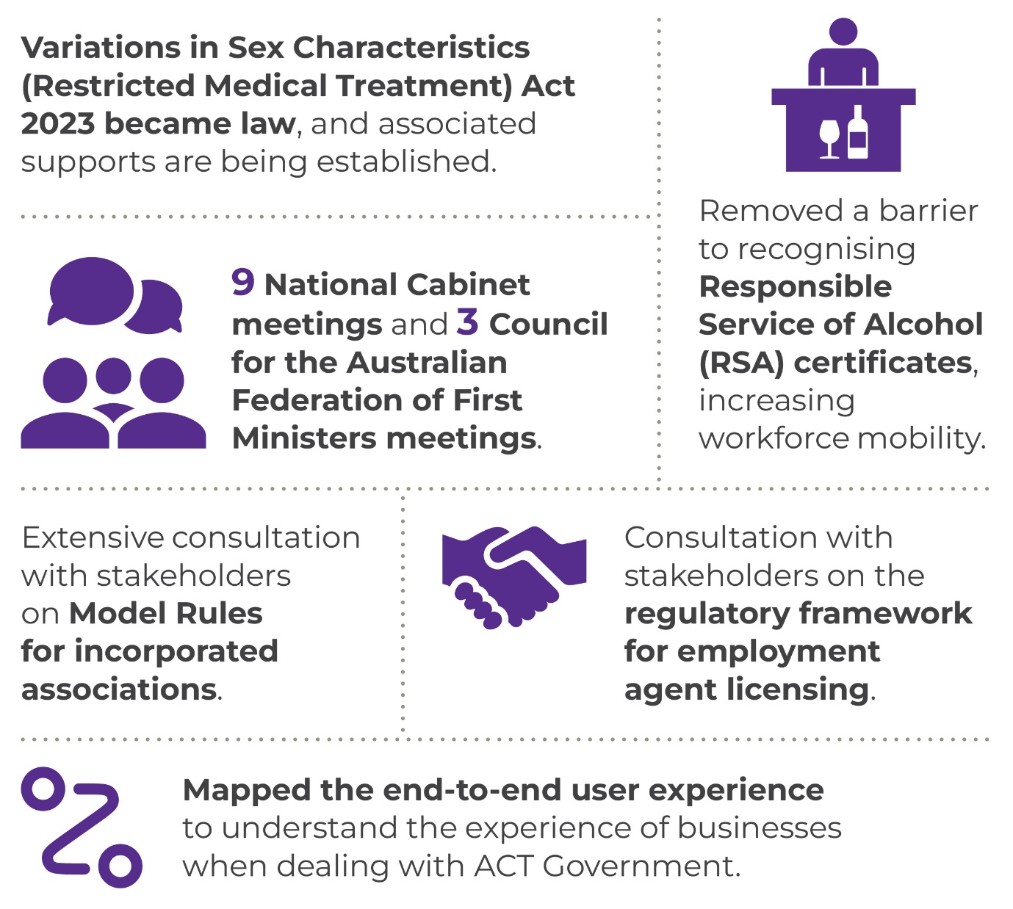
In 2022-23, we delivered a range of projects including:
- Through the Office of LGBTIQ+ Affairs, we finalised the first reform of its kind in the southern hemisphere to enhance care and legal protections for people with variations in sex characteristics (or ‘intersex’) and their families. This reform included a regulatory innovation confirming that intersex people must not be harmed by inappropriate medical interventions, and be able to make their own decisions about medical treatments that affect their bodies. The new law came into effect on 23 June 2023.
- Work also progressed on the evaluation of the Capital of Equality Strategy, including the first LGBTIQ+ Capital of Equality community survey dedicated to obtaining views from the ACT LGBTIQ+ community about the ACT Government’s progress towards becoming the most welcoming and inclusive city in Australia, feelings of inclusion and experiences of discrimination. A total of 427 valid survey responses were collected.
- Wellbeing was further embedded in the ACT Budget process, a strategic partnership with the Australian National University was announced to undertake analysis of the drivers of wellbeing outcomes, and work continued on strengthening the public sector performance reporting and accountability arrangements in the context of wellbeing. An update of the ACT Wellbeing Data Dashboard also commenced.
- We delivered a review of procurement, legislation, and administrative procedures with a small and medium enterprise (SME) lens. This included reviewing the Local Industry Participation Plan to ensure that it is meeting its intended outcomes.
- We conducted a range of actions to better understand business. We mapped the end-to-end user experience of a range of food and drink businesses, such as cafés, restaurants, takeaway food services, pubs, taverns, bars, food trucks, and pop-ups. By better understanding the processes businesses need to complete to comply with ACT regulations, we will be able to refine our regulatory system to address the pain points and take advantage of opportunities. Having a complete picture of the ‘journey’ of businesses from their start to when they’re well established means we can identify where best to reform regulation.
- We progressed the development of a night-time and entertainment economy (NTE) regulatory quality framework approach by reviewing existing policy, legislative, regulatory and process requirements for the NTE. So far, our completed actions include the development of a draft vision for the night-time economy for consultation and supporting Environment, Planning and Sustainable Development Directorate to establish a City Centre Entertainment Precinct in the Territory Plan.
- A barrier to recognising interstate Responsible Service of Alcohol (RSA) certificates was removed by amending the Guidelines instrument. Now an interstate RSA certificate holder need only complete an ACT refresher course instead of the full course, making it easier to work in the ACT.
- The new Cabinet room located in the ACT Government office block at 220 London Circuit was commissioned and has been operational since October 2022.
To support records management capability and open access to government information we:
- Continued the implementation of a five-year plan for improving the maturity of records and information capabilities across the ACTPS. This included building on Information Awareness Month as a focus for activities promoting the importance of good records management, and finalising of standardised content for records management induction programs across government.
- Connected our ACT Memory database of ACT government archives to the National Library of Australia’s Trove service, making it much more widely discoverable by the community. We also commenced the process of adding thousands of additional records descriptions to the database, catching up on the backlog of publicly available material accumulated before ACT Memory’s 2022 launch.
- Further developed our annual agency recordkeeping maturity self-assessments, setting targets for continuous improvement.

Our other activities in 2022-23 included:
- establishing the annual Senior Officials’ Dialogue under the ACT-NSW Memorandum of Understanding for Regional Collaboration to provide a whole of Government ACT-NSW engagement mechanism for prioritisation of action on cross-border issues.
- jointly releasing the Canberra Region Economic Development Strategy with the NSW Government and Canberra Region Joint Organisation (CRJO). This Strategy provides a prospectus for collaboration on shared economic development priorities across the Canberra Region.
- releasing two updates to the ACT Infrastructure Plan, setting out the Government’s infrastructure priorities in the Entertainment, Arts and Sports and Health sectors.
- reviewing regulatory settings for short-term rental accommodation and supported Procurement ACT to review the Canberra Region Local Industry Participation Policy.
We continued to progress work from previous years, including:
- coordinating the Parkwood Urban Release Area Governance Steering Committee to facilitate ongoing cooperation and negotiation on the provision of government services and infrastructure to the Parkwood development.
- supporting the delivery of services to Jervis Bay Territory under an existing Memorandum of Understanding (MoU) with the Commonwealth Government.
- supporting the ACT’s participation in the Council of Capital City Lord Mayors (CCCLM), who advocate on behalf of Australia’s capital cities.
- engaging with the NSW Government and local councils on issues that impact the Canberra Region. This has included supporting implementation of the ACT-NSW MoU on Regional Collaboration between the NSW and ACT Governments and continuing to work with local councils as an associate member of the CRJO.
- supporting the ACT Government’s engagement with National Cabinet; in 2022-23, we provided strategic advice, including on COVID-19, health sector reform and skills and migration and administrative support for the Chief Minister and Head of Service’s attendance at nine meetings of the National Cabinet. We also supported the Chief Minister at three meetings of the Council for the Australian Federation.

Coordinator-General for the Whole of Government (Non Health) COVID-19 Response
The ACT Government established the role of Coordinator-General, Whole of Government (Non-Health) COVID-19 Response (Coordinator-General) in March 2020. The ACT's whole of government emergency arrangements continued throughout 2021-22 and into 2022-23 to respond to the complex and dynamic nature of COVID-19.
Until February 2023, the Office of the Coordinator-General, Whole of Government (Non-Health) COVID-19 Response sat within the Policy and Cabinet Division and also supported the ACT’s engagement with National Cabinet and the National Coordination Mechanism of National Cabinet.
The role of the Coordinator-General drew together the efforts of all directorates and agencies, ensuring health and non-health related COVID-19 work was aligned, and responses were well-coordinated and working efficiently. The Coordinator-General maintained sound governance, decision-making and other processes, and supported a strategic approach on longer term issues.
In 2022-23 the Coordinator-General worked closely with all directorates and agencies, including:
- planning, through the Strategic Board and Coordinator-General’s Group, for different scenarios that could unfold in response to COVID-19, allowing consideration of the business continuity, health, economic and social implications of different approaches.
- driving whole of government responses to issues such as the continued vaccine rollout, managing the resilience of the ACT’s health system and transitioning the ACT to COVID-normal settings. Through the Coordinator-General, the ACT worked closely with other directorates, the Commonwealth and other states and territories in discussing matters of national significance.
The cross-government forum, the Coordinator-General’s Group, continued to review administrative processes and practices across government throughout the COVID-19 Public Health (COVID-19 Management) Declaration until it was lifted on 28 February 2023.
In 2022-23 the Coordinator-General engaged with national efforts to review the federation architecture, support the health system, develop national productivity priorities, assisted in addressing the skills shortage and continued to coordinate the ACT’s response to the ongoing challenges associated with the transition to COVID normal.
Following the lifting of the Public Health (COVID-19 Management) Declaration, the Coordinator-General’s Group was replaced by the Deputy Director-General’s Group led by the Deputy Director-General Policy and Cabinet, which continues to support information sharing and whole of government coordination on priority issues. These include broader ACT Government engagement in national priorities agreed by the National Cabinet.

Coordinator-General for Climate Action
The Parliamentary and Governing Agreement (PAGA) for the 10th Legislative Assembly includes an ambitious agenda for climate action in the ACT. To meet this agenda, the ACT Government established the Office for Climate Action (the Office) in 2021 to oversee the delivery of major projects, coordinate activities across government and identify ways to increase climate adaptation and resilience.
The Office has provided effective oversight of the delivery of key climate commitments during 2022-23, including:
- maintaining a cross-directorate Climate Action Steering Committee to oversee implementation and provide strategic advice and coordination relating to transport, fossil fuel gas transition and energy, household and community energy efficiency, and resilience and adaptation climate initiatives;
- supporting the Climate Action Subcommittee of Cabinet (CASC) in its role as secretariat and working collaboratively across directorates to develop and bring forward items for consideration;
- coordinating the Strategic Board Climate Action Subcommittee to discuss cross-cutting risks to the delivery of commitments and to ensure CASC materials provide sufficient information to support Cabinet deliberations on climate policy issues;
- support of the ‘Make your next choice Electric’ tool, helping the ACT Community to plan their electrification journey for when it’s right for them;
- completing a whole of government climate change risk assessment, to understand climate risks to government and inform policy and planning on adaptation;
- producing a whole of government adaptation framework;
- leading the delivery of key climate action initiatives with the Environment, Planning and Sustainable Development Directorate (EPSDD), including the continued delivery of the Sustainable Household Scheme and implementation of the Big Canberra Battery project;
- leading an initial program to upgrade insulation and undertake gas appliance replacement in 113 public housing properties under the Vulnerable Household Energy Support Scheme with the EPSDD and the Community Services Directorate.
As we move into 2023-24, the Office will focus on supporting the delivery of outstanding PAGA commitments around phasing out fossil fuel gas and achieving progress towards the ACT’s ultimate goal of net-zero emissions by 2045. This includes focusing the Sustainable Household Scheme on replacement of gas appliances, coordinating the delivery of the $50 million Vulnerable Household Energy Support Scheme, expanding Electric Vehicle public charging infrastructure and Zero Emissions Vehicle uptake in the ACT, and developing an Integrated Energy Plan to support the ACT’s electrification pathway to net-zero.
We will continue to work across government to embed adaptation planning and risk management into our operations, while undertaking analysis to understand optimal emissions reductions opportunities for the Territory, building resilience while achieving our objectives.

Future direction
In 2023-24, we will continue to support the Government by regularly advising Cabinet on the development, agreement to and implementation of ACT Government policies and programs.
We will continue to support the ACT’s intergovernmental relationships and forum participation by:
- engaging with the NSW Government and local councils on matters that impact the Canberra Region, including collaboration through the CRJO, and negotiating the development of refreshed priorities under a new ACT–CRJO Memorandum of Understanding;
- working with the Australian Government on service delivery to Jervis Bay Territory;
- working with the Australian Government and other relevant parties on matters relating to Canberra’s status as the National Capital;
- completing the staged update of the ACT Infrastructure Plan through the release of successive sector updates; and
- supporting the participation of the Chief Minister, Head of Service and other senior officials in intergovernmental forums such as National Cabinet, the Council for the Australian Federation, the First Secretaries Group and First Deputies Group.
We will continue to oversee implementation of the ACT Government’s Capital of Equality strategy, by:
- finalising subordinate legislation under the Variations in Sex Characteristics (Restricted Medical Treatment) Act 2023 and transitioning policy authority to the Health Directorate;
- overseeing implementation of the Second Action Plan for the Capital of Equality strategy, to further improve the wellbeing of LGBTIQ+ Canberrans;
- providing grant funding to support and strengthen Canberra’s LGBTIQ+ communities; and
- finalising an evaluation of the Capital of Equality Strategy to inform future work for LGBTIQ+ Canberrans.
To continue the delivery of key climate action initiatives in 2023-24 we will:
- develop, in collaboration with EPSDD, an Integrated Energy Plan to support the ACT’s transition to net-zero emissions via an electrification pathway;
- support EPSDD to make a regulation to prohibit new gas connections being made in most parts of the ACT;
- develop tools and guidance to better assess the emission abatement potential of climate action proposals, to enable the Government to make more informed and strategic decisions relating to the design, development and prioritisation of emission reduction initiatives;
- continue to implement the highly successful Sustainable Household Scheme, including delivering an $80 million funding extension that refocusses the Scheme on helping ACT residents to electrify their homes, and partnering with the Australian Government to support solar on multi-unit residential developments through rebates and zero interest loans;
- coordinate the delivery of the $50 million Vulnerable Household Energy Support Scheme which will improve building efficiency and sustainability for community and public housing, and low-income owner-occupiers, to reduce their home energy consumption and support resilience; and
- work with our selected suppliers on the delivery of a 250-megawatt (MW), 500 megawatt-hour (MWh) battery storage facility in Williamsdale, and 11 behind-the-meter batteries at government sites including schools and maintenance depots. These batteries, to be delivered as part of the Big Canberra Battery project, will increase energy security and reliability for Canberrans, further ease the pressure on the network and put downward pressure on electricity prices.
We will continue delivering the government’s Better Regulation Agenda by:
- reviewing existing policy, legislative, regulatory and process requirements for the night-time economy;
- in parallel, continuing to put in place the best settings for business recovery, longer-term growth and regulation in the ACT. We will work to further improve regulatory arrangements in the ACT, including how statutory declarations and deeds are executed, employment agents’ licensing framework, and finalise Model Rules for incorporated associations with an updated User Guide;
- partnering with the Australian National University School of Regulation and Global Governance to undertake a pilot project to test a methodology to measure the value and burden of existing regulation for certain business types. In the first instance, these will include food and drink businesses and health and fitness businesses.
- through delivering the Better Regulation Agenda, facilitating clear and open communication between business and government on regulatory issues, supporting a One Government approach.
To continue implementation of the ACT Wellbeing Framework, we will:
- operationalise a strategic partnership with the Australian National University that will analyse the drivers of wellbeing outcomes in the ACT;
- continue to embed wellbeing in our decision-making processes, including considering the use of metrics in assessing the relative merit of wellbeing proposals;
- continue to consider the strengthening of our public sector performance reporting and accountability arrangements in the context of wellbeing; and
- continue our partnership with the University of Canberra in analysing and understanding the wellbeing of Canberrans through survey-based engagement.
We will continue to improve archives, records and information management maturity by:
- commencing a skills analysis to inform future capability development planning; and
- embedding new arrangements to increase the efficiency of the management of and access to ACT Government archives.
Further information | Leesa Croke, Deputy Director-General, Policy and Cabinet
 | (02) 6207 3751 | Leesa.Croke@act.gov.au

Output 1.2 Workforce Capability and Governance

Overview
Through this output the directorate provided an employment and policy framework to support a professional, skilled and accountable public service that is responsive to the ACT Government and the community. The directorate also managed whole of government capacity building programs.
The directorate delivered this output by:
- developing and reviewing whole of government employment policies, regulations and standards and providing industrial relations services to support better employment practices;
- leading, supporting and co-ordinating enterprise bargaining, enterprise agreement implementation and application across the service;
- developing a whole of service vision for the ACTPS including workforce models and supporting culture and practices;
- delivering a whole of service survey every second year so that workforce trends and patterns inform strategic decision making;
- completing strategic whole of government projects and building the strategic capability of the service;
- supporting and coordinating workforce planning and capability development across government, including through whole of government leadership and talent strategies, and delivery of whole of government learning and capability development programs;
- driving transformational and cultural change towards more flexible working environments and work force practices, including the transition of the workforce currently operating from Winyu House;
- developing and implementing ACTPS capacity building programs, including attraction and development programs for graduates, and programs that attract, engage, develop and retain diverse talent;
- building the leadership capability of the ACTPS through the delivery of targeted SES programs;
- maintaining and monitoring whole of government ethics and accountability frameworks;
- supporting the Head of Service, the Public Sector Standards Commissioner, the Public Sector Workers Compensation Commissioner, the ACT Remuneration Tribunal, the Strategic Board and its sub-committees and the Secure Local Jobs Code Ministerial Advisory Council;
- implementing the Ethical Treatment of Workers Evaluation, managing the Secure Local Jobs Code certification scheme, assisting Territory entities and tenderers to meet their legislative obligations under the Code and undertaking education and awareness raising activities on the implementation of the Code; and
- developing and implementing a Secure Employment Framework across the ACT Public Sector to build the capability and expertise of the Public Sector and further solidify the role of the ACT Government in modelling good employment practices.

Performance

Accountability indicators
6 met or exceeded 2 not met
We met or exceeded six of our accountability indicator targets against this output. We exceeded our targets for:
- 1.2g – Issue Secure Local Jobs Code Certificates within five working days – (99.7 per cent met the timeframe following receipt of complete and correct audit report).
- 1.2h – Conduct SLJC Training sessions for industry and ACT Government (47 training sessions were conducted in 2022-23)
We did not meet our accountability indicator target for:
- 1.2a – ACTPS Graduate Program positively impacts on business area outcomes and objectives. We achieved a result of 73 per cent against a target of 75 per cent due to a change in the way supervisor satisfaction was calculated.
- 1.2d – Conduct entry level diversity and inclusion programs. The indicator will be considered achieved if 85 per cent of the participants complete their program. The result for 2022-23 reflects the activity for the Vocational Employment Program (VEP) in 2022-23 which was primarily focused on conducting a comprehensive review of the program and developing an improved program that provides access to more diversity groups. The last VEP intake was in 2020-21 and these program participants completed in 2021-22. There were zero active participants in the VEP for the majority of 2022-23 until the commencement of the new intake in June 2023. Thirteen participants have commenced in this new intake, who will form the basis for reporting on this indicator in 2023-24.

Highlights
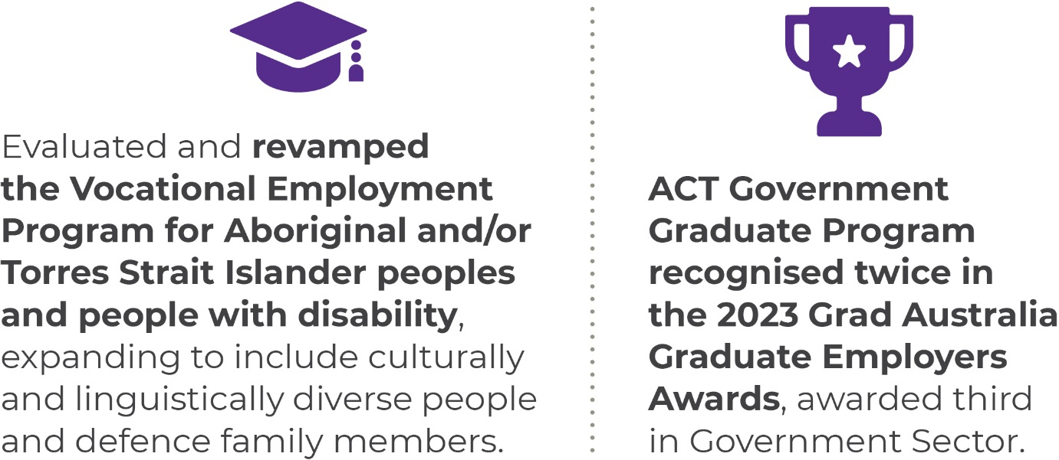
In 2022-23, we finalised the negotiation of the Common Core Agreement which forms the basis of ACTPS Enterprise Agreements. The agreement provides competitive pay increases, increases to superannuation, a new minimum full-time equivalent salary by December 2024, increased leave provisions (including an additional six weeks birth leave), a commitment to hybrid work arrangements, flextime for SOGA/SOGB and equivalent employees and increases to allowances.
We strengthened workforce diversity and inclusion in the ACTPS by:
- launching a SharePoint site which serves as a hub of information and resources on diversity, inclusion and belonging, and an Inclusion Terminology Guide which details best practice diversity and inclusion language for use in workforce contexts;
- providing LGBTIQ+ awareness and allyship training to ACTPS staff;
- providing e-learning to staff across the service on Aboriginal and Torres Strait Islander cultural awareness;
- coordinating the redesigned 2023-24 Vocational Employment Program (VEP) which led to the hiring of 13 staff members across the ACTPS from diverse backgrounds;
- coordinating ten fully funded placements for staff members of diverse communities in the Queensland University of Technology Public Sector Management Program;
- being awarded Soldier On’s Platinum Pledge Partner Status in recognition of the ACTPS as a veteran friendly employer;
- increased resources to support the recruitment, retention, and development of Aboriginal and Torres Strait Islander employees by:
- establishing two whole of government Aboriginal and Torres Strait Islander cultural advisors;
- improving the Aboriginal and Torres Strait Islander Graduate experience, including:
- a revised Graduate Employee value proposition and marketing package to highlight the importance of Aboriginal and Torres Strait Islander Graduates’ heritage in the future of the ACTPS;
- enhanced Graduate program promotion within Aboriginal and Torres Strait Islander education & recruitment networks;
- improved Aboriginal and Torres Strait Islander cultural safety in Graduate recruitment processes;
- coordinated access at onboarding to ACT and ACTPS Aboriginal and Torres Strait Islander employee networks including the Yarning Brew Network; and
- delivered dedicated Aboriginal and Torres Strait Islander cultural awareness learning and development modules to all graduates within the cohort.
To address future workforce needs and build capability in the ACTPS we:
- continued to grow and improve the ACT Government Graduate Program to support young people to find jobs in the community, create a key capability pipeline into the Service and attract, select and retain skilled graduates.
- 108 Graduates commenced the 2023 ACTPS Graduate Program on 6 February 2023, representing a program growth of 157 per cent over the last three years.
- A Graduate Talent Bank program supported the ACTPS to employ an oversupply of talented graduates and coordinated their placement into permanent roles during the ten-month Graduate Program. The Talent Bank Program employed 25 Graduates commencing in 2023, with eight placed in critical roles prior to program commencement in February.
- delivered leadership programs for 39 executives;
- managed the Learning Management System to enable booking, and attendance/completion of more than 40 face to face learning experiences (with 1400 attendees) and 69 e-learning courses (21,000 completions); and
- delivered the ACTPS Employee Survey in March 2023 and achieved a 63 per cent overall response rate. The survey results inform whole of service workforce insights and high priority workforce initiatives.
As part of coordinating enterprise bargaining and enterprise agreement implementation, we:
- successfully balloted the Infrastructure Services Enterprise Agreement. This agreement has since been approved by the Fair Work Commission.
- worked with directorates to finalise schedules for other ACTPS Enterprise Agreements.
To deliver this output in 2022-23 we also:
- continued to drive the adoption and enablement of flexible working across the ACT Public Service. We delivered three FlexiSpaces - high quality office environments accessible by ACTPS employees - in Tuggeranong, Belconnen and the City, as well as an Innovation Centre at the Canberra Nara Centre, designed to facilitate collaboration, learning, workshops and other problem-solving activities;
- continued to provide secretariat support to the ACT Remuneration Tribunal in reviewing remuneration, allowances and other entitlements for Members of the Legislative Assembly, full-time Statutory Office Holders, Executives, the Judiciary and Part-time Public Office Holders as part of their Spring and Autumn sittings;
- delivered the ACT Public Service Awards for Excellence;
- prepared the 2021-22 State of the Service Report, which provides an account of the management of the ACT Public Service during the reporting period 1 July 2021 to 30 June 2022;
- supported the passage of the Financial Management Amendment Bill No.2 2021, which passed the Assembly on 29 June 2023. This provides the legislative basis for the delivery of the ACT Government’s secure employment framework.
- in consultation with members of the ACTPS and ACT Unions, prepared policy material to support the operation of the secure employment framework;
- supported the operation of the Secure Workforce Conversion Policy, which provides a framework for converting casual and temporary ACTPS employees to permanent employment after 12 months of service;
- provided a review of full time Territory statutory office holders; and
- implemented the Ethical Treatment of Workers Evaluations, to strengthen procurement practices and legislative changes to support monitoring compliance with the Code.

Professional Standards Unit
The office of the independent Public Sector Standards Commissioner (PSSC) is established under the Public Sector Management Act 1994 (PSM Act). The PSSC is independent of the ACT Public Service and the ACT Government, meaning the PSSC is empowered to decide when and how to manage complaints, conduct investigations, and inspect or enquire into the operations of any part of the ACT Public Service, as set out in the PSM Act.
The directorate supports the functions of the PSSC through the Professional Standards Unit (PSU), which reports to the PSSC on complaints and independent investigations in relation to misconduct matters. During the 2022-23 financial year, the PSSC referred 104 misconduct-related matters to the PSU for investigation or management. This represents a 30 per cent increase from the previous financial year (See figure 1).

Figure 1: Misconduct matters referred to the PSU by financial year
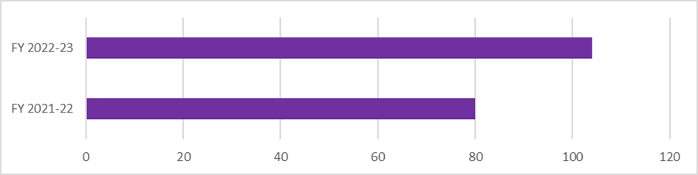
Year to year the number of referrals is dynamic either increasing or decreasing due to a number of factors, for example, of the 114 matters, 19 cases related to seven incidents/issues (i.e. seven incidents alleged to have involved 19 people).
An increase in referrals does not necessarily equate to an increase in misconduct across the Service. Of the 114 matters referred to the PSSC during 2022-23, there were 52 findings of misconduct, compared to 51 during 2021-22. When viewed against the totality of employees in the ACTPS, this number represents a very small portion of the workforce.
The two most prevalent reasons for commencement of a misconduct process across the ACT public sector during 2021-2022 and 2022-2023 were ‘failure to treat people with courtesy, sensitivity and respect’ and ‘fidenceailure to do the public servant’s job with reasonable care and diligence’. Matters involving failure to treat people with courtesy, sensitivity and respect increased by 38 per cent from the previous year, and failure to do the public servant’s job with reasonable care and diligence matters increased by 56 per cent.
Figure 2: Nature of alleged misconduct across the ACT public sector by financial year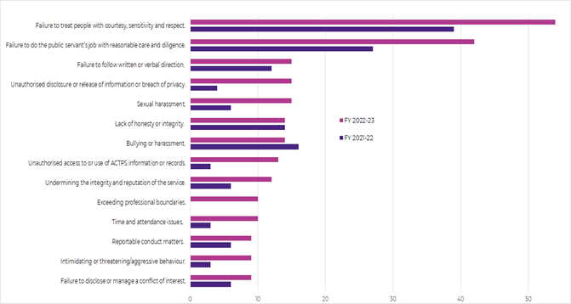
Note: only the most frequently received allegations are listed.
During the reporting period, the PSU observed an increase in the number of matters involving ‘unauthorised access to, use of, or disclosure of official information’ and sexual harassment. Given this observation, the PSU will continue to work with directorates and public sector entities to support the development and revision of policies relating to this issue.
The PSU completed 71 comprehensive reports for delegates, including 60 investigation reports and 11 admission statements, in accordance with relevant enterprise agreements. In addition, five investigation reports were completed by external investigation services, which were overseen by the PSU.
The PSU completed 80 per cent of its investigations in an average of 82 adjusted workdays (adjusted for delays beyond the control of the PSU). Notably, the average timeframe for the PSU to conduct an investigation is lower than previous years despite the 30% increase in the number of referrals received this financial year (see Figure 3).
Figure 3: Average time taken by PSU to complete misconduct investigations by financial year 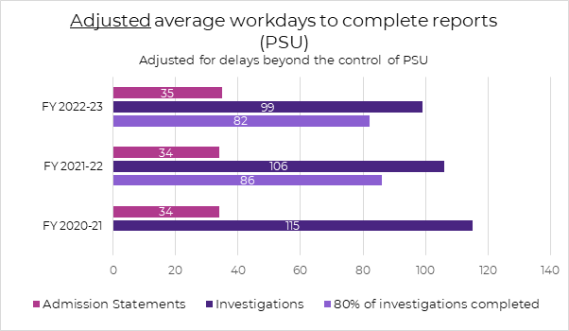
As in the previous year, some matters with significant delays continued to impact the total average time lapsed across an investigation (from notification to completion) which increased this year to 122 workdays from 116 workdays last year (see Figure 4). A number of factors contribute to the length of time between a referral being received by the PSU and an investigation being completed such as incomplete documentation, the availability of key witnesses, respondent un-fitness for duty/participation in an investigation process. The PSU is continuing to review the misconduct process to explore further efficiencies and refine processes to minimise delays where possible.
For comparison, Figure 4 also depicts the timeframe for PSU to conduct an investigation compared with the time taken for an external provider to complete an investigation. The PSSC may elect to utilise the services of an external investigation provider, where sensitivities suggest it is preferable to do so. In these circumstances, the PSU will oversight the investigation to support the provider to meeting the ACTPS misconduct process requirements and access to relevant witnesses/information.
Figure 4: Average workdays lapsed across investigations – not adjusted
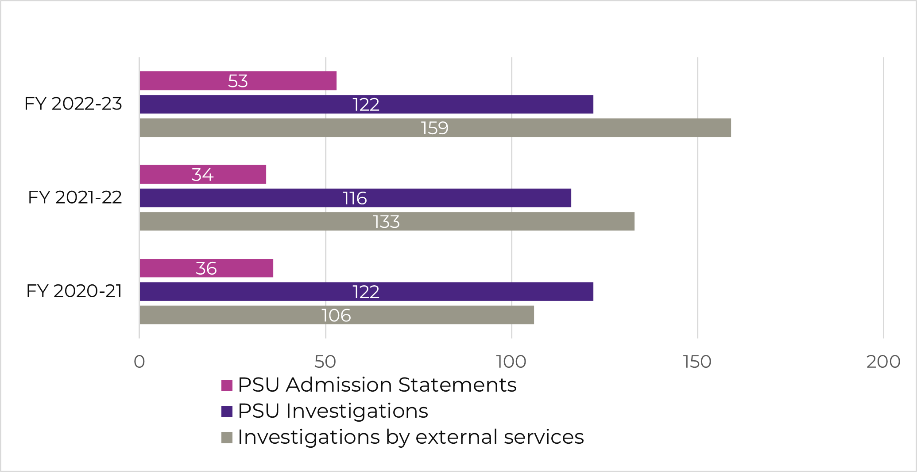
During the reporting period, the PSU commenced a review of the current Misconduct Guidelines and the Preliminary Assessment (PA) Guidelines in preparation for the implementation of new enterprise agreements.
The PSU continued to support employee relations teams throughout the ACTPS through regular communication, provision of timely advice and assistance concerning misconduct, integrity, and behavioural issues. This includes the development of supporting materials and tools for managers to assist them further in dealing with workplace issues.
In addition to providing support for misconduct and behavioural issues, the PSU piloted several integrity-related training initiatives including “Integrity in the ACTPS” which was delivered to Graduates and Vocational Employment Program cohorts, and “Integrity in Decision Making”. A training program for ACTPS managers in relation to the PA process is currently under development.

Future direction
In 2023-24 we will:
- facilitate leading edge and contemporary employment conditions for the current and future ACTPS workforce;
- deliver insights into the emerging needs of the ACTPS workforce and implement operational reform building on those insights (for example, the Secure Workforce Conversion);
- translate data and analytics into workforce insights that will drive high performance by channelling efforts into priority issues;
- complete strategic whole of government projects and build the strategic capability of the ACT Public Service;
- drive the hybrid and flexible work agenda including creating innovative workspaces and practices;
- guide cultural change across government to achieve greater collaboration and innovation in the delivery of the ACT Government’s priorities;
- lead whole of ACTPS senior executive leadership development including SES Induction, career development, leadership development and mobility to ensure the ACTPS has the required mix of leadership capabilities to support the ACTPS now and into the future;
- coordinate the ACTPS Graduate Program, including driving a national attraction campaign to attract top talent from across the country and supporting up to 70 graduates throughout three placements across the ACTPS; and designing and coordinating a contemporary program of learning and development;
- drive further growth of a diverse and inclusive ACTPS workforce through strategy development that brings employment targets and evidence based action together, and deliver employment programs that attract, engage, develop and retain diverse talent.
- finalise, launch and commence implementation of the inaugural ACTPS Gender Equity Strategy, following consultation, which reflects the unique challenges of the ACTPS, drives systemic change, and positively impacts economic outcomes for women;
- implement programs to support the attraction, retention and development of Aboriginal and Torres Strait Islander staff, and to enhance cultural awareness and understanding across the Service; and
- implement recommendations from the Ethical Treatment of Workers Review and continue to ensure Secure Local Jobs Code measures are administered in accordance with the legislation.
Further information | Geoffrey Rutledge, Acting Deputy Director-General, Office of Industrial Relations and Workforce Strategy
 | (02) 6207 5001 | Geoffrey.Rutledge@act.gov.au

Output 1.3 Coordinated Communications and Community Engagement

Overview
Through the Coordinated Communications and Community Engagement output the directorate delivers, communicates and engages with the community and provides protocol services and digital and web support to the ACT Government and community.
Communication and Engagement delivers this output by:
- ensuring coordinated communications to the Canberra community in times of Territory emergency;
- informing Canberrans about programs, policies and services through the ACT Government’s priority channels, including Our Canberra, ACT Government Facebook, Twitter and LinkedIn and We Are CBR Instagram;
- delivering priority strategic communications and engagement activities for the Chief Minister and the directorate’s Ministers, including the coordination and delivery of priority public information campaigns and the provision of high-quality creative services for priority projects;
- providing research and insights services to inform government decision-making and ensure high quality communication campaigns in line with community expectations;
- coordinating and enhancing engagement activities through the YourSay Community Conversations platform and other methods of engagement;
- providing proactive and reactive information to third parties, including the media;
- preparing an annual whole of government communications and engagement plan to outline the government’s priority public information campaigns and engagements;
- providing honours and awards, ceremonial and protocol services to the Chief Minister.

Performance

Accountability indicators
3 met or exceeded 1 not met
We met or exceeded three of our accountability indicator targets against this output, exceeding our target for:
- 1.3a – Annual number of ACT Government digital mail newsletters. We distributed 26 newsletters against a target of 22 due to additional editions being distributed across December and January, and during delivery of the 2023-24 ACT Budget.
- 1.3b – Annual number of ACT Government Our Canberra newsletters. We distributed 11 newsletters against a target of 11.
- 1.3c – Annual whole of government Communications and Engagement Plan. We delivered and published this plan on the Our Conversations webpage on the YourSay website, meeting our target.
We did not meet our target for:
- 1.3d – Annual number of YourSay Community Panel surveys conducted. We conducted 10 surveys against a target of 16. Fewer surveys were conducted due to a change in service offering which included more in-depth analysis of the surveys completed and the addition of qualitative research services.

Highlights
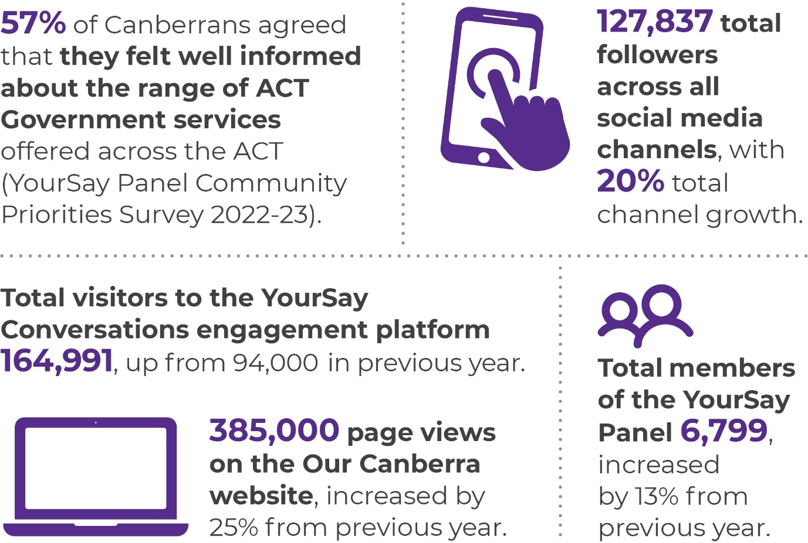
Across 2022-23, the YourSay Panel grew to almost 6,800 Canberrans, with strong engagement on all surveys. This included the highest ever response to a YourSay Panel survey about voluntary assisted dying, as well as community input into the ACT Women’s Plan, Canberra’s nightlife, swimming pool safety reform, and wood heaters. The Panel enables the collection of statistically representative data to better understand the behaviours and attitudes of Canberrans, which impact the decision-making processes of government. The annual Community Priorities survey was completed by over 2,000 members in 2022-23, and identified key priorities and issues the community would like the ACT Government to focus on.
The Our Canberra print and digital newsletters, as well as the accompanying website, supported direct communication with Canberrans on ACT Government news, programs and services, via:
- a news-focused website, which received over 385,000 page views in 2022-23 (up 25 per cent on 2021-22);
- a monthly regionalised newsletter to almost 200,000 Canberra households; and
- a digital newsletter delivered to approximately 46,000 subscribers, which received more than 160,000 clicks in 2022-23.

Table 7: E-newsletter performance in 2022-23
 | Our Canberra E-newsletter 22-23 (% change from 21-22) | Industry average 2023
Open Rate | 50.59% (-5%) | 41.23%
Click through rate | 8.55% (+22%) | 7.86%
In 2022-23 we continued to manage and grow the ACT Government’s primary social media accounts.

Table 8: Social media performance in 2022-23
Social media platform | Followers (% change from 2021-22) | Average monthly impressions
Facebook | 55,112 (+25%) | 1,382,160 (+7%)
Twitter | 22,456 (+2%) | 87,263 (-45%)
LinkedIn | 29,182 (+17%) | 98,444 (+5%)
Instagram | 21,087 (+30%) | 250,786 (+45%)
We also managed the Government’s online engagement website, YourSay Conversations. The website welcomed over 1,600 new members in 2022-23, an increase of over 10 per cent compared to the previous year, growing total members to 17,098. Visitation also grew significantly from 94,000 visitors in 2021-22, to almost 165,000 visitors in 2022-23.
In 2022-23 CMTEDD supported directorates and agencies to deliver 81 engagement activities on the YourSay Conversations platform. Of these, six engagement projects were directly managed by CMTEDD and included ACT Fuel Check, Budget Consultation, Women in Construction and future sporting facilities engagement.
In 2022-23, we continued our focus on ensuring the community was well informed about ACT Government policies, programs and services and that directorates were supported to communicate with a consistent approach.
Aligning with the One Government, One Voice communications approach, we supported business areas across CMTEDD and other directorates with the delivery of priority engagements and public information campaigns, including:
- leading the communication program for the Government’s approach to climate action, in collaboration with the Office of the Coordinator-General for Climate Action and other directorates. This included the development of the ‘make your next choice electric’ campaign under the Everyday climate choices brand.
- advising on engagement projects such as the ACT Planning System Review and Reform, Voluntary Assisted Dying, Stromlo Forest Park Tracks and Trails Masterplan, and other health and infrastructure engagement activities;
- leading the communication program for the 2022-23 ACT Budget;
- delivering a single Infrastructure narrative for the community through the Built for CBR campaign and website;
- leading the development of a communications framework to support cross-directorate communication activity on key projects within the ACT Infrastructure plan;
- ongoing coordination of the project to establish the Territory Coat of Arms;
- helping our community access government services available through Access Canberra; and.
- continued support and funding for the ACT’s eight community councils.
To deliver this output in 2022-23 we also:
- supported the independent review of campaign advertising under the Government Agencies (Campaign Advertising) Act 2009;
- increased our research capability and offering to include qualitative research, to provide a strengthened evidence base for priority communication campaigns;
- delivered the 2023 ACT Australian of the Year Awards, the Chief Minister’s Canberra Gold Awards, the Canberra Citizen of the Year Award and the ACT Honour Walk induction; and
- supported the delivery of the Order of Australia honours, including the Public Service Medal.

Future direction
In 2023-24 we will continue to lead a coordinated approach to communicating and engaging on the Government’s priorities for the ACT community. We will also continue to:
- lead and support communications as part of the Government’s response in times of Territory emergency;
- progress the One Government, One Voice communication approach by continuing to shape the way priority campaigns and creative services are delivered, including on ACT Government priorities, such as climate action, cost of living and infrastructure;
- increase engagement and reach of priority ACT Government social media channels and the Our Canberra Print, e-newsletter and website;
- improve our digital communications channels to make information clear and simple and improve the user experience for the community;
- support the ACT Government by seeking the views of our community to inform the development of policies and programs via the YourSay Community Panel and YourSay Community Conversations website;
- enhance the YourSay Community Panel by increasing membership and broadening its demographic bases;
- deliver and evaluate a Fostering Neighbourhood Democracy pilot, to improve local community connections and resilience; and
- coordinate a series of priority honours and awards processes as well as providing protocol advice and support to the Chief Minister and Head of Service.
Further information | Trish Johnston, Executive Group Manager, Communications and Engagement
 | (02) 6207 2644 | Trish.Johnston@act.gov.au

Output 1.4 Digital Strategy

Overview
Through the Digital Strategy output the directorate drives the digital transformation of government services and provides advice, support and project delivery on digital strategy development and implementation.
The directorate delivers this output by taking advantage of digital and data to achieve:
- better services for the community;
- greater engagement and better outcomes for business and academia;
- more sustainable and efficient government; and
- a more productive, engaged and learning workforce.

Performance

Accountability indicators
0 met or exceeded 3 not met
We did not meet the following indicators:
Output 1.4a ACT Data Analytics Centre. We achieved a result of 4 against a target of 6. The ACT Data Catalogue has been created as a trial using the Data Hub, however, more work is required with directorates to fully populate the key government datasets. Delays in publishing an update to the Wellbeing Data Dashboard during 2022-23 have been experienced. While data was able to be collected during this time period from data owners internal and external to government, there were unexpected delays in receiving around one third of the data, which subsequently impacted the preparation of the update within the 2022-23 financial year.
Output 1.4b the value delivered through technology investment improves. Three of the four targets have been met, however the outcomes for one target, whole of government Business Architecture, were only partially achieved. The need for whole of government architecture governance has been agreed across ACT Government. The establishment of the governance structure and the creation of the committee will occur early in 2023-24.
Output 1.4c delivery of joined up services achieve benefits for the community and for government. One of the two targets have been met. On 2 November 2022, Project Sponsors agreed to redirect activities to piloting the service with a different business area, following discovery of technical limitations that would prevent data matching to Digital Account records. Design work for the ‘Tell us Once’ and new pilot Service commenced mid-February with a view to delivery in early 2023-24.

Highlights
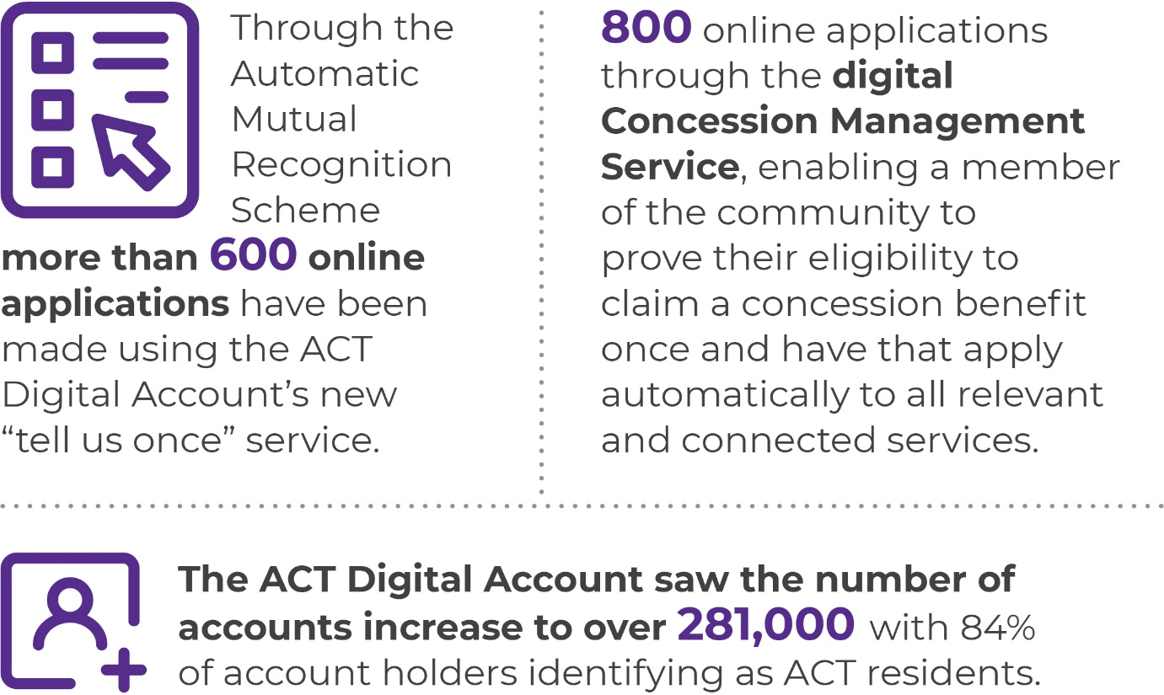
In 2022-23, we continued to embed the principles of the ACT Digital Strategy to provide a community centred approach to how we use technology to improve the quality of life for all Canberrans. This work involved working collaboratively across government to provide best practice advice on the design and delivery of two new digital initiatives – the Automatic Mutual Recognition Scheme and the Concession Management Service.
- Since July 2022, the Automatic Mutual Recognition Scheme has been available to workers who hold an occupational registration/licence in one State or Territory and want to work in the ACT – these workers no longer need to apply for separate registrations, only complete and submit a notification application through the ACT Digital Account. More than 600 online applications have been made through this service. Subsequent phases of this scheme will see information sharing between other States and Territories including validation of notifications and license conditions.
- The ACT Digital Program and ACT Revenue Office worked in partnership to pilot a Concession Management Service for three ACT Government Concessions – this service enables a member of the community to prove their eligibility to claim a concession benefit once and have that apply automatically to all relevant and connected services. This pilot has also enabled integrations with Centrelink and Veterans Affairs for real time concession checking. Over 800 online applications have been streamlined through this new service in the ACT Digital Account. The first group of three concession services released in July 2022 included:
- applications for rates rebate (for pension card holders);
- deferral of payments based on age (applicants over 65 years); and
- deferral of payments based on hardship.
In addition, the ACT Digital Program has been working on designing a number of new digital services including:
- a new digital enrolment and parent interaction capability in partnership with parents and the ACT Education Directorate; and
- seeking expert advice on technology options that could support the Territory’s Transport Licencing, Registration and associated services over the next 10 -15 years.
In 2022-23, the ACT Digital Account saw the number of accounts increase to over 281,000 with 84 per cent of account holders identifying as ACT residents. Forty-one per cent of ACT Digital Account holders took steps to uplift the level of identity assurance for their Digital Account, opening the opportunity to access services digitally rather than through face to face or phone channels.
In 2022-23, we continued to embed the principles of the ACT Digital Strategy to provide a community-centred approach to how we use technology to further improve the quality of life for all Canberrans. This work included:
- The Place Success Dashboard supporting the City Renewal Authority has continued to be maintained and extended. The dashboard is helping the City Renewal Authority to guide the urban renewal of Canberra City with a focus on social and environmental sustainability.
- Partnering with directorates and supporting the Technology Governance Group to provide guidance and advice on how to use the Best Practice Design and Delivery guide to meet the government’s strategic outcomes on key initiatives.
- Creating a whole of government view of projects and programs across government to support evidence-based consideration of future digital and technology priorities by the various governance forums, including the Technology Governance Group and the Budget Assessment Sub-Group.

Future direction
In 2023-24 we will deliver more digital services that provide real value to the community, including:
- expanding ACT Government’s ‘Tell us Once’ service to include change of address to enable ACT Digital Account holders to share, with consent, updated information in their account;
- continuing to broaden the digital Concession Management Service by enabling a concession or benefit to be verified using the individual's ACT Digital Account;
- continuing to grow the number of account holders and further enhance the citizen experience of the ACT Digital Account;
- continuing to support ACT Government directorates to implement the Whole of Government Data Governance and Management Framework, including to enhance data sharing across the service for public benefit. This includes working in partnership with directorates and the Data Reform Group to deliver key whole of government data management initiatives designed to support greater data sharing;
- making data discoverable through the implementation of a whole of government data catalogue referencing key government datasets and identifying data custodians and stewards, and the development of training materials to support data custodians and stewards in undertaking their roles;
- continuing to support national forums providing advice and guidance for the ACT’s leadership and participation in priority initiatives such as Birth of a Child, Digital Identity, National Data Sharing and Cyber Security initiatives; and
- building on the release of our Best Practice Design and Delivery guide in 2022-23, we will continue to develop and mature our design and delivery best practice to support the ACT Government to achieve better policy and service delivery outcomes, particularly for initiatives that have technology or data elements in their implementation. This approach includes engaging with industry to help support our design practice. We will continue to develop a whole of government view of programs and projects, and emerging demands to enable future prioritisation of technology or data initiatives, and to identify opportunities to develop and utilise shared capabilities to support whole of government solutions and deliver better services for our community.
Further information | Bettina Konti, Deputy Director-General, Digital, Data and Technology
 | (02) 6207 2242 | Bettina.Konti@act.gov.au

Output 1.5 International Engagement

Overview
The directorate, through the International Engagement output, supports the economic growth and diversification of the Canberra economy, and enhances Canberra’s global reputation as an innovative, creative, artistic, liveable and welcoming city.
The directorate delivers this output by:
- undertaking strategic leadership, oversight, development and delivery of a targeted program of international engagement activities, including Trade Missions, inbound delegations, export-promotion programs, and other activities that enhance Canberra’s economic welfare, international connectedness and reputation economically, culturally and socially;
- working with the Australian Government, including Austrade and its TradeStart program, the Canberra Business Chamber and other third parties, to make education and other export programs readily available to prospective and ongoing exporters;
- building relationships with the Canberra Diplomatic Corps for the purpose of nurturing relationships and connections supportive of exporting and enhancing Canberra’s international reputation;
- providing strategic leadership, oversight and coordination of inbound investment opportunities originating from target-market countries;
- continuing to build Canberra’s government-to-government relationships, including sister-city formal agreements;
- raising awareness of export and other opportunities within Canberra’s economic key areas of strength;
- ensuring alignment with our objectives to expand and diversify Canberra’s economy; and
- enhancing Canberra’s international visibility and reputation.

Performance

Accountability indicators
2 met or exceeded 1 not met
Output 1.5 had three accountability indicators each containing one measure. We met two of our targets for this output but did not meet our target for the following indicator:
- Output 1.5 b – Number of ACT businesses exporting because of essential support from the Office of International Engagement (OIE). Six businesses undertook export transactions as a direct result of assistance from OIE-related support, against a target of 10. Ongoing impediments to export flows, such as elevated air and sea freight costs, distorted supply-chain product flows and limited or costly passenger air travel extended the time horizon to successful exporting for many businesses. In addition, high inflation and global economic instability are weighing on business confidence in committing to expand operations at this time.

Highlights
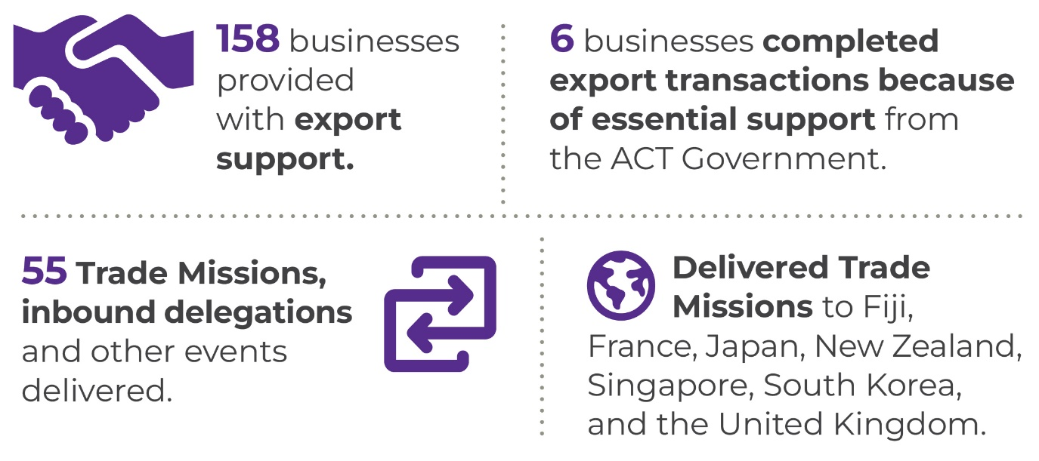
In 2022-23, we saw the continued opening of international borders, which enabled businesses to re-establish trade relations, as well as undertake new or expanded exports.
Through a range of targeted activities, the OIE also supported long-term export development and the advancement of Canberra’s international reputation as a premier place to work, invest, study, visit and live.
In 2022-23, the OIE delivered the following:
- Trade missions, to:
- New Zealand and Fiji – to re-establish direct flights, build opportunities for tourism, inbound investments and exports;
- Singapore – to advance aviation connection discussions, as well explore collaboration opportunities in tourism, renewable energy and the space sector;
- South Korea and Japan – to develop partnerships that advance our climate action and smart city agendas; and,
- France and the United Kingdom – to explore government-to-government links, export opportunities and business collaboration across multiple sectors.
- Inbound delegations – we facilitated 26 inbound delegations to raise the profiles of key economic areas of strength of the ACT, and bring other focused interest groups together for collaboration. For example, in March members of the ACT cyber and space sectors participated in business roundtables with counterparts from the United Kingdom and France, respectively.
- TradeStart Services – Canberra’s TradeStart Advisor provided strategic and tactical export advice to 84 businesses, provided referrals to additional Austrade services to select businesses, and facilitated other export-related events outside of the TradeStart program.
- Singapore Business Development Manager– our Business Development Manager supported 22 businesses and helped deliver seven events and meetings that supported export initiatives in the Singapore marketplace.
- Chief Minister’s Export Awards – the ACT Government continued to sponsor and support these annual Awards, which formally recognise excellence in international exporting and inspire other Canberra businesses to pursue their export ambitions. Category winners of these awards compete in the Australian Export Awards.
- Sister City Relationships – during 2022-23 the OIE continued to advise directorates and agencies on the protocols around developing formal international engagements, as described in the Sister-City and other International Agreements Framework. We continued to engage with the Canberra Nara Sister City Committee on a quarterly basis, to nurture Canberra’s relationship with Nara, Japan.
- Relationships with the Canberra diplomatic community – the OIE interacted with diplomatic missions in Canberra on economic, cultural and social matters, as well as in relation to the management of embassy properties.
- Local Business Commissioner – the OIE supported local businesses during the pandemic through the Local Business Commissioner.

Future direction
In 2023-24, the OIE will continue to broaden its outreach to businesses that are beginning export activity and those that are already established exporters. It will continue to advocate for the production and availability of detailed ACT services export data, to identify and more efficiently support our exporting community.
We will deliver the following priority initiatives:
- Trade Missions that support export development and export flows; attract inbound investment, visitors and tertiary students to the Territory; increase cultural and social connections; and enhance the international reputation of Canberra in general.
- events in Canberra and international markets that support our objectives. We intend to deliver a minimum of 20 events and Trade Missions in 2023-24, reflecting a gradual normalisation of international trade and travel.
- TradeStart Advisor services to a growing number of Canberra businesses that are ready for exporting or are already exporting in a normalising trade environment;
- ongoing export support to businesses through our Singapore Business Development Manager;
- the International Business Engagement Program, managed by the Canberra Chamber of Commerce, which educates and connects businesses to support their export journeys; and
- fund other export-support programs delivered by third parties.
Further information | Brendan Smyth, Commissioner for International Engagement CIE@act.gov.au

Output 1.6 Workforce Injury Management and Industrial Relations Policy

Overview
Through the Workforce Injury Management and Industrial Relations Policy output the directorate provided health and work sustainability solutions, focusing on risks arising from work and the relationship between employers and workers.
The directorate delivered this output by:
- managing ACT workers’ compensation, work health and safety and industrial relations regulatory and policy frameworks;
- supporting the Public Sector Workers Compensation Commissioner in the management of the Public Sector Workers Compensation Fund;
- developing and reviewing whole of government health, safety and rehabilitation policies and providing work health and safety services to support the policy framework;
- supporting workplaces to implement approaches to deliver good work for health and productivity;
- coordinating the Territory’s consultative bodies for industrial relations regulation, workers’ compensation and work health and safety; and
- administering the Loose Fill Asbestos Disease Support Scheme, on behalf of the Chief Minister, to provide financial assistance to people with an asbestos disease caused by living in a loose fill asbestos insulation (Mr Fluffy) contaminated home.

Performance

Accountability indicators
3 met or exceeded 1 not met
Three out of four accountability indicator targets for this output were met. The target for indicator 1.6b – Maintain consultative work injury management fora within the ACT was not met due to scheduling issues preventing achievement of the required quorum on one occasion.

Highlights
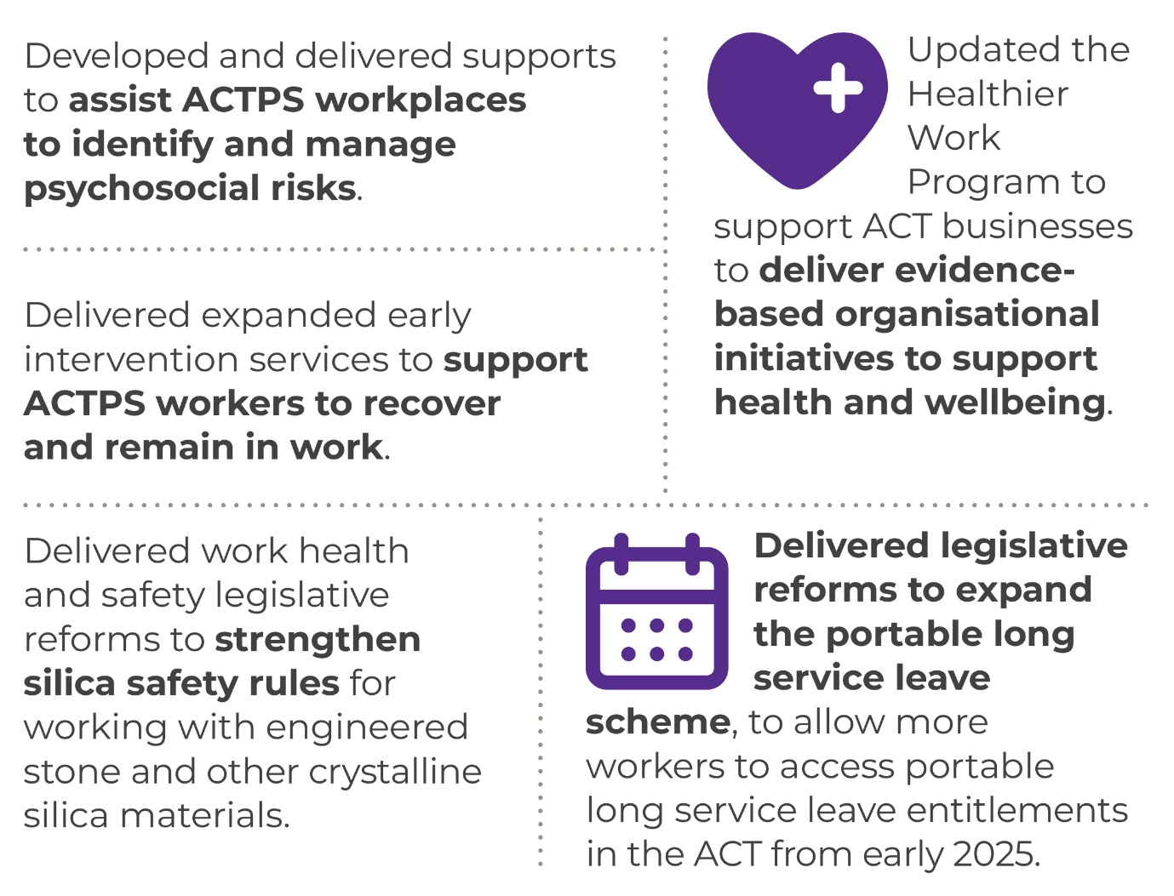
In 2022-23, we continued to review and update our approach to managing workplace risks associated with the COVID-19 pandemic to ensure that it remained responsive and appropriate to the changing situation. This included:
- developing an approach for the ACTPS to move to a staged response to better reflect the current situation and enable a swift response if the risk changes;
- a focus on supporting our workers to return to their usual workplaces; and
- reviewing and updating our guidance for changed work practices into our existing suite of resources and programs.
In 2022-23, we continued to improve whole of government approaches to support ACTPS workplaces to implement contemporary prevention, health promotion, early intervention, and work rehabilitation approaches to reduce the impact of illness and injury in our workplaces. We continued to develop our systems to support the delivery of WHS and work rehabilitation management for the ACTPS. We supported ACTPS directorates and agencies to monitor and review their systems through the continued delivery of the WHS Audit and Assurance program. We reviewed, updated and developed polices and guidance materials to deliver on our intent to deliver safe workplaces where our staff can participate fully and be productive.
We continued to support staff to safely access hybrid and flexible working arrangements through a suite of resources and programs to support physical and mental health and wellbeing.
The Healthier Work Program finalised a review of its Recognition Scheme and commenced the delivery of a rebranded and revamped program to better support employers to understand and implement evidence-based organisational initiatives to improve health and wellbeing outcomes.
In 2022-23, we also:
- worked closely with union and employer representatives to design changes to work health and safety laws to address exposure to silica dust, introduce sexual assault incident notification requirements and clarify that the ACT Legislative Assembly is a workplace;
- worked with union and employer representatives to develop work health and safety codes of practice for managing the risks of silica dust at work and managing psychosocial hazards at work; and
- expanded the coverage of the ACT portable long service leave schemes to workers in the hairdressing and beauty services sector and accommodation and food services industry from early 2025, following a two-year transition period.
The ACT Loose-Fill Asbestos Disease Support Scheme (the Scheme) provides financial support for people with an asbestos-related disease (and their families) from living in a loose-fill asbestos insulation (Mr Fluffy) affected property in the ACT. The Scheme, jointly funded by the Australian and ACT Government, was launched in March 2022.
Since its commencement, the Scheme has received nine applications from eligible persons seeking financial support and assistance, and acknowledged several notifications from persons seeking to register an intent to apply to the Scheme.
The Scheme’s total costs to 30 June 2023 are $3.2 million.
More information about the scheme is available on the ACT Government CMTEDD website at: https://www.cmtedd.act.gov.au/industrial-relations-and-public-sector-management/wsir/loose-fill-asbestos-disease-support-scheme.

Future direction
In 2023-24, we will continue to support ACTPS workplaces to understand the psychosocial risks associated with work and implement evidence-based actions to ensure our staff remain safe and healthy at work. We will continue to embed approaches that ensure WHS arrangements for hybrid working are in place and effective. We will continue to ensure that we are responsive to risks associated with COVID-19 and use our experiences managing COVID-19 to inform future approaches. We will also:
- improve workers’ compensation services for ACTPS workers who become injured or ill because of their work;
- support national considerations for labour hire industry regulation that leverage the ACT’s experience and existing labour hire licensing scheme;
- deliver, evaluate and enhance whole of government prevention, early intervention and injury management programs;
- support ACT employers to participate in the Healthier Work Program Recognition Scheme and develop and deliver evidence-based organisational health and wellbeing initiatives in their workplaces;
- work with the Work Health and Safety Commissioner to ensure data analytic and regulatory policy services are efficient; and
- provide more and better data to industry about its work safety performance.
Further information | Geoffrey Rutledge, Acting Deputy Director-General, Office of Industrial Relations and Workforce Strategy
 | (02) 6207 5001 | Geoffrey.Rutledge@act.gov.au

Output 2.1 Access Canberra

Overview
Access Canberra, as part of the broader directorate, contributes to the economic growth and vibrancy of the ACT community, and helps serve its citizens, the community and businesses through the delivery of regulatory and government services and functions. Access Canberra’s continued focus on recovery is responsive to the ongoing elevated risks and service pressures caused by COVID-19. We have continued to apply a risk-based approach to our regulatory functions in accordance with our ‘engage, educate and enforce’ philosophy pursuant to our Accountability Commitment; and actively engage with the community and business via a range of channels to promote positive outcomes. This engagement includes targeted and direct communications, which help enhance public understanding of our activities in support of community safety, and in turn drive voluntary compliance and behaviours to achieve positive regulatory outcomes.
Access Canberra delivers this output by:
- providing coordinated, consistent and quality government services and regulatory functions to support the priorities of government and meet community needs;
- providing simple and easy ways to transact with government through a ‘no wrong door’ approach while also ensuring accessibility of those services through various service channels;
- supporting economic outcomes by assisting business to grow and thrive in the ACT;
- delivering government services on behalf of other directorates and also collecting revenue for the Territory; and
- delivering regulatory, compliance and licencing functions that contribute to positive outcomes for the Territory, its people and the environment.

Performance

Accountability indicators
3 met or exceeded 6 not met
We met or exceeded three of our nine accountability indicator targets against this output. We did not meet our targets for:
- 2.1a – Percentage of customers satisfied with Access Canberra (85 per cent satisfaction against a target of 90 per cent);
- 2.1b – Percentage of the Canberra community satisfied with the ease of interacting with Access Canberra (86 per cent against a target of 95 per cent);
- 2.1d – Percentage of services completed online (achieved 89 per cent against a target of 90 per cent
- 2.1e – Reduction of regulatory burden on business by undertaking risk-based coordinated inspection activities (79 per cent result against a target of 80 per cent)
- 2.1f – Average number of days to issue business authorisation or personal registration (the average number of days to issue a business authorisation was greater than 10 days against a target of 10 working days or less; and
- 2.4g – Compliance rate during targeted campaign inspections (79 per cent against a target of 90 per cent).
Throughout 2022-23, Access Canberra focussed on recovery from the impacts of COVID-19 by maintaining regulatory protections and service delivery arrangements while applying additional resources to address backlogs and service pressures. As community recovery progressed, we adapted our focus to support the Territory’s overall economic recovery and changing priorities.
Service impacts due to COVID-19 restrictions unfortunately had a significant negative influence on customer satisfaction. Service delays increased overall processing times which had a negative flow-on impact for our customers. While Access Canberra continues to experience some workforce challenges, we are systematically addressing these service impacts through various measures including the reprioritisation of staff effort and improved business processes.
During the year Access Canberra transitioned out of business continuity planning arrangements but continues to manage elevated strategic risks due to the lingering effects of a previous COVID-19 operating environment. A strategic risk treatment action plan was put in place across the year to ensure that the identified strategic risks faced by the organisation were being systematically managed with mitigations being effectively applied to reduce the levels of risk and prevent them from being realised.

Highlights
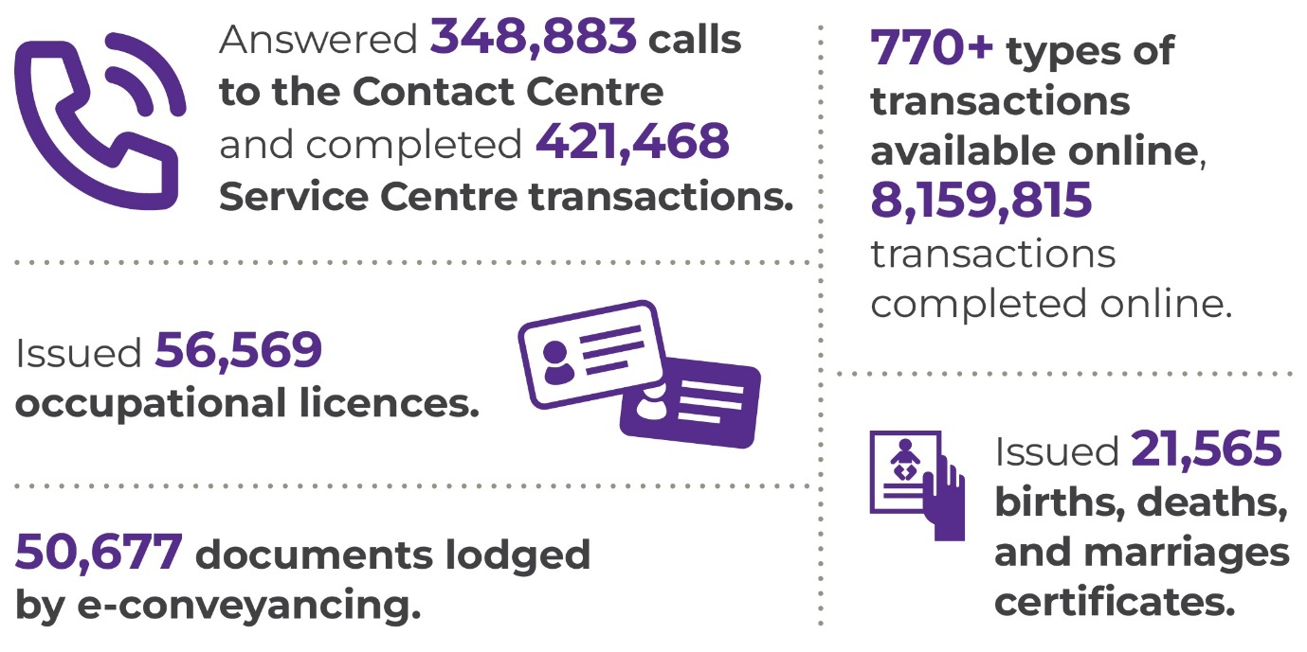

Protecting our people
As part of the 2022-23 Budget, Access Canberra introduced an additional concierge staff member at each Service Centre. The additional concierge provides a knowledgeable first point of contact for customers, replacing the security guards who had been in place as a risk mitigation against occupational violence during COVID-19.
During the year, Access Canberra undertook a range of initiatives to provide tools and pathways to support safety, health and wellbeing, minimise risk and improve culture for our people including:
- developing a range of resources to help Access Canberra staff manage work health, safety and wellbeing, including guides, operating procedures, plans and strategies;
- completing 100 per cent of the actions identified within our Occupational Violence Management and Action Plan;
- undergoing an internal audit on Occupational Violence at Access Canberra and completing all four audit recommendations; and
- all Access Canberra sites undergoing a minimum of two WHS workplace inspections in 2022-23 to support a safe operating environment.

Regulatory Protections
In 2022-23 Access Canberra introduced a compulsory conciliation process for consumer complaints in the ACT, which flowed from August 2021 amendments to the Fair Trading (Australian Consumer Law) Act 1992 (ACT).
The purpose of compulsory conciliations is to bring consumers and businesses together to resolve their dispute in a cooperative way through a mediated conciliation conducted by an accredited Access Canberra Conciliation Officer.
Access Canberra implemented the compulsory conciliation process through a scaled pilot model over the first 12 months of operation. The pilot successfully operated from 1 May 2022 to 30 April 2023.

Table 9: Compulsory Conciliations
Total matters carried over from 2021-22 financial year in the Conciliations Unit | Total matters referred to the Conciliations Unit in the 2022-23 financial year | In preparation for conciliation conference (as at 30 June 2023) | Proceeded to conciliation conference | Resolved through early resolution process | Assessed as not suitable for conciliation, or complaint withdrawn
14 | 53 | 19 | 7 | 15 | 12

Service pressure improvements:
As a direct result of the COVID extensions applied to Working with Vulnerable People (WWVP) registrations in the previous two years, there was an increase in renewal applications received by Access Canberra in 2022-23. There has also been an influx of new applications submitted in January to March this year.
Access Canberra was provided additional funding in 2022-23 Budget to implement strategies to mitigate the potential risk of delays in processing WWVP applications, including:
- temporary engagement of 11 additional staff to bolster processing efforts; and
- streamlining of internal processes and enhancements to the business system.
The current average processing time (as at 30 June 2023) for an application was 19 business days. Application processing times are published on the Access Canberra website.
Access Canberra continues to prioritise and make adjustments to improve its management of service pressures across the organisation. This work continues to see service improvements being achieved but remains an on-going area of focus.

Table 10: Service Pressure Improvements
Service Pressure | Count  FY (2022-23) | Reduction from previous FY
Service Centre average wait time | 7 minutes, 2 seconds | <17 minutes 40seconds
Contact Centre average wait time | 5 minutes 4 seconds | <3 minutes 2 seconds
Community Industry and Trader Licensing average processing days for the preceding year | 25.5 days | <0.9 days
Hume Motor Vehicle Inspection Station average waiting days for inspection | 6.75 days | <6.5 days
Infringement Review adjusted backlog | 18,899 | <28,287
WWVP backlog | 2,647 | <1,868

Supporting the Government recovery from COVID-19
In 2022-23, the ongoing repercussions from COVID-19, including work backlogs and service pressures, continued to result in significant operational effort for Access Canberra. Through our customer facing services and regulatory functions, we provided a critical role in enhancing public safety and supporting business confidence in the ACT through our efforts in engagement and information provision.

Serving the community
We continued to focus on delivering essential government services to the community and we were flexible in surging our workforce to the areas of most need to deliver services to the Canberra community.
This engagement response has been operationalised through the Access Canberra Event Coordination and Business Assist (ECBA) team, which expands on the existing event coordination function provided by Access Canberra. Access Canberra has now embedded this team so that it can continue to support business strategies into future years.
To further strengthen our customer services, we recruited an additional concierge at each of our Service Centres replacing the onsite security guards implemented during COVID-19. The additional concierges at the entrance of our Service Centre provides a knowledgeable first point of contact helping customers with their paperwork and to support improved customer service experiences.
We resumed services at our Dickson Specialised Centre, through a bookable appointment only model, on 10 October 2022. The booking of an appointment supports customers in allowing them to choose the time which best meets their needs to undertake government services and transactions. This was the first time such a model had been implemented in Service Centres. A total of 18 appointments were offered each day (90 a week) and most appointments were filled each week. Many of those choosing a booking are senior residents, or those requiring additional support to complete a transaction.
Following the introduction of a text (SMS) message reminder service for driver licence renewals, vehicle registration renewals and traffic/parking infringements payment reminders in 2021-22, we continue to see improved customer behaviour and positive compliance outcomes. This SMS service helps clients to avoid the added expense of a reminder notice fee as well as possible legal impacts from driving unlicensed or unregistered/uninsured if involved in an accident. A breakdown of the number of SMS reminder notices sent in 2022-23 are outlined in the below table.

Table 11: SMS Reminders sent
Month | Count
July 2022 | 16,812
August 2022 | 15,787
September 2022 | 15,628
October 2022 | 17,673
November 2022 | 16,714
December 2022 | 16,300
January 2023 | 19,156
February 2023 | 19,476
March 2023 | 19,415
April 2023 | 20,937
May 2023 | 20,611
June 2023 | 13,068
Across 2022-23 we completed 421,468 transactions through our Service Centres and answered 348,883 customer calls for assistance through our Contact Centre. We offered more than 770 types of digital transactions including introducing applications for Recognition of Early Pregnancy Loss certificates, registration of pet cats, and applications for rapid antigen tests for community aged care and disability sector workers. We also handled over 8 million digital transactions.
The Resolution Support Team (formerly the Complaints Management Team) continues to provide quality support to our community and help coordinate across government the resolution of concerns regarding various matters including businesses and traders. The team continued to receive a high volume of enquiries from the community over the past year:

Figure 5: Monthly RST Case Report to 30 June 2023
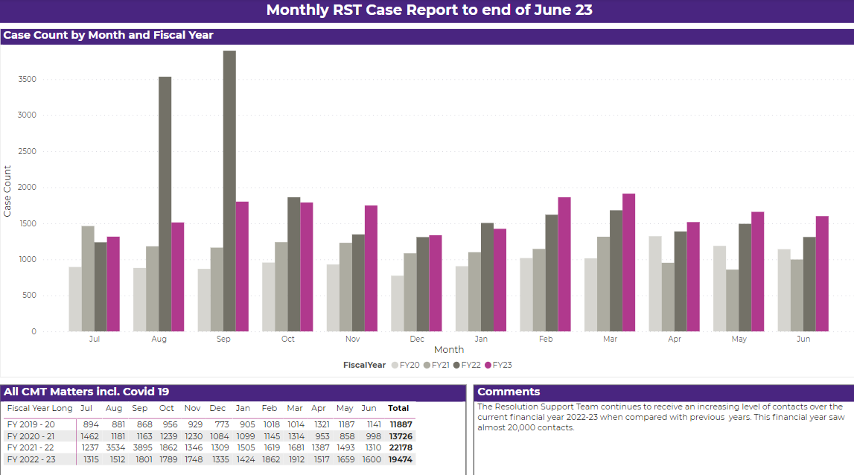

Table 12: Top 5 Contact Centre enquiries
Enquiry | Number
Registration - Renewal | 19,086
Infringements – Traffic Camera Operations | 19,011
Registration – Establish/Transfer | 15,832
Registration Inspections | 14,840
Registration – Unregistered Vehicle Permit | 13,233

Table 13: Top 5 Service Centre transactions
Transaction | Number
Create/Update client details (commonly completed in conjunction with another transaction) | 69,533
Establish Vehicle Registration | 27,769
Motor Vehicle Enquiry | 24,281
Driver Licence Enquiry | 23,799
Renew Vehicle Registration | 22,429

Land titles
The Access Canberra Land Titles Office is responsible, on behalf of the Registrar-General, for the registration of all land related transactions relating to the purchase and sale of land and properties in the ACT; and maintaining the land titles register under the Land Titles Act 1925, including all electronic conveyancing matters.
The Land Titles Office also supports the Australian Capital Territory Land Information System (ACTLIS) which holds accessible records of land and property title and transactions in the ACT.
The ACT commenced its offering of electronic conveyancing (E-conveyancing) in December 2021 for eligible industry subscribers under the Electronic Conveyancing National Law (ACT) Participation Rules.
E-conveyancing offers the choice of digital transactions for most property sales and transfers in the ACT and is a significant advance in service delivery and streamlines the process for the conveyancing industry to engage with the ACT. A total of 50,677 documents were lodged by E-conveyancing in 2022-23. A range of document types are available for E-Conveyancing and 78 per cent of lodgements are conducted through this channel. The average timeframe to perform registrations in 2022-23 was 8 working days, reduced from 10 working days in 2021-22.

Table 14: Land Titles
Transaction | Number
Total lodgements | 82,712
E-conveyancing | 50,677

Births, Deaths and Marriages
Following the introduction of Early Pregnancy Loss certificates in 2021-22, Access Canberra continues to provide all ACT families who have experienced early pregnancy loss (where the loss was before 20 weeks) a certificate of acknowledgement on request. These certificates are a commemoration of the pregnancy loss which aims to support parents and their families through the grief following their loss. Whether a parent experienced a recent or historical loss, they are eligible to apply to Access Canberra online and be issued a certificate at no cost. In 2022-23, Access Canberra issued 146 certificates to support parents and their families.

Image 4: Early Pregnancy Loss certificates options

In 2020, the Births, Deaths and Marriages Registration Act 1997 was amended to prescribe circumstances where a transgender, intersex or gender diverse young person could apply to change their registered sex and or given name in the ACT Births Register to better reflect their gender identity. The changes were introduced to remove barriers faced by vulnerable transgender, intersex and gender diverse young people born in the ACT. In 2022-23 Access Canberra, through the Registrar-General, recorded 21 registrations for a young person’s change of sex.
We continued to support individuals whose life events occurred in the ACT, such as a birth or marriage, and who were impacted by natural disasters including the 2022 floods in Queensland and NSW, by issuing a free replacement certificate. Access Canberra worked alongside interstate jurisdictions to facilitate the replacement of 26 certificates to support people impacted by natural disaster events.
In May 2023, Access Canberra introduced a second type of death certificate that excludes cause of death information to recognise the concerns that families may have in making this sensitive information available to organisations requiring evidence of a death. Many organisations do not need cause of death information for the administration of estates, and where there is no need to disclose those details, families will have the option to provide a death certificate that omits cause of death. There is no fee for the first issuance of an abridged certificate when ordered at the same time as the standard death certificate. A total of 86 abridged death certificates were issued up to 30 June 2023.
The following tables show some of our licensing and registration activity for 2022-23.

Table 15: Births, Deaths and Marriages
Registration type | Number of registrations | Standard Certificates issued
Births | 6,222 | 13,671
Deaths | 2,887 | 4,006
Marriages | 1,676 | 2,960
Civil relationships | 638 | 683
Changes of name | 1,278 | 731

Working with Vulnerable People (WWVP)
The WWVP scheme aims to reduce the incidence of sexual, physical, emotional, or financial harm or neglect of vulnerable people. In 2022-23, we issued 55,466 WWVP registrations to support the scheme, making it the busiest year since the inception of the scheme.
We also:
- resolved the backlog of applications and reduced the processing time for a WWVP application to an average of 13 business days;
- automatically cancelled four registrations and issued 14 negative notices (refusals) due to Class A disqualifying offences;
- actively monitored WWVP registrations and conducted 541 assessments triggered by new information about people who hold a WWVP registration, including notifications about new offences which we received automatically from the ACT Courts. Of these, 95 resulted in changes to WWVP registrations;
- issued 3,591 worker clearances in line with the national approach to background screening of people providing services through the National Disability Insurance Scheme (NDIS);
- worked with all other States and Territories to improve information sharing about people applying for registrations that allow them to work with children; and.
- sent negative decisions to the National Reference System and have exchanged information with other jurisdictions about people who have been disallowed from working with children.

Table 16: Working with Vulnerable People registrations
Application type | Number of applications received
New applications | 27,069
New NDIS clearance only applications | 1,743
Renewal applications | 23,132
Replacement card applications | 5,977
ALL | 57,921
Registrations | Number of registrations issued
New & Renewed registrations | 49,085
Registrations issued due to change of circumstances | 6,381
ALL | 55,466 (including 3,591 WWVP + NDIS registrations issued)

Road safety
Access Canberra’s Vehicle Safety Standards team make an important contribution to our road safety ‘Vision Zero’ through ensuring the safety of motor vehicles using the Territory’s road networks.
This is achieved by completing roadworthy inspections to ensure compliance to multiple vehicle standards and vehicle identity inspections to ensure that illegally obtained or rebirthed vehicles are not registered in the ACT. These inspections are conducted at the Hume Motor Vehicle Inspection Station (MVIS).
We also completed on road compliance through unattended vehicle inspections in carparks around the ACT and Roadside operations conducted by the Vehicle Safety Standards team, or in joint operation with ACT Policing and or the National Heavy Vehicle Regulator.
Also operating out of the Hume MVIS are the Authorised Examiner Scheme Auditors, who ensure that roadworthy inspections carried out by those authorised examiners are completed to the required standard allowing those attending non-government stations the same safety expectations.
The Transport Solutions team continue to authorise Public Transport operators and vehicles for use by Taxi, Rideshare, Hire Car and Bus companies providing a valuable service to the community. They also complete Government driving assessments to ensure that drivers are competent to keep themselves, friends, family, and all other road users safe. With the relaxing of COVID-19 restrictions the number of assessments has increased.
We introduced an important change to vehicle requirements for driver licence assessments to allow modern vehicles fitted with an electric park brake to be used, and also improved the driver licence appointment booking sheet to better prepare applicants and maximise assessment bookings.
We are responsible for the Authorising and Audit of driving instructors who provide the instruction and assessment of those looking to gain their licence through the competency-based scheme. We worked with industry to review and update the ACT Learner Driver Logbook.
In 2022-23, we completed the following activities to support Vision Zero and promote road safety outcomes in the ACT:
- completed 197 vehicle quality assurance inspections, where 69 vehicles passed and 128 failures were identified on initial inspection. Of those 128 inspection failures:
- 100 vehicles failed the inspection due to roadworthy concerns including issues with lighting, tyres, window tint and structural damage.
- 12 vehicle failures were classed as major faults;
- 104 vehicle issues were identified as minor faults;
- 16 failed vehicle inspections were due the authorised examiner making a clerical error on the certificate of inspection. These were quickly remedied.
- Note: some vehicles may have had a combination of clerical error and roadworthy faults which resulted in the failure.
- carried out 41 authorised inspection station audits, with 12 new inspection stations joining the scheme;
- conducted 9 training courses for authorised examiners and approved a total 37 renewing applicants and 31 new authorised examiner applicants;
- one authorised examiner had their authorisation cancelled for two years due to a failure to complete brake tests as required under the Road Transport (Vehicle Registration) Regulation 2000, which requires a vehicle to be assessed by an authorised examiner as roadworthy prior to vehicle registration being issued;
- partnered in joint on-road operations including:
- “Un-Regtober and PV’s” in October 2022 focussed on the registration status of vehicles and Public Vehicle Compliance;
- “An inspection to November” conducted in November 2022 focussed on vehicle registration, insurance and roadworthiness and “UBER Safe” focussing on rideshare compliance;
- “We wish you a merry intercept” in December 2022 focused on vehicle safety and registration;
- “April Sun in Jercuba” in the Jervis Bay Territory in April 2023 saw the completion of a joint operation between Access Canberra and the Australian Federal Police focusing on vehicle registration, insurance and roadworthiness as well as driver licence status; and
- continued collaboration between Access Canberra and ACT Policing for Summernats 35 and the City Cruise focusing on vehicle safety and compliance operations throughout the weekend of the festival.
- made decisions on over 39,000 medical restrictions on driver licences;
- assisted the community to understand their responsibilities to protect road safety through our Infringement Review team, and provided options for, and information about, infringement notice offences and remediation action;
- established over 14,400 Infringement Notice Management Plans and commenced 114 Work Development Plans - representing over 28,100 infringements and more than $8.5 million;
- delivered 3,003 practical driver licence assessments from a total 3,576 bookings. The overall pass rate for these assessments was 56 per cent, with 1,686 passing and 1,317 failing. This was a significant increase from the 2021-22 financial year where only 1,861 driver licence assessments were completed as this function was significantly impacted by COVID-19 restrictions.
- managed the accreditation of 172 driving instructors, 40 heavy vehicle assessors and 13 motorcycle assessors. This included onboarding 12 new driving instructors, overseeing the delivery of the Competency Based Training and Assessment Scheme, delivering 6 training sessions, conducting 89 on road audits and 35 desktop audits, and working with industry to update the ACT Learner Driver Logbook.
- completed 1,440 new rideshare vehicle licenses, 14 taxi licences (11 of those standard and 3 Wheelchair Accessible Taxis), 5 hire car licences and 1,560 applications for public passenger service operator accreditations. Rideshare made up 1,428, with 4 Hire Car, 11 Buses and 67 Taxis.
- completed the implementation of the new Vintage, Veteran and Historic Vehicle conditional registration scheme. The purpose of the scheme is to maintain and support Australia's motoring heritage by providing vehicle owners with lower cost registration for eligible vehicles that are at least 30 years old. A new feature is to include modified vehicles in the scheme.
In 2022-23 we delivered the following initiatives to support the ACT Government’s commitment to a zero emissions target by 2045:
- continued to provide owners of new or used zero emissions vehicles (ZEVs) in the ACT purchased or acquired between 24 May 2021 and 30 June 2024 two years of free registration;
- implemented database changes to provide for ZEVs transitioning off the two years free registration to move to the lowest weight fee; and
- implemented database changes to provide motor vehicle duty exemptions for new or used ZEVs and new plug-in hybrid vehicles (PHEVs) and hybrid vehicles (HEVs) purchased or acquired from 1 August 2022.

Table 17: Road Safety Inspections
Inspection type | Number of inspections
Vehicle roadworthy inspections | 8,028
Vehicle identity inspections | 3,982
On road inspections | 8,176
Special purpose vehicles inspections (e.g. cranes, mowers, and agriculture machinery) | 124

Table 18: Road Safety Defects/Infringements
Infringement type | Infringements issued
Defect notice | 347
Driving an unregistered vehicle | 53
Use of an uninsured vehicle | 52
Unsecured load | 1
Unlicenced driver/rider | 1
Not displaying Public Vehicle Authority card | 3

Table 19: Road Safety Authorised Examiner Audit Inspections
Inspection type | Number of inspections
Quality Assurance inspections | 197
Authorised Station inspections | 41 (12 New)
Authorisation Training courses | 9
Examiner sanctions | 1

Table 20: Road Safety Driver Licence Assessments and Authorised Driving Instructor Audit Inspections
Inspection type | Number of assessments and inspections
Accreditation of Driving Instructors | 172
Audit Inspections | 89
Authorisation Training courses | 6
Government Driving Assessments | 3,033

Table 21: Road Safety Public Transport
Inspection type | Number of Authorisations
Rideshare Vehicle Licenses | 1,440
Taxi Licences | 14
Hire Car Licences | 5
Public Passenger service operator applications | 1,560

Parking and Traffic Enforcement
Access Canberra's Parking Operations team undertakes important work in the ACT to support a safe and liveable city by ensuring drivers park safely and legally. The role of a parking officer is to provide enhanced education and engagement to the community to achieve compliance outcomes (in line with the Access Canberra Accountability Commitment).
The ACT road safety camera program complements police enforcement as part of the Government's speed management strategy. Access Canberra's Traffic Compliance Office undertakes important work in the ACT to support a safe and liveable city by enforcing speed limits on our roads by applying an ‘anywhere, anytime’ approach to enforcement.
Road safety within 40 km/h school zones continues to be a key area of focus for the Mobile Speed Van program to support vulnerable road users in and around schools. Over one third of all infringements issued by the mobile speed van unit were to vehicles exceeding the speed limit within 40km/h school zones.

Fair trading
The Commissioner of Fair Trading has a responsibility to promote a fair and informed marketplace for consumers and businesses, and is supported by the Fair Trading and Compliance branch within Access Canberra.
In 2022-23, we conducted nine proactive programs covering Access Canberra Fair Trading functions, conducting 657 inspections. This included four education programs, engaging with 194 businesses.
We also undertook fair-trading enforcement activities, including participating in three ongoing Court and Tribunal matters, finalising three Court and Tribunal matters and issuing one public warning notice about DSJB Group Pty Ltd (ACN 655 897 359) for possible contraventions of the Australia Consumer Law. Details of this can be found at: www.accesscanberra.act.gov.au/s/article/public-warnings-about-traders-and-businesses-tab-public-warnings).
In 2022-23, we continued to operate the Compulsory Conciliation Scheme that requires businesses to attend compulsory conciliations with consumers to attempt dispute resolution. In 75 per cent of conciliation conferences attended by both parties, businesses and consumers have reached agreement.
In approximately 28 per cent of all conciliation matters, agreements were facilitated prior to a conference being held. Evaluation of the pilot is being undertaken to assess opportunities for improvement before we start external stakeholder engagement to raise broader awareness of the Scheme.

Table 22: Fair Trading
Program | Number of inspections/Engagements | Enforcement activity
Working With Vulnerable People – Childcare Program | 173 | Nil
Major Events Program | 151 | Nil
Product Safety Program | 84 | Nil
High Risk Liquor Licensee Program | 33 | 7 x Reminder of Obligations letters  12 x educational emails  1 x warning letter
Incident Reporting Program | 22 | 8 x Reminder of Obligations letters
Security Industry Engagement Program | 0 | Nil
Single Use Plastics Engagement Program | 119 | Nil
FuelCheck Engagement Program | 58 | Nil
Retirement Villages Engagement Program | 17 | Nil

Controlled Sports
The statutory function of Controlled Sports Registrar sits within Access Canberra. Through the application of educative engagement and a risk-based approach, we worked with stakeholders to identify and mitigate risks related to the integrity of controlled sports events and contests, and also the health and safety of contestants. We continue to engage with various industry participants including promoters, officials and contestants to ensure they are provided with detailed and accurate information to ensure their compliance with the legislation, in particular the health and safety of all involved in controlled sports and the integrity of both registerable and non-registerable events.
In 2022-23, inspectors monitored 12 registrable and one non-registrable controlled sports events to ensure compliance with the Controlled Sports Act 2019.

Table 23: Licensing and Registrations – Controlled Sports
Registration type | Number of registrations
Registerable events | 12
Registered contestants | 84
Interstate contestants | 112
International contestants | 0
Officials | 36
Interstate officials | 102
Non-registerable event notifications | 23
Notes:
- Event applications for registration which were postponed or cancelled do not appear in the total.
- It is common for officials to register for more than one role.
- Non-registerable event notifications which were postponed or cancelled do not appear in the total.

Business and occupational licence support
Access Canberra provides support to ACT businesses across several channels and teams, including the Event Coordination and Business Assist (ECBA) team.
ECBA works closely with the licensing and regulatory areas of Access Canberra and across the ACT Government to support local business discover and navigate the various approvals and endorsements relevant to start or grow a business.
In June 2023, Access Canberra implemented a new appointment service for businesses to speak directly to ECBA. As of 30 June 2023, three businesses had engaged through the service and we expect this to increase into the future.
We also continued to support event organisers during the year. As of 30 June 2023, we had assisted 181 events to obtain 649 approvals and provided support to ensure events could continue. In addition, we supported 43 businesses to understand requirements around approvals – both new and existing.
We continued to deliver Government initiatives aimed at off-setting the financial impact of COVID-19 on the hospitality industry during COVID-19, including:
- construction occupation licence fees were reduced by 20 per cent;
- no fees for carrying on business as a hawker; and
- public unleased land permit where the activity for the permit is outdoor dining reduced by 50 per cent.
Access Canberra has continued our focus on publishing clear guidance material to assist businesses in understanding their legislative obligations attached to their licences. This includes updating the following guidelines:
- the Liquor (Responsible Promotion of Liquor) Guidelines 2022, which aims to set clear expectations consistent with the objects of the Liquor Act 2010 and the principles of harm minimisation and community safety, in relation to the advertisement and promotion of liquor, by describing the standards that underpin good practice; and
- a Guide for Using Public Land for Outdoor Dining Purposes, which outlines the process for applying for an outdoor dining permit so that a business can use public land for commercial purposes in accordance with the Public Unleased Land Act 2013.

Table 24: Public unleased land permits
Permit type | New | Renewed | Amended | Transferred
Outdoor dining | 10 | 164 | 3 | 15
Hawkers | 16 | 51 | 1 | 0
Vehicle verge | 1 | 6 | 0 | 0

Table 25: New liquor licences issued
Licence class | Number
General | 11
ON  - Bar  - Nightclub  - Café/restaurant | 9  0  67
OFF | 16
Club | 2
Catering | 2
Special | 1

Table 26: Liquor permits
Commercial | Non-commercial | TOTAL
432 | 286 | 718

Licensing and Registrations
Community, Industry and Trader Licensing (CITL) team within Access Canberra issues a range of licences and registrations including:
- real estate agents and salespeople
- security guards
- security masters
- charitable collections
- co-operatives
- brothels
- X18+ films
From 1 July 2022, the ACT Government implemented reforms which:
- divided real estate agent licences into two classes (class 1 and class 2) requiring all licensees-in-charge of a real estate business to hold a class 1 agent licence;
- renamed ‘salesperson’ as ‘assistant agents’ to better reflect the remit and responsibilities of this registration group; and
- introduced a new land auctioneering licence.

The amendments were progressed in response to both a nationally agreed approach to improving training requirements for the real estate industry, eliminating ambiguity around qualification outcomes, clearly defining skills, roles and career progressions, ensuring qualifications reflect industry roles and to future proof qualifications.
The below table captures the number of registrations managed by CITL, with other licensing and registrations being reported within the relevant section of the Annual Report.

Table 27: Licensing and Registrations – Community Industry and Traders Licensing
Registration type | New registration | Registration renewals
Security
Employee | 962 | 1,627
Master | 55 | 136
Trainer | 3 | 5
Agent licences
Real estate | 388 | 622
Business | 23 | 71
Stock and station | 34 | 60
Salesperson/Assistant Agents
Salesperson | 263 | 507
Business | 4 | 5
Stock and station | 2 | 7
Trader
Dealer | 21 | 36
Repairer | 43 | 85
Wholesaler | 5 | 3
Second-hand dealer | 12 | 17
Other
Employment agent | 44 | 55
Pawnbrokers | 0 | 1
Charitable collections | 1 | n/a
Associations | 97 | n/a
Co-operatives | 0 | n/a
Brothel notifications | 0 | 4

Improving building quality in the ACT
Information on Access Canberra’s role in supporting improved building quality in the ACT is contained in the ACT Construction Occupations Annual Report, annexed to this annual report.

Future direction
In 2023-24, Access Canberra will continue work on a focussed business improvement program to support the organisation to meet new and emerging issues, and to support better service outcomes and improved customer experience. We will look internally and work with policy directorates to improve regulatory and service outcomes for the community. We aim to better support our customers by delivering easy and effective user-friendly services on behalf of the ACT Government, regardless of the service channel chosen (i.e. online, in person or via telephone).
Access Canberra’s Accountability Indicators are changing for 2023-24 to improve their effectiveness by:
- increasing transparency relating to customer service experiences by reporting separate results for business and individuals interacting through person-to-person and online channels;
- generating more meaningful results and insights by measuring a broader range of Access Canberra activities;
- increasing awareness of the risk-based regulatory priorities of Access Canberra, including publication of upcoming areas of focus set out in statements of expectation; and
- providing better visibility of processing times for occupational licences to better inform the community and industry of realistic times, allowing traders to plan.
We will also continue to support our vision for a safe and liveable city by making our services simpler and easier by:
- improving website functionality and digital solutions;
- continuing to work with other directorates to expand our digital service offering, with a focus on end-to-end digital-first approaches;
- enhancing customer experience across all service channels;
- providing targeted services for those who need additional assistance;
- managing key systems and registries on behalf of government including Rego.act, Births, Deaths and Marriages, and Land Titles;
- continuing to apply a risk-based approach to regulation and compliance to ensure attention is focused on the areas that pose the greatest risk of harm to the community;
- continuing to improve how we collect, use and protect data to support our risk-based decision making, customer experience and inform policy development;
- supporting better regulation outcomes and assisting business to operate within the ACT;
- continuing to support the safety and protection of the ACT community through regulatory compliance and enforcement activity across a range of domains;
- strengthening regulatory protections in building, planning and the environment;
- using effective communications and engagement to support our regulatory ‘engage, educate and enforce’ approach under our Accountability Commitment Framework;
- supporting the safety of our staff though the delivery of the Occupational Violence Action Plan;
- continuing to improve our complaints resolution processes;
- continuing to support our statutory office holders including the Registrar-General, Commissioner for Fair Trading, Construction Occupations Registrar, Environment Protection Authority, Utilities Technical Regulator and the Controlled Sports Registrar to fulfil their legislative functions;
- continuing to build on our track record of making it easier for Canberrans to deal with us through ongoing improvement and release of digital enabled services, such as the introduction of electronic conveyancing, and new ways of providing up-to-date information to customers; and
- continuing to assist in the delivery of the ACT Government’s reform agenda by assisting in the practical implementation and administration of key policy changes, including the implementation of an Emissions and Distance Based Registration Scheme and the introduction of a Professional Engineers Registration scheme.
Further information | David Pryce, Deputy Director-General, Access Canberra
 | (02) 6205 9898 | David.Pryce@act.gov.au

Output 3.1 Economic Development

Overview
Through the Economic Development output the directorate:
- delivers on the government’s economic development priorities through programs, policies and initiatives to make Canberra an even better place to live, work, visit, study, invest in and do business;
- strengthens collaboration with universities, training providers, research organisations, commercialisation entities, business organisations and other government agencies through initiatives that connect Canberra’s business ecosystems, which actively facilitates and attracts responsible investment in the ACT;
- attracts visitors to the ACT through innovative tourism marketing and industry development programs, while also delivering, supporting and promoting key events for Canberrans and visitors to enrich Canberra’s reputation as a global destination;
- enhances the wellbeing of Canberrans through participation in organised sport and recreation by delivering programs, sporting infrastructure development and supporting player pathways;
- contributes to the liveability of Canberra by supporting arts and creative practice that is reflective of our community, as well as managing and maintaining arts facilities that support engaging and innovative art making for audiences to experience;
- supports the skills and workforce agenda for the ACT by facilitating skilled and business migration pathways; and
- manages and maintains key venues including GIO Stadium, Exhibition Park in Canberra, Manuka Oval, National Arboretum Canberra and Stromlo Forest Park as premier tourism and recreational attractions.

Performance

Accountability indicators
25 met or exceeded 6 not met
We met 25 of our 31 targets. The accountability indicators not met were:
- 3.1c Satisfaction of the tertiary education sector with the engagement of the ACT Government and its promotion of Canberra as a study destination of choice – The target of >80 per cent was not achieved, the actual result was 75 per cent. Annual survey results from the Canberra based institutions who were surveyed showed that no respondents expressed dissatisfaction with the Study Canberra program, however two respondents expressed a "Neutral" opinion.
- 3.1j Number of organisations funded to support participation opportunities in sport and recreation - We supported 76 organisations, against a target of 80. Changes have been made to the former Sport and Recreation Grants Program, including renaming the program (“Sport and Recreation Investment Scheme”) and a reduction in the number of categories which may have resulted in a lower number of funded organisations. The total amount of funding has however increased.
- 3.1k Estimated economic activity as a result of supporting local elite teams – End-of-season reports from teams indicated a total impact of $12.354 million, 12 per cent less than the target of $14 million. This variance is due to a decline in the average daily spend of visitors travelling to Canberra to attend a local elite team match.
- 3.1q Participation rate of 15-64 year olds in VET, all students (percentage) – The target of 5.9 per cent was not met; the actual result was 5.4 per cent. The Participation rate for students aged 15-64 decreased nationally in 2022. The ACT showed a similar trend.
- 3.1r VET graduate outcomes after training - Employed after training or in further study – The target of 92 per cent was not met with a result of 89.9 per cent, a slight decrease from the result achieved in 2021-22 of 90 per cent. We will continue to work with the skills sector to ensure VET graduates are attaining the right skills needed for in-demand jobs in the ACT.
- 3.1t – number of major events at GIO Stadium – the target of 20 was not met; the actual result was 19. The variance is due to the Raiders 2022 season draw having four matches after 1 July 2022, rather than the usual five matches in this period.

Highlights
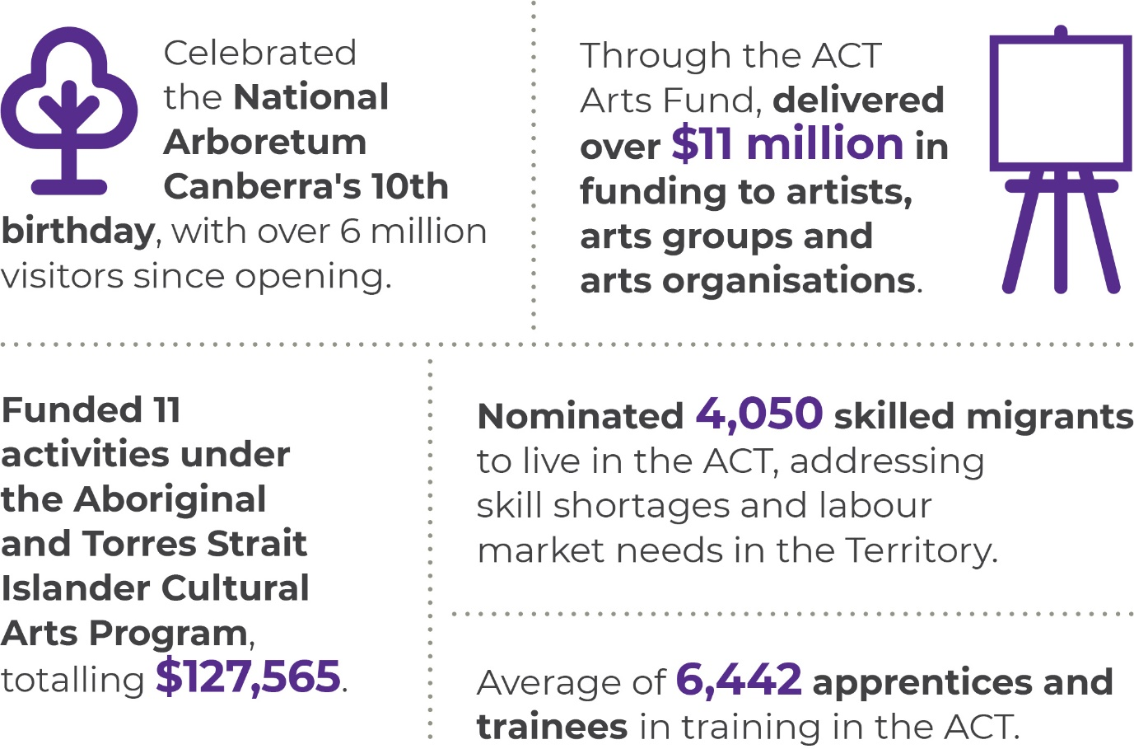
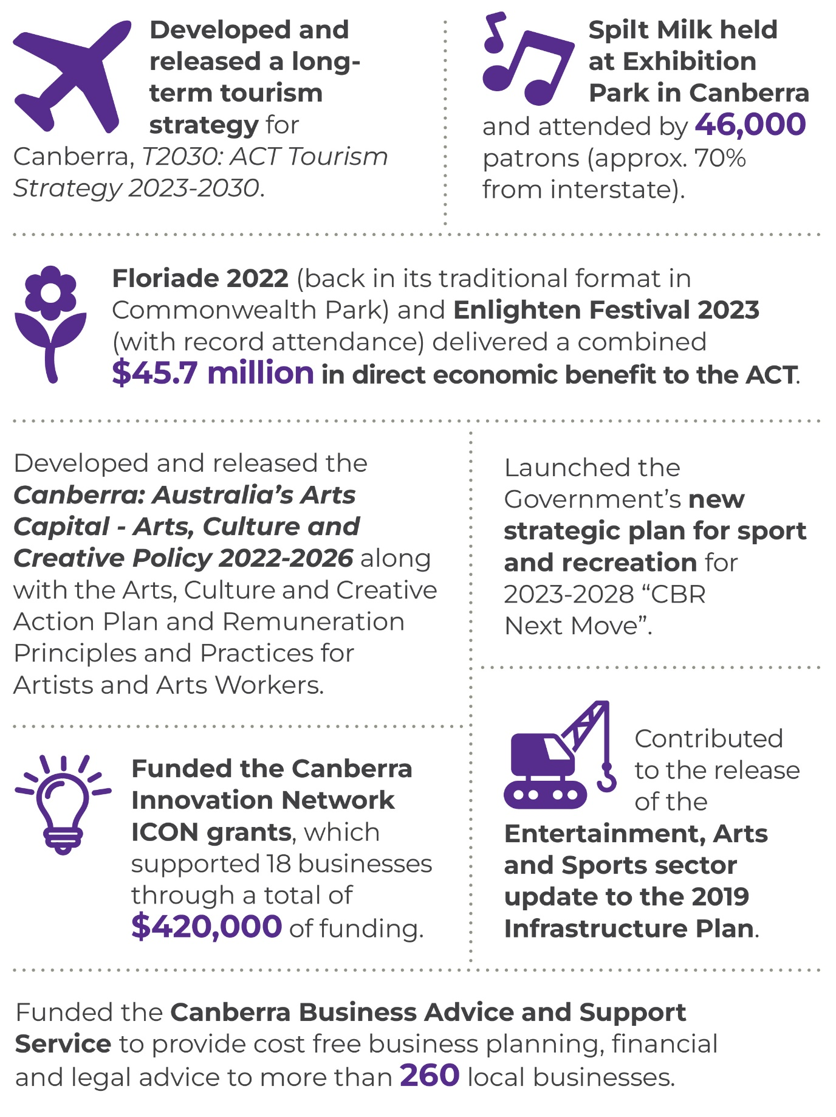
In 2022-23, we continued to deliver a wide range of policies and programs which have contributed to the Government priorities of making Canberra a great city in which to live, study, work, visit and invest. We have created opportunities – for businesses to grow, artists to thrive, sports people to excel, our learners to gain the skills they need to fulfil their ambitions, for visitors to enjoy being in Canberra and for our community to be active and participate in the many events and activities Canberra has to offer.

Tourism and Events
Floriade returned in 2022 to its traditional format in Commonwealth Park (for the first time since 2019) and a record Enlighten Festival attendance in 2023 saw these two major events deliver a combined $45.7 million in direct economic benefit to the ACT. We successfully delivered a full calendar of Events ACT events including Floriade, NightFest, Windows to the World, Canberra Nara Candle Festival, New Year’s Eve, Australia Day, Enlighten Illuminations, Lights! Canberra! Action!, Canberra Balloon Spectacular, Symphony in the Park, Canberra Day and Reconciliation Day. These events attracted an estimated total attendance of almost 913,000.
We continued to support the local event community by granting funds to 24 event organisers (delivering 31 events in 2023) through the ACT Event Fund. These funding recipients received the essential support and flexibility within the grant funding guidelines to develop, promote and grow their events.
We developed and released, in consultation with industry, a long-term tourism strategy for Canberra, T2030: ACT Tourism Strategy 2023-2030. This strategy outlines how the ACT Government, business and all stakeholders connected to the visitor economy, can align effort to realise Canberra’s potential as global destination. The strategy aligns with the ACT’s economic development priorities in Canberra Switched On and Austrade’s THRIVE 2030.
In 2022-23 we secured Canberra’s first international flight connection since the COVID-19 pandemic. Fiji Airways will fly direct from Nadi-Canberra twice per week from 21 July 2023, with onwards connections to North America (Los Angeles, San Francisco and Vancouver). We supported the Canberra tourism and the hospitality industry through $1 million of grant programs across 29 projects, supporting 71 local organisations and businesses to develop new tourism products and infrastructure, and to promote Canberra as a leisure destination in key interstate markets.
We developed and launched a new domestic destination marketing campaign, ‘there’s more than they’re telling us’, in key domestic markets. We worked with domestic airline and conversion partners to expand the reach of VisitCanberra’s domestic brand campaigns and to drive travel bookings to Canberra, including Expedia Group, Virgin Australia, Rex Airlines, Jetstar, Link Airways, and Darwin International Airport. In total, VisitCanberra executed 12 campaigns, with a total economic impact of more than $85 million this financial year.

Skills and workforce
In 2022-23, we supported the development of a skilled workforce through industry-led vocational education and training (VET) that responds to current and emerging skills needs and targets cohorts experiencing barriers to participation. We increased our consultation with industry, training providers and employers to better understand which occupations need investment in training and support. Through this increased engagement we achieved:
- a record of 491 employers responding to our ACT Skills Needs List Survey, helping to identify critical skills and workforce needs; and
- over 60 organisations from five ACT industries including Caring, Building and Construction, Technology, Experiences, Renewables and Sustainability, taking part in our Industry Roundtable Consultation, providing valuable insights and identifying emerging cross-industry themes that will inform our Industry Action Plans. The purpose of these roundtables was to understand the challenges and opportunities facing key industries with respect to skills. These discussions provided valuable insights to the ACT Government and identified emerging cross-industry themes that will inform our Industry Action Plans.
We successfully met our allocation of nomination places under the ACT Migration Program providing 2,025 permanent skilled nominated visas (subclass 190) and 2,025 provisional skilled work regional visa’s (subclass 491). This allocation is an increase of 100 per cent compared to the 2021-22 allocation of 2,025 places. To deliver on the expanded allocation and address the widespread skills shortages in the Territory, we eased the eligibility criteria and added 98 occupations to the ACT Critical Skills List.
We enrolled 1,263 students under the ACT JobTrainer Program; of those enrolments, 945 students have successfully completed their training. We also enrolled 1,406 students under the ACT Fee Free TAFE Initiative, supporting skills development in priority areas and recorded an average of 6,442 apprentices and trainees in training in the ACT.

Arts
On 28 July 2022, Canberra: Australia’s Arts Capital - Arts, Culture and Creative Policy 2022-2026 was released along with Arts, Culture and Creative Action Plan and Remuneration Principles and Practices for Artists and Arts Workers. Together these documents provide the ACT Government with a clear and transparent approach to prioritising outcomes and enable enhanced methods of engagement with artists, arts workers and audiences.
A key deliverable under the policy was the implementation of the new ACT Arts Organisation Investment Framework and guidelines. Recognising the important role our arts organisations play in contributing to the vibrancy and wellbeing of our city, the Government committed to providing new and ongoing funding for the framework, boosting the ACT Arts Fund by over $3 million over four years including $720,000 indexed and ongoing from 2025-26. With this increase over $9 million in multiyear funding each year will be provided to 29 leading Canberra arts and cultural organisations and arts centres to deliver programs, services, expertise and infrastructure to support and develop the arts and engage with the local community.
We led capacity building activities for our arts organisations, artists and arts workers including:
- AIATSIS Core Cultural Learning has been made available to all funded arts organisations, with 250 licences provided to staff and board members to access the training in 2023;
- partnership with Canberra Innovation Network to hold a Creative Collaboration Lab to bring artists and arts workers together with businesspeople to explore ways to increase cross sector collaboration;
- partnership with Creative Partnerships Australia to hold a workshop on ‘Intro to Arts Fundraising and the Australian Cultural Fund’;
- partnership with Australia Council for the Arts to provide professional development and capacity building opportunities for artists and arts organisations that support digital transformation; and
- partnership with Visit Canberra to hold cultural tourism workshops delivered by Tourism Collective for artists, arts and cultural organisations and businesses.
Through the ACT Arts Fund we delivered nearly $11 million in funding to artists, arts groups and arts organisations, including:
- funding to 29 arts organisations, totalling over $8.7 million;
- funding to ANU School of Music and School of Art and Design and five arts organisations totalling $1.15 million specifically for community outreach programs;
- funding for 11 activities under the Aboriginal and Torres Strait Islander Cultural Arts Program, totalling $127,565.
- two rounds of $5,000 to $50,000 arts activities funding for a range of arts activities and projects, with a total of $753,451 to 33 recipients; and
- an ongoing program for up to $5,000 arts activities funding for a diverse range of arts projects, with a total of $207,700 to 55 recipients.
Work continued on recognising the achievements of a significant woman through the commissioning of a public artwork. On 28 August 2022, the Hon. Susan Ryan AO, the ACT’s first Senator and former Federal Cabinet Minister was announced as the subject. Artist Lis Johnson was engaged in April 2023 and has commenced on the artwork design in collaboration with Susan Ryan’s family.

Entertainment, Arts and Sports Infrastructure
We contributed to the update to the 2019 Infrastructure Plan for the Entertainment, Arts and Sports Sectors. The updates to the plan reflect ACT Government’s ambition is for Canberra to be recognised as Australia’s emerging cultural, arts and entertainment hub.
We commenced planning for a new indoor entertainment pavilion that can hold at least 7,500 people to host a diverse range of touring artists, exhibitions, events, sporting events and performances. We also executed an MOU partnering with the Australian Sports Commission on a new or significantly renewed Stadium in the AIS precinct. We commenced planning for a new Canberra convention centre.
In 2022-23, we continued to progress significant projects such as the Kingston Arts Precinct and upgrades to Gorman Arts Centre and Tuggeranong Arts Centre. The ACT Government committed $7.9 million in 2022-23 to upgrade Gorman Arts Centre. With the Australian Government’s $5 million commitment, the total investment in this important project is $12.9 million for comprehensive renovations which will ensure it can continue to support and inspire the next generation of artists in Canberra, while respecting the rich heritage of the buildings. Draft preliminary sketch plans for the design were completed and work has commenced on detailed design and project costings.
We coordinated delivery of building management services at ACT Government owned arts facilities, including planned and reactive repairs and maintenance as well as minor upgrades and new specialist equipment supporting artistic practice including:
- replacement of master switchboards at Gorman House and Ainslie Arts Centres;
- new illuminated facility signage at The Street Theatre;
- new diamond wheel and furnace liner for Canberra Glassworks; and
- new mini scissor lift to the Tuggeranong Arts Centre to enable safe exhibition installation.
We progressed capital works design and planning for the Amaroo Tennis Centre, Throsby Home of Football and the Molonglo District Playing Fields, while also commencing construction of the new home for dragon boating at Grevillia Park.

Sport and Recreation
In 2022, we launched Government’s new strategic plan for sport and recreation for 2023-2028, “CBR Next Move.” The plan provides the direction and a roadmap for strengthening and developing sport and active recreation in the ACT over the next six years to 2028.
We provided continued support and leadership to the sports and recreation sector during 2022-23, and through the ACT Academy of Sport, performance service support for 123 athletes, with 12 current or former scholarship holders competing at the 2022 Birmingham Commonwealth Games and ten medals won.
We provided support to several community projects funded through the Sport and Recreation Investment Scheme including:
- a $1.3m investment (over two years) in redevelopment of the Canberra Rowing Club;
- support for governance capacity building for Freestyle BMX ACT;
- funding to Hockey ACT to convert all remaining lighting systems at the Lyneham Hockey Centre to more efficient LED;
- support to the Hall Pony Club for surface restoration at the publicly accessible riding arenas at Hall;
- funding to Woden Valley Soccer Club to acquire an automated paint line-marking robot to support field preparation and reduce volunteer workload; and
- funding to Brindabella Blues Football Club to undertake feasibility work for a new pavilion at Calwell District Playing Fields.
We finalised a new ten-year agreement with the AFL and the GWS Giants for the continued delivery of AFL and AFLW content at Manuka Oval.

Venues
The National Arboretum Canberra celebrated its 10th birthday in 2023 and since opening has cumulatively attracted over 6 million visitors. In 2022-23 the National Arboretum Canberra attracted over 900,000 visitors, including over 52,000 school students, with a 92 per cent customer satisfaction rate. The National Arboretum Canberra won the Tourist Attractions category in the 2022 Canberra Region Tourism Awards
Stromlo Forest Park announced its whole of park sponsorship naming rights with University of Canberra and also launched a five-year Stromlo Forest Park Tracks and Masterplan design consultation.
Over the last year, we delivered major events at our venues with a positive economic benefit. These events included:
- Spilt Milk, held at Exhibition Park in Canberra (EPIC) attended by 46,000 patrons, of which approximately 70 per cent came from interstate.
- Eighteen national and international matches and one entertainment event at GIO Stadium, including the largest NRL round match since 1994 with a crowd of over 21,000 in June 2023.
- Twelve national and international events at Manuka Oval. International men’s and women’s cricket matches were held over the summer and AFL matches hosted in the winter months.
- A total of 211 events at EPIC with an estimated attendance of 455,360.
We also undertook various capital works to improve our venues and patron experience, this included the installation of a second video replay board at the northern end of GIO Stadium. There has also been significant stakeholder engagement through the EPIC Redevelopment and Expansion project on the future of the precinct.

Business and innovation
In 2022-23, we continued delivery of a wide range of programs and initiatives, including the Future Jobs Fund, to support local business, innovation, investment and economic growth. We worked closely with the local business community and with industry stakeholders across the higher education, creative industries, defence, space, cyber and innovation sectors to support jobs growth and capitalise on the Territory's economic strengths. In 2022-23, we:
- secured Canberra Innovation Network’s (CBRIN) ongoing operations by executing a new two-year funding agreement, including provision for CBRIN’s ongoing delivery of the Innovation Connect (ICON) grant program to support the growth of local start-ups. We also provided CBRIN with a grant to commence detailed design work for its expansion to level 4, 1 Moore Street enabling it to further grow as Canberra’s thriving innovation ecosystem hub. CBRIN conducted 246 meetings with businesses regarding ICON grants and supported 18 businesses through grants totalling $420,000. Previous ICON recipients self-reported through CBRIN’s annual survey that they subsequently raised $75 million in capital and have an aggregate annual turnover of $9.7 million.
- facilitated the approval of the UNSW Canberra City Campus master plan, a key milestone for the new $1 billion campus to be built on Constitution Avenue that will build on Canberra’s reputation as the knowledge capital and bring up to 2,000 jobs and 6,000 students to Canberra.
- continued to work with space and adjacent technology sectors to design a Canberra Space Hub to further grow and develop Canberra’s space and advanced technology sectors. The work of the Canberra Cyber Hub also continued, focussing on growing Canberra’s cyber security workforce and education pathways, amplifying Canberra cyber businesses capabilities and fostering connections within the cyber sector. We also commenced engagement with key stakeholders in developing the concept for a Quantum Hub that will further grow Canberra’s quantum and advanced technology capability and sectors. These initiatives align with and will deliver on the Government’s ambitions outlined in CBR Switched On.
- provided ongoing support for local small to medium enterprise (SME) businesses though support programs, including the Canberra Business Advice and Support Service (CBASS), providing four hours of free business planning, financial and legal advice to the local small business community, and the Badji program, providing culturally appropriate support to Aboriginal and Torres Strait Islander people wanting to start or grow a business.
- continued to work with Canberra’s tertiary institutions to promote Canberra as an attractive education destination for international students. In 2022-23 Study Canberra established a Tertiary Education Working Group that meets quarterly to ensure a cohesive and effective approach to destination marketing.
Supporting the screen industry
The ACT Government supports the ACT screen industry (film, TV, and other media) by funding Screen Canberra for the delivery of the Screen Investment Fund, the Screen Attraction Fund, and other supports and advocacy for the screen industry.
Screen Canberra received $723,000 in 2022-23 in direct funding from the ACT Government. This comprised:
- $390,000 in base funding for the general operation of Screen Canberra.
- $150,000 for the administration of the Screen Investment Fund.
- $50,000 as a one-off payment in 2022-23 for the administration of the Screen Attraction Fund.
- $133,000 from artsACT to support arts practitioners and emerging artists in the screen space.
The ACT Government has committed $500,000 towards the Screen Attraction Fund - a proof-of-concept program aimed at attracting high budget screen productions to the ACT. This pilot program is being administered by Screen Canberra and is open for applications currently being assessed.
Screen Canberra also manages the ACT Government’s $5 million Screen Investment Fund. The Screen Investment Fund supports the local screen industry to become more commercially oriented and attracts screen production activities from outside the Territory.

In 2022-23 the Screen Investment Fund distributed $508,064 to the following projects.
- Evan & Hell
- Paranormal Blacktivity
- Runn the Nedd Brockmann Story
- History & Science Package: Rush, Shape it Ship it, Rise of the Dictators, WW2 War Machine
- With My Little Eye
- Bramble
- Poly
- Day Boi
- The Stoning
- Total Control Series Three
These projects are anticipated to generate approximately $4 million in local spending and create around 60 jobs in the local screen industry.

Future direction
In 2023-24, we will deliver the following priority initiatives:
- continue the delivery of partnership marketing campaigns with airlines and key distribution partners to support air routes, extend reach, and drive bookings for the city which includes pursuing opportunities to grow domestic and international aviation capacity, establishing new routes and attracting new carriers;
- finalise and introduce a new five-year National Skills Agreement that provides high-quality, responsive and accessible vocational education and training to boost productivity and support the ACT to obtain the skills needed to participate and prosper in the modern economy;
- facilitate an inaugural Small Business Expo for the ACT and surrounding region to showcase and promote local small business, offer networking opportunities and link businesses to potential customers and information regarding finance, business planning and marketing;
- work with the Australian Sports Commission and major stadium users, to agree a preferred approach for the Canberra Stadium development;
- deliver a new winter innovation and arts festival, Uncharted Territory. The festival will drive tourism to Canberra over the winter period, and position Canberra as a vibrant, future -focused city by promoting the ACT’s strengths in innovation and art.
- commence staged major construction works at the heritage-listed Gorman House Arts Centre to meet contemporary design standards and provide for a range of arts activities at the facility, and work closely with the Suburban Land Agency on the development of the Kingston Arts Precinct as a definitive destination for visual arts and culture in Canberra, and commence development of the brand and digital identity of the precinct;
- develop a Public Art Strategy for the ACT;
- launch the small business strategy and promote and deliver the relevant initiatives;
- work with key stakeholders and community groups to commence construction of a number of new facilities including the Throsby Home of Football, Phillip District Oval and the Amaroo (Gungahlin) Tennis Centre;
- support ACT athletes within, or vying for selection in, the Australian teams competing in the Paris 2024 Olympic and Paralympics Games;
- continue to support the Aboriginal and Torres Strait Islander Business Support Service to deliver a range of culturally appropriate services to help Aboriginal and Torres Strait Islander businesses develop and grow, including a concierge service to connect businesses to a range of service providers, mentoring and coaching and business accelerator;
- establish Canberra hubs for Quantum and Space through a process of co-design with stakeholders in these sectors to support the strengthening and growth of Canberra’s existing unique capabilities, job creation business and local business growth; and
- actively seek to attract new events to the Territory’s venues to support economic growth and diversification, liveability and social inclusion. We will also host more women’s national content at our venues including five NRLW matches at GIO Stadium, two AFLW matches at Manuka Oval and cricket content over the summer.
Further information | Kareena Arthy, Deputy Director-General, Economic Development
 | (02) 6207 5564 | Kareena.Arthy@act.gov.au

Output 4.1 Economic Management

Overview
The Economic Management output incorporates provision of economic and revenue modelling, economic analysis and policy advice to the ACT Government and agencies, management of Federal Financial Relations, and provision of insurance policy advice and regulation/administration of the Motor Accident Injuries and Lifetime Care and Support schemes. In 2022-23, the Government established the Office of the Coordinator General for Housing in Treasury to support its housing policy agenda.
The directorate has delivered this output by:
- working with the Commonwealth Government to deliver on the priorities of the Housing Accord;
- developing and implementing affordable housing policies and programs to deliver on Government commitments;
- coordinating housing policy initiatives across government;
- monitoring and providing advice on the state of the ACT economy;
- preparing economic forecasts and revenue forecasts for own source revenue;
- undertaking analysis and modelling to provide short, medium and long-term demographic projections;
- publishing tax expenditure statements;
- facilitating the development and review of taxation reform;
- providing advice on a range of economic policy matters considered by government including economic and regulatory impacts, competition reform, cost of living and industry sectoral matters (including regulation of water and energy markets);
- coordinating the function and responsibilities provided under the Intergovernmental Agreement on Federal Financial Relations;
- coordinating and/or contributing to:
- Heads of Treasuries, Board of Treasurers and Council on Federal Financial Relations processes; and
- ACT Government involvement with the Commonwealth Grants Commission;
- providing advice on the performance of selected government entities, including emerging issues and associated corporate governance arrangements;
- providing advice and regulating the Motor Accident Injuries (MAI) Scheme; and
- administering the Lifetime Care and Support (LTCS) Scheme.

Performance

Accountability indicators
3 met or exceeded
We met or exceeded all three accountability indicators for this output.

Highlights
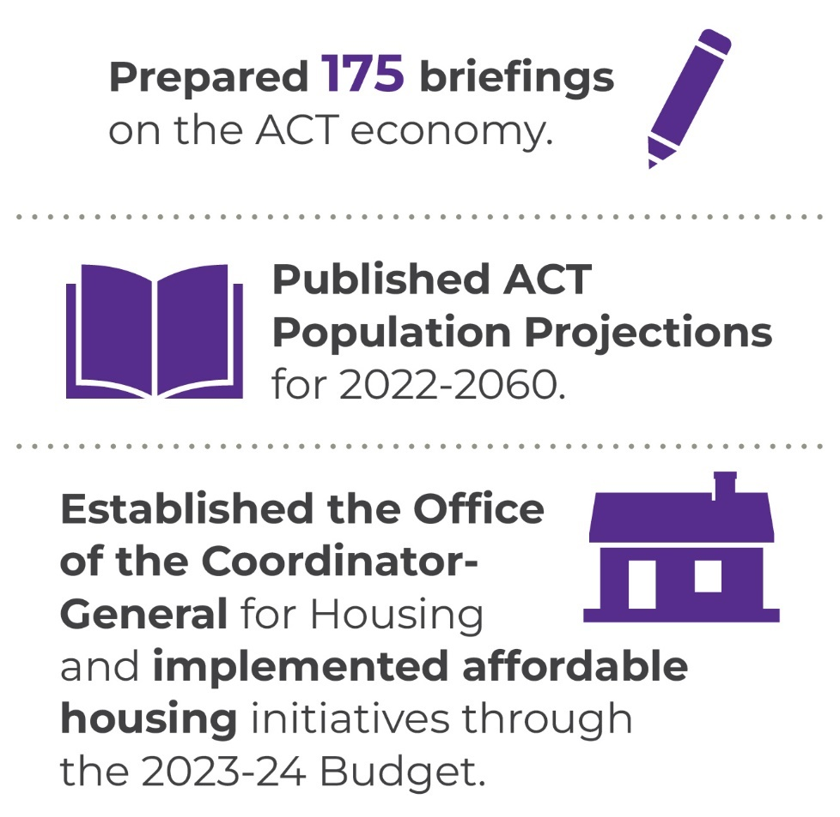
In 2022-23, we continued to monitor and provide economic and revenue analysis, forecasts and briefings to support the development of the 2022-23 ACT Budget and Budget Review, as well as the 2023-24 Budget. We worked collaboratively with the Australian Government and our state and territory counterparts to implement policy responses to the ongoing cost of living pressures. The Office of the Coordinator-General for Housing was established to support a whole of government approach to the development and implementation of housing policy initiatives.
In 2022-23, we also:
- developed a range of budget measures including a cost of living support package and a program of modest revenue increases to fund key government spending priorities;
- contributed to work across government on policies to encourage and support lower transport emissions from light vehicles;
- published a new 2023-2024 electricity reference price in June 2023, helping ACT households and small businesses to save money by being able to compare new financial year electricity offers quickly against a benchmark ACT annual price, based on average consumption;
- published population projections for the period 2022 to 2060 at the territory, district and suburb level reflecting Census 2021 updates;
- implemented and managed the long-term Management Agreement with Community Housing Canberra (CHC) as part of the agreed balance sheet restructuring of CHC. This arrangement is contributing to the growth of affordable housing in the ACT.
- supported and coordinated the development of housing initiatives announced in the 2023-24 Budget;
- continued to engage with the Commonwealth Grants Commission, including as part of its 2022 update of the GST Revenue Sharing Relativities work program, and provided advice to government on the implications of the update for the ACT’s GST share;
- provided support to the Treasurer in his role as Chair of the Board of Treasurers for 2022;
- participated in the development of funding agreements and reform options for federal financial relations and maintained a high level of engagement and collaboration across jurisdictions and between central and portfolio agencies; and
- supported the functions of the MAI Commissioner (see annexed MAI Commissioner Annual Report) and LTCS Commissioner of the ACT (see annexed LTCS Commissioner Annual Report).

Future direction
In 2023-24 we will continue to monitor and advise on the state of the ACT economy including the impact of emerging economic risks. We will also continue to work with the Australian Government and our state and territory counterparts on priority policy areas including health reform and productivity. We will also continue to work collaboratively with key stakeholders within and external to Government on initiatives aimed at growing the stock of affordable housing and to strengthen and grow the community housing sector in the ACT.
In 2023-24, we will also deliver work across priorities including:
- encouraging growth in the stock of affordable rental properties through promoting incentives for build to rent developments, managing the Affordable Housing Project Fund, administering the long-term management agreement with CHC, and working across the ACTPS and with external stakeholders;
- continuing to work with the Commonwealth to deliver commitments under the National Housing Accord;
- leading work across government on vehicle registration reform policies that encourage and support lower transport emissions from light vehicles;
- updating the 40-year demographic modelling, incorporating the latest ABS data;
- continuing to monitor and assess the impact of the tax reform program to prepare for the next phase of reform;
- engaging with the Commonwealth Grants Commission on its 2025 GST Methodology Review;
- supporting the three-year review into the operation of the Motor Accident Injuries Scheme;
- supporting the functions of the MAI Commissioner and the LTCS Commissioner of the ACT; and
- maintaining strategic financial oversight of selected government business entities including Icon Water, the Suburban Land Agency and the City Renewal Authority.
Further information | Mitch Pirie, Executive Group Manager, Economic and Financial Group
 | (02) 6207 9481 | Mitch.Pirie@act.gov.au

Output 4.2 Financial Management

Overview
Through the Financial Management output the directorate provides analysis, monitoring and reporting on the financial performance of agencies, the Territory’s budget, and major projects, management of financial investment assets and borrowing and superannuation liabilities and assists the ACT Government to achieve its policy objectives.
The directorate delivers this output by:
- managing the preparation and presentation of the ACT Government’s annual budget, budget review and annual financial statements;
- providing quarterly whole of government consolidated financial reports;
- reporting to external agencies including the Australian Bureau of Statistics;
- providing advice to the ACT Government on financial and budget policy issues;
- reviewing government programs and functions; and
- managing the Territory’s borrowings, financial investments, cash and liquidity needs and the defined benefit employer superannuation liabilities through the Territory Banking Account and the Superannuation Provision Account.

Performance

Accountability indicators
5 met
We met all our accountability indicator targets for this output.

Highlights
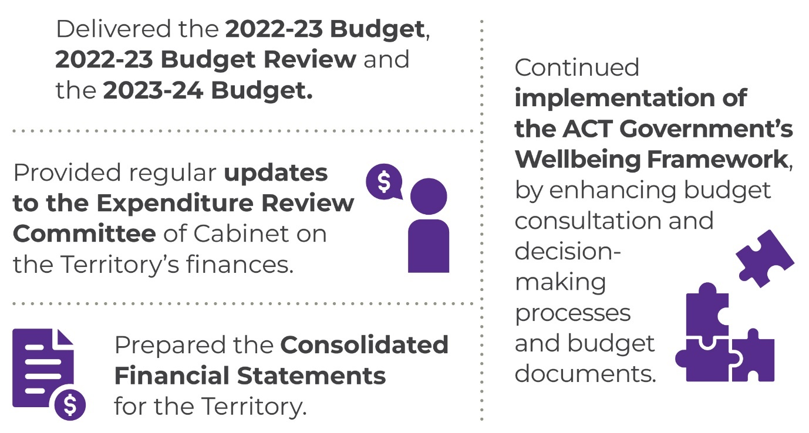
In 2022-23, we undertook the following work:
- delivered the 2022-23 Budget, 2022-23 Budget Review and the 2023-24 Budget;
- achieved an unmodified audit opinion on the 2021-22 Consolidated Financial Statements;
- continued implementation of the ACT Government’s Wellbeing Framework, by enhancing budget consultation and decision-making processes and budget documents;
- provided regular updates to the Expenditure Review Committee of Cabinet on the Territory’s finances, allowing the Government to manage public finances appropriately and maintain a strong balance sheet;
- provided advice to the Expenditure Review Committee of Cabinet on new spending proposals to enable the Government to prioritise available resources;
- prepared the Annual Financial Statements for the Territory, which were provided to the Auditor-General in the required timeframe;
- prepared the Quarterly Consolidated Financial Statements, which were presented to the Legislative Assembly in the required timeframe;
- prepared the budget appropriation bills – the Appropriation Act 2022-23 and Appropriation (Office of the Legislative Assembly) Act 2022-23;
- prepared the second appropriation bills – the Appropriation Act 2022-23 (No.2) and Appropriation (Office of the Legislative Assembly) Act 2022-23 (No.2);
- coordinated and participated in across government and national working groups and provided policy advice on national reform initiatives, including the National Health Reform Agreement and Training and Skills reforms;
- provided regular updates to the Government on the progress of its infrastructure program. These updates included regular reports to the Expenditure Review Committee of Cabinet and the Legislative Assembly.
- assisted directorates in policy development and financial management by providing budgeting, accounting, and analytical advice.

Future direction
In 2023-24, we will support the Government in delivering the 2023-24 Budget Review, the 2024-25 Budget and the Territory’s Consolidated Financial Statements.
In 2023-24, we will also:
- coordinate the Government’s budget processes and report on financial outcomes;
- provide regular updates to the Expenditure Review Committee of Cabinet on the Territory’s finances to allow the Government to manage the public finances appropriately and maintain a strong balance sheet;
- continue to support the implementation of the ACT Government’s Wellbeing Framework; and
- work with directorates to ensure sound financial management and high-quality policy advice to Cabinet.
Further information | Scott Austin, Executive Group Manager, Finance and Budget Group
 | Scott.austin@act.gov.au

Output 5.1 Revenue Management

Overview
Through the Revenue Management output, the directorate provides for the administration of the ACT Government’s taxation revenue.
Revenue Management (ACT Revenue Office) delivers this output by:
- collecting taxation revenue in accordance with legislation;
- providing high quality and timely advice to assist taxpayers in meeting their obligations;
- processing objections to taxation assessments and decisions, in accordance with timeframes published on the ACT Revenue Office website;
- ensuring the integrity, consistency and effectiveness of the ACT’s taxation system through prioritised compliance programs and regular reviews of legislation;
- processing concessions in accordance with legislation; and
- administering Rental Bonds.

Performance

Accountability indicators
1 met or exceeded 4 not met
We exceeded one of our accountability indicator targets for this output. The accountability indicators not met were:
- 5.1a – Debt management – level of overdue rates as a percentage of total rates revenue
- 5.1b – Debt management – level of overdue debt (not including rates) as a percentage of tax revenue (not including rates)
- 5.1c – Internal reviews of objections completed within 6 months
- 5.1d – Internal reviews of objections completed within 12 months
The results for 5.1a and 5.1b were higher than the targets as active debt recovery was not pursued during the COVID-19 pandemic.
The 5.1c and 5.1d targets were not met due to a large increase in the number of Unimproved Value objections that has taken some time to work through.

Highlights
The key focus for 2022-23 was the introduction of the Revenue Legislation Amendment Bill 2022 which updates the Territory’s Land Holder Duty provisions. We commenced two new IT projects to extend the life of a platform that supports several tax lines and a replacement system for land valuations.

Future direction
In 2023-24, we will:
- continue to administer the Australian Government HomeBuilder Grant;
- focus on assisting customers reduce outstanding liabilities and move towards achieving debt level KPIs;
- direct resources to tax compliance activities;
- prepare amendments to the Duties Act to simplify and update the landholder provisions;
- continue the build of a new land valuation IT system; and
- continue to enhance our IT security.
Further information | Kim Salisbury, Executive Group Manager, Revenue Management
 | (02) 6207 0010 | Kim.Salisbury@act.gov.au

Output 6.1 Human Resources, Finance and Record Services

Overview
Through this output the directorate provided a range of corporate services, including tactical and transactional human resource and finance services to directorates and agencies.
The directorate delivered this output by:
- providing payroll, personnel and recruitment services;
- providing records management and courier activities to government directorates;
- providing monthly and annual financial reporting services;
- providing accounts payable, accounts receivable, banking and debt management functions;
- providing general ledger, cash flow and fixed asset management;
- providing advice on Fringe Benefits Tax, Goods and Services Tax and PAYG, including arranging external advice as required;
- administering production and lodgement to the Australian Taxation Office of monthly Business Activity Statements and annual Fringe Benefits Tax Returns; and
- delivering salary packaging services for employees across the ACT Government.

Performance

Accountability indicators
5 met or exceeded 1 not met
We met or exceeded five of our six accountability indicator targets for this output, we did not meet the following indicator target:
6.1a –The KPI of 95 per cent of service requests logged by the HR Service Desk are resolved within agreed timeframes (five working days) was not met (actual result 88.5 per cent). The HR Service Desk is supported by Shared Services Payroll and Recruitment in the resolution of complex queries. Due to the complexity of enquiries that are escalated to the relevant subject matter experts in Payroll and Recruitment for resolution these enquires may take longer than five working days to resolve. Further automation opportunities are being explored to improve performance against this indicator. Both the Payroll and Recruitment teams are consistently achieving customer satisfaction ratings are more than 90 per cent satisfied or very satisfied.

Highlights
In 2022-23, we:
- successfully implemented the Expense Management System (EMS) in directorates across the ACTPS. The rollout process and solution received positive feedback from directorate strategic finance teams and other end-users. During 2022-23, approximately 1,100 EMS users had been trained and are now using the solution.
- progressed the delivery of e-Invoicing. A software vendor has been engaged to acquire e-Invoicing processing capability that will complement the existing Accounts Payable Invoice Automation System (APIAS) solution used by the Territory.
- consulted across the ACTPS and undertook a Request for an Expression of Interest (REOI) process followed by a Select Request for Proposal (RFP) to establish a new Whole of Government (WhoG) Banking Services Agreement with Westpac, commencing 1 July 2023;
- commenced actioning the major recommendations of the finance system feasibility study including the recommendation to replace the existing Oracle finance system;
- continued the rollout of Electronic Digital Records Management System (EDRMS) with more than 670 additional users now working with EDRMS as a core business tool, improving records management efficiency and accessibility of government records across the Territory;
- continued to work with directorates and vendors to increase the efficiency of digital records management across government by leading a number of projects aimed at enhancing system capabilities and integrations, amalgamating datasets into a central EDRMS and finalising the migration from on premises hosting systems to secure cloud-based solutions;
- logged 155,992 service requests through the HR Service Desk; and
- resolved 79 per cent of phone enquiries to the HR Service Desk on first contact and the HR Service Desk averaged a 97 per cent customer satisfaction rate.

Future direction
In 2023-24, we will:
- expand the usage of the Expense Management System across the WhoG by engaging with each directorate promoting the benefits in its usage for low-value and low-risk purchases;
- soft launch and pilot the go-live e-Invoicing for three entities with up to ten suppliers. Additionally, we will undertake orientation sessions for the Territory’s major suppliers to increase their awareness and adoption of e-Invoicing more broadly. Following the pilot, the solution will then be made available for use by all the Territory suppliers enabling the sending of e-Invoices to the ACT Government entities that use the APIAS system.
- commence the transition of the Territory’s existing banking products and services to new innovative products and services that are available to the Territory under the WhoG Banking Services Agreement;
- progress plans for the replacement of the financial management information system (FMIS). This will include procurement preparation, business process re-engineering across government and a review of all systems interfacing into the FMIS.
- continue to enhance digital record keeping with the uplift of the Electronic Digital Records Management System to the Cloud hosted platforms, increasing scalability and performance and automation/enhancements capabilities;
- finalise the uplift of the Electronic Records Management Systems from a Business Critical status to a Government Critical status, improving response to resolution times and decrease in outage times; and
- explore options and develop new working methods to support efficient, effective and integrated delivery of human resource business functions.
Further information | Geoffrey Rutledge, Acting Deputy Director-General, Office of Industrial Relations and Workforce Strategy
 | (02) 6207 5001 | Geoffrey.Rutledge@act.gov.au

Output 6.2 Digital, Data and Technology Solutions

Overview
Through this output the directorate provides a range of ICT services, including infrastructure, applications support and development and ICT projects to directorates and agencies.
The directorate delivers this output by:
- providing services to government agencies as outlined in the ICT catalogue of services and affirmed through various service level and support agreements;
- managing the whole of government data and communications network; and
- providing general service and help desk functions.

Performance

Accountability indicators
1 met or exceeded 2 not met
We met one out of three 2022-23 accountability indicators against this output. The accountability indicators not met were:
- 6.2a – ICT service requests made via the Service Desk are resolved within Service Level Agreements’ timeframes. We achieved a result of 86.8 per cent against a target of 90 per cent.
- 6.2b – Average time taken for telephone ICT service requests to be answered by a Service Desk Officer. We achieved a result of 63.8 per cent against a target of 80 per cent of calls answered within 240 seconds. Consideration continues to be given to appropriate support for hybrid work in consultation with directorates. The variance is due to a number of factors, including longer call times due to the complexity of the cases being resolved. We will review and assess the nature of the cases to better understand the drives and the work effort required to resolve cases contributing to the increased call duration.

Highlights
In 2022-23 we developed a comprehensive cyber security awareness program for all ACT Government staff. This included production of several learning management system training packages, roll-out of a whole of government intranet portal for cyber awareness, development of general and targeted materials to uplift security awareness, and regular monthly messaging form the Cyber Security Centre promoting better practice and to drive better cyber security culture in the workforce.

Future direction
In 2023-24, we will continue to improve payroll and human resource management through a revised implementation approach. The new approach will build on existing ICT investments by upgrading existing payroll and HR solutions and designing a new time and attendance solution through the establishment of a new payroll capability and human resource management program.
Upgrading existing payroll and HR solutions to the latest versions which are secure and well governed will address the most important elements of HR and payroll capability. Upgrading will offer increased process automation, additional payroll process functionality and offer enhancements to the HR self-service portal for ACTPS staff.
In 2023-24 we will commence early foundation work to advance compliance with Essential 8 Maturity Level One under the Commonwealth’s cyber security resilience framework.
Further information | Bettina Konti, Deputy Director-General and Chief Digital Officer, Digital, Data and Technology Solutions
 | (02) 6207 2242 | CDO@act.gov.au

Output 7.1 Infrastructure Finance

Overview
Through the Infrastructure Finance output, the directorate provides advice to government on the development and financing of major infrastructure projects, as well as managing unsolicited proposals in accordance with the relevant guidelines. We partner with directorates to ensure project business cases for capital projects provide the required evidence and analysis to inform the funding decisions of government.
We deliver this output by:
- advising on the development of infrastructure projects in accordance with the Capital Framework;
- providing financial and commercial advice on the development and procurement of Public Private Partnership (PPP) and other major, complex infrastructure projects, as well as managing life-of-project transactions for existing PPP projects;
- managing the process and providing commercial support for the assessment of Unsolicited Proposals; and
- maintaining and providing training on the policy frameworks that support the development and delivery of infrastructure projects, including the Capital Framework and the Partnerships Framework - Guidelines for Unsolicited Proposals and Guidelines for PPPs.

Performance

Accountability indicators
2 met or exceeded
We met both of the 2022-23 accountability indicator targets for this output:
- 7.1a – Life of Project PPP transactions successfully executed.
- 7.1b – Assessments of Unsolicited Proposals completed within the prescribed timescales.

Highlights
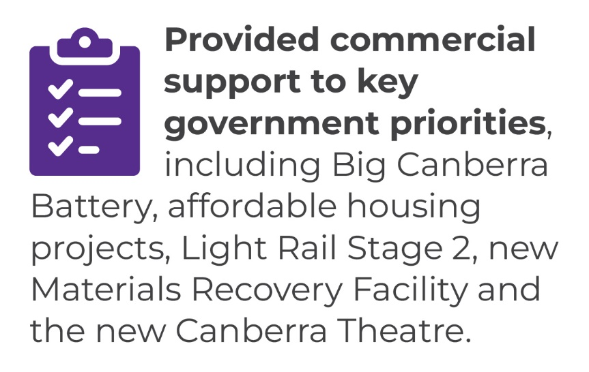
In 2022-23, we achieved this output by:
- providing commercial support to a range of key government priorities, including Big Canberra Battery, affordable housing projects, Light Rail Stage 2, the new Materials Recovery Facility and the new Canberra Theatre, in addition to administering a whole of life transaction for the ACT Law Courts PPP; and
- overseeing the Territory’s Unsolicited Proposals framework by responding to numerous approaches and actively supporting the consideration of one formal unsolicited proposal.
To deliver this output we also:
- continued to provide support to directorates using the Capital Framework process to develop stronger capital business case submissions, enabling thorough planning, appraisal and evaluation in the formative stages of the investment lifecycle;
- launched the updated Capital Framework, housed on a new user-friendly website, that supports enhanced agency collaboration and provides improved guidance on determining project tier levels, undertaking project analysis and developing business cases;
- supported ongoing development and improvement of government projects through Post Implementation Reviews of Margaret Hendry School and the ACT Law Courts projects; and
- initiated a review of the Public Private Partnerships Framework to ensure the policy framework that supports the development, procurement, and delivery of PPP projects keeps pace with best practice approaches.

Future direction
In 2023-24, we will continue to assist directorates and agencies by:
- advising on complex infrastructure projects, including Light Rail 2A and City to Woden, the new Canberra Theatre, Food and Organic Waste Facility, Materials Recovery Facility, as well as assisting with capital investment decision to support the transition to net zero and increasing the supply of affordable housing options;
- advising on funding and financing of the Territory’s Government Business Enterprises, notably the Suburban Land Agency and EvoEnergy;
- managing any life-of-project transactions for the Territory’s PPP projects;
- managing the process and providing commercial support for the assessment of Unsolicited Proposals;
- providing advice to directorates and agencies using the updated Capital Framework process, including with their early stakeholder engagement, robust analysis and preparation of business cases, as well as measurement of project outcomes;
- providing analysis and advice on new capital investment proposals, including complex commercial and financing matters; and
- launching the updated Public Private Partnerships Framework.
Further information | Mitchell Pirie, Executive Group Manager, Economic and Financial Group
 | (02) 6207 9481 | Mitchell.Pirie@act.gov.au

Output 7.2 Procurement

Overview
Through the Procurement output, the directorate has oversight of the ACT Government procurement framework. We assist ACT Government and suppliers through advice, support and services.
The directorate delivers this output by:
- providing procurement advisory services to Territory entities to support the pursuit of value for money in strategic goods and services procurements;
- supporting Territory Entities in undertaking low risk goods and services procurements by providing guidance and templates;
- developing and maintaining templated and standardised procurement guidance, documentation and processes to support all procurements, including coordinated and cooperative arrangements;
- applying category management processes and contract management skills to establish and manage cost effective whole of government coordinated arrangements on behalf of the Territory;
- managing and developing the legislation and policy that underpin the Procurement Framework ensuring it is aligned to the needs of the Territory;
- improving the maturity of procurement legislation, policies, systems, tools and practices, to support the pursuit of value for money, to drive transparent, supported and standardised procurement outcomes;
- uplifting procurement capability across the service by offering a range of training and knowledge sharing opportunities, including by coordinating a whole of service procurement community of practice and bimonthly procurement eNewsletter;
- administering whole of government procurement systems including ACT Government online tendering and contracts register platforms to comply with legislative obligations and international agreements;
- representing the ACT Government in cross-jurisdictional engagement on procurement policy matters, including in relation to international trade agreements; and
- working in collaboration with the Better Regulation Taskforce to reduce barriers faced by Small to Medium Enterprise in accessing ACT Government procurement opportunities.

Performance

Accountability indicators
3 met or exceeded 2 not met
We met or exceeded three of the five accountability indicator targets for this output.
The accountability indicators not met were:
- Indicator 7.2c – Overall results were 6.6 per cent below the target satisfaction rating of 85 per cent. Satisfaction with the Tenders ACT Support Team had the highest results with an overall satisfaction rating of 84.62 per cent, followed by satisfaction with the Tendering platform achieving an overall rating of 80.31 per cent. The lowest satisfaction rating was in response to the question 'does Tenders ACT assist in meeting your business needs / objectives?' which scored an overall rating of 73.33 per cent. Feedback indicates that users were least satisfied with aspects of system features and functionality, searchability of opportunities, ease of use and alerts. Elements of system design remain a priority as part of future work on our ICT infrastructure supporting procurement.
- Indicator 7.2e – Territory entity staff satisfaction with procurement training – We achieved a result of 81 per cent against a target of 85 per cent. Procurement training and support are being invigorated through our procurement reform program which will provide targeted learning and development for those interacting with and undertaking procurement across the ACT Public Service.

Highlights
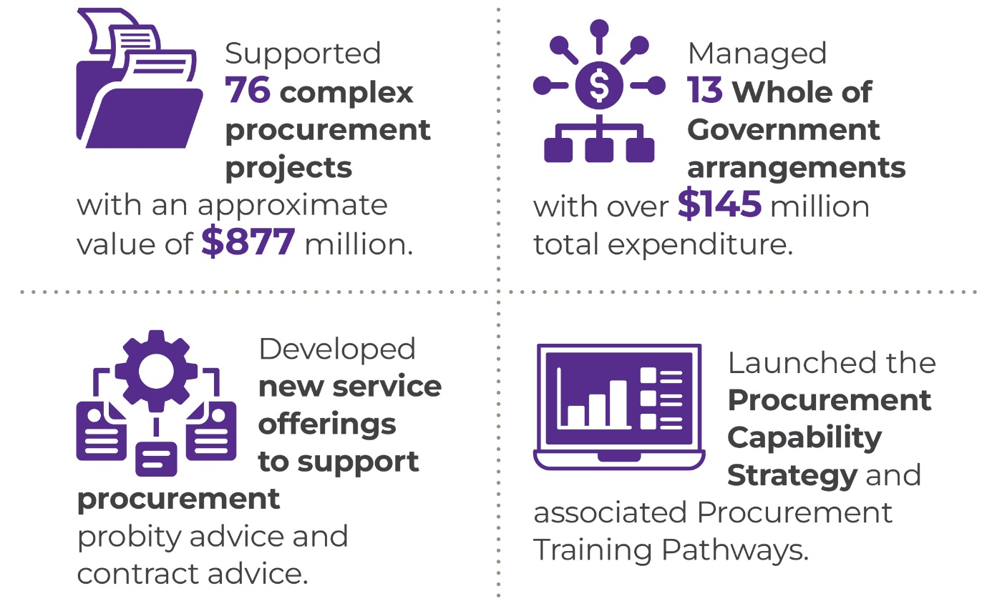
In 2022-23, we:
- supported 76 complex procurement projects with an approximate value of $877 million. Of these 50 procurements resulted in contracts with another 6 procurements resulting in panel arrangements with a total value of $775 million;
- conducted detailed due diligence to support the consideration of extending the Territory’s whole of government arrangements for electricity, stationery, medical services scheme, travel and related services;
- continued supporting the following suite of whole of government arrangements providing streamlined purchasing for a range of goods and services:
- Whole of Government Contractor Central
- Whole of Government Creative, Logistical and Printing related Services
- Whole of Government Employee Assistance Program (EAP) and Critical Incident Support (CIS) Services Whole of Government Media Placement and Advice
- Whole of Government Medical Services Scheme
- Whole of Government Panel of Training Providers
- Whole of Government Professional and Consulting Services Panel
- Whole of Government Provision of Supply of Electricity & Electricity Metering and Data Management Services to ACT Government Large Market Facilities
- Whole of Government Records Storage, Disposal, Management and Related Services, including Artefacts. (RMS)
- Whole of Government Stationery (29987.110)
- Whole of Government Supply of Natural Gas
- Whole of Government Valuation Services Scheme (27791)
- Whole of Government Vehicles Leasing and Fleet Management
- continued to pursue new and innovative future whole of government arrangements for services such as scribing, talent acquisition, research and technical engineering;
- continued to support a Procurement Community of Practice to bring together ACT Government procurement professionals to share knowledge, leverage their expertise and collaborate on innovation. The Procurement Community of Practice has regular communications on existing and new policies and processes, and new training and supports which has driven improvements in procurement capability.
- continued to implement the actions under the ACT Government Procurement Reform Program to deliver a framework for efficient, effective and accountable procurement practices and processes which included:
- the development and release of an ACT Government Procurement Capability Strategy which will uplift the capability of those undertaking and supporting procurement. The Strategy supports our procurement workforce and makes the ACT Government an employer of choice for procurement professionals, allowing us to attract and retain talented and highly skilled officers. The Capability Strategy delivers a series of actions through learning and qualification requirements which will embed the requisite skills, performance, and professional development of the procurement workforce.
- the development of a Goods and Services Accreditation Program to ensure that directorates and agencies undertaking goods and services procurement are properly supported to make good procurement decisions. The Accreditation Program provides a robust evaluation process supported by an independent governance body to review each Territory entity’s capacity and capability to manage its procurements. The Accreditation Program is aligned with the scale, scope and risk of the procurement to ensure that high risk and high value procurements are provided with additional centralised support. The Accreditation Program will commence in the 2023/24 Financial Year.
- the development of a Tiered Service Delivery Model which provides enhanced services to support procurement. This includes additional advisory services to provide specialist support and advice on probity and contract management to ensure that Territory entities are supported in their procurements right through to managing their contracts. The new tiered services also give confidence to delegates that their procurement process is being managed in accordance with the procurement framework. The Tiered Service Delivery Model will commence in the 2023-24 Financial Year.
In 2022-23, we also continued to undertake the following work:
- supporting directorates by engaging with them individually and through coordinated consultation and acting on their feedback and suggestions;
- working with our jurisdictional counterparts to develop improved nationwide procurement practices;
- reviewing and improving the ACT Government’s procurement framework, including guidance, templates and procedures. We will also continue to improve procurement policies and processes to optimise support for delivering effective procurement and advancing social outcomes;
- supporting procurement officers and suppliers through the provision of advice and assistance via the Procurement Help Desk; and
- enhancing the ACT Government’s procurement capability and promoting a shared understanding of our procurement framework and systems by developing a range of training packages, targeted engagement strategies and strategic procurement planning.

Future direction
In 2023-24, we will continue to work with and support agencies in the planning, preparation and conduct of complex goods and services procurements. We will also work with agencies to improve the program management and tracking of complex goods and services procurements.
We will continue to deliver actions associated with the Procurement Reform Program, these actions will deliver:
- enhanced and contemporary procurement legislation;
- a streamlined procurement policy framework that ensures that the ACT Government is an informed, ethical and socially aware purchaser;
- efficient and effective procurement advice and support, in accordance with the scale, scope and risk of the procurement; and
- new services to support procurement probity and contract advisory services.
The reform program will continue to provide more transparent opportunities for industry and local businesses to work with the Government. It will support the capability of our workforce through enhanced training and development programs so that the Government remains an employer of choice for procurement professionals. It also streamlines legislation, policy and processes to foster innovation and timely procurement outcomes.
Further information | Sanaz Mirzabegian, Executive Group Manager, Procurement ACT
 | Sanaz.Mirzabegian@act.gov.au

Output 8.1 Property Services

Overview
Through the Property Services output the directorate manages 226 Territory-owned buildings, including commercial buildings, government office and service provision accommodation, community/multipurpose buildings, and aquatic/leisure facilities. The directorate also leases 36 commercial buildings on behalf of the Territory.
The directorate delivers this output by:
- managing a portfolio of properties used for the delivery of government, community and commercial services by the ACT Government and tenant organisations;
- leading the delivery of government accommodation projects that will provide security, flexibility, and a long-term approach to government office accommodation;
- managing the ACT Government’s owned and leased government office buildings including sourcing and negotiating new leased properties;
- delivering property upgrade services and planned and reactive maintenance services for Territory-owned properties managed by ACT Property Group and other directorates;
- managing procurement and contract management of building maintenance service activities across multiple construction trades and maintenance service areas;
- ensuring continued operation of six ACT Government owned aquatic facilities including upgrades, maintenance and management of contracts with operators of the facilities;
- identifying and pursuing opportunities to improve the energy efficiency of Territory owned buildings to deliver ACT Government climate change priorities and policy; and
- representing the ACT Government at the National Government Property Group.

Performance

Accountability indicators
2 met or exceeded 1 not met
We met two of our accountability indicator targets for this output and did not meet the following one indicator:
8.1a – Percentage of customers satisfied with management of aquatic centres. The survey results for 2022-23 resulted in a lower than anticipated satisfaction rate of 87 per cent. Results were not available for two aquatic facilities (Civic Olympic and Dickson Aquatic Centres) due to low number of responses deeming results statistically invalid. Of the responses from the other four aquatic facilities there were lower levels of satisfaction from customers of Lakeside, Gungahlin and Stromlo Leisure Centres with scores indicating room for improvement in information provided on activities, events, bookings and closing times.

Highlights
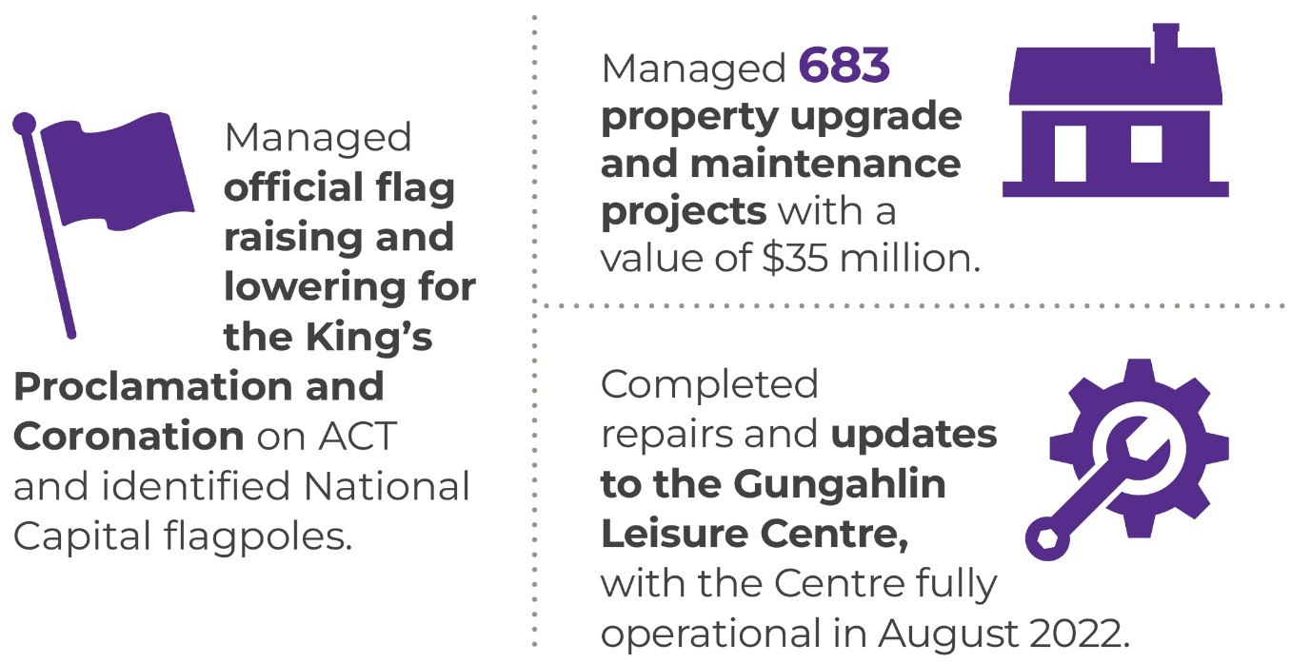
In 2022-23, we:
- managed the relocation of the ACT Civil & Administrative Tribunal (ACAT) from Level 4, 1 Moore Street to their permanent accommodation at Allara House;
- completed repairs to the pools at the Gungahlin Leisure Centre with the Centre fully operational in August 2022;
- erected flags and banners for events such as the King’s Proclamation, the King’s Coronation, Floriade, the Comedy Festival, Feared & Revered and the National Police Remembrance Day. We also managed adjustments to flags on behalf of the ACT and Commonwealth Governments to recognise passing of significant people including the passing of Queen Elizabeth II.
- in partnership with other ACT Government directorates, managed 683 property upgrade and maintenance projects with a value of $35 million;
- managed timely maintenance of ACT Government facilities through operation of a 24-hour, seven-day-a-week trades and services intake works allocation team. During the period we managed more than 13,000 calls and raised over 14,835 work orders for building repairs and maintenance.
- contributed to delivery of the ACT Government’s commitment in the Parliamentary Agreement of the 10th Legislative Assembly to engage public servants to deliver government services through:
- Engagement of ACT Public Service building trades staff and delivery of an increased program of property maintenance services by this team valued at $339,640 per annum; and
- Transitioning cleaning services for three Government Office Buildings (220 London Circuit, Nara Centre and Allara House) from delivery by a contractor to delivery by ACT public servants engaged by the Education Directorate.
- supported the Local Roads and Community Infrastructure Program Phase 3 to deliver capital upgrades to ACT Government owned properties at $1.8 million. This program included upgrades to seven community facilities including the National Convention Centre, the Tuggeranong Community Centre, the Tuggeranong Library and the Tuggeranong Youth Centre.
- completed the retiling of the 50-metre pool at the Dickson Aquatic Centre in October 2022. During this project, an accessible ramp was also installed to support community needs.
- ensured the continued provision of high-quality community and government facilities through completion of $8.7 million in building upgrades to government, leisure and community facilities in properties managed by CMTEDD. This included a package of building upgrades under the ACT Government’s Building Infrastructure Fund ($5.3 million), capital projects ($1.6 million) and the Australian Government’s Local Roads and Community Infrastructure program ($1.8 million).
- supported the Education Directorate in the delivery of high-quality school facilities through implementation of an agreement for management of heating and cooling infrastructure, and capital works projects including upgrades to bathrooms, staff rooms, learning spaces, administration areas, playgrounds, playing fields, double-glazing, electrification of HVAC & switchboards projects to facilitate upgrades of ageing school facilities and delivering sustainability and energy efficiency improvements;
- delivered significant projects for other ACT Government directorates and branches including:
- Refurbishment of 13 bathrooms in three weeks at Queen Elizabeth II Family Centre and building upgrades at Karralika Isabella for ACT Health;
- Full building refurbishment following termite damage at Exhibition Park in Canberra (Coorong Pavilion) and Bradman Stand bar refurbishment at Manuka Oval for Venues, CMTEDD; and
- Bathroom refurbishments at City Police Station for Justice and Community Safety Directorate; and sustainability upgrades at Stromlo Depot for Environment, Planning and Sustainable Development Directorate.
- continued to improve the energy efficiency of ACT Government properties managed by ACT Property Group including:
- Installed a 99.51kW rooftop solar PV system at 255 Canberra Ave workshops;
- Installed a 77kW expansion on the exiting rooftop solar PV system at Flynn Community Centre;
- Secured two ACTPG owned locations under the Big Canberra Battery program. The battery installations are expected to be complete in 2023-24;
- Finalised a priority list for energy efficiency upgrades including installing solar PV and LED lighting;
- Completed a detailed building façade and energy simulation to improve the energy efficiency of planned building façade and HVAC upgrade work;
- Commenced investigation of potential electrification and energy efficiency upgrades for ACT public swimming pools; and
- Carried out gas asset audit for ACTPG's whole portfolio and developed a priority list for electrification of gas assets across 38 known sites.
- completed reviews on community facilities in the Woden and Belconnen regions under the Community Facilities Asset Renewal which will inform better usage and planning for this portfolio of properties;
- progressed HVAC and Landscaping building maintenance trade and services panels;
- progressed procurement for management contracts for five government owned aquatic centres with anticipated transition to occur in the second half of 2023.

Future direction
In 2023-24, we will:
- continue to improve property management services;
- continue to progress the Community Facilities Renewal program;
- deliver improvements to ACT Government buildings, increasing functionality, efficiency, longevity and reducing running costs;
- improve project governance and delivery;
- continue to identify and implement delivery of property maintenance services by ACT Public Service staff for ACT Government properties;
- continue procurement of building maintenance trade and services panels and contracts across priority areas, seek continuous improvement in energy efficiency for assets and deliver positive outcomes to our tenants; and
- deliver funded capital works projects across the ACT Property Group managed property portfolio, and properties managed by other directorates, to deliver better community and government facilities.
Further information | Graham Tanton, Executive Group Manager, Property Group and Government Insourcing Group
 | (02) 6207 5757 | Graham.Tanton@act.gov.au

Output EBT 1 Territory Banking Account

Overview
Through the Territory Banking Account (TBA) output we recognise and manage the Government’s financial investment assets and borrowing liabilities.
Revenues on behalf of the Territory are transferred to the TBA and fortnightly appropriation disbursements are made to agencies from the TBA. CMTEDD, through the financial operations of the TBA, provides services to the Government including financial asset and liability management through the establishment of financial investment and borrowing policies and objectives, and the coordination and implementation of cash management, financial investment and borrowing activities.

Performance

Accountability indicators
9 met or exceeded 1 not met
We met nine of the 10 accountability indicator targets against this output. We did not meet EBT 1.1 d - Completion of the Principles for Responsible Investment Annual Reporting and Assessment Framework. The Principles for Responsible Investment organisation had a number of problems associated with their reporting tool and as a result, the ACT Government and other signatories were not required to make submissions for the 2022-23 financial year.

Highlights

Government’s Responsible Investment Policy
Reporting and disclosure of responsible investment related activity is available from the directorate’s website. This includes the disclosure of the Government’s Responsible Investment Policy, the Investment Plan, directly owned share holdings (updated quarterly), a summary of the Sustainability Proxy Voting guidelines, and share voting activity for the financial year (updated quarterly).

Future direction
In 2023-24, we will:
- manage the Territory borrowing program;
- manage cash and liquidity;
- manage the centralised investment platform for Territory financial investment assets; and
- manage the Government’s Responsible Investment policy framework.
Further information | Patrick McAuliffe, Executive Branch Manager, Investments and Borrowings  (02) 6207 0187 Patrick.McAuliffe@act.gov.au

Output EBT 1 Superannuation Provision Account

Overview
Through the Superannuation Provision Account (SPA) output, we assist the Government to effectively manage the defined benefit employer superannuation liabilities of the Territory.
The SPA is established to recognise the defined benefit employer superannuation liabilities of the Territory and the financial investment assets set aside to fund these liabilities over time. The liabilities include past and current ACT employees who are members of the Australian Government’s Commonwealth Superannuation Scheme and Public Sector Superannuation Scheme, and Members of the Legislative Assembly Defined Benefit Superannuation Scheme.

Performance

Accountability indicators
5 met or exceeded
We met all five accountability indicator targets against this output.

Highlights
In 2022-23, under this output we:
- managed the SPA investment portfolio in accordance with the established investment plan and policies; and
- completed the annual actuarial review of the defined benefit employer superannuation liabilities of the Territory.

Future direction
In 2023-24, we will:
- complete the triennial actuarial review of the defined benefit employer superannuation liabilities using salary and membership data as at 30 June 2023;
- monitor the funding plan to extinguish the unfunded defined benefit superannuation liability; and
- manage the Investment Plan and the financial investment assets of the SPA.

Further information | Patrick McAuliffe, Executive Branch Manager, Investments and Borrowings  (02) 6207 0187 Patrick.McAuliffe@act.gov.au

Scrutiny
Several bodies have responsibility for scrutiny for CMTEDD’s activities, including Committees of the ACT Legislative Assembly, the ACT Audit-General, the ACT Ombudsman and the ACT Integrity Commission.
The tables below describe progress on implementing recommendations by those bodies where the government has agreed to them. This includes both recommendations the government agreed to in 2022-23 and recommendations from previous years where the directorate undertook further work during 2022-23 to progress them to completion.
In accordance with the Annual Report Directions, we have not included recommendations below where the government’s initial response indicated that implementation of the recommendation was already complete.
The ACT Integrity Commission is not listed as it did not release a report in the period.

ACT Auditor-General reports

Table 28: ACT Auditor-General’s Report No. 2/2022 Fraud Prevention - Government Response released 2/8/2022
Recommendation number and summary | Status and action in reporting year
Recommendation 1: Fraud and Corruption Plans and Reporting – Agreed  CMTEDD should provide clarity on the purpose of Fraud and Corruption Prevention Plans and the requirements for annual reporting of fraud and corruption issues. This may be achieved through the current review of the ACTPS Integrity Policy (2010), which is scheduled for completion in early 2022. | Complete  CMTEDD has undertaken a review and revised the ACTPS Integrity Framework and the ACTPS Integrity Governance Policy. The revised ACTPS Integrity Framework and ACTPS Integrity Governance Policy was issued to all staff on 23 May 2022 and addresses fraud and corruption prevention plans, and the requirements for annual reporting of fraud and corruption issues.  As stated in the ACTPS Integrity Framework, each agency is required to appoint an individual as the Senior Executive Responsible for Business Integrity Risk (SERBIR). The SERBIR has primary responsibility for the implementation of the Integrity Framework, risk management and reporting of integrity and fraud and corruption prevention.  In accordance with Section 113(1)(a) of the Public Sector Management Standards 2016, agencies are required to develop and implement a Fraud and Corruption Prevention Plan which forms part of the agencies’ formal risk assessment. The agencies’ respective Audit and Risk Committees have oversight over the effectiveness of the integrity arrangements. The ACTPS Integrity Governance Policy provides further information as to what is required in a Fraud and Corruption Prevention Plan.  Directors-General and Chief Executive Officers must ensure the Fraud and Corruption Prevention Plan is assessed and reviewed every two years. There are also reporting requirements in the Annual Report Directions, whereby agencies must provide information on fraud prevention policies and practices and fraud detection strategies including the number of reports or allegations of fraud or corruption received and investigated during the year.
Recommendation 2: Conflict of Interest Registers – Agreed in principle  CMTEDD should provide guidance to ACT Government agencies on requirements for the documentation and recording of conflict-of-interest declarations. The guidance should address: a) whether conflict of interest declarations are expected to be recorded in a centralised register in the agency; and b) if they are, the circumstances in which the information in the register is to be used and for what purpose. | In progress  The Conflict-of-Interest Policy was updated in June 2021 and is now due for review (from June/July 2023). The recommendation will be considered in the course of the review.  There are considerations when determining whether an agency is to use a centralised register to record conflicts of interest. This includes ensuring staff privacy or whether issues could be better resolved through situationally specific or one-off conflict checks - for example, a recruitment round. Conflict of interest declarations are routine for recruitment panels to complete. In this scenario, an agency may find it more efficient, and secure for privacy purposes to record conflicts of interest with the documentation for that process.
Recommendation 3: Mandatory Reporting of Conflicts of Interest – Agreed  Where not already in place, ACT Government agencies should require all recruitment panel members to complete a conflict-of-interest declaration form when taking part in a recruitment process, including that they have no known actual or potential conflicts of interest. | Complete  Conflict of interest declarations are routine for recruitment panels to complete. Recruitment panel members are requested to complete conflict of interest declarations when taking part in a recruitment process.
Recommendation 4: Fraud and Corruption Induction Training – Agreed  Where not already in place, ACT Government agencies should:  a) provide mandatory induction training about the nature and risks of fraud and corruption and relevant ACT Public Service and agency policies. The training should be delivered with reference to examples and scenarios relevant to the business of the agency; and  b) keep timely and accurate records of the number of staff completing the mandatory induction training. | Complete  All new starters to the ACTPS are required to undertake induction training. Each directorate is responsible for providing core learning to their staff, of which fraud and ethics should be part.  Additional integrity and workplace behaviour training is presented to the graduate and vocational employment cohorts as part of their induction. This training is facilitated by the Professional Standards Unit and is also available by request across the ACTPS.  CMTEDD has relevant e-learning modules which track the number of staff completing the training.
Recommendation 5: Agency Staff Surveys – Agreed in principle  Where not already in place, ACT Government agencies should undertake staff surveys that collect information about the level of staff awareness of their fraud and corruption reporting obligations and the reporting channels they should use, as well as staff perceptions of the integrity of agency senior leadership. This information should be used to benchmark staff awareness levels and inform priorities for fraud and corruption prevention activities. | Complete  The ACTPS Employee Survey, delivered in March 2023, included questions relating to corruption. Select results and analysis of the whole of ACT Public Service outcomes will be published in the 2022-23 State of the Service Report. The ACTPS Employee Survey will be delivered every two years. Annual Reports are published in October each year.
Recommendation 6: Whole of Government Staff Survey – Agreed  CMTEDD should:  a) conduct a regular ACT Public Service survey that includes questions relating to fraud and corruption and integrity-related risks; and  b) publicly report on the results of these surveys. | Complete  The ACTPS Employee Survey, delivered in March 2023, included questions relating to corruption. Select results and analysis of the whole of ACT Public Service outcomes will be published in the 2022-23 State of the Service Report. The ACTPS Employee Survey will be delivered every two years. Annual Reports are published in October each year.

Table 29: Auditor-General’s Report No. 3/2022 ACT Taxi Subsidy Scheme - Government response tabled 14/10/2022
Recommendation number and summary | Status and action in reporting year
Recommendation 1: Scheme purpose and objectives – Agreed in principle  CMTEDD should:  a) review and clearly articulate the purpose and objectives of the Scheme; and  b) use this as a basis for identifying a policy for, and principles associated with, subsidy amounts and subsidy caps. | Complete  a) The ACT Revenue Office and Access Canberra websites clearly articulate the purpose and objectives of the Scheme.  b) CMTEDD considered the appropriateness of the subsidy levels and caps in 2022-23, which informed changes announced in the 2023-24 Budget.
Recommendation 2: Review and evaluation – Agreed  CMTEDD should periodically review and evaluate the operation of the Scheme. The review should assess the operation of the Scheme against its identified purpose and objectives and be informed by qualitative and quantitative data that is collected in relation to the operation of the Scheme. | Complete  CMTEDD reviewed and evaluated the operation of the Scheme in 2022-23, leading to changes announced in the 2023-24 Budget.
Recommendation 3: Policy and procedural guidance – Agreed  CMTEDD should review and update the policy and procedural guidance associated with the Scheme. | In progress  New procedures will be finalised, and necessary associated guidance materials updated by 31 March 2024.
Recommendation 4: Application form accessibility – Agreed  CMTEDD should explore opportunities to make the application forms associated with the Scheme web-based and able to be completed on-line. | In progress  CMTEDD has commenced work to improve the Scheme’s application process through the availability of an online editable form.

Table 30: Auditor-General Report No.11 of 2021 Digital Records Management – Government response tabled 23 February 2022
Recommendation number and summary | Status and action in reporting year
Recommendation 2 – Agreed  CMTEDD, through the Digital Records Governance Committee, should develop a performance framework for the implementation of EDRMS across ACT Government directorates and agencies. The performance framework should focus on the achievement and realisation of benefits associated with EDRMS implementation and inform the monitoring of progress beyond the number of users migrating to EDRMS platforms. | Complete  Shared Services through the Digital Records Governance Committee has implemented a governance strategy and performance framework focusing on the realisation of the benefits of moving to an Electronic Digital Records Management System (EDRMS).  This is supplemented by advice for agencies by the Territory Records Office on how they may be able to realise and measure the benefits of digital recordkeeping.
Recommendation 3 – Agreed  CMTEDD, through the Digital Records Governance Committee, should review and evaluate the funding arrangements and determine if a central recurrent funding model for the whole of government EDRMS is appropriate, noting that a number of records functions still need to be maintained within agencies. | In progress  Shared Services is progressing the funding model review for EDRMS support services in light of the upcoming changes to the hosting arrangements for both Content Manager/TRIM and Objective i.e., a migration from on premise hosting to cloud.  These projects are in progress and once ongoing costs are clearly defined funding arrangements can be revisited for the 2024-25 financial year.

Table 31: Auditor-General Report No.13 of 2021 Campbell Primary School Modernisation Project Procurement – Government response tabled 7 April 2021
Recommendation number and summary | Status and action in reporting year
Recommendation 1 – Agreed in principle  Major Projects Canberra, in cooperation with Procurement ACT, should review and revise its procurement guidance documentation, and associated templates, to explicitly require the preparation of independent probity advice where a delegate or decision-maker seeks to overrule the recommendation of the tender evaluation team. | In progress  An initial review of guidance documentation and templates was undertaken, with revisions to whole of government material made by Procurement ACT in consultation with Major Projects Canberra (MPC). Guidance material and e-learning training were developed by Procurement ACT on procurement probity and delegations. Further work has been undertaken through a Template Improvement Project, as part of the Procurement Reform Program, which has involved a comprehensive template review and refresh to ensure templates are aligned with streamlined processes. A new suite of templates will be released in the 2023-24 financial year. The Procurement Reform Program is also ensuring clearly defined roles and responsibilities through the implementation of an Accreditation Framework and tiered service delivery model which will be supported by the templates that are developed.
Recommendation 5 – Agreed  Major Projects Canberra and the Education Directorate should require staff to have received probity awareness training before participating in procurement activities. The training should also identify how staff can elevate and raise any concerns with probity or conduct during a procurement. | In progress  The Procurement Reform Program has delivered a Procurement Role Appropriate Training Pathways which will require all ACTPS (unless exempted by the Territory entity) to undertake Procurement and Probity Training, the training requirements are scaled based on an ACTPS Officer’s interaction with procurement. Capability and role appropriate training will also form a key aspect of the Procurement Accreditation Framework that is also being developed under the Procurement Reform Program. The Accreditation Framework will benchmark the capability and capacity of a Territory entity to undertake procurement in an effective manner. This ensures that Territory entities are provided with procurement support services commensurate with their capacity and capability to undertake procurement in an effective manner.

Table 32: Auditor-General Report No.1 of 2021 Land Management Agreements – Government response tabled 3 June 2021
Recommendation number and summary | Status and action in reporting year
Recommendation 6 – Agreed  MONITORING AND COMPLIANCE  The Environment, Planning and Sustainable Development Directorate and Access Canberra should develop a risk-based framework for the monitoring and enforcement of Land Management Agreements including processes for:  monitoring rural leaseholders’ compliance with their Agreements; and  taking enforcement action in the event of potential non-compliance. | In progress  Access Canberra is participating in and contributing to a response through its involvement in the Land Management Agreement Working Group. With other members, a draft compliance protocol has been prepared with a view to its implementation by December 2023. Work will continue to refine the protocol up until that time.

Table 33: Auditor-General Report No.3 of 2020 Data Security – Government response tabled 27 August 2020
Recommendation number and summary | Status and action in reporting year
Recommendation 3  CYBERSEC CONTROLS AND REPORTING  The Security and Emergency Management Branch (Justice and Community Safety Directorate), Shared Services (CMTEDD) and the Office of the Chief Digital Officer (CMTEDD), through the auspices of the Security and Emergency Management Senior Officials Group should:  a) Agreed - review and update the CYBERSEC requirements of the ACT Protective Security Policy Framework to reflect the most important system security measures from the ICT Security Policy (August 2019). These measures should be targeted at the areas of agency responsibility and able to be reported in dashboard form; and  b) Agreed - require agencies to report on the implementation of these measures in their ICT systems as part of the GOVSEC 4 reporting process of the ACT Protective Security Policy Framework, in order to provide reasonable assurance that data security risks are being effectively managed. | In progress  - In progress. The ACT Protective Security Framework (ACTPSF) is being revised in the context of the Threat Risk Assessment and new Commonwealth security of critical infrastructure legislation that regulates minimum standards of protective security for critical infrastructure entities, including government owned and operated critical infrastructure.  - In progress. The ACTPSF is being redeveloped to also align more closely with the Commonwealth framework. This includes refining the governance security requirements and preparing clear standards that outline measures to meet. These measures will include reporting mechanisms and risk management. The new ACTPSF is due to be finalised in 2023, with implementation commencing thereafter.
Recommendation 4  DATA SECURITY STRATEGY  The Office of the Chief Digital Officer and Shared Services (CMTEDD) and Security and Emergency Management Branch (Justice and Community Safety Directorate), in partnership with ACT Government agencies, should document and agree a whole of government data security strategy and plan. This document should identify:  a) The role and responsibilities of governance bodies and agencies responsible for managing and improving data security across ACT Government;  b) Any related whole‐of‐government plans for addressing specific data security issues, such as the planned Cyber Security Incident Emergency Sub‐plan to the ACT Emergency Plan;  c) Activities and resources to improve data security for ACT Government; and  d) Identifying the Chief Digital Officer as the responsible senior executive for implementing the strategy to improve data security across ACT Government. | In progress  - In progress. The ACT Data Governance and Management Policy Framework was endorsed and published in August 2020. It is being implemented by directorates (supported by CMTEDD and the Data Reform Group). Directors-General have appointed Executive Data Leads whose role will be to implement the Data Governance and Management Framework within directorates. Whole of government oversight of its implementation is provided by the Data Reform Group and supported by the Data Management Group. Data-specific roles and responsibilities have been identified within directorates to ensure good data security practice. The 2023 Whole of Government Data Maturity Assessment undertaken showed that directorates improved their maturity in ‘Make Data safe and secure’ with security protocols and incident response plans driving this improvement.  - Complete. The Cyber Emergency Sub-Plan is in effect under the ACT Emergency Plan.  - In progress. Cyber awareness uplift was identified as the priority Threat and Risk Assessment (TRA) recommendation to improve data security risks across ACT Government. Cyber Security Essentials e-learning modules have been developed for all staff, a specific course designed for Executives, a refresher course triggered 12 months after completion of the all-staff essentials course and a privileged user course. The training has been available to staff on the Territory’s WhoG learning management system.  Additional awareness material has been developed and delivered specifically for Senior Executives and decision makers.  NOTE: recommendation d) was previously listed as complete.
Recommendation 5  SYSTEM SECURITY RISK MANAGEMENT PLAN ASSESSMENTS  Shared Services (CMTEDD) should:  a) Partially agreed - in conjunction with Recommendation 4, ensure agencies take account of the full cost of managing security across a system’s lifecycle as part of ICT projects, including undertaking security assessments; and  b) Agreed - address the backlog of security risk management plan assessments so that agencies can access security assessments and advice to help them manage data security risks in a timely manner. | In progress  - In progress. The backlog of security assessments has lessened but has not been resolved during this reporting period. Funds provided in the 2021-22 budget for "Investing in public services: Strengthening cyber-security" have enabled additional staffing resources and software tooling to support more effective operations and service the increasing demand for security assessment services. DDTS Security continues to promote the use of external security services for critical systems requiring assessment in short timeframes.  NOTE: recommendation a) was previously listed as complete.
Recommendation 6  SYSTEM SECURITY MANAGEMENT PLANS  The Security and Emergency Management Branch (Justice and Community Safety Directorate) and Shared Services (CMTEDD) should:  a) In conjunction with Recommendation 3, require ACT Government agencies to report on the currency of their system security risk management plans using a common authoritative list of critical systems; and  b) In conjunction with Recommendation 1, develop a process to capture common risks and treatments from ACT Government agencies’ system security risk management plans to inform the whole of government data security risk assessment. | In progress  - In progress. Although the Whole of Government TRA has been finalised, the establishment of a centralised risk register for critical systems remains to be progressed.  NOTE: recommendation a) was previously listed as complete.
Recommendation 7 – Agreed  DATA SECURITY TRAINING  Shared Services (CMTEDD), with input from the Security and Emergency Management Branch (Justice and Community Safety Directorate) and the Office of the Chief Digital Officer (CMTEDD), should coordinate the development of data security training that:  a) Agreed - considers the specific training needs for all users, privileged users and executives; and  b) addresses the risk of using unsanctioned methods of sharing sensitive personal data.  The data security training package should be capable of being delivered and customised by ACT Government agencies as necessary.  NOTE: recommendation b) was previously listed as complete. | Complete  - Complete. Cyber Security Essentials e-learning modules have been developed for all staff; a specific course for Executives; a refresher course triggered 12 months after completion of the all-staff essentials course; and a privileged user course are available to all staff on the Territory’s WhoG learning management system. Additional awareness material has been developed specifically for Senior Executives and decision makers. DDTS Security also provides awareness information through the Cyber Community of Practice and the Cyber Aware Portal. These resources continue to be complemented with an ongoing program of cyber security information and awareness sessions delivered to directorates.

Table 34: Auditor-General Report No.2 of 2020 – 2018-19 Financial Audits – Computer Information Systems – Government response tabled 20 August 2020
Note: The recommendations below replace those reported in previous Auditor-General reports on Computer Information Systems. Open recommendations from previous Computer Information Systems reports are tracked as part of this 2020 report.
Recommendation number and summary | Status and action in reporting year
Recommendation 5 – Agreed  Reconciliation of System Changes  CMTEDD (Shared Services) should perform regular reconciliations of changes recorded in the audit logs to authorised change records in the change management system. | Complete  The sustainment activities of the ‘new’ Configuration Management Database (CMDB) reconciliation processes are now fully operationalised. As a result:  ACTGOV and CIT environments are being reconciled weekly, with the data continuing to be enriched.  The reconciliation of the ESA Production Environment went live in quarter 3 2022, with monthly environment reconciliations to gather data.  The Education Environment is in progress, currently awaiting the provision of blacklisting requirements and IP Address range provision.  Additionally, ServiceNow was engaged to review that the CMDB deployment has adopted the industry best practices (including CSDM Health Check) within ACT Government. The recommendations from the findings are implemented.
Recommendation 7 – Agreed  Monitoring of Audit Logs  a) CMTEDD (ACT Revenue Office) with respect to Community 2011 should:  i) formally assess the risk associated with the Community 2011 system not being capable of logging changes made by database administrators. This assessment should be documented and used as a basis for the directorate’s decision about the timing of the upgrade or replacement of the Community 2011 system to provide this capacity; and  ii) assess whether other compensating controls or reviews can be implemented that may assist mitigate this risk until the system is upgraded or replaced.  b) CMTEDD (ACT Revenue Office) with respect to TRev should:  i) document procedures for the independent review of audit logs of activities performed by privileged users;  ii) perform reviews of these audit logs on a regular basis (e.g. quarterly); and  iii) retain evidence of these reviews, including the date, name and position of the reviewing officer. This includes evidence that any errors or irregularities identified from the review have been investigated and resolved. | In progress  a)i) and ii) A risk assessment relating to the inability of the Community System to log database administrator actions was completed by September 2022 and further updates to the risk assessment have been made.  b)i) The Business Systems User Access Review Policy and the Privileged User Access Review Policy documents were developed in 2019 and 2020.  b)ii) The documents outline the procedures and independent review process to be undertaken quarterly.  b)iii) Documents associated with the reviews are stored in ACTRO’s SharePoint. To complement the independent review of privileged user reviews, a system generated audit log for actions taken by privileged users has been implemented and shows changes to user groups and “to do” roles. The log will be used in all independent quarterly privileged user reviews.  There was a delay in the Community Upgrade deployment and the UAT is expected to re-commence in September 2023. The audit logging issue is expected to be remedied at that point.
Recommendation 8 – Agreed  Generic (Shared) User Accounts  CMTEDD (Shared Services) should remove the generic (shared) user account that enables users to change EFT payment files relating to CHRIS21. | In progress  The current CHRIS21 software version has not changed and therefore the current risk mitigations remain in place. These mitigations are regularly reviewed each year by Shared Services and the ACT Audit Office to ensure they are satisfactory.  The CHRIS21 system is due to be upgraded in 2023-24. This may further improve the EFT payment file process.
Recommendation 9 – Agreed  Segregation of duties  CMTEDD (Shared Services) should:  a) document its risk assessment in the ORACLE System Security Plan; and  b) include the requirement for system-based controls which would prevent a system administrator from being able to create and use multiple user accounts in any future upgrade or replacement of the ORACLE application. | In progress  b) The ability to add a secondary approver to create user profiles has been investigated. Oracle has advised that the current e-Business Suite (version R12) does not have the functionality to accommodate this change. This is standard functionality in new financial management system software, and Shared Services Finance has incorporated the requirements of system-based controls to prevent a system administrator creating and using multiple user accounts into the requirements for the upcoming procurement of a new financial management information system.  NOTE: recommendation a) was previously listed as complete.

Table 35: Auditor-General Report No.6 of 2019 ICT Strategic Planning – Government response tabled 24 September 2019
Recommendation number and summary | Status and action in reporting year
Recommendation 3  In order to support the development of a whole of government ICT strategic plan CMTEDD should develop and implement a whole of government application portfolio management approach, including:  Identification and implementation of a software tools that assists directorates to identify:  existing ICT systems, hardware and capabilities;  future ICT systems, hardware and capabilities and associated investment needs; and  development and formalisation of governance arrangements, including roles, responsibilities and processes for the implementation and maintenance of the software tools and its data. | Complete  DDTS has worked with directorates to review and update the Configuration Management Database (CMDB). This has included undertaking a baseline review of business applications and the information on those applications via the CMDB that provides directorates with transparency on their application portfolios. This has achieved an improvement in Application Portfolio Management maturity overall.  DDTS has also established internal roles and responsibilities and processes to support directorates to maintain the currency of their business application information.

Table 36: Auditor-General Report No.8 of 2017 Selected ACT Government Agencies’ Management of Public Art – Government Response tabled 13 February 2018
Recommendation number and summary | Status and action in reporting year
Recommendation 1 – Agreed  artsACT should lead the development of an ACT Public Art Strategic Plan that covers all ACT Government public art. The plan should incorporate: a desired management model, mechanisms for the involved agencies to work cooperatively, and awareness raising of the contribution of ACT public art to the public realm. If the Australian Government and private sector entities who manage public art in the ACT agree, this plan should be jointly developed. | In progress  Canberra: Australia’s Arts Capital – Arts, Culture and Creative Policy 2022–2026 Action Plan commits to developing a Public Art Strategy for the ACT in 2023-24.
Recommendation 2 – Agreed  artsACT should improve its operational activities by:  a) Updating the Public Art Database so that information is available for all ACT Government public artworks. The cooperation and support of the Australian Government and private sector entities to list their works on this database should be explored.  b) Reviewing and updating the ACT Government Public Art Guidelines (2015), in consultation with stakeholders, providing further guidance on:  c) Different commissioning models that may be used.  d) Acceptance and management of public art loans.  e) Cultural and local Indigenous community protocols in procuring and decommissioning artwork. | In progress  - In progress  The Public Art Database is updated as new works are commissioned by or gifted to the ACT Government. A comprehensive database update will be completed in tandem with the development of the ACT Public Art Strategy in 2023-24.  d) Complete  The ACT Public Art Guidelines were revised to include diversity, equality and inclusion principles as part pf the criteria for considering acquisitions and new commissions. Commissioning models will be considered during the development of the ACT Public Art Strategy in 2023-24.  Note: Recommendations a, b, e, f, g, h and i were reported as complete in previous CMTEDD annual reports.

Table 37: Auditor-General Report No.6 of 2016 Management and Administration of Credit Cards by ACT Government Entities – Government response tabled 13 December 2016
Recommendation number and summary | Status and action in reporting year
Recommendation 3 – Agreed  Shared Services should progress actions to advance the implementation of an automated credit card acquittal facility for the administration of credit cards. | Complete  Shared Services Finance successfully implemented the Expense Management System (EMS) to all directorates across the ACTPS. During 2022-23, approximately 1,100 EMS users had been trained and are now using the solution, including cardholders, cardholder assistants, expense approvers and directorate finance team members.

ACT Legislative Assembly Committee reports

Table 38: Report No. 5 of the Standing Committee on Economy and Gender and Economic Equality - Inquiry into memorialisation through public commemoration - Government response tabled 1 December 2022
Recommendation number and summary | Status and action in reporting year
Recommendation 3 – Agreed in principle  The Committee recommends that the ACT Government conduct an education campaign to increase awareness on how nominations for public memorialisation can be made. | In progress  Through the normal course of business, CMTEDD Communications and Engagement promote nominations for awards and honours programs, which are used to recognise outstanding individuals and groups.

Table 39: Report No.3 of the Standing Committee on Environment, Climate Change and Biodiversity Inquiry into Annual and Financial Reports 2020-21 - Government response released 16 September 2022
Recommendation number and summary | Status and action in reporting year
Recommendation 6 – Agreed  The Committee recommends that the ACT Government deliver the VHESS as soon as possible to provide ACT Housing tenants with the benefits of energy efficiency and efficient electric heating in their homes. | In progress  The delivery of the Vulnerable Household Energy Support Scheme (VHESS) commenced in 2020-21. This program is being delivered jointly between EPSDD, CMTEDD and CSD. The program aligns with the Parliamentary and Governing Agreement of the 10th Legislative Assembly commitment to provide $50 million in funds for low-income household and public housing upgrades.  Under the VHESS in 2022-23, EPSDD delivered ceiling insulation and gas-to-electric appliance upgrades to 112 public housing properties as part of a pilot program. This project is being delivered in collaboration with the Office for Climate Action and CSD.
Recommendation 7 – Agreed  The Committee recommends that the ACT Government consider requiring end-of-life battery and solar panel recycling under the contracts for the Big Canberra Battery and under all government contracts involving procurement of large batteries. | In progress  For the Big Canberra Battery project, all contracts require suppliers to provide the Territory with decommissioning plans for large batteries and associated infrastructure that meet strict reuse and recycling criteria.  Under the Procurement Reform Program, a Template Modernisation Project is underway. The Contract Template Suite will be updated to require that end-of-life battery and solar panel recycling is considered under government contracts involving procurement of large batteries. In addition to this, the Charter of Procurement Values Guide will be updated to ensure that these considerations are made in accordance with the Environmental Responsibility Procurement Value.
Recommendation 11 – Agreed  The Committee recommends that the ACT Government consider the EDO report Implementing Effective Independent Environmental Protection Agencies in Australia and if the nine key recommendations are agreed, how these will be implemented. | In progress  In 2022-23 the EPA and EPSDD received funding to undertake the development of objectives, policies and guidelines to ensure the protection of the environment from climate change in line with changing expectations including in response to the EDO report. The work has involved development of a program covering the following six areas.  Protecting the community and environment  Strengthening regulatory controls  Improving the licensing and compliance framework  Modernising environmental standards  Meeting community expectations  Meeting new and emerging environmental challenges  Specific actions have been identified for each of the six areas, and these take into account the recommendations of the EDO report.
Recommendation 11 – Agreed in-principle  The Committee recommends that the ACT Government ensure the EPA’s resources and FTEs in line with increasing development and population growth. | In progress  The work program described above, which responds to the Environmental Defenders Office Report, also responds to the Committee’s recommendation to ensure that the EPA’s resources align with increasing development and population growth.

Table 40: Report No. 4 of the Standing Committee on Environment, Climate Change and Biodiversity Inquiry into Renewable Energy Innovation in the ACT - Government response tabled 20 October 2022
Recommendation number and summary | Status and action in reporting year
Recommendation 3 – Agreed  The committee recommends that the ACT Government explores enhanced mechanisms for coordination between directorates to ensure that renewable energy efforts across the ACT government are consistent and integrated. | Complete  The Office for Climate Action (OCA) has been established to coordinate and support the ACT Government’s ambitious agenda for climate action. This included the establishment of new governance arrangements across agencies. The ACT Government continues to review and refine coordination mechanisms on an ongoing basis.
Recommendations 7 and 8 – Agreed in-principle  The Committee recommends the ACT Government support the ACT Renewables Hub to have long term objectives and projects that focus on outcomes to address social, technological, environmental, and labour market barriers and innovation to support ACT leadership in the renewable energy field. The committee recommends that the ACT Renewables Hub be funded to conduct future mapping of the ACT renewable ecosystem, with a goal of identifying gaps and growth areas. | In progress  Under Skilled to Succeed, Economic Development is developing a Renewables Industry Action Plan which will include actions to address workforce needs in the renewables sector.
Recommendation 9 – Agreed  The committee recommends the ACT Government continue to look at delivering R&D and start-up grant schemes and funding that promotes innovation and diversity in the renewable energy sector. | Complete  The ACT Government funds the Canberra Innovation Network (CBRIN) to provide grants and programs (Innovation Connect, Griffin Accelerator) that promote innovation and entrepreneurship across all sectors, including renewable energy.  Through the Future Jobs Fund (FJF), the ACT Government funds the Priority Investment Program (PIP) that supports collaboration between ACT industry and the tertiary sector. It supports projects that seek to attract investment and grow established and emerging priority sectors of Canberra’s economy.
Recommendations 10 and 11 – Agreed  The committee recommends that the ACT Government continues to increase investment in renewable energy sector skills education and training, working in partnership with CIT and the ACT universities.  The committee recommends that the ACT Government continue to fund and support CIT Renewable Energy Skills Centre of Excellence to develop and grow to become the Australian and Asia-Pacific leader in renewable sector skill development. | In progress  CIT is delivering training in key renewable energy programs covering solar, wind and energy storage sectors. CIT has established strong industry networks in the renewable energy sector and built practical training facilities to meet emerging needs of the renewables industry. CIT has codesigned Electric Vehicle training with Tesla and worked with Neoen and GPG on solar and wind initiatives.  CIT’s Renewable Energy Skills Centre, developed in collaboration with industry, leads the development and teaching of practical, technical skills required by the renewable energy industry across the ACT Region. The Centre provides outstanding, practical training to prepare students for a career in the renewable energy sector and upskilling existing workers in the sector.
Recommendation 12 – Agreed  The committee recommends that the ACT Government look to engage the Australian Government in discussion around opportunities through current Asia-Pacific labour and mobility schemes to up-skill workers here in the ACT. | Complete  The ACT Government continues to engage with the Australian Government to increase visa pathways for skilled migrants to come to the ACT and to discuss developments related to the Australian Government’s Pacific Australia Labour Mobility (PALM) scheme. As of May 2023, there were 31 PALM workers in the ACT with six more scheduled to arrive.
Recommendation 15 – Agreed  The committee recommends that the ACT Government, through its plans/strategies/ frameworks/grants ensure that it prioritises and promotes diversity and inclusivity. | Complete  The ACT Government continued to promote and embed diversity and inclusion across a wide range of plans, policies and frameworks in 2022-23. Key examples include passing the Multiculturalism Act 2023 as well as progressing our city’s recognition and accreditation as a Welcoming City to ‘Advanced’ Level within the international Welcoming Cities Standard. Ongoing implementation of the Age-Friendly City Plan continued to ensure Canberra is an age-friendly city, as did work under the Capital of Equality Strategy which aims to ensure Canberra is Australia’s most LGBTIQ+ welcoming and inclusive city. Significant work is progressing under the Government’s commitments to both the ACT Aboriginal and Torres Strait Islander Agreement and the National Agreement on Closing the Gap. Development of a new Disability Strategy was undertaken in 2022-23, and the second action plan under the ACT Women’s Plan was completed, with further action expected in 2023-24. These examples demonstrate the ACT Government’s ongoing commitment to prioritise and promote diversity and inclusion.
Recommendations 16 and 17 – Agreed  The committee recommends that the ACT Government considers, as part of its policy and planning work in relation to renewable energy, the social and human dimensions associated with achieving renewable energy targets and objectives. The committee recommends that the ACT Government continues to ensure that renewable energy innovation contributes to achieving social goals as part of a just energy transition to net zero emissions. | Complete  Consistent with the Parliamentary Agreement for the 10th Assembly, the ACT Government continues to ensure a just transition for those impacted by the shift to net zero emissions, including considering the social and human dimensions associated with achieving renewable energy targets and objectives.  The ACT Government provides a variety of rebates, resources and support available via the ACT Government’s Everyday Climate Choices website to support households, community organisations and businesses. The ACT Government provides ongoing support to reduce energy hardship for vulnerable households, such as the Home Energy Support program which provides rebates for Australian Pensioner Concession and Veterans’ Affairs Gold Card holders for sustainable home upgrades for rooftop solar systems, hot water heat pumps, reverse cycle heating and cooling systems, and better ceiling insulation.
Recommendation 19 – Agreed  The committee recommends that the ACT Government provide more detailed and clear strategies on its implementation of the big batteries program, including that a diverse range of participants take up battery storage. | Complete  The ACT Government’s Climate Choices website provides up to date information on the implementation of the Big Canberra Battery program. The procurement activities outlined encourage all eligible businesses to apply. The ACT Government is looking to support a diverse range of participants to deliver the Big Canberra Battery program. The ACT Government delivered two procurements for batteries at government sites in 2022-23. These two procurements were split based on the size of batteries, to enable a diverse range of suppliers. A procurement for a large-scale battery was also delivered in 2022-23, resulting in a partnership between the ACT Government and Eku Energy for a 250-megawatt, 500 megawatt-hour battery in Williamsdale.
Recommendation 20 – Agreed  The committee recommends that the ACT Government ensures its renewable energy programs and specifically, its roll-out of community-scale batteries, occurs as a just transition. | In progress  The ACT Government is undertaking a feasibility analysis of neighbourhood scale batteries including community ownership options. This analysis will consider opportunities for just transition and social impacts.
Recommendation 27 – Agreed  The committee recommends that the ACT Government support dispatchable battery power through the co-location of renewable energy projects at suitable sites that can be connected to the ACT electricity network. | Complete  The Big Canberra Battery project will provide at least 250MW of dispatchable battery power connected to the ACT electricity network. This will encourage more renewable energy projects to connect to the network. In April 2023 the ACT Government partnered with Eku Energy on the development of a 250MW, 500MWh battery in Williamsdale.  The location of any future large-scale batteries will be determined by a range of factors including proximity to appropriate electrical infrastructure with headroom capacity suitable for the size of the proposal, as well as the availability of land that can be used for that purpose. As was the case at Williamsdale, this will often mean that batteries are located in the proximity of sites with existing or future renewable energy generation.
Recommendation 37 – Agreed in-principle  The committee recommends that all new and refurbished Government facilities are required to include renewable energy generation capability. | In progress  Due to the complex nature of this recommendation, significant policy consideration has been undertaken. The policy will be finalised in 2023-24.

Table 41: Report 6 - Standing Committee on Environment, Climate Change and Biodiversity - Inquiry into environmental volunteerism - Government response tabled 21 March 2023
Recommendation number and summary | Status and action in reporting year
Recommendation 2 – Agreed  The Committee recommends that the ACT Government standardise terms and conditions for grant applications and acquittal across ACT Government directorates, and where differentiation is necessary, those unique clauses to be outlined after the standard wording and requirements. | Complete  ACT Government officials administering grants have access to a standard deed of grant designed by the ACT Government Solicitor. This deed of grant template outlines a standardised set of terms and conditions which can then be followed by the specific requirements of a particular program. ACT Government grant programs are also required to follow the whole of government Administration of Government Grants in the ACT policy.  As part of a continual improvement cycle, the templates, standard forms and contracts, and further guidance of the use of those features are being revised in consultation with the ACT Government Solicitor’s office and grants administrators across the Territory. Further guidance on the use of these will also be developed as part of the next revision of the policy document to ensure that this element of grant programs is standardised as far as practicable.

Table 42: Report No 12 of the Standing Committee on Public Accounts Inquiry into the Work Health and Safety Amendment Bill 2022 – Government response tabled 27 June 2023
Recommendation number and summary | Status and action in reporting year
Recommendation 1 – Agreed in Principle  The Committee recommends that the Assembly pass the Work Health and Safety Amendment Bill 2022 with further amendment to ensure absolute clarity that the Assembly is a workplace. | Complete  The Work Health and Safety Amendment Bill 2022, including the Speaker’s amendment, was passed on 29 June 2023.
Recommendation 2 – Agreed in Principle  The Committee recommends that the Assembly pass the Speaker’s amendment, without the words ‘or otherwise interrupt’, to ensure there is no diminution or abrogation of the powers, privileges and immunities of the Assembly. | Complete  The Work Health and Safety Amendment Bill 2022, including the Speaker’s amendment, was passed on 29 June 2023.

Table 43: Report No. 7 of the Standing Committee on Health and Community Wellbeing Inquiry into the West Belconnen Supercell Thunderstorm - Government response tabled 7 February 2023
Recommendation number and summary | Status and action in reporting year
Recommendation 1 – Agreed  The Committee recommends that the ACT Government undertakes a gap analysis of communication with affected residents following emergencies. | In progress  Emergency communication processes have been reviewed, with processes for analysing our communication response being incorporated into planning where appropriate.
Recommendation 2 – Agreed  The Committee recommends that the ACT Government more clearly communicate the purpose of and intended users of emergency hubs in disasters. | In progress/complete/no longer required  This recommendation will be included in work being undertaken on preparation and resilience planning for emergencies.

Table 44: Report No.9 of the Standing Committee on Public Accounts – Inquiry into ACT Auditor-General’s Report 7/2021 Procurement Exemptions and Value for Money – Government response tabled 13 October 2022
Recommendation number and summary | Status and action in reporting year
Recommendation 1 Whole of life costs in value for money assessments – Agreed  The Committee recommends that the ACT Government mandate that every procurement includes whole of life costs factored into value for money assessments. | Complete  Section 22A(3)(d) of the Government Procurement Act 2001 requires that optimising whole of life costs must be considered when making decisions regarding the pursuit of value for money.  A ‘Calculating Whole of Life Costs Better Practice Guide’ was made available to Territory entities in January 2022. The better practice guide requires early considerations of optimising whole of life costs when assessing value for money. The Value for Money in Procurement eLearn released in June 2022 further reinforces the need to assess whole of life cost as one of the key considerations in the pursuit of value for money.  The availability of the Calculating Whole of Life Costs Better Practice Guide and Value for Money eLearn has been communicated through whole of government messages, the Procurement Community of Practice and Territory entity procurement teams.
Recommendation 2 Mandated conflicts of interest – Agreed  The Committee recommends that the ACT Government mandate that every procurement includes a signed declaration of conflict of interest. | Complete  The Probity in Procurement Guide, published in January 2020, was amended in May 2021 to clarify that all participants in a procurement must complete a conflict-of-interest declaration. This includes a written affirmation that staff do not have a conflict of interest in relation to a procurement.  “To help ensure any potential, perceived or actual conflicts of interest are actively managed, all ACTPS (Australian Capital Territory Public Service) officers and employees involved in a procurement must complete a Conflict-of-Interest Disclosure (see Appendix H), including, Page 4 where relevant, to affirm that they do not have a conflict of interest.”) (p7, Probity in Procurement Guide).  The Probity in Procurement Guide forms part of the ACTPS ethical and legal framework, set out in the ACTPS Integrity Framework (May 2022), and provides further advice that completed disclosures must be maintained as a record with other documents relating to the procurement.  The ACT Government also released the ‘Conflict of Interest Better Practice Guide’ in January 2022 which provides guidance to Territory entities on identifying and managing conflicts of interest as part of ensuring probity and ethical behaviour when conducting procurement activities.  The availability of the Conflict-of-Interest Better Practice Guide has been communicated through whole of government messages, the Procurement Community of Practice and Territory entity procurement teams.
Recommendation 3 Systematic capture of probity – Agreed in-principle  The Committee recommends that the ACT Government improve and strengthen procurement documentation processes to ensure that all aspects of probity are systematically captured and addressed. In doing so, the ACT Government should:  Conduct a review of all its current documentation templates and revise where the requirements of the relevant legislation are not reflected.  Ensure that all staff likely to undertake procurements are properly trained on whole of-life costs when assessing value for money, conflicts of interest, and risk management.  Ensure that delegates do not ‘sign off’ on procurements unless all aspects of probity are addressed. | In progress  Procurement ACT has undertaken a review and refresh of all procurement templates, these templates are undergoing review across the ACT Government, and we expect to release the new suite by the end of 2023.  Under the Procurement Reform Program, Role Appropriate Procurement Training Pathways are being developed. This will include mandatory training for all ACTPS Officers (unless exempt) on Procurement and Probity in addition to a suite of new training initiatives tailored to an officer’s knowledge and interaction with procurement.  Procurement ACT also developed a Value for Money in Procurement eLearn module in June 2022, available to all Territory entities. The eLearn includes information on assessing whole of life costs and conflict of interests. A factsheet and updated templates have also been developed to support improved risk management in procurement and were released in January 2022 and July 2022 respectively. Section 22A(3)(a) of the Government Procurement Act 2001 requires that Territory entities (including delegates) must have regard to probity and ethical behaviour when making value for money assessments in procurement. A Procurement Delegations eLearn has been developed and is available to Territory entities to support delegates in understanding the key procurement delegations under the relevant legislation.
Recommendation 4 Increased Procurement ACT support – Agreed  The Committee recommends that Procurement ACT provide greater direct support to ACT Government entities that conduct procurements infrequently, for both procurements below and above $200,000. | In progress  As part of the Procurement Reform Program, a tiered service delivery model is being developed to ensure that there is an appropriate service available to all procurements commensurate with the scale, scope and risk of that procurement. This includes enhanced self-service support for low value/ low risk procurements as well as more extensive support for procurements with a higher scale, scope and risk.  Tiered service delivery is expected to be rolled out progressively, with full rollout in 2024-25. In addition to support through tiered services, the Procurement Reform Program will implement the following in support of all procurements regardless of the scale, scope or risk of a procurement:  updated templates;  enhanced guidance on the internet and intranet;  enhanced Helpdesk support services; and  training and eLearn content to support ACTPS procurement capability.
Recommendation 5 Assurance Schemes – Agreed in-principle  The Committee recommends that, by December 2022, the ACT Government in collaboration with Procurement ACT, put in place assurance schemes across its directorates that:  monitor the effectiveness of procurement reforms;  ensure that there is an accurate and detailed record of instances of non-compliance in procurements;  annually report on adherence to probity and ethical considerations across tender processes;  record remediation actions undertaken for non-compliance; and  monitor that staff who undertake procurements have had the necessary and appropriate training. | In progress  The Procurement Reform Program will implement a procurement reform change management program to track progress, bring staff along the journey, know when outcomes have been achieved, sustain the desired state into the future, and build continuous improvement into the fabric of the Procurement Framework.  As part of the Procurement Reform Program, an accreditation program will benchmark the capability and capacity of each Territory entity to undertake procurement in an effective manner. Procurement ACT will monitor compliance against accreditation including through an assurance program.
Recommendation 6 Breaches and non-compliance – Agreed in-principle  The Committee recommends that the ACT Government implement a system of management action for staff undertaking procurements who breach the procurement framework. In doing so, the Committee recommends that non-compliance, and management action is monitored and reported through the relevant directorates performance management system. | In progress  Section 9 of the Public Sector Management Act 1994 sets out obligations of public sector conduct which include compliance with laws applying in the Territory and carrying out work with reasonable care, diligence, impartiality and honesty. This applies to conduct in relation to a procurement.  Under the Goods and Services Accreditation Program, consideration will be given to additional procurement compliance and reporting requirements.
Recommendation 7 Contract Register – Agreed in-principle  The Committee recommends the ACT Government ensure that all procurements above the threshold are accurately reported on the ACT Government Contracts Register. | In progress  Part 3 of the Government Procurement Act 2001 requires that Territory entities must report notifiable contracts and notifiable amendments.  Procurement ACT is exploring options to implement a whole of government procurement ICT system, subject to future budget approval processes.  An ACTPS-wide procurement ICT system would support Government Buyers undertaking procurement activities and enhance compliance and transparency.  Enhanced guidance, Helpdesk function, and training and eLearn content being developed under the Procurement Reform Program will support the ACT Government in ensuring that all procurements above the threshold are accurately reported on the ACT Government Contracts Register.
Recommendation 8 Government Procurement Board roles and relationship – Agreed  The Committee recommends that the ACT Government publishes online further guidance on the respective roles of, and relationship between, Procurement ACT and the Government Procurement Board. | In progress  Further guidance will be made available on the internet and intranet on the relationship between Procurement ACT and the Government Procurement Board.  Additional factsheets regarding the operation of the Government Procurement Board and requirements for Territory entities in engaging with the Government Procurement Board will also be updated and published pending any changes to the details arising amendments to the Government Procurement Act 2001 and the Government Procurement Regulation 2007, which are currently being progressed under the auspices of the Procurement Reform Program.

Table 45: Inquiry into Auditor-General Report No.1 of 2021 - Land Management Agreements - Government Response tabled 13 October 2022
Recommendation number and summary | Status and action in reporting year
Recommendation 5 – Agreed  The Committee recommends that, by December 2023, Access Canberra provide a report to the Committee on the number of referrals of potential non-compliance made to Access Canberra and the compliance action taken in response. | In progress  Access Canberra is developing reporting mechanisms with a view to providing this report by December 2023.

Table 46: Standing Committee on Public Accounts - Report 11 - Inquiry the Auditor-General's Report No.4 of 2020: Residential Land Supply and Release - Government response tabled 9 February 2023
Recommendation number and summary | Status and action in reporting year
Recommendation 6 – Agreed  The Committee recommends that the ACT Government continue to advocate for tax reform from the Commonwealth Government that will support housing affordability. | In progress  The ACT Government has previously indicated support for Commonwealth Government tax changes that will mitigate the effects of prioritising housing as an investment earning asset instead of a fundamental right.  Housing affordability is complex, and the solutions are not simple. Any changes to improve affordability will be undertaken in a holistic manner, where possible, to ensure there are no perverse or unforeseen impacts on the economy, homebuyers and renters. The ACT Government will continue to advocate for reforms that encourage real growth in wages, allowing for improvements in housing affordability.  The ACT Government will also continue to deliver on its commitments to increase the supply of more affordable homes and supporting Canberrans access the housing market. However, in the absence of the Commonwealth Government addressing the key drivers of house price growth, housing will remain tilted more towards being a wealth generating asset.  The ACT Government will continue to advocate for removing barriers to institutional investment in Build-to-Rent in Australia, including GST treatment and Managed Investment Trust rules. For example, National Cabinet agreed on 28 April 2023 to reduce the withholding tax rate for eligible fund payments from managed investment trusts to foreign residents on income from newly constructed residential build-to-rent properties after 1 July 2024 from 30 to 15 per cent, subject to further consultation on eligibility criteria.
Recommendation 7 – Agreed  The Committee recommends that the ACT Government undertake tax reform to support housing affordability in the ACT. | Complete  Stamp duty continues to be reduced through the ACT Tax Reform program.
Recommendation 9 – Agreed  The Committee recommends the ACT Government ensure any requirements for a minimum of 15% social and affordable housing for land release are more stringently enforced. | Complete  Under the ACT Housing Strategy (2018), the Government has committed to at least 15 per cent of residential land releases in the Indicative Land Release Program (ILRP) being dedicated to affordable, community, and public housing.  As part of the 2022-23 land release program, 368 sites were released to meet housing targets, which was greater than 15 per cent of the residential land released. These releases included:  79 public housing targets;  49 community housing targets; and  240 affordable housing targets.  In addition, the Government is committed to delivering more social and affordable housing through a range of initiatives announced in the 2023-24 Budget. including releasing sites for sale through the ILRP as well as the Government’s new housing initiatives to deliver affordable rental dwellings Community Housing Providers (CHPS). These initiatives will play an important role in meeting our affordable housing targets in the Housing Accord and PAGA.
Recommendation 10 – Agreed in-principle  The Committee recommends the ACT Government work in partnership with community housing providers to enable them to deliver more affordable and community housing. | In progress  The ACT Government worked in partnership with community housing providers (CHPs) to deliver more affordable housing in 2022-23 through the following initiatives:  Ginninderry Women’s Build-to-Rent-to-Buy 2023-24 budget initiative to deliver up-to 22 affordable dwellings.  CHPs submitted Build-to-Rent proposals with affordable rental on privately held land, expected to deliver up to 161 affordable rentals.  Over 140 properties managed by CHPs participated in the affordable housing land tax exemption scheme.  Establishment of a $60 million Affordable Housing Project Fund for assistance through a Request for Proposal processes.  Development of a pipeline of community housing sites to offer CHPs to deliver more affordable housing and access Commonwealth funding.

Table 47: Standing Committee on Public Accounts – Report 16 Inquiry into the Appropriation Bill 2022-2023 (No 2) and Appropriation (Office of the Legislative Assembly) Bill 2022-2023 (No 2) - Government response tabled 28 March 2023
Recommendation number and summary | Status and action in reporting year
Recommendation 1 – Agreed in-principle  The Committee recommends that the Government publish in its budget review the assumed rates for any bonds expiring in that financial year. | Complete  The rates have been reflected in the 2023-24 Budget and will be reflected in the future budget reviews.
Recommendation 4 – Agreed in principle  The Committee recommends that, given the significant cost of living pressures facing Canberrans, the Government include as part of its budget review process an update to the Cost-of-Living Statement, which details the measures committed through the budget review to alleviate cost of living pressures on Canberrans. | Complete  All new measures to alleviate cost of living pressures were detailed in the 2022-23 Budget and Budget Review papers. This included an additional temporary $50 rebate under the Utilities Concession in 2022-23 (2022-23 Budget) and the expansion of full motor vehicle registration discount to ACT Services Access and Australian Low Income Health Care card holders from 1 July 2023 (2022-23 Budget Review). Future measures will continue to be detailed in future Budget and Budget Review papers.

Table 48: Select Committee on Estimates 2022-23 Inquiry into the Appropriation Bill 2022-23 and Appropriation (Office of the Legislative Assembly) Bill 2022-23 - Government response tabled 11 October 2022
Recommendation number and summary | Status and action in reporting year
Recommendation 26 – Agreed in principle  The Committee recommends that the ACT Government reports timeframes for the Ice Rink Complex and indicate:  when details of the confirmed site will be released;  whether the facility will be a joint venture with external parties and sporting groups;  details of who will be responsible for the management and maintenance; and  a timeframe for when budget allocations will be made and report back to the Assembly. | Complete  The ACT Government has entered into an agreement with Cruachan Investments and Pelligra Holdings to progress the delivery of a new ice sports facility in Greenway.  Block 19, Section 46 (Greenway) is the proposed site for the new ice sports facility.  Pending finalisation of binding agreement, the entity (formed by Cruachan Investments and Pelligra Holdings) will own the facility and be responsible for all operations and management.  A budget allocation is expected to be made in 2023-24.
Recommendation 27 – Agreed in principle  The Committee recommends that the ACT Government advise:  the extent of the proposed feasibility study to determine the parameters for a new pool, featuring a dive pool, in the Stromlo Leisure Centre complex;  the extent of consultations that have already taken place with key interest groups about new or additional pool facilities; and  the likely timeframe for the study, timelines for consideration of the results by government and the allocation of any budget funding for the expansion of current pool facilities and report back to the Assembly. | In progress  The feasibility study will be released to market in the 2023-24 financial year. It is expected that the outcomes of the feasibility/scoping study into the potential inclusion of a dive pool facility at the Stromlo Leisure Centre will be available in 2024. Once the study has provided recommendations the Government will consider future actions.

Table 49: Standing Committee on Education and Community Inclusion - Report 7 - Inquiry into Access to Services and Information in AUSLAN - Government response tabled 7 June 2023
Recommendation number and summary | Status and action in reporting year
Recommendation 4 – Agreed in principle  That the ACT Government and public agencies translate highly trafficked webpages into Auslan and create provision for Deaf people to forward queries, feedback and submissions in Auslan. | In progress  The Digital Consolidation Project is currently underway and will increase the accessibility of all ACT Government websites over a 5-year period. The project will consider current best practices and jurisdictional comparisons to inform the way forward.
Recommendation 6 – Agreed in principle  That the ACT Government legislate all emergency warning systems in buildings (including Bimberi Youth Justice and Alexander Maconochie Centres) to include mechanisms that alert Deaf and hard-of-hearing people. | Complete  As part of the ongoing efforts to maintain and upgrade the systems within the ACT Property Group portfolio, the inclusion of visual emergency alert systems has been considered.  A comprehensive assessment of each site is conducted on a case-by-case basis, ensuring that the opportunity to incorporate visual alerts is actively pursued as systems reach their end of life and require replacement.  Moreover, the ACT Property Group acknowledges that additional funding may be necessary in certain instances to carry out these rectifications and improvements. To ensure the successful implementation of visual emergency alert systems, the ACT Property Group includes relevant information and funding requirements within the maintenance budget bids related to these enhancements and properties.
Recommendation 12 – Agreed in Principle  That the ACT Government reintroduce certified Auslan courses through the Canberra Institute of Technology. | Complete  The Canberra Institute of Technology (CIT) will explore the viability of establishing and delivering Auslan courses. In addition, Deaf Services Australia has a current Training Initiative Funding Agreement (TIFA) to deliver Auslan training in the ACT.
Recommendation 15 – Agreed in Principle  That the ACT Government provide subsidies to students of Auslan, including scholarships. | Complete  The Certificate II in Auslan; Certificate III in Auslan; Certificate IV in Auslan; and Diploma of Auslan are now included on the Skills Needs List. The ACT Government currently funds the Diploma in Interpreting as a traineeship under the User Choice program.

Table 50: Standing Committee on Public Accounts - Report 15 - Inquiry into Auditor-General’s Report No. 8 of 2021: Canberra Light Rail Stage 2A: Economic Analysis - Government response tabled 28 June 2023
Recommendation number and summary | Status and action in reporting year
Recommendation 8 – Agreed in-principle  The Committee recommends that the ACT Government publish a benefits realisation plan for Light Rail stage 2A as soon as possible. | In progress  Government will publish a “Benefits Realisation – Snapshot” report, for the integrated Light Rail program (Stages 1 and 2A), approximately one year after passenger operations commence for Stage 2A.

Table 51: Standing Committee on Economy and Gender and Economic Equality – Report 1 – Inquiry into COVID-19 Emergency Response Legislation Amendment Bill 2020 (No. 3) – Government response tabled 8 February 2021
Recommendation number and summary | Status and action in reporting year
Recommendation 1 – Agreed  The Committee recommends (to the extent that work is not already taking place) after the COVID-19 pandemic crisis has passed and the ACT has exited from its state of emergency, the ACT Government give consideration to examining and reviewing the emergency measures that were enacted. This should not be limited to the ACT but should also include emerging evidence of good practice from across Australia and the globe. | This item is now reported in the Justice and Community Safety Directorate Annual Report.

Table 52: Standing Committee on Planning, Transport and City Services - Report No. 6 – Appropriation Bill 2021-2022 and Appropriation (Office of the Legislative Assembly) Bill 2021-2022 – Government response table 23 November 2021
Recommendation number and summary | Status and action in reporting year
Recommendation 24 – Agreed  The Committee recommends that the ACT Government investigate barriers to community housing partnerships. | In progress  The ACT Government investigated barriers to community housing and worked in partnership with CHPs to boost the supply of affordable housing in 2022-23 through the following initiatives:  Ginninderry Women’s Build-to-Rent-to-buy 2023-24 budget initiative to deliver up to 22 affordable dwellings;  CHPs submitted Build-to-Rent proposals with affordable rental on privately held land, expected to deliver up to 161 affordable rentals;  over 140 properties managed by CHPs participated in the affordable housing land tax exemption scheme;  establishment of a $60 million Affordable Housing Project Fund for assistance through a Request for Proposal processes; and  development of a pipeline of community housing sites to offer CHPs to deliver more affordable housing and access Commonwealth funding.
Recommendation 27 – Agreed In-principle  The Committee recommends that the ACT Government consider all methods including additional advertising for increasing the uptake of the affordable "Rentwell" and “HomeGround” programs to increase the supply of affordable rentals. | In progress  $50,000 was allocated in the 2023-24 Budget for Treasury to promote the Community Housing Land Tax Exemption Scheme. CMTEDD, in cooperation with Rentwell and Homeground, is working on a strategy to promote the scheme and increase the number of participants.

Table 53: Standing Committee on Education and Community Inclusion – Report 2 – Appropriation Bill 2021-2022 and Appropriation (Office of the Legislative Assembly) Bill 2021-22 - Government response tabled 23 November 2021
Recommendation number and summary | Status and action in reporting year
Recommendation 39 – Agreed  The Committee recommends that the ACT Government continue providing updates to the Gungahlin community regarding the repair of Gungahlin pool. | Complete  Regular updates were developed by ACT Property Group and provided on the operators (YMCA) home page and through social media throughout the project. The 50-metre pool at Gungahlin Leisure Centre re-opened on the 22 August 2022.

Table 54: Standing Committee on Economy and Gender and Economic Equality – Report 3 – Appropriation Bill 2021-2022 and Appropriation (Office of the Legislative Assembly) Bill 2021-22 - Government response tabled 23 November 2021
Recommendation number and summary | Status and action in reporting year
Recommendation 3 – Agreed in principle  The Committee recommends that the ACT Government consider publishing milestones for how and when it will ensure slavery-free supply chains in procurement. | In progress  The Government Procurement (Charter of Procurement Values) Direction 2020 includes the Transparent and Ethical Engagement Value. In complying with the Procurement Values Direction, Territory entities must not knowingly engage with suppliers that demonstrate business practices that are objectionable, dishonest, unethical or unsafe. This includes being alert to modern-day slavery and leveraging national and inter-jurisdictional initiatives to abate such practices. The Secure Local Jobs Code, Government Procurement (Ethical Treatment of Workers) Direction 2021 and the Territory’s Labour Hire Licencing Scheme also work to ensure that the ACT Government is procuring from slavery-free supply chains.  Procurement ACT is developing the Addressing Modern Slavery in Public Procurement Guide which provides guidance to ACT Government Buyers on identifying and addressing risks of Modern Slavery in ACT Government Procurement and the guide is currently being reviewed across government and is expected to be released in the first half of the 2023-24 financial year. Through the Procurement Reform Program, Procurement ACT is also investigating how end-to-end Procurement ICT systems may assist the ACT Government in ensuring slavery-free supply chains.
Recommendation 4 – Agreed  The Committee recommends that the ACT Government consider the wide range of views and consult regarding paid parking in the Stromlo Forest Park carpark before a decision is made to introduce this measure. | Complete  Extensive consultation has occurred with a wide range of community groups and stakeholders, in particular with the Stromlo Stakeholder Consultative Committee (SSCC) regarding the proposal to introduce paid parking at the park. Committee members of the SSCC have provided letters of support about the implementation of paid parking. Feedback was also sought through social media and the Stromlo Forest Park website since August 2022. A decision that paid parking would be introduced at the carparking was announced in June 2023.
Recommendation 9 – Agreed in principle  The Committee recommends that the ACT Government monitor the ongoing impacts of the COVID-19 pandemic on travel and consider reviewing its $2.5 billion target for total domestic visitor expenditure for the year ending June 2022 as the recovery progresses, and publish any new goal that reflects an ambitious, yet achievable recovery of the domestic and international visitor economy. | Complete  In December 2022, the ACT Government released T2030: ACT Tourism Strategy 2023-2030. The target for total visitor expenditure was revised and a new goal was established - $4 billion in annual expenditure of domestic and international visitors by 2030.

Table 55: Standing Committee on Education and Community Inclusion – Report 1 – Annual and Financial Reports 2019-2020 and Appropriation Bill 2020-2021 - Government response tabled 20 April 2021
Recommendation number and summary | Status and action in reporting year
Recommendation 11 – Agreed  The Committee recommends that the ACT Government continue to provide updates to the Assembly on the repair work on the pool at Gungahlin Leisure Centre. | Complete  Regular updates and briefings were provided to the Minister and the community by ACT Property Group during the life of this project. The project has been completed and the Centre has been fully operational from August 2022.

Table 56: Standing Committee on Economy and Gender and Economic Equality – Report 2 – Report on Inquiries into Annual and Financial Reports 2019-20 and ACT Budget 2020-21 - Government response tabled 20 April 2021
Recommendation number and summary | Status and action in reporting year
Recommendation 5 – Agreed  The Committee recommends that the ACT Government in the implementation of COVID-19 investment recovery strategies give due consideration to avoiding risks associated with fragmenting the allocation of funding in a large number of small infrastructure projects in a desire to spend money rapidly at the expense of long-term priorities (for example, sustainability and resilience). | Complete  The $45 million Fast-track Program (the Program) in the Government’s COVID-19 response undertook small to medium projects that could be implemented rapidly to support local employment outcomes. The Program targeted a broad investment strategy including the design and construction of physical infrastructure across the Territory in diverse areas such as schools, community facilities, environmental efficiency measures, city services and active travel. The Program concluded on 30 June 2022. The Fast-track working group provided ongoing Program progress reports to Ministers, with the Chair of the Committee clearing the final program report to Ministers on 10 November 2022.

Table 57: Standing Committee on Economy and Gender and Economic Equality – Report No 2 - Report on Inquiries into Annual and Financial Reports 2019-20 and ACT Budget 2020-21 – Government response released 28 July 2021
Recommendation number and summary | Status and action in reporting year
Recommendation 11 – Agreed  The Committee recommends that the ACT Government should continue to build workplace flexibility in the ACT Public Service and give due consideration to normalising the option of working from home as a viable flexible work provision, where permitted by the demands and responsibilities of designated roles. | Complete  New FlexiSpaces have opened at Belconnen, Tuggeranong and in the city, providing locally accessible workspace for all ACTPS employees. A new Innovation Centre located in the Canberra Nara Centre supports flexibility by providing more opportunities for teams to come together in spaces designed to facilitate learning, team planning, workshops, project delivery, and other problem-solving activities. Normalisation of flexible working arrangements including working from home has been addressed through new EA provisions, policy and guidelines, and through education for line managers and the broader workforce on the availability of and process for accessing flexible working provisions.

Table 58: Select Committee on the COVID-19 2021 pandemic response – Inquiry into the COVID-19 2021 Pandemic Response - Government Response tabled 22 March 2022
Recommendation number and summary | Status and action in reporting year
Recommendation 10 – Agreed  The Committee recommends that the ACT Government undertake a full review of the rollout of the Business Support Grant and the Small Business Hardship Scheme in consultation with local businesses and present the findings of its review to the Assembly by the end of 2022. | Complete  The Minister for Economic Development tabled the Independent Program Evaluation Report of the rollout of the programs, in response to the 2021 Select Committee Inquiry into the COVID-19 Pandemic Response in March 2023.

Table 59: Standing Committee on Public Accounts – Report 9 - Inquiry Into Annual Reports 2018-19 - Government response tabled 23 July 2020
Recommendation number and summary | Status and action in reporting year
Recommendation 5 – Agreed  The Committee recommends that Shared Services amend its targets for response times for telephone service requests so that they require a certain percentage of positive service outcomes from interactions. | In progress  Digital, Data and Technology Solutions is seeking a review of the current targets for response times for telephone requests, given the ongoing complexity of supporting a workforce working from home and increased call volumes resulting from the changes to business practice resulting from the COVID-19 pandemic, and are currently looking at industry and government information to inform an appropriate rationale to inform the new target.

Table 60: Standing Committee on Economic Development and Tourism - Report 8 - Report on Annual and Financial Reports 2018-2019 – Government response tabled 23 July 2020
Recommendation number and summary | Status and action in reporting year
Recommendation 4 – Agreed  The Committee recommends that once digital drivers’ licences are introduced, the ACT Government continue to make accessible a hard-copy identity document. | In progress  The ACT Government is assessing the feasibility of a digital drivers’ licence in line with our broader digital service priorities and the work being undertaken in other jurisdictions.

Table 61: Select Committee on COVID-19 Pandemic Response - Interim Report No. 3 – Government response tabled 13 August 2020
Recommendation number and summary | Status and action in reporting year
Recommendation 17 – Agreed  The Committee recommends that the ACT Government continue to lower and/or remove stamp duty where possible as a lever to encourage housing sales. | Complete  Stamp duty continues to be reduced each year through the ACT Government’s Tax Reform program.

Table 62: Standing Committee on Environment and Transport and City Services Report No. 9 – Inquiry into Territory Coat of Arms – Government response released 24 December 2019
Recommendation number and summary | Status and action in reporting year
Recommendation 2 – Agreed  Dependent on the legal standing of the City of Canberra Coat of Arms, the Committee recommends that the ACT Government either adopt a Coat of Arms for the Territory or update the City of Canberra Coat of Arms. | In progress  During this period the Community Reference Group considered draft design submissions from the public and University of Canberra students. Advice from the Community Reference Group and community feedback is now being considered to inform a shortlist of designs for Government consideration.  Following selection of a new symbol or insignia by public vote, the Territory Coat of Arms or insignia will then be adopted in a gradual manner that allows community organisations to adopt it over time and in a way that minimises expense.
Recommendation 3 – Agreed  The Committee recommends that the ACT Government engage in community consultation to determine the final design for any new Coat of Arms for the ACT. | In progress  Feedback from the YourSay Panel conducted in 2021 along with feedback from the Community Reference Group is being used to inform a shortlist of designs for Government consideration.  As per the committee recommendation, the community will be engaged, and a public vote will be undertaken to decide the final design.
Recommendation 4 – Agreed in principle  The Committee recommends that in consultation with the community the ACT Government redesign the ACT Flag. | In progress  No action is required at this time as the redesign of an ACT Flag will be considered following the process to adopt a new Territory Coat of Arms.
Recommendation 5 – Agreed  The Committee recommends the ACT Government develop a guideline on the appropriate use of the ACT’s Official Symbols and make this publicly available. | In progress  This will be the final piece of work following the Coat of Arms and ACT Flag items above, and as such has not progressed.

Table 63: Select Committee on Estimates 2019-2020 – Inquiry into the Appropriation Bill 2019-2020 and the Appropriation (Office of the Legislative Assembly) Bill 2019-2020 – Government response tabled 13 August 2019
Recommendation number and summary | Status and action in reporting year
Recommendation 37 – Agreed in principle  The Committee recommends that the ACT Government include applications for Seniors Cards in the new online services package. | In progress  Work is underway at a whole of government level on Concessions, to provide ongoing verification of a citizen's concession status and have these automatically applied for all ACT Government services they access. This work is considered a predecessor to the establishment of an online Seniors Card application process, implementation of which will be subject to allocation of budget funding.
Recommendation 39  The Committee recommends that the ACT Government invest in recreational road biking amenity and opportunities, as well consider expanding Stromlo Forest Park and other recreational mountain biking locations, to encourage participation and community health, and to take advantage of growing tourism opportunities. | In progress  EPSDD is leading the response to this recommendation. The National Arboretum Canberra and Stromlo Forest Park Branch provides minor input in relation to Stromlo Forest Park.  In 2022-23, Stromlo Forest Park (SFP) worked on upgrading facilities across the site, including the completion of construction on the Criterium Track extension. A public announcement and media event was held on 17 June 2023 at SFP regarding the engagement of an external consultant to develop a five-year Tracks and Trails Masterplan.
Recommendation 48 – Agreed in principle  The Committee recommends that the two-year pilot of a land tax exemption scheme for affordable housing purposes be assessed after 12 months, so that decisions on any continuation of the scheme can be announced in time for participants to make appropriate plans. | Complete  The number of properties benefiting from land tax exemption for affordable community housing currently is over 140, which is under the property threshold of 250.  The land tax exemption scheme was reviewed in 2022-23 and assessed as effectively meeting its objectives.  As part of the ‘Increasing housing access, choice and affordability – Office of the Coordinator General for Affordable Housing’ initiative announced in the ACT 2023-24 Budget (Budget Outlook, p.116), the Government will be promoting uptake of this land tax exemption scheme to increase the number of affordable properties in the rental market.
Recommendation 55 – Agreed  The Committee recommends that the ACT Government ensure that Budget funding decisions are explicitly considered in the context of the zero emissions by 2045 target and associated interim targets, and the cost of carbon emissions (or ‘the social cost of carbon’) are factored into Treasury and directorate cost benefit analyses. | In progress  Work is underway across Government on valuing emissions reductions to inform Government decision making, including infrastructure. This includes engaging with other jurisdictions to understand approaches to valuing emissions in the context of infrastructure decision-making and delivery.  The Government has updated the Capital Framework, which guides directorates in methodically undertaking robust analysis of infrastructure projects to inform government investment decision making. This includes analysis under the Government’s Wellbeing Framework and sustainability goals and promoting the inclusion of funding for sustainability ratings into business cases.  The Government is developing tools to better assess the emission abatement potential of climate action proposals and seeking to develop further guidance on climate action considerations for use in decision processes including business case development and cost benefit analysis.

Table 64: Standing Committee on Public Accounts Report No.6 – Inquiry into commercial rates – Government response tabled 30 July 2019
Recommendation number and summary | Status and action in reporting year
Recommendation 21 – Agreed  The Committee recommends that the ACT Government give consideration to an education and information campaign for new and existing ACT ratepayers to ensure existing and future commercial property owners have a sufficient understanding of the commercial tax system in the ACT and how the reform is being achieved. | Complete  Information is now available on the ACT Revenue Office website explaining the calculation of commercial rates and the changes in commercial property values for rating purposes. A new process has been established that allows commercial property owners to obtain information on the local commercial property sales that have determined the unimproved value of their property.

Table 65: Report of the Select Committee on Estimates 2018-19 on the Inquiry into Appropriation Bill 2018-2019 and the Appropriation (Office of the Legislative Assembly) Bill 2018-2019 – Government response tabled 14 August 2018
Recommendation number and summary | Status and action in reporting year
Recommendation 29 – Agreed  The Committee recommends that the ACT Government, in consultation with the arts sector, review arts funding and the adequacy of CPI as a funding growth factor for key arts organisations. | Complete  Following consultation with the arts sector, a new arts policy and funding framework for arts organisations was implemented in 2022-23. The funding framework provides a clear pathway to revitalise the cohort of funded companies through open invitation, clear guidelines, and assessment processes. As a result of increased funding in the 2022-23 Budget to the ACT Arts Fund, multiyear funding of over $9 million per annum will be provided to 29 arts organisations. The framework supports funding arrangements that allow Government and organisations to respond to changing priorities and consider audience/consumer and sector demand.
Recommendation 48 – Agreed  The Committee recommends that the ACT Government develop a policy for when peppercorn rents will be offered to community groups leasing ACT Government property.  Recommendation 49 – Agreed  The Committee recommends that the ACT Government develop and publish new guidelines, systems and policies in relation to peppercorn rental agreements, and create a public register of those organisations who benefit from peppercorn rental arrangements during each financial year. | In progress  A public register of organisations who benefit from peppercorn rental arrangements is provided on the ACT Property Group website.  CMTEDD has progressed work on the policy on peppercorn rents. CMTEDD has established a cross Directorate Steering Committee to consider government owned community facilities and associated policies.

Table 66: Standing Committee on Economic Development and Tourism Inquiry into a New Convention Centre for Canberra – Government response tabled 31 July 2018
Recommendation number and summary | Status and action in reporting year
Recommendation 9 – Agreed  The Committee recommends that the ACT Government, in consultation with the private sector, investigate temporary solutions to Canberra’s lack of suitable largescale banqueting facilities. | Complete  The government has released the Infrastructure Plan and has commenced early planning for a new convention centre.

Table 67: Standing Committee on Health, Ageing and Community Service Report No.2 – Report on the Inquiry into Employment of People with Disabilities – Government response tabled 30 November 2017
Recommendation number and summary | Status and action in reporting year
Recommendation 20 – Agreed  The Committee recommends that the ACT Government implement the Doing it Differently recommendation of co-designing a developmental performance review system to support public servants with a disability. | No longer required  This is a historical item that has now been superseded by a number of other initiatives which support people with disability such as the ACTPS People With Disability Employment Framework, ongoing enhancements to reasonable/workplace adjustment resources, and increased access for all ACTPS staff to flexible work provisions.  The ACTPS Performance Framework continues to be used to improve the workplace experience of all employees as well as to improve overall performance and outcomes delivered across the Service.  The Framework focusses on universal principles that upskill managers and staff to engage in good quality, regular conversations about performance, continuous improvement and professional development.  Extensive resources are available to ACTPS staff and managers though HRIMS Learn, the ACTPS Employment Portal and at a local directorate level to assist them in building their capability to have meaningful performance conversations. Further, education and resources are also available through the same channels to understand more about inclusive workplace practices.

Table 68: Select Committee on the Legislative Assembly (Parliamentary Budget Officer) Bill 2016 Report No.1 – Inquiry into the Legislative Assembly (Parliamentary Budget Officer) Bill 2016 – Government response tabled 9 August 2016
Recommendation number and summary | Status and action in reporting year
Recommendation 1 – Agreed in principle  The Committee recommends that the Legislative Assembly (Parliamentary Budget Officer) Bill 2016 not be further considered by the Eighth Assembly, and that the Bill be scheduled for consideration by an appropriate committee of the Ninth Assembly in a manner that the Ninth Assembly may decide is appropriate following the formation of the Ninth Assembly. | In progress  The Government is reviewing this matter further and has not yet decided when it will be returned to the Assembly.

Table 69: Select Committee on Estimates 2015-2016 Report No.1 – Inquiry into Appropriation Bill 2015-2016 and the Appropriation (Office of the Legislative Assembly) Bill 2015-16 – Government response tabled 11 August 2015
Recommendation number and summary | Status and action in reporting year
Recommendation 46 – Agreed  The Committee recommends that the ACT Government update its Tourism 2020 strategy to consider the ten years to 2030 and take into account:  Accommodation.  Attractions.  Events. | Complete  In December 2022 the ACT Government released T2030: ACT Tourism Strategy 2023-2030. This mission-led strategy was developed in consultation with industry and sets the vision for the destination in 2030. The strategy provides the platform for developing solutions and making the right investments in the years ahead. T2030 is the overarching framework for all efforts by government and industry, including in accommodation, attractions and events.
Recommendation 80 – Agreed  The Committee recommends that the ACT Government update the Legislative Assembly on the outcomes of actions that are being taken to find suitable alternative accommodation for Gugan Gulwan. | Complete  The ACT Government provided funding in the 2021-22 Budget to the Community Services Directorate to deliver a purpose-built facility for the Gugan Gulwan Youth Aboriginal Corporation. ACT Property Group has provided suitable interim accommodation within its existing portfolio. Gugan Gulwan relocated to this building in May 2022. Redevelopment of the Gugan Gulwan site has commenced and the project is expected to be completed in 2024-25.

ACT Ombudsman

Table 70: Report No.3/2020 – Investigation into the transparency of commercial land valuation decisions in the ACT – Released August 2020 – ACT Revenue Office response dated 3 August 2020
Recommendation number and summary | Status and action in reporting year
Recommendation 2 – Agreed  This new policy should be complemented by an updated procedures manual, to provide guidance to decision-makers, particularly with respect to data entry and quality assurance processes, to promote more consistent decision-making and documentation. The new procedures should outline requirements in terms of valuation analysis and documentation of decisions. | In progress  The draft ACT Rating and Taxing Valuation Procedures Manual has been updated for recent changes in processes.
Recommendation 5 – Agreed  ACTRO provide clear advice to the community via its website and in relevant correspondence regarding:  the threshold for accepting an objection.  the information that must be provided in order to ‘sustain’ an objection. | In progress  Funding has been provided for a new valuation IT system that will provide additional valuation information to property owners. The build of this system includes new arrangements for accepting objections.
Recommendation 6 – Agreed  Once finalised, ACTRO (CMTEDD) publish the recommended policy as per its open access obligations under the Freedom of Information Act 2016 (FOI Act) or provide reasons why publishing the policy is not appropriate. | In progress  The updated procedures manual (Recommendation 2) and response to all other recommendations will be made available at the ACTRO website.

Risk Management
Effective risk management practices support the directorate’s commitment to ensuring the delivery of our services at all levels – strategic, business and operational.
CMTEDD’s approach to risk management is based on the Australian Risk Management Standard AS ISO 31000:2018 and is consistent with the ACT Government Risk Management Policy. Oversight of risk is monitored through the Executive Management Group, and the Audit and Risk Committee.
Our risk policies - Risk Management Framework and Policy; and Risk Management Plan, are reviewed every two years. A major review of these documents is underway, and once finalised will be supported via education workshops, training and communication to our teams.
At a business area level, Executives and Senior Managers maintain and review group and business area risks. At the Strategic Level, there continues to be a focus on emerging risks; the appropriateness of controls as appropriate for the environment; any need for additional treatments; and their relevance for inclusion in Group or Strategic level risk registers.
Business Continuity management forms part of CMTEDD’s risk management and corporate governance practices, which supports CMTEDD’s commitment to the ongoing delivery of the directorate’s critical business functions where a business interruption risk has been realised. CMTEDD Business Continuity and Disaster Recovery Framework outlines the directorate’s commitment to undertaking the delivery of critical services following a business interruption event and aims to build resilience and capability across all areas of the directorate.
During the 2022-23 reporting year, CMTEDD continued to look at the lessons learnt, and the longer-term changes to the work environment following the COVID-19 pandemic to ensure business continuity arrangements continue to be effective and support organisational resilience. This has included commencing the development of a Resilience Management Framework. The purpose of this Framework is to provide a holistic and structured approach to the CMTDD emergency, crisis and business continuity arrangement including linkages to wider whole of government obligations.
During 2022-23 specific risk management activities included:
- Governance
- Update to the Group level Risk Registers; the Strategic Risk Register, and development of the CMTEDD Strategic Risks Assurance Map.
- Engagement on, and commencing preparations for, the introduction of the revised Protective Security Framework.
- Commencing development of a Resilience Management Framework.
- The CMTEDD Fraud and Corruption Prevention Policy and Plan, and Fraud Risk register were reviewed in June 2023 through an external review process and have been updated to ensure the fraud risk controls remain effective, new fraud risk treatments have been identified and will be implemented to strengthen fraud risk management.
- Communication and engagement activities by the Senior Executive Responsible for Business Integrity Risk (SERBIR) through themed messages to staff and encouragement to undertake training.
- CYBER Security
- A continuation of a Cyber Security review group to connect activities of the Chief Information Officer with the Agency Security Executive.
- A continuation of activities to update and review Government and Business Critical System Security Plans.
- Situation Reporting and impact assessment of nation-wide Data Breach incidents.
- Testing new capabilities for “friendly” phishing attacks.
- Improved patching processes for legacy systems and migrating for end-of-life operating systems and database platforms to fully supported versions.
- Our Physical and Personal environment
- A continuation of the CMTEDD Physical Site Security Assessment Program.
- A continuation of the CMTEDD Emergency Coordination Centre response capacity assisting in whole of government emergency response arrangements.
- Implementation of the Whole of Government Closed Circuit Television Policy.
- Ongoing engagement with customer facing business areas on how security incidents are reported, including their connection to WHS and Occupational Violence.

Further information | Robert Wright, Executive Group Manager, Corporate
 | (02) 6207 0569 | Robert.Wright@act.gov.au

Internal Audit
The CMTEDD Audit and Risk Committee assists the Director-General and the Under Treasurer in fulfilling their oversight and governance responsibilities. The Committee’s role, composition, authorities and responsibilities are set out in the CMTEDD Audit and Risk Committee Charter.
The Audit and Risk Committee (Committee) provides independent assurance and assistance to the Director-General and Under Treasurer on the directorate’s risk, control and compliance frameworks, and its external accountability responsibilities. The Committee’s responsibilities are set out in the CMTEDD Audit and Risk Committee Charter which is reviewed by the Committee and approved by the Director-General annually.
Annual financial statements for the directorate are reviewed by the Audit and Risk Sub-Committee (Financial).
The Committee Chair provides advice to the Director-General and Under Treasurer on audit outcomes, significant risks and implementation of mitigation strategies via quarterly outcomes meetings.
The Audit and Risk Committee reviews the Strategic Risk Register on a regular basis through their ordinary meetings and specific risks at their special meetings. Business area risk registers are presented to the Audit and Risk Committee on a rotational basis at ordinary meetings. New or emerging risks are reported to the Committee as identified.
The membership of the Committee includes an external independent Chair, an external independent Deputy Chair, a Senior Executive from another ACT Government directorate and three advisors from within CMTEDD. There were the following changes to the Committee membership during 2022-23:
- a new independent Deputy Chair was appointed to the Committee in July 2022;
- the Senior Executive from another ACT Government directorate reached the end of the maximum available term supporting the Committee, resulting in a new Senior Executive from another ACT Government directorate being appointed to the position; and
- an internal advisor reached the end of the maximum available term supporting the Committee, resulting in a new internal advisor being appointed to the position.
Representatives from the ACT Audit Office and CMTEDD staff regularly attend to present to the Committee.
The Committee held four ordinary meetings and two special meetings focussing on specific risks. Details are in Table 71 below.

Table 71: Membership of the CMTEDD Audit and Risk Committee 1 July 2022 – 30 June 2023
Name of Member | Position | Duration | Meetings Attended
Greg Field | Independent Chair | 1 July 2022 – 30 June 2023 | 6
Len Gainsford | Independent Deputy Chair | 19 July 2022 – 30 June 2023 | 6
Geoffrey Rutledge | Senior Executive Officer from other ACT Government directorate | 1 July 2022 – 31 March 2022 | 3
Paul Ogden | Senior Executive Officer from other ACT Government directorate | 19 April 2022 – 30 June 2023 | 1
Sam Engele | Advisor | 1 July 2022 – 31 March 2023 | 4
David Pryce | Advisor | 1 July 2022 – 30 June 2023 | 5
Penny Shields | Advisor | 1 July 2022 – 30 June 2023 | 6
Kate Starick | Advisor | 19 April 2022 – 30 June 2023 | 2
The directorate develops the Internal Audit Program by identifying areas of strategic, operational or fraud risk. The Committee provides input into this Program prior to being endorsed by the Chair of the Audit and Risk Committee and approved by the Director-General and the Under Treasurer. CMTEDD engaged external service providers from the ACT Government Professional and Consulting Services Panel, or specialists, to undertake fieldwork and prepare Internal Audit reports in accordance with auditing standards.
The directorate finalised six audits in the 2022-23 financial year:
- Occupational Violence
- Business Systems – current position and future direction
- Public Servant Responsibilities
- Workforce Capability and Governance Whole of Government Policy Review
- Procurement Review for Under $25,000
- Territory Actuals Reporting System

Further information | Robert Wright, Executive Group Manager, Corporate
 | (02) 6207 0569 | Robert.Wright@act.gov.au

Fraud Prevention
CMTEDD has prepared and maintains the CMTEDD Fraud and Corruption Prevention Policy and Plan and CMTEDD Fraud Risk Assessment (incorporating the Fraud Risk Register).
The CMTEDD Fraud and Corruption Prevention Policy and Plan provides the overarching policy position for corruption prevention in the directorate and is consistent with the ACT Integrity Framework. The Policy and Plan and Risk Register are externally reviewed every two years. Both the policy, plan and register were last reviewed in June 2023 through an external review process and have been updated to ensure the fraud controls remain effective, new fraud risk treatments have been identified and will be implemented to strengthen the fraud risk management.
High fraud risk issues will continue to be monitored regularly and compliance auditing completed through the internal audit program with oversight through the Audit and Risk Committee and Executive Management Group. Medium and low fraud risks will be monitored through the compliance review program.

Fraud awareness activities
Fraud awareness and ethics are key themes for training and development within CMTEDD. Fraud awareness training is provided in the Fraud and Ethical Behaviour e-learning. In 2022-23, 1,822 CMTEDD staff completed the e-learning, of these 261 staff recompleted the e-learning as is required every three years.
The Senior Executive Responsible for Business Integrity Risk (SERBIR) also conducted the following awareness activities through all CMTEDD staff emails:
- Managing conflicts of interest – highlights the requirement for managing conflict of interest by ACTPS employees within identified areas such as: procurement, recruitment, second jobs and Declaration of Private Interests.
- Updated ACT Public Sector (ACTPS) Integrity Framework - the ACTPS Integrity Framework outlines how ACTPS employees make decisions, behave appropriately and ensure that the reputation of the ACTPS is maintained.
- End of Year Celebrations, Gifts, Events and Alcohol – provides staff with guidance on their obligations around gifts, attending events, consumption of alcohol and appropriate behaviour when attending end of year functions.
- Integrity and Fraud - as public servants, we have specific obligations in relation to our behaviour and conduct. In line with the ACTPS Values and Signature Behaviours, one of these obligations is to act with integrity.
- Fraud and Ethical Behaviour training - information to staff on how to access the e-learning module or schedule face to face team training sessions.
Executives engaged under a contract of employment are required to submit a Declaration of Public Interest (DPI). The purpose of the DPI is to place on record any interests they may have that conflict, or may be seen to conflict, with their public duty.
The Executive Declaration of Private Interests include:
- Real Estate / Share Holdings / investments / assets / other sources of income / sponsored gifts and travel
- Liabilities
- Trusts/Nominee Companies
- Directorship in Companies, Partnerships
- Secondary Employment
- Other non-pecuniary interests
CMTEDD participated in the 2023 ACTPS Employee Survey. Several questions related to fraud and integrity:
- A question was asked ‘My organisation operates with a high level of integrity’. 84% of CMTEDD employees responded positively to this question, an increase of 7% from the 2021 results and 11% higher than the ACTPS average.
- A question was asked ‘During the last 12 months, in your current organisation, have you witnessed behaviour that could be considered corruption?’ 3% of CMTEDD employees responded yes to this question. This was 1% less (from 4%) than the 2021 CMTEDD response and 3% lower than the ACTPS average of 6%.
The SERBIR meets regularly with the Chair of the Audit and Risk Committee, Chief Internal Auditor, Governance and Human Resources leads to discuss the importance of integrity as ACT public servants and the need to be open, honest and transparent in our work and in delivering services to the ACT Community.

Integrity Commission
CMTEDD has continued to engage with the ACT Integrity Commission on a range of integrity matters, ensuring a collaborative approach to fraud and corruption prevention.

Incidents of fraud reported in 2022-23
From 1 July 2022 to 30 June 2023, the SERBIR received 18 allegations of fraud and corruption in relation to CMTEDD staff. Of the 18, eight related to fraud and the remainder related to corruption. Four of the 18 matters were the subject of mandatory notifications to the ACT Integrity Commission, none of which are fraud related. Twelve matters did not reach the threshold of mandatory referral. Two of the allegations received by the SERBIR were a referral from the ACT Integrity Commission; one is currently subject to a preliminary assessment; and one was closed after the employee resigned.
Five matters remain ongoing as at 30 June 2023:
- Three corruption matters are progressing through the misconduct determination process following investigation by the Professional Standards Unit.
- A preliminary assessment is underway following referral to the SERBIR from the ACT Integrity Commission to determine what, if any, action is required.
- One matter has been referred to the Integrity Commission without any other further action being taken.
All other 2022-23 financial year matters have been closed as at 30 June 2023:
- Summary dismissal was commenced in five fraud matters, of which two employees were terminated and three others resigned before termination took effect. One of these matters was also referred to ACT Policing.
- Disciplinary action (increment reduction, fine and written reprimand) occurred in relation to one fraud matter following a preliminary assessment and misconduct investigation. A successful appeal saw the increment reduction sanction removed.
- Informal counselling occurred in relation to three matters, two of which included a preliminary assessment, with one being fraud and two corruption allegations.
- Preliminary assessments were completed but no further action taken in relation to three matters, one of which was fraud related.
- Another matter the SERBIR received from the ACT Integrity Commission was closed after the employee resigned.
In relation to the ongoing cases reported in the previous annual report, four matters remain the subject of assessment by the ACT Integrity Commission.

Further information | Robert Wright, Executive Group Manager, Corporate
 | (02) 6207 0569 | Robert.Wright@act.gov.au

Freedom of information
Section 96 of the Freedom of Information Act 2016 (the FOI Act) sets out the FOI reporting requirements for agencies and Ministers. We manage FOI applications on behalf of a number of public sector bodies aligned to CMTEDD and the reporting requirements for these entities are included in this section.

Making an access application
To apply for access to information under the FOI Act please visit the Freedom of Information page on the CMTEDD website, email CMTEDDFOI@act.gov.au or post to The FOI Information Officer, CMTEDD, GPO Box 158, CANBERRA ACT 2601. There is no application fee, but processing charges may apply.
We publish details of FOI requests we receive, including the access application, decision and any released documents, on the CMTEDD Disclosure Log. We do not publish access applications for personal information.

Availability of open access information
Open access information is publicly available government-held information that can be freely used, reused and redistributed (noting any copyright and attribution requirements). Open access information includes agencies’ functional information, policies, budgetary papers, information about government grants and other categories of government-held information listed under Section 23 of the FOI Act.

Table 72: Availability of open access information (Section 24 of the FOI Act)
 | Number
Number of decisions to publish open access information | 1,084 ¹
Number of decisions not to publish open access information | 178 ²
Number of decisions not to publish a description of open access information withheld | 0
Notes:
- Includes 555 Cabinet decisions.
- Includes 30 decision to not publish open access information in full (covers 17 Cabinet decision), and 148 decisions to not publish information in part.

Table 73: FOI applications received and decisions made
 | Number
Number of access applications received | 444
Number of applications where access to all information requested was given | 45
Number of applications where access to only some of the information requested was given (partial release) | 121
Number of applications where access to the information was refused¹ | 97
Number of applications transferred, withdrawn, completed outside of the FOI Act or still pending a decision at 30 June 2023 | 181
Notes:
- Total includes 39 requests for information where there were no documents found.

FOI processing timeframe
Section 40 (1) of the FOI Act states that an access application must be decided no later than 20 working days after receipt. Under section 40 (2) of the Act, if a relevant third party is consulted the period under subsection (1) is extended by 15 working days. The statutory timeframe is also met if an extension of time is negotiated/granted as provided for in sections 41 and 42 of the Act.

Table 74: Processing timeframes
 | Number
Total applications decided within the statutory timeframe | 444
Applications not decided within the statutory timeframe | 0
Number of days exceeding statutory timeframe | 0

Amendment to personal information
There were no requests made to amend personal information in the reporting period.

Applications for Ombudsman review

Table 75: Applications for Ombudsman review under section 74 of the FOI Act
 | Number
Affirmed | 4
Varied | 6
Set aside and substituted | 1
Withdrawn | 5
Other | 3
Total number | 19

Applications for ACT Civil and Administrative Tribunal (ACAT) review
There were no applications for ACAT review under section 84 of the FOI Act.

Charges collected from access applications
In 2022-23, CMTEDD did not collect any charges to process access applications.
Further information | Robert Wright, Executive Group Manager, Corporate
 | (02) 6207 0569 | Robert.Wright@act.gov.au

Community engagement and support

Community engagement activities
Our policies, programs and services are enriched by input from stakeholders and the ACT community. CMTEDD is committed to creating opportunities for the community and stakeholders to have their say on what is important to them and to help shape the way we live.
In 2022-23, CMTEDD initiated a range of community and stakeholder engagement activities to respond to the needs of the community and of business and industry. A selection of engagement projects is detailed in the following section.

COVID-19 Response
In 2022-23, we continued to respond to the needs of the community and of businesses and industry by developing and implementing responses to the impact of COVID-19.

Evaluation of Business Support Grant and Small Business Hardship Scheme
CMTEDD asked the business community for their input to evaluate the efficiency and effectiveness of the Business Support Grant (BSG) and Small Business Hardship Scheme (SBHS).
We surveyed all 11,000 applicants of the BSG and the SBHS, and received 1,100 completed surveys, hosted 8 in person consultations from a cross section of business applicants, and in person consultations with 14 other key external stakeholders including industry peak bodies and program delivery partners.
The evaluation found that despite a short implementation period, the programs were efficiently and effectively implemented. The programs have had positive impacts on participating businesses, providing short-term support to help manage some costs while businesses were unable to trade and operate. Multiple lessons learned from delivery of the programs can be used to inform the design and development of other government programs and initiatives. Lessons learned from evaluation of the programs are informing ongoing improvement to ACT Government grant administration and best practice guidance.

2023-24 Budget consultation process
Commencing in December 2022, Budget consultation was held to encourage interested community members, businesses and local organisations to share their views and suggestions on how the ACT Government’s resources are allocated, where services could be enhanced, and where possible efficiencies could be made.
At the completion of the process, the ACT Government had received 79 submissions and 114 survey responses. The survey responses, submissions and roundtable discussions provided valuable knowledge and insights from users and providers of services funded and delivered by the Government. The submissions and survey responses covered a diverse range of topics, including active travel, capital works proposals, community group support, community services (including support for disability and youth services), early childhood support, education, environment and the amenity of our city, government policy (such as proposed amendments to legislation), health services and mental health, housing support, seniors, social inclusion, wellbeing, and workforce skills.
The responses will be summarised into a ‘What we heard’ report, to be released in September 2023 on the ACT Government YourSay page.

Aboriginal and Torres Strait Islander Art Space
Between November 2022 and May 2023 CMTEDD consulted with the Aboriginal and Torres Strait Islander community to progress plans for the ACT Aboriginal and Torres Strait Islander Art Space at Kingston Arts Precinct. In person and online meetings were held with 13 Aboriginal and Torres Strait Islander arts practitioners from the ACT region, and representatives from national Aboriginal arts organisations and peak bodies.
The stakeholders have contributed to the development of a Terms of Reference for the future ACT Aboriginal and Torres Strait Islander Art Space at Kingston Arts Precinct.
Once ratified, artsACT will recruit for the first Reference Group members who will guide the design and development of this new arts organisation.

ACT Government Design Services
An industry briefing was held on 23 May 2023 to build an awareness of supplier profiles that offer services in human centred service design, and to receive feedback on the ACT Government design approach to improve current practice.
An online industry briefing was presented as a webcast through a Webex meeting with participants registering to attend. 118 people and organisations participated in the industry briefing session.
We received 66 responses to the request for information from industry, which are currently under review. Submissions included valuable industry feedback and insights on the ACT Government design approach. Communication and a summary were published to respondents in July 2023 following internal review and analysis.
The responses will help refine the way ACT Government engages with industry to undertake design and analysis projects.

ACT Small Business Strategy – consultation
In early 2023, CMTEDD held meetings with peak industry and business groups to help inform the development of the ACT Small Business Strategy 2023-2026.
We also held discussions with peak business and industry stakeholders as part of the Business and Economic Development Stakeholder Consultative Forum. Feedback was received from the Budget consultation process and comprehensive engagement was undertaken by the Better Regulation Taskforce.
Research was undertaken regarding workforce attraction, carried out by the University of Canberra and the regular interactions with Access Canberra through its information and regulatory responsibilities.
The research highlighted the importance of the one-government approach and having regard to the impact policy decisions can have on small businesses and improving regulation and reducing regulatory burden wherever possible.
The range of feedback informs the priority areas and actions captured in the ACT Small Business Strategy.

ACT Space Update and Space Hub co-design workshop
On 26 August 2022 CMTEDD facilitated a workshop involving a wide cross section of the ACT space sector. The aim was to develop the ACT Space Update and inform the focus for co-design of a Space Hub for Canberra. The Space Update and Space Hub will firmly position the ACT as the gateway to the Australian space industry.
Approximately 80 people attended including representatives from: space interest groups, research and academia, local industry, space facilities, the Australian Space Agency, Commonwealth Government departments and agencies, consulting firms with space expertise, and Primes.
The outcome was the delivery of the ‘What We Heard Report’ to inform the Space Update.
The workshop has informed the development of an ACT Space Update and provided focus for the co-design of Canberra’s Space Hub. The Space strategy and Hub will further strengthen the ACT’s space ecosystem and local business.

Annual Contractor Central Supplier Forum
In August 2022 CMTEDD held a virtual forum with key stakeholder to advise suppliers of relevant information when providing services to the Territory such as upcoming projects and responsibilities.
Key stakeholders who attended the forum include NSW Procurement, ACT Government hiring areas, Contractor Central suppliers, and Procurement ACT.
Suppliers were advised of the requirements relating to labour hire licences and work health and safety. They were also given updates on HRIMS and the My DHR project, as well as an overview of ACT Government data on expenditure/utilisation of labour hire services.

Annual Fleet Conference – Fleet Managers and Buyers Innovations Group
The Territory is a member of a national body of fleet managers - Fleet Managers and Buyers Innovations Group (FMBIG).
In November 2022 CMTEDD attended a national conference held in Brisbane along with all states and territories.
The national conference predominantly discussed Zero Emissions targets for all jurisdictions, with leading experts from Queensland providing the main presentation as to where they are looking to progress transition to Zero Emission target by 2030.
The results from the National Conference and a virtual meeting held in May 2023 will be used to support and increase understanding across the nation to drive change based on shared learnings.
FMBIG members nationally are bound by their jurisdictional targets to charging infrastructure and electric vehicle usage, with the Territory leading all jurisdictions in this field.

Back to school road safety
As students went back to school in July 2022 and February 2023, Access Canberra initiated campaigns to support road safety around schools. Children are some of Canberra’s most vulnerable road users and promoting safety around school zones is a key way Access Canberra supports the ACT Government’s Vision Zero through its Road Safety Strategy.
Underpinned by our engage, educate and enforce approach to compliance, mobile variable messaging boards were placed at six schools across the ACT where unsafe driving behaviours were observed in the past.
The campaign targeted parents and carers of school aged children and ACT public and private schools through the following channels:
- The campaign reached over 7,500 people via social media.
- Our Canberra article was viewed 111 times in July 2022 and 860 times in February 2023.
- Social media posts achieved a total of 70,126 impressions and 2,378 engagements.
- 150 children from Years K-7 attended the mobile speed van school visit.
Other campaign activities included stakeholder communication to all government and non-government schools in the ACT, which provided good engagement and reach and contributed to broader awareness of road safety during the back-to-school period.
Results show a slight decrease in driver non-compliance while the variable message boards were on display.
A decrease in non-compliance rates relating to speeding in school zones during the same period each year was observed, with non-compliance down from 1.42 per cent (2021) to 1.27 per cent (2022) to 0.85 per cent (2023).
Access Canberra will continue to collaborate with the Transport Canberra and City Services Directorate, ACT Policing and ACT Education to deliver proactive and targeted road safety messaging at the start of the school year (Jan/Feb) and in the middle of the school year (June/July) ensuring consistent messaging across collective channels to maximise road safety outcomes in our community.
Access Canberra will use the results of this campaign as a baseline to measure success of future campaigns.

Business Assist
In June 2023 CMTEDD commenced an initiative to increase community awareness of support available to new or existing businesses and to launch an appointment service to better assist businesses.
The service was promoted via Our Canberra, web content, Electronic Direct Marketing and through the ACT Government’s social media platforms.

Capital of Equality Strategy Evaluation - LGBTIQ+ Communities Survey
From November 2022 to June 2023, an online survey was available to create a baseline of evidence of experiences and diversity of LGBTIQ+ communities in Canberra, and articulate priorities for future policy work. The survey was promoted both through online platforms as well as at LGBTIQ+ community events such as FreshOUT Fair Day, and Night at the Museum – Queer.
CMTEDD received completed surveys from 427 participants, providing unique data on the diversity of LGBTIQ+ people in Canberra, reflections on the progress achieved since 2019 in relation to LGBTIQ+ equality and data on current issues that communities experience.
This data will be used toward the evaluation of the Capital of Equality Strategy and to develop a forward work plan.

CBR Next Move
In late 2022, consultations were held to provide the direction and a roadmap for strengthening and developing sport and active recreation in the ACT over the next six years.
CMTEDD held 16 face-to-face interviews with key stakeholders including Outdoors NSW/ACT, various ACT Government agencies, ACT Youth Council, YMCA and LGBTIQ+ groups.
62 responses to the broad sport and recreation sector survey were received and around 30 attendees participated at the state sporting organisation focus group.
The consultation informed ACT Government on the sport sector’s individual sport plans and community experiences in accessing physical activity opportunities. Sector feedback helped shape ACT Government’s priorities for sport and recreation for 2023 to 2028.

CBR Sports Awards
On 25 November 2022 the CBR Sports Awards recognised and celebrated the outstanding achievements of athletes, teams and special contributors throughout 2022.
300 people from the ACT sporting sector attended a formal dinner event to celebrate the past year of sporting achievements by the ACT community. Attendees included award finalists and their families and representatives from ACT peak sporting organisations, including staff and volunteers.

Choose a Tradie
To support ACT consumers to make informed decisions when engaging a tradesperson by increasing awareness of their consumer rights, Access Canberra commenced an ongoing campaign commencing in March 2023.
Not undertaking due diligence when hiring a tradesperson can have a significant impact on Canberrans, including the elderly. This campaign aimed to inform the community of practical ways they can make informed decisions when hiring tradespeople.
Messaging was delivered through a variety of channels including brochures, web content, social media and radio. Analysis found that there were 440,000 social media impressions and 177,000 people reached.
Following the campaign, consumers have an increased awareness of their rights and the best way to engage a tradesperson.
Access Canberra will use the results of this campaign to inform future communication and engagement with the community on this issue.

Community Priorities Survey 2022-23
In September 2022, the Community Priorities Survey (undertaken via the YourSay Panel) sought to establish what Canberrans believe should be the ACT Government’s priorities.
The directorate received 2,023 survey responses.
Health was identified as the number one priority to address, followed by housing affordability, climate action, infrastructure and cost of living.
The results from the survey inform policy, program and communications development across government and feed into the annual ACT Budget cycle, helping to ensure approaches are best aligned with community needs and trends.

Construction notes and newsletters
Throughout 2022-23 CMTEDD provided regular communications to industry stakeholders on industry updates, critical issues of non-compliance and safety messages from the Construction Occupations Registrar.
Construction newsletters were sent to approximately 9,000 people in December 2022 and June 2023 and 14 construction notes were issued. Construction notes are targeted at specific sectors of the industry, ranging from approximately 100 – 9,000 recipients per note.
These communications ensure that recipients are informed of regulatory changes within the industry as well as key compliance issues.
Newsletters will be sent quarterly for consistency and construction notes will continue to be sent out as needed.

Council on the Ageing (COTA) Silver is Gold Seniors Expo
On 28 September 2022 and 15 March 2023, the ACT Government was a stall holder at the Council on the Aging Silver is Gold Seniors Expos (Expo). The stall enabled the provision of information to senior citizens on services Access Canberra provides and support available for them to complete their transactions.
Approximately 3,000 people attended each Expo and over 200 people engaged with the Access Canberra stall.
Feedback received showed positive engagement with the community by answering questions and providing assistance with government services.
Consideration is being given to attending future COTA Expos and other community events.

Data Breaches (Optus, Latitude)
Following data breaches in September 2022, Access Canberra supported the community to understand the impacts of cyber data breaches, actions required by impacted customers and how Access Canberra was supporting the replacement of driver licences.
Engagement with the community included updating web content and social media, hosting a media stand-up and sending letters to impacted customers.
Letters were issued to approximately 120 people genuinely impacted who hadn’t already replaced their drivers licence cards and impacted ACT residents replaced their drivers’ licence.

Deep Excavation Safety Information
Throughout August and October 2022, Access Canberra undertook engagement with construction companies undertaking deep excavation work in wet weather events to ensure they were actively monitoring for any safety issues, including approximately 950 Class A licence holders in the ACT. This work was prioritised in response to significant rainfall and increased risks around damp ground.
This resulted in increased awareness and enhanced safety around deep excavation sites, and improved engagement with Access Canberra building inspectors to support improved building quality outcomes.
Access Canberra will continue its engagement with the construction sector on safety related matters to support improved community safety as required.

Destination Canberra Conference – Canberra’s Tourism Story Workshops
On 22 June 2023, ACT Government held a face-to-face workshop, in conjunction with the Destination Canberra Conference, to engage the tourism industry in early consultation on the development of Canberra’s Tourism Story.
Participants included 250 delegates who represented the Canberra region’s tourism industry, who provided input to key questions, which was retained by Brand Canberra for analysis.
Brand Canberra and VisitCanberra will use the outputs of this session to inform development of the Tourism Story.

Employment Agent Licensing: Review of the Existing Regulatory Framework in the ACT
Between 30 January and 10 March 2023 CMTEDD sent a consultation paper to 49 relevant stakeholders, including agents, peak bodies, unions, and community groups. This paper was also available on the Better Regulation webpage and a link was further provided on the Access Canberra webpage.
The aim of the paper was to obtain the views of relevant stakeholders on the licensing requirements for employment agents in the ACT, to understand the risks in the industry and how best to manage them.
The feedback received will be used to potentially scope future reform for this regulatory framework.

Engagement and Education - Safe and Legal Parking
Access Canberra engaged with the community and organisers of local events to educate them on safe and legal parking for their events. Supporting parking safety around events not only supports the safety of those attending, but also other road users.
In November 2022 an awareness campaign was undertaken through ACT Government social media channels, web content and Our Canberra articles.
Communication to embassies participating in Windows to the World (21), primary schools across the ACT (government and non-government), and peak bodies including P&C Council and Association of Parents and Friends of ACT Schools around school fetes contributed to raise awareness.
Results from this engagement saw an increased awareness of safe and legal parking practices to support community safety. The feedback will be used to inform future engagement activities.

EPIC redevelopment and expansion
Throughout 2022-23 CMTEDD undertook planning and stakeholder consultation to facilitate the staged expansion and redevelopment of the EPIC precinct.
Workshops and a design charette engaged approximately 100 attendees including the Royal National Capital Agricultural Society, National Folk Festival, Summernats, Spilt Milk, Handmade Markets, Canberra Region Farmers Markets, Canberra Harness Racing Club, Dogs ACT and ACT German Shepherd Club.
A report has been drafted including the design of a precinct, a strategy to divest land, and priority phasing for construction. The report will inform a future business case.

Expansion of the ACT’s long service leave portable schemes
CMTEDD conducted public consultation between June and August 2022 on expanding the ACT’s long service leave portable schemes.
The consultation process included:
- a consultation paper inviting written submissions was publicly released on 6 June 2022 for a period of 6 weeks on the CMTEDD webpage;
- direct email engagement to stakeholder groups representing identified sectors in the consultation paper; and
- stakeholder engagement sessions held on 14 and 15 July 2022.
Submissions were from the public covering businesses, industry peaks, employee and employer representative organisations and including the Long Service Leave Authority and Governing Board. A summary of the outcomes of public consultation was outlined in the What we Heard Report – made available on the CMTEDD webpage.
The Long Service Leave (Portable Schemes) Amendment Bill 2022 was developed following the consultation process and introduced in the ACT Legislative Assembly on 22 November 2022. The Amendment Bill was passed in the Assembly on 29 March 2023 and notified as the Long Service Leave (Portable Schemes) Amendment Act 2023.
The Amendment Act expands the ACT’s portable schemes to include coverage of the:
- hairdressing and beauty sector; and
- accommodation and food services sector.
The expanded coverage will commence after a two-year transition period in early 2025.

Festive Lights
In December 2022, Access Canberra commenced a campaign to provide proactive information to householders displaying Christmas/festive lights and to community members who enjoy these displays. Supporting parking safety around events not only supports the safety of those attending, but also other road users.
The campaign aimed to reduce complaints about noise and light pollution related to festive lights.
The campaign was promoted on the ACT Government’s social media platforms, Our Canberra, web content, radio and fact sheets. There were 26,000 impressions on social media content.
Access Canberra continues to monitor complaints about noise and light pollution.

First Nations Business Support Program
The directorate undertook an operational review of the Badji program in May 2023, which was a requirement in the Services Agreement to inform delivery of year 2 of the Program.
Client and stakeholder interviews and questionnaires, stakeholder workshops and desktop research were undertaken with approximately 30 stakeholders and clients.
Evidence was gathered to support continued investment in the Program and pathways to enhance delivery as it continues to establish itself in the broader ACT business ecosystem. The outcomes of the operational review will be used to inform the Program’s second year of delivery.

First Nations Business Trade Fair Canberra
The ACT Government held a face-to-face showcase of 80 Indigenous businesses at the First Nations Business Trade Fair Canberra at Parliament House, coinciding with Indigenous Business Month on 31 October 2022. This event’s purpose was to link ACT Government buyers with Indigenous businesses.
Key representatives from the ACT Government, including the Special Minister of State, National Indigenous Australians Agency, Department of Parliamentary Services, Supply Nation and 80 Indigenous businesses attended the event.
Learnings continue to inform the maintenance and development of new initiatives supporting the Aboriginal and Torres Strait Islander Procurement Policy.

Floriade and Enlighten Festival Strategic Planning (2024 to 2028)
Between July 2022 and March 2023, a series of community consultations were held to gather community, industry and stakeholder feedback and insights that could help inform the development of strategic plan documents for Floriade and the Enlighten Festival.
The YourSay Community Panel was used to conduct a major event survey, receiving feedback from 1,712 Canberrans. In addition, approximately 50 one-on-one stakeholder interviews and 4 facilitated stakeholder workshops/group sessions engaged approximately 40 attendees.
Feedback indicated high levels of community and stakeholder support for both events, the potential for both events to grow, and key areas of focus to support future event appeal, engagement, and growth.
Information gathered will support the development of clear, actionable five-year strategies for Floriade and the Enlighten Festival. Where required, conversations with relevant stakeholders will continue to help refine and finalise these strategic plans.

Future of school enrolment and interactions
Between October to December 2022, CMTEDD conducted one-on-one facilitated sessions online that included use of a prototype with 26 parents and carers of ACT school students. The purpose of these sessions was to co-design and test future-state experiences of school enrolment and interactions.
These insights informed a concept design identifying opportunities to make it easier for parents and carers to manage their interactions with ACT public schools. The concept design will be used to inform future planning and delivery.

Gorman House Arts Centre Centenary Upgrade
To shape the preliminary designs for upgrades to Gorman Arts Centre CMTEDD engaged with key stakeholders including residents, organisations and studio holders of Gorman Arts Centre between August 2022 to June 2023.
We held individual in person meetings with resident organisations and the resident user group. We issued fortnightly email communication providing updates to the project and responding to questions. In addition, we created a survey that went out to over 100 resident stakeholders and users of Gorman Arts Centre.
Following receipt of detailed design costings, the final project scope will be resolved in the context of the project budget and previous stakeholder input.

Gungahlin Tennis Facility
In July and August 2023 CMTEDD consulted the community to inform the design of the Gungahlin Tennis Facility. We sent letters to residents and held presentations to local groups. Over 50 people were engaged through YourSay Conversations.
The community’s feedback has been taken into account in the finalisation of the Estate Development Plan Development Application documentation and will be used to inform any further detailed design requirements.
The new Gungahlin Tennis Facility, which will be located in Amaroo on Horse Park Drive, will meet the needs of our community as tennis participation continues to grow in the ACT.

Incorporated Associations Regulatory Reforms
Between 13 January and 6 April 2023 CMTEDD provided all incorporated associations in the ACT an opportunity to provide feedback on proposed regulatory reforms, including draft revised Model Rules.
In addition to Model Rules, stakeholders were asked to provide comments on an additional reform to change the requirement to produce annual audited financial returns on request, instead of the current six months after the end of the financial year.
We contacted 2,963 associations by letter to inform them about the engagement. A fact sheet was included with the proposed incorporated associations regulatory reforms, including draft revised Model Rules, which were made available on the Better Regulation Taskforce webpage.
Officers from the Taskforce and Access Canberra also presented the proposed reforms at stakeholder meetings.
In response, the Taskforce was contacted by 99 stakeholders, including 76 qualitative submissions with additional feedback. The majority of submissions were supportive of the revised Model Rules and the proposed regulatory change, and many stakeholders provided further comments for consideration.
The Taskforce is currently reviewing submissions received during the consultation which will be used to create a final set of Model Rules for Ministerial approval.

Kingston Arts Precinct – Steering Committee
In 2022-23, the Kingston Arts Precinct Steering Committee engaged with key representatives to progress issues related to the future management of the Kingston Arts Precinct.
CMTEDD engaged representatives from the Aboriginal and Torres Strait Islander Arts Network, Canberra Contemporary Art Space, Canberra Glassworks, Craft + Design Canberra, M16 Artspace, Megalo Print Studio and PhotoAccess. We held in person and online meetings, workshops, and a walk on Country.
The Steering Committee contributed to the development of a Place Brief and Arts, Cultural and Creative Plan. The Place Brief documents the community’s aspirations for the site through seven design principles. The Arts, Cultural and Creative Plan identifies eight strategies for engaging artists in the precinct. Each strategy includes opportunities that could be implemented throughout the design, construction, or operational stages.
The Place Brief and Arts, Cultural and Creative Plan will guide the future design and management of the site.
Since being engaged in March 2023, the design team have developed three design concepts which respond to the documents. One concept will be chosen post stakeholder consultation and the design will be developed further.

Labelling for EV Vehicles
In November 2022, Access Canberra worked with ACT Emergency Services Agency as well as NSW Fire and Rescue on communications to increase community understanding of the reasons why not affixing EV labels to vehicles can be dangerous – including to emergency services workers and first responders. The key purpose of this requirement was to alert emergency and first responders to the potential hazards of an electric vehicle’s fuel cells. In December 2018, the ACT Government enacted legislation requiring all electric and hydrogen powered vehicles built after 1 January 2019 to have a label affixed to their number plates.
Letters and factsheets were sent to registered owners of electric or hydrogen powered vehicles, including two labels to affix to their numberplates. Approximately 5,000 letters were distributed, resulting in an increase in people putting the labels on their cars.

Mapping the End-To-End Business User Experience Project
Between September and December 2022, we ran a pilot to map the end-to-end business user experience for selected business types. CMTEDD conducted one-on-one interviews with target businesses and held focus group workshops with peak bodies, business advisors and consultants.
Primary research was held with target businesses including:
- 11 cafes, restaurants and takeaway food services
- eight pubs, taverns and bars
- seven food trucks or mobile food vendors
- eight pop-up or temporary uses such as events or markets.
This project led to a current state blueprint which covers the research insights, pain points, opportunities, and experiences of business, which helps us better understand the processes businesses need to complete to comply with ACT regulations. It also led to a future state blueprint that includes a vision for refining our regulatory system to address the pain points and maximise opportunities.
Having a complete picture of the ‘journey’ of businesses from their start to well-established means we can identify where best to reform regulation.
What we have learned will feed into other areas of our work to remove burdens, reduce the time spent on compliance activities for businesses, and to support regulator practice. The research insights are also informing work of other areas of ACT Government in support of ACT businesses, such as the revitalisation of the Business Hub including the development of information and guidance targeted at specific business types. The project will support these goals as it has built an understanding of business user needs and highlighting opportunities to improve the experience when interacting with ACT Government.

Member Experience Survey
In January 2023 CMTEDD conducted an online YourSay Panel Survey to understand member experiences of the YourSay Panel. We received 1,241 survey responses.
Members were largely satisfied with their panel experience and the nature and quality of the surveys in which they had engaged.
The results are used by the YourSay Panel team to ensure members continue to be active and engaged and optimise opportunities to improve experience, such as sharing back the outcomes of survey feedback.

Night-Time Economy Vision
In 2022-23 we engaged with key stakeholders to inform and capture their views on the draft Night-Time Economy Vision (Vision) and supporting principles.
Emails were sent to key stakeholders, including the draft Vision and supporting principles.
The Better Regulation Taskforce also presented at several forums and invited feedback on the draft Vision and principles.
The results will shape the future finalised iteration of the Vision and supporting principles.

Occupational violence
To reduce the instance of occupational violence towards Access Canberra staff, CMTEDD initiated an education and awareness campaign. The communication activities targeted Access Canberra staff, customers, stakeholders and the broader Canberra community.
Information was delivered through Our Canberra, displays and decals in Service Centres, stakeholder communication and internal direct email communication, and ACT Government social media platforms.
Overall, the campaign was received positively and had good engagement through Google analytics and social media and increased traffic and engagement with the intranet and website.
Access Canberra has implemented an Occupational Violence Management and Action plan which includes developing and progressing initiatives to prevent situations when occupational violence occurs, intervening early, and responding in a timely way to ensure that staff are supported, and our workplaces are safe. Access Canberra continues to take a strong stand against occupational violence to support the safety of its people, its workplaces and its customers.

Quantum Hub Reference Group
To shape the concept of an ACT Quantum Hub, CMTEDD held workshops engaging the ACT’s quantum ecosystem, and quantum counterparts from NSW and the Australian Government. Between 30-40 people with quantum expertise attended each workshop, including representatives from research, education, industry, and government.
The reference group provided valuable input to market research in qualifying the ACT’s unique quantum capabilities and strengths, to shape the concept of an ACT Quantum Hub.
Reference group insights informed the co-design of an ACT Quantum Hub with a broader ecosystem of stakeholders, including from quantum adjacent sectors. The hub will enable Canberra’s unique strengths and capabilities to be leveraged to benefit local business and the Territory economy. It will also position the ACT to make a significant contribution to implementation of the National Quantum Strategy.

Reforming care and legal protections for people with variations in sex characteristics
The Office of LGBTIQ+ Affairs was charged with finding a way to implement a nation leading reform to protect the rights of people with variations in sex characteristics in medical settings. Throughout 2022-23 the Office of LGBTIQ+ Affairs engaged closely with community members, professions, researchers and legal experts to identify, select and put forward a reform proposal.
Multiple stakeholder engagements were undertaken throughout the year, including formal workshops, as well as targeted consultation, and wider consultative processes with experts in the community and medical profession.
Central to the reform, stakeholder groups both set the objective of the reform for government, made submissions, provided trusted sounding board for communications with affected community members, introduced our team to individuals who could tell us their care histories and stories, participated in workshops on draft legislation and tested acceptability to community of final draft legislation.
The outcome was a suite of actions, focused on establishing a new care service, and a regulatory innovation introduced into the ACT Legislative Assembly in March 2023 and passed in June 2023 (the Variations in Sex Characteristics (Restricted Medical Treatment) Act 2023).
The results of this work were used to form the content and operational components of the legislation and inform the design of the care service offerings currently being established at Canberra Health Services.
This feedback will ensure that the scheme can work as intended to provide supports for people with variations in sex characteristics, and their families.

Screen Investment Fund review
CMTEDD conducted a review of Screen Canberra’s administration of the Screen Investment Fund. We held client and stakeholder interviews and questionnaires and stakeholder workshops with approximately 24 stakeholders and clients. A review of the administration of the Screen Investment Fund was undertaken as a requirement of the Funding Agreement
Overall, the Review found the Screen Investment Fund has made a significant contribution to the local economy and screen industry. CMTEDD will work with Screen Canberra through 2023 to address areas for improvement, identified by the review.

Service Accessibilities initiatives at Access Canberra
As part of CMTEDD’s commitments to the continuous improvement of our services and providing an accessible front door to Government, Access Canberra commenced bookable appointments at our Belconnen, Dickson, Gungahlin, Woden and Tuggeranong Service Centres. This new service offering further enhances the service options for customers wishing to transact with government.
Access Canberra staff who are fluent in languages other than English wear language badges to help customers easily identify a staff member who can assist them with their transactions in another language. This helps to support our multicultural community and further demonstrates the diversity of our workforce in reflecting the community we serve.

Short-Term Rental Accommodation Regulatory Review
In 2022-23, consultation was held with the community and key stakeholders on the Short-Term Rental Accommodation Regulatory (STRA) Review.
CMTEDD emailed nine key stakeholders to seek their views on the use of STRA in the ACT and how this may be impacting their members and the communities they serve.
In addition, 1,507 Canberrans participated in the YourSay panel, conducted to ascertain awareness and use of STRA, attitudes towards such accommodation, and to identify any emerging issues or concerns.
The feedback from the stakeholder engagement is contributing to the Review outcome.

Skilled to Succeed – Industry Roundtable consultation
To inform the development of Industry Action Plans under Skilled to Succeed: skills and workforce agenda for the ACT, the ACT Government sought the views of industry, training organisations and cross-government stakeholders.
We held a series of workshops with 67 organisations from across five ACT industries in the consultation. These industries included:
- caring
- building and construction
- technology
- renewables and sustainability
- experience (including hospitality, tourism, recreation and arts).
The consultation provided valuable insights and identified cross-industry themes. Listening reports were published on the Skills Canberra website.
This consultation has been used to aid the development of Industry Action Plans, which will be released for consultation in the first quarter of 2023-24. These plans will include actions for industry and ACT Government to address the issues specific to each industry.

Sport infrastructure survey
In early 2023 CMTEDD conducted a survey to establish a register of potential sport and recreation infrastructure projects in the ACT.
We received 54 eligible survey responses from ACT peak sporting bodies, ACT district community councils and ACT licenced clubs. Two hundred and sixty-eight infrastructure projects were submitted.
This register will assist ACT Government in identifying priority projects for inclusion in an ACT Government Sport and Active Recreation Infrastructure Plan. The infrastructure plan will guide potential development in the short to medium term through to 2032.

Stromlo Forest Park Carpark information sessions
On 8 and 13 February 2023, CMTEDD hosted two stakeholder community information nights to inform sporting community groups, local residents and public stakeholders of a new car park to be constructed in 2023.
The feedback from these consultations shows that stakeholders supported all car parking revenue being reinvested into the park’s maintenance and assets.

Stromlo Forest Park Tracks and Trails Masterplan
In June 2023 CMTEDD commenced consultation with the community and stakeholders to seek information and to inform the design of the Stromlo Forest Park Tracks and Trails Masterplan.
Engagement with the community and stakeholders included:
- YourSay online survey, signage onsite and postcard
- media launch
- face to face workshops
- feedback drop-in sessions, as well as direct email invitations, with Stromlo Forest Park key stakeholders
- two general public sessions.
We received over 300 Your Say survey responses in the first week of consultation.
Public and stakeholder feedback will help to inform the design of the Stromlo Forest Park Tracks and Trails Masterplan in the future.

T2030: ACT Tourism Strategy
Building on the engagement that commenced in 2021-22, a sample of stakeholders from the tourism industry were consulted in August and September 2022. We held 31 stakeholder interviews with tourism industry bodies, attractions, tourism products and offerings.
Participants provided input to the strategy, and this was captured in a ‘listening report’ that was circulated internally.
On 25 October 2022 selected industry stakeholders were invited to participate in a workshop to frame the vision of the strategy. We held an interactive half-day workshop with breakout sessions and group work, attended by 58 industry stakeholders.
In addition, we invited Canberrans to complete on an online survey on the ACT Tourism Strategy. We received over 800 survey responses.
Inputs from the survey were critical to shaping the missions and actions in the T2030: ACT Tourism Strategy 2023-2030, which was released in December 2022.

Women in Construction
In March 2023 CMTEDD commenced industry and community consultation to inform the development of a new Women in Construction Policy.
Key stakeholders involved in the consultation include ACT Government employees, industry groups, unions and businesses through a survey, submissions and face to face briefings.
Results and participation from the consultation are being used to shape the development of a Women in Construction Policy in accordance with the commitments in the ACT Women’s Plan Second Action Plan.

Workforce attraction research project
The ACT Government engaged the University of Canberra to undertake research to understand workforce shortages and barriers to workforce attraction in the ACT.
The University of Canberra completed qualitative and quantitative research including a desktop review, interviews with seven key organisations, a survey (335 employers surveyed) and six focus groups between May and September 2022.
Significant workforce shortages exist within diverse industry areas across the ACT. These include health, cybersecurity, hospitality and tourism, building and construction, and retail. Many of these industries align with national shortages.
The University of Canberra research highlighted that perceptions of Canberra are still a key barrier to workforce attraction.
The research is being used to inform a workforce attraction campaign to encourage more people to come and work in the ACT. Brand research underpins this campaign as it drives our unique value proposition to prospective residents. The research findings also inform the creation of resources for businesses to help them attract and retain staff.

Community support initiatives: grants and sponsorship
During 2022-23 CMTEDD provided grants, assistance and sponsorship to the following individuals and organisations. All amounts are rounded to the nearest whole number.

ACT Event Fund
The ACT Event Fund is a key mechanism for generating a range of positive economic, social and community outcomes for the Canberra region through the events sector. Grant funding in 2022-23 was provided through a competitive main round and an out-of-round funding allocation. The funding outlined below was delivered in 2022-23 to support events in the 2023 calendar year.

Table 76: ACT Event Fund recipients
Recipient | Project Purpose | Amount ($)
Australian Short Film Festivals | Canberra Short Film Festival | 10,000
B&T Creative Pty Ltd. | The Forage | 15,000
Beerfest No. 1 Pty Ltd. | Canberra Beerfest and lead-in satellite events | 25,000
Brindabella Motor Sport Club | National Capital Rally | 20,000
Canberra Comedy Company Pty Ltd. | Canberra Comedy Festival | 15,000
Canberra District Wine Industry Association | The Canberra Wine District Stomp Fest | 15,701
Canberra International Music Festival Ltd. | Canberra International Music Festival | 20,000
Canberra Multisport Events | Challenge Canberra Multisport Festival | 20,000
Canberra Potters Association Inc. | Fired Up! 2023 | 10,000
Friends of the Australian National Botanic Gardens | MEGAfauna: A walk through time! | 20,000
Interact Collaborations Pty Ltd. | Battle of the Bands – Tuggeranong | 10,000
Julius Anom Adu (Africa2Australia) | Africa Party in the Park | 15,000
Kicks Entertainment Events Pty Ltd. | Spilt Milk 2023 | 30,000
Mill Theatre at Dairy Road | Dairy Road Theatre Season 2023 | 14,917
MMR Entertainment Pty Ltd. | Botanica: Gin & Food Festival | 20,000
National Sheepdog Trial Association Inc. | The National Sheep Dog Trial Championships | 20,000
Rocky Trail Entertainment Pty Ltd. | Rocky Trail Mountain Bike ACT Event Series 2023 | 20,000
Tennis ACT Ltd. | The Canberra International and The ACT Claycourt International #1&2 | 30,000
The GAMMA.CON Society | GAMMA.CON | 30,000
Trustee for Bingley Investment Trust | Stromlo Running Festival 2023 | 15,000
Trustee for Sole Motive Unit Trust | Canberra Times Marathon Festival | 30,000
Tuggeranong Community Arts Association | TAC-TASTER Family Fun Day at Tuggeranong Arts Centre | 10,000
Tuggeranong Community Council Inc. | SouthFest in the Suburbs | 15,000
Warehouse Circus Inc. | Canberra Circus Festival 2023 | 25,000

Aboriginal and Torres Strait Islander Cultural Arts Program
The Aboriginal and Torres Strait Islander Cultural Arts Program is designed to enhance outcomes that reflect Canberra’s unique culture and identity, by funding self-determined activities that support and enhance arts and cultural outcomes for Aboriginal and Torres Strait Islander artists, as well as building cultural leadership.

Table 77: Aboriginal and Torres Strait Islander Cultural Arts Program recipients
Recipient | Project purpose | Amount ($)
Bradley Bell | To support the Ngunnawal cultural arts program | 15,000
Megan Daley & Rechelle Turner | Sisters Expression and Connection with Country | 15,000
Brenda Gifford | To compose, Djungga, a new work for jazz ensemble | 7,500
Rebekah Lane | To support 'Inherited' Exhibition at Belconnen Arts Centre | 4,546
Emma Laverty | To develop Dance Film for Project Dust | 15,000
Jenni Kemarre Martiniello | To lead a First Nations Cultural Residencies in Glass | 15,000
Jenni Kemarre Martiniello | To support Reconciliation Through Carpet Design | 6,346
Sisters in Spirit | To pilot Arts and Culture Practice with women of ACT region | 15,000
Patrice Soward | To compose new single “You Can’t Handle Me” including lyrics and music | 14,173
Jessika Spencer | To support Ngumbaaydyil: All Together | 15,000
Rechelle Turner | To support Murrambidya-giyalang (Belonging to the Murrumbidgee River) project | 5,000

Adult Community Education (ACE) 2022-23 JobTrainer grants program
The ACE JobTrainer grants program funds projects which support Canberrans experiencing barriers to learning, training and employment to develop and use foundation skills to effectively participate in the labour market and contribute to Canberra’s economic future.

Table 78: Adult Community Education 2022-23 JobTrainer grants program recipients
Recipient | Project purpose |  | Term of grant (if applicable) |  | Amount  ($)
Care | Budgeting for life – A series of workshops designed to develop participant’s skills in budgeting, saving, accessing services, and personal development. |  | 21/12/2022- 31/12/2024 |  | 91,502
Conflict Resolution Service | Work education communication and negotiation (WE CAN) – An innovative education program designed to develop participants skills in communication, collaboration, negotiation, and conflict resolution. |  | 21/12/2022- 31/12/2024 |  | 100,000
Master Builders Association (MBA) | Kickstart to construction – A training program to develop participants English language skills targeted towards enabling them to be construction worksite ready. MBA is partnering with the Migrant and Refugee Settlement Services (MARSS) to deliver this program. |  | 21/12/2022- 31/12/2024 |  | 99,520
Support Asian Women’s Friendship | Open doors – A training program which assists adults from culturally and linguistically diverse backgrounds, who are not currently employed, to develop workplace computer and English language skills. | 21/12/2022- 31/12/2024 |  | 84,446
Woden Community Service | Skills for life – A supportive training program designed to establish a clear and tangible pathway to support people to improve their existing language, literacy, and numeracy (LLN), and employability skills. | 21/12/2022- 31/12/2024 |  | 75,000
YWCA Canberra | The confidence, care, and clarity program – Participants come together to access support and to connect, learn and engage in a variety of events, excursions, workshops, one-on-one coaching sessions and activities to support pathways to success. | 21/12/2022- 31/12/2024 |  | 79,240

Arts Activities Funding Up to $5,000
Arts Activities Funding of up to $5,000 is offered all year round and supports Canberra artists, groups and organisations to undertake one-off self-identified arts activities across a range of activities and artforms. From 1 January 2023, screen and digital games activities are eligible through the Arts Activities categories, superseding the Screen Arts Fund previously administered by Screen Canberra.

Table 79: Arts Activities Funding recipients
Recipient | Project purpose | Amount ($)
Liz Lea | To support touring RED to the 2022 Edinburgh Festival Fringe, UK | 4,963
James Batchelor | To support the presentation of a new dance work in Bangkok, Thailand | 5,000
Hayden Fritzlaff (Helena Popp) | To support recording, mixing, mastering and artwork for Helena Popp’s new album | 4,851
Melanie Olde | To support the presentation of artwork at the Bridges Aalto 2022 international conference in Helsinki, Finland | 4,144
Mel Douglas | To support the delivery of a lecture and demonstration at the Glass Arts Society Conference, Sweden (carried over from 2020-21 due to COVID19) | 5,000
Chris Latham | To assist with performing and recording the songs of the Changi Songbook | 5,000
Meg Wilkinson | To participate in a flameworking course at the Corning Museum of Glass in New York, USA | 5,000
Amanda McLeod | To assist with editorial support and mentoring from Mark Tredinnick for a manuscript of poetry and prose, with images, ‘The Time, the Place’ | 4,400
Sia Ahmad | To perform at GIOfest XV: International Festival of Improvisation 2022 in Glasgow, UK | 2,422
Stuart McMillen | To assist with the print adaptation of a non-fiction comic ‘The Town Without Television’ | 4,980
Vanaja Dasika | To support the performances of Parijatham, a classical Indian Kuchipudi dance performance | 1,695
Susanne Ilschner | To support an exhibition in Melbourne of new print works on endometriosis by seven ACT artists | 2,255
Claire Jackson | To assist with attending the IMPACT 12 International Print Conference in Bristol, UK | 4,066
Alex Wason | To assist with attending the IMPACT 12 International Print Conference in Bristol, UK | 4,066
Kate Buerkner | To assist with costs of purchasing a lightbox for photographic painting | 1,138
Subhash Jaireth | To support the publication and promotion of a book of essays about places in Australia, Burma, and India | 4,000
Amelia Elwick | To support attendance at the Surrey International Writers Conference in Canada | 2,893
Mel Douglas | To present an international solo exhibition at Caterina Tognon Gallery, Venice, Italy | 5,000
Teresa Wojcik | To support professional development from two local mentors | 1,320
Ronan Apcar (This Is What We Have Today) | To support a multimedia new music concert presenting local emerging composers and performers | 4,046
Claudia Hogan | To support ‘Merging Realms’, a group exhibition of new multimedia artworks | 2,242
Jacqueline Bradley | To support the exhibition of new works by Jacqueline Bradley and Rosalind Lemoh at Post Office Projects (POP) Gallery in Adelaide | 4,776
Sionna Maple | To support a comedy variety performance celebrating marginalised voices | 2,066
Stellar Company | To support the presentation of A Stellar Lineup, an inclusive dance performance at Belconnen Arts Centre | 5,000
Melinda Heal | For travel and participation in ‘Katazome Today: Migrations of a Japanese Art’ at the Whatcom Museum, Washington, USA | 4,963
Bryan Foong | For travel to and participation in Pilotenkueche International Art Program residency in Leipzig, Germany | 4,491
Elmira Mohamed | To support performances by the Persian women’s dance group | 2,000
Somesh Putcha | To support mentorship with jazz artist Colin Stranahan, in New York, USA | 2,624
Harriet Schwarzrock | To attend Dr Wayne Strattman’s ‘Advanced Topics in Plasma/Neon Art’ in the USA | 4,069
Music Theatre Projects | To assist with the creative development of ‘Camelia’, a new music theatre work | 2,000
Tamara Henderson | To assist with the creation of new installation works for solo exhibitions in the UK | 5,000
Sparrow-Folk | To assist with the development of a new comedy show | 1,000
Paul Summerfield | To support a solo exhibition in Canberra of new visual artworks | 4,167
Georgia Bennett | To support the production and release of a new music video ‘Boots’ | 4,891
Shane Walsh-Smith | To support the development of a new TV series ‘Matchsticks 2.0’ through a digital writers’ room | 4,450
Rory King | To support the presentation of photographic works at the Chico Portfolio Review 2023 in Montana, USA | 4,023
Ayesha Inoon | To support travel and participation costs for a residency at KSP Writers’ Centre, WA | 1,979
Alice Taylor | To support professional and project development through attendance at the 2023 Australian International Documentary Conference in Melbourne | 2,523
Sia Ahmad | To support travel costs for performances of new music at SXSW festival Austin, Texas, USA | 4,098
John Ma | To support and promote Canberra musicians at four early-music concerts by Apeiron Baroque | 4,990
Tegan Garnett | To support Canberra artists in curated exhibition on queer glass at Sydenham International in Sydney | 4,989
Michelle Day | To assist with the costs of studio assistance, research and experimentation with materials for the development of a new large-scale installation | 5,000
Ethan McAlister (NORA) | To assist with promotional costs and tour logistics for the band NORA | 3,487
Nathan Nhan | To attend the 2023 Perth Institute of Contemporary Arts professional development program, engage with industry professionals and connect with young and emerging artists from around Australia | 1,068
Sotirios Dounoukos | For travel and accommodation costs to attend The Owl Screenwriting Workshop at Cannes Film Festival 2023 and promote KONITSA, a six-part series | 5,000
Merlinda Bobis | For travel and field research in the Philippines to develop a new novel | 3,872
Leah Blankendaal | For the development of 'Lake', a collection of a cappella pieces for five voices | 3,578
Diana Rule | For the second edit of the manuscript, “Until I Couldn’t Breathe” | 1,730
Mark Wilson | For the mixing, mastering and promotion of HYG’s debut album | 3,500
Neve Foxcroft | To attend a workshop at Pilchuck Glass School in Seattle, USA | 5,000
April Widdup | To support travel and material costs for attending workshops at Corning Museum of Glass and Lincoln City Glass in the USA | 5,000
Michael Sandford | Travel and exhibition costs for the development of new chalk works at Holden Garage in Berlin, Germany | 4,774
Jacqueline Konstantinou | Production of three new contemporary music recordings | 3,408
Eugenia Stuart | For the production and promotion of a debut EP | 4,700
Ruby Ballantyne | Contemporary dance workshop intensives and professional development in France and Germany | 5,000

Arts Activities Funding $5,000 to $50,000
Arts Activities Funding between $5,000 and $50,000 is offered twice a year and supports Canberra artists, groups and organisations to undertake one-off self-identified arts activities across a range of activities and artforms. From 1 January 2023, screen and digital games activities are eligible through the Arts Activities categories superseding the Screen Arts Fund previously administered by Screen Canberra.

Table 80: Arts Activities Funding recipients
Recipient | Project purpose | Amount ($)
Arts Activities $5-50k 2022 Round 2
ARCHIE | The production and promotion of a debut EP of new songs | 25,685
Joel Arthur | Creating a body of new exploratory paintings for a new exhibition | 9,463
Elliot Bastianon | Acquiring equipment and materials to develop a new body of copper sculptures | 15,159
Tracy Bourne | The production of ‘Finale’, a new music theatre work featuring Moya Simpson | 36,919
Ashlee Bye | Undertake creative development for a new contemporary dance work | 9,187
CLUBSCORE | The development of visual design elements for a new work ‘Arena Spectacular’ | 49,748
Elizabeth Cameron Dalman | To develop Mirramu, a ‘Dance-in-Nature’ professional development program with local and Taiwanese artists | 19,625
Zhi Yi Cham | Undertake a mentorship and to research and develop a collection of memoir and poetry works | 29,440
Michael Dooley | To create a professional audio/video recording of original contemporary classical compositions for piano and orchestra | 21,450
Jess Haas | The musical development and pre-production for 'The Girl Who Glows', a new music/theatre work | 28,520
Nicole Hasham | To write a non-fiction book about the histories, ecologies and cultural significance of Australian mountains | 18,650
Luminescence Chamber Singers | To develop and premiere performances of new work for vocal ensemble 'Of the Body' in Canberra and Sydney | 27,750
Stuart McMillen | To write ‘The Town Without Television’, a non-fiction comic | 17,430
Julie Monro-Allison | Residency in Cairns and the creation of ‘Oothecae’, an installation of new sculptural works | 13,778
Samantha Sly | The recording, promotion, and release of an EP of new songs | 23,225
Yamile Tafur Rios | Creating a series of new paintings about Canberra-based migrants | 13,203
Arts Activities $5-50k 2023 Round 1
Anecdote Games | To create a proof-of-concept and narrative bible for “Outpost”, a new digital game | 49,803
David Atfield | Creative development of a new play “A Better Tomorrow” | 13,294
Lisa Cahill | Creation of new work for a solo exhibition in San Francisco, USA | 40,000
Canberra City Band | “CANcophony”, Canberra singers/songwriters performing live music with Spectrum Big Band | 19,338
Nathan Collett | Sound design and mixing of a new documentary “Arcadia” | 7,550
Melanie Lane | Final development and rehearsal of “MOUNTAIN”, a new dance work | 25,000
Christopher Latham | Creative development, performance and recording of the 'Peacekeeping Symphony', a new music project | 15,100
Penelope Layland | Publication of an illustrated anthology of Australian bird poems, edited by Layland and Lebkowicz | 11,059
Musonga Mbogo | To support the development and promotion of a new solo exhibition | 23,757
Tania McCartney | Development of a new children’s book, “Flora: Australia's Most Curious Plants” | 24,000
Ylaria Rogers | Stage five Workshop Development of "We Are Not Alone", a new verbatim theatre work | 40,416
Lisa Sammut | Create and present a solo exhibition at Goulburn Regional Art Gallery | 13,151
Alice Taylor | To complete development for a new documentary, “Evan & Hell” | 24,467
Dylan Van Den Berg | Creative development of a new musical “Blak/Luv” | 16,697
Natsuko Yonezawa | To create “Kiku”, a 10-minute inter-generational dance film | 44,354
Us Mob Writing Group | To publish “Kuracca,” a poetry and short story Anthology | 14,056
Matt Withers | Recording, production and promotion of a debut album of new Australian guitar music | 12,177

Arts Community Outreach
Arts Community Outreach Funding enables the Canberra community to access and participate in a range of arts programs, as well as capacity building initiatives for organisations and individual artists. From 1 January 2023 Community Outreach has been incorporated into funding under the Arts Organisations Investment Program for those organisations that now receive funding under that Program.

Table 81: Arts Community Outreach recipients
Recipient | Project purpose | Amount ($)
Australian National University | To deliver a range of music and visual arts community access programs through the School of Music and School of Art and Design | 667,082
Belconnen Arts Centre | To assist with costs of delivering the community arts and cultural development program, and employing a community arts officer (incorporated in Arts Centre Investment Funding from 1 January 2023) | 142,174
Canberra Symphony Orchestra | To assist with costs of hiring Llewellyn Hall and for a range of community outreach activities (incorporated in Arts Centre Investment Funding from 1 January 2023) | 119,483
Music ACT | Design and provide a range of capacity building programs for the sector, delivered through a series of free or low-cost workshops and seminars on professional skills development (incorporated in Arts Centre Investment Funding from 1 January 2023) | 60,560
Screen Canberra | To provide a range of capacity building programs for the screen sector (incorporated in Arts Centre Investment Funding from 1 January 2023) | 58,962
Tuggeranong Community Arts Association | To assist with costs of delivering the community arts and cultural development program (incorporated in Arts Centre Investment Funding from 1 January 2023) | 100,453

Arts Organisation Investment Program
Funding under the Arts Organisation Investment Program commenced on 1 January 2023 and replaced the Key Arts Organisation Funding, Arts Program Funding and some programs funded under the Arts Special Initiative Funding.
The Arts Organisation Investment Program supports the arts sector in Canberra to create, develop and promote the arts for the benefit of artists and their work, and for the ACT community to have strong access to and engagement in the arts.
There are four streams in the ACT Arts Organisation Investment Program.
- Arts Centre Investment Funding
- Arts Organisation Investment Funding
- Emerging Arts Organisation Investment Funding
- Opportunity Investment Funding
As this Program commenced on 1 January 2023, funding reported below is for the period 1 January to 30 June 2023 only.

Arts Centre Investment Funding
This funding stream provides multi-year funding of between $100,000 and $1 million per year for ACT arts organisations that manage an ACT Government arts centre/s, aligned with a five-year licence to occupy the centre/s.

Table 82: Arts Centre Investment Funding recipients
Recipient | Project purpose | Term | Amount ($)
Arts Capital | To assist with annual program operating costs in managing the Ainslie and Gorman House Arts Centres, and for 2022-23 includes Budget Initiative funding of $125,000 | 5 years | 485,000
Belconnen Arts Centre | To assist with annual program operating costs and to manage the Belconnen Arts Centre, and for 2022-23 includes Budget Initiative funding of $150,000 | 5 years | 600,000
Canberra Potters Society | To assist with annual program operating costs for ceramics and to manage the Watson Arts Centre | 5 years | 100,000
Canberra Glassworks | To assist with annual program operating costs for glass art and to manage the Canberra Glassworks | 5 years | 425,000
PhotoAccess | To assist with annual program operating costs for photo media and to manage the Manuka Arts Centre | 5 years | 140,000
The Stagemaster | To assist with annual program operating costs in theatre and to manage The Street Theatre | 5 years | 475,000
Strathnairn Arts Assoc. | To assist with annual program and operating costs for visual arts and to manage Strathnairn Arts Centre | 5 years | 100,000
Tuggeranong Community Arts Assoc. | To assist with annual program operating costs for community arts programs and to manage the Tuggeranong Arts Centre | 5 years | 430,000

Arts Organisation Investment Funding
This funding stream provides multi-year funding of between $100,000 and $600,000 per year for leading ACT arts organisations.

Table 83: Arts Organisation Investment Funding recipients
Recipient | Project purpose | Term | Amount ($)
ACT Writers Centre (MARION) | Professional development programs for Canberra writers at all levels, and promoting their work | 2+2 years | 92,500
Australian Dance Council - Ausdance ACT | Support to independent professional dancers and deliver accessible dance programs across all genres | 4 years | 75,000
Australian Dance Party | Professional dance company creating new contemporary dance works for local artists | 4 years | 50,000
Canberra Contemporary Art Space | Opportunities for emerging and established artists to create and present contemporary visual arts and engage in audience programs | 4 years | 150,000
Canberra International Music Festival | Present an annual festival of classical and contemporary/fine art music | 4 years | 46,000
Canberra Symphony Orchestra | Program of classical music concerts and performances including community access programs | 4 years | 307,500
Canberra Youth Theatre | Creative opportunities for young people through theatre workshops, productions and creative pathways | 4 years | 150,000
Craft ACT: Craft and Design Centre | Contemporary craft and design programs and exhibitions for local artists | 4 years | 205,000
Girls Rock! Canberra | Participation opportunities in contemporary music for young people of marginalised gender identities | 2+2 years | 35,000
M16 | Program of exhibitions for local visual artists | 4 years | 35,000
Music For Canberra | Support to independent professional dancers and deliver accessible dance programs across all genres | 2+2 years | 150,000
Megalo Access Arts | Access to print media equipment and professional development programs and exhibitions | 4 years | 185,000
Music ACT | Professional development programs and services for contemporary musicians and bands | 2+2 years | 62,500
Rebus Theatre | Inclusive and accessible theatre making and presentation opportunities for people of all abilities | 4 years | 50,000
QL2 Dance | Support to independent professional dancers and deliver high quality, accessible dance programs across all genres | 4 years | 180,000
Screen Canberra | Professional development programs and opportunities for local screen practitioners | 4 years | 75,000
Warehouse Circus | Development programs and services for circus/physical theatre emerging artists | 4 years | 75,000
You Are Here Canberra | Professional development and presentation opportunities for local contemporary artists and producers | 2+2 years | 40,000

Emerging Arts Organisation Investment Funding
This funding stream provides two plus two years funding of up to $100,000 per year for organisations that have not received artsACT multi-year funding previously.

Table 84: Emerging Arts Organisation Investment Funding recipients
Recipient | Project purpose | Term | Amount ($)
Contour 556 | Biennial contemporary visual arts festival in public spaces | 2+2 years | 25,000
Luminescence Chamber Singers | Vocal/choral development programs and performances | 2+2 years | 20,000
Australian Talented Youth Project (The Stellar Company) | Develop and present inclusive dance activities for people of all ages, abilities and backgrounds | 2+2 years | 20,000

Opportunity Investment Funding
Organisations that are in receipt of one of the other three streams of funding under the Arts Organisation Investment Program may be eligible for Opportunity Investment funding, which provides up to $30,000 for one-off unforeseen opportunities, focussing on collaborative or innovative activities to develop an artform and/or expand into new markets.

Table 85: Opportunity Investment Funding recipients
Recipient | Project purpose | Amount ($)
Warehouse Circus | To work with two interstate circus companies, to offer an add-on emerging artists creative development and mentoring program to Warehouse’s Circus Festival in April 2023 | 25,774

Arts Special Initiatives
Special Initiatives Funding provides support to strategic arts initiatives and projects. From 1 January 2023 some initiatives have been incorporated into funding under the Arts Organisations Investment Program for those organisations that receive funding under that Program.

Table 86: Arts Special Initiatives recipients
Recipient | Project purpose | Amount ($)
Arts Law Centre of Australia | To assist with costs of providing legal advice to artists and arts organisations | 23,000
Arts Capital | To assist with costs of managing the Ainslie and Gorman Arts Centres (incorporated in Arts Centre Investment Funding from 1 January 2023) | 132,925
Belconnen Arts Centre | To assist with annual program operating costs and to manage the Belconnen Arts Centre (incorporated in Arts Centre Investment Funding from 1 January 2023) | 338,209
Canberra Glassworks | To assist with annual program operating costs for glass art and to manage the Canberra Glassworks | 401,412
Kulture Break | To assist with costs of delivering community arts programs that build the confidence and wellbeing of at-risk young people and to enhance the sustainability of the organisation into the future | 100,000
Belconnen Arts Centre | To deliver Pop-Up arts events and activities in Gungahlin and Woden in partnership with the Tuggeranong Arts Centre (incorporated in Arts Centre Investment Funding from 1 January 2023) | 135,000
Belconnen Arts Centre | For delivering community projects as part of the Regional Arts Fund | 18,190
Tuggeranong Community Arts Association | For delivering community projects as part of the Regional Arts Fund | 18,190
Canberra Contemporary Art Space | To assist with costs of delivering the Visual Arts and Craft Strategy | 50,854
Canberra Glassworks | To assist with costs of delivering the Visual Arts and Craft Strategy | 11,416
Craft ACT | To assist with costs of delivering the Visual Arts and Craft Strategy | 50,980
Megalo Print Studio + Gallery | To assist with costs of delivering the Visual Arts and Craft Strategy | 33,792
PhotoAccess | To assist with costs of delivering the Visual Arts and Craft Strategy | 19,719

Business and Innovation Grants
The directorate entered into the following agreements which serves to support the development of our innovation ecosystems and small businesses in priority sectors.

Table 87: Business and Innovation Grants recipients
Recipient | Project Purpose | Term of Grant | Amount ($)
Canberra Innovation Network | Deed of Grant to carry out detailed design work for the fit-out of Level 4, 1 Moore Street, Canberra City | 30 June – 31 October 2023 | 200,000

Business and Innovation Sponsorships
The directorate entered into the following agreements which serves to support the development of our innovation ecosystems and small businesses in priority sectors.

Table 88: Business and Innovation Sponsorships recipients
Recipient | Project Purpose | Term of Grant | Amount ($)
Canberra International Riesling Challenge | Sponsorship of Canberra International Riesling Challenge 223-2025 | 1 July 2023 - 30 June 2026 | 27,500 (including GST) per year
Australian National University | Sponsorship of National Science Week 2023 | 1 July 2023 - 30 June 2024 | 24,900 (including GST)
ACT Education Directorate | Sponsorship of 2023 ACT Space Industry Work Exploration Program | 26 June 2023 - 30 June 2023 | 20,000 (including GST)
University of Canberra | Indian Marketing Activity – Co-funding partnership between University of Canberra and the ACT Government | 6 December 2022 - 30 June 2023 | 35,000 (excluding GST)
University of Canberra | Co-funding partnership with the University of Canberra – Marketing campaign targeting onshore international students | 29 June 2023 - 31 March 2024 | 35,000 (excluding GST)
Australian National University | Co-funding partnership with Australian National University – Marketing campaign targeting post-graduate students | 29 June 2023 - 30 April 2024 | 35,000 (excluding GST)
Global Institute for Women’s Leadership - Australian National University | Sponsorship of the Diversity at the Frontier: Gender Equality in Space Conference, workshops, and public evening event brought together experts, industry, policymakers, and the next generation of the space workforce | 12 – 14 April 2023 | 80,000 (including GST)

Capital of Equality Grants Program - 2022-23 - Funded projects across all streams
In 2023 the Capital of Equality Grants Program was redesigned to meet the needs of the LGBTIQ+ community and LGBTIQ+ peer-led organisations introducing three streams of funding. Stream 1 Connection Fund supported projects that create a sense of belonging and “togetherness” for LGBTIQ+ people through events and other forms of community connection. Grants are awarded to individuals. Stream 2 Partnerships and Capacity Building supported 2-year projects by non-for-profit organisations that aim to build their organisational capacity, expand or create new service offerings. Stream 3 LGBTIQ+ Leadership provided small grants to individual LGBTIQ+ leaders to improve their leadership skills and work with LGBTIQ+ Canberrans.

Stream 1 - Connection Fund

Table 89: Capital of Equality Grants Program recipients
Recipient | Project description | Amount ($)
Queer Screen Limited | Mardi Gras Film Festival on Tour 2023 | 5,000
Ms Shellie Carr | She Rocks Women's Dance Party | 5,000
She Shapes History | She Shapes History Podcast | 6,809
Mx Shawna Cady | Daddys can be Divas too! | 5,000
Canberra Qwire | Canberra Qwire's Youth Participation Project | 5,000
Megan Munro | Out of the Shadows | 5,000
Canberra Frontrunners | Canberra Frontrunners - Building Healthy Connections | 1,200
Caitlin Winter | Queer Performing Arts Aesthetics Workshops | 5,000
Joanne Falvey | Pen to Paper Queer Writers Workshop | 4,800
Ziggy Davey | TGDI art project | 5,000
Rainbow Racquets Squash Canberra | Increase Participation and Visibility of Rainbow Racquets Squash Canberra | 3,000
Water Polo ACT | Water Polo ACT Inclusion Program | 1,175
Mali Jorm | Rainbow Crafternoon: Family-Friendly Queer Art Activities | 4,999
Rachel Reid | Music and Mayhem: REBELLION | 4,790

Stream 2 Partnerships and Capacity Building

Table 90: Capital of Equality Grants Program recipients
Applicant | Project description | Amount ($)
Qwire Canberra | Qwire Sustainability Project (2-year project) | 17,737
A Gender Agenda | Diversifying AGA's Service Capability (2-year project) | 100,000
Girls Rock Canberra | Capacity building and consultation costs (2-year project) | 30,074
Arts Capital | LGBTIQ+ Foundational Awareness and Allyship Training (1-year project) | 9,760
Forcibly Displaced People Network | Stronger together: organisational and community capacity building for change (2-year project) | 99,923
ACT Water Polo | Water Polo ACT Inclusion Program (1-year project) | 6,325
Woden Community Service Limited | Building capacity to support LGBTIQA+ people in our community (1-year project) | 22,877
The Stellar Company | The Sirius Program (1-year project) | 10,000
Canberra SpringOUT Association Incorporated | SpringOUT - Development and Capacity Building (2-year project) | 100,000

Stream 3 LGBTIQ+ Leadership (funds are given for a professional development opportunity)

Table 91: Capital of Equality Grants Program recipients
Applicant | Project description | Amount ($)
Recipients’ names withheld  (3 individuals) | Participation in the Better Together conference (17-18 February 2023, Adelaide) | $3,600 ($1200 each)
Recipient’s name withheld | Participation in the summer school of the Hunt-Simes Institute in Sexuality Studies, organised by the University of Sydney Social Sciences and Humanities Advanced Research Centre (20 February – 3 March 2023, Sydney) | $1,000
Recipient’s name withheld | Participation in the Sydney World Pride Human Rights Conference (1-3 March 2023, Sydney) | $1,497
Recipient’s name withheld | Attendance of a training on NGO Governance and boards in order to increase applicant’s capability for advocacy with local organisations working with LGBTIQ+ migrants, refugees and people of colour | $1,500
Recipient’s name withheld | Attendance of two online workshops for disability workers, ‘Sexuality Matters’: ‘Providing rights-based sexuality supports’ and ‘Design and Deliver a Sexuality Education Program’ in order to improve content of “queerABLE: an LGBTQIA+ inclusive Relationship & Sex Education program for disabled young people”. ‘QueerABLE’ is a program for schools designed by Tessa Yvanovic with the support of a 2020 Capital of Equality Grant | $755
Recipient’s name withheld | Professional mentorship in order to set up a not-for-profit organisation to benefit queer young people and their teachers in schools | $650
Recipient’s name withheld | Participation in a specialised holistic psychotherapy training program in order to expand on the existing service offering of breathwork sessions for queer men and offer psychotherapy as a standalone practice for queer men | $1,500
Recipient’s name withheld | Attendance at the Presenting with Confidence course offered by the National Institute of Dramatic Art, to help further develop presentation and public speaking skills. This opportunity builds upon previously funded project to deliver writing workshops for LGBTIQ+ Canberrans | $1,000

Club Enhancement Program
This program provides assistance to ACT sport and active recreation clubs, district associations and State Sporting Organisations to further develop the services and programs they provide within the Canberra community.

Table 92: Club Enhancement program recipients
Recipient | Project Purpose | Amount ($)
Royal Military College Golf Club | Dangerous goods container | 10,000
ACT Athletics | New high jump mat and protective cover | 10,000
Norths Gungahlin Basketball Club | Coaching improvement program | 4,500
Outdoors NSW & ACT | Volunteer professional development | 5,000
Canberra National Pistol Club | Laser training equipment | 2,600
Tuggeranong Archery Club | Purchase of tractor | 10,000
Royals Volleyball Club | Volunteer upskilling | 2,600
Canberra Cycling Club | Event timing equipment | 8,900
Woden Valley Soccer Club | Electronic line marker | 10,000
Croatia Deakin Soccer Club | Female Coaching Development Program | 4,700
Scouts ACT | Purchase of radios | 7,900
South Canberra Football Club | Game day equipment | 3,200
Hockey ACT | Volunteer Development | 10,000
Belconnen Ramblers Basketball Club | Governance improvement program | 5,000
Canberra Trampoline Sports Club | Purchase of new trampoline | 10,000
Freestyle ACT BMX Club | Volunteer Development | 4,900
Canberra Riding Club Pony Club | Venue safety upgrade | 6,000
Canberra Gliding Club | Digital transformation project | 2,600
Norths Rugby | Digital and safety project | 4,200
Burley Griffin Canoe Club | Purchase of battery and charger | 1,200

Community Council Annual Deed of Grant
An annual grant is provided to each of the eight ACT community councils in order to enable them to communicate the views, expectations and concern of community members to the ACT Government.

Table 93: Community council annual deed of grant recipients
Recipient | Project purpose | Amount ($)
Gungahlin Community Council Inc. | Annual grant to assist local community council | 12,821
Inner South Canberra Community Council Inc. | Annual grant to assist local community council | 12,821
Molonglo Valley Community Council Inc. | Annual grant to assist local community council | 12,821
North Canberra Community Council Inc. | Annual grant to assist local community council | 12,821
Tuggeranong Community Council Inc. | Annual grant to assist local community council | 12,821
Weston Creek Community Council Inc. | Annual grant to assist local community council | 12,821
Woden Valley Community Council Inc. | Annual grant to assist local community council | 12,821
Belconnen Community Council Inc. | Annual grant to assist local community council (requested only 50% of grant funding) | 6,411

Community Sport Facilities Program
This program provides assistance to not-for-profit sport, recreation and community organisations to develop fit for purpose, sustainable and accessible places and spaces for sport and active recreation.

Table 94: Community sport facilities program recipients
Recipient | Project Purpose | Amount ($)
Melba Tennis Club | Court conversion | 80,000
Brindabella Blues Football Club | Calwell 204 pavilion design and planning | 122,000
Turner Tennis Club | Hitting wall redevelopment | 18,500
ACT Table Tennis | Facility feasibility study | 55,500
Hockey ACT | National Hockey Centre LED lighting installation | 420,000
Canberra Rowing Club | Boathouse redevelopment | 1,000,000
The Pines Tennis Club | Court expansion planning and feasibility study | 9,000
Outward Bound | Diversification of adventure activities | 100,000
Kippax Tennis Club | Solar battery project | 25,000
Hall Pony Club | Arena surface upgrade | 20,000
ACT Football Federation | Lighting upgrades to Hawker Football Centre | 120,600

Community Support Fund
The Community Support Fund is designed to meet emerging community needs, fund initiatives that do not meet any existing ACT Government grants program eligibility requirements and make donations to charitable organisations on behalf of the ACT Government.

Table 95: Community Support Fund recipients
Recipient | Purpose | Amount ($)
Anglicare | Donation to support the 2023 Anglicare Pantry Appeal | 15,000
ACT Council of Social Services | Sponsorship of 2022 Antipoverty week activities | 15,000
Australia Triumphant Network (ATN) | Donation to support ATN Music Festival | 2,000
Australian Men’s Shed Association NSW | Donation to support ACT projects and activities | 10,000
Belco Bowl Jam | Donation to assist the 2023 Belco Bowl Jam seating | 6,000
Bonython Primary P&C | Donation for Bonython Primary Community Bike Track seating and shading | 8,000
Canberra Australian Youth Climate Coalition | Donation to attend Power Shift summit 2022 | 1,500
Canberra Multicultural Community Forum | Donation to support Voice to Parliament information event | 3,000
Canberra Pet Rescue | Donation to support services | 2,300
Canberra Tiny Vet Clinic | Donation to support services | 2,300
Canberra Yacht Club | Donation to support the 2023 Chief Minister's Regatta | 1,000
Cancer Council | Donation to support Dale Tomes in Cancer Council Box Rally | 1,000
Clare Young | Sponsorship of Clare Young at the 2022 Venice International Film Festival | 6,000
Gungahlin Rural Fire Service | Donation to support volunteer mental health and wellbeing | 2,500
Ginninderra Parkrun | Donation to support the maintenance of Ginninderra Parkrun | 1,500
Heart 2 Heart Walk | Donation to support first responder mental health and wellbeing | 5,000
Kulture Break | Donation to support Wanniassa School participation in Dance Nation | 4,000
Lions Club Canberra | Sponsorship of Blister Pack Recycling Program | 5,000
Migrant and Refugee Settlement Services Australia | Donation to support Turkey/Syria Earthquake recovery | 10,000
Mental Illness Education ACT | Donation to support services | 5,100
Ngunnawal Street Pantry | Donation to support services | 2,000
Order of Australia Association ACT Branch | Donation to support receptions for ACT recipients | 2,000
Rainbow Paws | Donation to support services | 2,300
Ros Kewley | Donation to establish the With Friends program, providing social opportunities for neurodiverse young people | 3,000
Rosebush Street Pantry | Donation to support services | 2,500
RSPCA | Donation in honour of the passing of Her Majesty The Queen and to recognise her lifelong dedication to animals | 20,000
Salvation Army | Donation to support the 2023 Red Shield Appeal | 15,000
Smith Family | Donation to the 2022 Smith Family Christmas appeal | 12,000
Special Children's Christmas Party | Sponsorship of 2022 Mix 106.3 Special Children's Christmas Party | 2,100
Special Children's Christmas Party | Sponsorship of 2023 Mix 106.3 Special Children's Christmas Party | 2,400
St Vincent de Paul | Donation to support the 2023 Vinnies Winter Appeal | 15,000
Tibetan Buddhist Society of Canberra | Donation to support the Temple's accessibility works | 2,500
Tuggeranong Valley Australian Football Netball Club | Donation to the Club’s Fire Appeal | 10,000
Woden Valley Youth Choir | Donation to support 2022 Carols by Candlelight event | 10,000

GovHack
GovHack is an annual open government data competition held across Australia and New Zealand. The ACT Government was a premier sponsor for the 2022 ACT GovHack event which was held on the weekend of 19-21 August 2022. Our sponsorship helped provide ACT participants with an immersive experience and funded specific ACT Government data challenges and prizes, as well as supporting venue hire and event administration. Minister Steel opened the event.

Table 96: GovHack recipients
Recipient | Project Purpose | Term of Grant | Amount ($)
GovHack (ACT) | The ACT Government was a premier sponsor for the 2022 ACT GovHack event which was held on the weekend of 19-21 August 2022. Our sponsorship helped provide ACT participants with an immersive experience and funded specific ACT Government data challenges, prizes as well as supporting venue hire and event administration. Minister Steel opened the event. | The Sponsorship was for the 2022 GovHack competition | 16,500

Key Arts Organisation Funding
Key Arts Organisation Funding provided five-year funding to arts organisations that delivered critical arts infrastructure in Canberra through high quality programs, services and/or facilities. This Funding Program closed on 31 December 2022 and has been replaced by the Arts Organisation Investment Program. Funding reported below is for the period 1 July 2022 to 31 December 2022 only.

Table 97: Key Arts Organisation Funding recipients
Recipient | Project purpose | Amount ($)
ACT Writers Centre | To assist with annual program operating costs for literature | 91,056
Arts Capital | To assist with annual program operating costs in managing the Ainslie and Gorman House Arts Centres | 159,239
Canberra Contemporary Art Space | To assist with annual program operating costs of contemporary visual arts and to manage the Canberra Contemporary Arts Space | 104,633
Canberra Potters’ Society | To assist with annual program operating costs for ceramics and to manage the Watson Arts Centre | 59,656
Canberra Symphony Orchestra | To assist with annual program operating costs for orchestral concerts | 186,033
Canberra Youth Theatre Company | To assist with annual program operating costs for youth theatre programs | 134,771
Craft ACT | To assist with annual program operating costs for craft and design programs | 113,589
Music for Canberra | To assist with annual program operating costs for music programs | 149,284
Megalo Print Studio + Gallery | To assist with annual program operating costs for print media programs | 153,753
PhotoAccess | To assist with annual program operating costs for photo media and to manage the Manuka Arts Centre | 107,972
QL2 Dance | To assist with annual program operating costs for youth dance | 179,246
The Stagemaster | To assist with annual program operating costs in theatre and to manage The Street Theatre | 450,491
Strathnairn Arts Association | To assist with annual program and operating costs for visual arts and to manage Strathnairn Arts Centre | 80,636
Tuggeranong Community Arts Association | To assist with annual program operating costs for community arts programs and to manage the Tuggeranong Arts Centre | 242,283
Warehouse Circus | To assist with annual program operating costs for youth circus | 52,461

Major Event Fund
The Major Event Fund supports new major event opportunities that can drive substantial economic impact for Canberra through visitation, provide opportunities for marketing and promotion of Canberra, provide high-quality, enticing event experiences that support the Canberra brand, and engage Canberra’s diverse communities.

Table 98: Major Event Fund recipients
Recipient | Project Purpose | Amount ($)
National Museum of Australia | Connection exhibition (final milestone payments) | 50,000
Summernats | Summernats 2023 | 400,000
National Gallery of Australia | Cressida Campbell exhibition | 250,000
National Portrait Gallery | PORTRAIT23 exhibition | 60,000
National Museum of Australia | Feared and Revered exhibition | 250,000
National Gallery of Australia | Ngura Pulka – Epic Country exhibition | 350,000

Performance Sponsorship Program
The Performance Sponsorship Program provides support for Canberra’s national league sporting teams to compete in their respective competitions and engage with the community through various sport and non-sport related activities. The ACT Government funding is critical to ensuring pathways exist from participation through to high performance for local athletes.

Table 99: Performance sponsorship program recipients
Recipient | Project Purpose | Amount ($)
Canberra Cavalry | Canberra Cavalry | 21,000
CBR Brave | CBR Brave | 21,000
Cricket ACT | ACT Meteors | 33,000
Hockey ACT | Canberra Chill | 66,000
Orienteering ACT | Canberra Cockatoos | 15,000
Volleyball ACT | Canberra Heat | 21,000

Skilled to Succeed 2023 innovation grants program
The Skilled to Succeed innovation grants program funds projects which support the development of a more responsive, flexible and future-focused skills system and workforce.

Table 100: 2023 skills to succeed innovation grants recipients
Recipient | Project Purpose | Term of Grant | Amount ($)
Clubs ACT | Clubs ACT workforce development initiative - This project will deliver accredited and non-accredited training to 400 existing workers and 20 new workers in the Clubs ACT sector in Canberra. Training delivery will be accompanied with mentoring and pastoral care supports dependant on participant and existing worker’s needs. | 15/06/2023–29/12/2024 | 71,710
Illawarra Retirement Group | Project core capabilities - This project involves the development and delivery of micro-credentialled training aligned to accredited units of competency to boost targeted key leadership and management skills for managers in the aged care sector. | 20/06/2023–30/06/2024 | 42,693
Communities at Work’s Centre of Professional Learning and Education | Language, Literacy, Numeracy and Digital Literacy (LLND) coaching program for early childhood educators - This project involves the development of a LLND coaching program to assist students to complete their Certificate III and/or Diploma of Early Education and Care. | 20/06/2023-30/06/2025 | 59,813
Cerebral Palsy Alliance | Student placement program to build skills in allied health for disability - This project brings together students in three allied health disciplines in a synchronous five-week placement program at Cerebral Palsy Alliance Scullin, ACT. | 30/06/2023-29/12/2024 | 41,904

Special Purpose Funding
The Special Purpose Funding is provided outside of established programs where a community need was identified.

Table 101: Performance sponsorship program recipients
Recipient | Project Purpose | Amount ($)
ACT Bandits Baseball Club | Facility Support | 1,500
Canberra Region Rugby League | Ministers Award for Inclusion | 3,000
Manuka Tennis Club | Ministers Award for Innovation | 3,000
Stromlo Running Festival | Ministers Award for Event Excellence | 3,000
Touch Football ACT | All-Abilities Team Support | 500

Sport and Recreation Operational Program
This program is designed to subsidise operational costs to assist eligible peak body organisations to work in partnership with Sport and Recreation to develop participation opportunities in sport and physical recreation in the ACT.

Table 102: Performance sponsorship program recipients
Recipient | Project Purpose | Amount ($)
ACT and Southern NSW Rugby Union | Triennial Assistance | 70,000
ACT Athletics | Triennial Assistance | 26,000
ACT Baseball | Triennial Assistance | 45,000
ACT Basketball | Triennial Assistance | 70,000
ACT Cricket | Triennial Assistance | 70,000
Auscycling | Triennial Assistance | 26,000
ACT Football Federation | Triennial Assistance | 70,000
ACT Gymnastics | Triennial Assistance | 70,000
ACT Little Athletics | Triennial Assistance | 26,000
ACT Netball | Triennial Assistance | 70,000
ACT Softball | Triennial Assistance | 45,000
ACT Squash | Triennial Assistance | 45,000
ACT Swimming | Triennial Assistance | 26,000
ACT Table Tennis | Triennial Assistance | 26,000
ACT Volleyball | Triennial Assistance | 35,000
AFL (NSW/ACT) | Triennial Assistance | 70,000
Australian Capital Territory Rowing | Triennial Assistance | 45,000
Australian Sports Medicine | Triennial Assistance | 45,000
Bowls ACT | Triennial Assistance | 45,000
Canberra District Rugby League | Triennial Assistance | 70,000
Hockey ACT | Triennial Assistance | 70,000
Orienteering ACT | Triennial Assistance | 26,000
Pedal Power ACT | Triennial Assistance | 45,000
Royal Life Saving Society | Triennial Assistance | 35,000
Snow Australia | Triennial Assistance | 26,000
Tennis ACT | Triennial Assistance | 70,000
Touch Football ACT | Triennial Assistance | 70,000
Triathlon ACT | Triennial Assistance | 70,000
ACT Badminton | Annual Assistance | 7,500
ACT Chess | Annual Assistance | 2,500
ACT District Amateur Water Polo | Annual Assistance | 7,500
ACT Equestrian | Annual Assistance | 10,000
ACT Fencing | Annual Assistance | 8,500
ACT Pistol | Annual Assistance | 5,000
ACT Rogaining | Annual Assistance | 5,000
ACT Water Ski | Annual Assistance | 5,000
ACT Wrestling | Annual Assistance | 2,500
Australian Capital Territory Ultimate | Annual Assistance | 8,500
Australian Sailing | Annual Assistance | 2,500
Billiards and Snooker ACT | Annual Assistance | 2,500
Boxing ACT | Annual Assistance | 5,000
Burley Griffin Canoe Club | Annual Assistance | 6,000
Calisthenics ACT | Annual Assistance | 10,000
Canberra Dragon Boat | Annual Assistance | 10,000
Canberra Rifle Club | Annual Assistance | 5,000
Floorball ACT | Annual Assistance | 2,500
Judo ACT | Annual Assistance | 5,000

Sports Loan Interest Subsidy Scheme
The Sports Loan Interest Subsidy Scheme provides assistance to eligible organisations undertaking 'significant' capital works developments.

Table 103: Performance sponsorship program recipients
Recipient | Project Purpose | Amount ($)
Tennis ACT | Redevelopment of National Sports Club | 16,626

Tourism Cooperative Marketing Fund
The Tourism Cooperative Marketing Fund encourages Canberra-based businesses to collaborate on innovative marketing campaigns to increase awareness of Canberra and the region as a leisure destination and drive demand.

Table 104: Tourism Cooperative Marketing Fund recipients
Recipient | Project Purpose | Amount ($)
National Museum of Australia | Cultural Icons Campaign | 100,000
Jamala Wildlife Lodge | Canberra's Ultimate Luxury Adventure campaign | 50,000
Toga Hotel Management Holdings Pty Limited | Toga Hotel group campaign | 50,000
ADAPT Services Pty Ltd T/A Novotel Canberra | Accor Canberra’s 2023 marketing campaign | 50,000
Ramada Diplomat Canberra | Say Hello to Reds campaign | 9,600
Dining Dome | Winter dining dome experience | 10,000
GetAboutAble Pty Ltd | Canberra: More than inclusive, more than accessible campaign | 10,000
ADAPT Services Pty Ltd T/A Novotel Canberra | Feared and Revered accommodation package | 10,000
Crowne Plaza Canberra | Theatre accommodation package | 10,000
Canberra District Wine Industry Association | Campaign to promote the Canberra Wine District online | 10,000
Classic Capital Golf Tours | Campaign for Capital Bucketlist tours | 9,500
Adapt Services Pty Ltd | Weekend escapes package campaign | 10,000
Handmade Market Canberra | Marketing campaign for the Handmade Hotel Room | 10,000
Mercure Canberra | Mountain biking package campaign | 10,000
Avenue Hotel Canberra | Hops into Canberra hotel package campaign | 10,000
Underground Spirits Pty Ltd | Hotel package and Underground Spirits visitor experience campaign | 10,000

Tourism Product Development Fund
The Tourism Product Development Fund (previously named the COVID-Safe Tourism Co-investment Program) supports the development of tourism experiences, products and infrastructure.

Table 105: Tourism Product Development Fund recipients
Recipient | Project Purpose | Amount ($)
Eco Suites Australia Pty Ltd | ESA Project | 100,000
Mercure Canberra | Mountain Bike/Accommodation Package- Infrastructure Project | 24,299
Margot Bar | Winter Wonderland by the Water | 35,854
The Truffle Farm | The Truffle Farm Renewable Energy Cooking Pods | 90,545
Capital Woodland and Wetlands Conservation Association Inc. | Treetops Adventure - Majura Pine | 100,000
10 Minutes South | Stables @ 10 Minutes South Events Venue Project | 20,000
National Capital Attractions Association Inc | Tour Groups – A Growing Market | 50,000
Lunetta | Red Hill Lookout Restaurant Refurbishment | 43,449
Problem Child Hospitality | Squeaky Clean Bar | 43,449
Cockington Green Gardens | Miniature Steam-Train Duplication Project | 42,301
The Lawns of the Lobby | The Lawns of the Lobby – National Triangle Tourist Kiosk and Events Kitchen | 50,000
Woodlands & Wetlands Trust | Sanctuary Cycles | 20,000
Canberra Guided Tours | Floriade Tour Program | 41,000

Aboriginal and Torres Strait Islander reporting
For CMTEDD, reconciliation involves collaborating and building partnerships with the Aboriginal and Torres Strait Islander Peoples of the ACT and surrounding regions. Our Stretch Reconciliation Action Plan (RAP) centres on working with Aboriginal and Torres Strait Islander Peoples. Our RAP continues to inform and direct our reconciliation journey while actively supporting the objectives in the ACT Aboriginal and Torres Strait Islander Agreement 2019-28.

CMTEDD’s Stretch Reconciliation Action Plan 2020-2023
We have delivered close to 90 per cent of Reconciliation Action Plan (RAP) deliverables, with significant progress made on those remaining. Importantly, many activities are now embedded in our policies, processes, and annual calendar of events. These include cultural protocols, celebrations of cultural events and days of significance, and cultural awareness training to build cultural capability of all staff. Some highlights of the Reconciliation Action Plan during 2022-23 include:
- implementation of the Aboriginal and Torres Strait Islander Community Led Births, Deaths and Marriages Access Policy. This policy acknowledges kinship relationships and provides for prescribed Aboriginal and/or Torres Strait Islander representatives in the community to verify identity, facilitating access to documents whilst protecting individual privacy.
- another highly successful Reconciliation Day public event held at the National Arboretum Canberra. The event brought together members of the community and ACT Public Service staff to celebrate First Nations cultures and learn about reconciliation.
- consultation on a draft Cultural Learning Strategy for CMTED staff with the support of local Aboriginal and Torres Strait Islander supplier, Coolamon Advisors; and
- the recognition of staff who made a significant impact in the Reconciliation category of CMTEDD’s Staff Awards.

Working with Aboriginal and Torres Strait Islander Peoples

Engagement with the Aboriginal and Torres Strait Islander Elected Body
The CMTEDD Senior Executive Group continued to meet with the Aboriginal and Torres Strait Islander Elected Body. These meetings ensure Aboriginal and Torres Strait Islander Peoples have a strong voice within government decision making and provide opportunities for the Elected Body to provide feedback, suggestions or raise issues of concern directly with senior officials. Representatives discussed progress on CMTEDD’s initiatives under the ACT Aboriginal and Torres Strait Islander Agreement and the directorate’s Stretch Reconciliation Action Plan, as well as activities underway to increase representation of Aboriginal and Torres Strait Islander people in our workforce.

ACT Aboriginal and Torres Strait Islander Elected Body Agreement 2019-2028, and National Agreement on Closing the Gap
In 2022-23 CMTEDD continued to work to improve outcomes for Aboriginal and Torres Strait Islander people through commitments under both the ACT Aboriginal and Torres Strait Islander Agreement 2019–2028 (the ACT Agreement) and the National Agreement on Closing the Gap (the National Agreement).
CMTEDD has progressed a range of initiatives under the ACT Agreement to contribute to the Focus Areas of Lifelong Learning and Economic Participation through our involvement with Vocational Education and Training, business development and government procurement. As a central agency, CMTEDD also plays an important role in supporting transformation of the ACT Public Service, which contributes to Focus Areas under the ACT Agreement such as Cultural Integrity and Inclusive Community, as well as key objectives under the National Agreement, particularly Priority Reform 3, to transform government institutions and organisations and support systemic and cultural change across government.

Table 106: Aboriginal and Torres Strait Islander Agreement action items
Commitment | Status
Children and Young People - Child Safe Standards  CMTEDD will continue to help ensure that the ACT’s institutions are culturally safe and appropriate for children by providing options to Government on the implementation of Child Safe Standards, a key recommendation made by the Royal Commission into Institutional Responses to Child Sexual Abuse. This advice will pay particular regard to upholding equity and the needs of Aboriginal and Torres Strait Islander Children.  Implementation of the Child Safe Standards are intended to help repair institutional trust by ensuring institutions adhere to community expectations. These standards will also apply to kinship care, which is an out-of-home-care pathway most commonly utilised by Aboriginal and Torres Strait Islander family groups. | Ongoing  In the 2023-24 Budget, the ACT Government committed $3.3 million over four years to establish a Child Safe Standards Scheme. This funding will be allocated to the ACT Human Rights Commission to administer the scheme. The initial focus will be on capacity building, raising awareness and developing resources for organisations to implement the Child Safe Standards. Consideration is being given to legislative models to implement that aspect of the commitment, along with options for timing that will give organisations the certainty they need and time to prepare.
Cultural Integrity - Reconciliation action plan  CMTEDD will implement reconciliation plans to guide it on a journey of meaningful reconciliation and convert good intentions into actions. | Ongoing  The CMTEDD Stretch RAP 2020-2023 expires in October 2023. Approximately 90 per cent of deliverables have been completed as of July 2023. Consultation with Reconciliation Australia on CMTEDD's next RAP has been ongoing since November 2022. CMTEDD has registered with Reconciliation Australia to commence developing its next RAP, which will be due for completion and launch in 2024.
Cultural Integrity – Awards  CMTEDD will ensure the Aboriginal and Torres Strait Islander community’s voice is heard through awards processes. | Complete  We continue to engage with the Aboriginal and Torres Strait Islander community on Awards programs, by promoting and encouraging nominations, and including community representatives in the judging process where possible.
Cultural Integrity - Unconscious biases  CMTEDD will examine unconscious biases that may exist in recruitment processes and take action to mitigate them in order to increase Aboriginal and Torres Strait Islander in the ACT Public Service. | Complete  Following the release of the refreshed ACTPS Recruitment Guidelines in 2021 which recommended training in unconscious bias, the ACTPS continued to provide free SBS Cultural Competence e-learning and unconscious bias training in 2022-23 through the ACT Government’s online learning platform.
Cultural Integrity - Engagement standards  CMTEDD and the Office for Aboriginal and Torres Strait Islander Affairs will build confidence for ACTPS Staff to engage with Aboriginal and Torres Strait Islander community by developing whole of Government cultural standards and protocols. (Supporting directorates: CSD) | Complete for CMTEDD  As part of the Engaging Canberrans initiative, and in consultation with the local community via OATSIA, a simple fact sheet was developed to support ACT Government staff in their engagement with the Aboriginal and Torres Strait Islander community. The fact sheet was finalised in December 2022 and is published on CMTEDD’s Intranet. The Yarning Circle Guide which was made available in June 2023 also seeks to increase awareness of this engagement activity. Community Services Directorate is now the key liaison point of all Aboriginal and Torres Strait Islander-related activities and will manage the ACT Indigenous Protocols.
Cultural Integrity - Social Inclusion and Equity  CMTEDD will engage with the community, the Aboriginal and Torres Strait Islander Elected Body and other stakeholders to identify initiatives to be included or supported through the newly created Social Inclusion and Equality portfolio. (Supporting directorates: All) | Complete  LGBTIQ+ Ministerial Advisory Council  2022 recruitment action included an identified position for an LGBTIQ+ Aboriginal and Torres Strait Islander person. One person was recruited because of this action, taking the number of Aboriginal and Torres Strait Islander people on the Council to two.  Capital of Equality Grants Program  LGBTIQ+ Aboriginal and Torres Strait Islander persons remained a priority cohort across all streams of the program. In the reporting period, two projects led by and benefiting LGBTIQ+ Aboriginal and Torres Strait Islander persons were funded.  Capital of Equality Strategy evaluation  The Office of LGBTIQ+ Affairs conducted a community survey to evaluate the progress of the Capital of Equality Strategy. The Office’s engagement across different communities helped ensure that the voices of LGBTIQ+ Aboriginal and Torres Strait Islander persons were included in the survey. As a result, 3% of responses came from LGBTIQ+ Aboriginal or Torres Strait Islander persons, providing valuable data to inform future work.
Inclusive Community – Apprenticeships  CMTEDD will continue to make available funding to support eligible traineeships, apprenticeships and Australian School-based Apprenticeships (ASBAs) for Aboriginal and Torres Strait Islander peoples employed under the Employment Inclusion Program. This includes subsidising the cost of the training delivered by the Registered Training Organisation and funding additional learning support to ensure the successful completion of the training. (Supporting directorate: CIT) | Ongoing  ACT User Choice funding supports traineeships, apprenticeships and Australian School-based Apprenticeships (ASbAs) and continues to be available for Aboriginal and Torres Strait Islander peoples who are employed under group training arrangements under the Employment Inclusion Program.
Inclusive Community - Service barriers  In consultation with the Aboriginal and Torres Strait Islander Community, CMTEDD will identify and remove specific barriers to accessing CMTEDD services. This will initially be focussing on applying and attaining WWVP registration and driver licenses. | Complete  DDTS was requested to commission an insight report to service accessibility. That action was completed when the Barriers to Service Report was tabled at the Aboriginal and Torres Strait Islander sub-committee of Strategic Board in May 2021. The recommendations for services design from the Insights Report have been incorporated into the Best Practice Design and Delivery Guide endorsed by Cabinet 10 May 2022 as the adopted framework for service design.
Inclusive Community - Murrunga Murrunga  With the Office for Aboriginal and Torres Strait Islander Affairs, refresh the ACTPS Aboriginal and Torres Strait Islander employee network. | Complete  The Yarning Brew network was established by Aboriginal and Torres Strait Islander staff for Aboriginal and Torres Strait Islander staff and has evolved as a means to bring First Nations staff together to share experiences and support one another. It includes an active Microsoft Teams group, a mailing list, weekly online drop-ins, and monthly in-person gatherings.  Yarning Brew network is promoted to new Aboriginal and Torres Strait Islander employees commencing through the Graduate Program, the Vocational Employment Program and via the ACTPS Inclusion and Belonging SharePoint site.
Inclusive Community - Education pathways  CMTEDD will work with CIT to ensure that a range of pathways and options are available for young Aboriginal and Torres Strait Islander Canberrans to move between schools and vocational and tertiary education. (Supporting directorates: CIT, Education) | Ongoing  The ACT Government continues to provide subsidies for Australian School-based Apprenticeships (ASbAs) for young Aboriginal and Torres Strait Islander Canberrans choosing to study with the Canberra Institute of Technology. The latest research reveals 38 per cent of Aboriginal and Torres Strait Islander ASbAs transition to full apprenticeships or traineeships after leaving school, compared to 43 per cent of non-Indigenous ASbAs. The difference between these two proportions has been tested and found not to be statistically significant.
Community Leadership - Elected Body engagement  CMTEDD will ensure that Aboriginal and Torres Strait Islander people have a strong voice within government decision-making through engagement with the Elected Body. | Ongoing  In 2022-23, CMTEDD continued to work with the ACT Aboriginal and Torres Strait Islander Elected Body (the Elected Body). As a representative of the Aboriginal and Torres Strait Islander community and a member of the Coalition of Peaks, the Elected Body has played an active role in the development and negotiations of the ACT and the National Agreement and has ensured that both agreements are aligned. The Elected Body and the ACT Government work in partnership to set the priorities and actions under the Focus Areas in the ACT Agreement.  In 2022-23 the Elected Body worked with the ACT Government on the development of Phase Two of the ACT Aboriginal and Torres Strait Islander Agreement 2019-2028 (the Agreement). This work has informed CMTEDD's implementation plan that captures Priority Actions that CMTEDD will be responsible for leading.  As part of the Budget process, the Elected Body was invited to share their insights on the issues impacting the community through Budget consultation, such as the construction of new accommodation for the Gugan Gulwan Youth Aboriginal Corporation and implementation of community-led culturally appropriate responses to domestic and family violence. The Elected Body met with ACT Government officials on 3 March 2023 to outline ATSIEB priorities for the 2023-24 Budget.  CMTEDD senior executives continue to meet regularly with the Elected Body, both directly and through the ACT Aboriginal and Torres Strait Islander Inter-directorate committee meeting.
Community Leadership 2- Staff engagement  CMTEDD will continue to support and encourage Aboriginal and Torres Strait Islander employment within the directorate, with focuses on both recruitment and retention. | Ongoing  CMTEDD is continuing to implement actions in the CMTEDD Employment Action and Retention Plan 2021-2024 to increase representation of Aboriginal and Torres Strait Islander staff in the CMTEDD workforce. Attraction initiatives include entry level programs, enhanced recruitment practices and advertising channels, and promoting an Employee Value Proposition to position the directorate as an employer of choice. Retention and development initiatives include additional funding to support development activities for First Nations staff, the appointment of a Cultural Adviser, ongoing support for the Aboriginal and Torres Strait Islander Staff Network's cultural activities, and activities to improve the cultural capabilities of all directorate staff.
Community Leadership - Certificate in Government  As the ACT’s largest provider of Certificate IV in Government qualifications in the ACT, CIT will work with directorates to support employment pathways for Aboriginal and Torres Strait Islander students and training outcomes for directorates and Aboriginal and Torres Islanders working in the ACT Public Service. | Complete  The ACT Government continues to subsidise the cost of training delivered by Registered Training Organisations and funding additional learning support to ensure the completion of training.  In 2022-23, 170 students identifying as Aboriginal and Torres Strait Islander commenced ACT Government funded training in the Territory.  The new approach to support this training is through specific budgets in business areas across the ACT Government, to ensure choice and flexibility is provided for Aboriginal and Torres Strait Islander people in the ACT wishing to participate in vocational training.
Community Leadership - Budget consultation  CMTEDD will investigate options to ensure the Aboriginal and Torres Strait Islander Community’s voice is heard during the budget process. | Ongoing  The Aboriginal and Torres Strait Islander Elected Body (ATSIEB) continued its participation in the 2023-24 Budget consultation process, through roundtable discussions on its priorities with ACT Government officials on 3 March 2023. In addition, ATSIEB was provided with a dedicated briefing on the outcomes of the 2023-24 Budget on 12 July 2023.  As part of the continued embedding of the wellbeing framework, information on the impact of Budget proposals on the wellbeing of Aboriginal and Torres Strait Islander Peoples in the ACT was provided to inform Budget discussion and decision-making.
Community Leadership - Policy and Cabinet position  CMTEDD will improve the diversity of views providing policy advice to the Chief Minister and Cabinet by creating an identified position in Policy and Cabinet. | Complete  This commitment was completed in 2019. A permanent identified position in Social Policy Branch, Policy and Cabinet in CMTEDD is in place, and has been upgraded from SOGC to SOGB since it was introduced.
Community Leadership - Cabinet impacts  Strengthen the requirements under the Cabinet process to consider impacts on Aboriginal and Torres Strait Islander community and to consider the submission’s contribution towards meeting the outcomes of the Agreement. | Ongoing  CMTEDD continued to embed wellbeing throughout the ACTPS and the work of government including in the Cabinet process where Wellbeing Impact Assessments (WIAs) are a requirement for Cabinet Submissions and Budget business cases. The use of WIAs supports Government to consider the wellbeing impacts of any proposal on the community, including on Aboriginal and Torres Strait Islander people.  The WIA template includes questions to prompt consideration of a proposal’s impact on the Aboriginal and Torres Strait Islander community. This includes questions to consider how the proposal supports commitments under the National Agreement on Closing the Gap and the ACT Aboriginal and Torres Strait Islander Agreement 2019-2028, particularly regarding self-determination, building the Aboriginal and Torres Strait Islander Community Controlled Sector, and data sovereignty. The WIA template also asks drafters to identify if they have engaged with the Aboriginal and Torres Strait Islander Elected Body or other representative bodies to inform the proposal.
Community Leadership - Boards and committee representation (WhoG)  Identify opportunities to increase representation of Aboriginal and Torres Strait Islanders on boards and committees. | Complete  All Boards and Committee secretariats across government are regularly reminded to update appointment details on the whole of government Boards and Committees Appointments Register. Further, the ACT Diversity Register connects members of the public, including women and people with diverse experiences, with ACT Government and non-government board vacancies. It also provides opportunities and resources to help prepare for a board or leadership role, and opportunities to participate in training and networking.
Community Leadership – Governance training  Identify training to support Aboriginal and Torres Strait Islander board members to perform effectively on government boards and committees. If suitable and appropriate training is not available, CMTEDD will work with CIT to explore development of new options. (Supporting directorate: CIT) | Complete  Suitable training, consisting of seven e-learning modules from the Australian Institute of Company Directors (AICD) was identified in 2020. Three Aboriginal and Torres Strait Islander staff members completed the e-learning modules shortly thereafter. Funding has been allocated in 2023-24 to support two Senior Aboriginal and Torres Strait Islander staff who are currently on boards and committees to undertake the AICD modules.
Connecting the Community - Reconciliation Day event  CMTEDD will deliver a Reconciliation Day event in 2019 and subsequent years subject to funding. | Ongoing  Reconciliation Day 2023 was delivered at the National Arboretum Canberra, with an estimated 5,987 attendees. Over 130 performers participated in the program which also included panel discussions, cultural workshops and exhibitors. A virtual event was held in 2022 due to the COVID-19 pandemic.
Connecting the Community - Arts programs  artsACT will implement the ACT Aboriginal and Torres Strait Islander Arts Consultation Action Plan, including ongoing support of the Aboriginal and Torres Strait Islander Arts Network and engagement of Aboriginal and Torres Strait Islander Arts Officer in artsACT. | Complete  Ongoing engagement with Aboriginal and Torres Strait Islander artists and arts workers will be through the ACT Government's Arts, Culture and Creative Policy 2022-2026 and accompanying Action Plan which was released on 28 July 2022. Under the Policy and Action Plan 'Elevating Aboriginal and Torres Strait Islander peoples’ cultural and artistic practices to enhance outcomes for Aboriginal and Torres Strait Islander artists and reflect Canberra’s unique culture and identity' is a key focus area. The Action Plan outlines activities, both ongoing initiatives and targeted projects against this focus area. Information on progress against the Action Plan will be published on the artsACT website arts.act.gov.au.
Connecting the Community - Cultural arts education  CMTEDD and CIT will identify opportunities to promote the CIT Yurauna Centre’s Aboriginal and Torres Strait Islander Cultural Arts courses, including their benefits to students and the community. (Supporting directorate: CIT) | Complete  Ongoing engagement with Aboriginal and Torres Strait Islander artists and arts workers will be through the ACT Government's Arts, Culture and Creative Policy 2022-2026 and accompanying Action Plan which was released on 28 July 2022. Under the Policy and Action Plan 'Elevating Aboriginal and Torres Strait Islander peoples’ cultural and artistic practices to enhance outcomes for Aboriginal and Torres Strait Islander artists and reflect Canberra’s unique culture and identity' is a key focus area. The Action Plan outlines activities, both ongoing initiatives and targeted projects against this focus area. Information on progress against the Action Plan will be published on the artsACT website arts.act.gov.au.
Lifelong Learning - Yurauna Centre staff training  CMTEDD will work with the Canberra Institute of Technology to support the Yurauna Centre, a dedicated learning environment where Aboriginal and Torres Strait Islander culture is nurtured, celebrated and shared with the community. (Supporting directorate: CIT) | Complete  CIT Yurauna was engaged by various directorates to deliver Cultural Awareness training throughout the period of the Action Plan as part of whole of service training arrangements.  Working with the CMTEDD Aboriginal and Torres Strait Islander Staff network, CMTEDD has broadened the scope of training available to staff whilst continuing to celebrate, nurture and Aboriginal and Torres Strait Islander culture through our Reconciliation Action Plan (RAP), Aboriginal and Torres Strait Islander Employment and Retention Plan and our draft Cultural Learning Strategy. National Indigenous Training Employment Solutions (NITES) is a local Aboriginal business that currently delivers CMTEDD’s Cultural Appreciation training and is engaged to develop e-learning with Ngunnawal and other local content recognising Aboriginal peoples’ connection to our region.  CIT Yurauna provides a dedicated Aboriginal and Torres Strait Islander Educational Centre of Excellence at CIT; a student support centre; tailored Aboriginal and Torres Strait Islander courses; study support and cultural advice from its Reid Campus location.  CIT Yurauna will relocate to a new culturally sensitive building at the Bruce campus. Consultation with local communities and key stakeholders on the appropriate setting and design for CIT Yurauna has been underway for some time and will continue as the project progresses.
Lifelong Learning - Vocational education and training  CMTEDD will support the achievement of training and employment outcomes for Indigenous people through apprenticeship, traineeship and other skills-based pathways, including working directly with CIT as the ACT’s public provider of vocational education and training. (Supporting directorate: CIT) | Ongoing  In 2022-23, 201 Aboriginal and Torres Strait Islander students commenced their vocational qualifications or skill sets through the ACT User Choice (Australian Apprenticeship) or Skilled Capital program. Of these students, 83 commenced their training with the Canberra Institute of Technology. In total, 100 Aboriginal and Torres Strait Islander students successfully completed their training with 38 students completing through the Canberra Institute of Technology.
Economic Participation - Indigenous Procurement  CMTEDD will implement the Aboriginal and Torres Strait Islander Procurement Policy (ATSIPP) to maximise opportunities for growth within Aboriginal and Torres Strait Islander businesses and community service organisations, driving economic participation and development. | Complete  The Policy commenced on 1 July 2019. Implementation is ongoing with training and education being delivered to all territory entities throughout 2022-23. A comprehensive review of the policy will be considered in late 2023, the review will consider the operation of the policy to date and any opportunities to strengthen the policy. The review will be actioned in accordance with the actions under the Procurement Reform Program.
Economic Participation - Indigenous enterprise  CMTEDD will support Aboriginal and Torres Strait Islander business development and entrepreneurship through the provision of and linkage to programs and activities that support existing businesses and new business creation. This may include secondments where appropriate and participation with programs such as Jawun. | Ongoing  In 2022-23, CMTEDD continued supporting Canberra’s Aboriginal and Torres Strait Islander businesses through the Badji program - a package of business support and concierge services to help ACT Aboriginal and Torres Strait Islander businesses develop and grow. Following an open tender process, Coolamon Advisors was engaged on 1 June 2022 and contracted to deliver the Badji program until 31 May 2024, while an operational review of the program is undertaken in 2023.
Core Focus Area: Inclusive Community  Pilot project to understand the nature and extent of systemic racism in ACTPS workplace settings. | Complete  The Addressing Systemic Racism Working Group of Strategic Board’s Aboriginal and Torres Strait Islander Affairs Sub-Committee is drafting a WhoG framework to address systemic racism for the ACTPS. Alongside this, the ACTPS is working towards having a better understanding of the nature and extent of systemic racism through five key work streams: 1. In the absence of an ACTPS Staff Survey at the time (late 2020; early 2021), running a series of small 'pulse surveys' to gauge the extent of racism experienced in the ACTPS by Aboriginal and Torres Strait Islander staff. 2. Delivering learning programs on Inclusion and Aboriginal and Torres Strait Islander cultural awareness. 3.The establishment of the Cultural Transformation Branch. 4. Supporting a Professional Doctorate student to examine the prevalence and nature of Systemic Racism in the ACTPS setting. 5. Analysing Aboriginal and Torres Strait Islander cohort data from the ACTPS Staff Survey (2023).
Community Leadership - Boards and committee representation  Identify opportunities to increase representation of Aboriginal and Torres Strait Islanders on boards and committees.  (CMTEDD Boards and Committees only) | Complete  Quarterly reminders sent to secretariats regarding the commitment to increase the representation of Aboriginal and Torres Strait Islander people on our boards and committees is now business as usual for the boards and committees reporting function within CMTEDD. These emails include reminders to advertise all vacancies on the ACT Diversity Register as well as the required consultation with the Office for Multicultural and Aboriginal and Torres Strait Islander Affairs.  Aboriginal and Torres Strait Islander representation on CMTEDD boards and committees has increased from 2 members in 2019 to 7 members as at June 2023.

Indigenous Leadership Summit
CMTEDD sponsored eight members of the Aboriginal and Torres Strait Islander Staff Network to attend the Indigenous Leadership Summit, the second year we have been represented at this event. Attendees joined with Indigenous leaders, inspiring individuals, government and industry stakeholders from across the country to examine cultural heritage, leadership opportunities and strengths, and what we can do to ensure greater opportunities in the future.
Staff members’ attendance at the summit links with RAP Action 10 ‘Improve employment outcomes by increasing Aboriginal and Torres Strait Islander recruitment, retention and professional development’ and the Employment Action and Retention Plan action ‘Providing individual Aboriginal and Torres Strait Islander staff with more development opportunities and career pathway support.’ Attendees have shared their insights from the summit to help inform reconciliation activities and recruitment and retention initiatives.

Engagement with Aboriginal and Torres Strait Islander LQBTIQ+ People
Two projects funded through this year’s Capital of Equality Grants program were led by LGBTIQ+ Aboriginal and Torres Strait Islander people. One project supported a production of the show called Daddys Can be Divas Too created by an LGBTIQ+ Aboriginal and Torres Strait Islander performer. The other project supported a dedicated Aboriginal and Torres Strait Islander position in A Gender Agenda to improve community engagement.
Further steps were taken to increase representation of LGBTIQ+ Aboriginal and Torres Strait Islander peoples on the LGBTIQ+ Ministerial Advisory Council; and one person was recruited in the most recent recruitment action. Currently, two members out of 13 are Aboriginal and Torres Strait Islander peoples.

NAIDOC Week 2022
Our Stretch RAP commits to engaging with Aboriginal and Torres Strait Islander cultures and histories by celebrating NAIDOC Week. The theme for NAIDOC Week in July 2022, was ‘Get Up! Stand Up! Show Up!’. During the week, CMTEDD coordinated a series of activities to improve employees’ cultural awareness and understanding of Aboriginal and Torres Strait Islander cultures. The activities included bush tucker workshops, a series of Yarning Circle tutorials delivered by members of the CMTEDD Aboriginal and Torres Strait Islander Staff Network and guided tours of the First Nations Gallery at the National Museum of Australia.

National Reconciliation Week 2023
The CMTEDD Stretch RAP commits to foster relationships and promote reconciliation throughout our sphere of influence. Events ACT, in collaboration with the ACT Reconciliation Council and the Office of Aboriginal and Torres Strait Islander Affairs (OATSIA), planned and delivered the sixth annual ACT Reconciliation Day event at the National Arboretum Canberra to mark the start of National Reconciliation Week 2023. Attended by close to 6,000 members of the public and ACT Public Service staff, this event promotes a deeper understanding of reconciliation within the Canberra community, with a strong focus on inclusion and a family-friendly environment. The 2023 program featured a range of engaging and educational activities, including a Smoking Ceremony, panel discussions and cultural workshops. Workshop attendees learnt about Ngunnawal language and Indigenous cultural practices such as basket weaving, painting, use of native plants for food and medicine and land management. The event also showcased traditional and contemporary performances by Aboriginal and Torres Strait Islanders as well as non-Indigenous performers, highlighting the spirit of unity and shared appreciation for Indigenous culture.
Image 5: CMTEDD staff learn about the history and culture of First Australians, touring the National Museum of Australia during NAIDOC Week 2022
During National Reconciliation Week CMTEDD staff participated in activities to inform and inspire their commitment to reconciliation, including Yarning Circles led by the CMTEDD Cultural Adviser and educational tours of the First Australians gallery at the National Museum of Australia.

Cultural learning activities for staff
CMTEDD introduced a new Required Learning Framework in 2022, which will ensure employees have the knowledge and skills to undertake their roles. Cultural Awareness Training is recommended for all staff and is now required learning for Senior Officers A/B and Executive staff, RAP Working Group members, Human Resources staff and supervisors of Aboriginal and/or Torres Strait Islander staff. The Cultural Awareness Training helps staff to gain an appreciation of Aboriginal and Torres Strait Islander Peoples, customs, cultures and histories and an understanding of issues affecting them. The training also helps build engagement tools and a knowledge of how to increase opportunities for Aboriginal and Torres Strait Islander Peoples. Ngunnawal Language Workshops were also held for senior leaders, promoting better understanding of the importance and meaning of Acknowledgements of Country.
CMTEDD conducted a cultural learning needs analysis and staff workshop in March 2023 to refine the draft Cultural Learning Strategy. The workshop, facilitated by cultural experts and learning and development specialists from Indigenous-owned Coolamon Advisors, included input from Aboriginal and Torres Strait Islander staff and explored the cultural learning needs of directorate staff across different levels, roles and supervisory responsibilities. The strategy will be finalised in 2023-24.
In 2022-23 CMTEDD progressed the provision of Aboriginal and Torres Strait Islander Cultural Awareness and other inclusion e-learning resources to ACTPS staff. Modules in this training suite include unconscious bias awareness, Aboriginal and Torres Strait Islander cultural awareness, as well as inclusion of other diversity workforce groups. Between 1 July 2022 and 30 June 2023 (inclusive), 4,823 modules were successfully completed by ACTPS employees.
Language workshops for VisitCanberra staff to learn greetings and other phrases in Ngunnawal language was implemented during 2022-23. A workshop was also held for visitors at the Canberra and Region Visitors Centre. A total of 22 visitors booked and attended the event.

Aboriginal and Torres Strait Islander Staff

Recruitment and retention
CMTEDD continued implementation of its CMTEDD Aboriginal and Torres Strait Islander Employment Action and Retention Plan 2021-24. This plan was a key deliverable under CMTEDD’s Stretch RAP to increase employment opportunities by improving our approach to recruitment, retention, and professional development over a three-year term.
Some key initiatives that have been implemented as part of the Employment Action and Retention Plan during 2022-23 include:
- enhancing business areas’ understanding of the Identified positions provision and how it can help create pathways for the progression of First Nations staff into senior positions;
- piloting a recruitment program for Identified positions at the ASO6 level and above, including testing different channels and job boards to advertise vacancies to better reach Aboriginal and Torres Strait Islander job seekers; and
- review of the Professional Development Fund guidelines to ensure funding supports CMTEDD’s First Nations staff to reach their career aspirations through suitable, relevant learning and development activities.
In 2022-23 CMTEDD delivered a reviewed and refreshed ACTPS Vocational Employment Program to drive improved recruitment of Aboriginal and Torres Strait Islander people, including:
- a less traditional approach to public service recruitment where candidates are invited to assessment centres which are more relaxed than formal interviews, provides opportunity for networking with fellow candidates, and considers individual preferences and workstyles through a number of different activities;
- placement based on employment preferences and job fit;
- support from the CMTEDD Cultural Adviser at the Assessment Centre;
- incorporating two cultural awareness modules into the Connection and Development days for all participants; and
- introduction and connection to Yarning Brew for Aboriginal and Torres Strait Islander participants.
We increased resources to support the recruitment, retention and development of Aboriginal and Torres Strait Islander employees by:
- establishing two whole of government Aboriginal and Torres Strait Islander cultural advisers; and
- putting measures in place to improve the Aboriginal and Torres Strait Islander Graduate experience, including:
- a revised Graduate Employee value proposition and marketing package to highlight the importance of Aboriginal and Torres Strait Islander Graduates’ heritage in the future of the ACTPS;
- enhanced Graduate program promotion within Aboriginal and Torres Strait Islander education and recruitment networks;
- improved Aboriginal and Torres Strait Islander cultural safety in Graduate recruitment processes;
- coordinated access at onboarding to ACT and ACTPS Aboriginal and Torres Strait Islander employee networks including the Yarning Brew Network; and
- delivered dedicated Aboriginal and Torres Strait Islander cultural awareness learning and development modules to all graduates within the cohort.

Supporting CMTEDD Aboriginal and Torres Strait Islander employees
In 2022-23 two whole of government Cultural Advisors were appointed to promote and advocate for the needs and aspirations of First Nations staff across the ACT Public Service. CMTEDD appointed Mr Mark Sanderson, a senior manager and proud Wiradjuri man, as its Cultural Advisor following the appointment of Mr Scott Saddler AM to one of the whole of government roles.
CMTEDD’s Aboriginal and Torres Strait Islander Staff Network continues to meet regularly for cultural exchanges, Back to Country activities, network meetings, Yarning Circles and mentoring. Members contributed their views to shape strategic initiatives including the Cultural Learning Strategy and the implementation of CMTEDD’s Stretch RAP and related activities. Yarning Brew continued to grow its membership as a staff-led network under the leadership of the Cultural Advisers, with support from the directorate. Upon invitation from the group, senior leaders including the Head of Service, the Under Treasurer, and the Executive Group Manager Corporate, attended Yarning Circles to listen to the voices of staff on further opportunities for reconciliation.
Image 6: Yarning Circle with CMTEDD Aboriginal and Torres Strait Islander Staff Network members, March 2023

Cultural Transformation Branch
The Cultural Transformation Branch (CTB) will house the overall whole of government inclusion and belonging agenda, encompassing strategy, initiatives, and programs for all historically underserved and underrepresented workforce communities, including Aboriginal and Torres Strait Islander staff. The formation of the CTB will allow the Office of Industrial Relations and Workforce Strategy (OIRWS) and the ACT Public Service more broadly to build on employment pathways, focus on retention and increase cultural capability across the service.
The CTB will be comprised of the Aboriginal and Torres Strait Islander Cultural Transformation Office (CTO) and the ACTPS Inclusion and Belonging Section, and will be led by an experienced and well-respected First Nations public servant.
Initial areas of focus for the Aboriginal and Torres Strait Islander CTO within the CTB will include lifting service-wide cultural capability, diversifying and strengthening career pathways into and within the ACT public sector for Aboriginal and Torres Strait Islander staff, and developing and implementing career development and advancement initiatives.

Aboriginal and Torres Strait Islander representation on CMTEDD boards
We have been actively working over several years to improve the representation of Aboriginal and Torres Strait Islander Peoples on CMTEDD boards and committees. This is in line with the action from the Aboriginal and Torres Strait Islander Agreement 2019-2028 to increase the number of Aboriginal and Torres Strait Islander members of ACT Government boards and committees. Representation levels have remained steady, with seven members in June 2023 (increasing from two in 2019), across approximately 200 positions.

Supporting improved educational, social and economic outcomes

Business support
The Engaging Canberrans initiative involved working with the local community through OATSIA to develop a simple fact sheet supporting ACT Government staff to engage with the Aboriginal and Torres Strait Islander community. The fact sheet was finalised in December 2022 and is published on CMTEDD’s Intranet. In June 2023 a Yarning Circle Guide was also provided to staff to increase awareness of this engagement activity.
Procurement ACT has commenced a full review of the Aboriginal and Torres Strait Islander Procurement Policy to ensure the policy continues to meet its objectives and to identify any opportunities to strengthen the policy, the results of the review are expected to be delivered in the 2023-24 Financial Year.
First Nations Indigenous Trade Fair coinciding with the Indigenous Business Month in October 2022
Procurement ACT in partnership with the National Indigenous Australians Agency, Department of Parliamentary Services and Supply Nation, hosted an in-person event at Parliament House that supported the achievements of the ACT Government’s Aboriginal and Torres Strait Islander Procurement Policy.
Over 80 Indigenous businesses attended from a variety of sectors; the event was a great opportunity to discover and interact with suppliers, foster relationships and continue to support the ACT Government’s commitment to Indigenous businesses and our Aboriginal and Torres Strait Islander Procurement Policy.
Image 7: Information flyer from Indigenous Business Month
We delivered on a commitment under the National Agreement on Closing the Gap by conducting a whole of government review of expenditure on Aboriginal and Torres Strait Islander specific programs and activities (the Expenditure Review). The Expenditure Review has established a baseline to assist the ACT Government to track and monitor expenditure. Understanding where and how expenditure intended to support Aboriginal and Torres Strait Islander people has been directed is a crucial step towards ensuring our priorities are correct.
The Expenditure Review, the first of its kind in the ACT, captured specific funding from the ACT Government directed to local Aboriginal and/or Torres Strait Islander communities under the following criteria:
- funding provided to known Aboriginal and/or Torres Strait Islander organisations;
- funding provided to individual Aboriginal and/or Torres Strait Islanders through grants and/or scholarships;
- funding provided to non-Indigenous organisations to deliver programs/projects for local Aboriginal and/or Torres Strait Islander communities; and
- procurement expenditure for services provided by Aboriginal and/or Torres Strait Islander enterprises.
Among other findings, the Expenditure Review found work under the ACT Government’s Aboriginal and Torres Strait Islander Procurement Policy (ATSIPP), including efforts to increase the use of Aboriginal and Torres Strait Islander providers for large building projects, is having a real impact. Procurement expenditure directed to Aboriginal and Torres Strait Islander providers more than doubled between 2019-20 ($7.8 million) and 2020-21 ($18.4 million).
We continued to give support to Canberra’s Aboriginal and Torres Strait Islander businesses through the Badji program - a package of business support and concierge services to help ACT Aboriginal and Torres Strait Islander businesses develop and grow.
In 2022-23 Badji supported 19 Canberra First Nations businesses across a range of industries including Health Care, Arts and Recreation, Administration and Support, Consultancy, Construction, Education and Training, and Cultural Services.
The Badji program also referred businesses to a range of eco-system support providers, including the CBR Innovation Network (CBRIN), the Canberra Business Advice and Support Service, artsACT, Indigenous Business Australia, the Australian Taxation Office, the Department of Industry, Science and Resources, and the Australian National University.

Sharing culture at the National Arboretum Canberra
In 2022-23 we progressed a permanent home for a Welcome to Country smoking near Forest 20 at the National Arboretum Canberra (NAC). NAC continues to develop and deliver Aboriginal tourism products, including tours to national and international tourists, and has delivered a new educational Aboriginal orienteering program for school students. NAC continues to offer its Walk on Country tour in Forest 20, Discover Art and Country Tour and Weaving for Wellbeing workshop, and has also trialled a new immersive First Nations cultural corporate program.

Aboriginal and Torres Strait Islander Community Led Births Deaths and Marriages Access policy
In May 2023, the Registrar-General through Access Canberra introduced the Aboriginal and Torres Strait Islander Community Led Births Deaths and Marriages Access policy. The policy ensures Aboriginal and Torres Strait Islander people can access essential births, deaths and marriage documents that are needed to obtain vital services and supports within the ACT community and includes certificate access criteria that better reflects family and kinship relationships in the Aboriginal and Torres Strait Islander community. The policy was developed through collaborative work between Access Canberra and the Aboriginal and Torres Strait Islander Elected body.

Indigenous Consumer Matters
Access Canberra is participating in a National Project to refresh a best practice enforcement guide titled A Guide to Enforcement: Indigenous Consumer Matters through the National Indigenous Consumer Strategy workgroup under the Consumer Senior Officials Network. The National Project will refresh the guide first published in 2005 and will include additional video segments with learning modules to provide investigators planning or conducting investigations with essential knowledge where misconduct has affected Aboriginal or Torres Strait Islander consumers. Seven modules will be included: Historical Context; Cultural Competency; Cultural and Social Protocols; Ways of Being; Communication; Bringing it Together for an Interview; and Delivering Outcomes. Work on this National Project is being led by the Indigenous Outreach Program in the Australian Securities and Investment Commission and is expected to be completed in September 2023.

Aboriginal and Torres Strait Islander students and employment pathways
In 2022-23, 58 Aboriginal and Torres Strait Islander students commenced in fee-free training at the Canberra Institute of Technology as part of a broader fee-free training initiative under the 12-month interim National Skills Agreement. Aboriginal and Torres Strait Islander students were listed as a priority cohort under the initiative and CIT’s Yurauna Centre administered dedicated courses exclusively for Aboriginal and Torres Strait Islander peoples.
We continued to support the transition of 35 Aboriginal and Torres Strait Islander students from school to either work or further study through Australian School Based Apprenticeships (ASbA). The latest data from the National Centre for Vocational Education Research (NCVER) student outcomes survey reveal 92 per cent of Aboriginal and Torres Strait Islander ASbA students were employed and/or in further study in the year following their training. This program contributes to closing the gap in post-school employment outcomes.

Support for Aboriginal and Torres Strait Islander art and artists
In 2022-23 CMTEDD delivered a targeted cultural arts funding program, developed in close consultation with the Aboriginal and Torres Strait Islander Arts Network. The two-stage process was assessed by an all Aboriginal and Torres Strait Islander panel with the assessors drawn from ACT Government staff and an external arts peer. Eleven community arts activities were supported across a range of artforms and cultural practices totalling $127,565.
We provided support to five Aboriginal and Torres Strait Islander artists to attend Purrumpa, a national gathering and celebration of First Nations arts and culture held over five days on Kaurna Yerta at the Adelaide Convention Centre from 31 October to 4 November 2022. The historic occasion marked the largest national gathering of First Nations arts and culture, convened by the Australia Council, in 50 years.
We granted funding for 250 licenses for ACT Government funded arts organisation staff and board members to access the AIATSIS Core Cultural Learning modules to support and build organisational cultural competency.
We completed the installation of a piece of art created by local Aboriginal artist Carla Knight at the Canberra and Region Visitors Centre. The mural represents the diversity of Aboriginal and Torres Strait Islander employees of the ACT Government. It recognises that many of us have come from different communities and homelands to work in and contribute to the Canberra community.
We provided support to the Aboriginal and Torres Strait Islander Network, which met twice in person and provided ongoing support on matters affecting Aboriginal and Torres Strait Islander artists. Two Gatherings of Aboriginal and Torres Strait Islander artists were hosted by the Network to engage with the sector and celebrate successful exhibitions at Belconnen Arts Centre and Tuggeranong Arts Centre. These Gatherings were attended by over 40 artists.

Work health and safety
Work health and safety (WHS) is managed in accordance with the statutory provisions of the Work Health and Safety Act 2011 (the WHS Act), the directorate’s Work Health and Safety Management System - PeopleSafety, and relevant whole of government policies.
In 2022-23 we continued to address significant work and community health and safety risks including COVID-19, while delivering key services to the ACT community. We ensured, so far as reasonably practicable, the health, safety and wellbeing of our workers and members of the community that use our services.

Health and safety structures and consultation arrangements

Table 107: Work Health and Safety Committee structure
Consultative Committee Structure
Tier 1 – Directorate-wide WHS Committee
Tier 2 – CMTEDD WHS Network
Tier 3 – Local WHS Committees
The tiered CMTEDD WHS Committees and Network met quarterly in accordance with the WHS Act and comprised Executives, Senior Managers, Health and Safety Representatives (HSRs), officers in safety and compliance roles and union representatives. The directorate has an extensive and engaged network of 52 HSRs, as well as local Work Health and Safety Coordinators (nine), officers in safety and compliance roles, who assist in maintaining work health and safety standards.
The Tier 1 WHS Committee supported effective consultation and engagement on Work Health and Safety arrangements, including COVID-19 controls to support workers and clients in the workplace.
Our committees also monitored the effectiveness of our Work Health and Safety Management System, monitored and managed safety issues, considered injury prevention initiatives and programs, and promoted the achievement of improved health and safety outcomes.

Highlights
- The ACTPS 2023 Employee Survey showed health and wellbeing continued as a key strength, with 83% of staff responding positively to the health and wellbeing related questions in the survey. This includes 90% of staff agreeing with the following statements:
- Health and Safety is taken seriously in my business unit/team.
- My manager is flexible and supportive of my mental health and wellbeing needs.
During the 2022-23 reporting period we:
- continued to focus on creating a mentally healthy workplace through the implementation of the CMTEDD Mental Health Action Plan 2021-2023, which included monthly meetings of the CMTEDD Mental Health Champions Network to implement actions;
- reviewed the psychosocial health component of CMTEDD’s WHS Management System (PeopleSafety), which provides a range of resources to assist areas meet their legislative requirements and provide a safe workplace for all;
- conducted and delivered a range of risk assessments, including psychosocial risk and COVID-19;
- in consultation with workers, reviewed WHS Work Group structures and held elections as required for HSRs;
- participated in WHS audit programs, including:
- Workplace Safety Group Whole of Government Tier 2 WHS audits
- Incident investigation and corrective actions
- Risk Management
- Annual CMTEDD WHS Assurance Program, including the audits of nine Business Units for compliance with PeopleSafety, CMTEDD’s WHS Management System.
- audit findings and recommendations for actions are monitored to completion by the Tier 1 WHS Committee, the Executive Management Group, and CMTEDD’s Audit and Risk Committee.
We also implemented a new approach to CMTEDD’s annual Safety Awards in 2022, which now features five award categories to reflect the pillars of our WHS Management System (PeopleSafety) and Mental Health Action Plan. Nominations increased by 29% from 2021 and recognised the achievements of 12 CMTEDD staff and one team who made significant contributions to health and safety across CMTEDD. The Deputy Director-General Policy and Cabinet and the Under Treasurer presented the awards at a virtual awards ceremony as part of Safety Month celebrations. The following table details the award recipients.

Table 108: 2022 CMTEDD Safety Awards
Award | Recipient/s
Manage | Winner: Kimberly Street  Highly Commended: Christina Thompson
Communicate | Winner: Cassia Payne  Highly Commended: Paul Pomazak
Prevent | Winner: Eli Lincoln and Saskia White  Highly Commended: Rebekka Bjarnadottir and Mathew Cross
Manage | Winner: Michael Mossler  Highly Commended: Annelise Morgan
Promote | Winner: MaryJane Lalliard  Highly Commended: The Belconnen Service Centre and Mark Sanderson

Injury prevention and health and wellbeing
CMTEDD promotes a culture where health, safety and wellbeing are a part of everyday business. In support of this we implemented a range of safety promotion, health and wellbeing, and early intervention and injury management initiatives, some of which are detailed below.

Ongoing response to COVID-19
Our work in 2022-23 included:
- providing ongoing communications and up-to-date information via our COVID-19 Intranet Page to ensure workers are able to access timely and relevant information;
- promoting our WHS Management System, PeopleSafety, as the established arrangements for the management of COVID-19 related WHS hazards and risks;
- reviewing local risk management arrangements to identify and implement controls in the workplace to reduce the potential for exposure to COVID-19 to workers, clients, visitors and others;
- developing and updating COVID-Safe plans, setting out the requirements for individual workplaces to ensure the ongoing safety of services accessed and delivered to the ACT Community;
- developing and promoting a range of supports to identify and manage psychosocial hazards associated with the COVID-19 health emergency. This includes accounting for increased occupational violence and ensuring workers feel supported when working remotely.
- promoting mental health and wellbeing resources to support staff and managers; and
- addressing WHS in messaging to our executives and senior leaders to reinforce WHS roles and responsibilities and promote available resources.

Safety, health and wellbeing promotion
Our work in 2022-23 included:
- developing and reporting against annual WHS key performance indicators and targets, which has enabled the prioritisation, and realisation of WHS performance improvements;
- promoting tools and resources to support worker welfare, and developing specific guidance, tools and resources to provide a framework for assessing and controlling associated WHS risks;
- the Mental Health Champion Network continued to meet monthly to implement the actions of the Mental Health Action Plan 2021-2023, achievements included:
- Mental Health First Aid training delivered to 120 CMTEDD staff;
- Virtual Guided Mindfulness series consisting of informative, 30-minute sessions, delivered by ACT Sports Psychologist, Kristine Dun;
- Participation in STEPtember, which actively promoted the positive impact physical health has on mental health and saw 241 CMTEDD staff record 57,887,903 steps and raised $20,223.30 for cerebral palsy;
- Communicating to CMTEDD workers through The Loop; with articles predominantly highlighting members of the Mental Health Champion Network; and
- Hosting a virtual R U OK? Day 2022 event for all CMTEDD staff with the CMTEDD Mental Health Champion.
- optimising Flexible Work webinar, hosted by David Burroughs, Workplace Psychologist at Australian Psychological Services, discussing SMART work design principles to optimise the experience of flexible work;
- interview with Dr Peta Miller discussing the principles of good job design to support employee wellbeing, which was incorporated into Safe Work Month celebrations and published on the intranet;
- continuation of Leadership Development Programs such as the Supervisor Development Program and Executive Coaching;
- providing ongoing support for flexible working arrangements and office relocations, while implementing COVID-Safe controls to ensure the ongoing safety and delivery of services to the community;
- delivery of the CMTEDD workplace influenza vaccination program, which vaccinated 1,108 workers onsite and provided a further 338 workers with vaccination vouchers to attend offsite clinics;
- identifying and managing the increased risks of occupational violence, including the development of action plans to manage high risk areas; and
- promoting National Safe Work Month with activities held to assist in the promotion of safety, health, and wellbeing at work.

Early intervention and injury management
Our work in 2022-23 included:
- continuing to promote virtual or in person workstation assessments to identify and manage WHS issues for home based and office-based workstation set ups;
- participating in the Early Intervention Ergonomics Program pilot, which was rolled out to Activity Based Work environments in September 2022 to assist individual employees who report ergonomic concerns;
- continuing to provide an early intervention physiotherapy program;
- promoting Facilitated Discussion, an early intervention program to support the establishment of positive workplace relationships;
- promoting the Reasonable Adjustment service to help people who are at risk of an injury or illness, or who have a medical condition, to stay healthy and well at work by employing a Workplace Rehabilitation Provider (WRP) to help identify and implement reasonable adjustments for employees; and
- promoting and offering professional counselling and support for employees through CMTEDD’s Employee Assistance Program, which is also available to employees’ immediate family members. The program also provides specialised services including manager assist and critical incident response.

Incident reporting and notices under the WHS Act
During 2022-23 there were 590 reported incidents across CMTEDD, and of those eight were reported to WorkSafe in accordance with Part 3 Section 38 of the WHS Act. This is a decrease from the 728 incidents reported last year.
During the reporting period, CMTEDD was issued (under Part 10 of the Act) with one improvement notice, issued to Events ACT in March.
CMTEDD was not issued (under Part 10 of the Act) with any prohibition or non-disturbance notices during the reporting period, nor did the directorate fail to comply with any enforceable undertakings under Part 11 or Part 2 (Divisions 2.2, 2.3 and 2.4) of the Act.

Performance against targets
In 2022-23 CMTEDD had 13 claims resulting in one or more weeks off work. This included five claims related to musculoskeletal disorders. Under the targets set in the Public Sector Work Health, Safety and Wellbeing Strategy 2019-2022, CMTEDD was set the following targets for 2022-23:
- incidence rate of 4.51 claims/1000 workers resulting in one or more weeks off work; and
- incidence rate of 1.74 claims/100 workers for musculoskeletal disorders resulting in one or more weeks off work
CMTEDD achieved the target for musculoskeletal disorders resulting in one or more weeks off work. However, CMTEDD did not achieve the overall target for a reduction in claims resulting in one or more weeks off work, due to an increase in psychological injuries during the reporting period. CMTEDD has continued to focus on creating a mentally healthy workplace, through initiatives including the CMTEDD Mental Health Action Plan 2021-2023, and updating the psychosocial health component of CMTEDD’s WHS Management System (PeopleSafety), providing a range of resources to assist areas provide a safe workplace for all.

Table 109: Target 1 – reduce the incidence rate of claims resulting in one or more weeks off work by at least 30 per cent*
Financial year | Number of new 5-day claims | Rate per 1000 employees | Directorate target | ACTPS number of new 5-day claims | Rate per 1000 employees | ACTPS Target
2012-13 | 16 | 7.47 | 4.63 | 274 | 13.42 | 12.08
2013-14 | 13 | 5.98 | 4.48 | 257 | 12.20 | 11.70
2014-15 | 18 | 7.63 | 4.34 | 228 | 10.49 | 11.33
2015-16 | 9 | 3.77 | 4.20 | 205 | 9.36 | 10.96
2016-17 | 17 | 7.01 | 4.05 | 243 | 10.91 | 10.58
2017-18 | 6 | 2.76 | 3.91 | 202 | 8.93 | 10.21
2018-19 | 8 | 3.49 | 3.77 | 201 | 8.50 | 9.84
2019-20 | 14 | 5.74 | 3.63 | 231 | 9.32 | 9.46
2020-21 | 7 | 2.68 | 3.48 | 325 | 9.32 | 9.09
2021-22 | 8 | 3.0 | 3.34 | 255 | 9.37 | 8.72
2022-23 | 13 | 4.51 | 3.34 | 255 | 8.98 | 8.72

Figure 6: Bar chart for Target 1 – reduce the incidence rate of claims resulting in one or more weeks off work by at least 30 per cent*
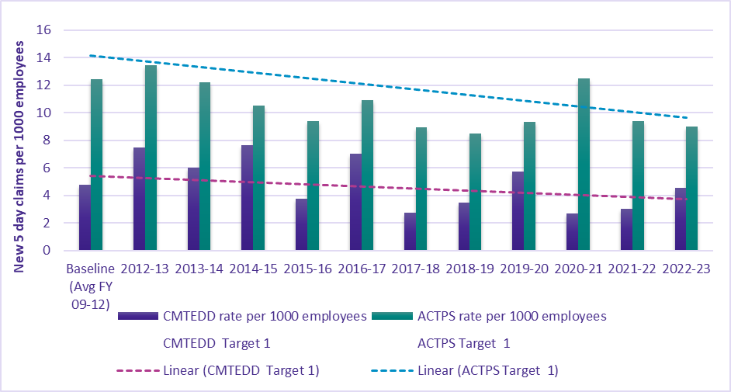

Table 110: Target 2 – reduce the incidence rate of claims for musculoskeletal disorders resulting in one or more weeks off work by at least 30 per cent*
Financial year | Number of new 5-day MSD claims | Rate per 1000 employees | Directorate target | ACTPS number of new 5-day MSD claims | Rate per 1000 employees | ACTPS Target
2012-13 | 9 | 4.20 | 3.35 | 183 | 8.96 | 8.29
2013-14 | 6 | 2.76 | 3.25 | 175 | 8.31 | 8.03
2014-15 | 12 | 5.09 | 3.14 | 144 | 6.63 | 7.78
2015-16 | 6 | 2.51 | 3.04 | 146 | 6.67 | 7.52
2016-17 | 10 | 4.12 | 2.94 | 150 | 6.73 | 7.26
2017-18 | 5 | 2.30 | 2.83 | 128 | 5.66 | 7.01
2018-19 | 5 | 2.18 | 2.73 | 102 | 4.31 | 6.75
2019-20 | 8 | 3.28 | 2.63 | 126 | 5.09 | 6.49
2020-21 | 4 | 1.53 | 2.52 | 194 | 7.44 | 6.24
2021-22 | 3 | 1.1 | 2.42 | 118 | 4.3 | 5.98
2022-23 | 5 | 1.74 | 2.42 | 106 | 3.73 | 5.98

Figure 7: Bar chart for Target 2 – reduce the incidence rate of claims for musculoskeletal disorders resulting in one or more weeks off work by at least 30 per cent*
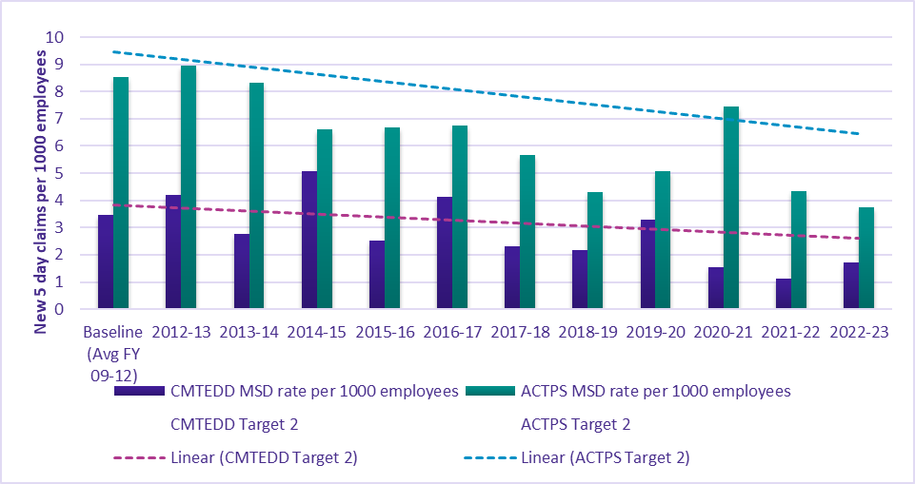
*Notes (for both tables and figures):
- Dates are based on those claims received by the Insurer in each financial year.
- Data is taken at 30 June in each of the years to allow for direct comparisons to be made between years.
- The report includes accepted claims which result in one or more weeks off work.
- Data includes claims up to 30 June 2023.

Further information | Robert Wright, Executive Group Manager, Corporate
 | (02) 6207 0569 | Robert.Wright@act.gov.au

Human resources management
In 2022-23 CMTEDD’s human resources priorities were guided by consolidating policy frameworks that have been implemented or modified in response to the ongoing impacts of COVID-19.

Culture, attraction and retention
Key initiatives to progress a positive culture, attract and retain staff during the reporting period included:
- conducting directorate-wide workshops to formulate the 2022 CMTEDD Staff Survey Action Plan. The plan focused on activities to support greater innovation and creativity, improve change management processes, and foster an environment to thrive.
- obtaining employee feedback regarding their experiences and perceptions on a range of workplace issues and practices through the 2023 ACTPS Employee Survey. All results showed improvement from the previous 2021 survey with 83% of employees expressing satisfaction with their job and 75% reporting a high level of engagement.
- celebrating employee excellence at the 2023 Staff Awards which received 195 nominations - the highest ever received. Nineteen individuals and teams were acknowledged across six categories that foster a progressive, sustainable, and innovative workplace.
- promotion of resources (training, webinars, staff networks, health and wellbeing reimbursement, messaging from the CMTEDD Mental Health Champion) and events (significant days, guest speakers, staff awards) that support positive mental health and wellbeing under the CMTEDD Mental Health Action Plan 2021-2023;
- commencing development of a new Diversity and Inclusion Strategy, adopting a best-practice organisational change model recommended by the Diversity Council of Australia;
- support for flexible work arrangements through the introduction of FlexiSpaces and a Flexible Working Team Charter to promote and support the ongoing use of flexible work arrangements within teams;
- continued implementation of the Aboriginal and Torres Strait Islander Employment Action and Retention Plan 2021-24, to strengthen the attraction, retention and career progression of Aboriginal and Torres Strait Islander employees;
- advancing reconciliation through the directorate’s Stretch Reconciliation Action Plan (RAP) 2020-2023, with 90 per cent of deliverables now finalised; and
- providing a range of flexible training and leadership-development opportunities to encourage staff retention.

Workforce planning and employment strategies
We continued to increase workforce diversity and build talent pipelines for the future. Graduate numbers increased significantly from previous years with 52 graduates engaged. Placements for School-based Apprentices on our CMTEDD Employment Pathway Program for Aboriginal and Torres Strait Islander People remain consistent with the previous year.

Table 111: CMTEDD participants in targeted employment programs
Program name | Participants
ACTPS Graduate Program | 52
CMTEDD Employment Pathway Program for Aboriginal and Torres Strait Islander People | 7¹
ACTPS Vocational Employment Program | 7
Note:
1. During the 2022-23 financial year, five participants completed the program and were appointed to permanent positions. Two remain in the program.
CMTEDD is currently finalising recruitment for the 2023-24 cohort and is aiming to engage 10 new participants.

Capability
The focus of our capability-building in 2022-23 was to:
- establish a Required Learning Framework to designate training requirements for staff based on classification, supervisory status and work area. Courses are categorised as required, recommended or optional and continue to be delivered face to face, virtually and via eLearning.
- review the supervisor, leadership and general development programs with a renewed focus on creating an environment to thrive through building respectful, inclusive, purposeful and psychologically safe teams; enabling constructive conversations; and fostering professional networks and connections.
- launch a new dashboard to drive performance against required learning completion rates.

Learning and development programs and activities
In 2022-23 there were 19,814¹ eLearning completions across 23 CMTEDD eLearning courses. There were 881¹ attendees at instructor-led training across six courses organised by CMTEDD Corporate.
Our learning areas included induction, work health and safety, respectful behaviours, diversity and inclusion, mental health, domestic and family violence awareness, governance and compliance topics and human rights. Our staff also participated in a range of leadership development opportunities including supervisor development, mentoring and leadership coaching. Webinars were also made available to assist staff in understanding wellbeing, superannuation and flexible working arrangements.
Additionally, there were 4573¹ completions of 113 whole of government training courses (71 eLearning and 42 instructor-led), with associated course fees of $59,077.23. Business areas also provided targeted training for their teams to meet their unique business goals and priorities.
We have continued to provide studies assistance, this year supporting 40 employees to undertake approved formal courses of study, with a total of $80,294.24 provided in financial assistance towards course costs.
Note:
1. Learning completion records are sourced from the HRIMS reporting system, they may vary due to staff movements within the ACTPS as the HRIMS system reflects the current staff profile. Staff can access and complete an eLearning module multiple times.

Future Learning and Development
CMTEDD established the Required Learning Framework in 2022 to provide staff with continuous learning opportunities to ensure they have the skills, knowledge, and awareness of core values and capabilities to undertake their roles. This will continue to be a focus in 2023-24 along with capabilities in Work Health and Safety, diversity and inclusion, mental health and wellbeing and leadership programs which create an environment to thrive through building respectful, inclusive, purposeful and psychologically safe teams.

Gender Action Plan and Gender Impact Assessment Reporting
The ACTPS Gender Equity Strategy is currently in its final stages of development, and this will provide the foundation for which CMTEDD will develop its Gender Action Plan in 2023-24. CMTEDD currently supports gender equality in a variety of ways, including:
- access to a range of leave types, including parental, carers, bonding, family violence, adoption, surrogacy, gender affirmation and assisted reproduction;
- access to flexible working conditions including part-time work, job-sharing and hybrid or remote work;
- flexible work - across the government, the FlexiSpace program is creating flexible working locations in a range of locations close to where people live. This provides benefits by reducing commutes and allowing better work-life balance for all employees, including those with caring responsibilities. There are currently FlexiSpaces in Civic, Greenway, Belconnen and Woden with additional locations in Dickson and Gungahlin due to come online in late 2023 and mid 2024 respectively.
- Within the 220 London Circuit FlexiSpace a family friendly workspace has been purpose built to support employees with children in their care who may need to access the workplace. Circumstances, such as a temporary loss of childcare arrangements (e.g. sick grandparent, pupil-free day), home repairs or maintenance requiring vacating the home, or an older child meeting their parent for a lift or to go to an appointment, may mean that this space is a positive alternative where an employee would otherwise need to take time off, or finish work early.
- The way we work is giving greater flexibility to our workforce and particularly those with caring responsibilities to work in a way that works for them.
- increased paid parental leave entitlements - from 1 January 2023, eligible CMTEDD employees were able to access an additional 6-weeks of birth leave, making the ACT Government one of the most beneficial birth leave entitlement providers;
- CMTEDD has retained its accreditation with the Australian Breastfeeding Association as a Best Practice Workplace;
- a range of initiatives that support gender equity within the community as part of the ACT Women’s Plan including:
- Supporting affordable pathways to home ownership for at-risk women by providing seed funding for the Ginninderry Women’s Build-to-Rent-to-Buy housing initiative;
- Improving opportunities for women in non-traditional fields, such as construction and STEM by developing a Women in Construction Procurement Policy and sponsoring the delivery of an ACT women in space conference; and
- Improved opportunities for women to participate in sports by improving the percentage of sportsground amenities that meet the Family Friendly Guidelines for local facility amenities.
- education and visibility for CMTEDD employees around gender equity including:
- celebrating International Women’s Day by promoting resources and a lunch and learn webinar;
- Promoting the International Day Against Homophobia, Biphobia and Transphobia including attending the ACT Government flag raising event and promoting a series of interviews with Meridian and a Gender Agenda; and
- Participation in Wear it Purple Day. In 2022 this involved promoting the theme ‘Still Me, Still Human’, encouraging staff to use themed virtual backgrounds and participate in a photo competition to inspire allyship and raise awareness of issues impacting LGBTIQ+ young people.

Staffing profile
The staff numbers in the tables below represent CMTEDD employees who received a payment on the last payday of 2022-23. The figures exclude board members and people on leave without pay. They also exclude ACT Insurance Authority and Cultural Facilities Corporation. Recruitment and separation rates are defined as commencing or departing the ACTPS respectively for permanent employees, and Executive Officers with long-term contracts. Internal transfers are not included.

Table 112: FTE (full-time equivalent) and headcount by business area
 | FTE | Headcount
Graduate Program | 47.0 | 47
Trainee Program | 0.6 | 2
Chief Minister | 2,006.3 | 2,096
Access Canberra | 769.5 | 795
Communications and Engagement | 54.8 | 58
Corporate | 98.2 | 101
Economic Development | 275.8 | 305
Office of Industrial Relations and Workforce Strategy¹ | 693.1 | 716
Office of the Head of Service | 3.0 | 3
Office of the International Engagement | 6.8 | 7
Policy and Cabinet | 79.6 | 85
Strategic Finance | 25.6 | 26
Treasury | 820.4 | 843
Digital, Data and Technology Solutions² | 488.3 | 501
Economic and Financial | 46.1 | 47
Finance and Budget | 60.2 | 61
Infrastructure Finance and Reform | 4.0 | 4
Investments and Borrowings | 7.0 | 7
Office DUT BPF | 3.0 | 3
Office DUT ERI | 2.6 | 3
Office Under Treasurer | 6.7 | 7
Procurement ACT | 42.3 | 44
Revenue Management | 160.3 | 166
Total for CMTEDD | 2,874.4 | 2,988
Notes:
1. Due to a restructure in December 2022 within Property and Shared Services and in March 2023 within Finance Services, the staffing numbers for these business areas are now included under Office of the Industrial Relations and Workforce Strategy in the Chief Minister Stream.
2. Staffing numbers for Digital, Data and Technology Solutions are listed as one line item under Treasury stream; however, this business area includes staff with reporting lines through both the Chief Minister Stream and Treasury Stream.

Table 113: FTE and headcount by gender
 | Female | Male | Non-Binary | Total
FTE by Gender | 1,548.5 | 1,320.9 | 5.0 | 2,874.4
Headcount by Gender | 1,628 | 1,354 | 6 | 2,988
Percentage (%) of Workforce | 54.5% | 45.3% | 0.2% | 100.0%

Table 114: Headcount by classification group and gender
Classification Group | Female | Male | Total
Administrative Officers | 991 | 535 | 1526
Executive Officers | 50 | 49 | 99
General Service Officers & Equivalent | 0 | 73 | 73
Information Technology Officers | 28 | 121 | 149
Legal Officers | 1 | 1 | 2
Professional Officers | 7 | 23 | 30
Senior Officers | 543 | 528 | 1071
Statutory Office Holders | 0 | 2 | 2
Technical Officers | 5 | 19 | 24
Trainees and Apprentices | 3 | 3 | 6
Total | 1,628 | 1,354 | 2,982
Note: Employees who identify as non-binary are not included in this table due to the small cohort and the need to maintain individuals’ privacy.

Table 115: Headcount by employment category and gender
Employment Category | Female | Male | Total
Casual | 13 | 14 | 27
Permanent Full-time | 1,177 | 1,122 | 2,299
Permanent Part-time | 181 | 37 | 218
Temporary Full-time | 238 | 172 | 410
Temporary Part-time | 19 | 9 | 28
Total | 1,628 | 1,354 | 2,982

Table 116: Headcount by diversity group
Diversity group | Headcount | Percentage (%) of Agency Workforce
Aboriginal and/or Torres Strait Islander | 58 | 1.9%
Culturally & Linguistically Diverse | 825 | 27.6%
People with a disability | 139 | 4.7%

Table 117: Headcount by age group and gender
Age Group | Female | Male | Total
Under 25 | 92 | 57 | 149
25-34 | 496 | 367 | 863
35-44 | 471 | 377 | 848
45-54 | 352 | 315 | 667
55 and over | 217 | 238 | 455
Total | 1,628 | 1,354 | 2,982

Table 118: Average length of service by gender
 | Female | Male | Total
Average years of service | 7.3 | 8.1 | 7.7

Table 119: Recruitment and separation rates
 | Recruitment rate (%) | Separation rate (%)
CMTEDD | 16.9% | 8.5%

Table 120: Gender Pay Gap
Classification group | Female | Male | Gap
Administrative Officers | $86,165 | $84,287 | -2.2%
Executive Officers | $228,824 | $236,594 | 3.3%
General Service Officers & Equivalent |  | $97,011 | N/A
Information Technology Officers | $98,532 | $94,605 | -4.2%
Legal Officers | $164,305 | $164,305 | 0.0%
Professional Officers | $98,903 | $97,499 | -1.4%
Senior Officers | $137,140 | $137,861 | 0.5%
Statutory Office Holders |  | $221,803 | N/A
Technical Officers | $89,122 | $98,089 | 9.1%
Apprentices | $63,874 | $63,122 | -1.2%
Trainees | $21,610 |  | N/A
TOTAL | $107,923 | $113,069 | 4.6%
Further information | Robert Wright, Executive Group Manager, Corporate
 | (02) 6207 0569 | Robert.Wright@act.gov.au

Ecological sustainability reporting

Support to the Commissioner for Sustainability and the Environment
The Environment Protection Authority (EPA) responded to the Commissioner for Sustainability and the Environment’s Investigation into wood heater policy in the ACT (released May 2022) and the State of the lakes and waterways in the ACT (released January 2023). The EPA response was provided both through meetings and written submissions included in whole of government responses. These responses aimed to take advice and make improvements to regulatory practices in response to matters raised.
In decision-making processes and when providing advice, for example on development applications and environmental authorisations, the EPA worked to integrate environmental, economic, and social considerations conducive to the underlying objectives and functions of the Commissioner for Sustainability and the Environment.
The EPA actively supports the objectives and functions of the Commissioner for Sustainability and the Environment through continuous improvements in the EPA regulatory responses aligned with the legislative mandate of the Commissioner for Sustainability and the Environment.
A key example of an EPA response was that the EPA considered the Commissioner for Sustainability’s investigation into the State of Lakes and Waterways in the ACT by targeting the work of staff towards significantly increasing the number of physical inspections of buildings sites to 1,509 in 2022-23, up from 891 in 2021-22. During these site inspections, the inspectors reported providing 1,403 points of advice to improve environmental performance. Operators were advised:
- 531 times to remove a sediment source from locations where they might enter stormwater;
- 516 times to install pollution controls;
- 258 times to stabilise the sites;
- 26 times to apply water to control dust;
- 12 times to clean out sediment control ponds; and
- 60 other opportunities to improve environmental outcomes.
The EPA also achieved a streamlining process for issuing infringement notices, to support an increase in enforcement actions for minor offences from 10 in 2021-22 to 51 in 2022-23. Of these:
- 6 were for pollution of waterways;
- 3 were to prevent development waste from entering waters;
- 8 were for areas near developments to be kept clear;
- 2 were to prevent discharge of stormwater to receiving waters;
- 1 was for a minor offence at a large development site; and
- 27 were to prevent environmental harm from small building sites.
There were also two environmental protection orders issued for unauthorised placement of soil and two other infringements.

Business area activities
The Coordinator-General for Climate Action and the Office for Climate Action were established within CMTEDD in 2021 to oversee the delivery of major projects, coordinate activities across the ACT Government and identify ways to increase climate adaptation and resilience. Further information can be found under Output 1.1 Government Policy and Reform in the Performance Analysis section.
Procurement ACT continues to actively promote and support Territory entities to adhere to the Government Procurement (Charter of Procurement Values) Direction 2020 (the Direction) and the six Procurement Values in the Charter of Procurement Values. In the 2022-23 year a total of 323 ACT Government procurements incorporated the Environmental Responsibility value.
The ACT Climate Change Strategy 2019-2025 drove the ACT Government’s Net Zero Emissions and the ACT Sustainable Energy Policy. As part of the policy, it is mandated that at end of economic life, gas systems are replaced with electric systems. The initiative is being operationally managed by the Environment, Planning and Sustainable Development Directorate (EPSDD) as the policy owners, however Procurement ACT as the contract managers for the supply of gas to the Territory continues to facilitate engagement between key operational and senior stakeholder groups, incorporating their feedback and endorsement into proposed procurement activities.
We supported the Office of Climate Action and other parts of Government with the following ACT Government announcements:
- zero emissions vehicles (ZEVs) strategy to expand the number of zero emission vehicles in the ACT, with a target of 80-90 per cent of new light vehicle sales by 2030;
- the launch of the Powering Canberra: Our Pathway to Electrification plan to transition from fossil fuel gas to renewable electricity by 2045; and
- partnership with Eku Energy to deliver the next stage of the Big Canberra Battery with a large-scale battery facility in Williamsdale.
Under the ‘Everyday Climate Choices’ brand, CMTEDD worked in partnership with EPSDD to develop and implement a campaign highlighting the need for Canberrans to begin thinking about switching from gas to electricity. The “Make your next choice electric” campaign was supported by an online tool helping people to plan, giving them access to advice from the Australian consumers association CHOICE on electric products, so that when their gas appliance needs replacing, they have the information they need to make their next choice electric. The campaign ran from 4 May to 29 June 2023, and drove the audience of almost 16,000 to the energy.act.gov.au website in that period. The CHOICE tool received 19,699 clicks and 4,518 transition plans were created.

Improving energy efficiency in government and property services
In 2018, the ACT Government announced a target of net zero emissions in the ACT by 2045. To support this target, the ACT Climate Change Strategy 2019-2025 set a target to reduce emissions from ACT Government operations by 33 per cent by 2025 (from 2020 levels) and zero emissions by 2040.
In 2022, the Parliamentary and Governing Agreement (PAGA) for the Tenth Legislative Assembly agreed to phase out fossil-fuel-gas in the ACT by 2045 at the latest, with a specific commitment to ensuring all new ACT Government buildings and facilities are fossil-fuel-gas free, including new leases. All retrofitting in Government buildings and facilities will have a goal of net-zero emissions post retrofit.
Examples in CMTEDD in 2022-23 include:
The preliminary sketch plans for major upgrades to Gorman House Arts Centre were completed in 2022-23. The designs follow ecologically sustainable design principles and include recommendations to replace gas-powered heating systems with electric systems as well as recommendations to improve the sustainability of building operations such as insulation and additional glazing to heritage windows.
Industry and government guidelines were produced to assist in the planning for procurement, construction and upgrading of ACT Government facilities.
The National Arboretum Canberra (NAC) and Stromlo Forest Park (SFP) continued to implement environmentally sustainable facility upgrades, including:
- the ongoing installation of LED lighting as older style lights require replacement;
- the ongoing replacement of diesel/fuel powered power tools with electric power tools; and
- the ongoing replacement of aging equipment in the commercial kitchen at NAC with more water and energy efficient equipment.
ACT Property Group contributed through:
- ensuring continued management and engagement with building owners in relation to Green Leases;
- completed the installation of a 99.51kW rooftop solar photovoltaic system at the 255 Canberra Ave workshop building;
- completed the installation of a 77kW expansion on the existing rooftop solar photovoltaic system at Flynn Community Centre;
- secured two ACT Property Group owned locations under the Big Canberra Battery program. The battery installations are expected to be complete in 2023-24.
- identified further opportunities to improve building and facility energy performance through a priority list for installing solar PV and LED lighting upgrades; and
- carried out a gas asset audit for ACT Property Group's whole portfolio and developed a priority list for electrification of all gas assets across 38 sites.
In 2023-24 ACT Property Group will:
- work towards completion of 255 Canberra Ave workshop heater upgrade to full electric units; and
- continue to support the roll out of the 255 Canberra Ave main building HVAC electrification and façade upgrade project.

Improving water efficiency
In 2022-23 we continued the use of rainwater recycling systems in new government office buildings. This includes 40,000L at 220 London Circuit servicing toilets flushing, and 160,000 at 480 Northbourne Avenue servicing cisterns, urinals and HVAC cooling towers.
We conducted the investigation of water submetering and interval data monitoring across ACT Property Group owned sites.
We continued to use rainwater and non-potable water for irrigation of grounds at NAC and SFP and at Venues Canberra’s major sporting and entertainment venues.
Minor civil upgrades to roads and grounds at the NAC and SFP were undertaken which have led to improved stormwater management across both sites, directing water to areas where it is needed (such as garden beds and water holding areas) and directing it away from areas where it creates damage or hazardous surfaces.
Significant upgrades were undertaken to the irrigation pumping system for the turf running track at SFP to improve efficiency in non-potable water delivery, as part of this year’s Better Infrastructure Funding.
The mulching program was continued at NAC, which ensures optimal soil health conditions and reduces the reliance on supplementary watering. Over 2,600 cubic meters of mulch was installed in eight different forests. Plans were furthered to extend the Arboretum’s Smart Sensor Soil Moisture system, so that in 2023-24, NAC can continue to refine soil moisture data and provide more targeted watering windows to ensure a balance between tree growth and water conservation.

Waste, reuse and recycling
In 2022-23 we undertook the following initiatives:
- recycling across all major sporting and entertainment venues. In 2022-23 the container deposit scheme was implemented at GIO Stadium, and all major venues are Accredited Sustainable Business Recyclers.
- the single-use plastics strategy continued at the Territory’s major venues of GIO Stadium, Manuka Oval and Exhibition Park in Canberra. Straws, sauce and condiment packets, plastic sleeves, plastic cutlery, stirrers and sandwich containers have been eliminated.
- in collaboration with appointed food vendors, Events ACT has been working to eliminate the use of plastic and bio-plastic plates, straws, stirrers, bags, and cutlery (with exceptions for specific exempted plastic items). Drinking fountains and water stations continued to be provided to facilitate the convenient refilling of reusable bottles.
- recycling our ICT assets. When ICT assets reach the end of their useful life, refresh, disposal and recycling is facilitated through offerings to the market as arranged by our disposal broker. The return to government this year was $182,229.95.
- in April 2023, NAC facilitated a research and development turf trial in collaboration with Vital Industries. The trial is intended to demonstrate the successful use of cellulose extracted from otherwise unusable waste textile, which is a significant global issue. Cellulose has been embedded in soil ameliorants and used as fibre in hydroturf to encourage seed germination. Several plots have been established to assess a variety of applications against a controlled environment. Results are due to be released early in 2023-24.

Table 121: Sustainable development performance: Current and Previous Financial Year
Indicator as at 30 June | Unit | Current FY | Previous FY | Percentage change
Stationary energy usage
Electricity use | Kilowatt hours | 13,557,232 | 12,336,233 | 9.9%
Natural gas use (non-transport) | Megajoules | 101,870,433 | 99,865,068 | 2.0%
Diesel use (non-transport) | Kilolitres | 0 | 1
Transport fuel usage
Battery Electric Vehicles (BEV) | Number | 18 | 10 | 80.0%
Hydrogen Fuel Cell Electric Vehicles (FCEV) | Number | 3 | 5 | -40.0%
Plug-in Hybrid Electric Vehicles (PHEV) | Number | 5 | 5 | 0.0%
Hybrid Electric Vehicles (HEV) | Number | 12 | 14 | -14.3%
Internal Combustion Engine (ICE) vehicles | Number | 149 | 150 | -0.7%
Total number of vehicles | Number | 187 | 184 | 1.6%
Fuel use – Petrol | Kilolitres | 23 | 22 | 3.8%
Fuel use – Diesel | Kilolitres | 228 | 207 | 10.0%
Fuel use – Liquid Petroleum Gas (LPG) | Kilolitres | 0 | 0 | N/A
Fuel use – Compressed Natural Gas (CNG) | Gigajoules | 0 | 0 | N/A
Water usage
Water use | Kilolitres | 161,291 | 142,064 | 13.5%
Resource efficiency and waste
Reams of paper purchased | Reams | 5,212 | 4,247 | 22.7%
Recycled content of paper purchased | Percentage | 70.4 | 86 | -18.1%
Waste to landfill | Litres | 2,643,235 | 2,900,476 | -8.9%
Co-mingled material recycled | Litres | 1,339,315 | 1,114,636 | 20.2%
Paper & Cardboard recycled (incl. secure paper) | Litres | 1,209,239 | 850,091 | 42.2%
Organic material recycled | Litres | 161,309 | 204,089 | -21.0%
Resource efficiency and waste – EventsACT
Waste to landfill (Events ACT Actsmart Public Events) | Litres | 677,830 | 19,889 | 3308.1%
Material recycled (incl. comingle recycling, paper and cardboard recycling, and organic recycling) (Events ACT Actsmart Public Events) | Litres | 1,484,667 | 125,780 | 1080.4%
Greenhouse gas emissions (excluding EventsACT)
Emissions from natural gas use (non-transport) | Tonnes CO2-e | 5,249 | 5,146 | 2.0%
Emissions diesel use (non-transport) | Tonnes CO2-e | 0 | 3
Emissions from transport fuel use | Tonnes CO2-e | 672 | 614 | 9.4%
Emissions from refrigerants | Tonnes CO2-e | 15 | 15 | -1.3%
Total emissions | Tonnes CO2-e | 5,937 | 5,775 | 2.8%
Notes:
The figures may include accrued data. Where actual data is not available, the ESP provides estimates using an accrual function. Accruals are calculated from the average annual daily consumption of the most current 12-month period applied for the number of days of missing data.
Some utility data may be incomplete at the time of data extraction. Where appropriate, accrued data is used to address any gaps. There may be some residual data gaps that will be addressed retrospectively in next year’s reporting period.
Note that some data reported for 2021-22 in the table above/below may differ from figures reported in the 2021-22 annual report. This is due to retrospective updates to agency occupancy and historical consumption data.
The ACT Government reports zero greenhouse gas emissions from electricity use as a result of the ACT’s 100 per cent renewable electricity supply.
Emissions reported for stationary energy and transport fuels include Scope 1 and Scope 2 emissions only. Scope 1 are direct emissions from sources owned and operated by the government, including emissions from transport fuel and natural gas use. Scope 2 are indirect emissions from mains electricity which is consider zero in the ACT.
Emission factors used to calculate natural gas and fleet fuel are based on the latest National Greenhouse Accounts factors.
Stationary energy usage
The increase in electricity use is due to a variety of factors, including the following:
- across all locations, increased electricity consumption attributed to the increase of heating degree days (of around 4 per cent compared to the previous year)
- a full year of events at all venues, EPIC and GIO Stadium especially (as compared to COVID-affected events schedules in prior year/s)
- additional hardware has been installed at both the Hume and Fyshwick Data Centres
- reopening of the 50m pool at the Gungahlin Leisure Centre from August 2022
- an additional ACT Government (non-CMTEDD) facility has been consuming electricity under the same account at Canberra Olympic Pool. It is not yet known if this additional consumption can be separated in the future.
The increase in gas use is due to a variety of factors, including the following:
- across all locations, increased gas consumption attributed to the increase of heating degree days (of around 4 per cent compared to the previous year).
- reopening of the 50m pool at the Gungahlin Leisure Centre from August 2022, requiring a full reheat and maintenance of the water in the 50m pool.
- the gas meter readings at Dickson Pool were estimated from March 2022 to December 2022, with all consumption during this period added to December period, resulting a large amount of consumption from the previous year added to 2022-23.
Transport fuel usage
- CMTEDD is complying with the whole of government requirement to replace ICE and Hybrid Electric vehicles with BEVs or FCEV where fit for purpose. The leases on several hybrid electric vehicles are coming due in 2023-24, so the BEV numbers are expected to further increase next year.
- Almost all the remaining ICE vehicles in the CMTEDD fleet are light commercial vehicles. There is currently no fit for purpose electric vehicle available on the market.
- The increase in fuel usage for both petrol and diesel is due to a full year of the resumption of normal business activities post-COVID.
Water usage
The increase in water usage is due to the following factors:
- water consumption levels at the territory’s pools have returned to their historical levels for full operation (the previous year’s consumption was lower due to 2021 COVID lockdown)
- the 50-metre pool at Gungahlin Leisure Centre has been refilled twice due to the repair work undertaken, and the program pool and toddler pool were refilled once due to upgrade work at the balance tank.
- the turf was replaced at GIO Stadium at the end of 2022, accounting for a significant increase in water usage at that location.
Resource efficiency and waste
- Paper purchases are in line with the increase in staff returning to working onsite.
- The drop in recycled content is due to a supply issue affecting 100% recycled paper.
- The waste and recycling data is normalising to pre-COVID affected levels.
- The events waste data year on year is not a meaningful comparison, as many of the major events were cancelled in the previous year. Both years’ waste data has been recalculated using agreed conversion factors for weight to litres.
Greenhouse gas emissions
- The increases in greenhouse gas emissions are in line with the increase in gas usage and transport fuel usage.

Further information | Robert Wright, Executive Group Manager, Corporate
 | (02) 6207 0569 | Robert.Wright@act.gov.au

Other reporting

Financial management reporting
All Financial Management reporting is included in Volume 2 of CMTEDD’s Annual Report, including:
- Financial Management Analysis (Management Discussion and Analysis);
- Financial Statements;
- Capital Works;
- Asset Management;
- Government Contracting; and
- Statement of Performance

Public land management plans
The Albert Hall precinct public land (Pd-Special Purpose Reserve) is managed by ACT Property Group as the custodian on behalf of the Territory. The Planning and Development (Albert Hall) Land Management Plan 2016 is available at https://legislation.act.gov.au/di/2016-78.

Covert surveillance authorisations issued to ACT employers
The Workplace Privacy Act 2011 (Workplace Privacy Act) requires employers to apply to the Magistrates Court for authority to conduct any workplace covert surveillance.
In the financial year ending 30 June 2023 the Magistrates Court issued nil covert surveillance authorities under the Workplace Privacy Act.

Annexed annual reports
Public sector bodies required to have their annual report annexed to CMTEDD’s report are listed below. Their reports are included in alphabetical order in the following annex.
- ACT Architects Board
- ACT Construction Occupations
- ACT Executive
- ACT Government Procurement Board
- Default Insurance Fund
- Director of Territory Records
- Environment Protection Authority
- Lifetime Care and Support Fund
- Motor Accident Injuries Commission
- Office of the Nominal Defendant of the ACT
- Public Sectors Workers Compensation Fund

Annexed reports

ACT Architects Board

Transmittal certificate
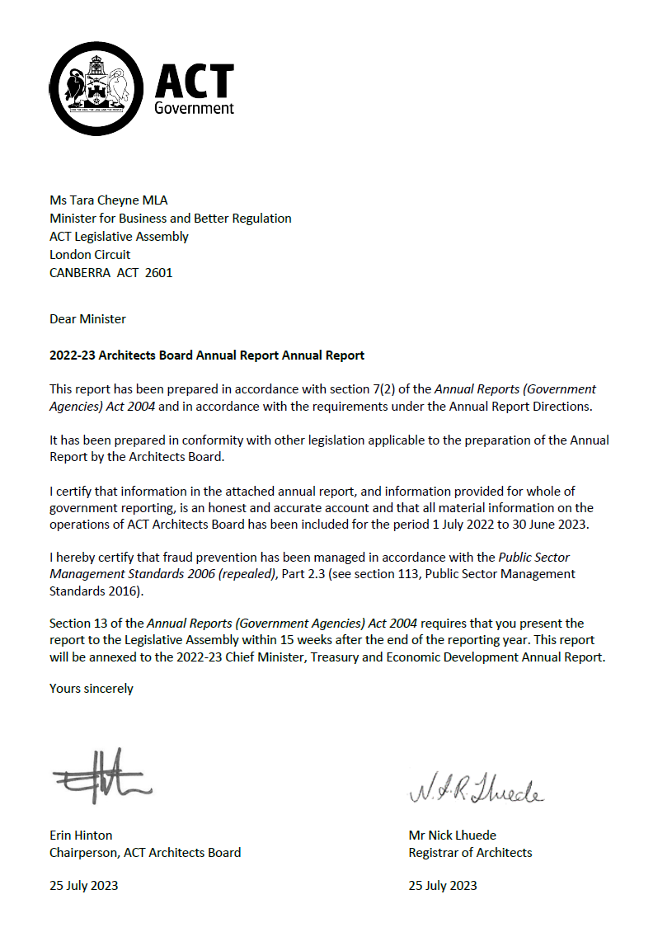

Compliance statement
The 2022-23 ACT Architects Board Annual Report must comply with the Annual Reports (Government Agencies) Directions 2023 (the Directions) made under section 8 of the Annual Reports (Government Agencies) Act 2004. The Directions are found at the ACT Legislation Register.
The Compliance statement indicates the subsections, under Parts 1 to 5 of the Directions, that are applicable to the ACT Architects Board and the location of information that satisfies these requirements.

Part 1 Directions overview
The requirements under Part 1 of the Directions relate to the purpose, timing and distribution, and records keeping of annual reports. The 2022-23 ACT Architects Board Annual Report complies with all subsections of Part 1 under the Directions.
To meet Section 15 Feedback, Part 1 of the Directions, contact details for the ACT Architects Board are provided within the 2022-23 ACT Architects Board Annual Report to provide readers with the opportunity to provide feedback.

Part 2 Reporting entity annual report requirements
The requirements within Part 2 of the Directions are mandatory for all reporting entities and the ACT Architects Board Annual Report complies with all subsections. The information that satisfies the requirements of Part 2 is found in the ACT Architects Board Annual Report as follows:
- A. Transmittal Certificate, see the previous page.
- B. Organisational Overview and Performance Analysis subsections, see the Organisational Overview and Performance section on the next page. As the ACT Architects Board sits within Access Canberra in CMTEDD, all other subsections in Section B, Part 2 of the Directions are contained within the CMTEDD Annual report.
- C. Financial Management reporting, inclusive of all subsections, see Volume 2 of the CMTEDD Annual Report.

Part 3 Reporting by exception
The ACT Architects Board has no information to report by exception under Part 3 of the Directions for the 2022-23 reporting year.

Part 4 Directorate and public sector body specific annual report requirements
The ACT Architects Board has additional reporting requirements under section 67 of the Architects Act 2004 and regulation 12 of the Architects Regulation 2004.

Part 5 Whole of government annual reporting
All subsections of Part 5 of the Directions apply to the ACT Architects Board. Consistent with the Directions, the information satisfying these requirements is reported in one place for all reporting entities as follows:
- Bushfire Risk Management, see the annual report of the Justice and Community Safety Directorate.
- Human Rights, see the annual report of the Justice and Community Safety Directorate.
- Legal Services Directions, see the annual report of the Justice and Community Safety Directorate.
- Public Sector Standards and Workforce Profile, see the annual State of the Service Report.
- Territory Records, see the CMTEDD Annual Report.
ACT Public Service directorate annual reports are found at the following web address: http://www.cmd.act.gov.au/open_government/report/annual_reports

Organisational overview and performance

Registrar functions
The role of the Registrar is to manage the administration of the board and to maintain the register of Architects, as outlined under section 13 of the Architects Act 2004 (‘the Act’).

ACT Architects Board
The ACT Architects Board (‘the Board’) is established under the Act. The Board ensures registered architects provide services to the public in a professional and competent manner. The Board has a range of powers to investigate complaints against architects and to discipline those who are found to have acted unprofessionally or incompetently. The Board’s functions are to:
- Register architects.
- Investigate complaints given to the Board about registered people and people who have been registered.
- Consider whether it is necessary to take disciplinary action against registered people and people who have been registered and, if it is, to take the necessary action.
- Consider and report to the Minister about issues referred to the Board by the Minister for advice.
- Advise the Minister in relation to the practice of architectural regulation, for example, about codes of professional conduct.
- Further a common and harmonious approach to the administration of legislation about architects by cooperation with local jurisdictions.
- Accredit courses of study in architectural regulation.
- Provide general advice to consumers about the professional conduct and standards of competence expected of registered architects.
The ACT Architects Board is also part of a national network of Boards that administer the state and territory legislation pertaining to architectural education and the registration of architects. The eight state and territory architect registration Boards are Nominated Bodies of the Architects Accreditation Council of Australia (AACA). The AACA was established by the Boards to ensure national consistency in the pathway that leads to registration as an architect in Australia. The Architects Board of the ACT is represented by the Registrar and the Board Chair, as are the other state and territory Registration Boards.
The AACA is recognised as the national organisation responsible for advocating, coordinating, and facilitating national standards for the registration of architects in Australia and for the recognition of Australian architects overseas by the relevant Registration Authorities. The AACA also has the responsibility for assessment of overseas qualifications in architectural regulation, for the purpose of migration to Australia under the Australian Government’s Skilled Migration program.

Complaints and disciplinary actions
In each state and territory of Australia it is a legal requirement that any person using the title architect, or offering services to the public as an architect, must be registered with the architect registration Board in that jurisdiction. Architect legislation has been enacted to protect consumers and the public. Only people whose names appear on a state and territory architect registration Board register can use the title architect in that jurisdiction. Therefore, it is illegal for people to use the title architect or offer architectural services if they are not on a register of architects in the state or territory in which they are practicing.
During 2022-23, the Board received two complaints about an individual and an organisation offering architectural services without a registered nominee and advertising without details. The Board reviewed each complaint to establish whether non-compliance had occurred. Of the two complaints received, both were found to be in breach of the Architects Act 2004. The Architect Board wrote to the entity requesting necessary action to remove all public advertising. As a result of the Board’s actions, compliance was achieved, and no further action was undertaken.

National engagement
In October and November 2022, the Registrar and Board Chair attended the AACA annual forum and Annual General Meeting via Zoom. These meetings were attended by Registrars, Board chairs and members from all Australian jurisdictions. These meetings provided an opportunity for Registrars and Board Chairs to share information about emerging issues in each jurisdiction and to look at ways to work together in the progression of architectural regulation across Australia.

Automatic Mutual Recognition of Architects
On 1 July 2021, the occupation of Architect was included in the commencement of an Automatic Mutual Recognition scheme through amendments made to the Commonwealth’s Mutual Recognition Act 1992. Between 1 July 2021 to 30 June 2023, 81 architects notified of their intention to utilise the scheme.

Architects’ registrations

Table 1: Registrations from 1 July 2022 to 30 June 2023
Type of registration | Number of registrations
New architects (including 12 through Mutual Recognition) | 48
Re-issued | 77
Renewed architects | 269
Registered architects as at 30 June 2023 | 434
Registered architects as at 30 June 2022 | 357

Internal accountability

Membership of the Board
Section 70 of the Act stipulates that the Board consists of the following members:
- 1 member nominated in writing by a representative body;
- 1 member who is, or has recently been, an academic architect;
- 1 member who is registered;
- 1 member who is a commercial lawyer; and
- 1 member to represent community interests who is not registered.
The Minister must appoint the Board members and an appointment must be for a term of no longer than three years.

Table 2: Membership of the Board and attendance for 2022-23 financial year
Members | Name | Meetings attended
Peak Body Representative | Melinda Dodd | 6
Academic architect representative | Erin Hinton | 10
Registered architect representative | Scott Hodgson | 9
Legal representative | Maurice Falcetta | 6
Community interest’s representative | Thomas Gascoigne | 6

Board meetings
The Board is required to meet at least four times a year. During 2022-23 the Board met ten times on the following dates:

Table 3: 2022-23 Architects Board meeting dates
Dates
18 July 2022 | 15 August 2022 | 12 September 2022 | 17 October 2022
14 November 2022 | 12 December 2022 | 6 March 2023 | 17 April 2023
15 May 2023 | 19 June 2023

Remuneration
In accordance with the Remuneration Tribunal Act 1995, the remuneration rate for the chair of the Board is $590 (per diem) and for a Member of the Board is $505 (per diem).

Further information | Nick Lhuede, Registrar ACT Architects Board
 | (02) 6207 8606 | Architectsboard@act.gov.au

ACT Construction Occupations

Transmittal certificate
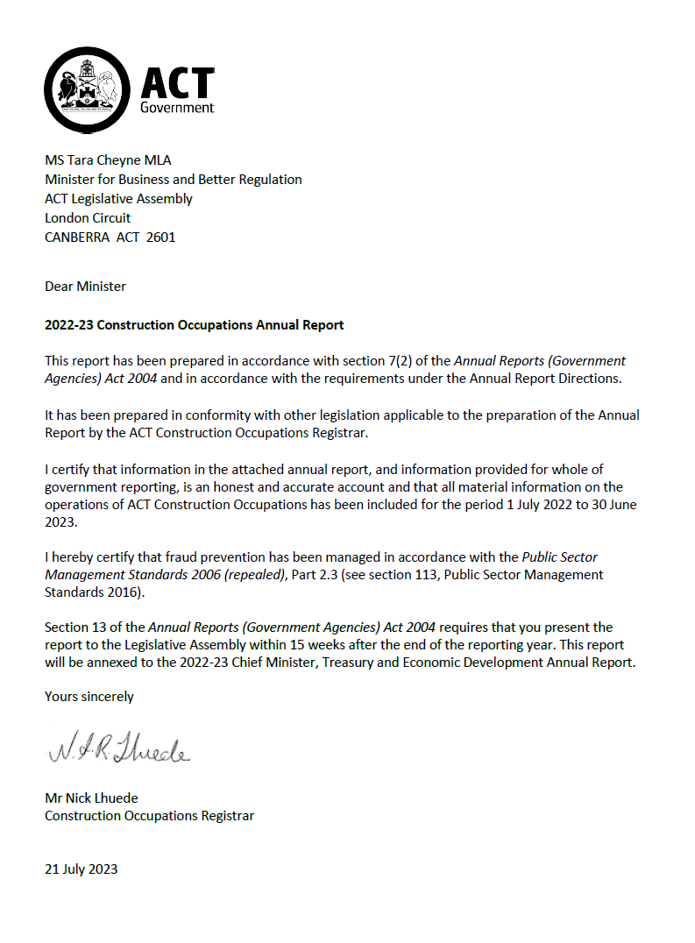

Compliance statement
The 2022-23 ACT Construction Occupations Annual Report must comply with the Annual Reports (Government Agencies) Directions 2023 (the Directions) made under section 8 of the Annual Reports (Government Agencies) Act 2004. The Directions are found at the ACT Legislation Register.
The compliance statement indicates the subsections, under Parts 1 to 5 of the Directions, that are applicable to ACT Construction Occupations and the location of information that satisfies these requirements.

Part 1 Directions overview
The requirements under Part 1 of the Directions relate to the purpose, timing and distribution, and records keeping of annual reports. The 2022-23 ACT Construction Occupations Annual Report complies with all subsections of Part 1 under the Directions.
To meet Section 15 Feedback, Part 1 of the Directions, contact details for ACT Construction Occupations are provided within the 2022-23 ACT Construction Occupations Annual Report to provide readers with the opportunity to provide feedback.

Part 2 Reporting entity annual report requirements
The requirements within Part 2 of the Directions are mandatory for all reporting entities and the ACT Construction Occupations Annual Report complies with all subsections. The information that satisfies the requirements of Part 2 is found in the ACT Construction Occupations Annual Report as follows:
- A. Transmittal Certificate, see the certificate on the previous page.
- B. Organisational Overview and Performance Analysis subsections, see Organisational Overview and Performance on the next page. As ACT Construction Occupations sits within Access Canberra in CMTEDD, all other subsections in Section B, Part 2 of the Directions are contained within the CMTEDD Annual Report.
- C. Financial Management reporting, inclusive of all subsections, see Volume 2.1 of the CMTEDD Annual Report.

Part 3 Reporting by exception
ACT Construction Occupations has no information to report by exception under Part 3 of the Directions for the 2022-23 reporting year.

Part 4 Directorate and public sector body specific annual report requirements
There are no specific annual report requirements for ACT Construction Occupations.

Part 5 Whole of government annual reporting
All subsections of Part 5 of the Directions apply to ACT Construction Occupations. Consistent with the Directions, the information satisfying these requirements is reported in the one place for all reporting entities as follows:
- Bushfire Risk Management, see the annual report of the Justice and Community Safety Directorate.
- Human Rights, see the annual report of the Justice and Community Safety Directorate.
- Legal Services Directions, see the annual report of the Justice and Community Safety Directorate.
- Public Sector Standards and Workforce Profile, see the annual State of the Service Report.
- Territory Records, see the CMTEDD Annual Report.
ACT Public Service directorate annual reports are found at the following web address: https://www.cmtedd.act.gov.au/open_government/report/annual_reports.

Organisational overview
This annual report has been prepared according to the Construction Occupations (Licensing) Act 2004 (s.112 Annual Report by Registrar) and the Construction Occupations (Licensing) Regulation 2004 (s.44 Information in report to Minister).

Role and functions
The Construction Occupations (Licensing) Act 2004 (COLA) is the principal legislation governing the responsibilities of construction occupation licensees including builders, plumbers, electricians, and building surveyors in the ACT. It also includes disciplinary and complaints processes for construction practitioners (including in relation to work undertaken under ‘operational Acts’ such as the Building Act 2004, the Electricity Safety Act 1971 and the Gas Safety Act 2000).
The Construction Occupations Registrar (‘the Registrar’) is appointed under section 103 of the COLA with their functions articulated under section 104.
The Registrar sits within Access Canberra, part of CMTEDD.

Table 1: Registrar’s roles and functions
WHAT WE DO
Decide applications for licences | Keep registers of construction occupations licensees | Monitor compliance
Respond to complaints | Take consistent regulatory action | Empower community and hold industry to account
Issue Certificates of Occupancy and Use | Register building approvals issued by private certifiers

Strategic priorities of the Registrar 2022-23
The Registrar’s strategic priorities for 2022-23 were citizen protection through effective regulatory response and industry engagement. These priorities reflect the key role Access Canberra plays in supporting a safe and liveable city. Consistent with Access Canberra’s Accountability Commitment and compliance frameworks, the Registrar applies a risk-based compliance approach to ensure resources are targeted to where the risks of harm, unsafe practices or misconduct are the greatest.

Table 2: Strategic priorities in 2022-23
STRATEGIC PRIORITIES 2022-23
Rapid regulatory response | Citizen protection | Industry engagement
In 2023, the Minister for Business and Better Regulation made a Statement of Expectations for the Registrar. This statement sets out the Minister’s key priority areas of focus for the Registrar and will form part of future annual reporting.

Functional areas
The work of the Registrar is undertaken by the functional areas in the Construction, Utilities and Environment Protection Branch of Access Canberra as identified below.

Table 3: Functional areas in 2022-23
Construction Occupations Registrar
Executive Branch Manager – Construction, Utilities and Environment Protection
Compliance Assessment Medium to High Rise Building | Compliance Assessment Low Rise Buildings and Energy Efficiency | Rapid Regulatory Response | Compliance Monitoring and Inspections | Construction and Planning Investigations
Lease Compliance and Occupational Licensing | Builder and Building Surveyor Licensing | Strategic Business and Coordination | Plumbing and Gas Inspectorate | Electrical Inspectorate

Building activity in the ACT – An overview

Table 4: Building activity overview
Activity type | Number
Building approval registrations processed | 4,302
Certificates of Occupancy and Use issued | 4,696
Certificates of Electrical Safety received | 53,027
Plumbing, Drainage, and Gas Certificates/Plans/Backflows processed | 27,489

Building Approvals
Building approval may be required when building, altering, adding to, or demolishing a building. Approval must be obtained before any building work begins. Building approvals are issued by class of building type.

Certificates of Occupancy and Use
For most new building work, including new buildings or additions to existing buildings, a Certificate of Occupancy and Use (COU) is required before the building, or new part of the building can be lawfully occupied. The COU specifies the class of building, which indicates the type of occupancy and uses that apply to the building.

Certificates of Electrical Safety
Electricians must submit a Certificate of Electrical Safety to the Registrar and the landowner within fourteen (14) days of completing electrical wiring work. The Electrical Inspectorate is responsible for inspecting all new electrical installations in the ACT.

Plumbing, Drainage, and Gas Certificates approvals and certificates
Table 5 provides details of plumbing and gas approval and certificates issued in 2022-23 for the following activities.

Work as Executed plans
Plumbers and drainers must notify the Registrar when work is ready for inspection by submitting a Work as Executed plan. Work as Executed plans show the final configuration of a plumbing and drainage system and replace the relevant interim drainage plan.

Commercial Works
Commercial plans certified by a plumbing plan certifier are required to be submitted to Access Canberra for all commercial plumbing and drainage work and pipes linked to a water service of 50mm or greater in diameter. Commercial, industrial and public buildings and all housing (except single residential buildings) are considered to be commercial work.

Interim Drainage Plans
Plumbers and Drainers are required to submit an Interim Plan when intending to do plumbing/drainage work in relation to a new single residential building. These plans assist Access Canberra Plumbing Inspectors when conducting early-stage inspections and are replaced by Work as Executed Plans once the work is complete.

Gasfitting Compliance Certificates
Gasfitters are required to notify the Registrar before commencing work and must submit compliance certificates to the Registrar on completion of all gasfitting work. Gasfitters and gas appliance workers must also inspect and test appliances immediately after completing appliance work, to ensure they operate as per the manufacturer's instructions and specifications.

Minor Works
The plan approval system does not apply to minor plumbing or drainage work (replacement and repairs up to a value of $1,000).
Minor works must be carried out by a licensed plumber and drainer and only a Hydraulic certificate of compliance is required.

Backflow Prevention devices
Where a testable backflow prevention device is installed, the specific testing and reporting requirements have to be met before booking a final inspection. These devices need to be tested annually to ensure they continue to operate as required.

Table 5: Plumbing, Drainage and Gas Certificates, Plans and Backflows
Type | Number
Work as Executed plans | 5,832
Commercial Plans Registered | 2,575
Interim Plans Registered | 1,818
Plumbing/Drainage Permits | 3,898
Gas Permits Gas Compliance Certificates | 1,211
Minor Works | 4,652
Backflow Prevention devices entered | 7,503

Performance – proactive programs

Overview
In 2022-23, the Registrar built upon a strong foundation of proactive programs of industry engagement, audits, and inspections, while maintaining the timeliness and effectiveness of regulatory actions.
Proactive programs and engagement improve understanding of regulatory requirements and operational policy. It seeks to prevent issues from arising and reduce the number of incidents of non-compliance.

Industry and stakeholder engagement

Publishing and disseminating newsletters, construction notes, letters and education campaigns
The Registrar published and disseminated newsletters, construction notes, letters and other information, education and communication materials in 2022-23 for improving building quality in the ACT by ensuring those working in the building and construction industry understand and meet their responsibilities, and to increase community confidence in the sector.
A quarterly newsletter was issued to licensed construction occupations informing industry updates, critical issues related to compliance and safety and messages to industry stakeholders.
Since 2021, the Registrar has undertaken a significant increase in communicating directly with building industry on specific issues through the use of construction notes. Since 2021, the Registrar has published 22 construction notes and advisories to the industry, which is a significant increase on previous years. Copies of these notes can be found at: https://www.accesscanberra.act.gov.au/s/article/construction-industry-information-tab-construction-note.

Stakeholder meetings
The Constructions Occupation Registrar and Access Canberra’s construction audit and compliance teams continue to meet and engage with key building and construction industry stakeholders and regulators across jurisdictions, including:
- Master Builders Australia;
- Housing Industry Association;
- National Electrical Contractors Association;
- Master Plumbers Association; and
- Plumbing Industry Leadership Alliance.
Members of the teams also sit on committees of the following bodies:
- Standards Australia;
- Gas Technical Regulator Committee; and
- Electrical Regulatory Authorities Council.

Building and Construction Interjurisdictional Workshop
In April 2023, the Registrar and their teams represented the ACT at a meeting of state and territory regulators. They discussed audit procedures of class 2 building work, regulation of prefabricated building work, use of data and intelligence for risk-based regulation, complaints management and industry capability development matters with other Australian states and territories.

Housing Industry Association
In addition to regular engagement and communication, the Registrar presented key strategic priorities to the Housing Industry Association on 29 September 2022.
A group of female inspectors from the Branch represented the Registrar at the 2023 Housing Industry Association International Women's Day lunch (8 March 2023) and celebrated the achievements of women in the building industry.

Master Builders Association ACT
In addition to regular engagement and communication, the Registrar and directors from Building and Planning Regulation within Access Canberra met with the Master Builders Association (MBA) ACT on 15 March 2023. The Registrar also met the MBA ACT and commercial builders again on 27 June 2023.

Engagement with Building Certifiers
Private building surveyors or building certifiers are responsible for issuing approvals for building work, conducting stage inspections during construction, and issuing certificates of completion for building work.
In 2023, the Registrar re-instituted and facilitated quarterly information workshops for ACT’s building certifiers, with two meetings on 23 February 2023 and 19 May 2023 to discuss emerging issues and areas of focus. These workshops will continue in 2023-24.
The Compliance Assessment - Medium to High Rise team also meets with individual building certifiers to explain the audit processes and minimum documentation requirements.

Engagement - Electrical, Plumbing and Gas Inspectorate
The Electrical Inspectorate presented at the annual National Electrical Contractors Association industry night on 17 November 2022 on the ACT’s electrical compliance requirements.
The Inspectorate also collaborated with other government agencies to present the Sustainable Household Scheme on 24 November 2022.
The Plumbing and Gas Inspectorate attended the Plumbing Code Committee meeting on 11 October 2022. Changes to the Code were centred around hot water in the ACT. The Inspectorate co-chaired the transitional Plumbing Industry Leadership Alliance on 15 August 2022.
The Trade Inspectorate worked with industry groups and those conducting training and awareness programs to assist in implementing the Australian Standard.

Community engagement
The Registrar attended the Molonglo Valley Community Forum on 23 March 2023 to inform community members and residents about the ACT’s building and construction compliance framework, the statement of expectations for the Registrar, and also to explain Access Canberra’s complaint resolution processes.

Training and development
Throughout the year, the Registrar’s team assisted training organisations in a number of ways:
- The Plumbing and Gas Inspectorate and Electrical Inspectorate are assisting industry groups and training programs in assessing and validating their courses to ensure they are compliant with requirements and relevant to the industry.
- The Inspectorate assisted the Canberra Institute of Technology re-establishing compliance procedures to help demonstrate compliance with Registered Training Organisation Standards in preparation for CIT's re-registration audit in 2024.
- The Electrical Inspectorate assisted Global Energy Training Solutions in reviewing 4th-year apprentices for final examinations on 18 November 2022.
- As a member of the Capstone industry reference panel, the Electrical Inspectorate assisted the National Electrical Contractors Association Electrical Trade School in undertaking final examinations for their 4th-year apprentices in March 2023.
- The Plumbing and Gas Inspectorate attended the Canberra Institute of Technology and Master Plumbers Association's Apprentice Industry Forums for first-year apprentices in May 2023 and third-year apprentices in October 2022. These forums introduced apprentices to various regulatory and industry bodies, while providing them with opportunities to learn about these regulatory bodies' functions and operations.

Collaboration and technical assistance to ensure complex building work and installations are safe
Following the collapse of a retaining wall in a construction site during heavy rain and ongoing wet weather, the Registrar and his teams undertook a range of responses, both reactive and proactive, to support community safety and building quality outcomes. To support the evolving situation, the Registrar's teams collaborated with all relevant parties, including WorkSafe and other ACT Government agencies, builders, developers, media, impacted residents, owners, and broader ACT communities:
- Regulatory actions were taken immediately to prevent further works on the site.
- The Registrar met with the builder and developer and discussed the required processes to follow regarding the remediation, next steps, and engagement with impacted residents.
- The Registrar engaged specialised resources of their teams to engage with the construction industry to identify risks of other similar events. The teams undertook desktop research, and they then physically inspected in detail all the other projects with similar stages of construction to the collapsed wall ensuring measures were in place in the construction sites to mitigate risk.
- The Registrar’s teams continued to regularly inspect the site and to support key stakeholders in providing technical assistance.
Through engagement and education with plumbing, gas and electrical installers and contractors, the Trade Inspectorate ensures that the installations are safe for ACT communities:
- Electrical Inspectors aided:
- the National Gallery of Australia regarding lighting upgrade on 19 September 2022;
- the Tesla Supercharger installation to ensure compliance with Australian Standards and legislative requirements;
- the YMCA pool regarding electrical compliance matters before reopening; and
- Events ACT in September 2022 with the setup of Floriade 2022 to ensure compliance with electrical requirements and newly phased Electrical Installations Standards.
- The Electrical Inspectorate also assisted the Canberra Hospital expansion project’s switchboard design and the National Museum of Australia’s 400-kilowatt solar installation initiatives in ensuring these comply with Australian Standards and the compliance of further electrical installations.
- In 2022-23, Plumbing and Gas inspectors engaged with builders and contractors regarding work on complex installations. They audited sanitary plumbing and water supply installations, checked whether they had certified hydraulic plumbing/drainage drawings and plumbing permits and provided technical assistance if required.

Advice to industry groups and training programs
The Electrical Inspectorate hosted a stall on 15 September 2022 at the Australian Institute of Refrigeration, Air Conditioning and Heating Canberra Industry Night regarding best practice installation supporting compliance with electrical and noise regulations.

Proactive inspections and audits
A core function of the Registrar is to monitor and determine levels of compliance with the requirements of legislation, licences, and other statutory instruments, to minimise incidents of non-compliance and reduce their impacts. The Registrar, through delegated Inspectors, undertakes targeted compliance audits of a proportion of building works.
Inspections/audits undertaken during 2022-23, compared with 2021-22, are in Table 6, and the results, including variations are discussed further below.

Table 6: Inspections/audits conducted in 2021-22 and 2022-23
Inspection/audit | 2021-22 | 2022-23
Construction | 1,048 | 1,121
Electrical | 30,552 | 35,541
Plumbing | 20,190 | 20,195
Gas | 2,823 | 1,922

Construction inspections
The purpose of auditing building construction and building construction related occupations licences is to identify and address these non-conformances before the issuance of the Certificate of Occupancy (CoU).
Proactive inspections undertaken by Access Canberra seek to ensure appropriate compliance levels in work undertaken by builders and building surveyors and protect the community by ensuring licensees meet their legislative obligations. To ensure that buildings have been built in accordance with the legislative requirements, the team conducted audits/inspections of building work across the Territory.
The focus of the audit program is to identify systemic errors or departures from administrative and legislative/code requirements, provide feedback and education to the industry on areas of non-compliance, and recommend areas for improvement. The program ensures that a continuing presence and engagement with industry is visible and maintained for the year.
In 2022-23, the Compliance Assessment Medium to High Rise Buildings Team and the Compliance Assessment Low Rise Buildings & Energy Efficiency Team performed 1,121 audits compared with 1,048 in 2021-22.

Table 7: Areas of focus, Construction Audit in 2022-23
Type of audit | Number of audits
Onsite Construction Audits | 639
Administrative audits TOTAL | 482
Single Dwelling Housing Code, General Audit, & General BCA Audit | 54
BCA Energy audits | 176
Sale of Premises Energy | 1
Cost of Work Application | 3
Class 2 – 9 Min doc assessments | 130
Class 2 COU checks | 86
Other audits (other specific audits, licence audit etc.) | 32
Audits TOTAL (onsite and administrative) | 1,121

Plumbing and gas inspections
The Plumbing and Gas Inspectorate inspects mandatory installations to ensure compliance with the Water and Sewerage Act 2000, the Gas Safety Act 2000 and their associated Regulations and Instruments and the Australian Standards. The Inspectorate also educates the industry, the community, and stakeholders on ACT’s regulatory requirements to promote compliance outcomes.
The inspections included assessing whether drainage systems, stacks, ties, and sanitary and water systems meet compliance requirements.
In 2022-23, the Plumbing and Gas Inspectorate conducted 22,117 inspections, compared with 23,013 in 2021-22.
The slight variation in the plumbing and gas inspections between 2022-23 and 2021-22 reflects a reduction in gas inspections due to implementing the Government’s Carbon Neutral Policy.

Electrical inspections
The Electrical Inspectorate is responsible for the regulation of licensed electricians and the auditing of their work. The Inspectorate’s responsibilities include inspecting new electrical installations, auditing certificates of electrical safety for compliance, electrical product safety, providing advice and assistance to other directorates, and investigating electric shock incidents.
In 2022-23, the Electrical Inspectorate conducted 35,541 audits of certificates of electrical safety, compared with 30,552 in 2021-22. The increase in electrical inspections between 2021-22 and 2022-23 is partly reflective of an increase in the number of solar installations in the period.
The electrical Inspectorate also responded to 52 reports of electrical shocks and tingles, with no electrocutions reported.

Licensing
Licensing plays a crucial role in proactive and reactive construction regulation in the ACT. Occupational discipline against licensees is part of the regulatory toolkit, with occupational disciplinary action being published on the Build, Buy and Renovate website (www.planning.act.gov.au/build-buy-renovate/home). The proactive and reactive licencing action forms part of delivering on the Construction Occupation Registrar’s Strategic Priorities of an empowered community and accountable industry.
Licences are required for the following occupations:
- builders, including owner-builders;
- electricians;
- plumbers, drainers, and gasfitters;
- building surveyors (private certifiers);
- building assessors;
- gas appliance workers;
- works assessors; and
- plumbing plan certifiers.
Tables 8 and 9 contain the number of current and new licences issued in 2022-23, and the total number of active licences for the identified occupations. Overall, the number of new and existing licences have not varied significantly from the previous year.

Table 8: New Builder licences issued, and total licences by Class under COLA in 2022-23
Class | Total new builder licences | Total active licences
Class A | 173 | 1,334
Class B | 33 | 888
Class C | 174 | 1,584
Class D | 18 | 262
Owner-Builder | 189 | 574
Total | 587 | 4,642

Table 9: New licences, and total licences for other occupations under COLA in 2022-23
Construction Occupation | Total new licences | Total active licences
Electrician | 462 | 5,085
Gas Appliance Worker | 18 | 169
Gasfitter | 208 | 1,732
Plumber | 245 | 2,258
Drainer | 154 | 1,347
Plumbing Plan Certifier | 0 | 16
Building Assessor | 7 | 61
Building Surveyor | 12 | 103
Works Assessor | 0 | 4
Total | 1,106 | 10,775
In 2023, the ACT Auditor-General commenced a performance audit of Construction Occupations Licensing. The Auditor-General’s report was tabled in the Legislative Assembly on 16 March 2023. The Government’s Response to the report will be tabled in the 2023-24 reporting period.

Performance – reactive compliance and regulatory actions

Response to complaints
The Registrar acts on complaints made about construction occupations licensees, including former licensees.
Access Canberra records ‘incidents’ when a member of the public makes contact about a matter - this may be an inquiry or a complaint. Where a complaint is made, a case will be opened. However, there may be multiple complaints relating to a single case, for example, where several complaints are received about a single site or building.
In 2022-23, the Registrar received 283 building complaints relating to 192 new or ongoing investigations, compared with 326 complaints relating to 252 new and ongoing investigations in 2021-22. While this reflects a decrease in complaints, it is not attributed to specific matters and reflects an acceptable level of variation from year to year.

Regulatory enforcement actions
The Registrar takes regulatory enforcement action against construction practitioners in line with the Access Canberra Accountability Commitment framework to protect the community.
Regulatory enforcement actions can include:
- issuing a rectification order requiring the practitioner to take action to rectify their work, or demolish a building and undertake work, or start or finish work;
- issuing demerit points against a construction licensee;
- in consideration of accumulated demerit points, or other factors, undertake occupational discipline under section 56 of the COLA;
- directing the licensee to undertake building work;
- issuing a stop notice prohibiting the carrying out of work; and
- issuing an infringement notice for failing to comply with an order or direction.

Table 10: Regulatory enforcement in 2022-23
Type of action | Number issued
Notice of Intention to issue a Rectification Order | 16
Rectification Order | 11
Emergency Rectification Order | 1
Demerit points | 449
Direction to undertake building work | 4
Stop work notice | 192
Infringement Notice | 3
Automatic Suspensions | 8
Occupational disciplinary actions | 4
Licence Disqualification | 1

Registers
In accordance with Part 9 of the COLA, specific information is made public when certain disciplinary action has been taken against a construction occupation licensee under the Act. The Disciplinary Register lists licensed professionals in the building industry who have incurred suspensions, cancellations, or occupational disciplinary action in the last ten years.
The disciplinary register is accessible to the public and is updated when disciplinary action or suspension takes effect against a licensee.
A full list of public registers can be found at www.accesscanberra.act.gov.au/s/public-registers. These registers list construction occupations licensees and other professionals in various sectors.
Further information | Nick Lhuede, Registrar ACT Construction Occupations
 | (02) 6207 8606 | Strategiccompliance@act.gov.au

ACT Executive
The ACT Executive consists of the Chief Minister and other Ministers and their staff. The ACT Executive has powers under the Australian Capital Territory (Self Government) Act 1988 to govern the Territory and execute and maintain enactments and laws.

Overview
During the reporting period the Chief Minister, Treasury and Economic Development Directorate (CMTEDD) was responsible for the administration of the ACT Executive budget appropriation. The ACT Executive financial results, including asset management, and the Management Discussion and Analysis are reported in Volume 2.2 of the 2022-23 CMTEDD Annual Report.

Table 1: Barr Ministry (as at 30 June 2023)
Minister | Portfolios
Andrew Barr | Chief Minister  Treasurer  Minister for Climate Action  Minister for Economic Development  Minister for Tourism
Yvette Berry | Deputy Chief Minister  Minister for Early Childhood Development  Minister for Education and Youth Affairs  Minister for Housing and Suburban Development  Minister for Women  Minister for the Prevention of Domestic and Family Violence  Minister for Sport and Recreation
Mick Gentleman | Manager of Government Business  Minister for Planning and Land Management  Minister for Police and Emergency Services  Minister for Corrections  Minister for Industrial Relations and Workplace Safety
Shane Rattenbury | Attorney-General  Minister for Consumer Affairs  Minister for Water, Energy and Emissions Reduction  Minister for Gaming
Rachel Stephen-Smith | Minister for Health  Minister for Families and Community Services  Minister for Aboriginal and Torres Strait Islander Affairs
Chris Steel | Minister for Transport and City Services  Minister for Skills  Special Minister of State
Tara Cheyne | Assistant Minister for Economic Development  Minister for the Arts  Minister for Business and Better Regulation  Minister for Human Rights  Minister for Multicultural Affairs
Rebecca Vassarotti | Minister for the Environment  Minister for Heritage  Minister for Homelessness and Housing Services  Minister for Sustainable Building and Construction
Emma Davidson | Assistant Minister for Families and Community Services  Minister for Veterans and Seniors  Minister for Disability  Minister for Justice Health  Minister for Mental Health

Staff
Staff are employed under the Legislative Assembly (Members Staff) Act 1989 (LAMS).

Table 2: Staff employed at 30 June 2023
Classification | Staff FTE | Staff headcount | Female FTE | Male FTE | Female headcount | Male headcount
Executive Chief of Staff | 0.85 | 1 | 0 | 0.85 | 0 | 1
Chief Adviser | 3 | 3 | 0 | 3 | 0 | 3
Senior Adviser L2 | 11.7 | 12 | 5 | 6.7 | 5 | 7
Senior Adviser L1 | 15.6 | 16 | 10.6 | 5 | 11 | 5
Adviser L2 | 9.4 | 10 | 4.8 | 4.6 | 5 | 5
Adviser L1 | 19.2 | 22 | 11 | 8.2 | 13 | 9
Total | 59.75 | 64 | 31.4 | 28.35 | 34 | 30

Table 3: Gender breakdown at 30 June 2023
LAMS – ACT Executive | Female | Male
FTE by Gender | 31.4 | 28.35
Percentage (%) of Workforce | 52.5 | 47.5
Headcount by Gender | 34 | 30
Percentage (%) of Workforce | 53 | 47

Other reporting
In the reporting period, CMTEDD provided the ACT Executive with financial management and associated reporting services. CMTEDD also provided payroll services through Shared Services.
The Office of the Legislative Assembly (OLA) controlled accommodation and building security. OLA also provided oversight of workplace health and safety and associated risk management, facilities management and workplace environmental management. Reporting on these issues is contained in the 2022-23 Office of the Legislative Assembly Annual Report. OLA managed emergency management and shared management of business continuity arrangements with CMTEDD.
CMTEDD provided the ACT Executive with corporate, administrative, and financial support, including protocol matters, awards, functions and events.
The ACT Government Solicitor’s Office provided the ACT Executive’s legal services and reviewed any issues to ensure compliance with the Model Litigant Guidelines.

Freedom of Information
During the reporting period the ACT Executive received one Freedom of Information (FOI) access request. This request was decided within the FOI processing timeframe, with full access provided within the scope of the request. There were no applications for Ombudsman review and no requests to amend personal information.

Availability of open access information
During 2022-23 the ACT Executive published 51 open access information documents on ministerial diaries, FOI, and ministerial staff travel and hospitality expenses. Ministers’ open access information is published at https://www.act.gov.au/open-access/ministers-information.
Further information | Robert Wright, Executive Group Manager, Corporate
 | (02) 6207 0569 | Robert.Wright@act.gov.au

ACT Government Procurement Board

Transmittal certificate

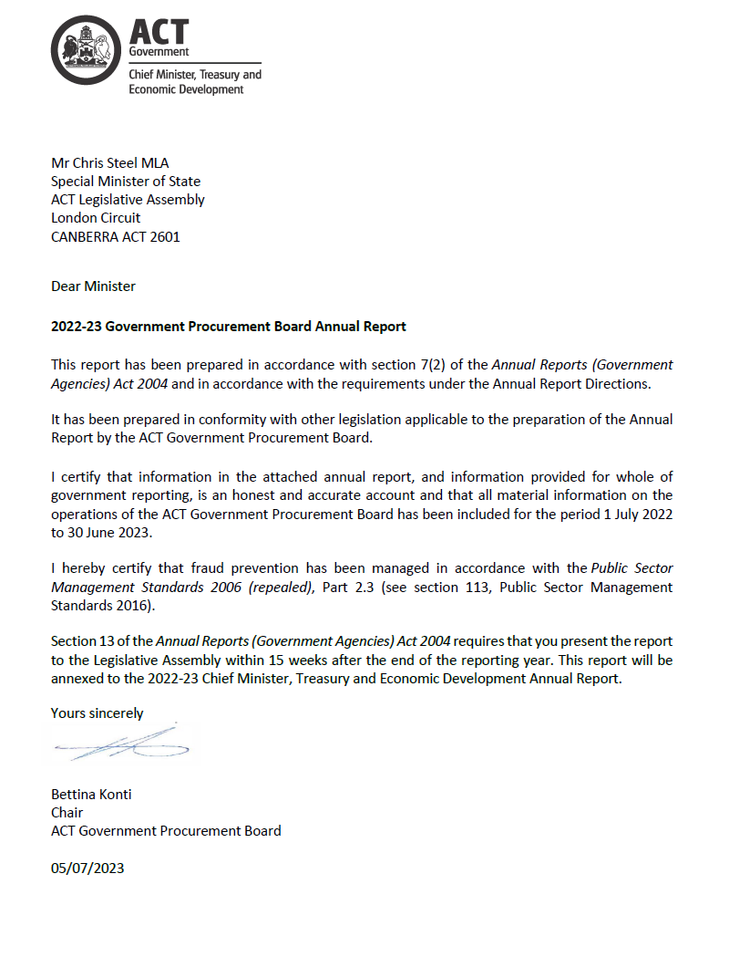

Compliance statement
The 2022-23 ACT Government Procurement Board Annual Report must comply with the Annual Reports (Government Agencies) Directions 2023 (the Directions) made under section 8 of the Annual Reports (Government Agencies) Act 2004. The Directions are found at the ACT Legislation Register.
The compliance statement indicates the subsections, under Parts 1 to 6 of the Directions, that are applicable to the ACT Government Procurement Board and the location of information that satisfies these requirements.

Part 1 Directions overview
The requirements under Part 1 of the Directions relate to the purpose, timing and distribution, and records keeping of annual reports. The 2022-23 ACT Government Procurement Board Annual Report complies with all subsections of Part 1 under the Directions.
To meet Section 15 Feedback, Part 1 of the Directions, contact details for the ACT Government Procurement Board are provided within the 2022-23 ACT Government Procurement Board Annual Report to provide readers with the opportunity to provide feedback.

Part 2 Reporting entity annual report requirements
The requirements within Part 2 of the Directions are mandatory for all reporting entities and the ACT Government Procurement Board complies with all subsections. The information that satisfies the requirements of Part 2 is found in the 2022-23 ACT Government Procurement Board Annual Report as follows:
- A. Transmittal Certificate, see the previous page.
- B. Organisational Overview and Performance, see the Organisational Overview and Performance section.
- C. Financial Management Reporting – the ACT Government Procurement Board has no information to report under this section.

Part 3 Reporting by exception
The ACT Government Procurement Board has no information to report by exception under Part 3 of the Directions for the 2022-23 reporting year.

Part 4 Annual Report Requirements for Specific Entities
There are no specific annual report requirements for the ACT Government Procurement Board.

Part 5 Whole of government annual reporting
All subsections of Part 5 of the Directions apply to the ACT Government Procurement Board. Consistent with the Directions, the information satisfying these requirements is reported in one place for all reporting entities as follows:
- Bushfire Risk Management, see the annual report of the Justice and Community Safety Directorate.
- Human Rights, see the annual report of the Justice and Community Safety Directorate.
- Legal Services Directions, see the annual report of the Justice and Community Safety Directorate.
- Public Sector Standards and Workforce Profile, see the annual State of the Service Report.
- Territory Records, see the CMTEDD Annual Report.
ACT Public Service directorate annual reports are found at the following web address: http://www.cmd.act.gov.au/open_government/report/annual_reports

Part 6 State of the Service Report
There are no specific annual report requirements for the ACT Government Procurement Board.

Organisational overview and performance

Organisational overview
The ACT Government Procurement Board (the Board) is established by the Government Procurement Act 2001 (the Act). The functions of the board under the Act are:
- To review, and give advice to Territory entities on, procurement issues.
- To review, and give advice on:
- Procurement proposals and activities referred to the Board by a Minister or responsible chief executive officer; or
- The procurement proposals for procurement matters declared by the Minister.
- To review procurement proposals of Territory entities in accordance with the regulations.
- To consider, advise on and, if appropriate, endorse procurement practices and methods for use by Territory entities.
- To provide advice to the Minister on any issue relevant to the procurement activities of Territory entities or the operation of this Act.
- To exercise any other function given to the Board under this Act or any other Territory law.
The Chair of the Board on 30 June 2023 is Ms Bettina Konti, Deputy Director-General and Chief Digital Officer, CMTEDD. The position of Chair, like all Board memberships, is part-time. Ms Konti was appointed by the Special Minister of State under the Act. The Chair reports directly to the Special Minister of State, the responsible Minister under the Act, in relation to her role on the Board.
The ACT Government has a policy of achieving and maintaining 50 per cent representation of women on its boards and committees. The Office for Women (Community Services Directorate) is consulted each time a Board vacancy is filled. The Offices of Disability, Aboriginal and Torres Strait Islander Affairs, Multicultural Affairs and LGBTIQ Affairs are also consulted each time a Board vacancy is filled.
In 2023-24, the Board will continue to provide strategic procurement advice and endorse procurement practices and methods for use by Territory entities.

Internal accountability

Membership of the Board
Section 11 of the Act stipulates the Board comprises nine part time members:
- Chair, who is a public employee member.
- Deputy Chair, who is a public employee member.
- Three other public employee members.
- Four non-public employee members.
The Chair of the Board at 30 June 2023 is Ms Bettina Konti.

Table 1: Membership of the Board for 2022-23 financial year
Name | Role | Meetings attended | Notes
Ms Bettina Konti  Chair  Public Employee Member | Chief Digital Officer  Chief Minister, Treasury and Economic Development Directorate | 24/33 | Ms Konti was re-appointed for a third term of one year on 12 May 2023.
Mr Geoffrey Rutledge  Deputy Chair  Public Employee Member | Deputy Director-General, Environment, Water and Emissions Reduction  Environment Planning and Sustainable Development Directorate | 29/33
Mr Damon Hall  Public Employee Member | Executive Group Manager, Project Development and Support  Major Projects Canberra | 27/33 | Mr Hall resigned from the ACTPS; his last meeting was on 6 June 2023.
Ms Anne Maree Sabellico  Public Employee Member | Executive Group Manager, Children, Youth and Family Services  Community Services Directorate | 23/33
Ms Meghan Oldfield  Public Employee Member | Executive Director, Corporate Services  Canberra Institute of Technology | 26/33
Ms Suzy Nethercott-Watson  Non-Public Employee Member |  | 31/33
Ms Susan Hall  Non-Public Employee Member |  | 14/33 | Resigned from the Board, her last meeting was on 22 November 2022
Mr Mathew Baldwin  Non-Public Employee Member |  | 31/33 | Mr Baldwin was re-appointed for a second term on 9 September 2022.
Ms Madeline Taylor  Non-Public Employee Member |  | 30/33 | Ms Taylor was re-appointed for a second term on 9 September 2022.
Ms Sommer Roles  Non-Public Employee Member |  | 1/33 | Ms Roles was appointed to the Board on 14 June 2023 and due to the timing of the Instrument and access to the ACT government network did not attend the meeting on 20 June 2023.

Conflict of interest
The Board has instituted arrangements to manage declarations of conflicts of interest to recognize that members, during the course of the year, may be faced with potential conflicts of interest due to their other responsibilities.
The Board has instituted the following arrangements:
- Members are aware and support the Board’s Charter and have signed a Code of Conduct agreement.
- Members are requested to identify whether they have a potential conflict of interest in respect of a proposal or policy matter prior to the related documents being considered.
- Prior to the commencement of all meetings, members are also invited to state any declarations of interest that may arise due to the business to be considered at the meeting.
- Members with a financial conflict of interest in a matter are not involved in the discussion or endorsement relating to that matter. For declarations of interest that are non-financial, Board consensus is reached as to whether the member who declared the interest partakes in the discussion or endorsement of the proposal.
The minutes of the meeting reflect the identification of any potential conflict(s) of interest and any action taken by the Board in respect of any conflict(s).
There were 25 declarations of a potential conflict of interest recorded during 2022-23 financial year, of which 22 disclosures were made by Public Employee Members and three were made by Non-Public Employee Members. For openness and transparency, Public Employee Members may declare a potential conflict of interest when a procurement proposal relates to their directorate even though they may not have a direct involvement with the proposal.

Remuneration
Public Employee Members of the Board do not receive any remuneration for their participation.
The remuneration for Non-Public Employee Members of the board is determined from time to time by the ACT Remuneration Tribunal. Currently, Non-Public Employee Members are paid $27,985 per annum. The latest determination can be viewed at: https://www.remunerationtribunal.act.gov.au/__data/assets/pdf_file/0008/2175443/Determination-13-of-2022-PTPOH.pdf

Support staffing and financial resources
The Board is supported by a Secretariat, resourced by Procurement ACT.

Consideration of proposals
The Board considered 65 procurement proposals, and 14 presentations and updates in the 2022-23 financial year. Of the 65 proposals presented for endorsement by the Board:
- 28: single pass proposals (procurement review, includes variations) and
- 35: two pass proposals (strategic review and procurement review).
- 2 strategic procurement plans.

Table 2: Board deliberations in comparison with previous years
Name | 2017-18 | 2018-19 | 2019-20 | 2020-21 | 2021-22 | 2022-23
Total board meetings | 28 ¹ | 35 ² | 33 ³ | 41 ⁴ | 44 ⁵ | 33
Business meetings | 1 | 1 | 1 | 1 | 1 | 1
Proposal meetings | 28 ¹ | 34 | 32 | 40 ⁴ | 44 | 33
Proposals considered | 68 | 73 | 69 | 97 | 90 | 65
Presentations |  |  |  |  | 13 | 14
Estimated value of proposals ($ million) | 1,848 | 1,790 | 3,313 | 2,138 | 2,566 | 2,354
Notes:
- This includes two meetings held electronically via email.
- This includes six meetings held electronically via email.
- This includes one meeting held electronically via email. From 31 March 2020 to 30 June 2020, the Board met virtually using an electronic meeting application. Proponents have been able to continue to meet with the Board via the electronic meeting application.
- This includes two meetings held electronically via email. The Board has continued to meet virtually in 2020-21 using an electronic meeting application. Proponents have been able to continue to meet with the Board via the electronic meeting application.
- This includes two meetings held electronically via email. The Board has continued to meet virtually in 2022-23 using an electronic meeting application. Proponents have been able to continue to meet with the Board via the electronic meeting application.
When comparing 2022-23 to 2021-22, there has been a decrease in the estimated value of proposals by approximately $212 million. This is due to the higher number of proposals cancelled by proponents ahead of their scheduled Board meeting in the 2022-23 financial year compared to 2021-22.

Table 3: Summary of proposals considered by the Board in the 2022-23 financial year
Procurement method | Number | Percentage (%) of number | Estimated value ($M) | Percentage (%) of value
Public tender | 46 | 58 | 1,265 | 54
Variations | 6 | 8 | 520 | 22
Single select tender | 9 | 11 | 461 | 20
Select tender | 4 | 5 | 26 | 1
Presentation and updates | 14 | 18 | 82 | 3

Table 4: Breakdown of procurement proposals and presentations/updates by directorate
Directorate | Number | Percentage (%) of number | Estimated value ($M) | Percentage (%) of value
ACT Health Directorate | 5 | 6 | 30 | 1.3
ACT Insurance Authority | 1 | 1 | 3 | 0.1
Canberra Health Services | 11 | 14 | 146 | 6.2
Canberra Institute of Technology | 0 | 0 | 0 | 0
Chief Minister, Treasury and Economic Development Directorate | 22 | 28 | 204 | 8.6
City Renewal Authority | 2 | 3 | 8 | 0.4
Community Services Directorate | 2 | 3 | 519 | 22.1
Cultural Facilities Corporation | 0 | 0 | 0 | 0
Education Directorate | 3 | 4 | 106 | 4.5
Environmental Planning and Sustainable Development Directorate | 4 | 5 | 57 | 2.4
Justice and Community Safety Directorate | 2 | 3 | 70 | 3
Emergency Services Agency | 2 | 3 | 44 | 1.9
Major Projects Canberra* | 14 | 18 | 962 | 40.9
Suburban Land Agency | 4 | 5 | 105 | 4.5
Transport Canberra and City Services Directorate | 7 | 9 | 100 | 4.3
*Note: Under the Administrative Arrangements 2020 (No 2), Major Projects Canberra is responsible for the delivery of designated major capital works projects and the delivery of physical capital works projects in coordination with government agencies.
In 2022-23 the Board has included in its focus the implementation of the Government Procurement (Ethical Treatment of Workers Evaluation) Direction 2021 which commenced on 1 February 2022. The requirements of the Direction apply to all procurements:
- to which a Secure Local Jobs Code applies;
- that has a total estimated value of $200,000 or more; and
- which is conducted by public tender.
The Direction requires supplier behaviour and business practices align to the Fair and Safe Conditions for Workers Procurement Value and, also ensures suppliers remain compliant with their obligations under the Secure Local Jobs Code.
Further information | Bettina Konti, Chair, ACT Government Procurement Board
 | (02) 6207 2242 | Bettina.Konti@act.gov.au
 | Secretariat, Government Procurement Board
 | (02) 6207 9000 | GovernmentProcurementBoard@act.gov.au

Default Insurance Fund

Transmittal certificate
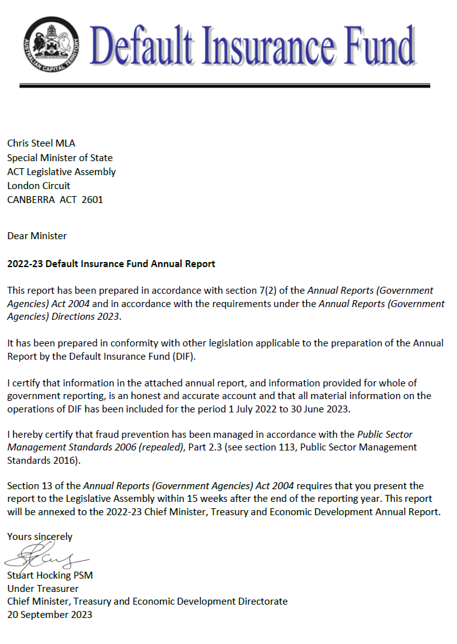

Compliance statement
The 2022-23 Default Insurance Fund Annual Report must comply with the Annual Reports (Government Agencies) Directions 2023 (the Directions) made under section 8 of the Annual Reports (Government Agencies) Act 2004. The Directions are found at the ACT Legislation Register.
The compliance statement indicates the subsections, under Parts 1 to 5 of the Directions, that are applicable to the Default Insurance Fund and the location of information that satisfies these requirements.

Part 1 Directions overview
The requirements under Part 1 of the Directions relate to the purpose, timing and distribution, and records keeping of annual reports. The 2022-23 Default Insurance Fund Annual Report complies with all subsections of Part 1 under the Directions.
To meet Section 15 Feedback, Part 1 of the Directions, contact details for the Default Insurance Fund are provided within the 2022-23 Default Insurance Fund Annual Report to provide readers with the opportunity to provide feedback.

Part 2 Reporting entity annual report requirements
The requirements within Part 2 of the Directions are mandatory for all reporting entities and the 2022-23 Default Insurance Fund Annual Report complies with all subsections. The information that satisfies the requirements of Part 2 is found in the 2022-23 Default Insurance Fund Annual Report as follows:
- A. Transmittal certificate, see the previous page.
- B. Organisational Overview and Performance Analysis, see Organisational Overview and Performance on the next page. The following subsections, contained within the 2022-23 ACT Insurance Authority Annual Report, apply to the Default Insurance Fund:
- Risk Management
- Internal Audit
- Fraud Prevention
- Community Engagement and Support
- Aboriginal and Torres Strait Islander Reporting
- Work Health and Safety
- Human Resource Management
- Ecological Sustainability Reporting.
- C. Financial Management reporting, see the Financial Management Reporting section of this report.
For the remaining subsections see Volume 2.2 of the 2022-23 CMTEDD Annual Report.

Part 3 Reporting by exception
The Default Insurance Fund has no information to report by exception under Part 3 of the Directions for the 2022-23 reporting period.

Part 4 Directorate and public sector body specific annual report requirements
Part 4 of the 2023 Directions is not applicable to the Default Insurance Fund.

Part 5 Whole of government annual reporting
All subsections of Part 5 of the Directions apply to the Default Insurance Fund. Consistent with the Directions, the information satisfying these requirements is reported in one place for all reporting entities as follows:
- Bushfire Risk Management, see the annual report of the Justice and Community Safety Directorate.
- Human Rights, see the annual report of the Justice and Community Safety Directorate.
- Legal Services Directions, see the annual report of the Justice and Community Safety Directorate.
- Public Sector Standards and Workforce Profile, see the annual State of the Service Report.
- Territory Records, see the Chief Minister, Treasury and Economic, Development Directorate Annual Report.
ACT Public Service directorate annual reports are found at the following web address: http://www.cmd.act.gov.au/open_government/report/annual_reports.

Organisational overview and performance

Organisational overview
The Workers Compensation Act 1951 (the Workers Compensation Act) was established to provide compensation to workers employed in the private sector for injuries arising out of or in the course of their employment.
The Default Insurance Fund (the Fund) was established under the Workers Compensation Act effective from 1 July 2006. It provides a safety net to meet the cost of workers’ compensation claims made by workers in circumstances where:
- an employer does not have a workers’ compensation insurance policy and cannot meet the claim costs payable under the Workers Compensation Act;
- an employer’s insurance company is wound up under the Corporations Act 2001 (Cth) or cannot provide the indemnity required to be provided under a compulsory workers’ compensation policy; or
- a worker is suffering from an imminently fatal asbestos-related disease as a result of exposure to asbestos fibres whilst employed as a worker in the Australian Capital Territory.
Funds are held in trust under the Financial Management Act 1996 in two separate accounts:
- the Uninsured Employer Fund (UEF); and
- the Collapsed Insurer Fund (CIF).
The General Manager for the ACT Insurance Authority (the Authority) is the appointed Fund Manager.
The Fund meets the cost of workers’ compensation settlements and any common law judgments including the payment of weekly compensation, medical expenses and rehabilitation costs. Funds required to satisfy the cost of claims and other relevant expenses are not guaranteed by the ACT Government. Part 8.2 of the Workers Compensation Act allows the Fund Manager to impose contributions and supplementary contributions on approved insurers and self-insurers to meet the cost of claims.
The Fund’s administrative operations are subject to the same governance controls in relation to risk management, fraud prevention and records management as the Authority. The reporting on these operations is included in the relevant sections of the Authority’s Annual Report.
The Authority also has oversight for workplace health and safety and associated risk management, accommodation, facilities management and workplace environmental management for the Fund. Reporting for these issues is contained in the Authority’s Annual Report.

Internal Accountability
The Default Insurance Fund Advisory Committee is established under Schedule 3 of the Workers Compensation Act. Its role is to monitor the operations of the Fund and, if requested by the Minister or the Fund Manager, advise on matters relating to the operation of the Fund.
The Committee consists of the Executive Group Manager, Workplace Safety Group (Chair), the Fund Manager and three members appointed by the Minister.

Table 1: Fund Advisory Committee membership 2022-23
Name | Member details
Michael Young | Executive Group Manager, Workplace Safety Group (Chair)
Belinda Farrelly | The Australian National University (Employer Representative)
Sharlene Watson | QBE Insurance (Insurer Representative)  membership expired 22 December 2022
Augustus Modelo | QBE Insurance (Insurer Representative)  membership commenced 16 February 2023
Rosalind Read | Construction, Forestry, Maritime, Mining and Energy Union (CFMEU) (Employee Representative)
Penny Shields | Fund Manager
The Committee met on four occasions during 2022-23. At each meeting, a report on the status of the Fund was provided and a schedule detailing the status of open claims was considered.

Performance Analysis
The Fund engaged Taylor Fry Consulting Actuaries to estimate the provision for claims payable (liability) and related claims expenses for the 2022-23 reporting period. Actuarial assumptions are based on past claims experience, risk exposure and projections of economic variables.

Uninsured Employer Fund (UEF)
This component of the Fund currently administers claims that have arisen when a worker has been injured and the employer did not hold an ACT workers’ compensation policy. Where the employer does not or cannot meet the cost of claims, the UEF responds on behalf of the employer as the default insurer.

Claims
When a claim is received, the Fund undertakes a search in an attempt to locate an insurer for the injured worker. In some cases, an insurer is identified, and the claim is then forwarded to the appropriate insurer.
When satisfied that an insurance policy is not in place, the Fund acts as the default insurer for the injured worker. The Fund arranges and facilitates appropriate rehabilitation and medical treatment for injured workers with the aim of returning an injured worker back to their pre-injury condition where possible. Claims are managed pursuant to the Workers Compensation Act, and the Fund meets the cost of all legislated entitlements for injured workers including medical expenses, rehabilitation costs, weekly compensation and lump sum settlements.

Table 2: Uninsured Employer Fund claims
 | Number
Total claims opened during the reporting period | 21
Total claims closed during the reporting period | 12
Total claims re-opened during the reporting period | 0
Current open claims | 75

Revenue
Section 168A of the Workers Compensation Act requires the Fund Manager to undertake a review of the UEF each year to determine the appropriate levy on approved insurers and self-insurers.
In determining an appropriate levy for 2022-23, the Fund Manager took into consideration a range of issues including a sensitivity analysis of the volatility of the UEF, the potential for an increase in claims costs, and claim numbers in the current and future insurance years.
The Fund Manager imposed contributions from insurers and self-insurers equal to 2.6 per cent of the gross written premiums resulting in $8.241 million in levy revenue.

Expenses
The expenses for UEF during the year were $3.350 million, which includes $2.946 million in claims expense and $0.404 million in supplies and services. The claims expense consisted of $2.799 million in settlements, compensation payments and other claims costs, along with an increase in the provision for claims payable of $0.147 million as a result of the 2022-23 actuarial valuation.

Balance Sheet
As at 30 June 2023, the UEF held total assets of $40.600 million consisting of $37.004 million in cash and cash equivalents and receivables of $3.596 million comprising current receivables of $2.361 million and non-current receivables of $1.235 million. The UEF’s liabilities total $36.755 million, which includes $0.050 million in payables, along with $5.486 million of current provision of claims payable and $31.219 million of non-current provision of claims payable.

Collapsed Insurer Fund (CIF)
This component of the Fund currently administers claims that have arisen from a previously approved workers’ compensation insurer that has been wound up or is in liquidation. Currently the Fund administers claims for two collapsed insurers, National Employers’ Mutual Association Ltd in 1990 (NEM) and HIH Insurance in 2001 (HIH).

Claims
When satisfied that an insurer is unable to pay, the Fund acts as the default insurer for the injured worker. The Fund arranges and facilitates appropriate rehabilitation and medical treatment for injured workers with the aim of returning an injured worker back to their pre-injury condition where possible. Claims are managed pursuant to the Workers Compensation Act, and the Fund meets the cost of all legislated entitlements for injured workers including medical expenses, rehabilitation costs, weekly compensation and lump sum settlements.
As at 30 June 2023, there was one open claim against NEM and three open claims against HIH. The Fund Manager represented the Fund on the Committee of inspection for the HIH liquidation.

Table 3: Collapsed Insurer Fund claims
 | Number
Total claims opened during the reporting period | 1
Total claims re-opened during the reporting period | 0
Total claims closed during the reporting period | 0
Current open claims | 4

Revenue
The CIF is not levying insurers or self-insurers for the CIF Fund at present. The fund can appropriately and responsibly manage the impact of any future insurance collapses within the workers’ compensation industry through the retention of its current reserve and the imposition of a tailored levy on employers in the event of a collapse. The CIF collected $0.262 million in interest from its investments during the reporting period.

Expenses
The total expenses incurred by the CIF during the year was $0.374 million, consisting of $0.015 million in supplies and services and $0.359 million in claims expense. The claims expense consisted of $0.075 million in compensation and an increase of $0.284 million in the provision for claims payable as the result of the 2022-23 actuarial valuation.

Balance Sheet
As at 30 June 2023, the CIF had cash and cash equivalents totalling $9.265 million with an estimated outstanding claims provision of $1.134 million. The CIF Fund’s total equity as at 30 June 2023 is $8.125 million.

Scrutiny
There were no inquiries or reviews from the ACT Audit Office, the ACT Ombudsman, ACT Integrity Commission or any Legislative Assembly Committees in 2022-23. The only scrutiny from the Audit Office during the reporting period was the audit of the 2021-22 Financial Statements.

Freedom of Information
The Freedom of Information Act 2016 (FOI Act) gives individuals the legal right to:
- access government information unless access to the information would, on balance, be contrary to the public interest;
- ask for personal information to be changed if it is incomplete, out-of-date, incorrect or misleading; and
- appeal a decision about access to a document, or a decision in relation to a request to amend or annotate a personal record.
In accordance with Section 96 of the FOI Act the Fund is required to report on the operation of the FOI Act in relation to the Fund for the reporting year. The Fund did not receive any requests for access to any information under the FOI Act during 2022-23.
Further information relating to FOI including how to make an FOI application, what details you need to make an application and contact details for the CMTEDD Information Officer can be found on CMTEDD’s website https://www.cmtedd.act.gov.au/functions/foi. There are also details of requests received by the directorate listed on the Freedom of Information Disclosure Log for CMTEDD.

Financial management reporting

Government contracting
The Fund engages consultants to perform specialised actuarial and legal services. The procurement selection and management processes for all contractors including consultants complied with the Government Procurement Act 2001 and the Government Procurement Regulation 2007.
The ACT Government Contracts Register records contracts with suppliers of goods, services and works, with a value of $25,000 or more and is available online.
A full search of Default Insurance Fund contracts notified with an execution date from 1 July 2022 to 30 June 2023 can be made at https://www.tenders.act.gov.au/contract/search.
Further information | Penny Shields, General Manager, ACT Insurance Authority
 | (02) 6207 0268 | ACTInsuranceAuthority@act.gov.au

Director of Territory Records

Transmittal certificate
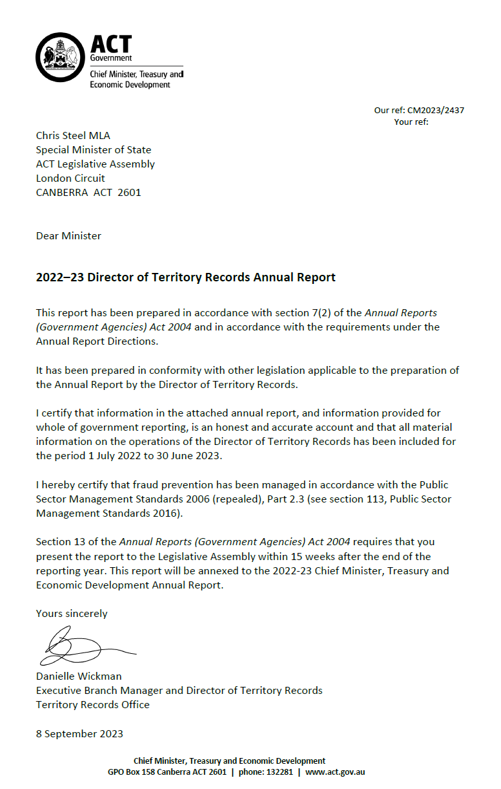

Compliance statement
The 2022-23 Director of Territory Records Annual Report must comply with the Annual Reports (Government Agencies) Directions 2023 (the Directions) made under section 8 of the Annual Reports (Government Agencies) Act 2004. The Directions are found at the ACT Legislation Register.
The compliance statement indicates the subsections, under Parts 1 to 5 of the Directions, that are applicable to the Director of Territory Records and the location of information that satisfies these requirements.

Part 1 Directions overview
The requirements under Part 1 of the Directions relate to the purpose, timing and distribution, and record keeping associated with annual reports. The 2022-23 Director of Territory Records Annual Report complies with all subsections of Part 1 under the Directions.
To meet Section 15 Feedback, Part 1 of the Directions, contact details for the Director of Territory Records are provided within the 2022-23 Director of Territory Records Annual Report to provide readers with the opportunity to provide feedback.

Part 2 Reporting entity annual report requirements
The requirements within Part 2 of the Directions are mandatory for all reporting entities and the Director of Territory Records Annual Report complies with all subsections. The information that satisfies the requirements of Part 2 is found in the 2022-23 Director of Territory Records Annual Report as follows:
- A. Transmittal Certificate, see the previous page.
- B. Organisational Overview and Performance Analysis subsections, see the Organisational Overview and Performance section. All remaining subsections are contained within the CMTEDD Annual Report.
- C. Financial Management Reporting, inclusive of all subsections, is contained within the CMTEDD Annual Report.

Part 3 Reporting by exception
The Director of Territory Records has no information to report by exception under Part 3 of the Directions for the 2022-23 reporting year.

Part 4 Directorate and public sector body specific annual report requirements
There are no specific annual report requirements for the Director of Territory Records.

Part 5 Whole of government annual reporting
All subsections of Part 5 of the Directions apply to the Director of Territory Records. Consistent with the Directions, the information satisfying these requirements is reported in one place for all reporting entities as follows:
- Bushfire Risk Management, see the annual report of the Justice and Community Safety Directorate.
- Human Rights, see the annual report of the Justice and Community Safety Directorate.
- Legal Services Directions, see the annual report of the Justice and Community Safety Directorate.
- Public Sector Standards and Workforce Profile, see the annual State of the Service Report.
- Territory Records, see the CMTEDD Annual Report.
ACT Public Service directorate annual reports are found at the following web address: http://www.cmd.act.gov.au/open_government/report/annual_reports.

Organisational overview and performance
The Territory Records Office supports the Director of Territory Records to lead the ACT Public Service (ACTPS) on records management policy, strategy and practice. The Territory Records Act 2002 (Territory Records Act) provides for the Director to develop recordkeeping standards and tools for ACT Government agencies, oversee the disposal of government records and assist members of the public to access ACT Government archives.
The main purposes of the Territory Records Act are to:
- Encourage open and accountable government by ensuring that Territory records are made, managed, and, if appropriate, preserved in accessible form.
- Support the management and operation of Territory agencies.
- Preserve Territory records for the benefit of present and future generations.
- Ensure that public access to records is consistent with the principles of the Freedom of Information Act 2016.
The Territory Records Act enables the Director of Territory Records to:
- Develop and approve standards and codes for records management by agencies.
- Examine the operation of agency records management programs.
- Encourage the development of records management training for staff.
- Encourage consistency in the preparation of tools to assist in the awareness of and access to records.
The Territory Records Act establishes the statutory position of the Director of Territory Records. The Territory Records Office (TRO) is an administrative unit within Policy and Cabinet in CMTEDD. The Office is made up of 7.6 full time equivalent staff, including the Director.
The current Director of Territory Records is Ms Danielle Wickman. The Director is a senior executive appointed under both the Public Sector Management Act 1994 and the Territory Records Act. Ms Wickman was reappointed to the statutory role under the Territory Records Act for five years commencing 24 May 2023. Ms Katharine Stuart was appointed Acting Director from 24 April to 23 May 2023 while Ms Wickman was on leave. The Director’s remuneration is as determined for all ACT Senior Executives under the Remuneration Tribunal’s Determination 2 of 2022 – Head of Service, Directors-General and Executives.
The Director’s responsibilities are to lead the work of the Territory Records Office and to provide advice to the Minister, the Strategic Board, CMTEDD Executives and ACT Government agencies on archives, records and information governance matters. The Director also exercises powers and functions under the Territory Records Act, including approving standards for government recordkeeping, authorising the disposal of Territory records, and making determinations regarding the restriction of records from public access.

Territory Records Advisory Council
The Territory Records Act establishes the Territory Records Advisory Council (TRAC) to advise the Director, particularly in relation to the development of standards and guidelines, access to and disposal of records, and on the protection of records about Aboriginal and Torres Strait Islander heritage.
Members of the Council are appointed on a part-time basis by the Minister. Appointments must be made from the range of categories set out in section 44 of the Territory Records Act. The Director of Territory Records is also a member of the Council. Members, apart from the Director, are appointed for a term of three years and may be reappointed. Members are paid a sitting fee in accordance with the ACT Remuneration Tribunal’s Determination 13 of 2022 – Part Time Public Office Holders.
The activities of the Council are funded from within the Territory Records Office’s budget. Financial oversight, including risk management, audit and fraud control arrangements, are managed within CMTEDD’s control systems. The ACT Public Service code of conduct applies to Territory Records Advisory Council members. The Council has also established Terms of Reference that derive from its responsibilities under the Act, and members are required to sign a conflict-of-interest declaration as part of the appointment process. The Council has not established any sub committees.
The Territory Records Advisory Council met four times during 2022-23 as follows:
- Meeting 1 of 2022-23, 4 August 2022, 220 London Circuit and online.
- Meeting 2 of 2022-23, 24 November 2022, 220 London Circuit and online.
- Meeting 3 of 2022-23, 3 March 2023, 9 Sandford Street Mitchell and online.
- Meeting 4 of 2022-23, 25 May 2023, 220 London Circuit and online.
Membership of the Council and attendance during the 2022-23 financial year is detailed in the following table. During this time the Council farewelled Dr Annette Weir, who elected to resign from the Council due to other ongoing commitments.

Table 1: Membership of the Territory Records Advisory Council during the year and the number of meetings each member attended
Name of member | Role | Meetings attended
Ms Liesl Centenera (Chair) | Public administration, governance, public accountability | 4 / 4
Mr Adrian Cunningham (Deputy Chair) | Records management and archives | 3 / 4
Ms Arden Jones | History and heritage | 3 / 4
Ms Lorien Mader | Records management and archives | 4 / 4
Dr Terhi Nurmikko-Fuller | History and heritage | 2 / 4
Ms Narelle Rivers | Aboriginal and Torres Strait Islander heritage | 2 / 4
Dr Annette Weier | ACT Government agencies | 1 / 2
Mr Keith Young | Public administration, governance, public accountability | 1 / 4
Ms Danielle Wickman | Director of Territory Records | 4 / 4
The Council receives regular reports on public access, relations with government agencies, and progress against the Territory Records Office’s business plan. The Director keeps the Council informed of, and seeks its advice on, significant initiatives of the Office. During 2022-23 the Council considered and advised on matters such as arrangements for the disposal of records on damaged and obsolete media, records management training for ACTPS staff, and marketing and promotions avenues for ArchivesACT. On 14 October 2022 the Council Chair, Ms Liesl Centenera, met with Special Minister of State, Chris Steel. The meeting canvassed the range of activities performed by the Territory Records Office and the Council, and their contribution to open and transparent access to government information.
An important aspect of Council’s role is to advise the Director on matters relating to public access to ACT Government archives. The Council’s meeting agenda includes a standing item on decisions to restrict archives from public access under section 28 of the Territory Records Act. No new section 28 declarations were made during 2022-23, meaning that no additional categories of records were identified as requiring restriction from public access. Existing section 28 declarations, which are listed on the ArchivesACT website, continue to be applied to relevant records when they are requested by the public.
The Territory Records Act gives the Council particular responsibility for advising the Director on the disposal of ACT Government records. The retention and disposal of records is authorised through records disposal schedules, issued under section 19 of the Territory Records Act. All draft schedules are referred to the Council for advice before they are approved by the Director. During 2022-23 Council considered two new or revised schedules. This is consistent with the number of schedules considered in the previous two years.
Council members maintained their interest in the development of the Office’s records and information management maturity assessment processes, and provided important feedback on the induction material being developed in collaboration with ACT Government agency records managers.
Following the launch of ACT Memory in early 2022, members were pleased to see the database becoming a platform for access to a range of archival records. The ACT Memory database provides searchable information about publicly available ACT government archives. During 2022-23 it has also been used to release Cabinet records that are 10 or more years old that are being made available under Executive Documents release arrangements. Members also welcomed the return of the Chief Minister’s Governance Lecture and Canberra and Region Heritage Festival events.
Since 2018-19, Council members have conducted an annual survey to complete a self-assessment of the Council’s performance and its satisfaction with the support provided by the Territory Records Office. Since the survey’s inception, results have consistently shown that members are satisfied with the performance of both the Council and the secretariat. Members most strongly agreed that the Council has clear goals and actions, its meetings focus on the most important issues for the Territory Records Office, debates are thoughtful and respectful, and papers are relevant, well-presented and timely. In previous surveys members had indicated a desire to be more closely involved in shaping the Office’s strategic direction, and on 4 April 2023 the Council Chair joined TRO staff in a planning session to discuss the Office’s strategic direction and messaging.

Performance overview and highlights for 2022-23
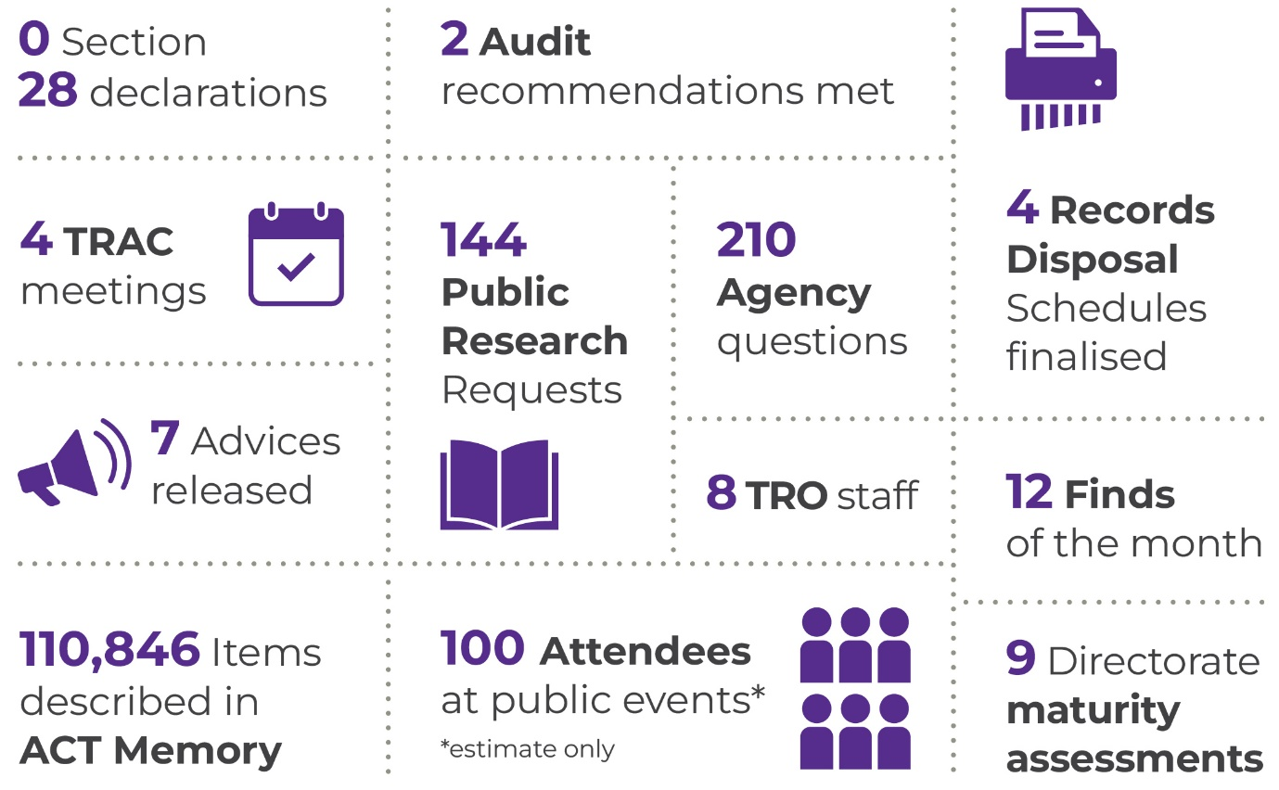

The year in snapshot
Our key area of focus continues to be building the ACTPS’ capability to deliver robust records management in a digital, whole of government environment. Two of our eight staff - both new positions created since the development of our capability plan in 2021 - are dedicated to delivering tools and strategies aimed at increasing the awareness of and capacity for managing ACT Government records and archives. In response to the plan, we have worked with agencies to develop standardised records management induction information, as well as the first in a series of case studies that demonstrate the importance of good records and information governance. We also finalised our responses to the Auditor-General’s 2021 report on Digital Records Management, providing additional guidance to agencies on how they can realise the benefits of digital recordkeeping, and how to identify appropriate strategies for digitising hard copy records.
These new roles have freed up other staff to continue to build our ongoing systems and processes. The quantity of information available through our ACT Memory database is progressively growing, and we have continued to refine our annual records management maturity assessment for agencies, making it an increasingly valuable tool for identifying strengths and priorities.
The Office’s core functions are guided by the Territory Records Act. We are both an information governance advisor to government and an archives service provider to the community. To fulfil the role set out for us under the Territory Records Act, we aim to:
- increase opportunities for the community to access records and information; and
- influence and embed good archives, records and information management principles and practices into ACT Government business.

Improving government recordkeeping capability
The Territory Records Office has taken the lead in driving the take-up of electronic document and records management system (EDRMS) capability in the ACTPS since the commencement of our pilot whole of government project in 2016. Our Digital Records for Digital Government initiative, which we led alongside colleagues in Shared Services, has formally come to an end, with the work transitioning to business-as-usual operations. We published our advice on benefits realisation for EDRMS deployments, and whole of government models for digitisation in response to the Auditor-General’s recommendations arising from his 2021 audit of the initiative.
EDRMS technology is one of many possible approaches to digital records management. We continue to work with our peers in government archives and records institutions in other jurisdictions to influence the development of Microsoft Office 365 products and to understand and advise on their potential and limitations in recordkeeping contexts. We have also published advice on ‘Records by Design’ concepts, to assist agencies to assess their recordkeeping requirements prior to systems design and procurement processes.
Our 2020 investigation of future digital recordkeeping systems and strategies noted that human and governance capabilities would be needed to deliver good outcomes regardless of the software used to support records management. This has informed our focus on capability development work, such as:
- using Information Awareness Month as a platform for promoting records and archives issues to the ACTPS and the public;
- codifying, through induction and other training, the records management knowledge essential to all public servants;
- developing tools that can help records professionals sell the benefits of good records management to stakeholders; and
- articulating for stakeholders the Office’s strategic purpose in driving good information governance.
Information Awareness Month, held in May each year, is a well-established event across the data, records, information, library and archives professional communities. As part of our focus on capability improvement, we have committed to using Information Awareness Month as a platform for highlighting the importance of records and information governance and promoting skills development for records managers and others across the ACTPS. This year we partnered with our colleagues in the CMTEDD Information Management unit to deliver highly successful information sessions on Freedom of Information and recordkeeping, and the impact of artificial intelligence on information governance. We also held a session for public servants on our ACT Memory database. Finally, we invited our colleagues at the ACT Fire Brigade Historical Society to speak at a public event about the Fire Brigade Occurrence Books. The TRO worked with the Society in 2021 to digitise these important records, which provide a window into emergencies, as well as more routine events, in Canberra between 1924 and 1969.
During the year we finalised our work with agencies on an agreed set of essential records management messages that should be part of all ACTPS induction and other onboarding processes. The TRO led a working group across all ACT Government directorates to distil key areas of knowledge into a brief that can inform development of any new starter or refresher training for staff.
We have also worked with agencies to identify case studies that illustrate how good records management practice can provide business benefits for organisations. The first of these looks at how records teams assisted staff to transition to activity-based work arrangements, by advising on the proper management of existing paper records and supporting staff to consider whether their work processes still required hard copy documentation. We intend to build a library of case studies in the future, and to increase the channels we use to promote their messages to stakeholders.
Part of our capability plan is to build the demand for good records management and position it, and the TRO, as enablers to government rather than potential compliance obstacles. In April 2023 staff came together with the Advisory Council Chair to discuss the development of a ‘purpose statement’ that articulates the business benefits of records and information management and the risks that such activity seeks to manage. This work, to develop a succinct statement of the value of the Office and its work, will continue into 2023-24, with stakeholder consultation to commence shortly.
We also continue to build on our records management maturity framework as a tool for assessing information governance strengths and identifying areas for further investment of our efforts. Our 2022 assessment indicates that important improvements, such as the development of information asset registers, have been made in some directorates. These types of initiatives can support the strategic management of digital records, by ensuring that agencies understand which business systems create and keep records, enabling them to be managed appropriately. All directorates have reached an ‘Essential’ level of maturity, meaning that they can meet minimum requirements for records management. Some directorates are assessed as being at the ‘Proactive’ level for some areas of activity, indicating that records and information governance is well established and continually improving, with these governance considerations routinely integrated into business decisions. Analysis of the 2022 results indicates that the TRO could continue to provide assistance for agencies to assess recordkeeping requirements early in the development of business systems and processes. Our goal is to assist directorates to reach this Proactive level against most or all of our 7 records and information governance principles, and in 2022 we set targets for agency action that are intended to improve their results in relation to our ‘Strategy’ and ‘Capability’ principles.
A core part of our business is to maintain the framework in which agencies can accountably dispose of records that do not have significant ongoing value to government or the community. Carefully considered arrangements for the disposal of government records are important for supporting both the preservation of archival records and the efficient functioning of government. We do this work primarily through the authorisation of records disposal schedules, which set out the minimum retention requirements for the records that arise from all areas of government business. The Territory Records Advisory Council has an important role in advising on community expectations for records retention and disposal. During 2022-23 the following records disposal schedules were notified on the ACT Legislation Register:

Table 2: Records Disposal Schedule notified during 2022-23
Schedule | Effective | Instrument number
Territory Records (Records Disposal Schedule – Health Treatment and Care Records) Approval 2023 (No 1) | 29 March 2023 | NI2023-114
Territory Records (Records Disposal Schedule – Protection of records relevant to the Royal Commission into Institutional Responses to Child Sexual Abuse) Approval 2022 (No 1) | 13 December 2022 | NI2022-620
Territory Records (Records Disposal Schedule – Student Management Records) Approval 2022 (No 1) | 25 November 2022 | NI2022-544
Territory Records (Records Disposal Schedule – Records on Damaged or Obsolete Media) Approval 2022 (No 1) | 15 July 2022 | NI2022-350

Improving information access
The Office marked the 20th anniversary of the passing of the Territory Records Act in 2002 with a special Chief Minister’s Governance Lecture. The TRO established the Chief Minister’s Governance Lecture in 2015 to highlight events documented in recently released ACT Government archives and link them to the issues and debates of today. In past years we have had lively discussions linking long-running campaigns for Very Fast Trains with current thinking on transport planning. We have connected historical decisions about access to health information with current arguments about trust in government and data stewardship. We have looked at the plight of artists during the pandemic, the plight of earless dragons during urban development, and the plight of public servants since the beginning of self-government in the ACT. For our 20th anniversary we joined with the annual conference of the Australian Society of Archivists in Canberra to discuss “Archives, Governance and Integrity”. Former diplomat and current Transparency International Australia board member Ms Deborah Stokes delved into the records of the Act’s development to share with us her thoughts on the essential relationship between archives and democratic and accountable government.
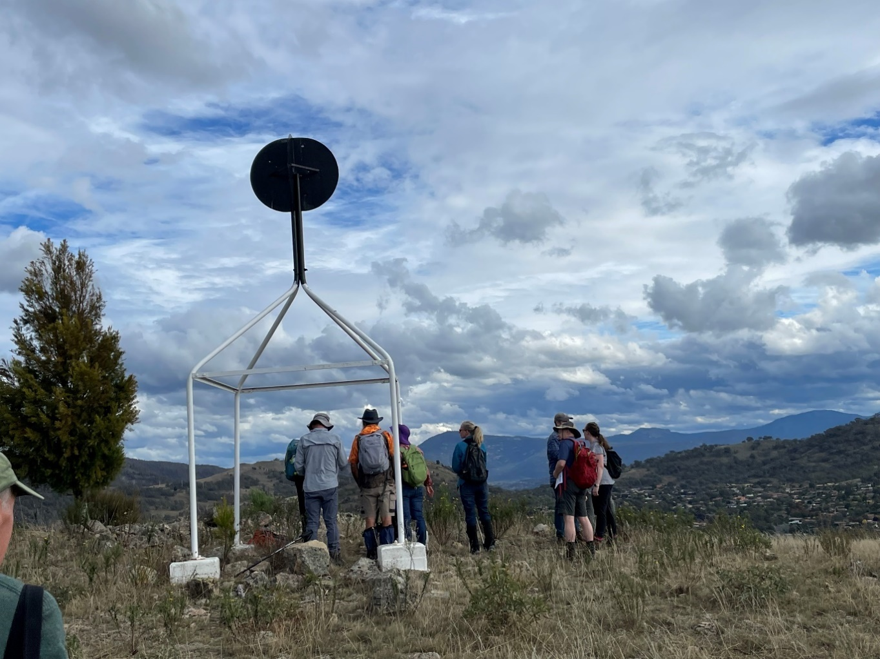
Image 1: Participants in the Heritage Festival event, Stories from the Border, look out from the trig station at Melrose Nature Reserve
Another fitting anniversary event came with the inclusion of the ACT’s Border Survey Notebooks on the Australian Memory of the World Register. The Register is a UNESCO initiative which aims to highlight and protect significant documentary heritage. In a first for an ACT Government collection, the original field books used to document the border of the new Federal Capital Territory in 1910 were accepted onto the Register. This places these important archives alongside other iconic documents and collections, including Captain Cook’s journal, the Mabo papers, convict records and the manuscript of Ethel Turner’s Seven Little Australians. To celebrate, our ArchivesACT service, which promotes and provides public access to ACT Government archives, partnered with the Canberra Bushwalking Club to conduct walks to two sites along the border. The walks, part of the Canberra and Region Heritage Festival, were well attended, and also attracted a degree of media interest, with stories in The Canberra Times, on ArtSound FM, and on ABC local television and radio.
Alongside these activities we have kept up our day-to-day work of bringing the ACT’s archival collections to the public. Our regular Find of the Month, which seeks to bring stories from the archives, both strange and familiar, to a wider audience, continues to be one of the most popular pages on our website. This year we looked at the origins of the Tidbinbilla Nature Reserve and the Botanic Gardens, lamented the demise of the Sundown and Starlight drive-in theatres, and explored the back streets of Westlake, Tuggeranong and Curtin.
Since the launch of ACT Memory with 12,000 item descriptions in April 2022 we have added almost a further 100,000 entries to the database in 2022-23. ACT Memory makes it possible for researchers and interested members of the community to search independently for the details of archival records that are available for public access. The majority of the records included this year are Territory Lease files, which document the history of individual leases across the ACT. ACT Memory is also the avenue for providing access to Cabinet records that are released after 10 years under the ACT’s Executive Documents Release arrangements. ArchivesACT plans to progressively increase the range of records that are searchable in the database. ACT Memory will also increasingly become the home of digitised historical records, reducing the need for researchers to visit in person to inspect records, and allowing ArchivesACT to share these documents with the whole community.
Our support for public access to information also takes other forms. We continue to help agencies to apply Creative Commons licensing to their publications, and we also maintain our role in managing the ACT Government’s license agreements to support the use of non-government intellectual property. In addition, we have an ongoing role in maintaining the ACT Government’s Open Access Portal, to support compliance with the open access provisions of the Freedom of Information Act 2016. This includes assisting the Chief Minister to make his annual statement under section 95 of the Territory Records Act about improving the public accessibility of government information.

Outlook
The coming year will be one of change and possibility for the Territory Records Office. As of 2 July 2023, the Office has taken direct responsibility for the storage and management of physical records that are no longer in current use by agencies, with the Physical Records Support team joining the TRO from the former Shared Services division within Treasury. While our two teams have always worked closely together, this administrative change provides us with the opportunity to more closely integrate our work, particularly in relation to the oversight of agency disposal decisions, and in our services to public researchers.
Having completed the goals we set last year for streamlining recordkeeping induction content, establishing maturity targets for agencies, and responding to the Auditor-General’s report on Digital Records Management, we will tackle the next steps in our capability development plan. The work commenced this year on case studies and our statement of purpose will be key deliverables for 2023-24. In addition, we expect to:
- review and enhance our channels for communicating with agencies and the community;
- update our understanding of the skills required to effectively manage digital records; and
- commence our Deadline 2025 project, which has received budget funding to digitise records on magnetic media that are at risk of significant deterioration.
As in recent years, our goal in this work is to help ACT Government agencies make records management an essential and seamless part of the way they do business. We also aim, through ACT Memory and our other public initiatives, to increase the opportunities for the community to make use of ACT Government records and archives and the stories they can tell us.

Whole of government reporting on Territory Records
The ACT Government’s Annual Report Directions require information about reporting entities’ records management arrangements to be consolidated in the Director of Territory Records’ Annual Report. The reporting requirements and reporting entities responses are set out below.
Reporting entities must provide a statement that:
- provides the date at which the most recent Records Management Program was approved by the reporting entity’s Principal Officer and submitted to the Director of Territory Records;
- provides details of how the public can inspect the Records Management Program as required by section 21(1) of the Territory Records Act;
- outlines the arrangements for preserving records containing information that may allow people to establish links with their Aboriginal or Torres Strait Islander heritage;
- outlines the areas on which the reporting entity intends to focus in the coming reporting period to improve its records management capabilities and makes comment on progress committed to in the previous reporting period; and
- for directorates—indicates whether a recordkeeping maturity assessment has been completed in conjunction with the Territory Records Office during the reporting period.

Records Management Programs

Table 3: Details of Records Management Programs (RMPs) by reporting entity
Entity | RMP approved on this date | RMP under review, completion scheduled on this date | RMP being developed, completion scheduled on this date | The RMP of this directorate has been adopted | Maturity assessment completed
ACT Health | May 2022 |  |  |  | Yes
Canberra Health Services | March 2023 |  |  |  | Yes
Chief Minister Treasury and Economic Development | December 2022 |  |  |  | Yes
ACT Insurance Authority |  |  |  | CMTEDD | n/a
Building and Construction Industry Fund Training Authority |  |  |  | CMTEDD | n/a
Cultural Facilities Corporation | August 2022 |  |  |  | n/a
Gambling and Racing Commission |  |  |  | CMTEDD | n/a
Independent Competition and Regulatory Commission | July 2018 |  |  |  | n/a
Long Service Leave Authority | June 2016 | 2023-24 |  |  | n/a
Community Services | June 2018 | December 2023 |  |  | Yes
Education Directorate | November 2020 |  |  |  | Yes
ACT Teacher Quality Institute | February 2023 |  |  |  | n/a
Canberra Institute of Technology | October 2017 | September 2023 |  |  | n/a
Environment, Planning and Sustainable Development | 2021 |  |  |  | Yes
City Renewal Authority |  |  |  | ESPDD | n/a
Commissioner for Sustainability and the Environment |  |  |  | EPSDD | n/a
Suburban Land Agency |  |  |  | EPSDD | n/a
Justice and Community Safety | April 2018 | December 2022 |  |  | Yes
Director of Public Prosecutions | August 2018 | Revised August 2019 |  |  | n/a
Human Rights Commission |  |  |  | JACS | n/a
Inspector of Correctional Services |  |  |  | JACS | n/a
Legal Aid Commission |  |  |  | JACS | n/a
Public Trustee and Guardian |  | 2023-24 |  |  | n/a
Transport Canberra and City Services | June 2022 |  |  |  | Yes
Major Projects Canberra | April 2022 |  |  |  | Yes
WorkSafe ACT | January 2021 | September 2023 |  |  | No

Table 4: How to access the Records Management Program (RMP) for each entity
Entity | Records Management Program access
ACT Health | The public can inspect the Records Management Program via the ACT Health internet page by following these links: >About Our Health System >Data and Publications >ACT Health Policies Records Management Practices. https://www.health.act.gov.au/
Canberra Health Services | The public can inspect CHS Records Management Program for Clinical Records by searching for “records management” on the public facing website.  Policies and guidelines search - Canberra Health Services (act.gov.au)  Records-Management-Program-for-Clinical-Records-2022.pdf (act.gov.au)
Chief Minister, Treasury and Economic Development | The public can inspect the current Records Management Program on the ACT Government Open Access webpage at www.act.gov.au/open-access.
The Australian Capital Territory Insurance Authority (ACTIA) | The public can inspect the current Records Management Program on the ACT Government Open Access webpage at www.act.gov.au/open-access
Cultural Facilities Corporation | The public can inspect the Records Management Program by viewing it on the ACT Government Open Access website at https://www.act.gov.au/open-access or the CFC website located at http://www.culturalfacilities.act.gov.au or by applying to:  Cultural Facilities Corporation  PO Box 939  CIVIC SQUARE ACT 2608
Independent Competition and Regulatory Commission | The public can inspect the Records Management Program by downloading it from our website at www.icrc.act.gov.au.
Long Service Leave Authority | The public can inspect the Records Management Program by requesting a copy of the Program from the Long Service Leave Authority.
Community Services | The public can inspect the Records Management Program by viewing it on the directorate’s website at www.communityservices.act.gov.au/about_us/records-management-policy
Education | The public can inspect the current Records Management Program by viewing it on the Education website at: https://www.education.act.gov.au/__data/assets/pdf_file/0008/1757420/ACT-Education-Records-Management-Program-RMP-DG-Signed.PDF
ACT Teacher Quality Institute | The public can inspect the Records Management Program on the Teacher Quality Institute website.
Canberra Institute of Technology | The current Records Management Program is a publicly accessible document and can be viewed on the CIT website at: https://cit.edu.au/__data/assets/pdf_file/0006/251727/CIT_Records_Management_Program.pdf
Environment, Planning and Sustainable Development | The public can inspect the Records Management Program by visiting EPSDD’s website https://www.planning.act.gov.au/about-us/management-of-records, or contacting the Information Governance team - EPSD.InfoGovernance@act.gov.au
Justice and Community Safety | The public can inspect the current Records Management Program by viewing it on the JACS website: https://justice.act.gov.au/jacs-records-information-and-data-management-program.
Director of Public Prosecutions | If you require further information regarding the Records Management Program, please contact 6207 5399 or email dppcorporate@act.gov.au.
Human Rights Commission | The Records Management Program is available at: https://www.justice.act.gov.au/publications/jacs-records-and-information-management-program
Legal Aid Commission | The public can inspect the Records Management Program by accessing it though Open Access or on the Legal Aid ACT external website at https://legalaidact.org.au/node/236
Transport Canberra and City Services | The public can inspect the Records Management Program, including the related Policy and Procedure at the following website: https://www.cityservices.act.gov.au/about-us/freedom_of_information/records_management_program
Major Projects Canberra | The public can inspect the Records Management Program by contacting the Records/Information Manager to request access
WorkSafe ACT | The public can inspect the Records Management Program by emailing worksafe@act.gov.au to request a copy

Aboriginal and Torres Strait Islander Heritage
ACT Government agencies report that records management programs, policies and procedures include specific arrangements for preserving records containing information that may allow people to establish links with their Aboriginal or Torres Strait Islander heritage. Some reporting entities also provide additional information about arrangements to protect records relevant to Aboriginal and Torres Strait Islander identity and heritage.

ACT Health
The ACT Health Directorate policy and procedures include specific arrangements for preserving records containing information that may allow people to establish links with their Aboriginal or Torres Strait Islander heritage. The ACT Health Directorate creates administrative records for targeted Health initiatives and programs for Aboriginal and Torres Strait Islanders. Records are reviewed as part of the disposal process to ensure that information pertaining to Aboriginal and Torres Straight Islanders is identified and preserved.

Canberra Health Services
The Canberra Health Services (CHS) Clinical Records Management policy and procedures include specific arrangements for preserving records containing information that may allow people to establish links with their Aboriginal or Torres Strait Islander heritage. Aboriginal or Torres Strait Islander status is a mandatory data element recorded for all patients registered in the previous ACT Patient Administration System (ACTPAS) and new Digital Health Record (DHR).

Chief Minister, Treasury and Economic Development Directorate
The Chief Minister, Treasury and Economic Development Directorate (CMTEDD) policy and procedures include specific arrangements for preserving records containing information that may allow people to establish links with their Aboriginal and/or Torres Strait Islander heritage.
The policy and procedures are documented within the Records and Information Governance Program which is available to all staff on the CMTEDD Intranet. The directorate also refers to policies, standards and factsheets as developed by the Territory Records Office.
The directorate’s Records Manager ensures that established links are captured via metadata within the directorate’s recordkeeping systems (Content Manager and Objective) as records are identified.

ACT Insurance Authority (including the Office of the Nominal Defendant and Default Insurance Fund)
CMTEDD policy and procedures adopted by the Authority include specific arrangements for preserving records containing information that may allow people to establish links with their Aboriginal or Torres Strait Islander heritage.

Cultural Facilities Corporation
The Cultural Facilities Corporation (CFC) policy and procedures include specific arrangements for preserving records containing information that may allow people to establish links with their Aboriginal or Torres Strait Islander heritage.
CFC staff members understand the sensitivities relating to records about Aboriginal and Torres Strait Islander people and the need for these records to be preserved for possible future access and reference. The Canberra Museum and Gallery (CMAG) owns a number of works of art by Indigenous artists. Records of these works of art are kept both on Territory Records files and on a database.
Records management procedures have been created and are available to all staff in the CFC via the internal shared drive, CFC Intranet and website.

Independent Competition and Regulatory Commission
Records management procedures have been created and are available to all staff in the Independent Competition and Regulatory Commission.
Due to the nature of our work, the commission does not hold any records relating to Aboriginal or Torres Strait Islander heritage. If this were to change in the future, the commission would modify its policy and procedures to include specific arrangements for preserving any records containing information that may allow people to establish links with their Aboriginal or Torres Strait Islander heritage.

Long Service Leave Authority
Records Management Procedures have been created and are available to all staff via accessing the Authority’s SharePoint.

Community Services Directorate
The Community Services Directorate’s policy and procedures include specific arrangements for preserving records containing information that may allow people to establish links with their Aboriginal or Torres Strait Islander heritage.
Records that could be used to establish links are identified and noted in the directorate’s recordkeeping system (HPCM9) and are preserved in secure but readily accessible facilities.

Education Directorate
The Education Directorate policy and procedures include specific arrangements for preserving records containing information that may allow people to establish links with their Aboriginal or Torres Strait Islander heritage. Detailed guidance, instructions and training has been developed as part of the Education Directorate Records Management Program.

ACT Teacher Quality Institute
Records management procedures have been created and are available to all staff in the ACT Teacher Quality Institute via the Teacher Quality Institute shared digital workspace.
The ACT Teacher Quality Institute’s policy and procedures include specific arrangements for preserving records containing information that may allow people to establish links with their Aboriginal or Torres Strait Islander heritage. Teachers or pre-service teachers may identify as an Aboriginal and/or Torres Strait person when they apply to be included on the teacher or pre-service teacher register. They may include previous names or subsequently change their name. Staff are advised that records relating to people who identify as an Aboriginal and/or Torres Strait Islander person must be preserved.

Canberra Institute of Technology
Canberra Institute of Technology’s (CIT) Records Management policy and procedures include specific arrangements for preserving records containing information that may allow people to establish links with their Aboriginal or Torres Strait Islander heritage.
All records identified for disposal are actively reviewed prior to destruction to ensure that records that establish links in this regard that should otherwise be retained are properly identified.

Environment, Planning and Sustainable Development Directorate
Environment Planning and Sustainable Development Directorate (EPSDD) is committed to ensuring its records that contain sensitive information, including those that contain personal information and those that may allow people to establish links with their Aboriginal and Torres Strait Islander heritage, are appropriately managed, preserved, and made available to individuals seeking information to connect them with their heritage. When managing requests for access from individuals seeking connection to their Aboriginal or Torres Strait Islander heritage, appropriate care is taken to identify those records that could be considered sensitive in nature.
Directorate staff are advised to contact the EPSDD Information Governance team to discuss any records requiring special protection to ensure appropriate arrangements are put in place for preservation and release. Procedures are currently being developed and will be made available to staff on the EPSDD Intranet.

City Renewal Authority
The City Renewal Authority (CRA) has adopted EPSDD’s Record Management Program, which includes guidance on preserving records containing information that may allow people to establish links with their Aboriginal or Torres Strait Islander heritage. The CRA works closely with the EPSDD Information Governance team to manage records requiring special consideration or protection. Procedures in relation to sensitive and significant records are currently being developed by EPSDD and will be adopted by the CRA.

Commissioner for Sustainability and the Environment
The Environment, Planning and Sustainable Development Directorate Records Management Program, adopted by the Office of the Commissioner for Sustainability and the Environment, includes guidance on preserving records containing information that may allow people to establish links with their Aboriginal or Torres Strait Islander heritage. The Office of the Commissioner for Sustainability and the Environment works with the EPSDD Information Governance team to manage records requiring special consideration or protection (as required). Procedures in relation to sensitive and significant records are currently being developed by EPSDD and will be adopted by Office of the Commissioner for Sustainability and the Environment.

Suburban Land Agency
The Suburban Land Agency (SLA) has adopted EPSDD’s record management program, policies and procedures and follows the guidance outlined in the Territory Records (Records and Information Governance) Standard 2022 (No 1), ensuring the principles of open and accountable government are upheld, and the way in which Territory records are managed, preserved and accessed meets compliance requirements and community expectations.
When managing requests for access from individuals seeking connection to their Aboriginal or Torres Strait Islander heritage, SLA takes appropriate care to identify those records that could be considered sensitive in nature. SLA staff are advised to contact the Corporate Services team or the EPSDD Information Governance team to discuss any records requiring special consideration or protection to ensure appropriate arrangements are put in place.

Justice and Community Safety
The Justice and Community Safety Directorate policy and procedures include specific arrangements for preserving records containing information that may allow people to establish links with their Aboriginal or Torres Strait Islander heritage. Staff are instructed to contact the records management team for further advice on the identification and preservation of records that contain name and family information that could be used to help people establish links with their Aboriginal and Torres Strait Islander heritage.

Director of Public Prosecutions
The Office of the Director of Public Prosecutions policy and procedures include specific arrangements for preserving records containing information that may allow people to establish links with their Aboriginal or Torres Strait Islander heritage.
The Office continues to work on improving the process for established links via its internal case management system (CASES).

Human Rights Commission
The Human Rights Commission’s policy and procedures include specific arrangements for preserving records containing information that may allow people to establish links with their Aboriginal or Torres Strait Islander heritage. The Commission’s case management database, Resolve, records Aboriginal or Torres Strait Islander status. Awareness of the importance of preserving records containing information about Aboriginal or Torres Strait Islander status is included in the Commission’s staff induction package.
The Commission’s cultural safety charter guides the way the Commission serves Aboriginal and Torres Strait Islander clients. The charter was developed under the guidance of a reference group of strong leaders and service users from the Aboriginal and Torres Strait Islander communities; and the Commission continues to meet with the reference group to guide the ongoing implementation of the charter.
Under the charter, the Commission defines cultural safety as providing clients, staff and colleagues with a safe, nurturing and positive environment where people are respected, and cultural rights and spiritual values accepted by Aboriginal and Torres Strait Island peoples are supported by the Commission’s values, processes and policies.
One of the charter’s priorities is to provide safe services for Aboriginal and Torres Strait Islander clients. The Commission is committed to continually improving in this area; and recognises that the cultural safety of its services is defined by those who receive or use the services.

Legal Aid Commission
Records management procedures have been created and are available to all staff in the Legal Aid Commission (ACT) via the Intranet.
The records management system used in the Legal Aid Commission (ACT) establishes records for archiving and destruction.
The practice management system records information at creation that allows for suitable and appropriate destruction and preservation of records in accordance with legislated schedules. Sentencing is undertaken and formal approval granted by the CEO before any records are destroyed.
Legal Aid Commission (ACT) policy and procedures include specific arrangements for preserving records containing information that may allow people to establish links with their Aboriginal or Torres Strait Islander heritage. Records of clients who identify as Aboriginal or Torres Strait Island peoples are determined at creation from information provided by the client. These records are retained in perpetuity.
Records identified for archiving are audited prior to proceeding to storage.

Public Trustee and Guardian
The Public Trustee and Guardian (PTG) follows the Justice and Community Safety Directorate (JACS) policy and procedures to the extent possible. The agency does not maintain additional policies unless required. PTG maintains procedures that relate to records management. The combination of the policies and procedures will include arrangements enabling preserving records containing information that may allow people to establish links with their Aboriginal or Torres Strait Islander heritage.

Transport Canberra and City Services Directorate
The Transport Canberra and City Services (TCCS) policy and procedures include specific arrangements for preserving records containing information that may allow people to establish links with their Aboriginal or Torres Strait Islander heritage.
Consistent with Section 17(1)(d) of the Territory Records Act, the Director of Territory Records establishes arrangements to protect records, information and data that establishes links to Aboriginal or Torres Strait Islander heritage. Those arrangements include regular briefings to the Territory Records Advisory Council on Aboriginal or Torres Strait Islander heritage matters, as well as consultation with the Council on the approved records disposal schedules. TCCS consults with the Territory Records Office on these matters as and when appropriate. The TCCS Records Management Program: Policy and Procedure provides information to support the identification and preservation of, and access to, Aboriginal or Torres Strait Islander heritage records (refer to sections 3.1.3 and 3.3.6 of the Policy and Procedure).

Major Projects Canberra
Major Project Canberra’s (MPC) records management policy and procedure include specific arrangements for preserving records containing information that may allow people to establish links with their Aboriginal or Torres Strait Islander heritage.
MPC staff are required to inform the Records Manager if a record establishes links with Aboriginal or Torres Strait Islander heritage, ensure the links are noted in Objective, and awareness and instructions are provided as part of MPC’s training program.

WorkSafe ACT
The Office of the Work Health and Safety Commissioner (WorkSafe ACT) Records Management Policy provides the basis for how the agency and its staff propose to adhere to legislation and better practice requirements for records, information and data. The Records Management Policy and Records Management Program are accessible by all WorkSafe ACT staff and include specific arrangements for preserving records containing information that may allow people to establish links with their Aboriginal or Torres Strait Islander heritage.

Records management capabilities

ACT Health
The ACT Health Directorate is completing the rollout of the whole of government Objective Enterprise Content Management, electronic records management system solution. A significant portion of the ACT Health Directorate staff have transitioned to digital recordkeeping using Objective. To further enhance and ensure that critical Health records and decisions are captured, the Objective ministerial module is also being implemented within the directorate. The completion of the transition to digital recordkeeping will allow for a greater focus on records management governance and compliance improvement activities.

Canberra Health Services
The Canberra Health Services (CHS) digitisation program utilises the InfoMedix Clinical Patient Folder application as the primary system for the management of CHS clinical records.
During the reporting period, CHS implemented the Epic Digital Health Record across Canberra’s public health services including all CHS facilities.

Chief Minister, Treasury and Economic Development Directorate
CMTEDD has a central full-time Records Management Team, including a Records Manager, Senior Records Officer, Digital Information Manager and two Digital Information Officers. Two full-time Records Officers are engaged by Access Canberra for maintaining records management processes within Access Canberra.
All directorate staff are responsible for undertaking a range of records management activities and are supported and encouraged to undertake recordkeeping in a way that is consistent and accountable. Records management training continues to be actively promoted and delivered, with digital recordkeeping requirements a focus.
CMTEDD Information Management team actively engaged with Information Awareness Month during May 2023, arranging and holding three events across the month. In addition, the records management induction training was reviewed with content to remain as mandatory training.
The CMTEDD Digital Records Management Strategy continues to be central to the overall Records and Information Governance Program. The Strategy’s Change Plan is regularly reviewed and updated to ensure it reflects the developing needs and continued improvement of the directorate’s digital records management capabilities.
CMTEDD is committed to sentencing and disposing of records that are no longer required for business, legislative or other reasons. During the reporting period CMTEDD commenced the Winyu Physical Records Sentencing and Disposal Project as part of the Winyu Flexible Working Program. This Project will continue during 2023-24.
CMTEDD continues to transition teams to controlled structures in electronic document and records management systems (EDRMS) that closely resemble how their business would operate in a traditional network environment. This approach encourages engagement with the EDRMS as teams are familiar with the logic of the structure and negates learning many new actions.

ACT Insurance Authority
The ACT Insurance Authority utilises the CMTEDD Records Management Program.
Records management procedures have been created and are available to all staff on the CMTEDD Intranet. The directorate also refers to policies, standards and factsheets as developed by the Territory Records Office.
The directorate’s Records Manager ensures that established links are captured via metadata within the directorate’s recordkeeping systems (HPE Content Manager and Objective) as records are identified.
Records management training continues to be actively promoted and delivered, via a mix of face to face and digital delivery consistent with business needs and flexible working arrangements. In April 2023, all Authority staff received in house training from Digital Records Support on the use of HPE Content Manager.
Training is provided to all new staff via the ACT Insurance Authority induction process and through e-learning available via the CMTEDD training portal, with refresher training available as required. Additional training is provided whenever the Records Management Program changes.
The activity of arranging for records to be archived is conducted by trained staff, as necessary.

Cultural Facilities Corporation
Cultural Facilities Corporation (CFC) staff members have been advised of their responsibilities to make full and accurate records of their activities; to ensure that such records are incorporated into the CFC’s recordkeeping system; and to comply with all Records management procedures. Records management training and support services are available to CFC staff members.
During 2022-23, the CFC commenced a digital plan to improve its overall records management by prioritising the digitisation of records and migrating these records to HPE Content Manager/WIRE platforms. Implementation of this plan leads to improved recordkeeping practices and greater accessibility to records. The CFC continues to seek and receive practical advice from the Territory Records Office and ACT Record Services in undertaking this work.
Specific records management work undertaken includes:
- Canberra Theatre Centre progressed with migration of past show records to HPE Content Manager/WIRE platforms; and
- ACT Historic Places continued accessioning and cataloguing of the Calthorpes’ House collection and in addition newly acquired material was documented into the Calthorpes House Research and Exhibition Collection. A large number of Mugga-Mugga collection documents were digitised throughout the year.
Digital records management is included in the CFC’s Business and Strategic Plans to ensure implementation across the CFC.

Independent Competition and Regulatory Commission
The Commission has adopted practices which meet the document retention and disposal requirements and the file registry requirements of the ACT Government. The Commission’s records management practices are embedded in the Commission’s business continuity plan, risk management plan, internet policy and administrative procedures.
The Commission’s Objective Administrator, who is also the Commission’s Records Manager, provides ongoing training and support to staff. New employees receive initial training through the commission’s induction process. All staff receive ongoing training through online e-learning, staff meetings, and on-the-job training.
All staff are aware of their legislative responsibilities for record keeping. The Objective Administrator oversees the creation of all new files to ensure they have been named appropriately and have the correct disposal schedule applied. The Objective Administrator has reviewed and updated the disposal settings for all migrated files and performs regular audits on the file structure to ensure documents are saved in the correct place and with the required security settings.
The Commission has developed a guideline outlining the Commission’s naming conventions and information on applying the correct disposal schedule. All staff receive ongoing training.
The Commission’s office and induction manual describes the key elements of record keeping. The manual is part of our Records Management Program.

Long Service Leave Authority
In accordance with the intended actions as published in the 2021-22 Annual Report, the Authority has:
- backed up its records on a daily basis;
- stored records in a secured location as part of the Authority’s business continuity plan and risk management practice; and
- provided training and resources to staff on records management to ensure compliance with the records keeping policy issued by the Territory Records Office.
To improve record management capability, the Authority transitioned to storing electronic records on SharePoint rather than the previous physical server arrangements. The Network Drive Transition project was completed in 2022-23.

Community Services Directorate
Through 2022-23, the Community Services Directorate has consolidated the use of digital records as the primary record keeping function in the directorate.
The directorate has continued to evolve its digitisation strategy utilising the current work of Housing ACT as a basis to be deployed across the whole Directorate.
An initial phase of 4000 property and citizen files have now been digitised. During the 2023-24 financial year, the project will continue with its digitisation efforts including internal digitisation of all physical files onsite and digital enablement of the services to improve the overall efficiency of business processes and compliance to the Territory Records Act 2002.
The directorate has developed a range of training packages for Records Management practices and Content Manager.
The directorate has been preparing records for a migration to the whole of government Electronic Document and Record Management System (EDRMS), which is scheduled for late in 2023.
To support the secure sharing of information with external agencies, Objective Connect has been implemented. This allows multiple services to securely share information with vendor, other ACT Government agencies and Sector partners.

Education Directorate
The Education Directorate is continuing to strengthen digital recordkeeping to support collaboration in line with whole of government practices to support an activity-based workplace. Business process improvements and training will continue to be conducted by the directorate’s Records Management team, leveraging the Shared Service Records Team and the Territory Records Office expertise.

ACT Teacher Quality Institute
For most Teacher Quality Institute (TQI) staff, the primary record keeping responsibility for teacher and organisation (schools, employers and accredited program providers) records is in the correct use of the business system (Microsoft Dynamics CRM). To this end all relevant staff must:
- use Microsoft Outlook and business system tracking functions to ensure all relevant emails sent and received are stored in the business system against the correct teacher/organisation record; and
- scan, add notes or service activities to the business system of any non-email interaction between TQI and the stakeholder.
Staff who create/manage administrative records that are not teacher or organisation specific or are not suitable for storage in the business system, must ensure that the appropriate records are correctly filed in Content Manager. Currently, however, TQI’s document management system, Content Manager, is not connected to the ACT Government Whole of Government Content Manager system. Rather, it is a standalone instance of Content Manager, accessed using a remote desktop to the TQI external hosting environment. Documents on G drive can be dragged and dropped to Content Manager. It is expected that TQI’s Content Manager will be transferred to the whole of government system in 2023. Until then, most records that would normally be created and saved in Content Manager, will be stored on G Drive. Due to the complexity of using a remote system, only two staff currently access Content Manager. It has been the practice that records that are more than three years old, and which are not regularly accessed, are transferred from G drive to Content Manager. This practice has been put on hold at present, in anticipation of the move to Whole of Government Content Manager.
To ensure people’s privacy is protected, TQI is also undertaking a large project of destroying hard and digital copies of documents provided to evidence a teacher’s ID.
Teacher Quality Institute provides staff training as part of the induction process. Refresher training is available. Additional training occurs as required to communicate records management changes.
The Teacher Quality Institute Records Management team was established in 2021 to: progress the review of the Records Management Program; to help embed sound records management practices into TQI’s operations; and to provide ongoing training and support to TQI staff.
TQI has three staff with specific records management responsibilities.
- Assistant Director, Professional Registration Services
- Assistant Director, Strategic Data and Digital Services
- Project Officer, Records Management
TQI Records Management staff are currently undertaking on-line training in the operation of Content Manager. Once TQI has moved to using the Whole of Government Content Manager, training will be provided to all staff.

Canberra Institute of Technology
As in the 2021-22 Annual Report, all staff are responsible for records management as part of their day-to-day work and broader responsibilities as Canberra Institute of Technology (CIT) employees. Records management training continues to be available and actively promoted across CIT and is provided on an as needs basis as part of the Institute’s Corporate Services and risk management framework. New staff receive training on records management via the induction process and through local area training.
CIT’s Records Management area has a full-time Records Manager and two full-time Records Management Officers. The team works collaboratively across CIT’s business areas to ensure that all staff have access to the knowledge, tools and system support to ensure records management practices (including storage, accessibility, assessing record values and records disposals) meet the legislative standards and requirements.
CIT utilises an electronic document and records management system (EDRMS) for records administration, which facilitates records management compliance. The HPE Content Manager application is deployed in this regard across CIT.

Environment, Planning and Sustainable Development Directorate
Environment Planning and Sustainable Development (EPSDD) demonstrates its commitment to best practice records management through the continued use of the Objective ECM, an Electronic Document and Records Management System (EDRMS) that has been identified as compliant with the Territory Records Act 2002, and through the provision of general guidance and training on recordkeeping requirements.
In 2022-23, the EPSDD Information Governance team comprised seven staff (ongoing and non-ongoing) whose primary functions included advising on and ensuring the proper management and preservation of Directorate records and information; processing of freedom of information and other information access requests; and helpdesk support for Objective. The team also supported privacy awareness, responded to privacy queries and complaints, and contributed to the effective implementation of the EPSDD Data Strategy 2022-25 via membership of the EPSDD Data Governance Committee and Working Group.
All EPSDD staff are responsible for undertaking records management activities and are supported and encouraged to undertake recordkeeping in a way that is consistent and accountable. New staff are required to complete ‘essentials’ online records management training, and existing staff are encouraged to complete the training as a refresher. The Information Governance team provides further tailored records management training to directorate staff on request. Records management procedures are available to all staff via the EPSDD Intranet and Objective.
A review of the directorate’s Records Management Program and policy and their supporting procedures will be a focus of the 2023-24 financial year, along with improvements to the processing of access applications and an increased focus on managing proactive document release, including under the Open Access Information Scheme.
The directorate is exploring the implementation of EDRMS workflow automation to better streamline the processing of ministerial approvals and freedom of information access applications. Following the review of the framework documents for information governance, the directorate will commence development of a new strategic plan to guide the directorate through the next three years of improving information governance practices.
The EPSDD Information Governance Strategic Plan 2020-2023, approved in 2021, is approaching its end of life, and developing a new strategic plan will be a focus in the coming reporting period to guide the directorate through the next three years of improving information governance practices. It is anticipated the next strategic plan will focus on continued improvement of information management maturity across the directorate; enhancing the management of digital and physical records; and restructuring Objective to better align with how staff work.

City Renewal Authority
Under a service level agreement, EPSDD provides support and advice to City Renewal Authority (CRA) staff aiming for continuous business improvement for information governance compliance under the Act. CRA encourages staff to complete records management training via the Whole of Government MyLearning platform.
The CRA will continue to adopt the EPSDD Records Management Program and associated policies and guidance material. EPSDD is exploring the implementation of EDRMS workflow automation programs to streamline the processing of Ministerial approvals and Freedom of Information access applications. These system improvements, when implemented, will be adopted by CRA to support consistency across the Portfolio, as well as streamline internal processes.

Commissioner for Sustainability and the Environment
The Office of the Commissioner for Sustainability and the Environment (OCSE) demonstrates commitment to best practice records management through the adoption of Objective ECM, an electronic document and records management system that has been identified as compliant under the Territory Records Act 2002 and through the provision of general and tailored instruction on recordkeeping requirements.
The Office of the Commissioner for Sustainability and the Environment regularly communicate to staff the importance of good recordkeeping practices.
A review of the directorate’s Records Management program, policy and its supporting procedures is currently underway and is anticipated this will be completed early in the 2023-24 financial year, along with improvements to processing of access applications and an increased focus on managing proactive document release. The OCSE will continue to adopt the EPSDD Records Management Program and associated policies, procedures, and guidance material.

Suburban Land Agency
A review of the Environment Planning and Sustainable Development Directorate (EPSDD) Records Management program, policy and its supporting procedures is currently underway and is anticipated to be completed early in the 2023-24 financial year, along with improvements to processing access applications and an increased focus on managing proactive document release. Suburban Land Agency (SLA) will continue to adopt the EPSDD Records Management program and its associated policies and guidance material. EPSDD is exploring the implementation of electronic document records management system (EDRMS) workflow automation programs to streamline the processing of Ministerial approvals and Freedom of Information access applications.
When implemented, SLA will adopt these system improvements to support consistency across the EPSDD Portfolio, as well as streamline internal processes.

Justice and Community Safety Directorate
The Justice and Community Safety Directorate continued to build on, and mature, its digital recordkeeping capabilities throughout 2022-23. This included the progressive rollout of the electronic document and records management system (EDRMS) across the directorate, supported by regular training and published user guides. A strategy will be developed in 2023-24 to complete this rollout to ensure all staff have access to an appropriate digital recordkeeping system where required.
An extensive review of the Records and Information Management Program, Policy and Standard Operating Procedure was completed in 2023, ensuring staff have access to contemporary better practice guidance to fulfill their recordkeeping obligations.
ACT Corrective Services continued the digitisation project commenced in 2021-22 to convert legacy physical files for digital access, supporting timely and effective use of vital information.
EDRMS new starter training is delivered on a monthly basis, along with tailored group and one-on-one sessions.

Director of Public Prosecutions
The Office of the Director of Public Prosecutions (ODPP) continues to work on improving its records management structure and capabilities.
The Office has continued to improve integration with the ACT Courts and Tribunal Integrated Case Management System (ICMS) and our internal case management system (CASES). Further, continued integration with the AFP case management system (PROMIS) has allowed quick and accurate exchange of information relevant to the administration of justice within the ACT, thus has enhanced work efficiency within the Office.
The ODPP is continuing to embrace a more paperless work environment for its employees. Improvements to the shared platform between external organisations and AFP has created efficiencies in time, cost and reduction in use of paper practices.
The Office commenced a project to convert offsite stored records from paper to an electronic record to integrate with the Office’s internal case management system.
Training of staff in use of digitised software and hardware continues to be a priority for record management.
It is expected that the ODPP will move towards adopting an Integrated Document Management System for it records and document management.

Human Rights Commission
Throughout the reporting period, the Commission continued to use its Resolve database, the major repository of records regarding clients, stakeholders and the community. The Commission continues to develop additional capabilities in the Resolve database.

Legal Aid Commission
Training provided to staff includes:
- Induction
- Operational training
- Operational Manuals
- ‘How to’ guides.
One Records Management Officer exists in the Commission and provides training and support to staff to undertake appropriate record keeping.
The Records Management Officer will continue to undertake auditing of the Records Management systems and archiving processes and provide ongoing training and support as identified.

Public Trustee and Guardian
The Public Trustee and Guardian continues to progress implementation of the use of Electronic Records Management Systems for our functions. The review of the Records Management Program flagged above and consideration of capabilities and activities across Justice and Community Safety Directorate will inform efforts in 2023-24 and beyond.

Transport Canberra and City Services Directorate
Transport Canberra and City Service (TCCS) is continuing to embed its Records Management Program and its Records Management Policy and Procedure which will significantly contribute to records management capability across TCCS. Records management training aligned with the new Program and Policy will be rolled out in 2023-24 for all staff and contractors. An eLearning module for the directorate’s electronic document and records management system, Objective, was rolled out in March 2023 and is available for all staff to access. A records management E-Learning is also being developed, providing an alternative to face-to-face training.
Transport Canberra and City Services worked with Territory Records Office and other agencies in establishing a Whole of Government Records and Information Induction Brief which was submitted to the Director of Territory Records for endorsement in June 2023.
Transport Canberra and City Services has recently established an Information and Quality Management role to support improved information management arrangements across the directorate. The position will monitor the directorate's information management maturity with a view to identifying and implementing processes and systems to improve maturity.
TCCS uses Objective as its approved electronic document records management system (EDRMS). Since adopting the EDRMS in late 2018-19, TCCS has successfully migrated 95 per cent of its business units onto the system and has 944 system users. The remaining migrations will be undertaken during 2023-24 after the Objective System upgrade.
EDRMS user training is currently undertaken on an as needs basis, and for all new users. Training is provided either face to face or virtually to suit staff requirements. The TCCS Records Management Policy and Procedure reinforce the requirement for EDRMS user training.
Transport Canberra and City Services completed a Recordkeeping Maturity Assessment, in conjunction with the Territory Records Office, during the reporting period. Overall, TCCS is reporting an increase in maturity level against 28 of the 67 assessment criteria. This is slightly offset by a decrease in maturity level against seven assessment criteria. The decreases primarily relate to records associated with non-approved EDRMS business systems. The TCCS Chief Information Office is currently undertaking work to assess business systems across the directorate to provide a greater understanding of our maturity in this area.
Another significant improvement in the directorate’s records management maturity is expected for the next assessment period, principally driven through the rollout of a comprehensive implementation plan for the records management program. Key activities will include:
- Records Management e-learning;
- Objective IQ rollout and associated training program;
- development of Digital Records Architecture Register;
- audit of physical records location and continuous archiving projects throughout TCCS depots and offsite offices, among others; and
- collaboration with the CIO to identify and manage records held on non-approved IT systems.

Major Projects Canberra
Major Projects Canberra (MPC) intends to continue to improve its records management capabilities across the organisation and within the current projects currently underway. Initiatives include:
- Electronic Document Records Management System (Objective) Rollout Project across MPC has been completed.
- Objective IQ (browser version) is currently being rolled out to all MPC staff.
- All new staff are required to complete mandatory training for Objective and Records Management as part of the onboarding process.
- Regular in-house training sessions are in development for new staff and refresher training for current users.
- Professional development opportunities for records staff.

WorkSafe ACT
The Office of the Work Health and Safety Commissioner (WorkSafe ACT) has continued actioning items identified in the Records Management Framework, which acknowledged the seven principles to assist with open and accountable governance to ensure records are managed and preserved to meet business requirements and community expectations.
All WorkSafe ACT staff have undertaken General Awareness Record Keeping, Freedom of Information and General Awareness Information Privacy eLearning. All new staff will now complete these eLearning modules as part of their induction process.
WorkSafe ACT has employed an electronic document and records management system (EDRMS) Administrator and Records Officer to assist in meeting its obligations under the Territory Records Act 2002 and will provide opportunities to further expand skills in this area.
A training program has been developed and implemented to ensure all staff receive initial and ongoing training in the use of the endorsed EDRMS called Objective. There are now two specific training modules in our induction that covers both general use and specific activities related to our regulatory work. We have also approved a WorkSafe ACT specific Objective manual to assist with this training.
A review of Objective and the records within it has been conducted to ensure all the relevant metadata, including the keywords and disposal schedule, has been captured. Workflows and enhancements have been developed and implemented to provide greater consistency around the information and data captured, and to ensure records are easily located when required.
The Office of the Work Health and Safety Commissioner (WorkSafe ACT) remains committed to ensuring best practice records management and will continue to strengthen records management practices and procedures in 2022-23 by further developing the actions identified in the Records Management Framework.
Further information | Danielle Wickman, Executive Branch Manager,  Director of Territory Records, Territory Records Office
 | (02) 6207 0194 | Dani.Wickman@act.gov.au

Environment Protection Authority

Transmittal certificate

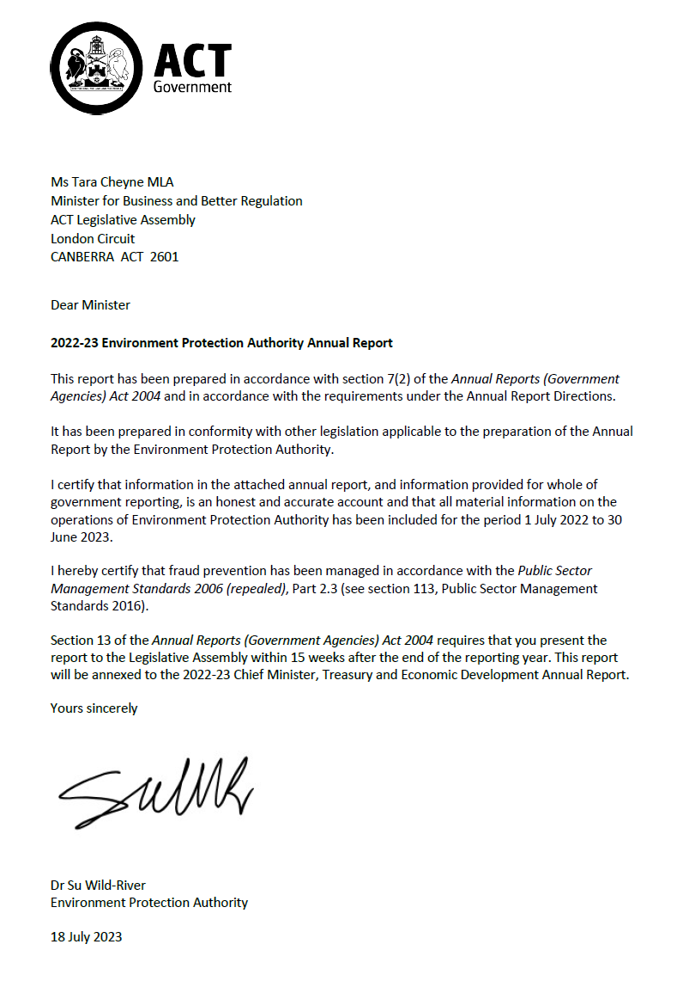

Compliance statement
The 2022-23 Environment Protection Authority Annual Report must comply with the Annual Reports (Government Agencies) Directions 2023 (the Directions) made under section 8 of the Annual Reports (Government Agencies) Act 2004. The Directions are found at the ACT Legislation Register.
The compliance statement indicates the subsections, under Parts 1 to 5 of the Directions, that are applicable to the Environment Protection Authority and the location of information that satisfies these requirements.

Part 1 Directions overview
The requirements under Part 1 of the Directions relate to the purpose, timing and distribution, and records keeping of annual reports. The 2022-23 Environment Protection Authority Annual Report complies with all subsections of Part 1 under the Directions.
To meet Section 15 Feedback, Part 1 of the Directions, contact details are provided within the 2022-23 Environment Protection Authority Annual Report to provide readers with the opportunity to provide feedback.

Part 2 Reporting entity annual report requirements
The requirements within Part 2 of the Directions are mandatory for all reporting entities and the 2022-23 Environment Protection Authority Annual Report complies with all subsections. The information that satisfies the requirements of Part 2 is found in the 2022-23 Environment Protection Authority Annual Report as follows:
- A. Transmittal Certificate, see previous page.
- B. Organisational Overview and Performance Analysis subsections, see Organisational Overview and Performance on the next page. As the Office of the Environment Protection Authority sits within Access Canberra in CMTEDD, all other subsections in Section B, Part 2 of the Directions are contained within the CMTEDD Annual Report.
- C. Financial Management Reporting, inclusive of all subsections, see Volume 2 of the CMTEDD Annual Report.

Part 3 Reporting by exception
The Environment Protection Authority has no information to report by exception under Part 3 of the Directions for the 2022-23 reporting year.

Part 4 Directorate and public sector body specific annual report requirements
There are no specific annual report requirements for the Environment Protection Authority.

Part 5 Whole of government annual reporting
All subsections of Part 5 of the Directions apply to the Environment Protection Authority. Consistent with the Directions, the information satisfying these requirements is reported in the one place for all reporting entities as follows:
- Bushfire Risk Management, see the annual report of the Justice and Community Safety Directorate.
- Human Rights, see the annual report of the Justice and Community Safety Directorate.
- Legal Services Directions, see the annual report of the Justice and Community Safety Directorate.
- Public Sector Standards and Workforce Profile, see the annual State of the Service Report.
- Territory Records, see the CMTEDD Annual Report.
ACT Public Service directorate annual reports are found at the following web address: http://www.cmd.act.gov.au/open_government/report/annual_reports

Organisational overview and performance

Organisational overview
The Environment Protection Authority (the Authority) is a statutory public servant position established by the Environment Protection Act 1997. The Office of the Environment Protection Authority (the EPA) sits within Access Canberra to support its regulatory functions. Several of the indicators reported here continue to show an increasing intensity of assessment and compliance matters faced by the EPA. The increases are understood to be related to increasing development and population growth in the ACT, occurring within a more compact city. Impacts of new and emerging pollutants, extreme weather events and community expectations for high quality local environmental values, also contribute to rising demand for environmental protection regulation.
In recognition of these increasing environmental protection challenges, and their significance for the health and wellbeing of our community, the Government committed to funding of $534,000 over two years from 2022-23 for two Environment Protection Officers to support compliance monitoring and regulatory oversight activities. This new investment also included funding a Senior Policy Officer for 12 months to develop a three-year action plan to achieve reforms necessary to deliver an enhanced and modernised environmental protection framework in the ACT.

Legislative framework and functions
The Authority administers the following legislation:
- Environment Protection Act 1997 and Environment Protection Regulation 2005
- Water Resources Act 2007 and Water Resource Regulation 2007
- Lakes Act 1976 and Lakes Regulation 2019, and
- Clinical Waste Act 1990.
The EPA is the primary environmental regulator for the ACT.
Our mission is to protect the health and well-being of the environment and our community.

Overview of functions

Environment Protection Act 1997
The Environment Protection Act 1997 and the Environment Protection Regulation 2005 provide for the protection of the environment, prevention of harm to human health and for related purposes.
The objects of the Environment Protection Act 1997 are to:
- Protect and enhance the quality of the environment.
- Prevent environmental degradation and risk of harm to human health.
- Achieve effective integration of environmental, economic, and social consideration in decision-making processes.
- Establish a single and integrated regulatory framework for environmental protection and provide for monitoring and reporting of environmental quality on a regular basis.
- Facilitate the implementation of national environment protection measures and laws.
- Ensure contaminated land is managed having regard to human health and the environment.
- Encourage responsibility by the whole community for their actions to protect the environment and human health – general environmental duty of care.

Water Resources Act 2007
The Water Resources Act 2007 and the Water Resources Regulation 2007 provides for sustainable management of the water resources of the Territory, and for other purposes.
The objects of the Water Resources Act 2007 are to:
- Ensure that management and use of the water resources of the Territory sustain the physical, economic, and social wellbeing of the people of the ACT while protecting the ecosystems that depend on those resources.
- Protect aquatic ecosystems and aquifers from damage and, where practicable, to reverse damage that has already happened.
- Ensure that the water resources are able to meet the reasonably foreseeable needs of future generations.

The Lakes Act 1976
The Lakes Act 1976 provides for the administration of activities on lakes and lake areas in the Territory outside of those areas governed by the Commonwealth. This includes the erection of signs, approval of buoys, wharves and jetties, boat mooring locations, prohibition and use of designated lake areas and the opening and closing of lakes.

The Clinical Waste Act 1990
The Clinical Waste Act 1990 provides for administration of the transport and handling of clinical wastes within the Territory.

Compliance framework
The EPA carries out proactive and reactive activities, with resources allocated based on the level of risk and harm posed to the environment and/or human health. Compliance activities are conducted in accordance with the Environment Regulation and Protection Compliance Guidelines. This forms part of the Access Canberra Accountability Framework, which can be accessed via www.accesscanberra.act.gov.au.
Where an issue is identified, the EPA seeks to resolve the matter before it leads to an adverse impact on human health and/or the environment.
Reactive monitoring relies on the community, business or industry reporting environmental concerns or events, such as pollution of our environment or illegal water use.
Information and guidelines for industry and the public in relation to EPA legislation is available via the Access Canberra website. Information is also routinely shared through social media, radio and print platforms informing the community of their environmental obligations, while also providing important updates which may influence better environmental decision making by persons.
This annual report summarises the activities and performance of the EPA in 2022-23.

Review in line with changing expectations
In 2022-23, the EPA and the Environment, Planning and Sustainable Development Directorate (EPSDD) received funding for a Senior officer to undertake the development of quality objectives, policies and guidelines to ensure the protection of the environment in line with changing expectations. The work has involved the development of a program covering the following six areas.
- Protecting the community and environment from new and emerging pollutants.
- Strengthening regulatory controls by identifying and resolving gaps in regulatory controls which result in impacts from unregulated pollution sources.
- Improving the licensing and compliance framework to better address risks of environmental harm.
- Modernising environmental standards to ensure they protect vulnerable people and environmental features.
- Meeting community expectations in applying the Environment Protection Act’s statutory objects and principles.
- Meeting new and emerging environmental challenges associated with a growing population and city.
Actions delivered by the EPA within this work program during 2022-23 include:
- representing the ACT Government with key environmental protection stakeholders and events including:
- Heads of Environment Protection Authorities meetings.
- Murray Darling Basin Regulatory Leaders Forum.
- Australasian Environmental Law Enforcement and Regulators network annual conference, communities of practice and working groups.
- The inaugural Science Symposium of Environment Protection Authorities from across Australia and New Zealand.
- National Chemicals and Emerging Contaminants of Concern Working Group.
- Australasian Land and Groundwater Association and the Environment Institute of Australia and New Zealand.
- Upper Murrumbidgee Catchment Network.
- National PFAS Intergovernmental Agreement Review Workshop.
- procuring the development of Green Card Training course to engage workers in the construction industry to better understand their environment protection duties, especially in relation to sediment and erosion control; and
- establishing a yarning circle process in the EPA to build relationships and progress work on recognising the importance of first nations people in protecting the environment.

Performance analysis

Environmental Authorisations
An Environmental Authorisation (Authorisation) is a form of licence granted under section 49 of the Environment Protection Act 1997. An Authorisation sets out the conditions under which activities with a significant potential to cause environmental harm may be conducted. Authorisations granted for an unlimited period are reviewed regularly on a risk-based assessment of the activity and the authorisation holder.
In 2022-23, a total of 28 Authorisations were granted, 25 Authorisations were terminated (of which 13 were ceased, 9 were expired, and 3 were cancelled), bringing the total number of Authorisations administered to 292 (refer to Table 1). During this period, 98 authorisations were reviewed and 21 varied.

Table 1: Number of Environmental Authorisations (EAs) issued per activity
Activity (Schedule 1 Class A) | New EAs issued in 2020-21 | New EAs issued in 2021-22 | New EAs issued in 2022-23 | EAs administered
Controlled burns | 0 | 0 | 0 | 2
Commercial incineration | 0 | 0 | 0 | 1
Composting | 0 | 0 | 0 | 2
Material crushing, grinding, or separating | 0 | 0 | 0 | 7
Commercial production of alcoholic beverages | 2 | 0 | 0 | 2
Crematorium | 1 | 0 | 0 | 2
Extraction of material from a waterway | 2 | 0 | 0 | 1
Extraction of material from Land | 0 | 0 | 0 | 1
Keeping poultry | 0 | 0 | 0 | 1
Commercial landfills | 0 | 0 | 0 | 2
Logging | 0 | 0 | 0 | 1
Milk production | 0 | 0 | 0 | 0
Motor sports | 1 | 0 | 0 | 5
Concert Venue | 1 | 0 | 0 | 2
Outdoor concerts | 3 | 5 | 10 | 11
Commercial use of agricultural and veterinary chemicals | 11 | 10 | 14 | 150
Petroleum storage | 1 | 0 | 1 | 71
Road building material production | 1 | 0 | 0 | 3
Production of concrete | 0 | 0 | 0 | 11
Sewage treatment | 0 | 0 | 0 | 4
Placement of soil on land | 4 | 7 | 4 | 12
Operation of waste transfer | 0 | 0 | 1 | 2
Transportation within the ACT of regulated waste | 1 | 0 | 0 | 13
Transport of Controlled Waste | 1 | 0 | 0 | 5
Sterilisation of clinical waste | 0 | 0 | 0 | 1
Timber milling | 0 | 0 | 0 | 1
Operation of a Firearm Shooting Range | 0 | 0 | 0 | 5
Generation of electricity by a generator | 0 | 0 | 1 | 1
Total | 29 | 22 | 31 | 319*
*Note: There are 292 Environmental Authorisations, some of which are for multiple activities, so the total by activity type is 319. Similarly, there were 28 Environmental Authorisations granted in 2022-23, with the activity type totalling 31.

Environmental Protection Agreements
Section 38 of the Environment Protection Act 1997 provides for the EPA to enter into Environmental Protection Agreements (Agreements) generally for the purpose of the Act. This section also allows Agreements to be used instead of an Authorisation where people are conducting certain activities that cause a moderately significant risk of environmental harm (listed in Schedule 1 Class B of the Environment Protection Act 1997 – see also subsection 42(2) of the Act). Agreements are designed to assist businesses to manage their environmental performance.
In 2022-23, the EPA entered into 27 Agreements, bringing the number of Agreements administered to 137 (refer to Table 2).

Table 2: Number of Environmental Protection Agreements issued per activity
Activity (Schedule 1 Class B) | 2020-21 | 2021-22 | 2022-23 | Total current Agreements
Land development/  construction | 39 | 30 | 27 | 120
Landfill gas management | 0 | 0 | 0 | 1
Municipal services | 1 | 0 | 0 | 1
E-Waste Dismantling and Storage | 0 | 0 | 0 | 1
Wastewater reuse | 0 | 0 | 0 | 0
Contaminated sites | 2 | 0 | 0 | 14
Total | 42 | 30 | 27 | 137

Erosion and sediment control plans
A condition of an Agreement is often the endorsement of an erosion and sediment control plan by the EPA prior to works commencing. During 2022-23 (refer to Table 3) the EPA:
- received and endorsed 99 erosion and sediment control plans; and
- conducted 1,509 inspections of development sites.
The 99 erosion and sediment control plans received and endorsed in 2022-23 was a decrease compared with the 114 that were received in 2021-22. This reduction reflects a lower number of development approvals for sites which triggered the requirement for plans to be submitted. The EPA considered the control plans and other site-based factors in applying a risk-based framework to identify, and focused regulatory attention on sites with higher sedimentation risks and builders with previous compliance issues. The EPA also supported a significant increase in the number of inspections undertaken (refer below).
Outcomes from building site inspections
Building activities in the ACT have the potential to cause environmental harm. Businesses undertaking these activities are required to take all reasonable and practicable steps to prevent or minimise any environmental harm. Some of the steps include the installation and maintenance of pollution controls on the building sites and ensuring building material is stored and managed appropriately.
In May 2022, the ACT Commissioner for Sustainability and the Environment published a report on the State of Lakes and Waterways in the ACT. The report identified sediment from building sites as a key risk to water quality and recommended reforms to land development to ensure that stormwater management is preventative and proactive.
In 2022-23, the EPA received funding to appoint two new inspectors, and this enabled a targeted regulatory program to ensure builders are meeting their general environmental duty under the EP Act. Specifically, inspectors focused on the installation of erosion and sediment controls, and systems in place to ensure that construction materials are safely contained, and not impacting on areas outside of their site. The program focused on engagement and education of builders and sub-contractors, of the impacts their activities may have on the environment to achieve an outcome of reducing sediment loads in waterways.
This program was a large contributor to the 1,509 site inspections undertaken at building sites throughout the year, significantly up from 891 such inspections in 2021-22. During these site inspections, the inspectors reported providing 1,403 points of advice to improve environmental performance, as summarised in the graph below. Operators were advised:
- 531 times to remove a sediment source from locations where they might enter stormwater;
- 516 times to install pollution controls;
- 258 times to stabilise the sites;
- 26 times to apply water to control dust;
- 12 times to clean out sediment control ponds; and
- 60 other opportunities to improve environmental outcomes.
In many cases, multiple points of advice were given at a single site.
Appropriate enforcement action was taken when developers failed to comply with advice and other educational approaches did not result in environmental improvements. This led to the issue of 27 infringement notices were issued and several environmental protection orders (refer to Tables 11 and 12).
The photograph below shows a site where sediment controls were insufficient to prevent their transfer to a footpath, and then to stormwater. The Building Sites Environmental Outreach Program supported pollution prevention actions here.
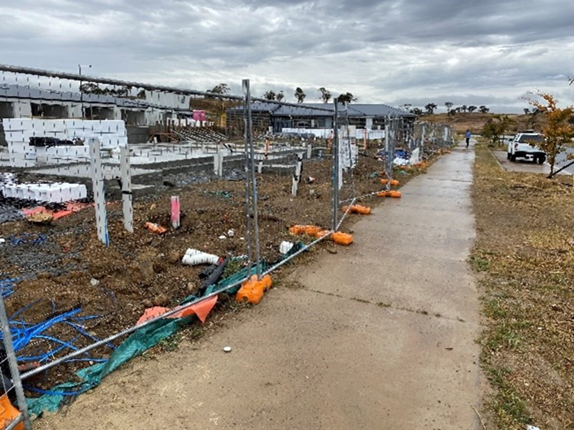

Figure 1: Directions given on building sites
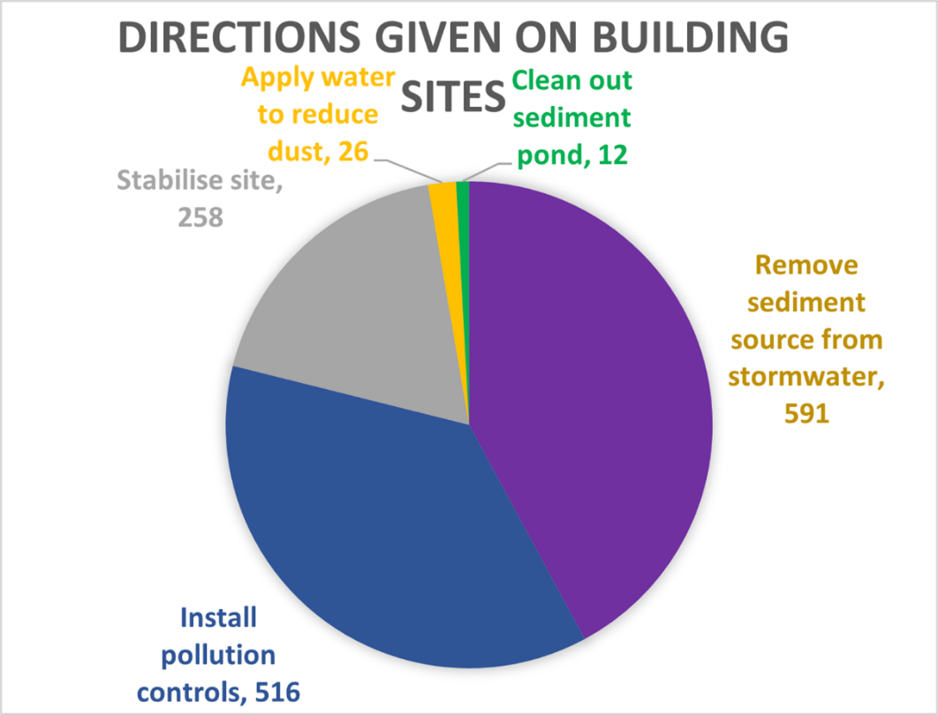

Table 3: Erosion and sediment control plans
Activity | 2020-21 | 2021-22 | 2022-23
No. of plans endorsed | 79 | 114 | 99
Inspections of development sites | 1,226 | 891 | 1,509

Inspections to strengthen regulatory controls
The EPA piloted a Business Environmental Outreach Program. The program targeted businesses in the Beard Industrial Estate which are not required to hold Environmental Authorisations, but which have a risk of environmental harm due to their use of hazardous chemicals, noisy equipment or other potential contaminants. Outcomes are detailed below.
Outcomes from building site inspections
Schedule 1 of the Environment Protection Act specifies types of businesses which are required to hold environmental authorisations, and Schedule 2 lists businesses which require environmental authorisations. The types of activities listed in these Schedules are largely aligned with similar schedules in other environmental protection acts throughout Australia and the world. Other activities do not require formal authorisations or agreements but are still bound by the EPA’s general environmental duty, requiring them to take practicable and reasonable steps to prevent or minimise environmental harm or environmental nuisance.
The Business Environmental Outreach Program involved proactive efforts to provide environmental management information and education to potentially polluting businesses which are not listed in Schedules 1 or 2 of the EPA. The Beard industrial estate was selected for a pilot program as it had not previously been the focus of such proactive investigations. Businesses with potential to pollute were identified through drive-by inspections and approached with an offer of environmental protection information.
Site visits were made to 57 businesses, with results shown in the graph below. In 46 cases, no specific environmental risks were identified, and so no advice was provided towards environmental improvements. Advice was provided to the other 11 businesses. This included advice to better manage:
- noise pollution at six by installing noise limiting equipment;
- water pollution at five, by installing sumps, bunding or other equipment to prevent polluted water going to the stormwater system;
- air pollution controls at two, for instance by installing filtered exhaust systems; and
- at two, systems to prevent pollution from waste management activities by sealing containers of liquid waste.
Figure 2: Types of advice given to businesses
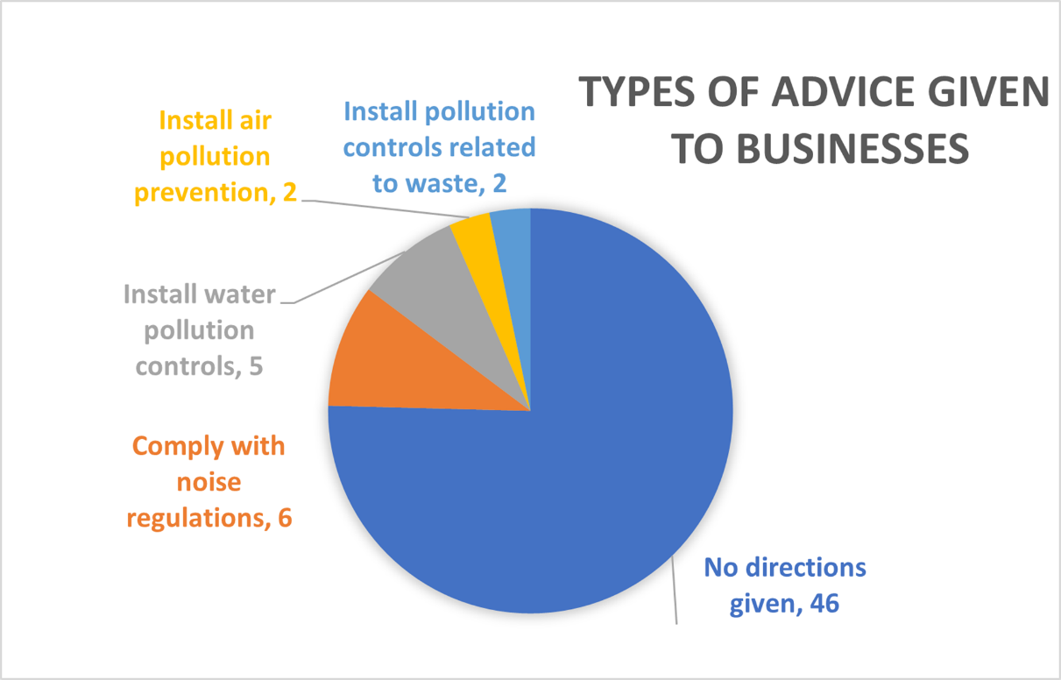

Contamination

Contaminated land notifications
During 2022-23, the EPA received seven contaminated land notifications under section 23A of the Environment Protection Act 1997. The number of notifications is slightly up from the four that were received in the previous year. The notifications related to chlorinated hydrocarbon, asbestos, and hydrocarbon impacts to soil and groundwater at the notified sites. There have been 134 notifications since the contaminated land provisions were enacted in 1999.

Contaminated sites
During 2022-23 the EPA (refer to Table 4):
- reviewed and endorsed nine independent contaminated land audits by EPA approved auditors. These primarily related to the development of greenfield and brownfield developments. These sites were potentially impacted by contamination from former contaminating activities such as printing, hydrocarbon storage, and contaminated material disposal.
- reviewed and endorsed 23 contaminated land environmental assessment reports into the suitability of sites for their proposed uses; and
- carried out nine inspections of known, or potentially contaminated sites to review whether activities had the appropriate approval and whether re-development activities were underway or complete. This number was down from previous years as an ongoing effect from practice changes which were made to administrative processes to achieve public health safety outcomes in light of the COVID-19 public health emergency. The current process involves correspondence and desktop reviews with fewer site inspections than in the past.

Table 4: Contaminated sites
Activity | 2020-21 | 2021-22 | 2022-23
Audits reviewed and endorsed | 15 | 9 | 9
Environmental assessment reports reviewed and endorsed | 41 | 43 | 23
Inspections of contaminated sites | 717 | 54 | 9

Register of contaminated sites
As of 30 June 2023, there are 256 contaminated sites recorded on the Register. This is a cumulative total, which has increased from the 242 in the previous year. Registration is required for sites that have been subject to a statutory environmental audit through the planning approval process. The change indicates that the EPA required that a higher number of sites which were submitted for development assessment underwent contaminated site audits. The condition requiring a contaminated site audit is applied based on a risk assessment which considers the types of activities which are likely to have caused contamination. The information on the Register is publicly available on the Access Canberra website and can also be obtained by contacting the EPA.

Contaminated land searches and data
The EPA maintains records of known, potentially contaminated and remediated land in the ACT. This information is made available through the Lease Conveyancing Enquiry through the ACT Planning and Land Authority and Contaminated Land Search through Access Canberra. It ensures persons with an interest in the land have access to records held by the EPA. The information is also provided under licence agreement to utility providers, their contractors, and other areas of the ACT Government for their operational requirements for installation and maintenance of infrastructure.
During 2022-23, the EPA received and responded to 338 Contaminated Land Search enquiries (refer to Table 5).

Table 5: Contaminated Land Searches and data
Activity | 2020-21 | 2021-22 | 2022-23
Licence Agreements | 0 | 0 | 0
Contaminated Land Searches | 599 | 511 | 338

Reuse approvals
Reuse involves the re-application of soil which has a level of contamination that does not pose (subject to appropriate management) a risk to human health or the environment for a particular land use. Applications for reuse are undertaken by suitably qualified environmental consultants and are subject to rigorous assessment in accordance with EPA adopted guidance and criteria.
During 2022-23, the EPA received, assessed and approved 27 applications for the reuse of approximately 89,080 cubic metres of low-level contaminated soil (refer to Table 6). This was a slight reduction from 34 applications approved in 2021-22, which was significantly less than the 76 applications in 2020-21. The long-term reduction in the number of soil reuse approvals is because the commencement of operations at Mugga 2 Quarry (M2Q). Soil that was disposed of at M2Q does not need a reuse approval and is assessed separately against the criteria contained in its environmental authorisation. Although the number of approvals decreased, the total cubic meters of soil re-used increased from 71,385 cubic meters in 2021-22. The reasons for the increase have not been assessed but it may be a feature of increasing scale of excavation on individual development projects, as a result of the increasingly compact and high-density developments in the Territory.

Table 6: Reuse Approvals
Activity | 2020-21 | 2021-22 | 2022-23
Applications for reuse approved | 76 | 34 | 27
Cubic metres of soil reused | 162,235 | 71,385 | 89,080

Controlled waste movements
In 2022-23, a total of 40 Consignment Authorisations were issued for the movement of a controlled waste into the ACT. Consignment Authorisations were issued primarily for the transport of clinical waste, asbestos, oily water, and polychlorinated biphenyl free oil from other jurisdictions, which resulted in 854 controlled waste movements into the ACT (refer to Table 7). These results are up on previous years, although reasons for this are not known.
During the same period, 1,198 controlled waste movements out of the ACT were notified and monitored by the EPA (refer to Table 7).

Table 7: Controlled waste movements
Activity | 2020-21 | 2021-22 | 2022-23
Consignment authorisations | 58 | 36 | 40
Controlled waste movements into the ACT | 625 | 626 | 906*
Controlled waste movements out of the ACT | 1,027 | 1,303 | 1,198
*Note: Number is reflective of total waste transport certificates received at the time of this report.

Planning and development
During 2022-23, the EPA received and reviewed 548 development applications referred from the Planning and Land Authority. This was a significant increase on the 421 received in 2021-22 and is a direct measure of the increasing rate of development activity in the Territory (refer to Table 8). Additionally, the EPA received and reviewed 290 referrals from the National Capital Authority and 645 other planning documents. The other planning documents include 100 Liquor Licensing referrals and 545 Local Area Access Notifications. In responding to these referrals, the EPA aims to prevent pollution by ensuring that activities that could cause environmental are identified and managed at the design stage.

Table 8: Development application referrals
Activity | 2017-18 | 2018-19 | 2019-20 | 2020-21 | 2021-22 | 2022-23
Development Applications Referred | 409 | 389 | 596 | 457 | 421 | 548

Complaint handling
During 2022-23, the Resolution Support Team (formerly Complaints Management Team) within Access Canberra received 3,518 complaints related to EPA matters, of which 2,876 (81 per cent) related to noise. This is a 3 per cent increase in the number of complaints since the previous year. Although this is a much smaller increase than was experienced previously, it does suggest that the increase in noise complaints that was previously linked to the significant increase in people working from home during the COVID-19 public health emergency has not reverted to pre-COVID levels.
This year there was a doubling of complaints associated with waterway pollution, up from 83 in 2021-22 to 166 in 2022-23. This appears to have been largely a result of unusually wet weather conditions leading to increased numbers and loads of sediment from building sites and other sources. Complaints about air pollution were down, from 446 last year to 323 this year. This is consistent with the results of the Annual Air Quality Report which showed that this year had the best air quality on record (refer to the section on Australian Government Commitments below).
Table 9 provides a percentage breakdown of categories of EPA complaints received by the CMT for the past three financial years.

Table 9: Categories of EPA complaints received by CMT from 2019-20 to 2022-23*
Category | 2019-20 | % | 2020-21 | % | 2021-22 | % | 2022-23 | %
Noise pollution | 1,883 | 75 | 2,028 | 82 | 2,708 | 79 | 2846 | 81
Air pollution | 427 | 17 | 307 | 12 | 446 | 13 | 323 | 9
Waterways pollution | 83 | 3 | 49 | 2 | 83 | 2 | 166 | 5
Land contamination | 39 | 2 | 56 | 2 | 83 | 2 | 95 | 3
Light pollution | 76 | 3 | 34 | 1 | 39 | 1 | 40 | 1
Authorised activity | 0 | 0 | 0 | 0 | 0 | 0 | 0 | 0
Tree protection | 0 | 0 | 0 | 0 | 0 | 0 | 0 | 0
No value | 6 | 0 | 15 | 1 | 52 | 2 | 38 | 1
Total | 2,514 | 100 | 2,511 | 100 | 3,411 | 100 | 3518 | 100

Table 10 shows noise complaints by category for comparison from 2019-20 until 2022-23. Increases were experienced in complaints about noise from amplified, mechanical and waste collection sources while complaints about construction, vehicles, people, alarms were all reduced.

Table 10: Noise complaints by category from 2019-20 to 2022-23
Category | 2019-20 | % | 2020-21 | % | 2021-22 | % | 2022-23 | %
Amplified | 863 | 46 | 973 | 47 | 1,275 | 47 | 1,518 | 53
Construction | 445 | 24 | 455 | 22 | 619 | 23 | 532 | 19
Mechanical plants and equipment | 174 | 9 | 232 | 11 | 341 | 13 | 452 | 16
Vehicles* | 121 | 6 | 108 | 5 | 150 | 6 | 91 | 3
People* | 90 | 5 | 132 | 6 | 145 | 5 | 86 | 3
Gym equipment | 106 | 6 | 66 | 3 | 19 | 1 | 18 | 1
Alarms | 44 | 2 | 29 | 1 | 63 | 2 | 36 | 1
Garden work | 24 | 1 | 35 | 2 | 43 | 2 | 43 | 2
Waste collection | 12 | 1 | 14 | 1 | 26 | 1 | 32 | 1
PA system | 4 | 0 | 3 | 0 | 4 | 0 | 3 | 0
No value | 0 | 0 | 3 | 0 | 23 | 1 | 3 | 0
Enquiry* |  |  |  |  |  |  | 32 | 1
Total noise pollution | 1,883 | 100 | 2,050 | 100 | 2,708 | 100 | 2846 | 100
*Note (Table 10): noise categories are not regulated under the EP Act.
* New subcategory in 2022-23

Enforcement actions
Individuals or businesses may incur penalties such as Infringement Notices, Environment Protection Orders, or prosecution for breaches of the Environment Protection Act 1997.
During 2022-23, the EPA undertook 56 enforcement actions (refer to Table 11 and Table 12). The EPA continues to take regulatory action to protect the environment and our community where appropriate. Increased compliance activities help to reinforce legislative obligations and provides a strong general and specific deterrent. The increased enforcement actions reported here result from streamlined administrative procedures, coupled with the additional capacity provided by increased resourcing. The EPA aims to continue to strengthen awareness of its environmental protection role, identified environmental issues and maintain a strong environmental protection posture through enforcement actions, where required.

Table 11: Enforcement actions under the Environment Protection Act 1997
Enforcement action | 2020-21 | 2021-22 | 2022-23
Infringement notices | 12 | 10 | 51
Environment Protection Orders | 8 | 6 | 5
Prosecution | 0 | 0 | 0

Table 12: Overview of enforcement actions under the Environment Protection Act 1997 in 2022-23
Offence | Number | Penalty ($)/Action
Infringement notices | 51 | 50,675
39(2) - Offence to make noise louder than noise standard | 1 | 200
44(1) - Pollution of waterways | 6 | 3,475
45(1) - Compliance with authorisation | 3 | 15,000
45(1)(a) - Development waste not to enter stormwater system or waterways | 3 | 1,500
46(1) - Areas near development to be kept clear | 8 | 4,000
50(1) - Discharge of stormwater into receiving waters | 2 | 2,000
66B - Development sites 0.3ha or greater | 1 | 875
66C - Development sites less than 0.3ha | 27 | 23,625
Orders | 5
Excessive Noise from air conditioner/heater | 3 | Rectify works
Unauthorised Placement of Soil | 2 | Immediately cease accepting soil
Prosecutions | 0
No enforcement actions from the previous financial year led to prosecutions during 2022-23.
Beneficial outcomes have resulted from a $200k enforceable undertaking reported in the 2020-21 Annual Report. Both recipients submitted their final reports on the funded projects this year. Outcomes are summarised below.
Outcomes from Ginninderry Conservation Trust
The Ginninderry Conservation Trust (the Trust) leverages public and private partnerships to conserve and enhance riverine landscapes and threatened species and ecosystems. Two projects were funded by the Enforceable Undertaking, one focused on farm dam restoration and one on riparian education and training.
Farm Dam Restoration
This habitat improvement project aimed to demonstrate the benefits of farm dams for wildlife while still being used for stock water. Two dams were restored through the following actions.
The Leaky Dam:
- plantings at inflow, margins, shallow water, wall, spillway;
- trees and shrubs planted to provide habitat and windbreaks;
- a total of 570 plants planted;
- full fencing with an access gate to updated with a step through section for public access; and
- volunteer engagement with discussion and education about planting benefits.
The Woodland Dam:
- plantings similar to Leaky dam, with 295 plants already planted, and another 120 planned;
- hardened access point added to reduce cattle damage to restoration works; and
- ongoing monitoring and discussion with the cattle farmer.
This project was inspired by the Australian National University’s ‘Sustainable Farms Initiative’. Plantings aim to create and enhance habitat for native birds, frogs, turtles and other wildlife, with fencing designed to provide access for larger native wildlife. Diverse sectors of the community have been involved in various ways such as through participation in plantings, tours by horticulture students, Facebook posts and newsletter articles. Baseline data are compared with ongoing monitoring results.

Riparian education and training
A package of community engagement activities was delivered through citizen science and restoration activities, with a focus on habitat restoration and a management program that will contribute to long term data through a broad range of activities.
A range of stakeholders have been involved including:
- work experience students from University of Canberra and Charles Sturt University;
- volunteers through the Trusts volunteer program (including residents at Ginninderry);
- Canberra Institute of Technology students, including those involved in the SPARK program;
- children involved in the Trusts two school holiday programs in September 2022 and April 2023;
- Friends of Grasslands (FoG);
- the Murumbung Rangers;
- contractors involved in the new suburb development;
- the cattle manager (farmer); and
- the Trust Facebook, Instagram and Twitter followers through frequent posts.
There are also regular meetings and discussions between stakeholders from the Riverview Group, University of Canberra, the Ginninderry Conservation Trust and others to identify and deliver on habitat improvement actions such as habitat improvement near rivers and streams.
Stream monitoring for water quality and macroinvertebrates has been set up for water quality and macroinvertebrates has been set up for the three main streams in the Conservation Corridor. These streams are each monitored four times a year, often with the help of university students. This allows for averages and baseline data for when pollution or rehabilitation happens to see declines or improvements in waterway health. A work experience student was also engaged in water sampling in an urban dam in Ginninderry to see if factors such as time of day and ducks had an impact on pH levels.
Other outcomes include:
- annual vegetation surveys;
- platypus and rakali surveys by project leaders and work experience students;
- FrogWatch sites established;
- two rounds of eDNA completed in the Conservation Corridor across ten sites;
- Rapid Appraisal of Riparian Condition assessments with an understanding gained of water health;
- engagement of OzFish Unlimited to assist in preparing a Murrumbidgee Riparian Zone Management Plan, with multiple community events already hosted;
- Revegetation of the Murrumbidgee River through plantings with the Kids on Country (ACT Natural Resource Management Program) as part of an African Lovegrass management trial;
- willow control along two major streams in the Conservation Corridor; and
- growth in volunteering supported by the Better Impact volunteer portal.

Outcomes from Ginninderra Catchment Group funding
The Ginninderra Catchment Group’s mission is to connect, support, and lead local communities to maintain and improve the health of the Ginninderra Catchment and surrounding environments. It supports 31 Landcare Groups and coordinates numerous community engagement and landscape-scale restoration programs.
Projects funded by the Enforceable Undertaking focused on engaging Youth and Junior Landcare programs in the Ginninderra Catchment area, specifically in Belconnen and Gungahlin ACT. The objective of the project was to establish connections with young people through various groups and organizations, including:
- primary and preschools;
- university groups;
- Scout and Lions Youth groups; and
- other community youth organizations
The project aimed to deliver educational events and on-ground activities with the following goals:
- enhancing knowledge about waterways, catchments, and the environment;
- promoting positive behaviour change among young individuals;
- encouraging youth stewardship of urban waterways and reserves through Landcare;
- improving the condition of the catchment area by addressing issues like weeds, biodiversity, and native species; and
- Involving local citizen science projects and community groups.
Over the course of the project, youth and junior participation increased in Landcare projects, especially in areas focused on local nature reserves. Events included biodiversity assessments of water quality and habitat, exploration of local wildlife, restoration of native grasslands and woodland habitats, as well as urban clean-up events. The Catchment Group has seen a surge in interest from teachers across all schools, seeking alternatives to indoor classroom education targeted at Nature Connecting for their students.
One important lesson learned from this project is that youth and junior engagement tends to be more successful when driven by local organizations (such as schools and youth groups) and members of the community, rather than external organizations or individuals from outside the region. Participants also display greater motivation when involved in fieldwork and hands-on learning activities, as opposed to traditional "classroom" teaching methods.
While the initial implementation of the project faced challenges in 2021 due to COVID restrictions and unfavourable weather conditions, recent achievements have demonstrated engagement with multiple youth groups and several schools in the region.
Key statistics:
- Number of events or activities held: 12
- Number of people participating (excluding teachers and group leaders): 120+
- Number of different Junior and Youth organisations involved: 5
- Outcomes from vegetation events: 100+ plants in 1.1 hectares
- Outcomes from weed control events: hundreds of woody weeds removed in 0.5 hectares.

Australian Government commitments

Air Quality Monitoring Report
The EPA produces an annual Air Quality Monitoring Report as part of its compliance with the Ambient Air Quality (AAQ) National Environment Protection Measure (NEPM). Canberra's air quality in 2022 was the best on record, with no exceedances of any of the AAQ NEPM standards at any of the ACT’s monitoring stations. Annual average levels for particulate matter (PM10 and PM2.5) were at the lowest levels experienced in the past 10 years and the daily PM2.5 standard was not exceeded for the first time since 2004 due to the wet weather in 2022. This is understood to be due to the wet weather and associated lack of any significant bushfire events, combined with the implementation of Government programs to minimise emissions from wood heaters and transition to renewable energy.
The Report can be accessed via the Access Canberra website (www.accesscanberra.act.gov.au/s/article/air-pollution-tab-related-resources).

National Pollutant Inventory
The National Pollutant Inventory (NPI) is a joint program between the Australian Government and all participating States and Territories. The legislative framework underpinning this is the NPI National Environment Protection Measure, which was originally made in 1998 and varied in November 2008. Section 159A of the Environment Protection Act establishes reporting requirements for industrial facilities in the ACT. During 2022-23, the EPA received and validated 17 NPI facility reports. Associated training, compliance audit and intergovernmental liaison was also undertaken during this period.

Per and poly-fluoroalkyl substances
In February 2018, all jurisdictions in Australia adopted the framework for per- and poly-fluoroalkyl substances (PFAS) management through the Intergovernmental Agreement on a National Framework for Responding to PFAS Contamination (February 2018) (IGA). The IGA is underpinned by the PFAS National Environment Management Plan (NEMP), first developed in February 2018, and updated on 3 March 2020 with the NEMP version 2.
In November 2022, the EPA hosted Canberra’s only face to face public consultation session on the draft PFAS NEMP 3, which was also the first such session held across Australia. About 30 industry stakeholders attended the presentation which was provided by Commonwealth Government experts.
The EPA continues to deliver on its PFAS Action Plan in accordance with the IGA and NEMP. The Action Plan includes activities such as the development of a PFAS inventory and a monitoring and sampling program. The Action Plan can be accessed via the Access Canberra website (www.accesscanberra.act.gov.au) by searching for “PFAS”. This year saw further assessment of sites already identified in the inventory of PFAS contaminated sites and routine regulation of former fire training sites and landfills.

Controlled waste
Controlled waste is the most hazardous category of waste and includes wastes that exhibit toxicity, chemical or biological reactivity, environmental persistence, or the ability to bio-accumulate or enter the food chain. These wastes need to be carefully managed and are closely regulated because of their potential to adversely impact human health and the environment. Some controlled wastes, such as tyres, are not strictly hazardous but they may also need special management.
The EPA has a statutory duty to protect the environment from the effects of controlled waste. Its powers range from requiring organisations to submit controlled waste data reports to enforcing the relevant provisions of the Environment Protection Act and other relevant legislation.
The National Environment Protection (Movement of Controlled Waste between States and Territories) Measure 1998 (NEPM) is an intergovernmental agreement made on 1 May 1992 to assist in achieving desired environmental outcomes. It provides a basis for ensuring that controlled wastes which are moved between states and territories are properly identified, transported, and otherwise handled in ways which are consistent with environmentally sound practices for the management of these wastes.
This NEPM provides a national framework for developing and integrating state and territory systems for the management of the movement of controlled wastes between states and territories originating from commercial, trade industrial or business activities. The desired environmental outcomes of this NEPM are to minimise the potential for adverse impacts associated with the movement of controlled waste on the environment and human health.

Water Resources Act
The Water Resources Act 2007 aims to ensure the use and management of the Territory’s water resources are sustainable while protecting the ecosystems that depend on the waterways. It is also designed to protect waterways and aquifers from damage.
Under the Water Resources Act 2007, licences are issued for regulating potential harmful activities ranging from water abstraction, bore drilling and construction of dams or modification of waterways (rivers, creeks and large stormwater drains).

Water Access Entitlements and Licences
The EPA administers 200 licences comprising of: 180 Licences to Take Water, 1 Recharge Licence, 2 Exemptions, 11 Drillers Licences, 4 Bore Work Licences and 2 Waterway Works Licences. It also administers 325 Water Access Entitlements. These are comprised of 184 Ground Water Entitlements, 29 Surviving Allocation (for both Ground Water and Surface Water) as well as 112 for Surface Water.
During 2022-23, there were 182 active Licences to Take Water, with no new licences issued. In this period, 1 licence expired and 1 was cancelled on the request of the licence holder. Table 13 indicates licensing activity by number of new licences and entitlements issued compared to the previous two financial years.

Table 13: Number of licences per type issued under the Water Resources Act 2007
Licence type | 2020-21 | 2021-22 | 2022-23
Bore Works | 4 | 5 | 1
Drillers | 8 | 0 | 7
Waterways Works | 0 | 1 | 0
Take Water (new) | 5 | 9 | 0
Water Access Entitlements | 4 | 2 | 2

Assessment of water use, protection of environmental flows and compliance
Water use by licence holders is assessed to ensure that extraction does not reach a level that negatively impacts upon our aquatic ecosystems. Water use by licence holders (including Icon Water) was below the volume of water held in entitlements during 2022-23 and there were no detections of non-compliance with licence conditions. The increased volume and frequency of rainfall during this reporting period may account for this general decrease in water use.

Metering of water use
All licenced water use in the ACT is metered. This ensures that water take can be accurately measured, which enables the government to charge a fair price for the use of the resource. The EPA also conducts an inspection regime which aims to have each meter inspected at least once every three years, or at more frequent intervals, as required. Table 14 lists the number of meter inspections performed and the type of meter inspected in 2020-21, 2021-22 and 2022-23.
To enhance accuracy, transparency and to assist in compliance, the ACT identifies meters using a unique serial number, mostly located on the face of the meter. This is referred to as the meter number which is also kept on a customer’s licence file. This information is publicly available upon request by contacting the EPA via email environment.protection@act.gov.au.
The ACT’s strict metering requirements also enable the ACT to meet the Murray Darling Basin Compliance Compact (which was introduced in 2018). The most current data from the 2021-22 Inspector General of Water Compliance Metering Report Card indicates that the ACT was the only jurisdiction within the Murray Darling Basin to have 100 per cent metered water take.
ACT licences also have conditions mandating the installation of a meter as well as requiring meter maintenance and data reporting. The ACT EPA Water Meter Installation, Maintenance and Replacement Guideline 2015 details metering standards that apply to various scenarios and aligns with the Compliance Compact and other states. This Guideline is currently being updated to reflect the new National Framework for Non-Urban Water Metering.
In 2022-23, there were 307 meters in use.
The decrease in the number of meters from previous years was a result of changed data management process, which excluded meters listed as “inactive” or “removed” in the 2022-23 data.

Table 14: Details of ACT non-utility network water meter fleet and inspections in 2020-21, 2021-22 and 2022-23
Activity type | 2020-21 |  |  | 2021-22 |  |  | 2022-23
 | Total | Groundwater | Surface water | Total | Groundwater | Surface water | Total | Groundwater | Surface water
Licences | 182 | n/a | n/a | 189 | n/a | n/a | 180 | n/a | n/a
Meters | 316 | 196 | 120 | 316 | 185 | 131 | 307 | 176 | 131
Meter inspections | 1 | 0 | 1 | 10 | 6 | 4 | 47 | 16 | 31

Memorandum of Understanding - Water Compliance Collaboration in the Murray Darling Basin
In December 2022, the EPA signed a new Memorandum of Understanding (MoU) with the Commonwealth Inspector General of Water Compliance. The MoU has been signed by other states within the Murray Darling Basin (the Basin), and supports collaboration on compliance matters across the Basin. The MoU aims to develop a working relationship between regulators to deliver a cooperative and collaborative approach, support robust, comprehensive and complementary water compliance arrangements and improve clarity around the respective roles and responsibilities of Commonwealth, state and territory governments in the Basin.

Lakes Act
A total of 337 inspections were completed at ACT lakes by the EPA, including 133 at Lake Ginninderra, 130 at Lake Tuggeranong, 41 at the Molonglo Water Skiing Reach and 33 at other locations. The National Capital Authority is responsible for inspecting and testing water at much of Lake Burley Griffin, and its results are not included here. One of the key contaminants of Canberra’s lakes is blue-green algae. This was suspected and samples taken for formal testing during 89 of the site inspections. The water was observed to be turbid (unclear) during 51 of the inspections and this was confirmed each time. The EPA works with other agencies to close the lakes as a result if the turbidity and algae measurements confirm that primary or secondary contact is not recommended due to poor water quality.
Further information | Dr Su Wild-River, Environment Protection Authority
 | (02) 13 22 81 | Environment.Protection@act.gov.au  www.accesscanberra.act.gov.au

Lifetime Care and Support Fund

Transmittal certificate
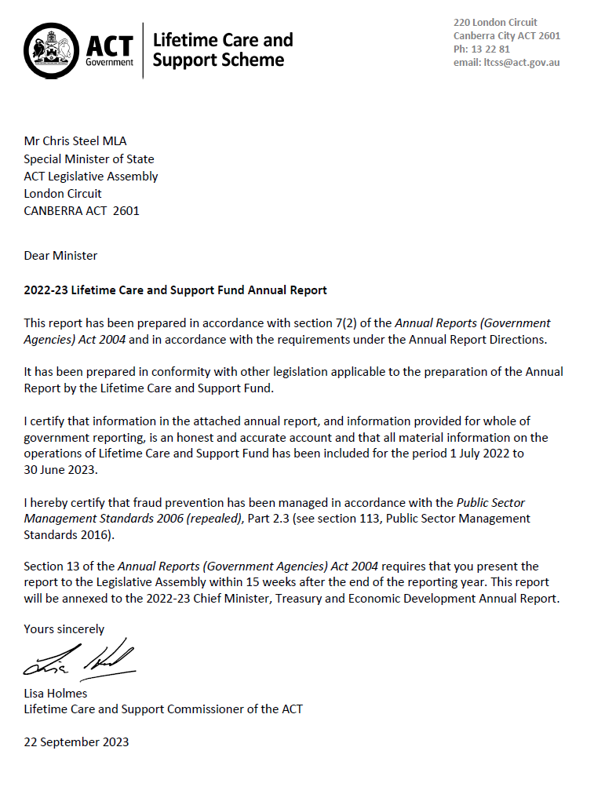

Compliance Statement
The 2022-23 Lifetime Care and Support Fund (LTCS Fund) Annual Report must comply with the Annual Reports (Government Agencies) Directions 2023 (the Directions) made under section 8 of the Annual Reports (Government Agencies) Act 2004. The Directions are found at the ACT Legislation Register.
The Compliance Statement indicates the subsections, under Parts 1 to 5 of the Directions, that are applicable to the LTCS Fund and the location of information that satisfies these requirements.

Part 1 Directions Overview
The requirements under Part 1 of the Directions relate to the purpose, timing and distribution, and records keeping of annual reports. The 2022-23 LTCS Fund Annual Report complies with all subsections of Part 1 under the Directions.
To meet Section 15 Feedback, Part 1 of the Directions, contact details for the LTCS Fund are provided within the 2022-23 LTCS Fund Annual Report to provide readers with the opportunity to provide feedback.

Part 2 Reporting entity Annual Report Requirements
The requirements within Part 2 of the Directions are mandatory for all reporting entities and the LTCS Fund Annual Report complies with all subsections. The information that satisfies the requirements of Part 2 is found in the LTCS Fund Annual Report as follows:
- A. Transmittal Certificate, see previous page.
- B. Organisational Overview and Performance Analysis, see Organisational Overview and Performance on the following pages. The following subsections, contained within the 2022-23 CMTEDD Annual Report, apply to the LTCS Fund:
- Scrutiny
- Risk Management
- Internal Audit
- Fraud Prevention
- Freedom of Information
- Community Engagement and Support
- Aboriginal and Torres Strait Islander Reporting
- Work Health and Safety
- Human Resources Management
- Ecological Sustainability Reporting
- C. Financial Management Reporting, all subsections, see Volume 2.2 of the 2022-23 CMTEDD Annual report.

Part 3 Reporting by Exception
The LTCS Fund has no information to report by exception under Part 3 of the Directions for the 2022-23 reporting year.

Part 4 Directorate and Public Sector Body Specific Annual Report Requirements
Part 4 of the 2023 Directions is not applicable to the LTCS Fund except Care and Carer Support Agencies. This is reported under Organisational Overview and Performance.

Part 5 Whole of Government Annual Reporting
Consistent with Part 5 of the Directions, the information satisfying the requirements is reported in the one place for all reporting entities as follows:
- Bushfire Risk Management, see the annual report of the Justice and Community Safety Directorate.
- Human Rights, see the annual report of the Justice and Community Safety Directorate.
- Legal Services Directions, see the annual report of the Justice and Community Safety Directorate.
- Public Sector Standards and Workforce Profile, see the annual State of the Service Report.
- Territory Records, see the CMTEDD Annual Report.
ACT Public Service Directorate annual reports are found at the following web address: http://www.cmd.act.gov.au/open_government/report/annual_reports

Organisational Overview and Performance

Organisational Overview
The Lifetime Care and Support Scheme (LTCS Scheme) is established under the Lifetime Care and Support (Catastrophic Injuries) Act 2014 (LTCS Act) and provides reasonable and necessary ongoing treatment and care to people who have been catastrophically injured because of a motor accident or private sector work accident in the Australian Capital Territory (ACT). The types of injuries covered by the Scheme are injuries that involve a spinal cord injury, traumatic brain injury, amputation, burns, permanent blindness or any other injury mentioned in the LTCS guidelines (more information can be found at http://www.treasury.act.gov.au/ltcss).
The LTCS Scheme covers pedestrians, cyclists, and people travelling on, or in motor bikes and motor vehicles provided there is at least one registrable motor vehicle involved in a motor accident that occurred on or after 1 July 2014, regardless of who is at fault for the accident. The Scheme also applies to catastrophic private sector work injuries that occurred from 1 July 2016.
As the LTCS Scheme is designed specifically for catastrophically injured people, participants will receive all their treatment and care needs under this scheme and not any other personal injury scheme under which they might have a claim / application (i.e., Compulsory Third-party Insurance, Motor Accident Injuries Scheme or private sector workers’ compensation scheme). As a no-fault scheme, the LTCS Scheme reduces stress on those injured and their families associated with litigating claims to meet ongoing treatment costs. It ensures early access to medical and rehabilitation care. Further, as treatment and care are ongoing, those injured do not have to worry about whether a lump sum payment will meet their needs for the rest of their life and whether they will receive the ongoing treatment and care they require.
Examples of treatment and care provided to participants in the Scheme include:
- medical treatment
- rehabilitation
- attendant care services
- home and transport modification.
For motor accident injuries the LTCS Scheme is funded by a levy on Motor Accident Injuries insurance policies. Private sector work injuries are funded through a separate levy collected from workers’ compensation insurers and self-insurers. The financial operations of the LTCS Scheme are reflected in the LTCS Fund which is a separate financial reporting entity.
The LTCS Act is administered by the Chief Minister, Treasury and Economic Development Directorate (CMTEDD). Under section 10 of the LTCS Act, the Minister must appoint a public servant as the LTCS Commissioner of the ACT. The position of the Executive Branch Manager, Insurance Branch, Economic and Financial Group (EFG), CMTEDD was appointed by the Minister as the LTCS Commissioner for a period of three years commencing 16 September 2022. The position of the Executive Group Manager of EFG was appointed by the Minister as the Acting LTCS Commissioner when the LTCS Commissioner is unavailable. During the reporting period, the acting arrangements were activated for different lengths of time between July 2022 and June 2023. In addition, the acting Executive Branch Manager performed the functions of the LTCS Commissioner for some of the period.
The functions of the LTCS Commissioner are supported by the Insurance Branch of EFG within CMTEDD.
The NSW Government provides operational support for the ACT Scheme. The NSW LTCS Authority (LTCSA) provides coordinated lifetime care and support services on behalf of the LTCS Commissioner to participants in the ACT Scheme. This arrangement commenced on 1 September 2015 and gives effect to the Intergovernmental Agreement signed by the ACT Government with NSW in February 2015.

LTCS Commissioner Responsibilities
Under the provisions of the LTCS Act, some of the key responsibilities of the LTCS Commissioner are to:
- Provide an indemnity and insurance scheme to respond to and pay assessed treatment and care needs for eligible participants.
- Determine the LTCS levy amount separately for both the motor vehicle and work injuries streams.
- Issue and monitor guidelines for the LTCS Scheme.
- Assess applications for eligibility for Scheme participation.
- Monitor the reasonable and necessary treatment and care needs of participants.

Highlights
The key priorities for the LTCS Commissioner during the 2022-23 financial year were to:
- administer the LTCS Scheme in accordance with the requirements of the LTCS Act and Guidelines;
- collect feedback from participants on their expectations and experience with the LTCS Scheme;
- continue to improve procedures for the efficient and effective delivery of the LTCS Scheme in consultation with our service partners – the NSW LTCSA;
- implement a framework for future funding requirements and levy setting; and
- undertake investments in accordance with the Fund’s investment strategy.
Against these priorities, the LTCS Commissioner:
- determined, having regard to independent actuarial advice, the LTCS levy for both motor vehicle and work injuries for 2023-24 (see Performance analysis, indicator (a) for further information on the levies);
- commissioned and received the eighth LTCS participant feedback report on the administration and effectiveness of LTCS Scheme services provided to participants, including insights on how aspects of service delivery may be further enhanced (see Performance analysis, indicator (b) for further information on the survey and its findings);
- assessed future funding requirements to address the Fund’s deficit position, progressively considering the framework developed by the Scheme actuary; and
- invested an additional $20 million of funds not required in the short-term in accordance with the approved LTCS Fund investment strategy. In 2022-23 investments recorded a positive return of 9.34% (2021-22: loss 6.15%) due to an increase in the market valuation of the investment portfolio mainly due to underlying gains on share investments.

Our participants

Applications to the Scheme
The LTCS Commissioner accepted five motor accident injury applicants and one work injury applicant as interim participants in the Scheme since 1 July 2022. The associated expenses for all six new participants are reflected in the LTCS Fund’s financial statements for 2022-23. Currently there are five notifications of severe injuries that occurred prior to 30 June 2023 that may give rise to applications to join the Scheme.

Applying to the Scheme
All participants commence as ‘interim participants’ for up to two years. During this time, the Scheme will pay for any reasonable and necessary treatment, rehabilitation and care related to the motor accident or work injury.
After two years, an interim participant may be eligible to become a ‘lifetime participant’. Children cannot apply for lifetime eligibility until they are at least five years old.
Decisions about whether an interim participant is accepted as a lifetime participant are made before the end of the interim participation period. Around six months prior to the end of the interim participation period, a participant’s eligibility to remain in the scheme is assessed to determine whether the person may have sufficiently recovered to the extent that they no longer meet the eligibility criteria after the two-year period.
If it is assessed that the injured person is likely to meet the eligibility criteria beyond two years, the person is accepted into the scheme for life.
During 2022-23, six interim participants were assessed and accepted for lifetime participation in the LTCS Scheme. Since the LTCS Scheme commenced in July 2014, 37 participants have been accepted into the Scheme (including one person whose interim participation has lapsed). As at 30 June 2023 there are currently 36 participants (31 motor accident injury participants, five work injury participants) who are receiving coordinated treatment and care benefits through the Scheme.
Of the 36 participants, 23 are lifetime participants (19 motor injury participants and four work injury participants) and 13 are interim participants (12 motor injury participants and one work injury participant).
The LTCS Scheme continues to have a relatively young profile with the average age of participants currently 35 years, slightly higher than last year. Of the 36 participants in the scheme as at 30 June 2023 two participants are under 10 years of age. Male participants comprise 83 per cent of all participants in the scheme.

Figure 1: Participant demographics

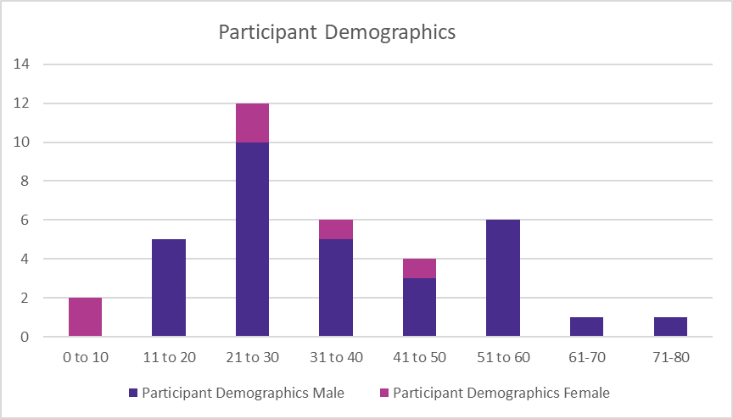
* Note: The above graph has 37 Scheme participants (including one person whose interim participation has lapsed).
The scheme covers five types of catastrophic injuries – traumatic brain injury, spinal cord injury, amputations, burns and vision loss. Of the accidents since 1 July 2022, five of the injuries were traumatic brain injuries and one of the injuries was a spinal cord injury. In total, 26 participants (70 per cent) have been accepted into the Scheme because of a traumatic brain injury. One participant was accepted for an amputation and 10 participants were accepted into the Scheme because of a spinal cord injury. Two participants who were accepted into the Scheme for a spinal cord injury also sustained a traumatic brain injury. One participant who was accepted into the Scheme for a traumatic brain injury also sustained a spinal cord injury.

Figure 2: Participant injury type
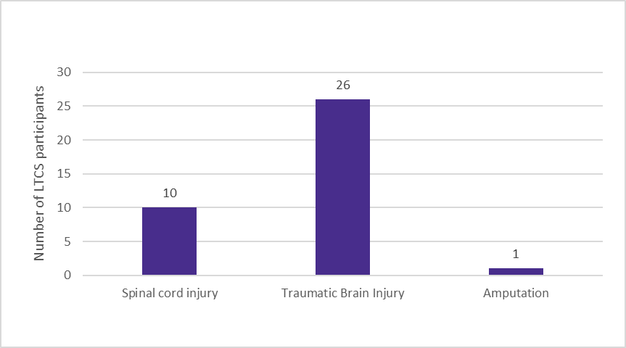
* Note: The above graph has 37 Scheme participants (lapsed participant has spinal cord injury).

Circumstances of accident
Of the scheme participants who have been injured in an accident involving a motor vehicle (including the work injury category):
- seven were passengers (19 per cent);
- six were pedestrians (17 per cent);
- four were riding bicycles (11 per cent); and
- 19 were drivers (53 per cent), including seven motorcycle riders (19 per cent).
Of the five work injury participants, four were injured in a work motor vehicle accident and one was injured on a work site.

Figure 3: Participant's role in accident
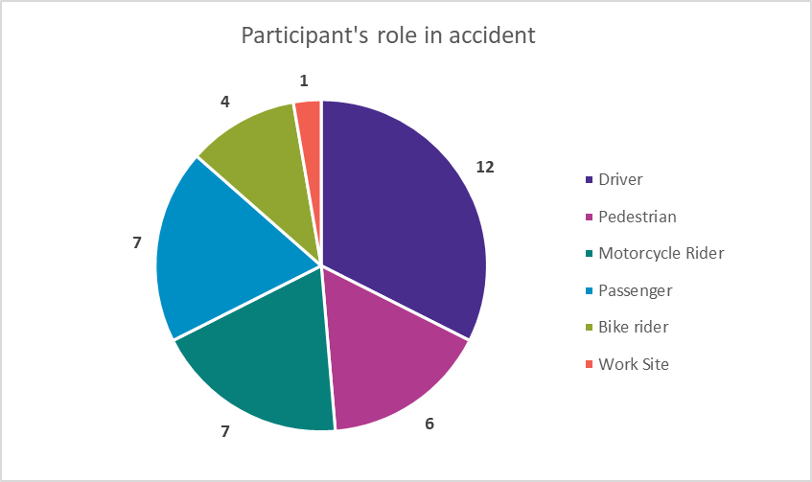
* The above graph has 37 Scheme participants (including one person whose interim participation has lapsed).

Provided Treatment, Rehabilitation and Care
In 2022-23, the LTCS Scheme spent a total of $6.307 million on services for participants (up by 35 per cent compared with the previous year). Attendant care services (50 per cent) was the largest category of participant expenses reflecting the severity and the ongoing complex high care needs of many of the Scheme’s participants.
The second highest expense category related to support services (15 per cent), which comprises mainly case management fees and travel expenses for participants and service providers to access and provide medical review and treatment. Hospital expenses (ten per cent), home modifications (seven per cent), rehabilitation (six per cent) and equipment (six per cent) were the next largest expense categories.

Figure 4: Participant benefit payments 2022-23
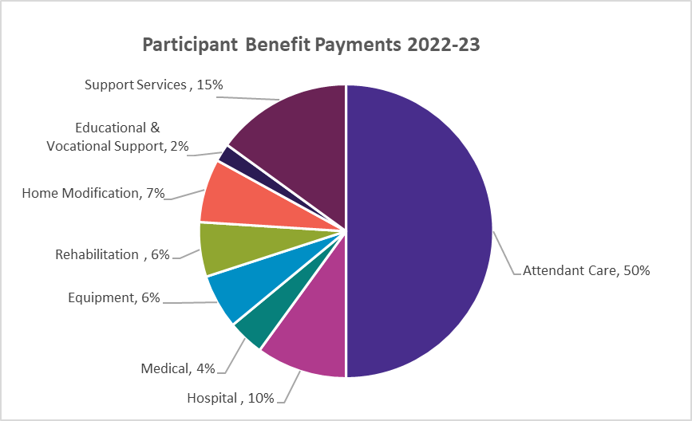

Accessing Services – How the scheme works with participants
The LTCS Scheme provides reasonable and necessary treatment, rehabilitation and care as it is required throughout the person’s life and assists them to plan their rehabilitation and care services.
Participants are supported as needed by a LTCS Scheme coordinator. The participant is also supported by a case manager to help plan and source services as required by the participant.
The case manager will work with the participant and their service providers to request approval for services. Services are organised as required and the participant and their families are closely involved in each of these requests. Usually, payment of approved treatment and care needs is made by the LTCS Scheme directly to the supplier of the services.

Care and Carer Support
The Carers Recognition Act 2021 provides for the recognition of carers and created an obligation on a public sector entity to promote the care relationship principles from 10 December 2021. The LTCS Scheme recognises the valuable social and economic contribution that carers make to the community and acknowledges the important role and support carers provide to Scheme participants in their journey through their recovery, rehabilitation and return to full community living. Importantly, the Scheme provides paid carers where needed throughout the participant’s journey. This supports family relationships.
Carers are formally recognised under the Scheme as ‘nominated representatives’ and are routinely consulted in the development of care needs assessment plans for Scheme participants. Carers are also invited to participate in annual research surveys on their experience of the Scheme and different aspects of the support delivered by the LTCS Scheme.

Participants’ experiences of the LTCS Scheme support for recovery and rehabilitation
Participant research surveys each year seek feedback on different aspects of the support delivered by the LTCS Scheme and are a performance indicator for the Scheme. This year’s survey further built on those of previous years and sought feedback from participants and their nominated representatives on three key outcome areas. First, how participants viewed the effectiveness and efficiency with the way that Scheme benefits are delivered and whether and how the Scheme is meeting their recovery goals. Secondly, how Scheme participants perceived their progress in terms of the stage of their recovery or rehabilitation and whether the scheme is responsive to their needs. Thirdly, how participants and their carers are supported by the allied health team framework – i.e., case manager and single point of contact (SPOCs) who coordinate and deliver Scheme services to them.
The survey interviewed some 65 per cent of selected participants (which also included in some cases their nominated representatives) and reported a good overall level of satisfaction with how the Scheme was meeting their needs. Against that background, participants offered a range of responses on how they were progressing with their rehabilitation or longer-term supports and well-being:
“The provision of services has been the biggest thing. [Pt] has gone from totally traumatised to doing most things [themselves]. If there was no icare we would have been left to the public health system and we just wouldn’t have gotten as far on our own. (Nominated Person)
“Lifetime Care accommodating many options. My case manager is a great support. She’s offered things I’d never thought of… She makes sure I get what I need. She is a big part of my recovery…” (Participant)
“When I need help, I get it” (Participant)
“They know more than I do about my injury and options. They suggest lots of things that I may not initially think I want but it ends up being positive.” (Participant)
Respondents indicated that goal development and service planning had been done well and covered the things most important to them for their recovery. Most felt their progress was at least reasonable and at best fully recovered. Almost all participants (80 per cent) had goals set as part of a MyPlan. Participants largely attributed the progress with their recovery to the provision of LTCS-funded services and equipment, including case management, but also to their own determination and the persistence of family supports. Almost all interviewed were satisfied with each of the nine tested services or equipment. Based on the overall satisfaction with the medical, support services and equipment provided through the Scheme, these results confirm that the Scheme is largely effective in meeting the needs of participants. However, as with any Scheme there is always the opportunity for improvement.
Participants who received services which included equipment (e.g. wheelchair replacement or repairs) and home modifications indicated that the most common problem was delays. This included delays in sourcing service providers or finding replacement providers, with the lack of specialist services in the ACT noted as potentially limiting choice in services and participant recovery progress. The survey also identified ways in which potential new service providers might be supported to minimise service provision delays, such as by implementing a helpline or providing targeted information on the Scheme to new service providers.
The survey noted that issues and challenges will occur from time to time in scheme implementation given the complex needs of participants and sometimes unpredictable aspects of recovery. It is important that there are systems and communications in place to identify and rectify issues where they occur in a timely and satisfactory manner. Reassuringly, the survey noted that most participants either had their problems sorted or expected them to be resolved.
Respondents continue to indicate a high level of satisfaction with their case management services and the frequency of contact with their case manager. Case managers and coordinators were seen as necessary for the efficient and effective implementation of the scheme. In particular, very positive comments were made about their expertise navigating the health system; knowledge of relevant specialists; and their ability to source allied health professionals which are difficult to procure. Overall, the evidence suggests case management relationships are supporting participants in line with the Scheme’s objectives.
While respondents reported positive working relationships overall with their SPOCs, a suggested improvement was for SPOCs to increase contact frequency to maintain a relationship with the participant and their family carer that is independent of the case manager. The survey also highlighted the importance of the coordinator-initiated regular communication through the recent changes in coordinators for ACT-based participants that occurred to support administrative changes for the Scheme’s administration partner, the NSW LTCSA. The survey reinforced the importance of coordinator-initiated regular communication for promoting Scheme services and implementation, and identifying and supporting the resolution of issues that arise.
Health literacy, an important factor associated with participant control and choice with treatment, rehabilitation and care, was again a focus of 2023 Survey. As noted in the 2022 survey, there is again clear evidence of confidence in health literacy as:
- all respondents indicated that they knew how to get the right help when they need assistance with health or injury management; and
- most respondents agreed they have enough control of the types of services and equipment provided and how supports are provided.
The survey reflected gratitude from participants and their nominated persons for the provision of Scheme-funded services, equipment and supports. Their comments noted the significant progress in the participants’ recovery and wellbeing to which Scheme benefits and supports significantly contributed that would otherwise not have been made through the public health system. Most respondents felt there were no improvements or greater understanding required.
“Everyone has been really accepting, welcoming. They are awesome” (Participant)
“Everything has been great” (Participant)
When asked what advice or information respondents would offer to someone who had just joined the Scheme, responses centred on the following common themes: speaking up as a participant or nominated person; importance of a good case manager and/or coordinator relationship; and patience and engagement with goals.
“Don’t hold back. Tell them all you need”. (Participant)
“Raise your concerns, do it, because it might be rejected but if you don’t ask you don’t know…. You have a voice, raise it as that’s the way change comes about.” (Nominated person)
“It really depends on the situation and the providers. Listen to the case manager and try to go with their recommendations.”
“Be patient. Continue trying. Don’t be discouraged. When you reach barriers don’t be put off – you need to find them to know what they are: And things do get easier”. (Participant)
“In the early stages, treat it as a part-time job. Make a good plan and set markers along the way and see how you are tracking so you are aware. I wish I had had clear goals in six-month chunks. It’s easy in hindsight.” (Participant)

Outlook
Strategic priorities for the LTCS Commissioner in 2023-24 include:
- administering the LTCS Scheme in accordance with the requirements of the LTCS Act and Guidelines;
- issuing / amending guidelines and determinations under the LTCS Act when required;
- collecting annual feedback from participants on their expectations and experience with the LTCS Scheme and in consultation with our service partner, the NSW LTCSA, implementing improvements when required to the way LTCS Scheme benefits are delivered to ACT participants;
- assessing future funding requirements of the Fund and levy setting;
- undertaking investments in accordance with the Fund’s investment strategy; and
- progressing the Memorandum of Understanding between the LTCS Commissioner and the National Disability Insurance Agency for the exchange of Information regarding mutual participants of both the LTCS and the National Disability Insurance Schemes.

Performance analysis
The LTCS Scheme’s 2022-23 performance indicators are included in the Budget Portfolio Statements for the LTCS Fund and are reported as part of the LTCS Fund’s Statement of Performance.

Explanation of Performance Indicators

a. LTCS Levies determined during the fourth quarter
The LTCS levies are the key funding source for the Scheme, with a levy applying to all Motor Accident Injuries insurance policies payable at the time of vehicle registration and a levy applying to private sector workers’ compensation insurers. As required by the LTCS Act, the levies are set by the LTCS Commissioner based on independent actuarial advice. The level at which the levies are set in any given year is intended to provide sufficient funds to meet the costs of all estimated present and future liabilities of new participants of the LTCS Scheme in that year. The LTCS levies are for a financial year and are set in May before the commencement of a financial year on 1 July.
In accordance with section 83 of the LTCS Act, before the beginning of the contribution period the LTCS Commission obtained a report from an independent actuary in relation to the amounts needed to be contributed to the LTCS fund for the contribution period.
Two actuarial reports for the 2023-24 contribution period were provided by the Scheme Actuary, Finity Consulting Pty Ltd, for the purposes of setting the 2023-24 LTCS levy for motor vehicle injuries and the LTCS levy for work injuries.
The LTCS Commissioner determined that the LTCS levy for a twelve-month Motor Accident Injuries insurance policy would increase to $90.40 in 2023-24 for all motor vehicles except those that are part of the ACT’s Veteran, Vintage and Historic Registration Scheme (VVHR). The LTCS levy determined for the VVHR Scheme was set at $18.10 in 2023-24 for a twelve-month MAI policy.
The LTCS Commissioner determined the total LTCS levy payable by private sector workers’ compensation insurers and self-insurers at $7.0 million.
The Levy determinations for the 2023-24 contribution period for motor vehicles and private sector workers’ compensation insurers and self-insurers, were notified on the Legislation Register on 18 May 2023 and 13 June 2023 respectively.
The LTCS Commissioner determined these LTCS levies based on the best available data. As the Scheme will only be in its tenth year of operation for motor vehicle accidents and in its eighth year of operation for work accidents, a high degree of uncertainty remains with respect to the number of participants and the costs of providing services. By the very nature of the injury type covered by the Scheme, the costs of the scheme can be expected to be volatile from year to year. Noting that it will take many years of experience before more robust Scheme data becomes available, the LTCS Commissioner will continue to reassess the levy amounts yearly, based on updated advice provided by an independent actuary.

b. Undertake an annual client feedback process
A survey of the LTCS Scheme participants was conducted by MODD Research + Evaluation, a social research consultancy that specialises in undertaking research of services in the disability and health sectors, in May 2023 with a report provided in June 2023.
The overall purpose of this year’s survey was to gain feedback to understand participant perceptions of, and experience with, the Scheme and associated services and supports, and to understand the effectiveness and efficiency of the Scheme in meeting participants’ recovery and rehabilitation needs. Qualitative feedback was sought on these key outcome areas for the Scheme.
The survey results indicate an ongoing overall satisfaction with how the Scheme meets participant needs. Where participants’ progress with their recovery was noted, it was largely attributed to the provision of LTCS-funded services and equipment, including case management services. Respondents were mostly satisfied with each of the nine tested services or equipment. Taken together, the survey results confirm that the Scheme is largely effective in meeting participants’ needs, with some opportunity for improvement. The main area for improvement was around delays in the provision of services (e.g. repair of wheelchairs, finding replacement support services) with difficulty sourcing certain specialist medical and support services in the ACT being a key factor.
As the survey recommendations covered aspects of the service delivery processes of the NSW LTCSA, a copy of the report has been provided to the NSW LTCSA and the key learnings discussed with them. The LTCS Commissioner thanks the participants for contributing to the survey and notes the findings of the report will inform consideration of improvements to the ACT LTCS Scheme and the service delivery and administration of Scheme benefits to participants.
Further information | Lisa Holmes, Executive Branch Manager, Insurance, Economic and Financial Group  (02) 6207 0207 lisa.holmes@act.gov.au

Motor Accident Injuries Commission

Transmittal Certificate

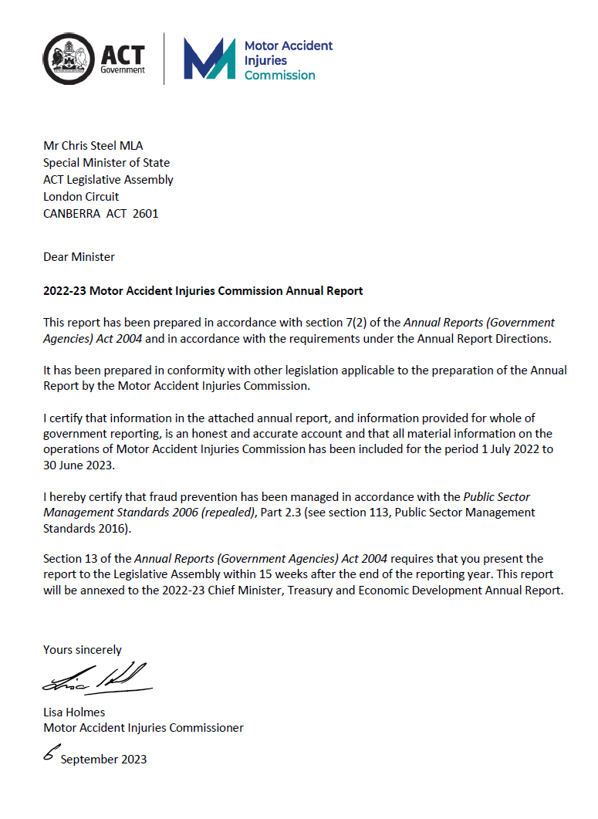

Compliance Statement
The 2022-23 Motor Accident Injuries Commission (MAI Commission) Annual Report must comply with the Annual Reports (Government Agencies) Directions 2023 (the Directions) made under section 8 of the Annual Reports (Government Agencies) Act 2004. The Directions are found at the ACT Legislation Register.
The Compliance Statement indicates the subsections, under Parts 1 to 5 of the Directions, that are applicable to the MAI Commission and the location of information that satisfies these requirements.

Part 1 Directions Overview
The requirements under Part 1 of the Directions relate to the purpose, timing and distribution, and record keeping of annual reports. The 2022-23 MAI Commission Annual Report complies with all subsections of Part 1 under the Directions.
To meet Section 15, Feedback, Part 1 of the Directions, contact details for the MAI Commission are provided within the 2022-23 MAI Commission Annual Report to provide readers with the opportunity to provide feedback.

Part 2 Reporting entity annual report requirements
The requirements within Part 2 of the Directions are mandatory for all reporting entities and the MAI Commission Annual Report complies with all subsections. The information that satisfies the requirements of Part 2 is found in the MAI Commission Annual Report as follows:
- A. Transmittal Certificate, see previous page.
- B. Organisational Overview and Performance Analysis, see Organisational Overview and Performance. The following subsections, contained within the CMTEDD Annual Report, apply to the MAI Commission:
- Scrutiny
- Internal Audit
- Fraud Prevention
- Freedom of Information
- Community Engagement and Support
- Aboriginal and Torres Strait Islander Reporting
- Work Health and Safety
- Human Resources Management
- Ecological Sustainability Reporting
- C. Financial Management Reporting, all subsections, see Volume 2.2 of the CMTEDD Annual report. MAI Commission reporting on Government Contracting is included in the CMTEDD Government Contracting section.

Part 3 Reporting by exception
The MAI Commission has no information to report by exception under Part 3 of the Directions for the 2022-23 reporting year.

Part 4 Directorate and public sector body specific annual report requirements
Part 4 of the 2023 Directions is not applicable to the MAI Commission.

Part 5 Whole of government annual reporting
Consistent with the Directions, in particular all subsections of Part 5, the information satisfying these requirements is reported in the one place for all reporting entities as follows:
- Bushfire Risk Management, see the annual report of the Justice and Community Safety Directorate
- Human Rights, see the annual report of the Justice and Community Safety Directorate
- Legal Services Directions, see the annual report of the Justice and Community Safety Directorate
- Public Sector Standards and Workforce Profile, see the annual State of the Service Report
- Territory Records, see the CMTEDD Annual Report.
ACT Public Service Directorate annual reports are found at the following web address: http://www.cmd.act.gov.au/open_government/report/annual_reports

Organisational Overview and Performance

Organisational overview
The Motor Accident Injuries (MAI) Commission is a Territory authority established under the Motor Accident Injuries Act 2019 (MAI Act). The MAI Commission started operations on the commencement of the MAI Act on 1 February 2020.
The Executive Branch Manager of the Insurance Branch, Economic and Financial Group, CMTEDD was appointed by the Minister as the MAI Commissioner for a period of 5 years commencing from 17 September 2019. The Executive Group Manager of the Economic and Financial Group, CMTEDD was also appointed by the Minister in 2019 as the Acting MAI Commissioner when the MAI Commissioner is unavailable. An acting Executive Branch Manager performed the functions of the MAI Commissioner for some of the reporting period. The functions of the MAI Commission are supported by the Insurance Branch, Economic and Financial Group, CMTEDD.

Principal objectives
The objectives of the MAI Act are specified in section 6 of the Act. The objectives include:
- Ensuring benefits are available to support all people injured in motor accidents on a no-fault basis, subject to some exclusions and limitations.
- Encouraging early and appropriate treatment and care of people injured in motor accidents to achieve optimum recovery and return to pre-accident levels of activity and work.
- Supporting people injured in motor accidents to access defined benefits.
- Promoting and encouraging the early, quick, cost-effective and just resolution of disputes.
- Keeping the costs of motor accident injury insurance at an affordable level, including through the prevention of accidents by contributing to campaigns.
- Providing for the licensing and supervision of insurers providing motor accident injury insurance, including keeping a register of applications and claims.

Functions
The functions of the MAI Commission are extensive with functions such as providing information and assistance on the MAI Scheme. The MAI Commission has a strong monitoring and regulatory role in relation to the provision of defined benefits by insurers. The MAI Commission’s functions are detailed in section 25 of the MAI Act. Its responsibilities include:
- Regulating the licensing of insurers under the MAI Scheme.
- Reviewing premiums to ensure they fully fund the present and likely future costs of the Scheme but are not excessive.
- Monitoring insurers’ compliance with their obligations under the Act.
- Providing information to the public about the MAI Scheme.
- Managing complaints about the market practices of licensed insurers and the handling practices of insurers under the MAI Scheme.
- Issuing, monitoring and reviewing the MAI guidelines and other statutory instruments under the Act.
- Monitoring and advising the Minister about the administration, efficiency and effectiveness of the MAI Scheme.
The MAI Commission is a self-funded statutory authority. The annual Motor Accident Levy (MA Levy) of $14 for 2023-24 and is a reduction of $2 or 12.5 per cent on the 2022-23 MA Levy of $16. The annual MA Levy of $14 is payable in relation to MAI policies issued with effect from 1 July 2023, except for veteran, vintage and historic (VVH) registration scheme vehicles and modified VVH vehicles. These VVH vehicles have an annual MAI levy of $3.50 in 2023-24 (2022-23: $4) per MAI policy. The annual levy applies for a full year policy and is pro­rated for shorter registration periods, which can be purchased for 3 month or 6-month periods. This levy has been estimated to fully fund the MAI Commission, noting it varies based on the number of vehicles registered in the ACT each year, for which the levy is applied.

Highlights

Operation of the MAI Scheme
The MAI Scheme has now been in effect for over three years. During the reporting year the legislative framework for the MAI Scheme was refined with the development of the Motor Accident Injuries Amendment Bill 2023. The Bill was passed on 28 June 2023. In addition, updates to the guidelines were made during the reporting period to ensure operations of the scheme remain optimal.
One of the ongoing objectives of the Government is to facilitate access to the Scheme by supporting injured people in navigating the scheme. Care Inc, a provider of financial counselling services in the ACT, has been commissioned to provide the Defined Benefits Information Service (DBIS) service under a three-year contract (from 1 May 2022, after an initial trial from 1 February 2020). The DBIS assists the public with information in relation to available benefits for injured people, the application process and how to navigate processes. An increase in services has been observed over the financial year, with a doubling of services as more people contacted the DBIS. Some of this increase was due to forms being updated to include the DBIS 1300 number. The DBIS continues to take proactive steps to ensure community organisations and ACT Policing (through Supportlink) provide the DBIS’ contact details to people injured in a motor accident.
The MAI Commission’s website and some forms were refreshed during the reporting year to provide additional step by step information on applying to the MAI Scheme, specifically in relation to the funeral benefits. The MAI Commission appreciates the feedback it receives on suggested improvements to its website and forms.

Competition and premium reductions
Since July 2013 there have been four licenced insurers in the ACT CTP / MAI insurance market, NRMA Insurance and three Suncorp brands being AAMI, APIA and GIO. There is evidence that strong competition continues to drive down the level of premiums. As shown in Figure 1, premiums reduced further over the course of 2022-23. From 1 July 2022 to 30 June 2023, the average private passenger vehicle premium fell by $27.28 (6.3 per cent). Since competition commenced in the ACT market in July 2013 until 30 June 2023, the average private passenger vehicle premium has fallen by over $185.00 or 31.3 per cent. Motorists continue to also benefit from product choice and various offers from the insurers.

Figure 1: Fall in CTP / MAI premium prices since the introduction of competition
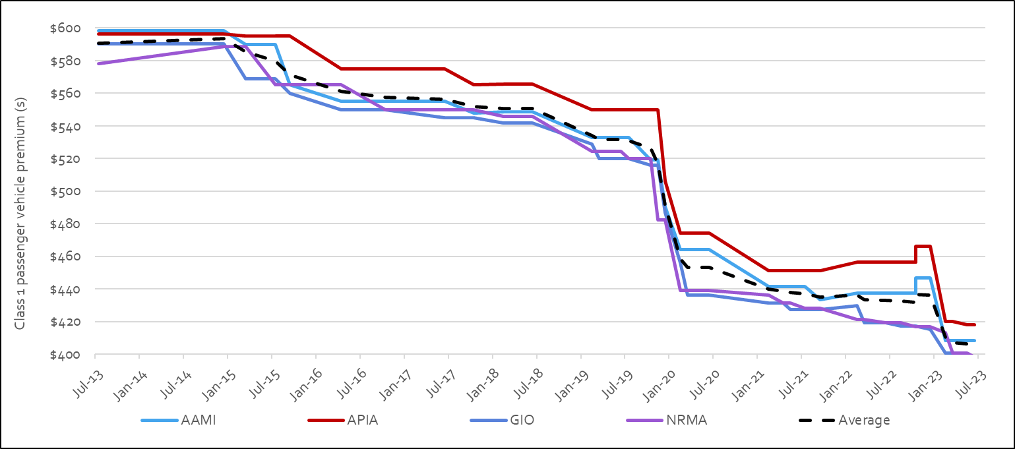

Maintaining claims statistics for the MAI Scheme
The MAI Commission maintains an ICT system known as the MAI Register to assist the Commission in monitoring compliance as well as analysing how the MAI Scheme is performing against its objectives. It allows for an enhanced and systematic data capture and reporting, assisting Commission staff and the Scheme’s actuary in its functions.
Data is collected from licensed insurers and the ACT Nominal Defendant at regular intervals. The MAI Commission also has an arrangement with the ACT Civil and Administrative Tribunal Registry staff to provide information to the Commission on external reviews of insurers’ reviewable decisions and applications for the payment of death benefits. De-identified information is reported through the MAI Scheme Quarterly reports.
In addition, the MAI Commission collects information about legal fees and related costs from lawyers providing legal representation to injured parties under the Scheme in certain circumstances.

MAI Scheme monitoring and insurer compliance
To monitor the operation of the MAI Scheme, the MAI Commission held regular meetings with MAI insurers and the ACT Nominal Defendant. These meetings focused on:
- operational aspects of the MAI Scheme including any significant matters arising from applications under the Scheme; and
- insurer compliance and updates on any remediation activities.
The Insurance Council of Australia provided comments on matters raised with the insurers in relation to consultations on legislation, including guidelines. Further feedback on the operation of the Scheme was also gathered through periodic discussions with the authorised providers for the DBIS and independent medical examinations, any complaints, and from direct community enquiries regarding the Scheme through the Commission’s website at http://www.act.gov.au/maic, telephone calls and correspondence.
The MAI Commission’s Compliance Monitoring Framework is available on the Commission’s website. Over this reporting period, the MAI Commission has continued with adopting the approach of education and engagement of insurers on issues that have arisen. As part of the compliance framework, the Commission has continued to review data in the MAI Register for quality and consistency with the MAI Act, regulations and guidelines. Data from the register is also used to identify trends and potential risks in each insurer’s systems and processes for administering the Scheme. During the reporting year five written requests were made to MAI insurers to provide further information about compliance risks identified through the MAI Commission’s monitoring activities. The MAI Commission also reviews for matters disclosed in the decisions of the ACT Civil and Administrative Tribunal. The MAI Commission actively worked with insurers, so all non-compliance identified was appropriately addressed, including through the development of improvement plans.
The Commission’s compliance activities also include a self-assessment tool for insurers. The tool was first issued to insurers in 2021. In June 2022 insurers were issued with a questionnaire focusing on recovery plans, internal review processes and the handling of quality-of-life applications. The questionnaire resulted in all licensed insurers making improvements to their internal processes and compliance monitoring systems to reflect risks they identified through using the tool. The next annual questionnaire will focus on income replacement benefit processing.

MAI Scheme premium process consultation
As part of the regular meetings held to monitor the operation of the MAI Scheme, a component of every meeting is devoted to discussing premium related matters with the MAI insurers. These meetings focus on a range of issues related to matters such as:
- premium filing matters;
- the risk rating of specific vehicle classes,
- progress reports of specific projects, such as the premium surplus refund; and
- Rego.act data matters.

Premium Surplus Refund
The MAI Scheme commenced on 1 February 2020 replacing the previous CTP Insurance Scheme. Refunds were due to many motorists as the policies they paid for prior to 1 February 2020, crossed over from the old CTP Scheme where the policy was a higher cost, into the MAI Scheme where it was a lower cost. Under legislation, these policies automatically became MAI policies on 1 February 2020. To ensure that insurers did not make an additional profit, the majority of vehicle owners that renewed their registration with a start date falling between 30 April 2022 and 29 April 2023, received a one-off MAI premium refund that applied at their first renewal. Each vehicle in an eligible vehicle class received the same average one-off refund, with the one-off reduction for a private car (class 1) being $19.90, irrespective of which MAI insurer the motorist selected as part of their registration renewal and the period of insurance selected (3, 6 or 12 months).
Up until 30 June 2023, the MAI Commission successfully returned to motorists $6.8 million of the $7.1 million (96 per cent) refunded by insurers to the Commission. In addition, it is expected that there will be some additional outstanding top-up payments to individual motorists made in the first half of 2023-24. The remaining amount relates to implementation costs such as the required ICT changes that were necessary to action the refunds to motorists.

Insurer Market Share
Market share indicates the proportion of the market held by each insurer and provides an indication of how the ACT community is responding to a competitive market. Figure 2 shows the average market share over each of the financial years from 2013-14 when competition began, through to the end of 2022-23. Market share is based on premiums collected by insurers. Between 2013 and the months immediately preceding the commencement of the MAI Scheme on 1 February 2020, premiums reflected the CTP Scheme design (common law, no caps on compensation). Premiums since 1 February 2020 reflect the MAI Scheme, a hybrid defined benefits common law scheme.
Over 2022-23, NRMA and the Suncorp Group held 56 per cent and 44 per cent of the market respectively.
- Relative to the 2021-22 market share: NRMA’s market share reduced slightly to 56 per cent over 2022-23 (a reduction of 0.8 percentage points (pp) compared to 56.8 per cent over 2021-22).
- GIO’s market share increased to 39 per cent over 2022-23 (an increase of 1.5 pp compared to 37.5 per cent over 2021-22).
- AAMI and APIA continue to hold relatively small market shares at 4.7 per cent and 0.3 per cent over 2022-23 respectively.

Figure 2: Movement in insurers’ average market share since the introduction of competition
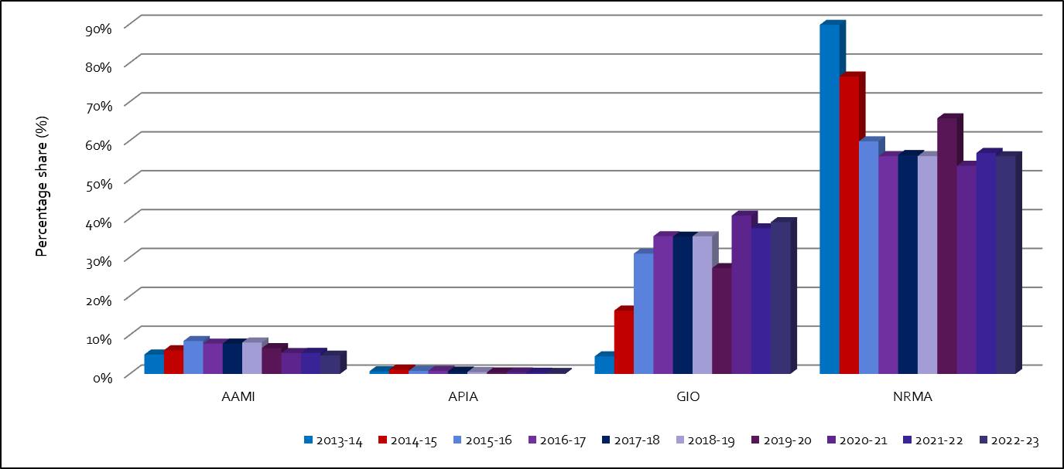

Road safety initiatives
The MAI Commission provided Transport Canberra and City Services Directorate (TCCS) with funding of $70,000 in 2022-23 to support the casual speeding awareness campaign ‘Casual Speeding. Every K Counts’, directed at changing motorists’ attitudes towards low level speeding in the ACT. The campaign was in response to a significantly high death toll on ACT roads in 2022 and in support of the Government’s road safety awareness identified as a 2023 Whole of Government Tier 1 communication project. The MAI Commission provided funding for the campaign to assist to localise the campaign content and with talent usage fees ($20,000), and distribution via media buy ($50,000). The campaign, targeting drivers before they get into the car and during their commute, commenced in March 2023 and ran across multiple channels including outdoor advertising, online and digital media and radio advertising.
The MAI Commission also incurred $22,383 to directly fund the development of a Road Safety Manual (Manual) for the ACT Taxi industry. The project was developed in response to the concerns expressed by the ACT Taxi industry regarding the high number of motor accidents involving taxis and the high taxi premiums relative to other vehicle classes, including rideshare vehicles.
As at 30 June 2023, the Manual had been drafted and was in the process of being finalised. It is based on consultation with the taxi industry, including taxi drivers, and provides a standardised taxi road safety framework for the ACT. It outlines key hazards and risks, and then how they may be mitigated or addressed. The Manual is designed to assist the taxi industry reduce the frequency and average cost (severity) of motor accidents resulting in personal injuries. Once finalised, the taxi industry is encouraged to implement the Manual’s framework for safer driving arrangements to reduce personal injuries and improve the likelihood of reducing taxi premiums in the medium term.

Premiums and scheme affordability
One of the objectives of the MAI Act is to keep the costs of insurance at an affordable level. The premiums charged by insurers reflect the benefit structure underlying the ACT’s insurance scheme. The MAI Scheme design provides fairer, faster and more comprehensive support for Canberrans if they are injured in a motor accident, regardless of whether they were at-fault in an accident or not. Everyone who is injured in a motor vehicle accident is entitled to receive treatment, care, and lost income benefits, for up to five years. People who are more seriously injured and were not at-fault in the accident are able to make a claim for further compensation through common law. Insurers reduced their premiums because of the scheme design compared to premiums under the previous CTP Scheme.
As shown in Figure 3, affordability, measured by premiums as a proportion of ACT average weekly earnings (AWE) improved between 2021-22 and 2022-23. Average premiums have fallen as a proportion of AWE by 15.3 percentage points over the period 2013-14 to 2022-23.

Figure 3: Average premiums for private passenger vehicles and as a proportion of ACT average weekly earnings
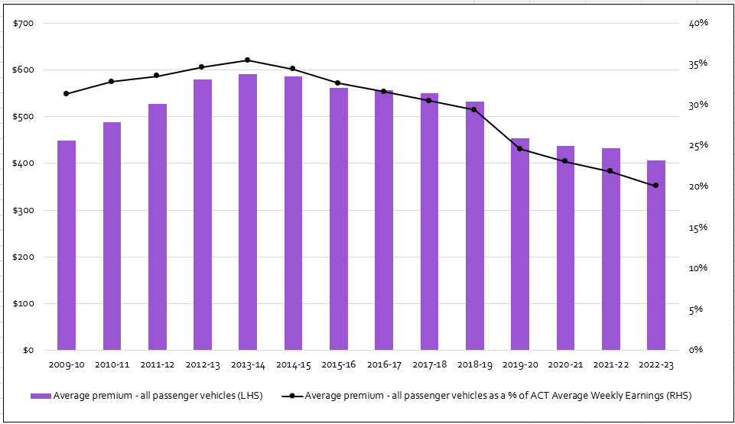
Note: The average CTP / MAI premium is for a class 1 passenger vehicle based on a 12-month policy.

MAI Scheme Statistics
The MAI Commission publishes scheme statistics quarterly, commencing with the period ending 30 June 2020. The quarterly reports up to and including the 30 June 2023 quarterly report are available at www.treasury.act.gov.au/maic/scheme-knowledge-centre. Below are some of the key statistics for the period 1 July 2022 to 30 June 2023.
- 442 applications were received, 394 of which were complete applications and 48 are in progress.
- A complete application is where the insurer has all the information it needs to assess liability.
- Further applications will be received for accidents that occurred prior to 30 June 2023 given the time injured people have to make an application to the Scheme.
- The number of applications received by insurers in 2022-23 is 42% higher than 2021-22 and covers periods less affected by lower traffic volumes associated with COVID-19 restrictions versus 2021-22. Despite this increase, it is expected to take some time for application numbers to reach maturity and for the community to fully engage with the new scheme.
- 97.4 per cent of complete applications were accepted by insurers in 2022-23.
- 10.4 per cent of applicants were either at fault in the accident or it was a blameless accident, with the fault status of 6.9 per cent of applications yet to be determined.
- One of the key advantages of the Scheme is that everyone injured in a motor accident can receive benefits, including those at-fault.
- In 2022-23, the Scheme paid out more than $15,197,000, 75.6 per cent of which related to payments for treatment and care, and income replacement. This reflects a key benefit of the Scheme, that injured people can receive timely treatment and care and income replacement assistance.
- Once an insurer received a complete application, the first treatment and care payment was made on average (median) in 10 days and 60 per cent of first payments were made within two weeks.
- Once an insurer received a complete application, the first income replacement payment was made on average (median) in 22 days and 61 per cent of first payments were made within four weeks. Income replacement payments can be made only after liability has been accepted by the insurer.
Figures 4 to 6 below provide profile information about scheme applicants (with a complete application) from 1 July 2022 to 30 June 2023. Applicants aged 30 to 44 made the highest number of applications to the Scheme. Most applicants (57 per cent) were driving a motor vehicle at the time of the accident. Of those applicants who declared their work status, the majority were earning an income prior to their accident.

Figure 4: Age groups of applicants to the Scheme from 1 July 2022 to 30 June 2023
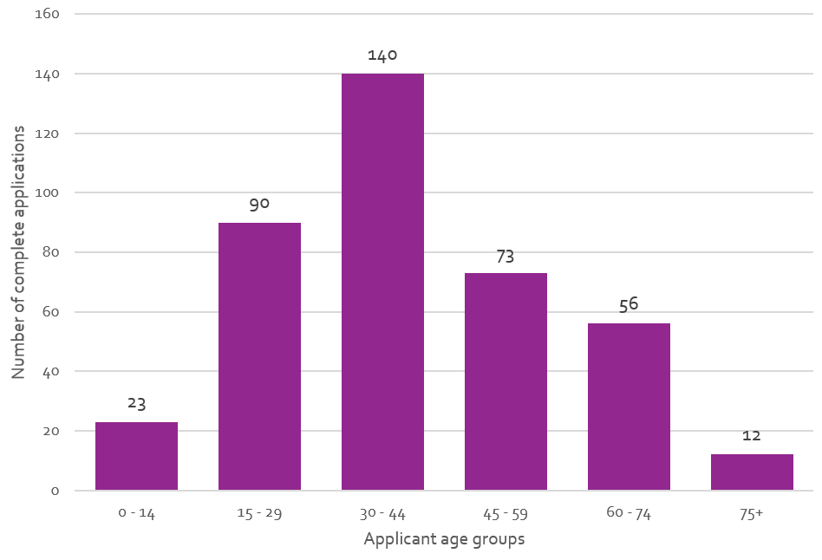

Figure 5: Applicants’ role in the accident, for applications to the Scheme from 1 July 2022 to 30 June 2023
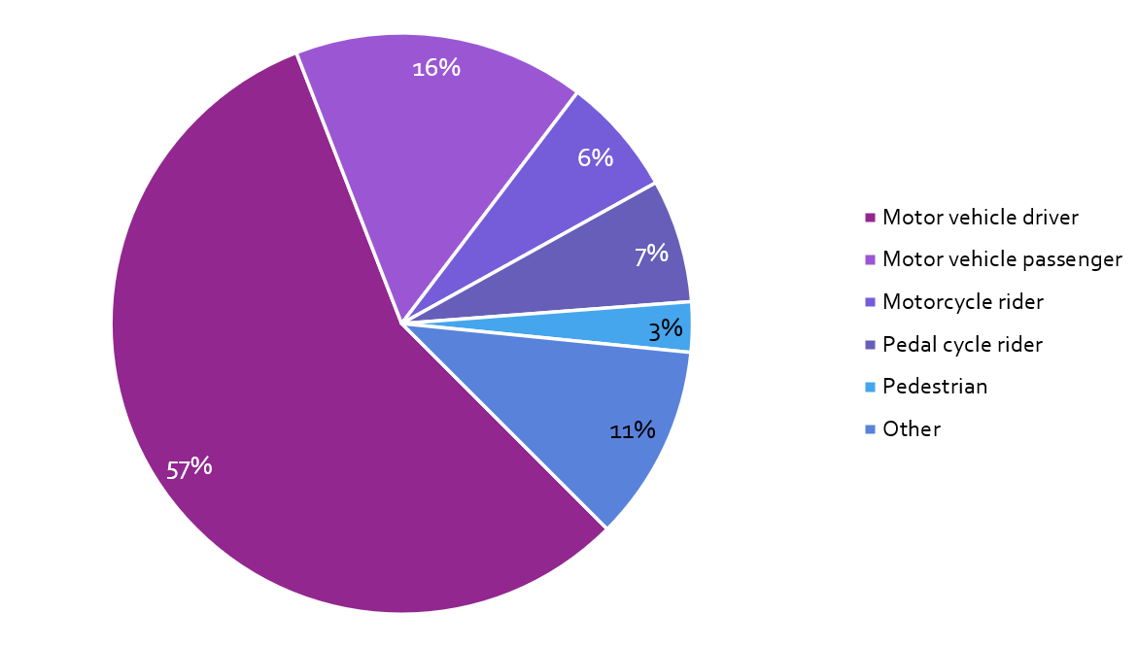

Figure 6: Applicants’ pre-accident work status, for applications to the Scheme from 1 July 2022 to 30 June 2023
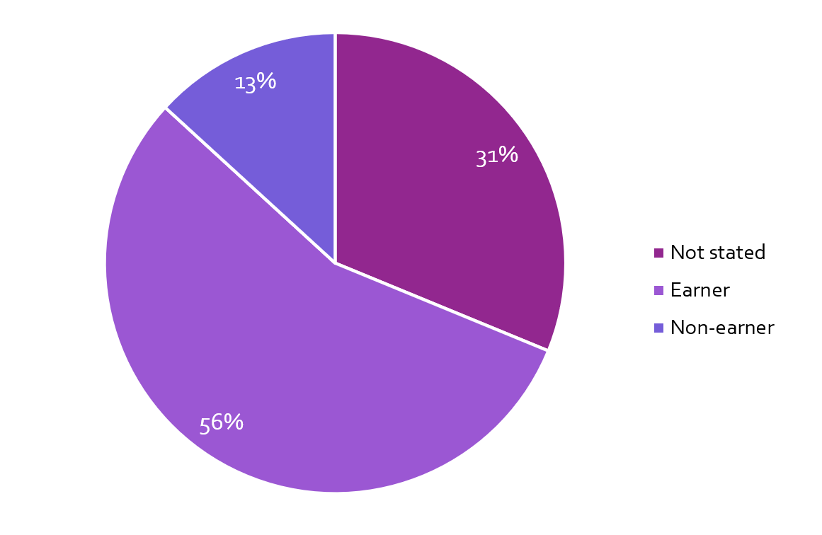

Premium determinations, loadings and levies
Under section 315 of the MAI Act insurers are only permitted to charge a premium approved by the MAI Commission. The MAI Commission will normally receive a premium filing from each licensed insurer at least annually. The Commission assesses each premium filing, based on expert independent actuarial advice, and may approve a premium if it is assessed that it will fully fund the insurer’s liabilities and is not considered to be excessive. If a premium filing is not received within a year, the Commission will review and assess the existing premium in accordance with the same criteria.
A premium filing assessment includes consideration of claims frequency, claim size, investment returns, administrative expenses and insurer profit – generally elements that make up the overall cost of service for an insurer participating in the MAI Scheme insurance market.
The role of the Scheme Actuary is to provide expert actuarial advice to the MAI Commission. This role is currently performed under contract by Finity Consulting Pty Limited.

Motorcycle premium support and loading
For motorcyclists, who are expected to have more claims against their vehicle class and higher cost claims under the MAI Scheme, premium affordability has been maintained through a subsidy from other vehicle classes that is reflected in premiums.
The most recent Motorcycle Premium Support and Premium Loading amounts for premiums commencing from 1 February 2023 were communicated to insurers and published in a notifiable instrument on the ACT Legislation Register.
The premium support is the amount that each motorcycle MAI premium is subsidised, while the premium loading is the amount that is included in premiums for most other vehicle classes to fund the motorcycle subsidies.

Nominal Defendant
The Nominal Defendant is a statutory office which exists to enable persons to be supported for injuries caused by uninsured, unidentified motor vehicles for which an MAI or CTP insurer cannot be identified and vehicles with an unregistered vehicle permit. Under section 16 of the MAI Act the Australian Capital Territory Insurance Authority (ACTIA) is the Nominal Defendant.
The Nominal Defendant is largely funded by a Nominal Defendant Loading that is part of the premiums paid by motorists. The MAI Scheme’s assessed Nominal Defendant Loading is published in a notifiable instrument on the ACT Legislation Register.

Lost investment income loading
The insurer’s lost investment income loading applies to premiums on policies with a duration of less than 12 months (‘Short Term Premiums’). The MAI Scheme’s lost investment income loading is published in a notifiable instrument on the ACT Legislation Register.

Outlook
Priorities for the MAI Commission in 2023-24 include:
- assisting with the first three-year review of the operation of the MAI Act;
- implementing the financial penalties framework following the passage of the Motor Accident Injuries Amendment Act 2023;
- working with the ACT taxi industry to finalise the ACT Road Safety Taxi Manual;
- issuing additional guidelines and regulations under the MAI Act, as required;
- updating forms for the MAI Scheme, as required;
- promoting and distributing information about the MAI Scheme, including via the MAI Commission website;
- assessing MAI premium filings and monitoring premium processes;
- maintaining an ICT system for the scheme’s data requirements and reporting on the scheme’s statistics;
- monitoring the scheme’s performance and undertaking compliance activities; and
- contributing to the Government’s road safety initiatives that assist in reducing motor accidents and personal injuries and mitigating their impact.

Explanation of performance indicators
The MAI Commission’s 2022-23 performance indicators were included in its Statement of Intent and reported as part of the Commission’s Statement of Performance. For the 2022-23 financial year, the MAI Commission developed and achieved the following indicators.

a. MAI Premium filings are reviewed by the Scheme actuary and are approved in accordance with the MAI Act, including fully funding the scheme
The MAI Commissioner is required to approve or reject a premium application under section 319 of the MAI Act. Under section 318, there are two key grounds on which the MAI Commissioner is permitted to reject a premium filing: the premiums applied for by MAI insurers are too low (the fully funded test); or are too high (the excessive premium test). All premium filings by licensed MAI insurers were reviewed by the Scheme Actuary to ensure they met the fully funded test. This ensures that the Scheme is able to pay out all present and future liabilities. The Scheme Actuary considered that all insurers’ premiums met the fully funded and not excessive test.
Consistent with premium streamlining arrangements, the MAI Commissioner approved premium partial filings if the change in premiums was within the permitted set bands and above the agreed minimum amount.
Premium filings for the MAI Scheme that were assessed and approved in accordance with the Act, were received from:
- GIO partial filing (received May 2022) and approved in June 2022 for MAI premiums commencing 10 August 2022;
- NRMA partial filing (received July 2022) and approved in August 2022 for MAI premiums commencing 7 October 2022;
- AAMI and APIA partial filings (received July 2022) and approved in August 2022 for MAI premiums commencing 18 October 2022;
- GIO partial filing (received September 2022) and approved in September 2022 for MAI premiums commencing 6 December 2022;
- AAMI, APIA, GIO and NRMA full de novo filings (received October 2022) and approved in November 2022 for MAI premiums commencing 1 February 2023;
- NRMA partial filing (received December 2022) and approved in December 2022 for MAI premiums commencing 21 March 2023;
- GIO and APIA partial filings (received March 2023) and approved in March 2023 for MAI premiums commencing 23 May 2023; and
- NRMA partial filing (received April 2023) and approved in April 2023 for MAI premiums commencing 30 June 2023.

b. Insurer MAI premiums for all vehicle classes are published on the MAI Commission’s website
The MAI Commission publishes the applicable MAI premiums for all vehicle classes on the MAI Commission’s website at www.treasury.act.gov.au/maic. The aim is to publish this information six weeks before the effective date and this indicator was met.

c. Promote public awareness of the new MAI Scheme
The communication campaign pivoted to using social media and associated tools to promote awareness of the scheme. It is intended to continue with this style of communication.

d. Promote public awareness of the causes of motor accidents through funding measures directed at reducing causes of motor vehicle accidents
In 2022-23, the MAI Commission:
- contributed $70,000 towards the casual speeding campaign - ‘Casual Speeding, Every K Counts’, to support and promote the prevention of motor accidents and the safe use of motor vehicles; and
- incurred $22,383 to directly fund the development of a Road Safety Manual for the ACT Taxi industry (Manual) designed to assist it in reducing the frequency and average cost (severity) of taxi related motor accidents resulting in personal injuries.

e. Reporting on the Scheme’s statistics
Report on the MAI Scheme for each quarter during 2022-23 was published on the MAI Commission website within target timeframes.

f. Queries handling within ten working days of receipt of the query
All queries received by the MAI Commission were responded to within ten working days of receipt.

g. Complaints handling within twenty-five working days of receipt of the complaint
The compliance indicator requires 85 per cent of complaints be responded to within twenty-five working days. During 2022-23, the Commission received a total of four complaints. Due to the multiplicity and complexity of the issues raised in each of the complaints, additional time was required to seek further information from parties where needed, as well as review and respond to the issues outlined in the replies. As a result, this compliance indicator was not met. However, where delay was experienced, the complainant was duly advised of the delay and the reasons for the delay.

h. Three-yearly review of the operation of the MAI Act in accordance with legislative timeframes (s493)
The Terms of Reference was agreed to by the Special Minister of State before 30 June 2023, but was not issued pending the finalisation of the accompanying Discussion Paper.

Risk Management
The MAI Commission has a risk management plan. The MAI Commission has overall responsibility for risk management, and for ensuring compliance with the risk management plan.
The risk management plan identifies the key risk areas as operational, financial, legal and reputational risk. The risk management plan has identified the following potential risks:
- The Commission not meeting stakeholder expectations.
- Insufficient staff and/or resources available to achieve outcomes.
- Failure to meet legislative requirements.
- Failure of the ICT System for the MAI Scheme.
These risks are mitigated through the use of appropriate governance structures, application of risk-based management strategies and financial reporting processes.
Further information | Lisa Holmes, Executive Branch Manager, Insurance, Economic and Financial Group, MAI Commissioner
 | (02) 6207 0207 | lisa.holmes@act.gov.au

Office of the Nominal Defendant of the ACT

Transmittal certificate
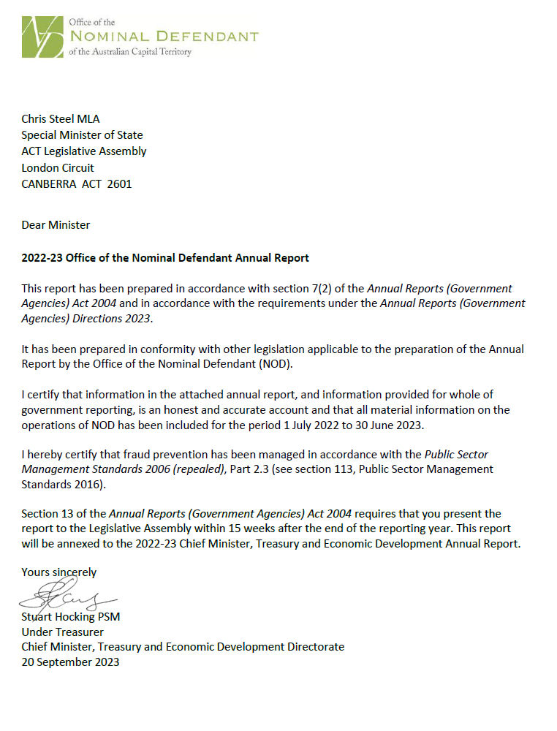

Compliance statement
The 2022-23 Office of the Nominal Defendant of the ACT Annual Report must comply with the Annual Reports (Government Agencies) Directions 2023 (the Directions) made under section 8 of the Annual Reports (Government Agencies) Act 2004. The Directions are found at the ACT Legislation Register.
The compliance statement indicates the subsections, under Parts 1 to 5 of the Directions, that are applicable to the Office of the Nominal Defendant of the ACT and the location of information that satisfies these requirements.

Part 1 Directions overview
The requirements under Part 1 of the Directions relate to the purpose, timing and distribution, and records keeping of annual reports. The 2022-23 Office of the Nominal Defendant of the ACT Annual Report complies with all subsections of Part 1 under the Directions.
To meet Section 15 Feedback, Part 1 of the Directions, contact details for the Office of the Nominal Defendant of the ACT are provided within the 2022-23 Office of the Nominal Defendant of the ACT Annual Report to provide readers with the opportunity to provide feedback.

Part 2 Reporting entity annual report requirements
The requirements within Part 2 of the Directions are mandatory for all reporting entities and the 2022-23 Office of the Nominal Defendant of the ACT Annual Report complies with all subsections. The information that satisfies the requirements of Part 2 is found in the 2022-23 Office of the Nominal Defendant of the ACT Annual Report as follows:
- A. Transmittal Certificate, see the previous page.
- B. Organisational Overview and Performance Analysis, see the Organisational Overview and Performance section. The following subsections, contained within the 2022-23 ACT Insurance Authority Annual Report, apply to the Office of the Nominal Defendant of the ACT:
- Risk Management
- Internal Audit
- Fraud Prevention
- Community Engagement and Support
- Aboriginal and Torres Strait Islander Reporting
- Work Health and Safety
- Human Resource Management
- Ecological Sustainability Reporting
- C. Financial Management Reporting, see the Financial Management Reporting section.
For the remaining subsections see Volume 2.2 of the 2022-23 CMTEDD Annual Report.

Part 3 Reporting by exception
The Office of the Nominal Defendant of the ACT has no information to report by exception under Part 3 of the Directions for the 2022-23 reporting year.

Part 4 Directorate and public sector body specific annual report requirements
Part 4 of the 2023 Directions is not applicable to the Office of the Nominal Defendant of the ACT.

Part 5 Whole of government annual reporting
All subsections of Part 5 of the Directions apply to the Office of the Nominal Defendant of the ACT. Consistent with the Directions, the information satisfying these requirements is reported in one place for all reporting entities as follows:
- Bushfire Risk Management, see the annual report of the Justice and Community Safety Directorate.
- Human Rights, see the annual report of the Justice and Community Safety Directorate.
- Legal Services Directions, see the annual report of the Justice and Community Safety Directorate.
- Public Sector Standards and Workforce Profile, see the annual State of the Service Report.
- Territory Records, see the CMTEDD Annual Report.
ACT Public Service directorate annual reports are found at the following web address: http://www.cmd.act.gov.au/open_government/report/annual_reports

Organisational overview and performance

Organisational overview
The ACT Insurance Authority is the Nominal Defendant of the ACT as defined under section 16 of the Motor Accident Injuries Act 2019 (the Act). Under section 330(1) of the Act the MAI Commission (the Commission) established the Nominal Defendant Fund (the Fund). Prior to the establishment of the Motor Accident Injuries (MAI) Scheme on 1 February 2020, the Fund was established under the Compulsory Third-party (CTP) Insurance Scheme.
The purpose of the Fund is to:
- provide a safety net mechanism to pay defined benefits and motor accident injury claims made by injured parties where:
- the vehicle involved does not have a motor accident insurance policy; or
- the injured person is unable to identify the driver and/or vehicle.
- ensure that persons, who are injured in the circumstances listed above, receive the same entitlements as an injured person would receive where the vehicle did have motor accident insurance;
- collect recoveries from uninsured drivers at fault to the sum paid out by the Fund; and
- receipt levies collected from licensed insurers in the Territory as well as the Australian and ACT Governments.
Funds required to satisfy the cost of claims and other relevant expenses for the Fund are not guaranteed by the ACT Government; however, Part 6.9 of the Act requires the Commission to collect amounts from licensed insurers and recognised self-insurers to meet the cost of nominal defendant claims.

Functions
The Fund exists to enable anyone who is injured in a motor vehicle accident and where there is no motor accident insurance to be compensated. The Fund meets the costs for individuals for treatment, care and lost income benefits for up to five years. Where possible, the Fund also recovers costs of claims from the at-fault driver of an unregistered vehicle.
The Fund’s administrative operations are subject to the same governance controls in relation to risk management, fraud prevention and records management as the ACT Insurance Authority. The reporting on these operations is included in the relevant sections of the 2022-23 ACT Insurance Authority Annual Report.
The ACT Insurance Authority also has oversight for workplace health and safety and associated risk management, accommodation, facilities management and workplace environmental management for the Fund. Reporting on these issues is contained in the 2022-23 ACT Insurance Authority Annual Report.

Internal accountability
As a small reporting entity, the Fund does not have any complex internal accountability structures and processes. As stated above, all administration operations and governance controls of the Fund are overseen by the ACT Insurance Authority.

Performance analysis

Revenue
Total income recognised by the Fund during the year was $6.699 million.
The Commission imposes a levy on licensed insurers and recognised self-insurers to meet the cost of nominal defendant claims in accordance with the Act.
The funds required to meet the cost of nominal defendant claims are apportioned among the insurers having regard to the amount of motor accident premium income they receive. Funds are transferred from the Commission to the Fund on a quarterly basis.
In addition, revenue is received by the Fund from the following sources:
- any penalties or penalty interest imposed under the Act;
- amounts recovered by the Fund;
- unregistered vehicle permits liability contributions;
- unregistered vehicle fines liability contributions; and
- interest accruing from investments.
The following table details funds received as other revenue during the period.

Table 1: Other revenue
Source | Amount ($m)
Unregistered vehicle permits | $0.305
Unregistered vehicle fines | $0.309
Insured recoveries | $0.000
Uninsured owners and drivers | $0.013
Interstate MAIS Recoveries | $0.536
Claims Management Fee – Interstate MAI Scheme | $0.019
Total | $1.182
There are currently 128 ‘recovery only’ claim files open. These files are claims that have either settled or been finalised and the Fund is pursuing recovery from unregistered vehicle owners and/or the drivers of unregistered vehicles responsible for the accident.
Where the Fund has made payments on a claim involving an uninsured motor vehicle, attempts are made to recover the cost of those payments from the owner or driver concerned.
Recovery prospects are poor in the majority of matters as it is often difficult to identify or locate the driver/owner and, when located, generally they do not have the capacity to repay any/all of the costs incurred.
The Office of the Nominal Defendant of the ACT financial statements are reported in Volume 2.2 of the 2022-23 CMTEDD Annual Report.

Claims
During the reporting period the Fund received 53 applications for defined benefits under the MAI Scheme and 2 claims under the previous Compulsory Third-Party scheme. 24 of the applications for defined benefits are being managed by the Nominal Defendant on behalf of interstate insurers. There are 46 open claims from received applications for the reporting period remaining as at 30 June 2023 with a combined total provision for all outstanding claims of $20.586 million.

Table 2: Claim types
 | Number | Percentage %
Unregistered and/or uninsured vehicles | 12 | 26
Unidentified vehicles | 11 | 24
Vehicles with unregistered vehicle permits | 1 | 2
Interstate insured vehicles | 22 | 48
Total | 46
An estimate of the provision for claims payable is completed annually by an independent actuary. The Fund engaged KPMG Actuarial Pty Limited to provide a full assessment of the provision for claims payable at 30 June 2023. The movement in the provision for claims payable can either reduce claims expense in the case of a reduction in liability or increase claims expense in the case of an increase in liability.

Claims frequency and vehicle registrations
As at 30 June 2023, the Australian Capital Territory has 367,744 registered vehicles.
For the financial year ending 30 June 2023, the ultimate claim frequency is estimated at approximately 0.12 claims per 1,000 vehicles registered.
A comparison between the number of vehicles registered and the number of ultimate claims estimated to be made to the Fund for each accident year is shown in the following chart:

Figure 1: Claim frequency and vehicle registrations
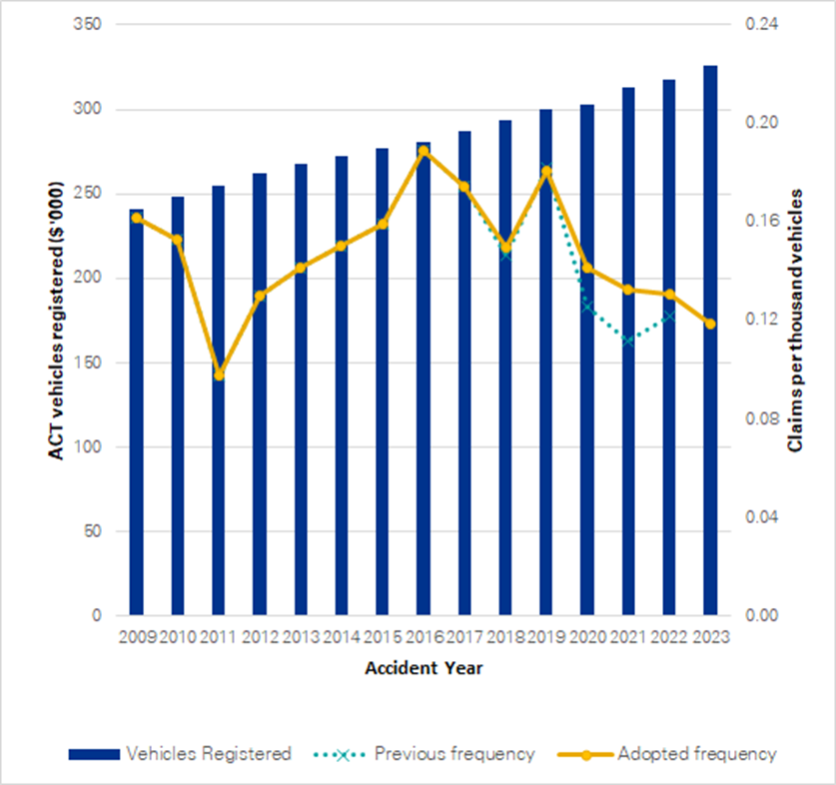
Notes:
- Source: Nominal Defendant Liability Valuation Report as at 30 June 2023 produced by KPMG Actuarial Pty Limited.
- The vehicle registrations for 2023 are sourced from Road User Services ACT, and other years from previous actuarial reports.
- Claim frequency refers to number of road incidents giving rise to a claim, whether one or more claimants. The measure is expressed per thousand vehicles registered.

Average claims size and cost per policy
A comparison between the estimated ultimate average size of a claim and the estimated ultimate cost of a motor accident policy is shown in the following chart for each accident year. For the most recent financial year ending 30 June 2023, the ultimate average claim size is estimated to be $0.158 million while the ultimate average motor accident claim per policy cost is estimated to be $18.79.

Figure 2: Average claim size and cost per policy by accident year (inflated and undiscounted)
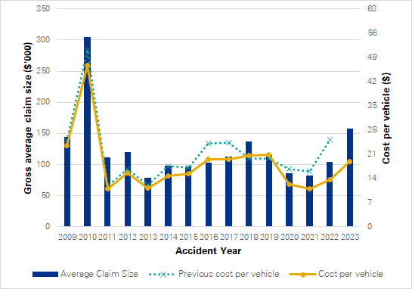
Notes:
- Source: Nominal Defendant Liability Valuation Report as at 30 June 2023 produced by KPMG Actuarial Pty Limited.
- Average claim size and Cost Per Policy (CPP) are in expected payment date values, but without allowance for time value of money (i.e. present value discounting) and are gross of all recoveries.
- The historical data component is sourced from previous actuarial reports.

Total expenses
The total expenses incurred by the Fund during the year was $1.190 million, which includes a total claims expense of $0.444 million and $0.746 million for Supplies and Services.

Balance sheet
The Fund had total assets of $40.841 million and liabilities of $20.655 million as at 30 June 2023, with total equity of the Fund of $20.186 million.

Scrutiny
There were no inquiries or reviews from the ACT Audit Office, the ACT Ombudsman, or any Legislative Assembly Committees in 2022-23. The only scrutiny from the ACT Audit Office during the reporting year was for the audit of the 2021-22 Financial Statements.

Freedom of information
The Freedom of Information Act 2016 (FOI Act) gives individuals the legal right to:
- access government information unless access to the information would, on balance, be contrary to the public interest;
- ask for personal information to be changed if it is incomplete, out-of-date, incorrect or misleading; and
- appeal a decision about access to a document, or a decision in relation to a request to amend or annotate a personal record.
In accordance with Section 96 of the FOI Act the Fund is required to report on the operation of the FOI Act in relation to the Fund for the reporting year.
The Fund did not receive any requests for access to any information under the FOI Act during 2022-23.
Further information relating to FOI including how to make an FOI application, what details you need to make an application and contact details for the CMTEDD Information Officer can be found on CMTEDD’s website https://www.cmtedd.act.gov.au/functions/foi. There are also details of requests received by the directorate listed on the Freedom of Information Disclosure Log for CMTEDD.

Financial management reporting

Government contracting
The Fund engages consultants to perform specialised actuarial and legal services. The procurement selection and management processes for all contractors including consultants complied with the Government Procurement Act 2001 and the Government Procurement Regulation 2007.
The Fund did not execute any new procurement activities during the reporting period.
The ACT Government Contracts Register records contracts with suppliers of goods, services and works, with a value of $25,000 or more and is available online.
A full search of Default Insurance Fund contracts notified with an execution date from 1 July 2022 to 30 June 2023 can be made at https://www.tenders.act.gov.au/contract/search.

Further information | Penny Shields, General Manager, ACT Insurance Authority
 | (02) 6207 0268 | ACTInsuranceAuthority@act.gov.au

Public Sector Workers Compensation Fund

Transmittal certificate

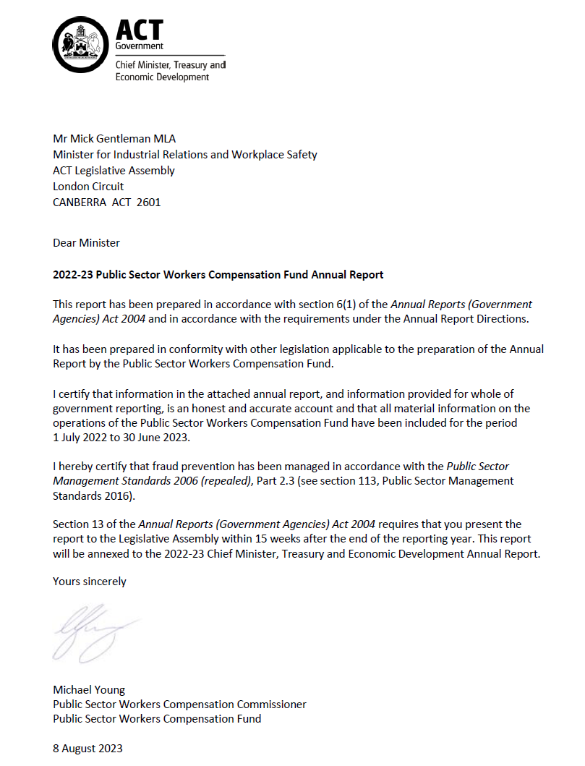

Compliance statement
The 2022-23 Public Sector Workers Compensation Fund (PSWC Fund) Annual Report must comply with the Annual Reports (Government Agencies) Directions 2023 (the Directions) made under Section 8 of the Annual Reports (Government Agencies) Act 2004. The Directions are found at the ACT Legislation Register.
The compliance statement indicates the subsections, under Parts 1 to 5 of the Directions, that are applicable to the PSWC Fund and the location of information that satisfies these requirements.

Part 1 Directions overview
The requirements under Part 1 of the Directions relate to the purpose, timing and distribution, and records keeping of annual reports. The 2022-23 PSWC Fund Annual Report complies with all subsections of Part 1 under the Directions.
Contact details for the PSWC Fund are provided within the 2022-23 PSWC Fund Annual Report to provide readers with the opportunity to provide feedback, as per Section 15, Part 1 of the Directions.

Part 2 Reporting entity annual report requirements
The requirements within Part 2 of the Directions are mandatory for all reporting entities and the PSWC Fund Annual Report complies with all subsections. The information that satisfies the requirements of Part 2 is found in the PSWC Fund Annual Report as follows:
- Transmittal Certificate, see the previous page.
- Organisational Overview and Performance Analysis, see the Organisational Overview and Performance section on the next page.
- Financial Management Reporting: Government Contracting, see the Financial Management Reporting section.
The remaining subsections are reported in Volume 2 of the CMTEDD Annual Report.

Part 3 Reporting by exception
The PSWC Fund has no information to report by exception under Part 3 of the Directions for the 2022-23 reporting year.

Part 4 Directorate and public sector body specific annual report requirements
Part 4 of the Directions is not applicable to the PSWC Fund.

Part 5 Whole of government annual reporting
All subsections of Part 5 of the Directions apply to the PSWC Fund. Consistent with the Directions, the information satisfying these requirements is reported in one place for all reporting entities as follows:
- Bushfire Risk Management, see the annual report of the Justice and Community Safety Directorate.
- Human Rights, see the annual report of the Justice and Community Safety Directorate.
- Legal Services Directions, see the annual report of the Justice and Community Safety Directorate.
- Public Sector Standards and Workforce Profile, see the annual State of the Service Report.
- Territory Records, see the CMTEDD Annual Report.
ACT Public Service directorate annual reports are found at the following web address: http://www.cmd.act.gov.au/open_government/report/annual_reports

Organisational overview and performance

Organisational overview
The PSWC Fund is established under the Public Sector Workers Compensation Fund Act 2018 (the PSWCF Act) and commenced operations on 1 March 2019.
The PSWCF Act provides a financial and prudential governance framework to support the Territory’s workers’ compensation self-insurance arrangements for public sector employees, which are delivered under a licence issued by the Safety Rehabilitation and Compensation Commission in accordance with the Safety Rehabilitation and Compensation Act 1988 (Cth) (SRC Act)
The PSWCF Act is administered by CMTEDD. The functions of the PSWC Fund are supported by the Work Safety Group, CMTEDD.

Functions
The PSWC Fund was designed to ensure the effective management of the Territory’s workers’ compensation assets and features governance and management arrangements in relation to those assets. The PSWC Fund is integral to the Territory’s compliance with its self-insurance licence.
The PSWC Fund is administered by the Public Sector Workers Compensation Commissioner (PSWC Commissioner) who is responsible for:
- Managing the PSWC Fund.
- Advising the Minister about the administration, efficiency and effectiveness of the PSWC Fund.
- In relation to a licence granted to the Territory under section 103 of the SRC Act:
- Managing the Territory’s liability under the SRC Act; and
- Managing claims under the SRC Act.
The PSWC fund is funded by the Territory, including from annual contributions apportioned by the PSWC Commissioner amongst Territory directorates and agencies. Assets are invested, with earnings retained to help meet workers’ compensation costs.

Internal accountability
The person occupying position number E00727 is appointed to the role of the PSWC Commissioner for a period of three years to 28 February 2025. As at 30 June 2023 the position is occupied by Mr Michael Young, Executive Group Manager, Work Safety Group, Office of Industrial Relations and Workforce Strategy, CMTEDD.
Section 24 of the PSWCF Act establishes a PSWC Advisory Committee with the following functions:
- To keep informed of the operations of the PSWC Fund to provide advice to the Minister in relation to the fund.
- To assist in meeting the Territory’s liabilities under the SRC Act by providing advice about claims management in relation to injured employees of the Territory.
Section 26 of the PSWCF Act stipulates the advisory committee consists of:
- The PSWC Commissioner;
- Three members appointed by the Minister to represent the interests of workers; and
- Two members appointed by the Minister to represent the interests of public sector bodies and territory instrumentalities.
The Chair of the advisory committee as at 30 June 2023 was Mr Michael Young, PSWC Commissioner. The PSWC Fund Advisory Committee met four times during 2022-23. Membership of the PSWC Fund Advisory Committee during the year and the number of meetings each member attended is included in the table below.

Table 1: Membership and attendance of the PSWC Fund Advisory Committee 2022-23
Name | Role | Meetings attended
Michael Young, PSWC Commissioner | Chair | 4
Penny Shields | Member | 4
Susie Walford | Member | 4
Patrick Judge | Member | 3
Melissa Payne | Member | 4
Matthew Harrison | Member | 2
Kasey Tomkins | Member | Nil
Notes:
- All meetings of the committee occurred in accordance with s27 of the PSWCF Act and the committee’s terms of reference.
- Mr Patrick Judge was unable to attend one meeting of the Committee.
- Mr Matthew Harrison resigned from his position on 30 November 2022.
- Ms Kasey Tompkins was appointed to the Committee on 5 April 2023.

Performance analysis
The PSWC Fund’s 2022-23 performance indicators are included in the 2022-23 Budget Portfolio Statements for the PSWC Fund and are reported on as part of the PSWC Fund’s Statement of Performance in Volume 2 of the CMTEDD Annual Report.

Explanation of performance indicators

a. Reduce the ACT public sector incidence of serious workplace injury
This accountability indicator is sensitive to public sector injury prevention activities and aligns with targets from the Safe Work Australia Australian WHS Strategy 2012-22. A serious workplace injury is an accepted workers’ compensation claim that results in the injured person being unable to perform their usual role for one or more weeks. This accountability indicator measures the number of ACT public sector workers’ compensation serious claims, per 1,000 employees.
Improved performance in relation to serious workplace injuries is indicative of improvements in injury prevention and management, for example from programs such as early intervention physiotherapy and safety auditing.

b. Achieve a conformance rating of 85 per cent or higher in the annual audit of the ACT workers’ compensation self-insurance rehabilitation management system
It is a requirement of the SRC Act that the Territory maintains a rehabilitation management system that complies with Australian Government guidelines and that conformance is audited annually. The 2022-23 audit was conducted by Bellchambers Barrett in March 2023.

c. Maintain a PSWC Fund asset to liability ratio greater than or equal to 100 per cent
This accountability indicator aligns with the PSWC Fund requirements under the Public Sector Workers Compensation Fund (Investment and Funding Ratio) Management Guidelines 2019 (No 1).
An asset to liability ratio of 100 per cent or more indicates that the fund contains sufficient assets to meet the expected lifetime cost of public sector workers’ compensation claims.

d. Achieve a conformance rating of 85 per cent or higher in the annual audit of the ACT workers’ compensation self­insurance claims management system
It is a requirement of the SRC Act that the Territory maintains a claim management system that complies with Australian Government guidelines and that conformance is audited annually. The 2022-23 audit was conducted by Bellchambers Barrett in March 2023.

Highlights
The key priorities for the PSWC Fund during the 2022-23 financial year were to:
- develop and deploy best practice health, wellbeing and return to work strategies, policies and interventions for the ACT public sector;
- ensure the effective and efficient management of new and existing ACT public sector workers’ compensation claims;
- ensure the effective and efficient management of the PSWC Fund assets in accordance with the PSWC Fund investment guidelines; and
- continuously improve injured worker and directorate satisfaction with workers’ compensation insurance and rehabilitation services.
In its fourth year the PSWC Fund:
- finalised 838 claims;
- received 574 new claims; and
- made all payments to third parties within ten days, and most within five.

Table 2: ACT public sector workers’ compensation claims in 2022-23
 | Number
Total claims opened during the reporting period | 574
Total claims closed during the reporting period | 838
Total reopened claims during the reporting period | 207
Current open claims | 1,136

Outlook
In 2023-24 the PSWC Fund will continue to progress the strategic and operational priorities from 2022-23.
Key focus areas of the PSWC Fund in undertaking its functions in 2023-24 include ensuring the effective and efficient funding of the in-house workplace rehabilitation service being established within the Work Safety Group, CMTEDD.

Scrutiny
Scrutiny of the PSWC Fund’s activities is undertaken by a number of bodies including Committees of the ACT Legislative Assembly, the ACT Auditor-General and the ACT Ombudsman.
The Auditor-General’s Report No. 6 of 2020 - Transfer of workers’ compensation arrangements from Comcare was provided on 30 June 2020. This report made a number of findings and no recommendations.
On 26 October 2022, the Legislative Assembly Standing Committee on Public Accounts started an inquiry into responses to the Auditor-General’s report. The PSWC Fund has provided timely responses to all requests from the committee in relation to this inquiry and the PSWC Fund activities.
There were no Ombudsman reports in 2022-23 in relation to the Fund.

Financial management reporting

Government contracting
The Territory and the PSWC Fund have engaged, pursuant to Sections 23 and 30 of the PSWCF Act, a claims manager responsible under section 23 for the following:
- investigating claims;
- assessing the Territory’s liability in relation to claims under the SRC Act, including initial liability and ongoing liability;
- calculating benefits and authorising payments under the SRC Act;
- paying amounts in relation to provisional liability medical costs;
- paying amounts in relation to workers’ compensation claims;
- managing claim data;
- managing disputes in relation to claims made against the Territory under the SRC Act; and
- anything else prescribed by regulation under the PSWCF Act.
Employers Mutual Limited (EML) continued to be engaged as the claims manager in the 2022-23 financial year and their contract has been extended to 28 February 2025.
Further information | Michael Young, Public Sector Workers Compensation Commissioner
 | (02) 6205 3095 | Michael.Young@act.gov.au

SPOCs are allied health professionals employed by NSW LTCS to support participants and their case managers in coordinating and approving the treatment and care services required by a participant to meet their recovery and rehabilitation goals.

