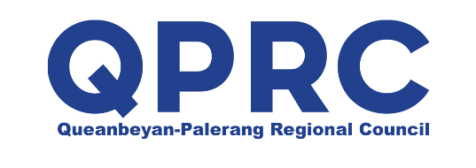

Letter of Intent
between
ACT Government and Queanbeyan-Palerang Regional Council
The proximity of the ACT and Queanbeyan-Palerang Regional Council (QPRC) requires an effective and productive relationship to support beneficial regional outcomes. This Letter signals the intention of the ACT Government and QPRC to formalise a relationship underpinned by the NSW/ACT memorandum of understanding and the NSW South East Regional Plan, and outline the principles and priority areas to be progressed between the ACT and Queanbeyan.
The principles for engagement include:
- optimising best of region outcomes
- pursuing a borderless approach to key infrastructure
- sharing information and data to inform planning and policy development and initiatives
Priority areas of engagement include:
- improving road and active transport connectivity
- collaborating on policy and planning opportunities to consider management of water, sewage, waste and renewable energy on a regional scale
- planning and collaborating on major contiguous developments
- understanding the infrastructure requirements to support population growth
- coordinating efforts to support major events across the ACT and QPRC
It is proposed the ACT Government and QPRC will develop a work plan for the next 12 months.
The priorities will be progressed through six monthly engagement between the ACT Government and QPRC officials to identify, implement and review projects of mutual interest.

Andrew Barr MLA |  | Tim Overall
Chief Minister  ACT Government |  | Administrator  Queanbeyan Palerang Regional Council
August 2016 |  | August 2016

