This factsheet has been developed to help ACT Government employees to understand the contents of their payslip.
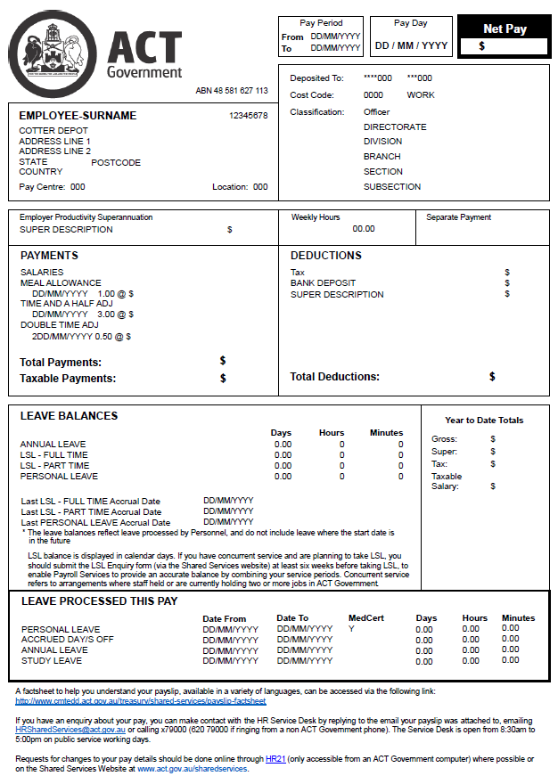
12
10
14
13
11
8
7
6
9
3
4
2
5
1

Pay Period From To
First and last dates of the pay fortnight. The pay fortnight starts on Thursday (the payday prior) and ends on the Wednesday two weeks later (the day before payday).

Pay Day
The date your pay is deposited into your account (bank, credit union or building society).

Net Pay
The amount of pay that will be deposited into your account, calculated by subtracting the amount shown at Total Deductions (section 10) from the amount shown at Total Payments (section 9).

Your name, AGS/Employee Number and address information
This section shows:
  - Your surname and initials;
  - Your Australian Government Service (AGS) or Employee Number which is unique to you;
  - Your work or postal address; and
  - Your Pay Centre and Location codes which are for office use only.

Information about your bank account, your classification and where you work
This section shows the:
  - BSB and account number of the account you have nominated to have your pay deposited into. Only the last 3 digits of both numbers are displayed to protect your privacy;
  - Classification you are currently employed at; and
  - Information about where your position is placed in your Directorate’s organisational structure, including the Cost Code your salary is paid against.

Employer Productivity Superannuation
The name of your superannuation fund and the amount of money the ACT Government pays to your fund.

Weekly Hours
The average number of hours you work per week.

Separate Payment
Usually this section will be blank. If a value does appear in this section though, it represents a separate payment (sometimes called an offline or advance payment) that was paid to you at any time during the pay period separate to your normal pay. This is usually for one of the following reasons:
  - you requested advance payment of leave;
  - you were owed pay such as base pay, penalties, overtime or allowances from a previous pay; or
  - you ceased employment and have been paid final entitlements such as base pay, unused annual leave, leave loading, long service leave, severance, or payment in lieu of notice.
The value shown in this section is the net amount that was deposited separately into your account. The gross amounts of the separate payment are included in section 9 (PAYMENTS) with any other amounts paid to you in the current pay. For example, the payment shown at SALARIES may include the current fortnight’s gross base pay as well as the gross base pay for a previous pay. The separate payment will also appear in section 10 (DEDUCTIONS). The separate payment is deducted here so that you don’t receive the payment twice. Tax relating to the separate payment will be added to tax for the current pay in the DEDUCTIONS section.

PAYMENTS
This section lists all of the payments you are being paid in the pay period, including the gross amounts of any separate payment you have been paid (see point 8 above). These may include:
  - Salaries – base salary or wages;
  - Leave payment – the dollar value of any leave you have taken. Where a leave payment appears on your payslip, this amount, plus the amount shown at ‘Salaries’, equals your fortnightly base pay;
  - Allowances such as Higher Duties (HDA), Qualification, Industry, Composite, etc that are specific to your position and/or skills; and/or
  - Shift penalties or overtime payments if you have worked early mornings, evenings, weekends or public holidays, or worked more than your normal hours;
Total Payments refers to the total amount paid (before tax is deducted).
Taxable Payments refers to the Total Payment less anything that reduces the amount of tax you have to pay (e.g. if you are salary packaging). The taxable payment is reduced by the amount of your salary packaging deduction or any other non-taxable allowance you may receive (i.e. an allowance you do not have to pay tax on).

DEDUCTIONS
This section lists all of the amounts that have been deducted from your Total Payments for the pay period. These may include:
  - Tax – the amount of tax withheld is calculated based on the information you provided on your Taxation Declaration form;
  - Separate payment recovery – if you have received a separate payment (see point 8 above), the amount paid into your account will be shown under deductions as SEP PAYMENT RECOVERY; and
  - Any other amounts you have elected to have deducted from your pay, such as:
    - Personal or Employee Superannuation Contributions;
    - Salary Packaging deductions including salary packaging fees, salary sacrificed superannuation, etc;
    - Deductions to accounts other than where your pay is deposited (e.g. BANK DEPOSIT 1, 2, 3 or 4);
    - Medical or health insurance fees; and/or
    - Union fees.
Total Deductions refers to the total of all deductions recorded in this section.
To make changes to any of your deduction amounts, please complete the Manage Bank Details and Deductions form on the Shared Services Website.

LEAVE BALANCES
This section includes your Annual Leave, Long Service Leave (LSL) and Personal Leave balances as at the last day of the pay period. These balances do not account for any future leave that has been processed or any future accruals.
Also displayed in this section are your Last Personal Leave and LSL Accrual Dates. These dates are usually the anniversary of the date you commenced with the ACTPS, however Leave Without Pay and Prior Service can affect the date.
Please note, the LSL balance that is displayed may not be accurate if you have concurrent service (that is, if you have held or are currently holding two or more jobs at one time in the ACT Government). If this applies to you, please submit the LSL enquiry form on the Shared Service Website to receive an accurate balance at least six weeks prior to taking LSL.
The total number of days of personal leave you have taken without a medical certificate since your last personal leave accrual does not show on payslips. HR21 users can check this information by counting the number of days in HR21 under Leave, Leave History. Staff who do not have access to HR21 can contact Shared Services on 620 79000 to confirm this information.

Year-to-Date Totals
This section shows financial year to date totals (i.e. including all amounts received since the first pay of the financial year until the current pay) for the following components:
- Gross income (pre-tax amounts of salary, including allowances, shift penalties and overtime paid);
- Personal super contributions made;
- Tax withheld;
- Taxable salary (gross income minus any pre-tax salary packaging deductions and non-taxed allowances).

LEAVE PROCESSED THIS PAY
This section shows any leave processed for you in the current pay period. Details displayed include the type of leave, the period the leave relates to, whether or not you provided evidence in support of the leave (for personal leave only, including a medical certificate or statutory declaration) and the total amount of leave that has/will be deducted from your balance.
To make changes to an approved leave application, you will need to speak with your delegate and complete the Cancel or Amend Approved Leave form on the Shared Services Website.

Shared Services Contact Information
This section provides contact details for Shared Services should you have any queries about your pay or leave. Alternatively, you can respond to the email your payslip is attached to.

